Overall findings in the Guidebook: What that evidence says

Cells with only Quantitative studies, cells with quantitative studies, and systematic review/ qualitative studies
The distribution of studies across cells reveals significant evidence concentration in a few areas while highlighting substantial gaps in others. Three cells contain more than 20 studies, including one examining DDR’s effects on the nature and scale of violence or atrocities and two related to sanctions—one on violence and atrocities and the other on economic security. Seven cells have more than 10 studies, covering topics such as military operations, diplomatic relations, intergroup relations, social funds, foundational state design and training, and job creation. Additionally, one cell contains exactly 10 studies, focusing on the effects of social funds/community-driven development, reconstruction intervention on the feeling of trust. 31 cells have fewer than 10 studies, 13 contain exactly five studies, 87 cells have fewer than five studies. However, 81 cells contain only one study and the majority of cells (168 cells) have fewer than five studies, highlighting significant evidence gaps in these areas.
Among the total cells, there were around 16% with large effect cells; 15% with moderate effect cells; 39% with small effect cells; 8% with no effect cells and 19% with adverse effect cells.

Among the total 223 cells, 84% (n=187) have low confidence in study findings, primarily due to the limited number of studies, the confidence rating of individual studies, and the lack of consistency in findings. Sixteen percent of the cells (n=36) have medium confidence in study findings, and there are no cells with a high confidence rating.
Table 3 – Overall What Evidence Says
Effect | Range | Number of Cells | Low confidence study rating | Medium confidence study rating
Large effect cells | Above 0.2 | 44 | 29 | 7
Moderate effect | 0.1 - 0.2 | 20 | 32 | 3
Small effect | 0.01-0.1 | 88 | 73 | 15
No effect | -0.01 - 0.01 | 35 | 17 | 3
Adverse effect | <0.0.01 | 36 | 37 | 7

Interventions studies have shown large effects
We identified a total of 36 cells where interventions had large effects on outcomes. One cell with six studies, found the large pooled effects of social funds, community-driven development and reconstruction on access to justice, rights, and public services. Additionally, four cells, each with five studies, found large effects in the following areas: mental health and psychosocial support on food security and nutrition and health security, peace processes and diplomacy on diplomatic relations, sanctions on government performance, and training and job creation on feelings of trust and acceptance of diversity. Another cell, with four studies, reported large effects of dispute resolution on diplomatic relations and peaceful dispute resolution. Furthermore, nine cells, each with three studies, highlighted large effects in areas such as transitional and restorative justice on sense of belonging and government performance. Seven cells with two studies and 13 cells with one study also showed large effects, including findings from dispute resolution, market development, and land reform interventions. Among them 80% of the cells have a low confidence rating in study findings.
For instance evidence from six studies on the effects of social funds and CDD on access to justice, rights, and public services showed improvements in local governance structures, with increased village development committees and access to counseling services. However, broader governance transparency and accountability effects remained weak. Public service infrastructure, particularly in education, water, and electricity, demonstrated significant gains, with higher school attendance, improved water access (15–34% increase), and expanded electricity coverage (26%). However, irrigation and transportation projects had limited or no lasting impact. Women's empowerment outcomes were mixed, with modest increases in association membership (6.4%), but little progress in local governance participation or legal rights. Service utilization, particularly in health access, remained unchanged in several cases. The effectiveness of these interventions was highly dependent on institutional stability, community participation, and long-term governance engagement.
Land reform interventions demonstrated the most significant large effects, appearing in seven cells. Evidence from three studies highlighted that land reform and natural resource management (NRM) initiatives enhanced economic security by improving tenure security, promoting long-term investments, and fostering financial stability. However, their effectiveness varied depending on contextual and implementation challenges. Evidence from one study found that land reform and NRM projects, particularly community-driven watershed restoration initiatives, contributed to educational security, increasing secondary school enrollment rates for girls. Another cell highlighted large effects on food security, nutrition, and health security, as community-driven watershed restoration initiatives improved dietary diversity and meal frequency. However, no significant improvements were observed in household access to drinking water.
A cell with three studies found large effects of land reform and NRM on feelings of trust and diversity. In Bolivia, participatory mapping increased trust levels, while in Indonesia, payments for ecosystem services (PES) fostered cooperation but did not significantly alter trust toward outsiders. In Mozambique, information campaigns improved trust in governance and civic engagement, but localized interventions led to elite capture. These findings emphasize that while NRM interventions can promote trust and inclusion, their success depends on equitable implementation, active community participation, and safeguards against elite control.
Evidence also suggests that dispute resolution interventions showed large effects in four cells. Evidence from four studies found significant impacts on diplomatic relations and peaceful dispute resolution. Programs such as CONCUR, IPNN, ECPN, RLS-I, and legal empowerment initiatives improved dispute resolution processes and trust in mediation. Additionally, IBN training, alternative dispute resolution (ADR) mechanisms, and interfaith initiatives enhanced negotiation skills and reduced coercion in conflict settings.

Interventions studies have shown moderate effects
We identified a total of 35 cells where interventions had moderate effects on outcomes. Among these, 12 cells were based on a single study, indicating limited evidence. Fifteen cells contained evidence from fewer than five studies, while five cells had findings from five to nine studies. Only three cells included evidence from more than 10 studies. Among these, the cell with the highest number of studies comprised 17 studies on the effects of intergroup contact and peace education on willingness to participate or help. Other notable examples include 15 studies on job training and economic security and 11 studies on social funds and community-driven development (CDD) on willingness to participate. Among them 88% of the cells have a low confidence rating in study findings.
For instance, evidence from 11 studies on social funds and CDD showed a pooled moderate effect on willingness to participate. Some interventions successfully increased civic engagement, participation in community groups, and contributions to public goods, particularly when emphasizing communication, democratic decision-making, and collaboration. However, several studies reported minimal or no sustained impact, with behavioral changes often limited to membership rather than active involvement.
Similarly, 15 studies examining the effects of training and job creation on economic security found moderate pooled effects. These programs—ranging from vocational training and business mentorship to financial assistance—generally led to higher employment rates and increased incomes. Notable cases include Liberia’s agricultural training program, where 77% of participants engaged in farming, and Tanzania’s RukaJuu! initiative, which raised earnings by 146% through entrepreneurship training. Additionally, public works programs like India’s NREGA played a critical role in stabilizing incomes during economic shocks. However, the impact was mixed in fragile and gender-unequal settings, where access to decent work remained constrained despite training opportunities.
The largest cell, with 17 studies, examined the moderate pooled effect of intergroup contact and peace education on willingness to participate or help. The evidence suggests that intergroup contact interventions can improve attitudes and increase engagement, though the effects vary. Longer programs incorporating behavioral reinforcement led to more sustained changes, while short-term interventions often resulted in temporary attitudinal shifts. Structural and perspective-taking interventions had only modest effects, indicating that the success of such programs depends on their design, duration, and context.
These findings highlight that while interventions with moderate effects can contribute to positive outcomes, their impact often depends on program design, contextual factors, and sustained engagement.

Interventions studies have shown small effects:
Most of the interventions studied showed a small pooled effect, with 88 cells indicating small effects. These include one cell with 26 studies on DDR programs and their impact on violence, another with 15 studies on military operations, eight cells with 10 or more studies, 16 cells with fewer than 10, six cells with five, 28 with fewer than five, and 25 with a single study. Among them 82% of the cells have a low confidence rating in study findings.
One cell, containing 26 studies on the effects of Disarmament, Demobilization, and Reintegration (DDR) programs and Peace Support/Keeping Operations on the nature and scale of violence or atrocities, showed small pooled effects. DDR programs and peacekeeping operations influence conflict dynamics by reducing violence and stabilizing postwar environments. UN peacekeeping presence shortens conflicts in fragmented settings and decreases battle deaths, while UN police effectively lower postwar violence. However, while peacekeeping reduces violence, it does not end conflict, as violence often transforms into other forms of instability. The success of interventions depends on mission size, mandate, and coordination with mediation efforts. Peacekeeping reduces electoral violence and atrocities, but its long-term impact on sustaining peace remains uncertain, particularly in complex conflicts with persistent security challenges.
Similarly, the cell with 10 studies on the effects of social funds, community-driven development, and reconstruction on trust and acceptance of diversity showed small effects. These interventions—ranging from block grants and infrastructure projects to civic engagement initiatives—produced localized improvements but no sustained impact on broader social cohesion. Trust levels remained largely unchanged, with slight increases reported toward specific groups like NGOs or local leaders. Acceptance of diversity showed localized improvements, particularly in interethnic and interreligious relations, but effects were often short-lived.
The cell with three studies on security sector reform interventions and their effects on the nature and scale of violence or atrocities also indicated small pooled effects. Security-focused strategies—such as Security-Only, Sequential, and Simultaneous approaches—were examined, along with sector security reforms like transitioning from international to local forces and Colombia’s ComunPaz program, which replaced rebel governance and improved justice in FARC-dominated areas. Security-Only and Sequential strategies were more effective in terminating conflicts and maintaining peace than Simultaneous approaches. ComunPaz reduced community disputes, and violence decreased by 10% under Afghan local security initiatives.
The cell with two studies on the effects of foundational state design processes, transitional political processes, and election support interventions on social norms regarding violence and atrocities showed small effects. Election support interventions, including election education events and civic engagement activities, influenced voter empowerment and willingness to use political violence. Town meetings, popular theatre, and door-to-door material distribution promoted electoral participation and governance legitimacy while discouraging violence. Studies in Nigeria and Côte d’Ivoire consistently demonstrated the effectiveness of these interventions.
The cell with one study on public sector provision, governance, and institutionalization interventions and their effects on food security, nutrition, and health security also showed a small effect. The Armed Forces of the Philippines’ Peace and Development Teams (PDT) program reduced child malnutrition in conflict-affected areas by 30% within three years, with lasting effects observed for at least seven years.
Finally, the cell with eight studies examining the effects of market development and macroeconomic policy on the nature and scale of violence or atrocities showed small pooled effects. While foreign aid and economic liberalization can reduce violence by addressing economic grievances and fostering stability, they may also exacerbate violence by increasing inequalities, fostering dependency, and becoming targets for insurgents. The effectiveness of these interventions depends on aid allocation, governance capacity, and complementary security measures. Some interventions successfully reduced violence, while others contributed to prolonged conflict. Economic policies such as trade liberalization promote long-term growth but may heighten short-term inequalities, increasing conflict risks. Tailored, well-coordinated approaches are necessary to ensure economic policies contribute to sustainable peace and development.

Interventions studies have shown no effects
We found 20 cells where interventions had no effect on outcomes. Among these, six cells were based on a single study, while nine cells had fewer than five studies. Additionally, four cells contained fewer than ten studies, and one cell, with 11 studies, examined the effects of diplomatic recognition and other diplomatic efforts on the nature and scale of violence and atrocities. Among them, 85% of the cells have a low confidence rating in study findings.
The diplomatic interventions cell, which analyzes evidence from 11 studies, assessed the impact of advocacy, sanctions, compensation, blacklisting, and economic programs on violence and atrocities. The findings revealed no pooled effect—while some studies reported a reduction in violence, others found that such interventions exacerbated repression or caused unintended economic and social disruptions. However, diplomatic scrutiny that combines both positive and negative feedback appeared to hold some promise for human rights improvements. The variation in outcomes stemmed from differences in intervention scale, type, and context, with some cases leading to increased violence or economic instability, particularly in fragile regions.
Similarly, policing and public security interventions also showed no significant effect on the nature and scale of violence and atrocities, based on evidence from six studies. For instance, integrated policing in Iraq successfully reduced ethnic tensions and support for anti-government violence by signaling fairness, while an increase in police presence in Afghanistan failed to curb election-related violence. Moreover, community policing initiatives across six countries demonstrated no measurable reductions in violence, trust, or cooperation.
Additionally, eight studies examined the effects of social funds, community-driven development (CDD), and reconstruction interventions on the nature and scale of violence and atrocities. The findings indicated no significant impact on reducing violent incidents, insurgent attacks, or conflict casualties. While some studies suggested weak reductions in violence under specific conditions—such as small-scale aid projects or targeted governance support—others found that certain programs inadvertently increased conflict casualties, highlighting the potential unintended consequences of development interventions in fragile settings.
These findings underscore the complex and context-dependent nature of interventions, where factors such as implementation design, local conditions, and political dynamics can influence their effectiveness or lead to unintended outcomes.

Interventions studied have shown adverse effects:
A total of 44 cells identify adverse effects of interventions. Among them 84% of the cells have a low confidence rating in study findings. The largest cell, with 24 studies, indicates that sanctions have adverse effects on the nature and scale of violence and atrocities. Another cell, containing 21 studies, highlights the sanctions have adverse pooled effect on economic security. Additionally, 11 studies suggest that foundational state design has adverse effects on nature and scale of violence and atrocities. Further, there are three with less than 10 studies, 18 cells have five and fewer than five studies and 17 cells contain only one study. For instance, media and communication interventions have an adverse impact on economic security (one study). A study on radio programming under the Peace through Development II (PDEV II) program negatively impacted economic security, as the focus was more on political and social transformation rather than economic stability (Finkel, 2018).
Similarly, civil society capacity-building and civic engagement initiatives have shown adverse effects on the nature and scale of violence and atrocities. This finding is based on a single study examining poverty alleviation transfers in Xinjiang under China’s 8-7 Plan (1994–2000). While the transfers led to increased local government spending on security (15%) and administration (10%), ethnic tensions persisted (Cheng, 2021).
Furthermore, civil society capacity-building pooled findings from five studies indicate that the intervention had adverse effects on civic participation. While local political engagement and voter coordination improved, leading to increased awareness and participation in civic activities, some initiatives reduced parochial voting and vote monopolization. Conversely, national-level political participation remained unchanged, and effects on democratic values, institutional trust, and decentralization support were limited or even negative.
Evidence on dispute resolution interventions also shows pooled adverse effects on social norms regarding violence or atrocities. Findings from two studies on the YE Peace Program in Niger and Conflict Management for Syrian Refugees in Jordan indicate that while these interventions aimed to reduce violence by fostering social cohesion and intergroup cooperation, they inadvertently supported political violence in certain contexts and revealed a tendency to accept violence.
Additionally, findings from three studies suggest that intergroup contact and peace education interventions have pooled adverse effects on economic security. In Lebanon and Liberia, these interventions did not lead to significant employment or investment gains, nor did they enhance property security or economic investment in Liberia. However, studies in Uganda reported modest improvements in business profits and household well-being, highlighting the mixed and uncertain nature of these economic impacts.

Descriptive Analysis of Included Studies
CAP aims and stage of conflict: The majority of studies (n=444; 78%) were of interventions with explicit conflict prevention (CP) aims (Figure 7). A significant proportion of studies were conducted of interventions that implicitly aimed to prevent both violent conflict and atrocities (CP/AP) (n=100; 18%). Only 25 studies (4%) were of interventions with solely atrocity prevention (AP) aims.
Figure 1: Distribution of studies by conflict and atrocity aims

Geography: By far the largest number of studies in any single global region were of interventions in sub-Saharan Africa (n=204; 36%), the greatest being in Liberia (n=37; 6%), reflecting the relatively greater number of active and dormant violent conflicts in sub-Saharan Africa than elsewhere.[1] However, when examining studies by country, we found relatively large numbers of studies of interventions with explicit conflict prevention aims in other parts of the world including Palestine (n=49; 9%), Afghanistan (n=32; 6%), and Colombia (n=29; 5%). A further 88 studies (15%) were conducted using global or regional data. Of the studies conducted with atrocity prevention aims, either explicitly or implicitly, 66 (12%) were done using global or regional data, while the largest number of studies in a single country was in Rwanda (n=19; 3%).

Figure 2: Global distribution of studies

Targeted populations: The majority of the studies were conducted among the general population, targeting and collecting data from civilians. Although a significant minority (n=52; 9%) were conducted among vulnerable groups (13 studies (2%) of women, 25 (4%) of children, 9 (2%) of displaced persons) and 35 studies (6%) collected data from combatants or ex-combatants (Figure 11).
Figure 3: Distribution of studies by study target group

Interventions
Intervention type: The majority of interventions evaluated were direct in nature (n=373; 62.27%), that is, most evaluated interventions that sought to respond to a specific violent conflict or atrocity directly (Figure 12).. In total, 226 studies (37.73%) evaluated the effects of indirect interventions that sought to address wider drivers of violent conflict and atrocity.

Figure 4: Distribution of studies by type of intervention

Note: N=603 because some studies evaluated the effects of multiple-component interventions, which could be coded as both direct and indirect.

Intervention groups: Across the six intervention groups specified in the framework, the most common intervention group evaluated was conflict management and mediation (n=165; 29%), followed by diplomacy, law, and accountability (n=146; 25%), socio-economic foundations (n=114; 20%), and safe environments (n=96; 17%) (Figure 13). Notably, we found the fewest studies within the civil society intervention group (n=48; 8%). ost common interventions largely following the overall trend identified above.

Intervention strategies: The most common interventions evaluated were intergroup contact (n=70; 42% of the conflict management and mediation group).For example, Alan et al. (2020) evaluated the impact of an educational intervention to build inter-ethnic cohesion in Turkish school. This was followed by peacekeeping operations (n=47; 49% of the safe environments intervention group. For example, Fjelde & Smidt (2022) evaluated the effects of a peacekeeping operation on the risk of electoral violence globally. These were largely interventions with CP aims. Sanctions (n=57; 39% of the diplomacy, law and accountability group) was the third most intervention, which was also the most common approach with explicit AP aims (n=13; 50% of the all 26 AP studies). This was followed by peace processes and diplomacy (n=40; 27% of the diplomacy, law and accountability group), and peace education (n=47; 28% of the conflict management and mediation group). Under socio-economic foundations, the largest numbers of studies were in the areas of cash transfers (n=28; 25% of this intervention group), land reform (n=23; 20%), market development and macro-economic policy (n=19; 17%), training (n=17; 15%) and employment creation (n=18; 16%).
Figure 5: Distribution of studies according to intervention groups

Outcomes
Types of outcomes: Studies evaluated both core (n=629; 110%) and secondary outcomes (n=499; 87%), which suggests some interest in analysis of causal pathways. The most common outcome group reported on was violence and atrocity prevention (n=335; 58%). This was followed by human security (n=233; 41%), social cohesion (n=191; 33%), and community and state governance (n=133; 23%)[3]. This trend was largely due to evaluations of programmes with explicit CP aims. Studies evaluating AP programming largely considered human security outcomes (n=14; 54% of all the AP studies).

Core outcomes: The largest number of core outcomes reported were on the nature and scale of violence and atrocities (n=206; 64% of the violence and atrocity prevention outcome group); 164 (48%) were for CP aims and (15%) were for AP or mixed AP/CP aims. For example, Corboz et al. (2019) focused on violence against children in war-affected Afghanistan reporting two measures: ‘nature and scale of violence or atrocities’ and ‘sexual and gender-based violence’, under the outcome domain violence and atrocity prevention. Relatedly, 74 studies (22% of the violence and atrocity prevention outcome group) reported on social norms around violence. Changes in social cohesion outcomes were also reported in many studies, especially feelings of trust (n=132; 69% of the outcome group) and willingness to participate or help others (n=56; 29%).

The least common core outcomes evaluated by studies were changes in the nature and level of diplomatic relations (one of the exceptions being Ruggeri et al. (2013), which evaluated the effect of UN peacekeeping missions in Africa on levels of cooperation at different levels), and sexual and gender-based violence, each which were evaluated by only three studies (1% of the violence and atrocity prevention outcome group). In the case of AP-interventions, several core outcome gaps were identified, including peaceful dispute resolution, sexual and gender-based violence.^{[4]}
Secondary outcomes: The most common secondary outcomes evaluated by studies were economic security (n=104; 45% of the human security outcome group) and government performance (n=92; 69% of the community and state governance group). These secondary outcomes also reflect those evaluated in studies of interventions with AP explicit aims. Food security and nutrition (n=7; 3% of the human security group) and transitions of power (n=3; 2% of the community and state governance group) were the least common secondary outcomes evaluated by the evidence base. Again, secondary outcome gaps for interventions with AP aims were found, including social safety nets, educational security and political security.
Figure 6: Distribution of studies by core and secondary outcomes evaluated

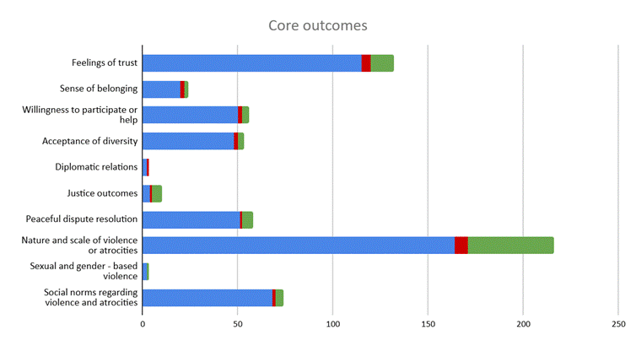

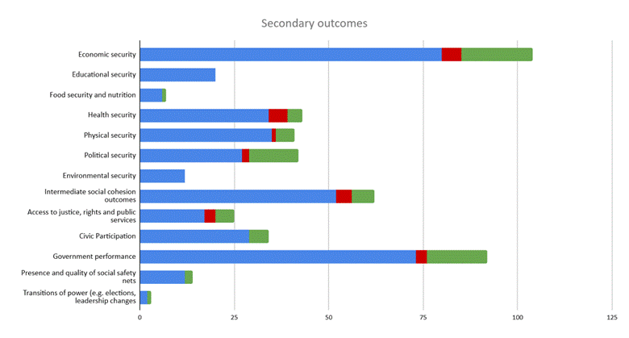

Confidence in research design and conduct
We found 25 evidence syntheses (4%). Primary studies used a range of designs, most commonly large-n quantitative approaches (459 studies; 80%) including randomised controlled trials, of which we included 127 RCTs (22%), and 333 quasi-experiments (58%; e.g., Best et al., 2011) (Figure 7). However, a significant minority of studies (n=89; 16%) used small-n theory-based qualitative approaches to measure the causal effect of the intervention strategy.
Figure 7: Types of study designs in EGM
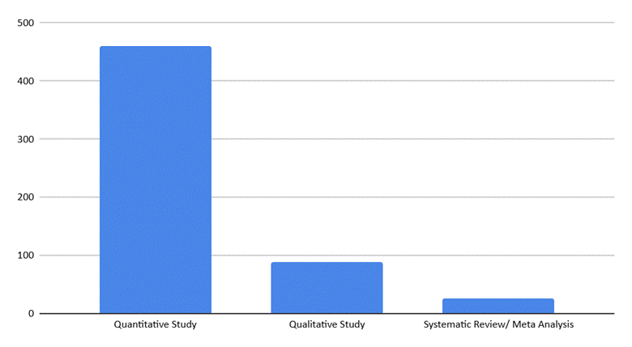
Evidence synthesis studies
We used AMSTAR2 (Shea et al., 2021) to appraise evidence synthesis studies (Figure 8). There are 16 total categories across seven critical domains, and overall confidence based on the assessment in the critical domains. We have modified the critical domains and include five critical items (1) adequacy of the literature search, (2) justification for excluding individual studies, (3) risk of bias from individual studies being included in the review, (4) appropriateness of meta-analytical methods, and (5) consideration of risk of bias when interpreting the results of the review.
Figure 8: Assessment of evidence synthesis studies

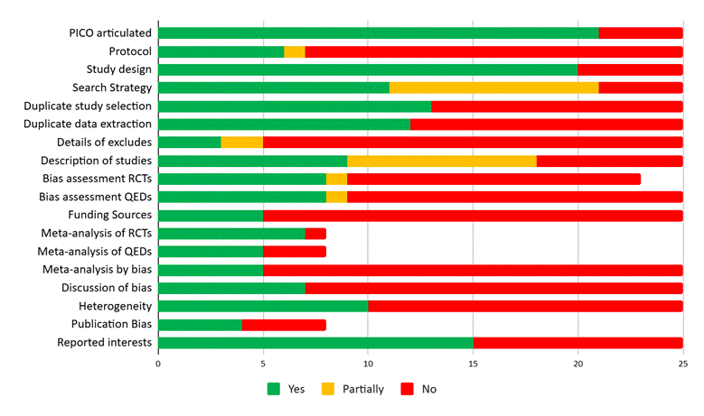

Eight studies (32% of the 25 completed synthesis studies) were assessed overall as at ‘high confidence’ based on the critical domains in the tool (Figure 9). Three studies were assessed as being of ‘medium confidence’ which meant more than one non-critical items, but ten (40%) studies were of ‘low confidence’ meaning that there was one critical flaw with non-critical weaknesses. A further four studies were rated as of ‘critically low confidence’, meaning that there were multiple critical flaws. Overall, the included evidence synthesis studies clearly reported the PICO components and search strategies and the list of databases and grey literature searched, but did not always transparently and adequately assess the risk of bias in the evidence included in the studies. Most studies also did not report important aspects of evidence synthesis including publication of a study protocol, reporting of funding sources or assessment of publication bias.
Figure 9: Overall confidence in evidence synthesis studies
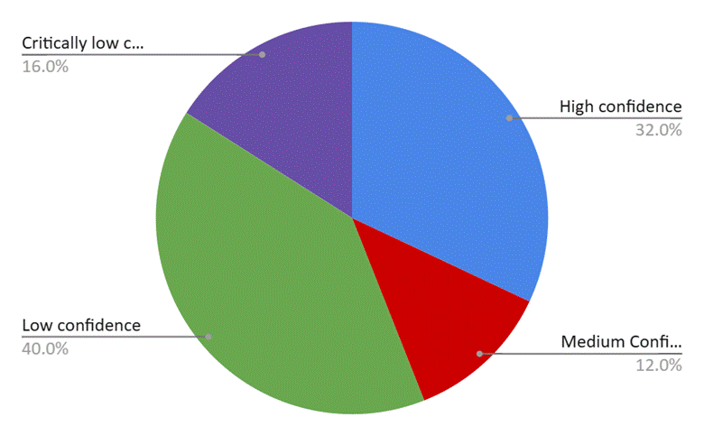

Large-n quantitative studies
We assessed the confidence in findings of the included studies based on key features including study design, methodology and reporting. The confidence assessment tool was developed by the Campbell Collaboration for EGMs. The tool contains critical dimensions of the evaluation, each of which is marked as ‘high confidence’, ‘medium confidence’, and ‘low confidence’. The overall score uses the ‘weakest link in the chain’ (or maxi-min) principle. Hence, the confidence in study findings can only be as high as the lowest rating given to the nine critical items in effectiveness studies.
In this map, 6 percent of the completed large-n quantitative studies (n=28) were rated as of ‘high confidence’, 43 percent (n=193) were rated as of ‘medium confidence’ and 51 percent (n=226) were rated as of ‘low confidence’ (Figure 22)[6]. The studies scored highly in terms of framing the evaluation questions, detailing the intervention and the outcomes, and regarding attrition (losses to follow-up or drop-outs) of study participants. Attrition is not always a relevant factor in impact evaluations, as in the case of studies that use cross-sectional evidence; these studies were not scored against attrition.
Thirty-two percent of the completed large-n quantitative studies (n=143 ) were rated as of ‘low confidence’ due to the absence of reporting on attrition (losses to follow-up). However, we did not consider reporting about power calculations as a critical item in the assessment. Many studies relied on existing data sources and hence did not need to perform tests to determine whether sample sizes were sufficient for detecting effects beforehand, in order to define the optimum sample size for data collection (i.e. power calculations). While power is still relevant in these studies (e.g., power to estimate effects overall or for particular population sub-groups) we opted not to mark down these types of studies if they did not report test of this nature for the purposes of our confidence assessments.
Figure 10: Assessment of large-n quantitative studies
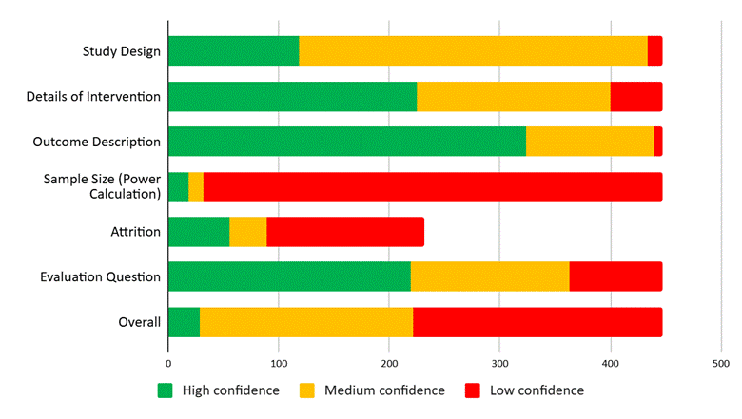
Small-n qualitative studies
There were in total 89 small-n studies included in the evidence map (16%). As shown in Figure 11, based on our assessment criteria, three studies (3% of the small-n studies) were rated overall at ‘medium certainty’: these studies were coded as at either ‘medium’ or ‘high certainty’ on each of the seven criteria. The other 86 studies (97%) were of ‘low certainty’ overall, meaning that they were assessed as at ‘low certainty’ for at least one of the seven items. No study was rated as at ‘high certainty’ overall (i.e., none was rated as at ‘high certainty’ on all items).
Figure 11: Assessment of small-n qualitative studies
