Cells With Impact Evaluation and Systematic review

4.1 Safe Environments

4.1.1 Policing and public security

4.1.1(1)
The effect of Policing & Public Security on Diplomatic Relations & Peaceful Dispute Resolution

Effect: Negative (While community mediation is viewed positively and holds significant potential, the perception of police mediation is documented negatively for addressing conflict, diplomatic relations & peaceful dispute resolutions in East Asia & Pacific countries)

Confidence in study findings: Low (one study, low confidence)

Summary
Indonesian men often perceive the police as ineffective and potentially corrupt, leading to widespread distrust. In contrast, community mediation is viewed positively and holds significant potential for conflict resolution, diplomatic relations, and peacebuilding in East Asia and Pacific countries. However, trust in mediation is largely limited to religious leaders. Suspicion of mediation interventions and other measures that are tied to the authority of the state means that the promise of service-oriented policing reforms may not be effectively implemented.
The intervention
The intervention refers to the perception of police intervention compared to community mediation in addressing violence among Indonesian men. It explored how mediators, including local leaders and religious figures, play a role in mitigating violence and fostering peaceful dispute resolution. The intervention encompasses pre-mediation, mediation, and post-mediation efforts, involving negotiation, reconciliation, and the reintegration of conflicting parties into the community.
How is the intervention expected to work
The specific interventions employed depend on the context of the conflict, the nature of the parties involved, and the skills and resources of the mediators. However, the overarching goal of these interventions is to shift the dynamics of the conflict from confrontation to collaboration, facilitate dialogue, and agreement building, and promote sustainable solutions that address the needs and interests of all stakeholders. For instance, the mediators could provide training on conflict management, negotiation, and communication skills. This empowers parties to address future conflicts constructively (p.135).
The evidence base
There is one qualitative study assessing the effect of Policing & public security on diplomatic relations & peaceful dispute resolution. The included study is by A. Demartoto, P. Nilan, A. Broom, & J. Germov (2014). Indonesian men's contrasting perceptions of how to deal with local violence. Asian Journal of Criminology, 9, 125-142. All references are from this study.
The evidence
Community-based mediation approach can be an effective tool to promote diplomatic relations & peaceful dispute resolutions in the region by addressing the root causes of conflict, training and building trust in religious leaders and the head of the family. However, the success of mediation depends on several factors, including the perceived legitimacy and authority of the mediators, the willingness of all parties to engage in a participatory process, and the capacity of mediators and institutions to implement agreements and address systemic issues
Confidence assessment
Overall confidence: Low Confidence Qualitative Study (It is unclear whether the study uses an established small n approach; theoretical framework is not presented; no triangulation done; sources of potential data bias are not discussed)

4.1.1(2)

Effect of policing and public security on nature and scale of violence and atrocities
Policing and public security interventions show mixed impacts on violence and atrocities. Effects tend to be moderated by implementation context and type of program.
Geographic region: Asia, Latin America, Africa, Middle East
Effect size: No effect (g=0.007)
Confidence in study findings: Low (6 studies with 20 effect sizes)

Short summary
Policing and public security interventions show varied effects on the nature and scale of violence and atrocities. Integrated policing in Iraq reduced ethnic tensions and support for anti-government violence by signaling fairness, while increased police presence in Afghanistan failed to curb election violence. Community policing across six countries showed no significant reductions in violence, trust, or cooperation. In Liberia, retrained police reduced domestic violence. Finally, foreign military aid often escalated state repression and human rights abuses.

The intervention
Policing and public security interventions target diverse populations and areas affected by violence, with strategies including integrated policing, increased security deployment, community policing, and foreign military aid. In Iraq, integrated policing aimed to reduce ethnic tensions by diversifying police units, while Afghanistan focused on securing polling centers through heightened police presence during elections. Liberia's "Confidence Patrols" deployed retrained officers to rural communities, enhancing security over 14 months. Foreign military aid supported post-conflict states globally, providing resources to stabilize governance. These interventions, ranging from temporary to long-term, sought to reduce violence, improve security, and foster trust, though outcomes were influenced by governance quality and local dynamics.

How the intervention is expected to affect this outcome
Policing and public security interventions are expected to reduce violence and atrocities by addressing the root causes of the lack of security, fostering trust in security institutions, and improving law enforcement capabilities. For instance, integrated policing is expected to reduce ethnic tensions and prevent violence by creating diverse, representative police units that signal fair treatment and reduce the likelihood of repression. Meanwhile, increased security deployment could deter insurgent violence and safeguard critical events, like elections, by providing a visible security presence. Community policing emphasizes engagement between police and communities through foot patrols, meetings, and problem-solving strategies. This approach seeks to build trust and cooperation, creating a virtuous cycle of security and accountability. Lastly, foreign military aid is expected to strengthen post-conflict governance and security, although it may pose a risk of escalating repression and human rights abuses if not paired with proper oversight and inclusive governance reforms.

The evidence base
This cell includes six impact evaluations, presenting heterogeneous results on the effects of policing and public security interventions on the nature and scale of violence.
The review discusses the effects of different interventions (which include security and policing) on mitigating or preventing armed violence in developing and middle-income countries.
Three primary studies were included: one involving six field experiments conducted in Brazil, Colombia, Liberia, Pakistan, the Philippines, and Uganda; another conducted in Liberia, and Papua New Guinea. Additionally, two studies utilized secondary data: one focused on Afghanistan and another drawing from a global dataset.

Evidence findings
The evidence suggests mixed results for policing and public security interventions in reducing violence and atrocities. Increased police deployment in Afghanistan led to decreased voter turnout due to negative perceptions of security forces, despite no significant reduction in election violence. Community policing in six countries showed no significant effects on trust, cooperation, or crime reduction, highlighting challenges in implementation and structural issues. Confidence Patrols in Liberia improved property security and reduced domestic violence but faced backlash from customary authorities. Foreign military aid was associated with increased human rights abuses and state repression.

The review evidence
The review identifies a moderate but low-quality evidence base on the impact of security and policing practices on urban violence, with mixed findings. High-quality studies highlight the importance of political leadership and localized approaches, while militarized responses have often failed to contain violence and, in some cases, exacerbated marginalization, fueling further conflict.

The impact evaluation evidence
This cell includes 6 impact evaluation studies. Thus, 6 summaries are provided below.
Blair et al. (2019) analysed the “Confidence Patrols" program in Liberia. This involved deploying teams of newly retrained, better-equipped police officers on recurring patrols to rural communities across three counties: Bong, Lofa, and Nimba. This initiative aimed to increase citizens' knowledge of the police and Liberian law, enhance security of property rights, and reduce crime, particularly in areas governed by customary authorities like chiefs and secret societies. The program was part of a broader effort to decentralize security and justice provision in rural Liberia, especially as the UN peacekeepers withdrew. The study employed a randomized controlled trial design, focusing on 74 communities with at least 500 residents, near usable roads, and with limited prior exposure to the program. These communities were grouped into nine geographic blocks, with four communities in each block randomly assigned to treatment and the rest to control. The evaluation began in June 2014 and continued until September 2015, with most treatment communities visited four or five times over 14 months. The findings indicate that the program reduced the incidence of simple assault and domestic violence. It also increased crime reporting, particularly for felonies, by approximately 50% compared to control communities. Notably, the increase in crime reporting was concentrated among residents who were not members of secret societies, suggesting the program provided an "exit option" for these individuals. The study is rated low confidence because of the lack of information on attrition rate and unclear evaluation questions.
Blair et al. (2021) analysed community policing as a reform strategy aimed at building trust between citizens and police by increasing engagement through foot patrols, community meetings, and problem-oriented policing strategies. The study involved six field experiments conducted in Brazil, Colombia, Liberia, Pakistan, the Philippines, and Uganda. Researchers collaborated with local police agencies to implement community policing practices tailored to each context. The interventions reached approximately 9 million people across 516 treated areas. The study design included random assignment of areas to either community policing practices or a control group, with data collected from 18,382 citizens and 874 police officers. Both self-reported and administrative data show no significant reduction in crime victimization. No significant effect was observed in any country, although Brazil shows wide confidence intervals, indicating variability in the data. No significant changes were observed in crime reporting or tips provided to the police. The study is considered to have low confidence due to the absence of detailed information on the attrition rate. While the study involved a large sample size, with surveys conducted on 18,382 citizens and 874 police officers, there is no explicit mention of attrition rates in the document.
Condra et al. (2019) examine the effect of security provisions in Afghanistan where the government deployed varying levels of Afghan National Police to polling centers to safeguard against insurgent violence. This intervention aimed to secure the election process and enhance public trust in the government amidst a backdrop of significant pre-election violence and concerns about insurgent attacks. The study utilized a quasi-experimental design, leveraging the unintentional variation in police deployment across polling centers with similar histories of violence. This allowed the researchers to isolate the effects of police presence on voter turnout. Data sources included internal government records, event-level violence data, certified voter turnout numbers, and pre- and post-election survey data from potential voters. Overall results suggest that the level of police deployment and historical violence did not significantly impact the level of violence during the election period, indicating that other factors not captured by these variables might be influencing the situation. The confidence level is considered medium confidence as it is a non-experimental study.
Cooper (2018) in Papua New Guinea aimed at enhancing policing in areas with limited state presence. The program empowers selected community members with police powers, including arrest and investigation, to address local offenses, particularly focusing on gender-based violence. These officers are unarmed and operate within their own communities, providing a bridge between the state and remote villages. The study employs a randomized controlled trial design, conducted in the Autonomous Region of Bougainville. It involves 39 villages and a sample size of 1,950 households and 45 candidates. The randomization was implemented through a lottery system at the Council of Elders level, resulting in cluster-level assignments for households and individual-level assignments for candidates. The study also includes a historical analysis using panel data from villages with CAP officers. The findings indicate that while the presence of community police does not significantly reduce the number of criminal incidents, it strongly reduces the perception of violence against women and property crime in the community. The study also finds that the presence of female CAP officers increases the probability of crimes being reported and resolved with the involvement of both police and chiefs. However, there is no conclusive evidence of a reduction in the crime rate itself. The intervention's completion status is marked as "No," indicating ongoing data collection or analysis. The study is rated medium due to its partial description of the evaluation questions.
Daugherty (2016) analysed the role of governmental and non-governmental actors in influencing intergroup conflict after war, particularly when group differences have been a significant aspect of war mobilization. The context of this study spans various countries, with specific case studies in Iraq and North Carolina, USA. The dissertation aims to understand how post-conflict institutions and policies can either exacerbate or mitigate group-based violence and identity politics. The study design includes cross-national, national, and sub-national analyses to explore the incentives for actors to institutionalize group differences after war. The research utilizes data from sources like Princeton’s Empirical Studies of Conflict project and public records, focusing on variables such as ethnic violence, political competition, and demographics in Iraq from 2003 onwards. In North Carolina, the study examines lynching violence and its correlation with state capacity and political competition, using historical data and imputation methods to address missing data. Findings from the Iraq case study indicate that higher representation ratios at the governorate level correlate with decreased sectarian violence, while increased budget allocations are associated with higher casualties. In North Carolina, the study finds that higher levels of county-level tax extraction relative to state-level extraction correlate with increased lynching violence, suggesting a political nature to racial violence. The study is rated low confidence as it is a non-experimental study with no clear description of the intervention, as the document primarily focuses on analysing variables such as representation ratios and budget allocations without explicitly detailing the intervention process or its implementation.. The study's reliance on existing datasets and imputation methods further complicates the understanding of the intervention's scope and impact.
Sullivan, Blanken, and Rice (2020) investigates the impact of foreign security assistance on human rights conditions, particularly on post-conflict and fragile states. The article determines if foreign assistance would improve human security or exacerbate negative governance and human rights conditions. The study used the Strategies and Tactics in Armed Conflict (STAC) dataset to identify cases of violent conflict between a government and an armed opposition movement of a state, during the period of 1945 to 2013. The dataset includes 171 internal armed conflict during the time period. The dependent variable is state repression, while independent variables include the volume of Major Conventional Weapons (MCW) suitable for use against domestic threats transferred to the post-conflict country and an indicator of military aid provision. The study utilized the continuously-updated GMM (CUE) estimator and ordinary least squares regression models. The results of the empirical analyses show that there is strong evidence that governments are more repressive upon receiving military aid or MCW post-conflict, with statistically significant increases in human rights violations. The study is rated low confidence due to its adequate description of the intervention.

Confidence Assessment
Overall low: This cell is rated low given that the findings tend to vary across the studies.
Link to review summaries
Cramer (2016)
All studies may be accessed via the EGM.

Other outcomes in this study:
Community and state governance / government performance
Community and state governance / presence and quality of social safety nets
Human security / political security
Social cohesion / feelings of trust and acceptance of diversity
Human security / physical security

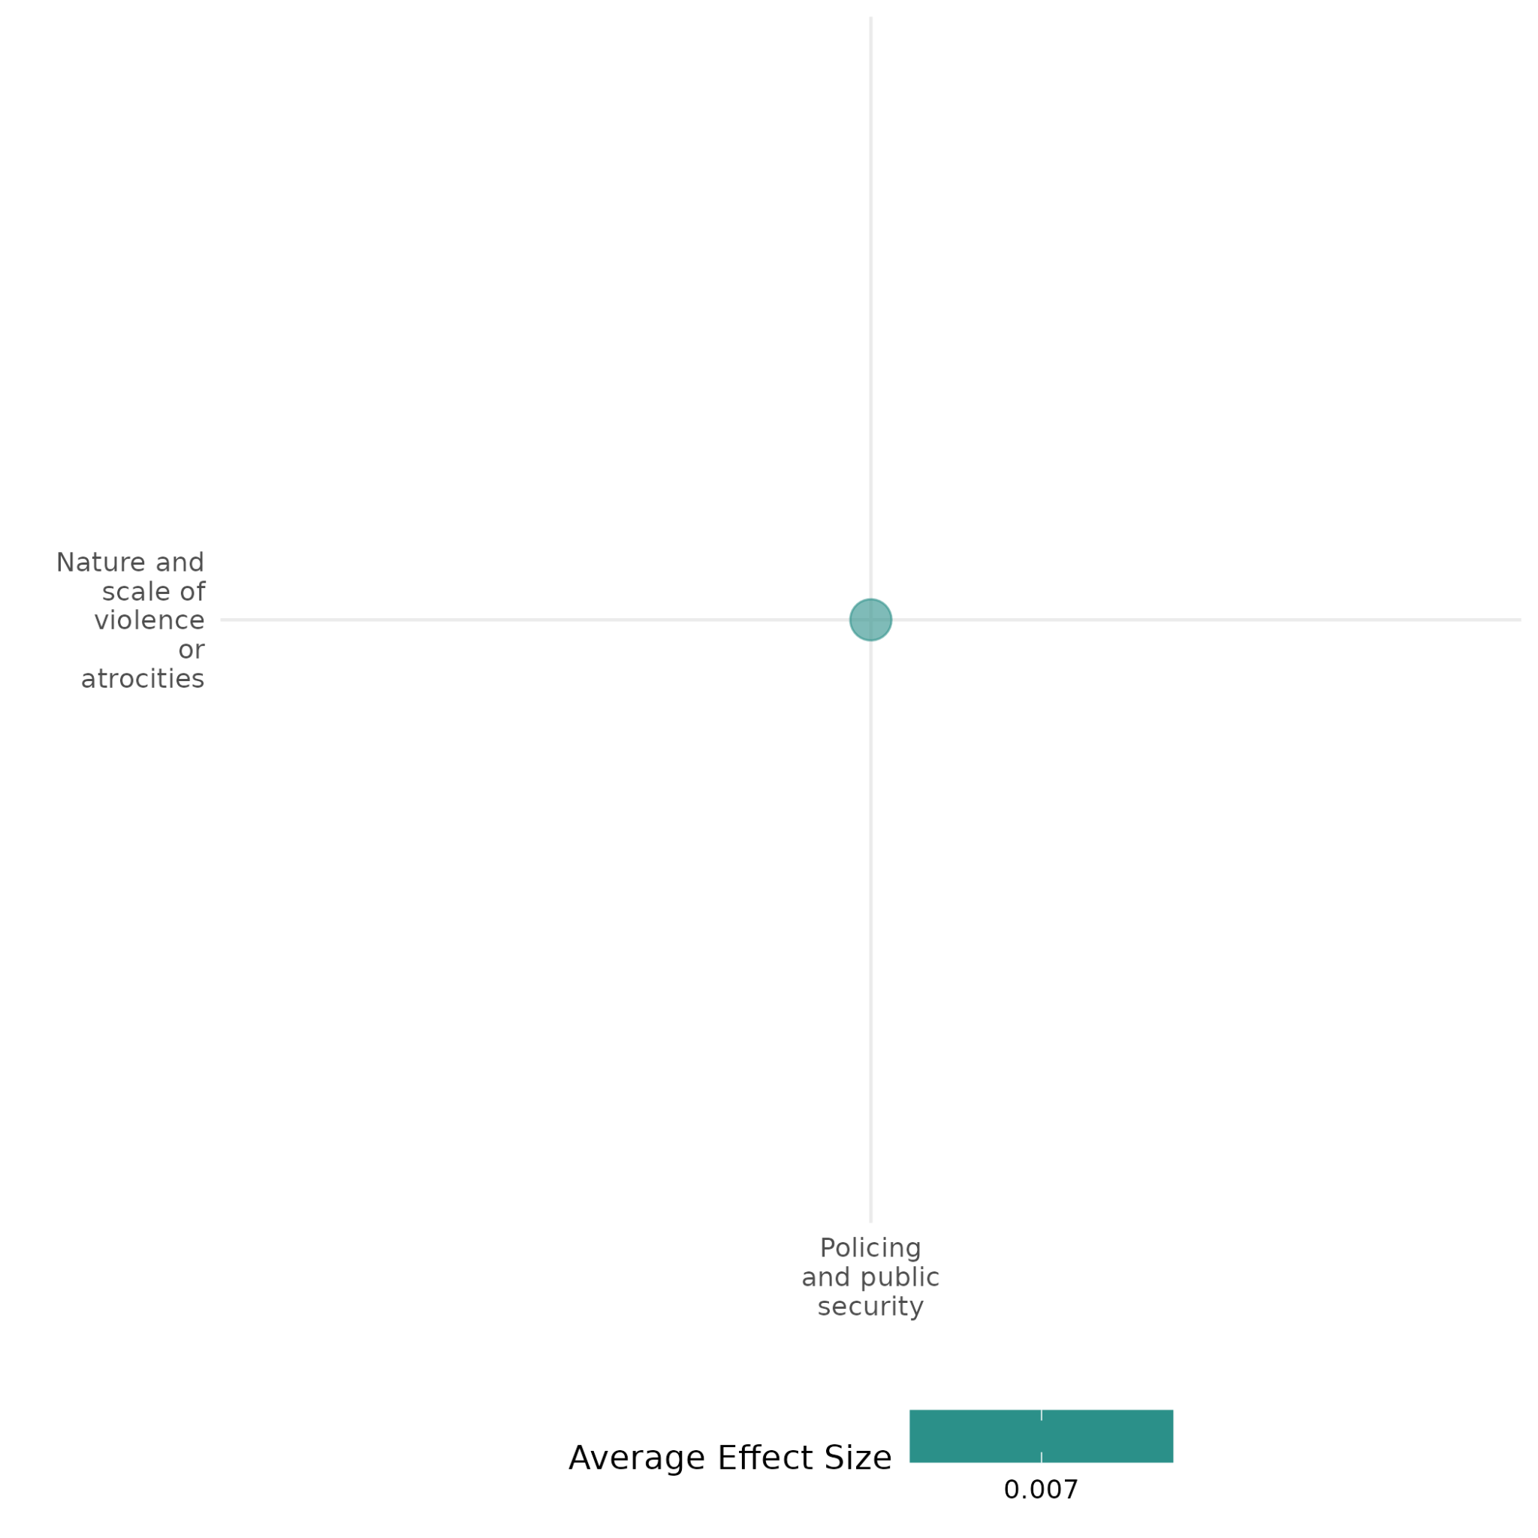

4.1.1(3)
The effect of policing and public security on feelings of trust and acceptance of diversity
Policing and public security measures, such as community policing practices, do not significantly improve the feelings of trust and cooperation.

Geographical region: Latin America, Africa, Asia

Effect size: Small effect (g=0.084)

Confidence in study findings: Low (1 study with 1 effect size)

Short summary
Policing and public security measures (e.g., community policing practices), aimed at fostering trust and cooperation between citizens and police while reducing crime, did not improve trust and acceptance of diversity in the Global South. Across six field experiments in Brazil, Colombia, Liberia, Pakistan, the Philippines, and Uganda, the interventions did not reduce crime, improve citizen-police trust, or increase citizen cooperation, largely due to inconsistent implementation, resource limitations, and structural barriers within police systems.

The intervention
Policing and public security interventions involves measures such as increased foot patrols, community meetings, and problem-oriented policing strategies to build trust and improve safety. The interventions are tailored locally to address citizen concerns and increase engagement. These measures have been implemented globally, with limited systematic evaluation in the Global South, where crime and police distrust remain high.

How the intervention is expected to affect this outcome
Community policing seeks to enhance citizen trust in police by increasing their visibility and responsiveness and fostering cooperation. It assumes that by addressing community concerns and engaging citizens regularly, the police can reduce crime and improve safety outcomes. The intervention is predicated on building a virtuous cycle of trust and collaboration between citizens and law enforcement.

The evidence base
The cell contains 1 study which conducted a meta-analysis of field experiments conducted in Brazil, Colombia, Liberia, Pakistan, the Philippines, and Uganda.

Evidence findings
The study revealed that community policing practices failed to produce significant improvements in citizen trust in the six evaluated sites. As such, the overall impact on key outcomes such as trust, and citizen cooperation was negligible. Structural barriers, such as inadequate resources, leadership turnover, and institutional challenges, undermined the effectiveness of the programs.

Included studies
Blair et al. (2021) analysed community policing as a reform strategy aimed at building trust between citizens and police by increasing engagement through foot patrols, community meetings, and problem-oriented policing strategies. This approach creates a virtuous cycle of cooperation and trust, ultimately reducing crime. The intervention has been implemented globally, but its effectiveness in the Global South remains uncertain. The study involved six field experiments conducted in Brazil, Colombia, Liberia, Pakistan, the Philippines, and Uganda. Researchers collaborated with local police agencies to implement community policing practices tailored to each context. The interventions reached approximately 9 million people across 516 treated areas. The study design included random assignment of areas to either community policing practices or a control group, with data collected from 18,382 citizens and 874 police officers. The findings revealed that community policing did not lead to improvements in citizen-police trust, cooperation, or crime reduction in any of the six sites. The meta-analysis shows that community policing generally does not produce significant effects on most outcomes across the countries studied. There was no significant improvement in how citizens perceive the police or how police perceive citizens. There were no significant improvements in citizens' perceptions of police intentions or capacity. No significant improvements in perceived state legitimacy or community trust, with some variability in Liberia and Uganda. Overall, the estimated treatment effects are close to zero, with none showing significant p-values after adjusting for multiple testing. Low because of the absence of detailed information on the attrition rate. While the study involved a large sample size, with surveys conducted on 18,382 citizens and 874 police officers, there is no explicit mention of attrition rates in the document. The study is rated low due to lack of reporting of the attrition rate.

Confidence assessment
Overall low: This cell is rated with low confidence as it only includes one study.

Other outcomes in the study:
Violence and atrocity prevention / nature and scale of violence and atrocities
Community and state governance / government performance
Human security / Physical security

4.1.1(4)
The effect of policing and public security on government performance

Policing and public security interventions have mixed results on perception of government performance.
Geographic region: Asia, Latin America, Africa
Effect size: Adverse effect (g=-0.004)
Confidence in study findings: Low (5 studies with 21 effect sizes)

Short summary
Policing and public security interventions aimed to improve governance through strategies like integrated policing, increased security deployment, and community policing. The evidence base shows mixed results. In Liberia, "Confidence Patrols" improved security but did not enhance trust in the government. Community policing across six countries failed to improve perceptions of state legitimacy. In Afghanistan, increased police presence during elections reduced voter turnout without curbing violence. However, integrated policing in Iraq reduced fears of repression and improved perceptions of fairness among minorities, highlighting its potential to strengthen government legitimacy in divided societies. Context and implementation were mediators to success.

The intervention
Policing and public security interventions aimed to improve governance by fostering trust, improving service delivery, and addressing community grievances. These strategies included integrating diverse officers into police units, increasing security deployment, and community policing. In Iraq, integrated policing aimed to reduce ethnic tensions by diversifying police units, while Afghanistan focused on securing polling centers through heightened police presence during elections. Liberia's "Confidence Patrols" deployed retrained officers to rural communities, enhancing security over 14 months.

How the intervention is expected to affect this outcome
Policing reforms are intended to enhance perceptions of government legitimacy by signaling fairness, promoting inclusivity, and strengthening state presence. Community policing, for example, focuses on collaboration with citizens, while integrated policing addresses historical grievances in divided societies by reducing fears of state repression. However, interventions may face challenges like uneven implementation or backlash from traditional power structures.

The evidence base
This cell includes five impact evaluations, presenting heterogeneous results on the effects of policing and public security interventions on government performance.
Three primary studies were included: one involving six field experiments conducted in Brazil, Colombia, Liberia, Pakistan, the Philippines, and Uganda; another employing a survey experiment in Baghdad, Iraq; a third conducted in Liberia; and finally an RCT conducted in Papua New Guinea. One secondary research focused on Afghanistan.

Evidence findings
The evidence reveals mixed effects of policing interventions on government performance. In Liberia, "Confidence Patrols" did not enhance trust in the police, courts, or government, with backlash from traditional power structures like secret societies undermining state efforts. Community policing across six countries failed to improve perceptions of police intentions, capacity, or state legitimacy due to uneven implementation and limited buy-in from leadership. In Afghanistan, increased police deployment during elections decreased voter turnout by 30%, driven by negative perceptions of security forces. However, integrated policing in Iraq reduced the minorities’ fears of repression by the police and government.

Included studies
Blair et al. (2019) analysed the “Confidence Patrols" program in Liberia. This involved deploying teams of newly retrained, better-equipped police officers on recurring patrols to rural communities across three counties: Bong, Lofa, and Nimba. This initiative aimed to increase citizens' knowledge of the police and Liberian law, enhance security of property rights, and reduce crime, particularly in areas governed by customary authorities like chiefs and secret societies. The program was part of a broader effort to decentralize security and justice provision in rural Liberia, especially as the UN peacekeepers withdrew. The study employed a randomized controlled trial design, focusing on 74 communities with at least 500 residents, near usable roads, and with limited prior exposure to the program. These communities were grouped into nine geographic blocks, with four communities in each block randomly assigned to treatment and the rest to control. The evaluation began in June 2014 and continued until September 2015, with most treatment communities visited four or five times over 14 months. Findings suggest that the program did not improve citizens' perceptions of the police, courts, or government. There was also some evidence of backlash from the customary sector, with increased reports of the "bush devil" appearing in treatment communities (a controversial ceremonial figure that secret societies use to maintain social order, often at the expense of non- members-Isser et al., 2009). The study is rated low confidence because of the lack of information on attrition rate and unclear evaluation questions.
Blair et al. (2021) analysed community policing as a reform strategy aimed at building trust between citizens and police by increasing engagement through foot patrols, community meetings, and problem-oriented policing strategies. The study involved six field experiments conducted in Brazil, Colombia, Liberia, Pakistan, the Philippines, and Uganda. Researchers collaborated with local police agencies to implement community policing practices tailored to each context. The interventions reached approximately 9 million people across 516 treated areas. The study design included random assignment of areas to either community policing practices or a control group, with data collected from 18,382 citizens and 874 police officers. Findings show that there were no significant improvements in citizens' perceptions of police intentions or capacity. There was also no significant improvement in how citizens perceive the police or how police perceive citizens. Finally, there was no significant improvements in perceived state legitimacy, with some variability in Liberia and Uganda. The study is considered to have low confidence due to the absence of detailed information on the attrition rate. While the study involved a large sample size, with surveys conducted on 18,382 citizens and 874 police officers, there is no explicit mention of attrition rates in the document.
Condra et al. (2019) examine the effect of security provisions in Afghanistan where the government deployed varying levels of Afghan National Police to polling centers to safeguard against insurgent violence. This intervention aimed to secure the election process and enhance public trust in the government amidst a backdrop of significant pre-election violence and concerns about insurgent attacks. The study utilized a quasi-experimental design, leveraging the unintentional variation in police deployment across polling centers with similar histories of violence. This allowed the researchers to isolate the effects of police presence on voter turnout. Data sources included internal government records, event-level violence data, certified voter turnout numbers, and pre- and post-election survey data from potential voters. Overall results suggest that the level of police deployment and historical violence did not significantly impact the level of violence during the election period, indicating that other factors not captured by these variables might be influencing the situation. The confidence level is considered medium confidence as it is a non-experimental study. The confidence level is considered medium confidence as it is a non-experimental study.
Cooper (2018) analysed the Community Auxiliary Police (CAP) program in Papua New Guinea aimed at enhancing policing in areas with limited state presence. The program empowers selected community members with police powers, including arrest and investigation, to address local offenses, particularly focusing on gender-based violence. These officers are unarmed and operate within their own communities, providing a bridge between the state and remote villages.The study employs a randomized controlled trial design, conducted in the Autonomous Region of Bougainville. It involves 39 villages and a sample size of 1,950 households and 45 candidates. The randomization was implemented through a lottery system at the Council of Elders level, resulting in cluster-level assignments for households and individual-level assignments for candidates. The study also includes a historical analysis using panel data from villages with CAP officers. There is no significant evidence that experience with community policing affects trust in government, propensity to vote with the chief, or knowledge of government. The study is rated medium due to its partial description of the evaluation questions.
Nanes (2019) examines the impact of police integration on support for anti-government violence in Iraq, a country marked by sectarian conflict. The intervention involves integrating police forces by including officers from various ethnic and religious groups in mixed units, rather than segregating them into homogeneous units. This integration aims to address the commitment problem between the powerful state and weaker minority groups by making future repression more costly for the state and signaling a commitment to fair treatment. The research employs a survey experiment conducted among 800 residents of Baghdad, Iraq. Respondents were randomly assigned to receive either a treatment or control vignette, with the treatment group being informed about police integration. The study uses a list experiment to measure support for anti-government violence and expectations of repression. The sample includes both Sunni and Shia Arabs, with efforts made to ensure a representative sample of Baghdad's diverse neighborhood. Findings of the study suggest that perceptions of police integration are associated with lower expected repression by both the police and the government, particularly among Sunnis. The study is rated medium confidence as it is a non-experimental study.

Confidence assessment
Overall low: While this cell has 5 impact evaluation studies, the findings across the studies tend to be inconsistent.

Other outcomes in this study:
Violence and atrocity prevention / nature and scale of violence and atrocities
Community and state governance / presence and quality of social safety nets
Human security / political security
Social cohesion / feelings of trust and acceptance of diversity
Human security / physical security

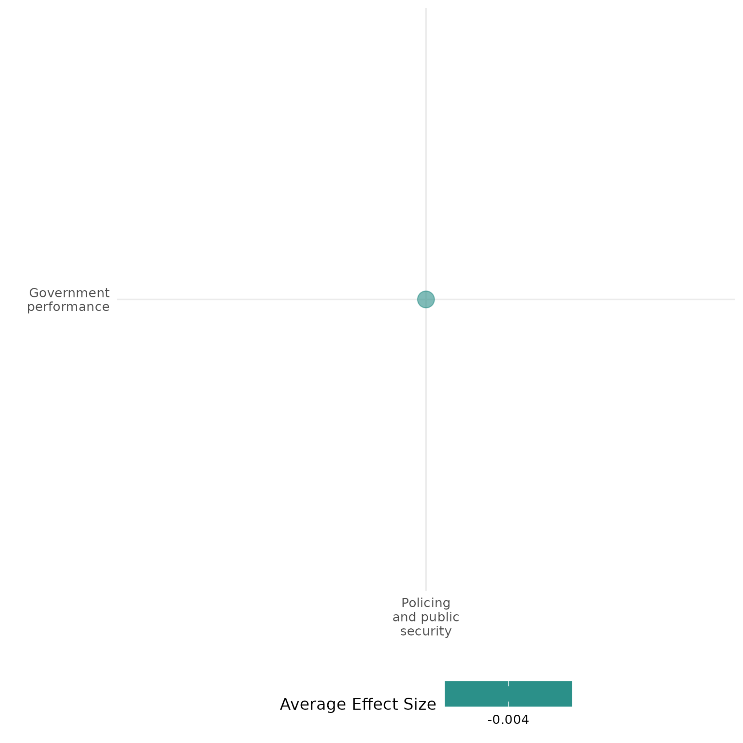

4.1.1(5)
The effect of policing and public security on presence and quality of social safety nets

Police deployment can undermine utilization of formal institutions for dispute resolution, while community policing may enhance trust in law enforcement.

Geographic region: Middle East, Asia, Africa, Global

Effect size: Small effect (g=0.045)

Confidence in study findings: Low (2 studies with 4 effect sizes)

Short summary
Policing interventions, such as deployment of police to polling stations and community policing programs in conflict-affected regions, have mixed effects on the presence and quality of social safety nets. The deployment of Afghan National Police to polling stations reduced citizens’ willingness to use courts or police for dispute resolution, largely due to negative perceptions of police corruption. Meanwhile, the Community Auxiliary Police (CAP) program in Papua New Guinea improved perceptions of procedural justice, increasing trust in law enforcement but without significantly reducing crime rates.

The intervention
This cell examines two interventions. One of which is the deployment of the Afghan National police to polling stations during the 2010 parliamentary elections to prevent insurgent violence and enhance public trust in the electoral process. The other is the Community Auxiliary Police (CAP) program, which assigned unarmed community members with police powers to enforce local laws, particularly regarding gender-based violence. Officers operated within their own villages, bridging the gap between the state and rural communities.

How the intervention is expected to affect this outcome
In conflict-affected regions, securing elections through police deployment is expected to increase public engagement with state institutions, improving governance and social safety net access. Similarly, community policing programs seek to enhance law enforcement reach, promoting trust in formal dispute resolution mechanisms over traditional or informal alternatives. However, the effectiveness of these interventions hinges on public perceptions of law enforcement. If police are viewed as corrupt or abusive, citizens may disengage from formal institutions, weakening social safety nets. Conversely, when policing fosters procedural justice and community trust, engagement with legal and social support systems can improve.

The evidence base
This cell includes 2 impact evaluation studies and 3 qualitative studies. The study settings include: Afghanistan (1 study), Papua New Guinea (1 study), Indonesia (1 study), Nigeria (1 study), and global (1 study).

Evidence findings
Findings suggest that increased police presence at polling stations significantly reduced citizens’ willingness to use courts or police for dispute resolution. Meanwhile, the Community Auxiliary Police (CAP) program improved procedural justice perceptions (P), increasing trust in law enforcement and formal dispute resolution mechanisms.

Included studies
Condra et al. (2019) examine the effect of security provisions in Afghanistan where the government deployed varying levels of Afghan National Police to polling centers to safeguard against insurgent violence. This intervention aimed to secure the election process and enhance public trust in the government amidst a backdrop of significant pre-election violence and concerns about insurgent attacks. The study utilized a quasi-experimental design, leveraging the unintentional variation in police deployment across polling centers with similar histories of violence. This allowed the researchers to isolate the effects of police presence on voter turnout. Data sources included internal government records, event-level violence data, certified voter turnout numbers, and pre- and post-election survey data from potential voters. Findings revealed that increased police presence at polling centers led to a significant decrease in voter turnout, averaging a 30% reduction compared to centers with fewer police. This decrease was not attributed to voter anticipation of election-day violence but rather to negative perceptions of the police as corrupt and predatory, which discouraged voter interaction with security forces. This is a high- to medium-confidence quantitative study.
Cooper (2018) analysed the Community Auxiliary Police (CAP) program in Papua New Guinea aimed at enhancing policing in areas with limited state presence. The program empowers selected community members with police powers, including arrest and investigation, to address local offenses, particularly focusing on gender-based violence. These officers are unarmed and operate within their own communities, providing a bridge between the state and remote villages. The study employs a randomized controlled trial design, conducted in the Autonomous Region of Bougainville. It involves 39 villages and a sample size of 1,950 households and 45 candidates. The randomization was implemented through a lottery system at the Council of Elders level, resulting in cluster-level assignments for households and individual-level assignments for candidates. The study also includes a historical analysis using panel data from villages with CAP officers. The findings indicate that while the presence of community police does not significantly reduce the number of criminal incidents, it strongly reduces the perception of violence against women and property crime in the community. There is no significant evidence that experience with community policing affects trust in government, propensity to vote with the chief, or knowledge of government. The study is rated medium due to its partial description of the evaluation questions.

Confidence assessment
Overall low: This cell is rated low as it has less than 4 impact evaluation studies. The study findings also tend to be inconsistent.

Other outcomes in the study:
Violence and atrocity prevention / nature and scale of violence and atrocities
Community and state governance / government performance
Human security / political security

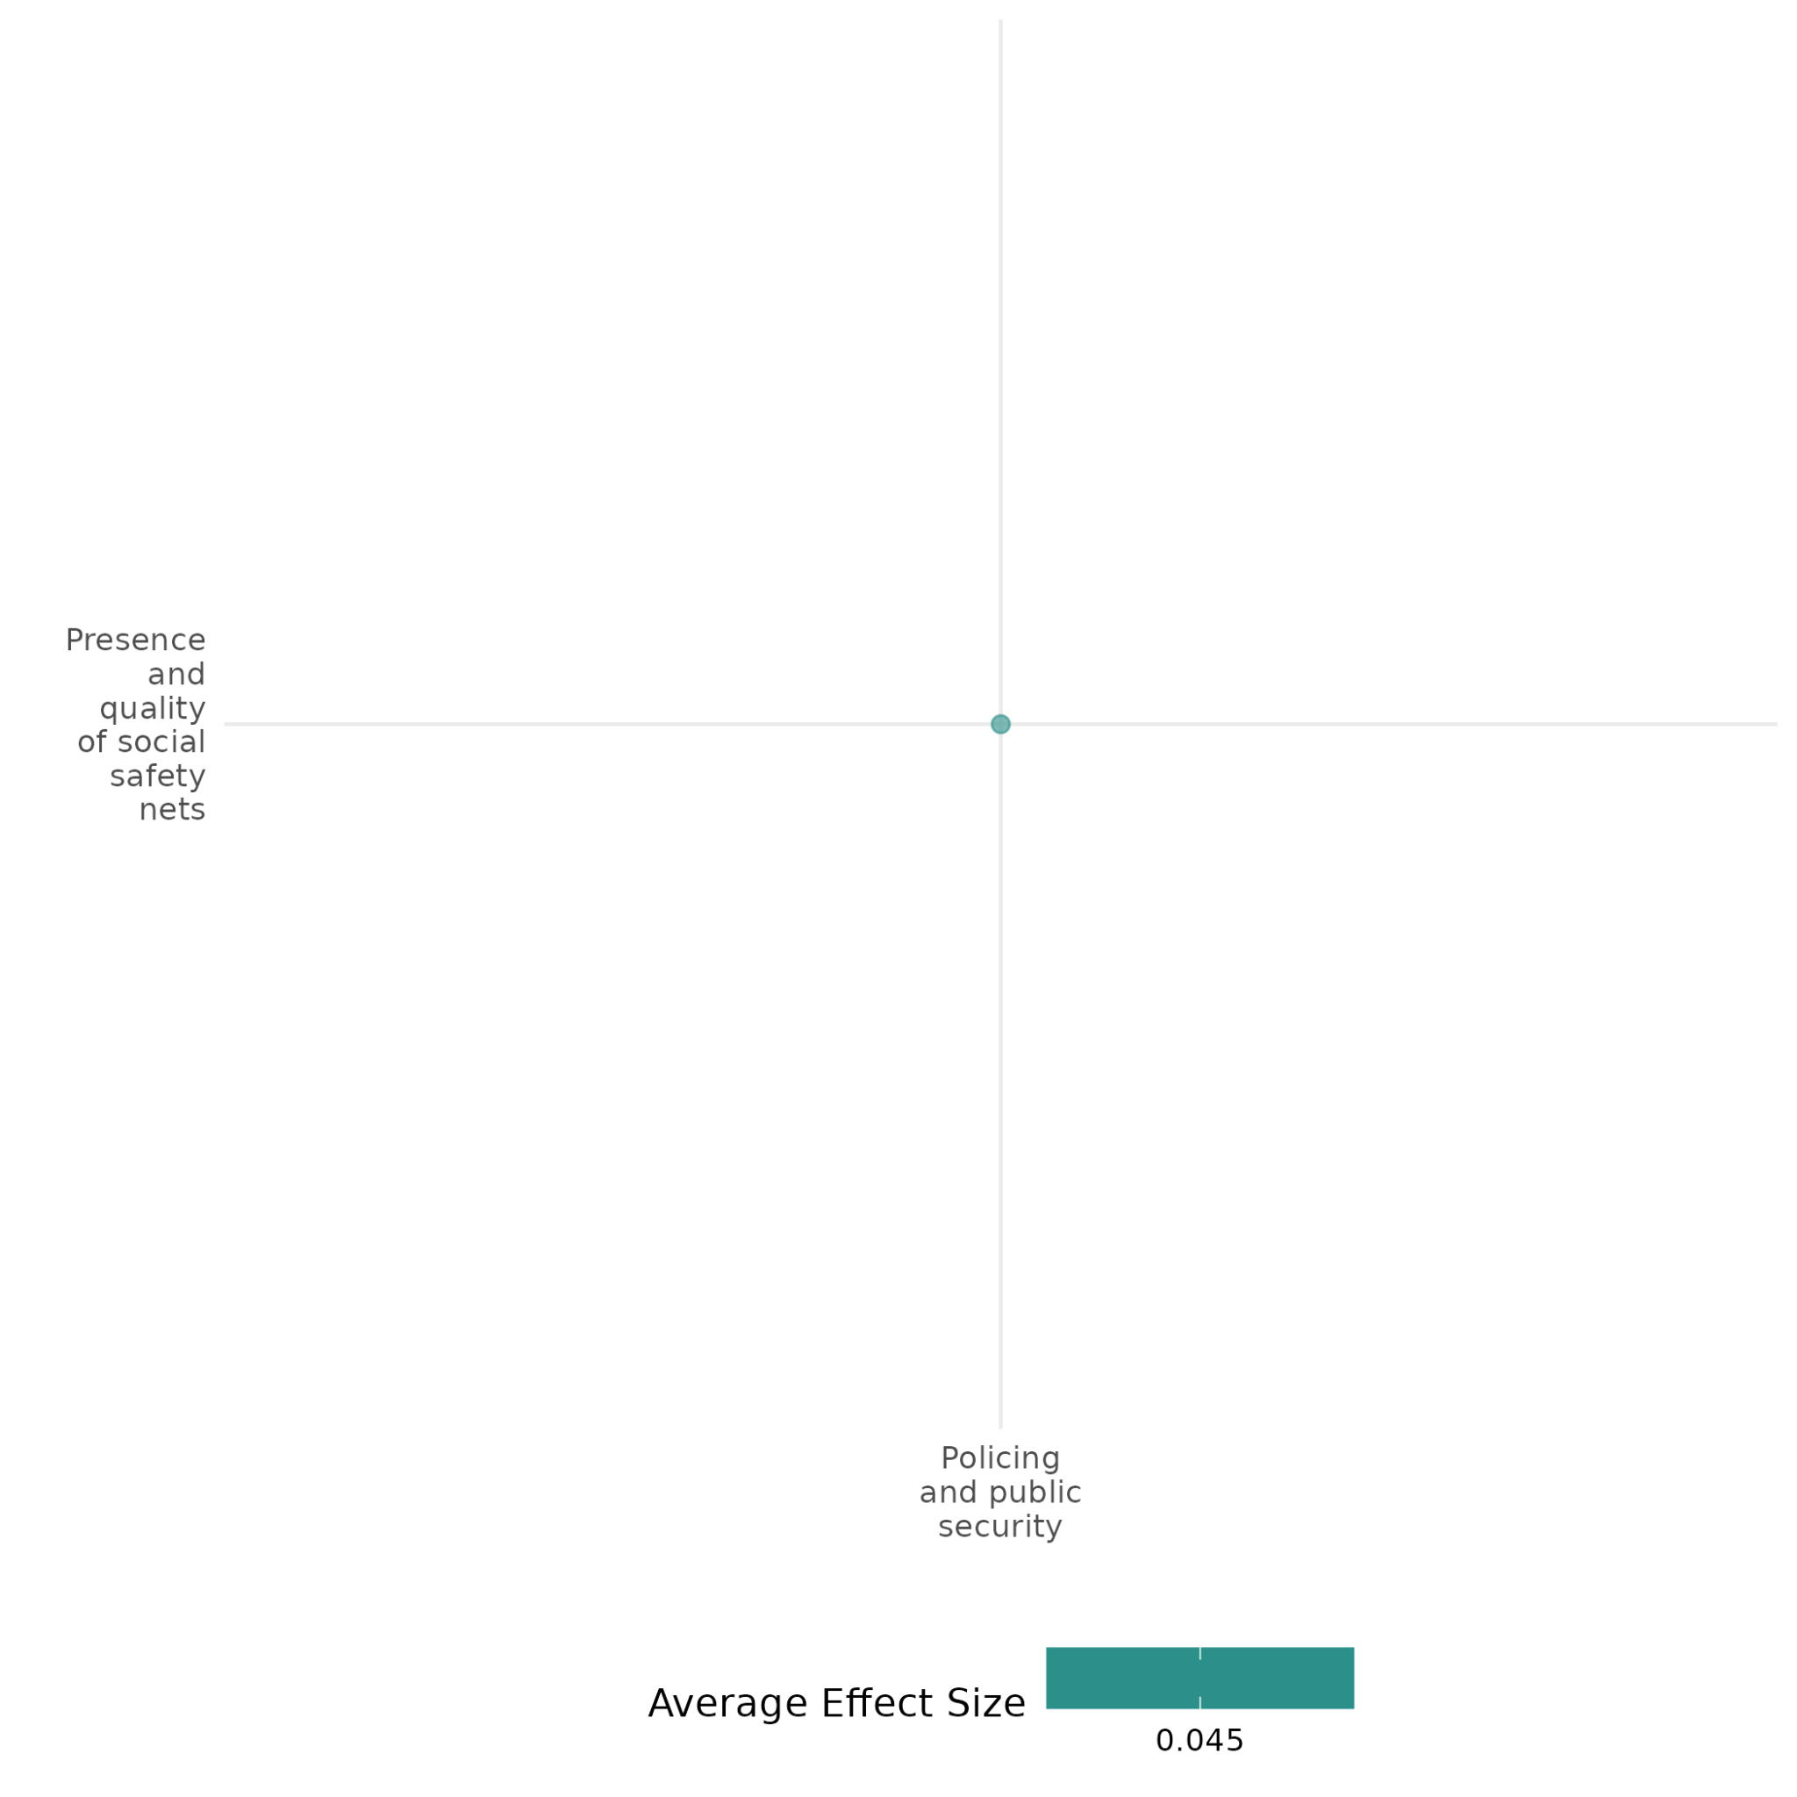

4.1.1(6)

Effect of policing and public security on physical security

Community policing strategies do not increase policy legitimacy, but when strong community partnerships are integrated, positive effects become present.

Geographic region: Asia, Latin America, Africa

Effect size: Large effect (g=0.453)

Confidence in study findings: Low (3 studies with 22 effect sizes)

Short summary
Policing and public security interventions may include community policing strategies and deployment of retrained police officers. Findings from the studies reveal mixed effects. While community policing seeks to improve trust and decentralize decision-making, it often falls short in enhancing police legitimacy or state capacity. However, interventions that foster strong community partnerships and address local issues like insecurity and youth unemployment are more likely to improve physical security.

The intervention
Policing and public security interventions vary in design, scope, and target populations, often addressing underserved or high-crime areas. It may include interventions which deploy retrained police officers to rural communities to improve security, reduce crime, and expand access to law enforcement. There are also community policing strategies which combine foot patrols, community engagement, and decentralized decision-making to foster trust and collaboration. In some areas, such interventions focus on addressing localized challenges, such as cattle rustling, youth unemployment, and community cohesion, by strengthening partnerships between security agencies and local populations.

How the intervention is expected to affect this outcome
Policing and public security interventions can be designed to improve physical security by addressing underlying barriers to trust and collaboration between citizens and law enforcement. By increasing police presence and accessibility, these interventions aim to reduce crime, enhance perceptions of safety in homes and communities, and ensure freedom of movement. Initiatives like Liberia’s "Confidence Patrols" focus on bridging the gap between state security and populations historically excluded from equitable access to justice, fostering perceptions of fairness and reducing reliance on biased customary systems. Community policing strategies emphasize collaborative problem-solving, frequent foot patrols, and community meetings, which are intended to rebuild citizen trust in the police and encourage cooperative behaviors, such as crime reporting. In Kenya’s "Nyumba Kumi" initiative, the emphasis on decentralized decision-making and local partnerships is expected to empower communities to take active roles in maintaining security, while also promoting the perception that the state values their safety concerns. Across all interventions, improving the visibility, responsiveness, and capacity of police is expected to shift citizen perceptions of security institutions, reducing conflict vulnerability and creating an environment where communities feel safer and more secure.

The evidence base
This cell includes three impact evaluations and one qualitative study.
Three primary studies were included: one involving six field experiments conducted in Brazil, Colombia, Liberia, Pakistan, the Philippines, and Uganda; another conducted in Liberia; and the last one employed in Kenya. The qualitative study was conducted in Indonesia.

Evidence findings
The evidence on policing and public security interventions shows mixed outcomes regarding their effects on physical security. While community policing strategies aim to improve collaboration, decentralize decision-making, and foster trust between citizens and law enforcement, they often fail to significantly enhance perceptions of police legitimacy or state capacity. In some cases, interventions have led to unintended consequences, such as resistance from local authorities or limited community buy-in. However, improvements in physical security are more likely when interventions successfully build strong community partnerships and address local challenges, such as insecurity, youth unemployment, or organized crime.

Included studies
Blair et al. (2019) analysed the “Confidence Patrols" program in Liberia. This involved deploying teams of newly retrained, better-equipped police officers on recurring patrols to rural communities across three counties: Bong, Lofa, and Nimba. This initiative aimed to increase citizens' knowledge of the police and Liberian law, enhance security of property rights, and reduce crime, particularly in areas governed by customary authorities like chiefs and secret societies. The program was part of a broader effort to decentralize security and justice provision in rural Liberia, especially as the UN peacekeepers withdrew. The study employed a randomized controlled trial design, focusing on 74 communities with at least 500 residents, near usable roads, and with limited prior exposure to the program. These communities were grouped into nine geographic blocks, with four communities in each block randomly assigned to treatment and the rest to control. The evaluation began in June 2014 and continued until September 2015, with most treatment communities visited four or five times over 14 months. Findings suggest that the program did not improve citizens' perceptions of the police, courts, or government. There was also some evidence of backlash from the customary sector, with increased reports of the "bush devil" appearing in treatment communities (a controversial ceremonial figure that secret societies use to maintain social order, often at the expense of non- members-Isser et al., 2009). The study is rated low confidence because of the lack of information on attrition rate and unclear evaluation questions.
Blair et al. (2021) analysed community policing as a reform strategy aimed at building trust between citizens and police by increasing engagement through foot patrols, community meetings, and problem-oriented policing strategies. The study involved six field experiments conducted in Brazil, Colombia, Liberia, Pakistan, the Philippines, and Uganda. Researchers collaborated with local police agencies to implement community policing practices tailored to each context. The interventions reached approximately 9 million people across 516 treated areas. The study design included random assignment of areas to either community policing practices or a control group, with data collected from 18,382 citizens and 874 police officers. Findings show that there were no significant improvements in citizens' perceptions of police intentions or capacity. Finally, there was no significant improvements in perceived state legitimacy, with some variability in Liberia and Uganda. The study is considered to have low confidence due to the absence of detailed information on the attrition rate. While the study involved a large sample size, with surveys conducted on 18,382 citizens and 874 police officers, there is no explicit mention of attrition rates in the document.
Nyapara and Sakataka (2015) evaluates the effectiveness of the Nyumba Kumi initiative, a community policing strategy introduced to enhance peace and security in West Pokot County, Kenya. The region faces persistent insecurity due to factors such as cattle rustling, youth unemployment, and lack of community cohesion. The initiative aims to improve collaboration between security organs and local communities by fostering partnerships and decentralized decision-making. Data were collected from interviews, surveys, and community discussions with stakeholders, including residents, police officers, and local leaders. Analysis include both discourse and regression methods. Multiple linear regression is used to measure the relationships between community partnerships, citizen involvement, participative management, and decentralized decision-making on peace and security outcomes. The regression analysis highlights that community partnerships through community policing significantly contribute to peace and security. While improvements in security were noted, challenges include limited community buy-in, persistent cattle rustling, and inadequate collaboration between citizens and law enforcement. The study is rated low confidence due to its little description of the intervention and the evaluation questions.

Confidence assessment
Overall low: This cell is rated overall low as it has less than 4 impact evaluations. All the studies included here are also rated low based on individual assessments.

Other outcomes in this study:
Violence and atrocity prevention / nature and scale of violence and atrocities
Social cohesion / feelings of trust and acceptance of diversity
Human security / government performance

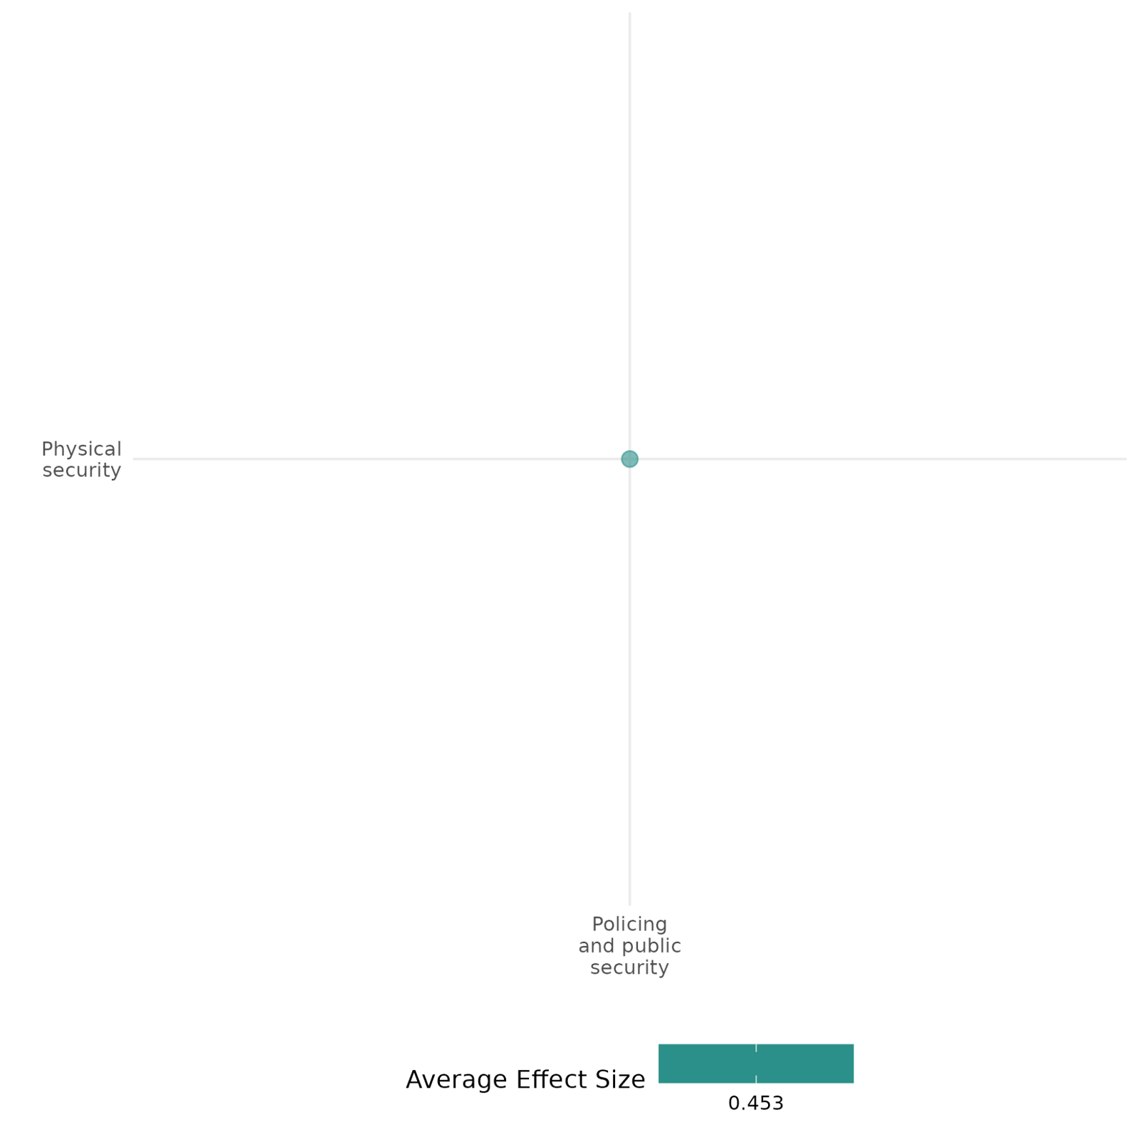

4.1.1(7)

Effect of policing and public security on political security
Policing and public security measures, such as increased police presence, has a negative effect on political security.
Geographical region: Middle East
Effect size: Small effect (g=0.034)
Confidence in study findings: Medium (1 study with 2 effect sizes)

Short summary
Enhanced policing and public security measures, such as increased police presence, has a negative effect on political security. In the context of Afghanistan, increased police deployments did not alleviate insecurity but instead reduced polling center-level turnout by 30%, driven by public mistrust in the Afghan National Police.

The intervention
Policing and public security measures, such as increased police presence, were deployed during Afghanistan’s 2010 parliamentary elections to safeguard voting processes and deter insurgent violence. The intervention aimed to protect civilians and polling stations, ensuring higher electoral participation. However, widespread public perception of the Afghan National Police as corrupt and abusive diminished trust in these forces, indirectly discouraging citizens from voting.

How the intervention is expected to affect this outcome
Heightened policing and public security measures aim to improve political security by addressing insecurity and reducing fear of attacks. The presence of law enforcement at polling centers is expected to deter violence, creating a safer environment that encourages voter turnout and participation in political processes. However, the intervention assumes that the public perceives security forces as legitimate and trustworthy. In contexts like Afghanistan’s 2010 elections, public mistrust of law enforcement—due to perceptions of corruption and abuse—can undermine these efforts.

The evidence base
The cell includes 1 impact evaluation study. The setting of the study is Afghanistan.

Evidence findings
The intervention, which is an increase in police presence, failed to achieve its intended outcomes of improving electoral participation. Instead, it lowered voter turnout by about 30%. Heightened insecurity and fear of attacks persisted during the elections, and the presence of security forces failed to alleviate these concerns effectively.

Included studies
Condra et al. (2019) examine the effect of security provisions in Afghanistan where the government deployed varying levels of Afghan National Police to polling centers to safeguard against insurgent violence. This intervention aimed to secure the election process and enhance public trust in the government amidst a backdrop of significant pre-election violence and concerns about insurgent attacks. The study utilized a quasi-experimental design, leveraging the unintentional variation in police deployment across polling centers with similar histories of violence. This allowed the researchers to isolate the effects of police presence on voter turnout. Data sources included internal government records, event-level violence data, certified voter turnout numbers, and pre- and post-election survey data from potential voters. Findings revealed that increased police presence at polling centers led to a significant decrease in voter turnout, averaging a 30% reduction compared to centers with fewer police. This decrease was not attributed to voter anticipation of election-day violence but rather to negative perceptions of the police as corrupt and predatory, which discouraged voter interaction with security forces. The study is rated as medium confidence as it is non-experimental.

Confidence assessment
Overall low: This cell is rated overall low as it only contains 1 study.

Other outcomes in the study:
Violence and atrocity prevention / nature and scale of violence and atrocities
Community and state governance / government performance
Policing and public security / presence and quality of social safety nets

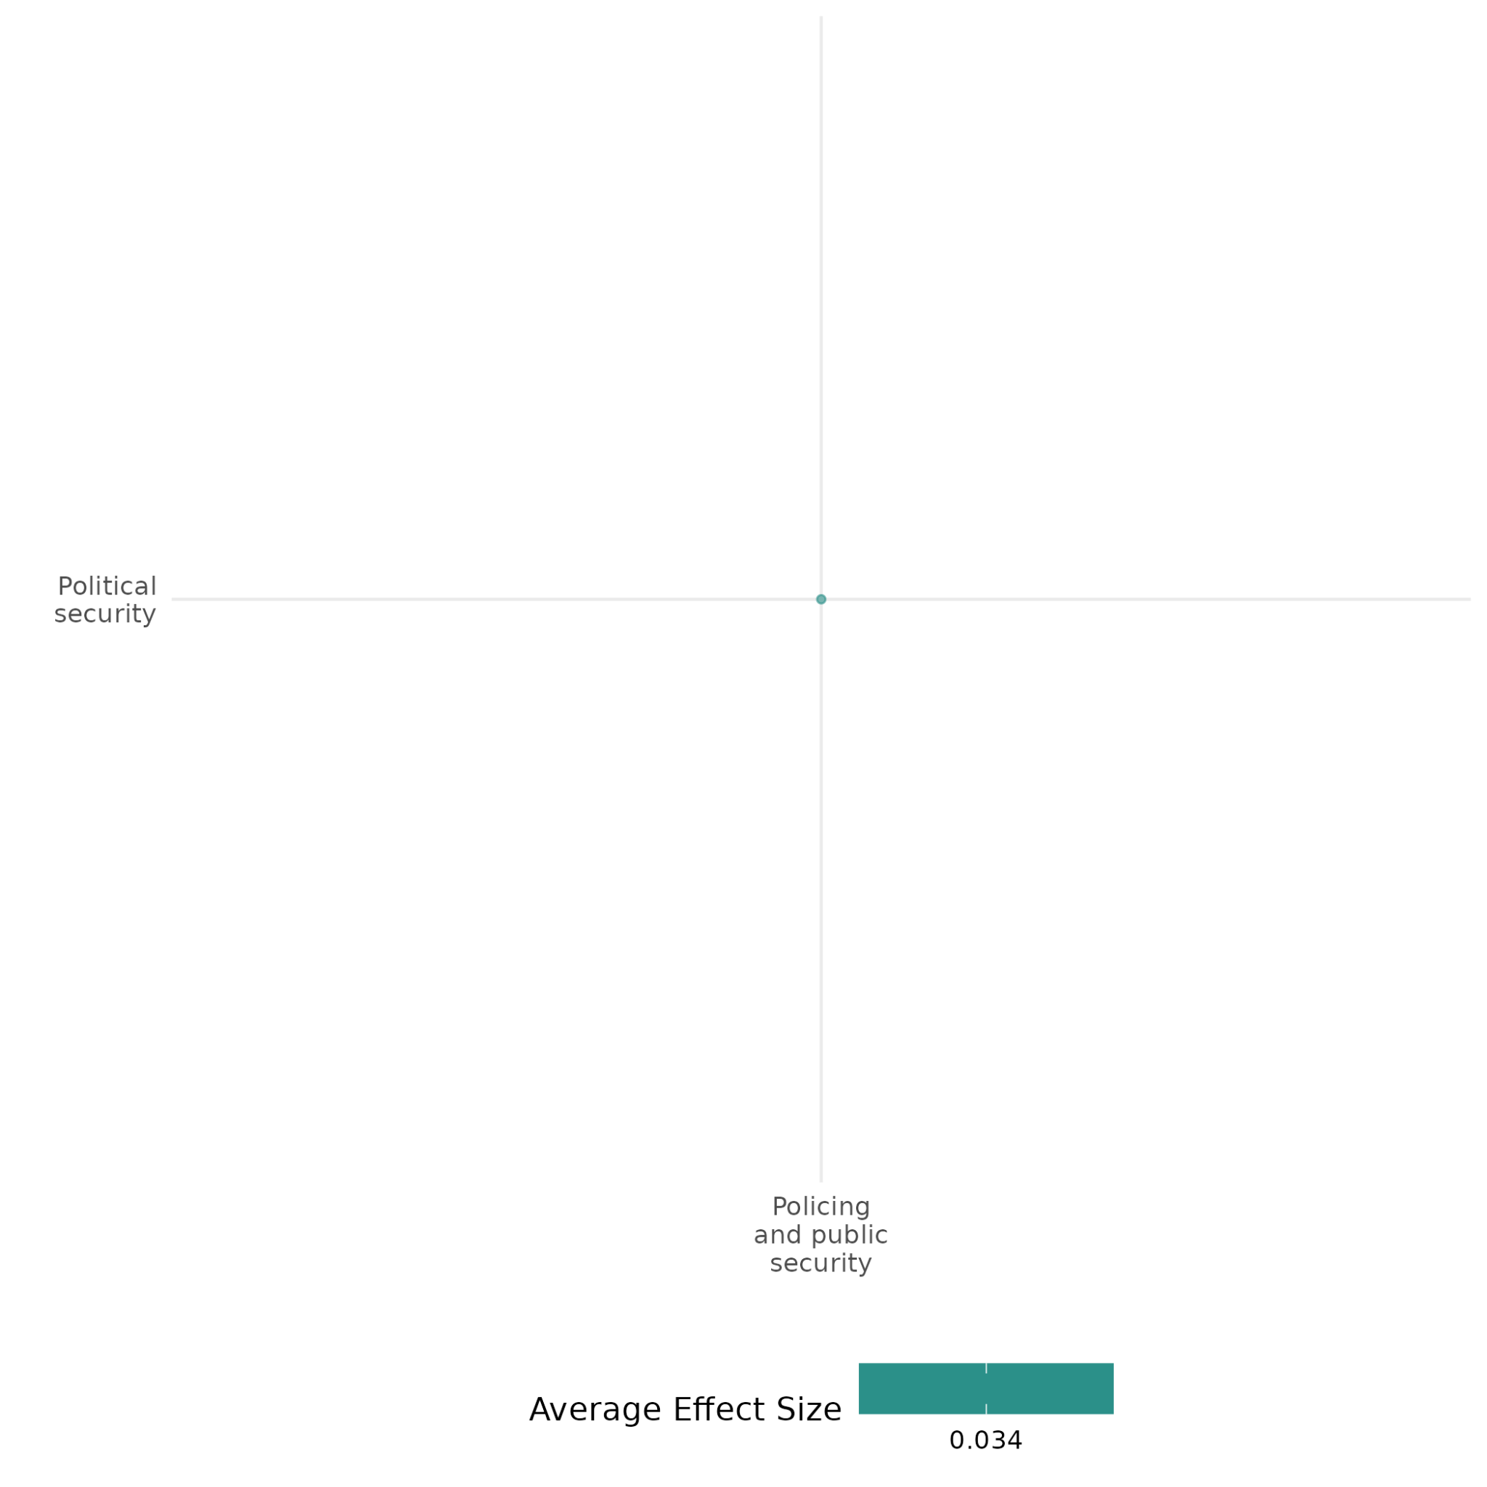

4.1.2 Military Operations
4.1.2(1)
Effect of Military operations on Diplomatic relations & Peaceful dispute resolution
The summary presents findings from two quantitative studies on military interventions. While support for rebels may increase negotiations, government-backed interventions may enhance agreement durability. However, interventions favoring one side can undermine peace efforts, making outcomes highly context-dependent.
Geographical region: Global
Effect: Moderate effect (g = 0.107)
Confidence in study findings: Low confidence

Short summary
Military interventions aim to prevent, de-escalate, or resolve conflicts and may affect diplomatic relations and dispute resolution by shaping negotiations and agreement stability. Findings suggest that while external interventions generally support agreements, those favoring one side reduce negotiation likelihood. Rebel-backed interventions increase negotiations but weaken agreement stability, whereas government-backed interventions hinder negotiations but strengthen agreements. Mediation and security guarantees have the most positive effects. Military support for the government makes agreements more likely to be upheld, while support for rebels lowers this likelihood. Outcomes depend on context, conflict stage, and strategic considerations.

Long summary
The intervention
Any efforts that involve the use of a state's armed forces to prevent, de-escalate or resolve a violent conflict or atrocity. This could be operations where armed forces are engaged in combat and those that do not have primary objectives to engage in combat (i.e. the presence of armed forces in specific locations. This also includes cyberwarfare operations when delivered by a state's armed forces.

How the intervention is expected to work?
Military interventions and support may have an effect on diplomatic relations and peaceful dispute resolution by shaping negotiations and agreement stability. Support for rebels may increase the likelihood of negotiations, while support for the government may enhance agreement durability. However, interventions favoring one side may undermine overall peace efforts, making outcomes context dependent.

Evidence base
This cell holds 2 quantitative studies: Biswas (2007) and Findley (2012)
Biswas (2007) uses cross-national data from 32 countries and 56 rebel groups, as included in the Minorities at Risk (MAR) dataset and Findley (2012) analyzes the dataset which includes 234 observations from 116 civil wars since 1945, comprising 116 observations in the first stage, 70 observations in the second stage, and 48 observations in the third stage, covering multiple countries worldwide. The cell also has 2 qualitative papers: Hasan (2015), Sub Saharan Africa and Fitzsimmons (2013), Middle East & North Africa.

Evidence findings
External intervention supports agreements and negotiations, though its effects vary. Biswas (2007) highlights that while external intervention generally aids these processes, military intervention favoring one side reduces the likelihood of both negotiations and reaching an agreement. Similarly, Findley (2012) notes that military intervention supporting the rebels has a significant positive effect on initiating negotiations, whereas military intervention on behalf of the government decreases this likelihood. Additionally, one of the most influential factors in maintaining an agreement is external military support for the government, while military intervention for the rebels lowers the likelihood of the agreement being upheld. Military intervention in support of the government makes negotiations less likely but increases the chances of the agreement being kept.

Included studies
Biswas (2007) examines the relative and combined impact of domestic institutions and international intervention on whether negotiations take place and whether a settlement is reached. It is commonly assumed that conflict-affected areas are failed states. But that is not the case. Conflict-affected states have wide variation in their capacity, and so there is a potential role for domestic political structures.
The author applies a cross-national logit analysis of the correlates of negotiation and agreement using data from the analysis using the Minorities at Risk (MAR) dataset. The data comprise 475 observations covering 32 countries and 56 rebel groups.
The analysis shows that democracy increases the likelihood of negotiations being held and an agreement being reached, though it has a weaker effect for agreement than negotiations. External intervention also helps with both of these, but with differing effects. Military intervention (which favours one side) in fact reduces the probability of both negotiations and an agreement. Mediation and security guarantees (that is the promise of action, or inaction, in a given set of circumstances) have the greatest positive effect. If negotiations had been held in the previous year, the likelihood of an agreement being signed increases significantly.
But there is substantial variation in effects. The positive effect of democracy is from Asia, with no effect in Africa, the Middle East and the Former Soviet Union (FSU). In contrast, mediation is most effective in Africa, the Middle East and former Soviet Union, but not in Asia. Security guarantees work in Africa and the Middle East, but not Asia (and have not been used in FSU).
The study is rated medium confidence as a non-experimental design with only partial description of interventions and outcomes. There is no allowance for selection bias.

Findley (2012) examines the conditions under which a peace process in a civil war may be successful. He considers factors which create uncertainty about the eventual winner should a conflict continue – these are stalemates and the number of actors – affect the likelihood of successful implementation of the peace process. Stalemates and the number of actors can encourage cooperation early in a peace process but may impede it later on.
The author estimates a nested logit model with the dependent variable being an ordered, sequential scale measuring the stages of the peace process (0 =negotiations not started, 1 =negotiations held, 2 =agreement and 3 = successful implementation). The dataset includes 234 observations from 116 civil wars since 1945, comprising 116 observations in the first stage, 70 observations in the second stage, and 48 observations in the third stage. The explanatory variables include both the presence and role of the peacekeepers and a variable for a security guarantee. The latter is defined as “an explicit promise by the third party to insure, with a significant number of troops, that the terms of a peace agreement are implemented and that the state does not return to war” (p.13). There is also a variable for third party military interventions, which will favour one side and thus may undermine the peace process.
The empirical analysis of the decision to negotiate shows that presence of a peace operation has a significant positive effect on the decision as does military intervention supporting the rebels, whereas military intervention on behalf of the government decreases the likelihood of negotiations. In contrast, peacekeeping has a negative (but just insignificant at 10%) effect on keeping an agreement, but a security guarantee has a large positive effect (also just insignificant at 10%). However, the positive effects of peacekeeping and a security guarantee disappear if the conflict had reached a stalemate.
The largest factors affecting whether an agreement is kept are power sharing and external military support for the government, whereas military intervention for the rebels decreases the likelihood of the agreement being kept.
The number of factions makes negotiations more likely but does not affect the agreement being kept.
The author's main conclusion is that the success of third party intervention depends on a range of factors – including information on who would win if the conflict continued – so there is no ‘one size fits all’ and more research is needed to understand what works where. The stage of the peace process also affects effectiveness. Military intervention in support of the government makes negotiations less likely, but increases the chances of the agreement being kept.
The study is rated as medium confidence as it is a non-experimental design with partial description of the intervention. It does not control for selection bias.

Confidence assessment
Overall, the cell is rated low confidence.

Other outcomes in the study/cell:
- Social cohesion/Willingness to participate or help

4.1.2(2)
Effect of Military operations on Nature and scale of violence or atrocities
Military interventions, counterinsurgency operations, and targeted strikes impact violence and conflict dynamics. The 15 quantitative studies find that while some interventions reduce insurgent attacks and casualties, others prolong conflicts or escalate violence. The effects vary based on strategy, actor bias, and local conditions.
Geographical region: Global, Middle East & North Africa, Latin America & Caribbean, South Asia, Europe & Central Asia, East Asia & Pacific
Effect: Small effect (g = -0.013)
Confidence in study findings: Medium confidence

Short summary
Military interventions, counterinsurgency efforts, and targeted strikes impact the scale and nature of violence. Studies find that drone programs and airstrikes can reduce insurgent attacks, while biased interventions often prolong conflicts. Military aid increases paramilitary violence in some cases, while foreign aid and troop presence can lower casualties. Insurgent tactics shift in response to countermeasures, sometimes increasing civilian harm. While interventions by democratic states improve human rights over time, punitive counterinsurgency strategies may escalate violence. The effectiveness of military operations varies, with some reducing conflict intensity while others contribute to prolonged instability or targeted violence.

Long summary
The intervention
Any efforts that involve the use of a state's armed forces to prevent, de-escalate or resolve a violent conflict or atrocity. This could be operations where armed forces are engaged in combat and those that do not have primary objectives to engage in combat (i.e. the presence of armed forces in specific locations. this also includes cyberwarfare operations when delivered by a state's armed forces.

How the intervention is expected to work?
A state’s armed forces, including military interventions, counterinsurgency efforts, and targeted programs such as drone strikes and airstrikes, are expected to have an effect on the nature and scale of violence and atrocities. These interventions may reduce insurgent activity, alter patterns of violence, or enhance security. However, their effectiveness may depend on factors like strategy, target selection, and local conditions, sometimes leading to unintended consequences such as prolonged conflict or increased civilian harm.

Evidence base
The cell holds 15 quantitative studies:
Of the 15 studies, 3 focus on global contexts, examining peacekeeping or intervention effects across multiple regions (Regan, 2002; Dimant, 2020; Papadogeorgou, 2020). Three studies focus on Sub-Saharan Africa (Allen, 2021; Blair, 2023; Steinert, 2019), while two studies explore Africa more broadly (Fielding, 2012; Dube, 2014). Southeast Asia, particularly Vietnam, is the focus of one study (Pham, 2013), while another examines South Asia, specifically Pakistan (Mir, 2019). The Western Balkans, focusing on Kosovo, is studied in one case (Postmus, 2023), and Eurasia, especially the post-Soviet states, is the focus of one study (Toft, 2012). Stellman (2011) focuses on East Asia & Pacific and South Asia. Lastly, one study investigates Latin America, specifically Chile (Floreani, 2021).

Evidence findings
Aerial bombing campaigns significantly increase collateral killings, with an estimated rise of approximately 30 civilian deaths per campaign year in the absence of Human Rights Organizations (HROs) (Allen, 2021). Border fortifications have altered insurgent tactics, leading to a shift from conventional, direct attacks to irregular, indirect fire tactics, such as mortars and rockets. Civilian victimization decreased in districts where insurgents shared identity ties with the local population (in-group areas). However, in mixed-identity districts, civilian harm increased as insurgents targeted out-group civilians to deter cooperation with government forces (Blair, 2023). Doubling U.S. military aid is associated with a 4.4 percentage point increase in anti-American terrorism in recipient countries, particularly in areas characterized by high corruption and exclusionary policies (Dimant, 2020).
In municipalities with military bases, U.S. military aid significantly increased paramilitary attacks without affecting guerrilla activity. During election years, aid was linked to heightened paramilitary homicides, especially in politically competitive areas, indicating targeted violence aimed at influencing electoral outcomes (Dube, 2014). Military aid with high fungibility was associated with increased violence against civilians (Fielding, 2012). Higher casualties correlated with lower household expenditures, underscoring the detrimental impact of violence on welfare. Foreign aid and troop presence were associated with increased household expenditures, therefore, pointing towards their association with lower casualties (Floreani, 2021).
The drone program in North Waziristan resulted in a monthly reduction of 9–13 insurgent attacks and 51–86 casualties. Before the program, the region experienced an average of 21 attacks and 100 casualties per month. Approximately 75% of the reduction in violence occurred during the program period without any strikes, while 25% was linked to the aggregated effects of individual strikes. In comparison, violence in control areas continued to increase or plateau, highlighting the program's unique impact (Mir, 2019). An increase in airstrikes was also found to alter insurgent violence patterns, with spatial distribution influenced by the prioritization of strike locations (Papadogeorgou, 2020). Moreover, a strong correlation was observed between the number of new radio messages broadcasted and a reduction in insurgent violence. Similarly, welfare engagements led to decreased insurgent activity within a 5000-meter radius of the engagements (Pham, 2013).
Military interventions were found to improve core human rights in conflict states over a five-year period, though conflict intensity negatively impacted these rights if escalated to war. Interventions by democracies were particularly effective in enhancing core rights (Postmus, 2023). However, military interventions also prolonged the expected duration of conflicts. While the probability of a conflict lasting 48 months is about 37% without intervention, it rises to 60% with intervention. Biased interventions, favoring either the opposition or the government, were found to decrease the likelihood of a conflict ending compared to neutral interventions (Regan, 2002). U.S. military training in India initially led to an increase of approximately two attacks per month, though violence declined towards the end of the training period, suggesting a potential stabilizing effect over time. In the Philippines, direct military interventions further decreased violence, with an estimated reduction of nearly six attacks per month. Joint military exercises, particularly Balikatan and operations in Carmen Town, had a significant impact in curbing separatist violence, reinforcing the effectiveness of military cooperation in counterinsurgency efforts (Shellman, 2011).
Conflicts involving Pro-Government Militias (PGMs) showed a higher likelihood of recurrence compared to those without such involvement. Statistical simulations indicated a significant increase in the risk of renewed violence when PGMs were active (Steinert, 2019). A denial strategy employed by coercive counterinsurgents was most effective at containing insurgent violence, as it reduced the risk of violence spreading to new areas. Conversely, punitive strategies proved counterproductive, as they increased violence in contested areas without preventing its spread. Combining denial and punishment strategies, or taking no action, showed mixed effectiveness (Toft, 2012).
Finally, a VAR analysis of Turkey’s military deterrence efforts against PKK militants revealed counterproductive outcomes. Incapacitation strategies failed to significantly reduce PKK violence and instead led to an increase in violent attacks, with an additional seven casualties observed in the sixth month following shocks to these efforts (Unal, 2022).

Included studies
Allen (2021) examines the unintended civilian deaths ("collateral killings") resulting from aerial bombings and explores how the presence of international non-governmental organizations (INGOs), particularly human rights organizations (HROs), can mitigate these effects.
The dataset combines information from the Uppsala Conflict Data Program (UCDP) and the International Military Intervention (IMI) project, spanning 1990–2006. The dependent variable is collateral civilian killings. Independent variables include the use of air power, the presence of ground troops, and HRO secretariat presence. Negative binomial regression models are used to estimate the impact of aerial bombing on collateral killings and the moderating effect of HROs.
Aerial bombing campaigns are found to significantly increase collateral killings, with an estimated rise of approximately 30 civilian deaths per campaign year in the absence of HROs. The presence of HROs reduces the positive effect of air strikes on civilian deaths, with three or more HRO secretariats causing a reduction in deaths. Conflict intensity positively correlates with higher civilian deaths.
The study is rated as medium as it is non-experimental and due to its partial description of the intervention.

Dube (2014) investigates how U.S. military aid to Colombia affects political violence, particularly paramilitary violence. The context is Colombia’s long-standing civil conflict involving left-wing guerrillas and right-wing paramilitary groups, with U.S. aid aimed at counter-insurgency and counter-narcotics. The study focuses on aid allocated to Colombian military bases.
Using a difference-in-differences approach, the study compares municipalities with and without military bases from 1988 to 2005, exploiting variation from increases in U.S. military aid globally (excluding Latin America) as an instrument to address endogeneity. Conflict data includes over 21,000 violent events, capturing attacks by paramilitaries, guerrillas, and the military across 936 Colombian municipalities. Election years are also analyzed to observe shifts in violence tied to political cycles.
The findings show that in municipalities with military bases, U.S. military aid significantly increased paramilitary attacks but had no effect on guerrilla attacks. During election years, aid was linked to increased paramilitary homicides, particularly in politically competitive areas, suggesting targeted violence to influence political outcomes.
The study is rated low confidence due to the inadequate description of the evaluation question.

Fielding (2012) investigates the dynamics of violence against civilians during the Peruvian civil conflict (1980-2000), particularly focusing on the roles of the Peruvian government and insurgent groups, such as the Sendero Luminoso (SL) and the Movimiento Revolucionario Tupac Amaru (MRTA). It examines how different types of foreign aid and intervention influenced the levels of violence against civilians. The authors argue that while some forms of aid may reduce violence, others can exacerbate it, highlighting the complexity of foreign intervention in conflict settings. The research utilizes data from the Peruvian Truth and Reconciliation Commission (TRC), which documented nearly 70,000 deaths during the conflict, with a significant number of casualties being unarmed civilians. The sample consists of data collected from approximately 17,000 witnesses to violence, analysis focuses on monthly observations of violence, including the number of attacks initiated by government forces and insurgents, as well as civilian casualties resulting from these attacks. The study finds a strong cyclical relationship between government and insurgent violence, where increases in violence by one side often provoke retaliatory violence from the other. The analysis reveals that the type of foreign aid provided to the Peruvian government significantly influenced the levels of violence against civilians. For instance, military aid with high fungibility was associated with increased violence against civilians, while development aid with low fungibility tended to have a mitigating effect.
The study is rated low confidence quantitative study as potential biases in reporting, particularly for rural events.

Floreani (2021) examines the relationship between conflict intensity and poverty in Afghanistan, focusing on the effects of foreign aid, troop presence, and casualties at the province level from 2007 to 2014.
The study employed ordinary least squares (OLS) and instrumental variables two-stage least squares (IV 2SLS) regression models, to examine the impact of conflict-related indicators (foreign aid, troop presence, and casualties) on household expenditures per capita in Afghanistan. The OLS models included household weights, with standard errors clustered at the province level to match the conflict indicators’ measurement. To address potential endogeneity in foreign aid, IV 2SLS was applied using USAID aid flows as an instrument.
The findings show that foreign aid and troop presence were associated with increased household expenditures. The presence of Afghan troops, more locally engaged, showed a stronger positive impact on consumption than international forces.
Higher casualties correlated with lower household expenditures, underscoring the detrimental impact of violence on welfare. However, the combined effects of aid and troop presence often offset the negative impact of conflict on poverty.
The study is rated low confidence due to the inadequate description of the evaluation question and intervention.

Mir (2019) The study investigates the impact of the US drone program in Pakistan on insurgent violence from 2008 to 2011. The program involved sustained aerial surveillance, communication interception, intelligence analysis, and rapid drone strikes aimed at insurgent groups like Al-Qaeda and the Pakistani Taliban. The study employs a difference-in-differences approach, comparing monthly insurgent attacks and casualties in North Waziristan (treatment area) with other areas in FATA (control regions) before and after the drone program's implementation. It uses geocoded data on violence, covering 32 tehsils (administrative units) in FATA, further stratified in the treatment region comprising 9 tehsils, while the control region included 23 tehsils.
The study documented the drone program was associated with a monthly reduction of 9–13 insurgent attacks and 51–86 casualties in North Waziristan. Before the program, the region experienced an average of 21 attacks and 100 casualties per month. Additionally, it showed that nearly 75 percent of the violence reduction is associated with the drone program period without any strikes, and about 25 percent is associated with aggregated effects of individual strikes. When violence compared to the control group it showed continued to increase or plateau in control areas, while it declined in North Waziristan, suggesting the program's unique impact.
The article is not found in EGM but can be rated as a medium-to-high confidence in its findings. It uses a robust empirical design and incorporates qualitative (e.g., interviews with officials and insurgents) and quantitative data.

Papadogeorgou (2020) investigates the causal effects of airstrikes on insurgent violence in Iraq, particularly during the period of the American military surge from February 2007 to July 2008. The researchers focus on two types of airstrike missions: close air support missions, which were primarily reactive to ongoing insurgent attacks, and pre-planned strikes against high-value targets. The study employs a spatio-temporal causal inference framework. The sample consists of airstrike data collected from the US Air Force, focusing on the locations and timings of airstrikes and insurgent attacks. The data includes both the airstrikes conducted and the insurgent violence reported in various locations. The study finds that the increase in airstrikes is associated with changes in insurgent violence patterns. The analysis suggests that the spatial pattern of insurgent attacks is influenced by the prioritization of airstrike locations.
The study should be rated as high and medium confidence study.

Pham (2013) measures the effectiveness of positive communications that counterinsurgents conduct as part of their information strategy to mobilize public support for the incumbent government in Afghanistan.
The study was designed as a quasi-experimental study. The study uses datasets of insurgent violence from international distributed unified reporting environment (INDURE) database for Zabul province from 2009 through 2011.
The study shows a strong correlation between the total number of new radio messages broadcasted per week and a reduction in insurgent violence throughout the province. Also there is a strong correlation between total welfare engagements conducted per week and a decrease in insurgent violence within a 5000-meter radius of the engagements.
The study is rated as medium confidence as it is designed as a non-experimental study design and has partially defined the interventions and outcomes in the study.

Postmus (2023) evaluate the impacts of third-party military interventions since the adoption of the Responsibility to Protect (R2P) doctrine in 2005, which justifies interventions to prevent violations of humanitarian and international human rights laws. The study examines how these interventions influence human rights practices in target states over a five-year period, focusing on "core rights" (e.g., right to life, freedom from torture) and "political rights and civil liberties" (e.g., freedom to participate in politics, religion, and unions).
Using a large-N quantitative approach with 852 cases from the Uppsala Conflict Data Program (UCDP) and the CIRI Human Rights Data Project, the researchers analyzed the relationship between interventions (independent variable) and human rights outcomes (dependent variables) via a Complex General Linear Model (CSGLM). Control variables included democracy status, GDP per capita, ethnic fragmentation, and conflict intensity.
Results indicate that military interventions improve core human rights in conflict states over five years, while conflict intensity negatively affects these rights if the conflict escalates to war. Conversely, interventions negatively impact political rights and civil liberties, with significant adverse effects from GDP per capita and conflict intensity. However, interventions by democracies positively affect both core and political rights. Across all models, conflict intensity remains a key factor reducing respect for core human rights.
The study is rated low confidence.

Regan (2002) examines the role of third-party interventions in the duration of intrastate conflicts. The author argues that interventions, which are a form of conflict management, would be expected to reduce the duration of civil conflicts. The study uses data on 150 civil conflicts during the period 1944-1999, of which 101 had outside interventions with a total of 1036 individual interventions. The outcome variable is the duration of the conflict in months. The predictor variables include characteristics of the conflicts, timing of interventions, type of interventions (military vs. economic), use of force, and whether the intervention was biased towards the government or opposition. Interventions that provoke opposing interventions and military/economic interventions increase the expected duration of conflicts. The probability of a conflict surviving to the 48th month is about 37% without an intervention, but about 60% with an intervention, suggesting that interventions contribute to longer conflicts until they become entrenched. The only aspect of the intervention strategy that reduces the likelihood of a conflict ending is if the intervention is biased in favor of either the opposition or the government, rather than a neutral intervention.
The study rated low confidence quantitative study as a small sample size, inadequate control of confounding factors, reliance on ex-post indicators, strong assumptions, and limitations in the study's methodology.

Steinert (2019) investigates the impact of pro-government militias (PGMs) on the recurrence of conflicts. PGMs are often used by governments as counterinsurgents during armed conflicts, deriving both material and non-material benefits from their involvement. These militias are typically excluded from peace negotiations and disarmament programs, which may incentivize them to disrupt post-conflict peace. The context of the study spans various global conflicts between 1981 and 2007, focusing on the role of PGMs in these settings.
The research employs a combination of statistical simulation, logistic regression models, and propensity score matching to analyze the effect of PGMs on conflict recurrence. The sample includes 121 conflict episodes with a five-year post-conflict observation window. The study identifies whether PGMs were active during these conflicts and if they participated in subsequent conflicts between the same actors.
The study finds that conflicts involving PGMs are more likely to recur compared to those without such involvement. The presence of PGMs increases the risk of conflict recurrence, as evidenced by statistical simulations showing a high probability of conflict relapse when PGMs are active. The effect of PGM activities on post-conflict relapse remains statistically significant, with a notable increase in the risk of renewed violence.
The study is considered to have medium confidence as it is a non-experimental study.

Toft (2012) evaluates the effectiveness of different coercive counter-insurgency strategies in the North Caucasus, Russia. The strategies analyzed include denial, which manipulates the costs of expanding insurgent activity to new locations, and punishment, which manipulates the costs of sustained fighting in contested areas. The study also considers a combination of both strategies and a scenario where no action is taken.
The research employs a mathematical model of epidemics to formalize the logic of conflict diffusion and derive conditions under which state coercion might limit the spread of insurgent violence. The study uses a new dataset of insurgent and government violence in Russia’s North Caucasus from 2000 to 2008. The sample includes 7,584 municipalities over 102 months, with a total of 773,568 observations.
The study finds that a denial strategy is most effective at containing insurgent violence, as it reduces the risk of violence spreading to new areas.
Punishment, on the other hand, is found to be counterproductive, as it increases the risk of continued violence in already contested areas and does little to prevent the spread of unrest.
The combination of denial and punishment, as well as taking no action, both lie somewhere in the middle in terms of effectiveness.
The study is rated as low confidence due to several methodological shortcomings such as there is little or no description of the evaluation question and the study does not report on attrition. Also the study is non-experimental.

Unal (2022) analysed Turkey's military deterrence efforts against the Kurdistan Workers' Party (PKK) from 1984 to 2018. The focus is on the incapacitation strategy, which involves neutralizing PKK members through military operations, with the aim of reducing PKK-induced violence. The context is Turkey's long-standing conflict with the PKK, which has been marked by both military and political dimensions, especially in light of regional developments such as the Syrian Civil War and the rise of the People’s Protection Units (YPG).
The study employs a mixed-methods approach, combining quantitative and qualitative analyses. The quantitative component uses vector autoregressive (VAR) analysis to explore the relationship between incapacitation efforts and PKK violence over a 34-year period. Two datasets are utilized: the Global Terrorism Database (GTD) and an official government dataset, covering monthly data from May 1994 to December 2018. The qualitative analysis provides a longitudinal review of the conflict's phases and the strategic interactions between Turkey and the PKK.
The VAR analysis reveals that incapacitating PKK militants did not significantly reduce PKK violence. Instead, the strategy was found to be counterproductive in the short term, as it did not deter the PKK's ability to continue violent attacks.
The results indicate that the incapacitation efforts led to an increase in violence, with about seven more casualties observed in the sixth month following a shock to incapacitation efforts.
The study concludes that Turkey's eliminationist approach, aiming to annihilate the PKK, did not achieve the desired deterrent effect and suggests that a more strategic, politically integrated approach is necessary.
The study is considered to have medium confidence due to the absence of a power calculation.

Blair (2023) explores the impact of border fortification on insurgent violence and local support in transnational conflicts, using the case of Iraq. Border fortification aims to limit insurgent access to resources and sanctuaries from neighboring countries. However, by impeding cross-border support, fortified borders may also drive insurgents to shift tactics and seek local civilian cooperation to recoup lost resources.
The study uses microdata from Iraq’s border fortifications built by the U.S. Army Corps of Engineers during Operation Iraqi Freedom, analyzing monthly violence data at the district level between 2004 and 2009. A difference-in-differences approach examines the effects of border fort construction on insurgent violence types and civilian victimization, contrasting districts with and without completed fortifications while accounting for pre-existing conflict trends and variation in nearby insurgent support networks.
Results show that border fortification led insurgents to shift from conventional, direct attacks to irregular, indirect fire tactics, such as mortars and rockets.
Also, fortification reduced civilian victimization in districts where insurgents shared identity ties with the local population (in-group areas). In mixed-identity districts, however, civilian harm increased, as insurgents targeted out-group civilians to deter cooperation with government forces.
The study is rated medium due to its non-experimental design.

Dimant (2020) examines how U.S. military aid may inadvertently increase anti-American terrorism through channels such as institutional degradation and social grievances in recipient countries, where increased aid may create resentment among excluded groups.
The study utilizes a large panel dataset with country-year observations (i.e., 173 countries from 1968 to 2014), applying an instrumental-variable approach to account for endogeneity. In here, U.S. military aid is instrumented with global aid trends (adjusted for regional aid distribution). The dependent variable, anti-American terrorism, is a binary measure indicating whether a country experienced at least one transnational terrorist attack against U.S. interests in a given year (coded as 1 if yes, 0 if no).
The results suggest that doubling U.S. military aid is associated with a 4.4 percentage point rise in anti-American terrorism in recipient countries, especially in areas with high corruption and exclusionary policies.
It was also found that aid often amplifies corruption and restricts political/economic access for marginalized groups, creating fertile conditions for anti-American sentiment.
The study is rated medium due to its non-experimental design and its partial description of the intervention.

Shellman (2011) examines the impact of U.S. military training in India (2002–2006) and U.S. diplomatic and military actions in the Philippines (1997–2006) on separatist violence. It investigates whether these interventions influenced the frequency of violent attacks by separatist groups and how different forms of U.S. engagement—military training, direct military actions, and diplomacy—affected conflict dynamics. The findings indicate that U.S. military training in India was associated with an increase in separatist violence, whereas U.S. diplomatic and military actions in the Philippines significantly reduced the number of separatist attacks. While military assistance in India may have inadvertently fueled insurgency by strengthening rebel capabilities or provoking retaliation, diplomatic engagement and counterterrorism operations in the Philippines helped suppress separatist violence.
The study employs a quantitative approach, using negative binomial regression models to predict separatist attacks based on factors such as military training, government repression, economic conditions, and societal sentiment. To ensure balanced case comparisons, a genetic matching algorithm was applied, reducing selection bias and improving the validity of causal inferences. A counterfactual analysis was also conducted to estimate what would have happened in the absence of U.S. interventions. Additionally, time-series techniques such as Autoregressive Integrated Moving Average (ARIMA) and Zero-Inflated Negative Binomial (ZINB) models were used to assess the direct effects of military training, diplomatic initiatives, and military actions on separatist violence, allowing for a more precise measurement of their impact.
The findings reveal that U.S. military training in India initially led to an increase of approximately two attacks per month, though violence declined towards the end of the training period, suggesting a potential stabilizing effect over time. In contrast, U.S. diplomatic actions in the Philippines reduced separatist attacks by about four per month, while direct military interventions further decreased violence, with an estimated reduction of nearly six attacks per month. Joint military exercises, particularly Balikatan and operations in Carmen Town, had a significant impact in curbing separatist violence, reinforcing the effectiveness of military cooperation in counterinsurgency efforts. Sentiment analysis also showed that increased public support for separatists correlated with higher levels of violence, whereas stronger government support contributed to a decline in attacks. Overall, the study highlights the differential effects of military and diplomatic interventions, emphasizing the importance of strategic engagement in conflict-affected regions. The study is rated a high and medium confidence quantitative study.

Confidence assessment
This cell is rated medium confidence. (consistency unsure)

Other outcomes in this cell
- Human security/ Economic security
- Human security/ Physical security
- Human security/ Political security
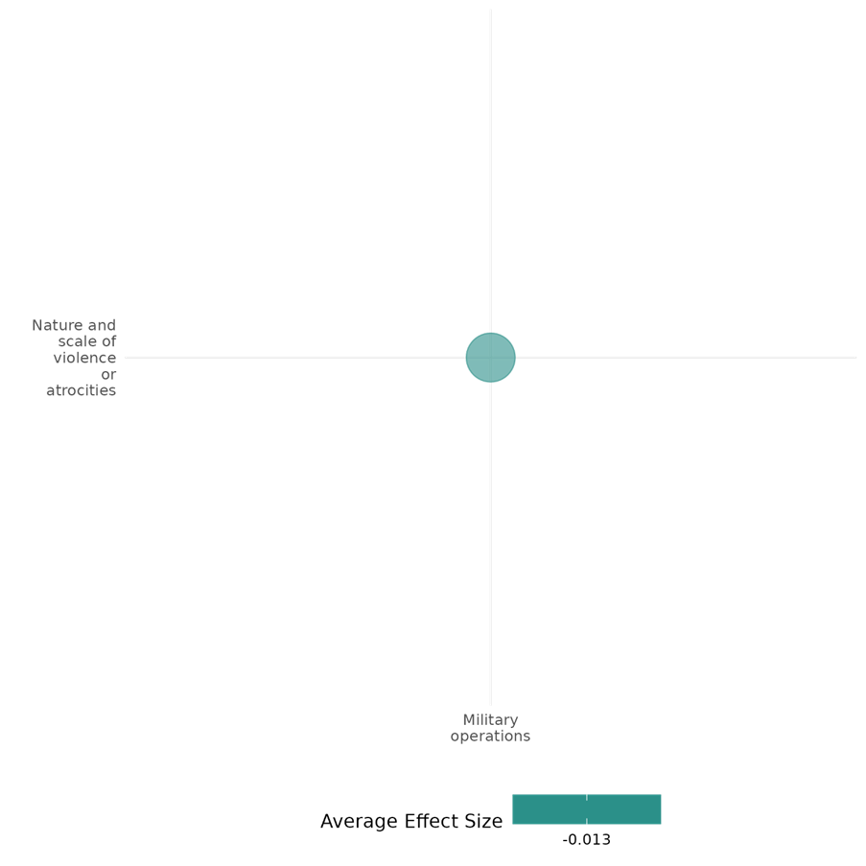

4.1.2(3)
Effect of Military operations on Sense of belonging
One qualitative study suggests that ECOWAS’s intervention may have fostered a sense of belonging by shaping national identity in Sierra Leone.
Geographical region: Sub Saharan Africa.
Effect: Positive
Confidence in study findings: Low confidence

Short summary
The intervention is expected to foster a sense of belonging by exposing civilians to regional influences, shaping national identity, and promoting cultural integration. ECOWAS’s presence enhances solidarity, helping individuals reconnect with their communities and reinforcing a shared sense of identity in Sierra Leone.

Long summary
The intervention
Any efforts that involve the use of a state's armed forces to prevent, de-escalate or resolve a violent conflict or atrocity. This could be operations where armed forces are engaged in combat and those that do not have primary objectives to engage in combat (i.e. the presence of armed forces in specific locations. this also includes cyberwarfare operations when delivered by a state's armed forces.

How the intervention is expected to work?
The intervention is expected to foster a sense of belonging by exposing the population to regional and international influences, which may shape national identity and cultural integration. Through ECOWAS’s presence, civilians may experience a sense of shared identity.

Evidence base
The cell includes one low-confidence qualitative study: Touray (2019), Sub Saharan Africa.

Evidence findings
The intervention, ECOWAS, which included the use of force, exposed the population to regional and international perspectives introducing new cultural and political influences, shaping national identity.

Included studies
Touray (2019) states that from 1991 to 2002, the Sierra Leone government and the Revolutionary United Front waged war against each other, subjecting Sierra Leone to a civil war. This war devastated the nation and resulted in many human casualties. Although many researchers have investigated the role of the Economic Community of West African States (ECOWAS) in counterinsurgency and conflict resolution, few studies have been conducted on the specific role of strategic processing tools used by ECOWAS during the Sierra Leone war to sustain a durable peace resolution in the country. Using Galula’s conceptualization of counterinsurgency and conflict resolution as a guide, the purpose of this qualitative, Touray used an explanatory case study to determine the elements that made strategic processing tools effective. Data were collected through open ended interviews with 10 Sierra Leoneans that experienced the conflict, publicly available documents, and mass media reports related to the Sierra Leone civil war. All data were manually coded and then subjected to constant comparative analytic procedures. The key finding of this study was that conflict resolution was successful because intervention by ECOWAS was largely viewed by Sierra Leoneans favorably and legitimate. The ECOWAS use of force was vital for the peace process. However, there were occurrences of human rights violations that were not fully resolved through the procedural mechanisms in place at the time. The positive social change implications stemming from this study includes recommendations to ECOWAS to establish a disciplinary unit to oversee violations of international humanitarian law and other serious abuses by ECOWAS troops. These actions may advance peace among religions, political parties, and ethnic groups in the region. The study is rated as a low confidence qualitative study.

Confidence assessment
The cell is rated low confidence.

The effect of Military operations on Sense of belonging

Effect: Positive (The Economic Community of West African States ECOWAS helped instill a sense of recognition and acceptance of one’s identity and dignity in the region)

Confidence in study findings: Low (one study, low confidence)

Summary
The Economic Community of West African States (ECOWAS) intervention in the Sierra Leone civil war was explored using open-ended interviews and document analysis of public records and field notes; has been widely viewed as legitimate and effective in achieving peace. The deployment of ECOWAS Monitoring Group (ECOMOG) troops was crucial in deterring rebel violence and establishing a secure environment. Additionally, it helped instil recognition and acceptance of one’s identity and dignity while understanding others. ECOWAS facilitated disarmament, demobilization, and reintegration (DDR) programs for former combatants, contributing to a unified national identity.
The intervention
Deployment of a peacekeeping force by the ECOWAS to Sierra Leone during the civil war (1991-2002). This force, known as the ECOWAS Monitoring Group (ECOMOG), was tasked with restoring peace and stability in the country
How is the intervention expected to work
ECOWAS intervention was expected to work by employing various strategic processing tools, both military and non-military. The deployment of ECOMOG troops was a key component of the intervention, serving to deter rebel violence and establish a secure environment. The non-military component encompassed diplomatic efforts to negotiate peace agreements, humanitarian aid to address the needs of the population, and economic support to promote recovery.
The evidence base
There is one qualitative study assessing the effect of Military operations on the sense of belonging in Sierra Leone. This study is by Touray, M. (2019). The Role of the Economic Community of West African States in Counterinsurgency and Conflict Resolution (Doctoral dissertation, Walden University). All references are from that study.
The evidence
Diplomacy efforts to build popular support contributed to a reduction in violence, the disarmament of combatants, and the restoration of a democratically elected government. However, the challenges reported highlight the importance of accountability, respect for human rights, and sustained engagement in peacebuilding efforts.
- ECOMOG’s military operations against the Revolutionary United Front (RUF) were crucial in creating a more stable environment where diplomatic efforts could be effective. The presence of a robust peacekeeping force also deterred further violence and provided a sense of security
- ECOWAS’s role as a mediator and facilitator of peace talks between the Sierra Leone government and the RUF culminated in the signing of the Lome Peace Accord in 1999, which provided a framework for ending the conflict. The peace accord included provisions for a ceasefire, disarmament, demobilisation, and the reintegration of former combatants. The ceasefire led to a significant reduction in violence (p.104)
- The organisation leveraged its regional influence and understanding of local dynamics to encourage dialogue and compromise. This included working with leaders from other West African countries to apply pressure on the RUF and the Sierra Leone government to engage in negotiations.
- ECOWAS helped instil recognition and acceptance of one’s identity and dignity and while understanding others. It also facilitated disarmament, demobilization, and reintegration (DDR) programs for former combatants, contributing to a unified national identity.

Confidence assessment
Overall confidence: Low Confidence Qualitative Study (It is unclear whether the study uses an established small n approach)

4.1.2(4)
Effect of Military operations on Government performance
Military operations impact public perceptions of government performance and security. The study examines how Kenya’s counterterrorism efforts influenced trust in state institutions among different ethnic groups.
Geographical region: Sub Saharan Africa
Effect: Moderate effect (g = 0.138)
Confidence in study findings: Low confidence

Short summary
Military operations like Kenya’s "Operation Linda Nchi" against al-Shabaab impact public perceptions of government performance. Such interventions are expected to influence people’s trust in state institutions by altering their perceptions of security and governance. Muibu and Cubukcu (2023) analyze Afrobarometer survey data to assess how counterterrorism efforts influenced trust in the police, the ruling government, and local authorities among ethnic groups. Post-intervention, Somalis showed lower trust in the police and government but increased obedience to the law and trust in local government, while non-Somalis reported higher trust in the police, government, and law enforcement.

Long summary
The intervention
Any efforts that involve the use of a state's armed forces to prevent, de-escalate or resolve a violent conflict or atrocity. This could be operations where armed forces are engaged in combat and those that do not have primary objectives to engage in combat (i.e. the presence of armed forces in specific locations. This also includes cyberwarfare operations when delivered by a state's armed forces.

How the intervention is expected to work?
Military operations like "Operation Linda Nchi," Kenya’s military offensive against al-Shabaab terrorist attacks, are expected to have an effect on people’s perception of government performance. Such interventions may influence trust in the police, the ruling government, and local authorities. Their impact varies across ethnic groups, shaping attitudes toward governance and security institutions.

Evidence base
The cell contains 1 quantitative study: Muibu (2023) focuses on Kenya. The cell includes one qualitative study: Fitzsimmons (2013), Middle East & North Africa.

Evidence findings
Post-intervention of Kenya’s military offensive, Somalis are less likely to trust the police but more likely to obey the law. They also trust the ruling government less but hold more favorable views of local government compared to pre-intervention levels. Non-Somalis, in contrast, show increased trust in the police, greater willingness to obey the law, and improved trust in local government.

Included studies
Muibu (2023) investigates the impact of counterterrorism measures in Kenya on Somali minorities’ perceptions of the police and government, comparing them to those of other ethnic groups. The intervention, known as "Operation Linda Nchi" (Operation Protect the Nation), was Kenya’s military offensive against al-Shabaab terrorist attacks. The study uses nationally representative data from the Afrobarometer project (Round 4: 2008, N=1,104; Round 6: 2014, N=2,397) to compare pre- and post-intervention periods across ethnic groups. The sample includes adults aged 18 and above, selected through a randomized, stratified, multistage area sampling method. Four ordered logistic regression models analyze outcomes: obligation to obey the law, trust in the police, trust in the ruling government, and trust in local government. Propensity score matching with bootstrapped kernel matching ensures robustness. Findings indicate that, post-intervention, Somalis are less likely to trust the police but more likely to obey the law. They also trust the ruling government less but hold more favorable views of local government compared to pre-intervention levels. Non-Somalis, in contrast, show increased trust in the police, greater willingness to obey the law, and improved trust in local government. The study is rated low confidence.

Confidence assessment
Overall, the cell is rated low confidence.

Other outcomes
No additional outcomes were found for this cell.

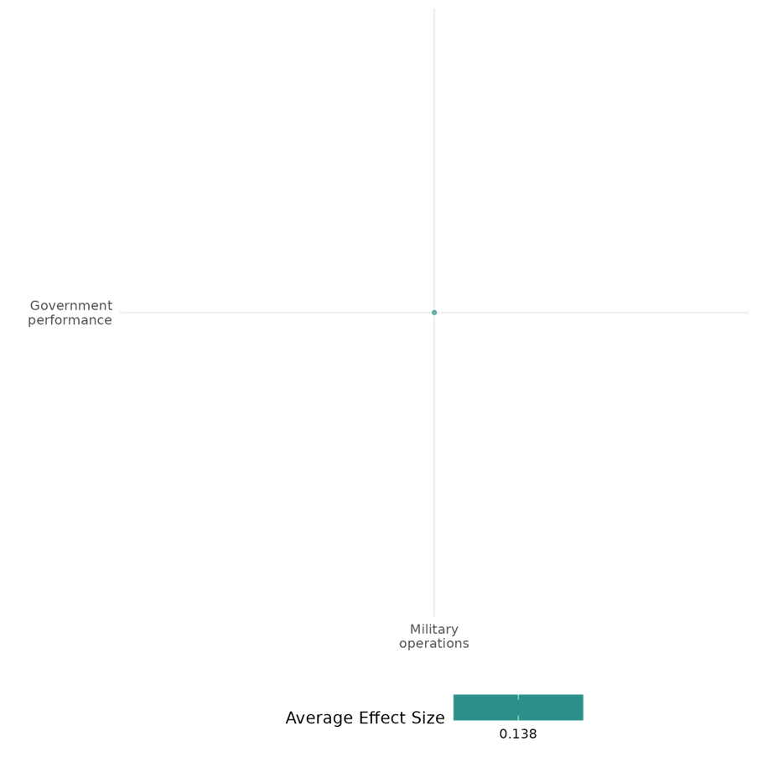

4.1.2(5)
Effect of Military operations on Presence and quality of social safety nets
Military operations may influence the presence and quality of social safety nets in recipient countries. One quantitative study finds that U.S. military aid does not reduce fragility and may worsen instability in weak states.
Geographical region: Global
Effect: Small effect (g = -0.005)
Confidence in study findings: Low confidence

Short summary
Military aid is expected to enhance institutional stability and reduce state fragility by strengthening security institutions and governance structures. However, findings from Schwab (2020) indicate that U.S. military aid often fails to improve institutional stability and may instead increase fragility, particularly in states with weak domestic institutions.

Long summary
The intervention
Any efforts that involve the use of a state's armed forces to prevent, de-escalate or resolve a violent conflict or atrocity. This could be operations where armed forces are engaged in combat and those that do not have primary objectives to engage in combat (i.e. the presence of armed forces in specific locations. This also includes cyberwarfare operations when delivered by a state's armed forces.

How the intervention is expected to work?
Military aid may influence institutional stability and state fragility in recipient countries. It is expected to strengthen state institutions and reduce fragility, particularly through capacity-building and security sector support. However, its effectiveness depends on domestic institutional strength, and in weak states, it may instead exacerbate fragility.

Evidence base
The cell holds 1 quantitative study: Schwab (2020). The study includes multiple countries globally, with detailed case studies on Colombia (Latin America) and Pakistan (South Asia).

Evidence findings
U.S. military aid often fails to improve institutional stability in recipient countries. Instead, it may exacerbate fragility, especially in states with weak domestic institutions. Aid does not effectively reduce fragility.

Included studies
Schwab (2020) explores how military aid is used to sustain U.S. influence in the global arms market, prevent state instability, and address strategic objectives, while questioning its overall success in achieving these goals. The study is divided into three chapters, each examining how the SSA reflects the interests of US policymakers, the relationship between SSA and a state’s level of fragility, and how the shifting interests of US policymakers affect the SSA, as seen in the cases of Colombia and Pakistan. The quantitative portion of Schwab (2020) employs regression analysis to evaluate the determinants and effects of U.S. military aid across multiple countries. Key variables include U.S. military aid allocation (dependent variable) and independent factors such as state fragility, arms market competition, and institutional stability. The study shows that U.S. military aid allocation is significantly correlated with the desire to maintain dominance in recipient states' arms markets. Countries with high competition from other suppliers, particularly Russia and China, are more likely to receive aid, highlighting a strategic motive. The regression results also indicate that aid does not effectively reduce fragility. The study is rated medium as it is non-experimental and due to its partial description of the intervention.

Confidence assessment
Overall, the cell is rated low confidence.

Other outcomes in this study
None

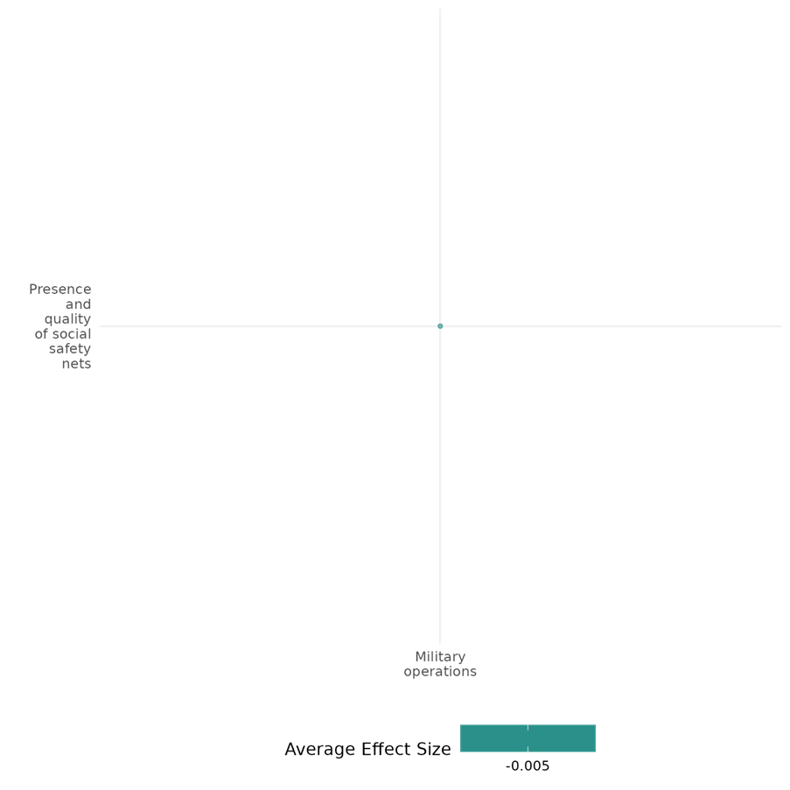

4.1.2(6)
Effect of Military operations on Economic security
Military operations impact economic security by influencing stability, growth, and poverty levels. The studies suggest that during conflict, combined military and economic aid can enhance economic stability, while post-conflict, prolonged intervention may hinder recovery. Troop presence, especially local forces, positively affect household expenditures, mitigating some negative effects of conflict.
Geographical region: South Asia, Global
Effect: Small effect (g = -0.015)
Confidence in study findings: Low confidence

Short summary
Military aid, combined with economic aid and troop presence, is expected to impact economic security. Creasey (2014) finds that during conflict, this combination modestly boosts economic growth, but post-conflict, prolonged aid reduces growth by hindering recovery. Floreani (2021) shows that troop presence and aid increase household expenditures in Afghanistan, with Afghan troops having a stronger positive effect than international forces. While aid and troops can offset poverty effects, higher casualties reduce household welfare. Both studies highlight the complex impact of military and economic interventions on stability and growth, with effectiveness varying based on context and duration.

Long summary
The intervention
Any efforts that involve the use of a state's armed forces to prevent, de-escalate or resolve a violent conflict or atrocity. This could be operations where armed forces are engaged in combat and those that do not have primary objectives to engage in combat (i.e. the presence of armed forces in specific locations. This also includes cyberwarfare operations when delivered by a state's armed forces.

How the intervention is expected to work?
Military aid, in combination with economic aid and troop presence, is expected to have an effect on economic security in areas where they are deployed. It can provide stability that enhances the effectiveness of economic support, fostering growth and reducing poverty. However, prolonged intervention may hinder natural recovery and limit domestic investment.

Evidence base
The cell has 2 studies: Both studies are quantitative.
One study, Creasey (2014), focuses globally, analyzing data from 176 countries across various conflict periods and aid interventions from 1960 to 2005, while the other, Floreani (2021), focuses on Afghanistan.

Evidence findings
During conflict, the combination of military and economic aid is associated with a modest positive effect on economic growth, as military aid can provide stability that enhances the effectiveness of economic support. In contrast, post-conflict continuation of both economic and military aid is linked to reduced growth, suggesting that prolonged intervention may hinder natural recovery and limit domestic investment (Creasey, 2014). Troop presence is correlated with increased household expenditures, with locally engaged Afghan troops showing a stronger positive impact on consumption compared to international forces. Additionally, the combined effects of aid and troop presence often help offset the negative impact of conflict on poverty (Floreani, 2021).

Included studies
Creasey (2014) examines the impact of nation-building efforts—economic aid and military assistance combined—on the economic growth of conflict and post-conflict countries. The study defines nation-building as providing both economic and military aid in conflict and post-conflict situations to foster security and stimulate economic growth. Assess if and how these interventions positively impact economic growth, particularly by reducing conflict-induced instability and encouraging private investment. A 45-year cross-country panel dataset encompassing military, economic, and conflict variables was used. A three-way interaction term involving economic aid, military assistance, and conflict regime is constructed. The study employs a two-stage approach to address potential endogeneity between aid and growth by instrumenting aid based on geopolitical factors. The sample includes 176 countries from 1960 to 2005, covering various conflict periods and aid interventions. Data sources include OECD data for economic aid, military assistance records, and UCDP-PRIO conflict data. During Conflict: Combined military and economic aid correlate with a modest positive effect on economic growth, as military aid may provide stability that enhances the effectiveness of economic support. Post-Conflict: Continuation of both economic and military aid post-conflict was associated with reduced growth, suggesting that prolonged intervention might hinder natural recovery and domestic investment.
The study is rated low confidence because selection bias remains due to data limitations (e.g., no data from non-OECD donors like China). Further, high-quality evidence on multilateral versus unilateral impacts is limited, affecting the confidence in conclusions.

Floreani (2021) examines the relationship between conflict intensity and poverty in Afghanistan, focusing on the effects of foreign aid, troop presence, and casualties at the province level from 2007 to 2014.
The study employed ordinary least squares (OLS) and instrumental variables two-stage least squares (IV 2SLS) regression models, to examine the impact of conflict-related indicators (foreign aid, troop presence, and casualties) on household expenditures per capita in Afghanistan. The OLS models included household weights, with standard errors clustered at the province level to match the conflict indicators’ measurement. To address potential endogeneity in foreign aid, IV 2SLS was applied using USAID aid flows as an instrument.
The findings show that foreign aid and troop presence were associated with increased household expenditures. The presence of Afghan troops, more locally engaged, showed a stronger positive impact on consumption than international forces.
Higher casualties correlated with lower household expenditures, underscoring the detrimental impact of violence on welfare. However, the combined effects of aid and troop presence often offset the negative impact of conflict on poverty.
The study is rated low confidence due to the inadequate description of the evaluation question and intervention.

Confidence assessment
Overall, the cell is rated low confidence.

Other outcomes in the study/cell:
- Violence and atrocity prevention/Nature and scale of violence or atrocities

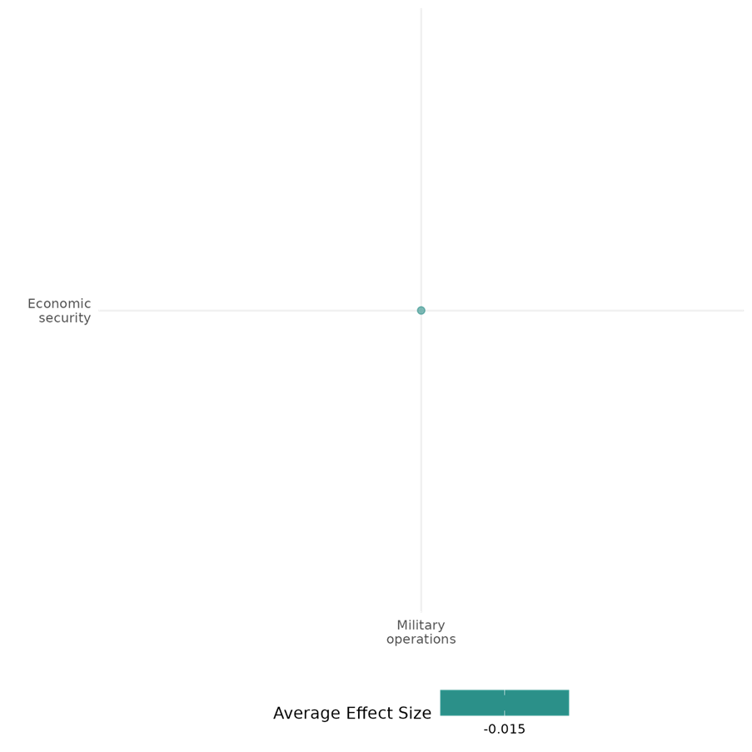

4.1.2(7)
Effect of Military operations on Physical security
The cell was expected to measure the effect of military operations like the U.S. drone program on physical security. The study finds that the program reduced insurgent attacks and casualties, with surveillance playing a key role in violence reduction.
Geographical region: South Asia
Effect: Moderate effect (g = 0.114)
Confidence in study findings: Low confidence

Short summary
The U.S. drone program in North Waziristan was expected to enhance security by reducing insurgent violence through sustained surveillance and targeted strikes. Mir (2019) finds that the program was associated with a monthly reduction of 9–13 insurgent attacks and 51–86 casualties. Nearly 75% of the violence reduction may be attributed to surveillance and intelligence gathering, while 25% is linked to targeted strikes. Compared to control areas, violence declined only in North Waziristan, suggesting the program’s unique impact.

Long summary
The intervention
Any efforts that involve the use of a state's armed forces to prevent, de-escalate or resolve a violent conflict or atrocity. This could be operations where armed forces are engaged in combat and those that do not have primary objectives to engage in combat (i.e. the presence of armed forces in specific locations. This also includes cyberwarfare operations when delivered by a state's armed forces.

How the intervention is expected to work?
A military operation, like the U.S. drone program, is expected to have an effect on the physical security of the targeted region by reducing insurgent attacks and casualties. Sustained aerial surveillance and intelligence gathering may disrupt militant activities, limiting their operational capacity. Targeted strikes are expected to weaken insurgent networks, potentially leading to a decline in violence.

Evidence base
The cell holds 1 quantitative study: Mir (2019). The study employs a difference-in-differences (DID) approach, comparing outcomes (insurgent violence) between treatment and control groups before and after the intervention (the US drone program). Fitzsimmons (2013), Middle East & North Africa and Touray (2019), Sub Saharan Africa are the 2 qualitative studies in this cell.

Evidence findings
The U.S. drone program in North Waziristan was associated with a significant reduction in insurgent violence, with a monthly decrease of 9–13 insurgent attacks and 51–86 casualties. This suggests an improvement in the physical security of the affected population, particularly in terms of reducing the number of violent incidents in the region, which could enhance perceptions of safety in the community. The study highlighted that nearly 75% of the reduction in violence was attributed to the effects of sustained surveillance and intelligence gathering, which reduced the vulnerability of the community to insurgent attacks. This could lead to improved perceptions of the state of peace and a decrease in conflict vulnerability, enhancing the feeling of safety and security in the area.

Included studies
Mir (2019) investigates the impact of the US drone program in Pakistan on insurgent violence from 2008 to 2011. The program involved sustained aerial surveillance, communication interception, intelligence analysis, and rapid drone strikes aimed at insurgent groups like Al-Qaeda and the Pakistani Taliban. The study employs a difference-in-differences approach, comparing monthly insurgent attacks and casualties in North Waziristan (treatment area) with other areas in FATA (control regions) before and after the drone program's implementation. It uses geocoded data on violence, covering 32 tehsils (administrative units) in FATA, further stratified in the treatment region comprising 9 tehsils, while the control region included 23 tehsils. The study documented the drone program was associated with a monthly reduction of 9–13 insurgent attacks and 51–86 casualties in North Waziristan. Before the program, the region experienced an average of 21 attacks and 100 casualties per month. Additionally, it showed that nearly 75 percent of the violence reduction is associated with the drone program period without any strikes, and about 25 percent is associated with aggregated effects of individual strikes. When violence compared to the control group it showed continued to increase or plateau in control areas, while it declined in North Waziristan, suggesting the program's unique impact. The study rated as a medium-to-high confidence in its findings. It uses a robust empirical design and incorporates qualitative (e.g., interviews with officials and insurgents) and quantitative data.

Confidence assessment
Overall, the cell is rated low confidence.

Other outcomes in the study/cell:
- Violence and atrocity prevention/Nature and scale of violence or atrocities

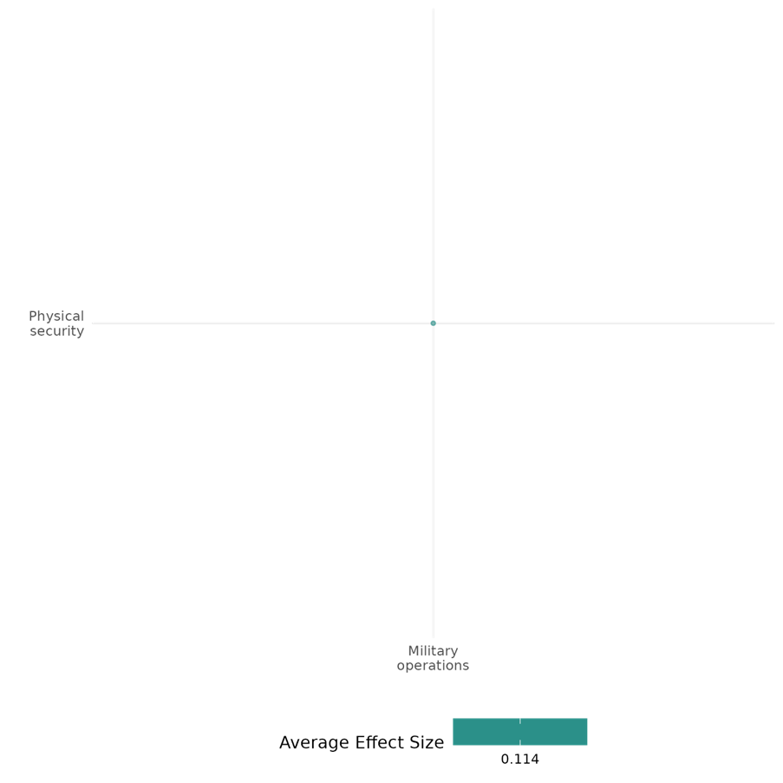

4.1.2(8)
Effect of Military operations on Political security
Military interventions may impact political security by influencing political rights and civil liberties. The study finds that while military interventions generally have a negative effect, those by democratic states may improve political rights.
Geographical region: Global
Effect: Large effect (g = 0.34)
Confidence in study findings: Low confidence

Short summary
Military operations are expected to affect political security, particularly political rights and civil liberties in the targeted region. Findings suggest that such interventions generally have a negative impact on political rights and civil liberties. However, interventions by democratic states are associated with a positive effect on these rights, highlighting the differing outcomes based on the intervening state.

Long summary
The intervention
Any efforts that involve the use of a state's armed forces to prevent, de-escalate or resolve a violent conflict or atrocity. This could be operations where armed forces are engaged in combat and those that do not have primary objectives to engage in combat (i.e. the presence of armed forces in specific locations. This also includes cyberwarfare operations when delivered by a state's armed forces.

How the intervention is expected to work?
Third-party military interventions may influence political security by affecting political rights and civil liberties in the targeted region. These interventions may lead to restrictions on freedoms due to heightened security measures or governance shifts. However, when conducted by democratic states, they may contribute to the protection or enhancement of political rights.

Evidence base
The cell contains 1 quantitative study: Postmus and Rrustemi (2023) evaluates the impacts of third-party military interventions on human rights and political rights, using a large-N quantitative approach with data from the Uppsala Conflict Data Program (UCDP) and the CIRI Human Rights Data Project.

Evidence findings
Military interventions tend to have a negative impact on political rights and civil liberties. However, interventions carried out by democratic states are generally associated with a positive effect on political rights.

Included studies
Postmus and Rrustemi (2023) evaluate the impacts of third-party military interventions since the adoption of the Responsibility to Protect (R2P) doctrine in 2005, which justifies interventions to prevent violations of humanitarian and international human rights laws. The study examines how these interventions influence human rights practices in target states over a five-year period, focusing on "core rights" (e.g., right to life, freedom from torture) and "political rights and civil liberties" (e.g., freedom to participate in politics, religion, and unions).
Using a large-N quantitative approach with 852 cases from the Uppsala Conflict Data Program (UCDP) and the CIRI Human Rights Data Project, the researchers analyzed the relationship between interventions (independent variable) and human rights outcomes (dependent variables) via a Complex General Linear Model (CSGLM). Control variables included democracy status, GDP per capita, ethnic fragmentation, and conflict intensity. Results indicate that military interventions improve core human rights in conflict states over five years, while conflict intensity negatively affects these rights if the conflict escalates to war. Conversely, interventions negatively impact political rights and civil liberties, with significant adverse effects from GDP per capita and conflict intensity. However, interventions by democracies positively affect both core and political rights. Across all models, conflict intensity remains a key factor reducing respect for core human rights.
The study is rated low confidence.

Confidence assessment
Overall, the cell is rated low confidence.

Other outcomes in the study/cell:
- Violence and atrocity prevention/Nature and scale of violence or atrocities

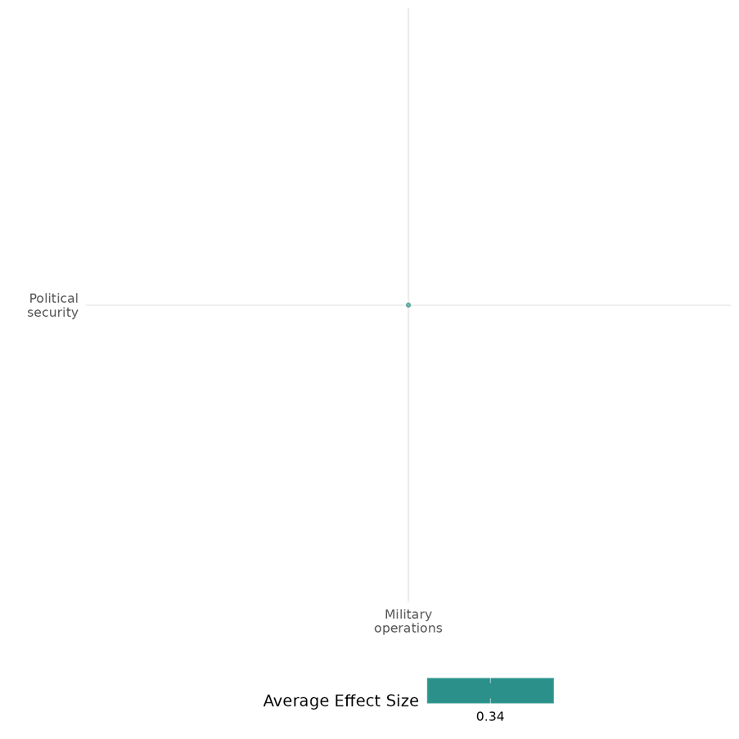

4.1.3 Disarmament, Demobilisation And Reintegration Of Ex-Combatants & Peace Support/Keeping Operations
4.1.3(1)
Effect of Peace support/keeping operations on Diplomatic relations & Peaceful dispute resolution
Peacekeeping operations facilitate mediation, improve peace agreement implementation, and enhance cooperation among conflict parties. Their presence fosters diplomatic engagement and trust-building, influencing negotiations and ceasefire agreements. The studies in this cell find that peacekeeping positively impacts diplomatic relations and peaceful dispute resolution.
Geographical region: Global, Sub Saharan Africa
Effect: Moderate effect (g = 0.16)
Confidence in study findings: Medium confidence

Short summary
Peacekeeping operations, particularly when combined with mediation, enhance diplomatic relations and peaceful dispute resolution. While peacekeeping alone does not significantly increase conflict termination, its presence strengthens mediation, improving negotiations and agreement longevity. A higher number of peacekeepers fosters trust, facilitates ceasefires, and improves local cooperation, particularly when rebels are weaker. However, involving multiple actors can complicate long-term peace implementation. Civilian peacekeepers play a key role in engaging state officials and reducing commitment issues, underscoring the importance of strong UN missions in managing mistrust and sustaining peace.

Long Summary
The Intervention
Peace Support Operations (PS0s) and Peacekeeping Operations (PKOs), where 1) PSOs encompass all multi-functional operations, conducted impartially, normally by States or by international or regional organizations, such as the United Nations (UN), the European Union (EU), the African Union (AU), or the North Atlantic Treaty Organization (NATO), involving military forces and diplomatic and humanitarian agencies, and are designed to achieve a long-term political settlement or other specified objective, and 2), the deployment of UN peacekeepers into countries in a post-conflict setting. This involves the deployment of international troops and police, who work with local civilian peacekeepers to provide security to an area (UN Peacekeeping n.d.). Operations with primary or secondary objectives to prevent, halt or reduce the risk of atrocities are also considered within this category. (DDR not found in the cell).

How the intervention is expected to work?
Peacekeeping operations are expected to enhance security, build trust, facilitate negotiations, and support ceasefire agreements by managing mistrust and commitment challenges. They are expected to create stable conditions for diplomatic engagement and mediation, thereby strengthening peace agreement implementation and cooperation among conflict parties. Hence, they may have an impact on diplomatic relations and peaceful dispute resolution.

Evidence base
This cell contains 8 studies: All 8 studies are quantitative studies.
7 studies focus on the globe, while 1 focuses on Sub Saharan Africa.

Evidence findings
While peacekeeping alone does not significantly increase the probability of conflict termination, its combination with mediation, particularly transformative peacekeeping, amplifies mediation's effectiveness in ending civil wars. Counterfactual analyses reveal that, without mediation and peacekeeping, the number of conflicts would have been significantly higher (Clayton, 2022). Although mediation alone does not substantially extend the duration of peace agreements, its interaction with UN peacekeeping operations (UNPKOs) positively influences agreement longevity (DeRouen, 2018).
The findings further suggest that the combined efforts of mediation and peacekeeping are essential for maintaining peace, with a more pronounced impact at lower probabilities of conflict recurrence. A higher number of UN personnel correlates with improved peace agreement implementation scores, though the difference is not substantial. Additionally, the presence of a UN political mission enhances the implementation process (Maekawa, 2019).
The presence of more actors increases the likelihood of negotiations by intensifying information challenges and motivating combatants to engage in dialogue. Conversely, a greater number of actors complicates the agreement stage due to increased complexities and the potential for spoilers. These factors also reduce the likelihood of successful implementation, as shifting alliances and unresolved information problems persist. Third-party involvement, while beneficial for successful implementation, can introduce challenges in earlier stages (Findley, 2012).
Higher numbers of peacekeepers are linked to an increased likelihood of mediated negotiations in non-state conflicts, reflecting the critical role of security concerns in initiating negotiations. However, the number of peacekeepers does not appear to influence mediated negotiations in intrastate conflicts (Duursma, 2022). The study strongly supports mediation-based logic, emphasizing the critical role of civilian peacekeepers in fostering trust between conflicting parties and addressing underlying conflict issues. Civilian peacekeepers effectively engage with state officials to promote peace and significantly increase the likelihood of ceasefire agreements in non-state conflicts.
From a capabilities-based perspective, larger deployments of peacekeeping troops help create secure conditions for negotiations, facilitate logistics to bring conflict parties together, and exert military pressure to encourage ceasefire agreements (Duursma, 2022). The presence of peacekeeping troops also positively impacts peace maintenance, although peacekeeping shows a negative relationship (Emmanuel, 2015). Larger UN missions are also associated with improved cooperation among local actors. However, this effect depends on the relative strength of rebels compared to the government. Specifically, when rebels are weaker, the presence of a robust UN force significantly enhances cooperation. These findings underscore the ability of UN peacekeeping missions to manage mistrust and address commitment challenges in civil wars, particularly when missions are strong, and rebel forces are at a disadvantage (Ruggeri, 2013).
Included studies
Clayton (2022) analyses mediation and peacekeeping for managing conflicts, with mediation aiming to facilitate negotiated settlements and peacekeeping focusing on preventing agreements from collapsing. These tools are often used simultaneously, especially in intrastate conflicts, where peacekeeping operations create a favorable context for mediation by providing independent information and stabilizing the situation. The study examines the effectiveness and complementarity of mediation and peacekeeping in ending violent conflicts, particularly in the post-Cold War period.
The study uses a variety of model specifications, including binary time-series cross-sectional (BTSCS) models and Heckman selection models, to evaluate the effects of mediation and peacekeeping on conflict termination. The analysis covers both inter- and intrastate conflicts from 1946 to 2013, using data from the Uppsala Conflict Data Program (UCDP). The study includes 1,523 observations of intrastate conflict-years and 258 interstate conflict-year observations, allowing for a detailed examination of the conditions under which mediation and peacekeeping are effective. The study is rated medium confidence as it is a non-experimental study.
The study finds that PKOs, combined with mediation, have a positive effect on diplomatic relations & peaceful dispute resolution.

DeRouen (2018) examines the role of mediation and United Nations peacekeeping operations (UNPKOs) in civil war peace agreements, focusing on their combined effect in reducing the risk of renewed or continued violence and enhancing the duration of peace agreements. The context includes various civil war scenarios globally, with a specific case study on the peace process in Guatemala during the 1990s, where mediation and peacekeeping efforts were instrumental in ending a long-standing conflict.
The research utilizes a sample of 154 civil war peace agreements signed between 1975 and 2011, sourced from the Uppsala Conflict Data Program (UCDP).. The study employs logit and hazard models to analyze the effects of mediation and UNPKOs on the likelihood of violence recurrence and the duration of peace agreements. The analysis includes control variables such as agreement design, democracy, and income per capita. The study is rated low confidence due to its non-experimental design and little description of the intervention.
The study finds that PKOs have a positive effect on diplomatic relations & peaceful dispute resolution.

Maekawa (2019) examine the effect of UN involvement and in the success of peace agreements which is measured by the risk of defections during the peace accord implementation phase. The authors discuss commitment to the peace process - that is whether the combatants are committed to achieving peace or may use the peace process as an opportunity to regroup and rearm and then resume hostilities. They distinguish between voluntary and involuntary defections, and so two different types of commitment problems. Voluntary defection is when a party intentionally reneges on a promise; involuntary is where they are unable to keep the promise due to factors beyond their control, notably polarised voting and weak state capacity. They argue that military presence in a UN peacekeeping mission is necessary when voluntary defection is likely.
The authors analyse the effectiveness of UN missions judged by the implementation of peace agreements. They use data from the Peace Accords Matrix Implementation Dataset from 1989 to 2010, and on personnel commitments to UN peacekeeping operations. The Peace Accords Matrix Implementation Dataset provides a peace agreement implementation score, which is the outcome variable. The study is rated medium confidence as it is a non-experimental study. It also takes no account of selection bias.
The study finds that PKOs have a positive effect on diplomatic relations & peaceful dispute resolution.

Ruggeri (2013) examines the role of United Nations peacekeeping operations (UN PKOs) in fostering cooperation between local governments and rebel forces in African civil wars. The focus is on how the size of the UN mission influences the willingness of local actors to cooperate, particularly in contexts where there is a significant imbalance of power between government and rebel forces. The study highlights the case of the United Nations Mission in Sierra Leone (UNAMSIL) as an example of a successful intervention where increased troop deployment led to improved cooperation.
The research utilizes newly collected event data on UN peacekeeping operations in Africa from 1989 to 2005. The data includes reports from the UN Secretary-General, which document cooperative events during peacekeeping missions. The study employs a negative binomial regression model to analyze the count of cooperative events, considering factors such as the size of the UN mission and the balance of power between government and rebel forces. The study is rated low confidence due to a lack of clear description of the evaluation question and it is a non-experimental study.
The study finds that PKOs have a positive effect on diplomatic relations.

Findley (2012) explores how earlier decisions and conditions in civil wars influence later stages of peace processes through path dependence. It examines civil war resolution as a sequential and interdependent process, focusing on the stages of negotiation, agreement, and implementation.
Using a nested logit model, Findley investigates key factors such as stalemates, the number of actors involved, third-party interventions, and power-sharing arrangements to determine how they shape outcomes at different stages. The study is rated as a low-confidence quantitative study.
The study finds that PKOs have a positive effect on diplomatic relations but can have a negative effect on dispute resolution in the initial stages.

Duursma (2022) introduces the African Peace Processes (APP) dataset, which provides comprehensive data on peacemaking efforts in Africa, covering both mediated and unmediated rounds of negotiations in state-based, intrastate, and non-state conflicts between 1989 and 2019. The dataset is built on data from the Uppsala Conflict Data Program (UCDP) and allows researchers to explore the dynamics of peace negotiations in Africa across different conflict types. The authors discuss the rationale for creating the dataset, the data collection process, and present some initial patterns observed from the dataset. They also demonstrate how the dataset can be used to examine relationships, such as the association between peacekeeping troop deployment and the onset of mediated negotiations.
The study finds that higher numbers of peacekeepers have a positive effect on diplomatic relations for non-state conflicts through mediated negotiation and no effect on intrastate conflicts’ negotiation process. The study is rated as a low-confidence quantitative study.

Duursma (2022) examines the role of both military and civilian peacekeeping components in facilitating the conclusion of local ceasefires in non-state conflicts. The author proposes two competing logics for understanding the impact of peacekeeping on ceasefires: the mediation-based logic, which highlights the role of civilian peacekeepers in facilitating negotiations and resolving issues, and the capabilities-based logic, which emphasizes the importance of military peacekeepers in providing security, logistics, and military pressure during ceasefire negotiations. The study uses an instrumental variable estimation to account for potential endogeneity issues. The results show support for both logics, with mediation by peacekeeping staff having a generally positive effect, and military peacekeeping troops showing a mixed effect but ultimately positively correlated with the conclusion of ceasefires. The study is rated as a low-confidence quantitative study.
The study finds that PKOs have a positive effect on diplomatic relations & peaceful dispute resolution.

Emmanuel (2015) investigates the role of economic aid as a peace incentive in post-conflict African countries. It examines how changes in donor aid patterns, particularly increases in economic assistance following peace agreements, can influence the success and longevity of peace processes. The context of the study spans 53 African countries, focusing on peace processes from 1989 to 2006.
The research utilizes a longitudinal dataset comprising 1,166 observations from 53 African countries over 22 years (1989–2010). The study employs various statistical techniques, including Generalized Least Squares (GLS) random-effects regression, to analyze the data. The analysis considers six explanatory variables: aid change, conflict intensity, state capacity, level of democracy, peacekeeping, and military victory. The dependent variable is the success of peace processes, defined as maintaining peace for at least five years post-agreement.
The study finds that economic aid plays a significant role in supporting peace processes. The aid change variable is positive and highly significant, indicating that increased economic assistance after a peace agreement enhances the likelihood of sustaining peace. The presence of peacekeeping troops also positively impacts peace maintenance, although peacekeeping shows a negative relationship. The study concludes that donor economic aid is a critical element in achieving lasting peace, suggesting that substantial development assistance can provide strong incentives for peace. The study is rated as a low-confidence quantitative study.

Confidence assessment
Overall, the cell is rated medium confidence.

Other outcomes in this cell/study
- Violence and atrocity prevention/Nature and scale of violence or atrocities

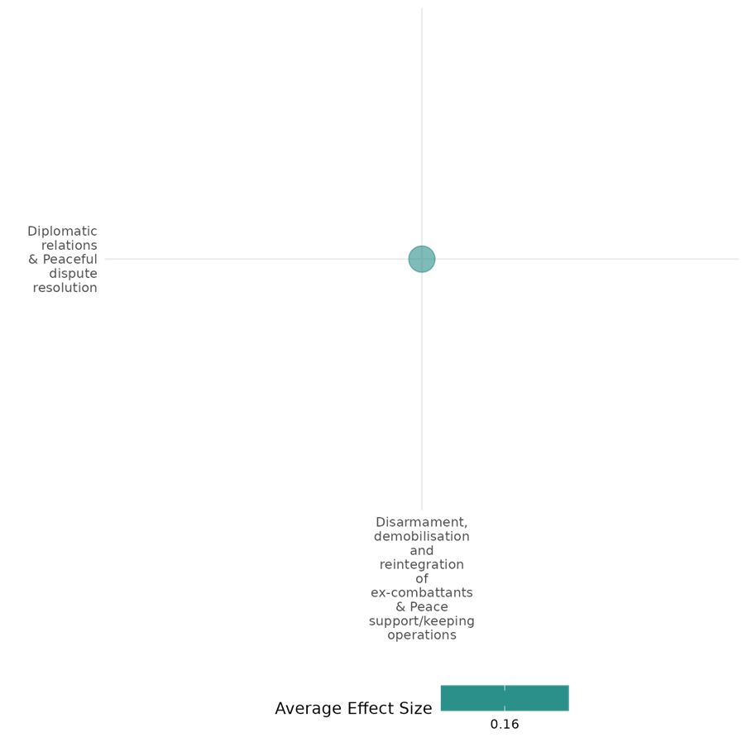

4.1.3(2)
Effect of Disarmament, demobilization and reintegration of ex-combatants & Peace support/keeping operations on Nature and scale of violence or atrocities
UN peacekeeping shortens conflicts, reduces battle deaths, and lowers postwar violence. UN police are more effective than troops in curbing organized violence. While peacekeeping mitigates electoral violence and atrocities, its long-term impact on stability remains uncertain.
Geographical region: Global, Sub Saharan Africa, South Asia, Latin America & Caribbean, East Asia & Pacific.
Effect: Small effect (g = 0.058)
Confidence in study findings: Medium confidence

Short summary
Disarmament, demobilization, and reintegration (DDR) programs, along with peacekeeping operations (PKOs) were expected to have an effect on nature and scale of violence and atrocities. They influence conflict dynamics by reducing violence and stabilizing postwar environments. UN peacekeeping presence shortens conflicts in fragmented settings and decreases battle deaths, while UN police effectively lower postwar violence. Peacekeeping reduces violence but does not end conflict, as it often transforms into other forms of instability. The success of interventions depends on mission size, mandate, and coordination with mediation efforts. Peacekeeping reduces electoral violence and atrocities, but its long-term impact on sustaining peace remains uncertain, particularly in complex conflicts with persistent security challenges.

Long summary
The Intervention
Disarmament, demobilisation and reintegration is a complex programme for ex-combatants that brings together reconciliation, security and socio-economic dimensions. The process typically involves removing weapons from combatants' hands, taking Individuals out of militarised structures, and providing them with training for new livelihoods as well as psychosocial support + Peace Support Operations (PS0s) and Peacekeeping Operations (PKOs), where 1) PSOs encompass all multi-functional operations, conducted impartially, normally by States or by international or regional organizations, such as the United Nations (UN), the European Union (EU), the African Union (AU), or the North Atlantic Treaty Organization (NATO), involving military forces and diplomatic and humanitarian agencies, and are designed to achieve a long-term political settlement or other specified objective, and 2), the deployment of UN peacekeepers into countries in a post-conflict setting. This involves the deployment of international troops and police, who work with local civilian peacekeepers to provide security to an area (UN Peacekeeping n.d.). Operations with primary or secondary objectives to prevent, halt or reduce the risk of atrocities are also considered within this category.

How the intervention is expected to work?
Peacekeeping operations and DDR may have an effect on the nature and scale of violence and atrocities by mitigating conflict intensity and reducing civilian harm. The presence of peacekeepers may deter armed groups from targeting civilians, while UN police deployments may help curb postwar violence by strengthening local security institutions. Higher fragmentation in conflicts may lead to prolonged and more intense fighting, but UN troop deployment may reduce the overall level of battle deaths. However, while peacekeeping may decrease large-scale violence, conflicts may transform into other forms of instability.

Evidence base
The cell includes 26 quantitative studies.
Global (7), Sub Saharan Africa (4), South Asia, Latin America & Caribbean, East Asia & Pacific.
The cell also includes 4 qualitative studies: Adedokun (2019, Sub Saharan Africa), Channel Research (2011), Sub Saharan Africa, Gromes (2019), Global, Leib (2019), Sub Saharan Africa.
1 systematic review/meta analysis: Cramer (2016), Global

Evidence findings
Fragmentation is associated with longer and more intense conflicts when UN peacekeepers are not present. However, the presence of UN PKOs mitigates these adverse effects. Specifically, fragmentation without UN involvement leads to a 31% decrease in the hazard rate, indicating longer conflicts, while UN presence is associated with an 11% increase in the hazard rate, suggesting shorter conflicts, although this effect is not statistically significant. Additionally, higher fragmentation correlates with increased battle deaths, but this effect diminishes with UN troop deployment. UN peacekeeping is effective in reducing the duration and intensity of conflicts in highly fragmented environments (Arı & Gizelis, 2020). UN police significantly reduce postwar violence, with deployments of as few as 400 police halving the predicted level of violence, and 1000 police reducing it by 84%. In contrast, UN troops do not have a significant effect on reducing postwar violence and may even be associated with an increase in violence by actors other than the main combatants. The effectiveness of UN police is attributed to their role in capacity-building and providing interim security, which helps mitigate organized collective violence (Bara, 2020). The study finds that both UN and regional peacekeeping operations are effective in reducing violence against civilians by governments, but only UN troops and police are effective in curbing civilian targeting by non-state actors. The analysis shows that larger UN missions, in terms of troop and police deployments, are associated with fewer civilian deaths caused by rebels. Regional peacekeepers do not have a significant effect on reducing violence by rebel groups. The study suggests that the effectiveness of peacekeeping may depend on the capabilities and mandates of the peacekeepers, with UN missions generally having more resources and experience (Bara & Lisa, 2020). Peacekeepers’ military presence improves security (observed and perceived) (Bove, 2002).
Peacekeeping reduces the level of violence, but does not end conflict, which transforms to other forms and there is no clear effect on domestic and personal security, with acts of violence actually increasing over time. Traditional peacekeeping missions show better performance on these indicators than stabilisation missions, with the poor performance of the latter largely driven by the case of Somalia. Higher levels of aid are associated with lower levels of violence, though this conclusion depends on the case of Liberia as an outlier (Brosig, 2018).
The presence of UNPKOs does not significantly stabilize peace. However, military victories have a positive effect when deployed in support of negotiated settlements, particularly those involving disarmament, demobilization, and reintegration (DDR) components (Caplan, 2017).
The interaction of mediation and UNPKOs shows a negative effect on recurrence, particularly at lower levels of recurrence risk. However, while mediation alone does not significantly extend the duration of agreements, its interaction with UNPKOs positively impacts agreement duration. The combined efforts of mediation and peacekeeping are beneficial in maintaining peace, although the effect is more pronounced at lower probabilities of recurrence (DeRouen, 2018). UN interventions significantly reduce the proportional hazard of returning to war by over 85%. Meanwhile, UN interventions during ongoing wars have no statistically significant impact on shortening the duration of conflicts, with estimates from unmatched samples overstating their effectiveness (Gilligan, 2008).
Presence of peacekeepers is associated with a measurable decrease in fatalities in elections, resulting in a lower likelihood of civil war (Fjelde, 2021). UN peacekeeping presence reduces risk of electoral violence, the count of UN bases is insignificant. Lastly, there is no significant difference between UN military presence in the pre- and post- election periods Fjelde, 2022).

Included studies
Arı (2020) examines the role of United Nations peacekeeping operations (UN PKOs) in mitigating the adverse effects of conflict fragmentation on civil war duration and intensity. Fragmentation, characterized by a higher number of competing actors, exacerbates coordination problems and increases the risk of opposition to peace processes, making conflicts longer and deadlier. The study focuses on the effectiveness of UN interventions in such fragmented conflicts, arguing that UN PKOs are particularly crucial in these challenging environments. The research employs a global dataset covering civil conflicts from 1990 to 2013, using the UCDP Conflict Termination Dataset to analyze conflict duration and the number of battle-related deaths to assess conflict intensity. The study introduces the Conflict Fragmentation Index (CFI) to measure fragmentation more accurately by considering the distribution of combat activity among conflict parties. The analysis includes Cox proportional hazard regressions and negative binomial regressions to evaluate the impact of UN peacekeeping on conflict duration and intensity, respectively. The study finds that fragmentation is associated with longer and more intense conflicts when UN peacekeepers are not present. However, the presence of UN PKOs mitigates these adverse effects. Specifically, fragmentation without UN involvement leads to a 31% decrease in the hazard rate, indicating longer conflicts, while UN presence is associated with an 11% increase in the hazard rate, suggesting shorter conflicts, although this effect is not statistically significant. Additionally, higher fragmentation correlates with increased battle deaths, but this effect diminishes with UN troop deployment. The findings suggest that UN peacekeeping is effective in reducing the duration and intensity of conflicts in highly fragmented environments. The study is rated as medium confidence as it is a non-experimental study.

Bara (2020) analysed the impact of UN peacekeeping operations on postwar violence, focusing on the roles of UN troops and police. It highlights that while peacekeepers are effective in maintaining peace between former combatants, the majority of postwar violence is perpetrated by other armed actors not covered by peacekeeping mandates. The context of the study spans various postwar situations globally between 1991 and 2016, including countries like Bosnia, DR Congo, and Kosovo. The research employs a global monthly dataset of peacekeeping and postwar violence from 1991 to 2016, observing postwar periods for up to five years unless conflict resumes. The study uses data from the UCDP/PRIO Armed Conflict Dataset and focuses on postwar periods of severe conflicts, ensuring sufficient information on battle locations to define conflict zones. The sample includes 71 postwar periods, with violence data sourced from the UCDP GED data. The study finds that UN police significantly reduce postwar violence, with deployments of as few as 400 police halving the predicted level of violence, and 1000 police reducing it by 84%. In contrast, UN troops do not have a significant effect on reducing postwar violence and may even be associated with an increase in violence by actors other than the main combatants. The effectiveness of UN police is attributed to their role in capacity-building and providing interim security, which helps mitigate organized collective violence. The study is rated medium confidence as it is a non-experimental study and due to the small sample size.

Bara (2020) examines the effectiveness of UN and non-UN peacekeeping operations in mitigating violence in civil conflicts. It highlights the increasing role of regional organizations and coalitions of states in peacekeeping, which have deployed more operations than the UN in recent decades. The focus is on understanding whether UN peacekeepers are more effective than their non-UN counterparts in managing civil conflicts and reducing violence against civilians. The research utilizes a novel dataset that provides monthly data on the number of troops, police, and observers in both UN and non-UN peacekeeping operations from 1993 to 2016. The dataset is compiled from SIPRI Yearbooks and the Peacekeeping Database, using linear interpolation to estimate monthly personnel levels. The study includes 121 missions across 52 conflicts in 36 countries, with 51 UN missions, 47 regional missions, and 23 international missions. The study finds that both UN and regional peacekeeping operations are effective in reducing violence against civilians by governments, but only UN troops and police are effective in curbing civilian targeting by non-state actors. The analysis shows that larger UN missions, in terms of troop and police deployments, are associated with fewer civilian deaths caused by rebels. Regional peacekeepers do not have a significant effect on reducing violence by rebel groups. The study suggests that the effectiveness of peacekeeping may depend on the capabilities and mandates of the peacekeepers, with UN missions generally having more resources and experience. The study is rated low confidence as it is a non-experimental study with unclear evaluation questions.

Bove (2002) suggests that civil wars affect the economic conditions of households by disrupting economic transactions and harming their psychological well-being. To restore basic conditions for local economic recovery in conflict-torn regions, the international community has only a limited number of tools at its disposal. This study asks whether UN peacekeeping is one instrument to mitigate the negative effect of conflict on households’ economic well-being. It argues that, by reducing violence and heightening perceptions of safety, UN missions (i) encourage labor provision and economic exchanges, and (ii) instill confidence by reducing the psychological impact of daily stressors. Combining high-frequency household survey data and information on subnational deployment of UN peacekeepers in South Sudan, the study shows that peacekeepers’ military presence improves security (observed and perceived), which in turn revitalizes local economies and households’ subjective well-being. These improvements ultimately boost households’ consumption, partially countering the negative effect of ongoing civil wars by keeping local communities’ economy afloat. The study first examines households’ consumption and then moves to testing the proposed causal mechanisms linking them to peacekeeping presence. The main difference across all models shown is the dependent variable. Because most outcomes are dichotomous, coefficients correspond to marginal effects on linear probabilities. The only exceptions are per capita goods (in units) and traveling time to the closest market (in hours). To assess whether the presence of peacekeepers improves households’ well-being, the study analyzes food consumption, irregular consumption, food purchases, and durable (nonfood) goods. The findings indicate that households report higher per capita food consumption—by about 24 units per capita—when peacekeepers operate in their county. Peacekeepers’ presence reduces the probability of a household reporting lack of food by almost 10 percentage points and increases food purchases by about 23 units per capita, suggesting an improvement in households’ capacity to buy food. Additionally, the likelihood of employment for household heads is higher, increasing by 7 percentage points in areas with peacekeeping presence. Traveling time to local markets is also shorter, reducing by more than 1 hour, as peace missions facilitate the return of market activities by improving security conditions. The study finds that UNMISS increased consumption of food and durable items for households in counties hosting peacekeepers and improved the security environment, restored economic opportunities, and had a positive impact on households’ psychological well-being. The mediated effect of peacekeeping via violence, safety, economic opportunities, and psychological well-being results in about a 2-unit increase in household per capita food consumption, though not statistically significant at conventional levels. Peacekeeping presence leads to a 2-percentage point decrease in the likelihood of reporting irregular food consumption and a 5.5-unit increase in per capita food purchases. Finally, peacekeeping presence is linked to improvements in psychological well-being, with expectations that living conditions will become at least “fairly good” being 14 percentage points higher and life satisfaction almost 5 percentage points higher in counties where peacekeepers are deployed. These findings highlight the mechanisms through which UN peacekeeping produces its economic-enhancing effects. The study is rated low confidence.

Brosig (2018) conducts a time trend analysis of 11 conflict-related indicators for the five years after the start of peacekeeping operations in Africa for the period 2000-2015. The study finds that: (1) peacekeeping reduces the level of violence, but does not end conflict, which transforms to other forms; (2) there is no clear effect on domestic and personal security, with acts of violence actually increasing over time; and (3) there is no clear improvement in accountability, rule of law or political stability. Traditional peacekeeping missions show better performance on these indicators than stabilisation missions, with the poor performance of the latter largely driven by the case of Somalia. But overall, the finding that ‘peacekeeping works’ ignores the different types of violence and dysfunction which may persist. The authors also report that higher levels of aid are associated with lower levels of violence, though this conclusion depends on the case of Liberia as an outlier. The study is rated low confidence.

Caplan (2017) investigates the factors contributing to the endurance of peace in countries that have experienced civil armed conflict. It focuses on the role of conflict termination types, such as military victories and negotiated settlements, and the impact of United Nations peacekeeping operations (UNPKOs) in post-conflict stabilization. The context includes countries like Burundi, East Timor, El Salvador, Liberia, Nepal, and Sierra Leone, which have all experienced civil wars and subsequent peace processes. The research employs a mixed-methods approach, combining statistical survival analysis with six detailed case studies. The survival analysis considers 205 peace episodes since 1990, using a hazards model to evaluate the duration of peace and the influence of various factors. The case studies provide qualitative insights into specific country contexts, complementing the quantitative data. The study uses data from the Armed Conflict Dataset (ACD) and other sources to define and analyze post-conflict periods. The study finds that military victories tend to result in more durable peace compared to negotiated settlements, which are more likely to break down. The presence of UNPKOs does not significantly stabilize peace. However, military victories have a positive effect when deployed in support of negotiated settlements, particularly those involving disarmament, demobilization, and reintegration (DDR) components. Economic factors like income per capita also positively influence peace duration, although other economic variables such as growth and aid were not significant. The study highlights the complexity of peace stabilization and the variability of factors influencing peace duration across different contexts. The study is rated low confidence as it is a non-experimental study and unclear evaluation question description.

DeRouen & Ishita (2018) examines the role of mediation and United Nations peacekeeping operations (UNPKOs) in civil war peace agreements, focusing on their combined effect in reducing the risk of renewed or continued violence and enhancing the duration of peace agreements. The context includes various civil war scenarios globally, with a specific case study on the peace process in Guatemala during the 1990s, where mediation and peacekeeping efforts were instrumental in ending a long-standing conflict. The research utilizes a sample of 154 civil war peace agreements signed between 1975 and 2011, sourced from the Uppsala Conflict Data Program (UCDP).. The study employs logit and hazard models to analyze the effects of mediation and UNPKOs on the likelihood of violence recurrence and the duration of peace agreements. The analysis includes control variables such as agreement design, democracy, and income per capita. The study finds that mediation significantly reduces the probability of renewed violence, with a negative and significant effect on the risk of recurrence. The interaction of mediation and UNPKOs also shows a negative effect on recurrence, particularly at lower levels of recurrence risk. However, while mediation alone does not significantly extend the duration of agreements, its interaction with UNPKOs positively impacts agreement duration. The findings suggest that the combined efforts of mediation and peacekeeping are beneficial in maintaining peace, although the effect is more pronounced at lower probabilities of recurrence. The study is rated low confidence due to its non-experimental design and little description of the intervention

Fjelde and Höglund (2021) introduces the Deadly Electoral Conflict Dataset (DECO), which is a comprehensive global dataset of election-related violence with lethal outcomes from 1989 to 2017. It addresses limitations of existing similar datasets, such as the National Elections across Democracy and Autocracy (NELDA) and Varieties of Democracy (V-Dem). DECO includes 4,233 incidents of lethal electoral violence, resulting in almost 24,000 deaths globally. The paper shows that DECO events appear more frequently in Africa and Asia than the Middle East, Europe, and the Americas. It categorizes events based on targets, perpetrators, timing within the electoral cycle (pre-, during, and post-elections). Derived from the Uppsala Conflict Data Program (UCDP) Georeferenced Event Dataset, DECO incorporates additional coding to establish the electoral context of these violent events. It also distinguishes between violence perpetrated by state forces, non-state actors, and civilians. The empirical findings of the study show that DECO often overlaps with other forms of political violence, including civil wars or communal conflicts. The dataset also highlights the involvement of other actors, such as political party supporters, armed groups, and government forces. Majority of the DECO events also identify targets as civilians, including voters, party supporters, and non-designated civilians. Finally, the results show that presence of peacekeepers is associated with a measurable decrease in fatalities in elections, resulting in a lower likelihood of civil war. The study is rated low confidence due to its little description of the intervention and evaluation questions.

Fjelde and Smidt (2022) explores the relationship implications of the presence of UN peacekeepers on electoral violence across sub-national administrative units in all countries that hosted UN peacekeeping missions in Africa from 1994 to 2017. The study employs a fixed-effect regression model on geo-referenced data on peacekeeping combined with high-resolution information on electoral violence incidents. The sample includes 16 unique elections in 8 countries, with a total of 730 unique administrative units. Data on election dates are taken from the National Elections Across Autocracies and Democracies database version 5 and local presence of peacekeepers were drawn from the Geo-PKO dataset. For the dependent variable, information was drawn from the DECO dataset and UCDP geo-referenced event database. Results show that additional UN base in an average sub-national unit decreases the risk of electoral violence by 0.5%. Additionally, electoral violence is more likely if war between the government and non-state armed groups are heightening over the past 2 years. Meanwhile, while UN peacekeeping presence reduces risk of electoral violence, the count of UN bases is insignificant. Lastly, there is no significant difference between UN military presence in the pre- and post- election periods. The study is rated low confidence due to its little description of the intervention.

Gilligan (2008) investigates the causal effects of the UN peacekeeping mission on civil wars – if it maintains peace post-conflict and reduces the duration of ongoing wars. The authors use matching techniques to address the non-random assignment of UN interventions, comparing treated (conflicts with interventions) and untreated (conflicts without interventions) cases. They identify key confounding variables and apply one-to-one nearest neighbor matching using GenMatch to balance these factors. The analysis focuses on two samples: post-conflict settings (examining peace duration) and active conflicts (measuring war duration). Matched data is analyzed using a Cox proportional hazards model. For post-conflict sample, the dependent variable is the number of months a certain country is at peace after a civil conflict. For in-war sample, the dependent variable is the duration of war once the UN intervened. Results show that UN interventions significantly reduce the proportional hazard of returning to war by over 85%. Meanwhile, UN interventions during ongoing wars have no statistically significant impact on shortening the duration of conflicts, with estimates from unmatched samples overstating their effectiveness. The study is rated medium confidence as it is non-experimental and due to its partial description of the intervention, outcomes, and evaluation questions.

Confidence assessment
The cell is rated medium confidence.

Other outcomes in this cell
- Human security/ Food security and nutrition & Health security
- Human security/ Physical security
- Human security/ Economic security
- Violence and atrocity prevention/ Diplomatic relations & Peaceful dispute resolution

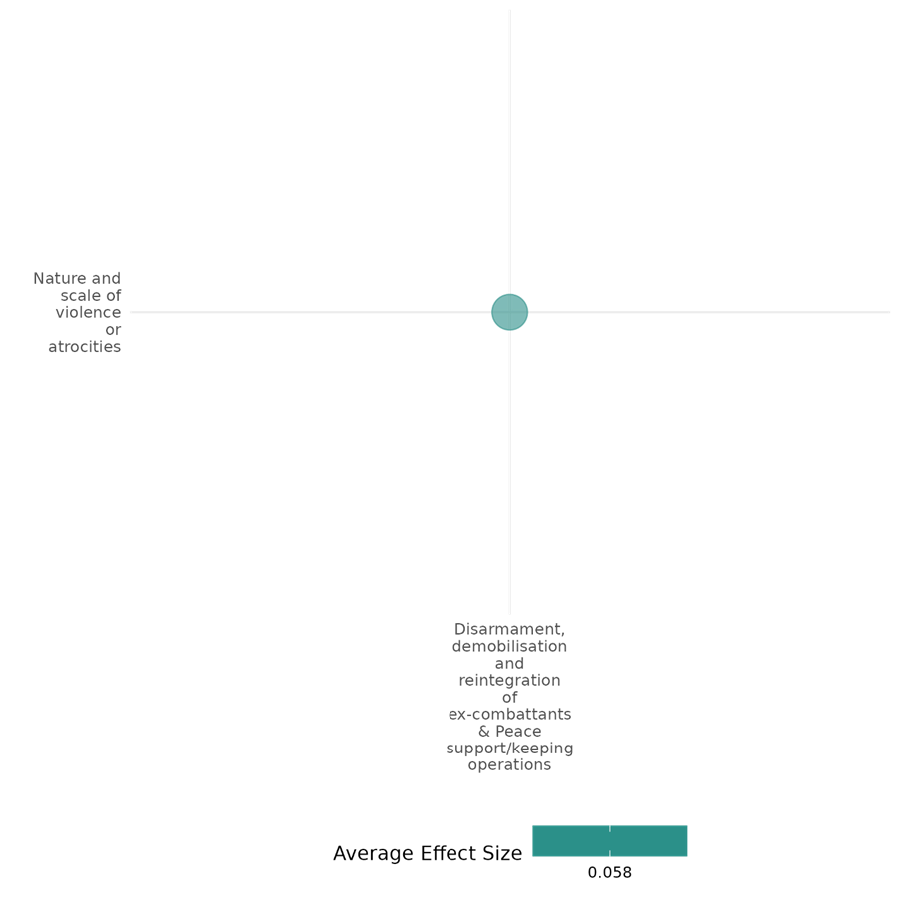

4.1.3(3)
Effect of Peace Support Operations and Peacekeeping Operations on Sexual and gender-based violence
The study in this cell assesses the way UN Missions with R2P mandates aim to safeguard civilians in armed conflict zones. The study suggests that such UN missions can exacerbate sexual and gender-based violence by rebels in an effort to display resolve.
Geographical region: Global
Effect: Small effect (g = -0.295)
Confidence in study findings: Low Confidence

Short Summary
The intervention, UN missions with Responsibility to Protect (R2P) mandates aim to safeguard civilians in armed conflict zones, was expected to have an effect on sexual and gender based violence. The one study in this cell finds that DDR and PKOs can unintentionally lead to an increase in sexual violence, particularly by rebels, as a substitute form of coercion and control.

Long Summary
The Intervention
Peace Support Operations (PS0s) and Peacekeeping Operations (PKOs), where 1) PSOs encompass all multi-functional operations, conducted impartially, normally by States or by international or regional organizations, such as the United Nations (UN), the European Union (EU), the African Union (AU), or the North Atlantic Treaty Organization (NATO), involving military forces and diplomatic and humanitarian agencies, and are designed to achieve a long-term political settlement or other specified objective, and 2), the deployment of UN peacekeepers into countries in a post-conflict setting. This involves the deployment of international troops and police, who work with local civilian peacekeepers to provide security to an area (UN Peacekeeping n.d.). Operations with primary or secondary objectives to prevent, halt or reduce the risk of atrocities are also considered within this category.

How the intervention is expected to work?
UN Peacekeeping Operations with R2P (Right to Protect) mandates which aim to safeguard civilians in armed conflict zones may have an effect on sexual and gender-based violence as warring parties escalate attacks to signal their resolve in ongoing conflicts.The UN Peacekeeping operations may incentivise or decrease sexual and gender-based violence.

The evidence base
There is only one quantitative study in this cell: It utilizes quantitative analysis of a novel dataset on UN peacekeeping mandates from 1990 to 2011. One-sided violence and sexual violence by rebels and governments were analyzed using georeferenced event data and statistical models, including instrumental variable techniques, to address the non-random deployment of R2P mandates. The study is rated high and medium confidence as it is non-experimental and due to its partial description of the intervention, outcomes, and evaluation questions.

Evidence Findings
Sexual violence by rebels increases when one-sided violence decreases, as warring parties seek to maintain their strategic positions without appearing to violate international norms. Government-perpetrated sexual violence shows a weaker link to R2P mandates, but similar dynamics may apply.

Included Study
Lloyd (2017) examines the outcomes of UN missions with Responsibility to Protect (R2P) mandates, which aim to safeguard civilians in armed conflict zones. The study theorizes that these mandates inadvertently incentivize violence as warring parties escalate attacks to signal their resolve in ongoing conflicts.
The study utilizes a combination of qualitative case studies (Uganda and the Democratic Republic of Congo) and quantitative analysis of a novel dataset on UN peacekeeping mandates from 1990 to 2011. One-sided violence and sexual violence by rebels and governments were analyzed using georeferenced event data and statistical models, including instrumental variable techniques, to address the non-random deployment of R2P mandates.
R2P mandates exacerbate civilian killings in conflicts where rebels or governments are desperate (e.g., during protracted conflicts or after significant battle losses). In less desperate conditions (e.g., successful rebels or governments facing prolonged, stable conflicts), R2P mandates deter one-sided violence against civilians.
Sexual violence by rebels increases when one-sided violence decreases, as warring parties seek to maintain their strategic positions without appearing to violate international norms. Government-perpetrated sexual violence shows a weaker link to R2P mandates, but similar dynamics may apply.
The study is rated high and medium confidence as it is non-experimental and due to its partial description of the intervention, outcomes, and evaluation questions.

Confidence assessment
Overall low: the cell is rated low confidence.

Other outcomes in the study/cell
- Violence and Atrocity Prevention/Nature and scale of violence or atrocities

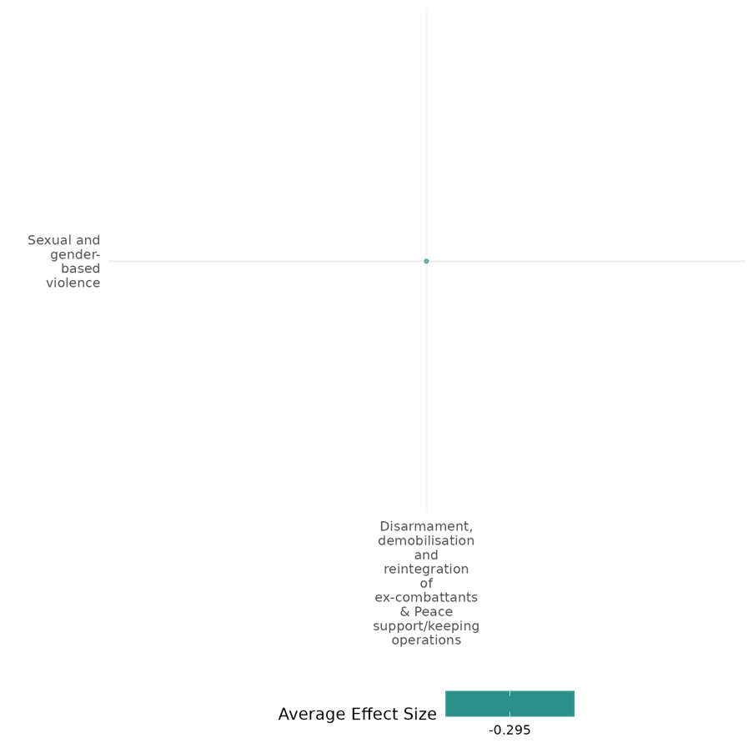

4.1.3(4)
Effect of Disarmament, demobilization and reintegration of ex-combatants on Social norms regarding violence and atrocities
Three quantitative studies assess the effects of DDR programs on ex-combatants’ attitudes, political reintegration, and community acceptance. Findings indicate that combatant roles and security conditions influence attitudes toward victims' rights, DDR modestly increases preference for civilian life, and female combatants are more likely to sever factional ties.
Geographical region: Latin America & Caribbean (1), Sub Saharan Africa (2)
Effect: Small effect (g = 0.081)
Confidence in study findings: Low confidence
Short summary
Disarmament, demobilization, and reintegration (DDR) programs were expected to have an effect on norms and behaviors related to violence, armed groups, and political reintegration. Three quantitative studies examine DDR’s impact in Colombia, Burundi, and Sierra Leone. One study finds that ex-combatants' attitudes toward victims' rights are shaped by their combatant roles and security conditions. Another study finds a modest increase in ex-combatants' preference for civilian life. The third study finds that female combatants were more likely to sever factional ties.

Long summary
The intervention
Disarmament, demobilisation and reintegration is a complex programme for ex-combatants that brings together reconciliation, security and socio-economic dimensions. The process typically involves removing weapons from combatants' hands, taking Individuals out of militarised structures, and providing them with training for new livelihoods as well as psychosocial support. (PKOs and PSOs are not found in this cell).

How the intervention is expected to work?
Disarmament, demobilization, and reintegration of ex-combatants may have an effect on the norms and behaviors surrounding violent conflicts and atrocities, including support for political violence or armed groups and attitudes toward the use of violence. By removing individuals from militarized structures, providing livelihood training, and offering psychosocial support, DDR programs may influence ex-combatants' perceptions of violence and political engagement. The effectiveness of these programs may vary depending on combatant roles, socialization into violence, and local security conditions.

The evidence base
There are three quantitative studies in this cell: One study focuses on Latin America & Caribbean and two studies focus on Sub Saharan Africa.
There is one qualitative study in this cell: Bateson (2017), Guatemala.

Evidence findings
Combatant roles negatively affect attitudes toward victims’ rights. Commanders often show more negative attitudes, but not significantly so across models. Ex-combatants who entered armed groups at an older age, having spent more time in civilian life, show greater respect for victims’ rights. Members of political paramilitary factions are less likely to express remorse, possibly due to socialization into viewing violence as justified. Ex-combatants living in high-insecurity areas may regret their participation in violence (Daly, 2018). On political reintegration, there was a modest increase in ex-combatants' preference for civilian life over combatant life (Gilligan, 2012) and female combatants were more likely to sever factional ties (Humphreys, 2007).

Included studies
Daly (2018) investigates the determinants of ex-paramilitaries’ support for transitional justice in Colombia, based on survey data from 10,951 former fighters. It emphasizes that ex-combatants’ attitudes toward transitional justice are influenced by their proximity to victimized communities, the norms of justice they have been exposed to, and the personal risks they face. These findings have significant implications for the effectiveness of transitional justice mechanisms in Colombia, particularly with FARC rebels, and for consolidating peace.
The study employs a quantitative analysis of original survey data collected from 10,951 Colombian ex-paramilitaries to explore the determinants of their support for transitional justice. It examines how factors such as proximity to and acceptance by victimized communities, exposure to justice norms, judicial risks tied to individual culpability, and security risks related to vulnerability to retribution influence their attitudes. By analyzing these variables, the research provides insights into the conditions under which transitional justice mechanisms are likely to gain the support of ex-combatants, offering a nuanced understanding of the interplay between socialization, risk, and justice in post-conflict settings. The study is rated low confidence.
DDR can influence social norms regarding violence and atrocities by fostering attitudes of remorse and accountability among ex-combatants, though their effectiveness may vary based on factors like combatant roles, socialization, and local security conditions.

Gilligan (2012) assesses the effect of the demobilization and reintegration (DDR) program in Burundi, following its 1993-2004 civil war, particularly on the ex-combatants’ economic well-being. The DDR program in Burundi is under the broader Multi-Country Demobilization and Reintegration Program (MDRP). The paper focuses on the program’s “socioeconomic reintegration package” and analyses if the enhancement of economic well-being would entail political integration of these individuals.
The analysis employs a matched comparison of treated and untreated individuals, using regression adjustments and inverse propensity weighting to control for selection bias and exposure heterogeneity. The study sample includes adult (aged 18 years old and above) male former rebel combatants. Respondents were drawn from those who received benefits from three different nongovernmental organizations, namely Twitezimbere (northern provinces), Planning and Development Collaborative (PADCO, southwest provinces), and Africare (center provinces).
The findings suggest that the program resulted in a 20–35 percentage point reduction in poverty incidence among beneficiaries. Income and livelihood outcomes, including access to skilled and unskilled occupations, also significantly improved.
On political reintegration, there was a modest increase in ex-combatants' preference for civilian life over combatant life. However, no significant effects were found on satisfaction with the peace process or support for current government institutions. The study is rated low confidence.

Humphreys (2007) evaluates the factors that affect the outcomes of Disarmament, Demobilization, and Reintegration (DDR) programs at a micro-level or individual level, using data from post-war Sierra Leone.
The study surveyed 1,043 ex-combatants from five major factions in Sierra Leone’s civil war, including both male and female participants as well as those who did and did not participate in DDR programs. The analysis employed a quantitative approach, using probit regression models to assess reintegration outcomes across four dimensions: breaking factional ties, employment, community acceptance, and confidence in democratic processes.
Overall, there is no significant effect on three of the four main measures of integration: ex-combatants breaking ties with their faction, acceptance by family and the community, or on the participant views of democracy. The only significant effect is in the wrong direction - being a negative effect on the views of the government.
The findings suggest that participation in abusive factions strongly hindered community acceptance. Female combatants were more likely to sever factional ties, while wealthier and better-educated individuals struggled with reintegration. Meanwhile, poorer individuals reported better employment outcomes. However, DDR participation was not significantly associated with improved economic conditions. Finally, distrust and dissatisfaction with peace agreements negatively affected confidence in democracy, and high-ranking combatants showed significant resistance to democratic norms. The study found little evidence that DDR programs significantly improved reintegration outcomes compared to non-participants.
The study is rated low confidence as attrition rates are not reported.

Confidence assessment
Overall, the study/cell is rated low confidence.

Other outcomes in the study/cell:
- Human security/Economic security
- Community and state governance/Government performance
- Social cohesion/Feelings of trust and acceptance of diversity

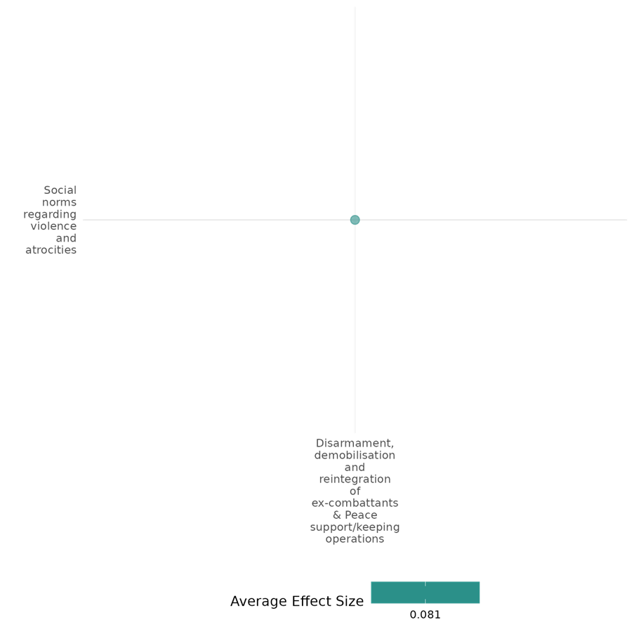

4.1.3(5)
Effect of Peace support/keeping operations on feelings of trust and acceptance of diversity
Two quantitative studies examine how peacekeeping operations influence feelings of trust and acceptance of diversity. The studies indicate that the presence of peacekeepers enhances trust in the rule of law by encouraging reliance on state authorities over non-state mechanisms for resolving crime and violence. Additionally, peacekeepers promote acceptance of diversity by fostering cooperative decision-making and equitable resource allocation among ethnic groups.
Geographical region: Middle East & North Africa, Europe & Central Asia
Effect: Small effect (g = 0.043)
Confidence in study findings: Moderate

Short Summary
The two studies in this cell suggest that the intervention Peace support/keeping operations, particularly, peacekeeping operations and the presence of peacekeepers have a positive effect on the feelings of trust in the rule of law and acceptance of diversity, respectively. The presence of peacekeepers influenced feelings of trust and acceptance of diversity by increasing reliance on state authorities over nonstate mechanisms for resolving crime and violence and increased cooperative decision-making and equitable resource allocation among ethnic groups.

Long summary
The Intervention
Peace Support Operations (PS0s) and Peacekeeping Operations (PKOs), where 1) PSOs encompass all multi-functional operations, conducted impartially, normally by States or by international or regional organizations, such as the United Nations (UN), the European Union (EU), the African Union (AU), or the North Atlantic Treaty Organization (NATO), involving military forces and diplomatic and humanitarian agencies, and are designed to achieve a long-term political settlement or other specified objective, and 2), the deployment of UN peacekeepers into countries in a post-conflict setting. This involves the deployment of international troops and police, who work with local civilian peacekeepers to provide security to an area (UN Peacekeeping n.d.). Operations with primary or secondary objectives to prevent, halt or reduce the risk of atrocities are also considered within this category. (DDR not found in this cell).

How the intervention is expected to work?
The deployment or aspects of Peace Support Operations and Peacekeeping Operations may affect the feelings of trust & acceptance of diversity by increasing individual’s reliance on state authorities over nonstate mechanisms for resolving crime and violence and by influencing cooperative decision-making among ethnic groups.

The evidence base
There are two studies in this cell: Both are quantitative studies. Blair (2019) uses an original survey and list experiment in Liberia to measure the effects of exposure to UNMIL. Multiple identification strategies are employed, including an instrumental variables approach using plausibly exogenous variation in UNMIL personnel distribution caused by the killing of seven peacekeepers in neighboring Côte d’Ivoire. These methods support a causal interpretation of the findings. Page (2018) employed a multi-stage stratified random sampling design. Individuals aged 18 and over were selected from households using a random route technique. The initial study in 2003 included 681 participants, while a follow-up replication in 2013 involved 449 participants.

Evidence findings
The intervention, UNMIL’s presence in Liberia, influenced feelings of trust and acceptance of diversity by increasing reliance on state authorities over nonstate mechanisms for resolving crime and violence. It also encouraged nonstate authorities to use legal mechanisms for dispute resolution. However, in the short term, exposure to UNMIL may have exacerbated perceptions of state corruption and bias, though these adverse effects diminished over time (Blair, 2019). Page (2018) found that areas with peacekeepers’ presence showed a significant increase in cooperative decision-making among ethnic groups. Specifically, participants in peacekeeping regions allocated resources more equitably, with a notable increase in positive interactions reported (30% more cooperation in resource-sharing tasks). The data suggests that peacekeepers can effectively reduce ethnic divisions in post-conflict settings.

Included studies
Page (2018) investigates the impact of international peacekeepers on ethnic divisions in post-conflict societies, specifically focusing on Bosnia and aims to understand whether the presence of peacekeepers can help mitigate ethnic tensions and foster cooperation. The study employed a multi-stage stratified random sampling design. The sample consisted of individuals aged 18 and over, selected from households using a random route technique, initial study in 2003 included 681 participants, while a follow-up replication in 2013 involved 449 participants.
The study found that areas with peacekeeper presence showed a significant increase in cooperative decision-making among ethnic groups in post-conflict Bosnia. Participants in peacekeeping regions allocated resources more equitably, with a notable increase in positive interactions reported, specifically 30% more cooperation in resource-sharing tasks. The study is rated as a high and medium-confidence quantitative study.
The findings suggest that peacekeepers can effectively reduce ethnic divisions in post-conflict settings.

Blair (2019) investigates the effects of a peacekeeping mission on the rule of law in a post-conflict setting. The study relied on an original survey and list experiment in Liberia to assess the effects of UNMIL. Causal interpretation was supported by multiple identification strategies, including an instrumental variables approach that exploited exogenous variation in UNMIL personnel distribution triggered by the killing of peacekeepers in neighboring Côte d’Ivoire. These effects were analyzed for their persistence over time, even in areas with no continued exposure to peacekeepers. Exposure to the UN Mission in Liberia (UNMIL) increased citizens’ reliance on state authorities over nonstate authorities to resolve serious incidents of crime and violence. It also encouraged nonstate authorities to rely on legal rather than illegal mechanisms for dispute resolution. However, exposure to UNMIL did not mitigate, and may have exacerbated, citizens’ perceptions of state corruption and bias in the short term, though these adverse effects dissipated over time. The study is rated as a low-confidence quantitative study.
Overall, the mission’s presence (PKO) had complex but largely positive impacts on fostering trust and reliance on state systems.

Confidence assessment
Overall, the cell is rated medium confidence.

Other outcomes in this cell/study
- Violence and atrocity prevention/Diplomatic relations & Peaceful dispute resolution

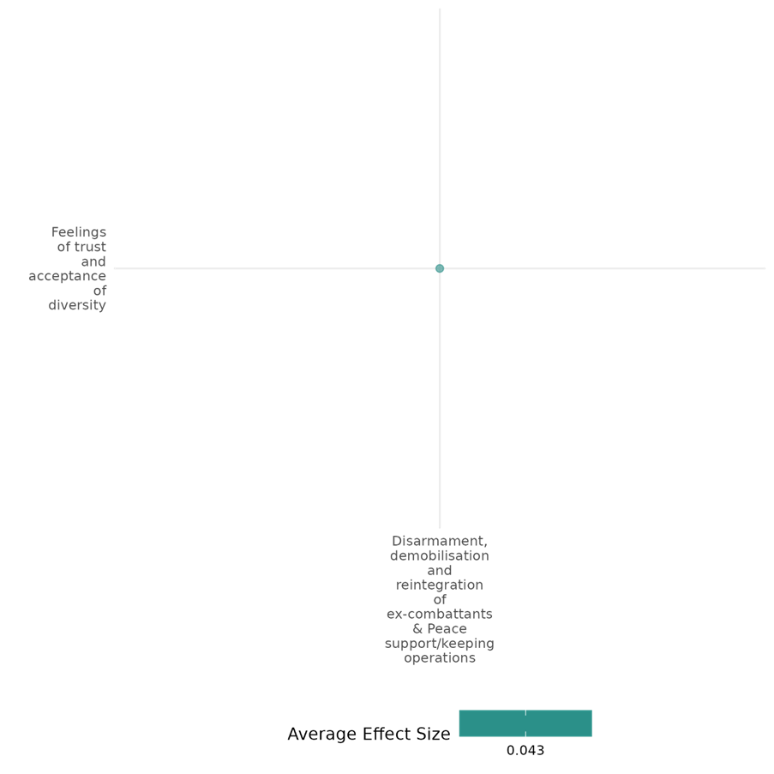

4.1.3(6)
Effect of Disarmament, demobilisation and reintegration on Sense of belonging
One quantitative study suggests that DDR programs do not significantly enhance ex-combatants' sense of belonging.
Geographical region: Sub Saharan Africa
Effect: Small effect (g = 0.094)
Confidence in study findings: Low. Only one low quality study.

Short summary
Disarmament, demobilisation and reintegration are intended to reduce conflict reoccurring. One part of this is for ex-combatants to break ties with their former faction and rebuild their sense of belonging in their community. However, evidence from one study in Sierra Leone finds they do not have this effect, especially for more affluent and better educated individuals. There may be some effect for women.

Long summary
The intervention
Disarmament, demobilisation and reintegration is a programme for ex-combatants that brings together reconciliation, security and socio-economic dimensions. The process typically involves removing weapons from combatants’ hands, taking individuals out of militarised structures, and providing them with training for new livelihoods as well as psychosocial support.
The row also includes peacekeeping operations, but there are no studies in this cell addressing these.

How the intervention is expected to work?
Reintegration activities such as psychosocial support and livelihoods interventions may lead to distancing from former faction connections and an increased sense of belonging.

The evidence base
There is one large n randomized controlled trial from Sierra Leone in this cell: Humphreys Macartan and Weinstein Jeremy M. (2007). Demobilization and Reintegration. Journal of Conflict Resolution, 51(4), pp.531-567. The study is rated low confidence on account of failure to report attrition.
The cell also includes 1 qualitative study: Touray (2019), Sub Saharan Africa.

Evidence findings
Disarmament, demobilisation and reintegration do not increase the sense of belonging of ex-combatants.

Included study
Humphreys and Weinstein (2007) evaluates the factors that affect the outcomes of Disarmament, Demobilization, and Reintegration (DDR) programs at a micro-level or individual level, using data from post-war Sierra Leone.
The study surveyed 1,043 ex-combatants from five major factions in Sierra Leone’s civil war, including both male and female participants as well as those who did and did not participate in DDR programs. The analysis employed a quantitative approach, using probit regression models to assess reintegration outcomes across four dimensions: breaking factional ties, employment, community acceptance, and confidence in democratic processes.
Overall, there is no significant effect on ex-combatants breaking ties with their faction. Female combatants were more likely to sever factional ties, while wealthier and better-educated individuals were less likely to do so.
Overall, the study found little evidence that DDR programs significantly improved reintegration outcomes compared to non-participants.

Confidence assessment
The cell is rated low confidence.

Other outcomes in this study
- Violence and atrocity prevention/Social norms regarding violence and atrocities
- Human security/Economic security
- Community and state governance/Government performance
- Social cohesion/Feelings of trust and acceptance of diversity

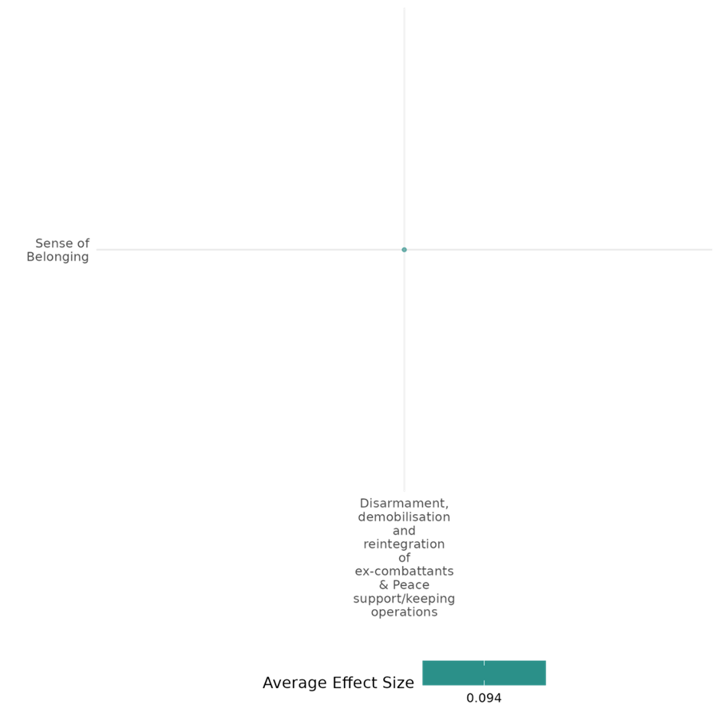

4.1.3(7)
Effect of Peace Support Operations and Peacekeeping Operations on Access to justice, rights and public services
The study in this cell suggests that UN peacebuilding missions increase democratisation probability to 68% in host countries. While mission capacity may enhance outcomes, statistical significance is lacking. The study highlights UN peacebuilding’s role in improving access to justice, rights, and services through democratisation.
Geographical region: Global
Large effect (g= 0.351)
Confidence in study findings: Low confidence

Short summary
UN Peacekeeping operations are designed to achieve a long-term political settlement or other specified objective. The one study in this cell suggests a positive impact of UN Peacebuilding operations in supporting democratization. It finds that democratization is significantly more likely if a UN peacebuilding mission is deployed, with a 68% probability of increased democracy in host countries compared to 34% in non-host countries.

Long summary
The Intervention
Peace Support Operations (PS0s) and Peacekeeping Operations (PKOs), where 1) PSOs encompass all multi-functional operations, conducted impartially, normally by States or by international or regional organizations, such as the United Nations (UN), the European Union (EU), the African Union (AU), or the North Atlantic Treaty Organization (NATO), involving military forces and diplomatic and humanitarian agencies, and are designed to achieve a long-term political settlement or other specified objective, and 2), the deployment of UN peacekeepers into countries in a post-conflict setting. This involves the deployment of international troops and police, who work with local civilian peacekeepers to provide security to an area (UN Peacekeeping n.d.). Operations with primary or secondary objectives to prevent, halt or reduce the risk of atrocities are also considered within this category. (DDR is not mentioned in this cell).

How the intervention is expected to work?
UN Peacebuilding Operations that specifically include democracy in their mandate may have an effect on access to justice, rights, and public services for individuals in deployed regions. Access to justice, rights, and public services includes all indicators of access to justice and rights, including the intent, capability and capacity to protect human rights in civilian and military settings (including access to documentation), and equitable access to public services (e.g. health, education), which are all possibilities of achieving democratization.

The evidence base
This cell has one quantitative study: Steinert (2014) employs a multinominal logistic regression analysis to assess the impact of UN peacebuilding missions on democratization trends in 103 post-civil war countries, of which 31 experienced a UN peacebuilding mission. The study is rated low confidence as it is a non-experimental study and lacks a clear description of the intervention.

Evidence findings
The study finds that democratization (which will include access to justice, rights, and public services) is significantly more likely if a UN peacebuilding mission is deployed, with a 68% probability of increased democracy in host countries compared to 34% in non-host countries. Descriptive statistics suggest that greater mission capacity, such as longer duration and more resources, may enhance democratization outcomes, although this relationship is not statistically significant.

Included studies
Steinert (2014) examines the effectiveness of United Nations (UN) peacebuilding missions in democratizing war-torn states, with a focus on missions that include democracy promotion components in their mandates. The context involves post-civil war countries where the UN has deployed peacebuilding missions to foster democratic transitions.
The research employs a multinominal logistic regression analysis to assess the impact of UN peacebuilding missions on democratization trends in 103 post-civil war countries, of which 31 experienced a UN peacebuilding mission. The study uses Freedom House data to measure democratization, comparing rankings from the first mission year to those five years later. The analysis controls for various factors, including battle deaths, peace agreements, and oil wealth, to account for selection bias in mission deployment.
The study finds that democratization is significantly more likely if a UN peacebuilding mission is deployed, with a 68% probability of increased democracy in host countries compared to 34% in non-host countries.
The presence of oil wealth negatively impacts democratization prospects, while a clear victory by one conflict party can lead to regime transitions in both directions.
Descriptive statistics suggest that greater mission capacity, such as longer duration and more resources, may enhance democratization outcomes, although this relationship is not statistically significant.
The study is rated as low confidence as it is a non-experimental study and lacks clear description of the intervention as it does not provide detailed information on the specific components or implementation of the UN peacebuilding missions, making it difficult to replicate or fully understand the intervention's scope and impact.

Confidence assessment
Overall low: The cell/study is rated low confidence as it is based on just one study.

Other outcomes in the study/cell
- Community and state governance/Transitions of Power

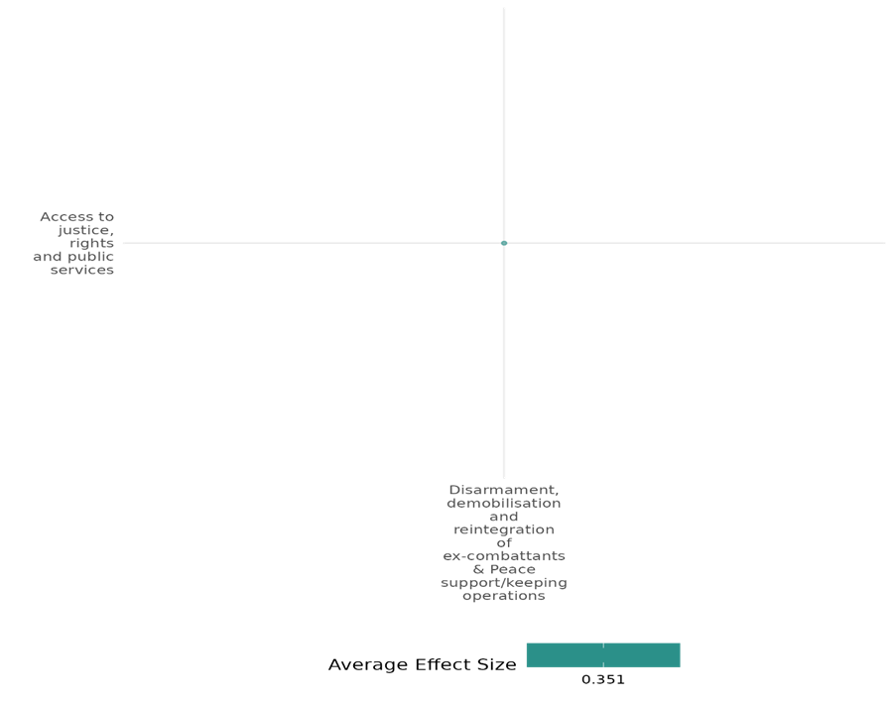

4.1.3(8)
Effect of Peace support operations and Peacekeeping operations on Civic participation
The two studies in this cell assess UN peacekeeping’s effectiveness and impact on local security and socio-economic revitalisation and non-violent protests. The studies suggest that UN peacekeeping operations’ deployment positively affects civic participation in terms of collective action like non-violent protests and community projects.
Geographical region: Global, Sub Saharan Africa
Effect: Small effect (g = 0.024)
Confidence in study findings: Low confidence

Short summary
Peacekeeping operations could have an impact on the civic participation of the host country. The studies in this cell suggest that peacekeeping missions indeed have a positive effect on the civic participation of individuals in the form of non-violent protests, a boost in community projects like wells and schools and participation in community organizations and politics.

Long Summary
The Intervention
Peace Support Operations (PS0s) and Peacekeeping Operations (PKOs), where 1) PSOs encompass all multi-functional operations, conducted impartially, normally by States or by international or regional organizations, such as the United Nations (UN), the European Union (EU), the African Union (AU), or the North Atlantic Treaty Organization (NATO), involving military forces and diplomatic and humanitarian agencies, and are designed to achieve a long-term political settlement or other specified objective, and 2), the deployment of UN peacekeepers into countries in a post-conflict setting. This involves the deployment of international troops and police, who work with local civilian peacekeepers to provide security to an area (UN Peacekeeping n.d.). Operations with primary or secondary objectives to prevent, halt or reduce the risk of atrocities are also considered within this category. (DDR is not found in this cell.)

How the intervention is expected to work?
The deployment and presence of Peacekeeping Operations like UNMIL and peacekeepers like UN police personnel may have an effect on civic participation, inclusive of collective action, in the host country. The presence of peacekeepers, especially from strong civil societies, are expected to impact the civil participation and collective action like non-violent protests, community projects, etc, in individuals in the area of deployment.

The evidence base
This cell holds 2 quantitative studies, Belgioioso (2020) uses a newly crafted dataset on nonviolent protests in post–civil war countries and peacekeeping missions’ presence, size, and home-country composition and examines the role of peacekeepers, especially UNPOL, who train local police forces and interact directly with protesters while Mvukiyehe (2021) employs coarsened exact matching to compare communities hosting UNMIL deployments (treatment) with those at least 15 kilometers away (control) to assess the micro-level impacts of peacekeeping operations (PKOs) in Liberia.

Evidence findings
Mvukiyehe (2021) finds that PKOs boost community projects like wells and schools and improve participation in community organizations and politics while Belgioioso (2020) finds that peacekeeping missions’ presence significantly increases nonviolent protests, which is part of civic participation, in post–civil war country-years and is largely explained by the presence of UNPOL from countries with strong civil societies.

Included studies
Mvukiyehe (2021) evaluates the micro-level effectiveness of peacekeeping operations (PKOs), focusing on Liberia’s civil war and the UN Mission in Liberia (UNMIL). The study examines the impact of UNMIL deployments on local security and socio-economic revitalization.
Using coarsened exact matching, the analysis compares communities hosting UNMIL deployments (treatment) with those at least 15 kilometers away (control), controlling for infrastructure, population, geography, ethnicity, and conflict exposure. Security outcomes include fear of victimization, victimization by crime, and in-migration of conflict victims. Socio-economic revitalization measures include infrastructure, income, food and higher-order consumption, and participation in community activities. The non-experimental design leads to a medium confidence rating.
The findings suggest that PKOs have a positive impact on community projects like wells and schools and participation in community organizations and politics.

Belgioioso (2020) uses a newly crafted dataset on nonviolent protests in post–civil war countries, along with information on peacekeeping missions’ presence, size, and home-country composition. The analysis examines the impact of peacekeepers on nonviolent political contention, particularly nonviolent public protest. The study focuses on the role of UN police personnel (UNPOL) from countries with robust civil societies, who train local police forces and interact directly with protesters.
The findings show that peacekeeping missions significantly increase nonviolent protests in post–civil war country-years. This effect is largely attributed to the presence of UNPOL from countries with strong civil societies. The results suggest that peacekeepers contribute to establishing a secure environment for nonviolent political contention, with important implications for post–civil war political revitalization and the composition of peacekeeping missions. The study is reported a high and medium confidence quantitative study.
Overall, the presence of peacekeeping missions has a positive effect on civic participation, here, non-violent protest.
Confidence assessment
Overall, the cell is rated low confidence.
Other outcomes
- Human security/Physical security
- Community and state governance/Access to justice, rights and public services
- Human security/Economic security
- Violence and atrocity prevention/Nature and scale of violence

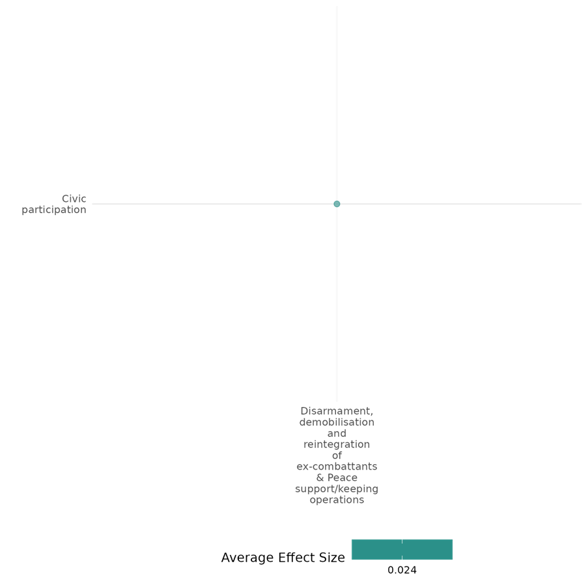

4.1.3(9)
Effect of Disarmament, demobilization and reintegration of ex-combatants & Peace support/keeping operations on Government performance
The disarmament, demobilization, and reintegration of ex-combatants, along with Peace Support and Peacekeeping Operations impact government performance. The studies suggest that while PKOs positively affect government institutions and public perception, DDR shows no effect or a negative impact on the functioning of government institutions and perceptions of government performance.
Geographical region: Middle East & North Africa, Sub Saharan Africa
Effect: Small effect (g = 0.036)
Confidence in study findings: Low confidence

Short summary
PKOs and DDR were expected to have an effect on government institutions and the perception of government performance. The studies in the cell find that PKOs have a positive effect on government performance, while DDR shows no effect or a negative effect on perceptions regarding government performance.

Long summary
The Intervention
Disarmament, demobilisation and reintegration is a complex programme for ex-combatants that brings together reconciliation, security and socio-economic dimensions. The process typically involves removing weapons from combatants' hands, taking Individuals out of militarised structures, and providing them with training for new livelihoods as well as psychosocial support + Peace Support Operations (PS0s) and Peacekeeping Operations (PKOs), where 1) PSOs encompass all multi-functional operations, conducted impartially, normally by States or by international or regional organizations, such as the United Nations (UN), the European Union (EU), the African Union (AU), or the North Atlantic Treaty Organization (NATO), involving military forces and diplomatic and humanitarian agencies, and are designed to achieve a long-term political settlement or other specified objective, and 2), the deployment of UN peacekeepers into countries in a post-conflict setting. This involves the deployment of international troops and police, who work with local civilian peacekeepers to provide security to an area (UN Peacekeeping n.d.). Operations with primary or secondary objectives to prevent, halt or reduce the risk of atrocities are also considered within this category.

How the intervention is expected to work?
The disarmament, demobilisation and reintegration of ex-combatants and the deployment or aspects of Peace Support Operations and Peacekeeping Operations may have an effect on the government's performance in the area of deployment. DDR and PKOs are expected to impact people’s perception of the government, trust in government institutions, and their functioning.

Evidence base
This cell contains 3 studies: All 3 are quantitative studies.
Blair (2019) focuses on Liberia, Gilligan (2012) on Burundi, and Humphreys (2007) focuses on Sierra Leone.
There is one quantitative study in this cell: Richmond (2011), with regional focus on Middle East & North Africa, Europe & Central Asia, and East Asia & Pacific.

Evidence findings
Exposure to UNMIL led to increased reliance on state authorities by citizens for resolving crimes and disputes, while nonstate authorities demonstrated greater reliance on legal rather than illegal mechanisms for dispute resolution. Although these behavioral improvements were evident, citizens’ perceptions of state corruption and bias worsened in the short term, possibly due to the increased visibility of systemic issues. Nevertheless, the positive effects on citizens’ trust in state institutions and nonstate authorities’ use of legal mechanisms persisted for two years, even in areas without continued peacekeeper presence. Overall, the impact of UNMIL was beneficial but underscored the complexities of addressing perceptions of state legitimacy and corruption (Blair, 2019). No significant effects were observed regarding satisfaction with current government institutions (Gilligan, Mvukiyehe, and Samii, 2012). DDR programs were found to negatively affect views of the government, with high-ranking combatants demonstrating significant resistance to democratic norms (Humphreys and Weinstein, 2007).

Included studies
Blair (2019) study examines the effects of international intervention on the rule of law after civil war, with a focus on Liberia. Rule of law is defined as state authorities adhering to legal limits on their power and citizens relying on state laws and institutions for dispute resolution. The research explores the role of the United Nations Mission in Liberia (UNMIL) in influencing citizens’ and nonstate authorities’ reliance on state mechanisms for addressing crime and violence.
The study used an original survey and list experiment to gather data on reliance on state versus nonstate authorities. To ensure causal interpretation, an instrumental variables strategy was employed, leveraging plausibly exogenous variation in the distribution of UNMIL personnel caused by the killing of seven peacekeepers in Côte d'Ivoire. This methodological approach allowed for robust analysis of the impact of international intervention on the rule of law in Liberia. The study is rated low confidence.
The study finds that PKOs have a positive effect on government performance.

Gilligan (2012) assesses the effect of the demobilization and reintegration (DDR) program in Burundi, following its 1993-2004 civil war, particularly on the ex-combatants’ economic well-being. The DDR program in Burundi is under the broader Multi-Country Demobilization and Reintegration Program (MDRP). The paper focuses on the program’s “socioeconomic reintegration package” and analyses if the enhancement of economic well-being would entail political integration of these individuals.
The analysis employs a matched comparison of treated and untreated individuals, using regression adjustments and inverse propensity weighting to control for selection bias and exposure heterogeneity. The study sample includes adult (aged 18 years old and above) male former rebel combatants. Respondents were drawn from those who received benefits from three different nongovernmental organizations, namely Twitezimbere (northern provinces), Planning and Development Collaborative (PADCO, southwest provinces), and Africare (center provinces). The study is rated low confidence.
The study found no effect of DDR on government performance.

Humphreys (2007) evaluates the factors that affect the outcomes of Disarmament, Demobilization, and Reintegration (DDR) programs at a micro-level or individual level, using data from post-war Sierra Leone.
The study surveyed 1,043 ex-combatants from five major factions in Sierra Leone’s civil war, including both male and female participants as well as those who did and did not participate in DDR programs. The analysis employed a quantitative approach, using probit regression models to assess reintegration outcomes across four dimensions: breaking factional ties, employment, community acceptance, and confidence in democratic processes. The study is rated low confidence as attrition rates are not reported.
The study found that DDR has a negative effect on government performance.

Confidence assessment
Overall, the cell is rated low confidence.

Other outcomes in the study/cell:
- Violence and atrocity prevention/Diplomatic relations & Peaceful dispute resolution
- Social cohesion/Feelings of trust and acceptance of diversity
- Human security/Economic security
- Violence and atrocity prevention/Social norms regarding violence and atrocities

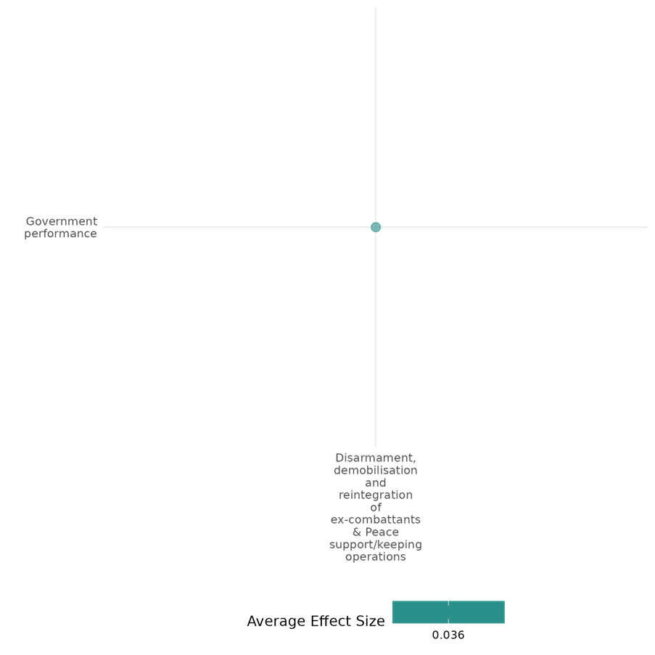

4.1.3(10)
Effect of Peace support/keeping operations on Transitions of power
Peacekeeping operations have an impact on transitions of power. The two quantitative studies in this cell find that peacekeeping missions positively impact democratisation and, hence, democratic transitions. Democracy mandates significantly increase the likelihood of democratic transitions, especially with civilian personnel. Additionally, peacebuilding missions enhance the probability of democratic outcomes.
Geographical region: Sub Saharan Africa, Global
Effect: Moderate effect (g = 0.138)
Confidence in study findings: Low confidence

Short summary
Peacekeeping operations are expected to have an effect on transitions of power. The two studies in this cell find that peacekeeping missions have a positive effect on democratization and democratic transitions. Hence, the deployment of peacekeeping operations is found to have a significant impact on transitions of power.

Long summary
The Intervention
Peace Support Operations (PS0s) and Peacekeeping Operations (PKOs), where 1) PSOs encompass all multi-functional operations, conducted impartially, normally by States or by international or regional organizations, such as the United Nations (UN), the European Union (EU), the African Union (AU), or the North Atlantic Treaty Organization (NATO), involving military forces and diplomatic and humanitarian agencies, and are designed to achieve a long-term political settlement or other specified objective, and 2), the deployment of UN peacekeepers into countries in a post-conflict setting. This involves the deployment of international troops and police, who work with local civilian peacekeepers to provide security to an area (UN Peacekeeping n.d.). Operations with primary or secondary objectives to prevent, halt or reduce the risk of atrocities are also considered within this category. (DDR not found in this cell).

How the intervention is expected to work?
The deployment or aspects of Peace Support Operations and Peacekeeping Operations like with democracy mandates and activities may have an effect on the transitions of power through increasing democratization. Greater mission capacity, such as longer duration, more personnel, especially civilian personnel compared to military personnel, and more resources, may enhance democratization outcomes and inevitably impact transitions of power.

Evidence base
This cell contains two studies: Both are quantitative studies. Blair (2023) and Steinert (2014), both focus on UN peacekeeping operations and democratization. Blair (2023) uses the Peacekeeping Mandates (PEMA) dataset to code two treatment variables and is rated medium confidence as it is a non-experimental study, while Steinert (2014) employs multinominal logistic regression analysis to assess the impact of UN peacebuilding missions on democratization trends in 103 post-civil war countries, of which 31 experienced a UN peacebuilding mission and is rated as low confidence as it is a non-experimental study and lacks a clear description of the intervention.

Evidence findings
Blair (2023) finds peacekeeping with democracy mandates and activities both increase democratization, leading to a democratic transition. The effect is larger when there is a mandate and is larger if there are more personnel, especially civilian personnel compared to military, support to elections is the most effective approach to improving electoral democracy, other activities are not statistically significant. Steinert (2014) finds that democratization is significantly more likely if a UN peacebuilding mission is deployed, with a 68% probability of increased democracy in host countries compared to 34% in non-host countries. Descriptive statistics suggest that greater mission capacity, such as longer duration and more resources, may enhance democratization outcomes, although this relationship is not statistically significant.

Included studies
Blair (2023) assesses the effects of UN peacekeeping missions on democratisation in Africa since the end of the Cold War (1991 to 2016). Specifically, they address three issues: mandates, composition of peacekeeping missions, and tactics.
The authors use the Peacekeeping Mandates (PEMA) dataset to code two treatment variables: UN peacekeeping missions with a democracy mandate, and those carrying out democracy-related activities despite not having the mandate. Democracy-related activities are voter education, assistance to political parties, assistance to democratic institutions such as parliaments, and assistance in planning and conducting elections. Sensitivity analysis is conducted including assistance to media and civil society organisations (for which the results do not substantially change). The number of countries with peacekeeping missions with democracy mandates and activities has grown markedly since 2001. The authors code the number and composition of peacekeepers from the Providing for Peacekeeping (PFP) project. The outcome is the Varieties of Democracy (V-Dem) electoral democracy index. This study is rated medium confidence as it is a non-experimental study.
The study finds that peacekeeping missions have a positive effect on democratization, which inevitably leads to a positive effect on transitions of power.

Steinert & Grimm (2014) examines the effectiveness of United Nations (UN) peacebuilding missions in democratizing war-torn states, with a focus on missions that include democracy promotion components in their mandates. The context involves post-civil war countries where the UN has deployed peacebuilding missions to foster democratic transitions.
The research employs a multinominal logistic regression analysis to assess the impact of UN peacebuilding missions on democratization trends in 103 post-civil war countries, of which 31 experienced a UN peacebuilding mission. The study uses Freedom House data to measure democratization, comparing rankings from the first mission year to those five years later. The analysis controls for various factors, including battle deaths, peace agreements, and oil wealth, to account for selection bias in mission deployment. The study is rated as low confidence as it is a non-experimental study and lacks a clear description of the intervention.
The study finds that peacekeeping missions have a positive effect on democratization.

Confidence assessment
The cell/study is rated low confidence.

Other outcomes in this cell/study
- Community and state governance/Access to justice, rights and public services

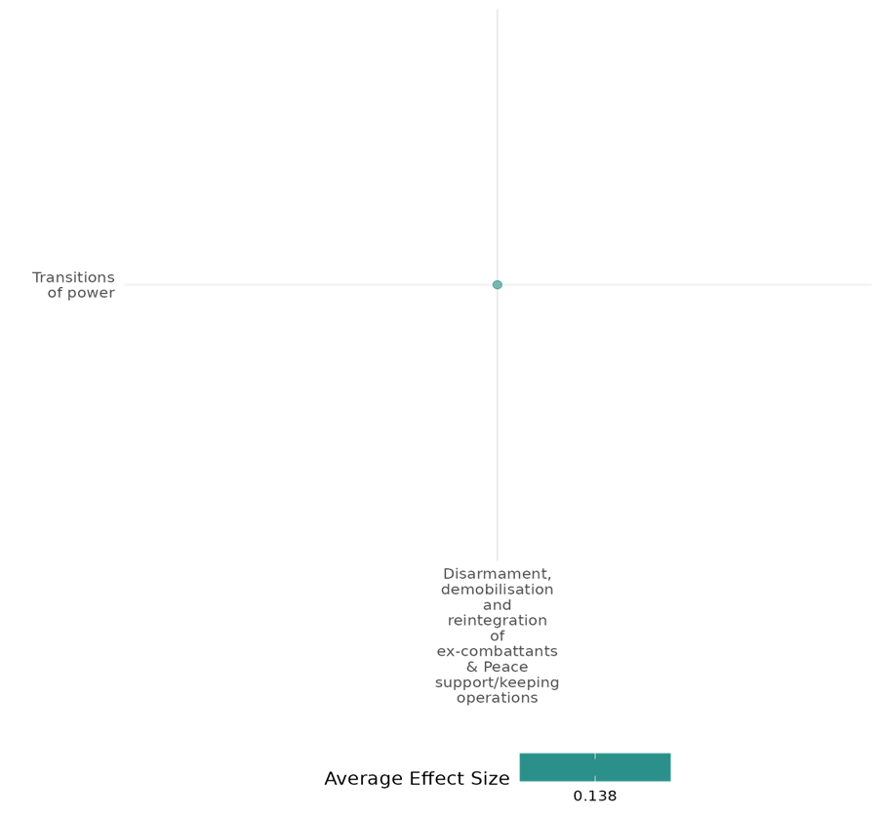

4.1.3(11)
Effect of Disarmament, demobilization and reintegration of ex-combatants & Peace support/keeping operations on Economic Security
DDR, PSOs, and PKOs have a mixed impact on economic security, with studies showing positive short-term benefits, while indicating limited or negative long-term impacts.
Geographical region: Sub Saharan Africa, Global
Effect: Small effect (g = 0.061)
Confidence in study findings: Low confidence

Short summary
DDR, PSOs, and PKOs have a significant impact on economic security. While one study suggests that PKOs increase GDP per capita, particularly in high-income regions, it indicates a dampening effect in low-income countries. DDR programs may improve economic reintegration and reduce poverty but benefits often fade over time. Peacekeeping deployments may help stabilize local economies, enhance employment, and restore market activity. However, some findings show no or even negative effects on economic security. Short-term economic booms from DDR funding can promote social acceptance but may not lead to long-term economic stability.

Long summary
The Intervention
Disarmament, demobilisation and reintegration is a complex programme for ex-combatants that brings together reconciliation, security and socio-economic dimensions. The process typically Involves removing weapons from combatants' hands, taking Individuals out of militarised structures, and providing them with training for new livelihoods as well as psychosocial support + Peace Support Operations (PS0s) and Peacekeeping Operations (PKOs), where 1) PSOs encompass all multi-functional operations, conducted impartially, normally by States or by international or regional organizations, such as the United Nations (UN), the European Union (EU), the African Union (AU), or the North Atlantic Treaty Organization (NATO), involving military forces and diplomatic and humanitarian agencies, and are designed to achieve a long-temi political settlement or other specified objective, and 2), the deployment of UN peacekeepers into countries in a post-conflict setting. This Involves the deployment of international troops and police, who work with local civilian peacekeepers to provide security to an area (UN Peacekeeping n.d.). Operations with primary or secondary objectives to prevent, halt or reduce the risk of atrocities are also considered within this category.

How the intervention is expected to work?
The disarmament, demobilisation, and reintegration (DDR) of ex-combatants, along with Peace Support Operations (PSOs) and Peacekeeping Operations (PKOs), are expected to impact economic security. DDR may help ex-combatants reintegrate by providing skills, livelihoods, and psychosocial support, reducing security risks. PSOs and PKOs may improve security by deploying troops and police, creating safer conditions for economic activity. Reduced violence is expected to encourage market participation, employment, and household stability. This intervention may restore economic security by enabling reintegration, supporting market recovery, and fostering stability in conflict-affected areas.

The evidence base
The 8 quantitative studies in this cell: The methods used include propensity score matching and regression analyses (Levely, 2014), matched comparison and regression adjustments (Gilligan, Mvukiyehe, & Samii, 2012), probit regression analysis (Humphreys & Weinstein, 2007), panel data methodologies (Ernst et al., 2014), and high-frequency household survey data with subnational analysis (Bove, 2022). Contexts examined include Côte d’Ivoire (Mvukiyehe, 2009), Liberia (Mvukiyehe, 2021; Levely, 2014), Burundi (Gilligan, Mvukiyehe, & Samii, 2012; D’Aoust, 2013), Sierra Leone (Humphreys & Weinstein, 2007), and South Sudan (Bove, 2022). Methodological limitations noted across studies include insufficient sample size power calculations (Gilligan, Mvukiyehe, & Samii, 2012; Mvukiyehe, 2009), high attrition rates (Levely, 2014), and limited intervention descriptions (Ernst et al., 2014).
The cell has 3 qualitative studies: Adedokun (2019), Sub Saharan Africa, Channel Research (2011), Sub Saharan Africa, and Richmond (2011), Middle East & North Africa, Europe & Central Asia, and East Asia & Pacific .

Evidence findings
One study finds that, on average, PKOs do not increase the growth rate of GDP but do increase the level of GDP per capita by approximately 1.08% to 1.92%. PKOs have a positive impact on GDP per capita in high-income countries, particularly in Europe and Central Asia, and the Middle East and North Africa. However, PKOs tend to have a dampening effect on GDP per capita in low-income countries. Another finds that the program resulted in a 20–35 percentage point reduction in poverty incidence among beneficiaries. Income and livelihood outcomes, including access to skilled and unskilled occupations, also significantly improved. Another study finds that wealthier and better-educated individuals struggled with reintegration. Meanwhile, poorer individuals reported better employment outcomes. However, DDR participation was not significantly associated with improved economic conditions. Another suggests that ex-combatants' participation in DDR programs significantly increased the likelihood of economic reintegration, including employment opportunities. Another suggests that households in areas with peacekeeping deployments experienced fewer economic losses and somewhat better recovery, although these findings are preliminary and require further causal analysis. Another study reports that there is no effect or rather a negative effect of PKOs on economic security. Another finds that the presence of peacekeepers revitalizes local economies. Households in counties with peacekeepers improved purchasing capacity. The likelihood of employment for household heads increases by 7 percentage points in these areas, further bolstering household consumption. Peace missions facilitate the return of market activities by improving security and reducing the cost of market access, enabling regular product availability and economic exchanges. Finally, the last study highlights the positive and significant impact of the demobilization program on ex-combatant households in the short run. The large amounts of money introduced into the local economy generated an economic boom, indirectly benefiting civilian households. These positive spillovers may have favored the acceptance of ex-combatants in their host communities, which is crucial for peace to sustain. In the long run, however, the positive impact on both beneficiaries and non-beneficiaries vanishes as the money reserves of demobilized ex-combatants run low.

Included studies
Ernst (2014) employs a panel data analysis using a multiplicative binary (dummy) variable approach to assess the economic effectiveness of PKOs. The sample consists of 39 countries where the UN had peacekeeping operations from 1980 to 2010. These countries are categorized into five regions: Europe and Central Asia, Latin America and Caribbean, Asia (South, East) and Pacific, Sub-Saharan Africa, and Middle East and North Africa. This study examines the United Nations peacekeeping operations (PKOs) aimed at creating conditions for lasting peace, facilitating political processes, protecting civilians, and supporting the disarmament, demobilization, and reintegration of former combatants. The study also considers income classifications as defined by the World Bank. The study finds that, on average, PKOs do not increase the growth rate of GDP but do increase the level of GDP per capita by approximately 1.08% to 1.92%.
PKOs have a positive impact on GDP per capita in high-income countries, particularly in Europe and Central Asia, and the Middle East and North Africa. However, PKOs tend to have a dampening effect on GDP per capita in low-income countries.
The study is rated low confidence.

Gilligan (2012) employs a matched comparison of treated and untreated individuals, using regression adjustments and inverse propensity weighting to control for selection bias and exposure heterogeneity. The study sample includes adult (aged 18 years old and above) male former rebel combatants. Quasi-experimental evidence from Burundi assesses the effect of the demobilization and reintegration (DDR) program in Burundi, following its 1993-2004 civil war, particularly on the ex-combatants’ economic well-being. The DDR program in Burundi is under the broader Multi-Country Demobilization and Reintegration Program (MDRP). The paper focuses on the program’s “socioeconomic reintegration package” and analyses if the enhancement of economic well-being would entail political integration of these individuals. Respondents were drawn from those who received benefits from three different nongovernmental organizations, namely Twitezimbere (northern provinces), Planning and Development Collaborative (PADCO, southwest provinces), and Africare (center provinces).
The findings suggest that the program resulted in a 20–35 percentage point reduction in poverty incidence among beneficiaries. Income and livelihood outcomes, including access to skilled and unskilled occupations, also significantly improved.
The study is rated low confidence.

Humphreys (2007) employed a quantitative approach, using probit regression models to assess reintegration outcomes across four dimensions: breaking factional ties, employment, community acceptance, and confidence in democratic processes. The study surveyed 1,043 ex-combatants from five major factions in Sierra Leone’s civil war, including both male and female participants as well as those who did and did not participate in DDR programs. The analysis employed a quantitative approach, using probit regression models to assess reintegration outcomes across four dimensions: breaking factional ties, employment, community acceptance, and confidence in democratic processes. The study finds that wealthier and better-educated individuals struggled with reintegration. Meanwhile, poorer individuals reported better employment outcomes. However, DDR participation was not significantly associated with improved economic conditions.
The study is rated low confidence.

Levely (2014) explores the impacts of Disarmament, Demobilization, and Reintegration (DDR) programs on the reintegration of ex-combatants into post-conflict societies. It focuses on economic reintegration, the reduction of violence, and social cohesion as critical dimensions of DDR's effectiveness.
The analysis is based on survey data collected from ex-combatants in Liberia. Statistical techniques such as propensity score matching and regression models were employed to assess the impact of DDR participation on various outcomes, including employment, social acceptance, and propensity for violence. The study accounts for biases related to program participation and variations in conflict exposure.
Participation in DDR programs significantly increased the likelihood of economic reintegration, including employment opportunities, but had mixed effects on reducing violence. Social acceptance was more variable, influenced by factors such as community dynamics and the presence of local reconciliation efforts.
The study is rated low as its attrition rate exceeded 20% and the differential attrition is over 10 percentage points.

Mvukiyehe (2009) evaluates the micro-level impacts of the United Nations Operations in Côte d’Ivoire (UNOCI) on security, economic recovery, and political reintegration after the 2002-2007 civil war.
The analysis used survey data from 1,459 civilians and ex-combatants, conflict event data, and socioeconomic indicators. It employed a mixed-methods approach, including panel methods for time-variant data and cross-sectional methods for static data, alongside hierarchical small-area estimation techniques to address sparsity in community-level observations. Sampling weights and clustering techniques were applied to ensure representativeness and robustness in the estimates.
The findings show that UNOCI deployments had minimal impact on reducing victimization rates, as these had already declined significantly prior to its arrival. However, there was limited evidence that UNOCI-monitored zones deterred renewed hostilities.
Households in areas with peacekeeping deployments experienced fewer economic losses and somewhat better recovery, although these findings are preliminary and require further causal analysis.
UNOCI’s electoral sensitization activities were associated with increased confidence in the fairness of upcoming elections. However, its presence did not significantly influence the return of local political leaders or broader political reintegration.
The study is rated low confidence.

Mvukiyehe (2021) assesses the effect of peacekeeping operations on local security, and local economic and social conditions. Post-conflict different types of violence can persist such as criminal gangs, partly as small arms remain available. The presence of peacekeepers can increase local security (‘the security bubble hypothesis’), and so the conditions for improved economic and social development, which are seen as pre-requisites for sustained peace. For example, better security will make entrepreneurs more likely to invest. In addition, multidimensional PKOs may provide direct assistance to social and economic development. These interventions may include activities which build community social cohesion.
The authors use exact matching based on the administrative data used for mission planning to identify comparable areas, matching on variables such as local infrastructure and ethnicity. To avoid possible spillover effects, comparison areas were at least 15 km from treatment areas. The dependent variables for local security are (i) victimisation by looting or physical attack, and (ii) in-migration by conflict victims, which should increase if the area is now seen as a safe space. The social-economic environment is measured by a range of indicators including infrastructure, cooperatives, credit groups, and migration status.
There is no effect of PKOs on local security as measured by actual physical victimisation and fear of victimisation, or on in-migration. In fact, local security worsens in areas with a PKO base with higher fear of violence and less in-migration. There are at best modest effects on socio-economic conditions with one well or school being (re)constructed in areas with a PKO base compared to those without, in which there are no such activities.
The authors conclude that peacekeeping on its own is not sufficient to ensure peace. Macro-level incentives, such as discouraging leaders to fight, may be better channels on which to focus attention.
The study reports that there is no effect or rather a negative effect of PKOs on local security which leads to a negative impact on economic security.

Bove (2002) writes that civil wars affect the economic conditions of households by disrupting economic transactions and harming their psychological well-being. To restore basic conditions for local economic recovery in conflict-torn regions, the international community has only a limited number of tools at its disposal. This study asks whether UN peacekeeping is one instrument to mitigate the negative effect of conflict on households’ economic well-being. It argues that, by reducing violence and heightening perceptions of safety, UN missions (i) encourage labor provision and economic exchanges, and (ii) instill confidence by reducing the psychological impact of daily stressors. Combining high-frequency household survey data and information on subnational deployment of UN peacekeepers in South Sudan, the study shows that peacekeepers’ military presence improves security (observed and perceived), which in turn revitalizes local economies and households’ subjective well-being. These improvements ultimately boost households’ consumption, partially countering the negative effect of ongoing civil wars by keeping local communities’ economy afloat.
The study first examines households’ consumption and then moves to testing the proposed causal mechanisms linking them to peacekeeping presence. The main difference across all models shown is the dependent variable. Because most outcomes are dichotomous, coefficients correspond to marginal effects on linear probabilities. The only exceptions are per capita goods (in units) and traveling time to the closest market (in hours). To assess whether the presence of peacekeepers improves households’ well-being, the study analyzes food consumption, irregular consumption, food purchases, and durable (nonfood) goods. The findings indicate that households report higher per capita food consumption—by about 24 units per capita—when peacekeepers operate in their county. Peacekeepers’ presence reduces the probability of a household reporting lack of food by almost 10 percentage points and increases food purchases by about 23 units per capita, suggesting an improvement in households’ capacity to buy food. Additionally, the likelihood of employment for household heads is higher, increasing by 7 percentage points in areas with peacekeeping presence. Traveling time to local markets is also shorter, reducing by more than 1 hour, as peace missions facilitate the return of market activities by improving security conditions.
The study finds that UNMISS increased consumption of food and durable items for households in counties hosting peacekeepers and improved the security environment, restored economic opportunities, and had a positive impact on households’ psychological well-being. The mediated effect of peacekeeping via violence, safety, economic opportunities, and psychological well-being results in about a 2-unit increase in household per capita food consumption, though not statistically significant at conventional levels. Peacekeeping presence leads to a 2-percentage point decrease in the likelihood of reporting irregular food consumption and a 5.5-unit increase in per capita food purchases. Finally, peacekeeping presence is linked to improvements in psychological well-being, with expectations that living conditions will become at least “fairly good” being 14 percentage points higher and life satisfaction almost 5 percentage points higher in counties where peacekeepers are deployed. These findings highlight the mechanisms through which UN peacekeeping produces its economic-enhancing effects.
The study is rated low confidence.

D’Aoust (2013) assesses the impact of the disarmament, demobilization, and reintegration (DDR) program implemented in post-conflict Burundi. Burundi is recovering from a civil war that lasted more than a decade. The armed conflict ended in 2009 with the voluntary demobilization of the last Hutu rebel group, the Palipehutu-FNL. In exchange for laying down their arms, ex-combatants received reinsertion allowances equivalent to an 18-month salary. Four years earlier, another Hutu rebel group, the CNDD-FDD, had benefited from the same allocations, along with in-kind payments between the two peace agreements.
First, a theoretical model was developed to predict the impact of demobilization cash transfers on beneficiary and non-beneficiary households. Then, a household panel dataset was used, collected in 2005, 2006, and 2010 in three rural provinces heavily affected by the conflict. The objective was to assess the short- and long-run impacts of the demobilization program on ex-rebel economic outcomes and to measure the externalities that may have affected civilian households.
The empirical analysis highlights the positive and significant impact of the demobilization program on ex-combatant households in the short run. The large amounts of money introduced into the local economy generated an economic boom, indirectly benefiting civilian households. These positive spillovers may have favored the acceptance of ex-combatants in their host communities, which is crucial for peace to sustain. In the long run, however, the positive impact on both beneficiaries and non-beneficiaries vanishes as the money reserves of demobilized ex-combatants run low. The study supports reinsertion programs as a short-run strategy to reduce the risk of relapse into conflict, but the reintegration phase fails to help ex-combatants engage in productive activities, raising concerns about long-term peace sustainability.
The study is rated low confidence.

Confidence assessment
Overall, the cell is rated low confidence. (Unsure due to the findings)

Other outcomes in the study/cell:
- Human security/ Physical security
- Human security/ Food security and nutrition & Health security
- Violence and atrocity prevention/Social norms regarding violence and atrocities
- Community and state governance/Government performance
- Social cohesion/ Feelings of trust and acceptance of diversity
- Community and state governance/ Access to justice, rights and public services
- Community and state governance/ Civic participation

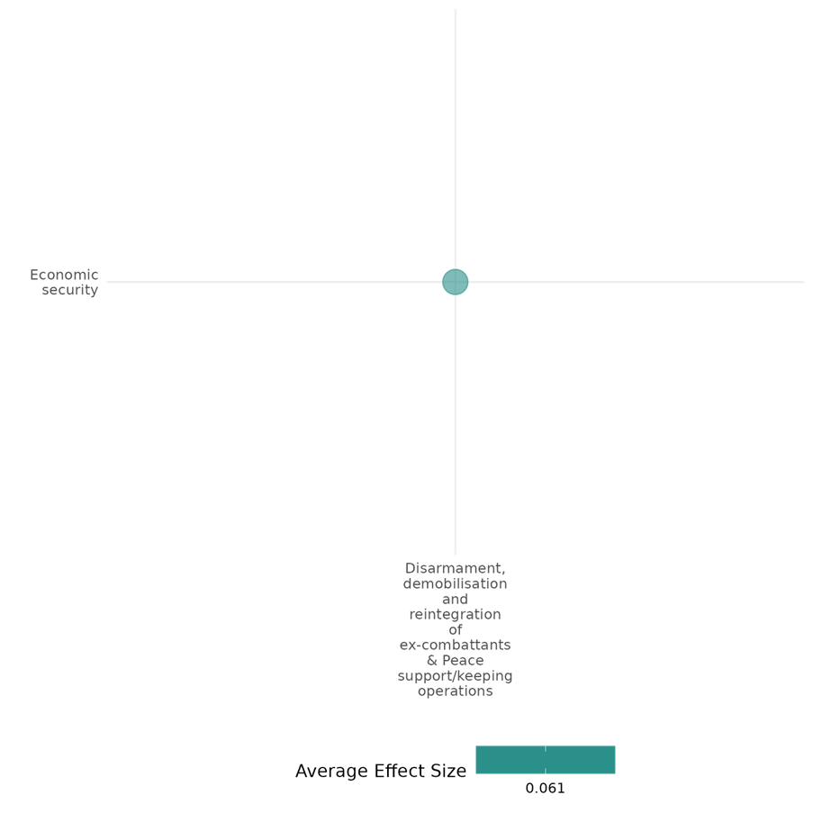

4.1.3(12)
Effect of Peace Support Operations and Peacekeeping Operations on Educational Security
Two studies assess UN peacekeeping’s role in educational attainment and access. UN peacekeeping operations have a positive effect on female’s access and attainment of education, while UN peacekeeping operations do not show much impact on male education.
Geographical region: Global, Sub Saharan Africa
Small effect size (g = 0.078)
Confidence in the study findings: Low confidence

Short summary
Peacekeeping operations are expected to have an effect on educational security in the area of deployment. The two studies in this cell find a positive effect of peacekeepers' deployment on the educational security of women. Both studies find that peacekeepers increase female education attainment and their access to education.

Long Summary
The Intervention
Peace Support Operations (PS0s) and Peacekeeping Operations (PKOs), where 1) PSOs encompass all multi-functional operations, conducted impartially, normally by States or by international or regional organizations, such as the United Nations (UN), the European Union (EU), the African Union (AU), or the North Atlantic Treaty Organization (NATO), involving military forces and diplomatic and humanitarian agencies, and are designed to achieve a long-term political settlement or other specified objective, and 2), the deployment of UN peacekeepers into countries in a post-conflict setting. This involves the deployment of international troops and police, who work with local civilian peacekeepers to provide security to an area (UN Peacekeeping n.d.). Operations with primary or secondary objectives to prevent, halt or reduce the risk of atrocities are also considered within this category. (DDR not found in this cell).

How the intervention is expected to work?
Peacekeeping Operations and the presence of peacekeepers may have an effect on educational security. The attainment and access to education in conflict-affected zones and post-conflict settings, respectively, specifically by females may be impacted by the presence and deployment of UN peacekeeping deployments.

Evidence base
There are two quantitative studies in this cell: Gizelis (2021), collected data from 45 African countries between 1990 and 2013 and used cases from the Democratic Republic of Congo, Cote d’Ivoire, and Liberia, which had comprehensive PKOs. Dataset were sourced from Demographic and Health Surveys (DHS), which include indicators of maternal health and women’s education. The study is rated low confidence. Reeder (2021) utilizes georeferenced data on local-level educational attainment (Graetz et al. 2018) and UN peacekeeping deployments (Cil et al. 2020), combined with conflict data from the UCDP and is rated as medium as it is non-experimental due to its partial description of the intervention. The cell includes one qualitative paper Adedokun (2019), Mozambique.

Evidence findings
Gizelis (2021) find that the presence of peacekeepers shows positive effects on women’s access to education which is supported by Reeder (2021) who finds that UN peacekeeping deployments are associated with significant improvements in female educational attainment, with a one standard deviation increase in deployment linked to a 4.89% rise in attainment. Prolonged deployments yield even greater gains, particularly for women. However, no statistically significant effects were found for male educational attainment.

Included studies
Gizelis (2021) explores UN’s peacekeeping operations’ (PKO) implications on women’s access to health, particularly health outcomes, and education in post-conflict settings. The study suggests that PKO create a “peacekeeping dividend” by encouraging development of public services.
The study uses the difference-in-difference technique, alongside geo-referenced data to evaluate maternal mortality rates (MMRs) and other outcomes at both the national and sub-national level. At the national level, data were collected from 45 African countries between 1990 and 2013, comparing changes in MMRs between countries with and without PKOs. At the subnational level, the study used cases from the Democratic Republic of Congo, Cote d’Ivoire, and Liberia, which had comprehensive PKOs. Dataset were sourced from Demographic and Health Surveys (DHS), which include indicators of maternal health and women’s education.
While the study is rated low confidence, it finds that peacekeepers have a positive effect on women’s access to education.

Reeder (2021) investigates how UN peacekeeping missions affect educational attainment in conflict-affected zones across Africa between 2000 and 2014.
The study utilizes georeferenced data on local-level educational attainment (Graetz et al. 2018) and UN peacekeeping deployments (Cil et al. 2020), combined with conflict data from the UCDP. Fixed-effects regression models and Coarsened Exact Matching (CEM) are applied to account for non-random deployment of UN forces. Key variables include male and female educational attainment and gender disparity, measured against conflict intensity, socioeconomic factors, and the duration of UN deployments. The study is rated as medium confidence.
Overall, the study finds that peacekeeping has a positive effect on the attainment of education for women.

Confidence assessment
The study/cell is rated low confidence.
Other outcomes in this cell/study
- Human security/Food security and nutrition & Health security

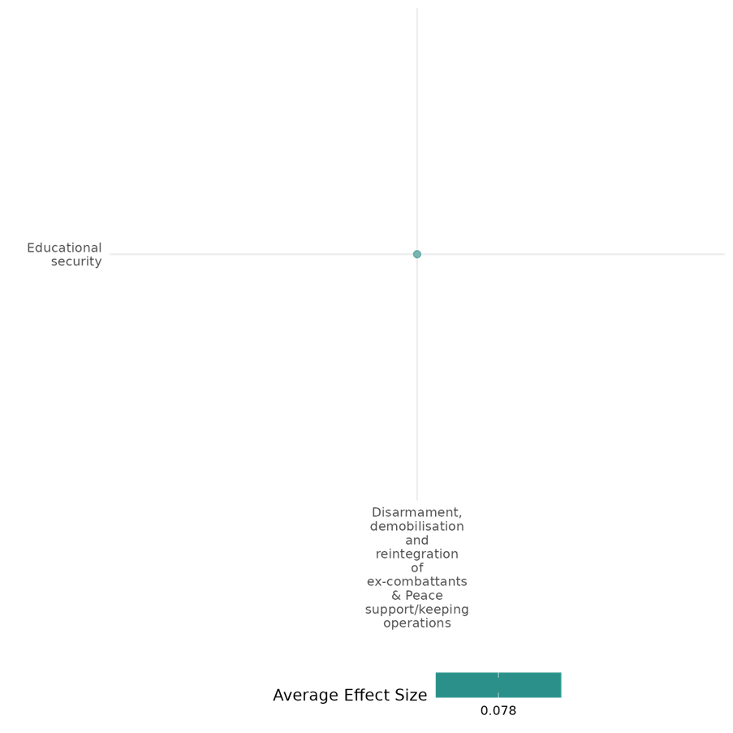

4.1.3(13)
Effect of Peace support/keeping operations on Food security and nutrition & Health security
Peacekeeping operations enhance food security and well-being by stabilizing conflict-affected areas. One quantitative study finds that UN peacekeeper deployment in South Sudan improves food consumption, reduces food scarcity, and increases optimism about future living conditions and life satisfaction.
Geographical region: Sub Saharan Africa
Effect: Small effect (g = 0.07)
Confidence in study findings: Low confidence

Short summary
Peacekeeping Operations aim to enhance security and stability in post-conflict settings, potentially improving food security, nutrition, and health security, including psychological well-being. A study on UNMISS in South Sudan finds that peacekeeper presence increases per capita food consumption, reduces food scarcity, and boosts household optimism about future living conditions. Additionally, life satisfaction levels rise in these areas, highlighting the positive impact of peacekeeping on both material well-being and psychological health.

Long summary
The Intervention
Peace Support Operations (PS0s) and Peacekeeping Operations (PKOs), where 1) PSOs encompass all multi-functional operations, conducted impartially, normally by States or by international or regional organizations, such as the United Nations (UN), the European Union (EU), the African Union (AU), or the North Atlantic Treaty Organization (NATO), involving military forces and diplomatic and humanitarian agencies, and are designed to achieve a long-term political settlement or other specified objective, and 2), the deployment of UN peacekeepers into countries in a post-conflict setting. This involves the deployment of international troops and police, who work with local civilian peacekeepers to provide security to an area (UN Peacekeeping n.d.). Operations with primary or secondary objectives to prevent, halt or reduce the risk of atrocities are also considered within this category. (DDR not found in this cell).

How the intervention is expected to work?
Peacekeeping Operations are expected to improve food security, nutrition, and health security by providing stability and reducing conflict-related disruptions. By securing conflict-affected areas, peacekeepers may help with improved safety, reduced violence, and enhanced economic opportunities, contributing to better food availability and overall well-being.

Evidence base
This cell contains one quantitative study: Bove (2022) combines high-frequency household survey data and information on subnational deployment of UN peacekeepers in South Sudan. The cell includes one qualitative paper Adedokun (2019), Mozambique.

Evidence findings
Households in UNMISS deployment areas show higher per capita food consumption (24 units per capita increase) while the probability of households reporting food scarcity is reduced by 10 percentage points. Households also purchase 23 more units of food per capita in these areas. Households in peacekeeper-deployed areas had a 14 percentage point higher optimism about future living conditions and life satisfaction levels were 5 percentage points higher in these areas.

Included studies
Bove (2022) evaluates the impact of UN peacekeeping on mitigating the adverse effects of civil wars on households' economic well-being. Civil wars disrupt economic transactions and harm psychological health, creating significant challenges for local economic recovery. The study examines whether UN peacekeeping can serve as a tool to counter these effects by (i) encouraging labor provision and economic exchanges, and (ii) instilling confidence by reducing the psychological impact of daily stressors.
This study uses high-frequency household survey data and geospatial information on UN peacekeeper deployments in South Sudan. Statistical models evaluate the impact of peacekeepers on consumption patterns, security, and psychological well-being. Mediation analysis explores indirect effects through improved safety, reduced violence, and enhanced economic opportunities. Robustness checks address endogeneity and confirm validity, leveraging granular subnational data for accurate measurement and stronger causal inferences. The study is rated as a low-confidence quantitative study.
The study finds that peacekeeping operations have a positive effect on food security of households and their psychological wellbeing.

Confidence assessment
Overall, the study/cell is rated low confidence.

Other outcomes in this study/cell
- Human security/Physical security
- Human security/Economic security

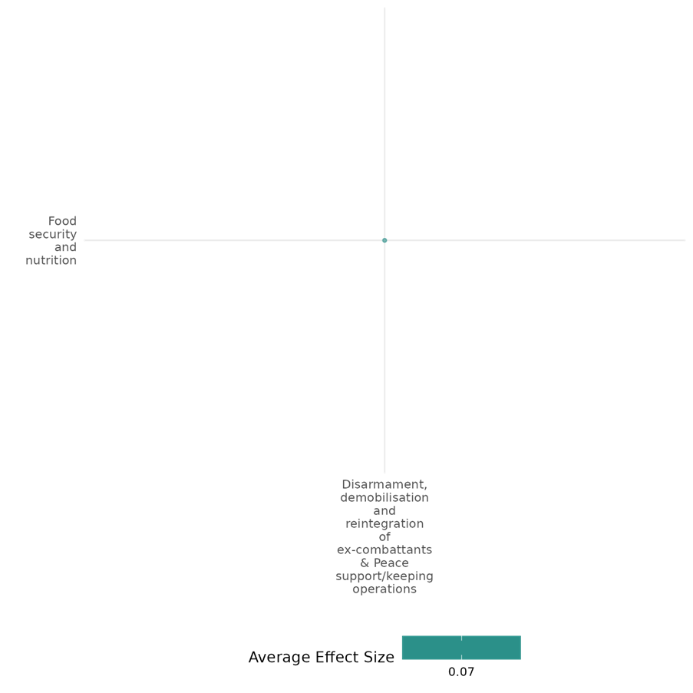

4.1.3(14)
Effect of Peace support/keeping operations on Physical security
Peacekeeping has mixed effects on perceived physical security. One quantitative study suggests that peacekeeping operations increase fear of crime, negatively impacting perceptions of safety, while another study shows that peacekeeping improves perceived security.
Geographical region: Sub Saharan Africa
Effect: Small effect (g = 0.034)
Confidence in study findings: Low confidence

Short summary
Peacekeeping operations are expected to have an effect on the perception of physical security. The two studies in this cell have mixed findings. One finds that PKOs negatively impact the perception of physical security by increasing fear of crime while the other finds that peacekeeping operations have a positive effect on perceived safety.

Long summary
The Intervention
Peace Support Operations (PS0s) and Peacekeeping Operations (PKOs), where 1) PSOs encompass all multi-functional operations, conducted impartially, normally by States or by international or regional organizations, such as the United Nations (UN), the European Union (EU), the African Union (AU), or the North Atlantic Treaty Organization (NATO), involving military forces and diplomatic and humanitarian agencies, and are designed to achieve a long-term political settlement or other specified objective, and 2), the deployment of UN peacekeepers into countries in a post-conflict setting. This involves the deployment of international troops and police, who work with local civilian peacekeepers to provide security to an area (UN Peacekeeping n.d.). Operations with primary or secondary objectives to prevent, halt or reduce the risk of atrocities are also considered within this category. (DDR not found in this cell).

How the intervention is expected to work?
Peacekeeping operations may have an effect on physical security by reducing violence, fostering stability, and strengthening local security institutions. The deployment of peacekeepers may also have an effect on perceptions of safety by enhancing security conditions and facilitating economic exchanges. However, the impact on fear of crime can vary, as peacekeeping may increase awareness of security threats.

Evidence base
The cell contains 2 quantitative studies: Mvukiyehe (2021), using coarsened exact matching, compares communities hosting UNMIL deployments (treatment) with those at least 15 kilometers away (control). Bove (2022) combines high-frequency household survey data and information on subnational deployment of UN peacekeepers in South Sudan.
The cell has 1 qualitative study, Touray (2019), Sub Saharan Africa.

Evidence findings
Mvukiyehe (2021) finds that PKOs increase fear of crime (by 53%), while Bove (2022) finds that households in UNMISS deployment areas reported a 12.5 percentage point improvement in perceived safety.

Included studies
Mvukiyehe (2021) evaluates the micro-level effectiveness of peacekeeping operations (PKOs), focusing on Liberia’s civil war and the UN Mission in Liberia (UNMIL). The study examines the impact of UNMIL deployments on local security and socio-economic revitalization.
Using coarsened exact matching, the analysis compares communities hosting UNMIL deployments (treatment) with those at least 15 kilometers away (control), controlling for infrastructure, population, geography, ethnicity, and conflict exposure. Security outcomes include fear of victimization, victimization by crime, and in-migration of conflict victims. Socio-economic revitalization measures include infrastructure, income, food and higher-order consumption, and participation in community activities. The study is rated medium confidence as it is non-experimental.
The study finds that peacekeeping operations increase fear of crime, negatively affecting the perception of physical safety.

Bove (2022) examines the role of UN peacekeeping in mitigating the adverse economic effects of civil wars on households in South Sudan. By reducing violence and enhancing security, UNMISS fosters economic exchanges, labor participation, and psychological well-being. The study evaluates these effects through household consumption patterns and improvements in local security and market dynamics.
The study utilizes high-frequency household survey data and subnational information on the deployment of UN peacekeepers under UNMISS. The analysis explores the impact of peacekeepers on household well-being by examining food consumption, security, market access, and psychological factors. Statistical models are used to measure direct and mediated effects through various channels, including violence reduction, economic opportunities, and perceptions of safety. The study is rated low confidence.
The study finds that peacekeeping operations have a positive effect on the perceptions of physical security.

Confidence assessment
Overall, the study/cell is rated low confidence.

Other outcomes in this cell/study
- Human security/Economic security
- Human security/Food security and nutrition & Health security
- Community and state governance/Civic participation
- Community and state governance/Access to justice, rights and public services

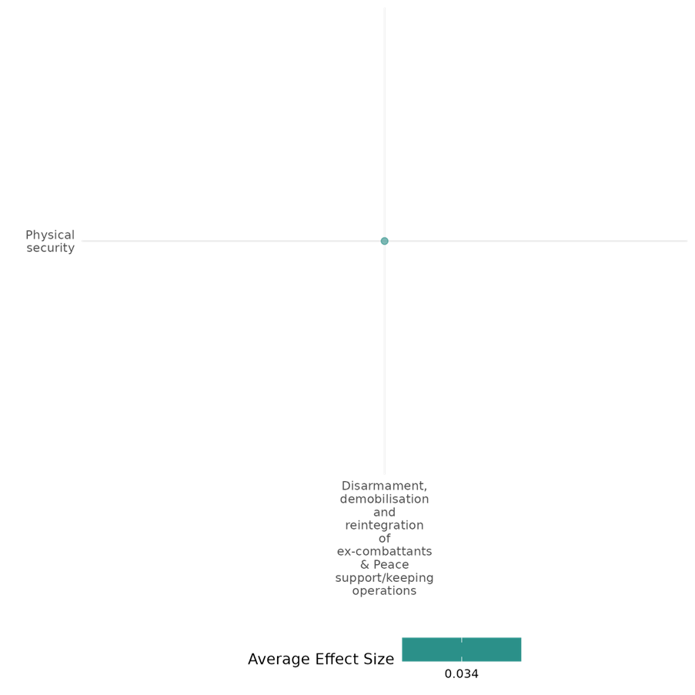

4.1.3(15)
Effect of Disarmament, demobilization and reintegration of ex-combatants on Intermediate social cohesion outcomes
DDR has a mixed effect on intermediate social cohesion outcomes. The study in this cell investigates the impact of DDR on intermediate social cohesion outcomes among Colombian ex-combatants, revealing mixed effects on justice support, victim acknowledgment, and community reintegration. While older recruits show greater respect for victims' rights, factors like political faction affiliation and resource wealth influence attitudes toward public apologies.
Geographical region: Latin America & Caribbean
Effect: Small effect (g = 0.06)
Confidence in study findings: Low confidence

Short summary
DDR has a positive impact on intermediate social cohesion outcomes by encouraging respect for victims’ rights and fostering accountability, particularly when ex-combatants feel accepted by their communities. However, its effects are mixed, as it has little influence on remorse, especially among political paramilitary members who justify past violence. Additionally, resource-rich groups show weaker support for public apologies, though this effect diminishes with reintegration experiences. While DDR helps promote some aspects of social cohesion, its ability to transform deep-seated attitudes and emotional responses remains limited.

Long Summary
The Intervention
Disarmament, demobilisation and reintegration is a complex programme for ex-combatants that brings together reconciliation, security and socio-economic dimensions. The process typically involves removing weapons from combatants' hands, taking individuals out of militarised structures, and providing them with training for new livelihoods as well as psychosocial support. (PKOs and PSOs not found in this cell).

How the intervention is expected to work?
DDR may have an effect on ex-combatants’ ability to reintegrate by reducing their reliance on violence and increasing their understanding of civilian norms. Additionally, it can influence their willingness to acknowledge responsibility for past actions, particularly when reintegration experiences foster positive interactions with local communities. The effectiveness of DDR depends on factors such as prior socialization, group dynamics, and resource availability, which shape ex-combatants’ attitudes toward justice and accountability.

Evidence base
There is 1 quantitative study in this cell: Daly (2018) is a primary study focused on Columbia based on survey data from 10,951 former fighters.

Evidence findings
Ex-combatants who joined armed groups at an older age were more likely to respect victims’ rights, suggesting stronger prior socialization into civilian norms. While the duration in an armed group had no significant impact on most variables, it was weakly positively correlated with support for public apologies. Members of more political paramilitary factions were less likely to express remorse, possibly due to internal group narratives justifying violence. Similarly, resource-rich armed groups were less supportive of public apologies, though this effect disappeared when reintegration experiences were controlled for. Notably, those who felt accepted by their communities were significantly more likely to acknowledge responsibility.

Included studies
Daly (2018) investigates the determinants of ex-paramilitaries’ support for transitional justice in Colombia, based on survey data from 10,951 former fighters. It emphasizes that ex-combatants’ attitudes toward transitional justice are influenced by their proximity to victimized communities, the norms of justice they have been exposed to, and the personal risks they face. These findings have significant implications for the effectiveness of transitional justice mechanisms in Colombia, particularly with FARC rebels, and for consolidating peace.
The study employs a quantitative analysis of original survey data collected from 10,951 Colombian ex-paramilitaries to explore the determinants of their support for transitional justice. It examines how factors such as proximity to and acceptance by victimized communities, exposure to justice norms, judicial risks tied to individual culpability, and security risks related to vulnerability to retribution influence their attitudes. By analyzing these variables, the research provides insights into the conditions under which transitional justice mechanisms are likely to gain the support of ex-combatants, offering a nuanced understanding of the interplay between socialization, risk, and justice in post-conflict settings. The study is rated low confidence.
The study suggests that DDR programs’ impact on social norms and intermediate social cohesion outcomes is limited. The success of DDR depends significantly on local acceptance and community reintegration.

Confidence assessment
Overall, the cell is rated low confidence.

Other outcomes in the study/cell:
- Violence and atrocity prevention/Social norms regarding violence and atrocities

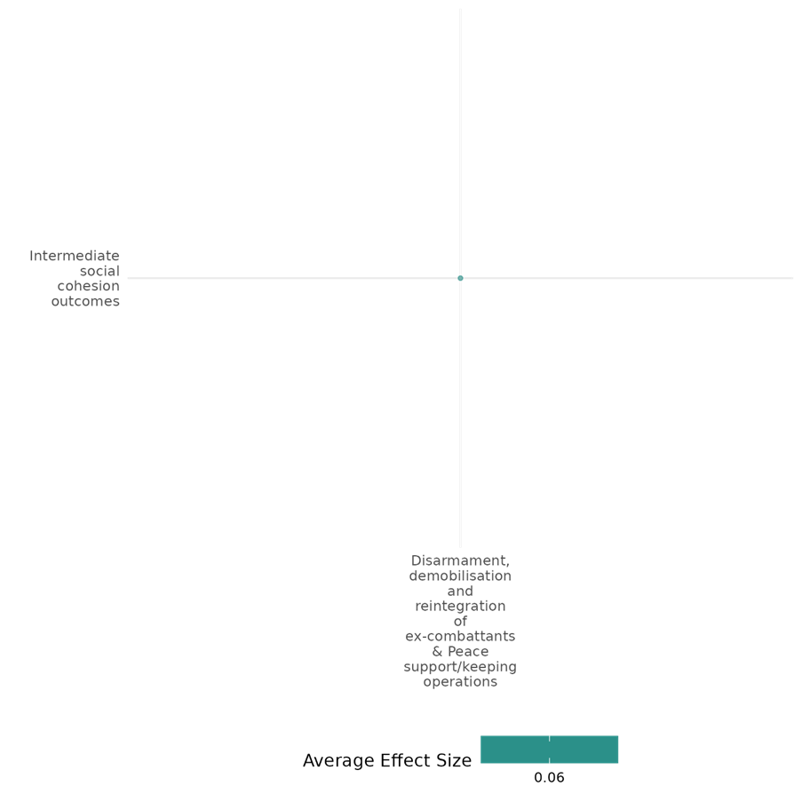

4.1.4 Support To Civilians And Non-State Armed Groups
The effect of support to civilians and non-state armed groups on nature and scale of violence or atrocities
Support to non-state armed groups and civilians could reduce the scale and severity of violence and atrocities, although these effects tend to be context-dependent.
Geographic region: Middle East, Latin America
Effect size: Adverse effect (g=-0.178)
Confidence in study findings: Low (1 study with 2 effect sizes)

Short summary
Support to civilians and non-state armed groups, such as political training on combatants and counterinsurgency aid to civilians, can have a positive effect on the nature and scale of violence and atrocities. For one, political training on combatants is found to reduce civilian harm. On the other hand, counterinsurgency aid to civilians were found to be effective in reducing insurgent violence in progovernment controlled areas, but negative effect was found in contested areas.

The intervention
Support to civilians and non-state armed groups includes political training for combatants and counterinsurgency aid in contested and controlled areas. Political training targets combatants and involves ideological education to reshape their perceptions and behaviour toward civilians. This process includes daily lectures, reading sessions, and group discussions, as well as training on rules of engagement to minimize civilian harm. Counterinsurgency aid focuses on gaining civilian trust to reduce their collaboration with insurgents, particularly in contested regions. Aid comes in various forms, including protective measures (e.g., military infrastructure), humanitarian assistance, and infrastructure development. While protective projects aim to enhance pro-government control, humanitarian aid addresses immediate civilian needs in efforts to influence behaviour and weaken insurgent support.

How the intervention is expected to affect this outcome
Support to non-state armed groups and civilians could reduce violence and protect civilian populations by reshaping combatant behavior and influencing civilian attitudes in contested and controlled areas. Political training is expected to reduce civilian harm by instilling behavioral norms and aligning combatants with group strategies that emphasize restraint toward civilian populations. By reshaping beliefs and preferences, political training reduces the reliance on punishment to enforce discipline, encouraging combatants to adhere to rules of engagement. Counterinsurgency aid operates by influencing civilian attitudes and behavior, fostering loyalty toward pro-government forces, and limiting cooperation with insurgents. This is believed to weaken insurgent influence and operations. However, outcomes may differ based on the type of aid: humanitarian aid is expected to meet civilian needs and reduce grievances, while protective infrastructure projects may provoke insurgent violence, particularly in contested areas where aid is viewed as a threat to insurgent control.

The evidence base
This cell includes 1 impact evaluation set in Colombia. The study is rated low confidence.

Evidence findings
Support to non-state armed groups and civilians reduces violence or atrocities. For instance, political training from the Revolutionary Armed Forces of Colombia (FARC) reduced civilian killings, as those who received the training were less likely to kill civilians.

Included studies
Oppenheim and Weintraub (2017) explores the implications of political training in reducing civilian killings, particularly in the case of Colombia from the Revolutionary Armed Forces of Colombia (FARC). The researchers argue that the political training matters to combatants’ conduct and reduce civilian killings. The study focuses on a particular form of training, which is the management of force which guides where and how violence and coercion should be applied. The researchers conducted a survey of 476 former FARC combatants, with a dataset collected from Fundacion Ideas para la Paz (FIP) in 2008. The sample was randomly drawn from the list of ex-combatants processed through the government’s reintegration program. The survey included information on the modes of training and the ex-combatants’ locations across time. These are combined with records of civilian killings from 1998 to 2005, gathered from the Colombian Human Rights Observatory. To analyse the relationship between political training and civilian casualties, the ordered logistic regression models and negative binomial regression models were used. The control variables include economic conditions, geographic characteristics, and conflict intensify in each region. The results show that political training within the FARC has a significant impact on reducing civilian killings, as FARC units with higher levels of political training are significantly less likely (at 68%) to kill civilians compared to units with less or no political training. The regression models also demonstrate that political training has a far more significant impact on reducing civilian killings, compared to military trainings. The study is rated low confidence due to its inadequate description of the evaluation questions.

Confidence Assessment
The study is rated low confidence as it only includes 1 study, and this study is also rated low confidence.

Other outcomes in the study:
None

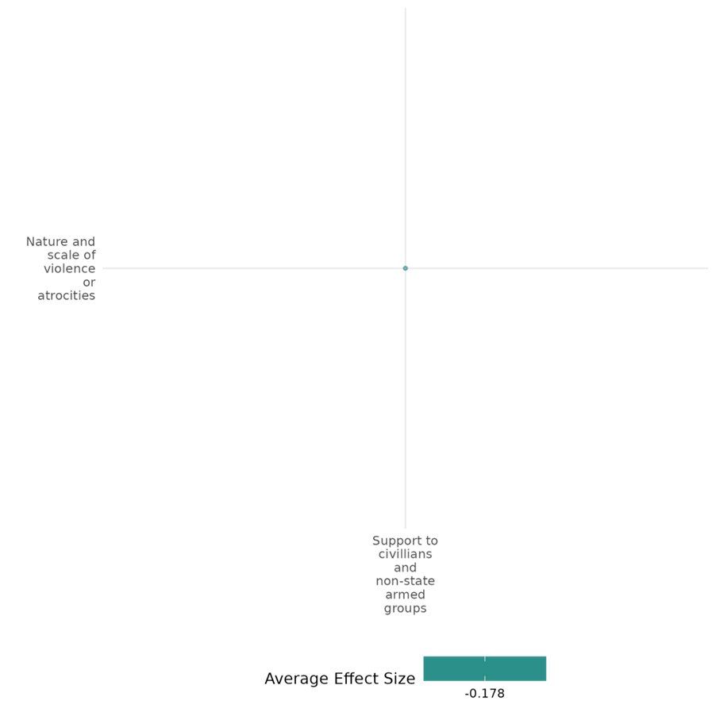

4.2 Diplomacy, Law And Accountability

4.2.1 Diplomatic Recognition + Other Diplomatic Efforts
4.2.1(1)
Effect of Diplomatic recognition and other diplomatic efforts on diplomatic relations and peaceful dispute resolution
Diplomatic recognition enhances diplomatic relations and dispute resolution, increasing support for partition but reducing territorial compromise. Human rights advocacy improves conditions but faces limited effectiveness due to mediation effects.
Geographical region: Middle East & North Africa and Global
Effect size: Small effect (g=0.081)
Confidence in study findings: Low confidence (2 studies; 5 ES)

Short summary
Diplomatic recognition and other diplomatic efforts positively influence diplomatic relations and peaceful dispute resolution. International recognition increases support for partition as conflict resolution but reduces willingness to compromise on territorial terms. Human rights advocacy improves conditions but faces diminished impact due to negative mediations, limiting overall effectiveness in dispute resolution. However, we have low confidence in this cell due to limited number of the studies in the cell.
The intervention
The intervention in the cell is human rights organizations' "naming and shaming" campaigns aimed at improving human rights conditions directly and indirectly through third-party actions like sanctions and interventions. The second study's intervention is international recognition of statehood (e.g., UNGA recognition of Palestine), examining its impact on public attitudes toward partition and territorial compromise in conflict resolution.
How the intervention is expected to work
The intervention in the cell is HRO naming and shaming campaigns is expected to work through two pathways: directly by applying moral pressure on violating states to improve human rights and indirectly by activating third-party actors to impose material costs, such as sanctions or interventions, coercing compliance. In the second study, the intervention of international recognition of statehood is expected to enhance legitimacy, increasing public support for peaceful conflict resolution principles, such as partition. However, recognition may also reduce willingness to make territorial compromises by strengthening identity and territorial claims, showcasing both empowering and limiting effects on conflict resolution dynamics.
The evidence base
The cell includes two primary studies, in the first study used a causal mediation model with global, time-series cross-sectional data. The second study employed a panel survey (before and after UNGA recognition) and a survey experiment using real-world framing, conducted in the West Bank, Palestine.
Evidence Findings
Diplomatic recognition enhances diplomatic relations and dispute resolution, increasing support for partition but reducing territorial compromise. Human rights advocacy improves conditions but faces limited effectiveness due to mediation effects.
Included studies
Allendoerfer (2019) examines how human rights organizations (HROs) use information campaigns (e.g., "naming and shaming") to improve human rights conditions, either directly or through third-party actions such as economic sanctions and military interventions. It draws on theories like the "boomerang" and "spiral" models, which suggest that HRO advocacy prompts external actors to pressure violating states, influencing their behaviour. The research is global, utilizing a time-series cross-section of countries between 1990 and 2005. The study employs a causal mediation model to analyze the direct effects of HRO activities and the mediated effects of third-party actions on human rights outcomes. Data sources include the CIRI Human Rights Data Project, the Threat and Imposition of Sanctions (TIES) dataset, and the International Military Intervention (IMI) project. Countries included: Non-perfect human rights countries with available data (1903 observations). The key findings suggested that HRO activities improve human rights outcomes directly (p=0.001). Despite negative mediations, the overall effect of HRO activities on human rights is positive but diminished. The study is rated as medium confidence as it is a non-experimental study with partial description of interventions and outcomes.
Shelef (2017) examine how international recognition of statehood affects public attitudes toward territorial compromise in conflicts involving self-determination. Specifically, it evaluates the impact of the United Nations General Assembly (UNGA) recognition of Palestine as a non-member observer state in 2012. The research focuses on how this recognition influences Palestinian support for partition and territorial compromise. The study was conducted in the West Bank, Palestine. The research employed a combination of a panel survey (two waves) and a survey experiment. Panel survey conducted in September 2011 (before recognition) and November 2012 (after recognition). Survey experiment used real-world framing based on news articles about the recognition event, with a control group reading neutral content. For panel survey, initial sample of 200 respondents, with 134 reinterviewed in the second wave. Survey experiment included 226 respondents (both new and panel respondents). The results of an ordered logit model using data from the panel survey conducted before and after the UNGA recognition of Palestine. International recognition increased support for the principle of partition as a conflict resolution strategy by 75% (odds ratio of 1.75, p=0.02) in the panel survey. The survey experiment confirmed a similar effect, with recognition increasing support for partition by 59% (odds ratio of 1.59, p=0.07). Recognition decreased willingness to compromise on territorial terms, such as land swaps, reducing support by 39% (odds ratio of 0.61, p=0.09). International recognition decreased the likelihood of respondents viewing partition as their ideal solution by 16%. The intervention of international recognition significantly increased support for partition as a principle, indicating its potential to shape attitudes toward peaceful conflict resolution. However, it reduced willingness to make territorial concessions and did not increase support for partition as the ideal resolution, highlighting its limited impact on deep-seated preferences and practical compromises. This study is rated as a high and medium confidence quantitative study.
Confidence assessment
The cell has low confidence due to a limited number of studies.
Other outcomes in the study/cell
- Violence and atrocities prevention/nature and scale of violence and atrocities
- Social cohesion/Feelings of trust & acceptance of diversity

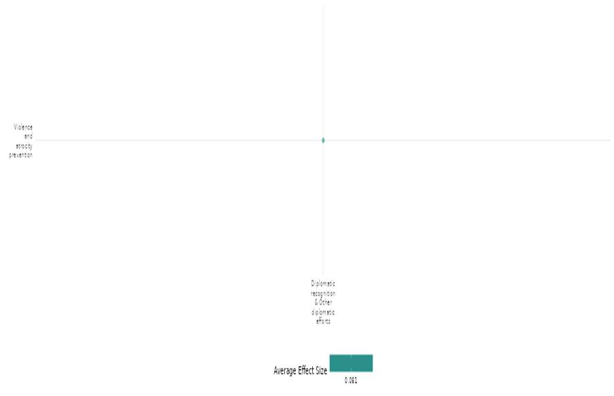

4.2.1(2)
Effect of diplomatic recognition and other diplomatic efforts on nature and scale of violence and atrocities
The cell analyses diplomatic interventions like advocacy, sanctions, compensation, blacklisting, and economic programs, examining their impact on violence and atrocities. Outcomes reveal mixed effects, with some reducing violence while others exacerbate repression or cause unintended economic and social disruptions.
Geographical region: Middle East & North Africa, Europe & Central Asia, Sub Saharan Africa, East Asia & Pacific, South Asia, Global
Effect size: No effect (g= -0.001)
Confidence in study findings: Low confidence (11 studies; 40 ES)

Short summary
The cell collectively examines the impact of diplomatic interventions on violence and atrocities, with varied outcomes depending on context, methods, and actors involved. Common interventions include human rights advocacy, sanctions, blacklisting, compensation payments, and economic programs, with mixed success. Economic and compensation strategies often reduce violence (e.g., “Iraqi First” initiative, detainee payments), while sanctions and naming-and-shaming campaigns sometimes exacerbate repression. Unlike isolated actions, diplomatic scrutiny combining positive and negative feedback shows promise for human rights improvement. Differences arise in intervention scale, type, and context, with some cases showing unintended consequences, such as increased violence or economic disruptions in fragile regions. We have low confidence in the cell due to inconsistency in the studies effect sizes.

The intervention
The cell explores diverse diplomatic interventions targeting violence and atrocities. Interventions include economic sanctions, military strategies, compensation payments, blacklisting terrorist organizations, and human rights advocacy (e.g., naming and shaming, scrutiny). Other approaches involve local economic revitalization, anti-piracy naval operations, and legislative measures like the Dodd-Frank Act. Interventions aim to influence behavior by imposing costs, incentivizing cooperation, or fostering accountability. Some interventions, such as balanced scrutiny and local economic spending, show promise in reducing violence. In contrast, others, like sanctions or isolated human rights campaigns, often exacerbate issues or yield negligible impact.

How the intervention is expected to work
The interventions aim to address violence and atrocities through varied mechanisms. Economic sanctions and blacklisting seek to disrupt resources and increase the costs of undesirable actions, expecting targeted actors to comply under pressure. Similarly, naming and shaming publicly expose violations to generate international or domestic accountability. However, compensation payments and local economic initiatives work by fostering goodwill and reducing grievances, aiming to mitigate violence through improved cooperation and trust. Navel interventions and counterinsurgency programs combine deterrence with protective measures, focusing on immediate stabilization but risking escalation in fragile zones. Legislative interventions like the Dodd-Frank Act target structural issues, attempting to curb resource-driven conflicts but occasionally destabilize local economies. While economic aid and balanced diplomatic scrutiny tend to foster cooperation, punitive measures such as sanctions and isolated criticism often provoke resistance or unintended consequences.

The evidence base
The cell includes 11 primary studies and one systematic review. There is a high degree of consistency in the review findings. The review is concerned with interventions for violence and atrocities.
Six of 11 studies followed quantitative analysis, three quasi-experimental designs, two mixed method designs, and the study employed qualitative analysis.
The studies are from Iraq (4 studies), the Democratic Republic of the Congo (2 studies), Somalia (1 study), Africa (1 study), the Philippines and Indonesia (2 studies), and Various regions (U.S. Pacific Command) (1 study).

Evidence findings
The interventions include sanctions, military actions, economic aid, counterinsurgency, and advocacy. Outcomes vary; some reduce violence or improve governance, while others exacerbate repression, conflict, or piracy.

The review evidence
The review findings suggested that diplomatic efforts can reduce violence through negotiations but may also worsen conflict by legitimizing actors or increasing repression. Outcomes depend on domestic politics, conflict dynamics, and external interests.
The impact evaluation evidence
Allendoerfer (2019) examines how human rights organizations (HROs) use information campaigns (e.g., "naming and shaming") to improve human rights conditions, either directly or through third-party actions such as economic sanctions and military interventions. It draws on theories like the "boomerang" and "spiral" models, which suggest that HRO advocacy prompts external actors to pressure violating states, influencing their behavior. The global research uses a time-series cross-section of countries between 1990 and 2005. The study employs a causal mediation model to analyze the direct effects of HRO activities and the mediated effects of third-party actions on human rights outcomes. Data sources include the CIRI Human Rights Data Project, the Threat and Imposition of Sanctions (TIES) dataset, and the International Military Intervention (IMI) project. Countries included: non-perfect human rights countries with available data (1903 observations). The key findings suggested that third-party actions (economic sanctions and military interventions) have a negative impact on human rights conditions (p<0.008). This indicates that these actions often exacerbate repression rather than improve human rights. The study is rated as medium confidence as it is a non-experimental study with partial description of interventions and outcomes.
Blair (2022) examines the effects of compensation payments, termed "detainee release payments," made to civilians wrongfully detained by counterinsurgent forces during Operation Iraqi Freedom (2004–2008). These payments aimed to mitigate grievances arising from wrongful detention and foster positive civilian perceptions, ultimately reducing insurgent violence. Compensation was distributed at the discretion of US military commanders and amounted to modest sums (e.g., $6 per day of detention). The research focuses on Iraq, explicitly analyzing data from nationwide districts during the insurgency period. The study employs a quantitative analysis using data from the Iraq Reconstruction Management System (IRMS) and violence metrics from the MNF-I SIGACT III database. The sample includes payments made across districts in Iraq, with millions of dollars allocated between 2006 and 2009. The findings suggested that detainee release spending significantly reduces insurgent violence (p<0.05), with a negative association between spending and insurgent-initiated SIGACTs, even with minimal controls included. This study is rated as a high and medium confidence quantitative study.
Bussmann (2015) examines the role of the International Committee of the Red Cross (ICRC), a neutral non-governmental organization, in promoting international humanitarian law (IHL) and protecting civilians during civil conflicts. It focuses on the ICRC's dissemination activities, such as training sessions for military personnel and public condemnations aimed at preventing atrocities. The study involves global analysis. The research uses a mixed-methods approach, quantitative panel regressions analyzing one-sided violence across 72 countries (1989–2004), and time-series analyses for Bosnia and Darfur using Granger causality tests. 72 countries in the quantitative analysis. Findings suggested that the number of years since ratification of the Geneva Conventions (GC-IV-1949) is positively associated with increased one-sided violence (OSV) by both governments and rebels, indicating a decline in compliance with international humanitarian law over time. The Additional Protocol II (AP-II-1977) shows a weak positive association with rebel violence but no significant impact on government violence. The presence of the ICRC in conflict zones does not significantly reduce one-sided violence (OSV) by either governments or rebel groups. In some cases, ICRC presence is associated with increased rebel violence, possibly due to its deployment in more severe conflict zones. In addition, neither ICRC seminars on International Humanitarian Law (IHL) nor public condemnations (naming and shaming) significantly reduce one-sided violence (OSV) by governments or rebel groups. These findings suggest that these specific interventions have limited effectiveness in preventing civilian harm during conflicts. This study is rated as a high and medium confidence quantitative study.
Davenport (2022) examines the termination of large-scale state repression (LSSR) and conceptualizes repression as a "spell" that is unlikely to terminate without significant disruption. Democratization is identified as the most consistent factor leading to the termination of LSSR, as it introduces accountability and institutional changes that disrupt repressive processes. The study is global in scope, analyzing 239 repression spells across various countries from 1976 to 2006. Empirical analysis using a Cox proportional hazards model to investigate the factors influencing the termination of repressive spells. The study draws on data from the Political Terror Scale (PTS), measuring repressive actions based on severity and scope. The analysis includes 239 large-scale repression spells over 30 years. 2,527 spell-year observations were analysed for the study. Democratization increases the likelihood of repression termination by 112% (p<0.01). The study is rated as low confidence as it is designed as a non-experimental study, and has little description of the intervention.
Iyengar (2010) focuses on the dynamics of violence and insurgent behavior in Iraq during the U.S. occupation. The study examines how new information about U.S. public support for its presence in Iraq influences insurgent behavior. It specifically investigates the impact of satellite television access in disseminating information about U.S. commitment, which insurgent groups use strategically. The context is the decentralized and factionalized nature of insurgencies in Iraq, where groups compete for visibility and resources. The study is conducted across 18 provinces in Iraq, focusing on variations in satellite TV access. The research uses a difference-in-differences approach to compare provinces with high versus low satellite television access. Data sources include U.S. military fatalities (Department of Defense), Iraqi civilian fatalities (Iraq Body Count), and satellite access (World Food Program survey). The findings indicate that satellite access amplifies the impact of poll releases on insurgent violence over time. In period 2 (Nov. 2005-2006), a 10% increase in satellite access correlates with a 6.5% rise in attacks, 20–30% drop in civilian fatalities, and 40–50% increase in U.S. military fatalities. By period 3 (Nov. 2006-2007), these effects grow stronger, with attacks increasing by 13%, while civilian and military fatality trends remained consistent. No significant effects are observed in Period 1 (Nov. 2004-2005). The study rated as low confidence quantitative study as the findings are based on short-term increases in violence post-poll releases. The study uses province-level data, which may obscure intra-regional differences in insurgent dynamics and satellite access, reducing precision in identifying information-driven changes.
Jo (2020) focuses on the U.S. Foreign Terrorist Organization (FTO) blacklist as an intervention. It explores how blacklisting terrorist groups affects their operations and behaviours, particularly regarding their funding sources and ability to perpetrate violence. Blacklisting involves financial sanctions, travel restrictions, and reputational damage. Groups dependent on private funding, such as donations or diaspora support, are particularly vulnerable, whereas those funded through state sponsorship, terrorist networks, or criminal activities often exhibit resilience or adaptability. The study is based on global data, with specific examples from regions like the Middle East, Sri Lanka, Colombia, and the Philippines. The U.S. is the primary actor administering the FTO list, but its effects extend internationally, influencing allied countries and global counterterrorism efforts. The study employs a mixed-method approach, combining statistical analysis of a dataset comprising 412 terrorist groups between 1970 and 2014 and case studies of specific terrorist organizations such as al-Qaeda, MeK (Mujahedin-e-Khalq), and FARC. Funding types were categorized into private funding, state sponsorship, terrorist networks, and criminal activities. The analysis reveals that FTO Blacklisting significantly reduces attacks for groups reliant on private funding (p<0.05) due to sanctions and stigmatization. No significant impact is observed for groups supported by state sponsors, terrorist networks, or criminal activities, highlighting their resilience to FTO interventions. Interaction effects underscore funding-source-specific vulnerabilities. This study is rated as a high and medium confidence quantitative study.
Kahn-Nisser (2018) explores the interplay between diplomatic efforts, particularly human rights (HR) "shaming," "faming," and combined "scrutiny “and changes in HR protection levels across different countries. The study focuses on three approaches: shaming: criticizing problematic hr practices, faming: acknowledging reforms and positive hr developments and scrutiny: a combination of shaming and faming to provide balanced feedback. The intervention targets countries that are part of the UN's Convention against Torture (CAT) and analyses the effect of these approaches on HR practices. The research analyses countries that have ratified the CAT from 2002 to 2017, without specifying individual locations but emphasizing international coverage. The study uses a mixed-methods approach: quantitative analysis of HR practices, utilizing the CIRI Physical Integrity Rights Index (0 to 8 scale) and examination of UN CAT committee reports for shaming, faming, and scrutiny. Total analysed reports over 200 in the observed years. Faming (p<0.01) and shaming (p<0.001) alone is negatively associated with human rights (HR) protection, suggesting that positive feedback without criticism may reduce pressure for reforms and criticism without acknowledgment of progress might provoke backlash or resistance. The combined intervention of shaming and faming (scrutiny p<0.001) is positively associated with HR protection, highlighting that balanced and detailed feedback promotes better HR practices. This study is rated as high and medium confidence quantitative study.
Shaver (2013) evaluates the U.S. military's "Iraqi First" initiative, a local-business revitalization program aimed at reducing insurgent violence in Iraq. The initiative directed billions of dollars towards purchasing goods and services from local businesses, as part of a broader economic-based counterinsurgency strategy. The intervention is contextualized within the theory that improving local economic conditions can diminish insurgent support and activities by altering opportunity costs and incentivizing cooperation with government forces. The study focuses on Iraq, analysing various provinces affected by insurgent violence during the U.S.-led coalition's counterinsurgency efforts in 2007-2008. The research employed a mixed-methods approach, combining quantitative analysis Using a two-stage least squares (2SLS) model to assess the causal impact of local spending on violence and contractual data from the U.S. Army Contracting Business Intelligence System, insurgency-related incidents from the MNF-I SIGACTS III database, and socioeconomic data from the ESOC Iraq Civil War Dataset includes 1,980 observations, representing monthly violence levels and economic activities across districts. The results indicated that for every $1 million spent on local contractual obligations, there is an estimated reduction of approximately 1.5 insurgent attacks in the region (p<0.05). This demonstrates that local economic revitalization programs, such as "Iraqi First," can effectively mitigate violence in conflict zones. The study is rated as high and medium confidence quantitative study.
Shellman (2011) analyses the impact of U.S. counterinsurgent (COIN) strategies, specifically focusing on Diplomatic, Informational, Military, and Economic (DIME) actions. These include military training conducted in India (e.g., Malabar naval training, cope air force training) and diplomatic and military actions in Philippines, involving agreements, intelligence sharing, and joint military operations like Balikatan. The study utilises quasi-experimental design with matched-case counterfactual analysis and time-series impact assessments. Data on separatist groups’ violent activities from 1997 to 2006. Positive diplomacy by the U.S. towards the Philippines has an almost negligible non-significant impact on separatist violence. Similarly, negative diplomacy shows a slight negative effect but is also statistically non-significant. The study is considered a low confidence quantitative study due to the lack of specific data sources, sample sizes, statistical methods, and effect sizes.
Shortland (2011) evaluates the impact of international naval interventions from 2008–2010 to address piracy in the Gulf of Aden and Somali Basin. The interventions included the establishment of the Internationally Recommended Transit Corridor (IRTC), deployment of naval forces by NATO, EU, and other countries, and anti-ransom regulations to deter pirate financing. These measures aimed to stabilize maritime trade and prevent alliances between pirates and terrorist organizations like Al-Shabaab. The study employed a mixed-methods design, combining quantitative analysis of piracy incidents with qualitative interviews with naval officers, shipowners, and risk consultants. A total of 882 piracy incidents were analysed, with geographical subgroups divided into the Gulf of Aden and Somali Basin. The results showed that the IRTC coefficient (0.49, p<0.05) indicates a moderate increase in piracy incidents due to strategic adaptation. IRTC shows a non-significant reduction in successful attacks. MSPA suggests increased successful attacks, likely due to concentrated shipping and limited patrols. The study is rated as high and medium confidence quantitative study.
Stoop (2018) examines the impact of Section 1502 of the Dodd-Frank Wall Street Reform and Consumer Protection Act, passed by the U.S. Congress in July 2010. This legislation aimed to reduce the link between mineral trade and armed conflict in the Democratic Republic of Congo (DRC). It required U.S.-listed companies to trace and declare the origins of certain minerals (tin, tantalum, tungsten, and gold). However, it led to a de facto ban on artisanal mining, adversely affecting local livelihoods and shifting violence dynamics. The study focuses on the Eastern Democratic Republic of Congo, particularly 27 territories in North Kivu, South Kivu, Maniema, and parts of Katanga and Orientale provinces, as designated by the U.S. State Department’s conflict mining zones. The study is a quantitative analysis using geo-referenced data on conflict events and mining sites from 2004–2015. The data includes reports on battles, violence against civilians, looting, and riots. The sample includes monthly observations of 27 treated territories impacted by the Dodd-Frank Act and control observations from non-treated territories. The Dodd-Frank intervention had no significant effect on looting or violence against civilians. It significantly increased battles (+7.5%), reflecting heightened competition in gold-rich areas, and marginally raised riots (+3.9%), likely due to economic disruptions impacting artisanal mining communities in treated territories. the study with high confidence due to extensive datasets and a robust analysis over a significant time period.

Confidence assessment
This cell has low confidence overall due to inconsistency in the studies effect sizes.
Link to review summaries
Cramer (2016)

Other outcomes in this study
- Violence and atrocities prevention/diplomatic relations and peaceful dispute resolutions
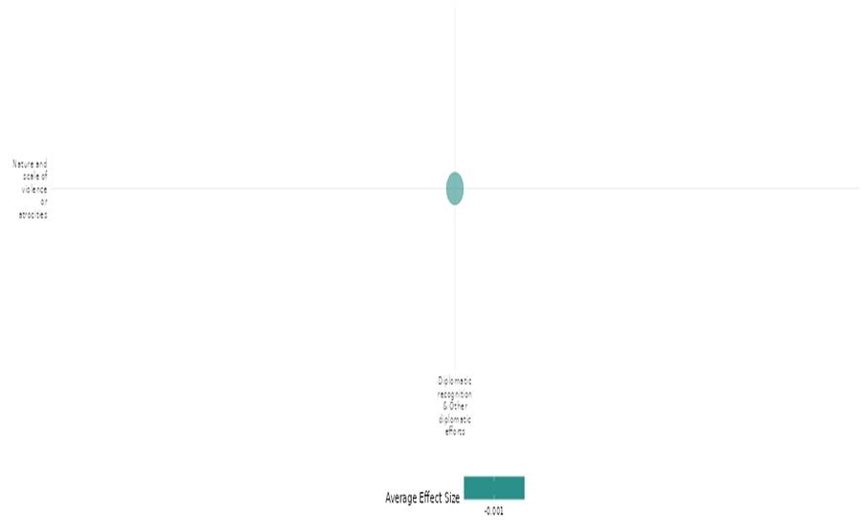

4.2.1(3)
Effect of diplomatic recognition and other diplomatic efforts on social norms regarding violence and atrocities
Diplomatic recognition and other diplomatic efforts shape social norms regarding violence and atrocities by influencing public perceptions of peace settlements. However, leader endorsements in conflict settings can backfire, reducing public trust and support when endorsed by out-group leaders. While diplomatic efforts aim to promote peace, social divisions and distrust may hinder their effectiveness.
Geographical region: Sub Saharan Africa
Effect Size: Large effect (g= 0.206)
Confidence in study findings: Low confidence (1 study; 2 ES)

Short Summary
The study examines how leader endorsements influence public support for peace policies in South Sudan during ethnic conflict. Using an experimental design with 490 respondents (875 total), it finds out-group endorsements significantly decrease support due to distrust, while in-group endorsements show minimal effects, reflecting deep-seated norms shaped by violence and atrocities. We have low confidence in the findings due to the limited number of the studies in the cell.

The interventions
The intervention involved an endorsement experiment in South Sudan, testing how in-group (ethnically aligned) and out-group leader endorsements affected public support for six peace policies. Respondents (n=490) were randomly assigned to control (no endorsement) or treatment groups, where policies were endorsed by either Dinka or Nuer leaders during ongoing conflict.

How the intervention is expected to work
The intervention leverages leader endorsements to influence public support for peace policies, if individuals use endorsements as informational shortcuts in low-information conflict settings. It hypothesizes that in-group leader endorsements would increase trust and support, while out-group endorsements would decrease trust due to perceived threats and distrust rooted in ethnic divisions and violence. By presenting real endorsements from Dinka and Nuer leaders, the intervention aimed to reveal how trust, fear, and ethnic identity shape public opinion on reconciliation and conflict resolution, ultimately affecting peace policy acceptance and implementation.

The evidence base
The cell includes one primary experimental study which uses an endorsement experiment design. The study was conducted in South Sudan, across 42 villages in 8 counties spanning 5 of South Sudan's 10 states.

Evidence findings
Diplomatic recognition and efforts influence social norms on violence but can backfire when out-group leaders endorse peace, reducing trust. While promoting peace, these efforts may be limited by social divisions and distrust.

Included studies
Haas and Khadka (2020) investigates the impact of leader endorsements on public support for peace settlements during civil wars. The core intervention involved testing whether public support for peace policies would change depending on whether the endorsement came from in-group or out-group leaders. The study was conducted in South Sudan, specifically covering 42 villages across eight counties in five states, during a brief lull in the civil war in 2016. The study involved an endorsement experiment designed to evaluate how leader endorsements affect public support for peace policies during civil conflicts. The study included a total of 875 respondents. The experiment assessed the impact of endorsements on six key peace policies drawn from real-world agreements, including power-sharing, military unification, and constitutional reform. By systematically varying the endorsing leader's identity, the study aimed to isolate the influence of social trust, fear, and perceived credibility on public support for peace settlements. The findings provide critical insights into the direct effects of endorsements by leaders from the Dinka and Nuer groups, irrespective of the respondent's ethnicity. Both in-group and out-group leader endorsements tend to reduce support for policies in the general population, with Dinka leaders having a more pronounced negative impact (p-0.005). The study rated as low confidence quantitative study due to the sample, while diverse, may not fully represent broader South Sudanese society, especially in regions less affected by conflict. The study captures short-term responses to endorsement cues.

Confidence assessment
We have low confidence in the cell due to a limited number of studies.
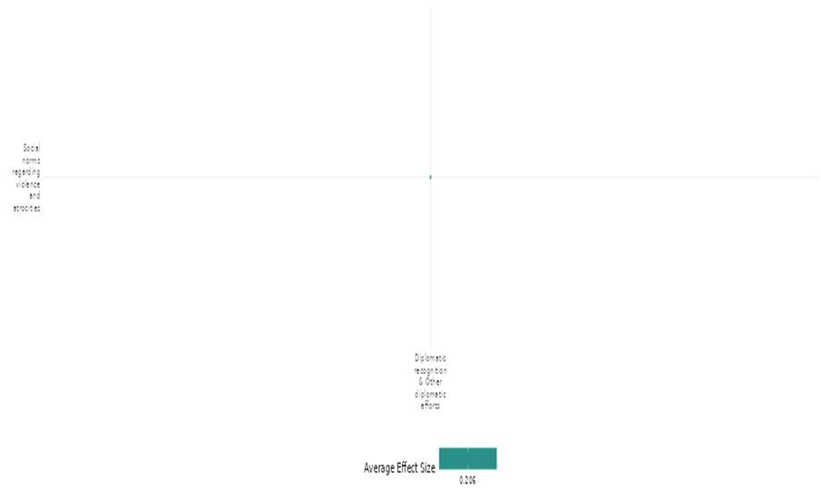

4.2.1(4)
Effect of diplomatic recognition and other diplomatic efforts on feeling of trust and acceptance of diversity
The intervention found that positive diplomatic messaging on social media significantly improved Indian perceptions of China, fostering trust. Additionally it also revealed that international recognition of Palestine by the UN increased support for territorial partition among Palestinians and enhanced trust in international actors. Both interventions effectively shaped public attitudes in their respective contexts.
Geographical region: South Asia, Middle East & North Africa
Effect size: Small effect (g= 0.093)
Confidence in study findings: Low confidence (2 studies; 10 ES)

Short summary
Diplomatic recognition and public diplomacy efforts influenced trust and acceptance of diversity. Positive Chinese diplomacy improved trust in China, while aggressive rhetoric backfired. UN recognition of Palestine increased perceived international support and trust in the UN. Overall, diplomatic recognition fostered trust, whereas divisive messaging reduced acceptance of diversity in international relations. We have low confidence in the study due to a limited number of studies.
The interventions
The cell used two types of China's public diplomacy: positive messages highlighting aid and cooperation, and negative messages featuring aggressive nationalism and criticism of the U.S. it has also examined the impact of Palestine’s international recognition by the United Nations, focusing on the political support and trust in the UN.
How the intervention is expected to work
In the cell, the interventions aim to influence public perceptions by shaping how individuals view political entities. In the first study, the positive public diplomacy messages are expected to enhance trust and foster a favourable view of China through soft power, focusing on aid and cooperation, while negative messages aim to provoke engagement but risk increasing divisiveness. In the second study, international recognition of Palestine is expected to improve perceptions of alignment with the global community and increase trust in the United Nations as a legitimate actor. The similarity lies in their goal of fostering trust and improving relationships. The difference is in the nature of the intervention: one is diplomatic messaging from a state, while the other involves international recognition and its symbolic impact.
The evidence base
The cell consists of two studies and both studies employed experimental designs to assess the effects of diplomatic interventions on public perceptions. The first study was conducted in India, the second took place in Palestine.
Evidence findings
Positive public diplomacy improved trust in China, while negative messaging backfired. International recognition increased perceived global support for Palestine and trust in the UN’s legitimacy.
Included studies
Mattingly (2022) examines the effects of public diplomacy efforts by China to shape public perceptions in India, especially in relation to trust and acceptance of diversity. The intervention centres around two types of public diplomacy messages: positive public diplomacy (Foreign Aid): messages focused on China’s aid and cooperation with India, highlighting China’s support during the COVID-19 pandemic, infrastructure projects, and economic cooperation. These messages aimed to foster trust and improve perceptions of China’s government and its people. Negative public diplomacy (Wolf Warrior): Messages that emphasize criticism of the United States and aggressive nationalist rhetoric. This type of messaging aimed to engage Indian audiences but may have had counterproductive effects, potentially reduced acceptance of diversity and promoting divisive perceptions of China. The study utilized a randomized controlled trial (RCT) design. Participants were randomly assigned to one of three groups: positive diplomacy (Foreign Aid): exposed to messages emphasizing China’s positive contributions (e.g., aid, support during the pandemic); negative diplomacy (Wolf Warrior): exposed to messages focusing on aggressive rhetoric against the U.S. and promoting China’s nationalistic stance; placebo/control: exposed to neutral messages unrelated to politics (entertainment content). Total sample size was 4,677 Indian participants. The sample was randomly assigned to one of three treatment groups. Exposure to positive diplomacy increased trust (p-0.011) in China’s government. Positive messages led to more favourable views of Chinese people (p-0.038) and an increased support for economic and defence cooperation (p-0.003). in addition, positive messaging improved views on China’s COVID response (<0.001). Exposure to negative messages did not improve any outcome and may backfire. These findings indicate that negative public diplomacy had detrimental effects on trust and acceptance of diversity. The study is rated as low confidence quantitative study as this study provides experimental evidence on the differential effects of positive and negative public diplomacy, with the caveat that the findings related to the impact of a crisis were not pre-registered and should be interpreted with lower confidence.
Shelef (2017) examine how international recognition of statehood affects public attitudes toward territorial compromise in conflicts involving self-determination. Specifically, it evaluates the impact of the United Nations General Assembly (UNGA) recognition of Palestine as a non-member observer state in 2012. the effect of international recognition on perceptions of international support, with two outcomes: perceived proximity between the Palestinian position and the international community, and trust in the United Nations. The study was conducted in the West Bank, Palestine. The research employed a combination of a panel survey (two waves) and a survey experiment. Panel survey conducted in September 2011 (before recognition) and November 2012 (after recognition). Survey experiment used real-world framing based on news articles about the recognition event, with a control group reading neutral content. For panel survey, initial sample of 200 respondents, with 134 reinterviewed in the second wave. Survey experiment included 226 respondents (both new and panel respondents). The results indicates that international recognition increased the odds of respondents perceiving the Palestinian position as "almost identical" to that of the international community by about 80% (p<0.02). This suggests that recognition positively influenced how respondents viewed the international political support for Palestine. In addition, international recognition increased the odds of respondents having "very much" trust in the United Nations by over 60% (p<0.05). This indicates that recognition contributed to greater trust in the UN as a legitimate actor in the peace process. This study is rated as high and medium confidence quantitative study.
Confidence assessment
The overall confidence in the cell is low due to a limited number of studies.
Other outcomes in the study
- Violence and atrocity prevention/Diplomatic relations & Peaceful dispute resolution
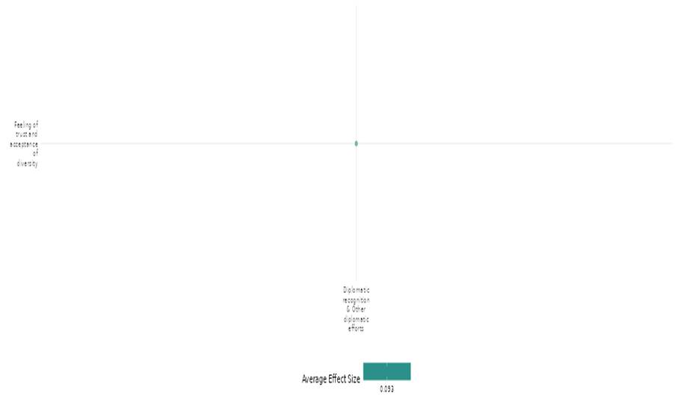

4.2.1(5)
Effect of diplomatic recognition and other diplomatic efforts on access to justice, rights and public services
Diplomatic recognition and efforts had no significant effect on improving access to justice, rights, or public services in minimally governed or ungoverned spaces across sub-Saharan Africa. While violent interventions increased government presence, non-violent efforts highlighted the limited effectiveness of non-violent strategies in achieving governance expansion
Geographical region: Global
Effect size: Moderate Effect (g= 0.109)
Confidence in study findings: Low confidence (1 study; 6 ES)

Short summary
The cell evaluates U.S. foreign policy's impact on African governance post-9/11. It found that government-involved violence significantly increased pooled government presence indicators (0.42 SD, p < 0.01). However, non-violent efforts, including government employment, voter turnout, and public sector births, showed no significant changes (p > 0.10), indicating limited impact through non-violent measures. We have low confidence in the cell due to a limited number of studies.
The intervention
The intervention involved U.S. foreign policy during the Bush administration post-9/11, pressuring nations, particularly in sub-Saharan Africa, to reduce terrorist safe havens by expanding state capacity and governance in ungoverned spaces. This was enforced through deterrence strategies, including the threat of U.S. intervention, aiming to enhance territorial control and public service delivery.
How the intervention is expected to work
The intervention relied on deterrence, where the U.S. demanded nations actively govern ungoverned spaces to eliminate terrorist safe havens, threatening military intervention because of inaction. It aimed to incentivize states, particularly in Africa, to expand territorial control and state capacity, thereby reducing spaces that could harbour terrorists. The policy assumed that the threat of U.S. force would compel governments to increase their presence through investments in governance, public goods provision, and security. Strengthening governance was expected to promote stability, discourage terrorism, and improve access to justice and public services, ultimately fostering state legitimacy and regional security.
The evidence base
The cell consists of one study which employed a quantitative design using a difference-in-differences approach to analyze the impact of U.S. interventions on governance. It focused on 764 provinces across 49 African countries.
Evidence findings
Diplomatic efforts had no significant impact on access to justice, rights, and public services.
Included studies
Downey (2021) focuses on evaluating the effectiveness of U.S. foreign policy during the Bush administration in encouraging African governments to govern ungoverned spaces as part of the global war on terror. The study examines the Bush administration's foreign policy post-9/11, emphasizing deterrence through the global war on terror. The administration demanded that nations actively reduce terrorist safe havens under threat of U.S. intervention. This policy was intended to pressure governments to expand territorial control and state capacity in ungoverned or minimally governed spaces. The study primarily focuses on sub-Saharan Africa, analysing data from 49 African nations. The research uses a difference-in-difference strategy to compare subnational data on government presence, public goods provision, and conflict before and after the U.S. invasion of Afghanistan in 2001. It employs both direct measures (e.g., voter turnout, access to public services) and indirect measures (e.g., government-involved violence) to evaluate state expansion efforts. The key findings showed that a one standard deviation increase in government-involved violence resulted in a 0.42 standard deviation increase in pooled government presence indicators (birth registration, voter turnout, public sector births) (p<0.01). Non-violent expansions of government in low-governed areas showed no significant changes. Government employment (share: -0.000, per capita: 0.002), voter turnout (0.002), and public sector births (0.009) all had p>0.10. Non-violent expansion efforts (0.003) also lacked significance, indicating minimal impact on government presence through non-violent measures. The study rated as low confidence quantitative study due to the lack of depth qualitative analysis limit the understanding of the underlying factors affecting governance in ungoverned spaces.
Confidence assessment
We have low confidence in the cell due to reliance on indirect measures, endogeneity, flawed assumptions, weak generalizability, and data constraints.
Other outcomes in the study/cell
- Community and state governance/Government performance
- Human security/Food security and nutrition & health security

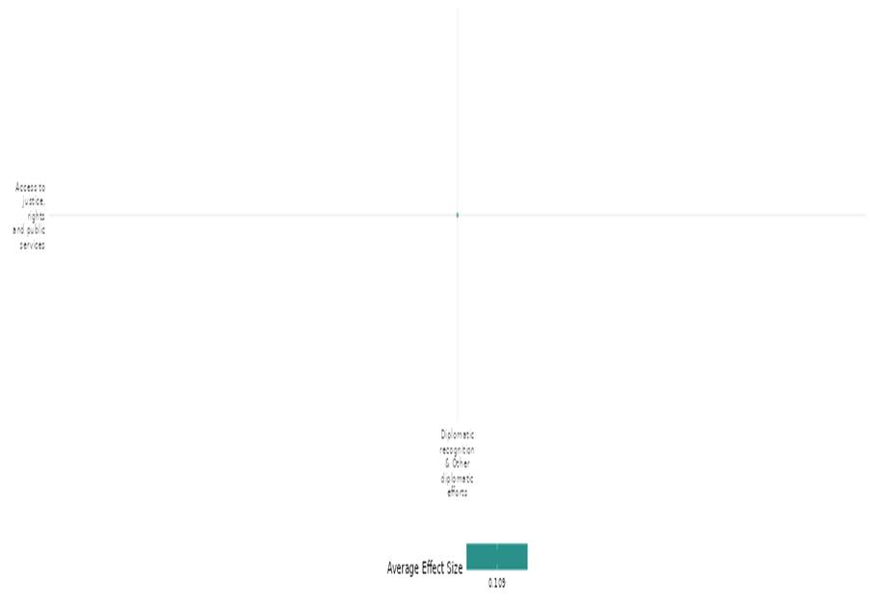

4.2.1(6)
Effect of diplomatic recognition and other diplomatic efforts on government performance
The diplomatic recognition and other diplomatic efforts aimed to strengthen governance in ungoverned African areas through non-violent expansions under U.S. policy post-9/11. However, the outcomes showed limited impact on government performance, with no significant improvements in public goods provision, such as water and sanitation, and a decline in infrastructure projects, highlighting the ineffectiveness of the strategy.
Geographical region: Global
Effect size: Small effect (g=-0.06)
Confidence in study findings: Low confidence (1 study; 4 ES)

Short summary
The cell evaluates U.S. foreign policy's impact on encouraging governance in ungoverned spaces in Africa post-9/11. While aimed at enhancing state capacity through deterrence, non-violent expansions showed limited impact, with no significant improvements in public goods provision (World Bank, water, sanitation projects) and a significant decline in infrastructure projects in low-governed areas. The outcomes showed limited impact on government performance highlighting the ineffectiveness of the strategy. The cell has low confidence due to a limited number of studies.
The intervention
The intervention involved U.S. foreign policy post-9/11, pressuring African nations to reduce terrorist safe havens and govern ungoverned spaces. By emphasizing deterrence through the threat of military intervention, it sought to expand state capacity, territorial control, and public service delivery in minimally governed areas to counter terrorism and promote stability.
How the intervention is expected to work
This intervention was based on deterrence, where the U.S. demanded that nations, particularly in Africa, reduce terrorist safe havens by expanding governance in ungoverned spaces. The policy assumed that the credible threat of U.S. military intervention would compel governments to strengthen their territorial control, improve state capacity, and enhance public service delivery. By establishing a stronger state presence, these regions would become less hospitable to terrorist groups, reducing threats to global security. The approach expected that increased governance would foster stability, improve access to justice, and promote economic development, ultimately bolstering state legitimacy and reducing reliance on external military actions.
The evidence base
The cell consists of one study which employed a quantitative design using a difference-in-differences approach to analyze the impact of U.S. interventions on governance. It focused on 764 provinces across 49 African countries.
Evidence findings
The outcomes showed limited impact on government performance, with no significant improvements in the provision of public goods such as water and sanitation, and a decline in infrastructure projects, underscoring the ineffectiveness of the strategy.
Included studies
Downey (2021) focuses on evaluating the effectiveness of U.S. foreign policy during the Bush administration in encouraging African governments to govern ungoverned spaces as part of the global war on terror. The study examines the Bush administration's foreign policy post-9/11, emphasizing deterrence through the global war on terror. The administration demanded that nations actively reduce terrorist safe havens under threat of U.S. intervention. This policy was intended to pressure governments to expand territorial control and state capacity in ungoverned or minimally governed spaces. The study primarily focuses on sub-Saharan Africa, analysing data from 49 African nations. The research uses a difference-in-difference strategy to compare subnational data on government presence, public goods provision, and conflict before and after the U.S. invasion of Afghanistan in 2001. It employs both direct measures (e.g., voter turnout, access to public services) and indirect measures (e.g., government-involved violence) to evaluate state expansion efforts. The key findings showed that non-violent expansions of government showed limited impact on public goods provision. World Bank projects (-0.085, p>0.10), water projects (0.013, p>0.10), and sanitation projects (-0.034, p>0.10) showed no significant changes, while infrastructure projects (-0.091, p<0.01) significantly declined in low-governed areas. The study rated as low confidence quantitative study due to the lack of depth qualitative analysis limit the understanding of the underlying factors affecting governance in ungoverned spaces.
Confidence assessment
The cell has low confidence due to a limited number of studies.
Other outcomes in the study/cell
- Community and state governance/Access to justice, rights and public services
- Human security/Food security and nutrition & health security
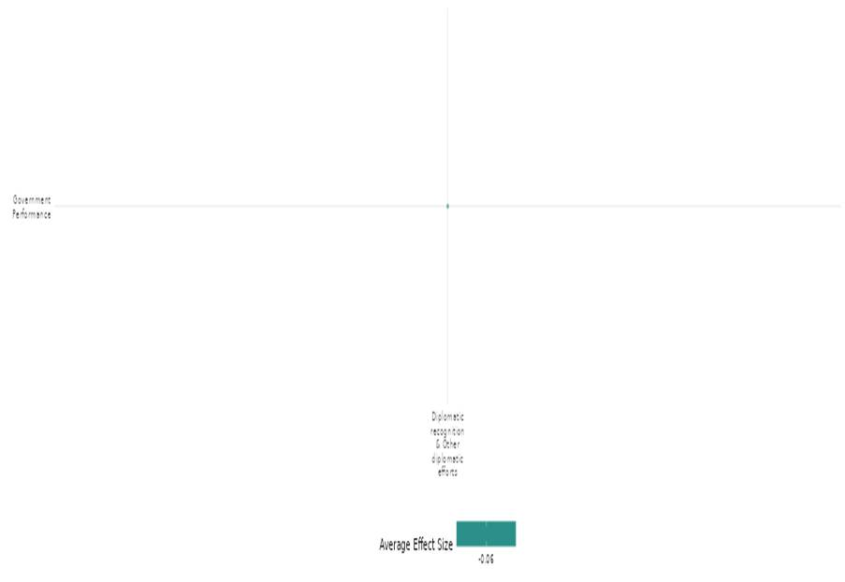

4.2.1(7)
Effect of diplomatic recognition and other diplomatic efforts on economic security
The diplomatic recognition and other diplomatic efforts effectively targeted the economic interests of Iranian political elites. This outcome demonstrates the intervention’s success in creating economic pressure on elites, aligning their financial incentives with diplomatic progress toward policy reforms, particularly concerning Iran's nuclear program.
Geographical region: Middle East & North Africa
Effect size: Small effect (g= 0.039)
Confidence in study findings: Low confidence (1 study; 4 ES)

Short summary
Diplomatic negotiations for sanctions relief increased economic security by incentivizing Iran’s political elites to support policy changes. Stock market responses showed that firms linked to targeted elites experienced stronger gains, confirming that sanctions effectively pressured decision-makers. However, we have low confidence in the study due to a limited number of studies.
Intervention
The intervention involves imposing multilateral sanctions targeting the economic interests of Iranian political elites, specifically the Islamic Revolutionary Guard Corps (IRGC) and entities linked to Iran's Supreme Leader, Ali Khamenei. These sanctions aimed to pressure elites by impacting their assets, primarily on the Tehran Stock Exchange (TSE), creating economic incentives to negotiate a deal for sanctions relief and nuclear policy reforms.
How the intervention is expected to work
The intervention leverages targeted economic sanctions to influence Iran’s political elites by impacting their key financial assets, primarily controlled by the IRGC and entities linked to Supreme Leader Ali Khamenei. By imposing financial restrictions and isolating these entities from international markets, the sanctions create significant economic pressures. The anticipated outcome is to incentivize these elites to negotiate policy changes, particularly regarding Iran's nuclear program, in exchange for sanctions relief. The strategy relies on aligning their financial interests with diplomatic progress, ensuring sanctions directly impact decision-makers while minimizing harm to broader populations.
The evidence base
The cell consists of one study which employs an empirical difference-in-difference (DID) approach to analyze the impact of multilateral sanctions on Iran. The study is based in Iran.
Evidence findings
The study finds that diplomatic negotiations for sanctions relief increased stock returns, indicating improved economic security. Targeted elite firms reacted more positively than non-target firms, confirming sanctions’ effectiveness.
Included studies
Draca (2022) investigates the effectiveness of multilateral sanctions on Iran, specifically targeting the economic interests of political elites influencing Iran's nuclear policies. It focuses on the assets controlled by two key entities: the Islamic Revolutionary Guard Corps (IRGC) and the office of Iran’s Supreme Leader, Ali Khamenei. The sanctions aimed to create economic incentives for these elites to negotiate a deal for sanctions relief, with the broader goal of influencing Iran's nuclear policy. The study is based on Iran, with a specific focus on stock exchange-listed assets within the Tehran Stock Exchange (TSE). This is an empirical analysis using a difference-in-difference approach. The study exploits "information shocks" about diplomatic negotiations for sanctions removal between 2012 and 2015. It compares stock market responses of firms tied to the targeted elite groups with those unrelated to them. Data sources include stock return information, news coverage databases (Factiva and GDELT), and ownership details of TSE-listed firms. The study analyses stock returns from 138 firms listed on the Tehran Stock Exchange, divided into a "target portfolio" of 50 firms (owned or influenced by the IRGC or Setad, the Supreme Leader's economic foundation) and a "non-target portfolio" of 88 firms with no known connection to these entities. The results indicated that both Factiva and GDELT measures show high-intensity sanctions-related news increased non-target firms' returns by 0.055% (Factiva, p < 0.01) and 0.069% (GDELT, p < 0.01), with target firms responding stronger at 0.065% (Factiva, p < 0.01) and 0.064% (GDELT, p < 0.01), confirming sanctions' targeting effectiveness. The study rated as low confidence quantitative study due to causal inference limitations: event studies are useful for observing immediate reactions, but are limited in establishing long-term causal relationships and the study does not distinguish between the impacts of different types of sanctions (e.g., financial vs. trade sanctions).
Confidence assessment
We have low confidence in the cell due to a limited number of studies.
Other outcomes in this study
None
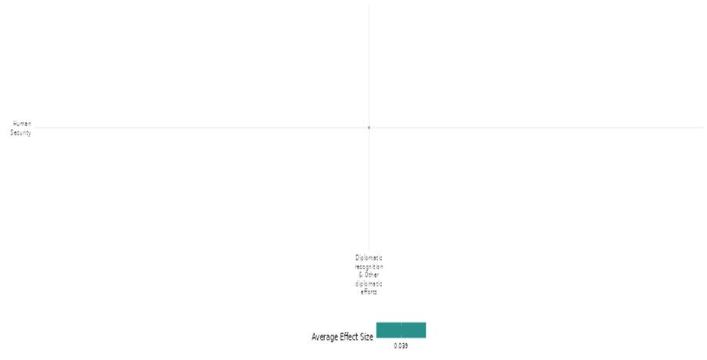

4.2.1(8)
Effect of diplomatic recognition and other diplomatic efforts on food and nutrition security and health security
The diplomatic recognition and other diplomatic efforts aimed to strengthen governance in ungoverned African spaces to improve public services and health security outcomes. While it achieved a modest reduction in under-5 mortality, there was no significant progress in malnutrition rates, infant mortality, or vaccination coverage, reflecting limited overall impact of health security outcomes.
Geographical region: Global
Effect size: Moderate effect (g=0.186)
Confidence in study findings: Low confidence (1 study; 4 ES)

Short summary
The cell examines the impact of diplomatic recognition and other diplomatic efforts namely U.S. foreign policy, particularly the "Bush Doctrine," on governance in 49 African countries post-September 11, 2001. It analyses the relationship between U.S. military threats and African government actions using a principal-agent model. Despite interventions aimed at enhancing governance and security, findings reveal no significant improvements in food and nutrition security or health outcomes, with high rates of malnutrition and infant mortality indicating a disconnect between military strategies and developmental goals. We have low confidence in the cell due to a limited number of studies.
The intervention
The intervention aimed to deter terrorism by encouraging African governments to assert control over ungoverned spaces. This strategy involved diplomatic recognition and military threats, with the expectation that improved governance would enhance food security and health outcomes, ultimately linking national security to developmental progress in the region.
How the intervention is expected to work
The interventions were expected to work by incentivizing African governments to strengthen governance in ungoverned areas, thereby reducing terrorism. Enhanced control would lead to improved public services, including food security and health care, ultimately fostering stability and development, which would contribute to broader U.S. national security objectives.
The evidence base
The cell consists of one study which employed a quantitative design using a difference-in-differences approach to analyze the impact of U.S. interventions on governance. It focused on 764 provinces across 49 African countries.
Evidence findings
Diplomatic efforts had no significant impact on malnutrition, infant mortality, or vaccination but modestly reduced under-5 mortality.
Included studies
Downey (2021) investigates the effectiveness of the U.S. "Bush Doctrine" and its associated military interventions in deterring the emergence of ungoverned spaces in Africa following the events of September 11, 2001. The study employs a systematic empirical analysis across 49 African countries, utilizing a balanced panel of provinces. The analysis focuses on several proxies for "ungoverned" spaces, including population density, distance to the capital, and terrain ruggedness. The key findings showed that Non-violent expansions of government showed minimal progress in health outcomes. Malnutrition rates (-0.003, p>0.10), infant mortality (-0.036, p>0.10), and vaccination rates (0.020, p>0.10) showed no significant changes. However, under-5 mortality (-0.085, p<0.05) significantly declined, indicating a modest improvement in child survival despite overall limited impact. The study rated as low confidence quantitative study due to lack the depth qualitative analysis limit the understanding of the underlying factors affecting governance in ungoverned spaces.
Confidence assessment
The cell is rated as low confidence due to a limited number of studies.
Other outcomes in the study/cell
- Community and state governance/Access to justice, rights and public services
- Human security/Food security and nutrition & health security


4.2.1(9)
Effect of diplomatic recognition and other diplomatic efforts on political security
Targeted diplomatic interventions strengthen political security by improving human rights conditions. A specific campaign significantly increased political prisoner release rates, while a combination of shaming and incentives led to measurable reforms across multiple countries. These efforts contribute to greater political stability, reinforcing adherence to international human rights norms and reducing state repression over time.
Geographical region: Global
Effect size: Moderate effect (g=0.139)
Confidence in study findings: Low confidence (2 studies; 4 ES)

Short summary
Diplomatic recognition and other diplomatic efforts, including shaming, incentives, and advocacy campaigns, influence political security by pressuring governments for human rights reforms. While rhetorical and financial incentives show limited independent effects, targeted diplomacy significantly increases the likelihood of political prisoners' release, demonstrating diplomatic engagement's role in enhancing political security. We have low confidence in the cell due to a limited number of studies.
The intervention
The cell focused on the European Neighbourhood Policy, combining public shaming and financial incentives to promote human rights reforms in 15 countries through monitoring reports, National Action Plans, and aid allocation tied to compliance. The other intervention in the cell examined a U.S.-led campaign using public diplomacy, including media efforts and "naming and shaming," alongside private negotiations and inducements to secure the release of female political prisoners from 13 countries.
How the intervention is expected to work
The intervention combines public shaming through critical monitoring reports and financial incentives to pressure countries into adopting human rights reforms. Shaming is expected to create reputational costs, while incentives provide tangible rewards for compliance, leveraging both rhetorical and economic influence. In addition, public diplomacy through media campaigns aims to raise international awareness and apply pressure on target governments, while private negotiations and inducements address bureaucratic barriers. Together, these strategies are designed to enhance accountability and incentivize action, with public efforts creating external pressure and private diplomacy facilitating practical solutions.
The evidence base
The cell consists of two primary studies, one using a quantitative design, spanning Europe, Asia, and Africa (e.g., Algeria, Ukraine, Tunisia). The second study employed a mixed-methods approach, combining quantitative analysis of release rates and qualitative interviews, focusing on 13 countries across various regions, including Azerbaijan, Myanmar, China, Egypt, and Venezuela.
Evidence findings
Diplomatic recognition and efforts shape political security by pressuring governments; while general incentives show limited impact, targeted diplomacy significantly improves political prisoner release rates and reforms.
Included studies
Kahn-Nisser (2018) discusses the combination of shaming and incentives as part of the European Neighbourhood Policy (ENP) to influence human rights reforms in 15 countries across Europe, Asia, and Africa. The study focuses on using shaming (public criticism) and financial incentives as mechanisms to push for human rights (HR) reforms. These efforts aim to create policy changes in targeted countries through rhetorical pressure and economic leverage. This policy framework facilitates engagement with countries near the EU, emphasizing political, economic, and legal reforms without offering EU membership. It uses National Action Plans (NAPs), annual monitoring reports, and aid allocation tied to compliance with reforms. The study spans 15 countries in Europe, Asia, and Africa, including Algeria, Armenia, Azerbaijan, Belarus, Egypt, Georgia, Israel, Jordan, Lebanon, Libya, Moldova, Morocco, Syria, Tunisia, and Ukraine. Study design is quantitative analysis using newly coded data. The study examines the interaction between shaming and incentives on HR policy changes. It employs regression models and Granger causality tests to evaluate the data. The sample includes 15 countries that participated in the ENP between 2001 and 2011. The outcome is the political empowerment human rights index, measuring freedoms like assembly, association, and elections. Shaming (p>0.05) and incentives (p>0.05) show no significant independent effects, highlighting their limited standalone influence on HR reforms. The study is of medium confidence due to Robust statistical analysis using diverse models
Myrick (2021) examines the U.S.-led human rights diplomacy campaign (#Freethe20) aimed at securing the release of 20 female political prisoners from 13 countries. The intervention involved both public diplomacies, through media campaigns, and private diplomacy, including direct negotiations and inducements. Public efforts were aimed at "naming and shaming" target governments, while private diplomacy resolved bureaucratic deadlocks within the U.S. foreign policy framework. The campaign targeted political prisoners in Azerbaijan, Burma (Myanmar), China, Egypt, Eritrea, Ethiopia, Iran, North Korea, Russia, Syria, Uzbekistan, Venezuela, and Vietnam. This research utilized a mixed-methods approach, including quantitative comparison of release rates between prisoners featured in the campaign and two comparison groups and qualitative interviews with government officials and analysis of media coverage. The primary focus was on 19 identifiable women featured in #Freethe20.the findings indicated that individuals in the campaign had 58% higher odds of being released compared to those not included. The result is highly statistically significant (p<0.01), indicating strong evidence that being part of the campaign positively influenced the likelihood of release of female political prisoners imprisoned between 2000 and 2015. The result remains highly significant (p<0.01), when accessed for female political prisoners who were imprisoned in 2015, the year when the #FREETHE20 campaign was launched. The study is considered high and medium confidence quantitative study.
Confidence assessment
The overall confidence of the cell is low due to a limited number of studies.
Other outcomes in the study
None
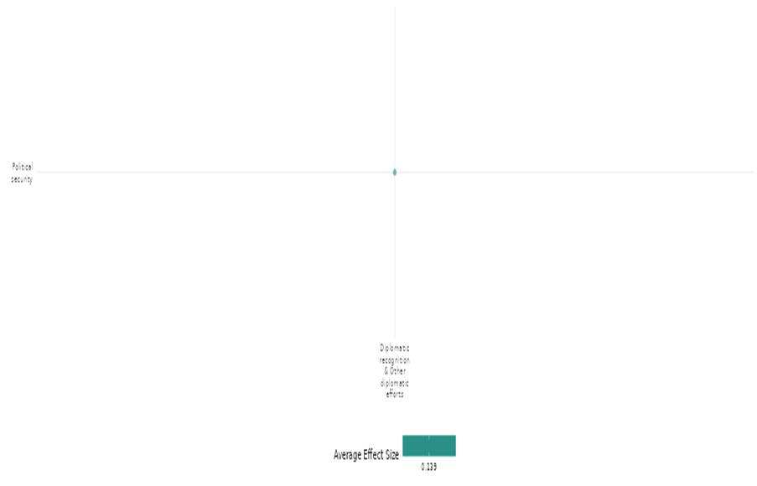

4.2.2 Human Security Law + International Criminal Court (ICC) Or Regional Equivalents
4.2.2(1)
Effect of Human security law & International Criminal Court (ICC) or regional equivalents on Diplomatic relations & Peaceful dispute resolution
The interventions had an impact on diplomatic relations and peaceful dispute resolutions.
Geographic focus: Global
Effect: Large effect (g=0.437)
Confidence in study findings: Low (3 studies with 53 effect sizes)

Short summary
The cell studies the International Criminal Court (ICC) involvement in civil war resolution, United Nations Convention on the Law of the Sea (UNCLOS) membership's impact on maritime claims management, and ICC's role in civil war peace negotiations interventions. ICC involvement influenced mediation, with 58.1% mediation in conflicts involving ICC-targeted parties, compared to 20.5% without. UNCLOS membership doubled third-party settlements and bilateral negotiations over maritime disputes, though Economic Exclusive Zones (EEZ) boundaries showed mixed effects. The ICC’s role in peace negotiations either led to comprehensive agreements or negotiation failures.

Long summary
The intervention
The studies provided systematic evidence on the effect of International Criminal Court (ICC) involvement on the prospects for the resolution of ongoing civil wars using the data from the Uppsala Conflict Database Program (UCDP). Different phase involved in peace processes studied includes onset mediation, peace agreement, and conflict resolution. The other set of interventions study UNCLOS membership and declared EEZs on the frequency and success of efforts to manage competing claims to maritime areas in the past century. The study used available maritime claims data coded by ICOW from 1900-2001 in the Western Hemisphere (North, Central, South, and Caribbean), Western Europe, and Eastern Europe. The third study assessed that why do some of the civil war peace negotiations involving the ICC end with full peace agreements, while others end with resumed violence.

How the intervention is expected to work
The ICC arrest warrants and summonses influence the onset of mediation processes. The ICC was involved and mediation in the 849-conflict dyad-years between 2002 and 2018, out of which 190 have experienced mediation. This constitutes around 22 percent of the total number of conflict dyad-years, from which it follows that international mediation is a standard approach to ending armed violence. The evidence shows that ICC involvement does not inhibit the occurrence of mediation. The second study shows that membership in UNCLOS has a significant effect on third party settlement attempts. Third party settlement is more than twice as likely if both states in a dyad share membership in UNCLOS and bilateral negotiations are also more frequent between dyads with shared UNCLOS membership. Also, the establishment of joint EEZ boundaries doubles the likelihood of bilateral negotiations to resolve maritime claims. On the other hand, EEZ boundaries have no significant effect on third party attempts to manage maritime claims or militarization of maritime conflicts. The third study also showed that international prosecution either makes peace negotiations more likely to completely fail or more likely to end in a comprehensive peace agreement.

The evidence base
The cell contains 4 studies: 3 impact evaluations designed as quasi-experimental studies 1 qualitative study (Birkeland 2009). There is consistency in findings across studies.
The studies are from Uganda (1) and present the global context (3).

Evidence findings
The evidence shows that ICC and UNCLOS impact conflict resolution, showing ICC involvement increases mediation rates and UNCLOS membership boosts maritime dispute settlements. ICC’s role in peace talks led to either full agreements or failures.

Included studies
There are 3 impact evaluations in the cell and evidence summaries of the 3 studies are thus provided here:

Duursma (2020) examined how ICC involvement affect the peace process in three distinct ways, through looking at the association between ICC involvement and (1) the onset of mediation (the pre-negotiation phase); (2) the conclusion of peace agreements (the negotiation phase); and (3) conflict resolution (the implementation phase), defined as the conclusion of a peace agreement that leads to a termination of the conflict. The study was designed as a quasi-experimental study. The study used data from data from the Uppsala Conflict Data Program (UCDP) on intrastate conflicts between 2002 and 2018. The study suggests that ICC arrest warrants do not inhibit the onset of mediation. Neither do ICC arrest warrants seem to prevent peace agreements from being concluded. Crucially, however, ICC arrest warrants do seem to undermine the prospects for conflict resolution, defined as the termination of a conflict through a negotiated settlement. The study was rated as medium confidence as it is a non-experimental study, the study has partial description of the intervention.

Nemeth (2007) evaluated 2 primary mechanisms for resolving competing maritime claims 1) the creation of private ownership of maritime zones in the form of Economic Exclusive Zones (EEZs), and 2) the creation of an institution, the United Nations Convention on the Law of the Sea (UNCLOS), to establish standards for maritime claims and resolve disputes. The study is designed as non-experimental study design. The data involved UNCLOS and EEZs on the peaceful and militarized management of maritime claims in the Western Hemisphere and Europe (1900-2001). There are a total of 272 claim dyad years for the Gulf of Fonseca maritime claim (through 2001). In the Western Hemisphere, Western Europe, and Eastern Europe, there are a total of 3,231 claim dyad-years from 1900-2001. The analyses suggest that declared EEZs work more efficiently for helping parties reach equitable agreements in bilateral negotiations, although membership in UNCLOS promotes more frequent third party conflict management efforts. The study is rated as medium confidence due to non-experimental study design and partial description and definition of outcomes.

Reilly (2019) assessed that how the Court affects the occurrence and outcome of peace negotiations and the role the Court plays is conditioned by the combination of the formal nature of the Court’s involvement in the situation, the Court’s public relations approach, and the public statements of human rights and peace advocates about the Court’s involvement and normative commitments. The study is designed as quasi-experimental study design. conduct logistic regression analysis of 367 instances of peace negotiations to end civil wars. The results confirm that international prosecution either makes peace negotiations more likely to completely fail or more likely to end in a comprehensive peace agreement. The study is rated as medium confidence due to non-experimental study design and partial description

Confidence assessment
Overall low confidence as there are only 3 studies in the cell. There is consistency in findings across all 3 studies.

Other outcomes in the studies
No other outcomes

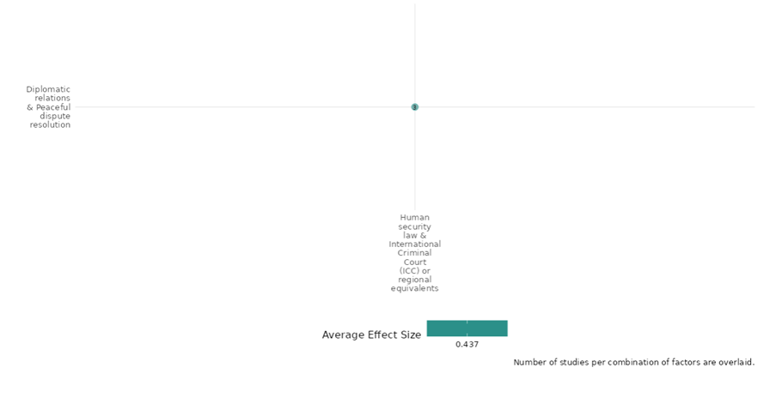

4.2.2(2)
Effect of Human security law & International Criminal Court (ICC) or regional equivalents on Nature and scale of violence or atrocities
The interventions had mixed impact on violence and atrocities outcomes including violence against civilians, attack on civilians, homicide rates, one sided violence, termination of high repression spells.
Geographic focus: Sub Saharan Africa, Europe and Central Asia, Latin America and Caribbean, Global
Effect: Adverse effect (g=-0.383)
Confidence in study findings: Low (6 studies with 46 effect sizes)

Short summary
The cell studied that how International Criminal Court (ICC) prosecutions during ongoing conflicts impact atrocities, focusing on legal optimism and pessimism. Key factors include the ICC's legal stages (investigations, indictments, trials), human rights treaties' direct and diffuse effects, and the role of democratization in halting repression. Evidence showed democratization’s effectiveness in ending large-scale repression, while human rights treaties had mixed impacts. Internationalized prosecution, a strategy of cooperation between international and domestic courts, reduced violence in some cases, as seen with CICIG in Guatemala. Findings were consistent across seven studies conducted in the DRC, Bosnia, Guatemala, and globally using quasi-experimental and randomized methods.

Long summary
The intervention
The interventions include ICC prosecutions initiated during ongoing conflict affect atrocities and the effects of prosecutions and transitional justice. The study the typology around legal optimism and legal pessimism, concerning the impact of ICC action initiated during the ongoing conflict on atrocities. The restraining effect of nongovernmental actor, is the distinctively neutral and independent International Committee of the Red Cross, whose mission includes the promotion of humanitarian law and the protection of the civilian population on the conflict parties. The influence of human rights treaties, with a focus on two kinds of treaty effects: direct—the effect of treaties on the countries that ratified them; and diffuse—the effect of treaties on countries regardless of ratification; democratization holds the greatest promise for stopping an ongoing spell of LSSR because of its ability to fundamentally alter the government engaged in relevant behavior; effect of ICC indictments on violence. Another intervention explored whether and how internationalized prosecution contributes to the reduction of large-scale criminal violence. Internationalized prosecution is a strategy of cooperation between international organizations and domestic judicial institutions to investigate and prosecute rogue state security agents and members of organized criminal groups who collude to create criminal structures through which they dominate illicit markets by force.

How the intervention is expected to work
The effects of ICC action on atrocities vary across stages of the legal process. The legal process is an initial variable in a typological theory of the effects of ICC action in ongoing conflict, with the “values” of this variable corresponding to the stages of the legal process, i.e. situation-level actions (including both preliminary examination and formal investigation), outstanding indictments, executed indictments, trials, and verdicts. The results show that the more time has passed since the ratification of the relevant Geneva Conventions and Protocols, the larger is the risk of civilian victimization. There was no evidence that the ICRC’s presence in conflict zones and the seminars it conducts to spread humanitarian law make a crucial difference. The human rights treaties influence, with a focus on two kinds of treaty effects: direct—the effect of treaties on the countries that ratified them; and diffuse—the effect of treaties on countries regardless of ratification. The analysis of 239 large-scale repression spells from 1976 to 2006, it was found that democratization is associated with spell termination and there is little systematic pacifying influence from anything else. Additionally, nonviolent movements for change principally drive democratization but that these movements have little direct impact on state repression spells in and of themselves. ICC reduces violence by engaging plea bargains and other negotiated settlements & International Commission Against Impunity in Guatemala (CICIG) prevented murders.

The evidence base
The cell contains 9 studies: 6 impact evaluations designed as quasi-experimental and randomized controlled trials; 2 qualitative studies (Birkeland 2009 and Block 2015); and 1 systematic review. The findings across studies are consistent.
The studies are from the Democratic Republic of Congo (DRC) (1), Bosnia and Herzegovina (1), Global /regional context (4), Guatemala (1), Uganda (1) and Kenya (1).

Evidence findings
The review findings
The review included justice and reconciliation interventions at the local (and ‘traditional’) level
as well as national and international level. It included discussion of truth commissions and
the ICC. There were 15 included studies in the review suggesting that evidence was largely mixed or ineffective, suggesting no clear evidence that these interventions are effective in reducing or preventing future violent conflict. Out of 15 studies, 7 were rated as high, 3 as moderate and 5 as low quality of evidence.

The impact evaluation findings
The evidence shows that there was an adverse impact of human security law interventions on the violence and atrocity outcomes. There are 6 impact evaluations and 1 systematic review in the cell and evidence summaries of the 7 studies are thus provided here:

Included studies
Broache (2015) assessed the impact of International Criminal Court (ICC) prosecutions initiated during the ongoing conflict on atrocities, with the goal of developing a typological theory specifying the conditions under which ICC prosecutions alternately prevent, exacerbate, or have no impact on wartime atrocities in the Democratic Republic of Congo (DRC). The study was designed as a quasi-experimental study. The case studies used in the study draw from over 100 original interviews with current and former members of these groups and other relevant actors in DRC. The study found the following findings: First, this analysis indicates that situation-level action has negligible average effects on atrocities. Second, I find that outstanding indictments tend to exacerbate atrocities, and third, that the execution of ICC indictments contributes to the prevention of atrocities. The study was rated as medium confidence as it is a non-experimental study

Bussmann (2015) assessed whether a nongovernmental actor, the distinctively neutral and independent International Committee of the Red Cross, whose mission includes the promotion of humanitarian law and the protection of the civilian population, has such a restraining effect on the conflict parties. The study was designed as a quasi-experimental study. The sample is limited to one-sided violence in civil wars for the years from 1989 to 2004 for 72 countries.
There was positive relationship between the number of years since a state party ratified the GC-IV-1949 and one-sided violence, by the government forces as well as by the rebel groups (p<0.01). The study was rated as medium confidence as it is a non-experimental study, the study has partial description of the intervention

Cole (2012) assessed the influence of human rights treaties, with a focus on two kinds of treaty effects: direct—the effect of treaties on the countries that ratified them; and diffuse—the effect of treaties on countries regardless of ratification. The study was designed as a quasi-experimental study. The study used political terror scale and civil liberties from 1970 to 2007 as dependent variables. The study shows that the average levels of political terror increased the longer a country was party to the Convention Against Torture (CAT), as evidenced by the significantly positive coefficient on the years-since-ratification variable (p<0.001). CAT membership did not directly affect civil liberties outcomes, as indicated by the statistically insignificant coefficients on the linear and quadratic years-since-ratification terms. CCPR also had diffuse effects on civil liberties. The study is rated as low confidence as it is designed as a non-experimental study, and has partial description of the intervention.

Davenport (2022) assessed repressive spell (similar to that in the study of war, civil war, and terrorism) and a new theoretical framework that conceptualizes repression as a sticky process that is unlikely to terminate unless it is disturbed in some manner. The study was designed as a quasi-experimental study. The study Investigated a new database regarding 239 large-scale repression spells from 1976 to 2006. The study shows that civil conflict, population, and youth bulges are all below 1 and statistically significant (p<0.05), suggesting that once started these make LSSRs go on longer. when a civil conflict recently terminated, or when the state in question has a more independent judiciary, repressive spells are shorter. The study is rated as low confidence as it is designed as a non-experimental study, and has little description of the intervention.

Miller (2022) applies the concept of assurance to explain that how the concept of assurance to explain that how the ICC reduces atrocities despite its limited capacity. The study is designed as non experimental study design. The study included data of 16 armed groups that had their punishment lifted and 16 groups associated with maintained punishment. The combined statistical findings of Kenya and Uganda indicates that the mechanism of assurance through negotiations and assurance through the judicial process are operative in their respective cases (p<0.05). The study is rated as low confidence due to non experimental study design and little description of the description.

Trejo (2019) explores whether and how internationalized prosecution contributes to the reduction of large-scale criminal violence in Guatemala. The study is designed as quasi-experimental study design. The data was constructed using a donor pool of 11 Latin American countries that resembles Guatemala as closely as possible. The findings show that internationalized prosecution – based on the use of intelligence and judicial action – can be highly effective in containing large-scale criminal violence. The study is rated as medium confidence due to non-experimental study design and partial description.

Confidence assessment
Overall low confidence as 3 of the 6 impact evaluations were rated as low confidence.

Other outcomes in the cell:
Human security/Political security

Link to review summaries
Cramer (2016)
All the studies can be accessed via the EGM.

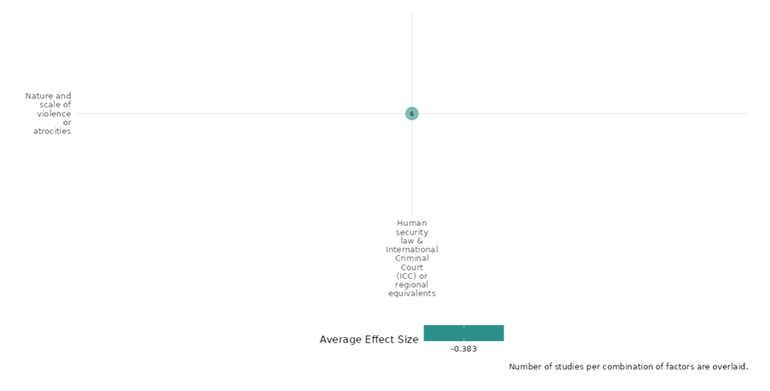

4.2.2(3)
Effect of Human security law & International Criminal Court (ICC) or regional equivalents on Food security and nutrition & Health Security
The intervention had an impact on improving mental health outcomes.
Geographic focus: Sub Saharan Africa
Effect: Large effect (g=0.21)
Confidence in study findings: Low (1 study with 10 effect sizes)

Short summary
The cell examined whether collective rituals, like Rwanda’s adapted gacaca system, could modify a nation's emotional climate after conflicts. Gacaca tribunals involved community discussions with survivors and accused prisoners. Prisoners expressing guilt received sentence reductions. Emotional analysis revealed anger decreased post-trial, while sadness, fear, and guilt increased, particularly for prisoners. Survivors reported stronger negative emotions overall. Perceptions of the general emotional climate worsened after the trials, with prisoners viewing it more positively than survivors. The evidence, based on one quasi-experimental study in Rwanda, highlights gacaca as a unique legal-social intervention addressing emotional impacts of past atrocities.

Long summary
The intervention
Emotional climate thus points to the quality of the environment that surrounds people and affects their behavior at the level of a nation. The present study addresses the issue of whether an emotional climate prevailing in a nation can be modified by social interventions relying upon the use of collective tools. More specifically, we wondered whether collective rituals instigated at a sociopolitical level could alter in a significant manner the emotional climate prevailing in a population as a result of past conflicts, violations of human rights, or massacres. To deal with this challenge, a traditional Rwandan community-based conflict resolution system called gacaca was transformed and adapted for judging all those accused of participation in the genocide. This modernized gacaca constitutes an unprecedented legal-social experiment in its size and scope. Throughout the country, gacaca tribunals have been created. They are composed of persons of integrity elected by the inhabitants of cells, sectors, districts, and provinces. Prisoners are brought before the tribunal in the community where they allegedly committed a crime. In their presence, survivors and the entire community discuss the alleged acts, providing testimony and counter-testimony. Prisoners who confess before the proceedings and ask for forgiveness can benefit from important reductions in sentences. Survivors of the genocide and prisoners accused of being responsible for the genocide, all living in the region of Kigali and awaiting their participation into gacaca trials, were contacted and invited to complete the study forms before
and after the trials.

How the intervention is expected to work
The seven primary emotions were analyzed separately using the same 2 (group: survivors vs. prisoners) × 2 (time: before Gacaca vs. after gacaca) mixed model ANOVA. There was a significant group's main effect on anger, fear, and, most interestingly, guilt. Not surprisingly, prisoners expressed less anger and fear than survivors. In contrast, prisoners reported substantially more guilt than survivors. The time main effect came out significant for all seven emotions. With the notable exception of anger, which was experienced less intensely after the Gacaca trial than before, primary emotions were reported to be stronger after than before the Gacaca trial. Three distinctive patterns emerged in the cell means. The first, which concerns sadness, fear, disgust, shame, and anxiety, is one in which the increase in emotional experience observed between the two measurement points was more important for survivors than for prisoners. For anger, prisoners expressed a lower level of anger after than before the Gacaca. Responses about guilt revealed yet another pattern. As expected, a significant increase was observed among prisoners, and a nonsignificant decrease emerged among survivors. For the general emotional climate item, prisoners thought the emotional climate was better than what survivors indicated. At the same time, the general emotional climate was perceived to be worse than before the Gacaca trial.

The evidence base
The cell contains 2 studies designed as a quasi-experimental and qualitative study (Brouneus 2008) in Rwanda (2) and 1 systematic review.

Evidence findings
The review evidence
The systematic review findings showed that there were 4 included studies which studied victim emotional or psychological recovery outcomes. The review reported only outcomes and did not conducted analysis to assess the impact on these outcomes.

The Impact evaluation evidence
The evidence showed that gacaca trial intervention had a large effect on the emotional health of the prisoners. There is 1 impact evaluation and 1 systematic review in the cell and evidence summaries of the study are thus provided here.

Included studies
Kanyangara (2007) builds upon Durkheim’s (1912) theory of collective rituals, predicts that participation in the gacaca would involve a reactivation of negative emotions in both groups and would also impact negatively on the perceived emotional climate. The study was designed as a quasi-experimental study. Among prisoners, 150 were contacted and 70 agreed to contribute, with 50 of them who completed all the forms before and after the trial. The study found a significant group main effect on anger, on fear, and, most interestingly, on guilt. Not surprisingly, prisoners expressed less anger and fear than survivors. In contrast, prisoners reported substantially more guilt than survivors. The time main effect came out significant for all seven emotions. The general emotional climate was perceived to be worse after than before the gacaca trial (P<0.01). The study was rated as medium confidence as it is a non-experimental study.

Confidence assessment
Overall low confidence as there is only 1 study in the cell.

Link to review summaries
Holder (2023)
All studies may be accessed via the EGM.

Shiny app screenshot
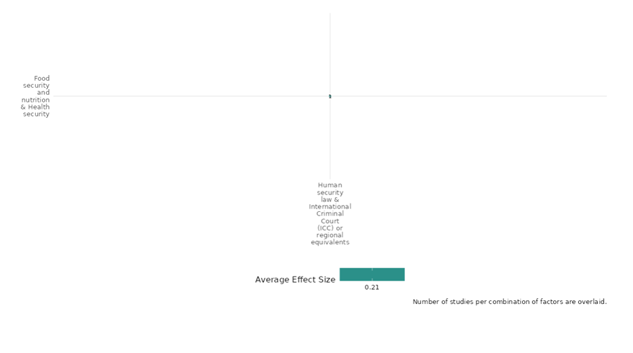

4.2.2(4)
The effect of Human security law on physical security

Effect: Negative (While the Gacaca courts documented increased insecurity for survivors, the ICC prosecutions also revealed resistance, witness intimidation, and a decline in public support. However, it helped curb electoral violence and reshape political alliances)

Confidence in study findings: Low

Summary
The effects of human security law interventions such as Gacaca courts and the International Criminal Court (ICC) revealed unintended consequences on physical security. Brounéus (2008) evaluated Rwanda’s Gacaca courts and revealed that rather than fostering reconciliation, testifying often led to increased threats, retraumatization, and physical insecurity for survivors. Block (2015) analyzes the ICC intervention in Kenya following post-election violence, finding that while the ICC prosecutions helped reduce electoral violence and reshape political alliances, they also encountered opposition, threats to witnesses, and decreased public confidence. Together, these studies highlight the complexities of legal interventions in transitional justice.
The intervention
The intervention studied across the two studies provides information on how community-led courts and ICC’s intervention affect the people, the country and the geographical region at large. Block(2015) looks at the prosecution of Kenyatta and Ruto/Sang by the ICCs for crimes against humanity. Brouness(2008) examines the psychological effects of testifying in Rwanda’s Gacaca courts, which were established as community-led tribunals for post-genocide reconciliation. The study also aimed to check if truth-telling aids reconciliation and healing.
How is the intervention expected to work
Interventions in justice and reconciliation are expected to promote accountability, healing, and social cohesion. However, without proper support systems, they can retraumatize victims and deepen divisions. Effective approaches must balance justice with emotional and community healing, ensuring that legal processes foster unity rather than exacerbate tensions and societal fractures.
Brouness(2008) found that survivors giving testimony in the Gacaca courts faced significant challenges due to the lack of psychological support, which heightened their vulnerability to re-traumatization. Additionally, ongoing ethnic and community tensions often undermined reconciliation efforts, making it difficult for survivors to feel safe or supported. The presence of perpetrators and their families in the hearings further contributed to a hostile environment, increasing fear and social isolation.
Block (2015) examined the ICC’s intervention in Kenya, which aimed to promote accountability by prosecuting high-ranking officials accused of crimes against humanity following post-election violence. It also sought to strengthen legal institutions by demonstrating the importance of impartial justice and deterring future political violence.
The evidence base
There are two qualitative studies assessing the effect of human security law on physical security in the Sub-Saharan Africa region. These studies are by Block NM. The ICC and the Situation in Kenya: Impact and Analysis of the Kenyatta and Ruto/Sang Trials (Doctoral dissertation); and Brounéus K. Truth-telling as a talking cure? Insecurity and retraumatization in the Rwandan Gacaca courts. Security dialogue. 2008 Mar;39(1):55-76. All references are from that study.
The evidence
- Survivors of the Gacaca process faced direct threats, vandalism, and social exclusion after testifying, undermining their security and well-being (Brounéus, 2008, p. 66-70).
- The ICC intervention helped reduce electoral violence but was met with political backlash, declining public trust, and allegations of witness intimidation, limiting its long-term impact (Block, 2015, p. 55-58).
- Both interventions revealed gaps in survivor protection and the challenges of implementing justice in politically sensitive environments.

Confidence assessment
Overall confidence: Low Confidence Qualitative Studies (Established small n approach is not used/Unclear, no analysis based on an explicit theory of change or theoretical framework, no triangulation done, in one study source of bias mentioned but not addressed whereas in second study it was not discussed)

4.2.2(5)
Effect of Human security law & International Criminal Court (ICC) or regional equivalents on Political security
The interventions had a negative impact on the political security outcomes.
Geographic Focus: Global
Effect: Adverse effect (g=-0.308)
Confidence in study findings: Low (2 studies with 8 effect sizes)

Short summary
The cell examines the influence of human rights treaties, focusing on direct effects on ratifying countries and diffuse effects globally. National courts enforce these treaties, balancing judicial strategies, national legal doctrines, and political risks. The Convention Against Torture (CAT) and Covenant on Civil and Political Rights (CCPR) were analyzed using the Political Terror Scale (PTS). Findings revealed political terror increased with longer CAT ratification, highlighting widespread noncompliance. Democracies respect civil rights more, but violations rise during civil wars and in populous countries. Judicial independence’s effect on rights violations remains unclear, requiring further research.

Long summary
The intervention
The interventions include the assessment of the influence of human rights treaties, with a focus on two kinds of treaty effects: direct—the effect of treaties on the countries that ratified them; and diffuse—the effect of treaties on countries regardless of ratification. And, national legal doctrines shaping national judicial strategies and, in turn, the effects of international law. Enforcing the international law, national judges act strategically to avoid political backlash, while being constrained by national legal doctrines on the application of treaties. The study assesses the enforcement of international human rights treaties by national courts. This is a crucial area for the role of national courts in international judicialization because enforcement of international human rights law is often delegated to domestic courts.

How the intervention is expected to work
"International human rights treaties, such as the Convention Against Torture (CAT) and the Covenant on Civil and Political Rights (CCPR), impact reducing political terror and human rights violations. The intervention examines the role of democratic governance in upholding civil rights and addresses how civil wars can increase violations. The findings shows that there was widespread noncompliance with human rights treaties. The other study shows that democracies are more likely to respect civil rights, and violations of rights are more likely during civil wars. Instances of rights violations are more likely, else equal, in countries with larger populations, as indicated by the negative coefficients we estimate for these variables. The coefficient of judicial independence is negative but only significant with respect to with respect to the freedom of discussion. This suggests that we cannot be sufficiently certain whether independent courts are associated with fewer violations of other rights once we control for the legal mechanisms available to those courts, although further research is needed to analyze this point.

The evidence base
The cell contains 2 studies: 2 impact evaluations designed as quasi-experimental studies and randomized controlled trials. There is consistency in findings across studies.
The studies present the global context of the intervention and outcome (2).

Evidence findings
The evidence shows that there was a negative impact of the intervention on political security outcomes by increasing the political terror. There are 2 impact evaluations in the cell. The studies are designed as a quasi-experimental study design and evidence summaries of the 2 studies are thus provided here:

Included Studies
Cole (2012) assessed the influence of human rights treaties, with a focus on two kinds of treaty effects: direct—the effect of treaties on the countries that ratified them; and diffuse—the effect of treaties on countries regardless of ratification. The study was designed as a quasi-experimental study. The study used the political terror scale and civil liberties from 1970 to 2007 as dependent variables. The study shows that the average levels of political terror increased the longer a country was party to the Convention Against Torture (CAT), as evidenced by the significantly positive coefficient on the years-since-ratification variable (p<0.001). CAT membership did not directly affect civil liberties outcomes, as indicated by the statistically insignificant coefficients on the linear and quadratic years-since-ratification terms. CCPR also had diffuse effects on civil liberties. The study is rated as low confidence as it is designed as a non-experimental study, and has a partial description of the intervention.

Lupu (2019) assessed that National courts must be careful to safeguard their independence in the face of potential backlash, but they face constraints in terms of the legal mechanisms available to them when enforcing international law. We focus on the availability of two legal mechanisms: direct effect, under which courts apply treaties directly, setting aside inconsistent domestic laws; and canons of interpretation, under which courts strive to interpret domestic laws in conformity with treaties. The study was designed as a quasi-experimental study. The temporal scope of our data includes the years 1982–2007. We test our hypotheses using a series of ordinary least squares models. The study finds that the effects of human rights treaty ratification are greater when courts have the canon available to them than it is when courts have a direct effect available to them. The study is rated as medium confidence due to the non-experimental study design.

Confidence assessment
Overall low confidence as there are only 2 studies in the cell. There is consistency in findings across all 2 studies.

Shiny app screenshot

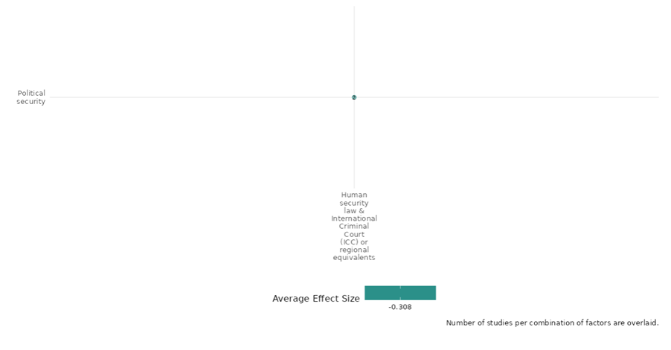

4.2.3 Peace Processes And Diplomacy
4.2.3(1)
Effect of peace processes and diplomacy on diplomatic relations
Mediation and informal peace agreements increase the likelihood of negotiations, agreements, and conflict termination, especially for intrastate conflicts.
Geographic region: Global, Africa
Effect size: Large effect (g=0.337)
Confidence in study findings: Medium (5 studies with 13 effect sizes)

Short summary
Peace processes and diplomacy interventions may include mediation and informal peace agreements in shaping diplomatic relations. Studies show that mediation is particularly effective in halting hostilities and enhancing the duration of peace agreements, especially when complemented by United Nations peacekeeping operations (UNPKOs). Informal peace agreements at the community level also contribute to stability, demonstrating that both formal and informal diplomatic interventions are essential for conflict resolution and long-term peacebuilding.

The intervention
Peace process interventions often involve mediation. While usually employed during the negotiation stage, mediation can also play a pivotal role in shaping the agreement and implementation phases of the peace process. It is typically conducted by international organizations (e.g., United Nations), regional bodies, or third-party states. As highlighted in one of the studies, mediation may be integrated with peacekeeping efforts to enhance its effectiveness. The duration of mediation varies significantly, ranging from short-term initiatives to extended engagements to address complex conflicts.

How the intervention is expected to work
Peace process through mediation works by fostering dialogue, building trust, and addressing information asymmetries among conflicting parties. It facilitates negotiations by reducing uncertainties and creating shared understanding, making agreements more likely. Mediation can encourage cooperation by breaking stalemates and promoting compromises. Its effectiveness may depend on the regional context and the stage of the peace process. Mediators often act as neutral third parties, leveraging their credibility to enhance communication and commitment among disputants.

The evidence base
The cell includes: 5 impact evaluation studies, 1 systematic review, and 9 qualitative studies.
The review examines and synthesizes findings from 49 studies on conflicts between rural communities and corporations, aiming to identify key features of anti-corporate activism in Indonesia.
The primary studies are set in: Kenya (1 study), Uganda (1 study), globally (6 studies), Indonesia & Philippines (2 studies), Myanmar (1 study), Palestine (1 study). Some qualitative studies include multiple countries, such as Greenberg (2000) (Russia, South Africa, Rwanda, Cambodia, Kyrgyzstan, Bosnia and Herzegovina, El Salvador, Croatia, North Korea; Ide (2018) (Rwanda, Uganda, Tanzania, Senegal, Congo, Rep, El Salvador, Mauritania), Lehrs (2021) (Palestine, Kosovo, Bosnia and Herzegovina).

Evidence findings
Mediation significantly increases the likelihood of conflict termination and reduces the risk of renewed violence, particularly when combined with peacekeeping, as it facilitates dialogue and fosters trust between conflicting parties (Clayton & Han, 2022; DeRouen & Ishita, 2018). Informal peace agreements, such as those studied in Adan (2020), also contribute to improved diplomatic relations.

The review evidence
These findings suggest that while informal diplomacy and negotiation can sometimes yield results, they are often slow and contingent on political dynamics rather than legal or institutional frameworks.

The impact evaluation evidence
There are 5 impact evaluations. Four study summaries are thus provided here:
Adan (2020) evaluates the role of informal peace agreements in managing community conflicts between the Borana and Gabra communities in Marsabit County, Kenya. The study focuses on the Maikona Declaration and other indigenous mechanisms as proactive tools for sustainable peace. The study employed a descriptive survey design, targeting 152 respondents, including elders, chiefs, women leaders, youth representatives, and NGO staff, with a final sample size of 110 participants. Data collection involved questionnaires and key informant interviews, with quantitative data analyzed through inferential statistics and qualitative data analyzed thematically. The findings suggest that informal peace agreements have played a significant role in managing conflicts between the Borana and Gabra communities, with notable success in fostering cooperation, reducing violence, and promoting peace. The study is rated medium as it is non-experimental and due to its partial description of the evaluation question, intervention, and outcomes.
Biswas (2007) examines the relative and combined impact of domestic institutions and international intervention on whether negotiations take place and whether a settlement is reached. It is commonly assumed that conflict-affected areas are failed states. But that is not the case. Conflict-affected states have wide variation in their capacity, and so there is a potential role for domestic political structures. The author applies a cross-national logit analysis of the correlates of negotiation and agreement using data from the analysis using the Minorities at Risk (MAR) dataset. The data comprise 475 observations covering 32 countries and 56 rebel groups. The analysis shows that democracy increases the likelihood of negotiations being held and an agreement being reached, though it has a weaker effect for agreement than negotiations. External intervention also helps with both of these, but with differing effects. Mediation and security guarantees (that is the promise of action, or inaction, in a given set of circumstances) have the greatest positive effect. If negotiations had been held in the previous year, the likelihood of an agreement being signed increases significantly. But there is substantial variation in effects. The positive effect of democracy is from Asia, with no effect in Africa, the Middle East and the Former Soviet Union (FSU). In contrast, mediation is most effective in Africa, the Middle East and former Soviet Union, but not in Asia. The study is rated medium confidence as a non-experimental design with only partial description of interventions and outcomes. There is no allowance for selection bias.
Clayton & Han (2022) analyses mediation and peacekeeping for managing conflicts, with mediation aiming to facilitate negotiated settlements and peacekeeping focusing on preventing agreements from collapsing. These tools are often used simultaneously, especially in intrastate conflicts, where peacekeeping operations create a favorable context for mediation by providing independent information and stabilizing the situation. The study examines the effectiveness and complementarity of mediation and peacekeeping in ending violent conflicts, particularly in the post-Cold War period. The study uses a variety of model specifications, including binary time-series cross-sectional (BTSCS) models and Heckman selection models, to evaluate the effects of mediation and peacekeeping on conflict termination. The analysis covers both inter- and intrastate conflicts from 1946 to 2013, using data from the Uppsala Conflict Data Program (UCDP). The study includes 1,523 observations of intrastate conflict-years and 258 interstate conflict-year observations, allowing for a detailed examination of the conditions under which mediation and peacekeeping are effective. The study finds that mediation is more effective than peacekeeping in halting hostilities, with mediation significantly increasing the likelihood of conflict termination in both inter- and intrastate conflicts. Peacekeeping, on its own, does not significantly affect the likelihood of conflict termination, but when combined with mediation, particularly transformative peacekeeping, it enhances the effectiveness of mediation in ending civil wars. The study is rated medium confidence as it is non-experimental study.
DeRouen & Ishita (2018) examines the role of mediation and United Nations peacekeeping operations (UNPKOs) in civil war peace agreements, focusing on their combined effect in reducing the risk of renewed or continued violence and enhancing the duration of peace agreements. The context includes various civil war scenarios globally, with a specific case study on the peace process in Guatemala during the 1990s, where mediation and peacekeeping efforts were instrumental in ending a long-standing conflict. The research utilizes a sample of 154 civil war peace agreements signed between 1975 and 2011, sourced from the Uppsala Conflict Data Program (UCDP).. The study employs logit and hazard models to analyze the effects of mediation and UNPKOs on the likelihood of violence recurrence and the duration of peace agreements. The analysis includes control variables such as agreement design, democracy, and income per capita. The study finds that mediation significantly reduces the probability of renewed violence, with a negative and significant effect on the risk of recurrence. The interaction of mediation and UNPKOs also shows a negative effect on recurrence, particularly at lower levels of recurrence risk. However, while mediation alone does not significantly extend the duration of agreements, its interaction with UNPKOs positively impacts agreement duration. The study is rated low confidence due to its non-experimental design and little description of the intervention.
Duursma (2022) examines how both military and civilian components of peacekeeping operations contribute to the conclusion of ceasefires in non-state conflicts. These conflicts, which do not involve a direct state actor, are often major sources of instability in fragile states. Using data from the African Peace Processes (APP) dataset, the study covers mediation and peacekeeping interventions in non-state conflicts across Africa from 1989 to 2018. The analysis employs an instrumental variable (IV) approach to address potential endogeneity in peacekeeping deployment, controlling for factors like intra-state conflict dynamics and the level of violence. The study finds that peacekeeping interventions—both military and civilian—have a significant effect on ceasefire agreements. Civilian peacekeeping staff, through mediation, improve trust between conflicting parties and engage state officials to prevent sabotage of peace efforts. The study is rated low confidence due to its little description of the intervention.

Confidence assessment
Overall medium: The cell is rated medium since it includes 4 studies and the findings across these studies display consistency.

Link to review summaries
Afrizal (2022)
All studies may be accessed via the EGM.

Other outcomes in this study:
Human security / economic security
Human security / physical security
Violence and atrocity prevention / nature and scale of violence and atrocities

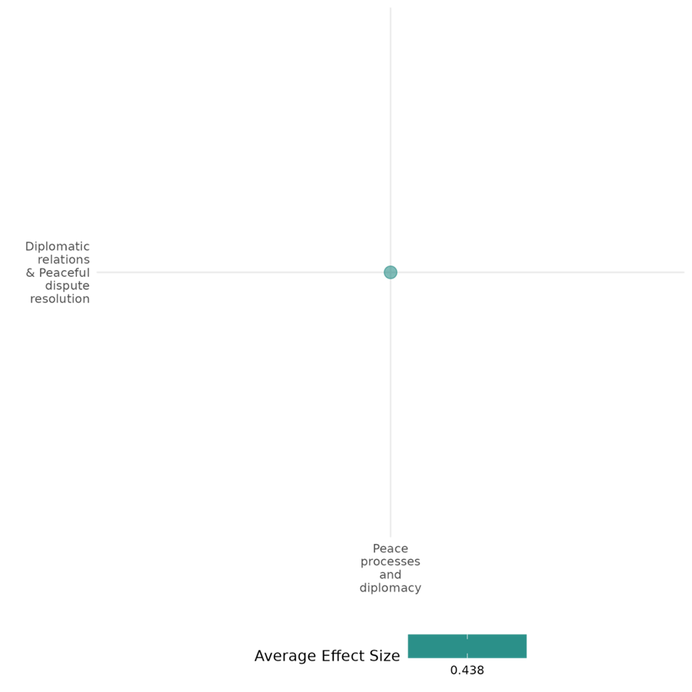

4.2.3(2)
Effect of peace processes and diplomacy on nature and scale of violence or atrocities
Peace process interventions, including mediation, ceasefires, and local agreements, generally reduce short-term violence, but can have unintended effects. Success varies based on context, conflict phase, and whether core issues are addressed.
Geographic region: Africa, Latin America, Middle East, Global
Effect size: Adverse effect (g=-0.44)
Confidence in study findings: Medium (9 studies with 28 effect sizes)

Short summary
Peace process interventions, including mediation, ceasefires, and local peace agreements, could reduce violence and foster sustainable peace. Mediation fosters dialogue, ceasefires provide temporary de-escalation, and local agreements can leverage indigenous practices to manage conflicts. These interventions often achieve short-term reductions in violence but can have unintended effects, such as rebel group fragmentation or selective violence. Evidence from 9 non-experimental studies across global, regional, and local contexts shows that success depends on the mechanisms used, the conflict phase, and local dynamics. Community-level and context-sensitive approaches yield more consistent outcomes in reducing the intensity of conflict.

The intervention
Peace process interventions often include mediation, ceasefires, and local peace agreements. These aim to reduce conflict intensity and foster sustainable peace. Mediation facilitates dialogue and negotiation between conflicting parties, while ceasefires serve to de-escalate violence temporarily. Local peace agreements leverage on indigenous mechanisms to promote cooperation and prevent the recurrence of conflict. These interventions are implemented in a variety of contexts, ranging from local-level disputes to large-scale civil wars, and their duration can vary depending on the scope and scale of the conflict.

How the intervention is expected to affect this outcome
Mediation reduces violence by addressing core issues of the conflict, fostering trust, and creating platforms for dialogue. Ceasefires halt hostilities temporarily, allowing space for further negotiations or the implementation of agreements. Local peace agreements are expected to de-escalate violence at the community level by engaging local leaders and leveraging culturally relevant conflict resolution practices.

The evidence base
The cell includes: 9 impact evaluation studies, 1 systematic review, and 5 qualitative studies.
The review discusses the effects of different interventions (which include infrastructure investment) on mitigating or preventing armed violence in developing and middle-income countries.

The primary studies are set in: Mozambique (1 study), Kenya & Côte d'Ivoire (1 study), Sudan (2 studies), Philippines & Chad (1 study), Colombia (2 studies), Syria (2 studies), Myanmar (1 study), and globally (4 studies).

Evidence findings
Peace process interventions generally reduce the scale of violence by fostering dialogue, building trust, and creating temporary or lasting agreements to de-escalate conflicts. Mediation and local agreements are commonly associated with short-term reductions in violence, especially when addressing core issues or involving local actors. However, these effects can vary, as interventions sometimes lead to unintended consequences, such as increased fragmentation among rebel groups or shifts in violence to other forms or regions. The effectiveness of interventions depends on the context, the conflict phase, and the mechanisms employed.

The review evidence
The review finds that domestic actors are central to resolving armed violence, while external mediators typically play a supplementary role but can sometimes escalate conflicts.

The impact evaluation evidence
There are 9 impact evaluations. Nine study summaries are thus provided here:
DeRouen & Ishita (2018) examines the role of mediation and United Nations peacekeeping operations (UNPKOs) in civil war peace agreements, focusing on their combined effect in reducing the risk of renewed or continued violence and enhancing the duration of peace agreements. The context includes various civil war scenarios globally, with a specific case study on the peace process in Guatemala during the 1990s, where mediation and peacekeeping efforts were instrumental in ending a long-standing conflict. The research utilizes a sample of 154 civil war peace agreements signed between 1975 and 2011, sourced from the Uppsala Conflict Data Program (UCDP). The study employs logit and hazard models to analyze the effects of mediation and UNPKOs on the likelihood of violence recurrence and the duration of peace agreements. The analysis includes control variables such as agreement design, democracy, and income per capita. The study finds that mediation significantly reduces the probability of renewed violence, with a negative and significant effect on the risk of recurrence. The interaction of mediation and UNPKOs also shows a negative effect on recurrence, particularly at lower levels of recurrence risk. The study is rated low confidence due to its non-experimental design and little description of the intervention.
Duursma (2021a) assessed how peace processes influence the likelihood of fragmentation within rebel groups during civil wars. The analysis builds on theories suggesting that internal rebel factionalism is often intensified by peace talks, as factions within rebel groups may hold divergent views on negotiations, peace agreements, or their implementation. Using a large dataset covering conflict dyads from 1975 to 2011, the study coded peace processes in three distinct phases: the initiation of peace talks, the signing of peace agreements, and the implementation of agreements. It then applied a logit model to analyze the probability of a rebel group splitting in relation to these phases, with data drawn from the Uppsala Conflict Data Program (UCDP) and the FORGE dataset to track rebel splits. The results show a statistically significant increase in the likelihood of rebel fragmentation during peace processes. Specifically, rebel groups are more likely to splinter when peace negotiations are in progress and more likely to fragment following the signing of a peace agreement. The study is rated low confidence due to its inadequate description of the intervention.
Duursma (2021b) examines the impact of local mediation efforts in reducing violence in Darfur, Sudan. Local mediation, involving negotiations led by local leaders and intermediaries rather than formal international actors, aims to manage and de-escalate violence between armed factions in the short term. Using event data on violent incidents in Darfur from 2003 to 2018, the study applies a logistic regression model to compare the likelihood of violent incidents before and after local mediation efforts, focusing on incidents involving different intercommunal groups and militias. The analysis finds that local mediation efforts are associated with a statistically significant reduction in violence in the short term. Specifically, the likelihood of violent incidents decreases in areas where local leaders successfully negotiate truces or agreements, suggesting that local mediation can temporarily mitigate conflict intensity and improve security. The impact of local mediation varies depending on the groups involved. The study is rated medium as it is non-experimental and due to its partial description of the intervention.
Gómez Triana and Ríos (2022) analyzes the effects of Colombia's 2016 peace agreement with the FARC-EP on armed violence in the Llanos Orientales region. As mentioned in the study, while the peace agreement aimed to end conflict with FARC-EP, this region, previously dominated by the FARC-EP's Eastern Bloc, continues to experience violence due to the emergence of dissident factions and other armed groups, including post-paramilitary groups and ELN guerrillas. The study applied a binomial logit regression model to analyze the presence of armed groups across 316 municipal observations in the Llanos Orientales region from 2016 to 2020. This model assesses factors like poverty, coca cultivation, and economic resources (e.g., oil exploitation) as predictors of armed group presence. Data is sourced from monitoring organizations on conflict, economic indicators, and local mapping software (QGIS) to visualize the spatial distribution of these armed groups post-peace agreement. Findings show that poverty and coca cultivation are significant predictors of armed group presence, especially for FARC-EP dissidents, while wax palm cultivation is associated with paramilitary successor groups. Armed group presence varies by economic resources in the region. Coca cultivation strongly correlates with dissident groups, while oil exploitation aligns with the ELN's areas of influence, reflecting each group’s financial strategies. The study is rated medium as it is non-experimental and due to its partial description of the intervention.
Gromes (2021) evaluates the hypothesis that military victories are more effective than peace agreements in preventing the recurrence of civil war. The authors critically examine post-conflict stability dynamics, proposing that negotiated settlements may be equally, if not more, effective in fostering enduring peace by addressing underlying governance issues. The study applies Weibull models to examine 48 civil wars ending between 1990 and 2009, assessing the effect of military victories versus peace agreements on the likelihood of conflict recurrence. It includes controls for factors such as GDP per capita, military balance, government effectiveness, and civil war fatalities. The analysis reveals that peace agreements are associated with a 77–94% decrease in recurrence risk. The study is rated medium as it is non-experimental.
Lundgren (2020) examined the causal mechanisms through which international organizations (IOs) mediate civil wars, with a focus on the Arab League and United Nations interventions in Syria during 2011-2012. The study employed a structured case comparison, analyzing the interventions by the Arab League and the UN using both quantitative and qualitative data. The study incorporates time-series analysis of fatality statistics and relies on interview data, official documents, and day-to-day reporting to trace causal mechanisms. Ordinary least squares (OLS) regression and autoregressive integrated moving average (ARIMA) time-series analysis are used to measure the interventions' effect on conflict intensity, particularly through daily fatality counts. The findings suggest that the UN’s mediation strategies produced statistically significant short-term reductions in violence. However, the significance of these reductions did not extend to long-term conflict resolution. It was also found that the UN’s capacity for broad ceasefire monitoring correlated with a statistically significant reduction in conflict intensity in monitored zones. The highlights the temporary calming effect in areas with active UN monitoring. The study is rated medium as it is non-experimental.
Lundgren, Svensson and Karakus (2023) examines local ceasefire agreements as mechanisms to reduce conflict intensity in civil wars, specifically analyzing 145 ceasefires from the Syrian Civil War (2011–2019). Local ceasefires are referred to as temporary, geographically limited agreements aimed at halting hostilities in specific areas without affecting fighting elsewhere. The study combines interrupted time-series analysis and spatial panel regression to assess the effects of ceasefires on conflict intensity. The sample includes geo-referenced data on local battle-related fatalities in Syria, segmented into 540 grid cells with daily observations. The study uses data from the Syrian Revolution Martyr Database and the Uppsala Conflict Data Program to track fatalities and spatially analyze violence trends before, during, and after ceasefire periods. The results show that local ceasefires have varied immediate effects, with some agreements leading to temporary escalation and others to de-escalation. Over time, however, the de-escalatory effects of ceasefires are more consistent. The study also finds that ceasefire effects extend to neighboring areas, suggesting a spatial diffusion of de-escalation. Areas adjacent to ceasefire zones often experience reductions in violence, as evidenced by a statistically significant decrease in battle-related fatalities in these regions. The study is rated low confidence due to the inadequate description of the intervention.
Prem et al. (2022) investigates the unintended consequences of the FARC's 2014 permanent ceasefire in Colombia, focusing on the increase in selective violence against social leaders in former FARC strongholds. The study employs a triple-differences methodology, leveraging temporal variation from the ceasefire and spatial variation in FARC presence and exposure to other armed groups. Municipal-level data on killings, armed group presence, and socio-economic indicators were analyzed to measure the differential impact of the ceasefire on social leader victimization. Findings suggest that the ceasefire led to a significant increase in the assassination of social leaders in areas both previously controlled by FARC and exposed to other armed groups. These killings were not observed in areas with only FARC presence or only exposure to other groups. The increase in killings was particularly pronounced in municipalities with weak state capacity, including low judicial efficiency and high electoral risk, high land restitution claims, and proximate to military bases. The study is rated low due the the lack of description of the evaluation questions.
Ruhe (2021) examines the role of third-party mediation in reducing conflict intensity, focusing on how mediation affects monthly fatality rates in civil conflicts across Africa from 1993 to 2007. Mediation, which encourages conflicting parties to negotiate, may vary in effectiveness depending on whether core issues of the conflict are addressed during talks. The analysis uses a temporally disaggregated approach, examining monthly data on battle-related fatalities from African intrastate conflicts between 1993 and 2007. Utilizing the UCDP Georeferenced Event dataset (GED) and the Managing Intrastate Conflict dataset (MIC), the study assesses conflict intensity at the bilateral-month level, distinguishing mediation types based on whether they address main conflict incompatibilities. The results of the study suggest that mediation addressing core conflict issues leads to a significant and lasting reduction in conflict intensity, with fatalities dropping by approximately 50% on average and maintaining lower levels over time. In contrast, mediation focused on conflict behavior rather than core issues results in only temporary reductions in violence, with fatalities rebounding to pre-mediation levels within a few months. The study is rated low confidence due to the inadequate description of the evaluation question.

Confidence assessment
Overall medium: While there are 9 impact evaluations included in this cell, the findings tend to be inconsistent.

Link to review summaries
Cramer (2016)
All studies may be accessed via the EGM.

Other outcomes in the study:
Violence and atrocity prevention / Diplomatic Relations & Peaceful dispute resolution
Community and state governance / Transitions of power
Community and state governance / Government performance
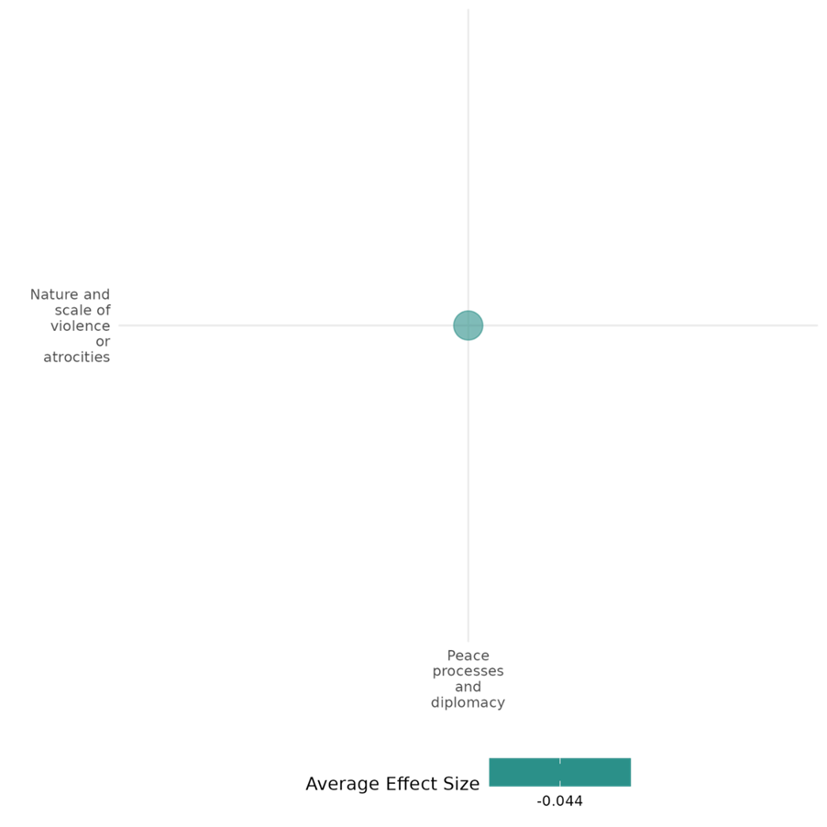

4.2.3(3)
Effect of training & job creation on social norms regarding violence and atrocities
Employment programs can reduce support for violence by improving economic security and fostering social cohesion, but their ability to shift social norms around violence varies. While some initiatives successfully decrease justification for violence, others show limited or no impact.
Geographic region: Africa, Middle East
Effect: Small effect (g=0.1)
Confidence in study findings: Low (8 studies with 41 effect sizes)

Short Summary
Employment programs may include vocational training and business support initiatives. Studies in Liberia, Somalia, and Afghanistan suggest mixed effects. While programs in Liberia and Somalia reduced support for violence and illicit activities, findings from Afghanistan show little or adverse impact on willingness to engage or support in violence.
The intervention
The studies analyzed various employment-focused interventions targeting high-risk youth in conflict-affected settings. In Liberia, the Action on Armed Violence (AoAV) Agricultural Training Program provided residential training, counseling, and life skills classes to young men involved in illicit activities such as logging and mining. Participants received farm inputs worth $125 at the end of the program. In Somalia, the International Labour Organization (ILO) YES and Y4C programs offered vocational training, cash-for-work opportunities, and microenterprise support to at-risk youth in Puntland, Somaliland, and South Somalia. These initiatives aimed to reduce support for violence by promoting economic inclusion and social cohesion. In Afghanistan, the UK-supported INVEST program provided vocational training to 25,000 youth in Helmand Province to improve employment outcomes and economic optimism.
How the intervention is expected to work
These interventions aim to shift social norms around violence through multiple mechanisms. By providing stable employment and skills, they reduce economic grievances that may otherwise push individuals toward violence. Training programs that bring together individuals from different ethnic or tribal backgrounds foster dialogue and social cohesion, potentially reducing intergroup tensions and support for violent movements. Additionally, perceived economic opportunity and government responsiveness may weaken the appeal of extremist groups that exploit economic and political frustrations. However, the extent to which these programs influence attitudes toward violence depends on the depth of economic benefits, program transparency, and participants’ initial predispositions.
The evidence base
This cell includes impact evaluation studies set in Liberia (3), Afghanistan (3), and Somalia (1).
The review evidence
Both reviews conclude that training interventions are successful in increasing employment. One of the reviews conducts meta-analysis, report a standardized mean difference of 0.07, which is a small effect.
Evidence findings
Findings indicate that employment interventions can reduce support for violence but with varying degrees of success. In Liberia, the agricultural training program led to a 20% reduction in illicit activities, though no participant abandoned them completely. During a short war that occurred during the study period, participants were less likely than the control group to engage with recruiters, suggesting that economic engagement can deter participation in violence. However, the long-term impact on social norms surrounding violence was unclear. In Somalia, the YES and Y4C programs significantly reduced support for violence. In Afghanistan, the INVEST program had no adverse or no measurable impact on young people’s willingness to use violence for political or other causes.
The impact evaluation evidence
There are 7 impact evaluations. Of these two papers are earlier versions of a later paper also included in the cell. Five study summaries are thus provided here:
Blattman and Annan (2011) and Blattman and Annan (2016) Specifically, the NGO Action on Armed Violence’s (AoAV) implemented a programme of residential agricultural training combined with counselling and “life skills” classes. The target group were youth engaged in illicit activities of mining and logging who were seen as at risk of engaging in conflict. At the end of the training participants received farm inputs worth $125. The NGO recruited 1100 high-risk men in 138 communities of which roughly half were assigned to the program on a random basis. Engagement in agriculture was of interest, with three-quarters of those assigned to the programme attending the training. Participants reduced their illicit activities by about 20%, though n one abandoned them completely. Incomes rose by on average US$12 a month. One-third of the participants did not receive the inputs because of supply issues, and so were promised future cash provided they stayed in the village. This group saw the largest reduction in illicit activities. A short war occurred during the study period. Participants were less likely than the control to have met with recruiters. The study is rated low confidence because of lack of information on power calculations.
Blattman (2014) evaluates a community education campaign on alternative dispute resolution (ADR) practices in Liberia, a country with weak formal institutions and high levels of property disputes and violence. The campaign aimed to promote informal dispute resolution skills, practices and norms to help parties reach self-enforcing bargains faster and at less cost than through the formal court system. The study used a randomized controlled trial design, with 116 communities randomly assigned to the treatment group and 130 to the control group. The intervention was implemented over 21 months, from March 2009 to November 2010, with communities randomly assigned to one of five phases. The study found limited evidence of changes in norms, with a small (4.3 percentage points) decrease in the likelihood of bringing money disputes to formal courts, but no significant changes in egalitarian attitudes or hypothetical dispute resolution approaches. The study is rated as high and medium confidence quantitative study.
Borino (2019) investigates the role of employment programs in reducing the willingness of individuals to engage in violence in Somalia. Specifically, it evaluates the impact of the International Labour Organization (ILO)'s "Joint Program Youth Employment Somalia" (YES) and "Youth for Change" (Y4C) initiatives on promoting stability and reducing support for violence among at-risk Somali youth. The YES and Y4C programs are employment-focused initiatives implemented in Somalia, targeting youth at risk of engaging in violent activities. These programs provide vocational training, cash-for-work opportunities, and support for micro, small, and medium enterprises (MSMEs). Although not designed explicitly for peacebuilding, their conflict-sensitive approach emphasizes inclusivity, transparency, and fostering social cohesion among beneficiaries in Bosasso (Puntland), Berbera (Somaliland), and Baidoa (South Somalia). The study analyzed data from approximately 200 participants to assess the impact of the YES and Y4C vocational training programs. Support for violence among beneficiaries significantly decreased, with those justifying violence for better services dropping from 16% to 6% and those endorsing violence for political causes falling from 37% to 27%. The study is rated as low confidence as it is before and after study design.
Kurtz (2015 and 2018) examines the effect of the UK-supported INVEST program, which offered vocational and technical training courses in nine technical vocational education and training (TVET) centres in Helmand Province in Southern Afghanistan from 2011. The programme was implemented by a US NGO, Mercy Corps. At the time of the evaluation 25,000 students had graduated from the programme of which nearly on-third were women. The study used propensity score matching to match recruits from February to April 2014 with successful applicants who had not yet started the programme. There was no effect on young people’s willingness to use violence for political or other cause. The study is rated low confidence because of lack of information on power calculations.
Lyall (2019) The study assessed that how aid can affect individual attitudes toward combatants (“combatant support”) in wartime. Study experimentally evaluated Mercy Corps’ “Introducing New Vocational Education and Skills Training” (INVEST) program in Kandahar, Afghanistan. INVEST sought to improve the economic livelihood of marginalized youth in a setting marked by high unemployment, weak government presence, and ongoing insurgency using two familiar staples of hearts and minds programming: vocational training (TVET) and unconditional cash transfers (UCT). The study was designed as a factorial randomized control trial design. Our sample consists of 2,597 at-risk men and women who were deemed vulnerable. The findings suggest that the intervention created a “boom and bust” dynamic marked by an immediate spike in pro-government sentiment followed quickly by a sharp reversal that led recipients to report increased support for the Taliban, including greater willingness to donate financially to its cause. Third, beneficiaries who received the combination of vocational training and cash transfers reported increased support for the government up to 7–8 months after INVEST concluded. The study is rated low confidence due to high attrition.
Confidence assessment
Overall low: The findings across the studies tend to be mixed, as also observed with the wide range of effect sizes. All the studies were rated low in their individual critical appraisals.

Link to review summaries
Lwamba (2022)
All studies may be accessed via the EGM.

Other outcomes of the study:
Social cohesion / Willingness to participate or help
Social cohesion / Feelings of trust & Acceptance of diversity
Social cohesion / Sense of belonging
Community and state governance / Government performance
Human security / Economic security
Human security / Food security & nutrition & Health security
Violence and atrocity prevention / Nature and scale of violence or atrocities
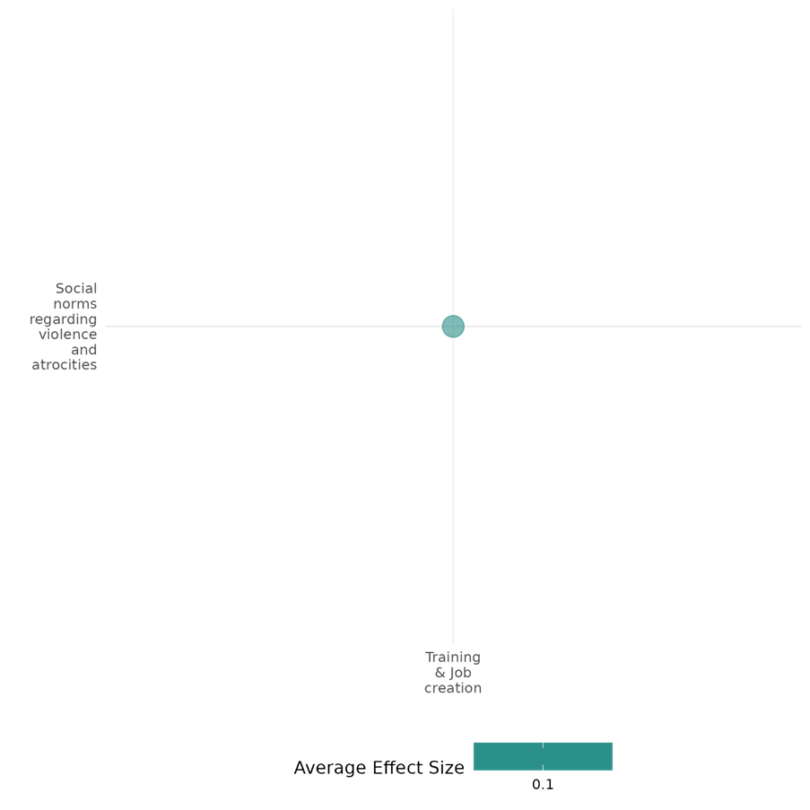

4.2.3(4)
Effect of the peace process and Diplomacy on Government performance
Effect: Negative (Failed to address the political dynamic due to elite dominance, military control, limited decentralization, and ethnic exclusion, which obstructed democratic reforms and contributed to a fragile governance structure)

Confidence in study findings: Low (three studies, low confidence)

Summary
The three qualitative studies examine post-conflict governance in Myanmar, Nepal, and global cases (Bosnia, Cambodia, Kosovo, East Timor, and the Middle East), documented military dominance, elite control, and ineffective peacebuilding. In Myanmar, the Tatmadaw maintained power through coercion and limited decentralization, obstructing democratic reforms. In Nepal, despite the 2006 Comprehensive Peace Accord (CPA), elite dominance and ethnic exclusion led to the collapse of the Constituent Assembly in 2012. Globally, the liberal peace model struggled as international interventions failed to address local political dynamics, entrenched divisions, and weak institutions, limiting sustainable governance.
The intervention
The Peace Process and diplomacy have faced significant challenges due to internal contradictions, external influences, and local adaptations. In contrast, some peace initiatives have been driven by illiberal strategies aimed at control rather than genuine conflict resolution. Dahal(2015) critically examines the liberal peace approach in Nepal's state-building and peacebuilding efforts. Richmond(2011) assessed the liberal peace approach to post-conflict state building, promoted by the US and UK since the 1990s. It examines case studies from Cambodia, Bosnia, East Timor, and Kosovo to highlight the failures of this approach, often due to internal contradictions or local manipulation. Stokke(2022)Peace initiatives in Myanmar over the last three decades have primarily served as illiberal strategies employed by the military to contain armed resistance groups, rather than genuine attempts at resolving the underlying causes of conflict.
How is the intervention expected to work
Post-conflict governance efforts are expected to rebuild state institutions, ensure political stability, and promote inclusive governance through constitutional reforms, power-sharing agreements, and international support. However, elite capture, military influence, and weak institutions frequently hindered these objectives. In Myanmar, governance efforts focused on hybrid models of military and civilian rule, but the 2021 coup reaffirmed military dominance. In Nepal, the CPA sought democratic transition, but the exclusion of key groups led to governance failure. Globally, peacebuilding efforts struggled as international interventions failed to account for local political complexities, limiting long-term stability.

The evidence base
There are three qualitative studies assessing the Effect of the peace process and Diplomacy on Government performance. These studies are by Stokke, K., Kham, K. K. M., Nge, N. K., & Kvanvik, S. H. (2022). Illiberal peacebuilding in a hybrid regime. Authoritarian strategies for conflict containment in Myanmar. Political Geography, 93, 102551; and Richmond, O. P. (2009). Liberal peace transitions: between statebuilding and peacebuilding. Edinburgh University Press; and by Dahal SH. Statebuilding and Peacebuilding in Nepal, 1990–2012: Anatomy of a Democratic Transition (Doctoral dissertation, George Mason University). All references are from these studies.
The evidence
The studies provide qualitative insights into post-conflict governance, highlighting how elite dominance, military control, and international interventions shaped state-building efforts.
- In Myanmar, political control was maintained through military offensives, ceasefire agreements, and economic incentives rather than genuine democratic reforms. While a hybrid regime was introduced, it primarily served military interests. The 2021 coup further entrenched military dominance, demonstrating the failure of previous governance efforts The military-based government institutionalized a hybrid regime with decentralization and representation as a framework for political transformation of EAOs. There was some degree of dual territorial, administrative and resource control at the local scale. The case study documented that the military used its tutelary power to obstruct substantive conflict resolution through negotiated state reforms, thus concluding that Myanmar’s peace initiatives during the last three decades should be understood as illiberal strategies for containing armed groups rather than attempts at substantive resolution of the core conflict issues (Stokke et al., 2022).
- In Nepal, the 2006 Comprehensive Peace Accord (CPA) aimed to transition Nepal toward democracy, but governance remained heavily influenced by elite dominance and ethnic exclusion. The collapse of the Constituent Assembly in 2012 highlighted the fragility of the state and the exclusion of key political actors from decision-making, ultimately weakening governance (Dahal, 2014).
- International efforts to promote liberal peace through democratization, economic reform, and legal frameworks often failed due to local manipulation, entrenched divisions, and weak institutional capacity. In Bosnia, Cambodia, Kosovo, East Timor, and the Middle East, peace interventions frequently reinforced elite power rather than fostering inclusive governance, limiting their long-term effectiveness (Richmond & Franks, 2011).
Across all three studies, a common finding observed that post-conflict governance efforts often failed to achieve substantive reform due to power imbalances, exclusionary politics, and ineffective international interventions.
Confidence assessment
Overall confidence: Low Confidence Qualitative Studies (for two studies It is unclear whether the study uses an established small n approach; for two studies no triangulation was found; for sources of potential data bias not for two studies)

4.2.3(5)
Effect of peace processes and diplomacy on economic security
Peace agreements can positively affect economic security through improvements in equitable resource sharing among communities.
Geographic region: Africa, Europe, Middle East, Asia, Latin America
Effect size: Large effect (g=0.667)
Confidence in study findings: Low (3 studies with 7 effect sizes)

Short summary
Peace agreements, such as the Maikona and Walda peace accords, can positively affect economic security, as seen in the Borana and Gabra communities in Kenya. Findings indicate that the majority of respondents view these agreements as effective in enhancing resource distribution and conflict management, therefore contributing to economic stability.

The intervention
The study in this cell examines the effect of informal peace agreements as a strategy for managing community conflicts, particularly between the Borana and Gabra communities in Marsabit County, Kenya. These agreements, such as the Maikona and Walda peace accords, aim to foster conflict resolution through community-based negotiations, equitable resource sharing, and sustained security efforts.

How the intervention is expected to affect this outcome
The study suggests that informal peace agreements, such as the Maikona and Walda peace accords, can positively influence economic security by fostering cooperation between conflicting communities. These agreements promote equitable resource sharing, which can reduce competition over scarce resources such as grazing land and water, crucial for the livelihoods of pastoralist communities like the Borana and Gabra.

The evidence base
This cell contains: 2 qualitative studies, and 3 quantitative studies. The study settings are Colombia, Kenya, Rwanda, and Mozambique. One of the qualitative studies had a larger scope, thus including the following: Bosnia and Herzegovina, Cambodia, Kosovo, Palestine, Timor-Leste. The study findings tend to be inconsistent.

Evidence findings
One of the studies found that peace agreements are effective in ensuring equitable resource sharing, with over 44% of the respondents thinking that the Maikona Declaration is effective, and 14% perceiving it as very effective in managing conflicts between the Borana and Gabra communities. Meanwhile, another study finds that peace agreements improved healthcare access but contribute to increased catastrophic health expenditures.

Included studies
Adan (2020) evaluates the role of informal peace agreements in managing community conflicts between the Borana and Gabra communities in Marsabit County, Kenya. The study focuses on the Maikona Declaration and other indigenous mechanisms as proactive tools for sustainable peace. The study employed a descriptive survey design, targeting 152 respondents, including elders, chiefs, women leaders, youth representatives, and NGO staff, with a final sample size of 110 participants. Data collection involved questionnaires and key informant interviews, with quantitative data analyzed through inferential statistics and qualitative data analyzed thematically. Survey responses revealed that a majority of respondents perceived the agreement as effective or very effective in ensuring equitable sharing of resources, thereby fostering greater cooperation and sustainable development in the region​. The study is rated medium as it is non-experimental and due to its partial description of the evaluation question, intervention, and outcomes.
Igei (2021) examines the impact of vocational training on economic empowerment and social reintegration among demobilized ex-combatants with disabilities in Rwanda. Using a pipeline approach, a quasi-experimental design that compares individuals who completed training with those about to start, the study finds significant positive effects on employment, income, and social reintegration. The training increased the probability of employment by over 60%, nearly tripled income levels, and improved social acceptance within families and communities. The study is rated medium due to its partial description of the intervention, outcomes, and evaluation questions. This is also a non-experimental study.
León-Giraldo et al. (2021) explored how Colombia's 2016 peace agreement with the FARC-EP affected inequalities in catastrophic health expenditures (CHE) in conflict-affected areas. The study focused on Meta, a region heavily impacted by conflict. Using survey data from the Conflicto, Paz y Salud (CONPAS) survey conducted in Meta, covering 1,309 households for the years 2014 and 2018, the study applies multivariate logistic regression to identify sociodemographic factors influencing CHE. To examine changes over time, the Oaxaca-Blinder decomposition method is used, which breaks down changes in inequality into factors such as distributional shifts in population and varying effects of sociodemographic characteristics. The findings suggest that the incidence of CHE slightly rose from 29.3% in 2014 to 30.7% in 2018, with inequality also increasing. Meanwhile, the decomposition analysis revealed that increased CHE inequalities were primarily due to shifts in the impact of sociodemographic factors, especially informal employment and residing in high-conflict zones. The results also show that the peace agreement improved healthcare access but also contributed to increased CHE inequality, with poorer households bearing a disproportionate financial burden.

Confidence assessment
Overall low: The rating for this cell is low considering that it includes less than 4 quantitative studies.

Other outcomes in the study:
Violence & atrocity prevention / Diplomatic relations & Peaceful dispute resolution
Human security / Physical security

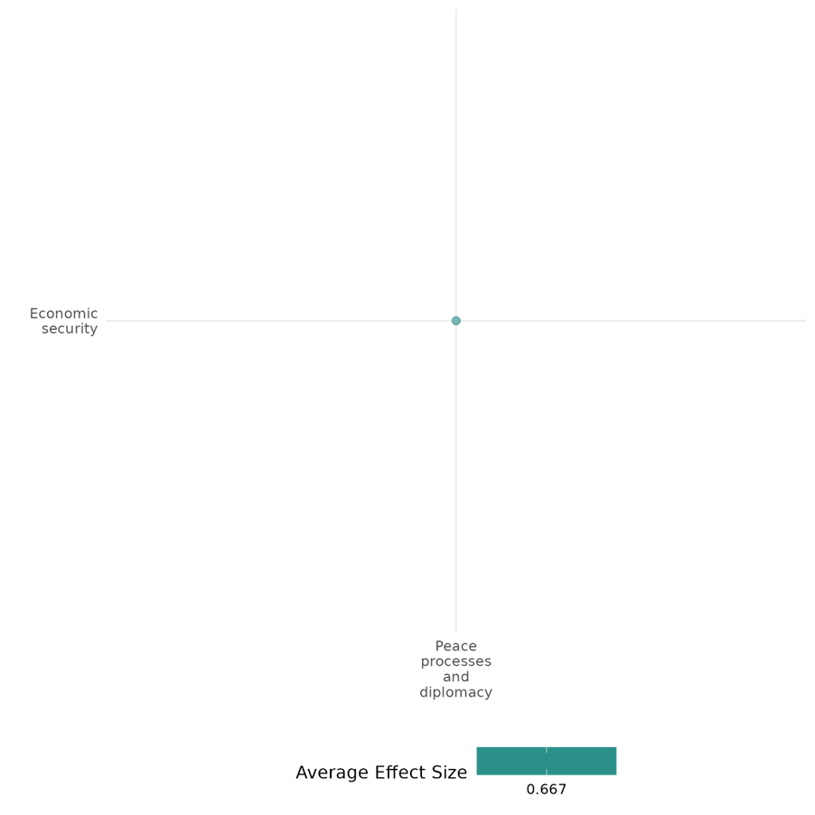

4.2.3(6)
Effect of peace processes and diplomacy on physical security
Informal peace agreements may foster prolonged security, while multilateral treaties require strong state capacity to be effective.
Geographic region: Global, Sub-Saharan Africa
Effect size: Large effect (g=1.422)
Confidence in study findings: Low (2 studies with 5 effect sizes)

Short summary
Peace processes and diplomacy interventions may include indigenous peace agreements and multilateral treaties. Indigenous peace agreements use traditional mediation and community-led negotiations, while multilateral treaties obligate state parties to respect human rights. Findings suggest that informal agreements contribute to long-term security, whereas treaties alone have no significant impact on physical integrity rights unless backed by strong state capacity.

The intervention
Interventions involving peace processes and diplomacy may include indigenous peace agreements and multilateral treaties. Indigenous peace agreements rely on traditional dispute resolution mechanisms, including clan elders' negotiations, local mediation, and community-based justice to prevent and mitigate violent conflicts over scarce resources. Meanwhile, multilateral treaties may obligate state parties to respect, protect, and fulfil fundamental civil and political rights, ensuring that individuals are protected from government abuses.

How the intervention is expected to affect this outcome
Informal peace agreements, often rooted in local customs and indigenous dispute resolution mechanisms, can help promote physical security by creating platforms for negotiations, fostering trust-building between conflicting parties, and institutionalizing mediation efforts. Meanwhile, strong state capacity and governance can play a crucial role in enforcing human rights protections, as strong bureaucratic institutions are expected to improve treaty compliance and enhance legal accountability.

The evidence base
The cell includes 2 non-experimental impact evaluation studies, and 1 qualitative study. One of the studies utilized a global dataset while the other two are set in Kenya and Sierra Leone.

Evidence findings
Findings suggest that informal peace agreements can foster peaceful coexistence and long-term security. In contrast, multilateral treaties show no significant impact on physical integrity rights outcomes. However, their effectiveness improves when combined with strong bureaucratic and infrastructural state capacity.

Included studies
Adan (2020) evaluates the role of informal peace agreements in managing community conflicts between the Borana and Gabra communities in Marsabit County, Kenya. The study focuses on the Maikona Declaration and other indigenous mechanisms as proactive tools for sustainable peace. The study employed a descriptive survey design, targeting 152 respondents, including elders, chiefs, women leaders, youth representatives, and NGO staff, with a final sample size of 110 participants. Data collection involved questionnaires and key informant interviews, with quantitative data analyzed through inferential statistics and qualitative data analyzed thematically. The findings suggest that informal peace agreements have played a significant role in managing conflicts between the Borana and Gabra communities, with notable success in fostering cooperation, reducing violence, and promoting peace. The study is rated medium as it is non-experimental and due to its partial description of the evaluation question, intervention, and outcomes.
Cole (2015) explores the role of state capacity in implementing human rights treaties, with a specific focus on the International Covenant on Civil and Political Rights (ICCPR). The study employs a two-stage regression model to examine the relationship between state capacity and treaty compliance across a sample of countries that are ICCPR signatories. The independent variables include various indicators of state capacity, such as bureaucratic quality, corruption control, military involvement in politics, and infrastructural strength, to test their impact on compliance with civil, political, and physical integrity rights. To address endogeneity, the following instrumental variables were used: ratification hurdles, legal system type, government type, and a global cumulative ratification measure. The study finds that higher bureaucratic efficacy, characterized by reduced corruption and military influence in politics, significantly enhances compliance with human rights commitments. Meanwhile, enhanced infrastructural reach, such as communication networks and urbanization, is associated with better protection of physical integrity rights. Finally, strong coercive capacities, indicated by larger military expenditures, were found to be linked to increased likelihood of rights violations. The study is rated medium confidence due to its partial description of the intervention and outcomes, and its non-experimental design.

Confidence assessment
Overall low: This cell has an overall low rating as it has less than 4 impact evaluations.

Other outcomes in the study:
Violence and atrocity prevention / Diplomatic relations & peaceful dispute resolution
Human security / Political security
Human security / Economic security

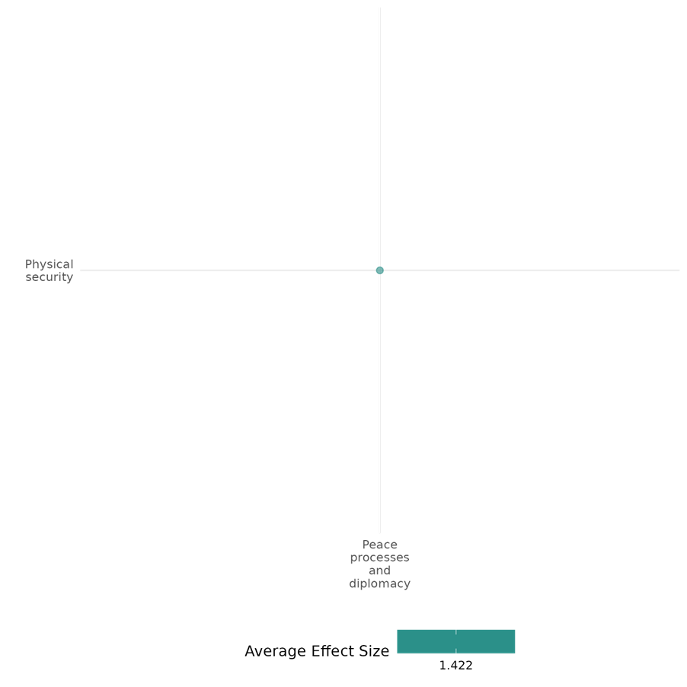

4.2.3(7)
Effect of peace processes and diplomacy on political security
Peace process interventions improve political security by enhancing civil liberties, and increasing women’s political participation through gender-inclusive agreements.
Geographic region: Global, Africa
Effect size: No effect (g=0.001)
Confidence in study findings: Low (2 studies with 6 effect sizes)

Short summary
Peace process interventions, such as agreements with human rights provisions could enhance political security by fostering stability, inclusivity, and civil liberties. Gender-specific provisions improve women’s political participation. Meanwhile, bureaucratic efficacy enhances the positive effects of human rights treaties on political security.

The intervention
Peace process interventions and diplomacy, which include peace agreements and provisions for human rights, aim to foster political stability and enhance civil and political rights. These agreements may incorporate gender-specific provisions, emphasizing inclusivity and equality. State capacity, including bureaucratic efficacy and reduced militarization, also plays a role in securing political rights by ensuring effective implementation.

How the intervention is expected to affect this outcome
Peace process interventions and diplomacy are expected to improve political security by fostering stability, reducing violence, and addressing systemic inequalities. Gender-specific provisions in peace agreements aim to increase women's political representation and civil liberties, creating a more inclusive political environment. Effective state capacity, characterized by strong bureaucratic systems and infrastructural reach, facilitates adherence to political rights and implementation of agreements. Conversely, excessive coercive capacity, such as militarization, may undermine these positive outcomes by increasing the likelihood of rights violations. Overall, these interventions aim to create a governance framework that secures and enhances civil and political rights post-conflict.

The evidence base
The cell includes 2 non-experimental impact evaluation studies, both of which include global datasets over a long-time frame. Bakken and Buhaug (2020) examines data from 160 countries between 1975 and 2017 while Cole (2015) evaluatesInternational Covenant on Civil and Political Rights (ICCPR) globally. There is also one qualitative study Adedokun (2019) included in this cell, which is set in Mozambique.

Evidence findings
Findings suggest that peace agreements that include gender-specific provisions are particularly effective in improving women’s political representation. It was also found that bureaucratic efficacy enhances the positive effects of human rights treaties on political security.

Included studies
Bakken & Buhaug (2020) examines the transformative potential of civil war on female empowerment, focusing on how conflict severity and termination conditions affect outcomes for women in the aftermath of civil conflict. The context includes various countries experiencing civil wars, with a particular emphasis on the role of peace agreements and gender-specific provisions in these agreements. The study employs a statistical analysis of changes in female empowerment across 160 independent countries from 1975 to 2017. It uses data from the Varieties of Democracy project to measure women's civil liberties and political representation. The analysis includes Ordinary Least Squares (OLS) models with panel-corrected standard errors to account for heteroskedastic residuals and autocorrelation. Findings suggest high-intensity conflicts lead to greater post-conflict improvements in women’s civil liberties and political representation compared to low-intensity conflicts. Peace agreements that include gender-specific provisions are particularly effective in improving women’s political representation. The study is rated as medium confidence as the study is non-experimental study and interventions are only partially described.
Cole (2015) explores the role of state capacity in implementing human rights treaties, with a specific focus on the International Covenant on Civil and Political Rights (ICCPR). The study employs a two-stage regression model to examine the relationship between state capacity and treaty compliance across a sample of countries that are ICCPR signatories. The independent variables include various indicators of state capacity, such as bureaucratic quality, corruption control, military involvement in politics, and infrastructural strength, to test their impact on compliance with civil, political, and physical integrity rights. To address endogeneity, the following instrumental variables were used: ratification hurdles, legal system type, government type, and a global cumulative ratification measure. The study finds that higher bureaucratic efficacy, characterized by reduced corruption and military influence in politics, significantly enhances compliance with human rights commitments. Meanwhile, enhanced infrastructural reach, such as communication networks and urbanization, is associated with better protection of physical integrity rights. Finally, strong coercive capacities, indicated by larger military expenditures, were found to be linked to increased likelihood of rights violations. The study is rated medium confidence due to its partial description of the intervention and outcomes, and its non-experimental design. The study finds that state capacity plays a critical role in improving both empowerment rights and physical integrity rights. High bureaucratic efficacy and territorial reach enhance adherence to these rights, enabling states to implement treaty commitments effectively, while excessive coercive capacity (e.g., militarization) often leads to rights violations. The effectiveness of human rights treaties is thus conditional on a state's administrative and infrastructural strength, with coercive states showing mixed or adverse outcomes. The study is rated medium confidence due to its partial description of the intervention and outcomes, and its non-experimental design.

Confidence assessment
Overall low: This cell has an overall low rating as it has less than 4 impact evaluations.

Other outcomes in the study:
Human security / Physical security

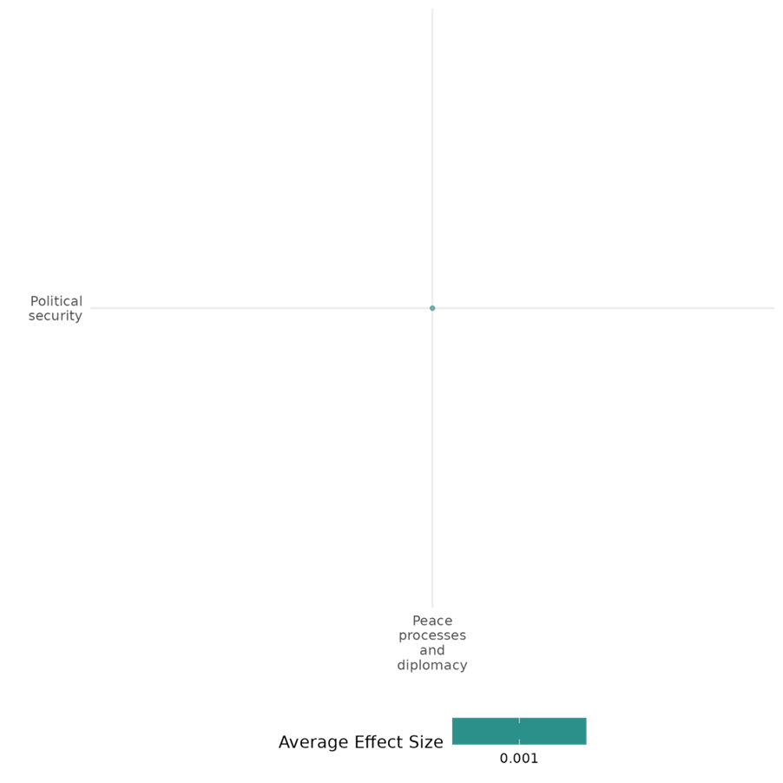

4.2.3(8)
The effect of peace processes and diplomacy on environmental security
Peace process and diplomacy interventions negatively affect environmental security, as it could accelerate deforestation and forest disturbance in protected areas.
Geographical Region: Latin America
Effect size: Adverse effect (g=-0.008)
Confidence in study findings: Low (2 studies with 4 effect sizes)

Short summary
Peace process and diplomacy interventions, such as Colombia’s 2016 peace agreement with the Revolutionary Armed Forces of Colombia (FARC), have negatively affected environmental security. While the agreement aimed to promote rural stability and reduce forest disturbance, it inadvertently accelerated deforestation and illegal land grabbing, particularly in protected areas. Success in improving environmental outcomes is mediated by enforcement capacity and governance.

The intervention
Peace process interventions and diplomacy interventions, specifically Colombia’s peace agreement with the Revolutionary Armed Forces of Colombia (FARC), aimed to stabilize rural areas through land redistribution, legal titling, and infrastructure development. These measures were intended to reduce conflict and foster sustainable land use, particularly in regions previously controlled by armed groups.

How the intervention is expected to affect this outcome
The intervention was expected to enhance deforestation and forest disturbance outcomes by reducing illegal land use, discouraging speculation, and promoting conservation practices. With formalized land ownership and rural development programs, areas previously protected by conflict-driven inaccessibility were anticipated to transition to regulated and sustainable land management.

The evidence base
The cell includes two non-experimental impact evaluation studies analyzing the environmental impacts of Colombia’s peace agreement using geospatial data. Both studies examined protected areas and conflict-affected regions using satellite imagery and local interviews, focusing on deforestation and forest disturbance trends post-agreement.

Evidence findings
Peace agreements can have unintended consequences on environmental security. Clerici (2020) found a 177% increase in deforestation within protected areas and 158% in buffer zones, exacerbated by weak governance and enforcement. Murillo-Sandoval et al. (2020) highlighted a 50% surge in forest disturbance, driven by illegal land grabbing and speculative activities in former FARC-controlled areas. These findings indicate that peace processes can undermine environmental security if there are no robust governance mechanisms to manage transitions effectively.

Included studies
Clerici (2020) analyzes the impact of Colombia's 2016 peace agreement with the Revolutionary Armed Forces of Colombia (FARC) on deforestation rates within and around Colombian protected areas (PAs). The peace deal ended five decades of armed conflict, which had indirectly protected some forested regions by limiting human access due to the presence of armed groups. Using high-resolution satellite data from the Global Forest Change dataset, the authors compared deforestation rates over two periods: three years before the peace agreement (2013–2015) and three years after (2016–2018). The analysis covered 39 Colombian protected areas and their surrounding 10-km buffer zones. The results indicate a statistically significant 177% increase in deforestation within protected areas after the peace agreement. In particular, deforestation surged in areas within the Amazon region previously under FARC influence, where the government’s presence and enforcement were historically weak. Buffer zones surrounding the PAs also saw a 158% rise in forest loss, totaling an additional 686 km². The study also highlights those regions like the Serranía de la Macarena National Natural Park experienced the most significant deforestation increases. The study is rated medium confidence due to its partial description of the intervention and outcomes, and its non-experimental design.
Murillo-Sandoval et al. (2020) investigates the impact of Colombia's 2016 peace agreement on forest disturbance, focusing on the Andes-Amazon Transition Belt (AATB). The agreement ended decades of conflict between the Colombian government and the FARC, with the FARC’s previous control acting as a form of enforced conservation. The agreement introduced reforms including land redistribution, legal land titling, and new road construction in former conflict zones. The study employed a mixed-methods approach, combining automated satellite disturbance detection from Landsat images (2010-2018) with ethnographic data. Satellite imagery was used to track changes in forest cover, with disturbance quantified across stages: wartime, negotiation, and post-peace (2017-2018). Ethnographic data from interviews (n=80) in Putumayo, including input from farmers, government officials, and community leaders, provided insights into local perceptions and land-use practices following FARC demobilization. After the peace agreement, forest disturbance surged by 50%, expanding into deeper Amazon areas. Protected areas, previously controlled by FARC, experienced notable increases in deforestation. The study also finds that the peace framework inadvertently accelerated land speculation and illegal land grabbing, particularly in protected areas. The study is rated low confidence due to the inadequate description of the outcomes.

Confidence assessment
Overall low: This cell is rated low as it only contains 2 studies.

Other outcomes in the study:
None
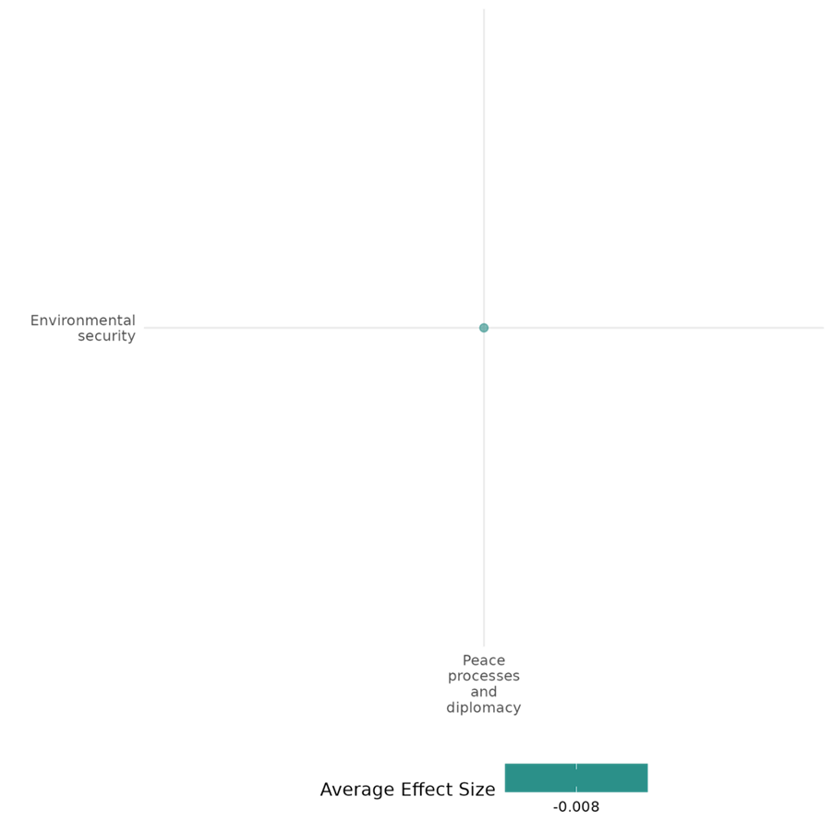

4.2.4 Sanctions
4.2.4(1)
Effect of sanctions on nature and scale of violence and atrocities
Sanctions have varying effects on the nature and scale of violence and atrocities, and these effects are moderated by sanction type and implementation.
Geographic region: Africa, Asia, Middle East
Effect size: Adverse effect (g=-0.13)
Confidence in study findings: Medium (24 studies with 68 effect sizes)

Short summary
Sanctions, implemented by governments and international organizations like the UN, EU, and U.S., target states, entities, or individuals responsible for violence, repression, or rights abuses. They include economic, arms, and targeted sanctions, often affecting entire economies or specific actors. Sanctions aim to reduce violence and atrocities by weakening financial and operational capacity while restricting access to weapons. However, comprehensive sanctions can inadvertently harm civilians and exacerbate grievances, leading to unrest, terrorism, or repression. Evidence from 27 evaluations highlights mixed effects, with outcomes influenced by sanction type, regime adaptability, and implementation context. Short-term, targeted measures showed greater success in specific contexts.

The intervention
Sanctions are coercive tools implemented by governments or international organizations, such as the United Nations (UN), European Union (EU), and the United States, to influence the behavior of target states, entities, or individuals. They include economic sanctions (trade restrictions, asset freezes), arms embargoes (bans on weapons transfers), targeted sanctions (focused on specific individuals or entities), comprehensive sanctions (affecting entire economies), and dual-use sanctions (restricting items with civilian and military applications). Sanctions often target governments, ruling elites, or institutions responsible for rights abuses, terrorism, or conflict but can indirectly harm civilians, especially under comprehensive measures. Their duration ranges from short-term to decades, as seen in sanctions against Iran or Cuba, and their design aims to balance economic pressure with minimizing harm to non-targeted populations. Multilateral sanctions, such as UN arms embargoes, focus on international peace and security, while unilateral sanctions, such as U.S. measures, often address national security and human rights concerns.

How the intervention is expected to affect this outcome
Sanctions are expected to affect the nature and scale of violence and atrocities through economic, political, and social mechanisms. Economic sanctions, such as trade restrictions and asset freezes, aim to weaken the financial and operational capacity of regimes or groups, reducing their ability to fund violence or atrocities. However, these sanctions can exacerbate economic hardship, fueling grievances and increasing domestic unrest, which may escalate violence, terrorism, or repression. Arms embargoes specifically restrict access to weapons, aiming to reduce conflict intensity and prevent large-scale atrocities, such as genocides or mass killings. Targeted sanctions, like travel bans or asset freezes on specific individuals, seek to disrupt networks of perpetrators without harming broader populations. Nevertheless, they can inadvertently strengthen authoritarian regimes by rallying domestic support against perceived external threats.
Sanctions can also influence violence indirectly by disrupting local economies and social structures. Comprehensive sanctions, which broadly target an entire economy, may heighten intergroup tensions by creating resource scarcity and competition, leading to increased violence or repression against marginalized groups. Conversely, arms embargoes and sanctions with humanitarian exemptions may mitigate such risks by limiting conflict resources while maintaining civilian protections. While sanctions are generally intended to deter violence and atrocities by imposing economic and logistical constraints, their success depends on the type of sanction, the context in which they are implemented, and the capacity of targeted actors to adapt to external pressures.

The evidence base
This cell includes 24 impact evaluations and 1 qualitative study. Most of the studies are rated with medium confidence.
All the impact evaluation studies utilized secondary data, with some analyzing global datasets and later narrowing their focus to economies subjected to sanctions (18). Two (2) studies concentrated on Africa, while others examined the broader implications of U.S. sanctions (1) or their effects on specific economies (2), including China, Iran, India, the Philippines, and Indonesia. Additionally, one study analyzed the impact of sanctions on the West Bank and Gaza Strip (1), while another focused specifically on Iran (1).
The qualitative study utilized a global dataset and included case studies from Haiti and North Korea.

Evidence findings
The evidence reveals mixed effects of economic sanctions on nature and scale of violence and atrocities, with significant heterogeneity in outcomes depending on the context, type of sanctions, and local mediators. In some cases, sanctions intensified terrorism, repression, and violence, as economic hardship and weakened state capacity created conditions for dissent, grievances, and increased operational capacity for violent actors. For instance, sanctions often led to increased domestic terrorism and human rights abuses, particularly in authoritarian regimes, as leaders relied on coercion to maintain control under economic strain. Conflict dynamics were also affected, with sanctions prolonging civil wars in certain cases.
However, the effects were not uniformly negative. Sanctions that were short-lived, incentivized compliance, or targeted specific actors showed some success in improving human rights or reducing violence. Regime type and local conditions played critical roles in shaping outcomes. Personalist regimes tended to increase repression under sanctions, while single-party systems displayed more resilience. Sanctions coupled with international pressure or alternative measures, such as arms embargoes, showed moderate success in curbing violence but often failed to address root causes.

Included studies
Altmann & Giersch (2021) examines the unintended consequences of economic sanctions, specifically focusing on their impact on terrorism in target states. It explores whether economic sanctions lead to an increase in the lethality of terrorism, using Iran as a contextual example where sanctions have led to significant economic contraction and social turmoil. The study utilizes country-year panel data from 1970 to 2009, covering 46 countries that experienced sanctions during this period. The dependent variables are the total number of fatalities from terrorist attacks and the average success rate of these attacks, sourced from the Global Terrorism Database (GTD). The analysis employs various regression models, including negative binomial regression and Tobit regression, to assess the relationship between sanctions and terrorism. The results indicate that economic sanctions are positively associated with an increase in the number of fatalities resulting from terrorist attacks, suggesting that sanctions may enhance the operational capacity of terrorist organizations. However, the study finds no significant relationship between sanctions and the success rate of terrorist attacks. The study is rated as medium confidence as it is a non-experimental study with only partial description of the intervention. The study focuses primarily on the consequences of economic sanctions rather than detailing the specific mechanisms or processes of the sanctions themselves
Amodio et al. (2021) examine the impact of security-motivated trade restrictions, specifically the dual-use list imposed by Israel, on political violence in the Occupied Palestinian Territories (OPT), which include the West Bank and the Gaza Strip. The dual-use list restricts the import of goods that can be used for both civilian and military purposes, affecting sectors that rely heavily on these inputs. The context is the ongoing Israeli-Palestinian conflict, with the West Bank being subject to these restrictions since 2008. The research employs a difference-in-differences strategy to compare economic and political outcomes across sectors and localities based on their intensity in dual-use inputs. The study uses data from a repeated cross-section of approximately 33,000 Palestinian manufacturing establishments surveyed from 1999 to 2012. It also incorporates data on political violence from the Integrated Crisis Early Warning System (ICEWS) dataset, covering events from 1999 to 2012. The analysis focuses on the West Bank, with the Gaza Strip serving as a placebo due to its complete blockade during the study period. The study finds that the policy accounted for 15.7% of all political violence events in the West Bank during the same period. The increase in political violence was more pronounced in localities with higher employment concentration in dual-use input intensive sectors. The study is rated as medium confidence as it is a non-experimental study.
Choi (2013) and Choi (2014) examines the impact of economic sanctions on international terrorism, highlighting how sanctions, often used by major powers to influence the policies of target economies, can unintentionally harm vulnerable groups within those countries. Economic sanctions are described as a foreign policy tool used by governments to pressure target countries into political or behavioral changes, such as promoting democracy or human rights. The study uses cross-sectional, time-series data, drawing on information about economic sanctions from Hufbauer et al. (2008) and terrorism incidents from the ITERATE and GTD databases. The analysis begins with a negative binomial regression model to evaluate the relationship between sanctions and terrorism. To address endogeneity, a two-step model is introduced: economic sanctions are first examined as a cause of poverty, and then predicted poverty levels are used to assess their impact on domestic terrorism. The results indicate a significant increase in domestic terrorism associated with economic sanctions. Specifically, the study finds that sanctions function as a "violence trigger structure," creating conditions that disproportionately impact impoverished populations, who, under heightened economic distress, are more prone to engage in terrorism. The analysis reveals a statistically significant 149% increase in domestic terrorist incidents in countries under sanctions, suggesting that sanctions lead to an intensified likelihood of terrorism by fostering economic grievances among disadvantaged groups who feel targeted by these external economic pressures.This study is rated medium confidence as it is a non-experimental study.
Clay (2018) evaluates the effect of economic sanctions on global human rights practices. It utilized data on 159 countries from 1981-2005. The independent variable of interest are human rights sanction events (i.e., fields on “improve human rights” and “issue”); sanction data come from the Threat and Imposition of Sanctions (TIES) dataset. From here, six dichotomous variables were created. Spatial weights were developed to consider state similarities relevant to the sanction event of interest. The outcome variable of interest is government respect for physical integrity rights, as embodied in the Physical Integrity Rights Inex of the CIRI Human Rights Data Project. The spatio-temporal autoregressive model is applied in some of the regressions reported in the study. The study finds that human rights sanctions impact both target states and similar neighboring countries. A threat of sanctions improves respect for physical integrity rights if it starts and ends within the same year without actual imposition. However, when sanctions are imposed, respect for these rights declines, though this effect typically fades by the following year. Nearby countries with strong human rights practices positively influence respect for these rights in the targeted state. The study is rated medium confidence as it is non-experimental study.
Carneiro and Apolinário (2014) investigate the human rights consequences of targeted economic sanctions, particularly focusing on whether these sanctions, aimed at specific groups within leadership rather than the general population, offer any human rights protections over conventional sanctions. The study examines cases of UN-imposed targeted sanctions on African countries between 1992 and 2008, using data from the Targeted Sanctions Consortium to analyze effects on physical integrity rights, including the right to life and the prohibition of torture. An ordered logit model on cross-sectional, time-series data, covering 22 UN targeted sanctions regimes in Africa and 918 country-year observations is employed. The standard errors were clustered at the country level. The Political Terror Scale is used to measure human rights violations, while controls include variables such as economic growth, armed conflict, and regime type. The findings reveal that targeted sanctions do not significantly protect human rights compared to conventional sanctions. Instead, they often worsen conditions for physical integrity rights (the right to life and prohibition of torture) in the targeted countries. The study shows a 1.74 times higher likelihood of worsening human rights protections in countries under targeted sanctions compared to those without sanctions. This escalation of violence is attributed to internal political dynamics; sanctions weaken targeted leaders, prompting opposition groups to increase demands, which are met with repression. The study is rated as medium confidence as it is non- experimental study design.
Drury and Li (2006) analyse the effectiveness of U.S. economic sanction threats against China from 1989 to 1995, particularly regarding human rights improvements. Following the Tiananmen Square incident, the U.S. threatened to revoke China's Most Favored Nation (MFN) trade status unless human rights conditions improved. This period marked a strategic attempt to leverage economic pressure to influence China’s domestic policies on human rights. The study uses a case analysis of U.S. threats to China's MFN status, examining both Congressional records and public statements as sources of sanction threats. Data on China’s human rights practices, including political repression and releases of dissidents, were gathered from Xinhua News Agency and weighted event data on political accommodations and repression from Drury and Olson (2001). The study employs a time-series analysis, with a seemingly unrelated regression model to capture the reciprocal nature of U.S.-China interactions over sanction threats and China's corresponding actions. The findings reveal that contrary to U.S. intentions, increased sanction threats led to a decrease in Chinese accommodations, such as the release of political prisoners or relaxation of restrictions. This study is rated medium confidence as it is a non-experimental study.
Escribà-Folch (2011) investigates how economic sanctions affect authoritarian regimes’ strategies regarding repression and public spending, focusing on how different regime types respond to external pressure. The study suggests that the impact of sanctions on a regime's stability and policy choices is closely tied to its type, with sanctions influencing authoritarian leaders’ reliance on repression or loyalty through public expenditures. The analysis covers 1970 to 2000, using data on regime types, public expenditures, and repression levels across authoritarian states. The study categorizes regimes into personalist, single-party, and military types, each with different support structures and governing strategies. To analyze the impact of sanctions, the study employs fixed-effects panel regression, instrumental variable Generalized Method of Moments estimator, and an ordered logistic regression. The results reveal that sanctions lead to a significant increase in repression in personalist regimes, as limited fiscal options force these regimes to rely heavily on coercion. Military regimes also show a significant, but more moderate, increase in repression, balancing it with loyalty efforts within the military. Single-party regimes, however, show no significant increase in repression. The study is rated low confidence due to the absence of detailed information on power calculation. The description of the intervention was also rather little.
Gutmann (2019) investigates the effects of U.S. economic sanctions on human rights, specifically examining whether sanctions are "precision-guided" or "blunt" in their impact across various human rights categories. The study applied an endogenous treatment-regression model. The dataset spans U.S. sanctions from 1976 to 2012 and includes multiple control variables for economic, political, and international alignment factors. The model recognizes that sanctions are not randomly assigned; rather, they are likely to be imposed on countries already exhibiting certain characteristics (e.g., human rights abuses), creating potential bias in the estimates. Instruments such as distance from the U.S. and alignment in UN General Assembly voting are therefore used to address endogeneity. Similarly, U.S. sanctions do not have a statistically significant impact on basic human rights, such as freedom from torture, unlawful imprisonment, or arbitrary detention. When putting into account the different forms of sanctions, the results show that U.S. economic sanctions, regardless of type or duration, do not significantly impact basic human rights. This study is rated medium confidence as it is a non-experimental study.
Harris (2019) explores the humanitarian value of economic sanctions, particularly their effectiveness and unintended consequences. The study examines specific case studies, such as sanctions imposed on Iran, and evaluates their outcomes through historical and empirical analysis. It also investigates the evolution of "smart sanctions" designed to minimize harm to civilian populations while targeting specific actors or sectors. The analysis relies on a literature review of economic sanctions and their historical application from the early 20th century to modern-day cases. It uses data from key sources, including the Hufbauer, Schott, and Elliott dataset on sanctions episodes. Empirical evaluations focus on success rates for different humanitarian objectives, drawing from secondary data and case-specific studies like sanctions on Iran. The study reports that sanctions intended to end civil wars were moderately successful (53–71% success rate), but their impact on other humanitarian goals—such as improving human rights or curbing terrorism—was generally limited, with success rates often below 25%. Sanctions frequently led to unintended consequences, such as intensifying human rights abuses. While theoretically less harmful, smart sanctions remain inconclusive in their effectiveness. Some evidence suggests they are less destabilizing than comprehensive sanctions but still fail to achieve humanitarian objectives consistently. This study is rated medium confidence as it is non-experimental and due to its partial description of the intervention, outcomes, and evaluation questions.
Hasan (2016) assesses the impact of natural resources on conflict intensity, with a focus on how international policies, particularly economic sanctions, influence both civil and inter-state conflicts. The context emphasizes conflicts in regions with abundant natural resources, where revenues from these resources often fuel prolonged conflicts. Cox proportional hazards models were used to assess the impact of sanctions on conflict duration. The dataset includes various types of sanctions, such as trade embargoes, arms sanctions, and aid suspensions, applied to countries experiencing civil conflicts. Control variables account for economic resilience, conflict severity, and resource dependency, isolating the effect of each sanction type on the likelihood of conflict resolution. The study finds that comprehensive embargoes and arms sanctions are the most effective at reducing conflict duration, as they restrict access to essential resources and military supplies, directly limiting the capacity of warring groups. Arms sanctions, in particular, are shown to have a statistically significant effect in shortening conflicts by curtailing the ability of groups to sustain prolonged military engagements. However, other types of sanctions, such as trade sanctions and aid suspensions, show limited impact on conflict duration. Trade sanctions, which primarily affect non-military goods, often fail to restrict the flow of necessary resources to warring parties, particularly in cases where resources are locally sourced. Aid suspensions also have a minimal impact, as they tend to reduce the humanitarian assistance available to civilians rather than constraining combatants’ access to resources. The study is rated low confidence due to lack of power calculation.
Heffington (2017) assesses the impact of economic sanctions on domestic terrorism within target states, focusing on how sanctions create economic hardship that can lead to increased recruitment and activity by terrorist groups. Using data from 158 countries from 1977 to 2009, the study employs negative binomial regression models to analyze the relationship between costly sanctions (those with significant economic impact) and the frequency of domestic terrorist attacks. The dependent variable is derived from the Global Terrorism Database (GTD), limited to incidents classified as domestic terrorism. The study finds that the imposition of costly economic sanctions significantly increases the frequency of domestic terrorist incidents within targeted states. Specifically, following the imposition of sanctions (and varying the sanctions from 0 to 1), the predicted number of terrorist attacks rises by 115%, from an expected baseline of approximately 2 incidents to around 4.3. The data also show that this increase in terrorism is most pronounced shortly after sanctions are imposed. Over time, however, the effect gradually diminishes. The study is rated low confidence due to the absence of detailed information on the intervention.
Hogendoorn (2009) evaluates the humanitarian impact of UN arms embargoes, focusing on their role in ending or limiting violent conflict. The quantitative component (using regression models) analyzed a dataset of all civil wars from 1945 onward, incorporating variables related to conflict duration, intensity, and humanitarian consequences, such as death tolls, displacement, and life expectancy changes. The primary independent variable is the imposition of arms embargoes, categorized as impartial (targeting all combatants) or partial (favoring specific parties). The dependent variables proxy humanitarian suffering, capturing the death and destruction associated with the conflict. The statistical analysis reveals that Impartial arms embargoes were statistically associated with prolonged conflicts. Meanwhile, there is no significant evidence that arms embargoes reduce death tolls, displacement, or other measures of humanitarian suffering. Instead, findings suggest that embargoes may inadvertently increase devastation, though these results are less robust statistically. The study is rated low confidence due to its little description of the evaluation questions.
Hultman (2015) examines how international sanctions, specifically economic sanctions and arms embargoes, influence the intensity of violence in civil conflicts. The analysis combines monthly data on conflict violence (measured by battle-related fatalities) in African civil conflicts from 1989 to 2005 with data on sanctions. The sanctions data are drawn from international sources documenting both economic sanctions and arms embargoes, providing granular information on the timing, type, and scope of each sanction. Using negative binomial regression, the study assesses the relationship between both threatened and imposed sanctions on conflict intensity, while accounting for various factors such as regime type, population, and GDP. The study finds that both threatened and imposed economic sanctions significantly increase conflict intensity in civil conflicts, as measured by battle-related fatalities. By contrast, arms embargoes have a significant negative effect on conflict intensity, meaning they are associated with a reduction in battle-related violence. The study also examines the impact of threatened sanctions and finds that even the threat of economic sanctions significantly increases violence, similar to imposed sanctions. The study is rated low confidence due to limited description of the intervention.
Krain (2016) examines the impact of economic sanctions on the severity of ongoing genocides or politicides. Economic sanctions are often implemented to deter regimes from violating international norms. However, their effectiveness in cases of systematic mass killings has been debated. This study seeks to clarify whether sanctions serve as a tool to reduce the severity of these atrocities or remain ineffective. This empirical study included country years from 1976 to 2008 when genocides or politicides were already occurring to assess the relationship between economic sanctions and atrocity severity in cases of genocide or politicide. Results indicated that sanctions neither exacerbate atrocities nor alleviate them. This result holds regardless of the number of sanctions imposed, cost, comprehensiveness, or duration. Mere threats of sanctions, even when coupled with other interventions (e.g., military action or naming and shaming), show no significant impact on reducing atrocity severity. Sanctions implemented by international organizations are not more effective than unilateral sanctions in reducing the magnitude of killings. The combination of sanctions with military interventions, impartial actions, or international naming and shaming campaigns does not alter their ineffectiveness. This study is rated low confidence due to its little description of the evaluation questions.
Liou, Murdie, and Peksen (2020) examines how economic sanctions affect human rights conditions in target countries, focusing on the pathways through which sanctions may lead to increased repression. The study analyzes both direct effects of sanctions on repression and two indirect mechanisms: increased domestic dissent and reduced government capacity. Using a time-series, cross-national dataset covering 152 countries from 1990 to 2005, the study applies causal mediation analysis to identify whether and how dissent and government capacity mediate the impact of sanctions on human rights abuses. The analysis relies on measures from the Physical Integrity Rights Index, sanctions data from the Threat and Imposition of Economic Sanctions (TIES) dataset, and additional variables capturing dissent intensity and government capacity. The study finds that economic sanctions lead to a significant decrease in physical integrity rights in sanctioned countries. One major pathway through which sanctions affect physical integrity rights is by intensifying domestic dissent. The study finds that the increase in dissent significantly mediates the relationship between sanctions and human rights violations. Notably, the impact is stronger when dissent turns violent. The analysis also shows that sanctions weaken government fiscal and administrative capacity, which indirectly leads to increased human rights violations. While less significant than dissent and capacity, the study notes that corruption also plays a role in mediating the effects of sanctions on human rights. Although this effect is weaker than other mediating factors, it still contributes to the overall increase in repression within sanctioned states. The study is rated low confidence due to little description of the intervention.

Confidence assessment
Overall medium: There are 25 studies included in this cell, however, the study findings tend to be inconsistent.

Other outcome categories
Community and state governance / Government performance
Human security / Economic security
Human security / Political security

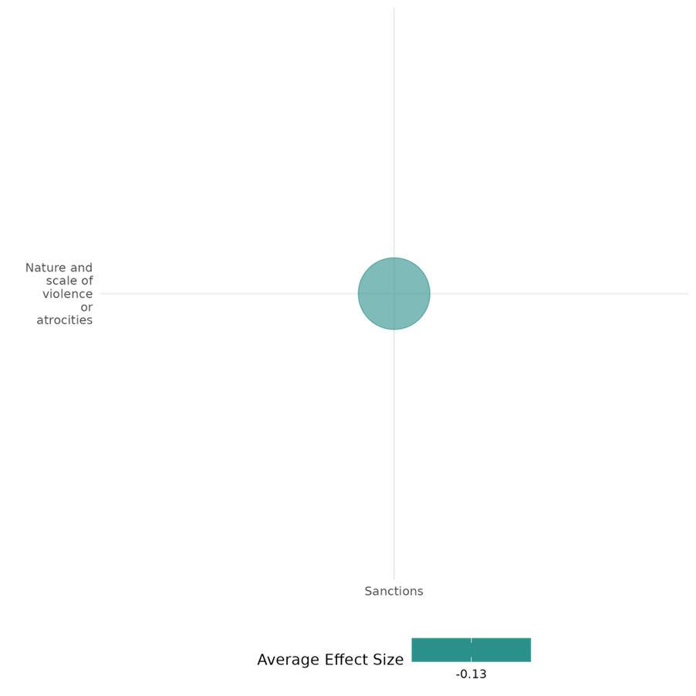

4.2.4(2)
The effect of sanctions on social norms regarding violence and atrocities
Sanctions, such as the checkpoint easement in the West Bank, positively affects social norms regarding violence and atrocities.
Geographic region: Middle East
Effect size: Adverse effect (g=-0.053)
Confidence in study findings: Low (1 study with 5 effect sizes)

Short summary
Sanctions, such as the checkpoint easement in the West Bank, implemented under the Jenin First Initiative, aimed to alleviate nonviolent repression and its social effects. By reducing movement restrictions, the intervention shifted social norms regarding violence and atrocities. The findings suggest that addressing perceived humiliation and repression reduces support for violence, promotes less militant attitudes, and fosters norms of peace.

The intervention
Sanctions, such as the checkpoint easement in the West Bank, targeted movement restrictions, aiming to improve mobility and reduce the daily hardships experienced by Palestinians. Implemented in 2009 as a pilot program, this initiative focused on areas near Za’atara, with neighboring checkpoints like Wadi Nar serving as control sites with no changes.

How the intervention is expected to affect this outcome
Sanctions, such as the checkpoint easement in the West Bank, aim to influence social norms regarding violence and atrocities by addressing perceived humiliation and repression. By easing travel restrictions, the intervention aimed to reduce frustration, restore dignity, and shift attitudes away from violence and militancy. The assumption was that alleviating nonviolent repression would foster a greater acceptance of peaceful political engagement and reduce social acceptance of violent norms.

The evidence base
The cell contains 1 impact evaluation study set in the West Bank.

Evidence findings
The intervention led to a significant reduction in support for violence and militant groups in areas affected by checkpoint easement. Social norms shifted as perceptions of humiliation decreased, fostering fewer militant attitudes and increased support for peaceful political solutions. In contrast, control areas with no changes in movement restrictions saw rising militancy and continued acceptance of violence.

Included studies
Longo (2014) examine the implications of checkpoints and the relaxation of travel restrictions in West Bank. This intervention was called the Jenin First Initiative, spearheaded by a Tony Blair-led Quartet, composed by the United States, the United Nations, the European Union, and Russia, and was implemented in 2009. The plan was to open economic corridors for Palestinian traffic and trade. The study used a natural experiment to analyze the effects of the 2009 Israel decision to ease travel restrictions in the West Bank on Palestinians, with a difference-in-difference estimation model to see the difference before and after the intervention, particularly in Za’atara (treatment) and Wadi Nar (control). The study revealed that the easing of travel restrictions resulted to a significant decrease of support for violence against Israel and produced a more positive perception regarding extremism, which is an indicator of diminished radicalism. Moreover, Palestinians in the treatment group had lesser negative attitudes toward Israel but still showed ambiguous reactions for a two-state solution. The intervention also resulted to the increased support over secular-nonviolent parties (Fatah) over religious-violent ones (Hamas). This study is rated medium confidence as it is a non-experimental study.

Confidence assessment
Overall low: This cell is rated low as it only contains one study.

Other outcomes in the study:
Social cohesion / feelings of trust & acceptance of diversity
Social cohesion / willingness to participate or help

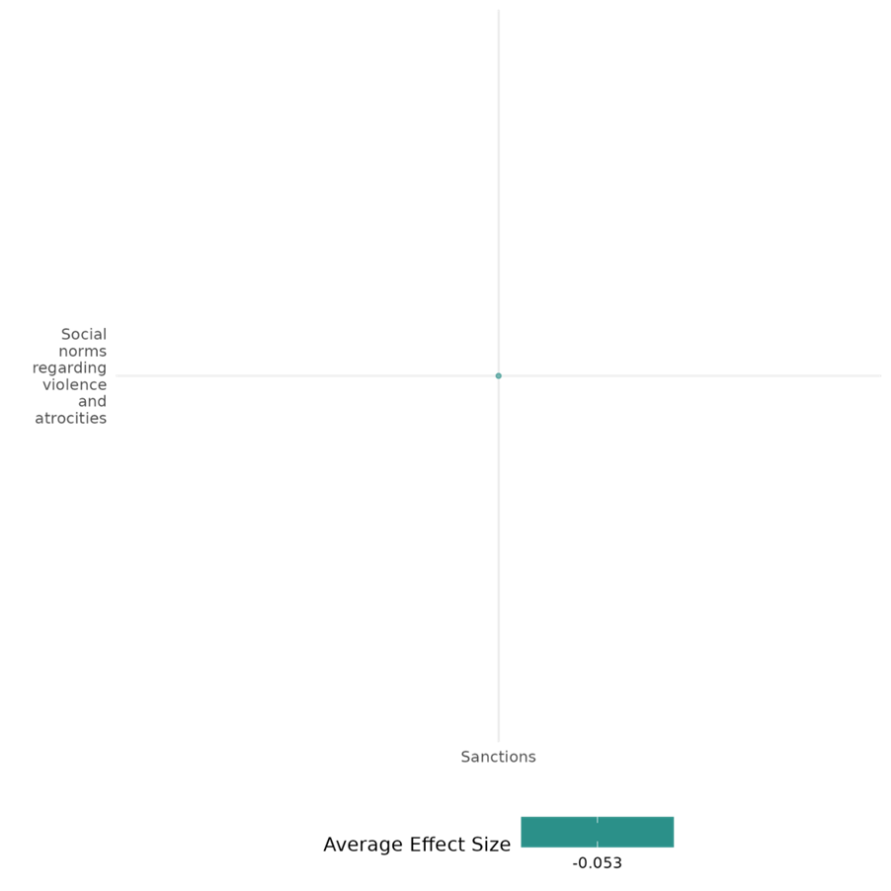

4.2.4(3)
Effect of sanctions on feelings of trust & acceptance of diversity
Sanctions tend to adversely affect feelings of trust and acceptance of diversity, especially among minority groups. Comprehensive sanctions tend to have stronger negative effects.
Effect size: Small effect (g=0.068)
Confidence in study findings: Medium (2 studies with 3 effect sizes)

Short summary
Sanctions are considered as coercive measures aimed at influencing state behaviour through economic restrictions. Sanctions, whether comprehensive or targeted, can significantly impact trust and acceptance of diversity, especially among minority groups. However, the effects of comprehensive economic sanctions tend to be more adverse. In contrast, easing restrictions, as seen in the Jenin First Initiative, can reduce negative attitudes and improve social cohesion, though its effects on broader political solutions remain ambiguous.

The intervention
Sanctions are generally considered as coercive measures aimed at influencing state behaviour through restrictions in trade, financial resources, or other forms of international involvements. It could be comprehensive or targeted. Comprehensive sanctions can affect entire economies while targeted sanctions are focused on specific individuals, entities, or sectors. In reverse, there are also initiatives which ease restrictive measures or sanctions. An example is the Jenin First Initiative, which involved the relaxation of travel restrictions and removal of checkpoints in the West Bank.

How the intervention is expected to affect this outcome
Sanctions can undermine trust and acceptance of diversity by intensifying resource scarcity and competition, which may lead to increased societal bias and exclusion of minority groups. Comprehensive sanctions are particularly damaging, as they create broader economic hardships and foster environments conducive to negative stereotyping and propaganda, further eroding intergroup trust and inclusivity. In contrast, lifting restrictions, as demonstrated in the Jenin First Initiative, can reduce barriers and foster conditions conducive to improved trust and acceptance.

The evidence base
The cell includes two impact evaluations: one examines the effects of imposing sanctions, while the other explores the outcomes of lifting sanctions or easing restrictions.
One of the studies include the analysis of global dataset, while the other analyses the case for West Bank.
Evidence findings
Sanctions are found to adversely affect feelings of trust and acceptance of diversity. For one, the findings in one of the studies demonstrate that economic sanctions significantly increase societal exclusion and discrimination of minority groups. Comprehensive sanctions worsen these effects. On the other hand, lifting of sanctions tend to lessen negative attitudes towards a particular group, although its effects on support for two-state solutions tend to be ambiguous.

Included studies
Longo, Canetti, and Hite-Rubin (2014) examine the implications of checkpoints and the relaxation of travel restrictions in West Bank. This intervention was called the Jenin First Initiative, spearheaded by a Tony Blair-led Quartet, composed by the United States, the United Nations, the European Union, and Russia, and was implemented in 2009. The plan was to open economic corridors for Palestinian traffic and trade. The study used a natural experiment to analyze the effects of the 2009 Israel decision to ease travel restrictions in the West Bank on Palestinians, with a difference-in-difference estimation model to see the difference before and after the intervention, particularly in Za’atara (treatment) and Wadi Nar (control). Findings of the study suggest that Palestinians in the treatment group had lesser negative attitudes toward Israel but still showed ambiguous reactions for a two-state solution.
Onder (2022) examines the effects of economic sanctions on vulnerable minority groups within sanctioned states, highlighting how these measures exacerbate resource inequities and ethnic tensions through case studies of Iraq, Yugoslavia, and Rhodesia. The study employs panel data from 1981 to 2000 and utilizes ordered logit regression models to assess three key dimensions of ethnic discrimination: economic, political, and social. Data sources include the Minorities at Risk Project for economic and political discrimination and the World Values Survey for social discrimination. Social discrimination emerged as the most severe and statistically significant consequence of economic sanctions. Minority groups experienced intensified societal exclusion and negative stereotyping, fueled by government propaganda and public bias—dynamics that were particularly acute under comprehensive sanctions.

Confidence assessment
Overall low: This cell is rated low as it has less than 4 impact evaluation studies.

Other outcomes in this study:
Human security / Economic security
Human security / Political security
Violence and atrocity prevention / Social norms regarding violence and atrocities
Social cohesion / Willingness to participate or help

4.2.4(4)
Effect of sanctions on willingness to participate or help
Sanctions, such as the checkpoint easement in the West Bank, fosters political engagement and willingness to participate in elections.
Geographic region: Middle East (West Gaza)
Effect size: Adverse effect (g=-0.218)
Confidence in study findings: Medium (1 study with 1 effect size)

Short summary
Sanctions, such as the checkpoint easement in the West Bank under the Jenin First Initiative, influenced willingness to participate or help by reducing nonviolent repression. The intervention fostered greater political engagement, with residents in eased areas showing increased willingness to participate in civic activities.

The intervention
Sanctions, such as the checkpoint easement in the West Bank, was implemented to reduce nonviolent repression and its associated grievances. The intervention targeted movement restrictions, aiming to improve mobility and reduce the daily hardships experienced by Palestinians. Implemented in 2009 as a pilot program, the measures focused on areas near Za’atara, with neighboring checkpoints like Wadi Nar serving as control sites with no changes.

How the intervention is expected to affect this outcome
By reducing the perceived humiliation and hardships of restrictions in movement, the intervention aimed to foster a sense of empowerment and agency among residents. This was expected to translate into increased willingness to participate in civic and political processes, including elections, and greater support for peaceful means of conflict resolution.

The evidence base
The cell contains 1 impact evaluation study set in the West Bank (Middle East).

Evidence findings
The intervention led to an increase in willingness to participate or help in areas affected by the eased restrictions. Residents near the Za’atara checkpoint exhibited higher levels of political engagement, including increased likelihood of participating in elections.

Included studies

Longo, Canetti, and Hite-Rubin (2014) examine the implications of checkpoints and the relaxation of travel restrictions in West Bank. This intervention was called the Jenin First Initiative, spearheaded by a Tony Blair-led Quartet, composed by the United States, the United Nations, the European Union, and Russia, and was implemented in 2009. The plan was to open economic corridors for Palestinian traffic and trade. The study used a natural experiment to analyze the effects of the 2009 Israel decision to ease travel restrictions in the West Bank on Palestinians, with a difference-in-difference estimation model to see the difference before and after the intervention, particularly in Za’atara (treatment) and Wadi Nar (control). The study revealed that the easing of travel restrictions resulted to greater willingness to participate in elections among Residents near Za’atara, highlighting a move toward political engagement as a viable means for change. This study is rated medium confidence as it is a non-experimental study.

Confidence assessment
Overall low: This cell is rated low considering that there is only one study which falls under it.

Other outcomes in the study:
Violence and atrocity prevention / social norms regarding violence and atrocities
Social cohesion / feelings of trust and acceptance of diversity

4.2.4(5)
Effect of sanctions on access to justice, rights, and public services
Sanctions have negative effects on press freedom and private property rights, and this is usually more pronounced in comprehensive sanctions..
Geographic region: Global
Effect size: Adverse effect (g=-0.114)
Confidence in study findings: Medium (2 studies with 17 effect sizes)

Short summary
Sanctions often reduce press freedom and weaken private property rights as target regimes tighten control and reallocate resources to maintain stability. Comprehensive sanctions exacerbate repression and economic insecurity, undermining institutional protections which hinder access to justice, rights, and public services in affected countries.

The intervention
Economic sanctions are imposed by states and international bodies to influence the policies of target governments, often aiming to promote democracy, human rights, and the rule of law. Sanctions may include trade embargoes, asset freezes, and restrictions on financial transactions. However, their impact extends beyond the intended targets, affecting the broader socio-political landscape, including press freedom and private property rights. The sanctions are implemented by entities such as the United Nations, the United States, and the European Union and can persist for extended periods, exacerbating economic and institutional pressures in the targeted countries.

How the intervention is expected to affect this outcome
Sanctions are expected to pressure governments into adopting democratic reforms and respecting human rights. However, in practice, they often lead to unintended consequences such as increased authoritarianism, suppression of dissent, and weakening of institutional protections for private property. In response to economic hardship, sanctioned regimes may tighten control over the media to prevent criticism and reallocate resources away from essential sectors to maintain political stability. These measures can restrict press freedom, limit access to unbiased information, and create an environment of economic insecurity that threatens property rights.

The evidence base
The cell contains 2 impact evaluation studies which utilized global datasets. Peksen (2010) includes 147 economies while Peksen (2014) includes 133 economies in the analysis.

Evidence findings
The evidence suggests that economic sanctions have a detrimental effect on access to justice, rights, and public services. For one, sanctions lead to increased government control over the media, reducing press freedom by limiting access to independent information and imposing restrictions on journalistic activities. The findings indicate that comprehensive sanctions exacerbate these effects more severely than targeted measures. Sanctions could also contribute to the erosion of private property rights, as governments facing economic constraints resort to arbitrary confiscation and redistribution of wealth to sustain political support and economic stability. In sanctioned states, the deterioration of property rights is more pronounced under comprehensive sanctions, which significantly weaken legal protections and encourage state-led expropriation.

Included studies
Peksen (2010) The study assesses the impact of coercive diplomacy (in the form of economic sanctions) on press freedom. It is argued that foreign economic coercion will likely deteriorate press freedom by (1) restricting a sanctioned country’s interactions with the outside world, thereby allowing the target regime to have greater control over the free flows of information, and (2) inflicting significant economic damage on the sustainability and development of independent media outlets. The study was designed as a quasi-experimental study. The study uses time-series, cross-national empirical data over a large number of countries for the period 1980–2000. The results for the severity of economic sanctions (p<0.01) demonstrate that both extensive and limited sanctions have a statistically significant inadvertent corrosive impact on press freedom. The models that look at the possible differential impact of unilateral and multilat­eral sanctions also confirm that both types of sanctions will cause significant damage to the media’s independence and sustainability under foreign economic pressures. The study is rated as medium confidence as it is designed as a non-experimental study design and has partially defined the outcomes in the study. The study is rated as medium confidence as it is designed as a non-experimental study design and has partially defined the outcomes in the study.
Peksen (2014) The study assesses the extent to which economic sanctions prompt the target regime to manipulate the domestic economic conditions through arbitrary confiscation and redistribution of private property and wealth. It is argued that economic coercion as a direct threat to political survival and the coercive capacity of the target government creates incentives for politically insecure elites to engage in the policy of predation to counter the negative economic effects of the coercion on themselves and their constituency. The study was designed as a quasi-experimental study. The study uses time series cross-national data from 1960 to 2005. The sanction regimes that are comprehensive and costly tend to be more detrimental to private property rights than the limited and low-cost sanction regimes (P<0.01). The study is rated as medium confidence as it is designed as a non-experimental study design and has partially defined the outcomes in the study.

Confidence assessment
Overall low: The overall confidence for this cell is low as it only includes 2 studies.

Other outcomes in this study:
None
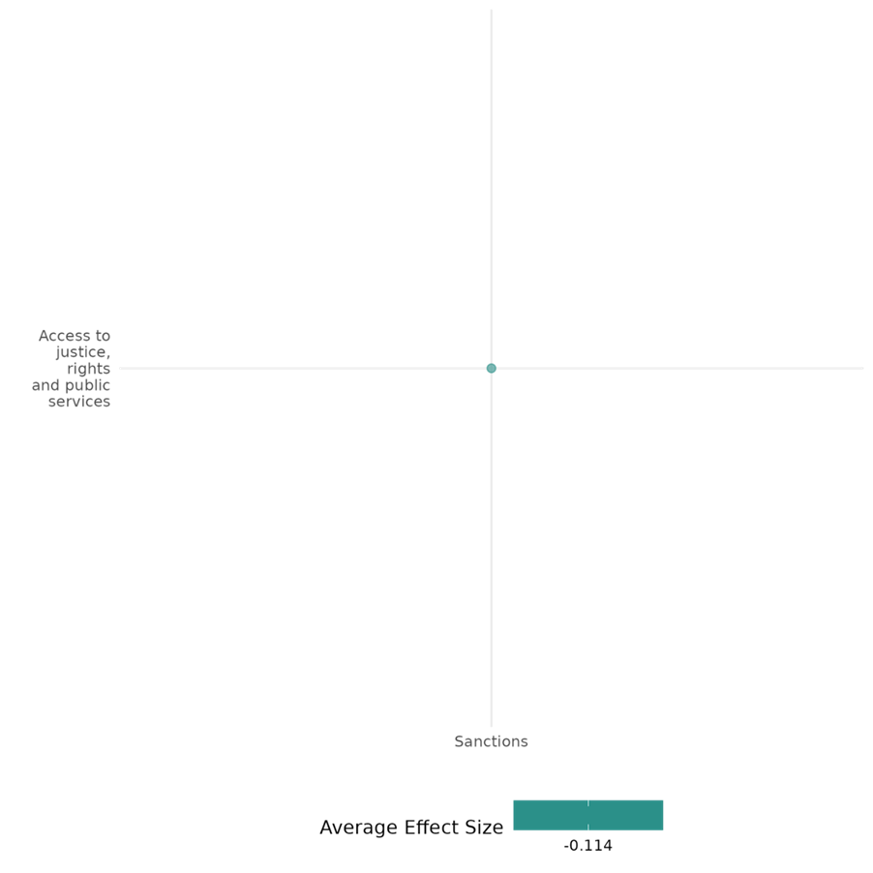

4.2.4(6)
The effect of sanctions on civic participation
Sanctions influence civic participation in authoritarian regimes, with threats increasing anti-government protests and imposed sanctions often fuelling pro-government mobilization, particularly in environments with high-media censorship.
Geographic region: Global
Effect size: Adverse effect (g=-0.104)
Confidence in study findings: Low (2 studies with 11 effect sizes)

Short summary
Sanctions negatively affects civic participation, especially in authoritarian regimes. Threats of sanctions signal international disapproval, emboldening opposition groups and increasing anti-government protests. In contrast, imposed sanctions are often framed by regimes as attacks on national sovereignty, fueling pro-government mobilization. This effect is particularly pronounced in regimes with high media censorship. Evidence from global datasets shows that sanction threats have stronger effects on dissent, while imposed sanctions enable regimes to consolidate support through nationalist framing and coercion.

The intervention
Sanctions, including both threatened and imposed measures, are policy tools used to influence the domestic politics of authoritarian regimes. Sanctions aim to pressure governments to alter policies, address governance issues, or foster democratization. Threats of sanctions serve as signals of international disapproval and support for opposition movements, while imposed sanctions can take the form of economic restrictions or other measures targeting governments or specific entities. These interventions often focus on addressing human rights violations or political repression, and their duration and intensity vary depending on the sender and goals. Sanctions, whether threatened or enacted, interact with domestic political dynamics and can affect civic participation by influencing dissent or bolstering regime support.

How the intervention is expected to affect this outcome
Overall, sanctions are expected to influence domestic political dynamics of a targeted state. Sanctions and their threats may signal an international disapproval of an authoritarian regime. It acts as a catalyst to mobilize public dissent, which may encourage citizens to participate in collective actions and protests. On the other hand, authoritarian leaders may strategically frame sanctions as a form of attack on national sovereignty. This kind of narrative may fuel nationalist sentiment and motivate citizens to conduct progovernment demonstrations. Moreover, the regime may coerce or incentivize participation to the protests. Media control also plays a critical role as authoritarian regimes may utilize propaganda and censorship to suppress opposition.

The evidence base
This cell includes 2 impact evaluations. One of the studies is rated with medium confidence while the other is rated with low confidence.
All the studies utilized secondary data. Both studies utilize global datasets, consequently narrowing down the sample to authoritarian regimes.

Evidence findings
Threats of international sanctions, rather than those which are implemented, increase anti-government protest activity in targeted authoritarian regimes. Sanction threats are seen as a signal of international disapproval of the regime and support for opposition groups, thus creating opportunity for domestic dissent and collective action, even prior material deprivation. Moreover, sanctions focused on human rights violations or issued by multiple actors send clearer signals for domestic dissents. On the other hand, imposed sanctions do not lead to increased protest as it may allow regimes to deflect bale or appeal to nationalist narratives. Sanctions or threats also frequently leads to increase in progovernment mobilization in authoritarian regimes as autocratic leaders exploit these interventions and frame them as a threat to national sovereignty, fuelling nationalism and encouraging government support. This is more pronounced in regimes that has high levels of media censorship, allowing leaders to suppress opposing viewpoints and amplify their narratives.

Included studies
Grauvogel, Licht, and von Soest (2017) explore how international threats of sanctions impact domestic protest activity in authoritarian regimes, proposing that these threats serve as signals of support for opposition movements. The authors argue that sanction threats, especially those backed by multiple countries or aimed at human rights violations, send strong international signals that embolden citizens to protest against their government, even before any economic impact occurs. The study uses the Threats and Imposition of Sanctions (TIES) dataset alongside the Mass Mobilization dataset to track monthly instances of protest in various regimes from 1990 to 2005. Count models (i.e., zero-inflated models and fixed effects estimators) are applied to assess the effect of both sanction threats and actual sanctions on protest activity, while controlling for factors like regime type and previous repression levels. The findings suggest that the threat of international sanctions significantly mobilizes protest activity in authoritarian regimes, while the actual imposition of sanctions has little effect. This effect is strongest when threats specifically target human rights abuses are backed by multiple international actors, as these factors increase perceived legitimacy and external backing for opposition movements.This study is rated medium confidence as it is a non-experimental study.
Hellmeier (2020) assesses how international pressure, including economic sanctions and diplomatic threats, affects domestic mobilization in favour of authoritarian regimes. The study explores how authoritarian leaders in countries such as Venezuela, Iran, and Zimbabwe use foreign pressure as a tool to rally public support, often framing sanctions as attacks on national sovereignty to foster nationalist sentiment. Using a quantitative analysis with data from 74 authoritarian regimes between 2003 and 2015, the study combines information on pro-government rallies from the Mass Mobilization in Autocracies Database with sanctions and threat data from the European Sanctions Database. A multivariate regression analysis is employed to examine the frequency of pro-government rallies in response to foreign pressure. The study also tests how the presence of media censorship in target countries moderates this relationship. This study finds a significant increase in the probability of pro-government rallies in response to foreign threats and sanctions. In authoritarian regimes, these external pressures prompt leaders to organize rallies that frame sanctions as threats to national sovereignty. The effect is amplified in countries with high media censorship.The study is rated low confidence due to little description of the intervention and evaluation questions.

Confidence assessment
Overall low: the cell contains less than four studies and one of the studies is rated as low confidence, while the other is rated as medium confidence.

Other outcomes in the study:
None
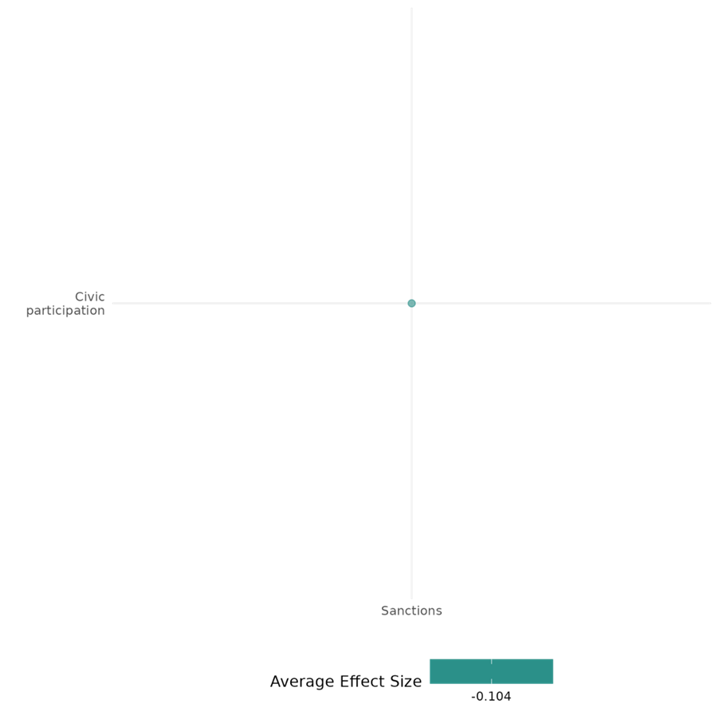

4.2.4(7)
Effect of sanctions on government performance
Sanctions often undermine government performance, although the effects are mediated by the type of regime.
Geographical region: Global
Effect size: Large effect (g=0.288)
Confidence in study findings: Low (5 studies with 9 effect sizes)

Short summary
Sanctions, including financial penalties, trade restrictions, and asset freezes, target authoritarian regimes to pressure political reform and improve governance. While sanctions often weaken fiscal and administrative capacities, their impact varies by regime type. Personalist regimes experience destabilization and reduced public spending, whereas single-party and military regimes reallocate resources to maintain support, highlighting mixed governance outcomes.

The intervention
Sanctions include comprehensive and targeted measures such as financial penalties, trade restrictions, and asset freezes. These sanctions often aim to pressure authoritarian regimes into political reforms, improve governance, or address human rights abuses. They target key regime actors and institutions, including governments, ruling elites, and state apparatuses. The studies span different timeframes and contexts, with data covering sanctions from the 1950s to the 2010s. Examples include U.S. and U.N. sanctions, democratic sanctions, and post-9/11 targeted sanctions, which vary in their scope and duration.

How the intervention is expected to affect this outcome
Sanctions are designed to influence access to justice, rights, and public services by constraining the resources and behavior of targeted regimes. Resource constraints, such as financial penalties, trade restrictions, and asset freezes, reduce a regime’s fiscal and administrative capacity, weakening judicial systems, public service delivery, and legal protections. The rationale is that by limiting resources, sanctions will pressure regimes to prioritize reforms over repression. However, the impact varies across regime types: personalist regimes often cut public expenditures to maintain elite loyalty, while single-party and military regimes reallocate resources toward subsidies or military priorities, thereby mitigating the intended effects of sanctions.

The evidence base
This cell includes: 5 impact evaluations and 2 qualitative studies. All of the studies used global global datasets, spanning various timeframes and regions, with some studies assessing the impact of democratic sanctions and post-9/11 targeted sanctions.
Evidence findings
Sanctions impact government performance differently across regime types and contexts. In personalist regimes, they reduce public spending, and destabilize leadership, increasing the likelihood of irregular transitions. Single-party and military regimes reallocate resources toward subsidies and military spending, demonstrating greater resilience. Sanctions weaken fiscal and administrative capacity. While democratic sanctions modestly improve governance by increasing democracy scores, their effectiveness depends on context. Post-9/11 targeted sanctions exacerbate governance challenges like corruption but do not significantly destabilize government structures overall.

Included studies
Escribà-Folch (2010) investigates the effects of economic sanctions on the stability of authoritarian regimes, with a focus on how different regime types—personalist, single-party, and military—mediate these impacts. The study examines how sanctions influence the likelihood of leadership changes and regime durability, distinguishing between regular and irregular (such as coup-driven) transitions. Using panel data from authoritarian regimes between 1950 and 2002, the authors employ logistic regression to assess the relationship between sanctions and leadership stability across regime types. The study controls for factors such as economic growth, regime duration, and conflict involvement to isolate the effects of sanctions on authoritarian rule. A Cox proportional hazards model and a fixed-effects model were further employed to check for robustness. Findings suggest that in personalist regimes, sanctions significantly increase the likelihood of ruler exit by depleting resources and weakening the ruler's ability to maintain loyalty. In contrast, single-party regimes are more resilient, with sanctions decreasing the likelihood of exit as these regimes bolster support through increased public expenditures on subsidies and transfers. Military regimes show mixed effects, reallocating resources to maintain elite loyalty but with no clear pattern of increased ruler exit. This study is rated medium confidence as it is a non-experimental study.
Escribà-Folch (2011) investigates how economic sanctions affect authoritarian regimes’ strategies regarding repression and public spending, focusing on how different regime types respond to external pressure. The study suggests that the impact of sanctions on a regime's stability and policy choices is closely tied to its type, with sanctions influencing authoritarian leaders’ reliance on repression or loyalty through public expenditures. The analysis covers 1970 to 2000, using data on regime types, public expenditures, and repression levels across authoritarian states. The study categorizes regimes into personalist, single-party, and military types, each with different support structures and governing strategies. To analyze the impact of sanctions, the study employs fixed-effects panel regression, instrumental variable Generalized Method of Moments estimator, and an ordered logistic regression. The findings reveal that sanctions lead personalist regimes to significantly reduce public expenditures across all categories, weakening their capacity to support key constituencies. In contrast, single-party and military regimes increase targeted spending to benefit their support groups, mitigating the destabilizing effects of sanctions on regime stability. The study is rated low confidence due to the absence of detailed information on power calculation. The description of the intervention was also rather little.
Liou (2020) examines how economic sanctions affect human rights conditions in target countries, focusing on the pathways through which sanctions may lead to increased repression. The study analyzes both direct effects of sanctions on repression and two indirect mechanisms: increased domestic dissent and reduced government capacity. Using a time-series, cross-national dataset covering 152 countries from 1990 to 2005, the study applies causal mediation analysis to identify whether and how dissent and government capacity mediate the impact of sanctions on human rights abuses. The analysis relies on measures from the Physical Integrity Rights Index, sanctions data from the Threat and Imposition of Economic Sanctions (TIES) dataset, and additional variables capturing dissent intensity and government capacity. The analysis also shows that sanctions weaken government fiscal and administrative capacity. The study is rated low confidence due to little description of the intervention
Peksen (2009) examine the unintended consequences of economic sanctions on political repression, focusing on their impact on democratic freedoms and human rights. Using cross-national, time-series data from 1972 to 2000, the study employs regression analysis with two key measures: the Freedom House Index for political rights and civil liberties, and the CIRI Physical Integrity Rights Index for respect for human rights. The analysis differentiates between sanctions aimed at promoting democracy and those with other policy goals, focusing on the first 10 years of sanctions to assess their immediate effects. The results show that sanctions, especially those targeting democracy promotion, significantly increase political repression—political freedoms decline by over 30% and respect for human rights drops by nearly 70%. The study is rated as medium confidence as it is a Non- experimental study design.
von Soest (2014) examines the effects of “democratic sanctions” (those that explicitly aim to promote democracy), on authoritarian regimes (which have become the most common type of sanction issued against authoritarian states). It introduces a data set that categorizes sanctions by their explicit objectives, distinguishing those aimed at democratization from other types of imposed sanctions from 1990–2010. This cross-sectional time-series study includes a sample of 2,079 country-years, with 532 country-years during which sanctions were imposed. All included cases were considered authoritarian at the start of the sanction episode. The main outcome of interest was the change in the level of democracy, measured using a combined Freedom House and Polity IV score. The study found that Democratic sanctions were associated with an increase of 0.160 points per year in the democracy score of targeted authoritarian countries. This result was statistically significant (p < 0.05). The positive effect of democratic sanctions remained significant after controlling for comprehensive sanctions, with the coefficient slightly larger at 0.197 in additional analyses. The study is rated as medium confidence as it is a non- experimental study design.

Confidence assessment
Overall low: While most of the studies are rated medium, the findings across the studies tend to be inconsistent.

Other outcomes in the study:
Violence and atrocity prevention / Nature and scale of violence or atrocities
Human security / Economic security
Human security / political security
Violence and atrocity prevention / nature and scale of violence and atrocities

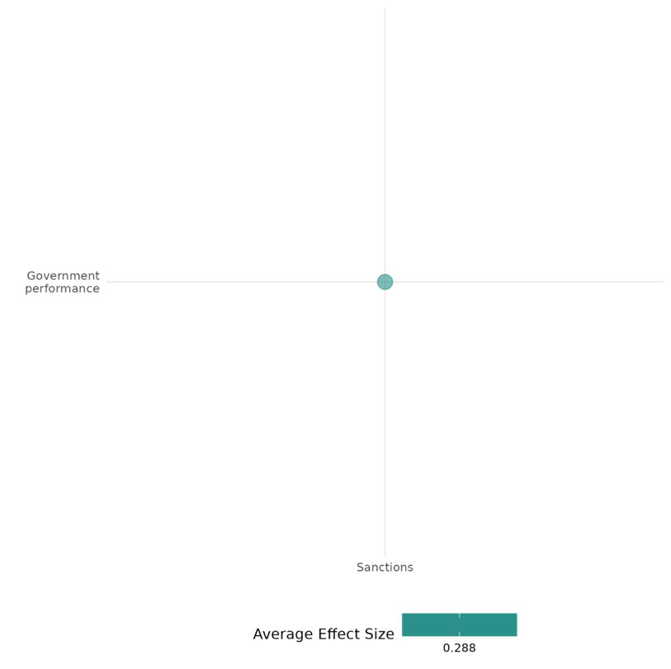

4.2.4(8)
Effect of sanctions on economic security
Sanctions significantly undermine economic security by exacerbating poverty, inequality, and employment losses while disrupting trade, foreign direct investment (FDI), and GDP growth. Comprehensive sanctions have the most severe impact, particularly on trade-dependent and labor-abundant economies.
Geographical scope: Global, Russia, Middle East, Africa, Asia
Effect size: Adverse effect (g=-0.001)
Confidence in study findings: Medium (21 studies with 71 effect sizes)

Short summary

Sanctions—comprehensive and targeted—exert economic pressure by restricting trade, financial systems, and aid. However, they frequently harm economic security, leading to increased poverty, inequality, and employment declines, particularly in trade-reliant industries. Comprehensive sanctions disrupt GDP growth, FDI, and trade flows, with spillover effects on neighboring economies (e.g., CIS countries due to Russia's downturn). Financial sanctions exacerbate income inequality and firm-level declines in revenue and employment, while authoritarian regimes often respond with increased economic control, further misallocating resources. Although targeted sanctions aim to minimize collateral damage, evidence consistently highlights their broader adverse effects on economic stability and security.

The intervention

Sanctions are coercive economic measures imposed by states or international bodies to influence target countries' behavior. These sanctions can be comprehensive, affecting entire economies, or targeted, aimed at specific sectors, entities, or individuals. Sanctions include financial restrictions, trade bans, export/import limitations, and aid suspensions. Implementing bodies often include the United Nations, the United States, the European Union, and regional alliances like the Arab League. Sanctions often last for prolonged periods, ranging from years to decades, significantly impacting countries reliant on trade, financial markets, and foreign investments.

How the intervention is expected to affect this outcome

Sanctions are designed to exert economic pressure on target states to encourage compliance with political, security, or human rights objectives. However, they frequently undermine economic security, worsening poverty, inequality, employment, and trade. Trade sanctions limit access to international markets, reducing economic output and disrupting employment in sectors reliant on trade or imported inputs. Financial sanctions restrict access to global financial systems, diminishing investment and depleting capital flows. Targeted sanctions, while designed to minimize collateral damage, often impact broader economic sectors through spillover effects. In addition, governments under sanctions may consolidate economic control, leading to resource misallocation and predatory economic practices, which further harm economic stability.

The evidence base

This cell includes 21 impact evaluations, and the evidence consistently points out on the adverse effect of sanctions on economic security. Most of the studies are rated with medium confidence.

All the studies relied on secondary data, with some analyzing global datasets before narrowing their focus to target states (8), authoritarian regimes (1), and developing economies (1). Two studies specifically examined sanctions imposed jointly by the U.S. and U.N. in target states (2), while three studies explored the broader implications of U.S. sanctions across all target economies (3). Several studies focused on the effects of sanctions on individual economies, including Burundi (1), Syria (1), and Iran (1), with additional analyses on EU-imposed (1) and UN-imposed sanctions on Iran (1). Further studies investigated sanctions on Russia (2), covering both general sanctions and those imposed by the U.S. and EU, as well as sanctions on Myanmar (1) under U.S. and EU measures. One study examined Israel's dual-use list sanctions on the West Bank and Gaza Strip (1).

Evidence findings

Sanctions have a detrimental effect on economic security. Evidence suggests that sanctions increase income inequality and poverty, especially in labor-abundant economies or countries heavily reliant on aid and trade. Employment declines significantly, especially in industries dependent on imported inputs. Comprehensive sanctions have the most adverse effects, severely disrupting trade, FDI, and GDP growth. Financial sanctions, while targeted, exacerbate economic disparities and reduce firms' performance, leading to declines in revenue, asset value, and employment. Sanctions also create spillover effects on neighboring economies, as seen in the CIS, where Russia's downturn reduced GDP growth and trade across the region. In authoritarian regimes, sanctions increase state control over economies, restricting economic freedoms and prompting resource predation. Though sanctions may achieve political objectives in isolated cases, they often exacerbate economic vulnerabilities, undermining economic security in both direct and indirect ways.

Included studies
Afesorgbor and Mahadevan (2016) examine the impact of economic sanctions, both comprehensive and targeted, on income inequality in target states. The study utilized a panel dataset covering 68 target states between 1960 and 2008. The key dependent variable is income inequality, measured through Gini coefficients from two datasets: SWIID (Standardized World Income Inequality Database) and UNU-WIDER. Economic sanctions are the primary independent variable, categorized into financial sanctions, trade sanctions (exports and imports), and combinations thereof. Fixed-effects regression models, robustness checks, and generalized method of moments (GMM) were applied to address endogeneity and omitted variable bias. The study finds that economic sanctions significantly increase income inequality, with Gini coefficients rising by 1.5–1.7 points on average during sanction periods. Longer sanctions were found to worsen inequality more. Across sanction types, financial sanctions were found to have the most adverse effects. The study is rated medium as it is non-experimental and due to its partial description of the intervention.

Ahn (2019) examines the economic impact of targeted sanctions imposed by the United States and European Union on Russian entities following the 2014 Ukraine crisis. It aims to evaluate whether targeted sanctions effectively harm their intended targets while minimizing collateral damage, particularly to the broader Russian economy and neighboring countries. The study utilizes firm-level data from the Orbis database. The analysis tracked the performance of firms for over three years (i.e., 2013-2015). Key metrics include operating revenue, asset value, and employee numbers. The study employs the difference-in-differences (DID) analysis, to compare the economic performance of sanction-targeted countries to a control group of countries that were not subject to sanctions, before and after sanctions were imposed. The findings suggest that targeted sanctions have a statistically significant negative impact on the economic performance of target states. For one, sanctioned firms experienced a significant average decline: 30% in operating revenue, 55% in asset value, and 30% in employment compared to non-sanctioned peers. Sanctions' overall macroeconomic impact on Russia’s GDP was modest, contributing about 1% to the observed economic decline. The study is rated low confidence due its inadequate description of the evaluation questions.

Amodio et al. (2021) examine the impact of security-motivated trade restrictions, specifically the dual-use list imposed by Israel, on political violence in the Occupied Palestinian Territories (OPT), which include the West Bank and the Gaza Strip. The dual-use list restricts the import of goods that can be used for both civilian and military purposes, affecting sectors that rely heavily on these inputs. The context is the ongoing Israeli-Palestinian conflict, with the West Bank being subject to these restrictions since 2008. The research employs a difference-in-differences strategy to compare economic and political outcomes across sectors and localities based on their intensity in dual-use inputs. The study uses data from a repeated cross-section of approximately 33,000 Palestinian manufacturing establishments surveyed from 1999 to 2012. It also incorporates data on political violence from the Integrated Crisis Early Warning System (ICEWS) dataset, covering events from 1999 to 2012. The analysis focuses on the West Bank, with the Gaza Strip serving as a placebo due to its complete blockade during the study period.The study finds that the dual-use list led to a 4.6% loss in the total value of manufacturing output in the West Bank from 2008 to 2012. Sectors more intensive in dual-use inputs experienced a significant decrease in output value and wages, with a 22% differential fall in sectoral wages. The study is rated as medium confidence as it is a non-experimental study.

Apergis & Cooray (2019) examine the impact of human rights on income distribution and poverty, focusing on how aid and trade can influence these outcomes through human rights. The context involves 125 countries across various regions, including Eastern Europe, Central Asia, the Middle East, North Africa, Latin America, the Caribbean, East Asia, the Pacific, South Asia, Africa, and high-income OECD countries. The study aims to understand the relationship between human rights violations and income inequality and poverty, considering the role of trade and aid as channels through which human rights conditions may affect poverty. The study employs a panel data approach using annual data from 1990 to 2014. It utilizes the generalized method of moments (GMM) estimation method to address potential endogeneity bias. The analysis includes various control variables such as per capita income, school enrollment, government expenditure, corruption, population, and political regime quality. The study uses two measures of human rights: the Cingrenelli-Richards (CIRI) Physical Integrity Rights Index and the Political Terror Scale (PTS). The findings suggest that stronger human rights records contribute to greater income equality and poverty reduction. The interaction of human rights with official development assistance (ODA) and trade flows shows that as these increase, or as human rights records improve, both ODA and trade flows reduce poverty and lead to greater income equality. The results are particularly strong for African countries, followed by the Americas, Asia and the Pacific, and Europe. The study is rated as low confidence as attrition was not reported.

Choi (2014) examines the impact of economic sanctions on international terrorism, highlighting how sanctions, often used by major powers to influence the policies of target economies, can unintentionally harm vulnerable groups within those countries. Economic sanctions are described as a foreign policy tool used by governments to pressure target countries into political or behavioral changes, such as promoting democracy or human rights. The study uses cross-sectional, time-series data, drawing on information about economic sanctions from Hufbauer et al. (2008) and terrorism incidents from the ITERATE and GTD databases. The analysis begins with a negative binomial regression model to evaluate the relationship between sanctions and terrorism. To address endogeneity, a two-step model is introduced: economic sanctions are first examined as a cause of poverty, and then predicted poverty levels are used to assess their impact on domestic terrorism. Robustness checks, including two-step regression models, confirm that sanctions exacerbate poverty, which then mediates the relationship between sanctions and terrorism. This study is rated medium confidence as it is a non-experimental study.

Escribà-Folch (2011) investigates how economic sanctions affect authoritarian regimes’ strategies regarding repression and public spending, focusing on how different regime types respond to external pressure. The analysis covers 1970 to 2000, using data on regime types, public expenditures, and repression levels across authoritarian states. The study categorizes regimes into personalist, single-party, and military types, each with different support structures and governing strategies. To analyze the impact of sanctions, the study employs fixed-effects panel regression, instrumental variable Generalized Method of Moments estimator, and an ordered logistic regression. Findings suggest that personalist regimes suffer the most severe economic losses, with foreign aid decreasing by 19–20% and trade by nearly 5%, leading to sharp budget constraints and cuts in public expenditures, particularly capital spending. In contrast, single-party regimes maintain stability by increasing spending on subsidies and transfers to support their key constituencies, as sanctions have minimal effects on their revenue streams. Military regimes respond by reallocating resources to goods and services spending, including wages and military expenditures, to secure military loyalty, despite experiencing a similar 5% decline in trade. The study is rated low confidence due to the absence of detailed information on power calculation. The description of the intervention was also rather little.

Fesharaki (2017) (third essay) examines the economic impact of UN-imposed sanctions on Iran, with a focus on how financial and trade restrictions, particularly post-2010, have affected Iran’s overall economic performance. The sanctions are aimed at curtailing Iran’s nuclear program and limiting its regional influence, using economic pressure as a means of coercion. The study employs the synthetic control method to estimate Iran’s GDP in a hypothetical scenario without sanctions, allowing for a comparison with actual GDP figures. This method creates a counterfactual “synthetic Iran” based on a weighted combination of other countries with similar economic characteristics before sanctions were imposed, spanning several years of economic data. The synthetic control analysis yields highly significant estimates indicating a marked decline in Iran’s GDP due to sanctions, particularly following the intensified financial sanctions beginning in 2010. The estimates for trade flows and foreign direct investment also reveal significant decreases under sanctions, demonstrating the economic isolation imposed on Iran. The study is rated low confidence due to the absence of detailed information on evaluation questions.

Ghodsi and Karamelikli (2021) investigate the impact of EU-imposed sanctions on Iran, focusing on general versus targeted sanctions and their effects on bilateral trade between Iran and the 19 euro area countries (EA19). The study differentiates between general sanctions, which target Iran’s entire economy, and smart sanctions, which focus on specific entities and individuals linked to military activities. The study uses a nonlinear autoregressive distributed lag (NARDL) model to analyze quarterly trade data from 1999 to 2018, controlling for exchange rate fluctuations and income variables. Trade data covers various sectors to observe sector-specific impacts of each type of sanction. The results indicate that general sanctions severely disrupt trade, significantly decreasing EA19’s imports from Iran by over four times the impact seen on exports. General sanctions impact nearly all sectors, except primary industries. In contrast, smart sanctions have a more limited impact, affecting EA19’s exports across most sectors but showing little statistical significance for imports. The study is rated low confidence due to lack of power calculations.

Gutmann (2019) investigates the effects of U.S. economic sanctions on human rights, specifically examining whether sanctions are "precision-guided" or "blunt" in their impact across various human rights categories. The analysis focuses on sanctions imposed by the US, which often aim to influence target countries’ policies by creating economic pressure. The study is set within a context where sanctions are intended to address concerns such as political repression or human rights abuses without resorting to military intervention. Using an endogenous treatment-regression model, the study examines the causal impact of sanctions on economic rights, political and civil rights, basic human rights, and emancipatory rights, including women’s rights. The dataset spans U.S. sanctions from 1976 to 2012 and includes multiple control variables for economic, political, and international alignment factors. When putting into account the different forms of sanctions, the results show that U.S. economic sanctions, regardless of type or duration, do not significantly impact economic rights in targeted countries. This study is rated medium confidence as it is a non-experimental study.

Harris (2019) explores the humanitarian value of economic sanctions, particularly their effectiveness and unintended consequences. The study examines specific case studies, such as sanctions imposed on Iran, and evaluates their outcomes through historical and empirical analysis. It also investigates the evolution of "smart sanctions" designed to minimize harm to civilian populations while targeting specific actors or sectors. The analysis relies on a literature review of economic sanctions and their historical application from the early 20th century to modern-day cases. It uses data from key sources, including the Hufbauer, Schott, and Elliott dataset on sanctions episodes. Empirical evaluations focus on success rates for different humanitarian objectives, drawing from secondary data and case-specific studies like sanctions on Iran. Sanctions lead to significant reductions in GDP. For example, in the case of Iran (2012–2015), comprehensive sanctions caused a $200 billion GDP loss, severely harming the country's economic performance.

Jeong (2020) examines the relationship between economic sanctions (import sanctions, export sanctions, foreign aid sanctions) and income inequality in sanctioned states. The analysis uses data from 152 countries from 1974 to 2011. It employs econometric modeling techniques to assess the effects of different sanction instruments on income inequality. Import sanctions were found to increase inequality in labor-abundant target countries, but this effect disappeared in labor-scarce targets. The study found no reliable evidence for the effect of export sanctions on inequality. Foreign aid sanctions were shown to reduce inequality in target countries highly dependent on foreign assistance. The study rated as low confidence quantitative study due to small sample size and omitting relevant variables.

Kelishomi (2022): This paper investigates the effect of economic sanctions on employment, specifically the imposition of a series of unexpected and unprecedented international economic sanctions on Iran in 2012. It also estimates the short-run effects of the change in import exposure on manufacturing employment at the industry level. The sanctions severely disrupted trade by limiting import and export activities and targeting industries reliant on imported inputs, aiming to induce financial and trade isolation. A natural experiment design consists of a dataset covering 116 non-oil manufacturing industries in Iran, analyzed over two sub-periods: Pre-sanctions (2008–2010) and post-sanctions (2012–2014). Results suggest that import exposure has no significant effect on employment overall, and the impact of an increase in import exposure decreases with the import share. In short, the study documented significant asymmetric effects of import competition on industries with different ex-ante import shares, indicating significant employment reallocation effects across sectors with different degrees of exposure to international trade. Specifically, the study documented that the sanctions negatively impacted employment. Study estimates suggest that, due to the sanctions, the employment growth rate in the manufacturing sector declined by 16.4 percentage points over 2012–2014. An additional 17,731 jobs could have been preserved in the absence of sanctions over 2012–2014. The article is not found in EGM but can be rated as high impact due to study is well-designed and provides credible evidence on the employment effects of economic sanctions, particularly in a developing economy context using pre- and post-intervention comparisons and Rigorous statistical controls and robustness checks (e.g., placebo tests, sensitivity analyses).

Khan (2019) assessed how can we pursue justice for atrocity crimes in the absence of the willingness of the state or United Nations Security Council (UNSC) and the mechanisms and instruments are available and how are those applicable in Myanmar context. The research is primarily based on content analysis of relevant UN documents; it includes examining the Resolutions, Statements, Reports, and Letters by state actors, UN agencies, Expert Commissions, Civil Society Organisation (CSOs) related to the four ICTs, human rights issues in Myanmar and the declarations upon ratifications of relevant instruments by states. The quantitative section focuses on the extent of sanctions and international interventions, revealing that Myanmar previously endured 936 sanctioned entities and 564 individuals under EU measures, yet sanctions have had limited success in altering state behavior. Historical comparisons with Cambodia show that significant inflows of foreign aid and FDI coincided with political shifts supporting the establishment of the ECCC. The study was rated as low confidence as it has done content analysis.

Lektzian and Biglaiser (2013) investigate how US economic sanctions impact foreign direct investment (FDI) from non-US firms in sanctioned countries. US sanctions are often intended to weaken targeted states by limiting their access to capital, with the assumption that foreign investors may view sanctioned states as higher-risk environments, thereby reducing FDI. Using panel data on 171 countries from 1969 to 2000, the authors apply fixed-effects regression models to assess the impact of U.S. sanctions on global FDI inflows to these countries. The analysis controls for factors such as economic stability, regime type, and previous U.S. FDI to understand how sanctions influence global investment patterns. The study finds that, rather than deterring foreign investment, U.S. sanctions often lead to an increase in FDI from non-U.S. sources. When U.S. firms disinvest due to sanctions, foreign firms frequently step in to replace them, viewing these situations as opportunities to gain market share. This effect is more pronounced when sanctions do not involve a high economic cost or international cooperation, as these scenarios pose fewer risks to foreign investors. The study is rated medium confidence as it is non-experimental.

Lektzian (2021) investigates how economic sanctions affect economic freedom within targeted countries. It examines the hypothesis that sanctions encourage affected governments to exert more control over their domestic economies. This state intervention typically limits individual economic freedoms in several ways, including reduced freedom to trade, restrictions in legal property rights, currency devaluation, and increased regulation. Economic sanctions have become a common foreign policy tool by powerful states, aiming to alter target states' behavior, as seen in examples like Venezuela, Russia, and North Korea. This study employs a large-N empirical analysis using a cross-sectional time-series dataset, with the unit of analysis being the country-year. It covers 729 sanction cases from 2000 to 2016, focusing on the Economic Freedom of the World (EFW) index from the Fraser Institute. The study showed that 1) sanctions significantly reduce the overall index of economic freedoms, with one additional sanction decreasing freedom by about 12%. 2) Sanctions lead to substantial restrictions on trade freedom, including limitations on international trade and capital control 3) Sanctions correlate with increased government intervention in domestic business regulation, aligning with the hypothesis that governments use sanctions to consolidate economic control. Additionally Initial reductions in government size (due to resource constraints) are observed in the short term, while long-term effects see increased government economic control. However, the impact on monetary soundness and property rights is less significant or clear. The article is not found in EGM but can be rated as as a high level of confidence in its findings due to its large-N design, extensive controls, and use of robust empirical methods.

Neuenkirch (2015a & 2015b) investigates the impact of US economic sanctions on poverty levels in targeted countries. It aims to understand how these sanctions, intended to coerce political change or protect human rights, may inadvertently worsen poverty among the affected populations. The study also investigates the impact of economic sanctions imposed by the United Nations (UN) and the United States (US) on the economic growth of targeted countries. It aims to understand how different levels of sanctions (mild, moderate, and severe) affect GDP growth, considering various time frames around the sanction periods. The research covers a range of countries that have been subjected to US sanctions from 1978 to 2011. Specific countries included in the analysis are Brazil, Cambodia, China, Iran, and others. The authors employed a quasi-experimental design using a nearest neighbour matching approach. It also employs an empirical model to estimate the effects of sanctions on economic growth. The sample consists of country-year observations categorized into those with US sanctions and those without. The study includes various levels of sanctions, defined as mild, moderate, and severe. The study analyzed a total of 60 country-year observations where US sanctions were in place, compared to a larger control group of 247 observations without sanctions. The findings indicate that US sanctions significantly increase the poverty gap in sanctioned countries. The study reports that the poverty gap increased in countries under sanctions. The maximum adverse effect of severe sanctions is reported as a decrease of –7.80 percentage points (pp) in GDP growth when considering only the three years before the sanction period. Not found it EGM but the study should be rated as high and medium confidence study.

Önder (2022) investigates the impact of economic sanctions on minority groups within targeted states. It emphasizes that sanctions can lead to increased discrimination against these groups, particularly in economic, political, and social dimensions. The research aims to understand how different types of sanctions (comprehensive vs. targeted) affect the treatment of minorities. The study employs an empirical approach using ordered logit models to analyze the effects of economic sanctions on minority groups. The sample consists of data related to countries that have experienced economic sanctions, focusing on the treatment of minority groups within these nations. Results show that comprehensive sanctions significantly exacerbate economic marginalization compared to targeted sanctions, with odds ratios nearly three times higher for economic discrimination. The study is rated medium confidence as it is non-experimental and due to its partial description of the intervention.

Peksen (2014) assesses the extent to which economic sanctions prompt the target regime to manipulate the domestic economic conditions through arbitrary confiscation and redistribution of private property and wealth. It is argued that economic coercion as a direct threat to political survival and the coercive capacity of the target government creates incentives for politically insecure elites to engage in the policy of predation to counter the negative economic effects of the coercion on themselves and their constituency. The study was designed as a quasi-experimental study. The study uses time series cross-national data from 1960 to 2005. The sanction regimes that are comprehensive and costly tend to be more detrimental to private property rights than the limited and low-cost sanction regimes (P<0.01). The study is rated as medium confidence as it is designed as a non-experimental study design and has partially defined the interventions and outcomes in the study.

Dom and Roger (2018) examine the impacts of economic sanctions and suspension of budget support on a target government, such as in the case of Burundi following the 2015 political crisis. The paper analyses the fiscal response of the Burundian government following shortfall of aid and complete suspension of budget support, as well as the possible interaction between aid and domestic borrowing, and between aid and recurrent expenditure. The study utilized time series analyses using the autoregressive distributed lag (ARDL) model and a vector autoregressive (VAR) approach. The dataset includes monthly data from the Burundian Central Bank (BRB) during the period January 2005 to October 2017. The dependent variables include recurrent expenditure and domestic borrowing. The study finds that suspension of cash grants has no effect on recurrent expenditure as it is substituted with domestic borrowing. After the suspension of budged aid in Burundi due to its 2015 political crisis, the government managed to counterbalance it by increasing its domestic borrowing. Average monthly borrowing 12 months after the crisis resulted to 55%, compared to the 4% before the crisis. However, the study underscored that there may be significant medium to long-term costs related to the approach, which may have implications on fiscal space and economic growth. The study is rated medium confidence due to its partial description of the intervention and outcomes.

Rosenberg et al. (2016) examines the effects of US economic sanctions targeting states and non-state actors (post-9/11 attacks) on foreign investment, corruption, ease of doing business, and other related measures. In this light, the US has used financial/economic sanctions as a tool to address security threats, such as terrorism, nuclear proliferation, and territorial aggression, and what role does it play in national security strategy. The dataset included 22 post-9/11 sanctions cases from Rice University’s Threat and Impositions of Sanctions (TIES) dataset, the Petersen Institute for International Economics (PIIE) dataset of 21st century cases, the US Treasury Department’s OFAC sanctions website, the International Monetary Fund (IMF), the Political Risk Services (PRS), the Worldwide Governance Index (WGI), and the Polity IV. The methodology followed an approach previously used by the U.S. Government Accountability Office to assess U.S. sanctions on Iran. This method involved selecting a set of "peer economies" for each sanctioned country—five similar countries matched on regional, economic, and political characteristics. By comparing the sanctioned countries with their peer economies, the study aimed to isolate changes in economic and political conditions that could be attributed to sanctions. Findings suggest that sanctions reduce foreign investment. The study is rated as medium due to its partial description of the intervention.

Shin (2016) investigates the impact of economic sanctions on the economic performance of target countries. It evaluates how sanctions affect international trade and foreign investment. The research aims to provide empirical evidence on whether sanctions achieve their intended economic effects. The study encompasses a global perspective, focusing on 133 developing countries from various regions. The data spans from 1970 to 2005. The research employs a cross-national, time-series data analysis approach. The study's findings indicate that no sanction variables, including severe cost sanctions, consistently emerge as significant predictors of the economic performance of the target countries. The authors conclude that sanctions do not impair target economies significantly, as evidenced by the lack of consistent statistical significance across different models. The study is rated as high and medium confidence quantitative study.

Suliman and Khwanda (2020) assesses the negative impacts of multilateral economic sanctions in the political behaviour of Syria and its effect on the social fiber of the country in terms of its human and economic development. The Syrian economy, historically reliant on trade with Europe and neighboring Arab countries, faced extensive sanctions beginning in 2011, with restrictions imposed by the U.S., EU, and Arab League targeting government entities, individuals, and commercial activities due to the Syrian conflict. The study used a panel gravity model to analyze trade flows between Syria and 78 countries from 1987 to 2017. The countries were identified into two groups, particularly trading partners (42 countries) that imposed diverse type of economic sanctions against Syria and countries (36 countries) that did not impose any economic sanction to Syria. Sanctions and conflict jointly reduced Syria's bilateral trade by approximately 65%. Extensive sanctions by the EU and U.S. decreased trade by 77.5%, while moderate sanctions by the Arab League lowered trade by 49%. The study is rated low due to its inadequate description of the intervention and evaluation questions.

Sultonov (2022) examines the repercussions of international sanctions imposed on Russia and its effects on the economies of the Commonwealth of Independent States (CIS. These sanctions mainly target Russia but have indirect effects on CIS countries, which share strong trade, financial, and remittance ties with Russia. The paper used the vector autoregressive (VAR) model and the Granger causality test to assess how Russian economic changes influence other CIS economies. Additionally, the study includes dummy variables to capture the effects of sanctions and the global financial crisis, allowing for an examination of sanctions' direct impacts on Russia and their spillover effects within the CIS. Results show that Russia’s economic downturn due to sanctions indirectly reduced GDP growth and trade in neighboring CIS economies, particularly those with high dependence on Russian remittances and trade. Finally, Granger causality tests reveal that changes in the Russian ruble exchange rate influence the currencies of other CIS nations, with the ruble’s depreciation leading to similar trends across the CIS region, especially in Armenia and Belarus. The study is rated low due to its inadequate description of the intervention and evaluation questions.

Confidence assessment
Overall medium: There are many large N and impact evaluation studies included in this cell, although the effects tend to vary in some of the studies.

Other outcomes in the study:

Violence and atrocity prevention / Nature and scale of violence or atrocities
Social cohesion / Willingness to participate or help
Social cohesion / Feelings of trust & Acceptance of diversity
Social cohesion / Sense of belonging
Community and state governance / Government performance
Human security / Economic security
Human security / Food security & Nutrition & Health security
Human security / Political security

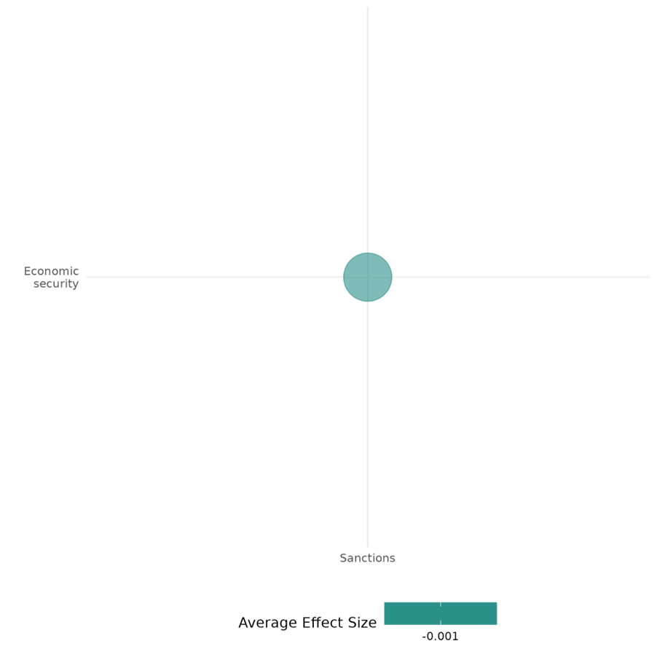
4.2.4(9)
The effect of sanctions on food security and nutrition & health security
Sanctions worsen food security and health outcomes, especially in conflict-affected regions.
Geographic region: Global, Africa
Effect size: Adverse effect (g = -0.005)
Confidence in study findings: Low (2 studies with 13 effect sizes)

Short summary
Sanctions, particularly economic and trade measures, negatively impact food security, nutrition, and public health. They reduce access to food, clean water, and healthcare services while decreasing immunization rates and government health spending. In conflict-affected areas like the Democratic Republic of the Congo, sanctions significantly worsen infant mortality and aggravate resource scarcity, disproportionately harming vulnerable populations.

The intervention
Sanctions are tools used to influence state behaviour, often imposed in response to human rights violations, political repression, or conflict. Sanctions can be comprehensive, affecting entire economies through trade restrictions and financial measures. They could also be targeted, focusing on specific sectors, individuals, or entities. Trade sanctions, such as those implemented through the Dodd-Frank Act (2010) in the Democratic Republic of the Congo (DRC), aim to disrupt funding sources for armed groups by restricting the mining and trade of conflict minerals, such as tin, tantalum, and tungsten. While these interventions are intended to promote stability and security, they can also have significant consequences for food security, nutrition, and health, particularly in regions dependent on resource extraction and already facing fragile governance systems.

How the intervention is expected to affect this outcome
Sanctions are intended to influence state or group behaviour by restricting access to economic resources. The logic behind these measures is that depriving regimes or armed groups of financial resources will weaken their capacity to sustain conflict or repression. In cases like the DRC, trade sanctions are designed to limit armed groups' access to revenue from conflict minerals, with the expectation that this will reduce violence and improve security outcomes. However, these measures can disrupt local economies and livelihoods, particularly in communities dependent on resource extraction. Reduced economic activity limits households' access to food, clean water, and healthcare services, which could result to higher levels of malnutrition and mortality, especially among vulnerable groups. Sanctions have also been shown to decrease government health spending, immunization rates, and overall life expectancy. In conflict zones, the combined effects of economic sanctions and ongoing instability can further exacerbate food and health insecurity.

The evidence base
This cell includes 2 impact evaluations. One of the studies is rated with medium confidence while the other is rated with low confidence.
All the studies utilized secondary data. One utilizes a global dataset while the other focuses on the implications of U.S. trade sanctions (under the 2010 Dodd-Frank Act) on the DRC.

Evidence findings
Sanctions negatively impact food security, nutrition, and health by reducing access to essential resources, weakening healthcare systems, and exacerbating vulnerabilities in conflict-affected areas. They contribute to decreased immunization rates, lower government health spending, and declining life expectancy, with particularly severe effects on infant mortality and health-adjusted life expectancy (HALE). When combined with military conflict or policies disrupting local economies, sanctions significantly worsen food insecurity and health outcomes, disproportionately harming vulnerable populations.

Included studies
Allen and Letzkian (2013) investigates the impact of economic sanctions on public health in targeted countries, comparing their effects to those of military conflicts. The study employs generalized estimating questions (GEE) and Heckman selection models to analyse cross-national data from 1990-2007, examining the public health impacts of economic sanctions and military conflicts. Key variables include public health indicators—food supply, immunization rates, government health expenditures, life expectancy, and health-adjusted life expectancy (HALE)—as dependent variables, with sanctions and conflict intensity as independent variables. Sanctions alone have minimal statistical effect on food availability, but the combination with military conflicts significantly exacerbates food insecurity. Regression results show that both sanctions and military conflicts significantly harm public health. Sanctions reduce immunization rates, government health spending, and life expectancy, with major sanctions having particularly severe impacts on health-adjusted life expectancy (HALE). These effects are amplified when sanctions coincide with ongoing military conflict. The study is rated medium confidence as it is non-experimental.
Parker(2016) explores the impact of the US policy on preventing certain companies from sourcing particular conflict minerals from the eastern Democratic Republic of the Congo (DRC), particularly on infant mortality. This intervention is known as the 2010 Dodd-Frank Wall Street Reform and Consumer Protection Act and the study compares the infant mortality rates in areas regulated by the policy to those in non-mining and non-regulated areas, before and after its implementation. The study applied a difference-in-difference approach on the ‘birth recode’ data set from five eastern Congo provinces. The treatment group has two conditions: the area (or village) must have within the Dodd-Frank policy zone and must be in close proximity to at least one 3T (tin, tantalum, and tungsten) mine operating prior to the Dodd-Frank. Meanwhile, the control group consists of villages in close proximity to a 3T mine, but outside the policy zone or villages within the policy zone but further from a 3T mine. The results indicate a significant increase in infant mortality in villages near conflict mineral zones after the Dodd-Frank effect took effect. Mortality rose by an estimated 143% from a baseline of 60 deaths per 1,000 births to 146 per 1,000. The study is rated low confidence due to a lack of reporting attrition.

Confidence assessment
Overall low: The cell has less than 4 impact evaluation studies. One of the studies is rated as low confidence while the other is rated as medium confidence.

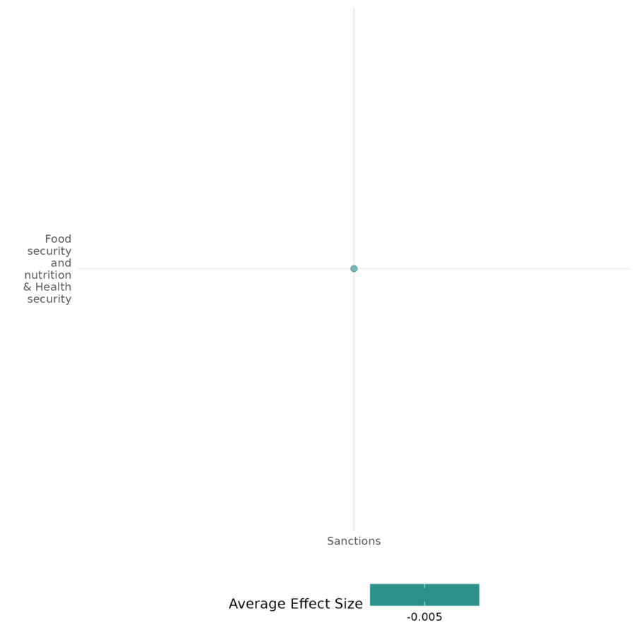

4.2.4(10)
Effect of sanctions on political security
Sanctions negatively affect political security by reducing civil liberties, restricting political participation, and increasing repression, especially under comprehensive measures.
Geographic region: Global
Effect size: Small effect (g=0.027)
Confidence in study findings: Medium (6 studies with 19 effect sizes)

Short summary
Sanctions, which may include comprehensive and targeted measures, are imposed by states or organizations like the U.N. to influence regimes, often in response to human rights violations or political repression. However, evidence from five impact evaluations shows that sanctions frequently undermine political security, as it may reduce civil liberties, political participation, and openness. Comprehensive sanctions exacerbate repression and societal divisions, while targeted sanctions can still justify regime consolidation. Minority groups face increased exclusion. Positive effects, such as improved women’s rights, are rare and highly context-dependent.

The intervention
Sanctions typically include economic sanctions imposed by states or international organizations, such as the U.S. and the U.N., to influence the behavior of targeted regimes. These sanctions take various forms: comprehensive sanctions that impact entire economies (e.g., trade restrictions and financial measures), and targeted sanctions, which focus on specific individuals, entities, or sectors. Sanctions are often imposed in response to human rights violations, political repression, or actions aimed at destabilizing regimes. The design, scope, and application of these sanctions vary widely, with multilateral sanctions often involving coordinated action through international organizations and unilateral sanctions reflecting individual state policy goals.

How the intervention is expected to affect this outcome
Sanctions are intended to influence political security by pressuring targeted regimes to implement reforms, improve civil and political rights, and increase openness in political participation. However, the evidence suggests that sanctions often lead to unintended consequences, particularly in authoritarian or fragile states. Economic sanctions may incentivize governments to consolidate power, restrict civic freedoms, and suppress political participation as a means of maintaining control. Comprehensive sanctions, in particular, can exacerbate political insecurity by intensifying economic hardship, reducing political space, and fostering societal divisions. While targeted sanctions aim to limit adverse effects, they can still allow regimes to frame sanctions as external threats, rallying domestic support and justifying repressive measures. As a result, sanctions may hinder political and civic freedoms, limit participation in political processes, and reduce openness in the political space, with outcomes shaped by the type of sanctions and the political context in which they are applied.

The evidence base
This cell includes 6 impact evaluations, and the evidence consistently points out the unintended consequences of sanctions on political security. Most of the studies are rated with medium confidence. Note Rosenberg (2016) is not included in the effect size calculation as it did not have enough information to compute for d.
All the studies utilized secondary data, with some analyzing global datasets and later narrowing their focus to economies subjected to sanctions or those which have authoritarian regimes. Three studies concentrated on broader implications of U.S. sanctions.

Evidence findings
Sanctions have a predominantly negative impact on political security, leading to a decline in political and civil rights, reduced openness in the political space, and increased repression. Comprehensive sanctions worsen political insecurity by intensifying political repression. Civil liberties deteriorate significantly under sanctions, as governments restrict civic freedoms and resort to coercive measures to maintain control. Minority groups face heightened exclusion and discrimination. While targeted sanctions show fewer adverse effects, they can still enable regimes to consolidate power and justify repression. Positive outcomes, such as improvements in women’s rights, are rare and context-specific.

Included studies
Adam and Tsarsitalidou (2019) analyse the impact of U.S.-imposed economic sanctions on civil liberties in targeted countries from 1972 to 2014. The study used a panel dataset of 166 countries, covering 42 years. It employed fixed-effects panel regressions and applied a potential outcomes framework. There were two dependent variables used to measure civil liberties, namely the Freedom House civil liberties index and the Cingranelli and Richards empowerment rights index. Meanwhile, the control variables included GDP per capita, regime type, and occurrences of war, to cite a few. The study finds that sanctions lead to a statistically significant decline in civil liberties in targeted countries, with the effects most pronounced for sanctions explicitly aimed at addressing human rights violations or destabilizing regimes. Multilateral sanctions, especially those involving international institutions, had stronger adverse effects on civil liberties compared to unilateral sanctions. The study is rated medium as it is non-experimental and due to its partial description of the intervention.
Gutmann (2019) investigates the effects of U.S. economic sanctions on human rights, specifically examining whether sanctions are "precision-guided" or "blunt" in their impact across various human rights categories. The analysis focuses on sanctions imposed by the US, which often aim to influence target countries’ policies by creating economic pressure. The study is set within a context where sanctions are intended to address concerns such as political repression or human rights abuses without resorting to military intervention. The study applied an endogenous treatment-regression model. The dataset spans U.S. sanctions from 1976 to 2012 and includes multiple control variables for economic, political, and international alignment factors. Under the endogenous treatment model, the study finds that U.S. economic sanctions do not lead to significant negative effects on political rights in targeted countries. Political rights, which include freedoms related to political expression, assembly, and participation, show no statistically significant deterioration under sanctions. Notably, the study finds a statistically significant and positive association between U.S. sanctions and women’s rights, indicating that emancipatory rights improve under these sanctions. The authors hypothesize that sanctions may create an environment in which social groups, including women, are granted greater rights, either as a strategic move by sanctioned governments to gain domestic support or as an unintended side effect of international pressure. When putting into account the different forms of sanctions, the results show that U.S. economic sanctions, regardless of type or duration, do not significantly impact basic political rights and civil liberties in targeted countries. However, sanctions show a positive effect on emancipatory rights, especially when mild, directed at improving human rights, or imposed on democracies. This study is rated medium confidence as it is a non-experimental study.
Önder (2022) investigates the impact of economic sanctions on minority groups within targeted states. It emphasizes that sanctions can lead to increased discrimination against these groups, particularly in economic, political, and social dimensions. The research aims to understand how different types of sanctions (comprehensive vs. targeted) affect the treatment of minorities. The study employs an empirical approach using ordered logit models to analyze the effects of economic sanctions on minority groups. The sample consists of data related to countries that have experienced economic sanctions, focusing on the treatment of minority groups within these nations. The results indicate that economic sanctions are associated with higher levels of discrimination (p<.01) against minority groups, particularly under comprehensive sanctions (p<.01). The study is rated medium as it is non-experimental.
Øygarden (2017) investigates the impact of economic sanctions on human rights violations, particularly focusing on physical integrity rights and civil and political rights. The context is rooted in the debate over whether sanctions, often employed by major powers to achieve political objectives, inadvertently exacerbate human rights abuses in targeted countries. The study encompasses a global perspective, analyzing data from various countries that have been subjected to economic sanctions between the years 1981 and 2005. The research employs a quantitative analysis framework. The study utilizes a significant dataset, with the original dataset comprising 1,607 observations for physical integrity rights and an extended dataset that includes approximately 2,825 observations for empowerment rights indicators. The results revealed that economic sanctions are associated with an increase in violations of physical integrity rights, with a mean index score of 3.401 (N = 1,595) indicating significant abuses such as torture and political imprisonment. The empowerment rights index shows that sanctions negatively impact civil and political rights, including freedom of speech and movement. Sanctions lead to a rise in extra-judicial killings, with a mean score of 0.749 (N = 1,600). The study is rated medium as it is non-experimental.
Rosenberg et al. (2016) examines the effects of US economic sanctions targeting states and non-state actors (post-9/11 attacks) on foreign investment, corruption, ease of doing business, and other related measures. In this light, the US has used financial/economic sanctions as a tool to address security threats, such as terrorism, nuclear proliferation, and territorial aggression, and what role does it play in national security strategy. The dataset included 22 post-9/11 sanctions cases from Rice University’s Threat and Impositions of Sanctions (TIES) dataset, the Petersen Institute for International Economics (PIIE) dataset of 21st century cases, the US Treasury Department’s OFAC sanctions website, the International Monetary Fund (IMF), the Political Risk Services (PRS), the Worldwide Governance Index (WGI), and the Polity IV. The methodology followed an approach previously used by the U.S. Government Accountability Office to assess U.S. sanctions on Iran. This method involved selecting a set of "peer economies" for each sanctioned country—five similar countries matched on regional, economic, and political characteristics. By comparing the sanctioned countries with their peer economies, the study aimed to isolate changes in economic and political conditions that could be attributed to sanctions. Results show that economic sanctions have no significant effect on civil disorder or aggregate government stability. The study is rated as medium due to its partial description of the intervention.
von Soest (2014) examines the effects of “democratic sanctions” (those that explicitly aim to promote democracy), on authoritarian regimes (which have become the most common type of sanction issued against authoritarian states). It introduces a data set that categorizes sanctions by their explicit objectives, distinguishing those aimed at democratization from other types of imposed sanctions from 1990–2010. This cross-sectional time-series study includes a sample of 2,079 country-years, with 532 country-years during which sanctions were imposed. All included cases were considered authoritarian at the start of the sanction episode. The main outcome of interest was the change in the level of democracy, measured using a combined Freedom House and Polity IV score. The study found that Democratic sanctions were associated with an increase of 0.160 points per year in the democracy score of targeted authoritarian countries. This result was statistically significant (p < 0.05). The positive effect of democratic sanctions remained significant after controlling for comprehensive sanctions, with the coefficient slightly larger at 0.197 in additional analyses. The study is rated medium confidence due to the partial description of the intervention,

Confidence assessment
Overall moderate: The cell covers studies with medium individual confidence assessments. There tends to be high consistency in the study findings, showing the negative effects of sanctions on political security.

Other outcomes of the study
Community and state governance / Government performance
Violence and atrocity prevention / Nature and scale of violence and atrocities
Human security / Economic security
Social cohesion / feelings of trust and acceptance of diversity

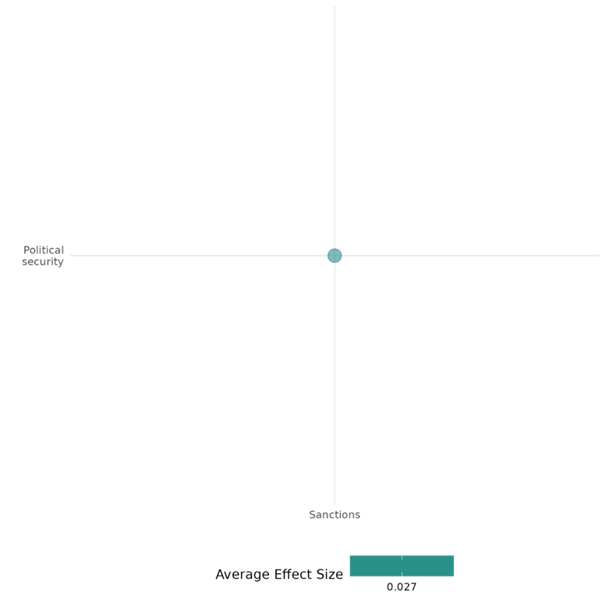

4.2.5 Aid assistance and aid conditionalities
4.2.5(1)
Effect of aid assistance and aid conditionalities on Diplomatic relations & Peaceful dispute resolution
Foreign aid sanctions influence diplomacy by coercing compliance, fostering short-term dispute resolution, but weaken over time as recipients adapt, requiring balanced aid strategies for sustainable peace.
Geographical region: Global
Effect size: Large effect (g=0.347)
Confidence in study findings: Low confidence (1 study; 01 ES)

Short summary
Foreign aid assistance shapes diplomacy by coercing compliance and stabilizing relations. Aid sanctions accelerate capitulation but weaken over time as recipients adapt. While effective short-term, they are unreliable for long-term peace. Aid withdrawal may strain relations, requiring a balanced approach combining negotiation and diplomacy for sustainable conflict resolution. However, we have low confidence in this cell due to a limited number of the studies in the cell.

The intervention
The intervention involves foreign aid sanctions, where sender countries reduce or terminate foreign aid to target states to pressure them into compliance. These sanctions disproportionately affect political elites and regime supporters, accelerating target capitulation. However, their impact diminishes over time as target governments adapt through alternative financial or political strategies.

How the intervention is expected to work
Foreign aid sanctions are expected to work by imposing economic hardship on politically influential elites and crucial regime supporters in target states. Since foreign aid is often distributed among key political and economic actors, its suspension directly weakens the regime’s ability to maintain loyalty and control. This pressure increases the likelihood of target governments conceding quickly to the sender’s demands to restore aid and stabilize internal political support. However, over time, governments may adjust by seeking alternative funding sources, implementing economic redistribution, or repressing dissent, reducing the sanctions' effectiveness. Thus, aid sanctions are most impactful when applied swiftly and decisively before adaptation occurs.

The evidence base
The cell includes one primary study that uses quantitative analysis with the Threats and Imposition of Economic Sanctions (TIES) dataset (1961-2012), covering global economic sanctions cases.

Evidence Findings
Foreign aid sanctions influence diplomacy by coercing compliance, fostering short-term dispute resolution, but weaken over time as recipients adapt, requiring balanced aid strategies for sustainable peace.

Included studies
Jeong (2018) investigates the impact of foreign aid sanctions on the duration of economic sanctions and target capitulations using the Threats and Imposition of Economic Sanctions (TIES) dataset (1961-2012). The findings reveal that foreign aid sanctions significantly expedite target capitulation compared to non-aid sanctions, as they disproportionately affect political elites and crucial regime supporters. However, this effect diminishes over time as target governments adjust through economic and political countermeasures. The statistical analysis shows that foreign aid sanctions have a highly significant effect (p<0.01) on accelerating target surrender. In the first month of implementation, these sanctions increase the probability of target acquiescence by 461%-554% compared to non-aid sanctions. However, this effect weakens over time, becoming statistically indistinguishable from other forms of sanctions after 16-30 months. This suggests that for aid sanctions to be effective, they should be imposed swiftly and decisively before target states find alternative financial resources or implement domestic strategies to counteract the pressure. This study is rated as high and medium confidence quantitative study.

Confidence assessment
Overall: Low confidence as there is a limited number of studies.

Other outcomes in the study
None

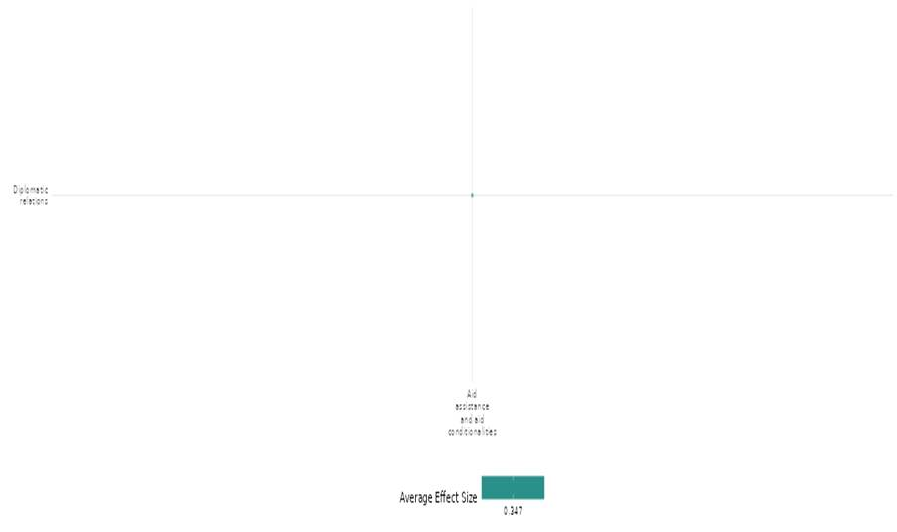

4.2.5(2)
Effect of aid assistance and aid conditionalities on nature and scale of violence and atrocities
Aid assistance and aid conditionalities had mixed effects on nature and scale of violence and atrocities. Military and cash aid can escalate conflicts, while dispersed aid has weaker links to violence. Aid may provoke insurgent attacks in contested areas but reduce violence in secured regions.
Geographical region: Global, South Asia, Sub Saharan Africa
Effect size: Adverse effect (g= -0.018)
Confidence in the study findings: low confidence (4 studies; 35 ES)

Short Summary
Foreign aid impacts violence differently based on context. Military and cash aid can escalate conflicts, while project and humanitarian aid have minimal effects. Concentrated aid funding increases military and civilian fatalities, whereas dispersed aid has weaker links to violence. In contested areas, aid can provoke insurgent attacks, while in secured regions, it may reduce violence. We have low confidence in the cell due to a limited number of the studies.
The Intervention
The interventions across the cell focused on aid assistance and aid conditionalities. Technical and cash aid stabilize regions, while military and concentrated aid may escalate violence. Counterinsurgency aid reduces violence in secured areas but increases resistance in contested zones. Strategic allocation and monitoring are essential to ensure aid fosters stability rather than worsening conflict.
How the intervention is expected to work
Foreign aid interventions aim to influence conflict dynamics by addressing economic instability, governance deficits, and humanitarian needs. Technical and cash aid can strengthen institutions and improve livelihoods, reducing grievances that fuel violence. However, military and concentrated aid may escalate conflict by altering power balances and increasing competition among groups. Counterinsurgency aid is effective in reducing violence in secured areas but may provoke resistance in contested regions. Strategic allocation, monitoring, and adaptation to local conditions are essential for ensuring aid mitigates rather than exacerbates conflict.
The evidence base
The cell includes four impact evaluations. The four studies employ quantitative and primarily observational, with some employing quasi-experimental methods. They analyze using statistical techniques such as fixed effects models, propensity score matching, Bayesian estimation, and spatial analysis.
The studies are conducted in Afghanistan, Democratic Republic of Congo, Ethiopia, Sudan, and various sub-Saharan African nations.
Evidence findings
The interventions had mixed effects with technical and cash aid reducing violence, while military and concentrated aid escalate conflict. Aid conditionalities shape outcomes, as counterinsurgency aid decreases violence in secured areas but increases it in contested zones. Strategic allocation and monitoring are crucial to ensuring aid mitigates rather than exacerbates violence and atrocities.
Included studies
Said (2017) investigates the relationship between foreign aid and civil conflict, suggesting that foreign aid can play a crucial role in conflict prevention and peacebuilding. It categorizes different types of foreign aid, including Official Development Assistance (ODA) such as project aid, humanitarian aid, technical aid, and loan aid, as well as Other Official Flows (OOF) like military assistance and cash assistance. The research focuses on UN member countries with a population of 500,000 or more as of the year 2000. The study included 156 countries. The study employs a quantitative research design. The final sample size is 6,473 country-year observations. The author found that civil conflict incidence, was recorded in 14% of the observations, with 900 instances of civil conflict occurring across the sample. The average country received ODA equivalent to 5% of its GDP, with project aid constituting 3% of GDP, the largest category of ODA. Between 1945 and 2000, there were 314 incidents of civil conflict recorded in the 1990s alone, compared to only 48 incidents in the 1950s. The study found that military assistance and cash assistance had varying impacts on civil conflict, with specific percentages of aid to GDP reported for each category. The results indicate that technical aid (β = 5.03, p < 0.05), loan aid (β = 27.40, p < 0.1), military assistance (β = 12.85, p < 0.01), and cash assistance (β = -2.11, p < 0.05) show statistically significant relationships with civil conflict incidence, while project aid and humanitarian aid are not significant. Economic and demographic indicators such as GDP per capita (β = -18.04, p < 0.01), ethnic dominance (β = 1.33, p < 0.01), geographic dispersion (β = 0.12, p < 0.01), and policy (β = 0.01, p < 0.01) also exhibit significant associations. The confidence assessment of the study is high and medium confidence quantitative study.
Strandow (2014) investigates how foreign aid to conflict-affected regions impacts the intensity of civil conflict, particularly in sub-Saharan Africa. The focus is how aid distribution can influence territorial control contests between warring parties, increasing or decreasing violence. Two factors are central: funding concentration (aid given in specific, high-value locations versus diffused broadly) and barriers to exploiting aid (aid types that are easier or harder to misappropriate by either state or non-state actors). This quasi-experimental study, using propensity score matching, analyzes geo-coded aid data and battleground control records to explore the relationship between violence intensity and aid disbursement patterns in sub-Saharan Africa (1989–2008). The dataset spans 19 years, covering numerous localized battlegrounds and subnational observations matched by geographic and conflict variables. The results showed an increase in military fatalities by 47% (log-transformed measure) without matching adjustments, and post-matching, it was Increased by 43%, equating to an average rise of 3.26 fatalities (109 %, or 3.3 fatalities compared to if there were low or no funding con centration). Civilian Fatalities (Low-Barrier Aid): Increased civilian deaths by 30% without matching adjustments. There was no statistically significant effect post-matching in the overall model for education aid. The Impact of Education Aid (Military Fatalities) Initially, it showed a smaller or more negative effect. Post-matching resulted in a 75% increase, corresponding to an additional 2.61 military fatalities. Findings suggest that areas with concentrated aid funding see increased military fatalities, while areas with low-barrier, easily lootable aid experience higher civilian fatalities due to heightened competition and looting. This pattern highlights how aid types and concentration impact conflict dynamics differently. The study is rated as high and medium confidence quantitative study.
van Weezel (2015) examines the effect of foreign aid on conflict intensity at a sub-national level in three African countries: Democratic Republic of Congo, Ethiopia, and Sudan. The main question is whether aid allocations influence local conflict levels, potentially by either deterring or intensifying conflict in these areas. This study uses a spatial analysis using 1,000 pre-existing district-level observations from the selected countries from 1999 to 2008 on aid distribution and conflict intensity with Bayesian estimation to evaluate foreign aid and conflict data. Aid data is mapped to conflict data, allowing for spatial and temporal analysis of aid's impact on conflict. Findings show that, in general, there is little evidence to support a strong effect of aid on conflict intensity. There is a minor negative link with conflict of non-fungible assistance, with a decrease of only about 0.2% in conflict intensity when moving from low to high aid levels, which is statistically weak. The spatial analysis also reveals that conflict is localized in peripheral areas, while aid is often concentrated near capitals. The province-level results contrast with the district level, where the magnitude of the estimated effect is near 0, and the probability of a negative link is just 0.46. This large difference in probability could be because, at the district level, there is no link between aid and conflict. Results showing that conflict onset at the province level is 0.11 and 0.36 at the district level, with log conflict intensity values of 5.36 and 5.08, respectively. Foreign aid, lagged by one year, has an average log value of 16.63 at the province level and 14.44 at the district level. Foreign aid has a small, statistically insignificant effect on conflict onset, with estimates of 0.4 (95% CI: -0.8 to 1.7) at the province level and 0.4 (95% CI: -0.1 to 0.9) at the district level, while ethnic polarization at the district level shows a significant effect (1.2, 95% CI: 0.5 to 2.0). Increasing aid levels correspond with a 0.2% decrease in conflict intensity at the province level, with an 82% probability of a negative link, while at the district level, the effect is nearly zero (46% probability of a negative correlation). The study is high and medium confidence quantitative study.
Sexton (2016) examines the effects of counterinsurgency aid, specifically the Commander's Emergency Response Program (CERP), on insurgent violence in Afghanistan. The study suggests that insurgents strategically respond to aid by resisting through violent means, especially in contested areas not under government control. The study uses observational data on CERP spending and various measures of insurgent violence (bombings, enemy actions, and explosive hazards) at the district-week level in Afghanistan from 2008 to 2010. The authors employ an empirical strategy that focuses on the week-by-week variation in CERP spending to isolate the causal effect on violence. The key findings are: Civilian aid only reduces insurgent violence when distributed in districts already controlled by pro-government forces. Civilian aid allocated to contested districts causes a significant increase in insurgent violence. Military defence infrastructure projects in contested areas greatly increase insurgent attacks, while humanitarian aid has no effect. Results show that in contested districts, $100,000 of aid spending increases bombings by 0.08, enemy actions against progovernment forces by 0.05, and explosive hazards by 0.10, indicating that aid provokes insurgent violence in these areas. However, in secured districts (controlled by U.S./progovernment forces), the same amount of aid reduces bombings by 0.08, enemy actions by 0.07, and explosive hazards by 0.16, suggesting that aid only decreases violence where military control is already established. The lagged effects show that past aid spending does not significantly reduce future violence in contested districts, but its violence-reducing impact persists in secured districts over time. The study is rated as low confidence quantitative study as it is an observational study, the authors acknowledge that the effects of aid on violence can be overridden by macrolevel strategic changes in the conflict, as demonstrated by the case of the Northern Distribution Network.
Confidence assessment
We have low confidence in the cell due to a limited number of studies in the cell.
Other outcomes in this study
None

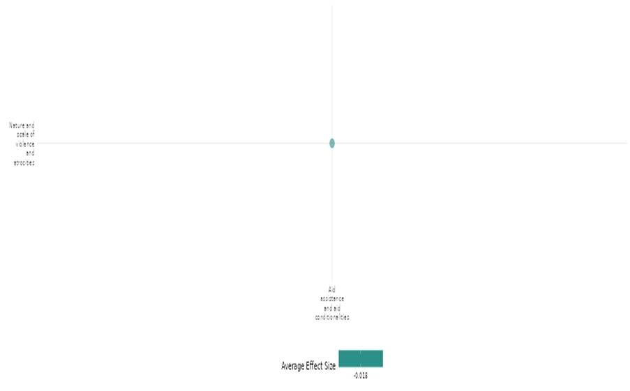

4.2.5(3)
Effect of aid assistance and aid conditionalities on economic security
This study analyses the impact of nation-building interventions (economic aid and military assistance) on GDP growth during conflict and post-conflict periods. It finds aid enhances growth during conflict but may hinder post-conflict recovery.
Geographical region: Global
Effect size: Small effect (g=0.052)
Confidence in study findings: Low confidence (1 study; 11 ES)

Short summary
Foreign aid sanctions reduce income inequality by targeting wealthy elites, enhancing economic security in aid-dependent nations. Aid conditionalities shape income distribution, potentially stabilizing economies by limiting elite financial benefits while minimizing adverse effects on lower-income groups, promoting fairer economic outcomes. We have low confidence in the cell due to a limited number of studies.
The intervention
The intervention examines the impact of economic sanctions, specifically trade restrictions (import/export bans) and foreign aid suspensions, on income inequality in sanctioned countries. Sanctions are imposed to pressure governments for political concessions but have unintended economic consequences, affecting income distribution differently based on a country's labour endowment and aid dependence.
How the intervention is expected to work
This intervention is expected to work by exerting economic pressure on targeted governments through trade restrictions and foreign aid suspensions, forcing them to change policies. Import sanctions restrict goods entering a country, harming industries that rely on exports, often worsening income inequality in labor-abundant nations. Export sanctions limit the availability of foreign goods, potentially benefiting domestic producers but with uncertain effects on inequality. Foreign aid sanctions cut financial assistance, disproportionately affecting the wealthy elites who benefit most from aid, thereby reducing inequality. The overall impact depends on a country’s economic structure, with varying effects on different income groups.
The evidence base
The cell includes one primary study that uses cross-national panel-data regression analysis on 152 countries (1974-2011), utilizing TIES and SWIID 6.0 datasets to assess sanctions' effects.
Evidence Findings
Foreign aid sanctions reduce inequality by disproportionately affecting wealthy elites, improving economic security in aid-dependent countries. Aid conditionalities influence income distribution, potentially stabilizing economies without severely harming lower-income groups.
Included studies
Jeong (2020) examines the effects of economic sanctions—trade restrictions (import/export bans) and foreign aid suspensions—on income inequality in sanctioned countries. The study covers 152 countries from 1974 to 2011, using a cross-national, panel-data regression analysis with data from the Threats and Imposition of Economic Sanctions (TIES) dataset and the Standardized World Income Inequality Database (SWIID 6.0). With a sample size of 3,436 country-year observations, the study analyses how different sanctions influence income inequality, considering factors such as labour endowment, economic aid dependence, and trade openness. The findings indicate that import sanctions increase inequality in labour-abundant countries, with a statistically significant increase in the Gini coefficient by 5.1% to 15.3% (p<0.05). In contrast, foreign aid sanctions reduce inequality, particularly in countries that rely heavily on aid, leading to a Gini coefficient decrease of 3.6% to 10.7% (p<0.05). However, export sanctions show no significant effect on income inequality (p>0.1). The study highlights the complex distributional consequences of sanctions, with their impact depending on economic conditions in the targeted countries. The study rated as low confidence quantitative study due to small sample size and omitting relevant variables.
Confidence assessment
Overall: Low confidence as there is a limited number of studies.
Other outcomes in the study
None
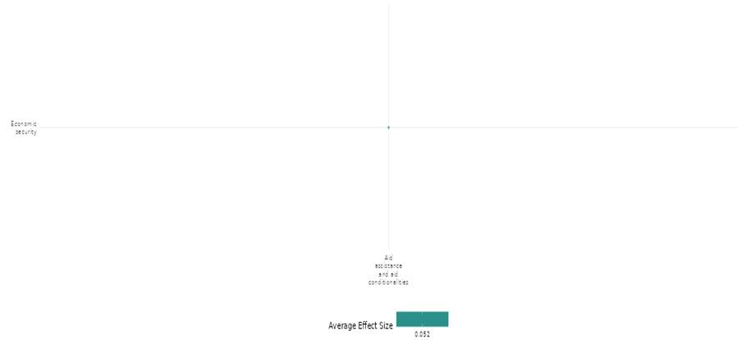

4.3 Conflict Management And Mediation

4.3.1 Research, Monitoring, And Assessments
4.3.1(1)

Effect of Research Monitoring & assessment on Diplomatic relations & peaceful dispute resolution
RMA interventions assess civil war resolution and peacekeeping. Stalemates foster negotiation, but power struggles weaken agreements. UN missions aid security, prevent defections, and support governance, while strong institutions ensure lasting peace.
Geographic region: Global (post-civil war countries)

Effect: Moderate effect (g=0.139)

Confidence assessment: low confidence (2 studies with 15 Effect size)

Short summary
Research, Monitoring, and Assessment (RMA) interventions help evaluate how civil wars are resolved and how peacekeeping efforts contribute to stability. Studies show that while military stalemates push groups toward negotiation, unresolved power struggles and coordination problems can weaken peace agreements. Monitoring of UN peacekeeping missions highlights their role in preventing defections, improving security, and supporting stable governance, as seen in data from past civil wars and peace agreements. These findings show that negotiation, agreement, and implementation are closely linked, with early conditions shaping long-term success. Regular monitoring of interventions highlights the need for strong institutional support, showing that while peacekeeping can improve stability, unresolved power imbalances may lead to renewed conflict.

The Intervention
The intervention assessed in these studies focuses on the systematic evaluation of civil war resolution and peace agreement implementation through research, monitoring, and assessment. By analysing the factors influencing negotiations, agreement formation, and successful implementation, these studies identify key risks such as military stalemates, the number of actors, and UN peacekeeping involvement that affect long-term peace stability. Using empirical data and statistical modelling, the research examines how combatants' decision-making evolves across different stages of the peace process and how international interventions shape peace outcomes.
How is the intervention expected to work
The intervention is expected to work by addressing the key risks that influence civil war resolution and peace agreement implementation through systematic monitoring and empirical assessment. The underlying theory of change suggests that conflict resolution is a sequential process where factors such as military stalemates and the number of actors shape negotiation dynamics, while international interventions like UN peacekeeping can enhance agreement implementation. By reducing uncertainty, facilitating credible commitments, and mitigating risks of defection, peace agreements are more likely to be successfully implemented. Through continuous assessment of these stages, the intervention aims to improve strategic decision- making, ensuring that negotiated settlements lead to long-term stability and conflict prevention.

The Evidence base
The cell includes two primary impact evaluations (IEs) that analyze multiple post-civil war countries using global data from the Peace Accords Matrix Implementation Dataset (1989– 2010), covering conflict-affected regions with UN peacekeeping missions. It adopts a quantitative research design to assess peace agreement implementation scores across multiple cases.

Evidence Findings
RMA interventions, such as evaluating the effectiveness of civil war resolution and peacekeeping, have shown that stalemates may drive negotiations, but power struggles and coordination issues can weaken agreements. UN missions have historically aided in preventing defections, enhancing security, and supporting governance, with strong institutional support being crucial for lasting peace.

Included studies
There are two primary studies included under this cell. The detailed summary thus provided below:

Findley (2012) examines civil war resolution as an interdependent process, where peace emerges through sequential stages: battle → negotiation → agreement → implementation. Using bargaining theory, the study analyzes how military stalemates and the number of actors influence each stage. While these factors encourage negotiations, they often undermine long- term peace implementation due to coordination challenges and unresolved power dynamics. Employing a nested logit statistical model, the research evaluates 116 civil wars, capturing the interdependence of negotiation, agreement, and implementation phases.

Findings indicate that military stalemates push conflicting parties toward negotiation but fail to ensure lasting peace, while a higher number of actors makes agreements easier to reach but harder to implement due to spoilers and coordination issues. Uncertainty in power distributions leads to unstable agreements, increasing the likelihood of conflict recurrence. Additionally, third-party interventions, such as peacekeeping missions and security guarantees, have varied effects depending on when they occur.This study falls under the intervention category of research, monitoring, and assessments, systematically evaluating factors that impact peace durability. It highlights that early negotiation conditions shape later implementation success, and stalemates often result in temporary peace deals that collapse due to unresolved power asymmetries.The study is rated as low confidence.

Maekawa et al. (2019) examine the role of United Nations (UN) involvement in implementing civil war peace agreements, focusing on how UN missions mitigate risks of defection during the peace process. They identify two types of commitment problems: involuntary defections, where actors are unable to implement agreements due to polarized voting or weak state capacity, and voluntary defections, where actors deliberately renege due to shifting power dynamics and changing incentives. These challenges can undermine agreement implementation and increase the risk of conflict recurrence.Using data from the Peace Accords Matrix Implementation Dataset (1989–2010) and UN personnel commitments, the study finds that larger UN peacekeeping missions improve peace agreement implementation by reducing the likelihood of defections, increasing security, and supporting institutional stability. UN peacekeeping missions play a critical role in preventing conflict relapse by enforcing agreements, monitoring compliance, and providing technical and logistical support to post- conflict governmentsThe study employs a quantitative research design, analyzing a comprehensive dataset of peace agreements to assess implementation scores across multiple cases. Findings indicate that polarized voting and weak state capacity cause delays in implementation, while power shifts and rebel fragmentation further undermine success. However, stronger government leverage improves outcomes, reinforcing the UN’s role in stabilizing post-conflict environments. This research falls under the intervention category of research, monitoring, and assessments, systematically evaluating the effectiveness of UN missions in ensuring sustainable peace. The study is rated as high-medium confidence.

Confidence assessment:
Overall the cell represents low confidence due to the small number of studies, inconsistency in findings.

Other outcomes under this cell (studies):
None

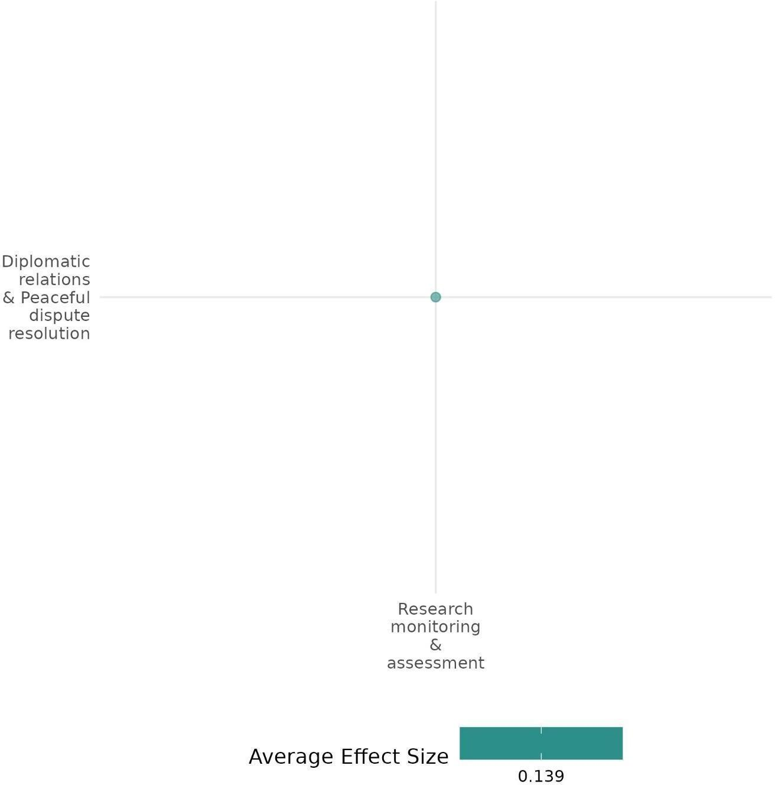

4.3.1(2)

Effect Research Monitoring & Assessment on Nature & scale of violence or atrocities

Peacekeeping interventions show that UN military and police forces deter attacks, enforce ceasefires, and stabilize post-conflict areas, while regional forces mainly control government violence but fail to curb rebel atrocities.

Geographical Regions: Global, East Asia & Pacific, Latin America & Caribbean, South Asia, Sub-saharan Africa, middle east & North Africa

Effect: Small effect (g=0.022)

Confidence in the study assessment: Low (9 studies with 44 effect size)

Short Summary
Research, monitoring, and assessment systematically evaluate peacekeeping interventions and their impact on post-conflict violence. Using quantitative methods like survival analysis and statistical modelling, studies analyze global and regional conflict data (1946–2018) and case studies from Africa, Nepal, Syria, and beyond to examine peace duration, conflict fragmentation, and violence reduction. Findings indicate that UN peacekeeping operations, mainly military troops and police forces, significantly reduce civilian fatalities, battle deaths, and geographic violence. Larger UN deployments enhance security, enforce ceasefires, and deter violence by both government and rebel forces, while UN police strengthen local law enforcement and prevent ongoing violence. However, unarmed observer missions show little impact. Regional peacekeeping forces effectively limit government violence but fail to curb rebel atrocities. Studies also show that fragmented conflicts last longer and are deadlier, but UN interventions mitigate these effects by improving coordination and discouraging spoilers. Ceasefires and military victories ensure more durable peace than negotiated settlements, which frequently collapse. Economic conditions and governance strongly influence stability, with lower-income states facing higher risks of renewed conflict. Overall, well-resourced, strategically deployed peacekeeping missions are essential for reducing conflict intensity, violence scale, and civilian victimisation.
The intervention
Research, monitoring & assessment Interventions include peacekeeping operations, ceasefire monitoring, and conflict resolution mechanisms. UN and regional peacekeeping forces deploy troops, police, and observers to reduce violence and protect civilians. Civil society involvement monitors ceasefires, reports violations, and fosters compliance. Peace agreement implementation involves enforcement mechanisms, reconciliation efforts, and conflict prevention strategies. Key mechanisms include incentivizing compliance, deterring spoilers, improving stakeholder coordination, and preventing conflict escalation. Research, monitoring, and assessments refine strategies using empirical data analysis and case studies to enhance intervention effectiveness.

How is the intervention expected to work
The intervention is expected to work by systematically monitoring conflict dynamics, assessing intervention effectiveness, and identifying key mechanisms that sustain peace and prevent violence. Based on the theory of change, peacekeeping forces and civil society monitoring alter incentives for compliance, deter spoilers, and reduce the likelihood of conflict escalation. UN and regional peacekeepers protect civilians by interceding between warring factions, while civil society actors enhance ceasefire implementation by fostering trust, preventing blockages in negotiations, and ensuring accountability. By improving coordination among stakeholders and addressing security and governance gaps, these interventions create conditions for sustained peace, reducing the risk of conflict recurrence and postwar violence.

The Evidence base
The cell includes 11 studies, where one is a high-medium confidence systematic review, and 10 are impact evaluations focused on Sub-Saharan Africa (Burundi, Liberia, Sierra Leone, East Timor, Sudan), South Asia (Nepal), and the Middle East (Syria), with global analyses covering civil conflicts from 1946 to 2018.
Among the 10 impact evaluations, one study was excluded from the cumulative effect size calculation due to insufficient data.

Evidence findings
UN military and police forces stabilize post-conflict areas by deterring attacks and enforcing ceasefires, while regional forces mainly curb government violence but not rebel atrocities. Well-resourced deployments reduce conflict fragmentation, prevent escalation, and limit armed group recruitment, ensuring lasting peace.

The review evidence
The review evidence suggested that community-driven development and reconstruction efforts had mixed effects on violence, with some interventions reducing conflict, others failing, and some exacerbating violence due to misappropriation or sabotage, highlighting the need for rigorous evaluation.
Included studies
Akman (2010) examines the relationship between security and development in post-conflict peace operations, assessing different strategies for integrating these dimensions. The study categorizes peacebuilding strategies into three models: Security-Only (prioritizing security before development), Sequential (security first, then development), and Simultaneous (security and development pursued together). The study employs a mixed-methods approach, combining logistic regression analysis on a dataset covering all civil wars from 1946 to 2006 and structured, focused comparisons of six case studies. The study falls under research, monitoring and assessments as it systematically evaluates different peacebuilding strategies through data collection and empirical analysis, identifying conditions under which peace operations are most effective. The study highlights that conflict intensity significantly impacts peace outcomes. Low-intensity conflicts (25-999 deaths) have a 42% chance of reaching peace within two years, compared to 12% for full-scale wars (>1,000 deaths). Over time, peace remains more achievable in low-intensity conflicts, while full-scale wars tend to prolong hostilities. Additionally, ceasefires and military victories are the most effective for lasting peace, with 77% of ceasefires maintaining stability for five years. In contrast, only 18% of peace agreements achieve the same durability, showing that negotiated settlements often struggle. The conflict resolution method plays a key role in sustaining long-term peace. The study is rated as a high-medium confidence study.

Arı (2020) analyze the effectiveness of United Nations (UN) peacekeeping operations (PKOs) in managing civil conflicts characterized by actor fragmentation. They argue that fragmented conflicts, with multiple competing factions, tend to be longer and deadlier due to coordination challenges and spoiler violence. This study systematically evaluates the impact of peacekeeping on conflict fragmentation using empirical analysis, providing insights into the mechanisms through which international interventions reduce violence and hence fall under the research, monitoring and assessments category. Using the Conflict Fragmentation Index (CFI), the study finds that greater fragmentation increases conflict duration and violence. However, UN peacekeeping mitigates these effects by addressing commitment issues, discouraging spoilers, and improving coordination. Analyzing global civil conflict data (1990– 2013) and African battle deaths (1992–2011) through statistical modeling, the study shows that UN interventions shorten conflicts and reduce fatalities, especially in highly fragmented wars. The study is rated as a low-confidence study.

Bara (2020) examines the effectiveness of UN peacekeeping operations in mitigating postwar violence, particularly violence perpetrated by actors other than the former warring parties. The study argues that while peacekeepers effectively stabilize postwar environments, their impact varies depending on the type of personnel deployed. The study employs a quantitative research design, using a global dataset of postwar violence covering 71 postwar episodes between 1991 and 2016, analysed through statistical modelling. The study falls under the research, monitoring and assessments category as it systematically evaluates how different types of UN peacekeepers impact various forms of postwar violence using empirical data and a novel spatial approach. The study finds that UN police effectively reduce postwar violence by filling security gaps and supporting local law enforcement, while UN troops mainly deter attacks on civilians but have little impact on broader violence. UN police play a crucial role in stabilizing postwar societies by enhancing security and rebuilding institutions, making them more effective than military troops in managing ongoing violence. The study is rated as low - confidence.

Bara (2020) compares the effectiveness of United Nations (UN) and non-UN peacekeeping operations in reducing violence against civilians in civil conflicts. The study employs a quantitative research design, using a novel dataset covering monthly deployments of UN and regional peacekeeping personnel in civil conflicts worldwide between 1993 and 2016, analysed through statistical modelling. The study falls under research, monitoring and assessments as it systematically evaluates the impact of UN and regional peacekeeping on civilian protection using empirical data, providing insights into the relative effectiveness of different international actors. The study finds that both UN and regional peacekeeping operations effectively reduce violence by government forces. However, only UN troops and police significantly curb civilian targeting by rebel groups, while regional missions have no impact on rebel-perpetrated violence. UN missions are generally more effective due to their larger scale, diverse personnel, and better resources, whereas regional missions are more militarized and deployed in less severe conflicts. While regional forces often act as first responders, UN interventions play a stronger role in stabilizing high-intensity post-conflict environments. The study is rated as high-medium confidence.

Caplan (2017) investigate the factors that contribute to the long-term stability of peace following civil wars. Using survival analysis on 205 post-conflict episodes since 1990 with six in-depth case studies (Burundi, East Timor, El Salvador, Liberia, Nepal, Sierra Leone), they assess the impact of conflict termination type, UN peacekeeping operations, and socio- economic conditions on peace duration. The study finds that negotiated settlements are more likely to break down than military victories, and that UN peacekeeping operations do not significantly extend peace duration unless they support negotiated settlements. Economic development and governance quality also play a role in stabilizing peace. It falls under research, monitoring and assessments category as the study systematically monitors and evaluates factors influencing post-conflict stability using empirical data, identifying key risks for peace failure. The study is rated as a low-confidence study.

Hultman (2013) examine whether United Nations (UN) peacekeeping effectively protects civilians during civil wars. They argue that deploying large numbers of military troops and police significantly reduces civilian killings by interceding between combatants and imposing physical barriers to violence. Using monthly data from 1991 to 2008 on UN peacekeeping deployments and civilian deaths in African conflicts, The study employs a statistical analysis of conflict data across multiple civil wars in sub-Saharan Africa to assess the impact of peacekeeping forces. This research falls under the intervention category of research, monitoring, and assessments as it systematically evaluates the role of peacekeeping in mitigating violence through data collection and empirical analysis. By identifying how different UN personnel types influence civilian protection, the study provides insights into conflict risks and contributes to the development of more effective international intervention strategies.The study finds that larger UN military and police deployments significantly reduce civilian fatalities, while unarmed observer missions have little impact. An 8,000-troop deployment lowers deaths from 106 to fewer than 2 per month. Well-resourced missions enhance security, enforce ceasefires, and deter attacks, whereas understaffed missions fail to prevent violence. The study is rated as a low-confidence study.

Kathman (2016) examine the effectiveness of United Nations (UN) peacekeeping missions in reducing post-conflict civilian victimization. They argue that although wars officially end, civilians remain vulnerable to targeted violence from former combatants and emerging armed groups. Using a quantitative research design, analysing monthly data from African post- conflict settings (1992–2010) using statistical models to assess the impact of different types of peacekeeping personnel on civilian victimization, The study falls under research, monitoring and assessments category as it systematically evaluates the role of peacekeeping forces in protecting civilians through empirical analysis, providing insights into how different personnel types influence violence reduction.The study finds that larger UN troop deployments reduce civilian deaths by up to 75% by deterring reprisals and enforcing security. UN police help curb rebel-led violence but have little effect on government-led killings, while UN observers may increase civilian deaths due to their lack of enforcement power. The findings emphasise that well-equipped, military-backed peacekeeping missions are essential for postwar stability, whereas weak or symbolic interventions can worsen civilian victimisation.

Lundgren (2020) examines the causal mechanisms of international organization (IO) interventions in civil war mediation. It employs a structured case comparison of the Arab League and UN interventions in Syria (2011–2012), using qualitative interviews, fatality statistics, and IO reports to trace causal mechanisms The study explores how institutional capabilities and member state preferences shape the effectiveness of mediation and ceasefire monitoring. Using interview data, fatality statistics, and organizational documentation, the study finds that while both IOs pursued similar mediation and monitoring strategies, the UN’s superior institutional resources allowed it to temporarily reduce violence. However, both interventions ultimately failed due to member state divisions, which undermined their credibility and enforcement capacity. The study falls under research, monitoring and assessments category as it systematically evaluates the effectiveness of international mediation and monitoring strategies, providing empirical evidence on the causal mechanisms that influence conflict resolution outcomes. The study is rated as high-medium confidence.

Pinaud (2021) investigates the role of civil society in ceasefire monitoring and its impact on peace processes. The study examines how civil society actors contribute to ceasefire implementation by reducing violence, fostering cooperation between conflict parties, and influencing broader political transitions. Using a mixed-methods approach, including survival analysis on a dataset of ceasefires from 1990 to 2018 and an in-depth case study of Nepal’s Maoist insurgency, the study finds that civil society involvement can help prevent ceasefire breakdowns by altering incentives for compliance, preventing escalations, and reducing opposition from spoilers. However, its effectiveness is limited by political constraints, lack of resources, and impartiality concerns. The study under the research, monitoring and assessments category as it systematically evaluates the role of civil society in ceasefire monitoring through empirical data collection and analysis, identifying.The study is rated as low confidence.
Hoeffler (2019) - examines post-conflict stabilization in Sub-Saharan Africa, focusing on the effectiveness of United Nations Peacekeeping Operations (UNPKOs). Using survival analysis, it finds that military victories lead to more stable peace, whereas negotiated settlements and ceasefires have a higher risk of breakdown. UNPKOs significantly improve peace duration, reducing the risk of failure by about 15%. However, their effectiveness depends on troop strength and mission mandates. The study highlights Africa’s higher post-conflict instability, with conflicts causing over 10,000 battle-related deaths on average. Many conflicts do not formally end but continue at lower violence levels, increasing recurrence risks. Economic conditions play a crucial role, as lower-income countries experience more conflict relapses. Poor governance, natural resource exploitation, and unresolved grievances further fuel instability. While peacekeeping operations help stabilize settlements, their success is contingent on adequate resources, strong local government partnerships, and regional support. The study is rated as a low confidence.
Confidence assessment
Overall confidence is low due to inconsistent findings across studies. The wide effect size range (g = -0.244 to 0.334) exceeds the ±0.1 threshold, indicating substantial variability. Despite including both IE and SR studies, with large sample sizes in IE, this variability remains.

Link to review summaries
Cramer Christopher (2016).
The study may be accessed via the EGM.

Other outcomes under this cell
Violence and atrocity prevention/ Diplomatic relations + Peaceful dispute resolution Human security/Physical security
Social cohesion/Feelings of trust & acceptance of diversity
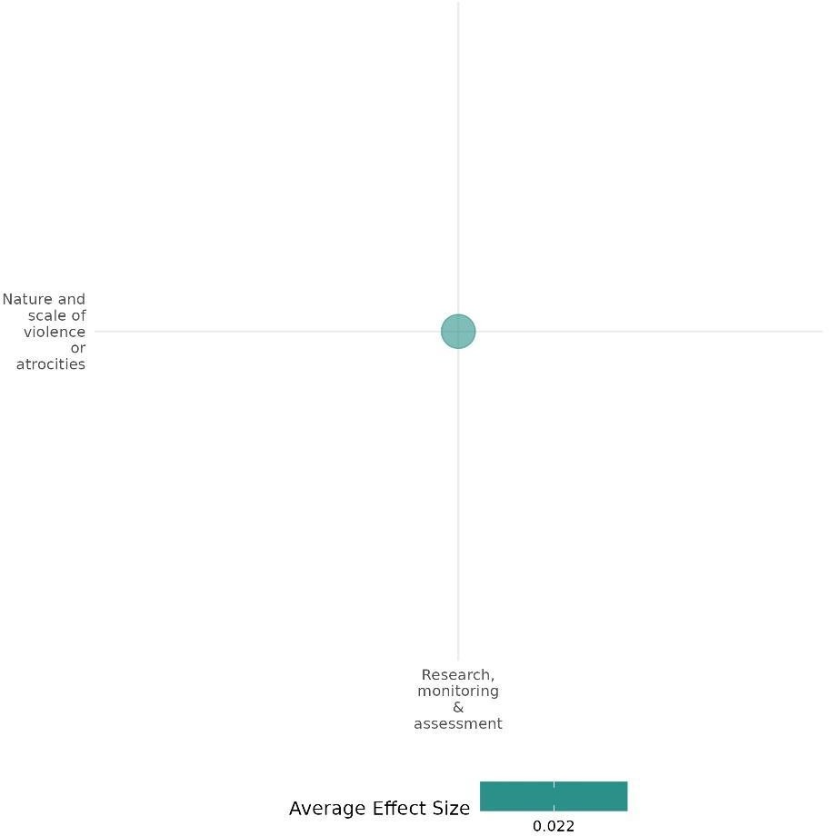

4.3.1(3)

Effect of Research, monitoring, and assessment on willingness to participate or help
Research on civic education and town hall programs boosted political participation, while security committees had no impact. The combined intervention showed a moderate effect.
Geographical Region: Sub-Saharan Africa

Effect: Large effect (g=0.247)

Confidence in study findings: Low (1 study with one effect size)
Short summary
Research, monitoring, and assessment interventions included two democracy promotion programs: Civic Education and Town Hall Program and Security Committee Program. The civic education program provided electoral education and facilitated discussions to enhance voter knowledge and coordination, while the security committee program established village- level committees in collaboration with UN peacekeepers to improve electoral security and communication. The study, conducted across 142 towns in five counties, found that civic education and combined programs significantly increased enthusiasm for political participation, with an effect size of 0.25 standard deviations. In contrast, the security committee program had no significant impact. This intervention aligns with Democracy Promotion and falls under RMA through electoral security monitoring and conflict risk assessment.

The intervention
Mvukiyehe (2017) implemented two democracy promotion programs in rural Liberia. The Civic Education and Town Hall Program provided electoral education, discussed governance and candidates, and facilitated open community discussions. The Security Committee Program established village-level committees in collaboration with UN peacekeepers to monitor electoral security and improve communication. This intervention aligns with Democracy Promotion and falls under RMA through electoral security monitoring and conflict risk assessment.

How the intervention is expected to work
The interventions aimed to address key barriers to electoral participation in fragile states, including lack of information, coordination challenges, and insecurity. The Civic Education and Town Hall Program sought to reduce misinformation, improve knowledge of electoral rights, and encourage voter coordination toward national rather than local candidates. The Security Committee Program aimed to enhance both perceived and actual security by connecting communities with UN peacekeepers, empowering voters to express their preferences without fear of intimidation.

The evidence base
The cell includes one primary study or impact evaluation (IE) study, which was carried out in rural villages across five counties in Liberia: Bong, Grand Bassa, Grand Gedeh, Lofa, and Nimba.

Evidence findings
Research, monitoring, and assessment intervention in civic education and town hall programs & combined intervention significantly increased individuals' willingness to participate in political activities.

Included study: The impact evaluation assessed the effects of two interventions on willingness to participate or help, presenting both individual and combined intervention impacts. A summary of the study is provided here:

Mvukiyehe (2017) evaluated two democracy promotion programs in Liberia: the Civic Education and Town Hall Program, which provided electoral education and facilitated community discussions, and the Security Committee Program, which established village-level committees in collaboration with UN peacekeepers to monitor electoral security and improve communication. These interventions aimed to address key barriers to electoral participation in fragile states by improving voter knowledge, fostering coordination, and enhancing security. The civic education program sought to reduce misinformation and encourage voting for national candidates, while the security committee program aimed to empower voters by strengthening their sense of security. The study used a cluster-randomized field experiment conducted in rural villages across five Liberian counties (Bong, Grand Bassa, Grand Gedeh, Lofa, and Nimba), with a final sample size of 142 towns after minor attrition.
The study found that the civic education/town hall and combined programs significantly
increased enthusiasm for political participation, with an effect size of about 0.25 standard deviations, while the security committee program had no significant impact. Key drivers of increased participation were rally attendance, news purchases, and petition signing. Voter registration and turnout showed a ceiling effect, with self-reported rates far exceeding official figures, likely due to response bias. While civic education had the strongest estimated effects, it was not statistically distinguishable from the combined program. Overall, the study is rated as a confidence medium-high quantitative study.

Confidence assessment
Overall, the cell has low confidence due to the limited number of studies.

Other outcomes in this study:
Community & state governance/Civic participation Human security/Political security

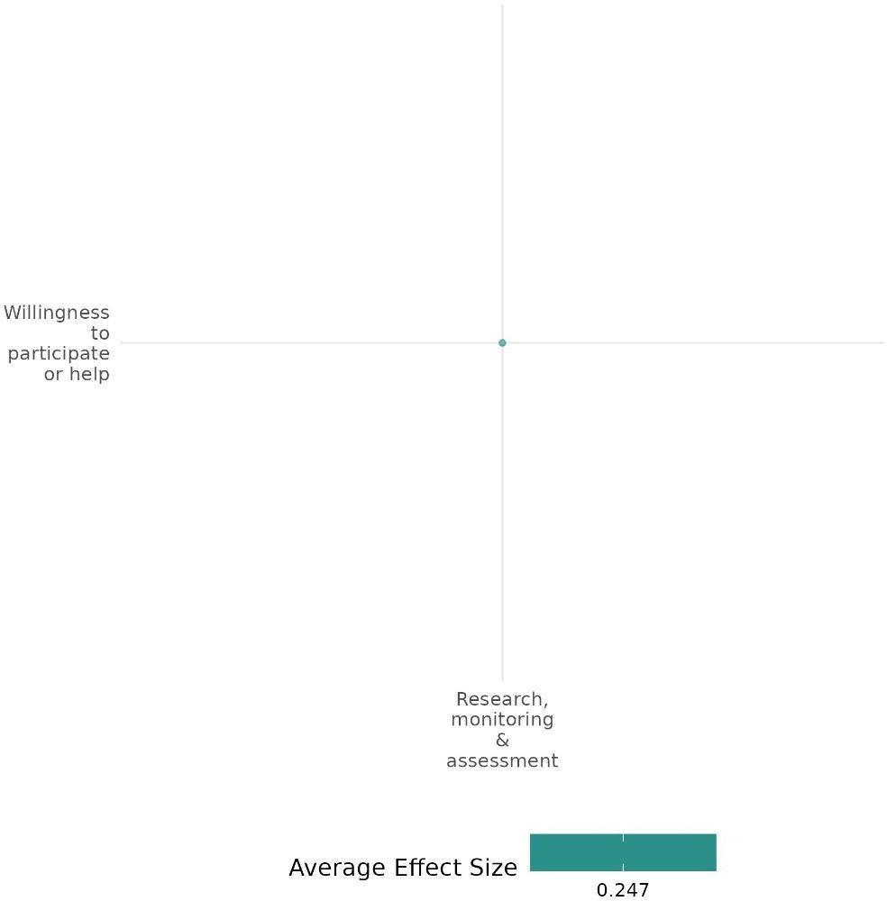

4.3.1(4)

Effect of Research, Monitoring, and Assessment (RMA) on Civic Participation

Civic education and security interventions showed that security monitoring increased vote diversity, while civic education improved voter coordination.

Geographical region: Sub-saharan Africa

Effect size: Adverse effect (g = -0.03)

Confidence in study findings: Low (1 study with 3 effect size)

Short summary
A research, monitoring, and assessment (RMA) study on electoral dynamics in rural Liberia before the 2011 elections evaluated the effects of civic education and security interventions across 142 towns. Results showed that security monitoring slightly increased vote diversity (p<0.10), while civic education improved voter coordination. These findings highlight how RMA-driven interventions can inform electoral strategies by identifying and addressing localized voting patterns, ultimately enhancing democratic participation in post-conflict settings.

Intervention
The Civic Education and Town Hall Program provided electoral education, discussed governance and candidates, and facilitated open community discussions. The Security Committee Program established village-level committees in collaboration with UN peacekeepers to monitor electoral security and improve communication.

How the intervention is expected to work
The interventions aimed to address key barriers to electoral participation in fragile states, including lack of information, coordination challenges, and insecurity. The Civic Education and Town Hall Program sought to reduce misinformation, improve knowledge of electoral rights, and encourage voter coordination toward national rather than local candidates. The Security Committee Program aimed to enhance both perceived and actual security by connecting communities with UN peacekeepers, empowering voters to express their preferences without fear of intimidation.
The evidence base
The cell includes a single primary study or impact evaluation (IE) study, carried out in rural villages across five counties in Liberia: Bong, Grand Bassa, Grand Gedeh, Lofa, and Nimba.

Evidence findings
An RMA study in rural Liberia before the 2011 elections revealed that security monitoring increased vote diversity, while civic education improved voter coordination. The findings underscore how RMA- driven interventions can refine electoral strategies and strengthen democratic participation in post- conflict settings.

Included studies
The impact evaluation assessed the effects of two interventions on civic participation, presenting both individual and combined intervention impacts. A summary of the study is provided here:

Mvukiyehe (2017) examines two democracy promotion interventions in rural Liberia ahead of the 2011 general elections: a civic education program with town halls and a security committee program. Conducted in five counties, the interventions aimed to enhance electoral quality in a post-conflict state marked by fragmented authority and clientelistic systems. The study involved 142 towns, randomly assigned to receive civic education, security interventions, both, or none. Data included polling place results and surveys. The diversity of vote choice, measured via the Herfindahl index, improved modestly in communities exposed to the security committee program (p<0.10), indicating reduced vote monopolization. However, the civic education program produced a coordinated shift in voting, particularly toward national-level candidates such as the Unity Party (p<0.01), reducing parochial voting (-9%; p<0.01). Combined interventions showed similar but weaker effects. Overall, civic education increased voter coordination, while the security program modestly reduced localized influences. These findings underscore the potential of targeted interventions to improve electoral dynamics in fragile, post-conflict democracies. The study is rated as high to medium confidence.

Confidence assessment
Overall, confidence in this cell is low due to the limited number of studies. However, the included studies are highly rigorous, featuring strong experimental designs, multiple outcome measures, bias controls, and actionable policy insights.

Other outcomes in the study
Social cohesion/Willingness to participate or help
Human security/Political security

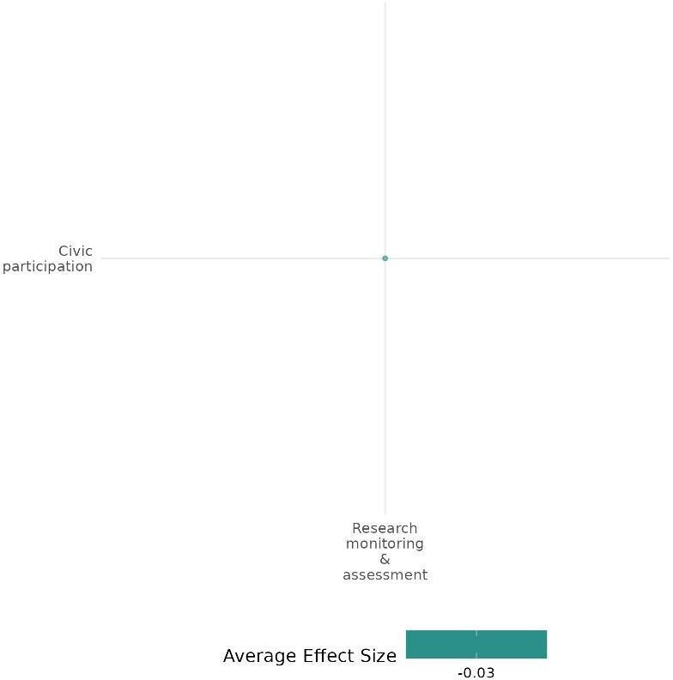

4.3.1(5)
The effect of Research, Monitoring, and Assessments on Government performance

Effect: positive (attributed to increased accountability among government leaders, strong collaborative relation between community members & government & transformation in the security management approach)

Confidence in study findings: Low (one study, low confidence)

Summary
The implementation of the Early Warning and Early Response System (EWERS) led to a variety of positive outcomes in the conflict clusters in Northwestern Kenya. The report primarily attributes these outcomes to the system’s ability to facilitate information sharing, leading to quicker and more effective responses to potential security threats. This, in turn, contributed to increased accountability among government leaders, and strengthened collaborative relations between community members and the government, resulting in a transformation of the security management approach.
The intervention
EWERS is an Early Warning and Early Response System implemented by a Faith-Based Organization (FBO) in Kenya to address ethnic violence. The system is designed to facilitate communication and collaboration between community members and authorities, enabling timely reporting and response to potential security threats
How is the intervention expected to work
The outcomes demonstrate that the EWERS, as an ICT-based intervention, played a significant role in promoting peacebuilding efforts and inclusivity by:
- Strengthening Bridging and Linking Social Capital: the system facilitated connections and trust between different ethnic groups and between communities and authorities.
- Weakening Bonding Social Capital: it broke down the barriers of exclusivity within certain groups that contributed to the marginalization of others.
- Creating New Forms of Social Capital: it led to the emergence of peace networks and collaborative relationships that transcended ethnic divides and power structures.
This enabled the leveraging of existing social capital mechanisms and fostered a more balanced and equitable distribution of social capital resources.

The evidence base
There is one qualitative study assessing the effect of Research, Monitoring, and Assessments on Government performance in Kenya. This study is by F. Mukoya and AS. Mukherjee (2020). The Role of Social Capital in Mediating ICT-Enabled Peace Building Efforts: A Case Study from Kenya. In The Future of Digital Work: The Challenge of Inequality: IFIP WG 8.2, 9.1, 9.4 Joint Working Conference, IFIPJWC 2020, Hyderabad, India, December 10–11, 2020, Proceedings (pp. 326-340). Springer International Publishing. All references are from this study.
The evidence
- ICTs facilitated strong collaborative relations between community members and security agencies, particularly the police. The EWERS system relied on community networks to share real-time security information, mitigating trust barriers. Previously, residents feared intimidation and victimization when reporting crimes, causing underreporting. The anonymization feature empowered them to report incidents safely, ensuring more responsive law enforcement actions (p. 6).
- The EWERS transformed security management, prompting police to attend community forums, seminars, and public security meetings. They invited community members for motivational talks and educated the public on case reporting and investigation processes. This strengthened bonds between police and community leaders, improving reporting and ensuring effective responses (p. 6-7).
- The integration of EWERS in violence prevention increased accountability among government leaders, especially chiefs and security personnel, who were now expected to respond to security alerts. Reports were also sent to their superiors, ensuring accountability. Previously ignored cases were now addressed, strengthening trust between officials and communities. Frequent interactions during response efforts fostered transparency, with chiefs and assistants holding regular consultative meetings to address emerging issues (p.7).
Confidence assessment
Overall confidence: Low Confidence Qualitative Study (It is unclear whether the study uses an established small n approach; no triangulation done; sources of potential data bias is not addressed)

4.3.1(6)

Effect of Research, monitoring, and assessment on Political security

The Civic Education and Town Hall Program improved voter awareness, reduced fear, and lowered invalid votes. The Security Committee Program had a similar but smaller impact. Both enhanced electoral integrity but minimally affected political security.
Geographical Region: Sub-Saharan Africa

Effect: Small effect (g=0.055)

Confidence in study findings: Low (1 study with 6 effect sizes)

Short Summary
Research, monitoring, and assessment interventions included two democracy promotion programs: Civic Education and Town Hall Program and Security Committee Program. The civic education program provided electoral education and facilitated discussions to enhance voter knowledge and coordination, while the security committee program established village- level committees in collaboration with UN peacekeepers to improve electoral security and communication. The study, a cluster-randomized field experiment across 142 towns in five Liberian counties, assessed their impact on political security. The study found that civic education increased voter awareness of manipulation (+14%) and reduced fear of retribution (-5 percentage points). It also improved electoral quality by reducing invalid votes (-5 percentage points, p<0.05). The security program had a smaller impact but slightly lowered invalid votes. Overall, civic education empowered voters while enhancing electoral participation, though it may have briefly intensified local contestation.

The intervention
Mvukiyehe (2017) implemented two democracy promotion programs in rural Liberia. The Civic Education and Town Hall Program provided electoral education, discussed governance and candidates, and facilitated open community discussions. The Security Committee Program established village-level committees in collaboration with UN peacekeepers to monitor electoral security and improve communication.
How the intervention is expected to work
The interventions aimed to address key barriers to electoral participation in fragile states, including lack of information, coordination challenges, and insecurity. The Civic Education and Town Hall Program sought to reduce misinformation, improve knowledge of electoral rights, and encourage voter coordination toward national rather than local candidates. The Security Committee Program aimed to enhance both perceived and actual security by connecting communities with UN peacekeepers, empowering voters to express their preferences without fear of intimidation.

The evidence base
The cell includes a single primary study or impact evaluation (IE) study, which was carried out in rural villages across five counties in Liberia: Bong, Grand Bassa, Grand Gedeh, Lofa, and Nimba.

Evidence findings
Research, monitoring & assessment using civic education and town hall initiatives had a limited impact on political security, with the outcomes being mixed and having little impact.

Included studies: the cell includes one impact evaluation, assessing the effects of two interventions on political security, presenting both individual and combined intervention impacts. A summary of the study is provided here:

Mvukiyehe (2017) focusing on manipulation, surrendering of rights, and invalid vote proportions. The study evaluated two interventions during Liberia's 2011 elections: civic education and security committees, using a cluster-randomized design across 142 towns, targeting rural, war-affected communities. The civic education program included town halls discussing governance, elections, and voter rights, while the security program created community-based early-warning systems to address election violence. The civic education program increased participants’ awareness and willingness to report voter intimidation, with self-reported exposure to manipulation rising by 14% compared to control groups. However, this effect may indicate greater willingness to recognize and report manipulation rather than an increase in actual intimidation. Notably, civic education reduced perceptions of being "in trouble" for voting against local patrons by 5 percentage points. The civic education intervention significantly reduced invalid votes by 5 percentage points in presidential and senate races (p<0.05). This reduction reflects improved voter understanding of ballots due to the program's training components. The security program, while less impactful, also contributed to slight reductions in invalid votes. Overall, the study highlights civic education
dual effect: empowering voters against manipulation and enhancing electoral quality, though potentially increasing short-term local contestation.

Confidence assessment
Overall, the cell has low confidence due to the small sample size, even though the individual included studies exhibit high rigor with strong experimental design, multiple outcome measures, bias controls, and actionable policy insights.

Other outcomes in this study:
Social Cohesion/ willingness to participate. Community & state governance/Civic participation
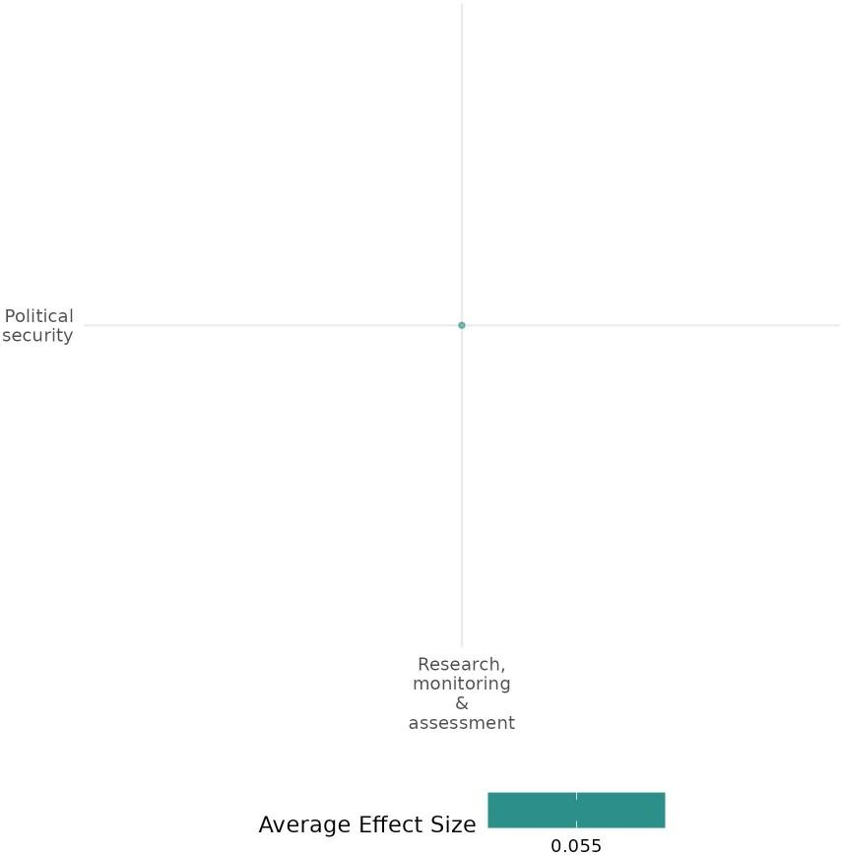

4.3.2 Dispute resolution
4.3.2(1)
Effect of Dispute resolution on Diplomatic relations & peaceful dispute resolution:
CONCUR, IPNN, ECPN, RLS-I, and legal empowerment programs improved dispute resolution and trust in mediation. IBN training, ADR mechanisms, and interfaith initiatives strengthened negotiation and reduced coercion, while coercive approaches escalated conflicts.
Geographical space: Global, Sub Saharan Africa, East Asia & pacific, South asia
Effect: Large effect (g = 0.207)
Confidence in study findings: Low confidence (4 studies 35 effect size)

Short Summary
Dispute resolution interventions, including CONCUR, IPNN, ECPN, RLS-I, and legal empowerment programs, were evaluated across multiple countries to strengthen mediation, promote non-coercive conflict resolution, and improve access to justice. These programs targeted both community and state-level dispute resolution, focusing on negotiation capacity, reducing coercion, and ensuring fair outcomes. Studies used RCTs, and difference-in-differences (DiD) analysis with sample sizes ranging from 200 to over 10,000 participants. Findings showed notable improvements in dispute resolution, trust in mediation, women's participation, and sustainable peace agreements. Non-coercive strategies, such as IBN training, ADR mechanisms, and interfaith initiatives, proved most effective, while coercive interventions worsened conflicts. Successful approaches combined international mediation, local leadership, and legal empowerment, emphasizing nonviolent negotiation and power-sharing. Women’s access to dispute resolution improved, especially in Afghanistan, India, and Morocco, though gender disparities in justice satisfaction remained. Overall, non-coercive mediation, legal reforms, and structured negotiation training contributed to long-term conflict resolution.

The intervention
Dispute resolution interventions utilize both coercive and non-coercive strategies to address ethnic conflicts. Key initiatives, including CONCUR, IPNN, ECPN, RLS-I, and legal empowerment programs, focus on Interest-Based Negotiation (IBN) training, mediation efforts, and community-driven initiatives such as joint economic projects, policy advocacy, and capacity-building for local peacebuilders. Programs like CONCUR and IPNN in Nigeria and ADR and RLS-I in Afghanistan promote conflict resolution and peacebuilding through collaborative approaches, emphasizing cooperation, tension reduction, and addressing root causes of conflict, particularly in marginalized communities.

How the intervention is expected to work
The interventions aimed to resolve conflicts through mediation, negotiation, and legal empowerment. IBN and ADR mechanisms enabled local leaders, religious figures, and community members to mediate disputes impartially. Policy advocacy and legal training strengthened formal-informal justice linkages, while community projects fostered cooperation between conflicting groups.

The evidence base
This cell comprises 12 studies, consisting of 5 impact evaluations (IEs), 6 qualitative studies, and 1 low confidence systematic review (SR).
Among the five included IEs, one (Killian - 2014) was excluded from the cumulative effect size calculation due to insufficient data for Cohen’s d computation. These studies were conducted in Nigeria (Kaduna, Nasarawa, and Plateau states), Afghanistan, India, Namibia, Rwanda, Morocco, Papua New Guinea, Sri Lanka, and India, employing Randomized Controlled Trials (RCTs), difference-in-differences (DiD) analysis, and mixed-method approaches.
The 6 qualitative studies were authored by Coffey (2012), Mengstie Missaye Mulatie (2022), Malla Trilochan Bahadur (2016), Laats Henkjan (2005), Demartoto Argyo (2014), and Dhiaulhaq Ahmad (2014, 2015).

Evidence findings
CONCUR, IPNN, ECPN, RLS-I, and legal empowerment programs improved dispute resolution and trust in mediation, enhancing negotiation skills and promoting sustainable peace. IBN training, ADR mechanisms, and interfaith initiatives were most effective, while coercive measures escalated conflicts, underscoring the need for nonviolent mediation and legal reforms.

The review evidence
This review examines the impact of land-use conflicts on peaceful dispute resolution and diplomatic relations in Indonesia. Rural communities rely on customary laws and informal mediation rather than legal frameworks due to weak land rights protections and corporate-government collusion. Unlike rightful resistance seen elsewhere, disputes are resolved with minimal legal enforcement, limiting formal dispute resolution mechanisms and diplomatic engagement between communities, corporations, and authorities.

Included studies
There are five impact evaluation studies. The detailed summaries of all included studies are thus provided here:
Baran (2017): evaluated two conflict resolution interventions in Nigeria: CONCUR and IPNN. CONCUR aimed to reduce pastoralist-farmer conflicts in the Middle Belt through interest-based negotiation (IBN) training, joint economic projects like community gardens, and policy advocacy for long-term solutions. IPNN focused on nonviolent conflict resolution by engaging religious leaders in IBN training, interfaith initiatives, and media peace campaigns. A mixed-methods impact evaluation using difference-in-difference (DiD) analysis surveyed 1,096 CONCUR and 710 IPNN households at baseline, and 923 CONCUR and 1,041 IPNN households at endline. Recruitment was conducted through random sampling in conflict-affected areas of Kaduna, Nasarawa, and Plateau states.
Findings related to diplomatic relations and peaceful dispute resolution showed significant improvements in CONCUR sites. At baseline, dispute resolution success was rated 0.45 points lower than in comparison sites, but by endline, it improved by 0.91 points relative to comparison sites (p < 0.01). Similarly, peaceful management of shared resources in CONCUR sites improved by 1.23 points (p < 0.01), although the frequency of resource sharing remained unchanged. These improvements were attributed to the effectiveness of IBN training, which enabled local leaders to mediate disputes impartially. The study is rated as a high-medium confidence quantitative study.
Biswas (2007): The study investigates how domestic institutions and international interventions influence the management and de-escalation of ethnic conflicts, focusing on both coercive (e.g., military action) and non-coercive (e.g., mediation) interventions. It examines the impact of these interventions in stable democracies and states with weak institutions, with specific case studies, such as Sri Lanka, exploring the roles of dialogue facilitation, mediation, and domestic reforms driven by international actions. The study uses a mixed-methods approach, combining quantitative analysis using the Minorities at Risk (MAR) dataset and qualitative case studies.
Non-coercive interventions, such as mediation, were more effective in promoting negotiations and sustaining peace agreements, particularly in stable democracies. In Sri Lanka, Norwegian-led mediation (2001–2004) facilitated ceasefires but failed to secure long-term agreements due to internal instability. Conversely, coercive interventions, like India’s military involvement, escalated tensions and hindered conflict resolution, especially in weak domestic institutions. Democracies had a 72% probability of engaging in negotiations when mediation was the primary approach, though internal divisions often delayed implementation. Coercive interventions prolonged hostilities, reducing the success of peace agreements. Successful cases, like Papua New Guinea and India, involved power-sharing and decentralization. Overall, non-coercive approaches proved more effective in achieving lasting peace, requiring a mix of international mediation, domestic reforms, and power-sharing arrangements. The study is rated as a high-medium confidence quantitative study
Dawop (2019): evaluates the Engaging Communities for Peace in Nigeria (ECPN) program addressed farmer-pastoralist conflicts in Nigeria’s Middle Belt through mediation training, joint peace committees, community projects, and conflict prevention forums. The study used a mixed-method approach, combining a community-level RCT and individual pre/post-intervention analysis. It covered 30 communities (15 sites), surveying 1,539 participants at baseline and 1,523 at endline. Individual resurveying included 287 participants (74 direct, 121 indirect, 92 controls). Data collection (2015–2018) included surveys, behavioral games, and observational monitoring, with quantitative analysis using regression, difference-in-difference, and multiple hypothesis testing.
The study found mixed results in dispute resolution, with variations in impact at the community and individual levels. At the community level, perceptions of dispute resolution effectiveness declined from baseline to endline in both ECPN and control communities, with a slightly greater but statistically insignificant decrease in ECPN areas. This suggests that community-wide awareness of resolution efforts remained limited. At the individual level, ECPN indirect participants reported lower improvements in dispute resolution perceptions compared to direct participants, with no significant difference from controls. This may be due to limited engagement in mediation and a lack of awareness of the 528 disputes resolved, mainly concerning shared resources such as farmland, pastures, and markets. While direct participants saw notable benefits, the program's broader community impact was inconsistent. The study is reported as a low-confidence quantitative study.
International Development Law Organization (2013): The study evaluated a legal empowerment intervention aimed at improving women's access to justice across diverse legal systems, addressing barriers in both formal and informal settings. Key activities included legal education and rights awareness programs, training paralegals and community leaders, establishing alternative dispute resolution (ADR) mechanisms, and providing legal aid services integrated with other social support systems. The analysis drew on case studies from countries such as Afghanistan, India, Namibia, Rwanda, Morocco, and Papua New Guinea, synthesizing qualitative evidence and lessons from multiple projects.
The study findings revealed that Training in interest-based negotiation improved access to justice, making participants 1.37 times more likely to support peaceful conflict resolution. ADR centres in India resolved 78% of disputes involving women within a year, while in Morocco, ADR initiatives increased fair dispute outcomes for women by 20%. Satisfaction with dispute resolution was high: 98% felt encouraged to express their views, 91% were satisfied with the mediator, and 97% fully participated. The process restored community harmony (86%), improved relationships (86%), and helped 88% move forward. 85% were satisfied with the outcome. This study is rated as a low-confidence quantitative study.
Killian (2014): The study assessed the Rule of Law Stabilization - Informal Component (RLS-I) in Afghanistan, aimed at strengthening Traditional Dispute Resolution (TDR). The program included six legal education workshops (30 hours over 4-6 months) for elders and dispute resolvers, covering conflict resolution, inheritance, and family law. Additional activities included discussion sessions, coordination meetings, and networking to promote equitable dispute resolution. The study sampled 850 elders, 996 disputants, and 3,820 citizens across six districts (three treatment, three control), with participants drawn from 35 villages per district. A difference-in-differences evaluation was used to measure changes in dispute resolution practices, attitudes, and women's roles, using surveys and a 5-point perceptual index.
Key findings on diplomatic relations and peaceful dispute resolution revealed that Afghans seeking mediation from RLS-I elders experienced a 11% higher satisfaction with procedural fairness and an 8% increase in overall justice perceptions. Additionally, there was a 4.6% decline in support for giving away girls in marriage as a dispute resolution method. In RLS-I districts, women’s direct engagement in dispute resolution increased by 17%, with 19% more households supporting women as dispute resolvers and 24% favouring female dispute resolvers. However, while male disputants reported positive views on procedural fairness and justice outcomes, female disputants expressed negative assessments of the same processes. The study is rated as low confidence.
Confidence assessment
Overall, this cell is rated as low confidence because the included studies and reviews themselves exhibit low confidence and also represent the inconsistency in their independent Cohen's d. despite the number of studies being representative.

Link to review summaries
Afrizal (20220).
All studies may be accessed via the EGM.

Other outcomes assessed in the study
Community & state governance/Access to justice, rights & public services, Government performance
Violence & atrocity prevention/ Diplomatic relation & peaceful dispute resolution, Nature and scale of violence or atrocities
Human security/Economic Security, Intermediate social cohesion outcomes, physical security
Social cohesion/feelings of trust & acceptance of diversity, Willingness to participate/help

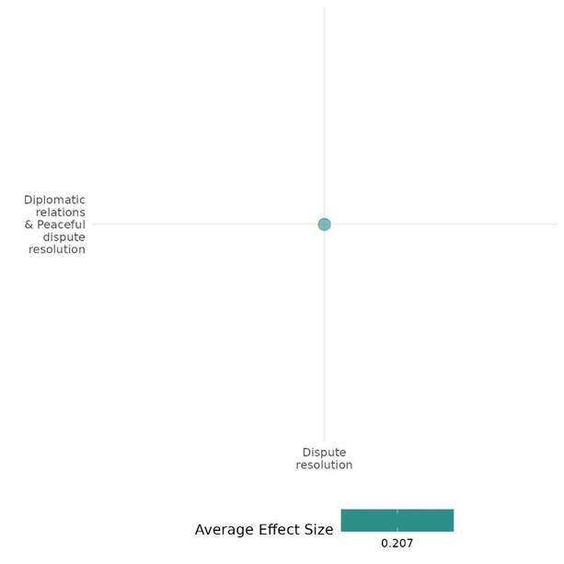

4.3.2(2)
Effect of Dispute resolution on Nature & scale of violence or atrocity
PEACE and Community Empowerment improved local dispute resolution but had little effect on broader violence. While disputes declined, inter-tribal violence persisted, youth-elder conflicts rose, and armed incursions increased in some areas.
Geographical region: Sub Saharan Africa
Effect size: Small effect (g = 0.03)
Confidence in study findings: Low confidence (2 studies with 25 effect size)

Short Summary
Dispute resolution interventions, including the PEACE and Community Empowerment programs, used participatory approaches like mediation, workshops, and infrastructure projects. A rigorous evaluation in Liberia (RCT with 10,000+ individuals) showed reduced unresolved disputes but no decline in inter-tribal violence, while youth-elder disputes increased. In Niger, a quasi-experimental study (40 villages, 1,843 respondents) found no significant impact on violence, with some areas experiencing more armed incursions. Overall, both programs improved local dispute resolution but had limited effects on broader violence, with studies rated as low-confidence quantitative research.

The intervention
The Community Empowerment Program in Liberia conducted eight-day workshops over two months, focusing on dispute resolution, problem-solving, and reducing court reliance through lectures, group discussions, and participatory dramas. Similarly, the PEACE program in Niger employed the CATALYSE approach, promoting community-driven initiatives like mediation, infrastructure development, equitable resource management, and economic programs.
How is the intervention expected to work
The Community Empowerment Program is expected to reduce violence by teaching community members constructive dispute-resolution skills and promoting local solutions instead of relying on formal judicial systems. By embedding facilitators in communities, it sought to build trust and encourage peaceful problem-solving. Similarly, the PEACE program focused on reducing vulnerability to violent extremism through collaborative activities to address conflict drivers.

The evidence base
This cell comprises three studies; two low-confidence primary studies and one systematic review with high to medium confidence. The primary studies, conducted in Liberia and Niger, utilized a randomized controlled trial (RCT) and a quasi-experimental design. The systematic review included research spanning Africa, Asia, Latin America, and Eastern Europe.

Evidence findings
Dispute resolution interventions such as PEACE and Community Empowerment have enhanced local dispute resolution mechanisms; however, their influence on broader violence was found to be limited. While the number of unresolved disputes declined significantly, inter-tribal violence remained static.
The review Evidence
The systematic review examined 149 studies on interventions covering themes like peace mechanisms, mediation, economic programs, governance, security, justice, and media interventions. Findings showed mixed effectiveness, such as peace mechanisms had some success, while militarised policing often escalated violence. and some peace operations had unintended adverse effects.

Included studies
The cell includes two low-confidence primary studies. The detailed summary thus provided below,

Blattman (2012): The study evaluated the alternative dispute resolution (ADR) campaign, known as the "Community Empowerment Program" in rural Liberia, designed to strengthen informal dispute resolution by training community members. The program included eight-day workshops over two months, focusing on direct dispute engagement, problem-solving, positive-sum resolutions, and reducing reliance on formal courts. Training, led by two facilitators for groups of 35, included lectures, group discussions, participatory dramas, and experience-sharing. Facilitators lived in the communities for 2-4 months, building trust and reinforcing workshop principles—the training aimed to address violence by encouraging constructive dispute resolution and discouraging forum shopping.
The evaluation used a randomized controlled trial (RCT) combined with qualitative research, surveying over 10,000 individuals across 243 communities, with 85 receiving the intervention. Conflict-prone communities were nominated by local officials, and leaders mobilized residents to participate.The intervention showed no reduction in land conflict levels, but treated communities reported higher resolution rates, more frequent use of informal mechanisms, and greater satisfaction with outcomes, particularly for long standing disputes. While land dispute incidence remained unchanged (22% in both treatment and control), unresolved disputes decreased by 28%, and resolution satisfaction increased by 12%. Informal forums saw a 22% rise in usage. Money and business disputes saw non-significant increases in incidence (15%) and satisfaction (9%). Inter-tribal violence and violent protests decreased (35% and 50%, respectively, but not significantly). Youth-elder disputes rose by 70%, reflecting a shift in youth asserting their rights. The study is rated low confidence quantitative study.
Lichtenfeld (2022)-The study evaluates the PEACE (Preventing Violent Extremism Actions through Increased Social Cohesion Efforts) program, which aims to reduce the vulnerability to violent extremism by enhancing social cohesion in the Tillabéri region of Niger. The intervention employed Mercy Corps’ CATALYSE approach, a methodology focused on community mobilization and participatory planning. This approach engaged communities in identifying and addressing shared needs to promote trust and cooperation among different groups. The main activities included in the PEACE program are: 1) Mediation and dialogue initiatives to foster conflict resolution skills and promote peaceful interaction.2) Infrastructure projects that involved the collaborative development or rehabilitation of community assets. 3) Access to shared natural resources initiatives to manage and equitably distribute resources like water and land. 4) Livelihoods and economic inclusion efforts designed to enhance economic opportunities for youth and women. 5) Cultural and sporting events aimed at bringing communities together through shared cultural expressions and recreational activities. The study used a quasi-experimental design involving 40 villages, randomly assigned into treatment (20 villages) and control (20 villages) groups in the program's first phase. Data collection occurred at three points—baseline in 2020, midline in 2021, and endline in 2021—yielding insights from 1,843 respondents (55% male, 45% female). The PEACE program did not significantly reduce the frequency or scale of violent incidents, as measured by data on battles, attacks on civilians, and other violent events in villages that participated in the PEACE program compared to those that did not. Some villages, including those involved in PEACE, experienced increased armed group incursions during the program’s implementation period. This trend reflects worsening security dynamics in the Tillabéri region. These findings highlight the limited direct impact of the PEACE program on violent events, underscoring that its interventions were more focused on addressing community-level grievances rather than external security threats or broader armed group activity. The study is rated as a low-confidence quantitative study.

Confidence assessment
Overall, the cell is rated as low confidence due to the limited number of studies, all of which are also classified as low-confidence quantitative studies.

Link to review summaries
Cramer Christophe (2016).
The study may be accessed via EGM.

Other outcomes assessed in the study
Violence and atrocity prevention/Nature and scale of violence or atrocities
Human security/Economic Security/Intermediate social cohesion outcomes
Social cohesion/acceptance of diversity
Community & state governance/Civic participation/Government performance

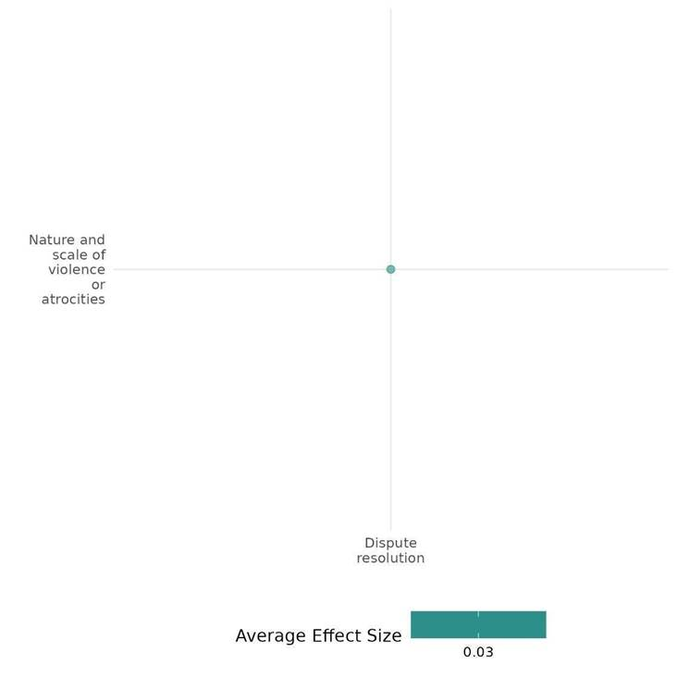

4.3.2(3)
Effect of Dispute resolution on Social norms regarding Violence or Aocity
PEACE and Conflict Management programs strengthened social ties and reduced violence justification but had little impact on political violence support. Economic hardships and resource competition deepened grievances.
Geographical region: Sub Saharan Africa & Middle East & North Africa
Effect: Adverse effect (g = -0.132)
Confidence in study findings: Low (2 studies with 5 effect size)

Short Summary
Dispute resolution interventions, such as the PEACE program in Niger and Conflict Management for Syrian Refugees in Jordan, aimed to reduce violence by fostering social cohesion and intergroup cooperation. The PEACE program engaged 1,843 respondents across 40 villages, while the Jordanian initiative involved 854 respondents, focusing on leadership empowerment and joint community development. While these programs lowered justification for violence and strengthened social ties, they had limited impact on directly reducing support for political violence. Economic hardship, discrimination, and resource competition sometimes reinforced grievances, highlighting the need for context-sensitive strategies.

The intervention
Dispute resolution programs, such as the PEACE program in Niger and the Conflict Management program in Jordan, promoted peaceful conflict resolution through community-driven initiatives. These efforts encompassed mediation, infrastructure projects, resource management, livelihoods, cultural events, leadership training, and the creation of safe spaces to foster trust between refugees and host communities.

How the intervention is expected to work
The PEACE program aimed to reduce support for violent extremism by addressing social grievances and fostering trust between groups through shared projects and dialogue, expecting mediation efforts to reduce indirect support for armed groups. The Conflict Management program sought to challenge norms legitimizing violence by equipping leaders with negotiation skills, fostering mutual understanding, and promoting cooperative projects to build trust and reduce tensions between Syrian refugees and host communities.

The evidence base
The cell includes two primary studies from the Tillabéri region of Niger and Northern Jordan, employing a quasi-experimental and mixed-methods evaluation design.

Evidence findings:
PEACE and Conflict Management programs strengthened social ties and reduced justification for violence but had little effect on support for political violence. Economic hardships and resource competition often deepened grievances.

Included studies
The cell contains two low-confidence primary studies. The detailed summaries are thus provided here:

Lichtenheld (2022): The study evaluates the PEACE (Preventing Violent Extremism Actions through Increased Social Cohesion Efforts) program, which aims to reduce the vulnerability to violent extremism by enhancing social cohesion in the Tillabéri region of Niger. The intervention employed Mercy Corps’ CATALYSE approach, a methodology focused on community mobilization and participatory planning. This approach engaged communities in identifying and addressing shared needs to promote trust and cooperation among different groups. The main activities included in the PEACE program are: 1) Mediation and dialogue initiatives to foster conflict resolution skills and promote peaceful interaction.2) Infrastructure projects that involved the collaborative development or rehabilitation of community assets. 3) Access to shared natural resources initiatives to manage and equitably distribute resources like water and land. 4) Livelihoods and economic inclusion efforts designed to enhance economic opportunities for youth and women. 5) Cultural and sporting events aimed at bringing communities together through shared cultural expressions and recreational activities. The study used a quasi-experimental design involving 40 villages, randomly assigned into treatment (20 villages) and control (20 villages) groups in the program's first phase. Data collection occurred at three points—baseline in 2020, midline in 2021, and endline in 2021—yielding insights from 1,843 respondents (55% male, 45% female).
The PEACE program did not show significant improvements in reducing support for political violence or armed groups. However, indirect measures indicated that the timing and type of intervention—particularly mediation and dialogue—helped reduce support for groups like ISGS. It also suggests that social cohesion programs can lower justification for violence through mediation, infrastructure, and community engagement. Despite these efforts, some implicit support for armed groups persists, as revealed by indirect measures. The study, rated as a low-confidence quantitative study,
Maroni (2015):The Conflict Management for Syrian Refugees, Host Communities, and Municipal Actors in Jordan intervention, implemented by Mercy Corps in the Northern Jordan governorates of Mafraq and Irbid, aimed to reduce tensions and mitigate conflict risks between Jordanian host communities and Syrian refugees. The program included training community leaders (Jordanian, Syrian, and municipal) in interest-based negotiation, supporting community development projects collaboratively designed by these leaders to benefit both groups, and establishing safe spaces to promote interaction and cooperation.
The study used a mixed-methods evaluation design combining quantitative and qualitative approaches. Household surveys were conducted in June 2013 (baseline) and May 2014 (12-month follow-up), sampling 854 individuals at baseline (667 in treatment areas, 187 in comparison areas) and 845 individuals at follow-up (662 in treatment areas, 183 in comparison areas). Additionally, 12 focus group discussions were held with 114 participants (69 Jordanians, 45 Syrians; 51 male, 63 female). Studies have reported support for violence under the theme of social norms regarding violence or atrocity. Additionally, it reported community stability, economic conditions, influence over decision outcomes, intergroup social relationships, conflict management capacity, social trust, and cohesion.
The study found that economic competition and resource scarcity were the primary drivers of tensions between Jordanian hosts and Syrian refugees, with 28% of Jordanians and 27% of Syrians citing job scarcity as the main source of conflict. Discrimination increased support for violence, as Syrians who felt discriminated against were 1.5 times more likely to justify it. Mercy Corps' conflict management program reduced support for violence, as target communities saw a decline in acceptance of violence, while non-participant communities experienced an increase. However, limited quantitative evidence was found for changes in intergroup interactions, decision-making inclusion, or discrimination experiences. Despite reduced support for violence in program areas, economic hardship and political empowerment correlated with greater acceptance of violence, suggesting that grievances and perceptions of influence shape conflict attitudes. This study is rated as a low-confidence quantitative study.

Confidence assessment
Overall. The cell is rated as low-confidence quantitative evaluations due to limited number of studies.

Other outcomes in this study
Violence and atrocity prevention/Nature & scale of violence
Violence and atrocity prevention/ Diplomatic relations + Peaceful dispute resolution
Social cohesion/feeling of trust & acceptance of diversity.
Community & state governance/ Civic Participation
Community & state governance/ Government performance

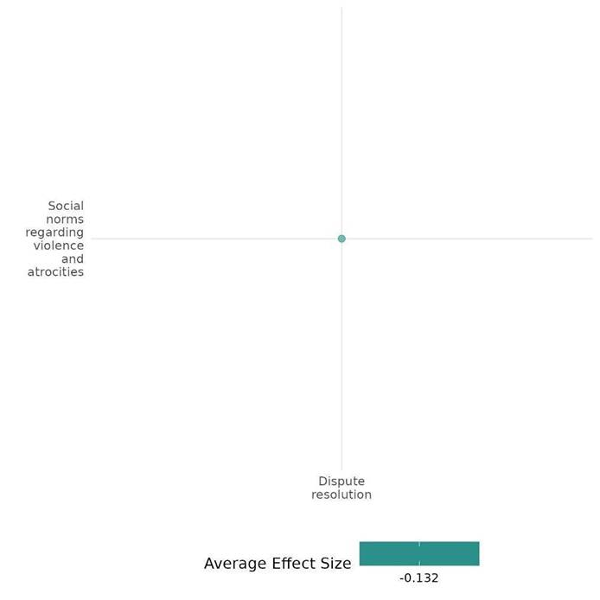

4.3.2(4)
Effect of Dispute Resolution on the Feeling of Trust & Acceptance of Diversity.
Dispute resolution programs like CONCUR, IPNN, ECPN, and PEACE improved trust and tolerance significantly, such as increasing intergroup trust by up to 49 points. However, low baseline trust and ethnic homogeneity have limited impact in some contexts.
Geographical Region: Sub Saharan Africa & Middle East & North Africa
Effect: Moderate effect (g = 0.133)
Confidence in study findings: Low confidence (6 studies with 28 Effect size)

Short Summary
Dispute resolution interventions, including CONCUR, IPNN, UNMIL, and the PEACE program, employed strategies such as interest-based negotiation training, joint economic projects, community dialogue, and resource-sharing initiatives to enhance trust and acceptance of diversity in Nigeria, Liberia, Niger, and Jordan. These programs aimed to foster cooperation among conflicting groups by promoting economic collaboration and peacebuilding efforts. In Nigeria, CONCUR and IPNN strengthened trust between farmers, pastoralists, and religious communities, with CONCUR achieving a 49% increase in trust. Similarly, ECPN demonstrated modest improvements in trust and cooperation, though its impact on inter-group relations remained limited. In Liberia, UNMIL enhanced trust in formal dispute resolution mechanisms, while community empowerment programs promoted ethnic tolerance and reduced reliance on formal courts. In Niger, the PEACE program fostered intra-community cohesion and inter-group trust, particularly in diverse areas, though in more homogeneous communities, it sometimes reinforced within-group trust instead. In Jordan, the Conflict Management program helped Syrian refugees and host communities build trust through community-led projects and negotiation training, though gender norms and security concerns posed barriers to broader social cohesion.

The Intervention
Dispute resolution interventions—CONCUR, IPNN, ECPN, UNMIL, PEACE, and the Conflict Management Program—sought to build trust and social cohesion through various activities. CONCUR focused on interest-based negotiation training and joint economic projects, while IPNN promoted interfaith initiatives. ECPN established community committees and conflict prevention forums. UNMIL provided patrols and reinforced state authority, and PEACE implemented resource-sharing activities through the CATALYSE approach. The Conflict Management Program supported community development and safe dialogue spaces. Each intervention addressed unique conflict dynamics in Nigeria, Liberia, Niger, and Jordan.

How the intervention expected to work
These interventions enhance trust, acceptance of diversity, and social cohesion through conflict-resolution strategies and community-building activities. By engaging local leaders and community members in dialogue, training, and joint projects, these programs promote cooperation across ethnic, religious, and social divides. Utilizing interest-based negotiation and resource-sharing initiatives aims to reduce tensions, improve intergroup relationships, and foster a shared responsibility for peace.

The evidence base
The cell includes a total of 7 studies; six primary studies and one qualitative study by Dhiaulhaq Ahmad (2016). These primary studies were conducted in Nigeria (three studies, including two by the same author on the same intervention, with an additional intervention in one), Liberia (two studies with different interventions by different authors), Niger (one study), and Jordan (one study).

Evidence findings
Dispute resolution interventions improved trust and acceptance by fostering intergroup cooperation and tolerance, though their impact varied by context. While some programs significantly strengthened social cohesion, challenges like low baseline trust and ethnic homogeneity limited broader outcomes.

Included studies:
There are six impact evaluations. The detailed summaries are thus provided here:
Baran (2017) evaluated the Community-Based Conflict Management and Cooperative Use of Resources (CONCUR) program, implemented by Mercy Corps from December 2012 to December 2016 in Nigeria's Middle Belt. The program aimed to mitigate conflicts between pastoralist and farming communities through Interest-Based Negotiation (IBN) training for local leaders, joint economic projects (e.g., shared grazing areas, community marketplaces), and policy advocacy addressing long-term economic drivers of conflict. Additionally, an interfaith peacebuilding initiative engaged religious leaders in non-violent conflict resolution through IBN training, interfaith initiatives, and media campaigns. A mixed-methods impact evaluation utilized a difference-in-difference (DiD) framework, comparing conflict-affected CONCUR-targeted communities with neighboring comparison areas. Surveys at baseline (1,806 households) and endline (1,276 households) covered 10 intervention and six comparison sites across Kaduna, Nasarawa, and Plateau states. Households were selected through community mapping, and the study integrated quantitative analysis (DiD and cross-sectional regression) with qualitative insights from focus group discussions and key informant interviews.Findings showed significant improvements in social cohesion and trust. In CONCUR sites, trust between conflicting groups increased by 49 percentage points, while comparison communities saw a decline. Acceptance of diversity improved, with intergroup tolerance rising from 69% to 90% in CONCUR sites and from 64% to 90% in interfaith initiative sites. Economic collaboration also strengthened intergroup relationships, with 86% of CONCUR households reporting reduced tensions at the endline, compared to 56% in comparison areas. While the study demonstrated positive conflict mitigation outcomes, low baseline trust in some areas posed challenges for deeper intergroup trust-building. The study was rated as a high-medium-confidence quantitative study.
Blair (2019) : The study assessed the impact of the UN Mission in Liberia (UNMIL) on the rule of law in post-conflict Liberia, focusing on building confidence in state institutions such as the police and courts, enforcing the separation between formal (state) and informal (non-state) dispute resolution methods, and eliminating illegal practices like trial by ordeal. UNMIL's activities included patrols, public works, and dispute resolution interventions, often in collaboration with local leaders and state actors. The survey covered 242 rural communities in Lofa, Nimba, and Grand Gedeh counties, focusing on jurisdictional disputes and UNMIL activities. Data were collected in three waves (2009, 2010-2011, 2013) from residents, local leaders, and UN/government officials through quantitative surveys, qualitative interviews, and a list experiment. Using a mixed-method approach, the study applied difference-in-differences and instrumental variable analysis to assess causal effects.
Findings related to feelings of trust & acceptance of diversity revealed that Communities exposed to UNMIL showed a 16-percentage point increase in citizens choosing state authorities over non-state alternatives to resolve serious incidents like murder or mob violence. Exposure to UNMIL patrols significantly increased citizens' trust in formal authorities, with a 25% greater likelihood of calling the police and 25% less reliance on informal methods like trial by ordeal in communities with weekly patrols. Even after UNMIL's withdrawal, reliance on formal institutions (police, courts) persisted, suggesting a long-term impact on institutional trust and conflict resolution methods. While there was no direct measure of hate or discrimination, the shift from informal, potentially biased practices to formal justice mechanisms likely contributed to greater fairness and equity. The study is rated as a low-confidence quantitative study.
Blattman (2012): The study evaluated the alternative dispute resolution (ADR) campaign, known as the "Community Empowerment Program" in rural Liberia, designed to strengthen informal dispute resolution by training community members. The program included eight-day workshops over two months, focusing on direct dispute engagement, problem-solving, positive-sum resolutions, and reducing reliance on formal courts. Training, led by two facilitators for groups of 35, included lectures, group discussions, participatory dramas, and experience-sharing. Facilitators lived in the communities for 2-4 months, building trust and reinforcing workshop principles—the training aimed to address violence by encouraging constructive dispute resolution and discouraging forum shopping. The evaluation used a randomized controlled trial (RCT) combined with qualitative research, surveying over 10,000 individuals across 243 communities, with 85 receiving the intervention. Local officials nominated conflict-prone communities, and leaders mobilized residents to participate.
The study found modest improvements in trust and acceptance of diversity, with a 24% decline in residents’ reliance on formal courts for money disputes, indicating greater trust in informal dispute resolution. There were small but positive shifts in support for minority rights, ethnic tolerance, and intermarriage acceptance, though only the latter was statistically significant. In villages with more PEACE activities, 14% more respondents reported improved access to social services, and there was a slight increase in trust in community leaders' commitments. While infrastructure projects had the strongest impact on vertical cohesion, statistical significance varied. Overall, the program showed positive but limited effects, and the study is rated low-confidence quantitative.
Dawop (2019): The study evaluated the Engaging Communities for Peace in Nigeria (ECPN) program, which aimed to mitigate farmer-pastoralist conflicts in Nigeria's Middle Belt. The program involved training community leaders in dispute mediation, forming joint committees (peace, early warning, and project committees), implementing community projects (e.g., boreholes and fences), and facilitating conflict prevention forums with community members and government officials. The study used a mixed-method approach, combining a community-level RCT with individual-level pre/post-intervention analysis. Thirty communities were selected, with surveys conducted at baseline (2015) and endline (2018), including behavioral games and observational monitoring. Quantitative analysis applied regression, difference-in-difference comparisons, and multiple hypothesis testing, while qualitative data captured market and social interactions.
Findings on trust and intergroup cohesion showed modest improvements in intervention communities, while trust declined in control groups. The community-level effect size was 0.49, representing a 13% difference between groups (p = 0.06). At the individual level, trust improved most for direct participants, followed by indirect participants, with the smallest improvement in the control group (effect size 0.15, or a 5% difference, p = 0.072). In an endorsement experiment, intervention community members were more likely to support policies advocated by the other group than controls, though this result was not statistically significant. Intergroup Cohesion followed the expected trend, with stronger improvements in intervention groups than controls, but results were not statistically significant. The study is reported as a low-confidence quantitative study
Lichtenheld (2022): The study evaluates the PEACE (Preventing Violent Extremism Actions through Increased Social Cohesion Efforts) program, which aims to reduce the vulnerability to violent extremism by enhancing social cohesion in the Tillabéri region of Niger. The intervention employed Mercy Corps’ CATALYSE approach, a methodology focused on community mobilization and participatory planning. This approach engaged communities in identifying and addressing shared needs to promote trust and cooperation among different groups. The main activities included in the PEACE program are: 1) Mediation and dialogue initiatives to foster conflict resolution skills and promote peaceful interaction.2) Infrastructure projects that involved the collaborative development or rehabilitation of community assets. 3) Access to shared natural resources initiatives to manage and equitably distribute resources like water and land. 4) Livelihoods and economic inclusion efforts designed to enhance economic opportunities for youth and women. 5) Cultural and sporting events aimed at bringing communities together through shared cultural expressions and recreational activities. The study used a quasi-experimental design involving 40 villages, randomly assigned into treatment (20 villages) and control (20 villages) groups in the program's first phase. Data collection occurred at three points—baseline in 2020, midline in 2021, and endline in 2021—yielding insights from 1,843 respondents (55% male, 45% female).
The PEACE program improved intra-community cohesion, with greater participation and activity implementation leading to increased trust among community members. Infrastructure and cultural activities had a statistically significant impact on inter-group trust, fostering collaboration by addressing shared needs. However, mediation and dialogue activities had limited reach, as they engaged smaller groups rather than the broader community. The program was more effective in diverse communities, while in homogeneous villages, it reinforced within-group trust at the expense of broader social cohesion. Resource-sharing activities sometimes exacerbated disputes, highlighting the need to tailor interventions to community dynamics for sustained impact. The study is rated as a low-confidence quantitative study.
Maroni (2015): The Conflict Management for Syrian Refugees, Host Communities, and Municipal Actors in Jordan intervention, implemented by Mercy Corps in the Northern Jordan governorates of Mafraq and Irbid, aimed to reduce tensions and mitigate conflict risks between Jordanian host communities and Syrian refugees. The program included training community leaders (Jordanian, Syrian, and municipal) in interest-based negotiation, supporting community development projects collaboratively designed by these leaders to benefit both groups, and establishing safe spaces to promote interaction and cooperation. The study used a mixed-methods evaluation design combining quantitative and qualitative approaches. Household surveys were conducted in June 2013 (baseline) and May 2014 (12-month follow-up), sampling 854 individuals at baseline (667 in treatment areas, 187 in comparison areas) and 845 individuals at follow-up (662 in treatment areas, 183 in comparison areas). Additionally, 12 focus group discussions were held with 114 participants (69 Jordanians, 45 Syrians; 51 male, 63 female).
The study reported improved interpersonal relationships in treatment communities, with women’s focus groups highlighting the importance of playgrounds and community-friendly spaces in fostering positive interactions. The program also set a precedent for building intergroup trust by demonstrating the role of NGOs in cultivating strong, respectful relationships with local authorities and communities. The study is rated as high-medium confidence.
Confidence assessment
Overall, the cell is rated as low confidence due to inconsistent independent effect sizes among all included studies and the majority of included studies also being classified as low confidence.

Other outcomes assessed in the study
Social cohesion/ Willingness to participate/help
Community & state governance/Government performance, Civic Participation, Access to justice, rights & public services
Violence and atrocity prevention/Social norms regarding violence and atrocities, Nature & scale of violence or atrocity, Diplomatic relation & peaceful dispute resolution
Human security/Intermediate social cohesion outcomes, economic security, physical security

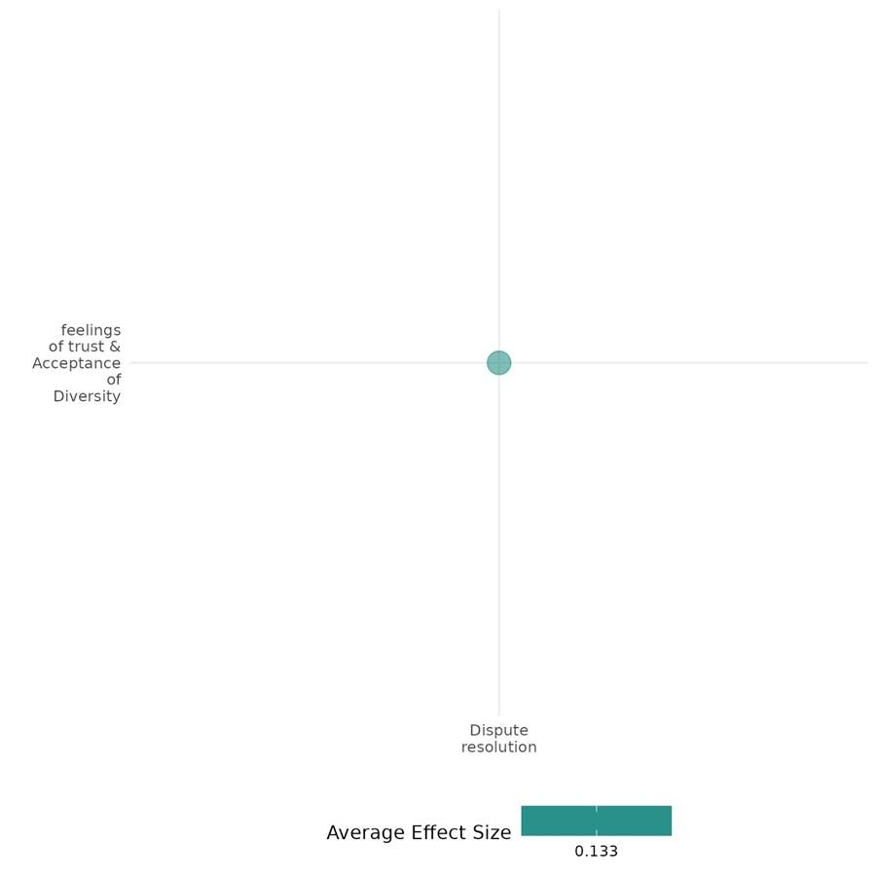

4.3.2(5)
Effect of Dispute Resolution on willingness to Participate or help
The PEACE program strengthened social cohesion through participatory projects, significantly enhancing cooperation intensity. However, it had no notable impact on participation levels or cooperation timing.
Geographical Space: Sub Saharan Africa
Effect: Large effect (g=0.28)
Confidence in the study findings: Low (one study with 5 effect size)
Short summary
The PEACE program in Niger's Tillabéri region, focusing on its impact on social cohesion. A survey of 1,843 individuals across 40 villages revealed that the program significantly enhanced cooperation intensity. However, it did not have any notable effect on the level of participation or the timing of cooperation. Furthermore, collective action norms improved significantly, with a 14% increase observed in treatment communities compared to control communities from baseline to midline. Notably, direct participants demonstrated greater improvements than indirect participants, and these differences remained statistically significant at the endline.

The Intervention
The PEACE program (2019–2021) in Niger’s Tillabéri region aimed to enhance social cohesion and reduce vulnerability to violent extremism through Mercy Corps’ CATALYSE approach. This involved participatory community projects addressing shared needs, such as infrastructure rehabilitation, cultural events, mediation initiatives, and natural resource management.

How the intervention is expected to work
The intervention is expected to work by promoting collaborative planning and implementation of projects that require inter-group cooperation and shared responsibility.

The evidence base
The cell included two studies: a primary study or IE conducted in Niger's Tillabéri region and Dhiaulhaq Ahmad (2015) qualitative studies,a series of case studies from six locations across Cambodia, Indonesia, and Thailand.

Evidence findings
The PEACE program under dispute resolution intervention showed significant improvements in collective action.
Included studies
The cell includes one IE which was focused on the peace process. The details of the included study summary thus provided below; .
Lichtenheld et al. (2022) evaluated the USAID-funded PEACE program, implemented by Mercy Corps from 2019 to 2021 in Niger’s conflict-prone Tillabéri region. The program aimed to strengthen social cohesion through Mercy Corps’ CATALYSE approach, which engaged 40 villages in participatory planning and joint projects such as infrastructure development, cultural events, and mediation efforts. Villages were randomly assigned to treatment and control groups, and surveys were conducted among 1,843 respondents at baseline, midline, and endline to assess program impacts.

The PEACE program demonstrated a significant positive impact on cooperation intensity, although it did not affect the level of participation or timing of cooperation. Collective action norms improved substantially, with a 14% increase in treatment communities compared to control communities from baseline to midline. Direct participants experienced greater improvements than indirect participants, with these differences remaining statistically significant at the endline. The study is rated as a low confidence.

Confidence assessment
Overall, this cell reflects low confidence due to the limited number of studies included, and the available study itself was also of low confidence.

Other outcomes in this study
Social cohesion/Feelings of trust & acceptance of diversity
Community and state governance/Government performance
Community and state governance/civic participation
Violence and atrocity prevention/Nature & scale of violence
Violence and atrocity prevention/social norms regarding violence or atrocity

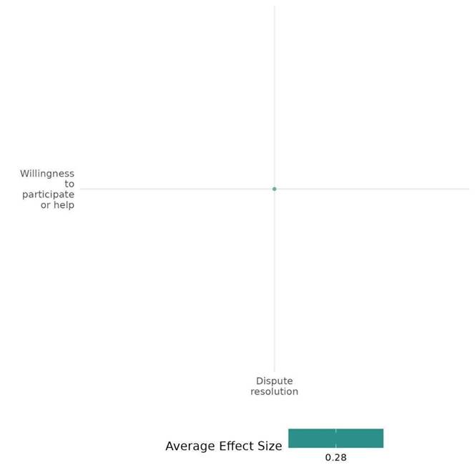
4.3.2(6)
Effect of Dispute resolution on Access, Justice, and Public Service
Legal empowerment and conflict management programs improved fairness through trained mediators, but gender disparities and power imbalances limited justice access.
Geographical region: East Asia & pacific, Middle East & North Africa
Effect: large effect (g = 0.479)
Confidence in study findings: Low confidence (2 studies with 9 effect size)

Short Summary:
Dispute resolution mechanism interventions such as A legal empowerment and Conflict Management intervention aimed at improving women's access to justice in Afghanistan, Namibia, Papua New Guinea, and other regions focused on legal education, paralegal training, ADR mechanisms, and legal aid services. Findings showed that trained mediators enhanced fairness and satisfaction, but gender disparities and power imbalances persisted, limiting women’s ability to seek justice. Similarly, the Conflict Management for Syrian Refugees and Host Communities in Jordan, implemented by Mercy Corps, strengthened social cohesion through community projects but struggled against economic hardships, fuelling tensions.

The intervention
Dispute resolution intervention includes legal empowerment and community-driven development (CDD). aims to address barriers to justice, reduce tensions, and promote cooperation through Key activities, including training local leaders (e.g., paralegals, community representatives) in dispute resolution and rights awareness, establishing Alternative Dispute Resolution (ADR) mechanisms, and designing joint community development projects (e.g., playgrounds and health centres).

How the Interventions are Expected to Work
The interventions aim to empower communities to resolve disputes peacefully and inclusively by enhancing local capacity and promoting shared decision-making. Legal education increases rights awareness, enabling women and other marginalized groups to assert their rights more effectively. These efforts address structural inequalities, strengthen community resilience, and promote equitable access to services, justice, and public resources.

The evidence base
The cell contains two primary studies. The first synthesizes case studies from six countries: Afghanistan, Namibia, and Papua New Guinea. The second study was conducted in Jordan.

The Evidence Findings
Legal empowerment training & conflict management interventions improved fairness but left gender disparities and power imbalances unaddressed. It also promoted social cohesion through community projects but struggled with economic hardships that heightened tensions.

Included studies
This cell contains summaries of two impact evaluations, the detailed summaries thus provided below:
The International Development Law Organization (2013) evaluated a legal empowerment intervention to improve women's access to justice in formal and informal systems, addressing discriminatory norms and resource limitations. Key activities included legal education, paralegal training, ADR mechanisms, and legal aid services. Based on case studies from Afghanistan, India, Namibia, Rwanda, Morocco, and Papua New Guinea, findings showed that trained mediators improved fairness and satisfaction, with respondents more likely to feel their views were considered (89% vs. 55%) and to receive legal explanations (75% vs. 52%). However, gender disparities persisted, with women facing greater difficulty expressing perspectives (39% vs. 28%) and lower chances of reaching a resolution. Power imbalances remained a challenge, underscoring the need for targeted interventions. The study is rated as a low-confidence quantitative study.

Maroni (2015) evaluates the Conflict Management for Syrian Refugees, Host Communities, and Municipal Actors in Jordan, implemented by Mercy Corps in Mafraq and Irbid, aimed to reduce tensions between Jordanians and Syrian refugees. The program trained community leaders in interest-based negotiation, supported joint community development projects and established safe spaces for cooperation. Using a mixed-methods evaluation, household surveys were conducted in 2013 (baseline) and 2014 (follow-up) with around 850 respondents, alongside focus groups. Findings showed that joint projects (e.g., playgrounds, and health centres) improved public space access and inclusion, strengthening social cohesion. However, economic hardship contributed to increased tensions, affecting attitudes toward justice, rights, and equitable access to services. The study is classified as a low-confidence quantitative study.

Confidence assessment
Overall. The cell is rated as low-confidence quantitative studies due to the limited number of studies

Other outcomes assessed under these studies:
Community & state governance/Civic Participation
Social cohesion/willingness to participate/feelings of trust & access of diversity/sense of belonging.
Violence and atrocity prevention/Social norms regarding violence and atrocities

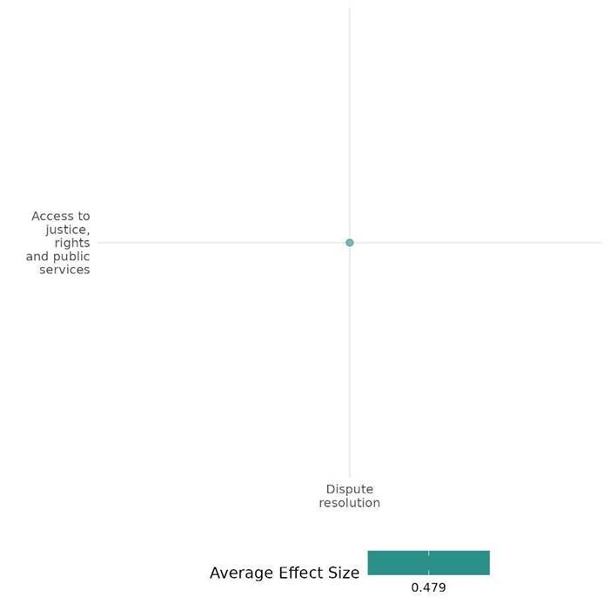
4.3.2(7)
Effect of Dispute Resolution on Civic Participation
The PEACE program in Niger’s Tillabéri region (2019-2021) showed that the program, in general, has not had any impact on civic participation.
Geographical Regions: Sub Saharan Africa
Effect: Small effect (g= -0.041)
Confidence in the study findings: Low confidence ( 1 study s with 9 effect size)

Short summary
The study evaluated the PEACE program in Niger's Tillabéri region, which aimed to enhance social cohesion and reduce vulnerability to violent extremism. A survey of 1,843 individuals across 40 villages revealed that, overall, the PEACE program did not influence government engagement with communities in terms of decision-making timing, intensity, or level of participation. However, specific components of the program, particularly infrastructure development and cultural and sports activities, showed a significant positive impact on the government involved communities in these decision-making processes.

The Intervention
The PEACE program (2019–2021) in Niger’s Tillabéri region aimed to enhance social cohesion and reduce vulnerability to violent extremism through Mercy Corps’ CATALYSE approach. This involved participatory community projects addressing shared needs, such as infrastructure rehabilitation, cultural events, mediation initiatives, and natural resource management.

How the intervention is expected to work
The intervention is expected to work by promoting collaborative planning and implementation of projects that require inter-group cooperation and shared responsibility.

The evidence base
The cell includes one impact evaluation (primary) study conducted in Niger's Tillabéri region from 2019 to 2021. The program adopted Mercy Corps’ CATALYSE approach, engaging 40 villages in participatory planning and joint initiative and enrolled 1,843 respondents to evaluate the program's impact.

Evidence findings
The PEACE program in Niger’s Tillabéri region (2019-2021) showed that the program, in general, has not had any impact on civic participation.

Included studies
The cell includes one low-confidence impact evaluation. The details of the summary thus are provided below.

Lichtenheld et al. (2022) assessed the USAID-funded PEACE program implemented by Mercy Corps in Niger’s conflict-prone Tillabéri region from 2019 to 2021. Designed to strengthen social cohesion and reduce vulnerability to violent extremism, the program utilized Mercy Corps’ CATALYSE approach, engaging 40 villages in participatory planning and joint initiatives such as infrastructure development, cultural activities, and conflict mediation. Villages were randomly assigned to treatment and control groups, with surveys conducted at baseline, midline, and endline among 1,843 respondents to evaluate the program's impact. The PEACE program had a limited overall impact on improving the government's inclusion of communities in decision-making. However, infrastructure projects and cultural activities significantly improved community engagement. Efforts to increase the participation of marginalized groups, especially women and youth, faced significant challenges. Despite targeted initiatives, perceptions of their roles in decision-making remained unchanged due to structural barriers like patriarchal norms, household duties, and interference from community leaders, limiting their meaningful involvement in governance.
The study also explored broader outcomes related to vertical cohesion (Perceived improvement in services, Leaders keeping commitments to the community), measuring trust, intergroup interactions, tolerance, perceptions of government responsiveness, and violence incidence. This study is rated as a low confidence study.

Confidence assessment
Overall, the cell reflects low quality due to the limited number of studies, and the included study itself has low confidence.

Other outcomes in this study
Community and state governance/Government performance
Violence and atrocity prevention/Nature and scale of violence or atrocities
Violence and atrocity prevention/Social norms regarding violence and atrocities

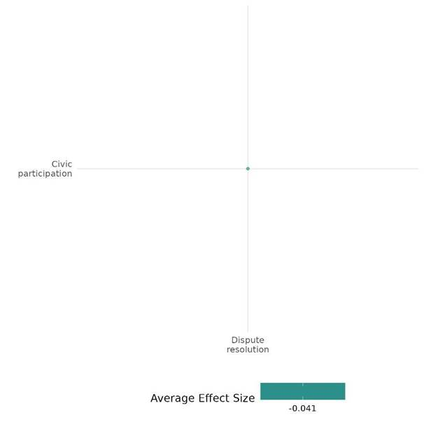

4.3.2(8)
Effect of Dispute Resolution on Government Performance
Dispute resolution interventions boosted trust in justice systems but faced governance challenges. While some improved justice coordination and public confidence, gaps in implementation, corruption, and enforcement issues limited effectiveness.
Geographical Region: Sub Saharan Africa, Middle East & North Africa, South Asia
Effect: Small effect (g = 0.03)
Confidence in study findings: Low ( 2 studies with 9 effect size)

Short Summary
Dispute resolution interventions, including UNMIL in Liberia, RLS-I in Afghanistan, and PEACE in Niger, have been evaluated for their impact on governance and dispute resolution. Across these studies, it was found that UNMIL enhanced trust in the police, yet also led to a notable increase in perceptions of government corruption, particularly in patrol communities, with an increase of 10-11%. RLS-I successfully strengthened coordination between Traditional Dispute Resolution (TDR) and the formal justice system, although there was a lack of quantitative evidence regarding registration rates. The PEACE initiative improved citizen-government trust, as evidenced by a 14% increase in net social service availability, and bolstered mediation efforts, but its effectiveness was limited in infrastructure-focused areas. While these interventions strengthened the connections to formal justice systems, challenges such as perceptions of corruption and inconsistencies in enforcement remained significant.

The Intervention
Dispute resolution interventions, including UNMIL, RLS-I, and PEACE, aimed to strengthen governance and justice systems. UNMIL conducted patrols, public works, and dispute-resolution efforts in partnership with state and local leaders. RLS-I provided six legal education workshops over 4-6 months, along with discussion sessions, coordination meetings, and networking activities to enhance Traditional Dispute Resolution (TDR). PEACE used the CATALYSE approach, incorporating mediation, infrastructure projects, resource access, economic inclusion, and cultural/sporting events to promote social cohesion and conflict resolution.

How the intervention is expected to work
The UNMIL intervention aimed to build trust in the state by enforcing legal norms, curbing illegal practices such as trial by ordeal, and strengthening linkages between formal and informal justice systems. RLS-I focused on enhancing Traditional Dispute Resolution (TDR) by increasing elders’ legal knowledge, promoting collaboration with formal justice institutions, and discouraging harmful social practices. The PEACE initiative sought to reduce vulnerability to violent extremism by fostering community trust, improving access to government services, and reinforcing conflict resolution mechanisms to promote stability and social cohesion.

The Evidence base
This cell includes three impact evaluations conducted in Niger, Afghanistan, and Liberia, though one study was excluded from effect size (ES) calculation due to insufficient data for computing Cohen’s d.

Evidence findings
Dispute resolution interventions assessed under this cell documented boosted trust in justice systems but faced governance challenges. Issues like implementation gaps, corruption, and inconsistent enforcement limited their effectiveness.

The Impact evaluation evidence
There are three IEs included in this cell. The detailed summary thus provided below;
Blair (2019): The study evaluated the UN Mission in Liberia (UNMIL) and its impact on the rule of law in post-conflict Liberia. It aimed to build confidence in state institutions, enforce formal-informal justice separation, and eliminate illegal practices like trial by ordeal. UNMIL activities included patrols, public works, and dispute resolution interventions with local leaders. The study surveyed 242 rural communities across Lofa, Nimba, and Grand Gedeh counties, collecting data in three waves (2009, 2010-2011, 2013) from residents, local leaders, and officials. A mixed-method approach was used, incorporating surveys, list experiments, qualitative interviews, and difference-in-differences analysis.
Findings related to government performance revealed increased perceptions of corruption with higher exposure to UNMIL, particularly through patrols, interventions, and public works, with citizens in weekly patrol communities being 10-11% more likely to describe the state as corrupt. While formal institutions (e.g., the police) gained increased trust, citizens' perceptions of corruption within the government were exacerbated, especially in communities with frequent UNMIL patrols. This suggests that although the police were seen as more reliable, the overall quality of governance and service provision remained questionable due to corruption concerns. Direct interaction with UNMIL personnel reduced perceptions of corruption within UNMIL itself, with a 4% decrease in views of UNMIL as corrupt and biased. There was no significant change in perceptions of democratic practices or the strength of democracy, even as reliance on formal institutions grew. The study is rated as a low-confidence quantitative study.
Killan(-2014): assessed the Rule of Law Stabilization - Informal Component (RLS-I) in Afghanistan, aimed at strengthening Traditional Dispute Resolution (TDR). The program provided six legal education workshops (30 hours over 4-6 months) for elders and dispute resolvers, covering conflict resolution, inheritance, family law, and other legal topics. Additional activities included discussion sessions, coordination meetings, and networking. The study sampled 850 elders, 996 disputants, and 3,820 citizens across six districts (three treatment, three control). Using a difference-in-differences approach, it measured changes in dispute resolution practices, attitudes, and women’s roles. Findings were assessed through surveys and a 5-point perceptual index, though the study is rated low confidence.
Key findings on government performance revealed Increased coordination between TDR and formal justice mechanisms, as evidenced by efforts to register TDR decisions with government entities. However, quantitative data on registration rates are not explicitly provided. Discussion sessions and coordination meetings with state justice actors likely strengthened the alignment between informal and formal justice systems. The study is rated as a low confidence study.
Lichtenheld (2022): evaluates the PEACE program in Niger’s Tillabéri region, aimed at reducing vulnerability to violent extremism by fostering social cohesion. Using Mercy Corps’ CATALYSE approach, the intervention engaged communities in participatory planning to promote trust and cooperation. Key activities included mediation and dialogue, infrastructure development, resource management, economic inclusion for youth and women, and cultural/sporting events. A quasi-experimental design was used across 40 villages (20 treatment, 20 control), with data collected at baseline (2020), midline (2021), and endline (2021) from 1,843 respondents (55% male, 45% female). The PEACE program made modest improvements in relations between citizens and governing actors. Communities exposed to more PEACE activities reported increased trust, with more respondents stating that leaders kept their commitments to the community. Treatment communities showed a 2.5% increase in the availability of social services, while control communities experienced a 9.5% decrease, resulting in a 14% difference between the two groups. Additionally, treatment communities saw a statistically significant improvement in the perceived effectiveness of conflict resolution mechanisms, with a greater impact in villages that received mediation and dialogue activities. The increase in perceived effectiveness was not observed in villages that received infrastructure-focused activities. The study is rated as a low-confidence quantitative study.
Overall confidence assessment
Overall, the confidence level is low, as the cell comprises three studies, all rated as low confidence.
Other outcomes assessed
Violence & atrocity prevention/Diplomatic relation & peaceful dispute resolution
Community & state governance/Access to justice, rights & public services
Community & State Governance/Civic Participation
Violence & atrocity prevention/Social norms regarding violence or atrocities
Violence & atrocity prevention/Nature & scale of violence or atrocities
Social cohesion/feelings of trust & acceptance of diversity

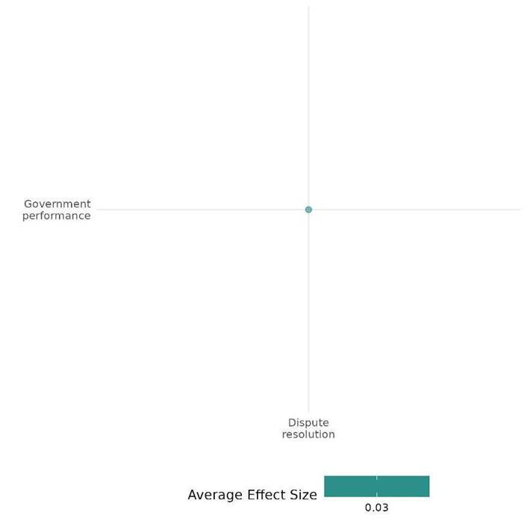

4.3.2(9)
Effect of Dispute Resolution on Economic Security
CONCUR in Nigeria improved economic access, while IPNN enhanced social cohesion but had no economic impact, highlighting the need for sustained efforts.
Geographical Region: Sub Saharan Africa
Effect: Small effect (g= 0.077)
Confidence in study findings: Low confidence ( 1 study with 11 effect size)

Short Summary
Dispute resolution interventions such as CONCUR and IPNN in Nigeria aimed to mitigate conflict and promote stability through community engagement and leadership training. CONCUR reduced pastoralist-farmer conflicts via Interest-Based Negotiation (IBN) training, joint economic projects, and policy advocacy, while IPNN engaged religious leaders through IBN training, interfaith initiatives, and media campaigns. A difference-in-difference (DiD) evaluation of 1,806 CONCUR and 710 IPNN households documented that CONCUR improved economic access, increasing work opportunities (18% to 66%) and goods availability (9% to 50%), but income stability remained mixed, and farmland sharing saw limited progress (71% to 74%). IPNN boosted social cohesion (trust: 16% to 39%, interfaith acceptance: 88% to 95%) but had no clear economic impact.

The intervention
The CONCUR and IPNN interventions in Nigeria implemented various dispute resolution activities, including community engagement, leadership training, and Interest-Based Negotiation (IBN) training. CONCUR focused on joint economic projects, policy advocacy, and resource-sharing initiatives to address pastoralist-farmer conflicts. IPNN engaged religious leaders through IBN training, interfaith initiatives, and media campaigns to promote conflict resolution.

How the intervention is expected to work
These interventions are expected to empower local leaders and community members to mediate conflicts peacefully by providing them with the necessary tools to manage disputes and promote cooperation. IBN training helps leaders facilitate impartial dialogue, reducing tensions and preventing conflicts from escalating. Joint economic projects foster collaboration between different groups, building trust and addressing the economic drivers of conflict. Through these efforts, the interventions seek to improve economic stability.

The evidence base
The cell contains two studies; one is primary study conducted in Nigeria and another is low-confidence qualitative study authored by Dhiaulhaq Ahmad (2014).

Evidence findings
CONCUR in Nigeria improved economic access, while IPNN strengthened social cohesion but had no significant economic impact.

Included studies
There is one impact evaluations of the same author only, and both study summaries are thus provided here:
Baran (2017) assessed conflict resolution interventions in Nigeria, focusing on the economic impact of the Community-Based Conflict Management and Cooperative Use of Resources (CONCUR) program, implemented by Mercy Corps (2012–2016) in Nigeria’s Middle Belt, and the Inter-Religious Peacebuilding in Northern Nigeria (IPNN) initiative. CONCUR sought to mitigate conflicts between pastoralist and farming communities through Interest-Based Negotiation (IBN) training, joint economic projects (e.g., community gardens, shared grazing areas, marketplaces), and policy advocacy addressing the economic roots of conflict. IPNN, on the other hand, worked with religious leaders to promote non-violent conflict resolution through IBN training, interfaith initiatives, and peace-focused media campaigns. The study employed a mixed-methods impact evaluation using a difference-in-difference (DiD) framework, comparing baseline and endline data from conflict-affected communities in Kaduna, Nasarawa, and Plateau states. The sample included 1,806 baseline and 1,276 endline surveys for CONCUR, and 1,096 baseline and 923 endline surveys for IPNN, with random sampling conducted through community mapping. Qualitative data from focus groups and key informant interviews provided additional insights. Findings indicated notable improvements in economic security, particularly in CONCUR communities, where households reporting increased work opportunities rose from 18% to 66%, and access to goods improved from 9% to 50%. Furthermore, 47% of CONCUR households reported that conflict no longer affected their livelihoods, a significant improvement relative to comparison sites (p < 0.01). However, income stability showed mixed results, as 70% of CONCUR households reported income growth compared to the previous year, but this change was not statistically significant compared to control sites. Investment in productive assets such as livestock and equipment also showed no significant improvement. The study was rated high to medium confidence.
Confidence assessment
Overall, the study is rated as low confidence due to the limited number of studies in the cell (fewer than three) and its reliance on a non-experimental study design.

Other outcomes assessed:
Human security/physical security
Violence & atrocity prevention/Diplomatic relation & peaceful dispute resolution
Social cohesion/feelings of trust & acceptance of diversity

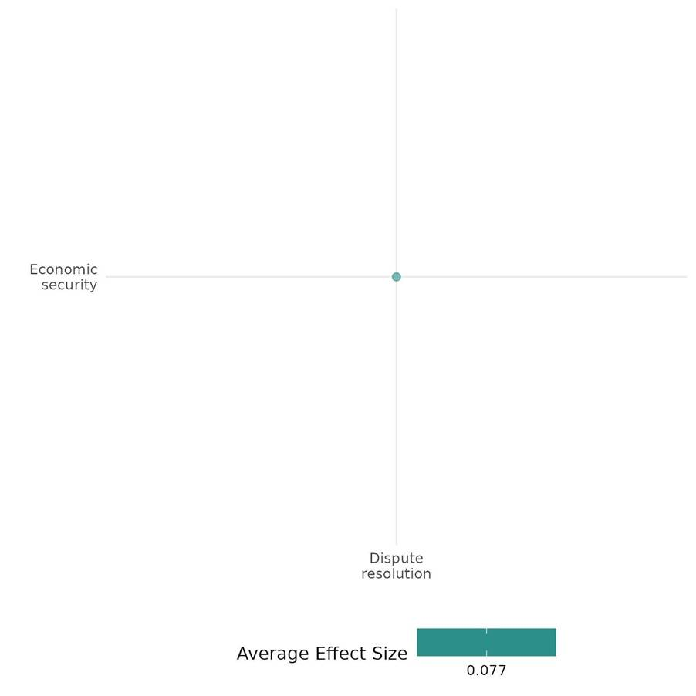

4.3.2(10)
Effect of Dispute Resolution on Physical Security
CONCUR, IPNN, and ECPN improved physical security in conflict-affected Nigerian areas. Freedom of movement rose to 72% (CONCUR) and 62% (IPNN), while ECPN sites had 15% higher security perception than controls.
Geographical Region: Sub Saharan Africa
Effect: Large effect (g=0.288)
Confidence in study findings: low ( 2 studies with 7 effect sizes)
Short summary
Dispute resolution interventions, including CONCUR, IPNN, and ECPN, were evaluated for their impact on conflict mitigation and security in Nigeria. Using mixed-method impact evaluations with difference-in-difference (DiD) analysis and randomized trials, studies surveyed thousands of households across conflict-affected areas. Findings showed significant improvements in physical security and freedom of movement. In CONCUR sites, freedom of movement increased from 0% to 72%, while IPNN sites saw a rise to 62%. ECPN intervention communities reported a 15% higher security perception than control sites. The programs effectively reduced tensions and improved safety, allowing greater mobility for families and children.

The intervention
The CONCUR project (Conciliation in Nigeria through Community-Based Conflict Management) and the IPNN initiative (Inter-Religious Peacebuilding in Northern Nigeria) are designed to mitigate community tensions by implementing Interest-Based Negotiation (IBN) training. These initiatives promote collaborative endeavours, including the establishment of shared grazing areas and community gardens, alongside advocacy efforts aimed at fostering sustainable peace within the region.

How the intervention is expected to work
These interventions are expected to empower local leaders and community members to mediate conflicts peacefully by providing them with the necessary tools to manage disputes and promote cooperation. IBN training helps leaders facilitate impartial dialogue, reducing tensions and preventing conflicts from escalating. Joint economic projects foster collaboration between different groups, building trust and addressing the economic drivers of conflict. Through these efforts, the interventions seek to improve economic stability.

The evidence base
The cell includes five studies: two impact evaluations (IEs), two low-confidence qualitative studies conducted by Demartoto Argyo and Dhiaulhaq Ahmad (2014), and one medium-to-high-confidence systematic review.

Evidence findings:
Dispute resolution programs CONCUR, IPNN, and ECPN enhanced security in conflict-affected Nigeria, with freedom of movement and improved perceptions of security.

Review Findings
The review analyzed studies from fragile and conflict-affected regions, including Sub-Saharan Africa, the Middle East, North Africa, Europe, and Asia, excluding Latin America. It focused on low- and middle-income countries with intergroup tensions. Interventions included peace education, intergroup dialogues, collaborative programs, media campaigns, and economic support. Findings showed small positive effects on perceived security and community safety.

Included studies
There are two impact evaluations under this cell. The detailed summaries are thus provided here:
Baran (2017) evaluated Mercy Corps’ Community-Based Conflict Management and Cooperative Use of Resources (CONCUR) program (2012–2016) in Nigeria’s Middle Belt. The program aimed to mitigate farmer-pastoralist conflicts through Interest-Based Negotiation (IBN) training, joint economic projects (e.g., shared grazing areas, marketplaces), and policy advocacy. A mixed-methods impact evaluation utilized difference-in-difference (DiD) analysis, comparing baseline and endline surveys across conflict-affected communities in Kaduna, Nasarawa, and Plateau states. The study sampled 1,806 households at baseline and 1,276 at endline, employing random selection through community mapping. Qualitative insights were drawn from focus groups and key informant interviews.
Findings on physical security demonstrated substantial improvements. The proportion of respondents reporting complete freedom of movement increased from 0% at baseline to 72% at endline, reflecting a 44-percentage point improvement relative to comparison sites (p < 0.01). Enhanced security also facilitated greater mobility for children and families, improving access to schools. Additionally, 79% of respondents in CONCUR communities reported reduced tensions between conflict groups at endline, compared to 45% at baseline. The study is rated as a high-medium confidence assessment.
Dawop (2019): The study evaluated the Engaging Communities for Peace in Nigeria (ECPN) program, which aimed to reduce farmer-pastoralist conflicts in Nigeria’s Middle Belt. It involved training community leaders in mediation, forming joint committees, implementing community projects (e.g., boreholes, fences), and hosting conflict prevention forums. A mixed-method approach was used, combining a community-level RCT with individual pre/post-intervention analysis. Data was collected from 30 communities (15 sites), with 1,539 baseline and 1,523 endline surveys, plus 287 resurveyed individuals (direct, indirect, and control participants). Communities with prior violence were targeted, and household selection used a listing exercise. Data collection included surveys (2015, 2018), behavioral games, and observational monitoring. Analysis employed regression, difference-in-difference comparisons, and qualitative market/social observations.
Findings on physical security revealed that the ECPN program successfully improved perceptions of security in intervention communities. By the end of the program, perceptions of security in intervention communities had increased significantly compared to control communities, with a 15% difference in change (effect size = 0.84, p = 0.01). Initially, intervention communities felt less secure, but they ended up feeling more secure than control communities. At the individual level, direct and indirect participants in intervention communities reported greater increases in security perceptions than control participants, though there was no significant difference between direct and indirect participants. The effect size at the individual level was 0.12, indicating a 3% difference between groups (p = 0.10). The pattern suggests that peace committees may have made participants more aware of security incidents, especially in Benue, where pastoralist direct participants reported a decrease in security perceptions. The study is reported as a low-confidence quantitative study.
Confidence assessment
Overall, the studies are rated with low confidence in their findings due to small numbers of studies included under this category.

Link to review summaries
Spangaro Jo (2013).
All studies may be accessed via the EGM.
Other outcomes assessed in these studies:
Human security/economic security/physical security
Violence & atrocity prevention/Diplomatic relation & peaceful dispute resolution
Social cohesion/feelings of trust & acceptance of diversity

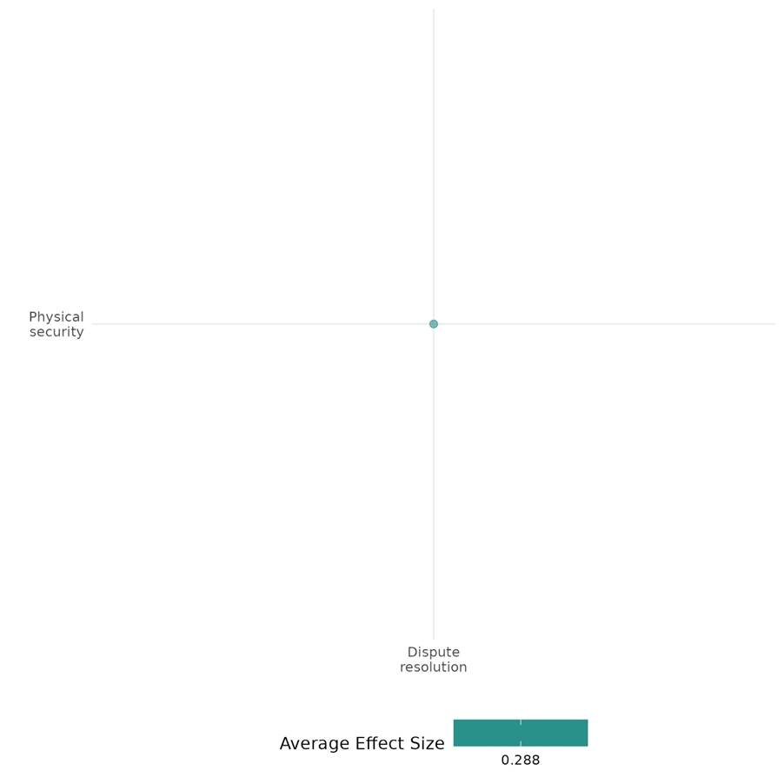

4.3.2(11)
The effect of Dispute resolution on intermediate social cohesion outcomes

Effect: positive (Mediation not only resolved conflicts but also increased the capacity of stakeholders to find solutions to conflicts in various contexts in Southeast Asia)

Confidence in study findings: Low (one study, low confidence)

Summary
While mediation holds significant potential for addressing conflict and increasing the capacity of stakeholders to find solutions to conflicts in Southeast Asian countries, its effectiveness hinges on many factors. These include the perceived legitimacy and authority of the mediators, the willingness of all parties to engage in a participatory process, and the capacity of mediators and institutions to implement agreements and address systemic issues
The intervention
The intervention refers to mediation as a structured approach to resolving plantation conflicts, implemented in three key phases: pre-mediation, mediation, and post-mediation. These phases included a range of activities such as conflict analysis, trust-building, and securing stakeholder commitment. Mediators established communication, addressed concerns about neutrality, and formalized party representation for legitimacy.
How is the intervention expected to work
The specific interventions employed will vary depending on the context of the conflict, the nature of the parties involved, and the skills and resources of the mediators. However, the overarching goal of this intervention is to go beyond just stopping the conflict. Rather, the mediation was pursued with the intent to achieve conflict transformation, including sustainable resource management. In the Chiang Mai (Thailand) case, for example, the mediation sought to enable the highland and lowland communities to manage the Mae Tia Mae Tae watershed together sustainably and equitably and share the benefits (p.137)
The evidence base
There is one qualitative study assessing the effect of Dispute resolution on intermediate social cohesion outcomes in Southeast Asia- Cambodia, Indonesia, and Thailand. The study is by A. Dhiaulhaq, T. De Bruyn, & D. Gritten (2015). The use and effectiveness of mediation in forest and land conflict transformation in Southeast Asia: Case studies from Cambodia, Indonesia and Thailand. Environmental Science & Policy, 45, 132-145. All references are from that study.
The evidence
Mediation increased the capacity of stakeholders to find solutions to conflicts. This states that mediation can enhance intermediated social cohesion outcomes by providing a platform to get to know the parties, build trust, build relations, and understand the culture during the social preparation before mediation, training & several meetings to discuss the conflicts & way forward. However, the success of mediation depends on several factors, including the perceived legitimacy and authority of the mediators, the willingness of all parties to engage in a participatory process, and the capacity of mediators and institutions to implement agreements and address systemic issues
Confidence assessment
Overall confidence: Low Confidence Qualitative Study (It is unclear whether the study uses an established small n approach; theoretical framework is not presented; no triangulation done; sources of potential data bias is not addressed)

4.3.3 Intergroup contact + Peace education

4.3.3(1)
Effect of intergroup contact and peace education on diplomatic relations and peaceful dispute resolutions
Intergroup contact and peace education interventions had mixed impacts on diplomatic relations and peaceful dispute resolutions. Studies show more non-violent conflict resolution, better land conflict resolution, and fewer violent disputes, but long-term peace impact remains uncertain.
Geographical region: Sub Saharan Africa,
Effect size: Large effect (g=0.203)
Confidence in the study findings: Low confidence (3 studies; 24 ES)

Short summary
Intergroup contact and peace education interventions had mixed impacts on diplomatic relations and peaceful dispute resolutions. Studies show more non-violent conflict resolution, better land conflict resolution, and fewer violent disputes, but long-term peace impact remains uncertain. We have low confidence in the cell due to a limited number of studies in the cell.

The intervention
The interventions across the cell aimed to promote civic education, human rights, and alternative dispute resolution techniques in conflict-prone communities through training in negotiation, mediation, and conflict resolution. Workshops reinforced skills over months, aiming to reduce violence and improve land dispute resolution. While conflicts decreased, effects on norms were mixed, with limited attitudinal shifts and occasional increases in interpersonal disputes, highlighting challenges.

How the intervention is expected to work
These Intergroup contact and peace education interventions are expected to work by educating and equipping community members with conflict resolution skills through interactive workshops on mediation, negotiation, and ADR techniques. By reinforcing these skills with follow-up activities, it encourages informal dispute resolution, reducing reliance on legal systems. This approach fosters dialogue, mutual understanding, and peaceful conflict management, ultimately shifting community norms and improving dispute resolution effectiveness.
The evidence base
The cell includes 3 impact evaluations and 1 systematic review. There is a low degree of consistency in the review findings. The review is concerned with interventions including intergroup contact and peace education for dispute resolution. The cell also includes a qualitative study by McMahon (2009) from Ethiopia.
The three studies employ randomized controlled trials (RCTs). The studies are conducted in Liberia, West Africa.

Evidence findings
The intervention led to significant reductions in violence, land disputes, and harmful practices, but also caused unintended increases in youth-elder conflicts and social tensions.

The review evidence
The review evidence suggested that the current evidence base gives too little attention to resources and capacities that enable people to engage in conflict mitigation behaviours.

The impact evaluation evidence
Blattman (2011) evaluates Liberia’s Community Empowerment Program (CEP), a large-scale peace-building initiative promoting civic education, human rights, and non-violent dispute resolution. Using a randomized controlled trial (RCT) across 67 treated and 170 control communities, the study assessed the impact on diplomatic relations and peaceful dispute resolution. Findings indicate higher rates of non-violent conflict resolution, increased land conflict reporting but improved resolution, and moderate shifts toward human rights and equity. Results show that land conflicts increased in early-treated communities but decreased in recently treated ones, indicating a delayed effect of the program. Violent land conflicts were lower in treated communities, and conflict resolution rates were higher, with more reported satisfaction in communities that underwent training. However, trainees and general community members experienced the program differently, as trainees reported lower levels of land conflict, while community members initially reported higher levels before resolution increased. While the program reduced violent disputes, it also surfaced latent conflicts, emphasizing the complexities of peace education interventions. Ultimately, the study highlights the potential and risks of such programs, showing their ability to shift conflict resolution norms but also their need for sustained engagement to ensure long-term peace​. The study rated as low confidence due to the lack of reporting of attrition.
Blattman (2014) assesses the impact of an Alternative Dispute Resolution (ADR) education program in 86 Liberian communities, implemented by UNHCR and the Justice and Peace Commission, training 15% of adults in negotiation, mediation, and conflict resolution through eight-day workshops over two months, with facilitators reinforcing ADR norms for up to four months. The intervention led to a 29% reduction in unresolved land disputes, a 32% decrease in property destruction, and a 10% increase in satisfaction with dispute outcomes, with 17% more disputes resolved informally. While residents were 22% less likely to take minor disputes to courts, there was no major shift in dispute resolution norms or egalitarian attitudes, though acceptance of ethnic intermarriage increased slightly. However, money or business disputes increased slightly (15%) without significant improvements in resolution, and physical fights rose by 32%. Overall, the ADR intervention effectively reduced land disputes and encouraged informal resolution, but had limited impact on broader attitudinal change and may have contributed to an increase in interpersonal conflicts. The study is rated as high and medium confidence quantitative study.

Hartman (2018) The intervention, known as the Alternative Dispute Resolution (ADR) peace education program, was implemented in Liberia and involved training community members in negotiation and mediation techniques to resolve disputes. The study followed an experimental design with a sample of 246 communities, randomly assigning 116 to receive treatment. The total sample included 5,435 individuals at the 1-year endline and 4,011 at the 3-year endline, with additional subsamples for specific dispute-related analyses​. The impact of intergroup contact and peace education was observed through reductions in unresolved disputes by 28% at the 1-year mark, and a 41% decrease in threats, property destruction, or interpersonal violence at 3 years​. Results show that unresolved disputes decreased from 0.07 to 0.024 (a 28% reduction), while disputes involving threats, property destruction, or violence dropped by 28.4% at 3 years. Other results highlight a 20.7% reduction in disputes involving violence and a 40.5% decrease in property destruction at 3 years​. This study is rated as high and medium confidence quantitative study.

Confidence assessment
The cell’s confidence is low due to the limited number of studies.

Link to review summaries
Ditlmann (2017)

Other outcomes in this study
- Violence and atrocity prevention / Nature and scale of violence or atrocities
- Human security / Economic security / Intermediate social cohesion outcomes
- Community and state governance/Government performance
- Social Cohesion / Willingness to help

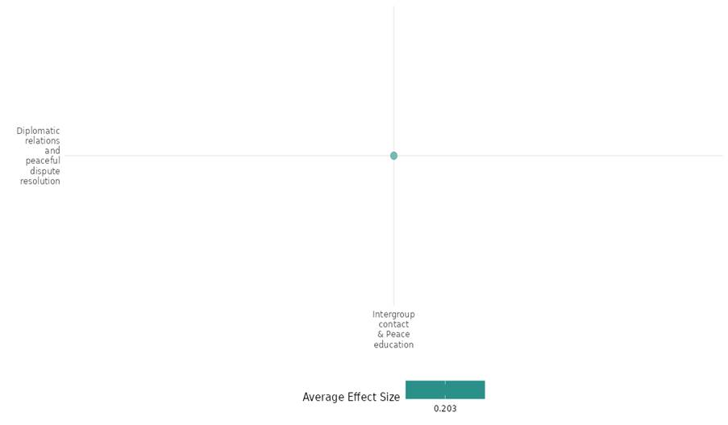

4.3.3(2)
Effect of intergroup contact and peace education on nature and scale of violence and atrocities
Intergroup contact and peace education programs reduce violence by fostering empathy, trust, and conflict resolution skills, leading to fewer violent incidents and ethnic tensions. While they help mitigate aggression and promote non-violent approaches, sustained impact depends on continued engagement, institutional support, and integration into broader societal structures for long-term effectiveness.
Geographical region: Europe & Central Asia, Sub Saharan Africa, South Asia
Effect size: Moderate effect (g=0.15)
Confidence in study findings: Low confidence Low (8 studies; 47 ES)

Short Summary
Intergroup contact and peace education promoted conflict resolution, social cohesion, and non-violent dispute resolution through education and skill development. Targeting diverse groups, they improved intergroup relations, reduced violence, and strengthened social ties. While some achieved short-term success, long-term impact varied. We have low confidence in the cell due to most of the studies falls in low confidence category and the inconsistency in effect sizes.

The Intervention
The interventions across the cell aimed to promote peace, reduce violence, and foster social cohesion through community-based programs, peace education, and conflict resolution training. These programs demonstrated positive impacts on reduced violence particularly in schools and communities affected by conflict. Outcomes were mixed—some interventions reduced violence short-term, while others lacked lasting impact.

How the Intervention is expected to work
Intergroup contact and peace education programs, such as Alternative Dispute Resolution (ADR), LivingSideBySide® (LSBS), "Understanding Each Other", and the Community Empowerment Program (CEP), aim to reduce violence, foster trust, and improve conflict resolution. Many interventions show short-term success in reducing disputes, ethnic tensions, and peer violence, but their long-term sustainability remains uncertain. While some programs enhance cooperation and dispute resolution, challenges like extrajudicial punishment and limited diffusion of benefits persist. Achieving lasting impact requires sustained engagement, integration into broader societal structures, and comprehensive strategies tailored to specific conflict dynamics and contexts.

The evidence base
The cell contains two systematic reviews and seven impact evaluations. The overall evidence base is fragmented and weak in review findings.
The seven studies employ a mix of randomized controlled trials (RCTs) at the community and individual levels, cluster RCTs, cross-sectional designs, interrupted time series, and behavioral experiments. Some use mixed methods, including surveys, focus groups, and qualitative assessments, while others rely on self-reported data.
The studies are conducted in Kyrgyzstan, Turkey, Liberia, Afghanistan, Nigeria.

Evidence Findings
The interventions showed short-term reductions in violence, but long-term sustainability remained uncertain.

The review evidence
The reviews assess interventions to reduce armed violence and gender-based violence in conflict settings, finding limited but evolving evidence on effectiveness.

The impact evaluation evidence
Aladysheva (2017) The LivingSideBySide® (LSBS) peacebuilding programme in Kyrgyzstan aimed to foster interethnic tolerance and reduce prejudice among adolescents through structured after-school training. Implemented in ten schools with individual-level randomization, the study used surveys, behavioural experiments, and focus groups to assess its impact. The intervention, categorized under Intergroup Contact and Peace Education, sought to improve trust, cooperation, and conflict resolution skills. Results indicate mixed but generally positive effects: trust in strangers increased, especially among boys, while girls showed improved interreligious trust. However, there was no significant reduction in aggressive behaviours, and self-confidence in conflict resolution slightly declined, possibly due to increased self-awareness. The study highlights the limited but promising impact of peace education, suggesting that longer and more intensive interventions may be necessary for sustained change. Future efforts should consider integrating such programmes into national curricula for broader and lasting effects. The study is rated high.
Alan (2021) evaluates the "Understanding Each Other" educational intervention, designed to foster social cohesion among ethnically diverse elementary school students in Turkey. The intervention falls under the Intergroup Contact and Peace Education category and aims to reduce violence, social exclusion, and ethnic bias while promoting prosocial behaviors. Implemented as a cluster randomized controlled trial (RCT) across 80 schools with 6,500 children aged 8–12, the program trained teachers to deliver a structured curriculum emphasizing perspective-taking. The outcome sub-category is the Nature and Scale of Violence and Atrocities, as it measures reductions in peer violence and victimization, social exclusion, and improvements in trust, cooperation, and reciprocity. Results indicate a significant reduction in peer violence, with treated children perpetrating 1.21 fewer violent incidents on average over ten school days, a 64% decline, and victimization rates dropping by 50%​. The other result reveals that the program also increased emotional and academic support among classmates, strengthened social ties, and reduced ethnic segregation by 15-21%​. Confidence in the findings is strengthened by robust experimental design elements, such as stratified randomization and high statistical power, though some effects on behavioural norms and impulsivity did not survive multiple hypothesis corrections​. The study is rated low confidence due to its little description of the intervention.

Blattman (2011) evaluates the Community Empowerment Program (CEP) in Liberia, a program aimed at promoting peace, human rights, and civic participation. The program provided training and facilitated community dialogues to build skills for non-retributive dispute resolution and promote constructive engagement. The study used a randomized evaluation design, comparing outcomes between communities that received the CEP program and control communities that did not. The analysis focused on "potential trainees" identified in advance as well as other community members who attended the program. The program had modest impacts on respect for human rights and equality, but significant impacts on conflict and conflict resolution, increases in non-violent interpersonal and inter-group disputes, suggestive evidence of a decrease in violent disputes, increased rates of dispute resolution and satisfaction with resolutions. Results showing significant increases in certain non-violent disputes while reducing violent strikes and inter-group violence by 59%, though this reduction was not statistically significant. There was a 93% increase in conflicts between youth and elders, with treatment communities being twice as likely to experience peaceful protests and three times as likely to report a witch killing, though the latter was not statistically significant. Additionally, while violent crime prevalence, including fights and murders, was slightly lower in treated communities, these effects were not statistically significant, aligning with the observed reduction in violent communal disputes. The study is rated as low confidence quantitative study due to lack of reporting attrition.

Blattman (2014) evaluates the short-term impacts of a community education campaign on alternative dispute resolution (ADR) practices in Liberia, a country with weak formal institutions and high levels of property disputes and violence. The campaign aimed to promote informal dispute resolution skills, practices and norms to help parties reach self-enforcing bargains faster and at less cost than through the formal court system. The study finds that the education campaign led to shorter and less violent land disputes, with treated communities seeing a 29% reduction in unresolved land disputes and a 32% reduction in property destruction. However, the campaign also led to unintended consequences, including increases in informal extrajudicial punishment and more (largely peaceful) disagreements and demonstrations. The results suggest that mass education can change high-stakes behaviors, and improving informal bargaining and enforcement can promote order in weak states, though the approach carries risks of heightened conflict. The study design involved randomizing the intervention at the community level, with 116 of 246 communities initially assigned to treatment. The study has strong internal validity, though the generalizability of the findings may be limited by the specific context of Liberia. The study is rated as high and medium confidence quantitative study.

Corboz (2019) presents the results of an evaluation of a school-based peace education and community-based intervention implemented in Afghanistan to reduce violence against and between children. The intervention aimed to change harmful social norms and practices related to gender and the use of violence in conflict resolution. The evaluation found significant reductions in various forms of violence at the school level, including peer violence victimization and perpetration, and corporal punishment by teachers. There were also significant reductions in children's experience of corporal punishment at home and observation of family violence, particularly among girls. Both boys and girls showed more equitable gender attitudes, less violence-supportive attitudes towards children's punishment, and fewer symptoms of depression. Girls' school attendance also increased significantly. The study used a cross-sectional, interrupted time series design with three data collection points over 12 months. The findings suggest that the peace education intervention combined with community-level components can be an effective approach to reducing various forms of violence against children in a conflict-affected setting like Afghanistan. The study is rated low confidence quantitative study.

Fafchamps (2013) assesses the "No to Political Violence! Vote Against Violent Politicians" campaign, an intergroup contact and peace education intervention aimed at reducing electoral violence and fostering social cohesion in conflict-prone regions of Nigeria. The intervention was implemented through community-based awareness campaigns, including home visits, town meetings, and popular theater, to encourage peaceful conflict resolution. The study, designed as a randomized controlled trial (RCT) across multiple states, measured the nature and scale of violence and atrocities by analyzing behavioral changes in targeted and untargeted individuals. Results indicate that exposure to the campaign significantly increased participation in community peace-building activities, while social proximity to other targeted individuals reinforced these effects and it also reveals limited diffusion of these benefits to untargeted individuals, suggesting that direct engagement was crucial for impact. This study is rated as low confidence quantitative study as both the targeted & untargeted sample sized was not drawn differently, it follows the same method & source.

Hartman (2018) evaluates the impact of the Alternative Dispute Resolution (ADR) training program as an intervention within the sub-category of Intergroup Contact and Peace Education, assessing its effects on the Nature and Scale of Violence and Atrocities. The study employs a cluster-randomized controlled trial in conflict-affected regions, measuring the impact of ADR training on dispute resolution, land conflicts, and social norms. Result presents findings related to the effectiveness of the ADR intervention in reducing unresolved disputes, particularly land conflicts, by approximately 28% in the first year but with no significant effect observed at the three-year mark. This suggests that ADR was effective in resolving immediate disputes but lacked long-term sustainability. The study reports moderate confidence in its findings due to potential self-reporting biases, but the robustness checks, including heterogeneity analysis, confirm the intervention's significant short-term impact. The intervention led to improved dispute resolution processes and reduced reliance on violent means, though it did not eliminate conflicts over time. This study is rated as high and medium confidence quantitative study.

Smidt (2020) evaluated local intergroup dialogue activities organized by the United Nations Peacekeeping Operation in Côte d’Ivoire (UNOCI). These dialogues aimed to reduce communal violence by addressing information gaps, rebuilding trust among different ethnic communities, and promoting norms for peaceful coexistence. The study used a quasi-experimental design with bivariate probit and matching models to address the nonrandom selection of intervention sites. The dataset covered 107 departments and tracked both intergroup dialogue events and instances of communal violence from 2011 to 2016. A total of 586 department months with at least one dialogue activity were analyzed. The study documented a reduction in Communal Violence by Civilians, i.e., Departments hosting at least one dialogue event in the preceding three months experienced a decrease in the likelihood of communal violence by 25.4 percentage points on average, and Similar dialogues reduced the probability of communal violence involving armed groups by 26.9 percentage points as confirmed by post-matching analyses. These reductions were statistically significant (p < .01), demonstrating that UNOCI’s interventions had a meaningful impact on mitigating communal violence. The documented mechanisms to improve coordination among community leaders were like tripartite commissions (e.g., in Bayota, a commission was set up to resolve disputes and prevent violence) for like and in addition to those positive changes in attitudes, such as reduced biases and increased commitment to peacebuilding, demonstrated by participants’ public apologies and promises to promote harmony. This is a low confidence quantitative study.

Confidence assessment

The overall confidence is low due to most of the studies falls in low confidence category and the inconsistency in effect sizes.low due to self-reporting biases, lack of long-term sustainability, and mixed results. Methodological issues like lack of randomization, cross-sectional designs, and unintended consequences further limit causal conclusions and reliability.

Link to review summaries
Cramer (2016)
Jo (2021)

Other outcomes in this study
- Violence and atrocity prevention/ Diplomatic relations and peaceful dispute resolution/ Social norms regarding violence and atrocities
- Social Cohesion/ Feelings of trust/ Acceptance of diversity/ Sense of belonging/ Willingness to participate or help/ Intermediate social cohesion outcome
- Community and state governance/Government performance
- Human Security/ Educational Security/ Intermediate social cohesion outcomes/ Physical security/ Health security/ Political Security/ Economic security

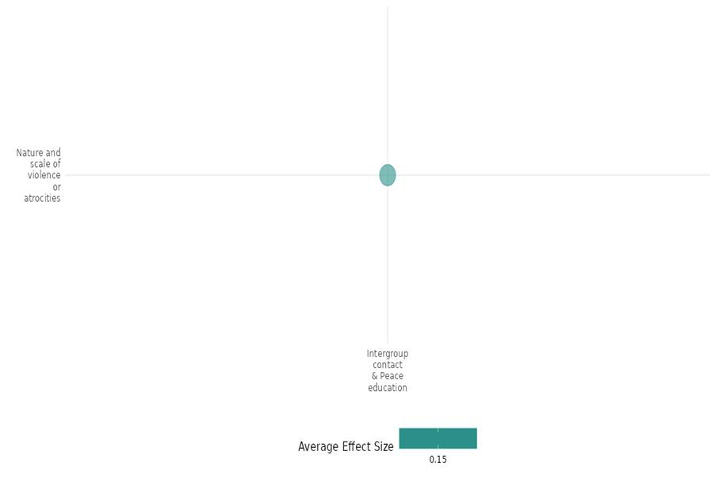

4.3.3(3)
Effect of Intergroup contact and peace education on Sense of belonging
Intergroup contact and peace education programs show mixed effects on sense of belonging. Some interventions foster trust, social cohesion, and national pride, while others lead to reduced self-efficacy or no change in intergroup attitudes.
Geographical region: Europe & Central Asia, Middle East & North Africa, Sub Saharan Africa
Effect size: Small effect (g= 0.089)
Confidence in the study findings: Low Confidence (5 studies; 14 ES)

Short Summary
Intergroup contact and peace education programs have varied effects on sense of belonging. Exposure to diverse communities strengthens both national and ethnic identities, while others report declines in belonging due to shifts in self-perception or external social dynamics. We have low confidence in the cell due to most of the studies falling in low confidence and inconsistency in the effects sizes.

The Intervention
The interventions across the cell focused on intergroup contact and peace education interventions aimed to foster trust, social cohesion, and belonging. Programs using volunteering, theatre, and structured peacebuilding showed mixed results—some increased trust and community engagement, while others reduced self-efficacy or had limited effects.
How the intervention is expected to work
Interventions on intergroup contact and peace education aim to enhance a sense of belonging by fostering trust, empathy, and shared identity through structured interactions. By promoting positive engagement between diverse groups, these programs reduce prejudice, encourage cooperation, and build social cohesion. Activities such as volunteering, theater, and national service create opportunities for meaningful relationships and collective action, reinforcing individuals' connection to their communities. Additionally, exposure to different perspectives broadens understanding and fosters inclusion. However, effectiveness depends on sustained interaction, equal-status engagement, and institutional support to ensure long-term attitudinal change and integration.
The evidence base
The cell includes five impact evaluations and 1 systematic review. There is a high degree of consistency in the review findings. The review is concerned with interventions, including intergroup contact and peace education on sense of belonging.
The five studies employ quasi-experimental, difference-in-differences, field experiments, lab-in-the-field experiments, and instrumental variable regression designs to assess intergroup contact and peace education interventions.
The studies are conducted in Kyrgyzstan, Lebanon, Liberia, Nigeria.
Evidence findings
The interventions had mixed effects on sense of belonging, with some increasing trust and national pride while others led to reduced self-efficacy or had no impact on intergroup attitudes.
The review evidence
The review evidence suggested that the effect of intergroup contact and peace education intervention is mixed on sense of belonging.
The Impact evaluation evidence
Aladysheva (2017) evaluates the LivingSideBySide® (LSBS) peacebuilding program in Kyrgyzstan, focusing on its impact on students' sense of belonging. It uses a quasi-experimental design with a difference-in-means approach, analyzing treatment and control groups across various schools. The sample includes 912 students, with subgroups analyzed for gender and ethnicity. Results show a significant increase in trust towards first-time acquaintances (0.32, p<0.01), a decrease in self-efficacy (-2.50, p<0.01), and reduced feelings of belonging in Kyrgyzstan (-0.19, p<0.01)​. Other results highlight positive program impacts on girls, such as improved trust in same-ethnicity peers (0.17, p<0.05) and similar trends for boys​. The study is rated high confidence.
Alaref (2019) evaluates the impact of the National Volunteer Service Program (NVSP) in Lebanon using a quasi-experimental design with a difference-in-difference (DiD) approach. The intervention involved inter-community volunteering and soft skills training, targeting youth from 22 NGOs (treatment group) and comparing them to youth from 16 non-selected NGOs (comparison group). The final sample included 759 youth (473 treatment, 286 comparison). The program had a statistically significant impact on the sense of belonging, with a 0.3–0.4 standard deviation (S.D.) increases for selected youth, mainly because non-selected youth experienced a sharper decline in belonging perceptions. Results show that perceptions of belonging to the Lebanese community increased by 0.35–0.36 S.D​. The study is rated low confidence due to its little description of the intervention.
Feuchte (2020) investigated the effects of Forum Theater interventions in postwar Liberia. Conducted in two communities with a sample of 218 diverse Liberians, the field experiment evaluated two plays: one addressing rebuilding trust after intergroup conflict and another focusing on a public health issue. Participants were divided into groups corresponding to each play, with a control group receiving no intervention. The study found that both Forum Theater interventions enhanced participants' sense of community and willingness to engage in collective action. Specifically, the effect sizes for improvements in the sense of community were 0.452 and 0.537. Notably, only the play centered on intergroup conflict increased intergroup trust and reduced social distance toward a disliked group. The study is Low confidence quantitative study.
Karim (2018) examines gender balancing in the Liberian National Police (LNP) using a lab-in-the-field experiment with 612 officers in Monrovia, Liberia. Participants were randomly assigned to 102 groups of six officers with varying gender compositions (0%, 33%, 67%, or 100% women). The study found that increasing female representation improved unit cohesion in terms of preference alignment, with all-female groups exhibiting an increase of 0.171 standard deviations (p < 0.05) compared to all-male groups. However, collegiality declined slightly, with all-female groups showing a 0.132 standard deviation increase in non-collegiality, though not statistically significant. Gender balancing did not enhance sensitivity to sexual and gender-based violence, as neither men nor women showed a significant tendency to identify such crimes (effect sizes: 0.839 for all-female groups, -0.943 for four-women groups, 0.328 for two-women groups, all statistically insignificant). Male officers’ beliefs about women's roles in policing remained unchanged (effect sizes: 0.0058 for all-female groups, 0.0228 for four-women groups, -0.0441 for two-women groups, all statistically insignificant). However, participation increased significantly in groups with more women (0.478 standard deviations for all-female groups, p < 0.05). The study is rated as low confidence quantitative study because there was no information about the sample size.
Okunogbe (2018) investigates the impact of Nigeria’s National Youth Service Corps (NYSC) program, which randomly assigns university graduates to serve in different regions, on interethnic relationships and national identity. Conducted in Nigeria, this quantitative study employs an instrumental variable (IV) regression design with a sample of 644 respondents, focusing on Yoruba participants posted to non-Yoruba regions. Results show that serving in a non-Yoruba region increased pride in being Nigerian (β = 0.181, p < 0.1), reduced interactions with Yoruba peers (-0.403, p < 0.01), and improved interethnic dating rates (+0.144, p < 0.05) but had limited effects on attitudes toward other ethnic groups​​​. This study can be rated as low confidence quantitative study due to generalizability is limited to Yoruba participants and self-reported data could introduce recall or social desirability bias.

Confidence assessment
The cell’s confidence is low due to most of the studies falling in low confidence and inconsistency in the effects sizes.

Link to review summaries
Sonnenfeld (2021)

Other outcomes in the study
- Human security/Educational security/ Intermediate social cohesion outcomes/ Physical security/ Economic security
- Violence and atrocity prevention/Nature and scale of violence or atrocities
- Social cohesion/Feelings of trust/ Acceptance of diversity/ Willingness to participate or help/ Intermediate social cohesion outcomes

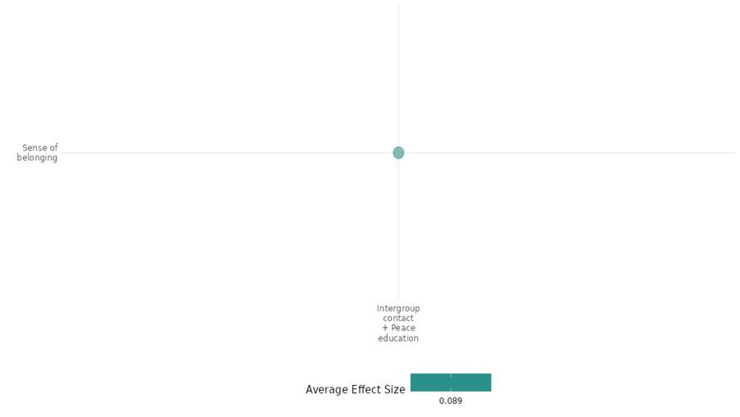

4.3.3(4)
Effect of intergroup contact and peace education on willingness to participate or help
Intergroup contact and peace education programs have shown varying degrees of success in promoting willingness to engage or help. While longer interventions that incorporate behavioural reinforcement led to lasting changes, shorter programs primarily result in temporary shifts in attitudes. Structural approaches and perspective-taking strategies have demonstrated only modest effects.
Geographical region: Europe & Central Asia, Sub Saharan Africa, Middle East & North Africa, Latin America & Caribbean, South Asia
Effect size: Moderate effect (g=0.189)
Confidence in study findings: Low lconfidence (17studies; 87 ES)

Short Summary
Intergroup contact interventions show mixed success in fostering willingness to participate or help. Longer interventions with behavioural reinforcement yield lasting impact, while short-term programs show temporary attitudinal shifts. Structural and perspective-taking interventions had modest effects. We have low confidence in the cell as maximum studies falls into low confidence category and there is inconsistency in the effect sizes of the studies.

The Intervention
The interventions across the cell focused on intergroup peace contact and peace education interventions, including reconciliation programs, structured dialogues, vicarious contact, and deliberative democracy, generally increased willingness to participate or help. While some boosted empathy and prosocial behaviors, others had mixed or short-term effects due to small samples, selection bias, and weak external validity, limiting long-term impact in real-world conflict resolution.

How the Intervention is expected to work
Intergroup peace contact and peace education interventions aim to enhance willingness to participate or help by fostering trust, empathy, and cooperation among conflicting groups. Studies show that structured interactions, such as dialogue workshops, sports-based contact, and reconciliation programs, can improve attitudes toward outgroups. However, while some interventions increased prosocial behaviors, others showed mixed effects, such as reduced empathy or no sustained impact. Long-term success depends on intervention duration, reinforcement, and real-world applicability. Biases, small samples, and self-reported data often limit confidence in findings and real-world effectiveness.

The evidence base
The cell contains four systematic reviews and seventeen impact evaluations. The overall evidence base is fragmented and weak in review findings.
The seventeen studies employ various quantitative and mixed-methods designs, randomized controlled trials (RCTs), longitudinal designs, pre-test/post-test designs, Quasi-experimental designs, mixed-methods approaches.
The studies are conducted in Kyrgyzstan, Turkey, Liberia, Lebanon, Colombia, Israel, Sri Lanka, Iraq, Palestine.

Evidence Findings
The evidence suggests that intergroup contact interventions can improve attitudes and increase willingness to participate or help, but effects vary, with some studies showing lasting impact while others reveal limitations.

The review evidence
Intergroup contact and peace education interventions show promise in fostering social cohesion and encouraging participation and helping behaviors. Their effectiveness depends on contextual factors, resource availability, and implementation quality.

The impact evaluation evidence
Aladysheva (2017) evaluates the LivingSideBySide (LSBS) program, a school-based peacebuilding initiative implemented in southern Kyrgyzstan following the 2010 interethnic violence between Kyrgyz and Uzbek communities. The program aimed to promote interethnic understanding and tolerance among youth aged 13–18 through an extracurricular training program focusing on identity, communication, prejudice reduction, and conflict resolution. The study employed a randomized controlled trial (RCT) using an oversubscription design, where participants were randomly selected from applicants in 10 treatment schools. Control groups were established within the same schools. It included 553 treatment participants and comparable control groups across three oblasts (Osh, Jalalabad, Batken). The data is collected before, immediately after, and one year following program completion. Cooperation levels improved, particularly in Game 2, where the coefficient increased by 0.45 (p<0.01) for all students. Girls showed increased in cooperation but had a decline in self-confidence (-1.85, p<0.05). The study is rated high confidence.

Alan (2020) investigated the impact of a behavioral intervention on social cohesion among school children in a randomized controlled trial (RCT) conducted in a school setting. The sample included 6,500+ students, with outcomes measured through trust, cooperation, and altruism games. Results showed that treated students exhibited higher in-group trust (+0.272) and out-group trust (+0.207), and in-group payoffs increased (+0.269), but out-group payoffs declined (-0.117)​. Other results reported increased in-group cooperation (+0.044) but no effect on out-group cooperation (-0.003), while in-group payoffs rose (+0.133) with no change in out-group payoffs (-0.011)​. Additionally, it showed that willingness to donate increased (+0.067) and fraction donated also rose (+0.050)​. The study is considered low confidence.

Alan (2021) evaluates the effect of an education cohesive program in ethnically diverse elementary schools in Sanliurfa and Mersin, southeastern Turkey. The program, "Understanding Each Other," emphasizes perspective-taking to reduce peer violence, social exclusion, and ethnic segregation while improving prosocial behaviors and academic outcomes. A cluster randomized controlled trial was used, with a sample of 6,500 students (16% refugees) from 80 elementary schools. The intervention focused on perspective-taking through three-hour extracurricular lecture for a year. Control schools continued standard extracurricular projects. Treated children also showed an increase of reciprocity and altruism in incentivized tasks, being 6.9% more likely to donate - 3.4% higher if to a Syrian refugee. 5.3% more tokens are donated as well to both groups. Refugee children are particularly less likely to report feelings of social exclusion in the treatment group. There was a large and significant effect improving on Turkish test scores for refugee children, but not for Math scores. The study is rated low confidence due to its little description of the intervention.

Blair (2016) examines the impact of ethnic balancing policies in the Liberian National Police (LNP), which were implemented after the Liberian civil war to integrate minority ethnic groups into the security sector. The authors test the competing arguments that ethnic balancing reduces discrimination against minority groups but erodes cooperation and social cohesion. The study uses surveys and lab-in-the-field experiments with LNP officers to measure discrimination against Mandingo civilians and cooperation among LNP officers. They find that teams with minority (Mandingo) officers are no more or less cooperative than homogeneous teams but are more discriminatory against Mandingo civilians. This counterintuitive result suggests that pressure to assimilate can lead minority officers to publicly discriminate against their own co-ethnics to prove their loyalty to the integrated institution. The study is rated as low confidence quantitative study due to lack of reporting attrition.

Blattman (2011) aimed at promoting peace, human rights, and civic participation. The program provided training and facilitated community dialogues to build skills for non-retributive dispute resolution and promote constructive engagement in Liberia. The study used a randomized evaluation design, comparing outcomes between communities that received the CEP program and control communities that did not. The analysis focused on "potential trainees" identified in advance as well as other community members who attended the program. The program had modest impacts on respect for human rights and equality, but significant impacts on conflict and conflict resolution, increases in non-violent interpersonal and inter-group disputes, suggestive evidence of a decrease in violent disputes, increased rates of dispute resolution and satisfaction with resolutions. The results indicate varying impacts of community participation, within potential trainess with contributions to public goods showing a slight decline of 4%, while total group membership (excluding peace groups) increased by 10%. Notably, membership in a community peace group exhibited the highest rise at 22%, whereas leadership in a community group saw a modest 3% increase. The results within community members indicate a 2% increase in both contributions to public goods and total group membership (excluding peace groups). Membership in a community peace group shows the highest rise at 50%, while leadership in a community group also sees a notable 22% increase. These findings suggest a significant boost in participation in peace groups and leadership roles, with smaller gains in general group membership and public goods contributions. These findings highlight differing engagement levels across community roles. The study is rated as low confidence quantitative study due to lack of reporting attrition.

Chang (2019) assesses the participant group discussions, comparing groups subjected to these interventions with baseline groups without interventions using laboratory-in-the-field experiment. Each group remained fixed throughout the study, with tasks and games facilitated by moderators​. The laboratory-in-the-field experiment is set in Lebanon’s capital, Beirut, and involves interactions between 180 Shia and 180 Sunni Muslim participants. Participants were recruited across Beirut to achieve a representative sample, ensuring sect, neighborhood, and age diversity. On arrival, individuals were randomly assigned to six-member groups. Each group was balanced regarding sect (three Shia and three Sunni), gender (three men and three women), and age (three participants aged 18–40 and three aged 41–64). The findings show that the expert appeal intervention significantly reduced sectarian voting by 19–23%, indicating an increase in unconditional cooperation. In contrast, group discussions did not significantly reduce sectarian voting; instead, they slightly increased the likelihood of voting for a co-sectarian by 7–9%, though this effect was not statistically significant. Disaggregated results confirmed that expert appeals led participants to vote less frequently along sectarian lines, especially when the candidate exclusively favored their sect. The results indicate that the expert appeal intervention significantly reduced the allocation of tokens to co-sectarians by about one token (from seven to six), showing a meaningful increase in altruistic regard toward the outgroup. This suggests that the expert appeal successfully encouraged intersectarian cooperation in unconditional exchanges. In contrast, group discussion did not significantly reduce token allocation to co-sectarians, indicating it did not impact altruistic behavior across sectarian lines. Given the structured approach and robust experimental design with balanced group composition and randomization, this study appears to be of medium to high confidence, though limitations regarding real-world applicability may reduce external validity.​

Chatruc (2021) used two perspective-taking interventions to increase empathy toward Venezuelan migrants in Colombia. Participants were randomized into one of three groups: 1) Game Treatment: Participants played "En Otros Zapatos (EOZ)," where they took on the role of Mile Rodriguez, a fictional Venezuelan migrant. The game required participants to make life-altering decisions for her, read her story, and interact with immersive content (e.g., letters and messages). 2) Video Treatment: Participants watched a 6:39-minute documentary titled "Walking for Freedom," showcasing Venezuelan migrants’ struggles as they crossed into Colombia. 3) Control Group: Participants did not engage in any activity but completed a survey. Recruitment involved an email invitation sent to 2,132 individuals from the REBEL pool, encouraging participation in a one-hour online experiment in exchange for monetary compensation. From these, 897 individuals registered, and 858 completed the intervention​ The result showed that Both the game and video significantly increased donations to a Venezuelan NGO by 10.6 and 11.1 percentage points, respectively, raising the donation probability from 66.7% (control) to around 77%. This represents a 16% increase for both interventions, showing equal effects on altruistic behavior. Although the point estimates are positive, the video does not have statistically significant effects on any of the scales. The study is rated as low confidence, given online self-reported data.
Feuchte (2020) examined the impact of Forum Theater, a participatory performance approach by Boal (1989), as an intervention to foster improved intergroup attitudes, community sense, and collective action intentions in post-conflict settings. Two Forum Theater plays were presented: one focused on rebuilding trust after intergroup conflict, and the other addressed a public health issue. The plays encouraged audience interaction and engagement with themes relevant to post-conflict recovery. In two Liberian communities, 218 participants were recruited for this field experiment. These participants were drawn from diverse backgrounds to represent the local community's variation, and they were randomly assigned to either one of the Forum Theater play interventions or a control group that did not receive any intervention. The study showed that Participants who experienced intergroup contact had a mean social distance score of 2.28 (SD = 0.79) compared to the control group’s mean score of 2.59 (SD = 0.76). The t-test result was t(64) = -2.09, p < .05, indicating a significant difference with an effect size of d = -0.39. These findings suggest that intergroup contact can effectively reduce social distance, while intergroup conflict scenarios also have a positive impact, though to a lesser extent. It is a low confidence quantitative study.

Goldenberg (2016) examined a pre-encounter intervention focused on changing perceptions of group malleability to increase cooperation and improve intergroup emotions between Jewish-Israeli and Palestinian-Israeli adolescents during a contact encounter in Israel. The intervention was conducted in a classroom setting prior to the intergroup contact. The participants were Jewish-Israeli and Palestinian-Israeli middle school students, specifically 8th and 9th graders. The school principals were not aware of the specific goals of the study. The study used a randomized controlled design. Participants were randomly assigned to either a group malleability condition or a coping skills control condition. The cooperative behaviour score was 37% higher in the group malleability condition compared to the coping condition, with an effect size of r=0.37 [0.13,0.57]. Observers rated participants in the group malleability condition as having 33% more positive emotions than those in the coping condition, with an effect size of r=0.33 [0.08,0.54]. Participants in the group malleability condition self-reported 15% more positive emotions compared to those in the coping condition, with an effect size of r=0.15 [0.01,0.31]. This is a high and medium confidence quantitative study due to a well-designed and executed study with a robust methodology and clear findings.

Halabi (2018) investigates the effects of different types of apologies (intergroup vs. interpersonal) on help-seeking behaviors among members of low status groups, particularly in the context of educational disparities between Jewish and Arab populations in Israel. The study consists of two main experiments: Study 1: participants were divided into two groups based on the type of apology they received (intergroup vs. interpersonal) and the stability of their status (stable vs. unstable). Study 2: this study further explored the effects of the type of apology and stability of status on various outcomes, including evaluations of help and perceptions of the helper's honesty. The total sample size included 78 Israeli-Arab high school students (19 male and 59 female). Results of study 1 showed that Help-Seeking Behavior for participants with unstable status receiving intergroup apologies, the mean for autonomy-oriented help seeking was 2.47 (SD = 0.96), while dependency-oriented help seeking was 0.50 (SD = 0.76). In contrast, for stable status, autonomy-oriented help seeking was lower compared to dependency-oriented help seeking. Results of study 2 showed that participants evaluated the dishonesty of the helper significantly lower in unstable intergroup apologies compared to stable intergroup apologies. The evaluation of help was higher for stable intergroup apologies (4.68, SD = 1.81) compared to unstable intergroup apologies (3.20, SD = 1.74). This study is rated as low confidence quantitative study due to highly contextual results focusing on a specific demographic and the nature of the apologies and the experimental setup could introduce biases in participants' responses.

Levy (2022) assessed a dialogue-enhancing intervention called "Tools of Dialogue," targeting Israeli and Palestinian youth aged 16-18. Conducted in the context of the Israeli-Palestinian conflict, this intervention aimed to reduce implicit prejudice and foster attitudes toward peace. The intervention included synchronized activities and group discussions on affiliation, empathy, and conflict resolution, intending to promote prosocial attitudes and reduce neural markers of prejudice. Implementing a randomized controlled trial design, with a sample of 47 participants comprising Jewish-Israeli and Arab-Palestinian adolescents. Adolescents underwent magnetoencephalography before and after the 8-week intervention to assess a neural marker of implicit prejudice and were interviewed on their attitudes toward the conflict. Peace support attitudes, measured on a 3-point scale, increased significantly in the intervention group after the intervention. At T1 (pre-intervention), the intervention group had a peace support score (M = 1.46, SD = 0.14), which rose to (M = 1.60, SD = 0.18) at T2 (post-intervention). This change was statistically significant (t(1,20) = -3.56, P = 0.001, Cohen’s d = 0.76), a large effect size. In contrast, the control group showed no significant change in peace support attitudes between T1 and T2 (P = 0.99). Seven years after the intervention (T3), peace proactivity was measured on a similar scale, and participants in the intervention group reported moderate-to-high levels of peace proactivity (M = 2.52, SD = 0.26). Although there was no significant difference in T3 peace proactivity between the intervention and control groups (P = 0.66), a positive correlation was found within the intervention group between the neural change from T1 to T2 and peace proactivity at T3 (r = 0.47, P = 0.04). The study is high and medium confidence quantitative study.
Lonergan (2017) involved a five-week reconciliation program designed for a diverse student body, aiming to foster positive relationships among different ethnic groups (Sinhala, Tamil, and Muslim) in Sri Lanka. The program included interactive learning activities, team-building exercises, and sessions focused on themes such as identity, coexistence, trust, empathy, and mutual acknowledgment of past wrongs. The study employed a mixed-methods design, incorporating both quantitative and qualitative approaches. It included pre- and post-program surveys to measure changes in attitudes related to atrocity risk and reconciliation outcomes, alongside semi-structured interviews with participants to gain deeper insights into their experiences. The sample consisted of university students from three ethnic groups: Sinhala, Tamil, and Muslim. The selection aimed to reflect the demographic dynamics of the country, ensuring representation across gender and ethnicity. Approximately 50% of the sample was Sinhala, 25% Tamil, and 25% Muslim, with an equal distribution of men and women. The total sample size was around 50 participants. statistical results on willingness to participate or help in reconciliation efforts. The findings indicate a significant increase in positive attitudes toward reconciliation (p = 0.023), suggesting a greater openness to engagement. However, empathy levels decreased (p = 0.021), which may affect the depth of willingness to help. These mixed results highlight both progress and challenges in fostering long-term commitment to reconciliation. The study is rated as low confidence quantitative study because the uneven representation of the sample, short duration of the intervention.

Malhotra (2005) designed to foster intergroup contact between young adults from the Sinhalese majority and Tamil minority in Sri Lanka, who have been engaged in political and violent ethnic conflict for decades. The program aimed to promote understanding and empathy through structured dialogue and activities over a four-day workshop. The study employed a longitudinal design, measuring attitudes and behaviors of participants one year after the completion of the peace workshop. The sample consisted of young adults from two ethnic groups in Sri Lanka: the Sinhalese majority and the Tamil minority. Participants were selected based on their involvement in the peace workshops. The study found that even brief contact (four days) could have a long-term impact on participants' attitudes, measured one year later. the results indicate a positive effect of the workshops on intergroup attitudes. Results found that participants in peace workshops exhibited significantly greater empathy (3.4 vs. 3.0) and donated more money (Rs. 186 vs. Rs. 148) to help poor children from the other ethnic group compared to non-participants. These effects persisted one year after the four-day intervention, demonstrating long-term impact. The statistical significance of the findings further strengthens its reliability in assessing the effectiveness of peacebuilding programs​. The study is rated as high and medium confidence quantitative study.
Mousa (2020) assesses the intergroup contact intervention in reducing prejudice and improving behaviors in a post-conflict setting marked by deep mistrust and social segregation between Christians and Muslims in post-ISIS Iraq. This randomized controlled field experiment involved approximately 459 Christian participants across 42 teams, with Muslim players comprising around 25% of mixed-team squads. Christian soccer players were randomly assigned to either all-Christian teams or mixed teams that included Muslim players. The study aimed to evaluate the effectiveness of intergroup contact in fostering tolerance and reducing prejudice. The study found that treated players on mixed Christian-Muslim soccer teams were significantly more likely to engage in positive behaviors toward Muslim peers, including being 13% more likely to accept a mixed team (P = 0.044), 26% more likely to vote for a Muslim player for a sportsmanship award (P = 0.003), and 49% more likely to train with Muslims six months after the intervention (P < 0.001). The national unity index increased by 0.43 standard deviations (P < 0.001), reflecting stronger beliefs in the arbitrariness of ethnic/religious divisions. Players on successful teams showed stronger tolerance toward Muslim strangers, while no increased hostility was detected in matches. This study can be rated as low confidence.

Mazziotta (2014) focuses on post-conflict intergroup relations in Liberia following its civil wars. The intervention involved guiding participants to adopt different perspectives on their group’s role during the conflict. This field experiment used a randomized controlled design with 146 participants, who were randomly assigned to one of two focus conditions (perpetrator-focus or victim-focus) to assess shifts in intergroup perceptions and behavioral intentions. Participants who were assigned to the perpetrator-focus condition showed increased willingness to engage in cross-group contact. These participants also exhibited a greater need for acceptance and higher levels of intergroup empathy. The standardized effect size ddd for the outcome as a positive measure is -0.889, indicating a negative effect in the given context. The variance is 0.031, and this value remains the same even after cluster adjustment V(d)V(d)V(d) with cluster-adjustment = 0.031. The Hedges’ g value is 0.884, which adjusts for small sample bias for social cohesion. Notably, the intervention did not impact the participants’ need for empowerment, indicating a specific effect on social emotions and contact intentions rather than on broader psychosocial needs. The study rated as low confidence quantitative study because of small sample size and no follow-ups.

Nasie (2021) focused on a vicarious contact intervention program designed to improve intergroup attitudes among Jewish-Israeli children. The intervention utilized persona dolls representing various social groups (secular Jews, religious Jews, Ethiopian-descendant Jews, and Arabs) to promote empathy and understanding. The research was conducted in two middle-class cities in central Israel, specifically within the educational settings of kindergartens. The study employed a mixed design with kindergarten religious affiliation (secular vs. religious) as a between-subjects variable. Time (T0 vs. T1) and group membership of the targets (ingroup vs. outgroup) were treated as within-subjects variables. The participants were 109 Jewish-Israeli children, included from both secular (54 participants) and religious (55 participants) kindergartens. The intervention resulted in significant increases in children's knowledge and attitudes towards outgroups. Knowledge regarding an Israeli increased significantly (p = .01). Knowledge about Ethiopian descendants showed a substantial increase (p < .001). Knowledge about secular individuals (p < .001) and religious individuals (p < .01) also improved significantly. The results show that the intervention significantly improved willingness to participate or help, as indicated by increased liking and reduced social distance towards certain outgroups. Religious children's liking for Arabs increased from 2.17 (SD = 1.04) at T0 to 2.57 (SD = 1.14) at T1 (F = 6.22, p = .010, ηp² = .10), and both secular and religious children showed reduced distance from Ethiopian-descendant individuals (T0: 4.98, SD = 2.50; T1: 4.36, SD = 2.61; F = 5.06, p = .020, ηp² = .04). The low confidence quantitative study.

Ugarriza (2016) examines the potential for deliberative democracy to transform beliefs and behavior in post-conflict settings with high levels of polarization, social grievances, and a history of violence—the deliberation treatment involved providing participants with classic deliberative instructions to produce higher discourse quality. The authors conducted a randomized controlled experiment in Colombia, organizing discussion groups with a mix of former combatants and members of conflict-affected communities. A total of 174 individuals were randomly drawn from our pool of potential participants (82 ex-combatants and 92 community members), and then randomly assigned to treatment and control conditions in 21 almost perfectly balanced groups. The remaining individuals from the pool of potential participants were assigned to non-experimental discussion groups, which are not included in the present analysis Results showed that the overall deliberative mean score (DQI-Discourse Quality Index scores) revealed that the experimental group (Deliberation) was 4.79, compared to 4.71 in Control 1 and 4.92 in Control 2. However, no statistically significant difference existed between the deliberation group and the controls (t = 0.054, ( p = 0.956 ). The intervention (deliberation group) showed a significant positive impact on participation (intervention) and marginal effects on sophisticated reasoning and disposition to change due to the force of a better argument. Other dimensions, including respect, justification, reciprocity, and common-good orientation, did not show statistically significant differences This study can be rated as high and medium confidence quantitative study due to robust methodology.

Confidence assessment
The overall confidence of the cell is low as maximum studies falls into low confidence category and there is inconsistency in the effect sizes of the studies.

Link to review summaries
Sonnenfeld (2021)
Ditlmann (2017)
Burde (2016)
King (2010)

Other outcomes in this study
- Violence and atrocity prevention/ Nature and scale of violence or atrocities/ Diplomatic relations and peaceful dispute resolution/ Social norms regarding violence and atrocities
- Social Cohesion/ Feelings of trust/ Acceptance of diversity/ Sense of belonging/ Intermediate social cohesion outcome
- Community and state governance/Government performance
- Human Security/ Educational Security/ Intermediate social cohesion outcomes/ Physical security

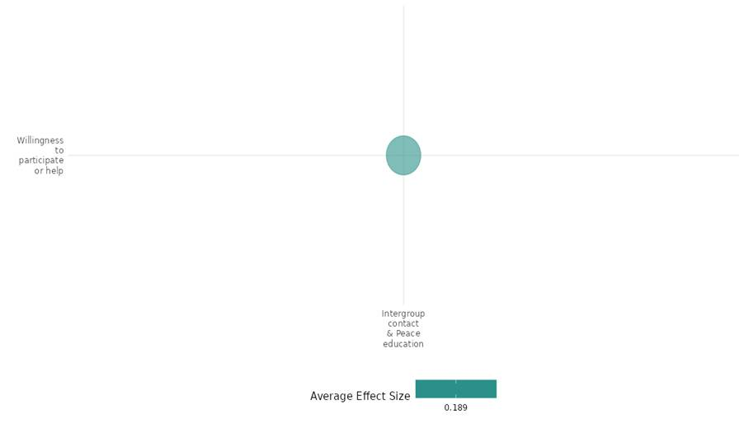

4.3.3(5)
Effect of Intergroup contact and peace education on government performance
Intergroup contact and peace education had minimal impact on government performance perceptions, with slight improvements in local safety but no change in national government trust. It boosted community participation and conflict resolution without significantly altering views on governance.
Geographical region space: Sub Saharan Africa Liberia
Effect size: Adverse effect (g=-2.029)
Confidence in the study findings: Low Confidence (1 study ;7 ES)

Short Summary
Intergroup Contact and Peace Education interventions had minimal effects on governance perceptions. Results indicate, a weak increase in community safety and civility and no significant change in trust towards the national government. We have low confidence in the cell because it has only one study in the cell.

The Intervention
The intervention across the cell promoted human rights, civic participation, and non-violent conflict resolution in 67 conflict-prone communities. Through 8-day workshops, facilitators trained 10% of residents in mediation and political education. Community Empowerment Program (CEP) improved community engagement and dispute resolution but had little impact on perceptions of government performance.

How the intervention is expected to work
These intergroup contact and peace education intervention aims to improve community dynamics by promoting civic education, conflict resolution, and increased participation. It educates individuals on human rights and democratic principles, encourages non-violent conflict resolution, and strengthens community engagement in governance. By empowering marginalized groups and forming peace committees, the program seeks to reduce violence, foster cooperation, and enhance trust in governance.

The evidence base
The cell includes one impact evaluation. One study employs randomized controlled trials (RCTs). The study is conducted in Liberia.

Evidence findings
The interventions had little impact on perceptions of local or national government performance.

The Impact evaluation evidence
Blattman (2011) evaluates Liberia’s Community Empowerment Program (CEP), an intervention aimed at improving civic education, conflict resolution, and community participation in 68 conflict-prone communities, compared to 179 control communities. Implemented by UNHCR and JPC (2009-2010), the program provided 8-day training workshops covering human rights, dispute resolution, and democratic values. Using a randomized controlled trial (RCT), researchers surveyed leaders and community members before and after the program, with follow-up periods ranging from 1 to 22 months. While the program increased community participation and non-violent conflict resolution, it had little impact on perceptions of local and national government performance, as shown in Figures 5a and 5b, where confidence in governance remained unchanged. This suggests that while civic education can shape community dynamics, trust in government may require institutional reforms beyond local-level interventions. The study is rated as low confidence quantitative study due to lack of reporting attrition.

Confidence assessment
The cell's confidence is low due to the only one study in the cell. The cell’s confidence is lbecause it has mixed results, relies on self-reported data, and shows delayed/conflicting effects, reducing confidence in its findings.

Other outcomes in this study:
- Violence and atrocity prevention/ Diplomatic relations and peaceful dispute resolution
- Community and state governance/Government performance
- Social Cohesion/ Willingness to help

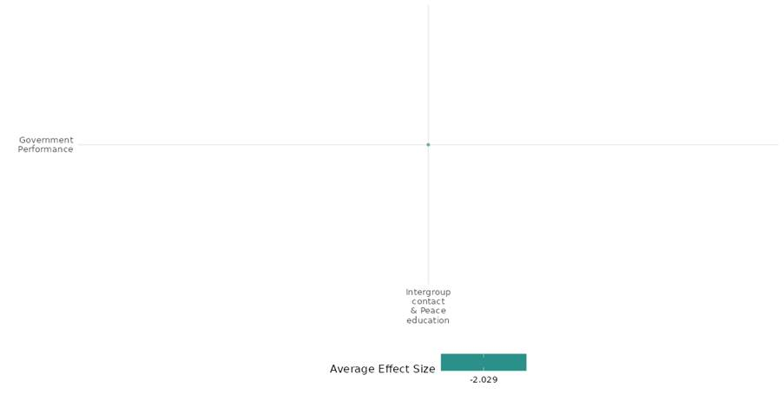

4.3.3(6)
Effect of Intergroup contact and peace education on Economic Security
Intergroup contact and peace education programs show limited impact on economic security. Evidence reveals minimal improvements in employment, business profits, or property security. While some mentorship and dispute resolution efforts had localized benefits, these gains were neither widespread nor sustained.
Geographical region space: Middle East & North Africa, Sub Saharan Africa.
Lebanon, Uganda, and Liberia
Effect size: Adverse effect (g=-0.089)
Confidence in the study findings: Low confidence (3 studies: 67 ES)

Short summary
Intergroup contact and peace education programs have minimal impact on economic security. While mentorship and dispute resolution provide localized benefits, improvements in employment, business profits, and property security are limited and not widely sustained across groups. We have low confidence in the cell due to a limited number of the studies.

The intervention
The interventions across the cell focused on intergroup contact and peace education, aiming to enhance economic security. Some programs incorporate economic components, such as business mentorship or cash grants, to strengthen employability and entrepreneurship. However, their impact on long-term economic security remains limited due to methodological challenges, contextual factors, and inconsistent treatment effects.

How the intervention is expected to work
These Intergroup contact and peace education interventions aim to enhance economic security by fostering intergroup contact and peace education through volunteering, mentorship, and dispute resolution training. By building trust, reducing prejudice, and promoting conflict resolution, it seeks to create a stable environment for economic activities. Some programs also include economic support, such as mentorship or cash grants, to improve employability and entrepreneurship. The assumption is that social stability will facilitate economic opportunities, but the extent of these benefits remains uncertain due to contextual and methodological limitations.
The evidence base
The cell includes three impact evaluations and one systematic review. The review is concerned with gender-specific and transformative interventions in fragile contexts and it improves economic security and social inclusion but have limited impact on reducing gender-based violence.
The evidence base consists of studies conducted in Lebanon, Uganda, and Liberia, using a mix of quasi-experimental and randomized controlled trial (RCT) designs to evaluate the impact of intergroup contact and peace education on economic security.

Evidence findings
The interventions had limited effects on economic security, with no significant employment or investment gains in Lebanon and only modest improvements in business profits and household well-being in Uganda. In Liberia, dispute resolution reduced violence but did not enhance property security or economic investment, making overall economic impacts inconsistent and uncertain.

The review evidence
The review finds that gender-specific and transformative interventions in fragile contexts have a positive but variable impact on mixed security, improving economic security.

The impact evaluation evidence
Alaref (2019) evaluated the impact of an inter-community volunteering program in Lebanon, consisting of 80 hours of volunteering activities and 20 hours of soft skills training, aimed at enhancing social cohesion. Using a quasi-experimental difference-in-difference (DiD) design, it tracked 759 youth (473 treatment, 286 comparison) from different regions. Results from Table 5 showed that while the intervention increased tolerance values by 0.26 standard deviations (SD) and a sense of belonging by 0.35 SD, it had no significant impact on economic security outcomes, employability, or employment, with unemployment rates dropping similarly in both treatment and control groups. The study is rated low confidence due to its little description of the intervention.
Baseler (2021) conducted in Uganda, used a randomized controlled trial (RCT) to assess the impact of cash grants, refugee aid-sharing information, and mentorship programs on 1,406 Ugandan microentrepreneurs in salons and tailoring businesses. The results showed that mentorship by a Ugandan (T5) increased business profits by 23% (p < 0.1), while mentorship by a refugee (T4) and cash grants alone (T2) had no significant profit effects. Other results revealed that marketing practices improved by 0.12 SD (p < 0.05) under the cash and information treatment, though record-keeping and inventory management effects were weaker and the mentorship by a Ugandan (T5) increased household well-being by 0.134 SD (p < 0.08) and boosted household savings, though no significant changes in total household income were observed. The study is rated as medium confidence due to attrition rate.
Hartmann (2018) evaluates the long-term impact of an Alternative Dispute Resolution (ADR) intervention in rural Liberia, implemented through a randomized controlled trial (RCT) across 246 communities in Lofa, Nimba, and Grand Gedeh counties. The intervention, conducted by UNHCR and JPC, trained approximately 12,000 individuals in mediation and conflict resolution to reduce violence and improve property security. While the study found a 28% reduction in threats, property destruction, and violence, it did not significantly improve perceived property rights or economic investment. Politically connected individuals benefited more, while poorer and less-connected residents felt less secure about their land. This study is rated as high and medium confidence quantitative study.

Confidence Assessment
The overall confidence in the cell is low due to a limited number of the studies.

Link to review summaries
Lwamba (2022)

Other outcomes in the study
- Violence and atrocity prevention / Diplomatic relations and peaceful dispute resolution / Nature and scale of violence or atrocities
- Social cohesion / Acceptance of diversity / Sense of belonging
- Human security / Educational security/Intermediate social cohesion outcomes

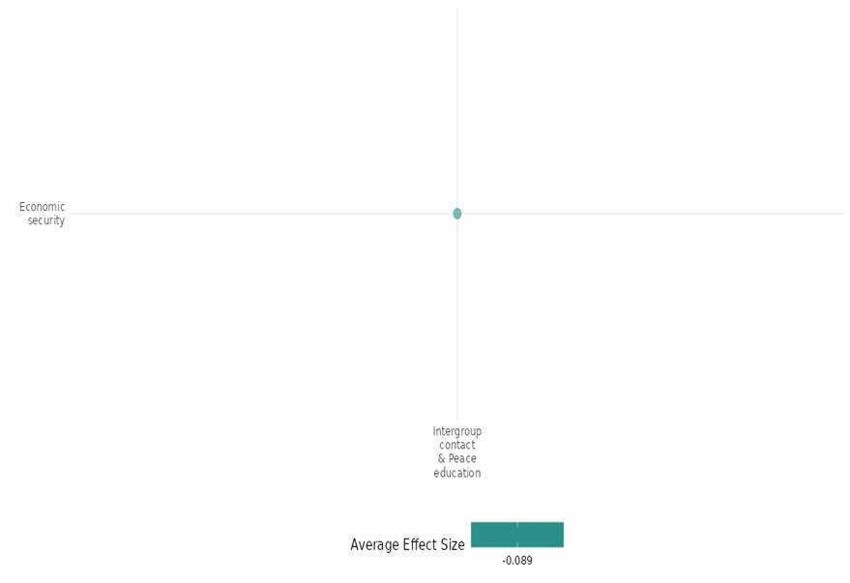

4.3.3(7)
Effect of Intergroup contact and peace education on Educational Security
Intergroup contact and peace education interventions improve educational security by enhancing communication, trust, and reducing violence, though effects on leadership and self-efficacy are mixed.
Geographical region space: Lebanon, Kyrgyzstan, Afghanistan.
Europe & Central Asia, Middle East & North Africa, South Asia, Sub Saharan Africa
Effect size: Small effect (g= 0.086)
Confidence in the study findings: Low confidence (4 studies: 13 ES)

Short summary
Intergroup contact and peace education interventions generally enhance educational security by fostering communication, confidence, trust, cooperation, and school attendance while reducing violence in educational settings. We have low confidence in the cell because of limited number of studies and half of them are low confidence.
The intervention
The interventions aimed at educational security include volunteer and soft skills training programs to enhance communication, confidence, and social cohesion; peace education programs to foster trust, cooperation, and conflict resolution; and violence prevention initiatives to reduce peer violence, corporal punishment, and family violence. These efforts collectively contribute to a safer and more inclusive educational environment, promoting resilience and stability in fragile settings.

How the intervention is expected to work
The intervention is expected to work by fostering social cohesion, skill development, and violence reduction, ultimately enhancing educational security. Volunteer and soft skills training programs encourage intergroup interactions, improving communication, confidence, and teamwork, which can lead to greater inclusivity in educational and social settings. Peace education initiatives equip students with conflict resolution and cooperation skills, fostering trust and reducing biases, thereby creating a more supportive learning environment. Violence prevention programs aim to decrease peer aggression, corporal punishment, and exposure to family violence, ensuring a safer school atmosphere that promotes consistent attendance and psychological well-being. By addressing social and behavioural factors, these interventions enhance students' ability to learn, participate, and thrive in educational settings.

The evidence base
The cell includes four impact evaluations. The evidence base consists of quasi-experimental and observational studies using Difference-in-Differences (DiD), interrupted time series, and difference-in-means tests, showing mixed effects on communication, confidence, cooperation, and violence reduction.
The studies are conducted in Lebanon, Kyrgyzstan, Afghanistan.

Evidence findings
The evidence findings on educational security show positive effects on communication, confidence, trust, and cooperation, as well as reductions in violence, bullying, and corporal punishment. However, some interventions showed mixed results, with limited improvements in leadership skills and employability, and a decline in self-efficacy in certain groups.

The impact evaluation evidence
Aladysheva (2017) The LivingSideBySide® (LSBS) programme is an eight-week peace education initiative in southern Kyrgyzstan, designed to enhance trust, cooperation, and conflict resolution among youth. Using a quasi-experimental design, the study analyzed programme impacts through difference-in-means tests across treatment and control groups. Results show that the programme increased trust in people of the same ethnicity (by 0.17, p<0.05), in other ethnicities (by 0.04, not significant), and in first-time acquaintances (by 0.32, p<0.01). Cooperation improved significantly, especially among girls (+0.23, p<0.1), while bullying decreased (-0.03, p<0.05). However, self-efficacy declined (-2.50, p<0.01), particularly among female participants, and nationalist attitudes remained unchanged​​. The study is rated high confidence.
Alaref (2019) evaluates the impact of the National Volunteer Service Program (NVSP) in Lebanon, an intervention aimed at fostering social cohesion among youth through inter-community volunteering activities and soft skills training. The quasi-experimental study design used a difference-in-differences (DiD) approach, comparing 473 treatment youth from 22 selected NGOs with 286 comparison youth from 16 non-selected NGOs. The final sample included 759 youth. The results indicate that tolerance values among selected youth improved by 0.26 standard deviations (SD) (p<0.05), while the sense of belonging to the Lebanese community increased by 0.35 SD (p<0.1) compared to non-selected youth​. However, there was no significant impact on employability, with no meaningful differences in labor market participation, wage employment, or job offers​. The study is rated low confidence due to its little description of the intervention.
Corboz (2019) evaluates the effectiveness of a school-based peace education and community social norms change intervention in reducing violence against children in Afghanistan. Conducted in 11 secondary schools across three districts in Jawzjan province, the study used an interrupted time series design with three data collection points over 12 months. The sample included 361 boys and 373 girls at the endline. Key outcomes measured included peer violence victimization and perpetration, corporal punishment at school and home, and exposure to family violence. Results from Table 3 indicate significant reductions in peer violence, with boys’ victimization decreasing from 49.7% at baseline to 25.2% at endline and girls’ from 43.3% to 21.7%. Peer violence perpetration also dropped for boys (31.7% to 13.6%) and girls (17.6% to 7.2%). Corporal punishment by teachers reduced for boys (43.7% to 27.2%) and girls (35.0% to 14.2%), while corporal punishment at home saw a sharp decline for boys (16.6% to 4.7%) and girls (20.0% to 2.7%). Observations of family violence also decreased, with fewer boys (2.3% to 0.3%) and girls (2.1% to 0.8%) witnessing their mothers being beaten. Depression scores improved for both boys (63.7 to 57.7) and girls (57.7 to 52.1). Girls' school attendance significantly improved, with missed days dropping from 2.2 to 1.4 per month, while boys’ attendance showed no significant change (2.4 to 3.0 days). Gender-equitable attitudes improved, increasing from 29.3 to 32.1 for boys and 30.8 to 34.3 for girls. The study is rated as a low confidence.
Corno (2019) evaluates the National Volunteer Service Program (NVSP) in Lebanon, which aimed to enhance youth social cohesion and soft skills through 80 hours of volunteering and 20 hours of soft skills training. Using a Difference-in-Differences (DiD) design with 759 participants, it assessed the program’s impact on educational security, particularly leadership, communication, and confidence. Leadership skills showed a slight negative impact (DiD = -0.02, p=0.11), while communication (DiD = 0.19, p=0.12) and confidence (DiD = 0.17, p=0.14) exhibited slight positive effects. Conducted with rigorous econometric methods, including OLS estimation, fixed effects, and inverse probability weighting. The study is high confidence due to its large sample size, strong follow-up rate (88%), and intent-to-treat (ITT) analysis. Its findings provide valuable insights for policymakers on fostering youth employability and resilience in fragile settings. The study is rated as a high-confidence quantitative study due to the combination of the randomized design, large sample size, detailed methodology, rigorous data analysis, and consistent findings.
Confidence Assessment
We have low confidence in the cell because of limited number of studies and half of them are low confidence.

Other outcomes in the study
- Violence and atrocity prevention / Nature and scale of violence or atrocities/ Social norms regarding violence and atrocities
- Social cohesion / Feelings of trust/ Acceptance of diversity/ Sense of belonging/ Willingness to participate or help/ Intermediate social cohesion outcomes
- Human security/Intermediate social cohesion outcomes/Physical security/Health security/ Economic security

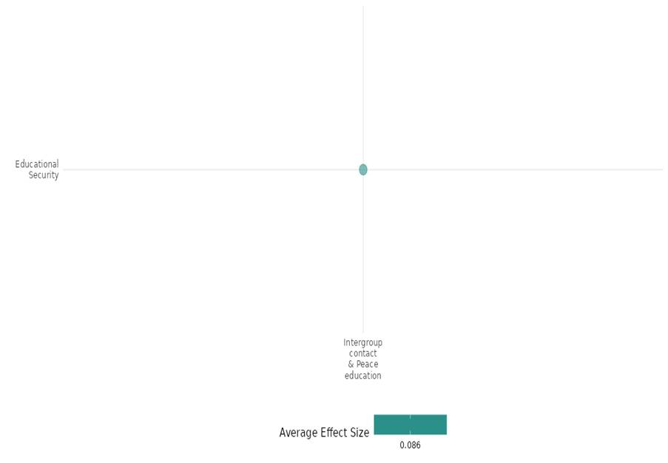

4.3.4 Media and communication
4.3.4(1)
Effect of Media & Communication on Nature & scale of atrocity prevention
Defection messaging through FM radio broadcasts led to a slight reduction in conflict-related fatalities and violence against civilians.
Geographical region: Sub-Saharan Africa
Effect: Small effect (g=0.014)
Confidence in study findings: Low ( one study with 6 effect sizes)

Short summary
The impact of FM radio broadcasts on reducing violence during the Lord’s Resistance Army (LRA) insurgency used The broadcasts encouraged LRA defections through logistical guidance, family messages, and reintegration assurances. Analyzing data from 21 radio antennas and 60,600 grid cells, the study found that increasing messaging by 19 minutes daily reduced LRA-related fatalities by 2.7% and civilian violence by 1%, while boosting defections by 1%. However, it had limited reintegration effectiveness and led to a 1.6% increase in looting. Overall, radio messaging helped reduce conflict but had unintended consequences.

The Intervention
The intervention involves using FM radio broadcasts to encourage defections from the Lord’s Resistance Army (LRA) during the insurgency. These broadcasts include logistical instructions for surrender, assurances of reintegration, and personal messages from families and reassurances of safe reintegration into society.

How the intervention is expected to work
The intervention is expected to work by using persuasive communication to influence combatants’ behavior through two mechanisms. First, the belief-based model assumes combatants rationally update their beliefs based on new information, such as assurances of safety and reintegration. Second, the preference-based model suggests that messages can shift underlying preferences by appealing to emotional ties or the inherent value of returning to civilian life. Both mechanisms aim to reduce perceived barriers to defection.

The evidence base
The cell includes two studies, one systematic review & one primary study. The primary study was conducted in regions affected by the LRA insurgency, spanning Uganda, the Democratic Republic of Congo (DRC), South Sudan, and the Central African Republic (CAR). These areas are characterized by remote locations where radio was an effective medium for communication.

Evidence Findings
Media & communication using FM radio broadcasts reduced violence during the Lord’s Resistance Army (LRA) insurgency.

The review evidence
The review underscores the role of media and communication in influencing policy debates on conflict prevention and the need for stronger evidence in this area. It also examines the nature and scale of violence, finding limited high-quality studies on effective interventions, with some efforts unintentionally worsening conflicts rather than mitigating them.

Included studies
The cell consisted of one low confidence IE. the detailed summary thus provided here
Armand Alex et al. (2020) evaluated how FM radio broadcasts influenced the reduction of violent conflict during the Lord’s Resistance Army (LRA) insurgency. The broadcasts aimed to encourage LRA fighters to leave the group by providing practical instructions, messages from families, and reassurances of safe reintegration into society. The study used data from 21 radio antennas covering LRA-affected regions, along with conflict information from databases like the LRA Crisis Tracker. It analyzed data from 60,600 grid cells, focusing on conflict intensity, radio messaging coverage, and outcomes.
The study found that an increase of 1 standard deviation in messaging intensity leads to a 2.7% reduction in LRA-related fatalities, corresponding to 19 minutes of daily messaging in areas with full radio coverage. Higher intensity defection messaging significantly increases the number of returnees, with a 1 standard deviation increase resulting in a 1% rise in returnees. This suggests defection messaging effectively encourages LRA members to reintegrate into civil society. Regarding abductions, the study found no significant evidence that defection messaging increased LRA abductions, although a slight reduction was observed. Additionally, defection messaging was associated with a 1% decrease in violence against civilians and clashes with security forces, suggesting a potential mechanism for reducing fatalities through fewer attacks. However, no evidence was found that the LRA increased the severity of attacks. One notable downside was a 1.6% increase in looting events linked to higher-intensity defection messaging. While defection messaging generally helped reduce conflict, it may have unintentionally led to more looting. The study is rated as a high confidence quantitative study.
Confidence assessment
Overall, the cell reflects low confidence due to the limited number of studies and the low confidence rating of the included study.

Link to review summaries
Cramer Christopher (2016) (Systematic review).
Studies may be accessed via the EGM.
Other outcomes in this study
None

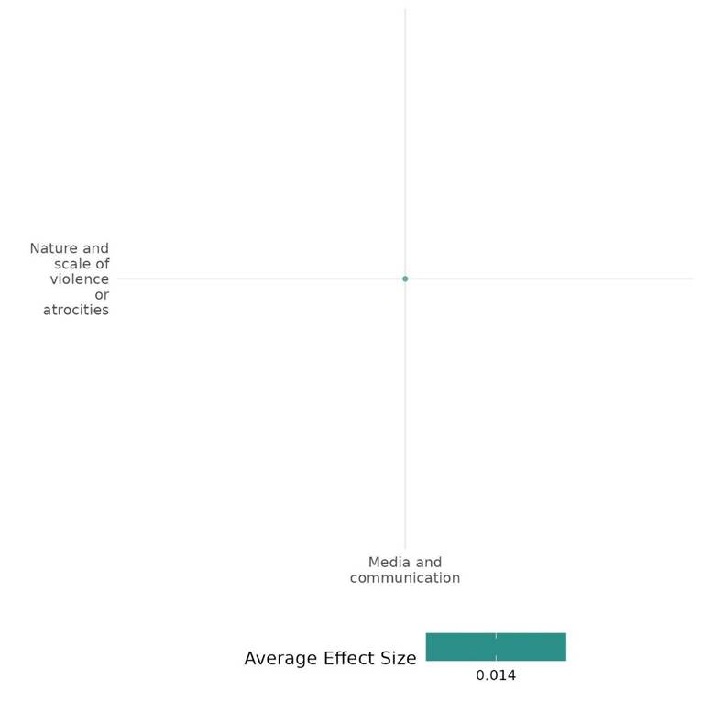

4.3.4(2)
Effect of Media & communication on social norms of violence or atrocity prevention
Media interventions had mixed success in shifting norms on violence. While some fostered tolerance and reduced in-group superiority, deeper beliefs persisted. Long-term programs like PDEV II proved more effective in promoting peace.
Geographical region: Sub-saharan Africa, Latin America & Caribbean, Middle east & North africa
Effect: Small effect (g=0.014)
Confidence in study findings: Medium (9 studies with 54 effect size)

Short summary
Media-based interventions have been widely used to influence social norms related to violence and atrocity, with varying levels of effectiveness. Radio dramas, video content, sermons, and social media campaigns have been deployed to counter extremist narratives, promote reconciliation, and shift conflict-related attitudes. While some interventions successfully reduced in-group superiority, increased intergroup tolerance, and strengthened opposition to violence, others had limited or no impact on deeper ideological beliefs. Radio programs promoting peace and reconciliation in Burundi, Burkina Faso, and Rwanda showed mixed effects—some reducing biases and fostering dialogue, while others failed to shift perceptions of victimhood or bystander responsibility. Religious messaging and short media clips in Burkina Faso and Colombia had minimal long-term effects due to pre-existing low support for violence. Social media campaigns in Colombia briefly increased positive engagement but did not alter entrenched attitudes. However, large-scale, long-term interventions like PDEV II demonstrated measurable success in reducing justification for religious violence and normalizing peace-oriented social norms

The Interventions
Media and communication interventions utilized diverse formats, including radio dramas, video narratives, religious sermons, social media campaigns, and paradoxical messaging. Radio programs combined storytelling with facilitated discussions, while large-scale initiatives integrated broadcasts with community engagement and vocational training. Video-based interventions featured real-life narratives, and religious sermons were delivered via recorded messages. Social media campaigns used targeted messaging, and paradoxical thinking interventions employed multimedia content to challenge entrenched beliefs.

How the intervention is expected to work
The media and communication expected to shape social norms by influencing perceptions, fostering dialogue, and reinforcing alternative narratives to violence. Radio dramas and video narratives use emotional engagement and identification with characters to encourage perspective-taking and social cohesion. Social media and religious messaging leverage moral and ideological framing to align with audience values and promote tolerance. Large-scale programs integrate media with community activities to enhance civic participation and trust-building. Cognitive-based approaches, such as paradoxical thinking, challenge deeply held beliefs through exaggerated narratives, prompting critical reflection and attitude shifts.

The Evidence base
The cell comprises 11 studies, including one low-confidence systematic review (SR) and 10 impact evaluations (IEs). Of the 10 IEs, one was excluded from the cumulative effect size calculation due to insufficient data. The included IEs were conducted in conflict-prone regions across West Africa (Burkina Faso, Mali, Chad, Niger), East Africa (Burundi, Rwanda), Latin America (Colombia), and the Middle East (Israel).

Evidence findings
Media interventions had mixed effectiveness; some reduced biases and promoted tolerance, while others failed to shift deep-seated beliefs, especially the progrram which were short-term.

The review evidence
The review assessed media-based interventions, including radio dramas, media campaigns, intergroup dialogues, contact programs, conflict resolution training, and self-reflection activities, across 19 studies in Sub-Saharan Africa, the Middle East, South Asia, and Latin America. Findings showed mixed effectiveness—some interventions successfully reduced in-group superiority, social distance, and stereotypes, while others had limited impact on deeply rooted beliefs.

Included studies
there are 9 IEs with varied quality of confidence included under the cell. The details summary thus provided as below;

Aldrich (2014) study focuses on USAID's Trans-Sahara Counter-Terrorism Partnership (TSCTP), including programs like Peace through Development (PDEV) and PDEV II, aimed at countering violent extremism by addressing its root causes. Objectives include reducing extremist recruitment, fostering peace and civic engagement, and building community resilience. Key activities include teacher training, curriculum support, peace and tolerance radio broadcasts, workshops for civic engagement, rural job creation, micro-grants for local NGOs, and youth empowerment initiatives. By promoting norm change, civic participation, economic stability, strengthened social networks, and institutional capacity building, the intervention seeks to provide alternatives to extremist narratives and foster long-term resilience. Research conducted in Timbuktu and Dire, two adjacent cities in northern Mali, involved 200 respondents evenly split between the treatment groups. The results indicated that the intervention had no significant impact on more abstract or ideological beliefs regarding U.S. actions or the justification of violent extremism. Study is rated as Low confidence study.

Bilali et al. (2015) evaluated a media-based reconciliation program implemented in Burundi through a radio drama titled Murikira Ukuri (Shedding Light on the Truth). The program used an entertainment-education approach, embedding educational messages within an engaging fictional narrative. Its objectives included raising awareness of the causes and progression of mass violence, promoting reconciliation by encouraging active bystandership and reducing passivity in the face of violence, challenging in-group superiority, and fostering inclusive victimhood and intergroup trust. The program also provided role models for behaviors such as speaking out against violence and empathizing with out-group members. The radio drama portrayed a fictional conflict between two ethnic groups, enabling listeners to engage with complex power dynamics and grievances while promoting positive intergroup norms. The study used a quasi-experimental design with propensity score matching to estimate the intervention's causal effects. The final sample included 1,074 participants—714 listeners and 360 non-listeners—from 12 communities across five provinces in Burundi, chosen for their ethnic diversity and varying exposure to conflict-related violence.The study employed a quasi-experimental design with propensity score matching to estimate the causal effects of the intervention, as random assignment was not possible. The final sample included 1,074 participants—714 listeners and 360 non-listeners—recruited from 12 communities across five provinces in Burundi, selected for their diverse ethnic compositions and varying levels of exposure to conflict-related violence.

The findings revealed no significant differences between listeners and non-listeners regarding inclusive victimhood or historical perspective-taking. However, listeners were less likely to view their in-group as superior and were less inclined to blame the out-group. They also showed a greater tendency to recognize their in-group's responsibility for the country's problems. Additionally, listeners were more likely to act as active bystanders when witnessing derogatory treatment of an out-group member. However, they displayed a lower awareness of the role that passive bystanders play in escalating violence. The study is rated as a medium-high confidence study.

Bilali et al. 2019 evaluated the Voices for Peace project, featuring the radio drama Wuro Potal, designed to counter violent extremism in Burkina Faso's Sahel region. The intervention aimed to reduce vulnerability to extremism by raising awareness, promoting dialogue, fostering social cohesion, and encouraging collaboration with security forces. Activities included weekly listening sessions in 66 treatment villages over 12 weeks, where participants engaged in 52 episodes addressing issues such as corruption, governance, and police-community relations. Training personnel facilitated group discussions and encouraged reflection on key themes and collective learning. Conducted in Seno Province—the study surveyed 2,904 core participants from 132 villages (66 treatment, 66 control) at baseline and endline, partially including 2,112 network participants. The radio drama intervention resulted in mixed results in influencing attitudes and priorities related to violent extremism. While the justification for extremist violence was already low, the intervention led to a further slight reduction (3.7% lower than the control group average, or about 0.1 standard deviation). Participants exposed to the intervention were more likely to identify governance (5% increase) and insecurity/violent extremism (2.5% increase) as government priorities. For attendees of one or more sessions, these effects were amplified (23% and 15%, respectively). However, the intervention did not alter beliefs about the causes or motivations of violent extremism, nor did it affect perceptions of support for violent extremism across groups or discussion items. The overall impact on shifting underlying beliefs and stimulating dialogue about violent extremism was limited. Overall, the study presents high-medium confidence.

Bruneau (2022) evaluated a 5.5-minute media video intervention designed to address psychological barriers to peace in Colombia. Created in collaboration with Colombian filmmakers, the video featured interviews with ex-FARC combatants and non-FARC Colombians. It focused on reducing negative beliefs about the willingness and ability of FARC members to reintegrate into society. The intervention highlighted successful coexistence initiatives, such as mixed sports teams and community events in demobilization camps, to demonstrate FARC members' capacity for positive change. The primary objective was to promote peace and reintegration by challenging the belief that FARC members are unwilling and incapable of change. This objective was guided by a theory of change rooted in cognitive belief modification rather than affective pathways, such as empathy, to reduce psychological barriers to reconciliation.The study revealed that the intervention significantly increased support for peace and reintegration policies while reducing beliefs about FARC members' unwillingness and inability to change. The study is rated as a low confidence study.

Grossman (2022): The “Pro-Peace Messaging through Religious Sermons” intervention involved exposing adolescents to audio excerpts of a sermon delivered by a prominent Burkinabé imam, Alidou Ilboudo. The sermon emphasized Islamic teachings promoting peace, tolerance, and non-violence while invoking a shared national identity among Burkinabé citizens. The intervention was implemented as part of a randomized survey experiment in 12 schools across rural and peri-urban regions of Burkina Faso, targeting students aged 12 to 18. Enumerators played the sermon recordings to participants individually, ensuring comprehension by allowing clarifying questions or repeated playback if needed. The aim was to test whether such messaging could enhance intergroup tolerance, reduce support for violent extremism, and increase civic participation among at-risk youth in a region affected by Islamist extremist insurgencies.The study documented no clear effect of pro-peace messaging on attitudes toward extremism, with no variation by ethnicity. High concern about extremism (90%) and low justification for violence (3%) suggest floor and ceiling effects, potentially limiting observable changes. Overall, the study is high-medium quality, with rigorous design offset by practical limitations and mixed results.

Gallego (2019) evaluated how social media bots influence political discourse using a randomized experiment on 4,500 Colombian Twitter users before the 2016 Peace Plebiscite. The intervention involved automated Twitter accounts posing as a general, a scientist, and a priest, sending messages promoting the peace agreement with FARC. These messages were framed using conservative values (patriotism, authority, sanctity) and liberal values (harm, fairness, reciprocity) to assess whether different messengers and message framings influenced engagement and political expression. The intervention was grounded in Moral Reframing Theory and Political Deliberation Theory, the intervention tested whether messages aligned with users’ ideological values would increase engagement and discussion. The intervention had no statistically significant effect on mean sentiment over time (p > 0.05), with only a short-lived positive effect observed on the first day post-treatment. While the intervention significantly increased positive tweets about the peace process in the first week (p < 0.01), this effect was weaker among conservative users. Pre-treatment sentiment played a key role—users with prior negative tweets Overall, while the treatment amplified existing support, it failed to change underlying attitudes in the long term. The study is rated as low confidence due to the limited generalizability of the results to the broader population.

Finkel (2018) evaluates The Peace through Development II (PDEV II) program, implemented from 2011 to 2016, aimed to enhance resilience to violent extremism (VE) in at-risk communities across Burkina Faso, Chad, and Niger. It focused on four strategic objectives (SOs): empowering youth, amplifying moderate voices, strengthening civil society, and improving local governance. The program combined community activities with media efforts, notably radio, to reach wider audiences. Under SO1, "Youth Empowered," PDEV II offered vocational training, leadership programs, and literacy support. SO2, "Moderate Voices Increased," focused on media capacity-building, public campaigns, and interfaith dialogues. SO3, "Civil Society Capacity Increased," aimed to strengthen civil society organizations through training and the formation of Community Action Committees (CACs). SO4, "Local Government Strengthened," improved the skills of local officials in public administration and governance.
The program targeted 83 zones, with core zones receiving full interventions, non-core zones focusing on radio, and no-activity zones having limited engagement. It used high and low-intensity zones to prioritize resources and activities for deeper community engagement.
The evaluation of the PDEV II radio component demonstrated a positive impact on social norms concerning violence and atrocity prevention. Notably, it helped moderate the rise in support for violence justified by Islam and significantly reduced the justification for religious violence as well as the belief in violence as an effective solution. Overall, the program played a meaningful role in shifting norms and attitudes away from endorsing violence. Overall, the study was of medium to high quality, with a strong, multidimensional approach and focused on long-term sustainability.

Hameiri (2016) evaluated the Paradoxical Thinking Intervention, a psychological approach designed to reduce conflict-supporting attitudes by presenting exaggerated versions of widely held beliefs, leading individuals to reconsider their positions. The intervention was implemented through a multichannel campaign called “The Conflict”, which targeted a right-wing, religious city in central Israel (~25,000 residents) during the Knife Intifada. Over six weeks, residents were exposed to online banners, YouTube ads, billboard posters, and distributed materials (t-shirts, balloons, brochures). The intervention amplified societal beliefs to an extreme, creating cognitive dissonance that encouraged reevaluation of views and reduced support for violence. A randomized field experiment (pre-post design) with 215 intervention and 320 control participants tested its impact on conflict-supporting attitudes, aggressive policies, and conciliatory measures.The paradoxical thinking intervention reduced conflict-supporting attitudes, especially among right-wing participants, leading to less support for aggression and more for conciliation. However, centrists showed unexpected lower support for conciliation, possibly due to a literal interpretation of the messages. The study is rated as high-medium confidence with strong rigorous methodology,

Paluck (2009) – evaluated Musekeweya ("New Dawn"), a radio soap opera designed to promote reconciliation, trust, and empathy while discouraging prejudice and violence in post-genocide Rwanda. Through fictional narratives about two Rwandan communities, it conveyed educational messages on intergroup cooperation, trauma healing, and rejecting violent norms. The study hypothesized that exposure to the program would shift personal beliefs, alter perceptions of social norms, and encourage behaviors like dissent, cooperation, and reconciliation, with emotional engagement and group discussion amplifying its impact. Participants were drawn from general population, genocide survivor, and Twa communities across four regions. Communities were stratified by demographics, matched into pairs, and randomly assigned to the reconciliation or control program. From each community, 40 adults were randomly selected, ensuring gender, age, and family balance.Study findings documented that the reconciliation program did not significantly impact beliefs about violence. Both groups strongly agreed that violence builds gradually but showed only moderate agreement on violence erupting suddenly, with no measurable differences between them. Additionally, the program had no effect on perceptions of bystander responsibility for violence. Overall, the study presents Low confidence.
Bowers 2017 examined the impact of the Arewa24 television channel in Nigeria, particularly its flagship soap opera Dadin Kowa, which aimed to shift attitudes toward violence, intergroup tolerance, and gender norms. The intervention was based on social learning theory, which posits that observational learning through media can influence attitudes and behaviors. The study used an encouragement design where subjects in northwestern Nigeria were randomly encouraged to watch Arewa24, while placebo and control groups watched other channels or no specific programs. The study employed a pre-post survey design, surveying 60 neighborhoods at the onset of Arewa24’s programming and again after two years. Sampling involved randomized assignment within gender-defined blocks, with respondents completing weekly interactive voice response (IVR) surveys over 25 weeks.
Findings on social norms regarding violence prevention revealed mixed outcomes. Although the intervention sought to reduce support for violence, its effectiveness was inconsistent. Viewers in 2015 were not significantly less supportive of violence than non-viewers, suggesting limited impact in changing violent norms. In some matched comparisons, Arewa24 viewers even exhibited higher support for violence, possibly due to pre-existing attitudes among those who chose to watch the channel. Additionally, while Arewa24 included anti-violence messaging, its overall influence was diluted by broader media exposure and external socio-political changes. The findings highlight the challenges of using media alone to reshape deeply entrenched social norms regarding violence in conflict-affected regions. the study is rated as low confidence.
Confidence assessment
The overall cell is rated as Medium Confidence, acknowledging the large number of included studies, but inconsistencies in individual effect sizes and variability in intervention effectiveness limit its reliability.

Link to review summaries
Ditlmann Ruth K (2017).
The study may be accessed via EGM.

Other outcomes studied:
Social cohesion/Feelings of trust & acceptance of diversity
Social cohesion/Willingness to participate/help
Human security/Intermediate social cohesion outcomes
Human security/Economic security
Human security/Political security
Community & state governance/Civic participation
Community & state governance/Government performance

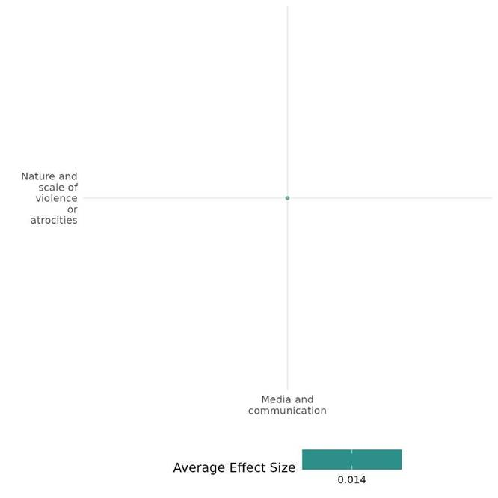

4.3.4(3)
Effect of Media & Communication on Feelings of trust & Acceptance of diversity
Radio dramas and video storytelling foster reconciliation in conflict zones. While some initiatives build trust, others may unintentionally deepen divisions.
Geographical region: Sub-Saharan Africa
Effect: small effect (g = 0.015)
Confidence assessment: Low (9 studies with 49 effect size)

Short Summary
Media and communication strategies, primarily radio dramas and video content, foster reconciliation, trust, and peacebuilding in conflict-affected regions. These interventions leveraged entertainment education, role modelling, and cognitive belief modification to challenge prejudices, promote intergroup cooperation, and reshape social norms. Most studies employed experimental, quasi-experimental, or mixed-methods designs, incorporating randomized controlled trials, propensity score matching, and focus group discussions. Sample sizes varied, ranging from a few hundred to over 1,500 participants. Findings were mixed—some interventions successfully increased intergroup trust reduced social distance, and encouraged inclusive victimhood (e.g., Bilali et al. 2015; Bruneau 2022), while others had unintended consequences, such as reinforcing ethnic divisions or reducing openness to intergroup cooperation (e.g., Bilali et al. 2017; Grossman 2022). Radio-based interventions in Rwanda and the DRC showed promising results in shifting ethnic identity perceptions and reducing exclusive victimhood.

The Intervention
Media and communication interventions, such as radio dramas, video-based storytelling, religious messaging, and community engagement programs, foster reconciliation, social cohesion, and conflict resolution. Activities conducted under these interventions include fictional storytelling in radio dramas that embed messages of peace, trauma recovery, and intergroup cooperation, promoting role models who encourage bystander intervention and conflict resolution.

How the intervention is expected to work
The interventions aim to reshape attitudes, foster social cohesion, and drive behavioral change through psychological and social mechanisms. Entertainment-education uses engaging narratives to model positive norms, encouraging trust-building, cooperation, and inclusive victimhood. Religious and government messaging shifts identity perceptions to promote unity, while civic engagement initiatives empower communities and counter extremist ideologies.

The Evidence base
The cell includes 15 studies—5 systematic reviews (SRs) and 10 impact evaluations (IEs)/primary studies.

Among the 10 included IEs, one was not considered for cumulative effect size due to insufficient data. The primary studies used quasi-experimental, mixed-methods, RCTs, natural experiments (e.g., radio signal variation), and experimental priming to assess shifts in attitudes and behaviours in post-conflict and violence-affected regions like Burundi, Eastern DRC, Rwanda, Colombia, Burkina Faso, Chad, and Niger.

The SRs varied in confidence, with three rated high-medium and two low. Studies covered L&MICs and fragile contexts across Sub-Saharan Africa, the Middle East, Latin America, Europe, and North America, including Burkina Faso, Mali, Chad, Niger, Burundi, Rwanda, Colombia, and Israel.

Evidence findings
Media and communication interventions, such as radio dramas and video storytelling, have shown mixed results—while some successfully enhanced intergroup trust and reduced social distance, others unintentionally reinforced ethnic divisions or weakened cooperation.

The review Evidence
The systematic reviews examined various interventions aimed at fostering trust and acceptance of diversity in fragile and conflict-affected settings, including citizen engagement, counter-narratives, media campaigns, peace education, and intergroup contact. Studies covered L&MICs, Sub-Saharan Africa, the Middle East, Latin America, and North America, using experimental and quasi-experimental designs. Findings were mixed—some interventions increased trust and willingness to help, while others had limited or inconsistent effects, especially in reducing symbolic threats. Prejudice reduction was more effective in structured settings and younger populations, but overall success varied by context, target groups, and implementation strategies.

Included studies
The cell includes 11 primary or impact evaluation studies with low to high quality of confidence, where two were not considered for cumulative effect size. The detailed summary thus of all included studies are provided below;

Bilali et al. (2015) evaluated a media-based reconciliation program implemented in Burundi through a radio drama titled Murikira Ukuri (Shedding Light on the Truth). The program used an entertainment-education approach, embedding educational messages within an engaging fictional narrative. Its objectives included raising awareness of the causes and progression of mass violence, promoting reconciliation by encouraging active bystandership and reducing passivity in the face of violence, challenging in-group superiority, and fostering inclusive victimhood and intergroup trust. The program also provided role models for behaviors such as speaking out against violence and empathizing with out-group members. The radio drama portrayed a fictional conflict between two ethnic groups, enabling listeners to engage with complex power dynamics and grievances while promoting positive intergroup norms. The study used a quasi-experimental design with propensity score matching to estimate the intervention's causal effects. The final sample included 1,074 participants—714 listeners and 360 non-listeners—from 12 communities across five provinces in Burundi, chosen for their ethnic diversity and varying exposure to conflict-related violence. The findings revealed that compared with non-listeners, listeners reported more out-group trust, less social distance, and endorsed norms about trauma disclosure. The study is rated as a high-medium confidence study.

Bilali (2015) evaluates the intervention involved in a radio drama, Kumbuka Kesho, broadcast in Eastern DRC to promote peaceful intergroup relations amidst ongoing violence, it used fictional narratives grounded in social psychology theories to model reconciliation and trauma recovery behaviors. The objective was to test if media-based interventions effective in post-conflict settings (e.g., Rwanda, Burundi) could foster inclusive victim consciousness, reduce social distance, and mitigate conflict-enhancing attitudes in an ongoing conflict context. A mixed-methods study included an experimental priming paradigm with 1,522 participants and focus group interviews with 51 listeners. The intervention showed that listening to the radio drama significantly reduced exclusive victimhood (p = 0.008), indicating a shift away from the belief that only one’s own group has suffered. Inclusive victimhood increased among listeners (p = 0.03), with priming further amplifying this effect. Social distance decreased among listeners, suggesting greater openness to intergroup relationships, but the effect was significant only in the priming condition. The study is rated as low confidence.

Bilali et al. (2017) evaluated a media-based program using the radio drama Kumbuka Kesho ("Remember Tomorrow") in the Eastern Democratic Republic of Congo (DRC). Rooted in social cognitive theory, it aimed to promote positive social change and intergroup relations in a conflict-affected context. The program used role modeling to portray inclusive collective actions, such as protests, micro-loan programs, and intergroup collaboration, to address grievances like corruption, poverty, child labor, and injustice. The control show discussed these grievances without proposing any actions.
The role-modeling show unexpectedly reduced tolerance and openness to intergroup cooperation. Participants were more likely to believe that discussions among different ethnic and political groups worsened issues and less likely to support the expression of diverse opinions compared to the control group. In contrast, tolerance significantly increased in the control show compared to the no-show condition, though there was no difference between groups regarding openness to intergroup cooperation. The study is rated as high quality due to its robust group-randomized experimental design, the inclusion of control and treatment groups, and rigorous analysis methods.

Bruneau (2022) evaluated a 5.5-minute media video intervention designed to address psychological barriers to peace in Colombia. Created in collaboration with Colombian filmmakers, the video featured interviews with ex-FARC combatants and non-FARC Colombians. It focused on reducing negative beliefs about the willingness and ability of FARC members to reintegrate into society. The intervention highlighted successful coexistence initiatives, such as mixed sports teams and community events in demobilization camps, to demonstrate FARC members' capacity for positive change. The primary objective was to promote peace and reintegration by challenging the belief that FARC members are unwilling and incapable of change. This objective was guided by a theory of change rooted in cognitive belief modification rather than affective pathways, such as empathy, to reduce psychological barriers to reconciliation. The study revealed that the intervention consistently increased empathy towards FARC members across studies and over time. Its effects on reducing prejudice were significant initially but not sustained or replicated in subsequent analyses. The study is rated as High confidence in the consistency of findings.

Blouin (2019) – examines the impact of government-run radio propaganda on inter-ethnic attitudes in post-genocide Rwanda, focusing on Radio Rwanda, a state-controlled broadcaster promoting national unity while de-emphasizing ethnic identity. Using natural variations in radio reception caused by Rwanda’s mountainous terrain, the research assesses whether exposure to propaganda reduces ethnic salience and strengthens inter-ethnic trust. The study hypothesizes that media exposure reshapes identity perceptions, fostering trust and cooperation across ethnic lines. The study, conducted in 52 rural villages with 438 farmers (plus a follow-up survey of 154 participants), used random selection from local political representative lists. Findings reveal that Radio Rwanda reduced ethnic salience by 10-13 percentage points (p < 0.05) and boosted inter-ethnic cooperation by 15.6 percentage points (p < 0.01). In the private trust game, inter-ethnic trust offers were 47% higher (p < 0.01) in radio reception areas. Additionally, public trust offers were 25% higher than private trust offers in non-radio areas, indicating that propaganda aligns private and public behavior. The results strongly suggest that state-controlled media can reshape ethnic attitudes and promote national unity. The study is rated as low confidence study.

Finkel (2018) evaluates The Peace through Development II (PDEV II) program, implemented from 2011 to 2016, aimed to enhance resilience to violent extremism (VE) in at-risk communities across Burkina Faso, Chad, and Niger. It focused on four strategic objectives (SOs): empowering youth, amplifying moderate voices, strengthening civil society, and improving local governance. The program combined community activities with media efforts, notably radio, to reach wider audiences. Under SO1, "Youth Empowered," PDEV II offered vocational training, leadership programs, and literacy support. SO2, "Moderate Voices Increased," focused on media capacity-building, public campaigns, and interfaith dialogues. SO3, "Civil Society Capacity Increased," aimed to strengthen civil society organizations through training and the formation of Community Action Committees (CACs). SO4, "Local Government Strengthened," improved the skills of local officials in public administration and governance. The program targeted 83 zones, with core zones receiving full interventions, non-core zones focusing on radio, and no-activity zones having limited engagement. It used high and low-intensity zones to prioritize resources and activities for deeper community engagement. The evaluation of the PDEV II radio component revealed significant differences between the "Radio" and "Non-radio" groups in various dimensions of trust and perceptions. The "Non-radio" group experienced a decline in interpersonal trust of about -0.15, while the "Radio" group maintained stable levels near 0, suggesting that radio exposure helps preserve trust. A similar trend was seen in institutional trust, with the "Non-radio" group declining by around -0.10 compared to a minimal decline in the "Radio" group. Regarding interethnic marriage, the "Non-radio" group showed a small positive change (0.05), whereas the "Radio" group demonstrated a larger improvement (0.2), indicating radio's potential to foster positive attitudes. Both groups reported decreases in perceived ethnic and religious differences, with the "Non-radio" group experiencing slightly greater declines (-0.2) than the "Radio" group (-0.15). In summary, these findings suggest that radio exposure positively influences trust and interethnic attitudes while also slightly reducing perceived ethnic and religious differences. Overall, the study was of medium to high quality, with a strong, multidimensional approach focused on long-term sustainability.

Grossman (2022): The “Pro-Peace Messaging through Religious Sermons” intervention involved exposing adolescents to audio excerpts of a sermon delivered by a prominent Burkinabé imam, Alidou Ilboudo. The sermon emphasized Islamic teachings promoting peace, tolerance, and non-violence while invoking a shared national identity among Burkinabé citizens. The intervention was implemented as part of a randomized survey experiment in 12 schools across rural and peri-urban regions of Burkina Faso, targeting students aged 12 to 18. Enumerators played the sermon recordings to participants individually, ensuring comprehension by allowing clarifying questions or repeated playback if needed. The aim was to test whether such messaging could enhance intergroup tolerance, reduce support for violent extremism, and increase civic participation among at-risk youth in a region affected by Islamist extremist insurgencies.
The study found no significant impact of the pro-peace message on trust or attitudes toward religious out-groups, with treatment effects being modest and statistically indistinguishable from zero. However, the imam’s speech reduced tolerance for other ethnic groups as neighbors by 0.037 and trust in other ethnic groups by 0.065. These findings suggest that the treatment influenced attitudes, but in unexpected ways, likely due to the salience of ethnic divisions in response to religious extremism in Burkina Faso. The study is rated as a medium – high-quality confidence.

Paluck (2009) evaluated Musekeweya ("New Dawn"), a radio soap opera designed to promote reconciliation, trust, and empathy while discouraging prejudice and violence in post-genocide Rwanda. Through fictional narratives about two Rwandan communities, it conveyed educational messages on intergroup cooperation, trauma healing, and rejecting violent norms. The study hypothesized that exposure to the program would shift personal beliefs, alter perceptions of social norms, and encourage behaviors like dissent, cooperation, and reconciliation, with emotional engagement and group discussion amplifying its impact. Participants were drawn from general population, genocide survivor, and Twa communities across four regions. Communities were stratified by demographics, matched into pairs, and randomly assigned to the reconciliation or control program. From each community, 40 adults were randomly selected, ensuring gender, age, and family balance.
Study findings documented that Reconciliation listeners were significantly more likely to agree that trusting others is not naive (p = 0.04). Additionally, the belief that intermarriage should be allowed within families showed a significant positive effect (p = 0.01), reflecting progress toward promoting reconciliation and reducing prejudice. However, there was no statistically significant difference between the reconciliation and health groups regarding perceptions of mistrust (p = 0.52). Overall, the study presents Low confidence.

Paluck (2010) examined the impact of a weekly radio talk show in eastern DRC designed to promote tolerance, outgroup engagement, and perspective-taking. The study had three key objectives: assessing mass media's ability to spark interpersonal discussion about community conflict, testing its effects on intergroup contact and perspective-taking in unsupervised conflict settings, and presenting an experimental approach to studying discussion-based interventions. The underlying mechanism of the intervention was that media-driven discussions, through fostering social norms and shared cognition, could shape behaviors by encouraging listeners to engage with a variety of perspectives and understand outgroup members.
Data from 842 participants representing diverse ethnic and linguistic groups revealed no differences in perspective-taking between talk show and baseline listeners. While the show did not affect general outgroup tolerance, it was associated with reduced tolerance for disliked groups. Talk show listeners were more likely to oppose disliked groups joining community associations and believed peace would be impossible if these groups remained in DRC. These effects were stronger among individuals who actively discussed the program. Overall, the study demonstrated medium confidence.

Bowers et al. (2017) assessed the Arewa24 intervention in Northern Nigeria, a Hausa-language television channel aimed at reducing support for violence, increasing tolerance, and promoting gender equality. The study employed a matched observational design, comparing 2013 (pre-launch) and 2015 (post-launch) survey data, alongside an experimental encouragement design. Data was collected from 17,196 respondents across 1,642 neighborhoods. Findings were unexpected, as viewers showed increased support for violence and less progressive gender attitudes, though some improvements in intergroup tolerance were observed​. The study is rated as low -confidence.

Cole et al. (2003) assessed the Rechov Sumsum/Shara’a Simsim intervention in Israel, the West Bank, and Gaza, a bilingual Sesame Street adaptation designed to promote respect and understanding among Israeli-Jewish, Palestinian-Israeli, and Palestinian children. Using a pre-post-test design, the study surveyed 275 preschoolers in Tel Aviv, Acre, and Ramallah. Findings showed that while children demonstrated increased prosocial justifications for conflict resolution and improved knowledge of cultural symbols, negative stereotypes of Jewish and Arab adults persisted, particularly among Palestinian children​. The study is rated as a low confidence.

Confidence assessment
Overall, the cell is rated with low confidence due to inconsistencies in effect sizes across primary studies and varying confidence levels among included systematic reviews, despite the inclusion of a large number of IEs.

Other outcomes in this study
Violence and atrocity prevention/Social norms regarding violence and atrocities
Human security/Intermediate social cohesion
Human security/willingness to participate or help

Link to review summaries
Ditlmann Ruth K (2017)
Carthy Sarah L (2020)
Aboud Frances (2012)
Sonnenfeld Ada (2021)
Hsieh Wing (2021)
All the studies may be accessed via EGM.

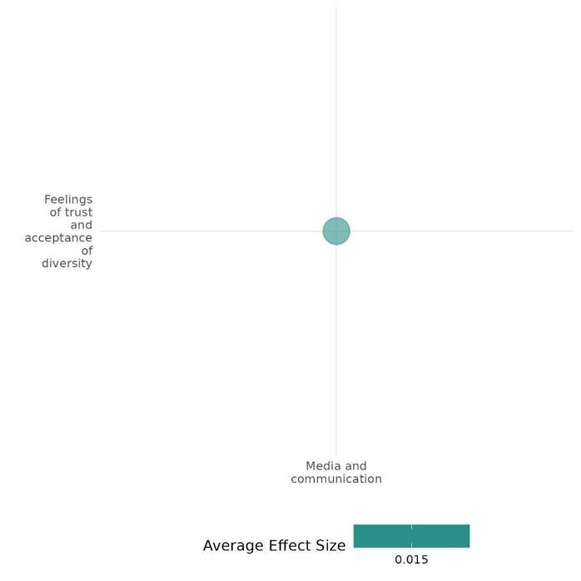

4.3.4(4)
Effect of Media and Communication on Willingness to participate or help
Musekeweya radio soap operas, radio talk shows, and government-led radio propaganda showed some positive effects on reconciliation, while a DRC talk show had mixed results on donations.
Geographical Region: Sub - Saharan Africa
Effect: Moderate effect (g=0.108)
Confidence in study findings: Low (4 study with 19 effect sizes)

Short Summary
Media and communication interventions, such as radio programs and propaganda broadcasts, influenced willingness to participate or help by shaping perceptions of reconciliation, tolerance, and intergroup cooperation. Studies in post-genocide Rwanda and the DRC show mixed effects—while some interventions increased support for open dissent and improved inter-ethnic cooperation, others failed to reduce social divisions or even discouraged prosocial behavior, such as donations. For instance, radio soap operas and talk shows promoting peace-building often encouraged open dialogue but did not consistently translate into behavioral change. In some cases, exposure to media-driven narratives on tolerance even led to decreased willingness to help. However, propaganda broadcasts unexpectedly fostered cooperation, demonstrating how media influence depends on framing and audience reception.

The intervention
Media and communication interventions, including the Musekeweya radio soap opera, radio talk shows, and government-led broadcasts, utilize fictional storytelling, discussions, and strategic messaging to foster perspective-taking, bridge ethnic divides, and promote national unity. Through educational programming, these campaigns aim to reshape attitudes and behaviors, reinforcing social cohesion and encouraging cooperation in post-conflict societies.

How the intervention is expected to work
Media interventions operate based on social learning theory, where exposure to modeled behaviors through media content can alter personal beliefs and societal norms. The hypothesis is that the media can influence willingness to participate or help by portraying positive behaviors and encouraging empathy and cooperation. Programs like Musekeweya use relatable characters and emotionally engaging narratives to shift attitudes, reduce prejudice, and promote prosocial behaviors. Media is expected to shape social norms, fostering a collective shift in attitudes towards conflict resolution and cooperation.

The Evidence base
The cell contains six studies: two systematic reviews and four impact evaluations. Among four IEs three are from Rwanda, and one is from the Democratic Republic of Congo. The reviews are mainly from Sub-Saharan Africa, the Middle East, North Africa, Europe, and East Asia.
Evidence findings
Media & communications, mainly radio-talk shows used in these included studies showed mixed effect on open dissent, social division and inter-ethnic cooperation. In specific, while some interventions increased support for open dissent and improved inter-ethnic cooperation, others failed to reduce social divisions or even discouraged prosocial behavior, such as donations.

The review evidence
The reviews evaluated Peace-building interventions in fragile contexts, including education, collaborative activities, dialogues, economic cooperation, media, and training. While contact-based interventions showed small positive effects on participation, media and school programs had mixed or negative results. Behavioral impacts, like donations and anti-violence actions, were inconsistent, with self-reported willingness often higher than actual behavior. Many interventions combined multiple strategies, making effects difficult to isolate. Overall, findings suggest limited but variable success, highlighting the need for more rigorous evaluations.

Included studies:
The cell includes four IEs. the detailed summary thus provided as below;

Paluck (2009) evaluated Musekeweya ("New Dawn"), a radio soap opera designed to promote reconciliation, trust, and empathy while discouraging prejudice and violence in post-genocide Rwanda. Through fictional narratives about two Rwandan communities, it conveyed educational messages on intergroup cooperation, trauma healing, and rejecting violent norms. The study hypothesized that exposure to the program would shift personal beliefs, alter perceptions of social norms, and encourage behaviors like dissent, cooperation, and reconciliation, with emotional engagement and group discussion amplifying its impact. Participants were drawn from general population, genocide survivor, and Twa communities across four regions. From each community, 40 adults were randomly selected, ensuring gender, age, and family balance.
Study findings documented significant effects of the reconciliation program. Participants exposed to the program were 0.26 to 0.29 probits more likely to support open dissent and 0.22 probits more likely to agree that discussing personal trauma is important. The program also increased empathy, with reconciliation listeners scoring significantly higher on an empathy index. In contrast, the health program showed a 0.56 probit effect on agreement that all pregnant women should be tested for AIDS, with a 1% higher likelihood compared to the reconciliation group. Overall, the study presents Low confidence.

Paluck (2009) assessed the impact of a radio soap opera, Musekeweya ("New Dawn"), on post-genocide Rwandan communities, aiming to challenge harmful political and social norms, particularly those of blind obedience, while promoting reconciliation and intergroup cooperation. The program encouraged behaviors such as dissent, collective problem-solving, and trauma healing, with a focus on fostering mutual trust. In contrast, the control group listened to a separate health-focused soap opera. Grounded in social learning theory, the intervention utilized relatable characters to model desirable behaviors and aimed to shift perceptions of trust, dissent, and community engagement. The study employed a cluster-randomized experimental design involving 14 Rwandan communities, stratified based on demographic factors such as general population, genocide survivors, and prisoners, with a total sample size of 556 participants.
The study documented that the reconciliation program significantly increased participants' support for open dissent, with reconciliation listeners showing a greater likelihood of expressing disagreement (p < 0.01). However, there was no significant difference in social distance measures, such as willingness to greet, work with, or marry individuals from other groups, between the reconciliation and control groups. Overall, the study is low confidence.

Paluck (2010) examined the impact of a weekly radio talk show in eastern DRC designed to promote tolerance, outgroup engagement, and perspective-taking. The study had three key objectives: assessing mass media's ability to spark interpersonal discussion about community conflict, testing its effects on intergroup contact and perspective-taking in unsupervised conflict settings, and presenting an experimental approach to studying discussion-based interventions. The underlying mechanism of the intervention was that media-driven discussions, through fostering social norms and shared cognition, could shape behaviors by encouraging listeners to engage with various perspectives and understand outgroup members.
Data from 842 participants representing diverse ethnic and linguistic groups revealed that 63% of participants donated salt, but talk show listeners were less likely to donate than baseline listeners (59% vs. 80%). The amount of salt donated was similar between the groups, but talk show listeners were likelier to view their donation as strategic or motivated by negative grievances. Those who believed they were donating to a disliked military group were significantly less likely to donate. Overall, while talk show exposure led to less giving, it influenced participants' motivations, with more negative and strategic reasons cited by talk show listeners. Overall, the study demonstrated high-medium confidence.

Blouin (2019) explored the impact of propaganda from Radio Rwanda on inter-ethnic attitudes in post-genocide Rwanda. The intervention leveraged government messaging through radio broadcasts, designed to reduce the salience of ethnic identity and promote reconciliation between the Hutu and Tutsi groups. Conducted in rural Rwandan villages, the study involved 438 participants who were randomly selected from village lists provided by local representatives. Data collection took place in town halls, where participants engaged in experiments and surveys. The study hypothesized that consistent messaging emphasizing a unified national identity over ethnic differences would foster improved inter-ethnic trust and cooperation, aligning with theories on reconciliation in post-conflict settings.
One key outcome was a partner selection task, where participants in villages exposed to Radio Rwanda were 15.6 percentage points (or 0.54 standard deviations) more likely to choose individuals from the other ethnic group for a cooperative interaction. Overall study presented low confidence.

Confidence assessment
Overall, the cell is rated low confidence due to inconsistencies in individual effect sizes, despite a representative number of studies.

Link to review summaries
Sonnenfeld (2021) and Ditlmann Ruth K 2017.
The studies may be accessed via EGM.

Other outcomes in this studies:
Social Cohesion/Feelings of trust/acceptance of diversity
Social Cohesion/Willingness to participate or help
Violence or atrocity prevention/Social norms regarding violence or atrocity

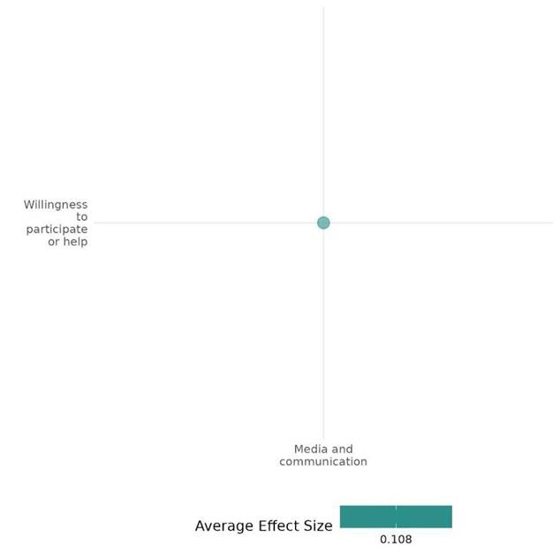

4.3.4(5)
Effect of Media & Communication on Access to Justice, right & Public Services
The Rwanda Threshold Program highlighted low awareness but a strong preference for submission boxes among informed citizens, signaling a shift toward indirect engagement with law enforcement.
Geographical region - Sub -Saharan Africa
Effect: Moderate effect (g= 0.148)
Confidence in the study findings: Low (1 study with 9 effect sizes)

Short Summary
Media and communication interventions under the Rwanda Threshold Program (RTP) sought to enhance governance and civic engagement by strengthening police accountability, judicial transparency, media independence, and civil society participation. Implemented nationwide from 2009 to 2011, the program's evaluation revealed limited awareness of submission boxes, with only 25% of respondents recognizing them. However, among those aware, 75% found them convenient, and 45% preferred them for engaging with law enforcement. The presence of submission boxes correlated with increased awareness and preference for indirect reporting channels over direct contact with police supervisors or local officials, indicating a shift in citizen-police interaction patterns.

The Intervention
The intervention focused on raising awareness and improving access to the complaint and commendation submission boxes for citizens. Key activities included community outreach to inform residents about the submission boxes, ensuring their strategic placement in accessible locations, and providing information on their use through local communication channels. Additionally, efforts were made to engage citizens in the Every Voice Counts campaign, promoting its benefits for transparent communication with the Rwanda National Police (RNP). Training sessions for local leaders were also conducted to encourage greater community participation.

How the intervention is expected to work
The intervention is expected to increase citizen engagement and trust in the Rwanda National Police (RNP) through accessible complaint and commendation submission boxes. By raising awareness and ensuring convenient box locations, citizens will be more likely to use these channels to voice concerns or commendations. The initiative aims to foster transparency, improve communication between the public and the police, and enhance accountability. Ultimately, it is designed to create a more responsive and open policing system, strengthening community-police relations.

Evidence base
The cell includes one primary study or IE conducted across Rwanda’s 416 sectors, providing a nationwide evaluation of the program's impact.

Evidence findings
The Rwanda Threshold Program (RTP) evaluation highlighted low awareness but a strong preference for submission boxes among informed citizens, signaling a shift toward indirect engagement with law enforcement.

Included studies
The cell includes one primary study or IE. the detailed summary thus provided here;

Nichols-Barrer et al. (2014) evaluated the Rwanda Threshold Program (RTP), an initiative sponsored by the Millennium Challenge Corporation, aimed at improving governance and civil society engagement in Rwanda. The intervention, implemented between 2009 and 2011, included four major components: strengthening the professionalism and accountability of the Rwanda National Police (RNP), enhancing the rule of law through judicial reforms, supporting media professionalism and independence, and increasing civic participation by empowering civil society organizations and local governments. The study was conducted across Rwanda’s 416 sectors, providing a nationally representative evaluation of the program's impact on governance indicators, citizen engagement, and access to justice and public services. The diverse settings included rural and urban areas, allowing for a comprehensive analysis of how the intervention addressed critical governance challenges in post-conflict Rwanda.
The study found that awareness of submission boxes was low, with only 25% of respondents in relevant sectors aware of them. However, among those aware, 75% found the boxes convenient, and 45% preferred them for communicating with the Rwanda National Police (RNP). Only 8% knew someone who used the box. Respondents in sectors with submission boxes were significantly more likely to be aware of the campaign, find the boxes convenient, receive information about them, and prefer using them for communication. These respondents also showed a reduced preference for contacting police supervisors or local government officials. Overall the study presents high-medium confidence.

Confidence assessment
Overall, the study presents low confidence due to the limited number of studies included under this category.

Other outcomes in this study
Community and state governance/Civic participation
Community and state governance/Government performance
Community and state governance/Presence and quality of social safety nets
Human security/Political security
Human security/Intermediate social cohesion

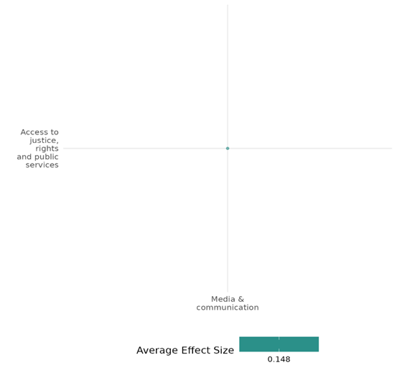

4.3.4(6)
Effect of Media & Communication on Civic Participation
Media and communication served as key tools in fostering participation, though their effectiveness varied depending on the specific context.
Geographical region: Sub-Saharan Africa
Effect: Small effect (g=0.049)
Confidence: Low (6 studies with 13 effect size)

Short Summary
Media-based interventions have shown varied success in promoting civic participation. Across studies, radio dramas, public campaigns, and media dialogues aimed to amplify moderate voices, promote collaboration, and enhance engagement. The PDEV II program demonstrated small success, with radio interventions sustaining higher civic engagement levels than non-radio zones. The Voices for Peace project in Burkina Faso had significant impacts, with participants 18% more likely to collaborate with security forces and 10% more likely to report suspicious activities. The DRC’s Kumbuka Kesho program showed moderate effectiveness, increasing collective action willingness compared to a control group. Conversely, the Pro-Peace Messaging through Religious Sermons study in Burkina Faso had limited impact, with no significant changes in participation. Aldrich's Mali study reported a significant increase, with program-exposed residents 40% more likely to engage in governance. Overall, media interventions show potential, but effectiveness relies on sustained efforts, targeted messaging, and local relevance.

The Intervention
Media-based interventions employed diverse strategies, with radio being a central tool. PDEV II utilized radio broadcasts alongside community activities to amplify voices and strengthen civil society. The Voices for Peace project featured a radio drama paired with weekly listening sessions and facilitated discussions on governance, corruption, and police-community relations. The Kumbuka Kesho program in the DRC employed role-modeling radio dramas to showcase positive collective actions, such as protests and intergroup collaboration. Burkina Faso’s Pro-Peace Messaging through Religious Sermons delivered sermons promoting peace and tolerance, while Aldrich’s study in Mali integrated peace radio programs, workshops, and community-level governance initiatives.

How the intervention is expected to work
The interventions focus on encouraging civic engagement through strategic initiatives that raise awareness, shape narratives, and enhance civic participation.

Evidence base
This cell consists of a total of six IEs conducted in varied regions, including Burkina Faso, Chad, Niger, Rwanda, Burkina Faso's Sahel region, Democratic Republic of Congo (DRC), and northern Mali.

Evidence findings
The media played a crucial role in encouraging participation; however, its effectiveness differed depending on the specific context.

Included studies: The cell consist six IEs & the the detailed summary thus provided here
Aldrich (2014) study focuses on USAID's Trans-Sahara Counter-Terrorism Partnership (TSCTP), including programs like Peace through Development (PDEV) and PDEV II, aimed at countering violent extremism by addressing its root causes. Objectives include reducing extremist recruitment, fostering peace and civic engagement, and building community resilience. Key activities include teacher training, curriculum support, peace and tolerance radio broadcasts, workshops for civic engagement, rural job creation, micro-grants for local NGOs, and youth empowerment initiatives. By promoting norm change, civic participation, economic stability, strengthened social networks, and institutional capacity building, the intervention seeks to provide alternatives to extremist narratives and foster long-term resilience.
Research conducted in Timbuktu and Dire, two adjacent cities in northern Mali, involved 200 respondents evenly split between the treatment groups. The findings revealed that residents of Timbuktu were approximately 40% more inclined to engage in local government activities compared to their counterparts in Dire. Overall, the study is Low confidence quantitative study.

Bilali et al. (2017) evaluated a media-based program using the radio drama Kumbuka Kesho ("Remember Tomorrow") in the Eastern Democratic Republic of Congo (DRC). Rooted in social cognitive theory, it aimed to promote positive social change and intergroup relations in a conflict-affected context. The program used role modeling to portray inclusive collective actions, such as protests, micro-loan programs, and intergroup collaboration, to address grievances like corruption, poverty, child labor, and injustice. The control show discussed these grievances without proposing any actions.
The study findings documented that the participants who listened to the role-modeling show expressed a higher willingness to participate in collective action than participants listening to the control show. There was no difference in collective action between the control show and the no-show condition (b = −0.22, SE =0.20,p = 0.27, 95% CI: [−0.62; 0.17]). Overall the study is of high quality due to its robust group-randomized experimental design, including control and treatment groups and rigorous analysis methods. The study is rated as low confidence.

Bilali et al. 2019 evaluated the Voices for Peace project, featuring the radio drama Wuro Potal, designed to counter violent extremism in Burkina Faso's Sahel region. The intervention aimed to reduce vulnerability to extremism by raising awareness, promoting dialogue, fostering social cohesion, and encouraging collaboration with security forces. Activities included weekly listening sessions in 66 treatment villages over 12 weeks, where participants engaged in 52 episodes addressing issues such as corruption, governance, and police-community relations. Training personnel facilitated group discussions and encouraged reflection on key themes and collective learning. Conducted in Seno Province—the study surveyed 2,904 core participants from 132 villages (66 treatment, 66 control) at baseline and endline, partially including 2,112 network participants.
The radio drama intervention revealed that approximately 60% of participants viewed collaborating with the police or reporting suspicious activities as the most effective way to combat violent extremism. The intervention significantly increased this behavior, with intervention participants 6% more likely to report collaboration as a strategy and 18% more likely if they attended at least one session. In a “suspicious person” scenario, intervention participants were 10% more likely to agree they would contact authorities compared to the control group. These findings highlight the intervention's success in promoting proactive civic participation in security efforts. Overall, the study presents high-medium confidence.

Finkel (2018) evaluates The Peace through Development II (PDEV II) program, implemented from 2011 to 2016, aimed to enhance resilience to violent extremism (VE) in at-risk communities across Burkina Faso, Chad, and Niger. It focused on four strategic objectives (SOs): empowering youth, amplifying moderate voices, strengthening civil society, and improving local governance. The program combined community activities with media efforts, notably radio, to reach wider audiences.
Under SO1, "Youth Empowered," PDEV II offered vocational training, leadership programs, and literacy support. SO2, "Moderate Voices Increased," focused on media capacity-building, public campaigns, and interfaith dialogues. SO3, "Civil Society Capacity Increased," aimed to strengthen civil society organizations through training and the formation of Community Action Committees (CACs). SO4, "Local Government Strengthened," improved the skills of local officials in public administration and governance. The program targeted 83 zones, with core zones receiving full interventions, non-core zones focusing on radio, and no-activity zones having limited engagement. It used high and low-intensity zones to prioritize resources and activities for deeper community engagement.
The PDEV II radio component evaluation revealed a decline in community decision-making for both groups, but it is more significant for the "Non-radio" group. The "Radio" group experienced a smaller decline, suggesting that radio exposure helps sustain higher levels of community engagement over time. Overall, the study was of medium to high quality, with a strong, multidimensional approach focused on long-term sustainability.

Grossman (2022): The “Pro-Peace Messaging through Religious Sermons” intervention involved exposing adolescents to audio excerpts of a sermon delivered by a prominent Burkinabé imam, Alidou Ilboudo. The sermon emphasized Islamic teachings promoting peace, tolerance, and non-violence while invoking a shared national identity among Burkinabé citizens. The intervention was implemented as part of a randomized survey experiment in 12 schools across rural and peri-urban regions of Burkina Faso, targeting students aged 12 to 18. Enumerators played the sermon recordings to participants individually, ensuring comprehension by allowing clarifying questions or repeated playback if needed. The aim was to test whether such messaging could enhance intergroup tolerance, reduce support for violent extremism, and increase civic participation among at-risk youth in a region affected by Islamist extremist insurgencies.
The study found that participants in the intervention group were less likely to engage in pro-peace civic activities, such as recording and sending a message to authorities, compared to those in the control group. While non-intervention participants showed a slight increase in willingness, this was not statistically significant, and overall civic participation remained low across all groups. Overall, the study is of high-medium quality confidence.
Nichols-Barrer et al. (2014) evaluated the Rwanda Threshold Program (RTP), an initiative sponsored by the Millennium Challenge Corporation, aimed at improving governance and civil society engagement in Rwanda. The intervention, implemented between 2009 and 2011, included four major components: strengthening the professionalism and accountability of the Rwanda National Police (RNP), enhancing the rule of law through judicial reforms, supporting media professionalism and independence, and increasing civic participation by empowering civil society organizations and local governments. The study was conducted across Rwanda’s 416 sectors, providing a nationally representative evaluation of the program's impact on governance indicators, citizen engagement, and access to justice and public services. The diverse settings included rural and urban areas, allowing for a comprehensive analysis of how the intervention addressed critical governance challenges in post-conflict Rwanda.
The Rwanda Threshold Program (RTP) showed a small positive impact on awareness of local government meetings, increasing by 1.4 percentage points; however, this result was statistically insignificant. Additionally, there were negatively insignificant effects on familiarity with local government officials and perceived access to government information. On the other hand, both treatment and control districts exhibited positive trends in citizen influence and knowledge about local government affairs, with the improvements being more notable in the control districts. Overall, the study presents high-medium confidence.

Confidence assessment
Overall, the study is rated low confidence due to inconsistencies among the included studies, despite a fairly representative sample.

Other outcomes in the cell
Community & state governance/ government performance
Community & state governance/ Access to justice, rights and public services
Violence & Atrocity preventions/social norms regarding violence or atrocity
Human security/intermediate social cohesion outcomes
Social cohesion/feelings of trust & acceptance of diversity
Human security/Political security
Human security/Intermediate social cohesion outcomes

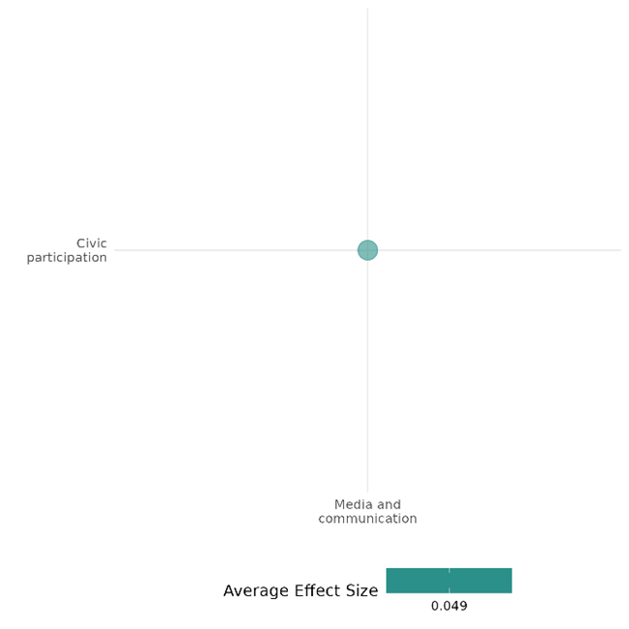

4.3.4(7)
Effect of Media & Communication on Government Performance
Media interventions had limited impact on transparency and accountability, showing minimal effects on trust and governance. In some cases, local satisfaction declined, highlighting challenges in shaping public perceptions across diverse contexts.
Geographical Region: Sub -Saharan Africa
Effect: No effect (g=-0.006)
Confidence in this study findings: Low ( 2 studies with 14 effect size)

Short Summary
Media-focused interventions often aim to enhance governance and civil society engagement by strengthening media professionalism and independence. The program sought to improve government performance, transparency, and accountability perceptions. However, their impact on perceptions of government performance remains limited and context-dependent. While programs like the Rwanda Threshold Program and Voices for Peace project sought to improve transparency, accountability, and collaboration with security forces, their effects on trust, fairness, and institutional effectiveness were generally small or statistically insignificant. In some cases, satisfaction with local governance even declined, highlighting the challenges of using media to shift public perceptions and institutional trust in varying political and social environments.

The Intervention
Media and communication includes Rwanda Threshold Program (RTP) and radio drama Wuro Potal to promote governance and citizen engagement. The interventions employed diverse strategies, with radio being a central tool to raise awareness, foster public dialogue, and encourage accountability in governance. In contrast, the Voices for Peace project in Burkina Faso utilized a 12-week radio drama, Wuro Potal, along with weekly listening sessions and facilitated discussions on governance, police-community relations, corruption, and social cohesion.

How the intervention is expected to work
Both interventions used media to promote social and behavioral change. The Rwanda Threshold Program (RTP) established community radio stations to spread information about transparent governance, aiming to boost civic participation and trust. Meanwhile, the Voices for Peace Radio Drama employed edutainment to counter violent extremism by embedding positive social norms in compelling narratives. This approach encouraged collaboration with security forces and raised awareness about governance issues through engaging fictional characters. Both strategies relied on storytelling and public communication to influence community attitudes and behaviors.

Evidence base
The cell includes two primary studies (IE) conducted in Rwanda and Burkina Faso's Sahel region.

Evidence findings
The interventions with radio being a central tool documented the limited but context-sensitive statistical impact of media and communication strategies on perceptions of government performance.

Included studies:
The cell consists of two primary studies/IEs and The details of the study summary are provided here.
Nichols-Barrer et al. (2014) evaluated the Rwanda Threshold Program (RTP), an initiative sponsored by the Millennium Challenge Corporation, aimed at improving governance and civil society engagement in Rwanda. The intervention, implemented between 2009 and 2011, included four major components: strengthening the professionalism and accountability of the Rwanda National Police (RNP), enhancing the rule of law through judicial reforms, supporting media professionalism and independence, and increasing civic participation by empowering civil society organizations and local governments. The study was conducted across Rwanda’s 416 sectors, providing a nationally representative evaluation of the program's impact on governance indicators, citizen engagement, and access to justice and public services. The diverse settings included rural and urban areas, allowing for a comprehensive analysis of how the intervention addressed critical governance challenges in post-conflict Rwanda.
The Rwanda Threshold Program (RTP) found no significant changes in perceptions of the Rwanda National Police (RNP) 's fairness, trustworthiness, or effectiveness. Satisfaction levels remained high (over 75%), and 72% to 88% agreed on the RNP's fairness and consistency across both sector groups. Similarly, satisfaction with local government services declined significantly in treatment districts (by 6 percentage points) compared to no change in control districts. Differences between groups for both outcomes were minimal and not statistically significant. Overall, the study presents medium confidence due to the modest sample size and low engagement levels.
Bilali et al. 2019 evaluated the Voices for Peace project, featuring the radio drama Wuro Potal, designed to counter violent extremism in Burkina Faso's Sahel region. The intervention aimed to reduce vulnerability to extremism by raising awareness, promoting dialogue, fostering social cohesion, and encouraging collaboration with security forces. Activities included weekly listening sessions in 66 treatment villages over 12 weeks, where participants engaged in 52 episodes addressing issues such as corruption, governance, and police-community relations. Training personnel facilitated group discussions and encouraged reflection on key themes and collective learning. Conducted in Seno Province—the study surveyed 2,904 core participants from 132 villages (66 treatment, 66 control) at baseline and endline, partially including 2,112 network participants.
The radio drama intervention resulted in statistically significant but limited improvements in perceptions of police fairness. Participants exposed to the intervention were slightly more likely to view the police as fair and professional compared to the control group. Similarly, beliefs about collaboration with security forces improving personal or community security showed minimal or negligible change. These results highlight that while the intervention influenced perceptions of fairness to some extent, it failed to impact trust or attitudes toward collaboration with security forces substantially. The study is rated as medium confidence.
Confidence assessment
Overall, the study presents low confidence due to small number of studies included in the cell

Other outcomes in this study
Community and state governance/Civic participation
Community and state governance/Access to Justice, Rights & Public Services
Human security/Political security
Human security/Intermediate social cohesion
Violence or atrocity prevention/ Social norms regarding violence or atrocity
Social cohesion/Willingness to participate or help
Social cohesion/Feelings of trust & acceptance of diversity

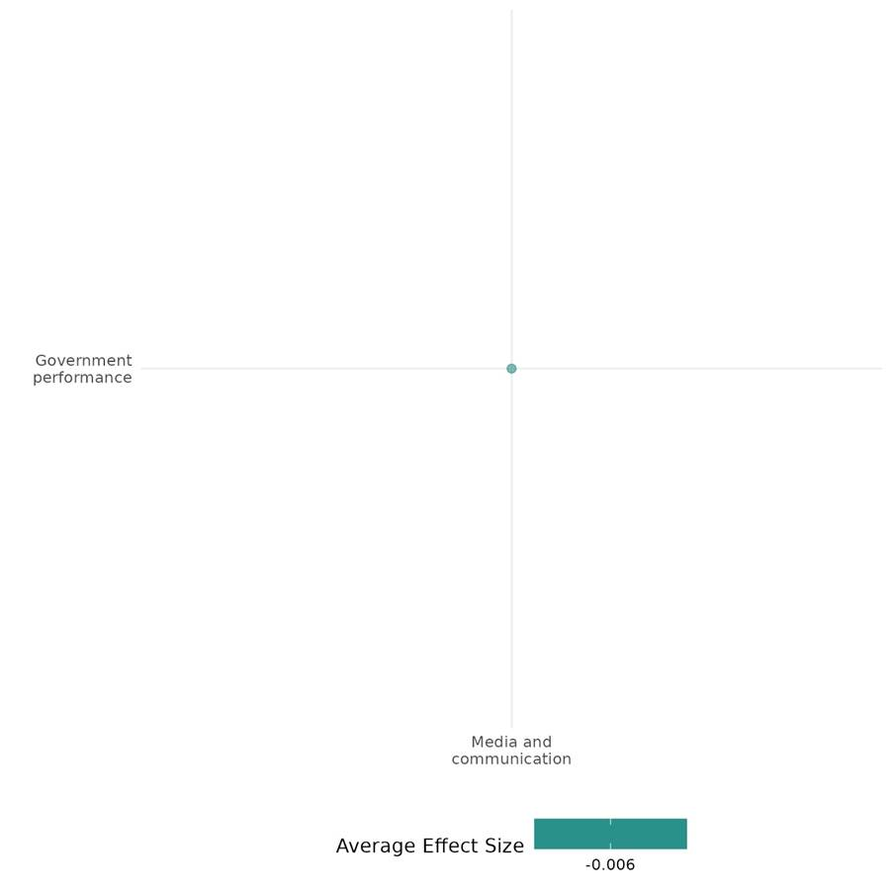

4.3.4(8)
Effect of Media & Communication on Economic Security
The radio programming under the PDEV II program showed no measurable effect on economic security. The focus remained more on political and social transformation rather than economic stability.
Geographical region : Sub-Saharan Africa
Effect: Adverse effect (g = -0.013)
Confidence in study findings: Low (1 study with 3 effect size)

Short summary
The Peace through Development II (PDEV II) program, implemented from 2011 to 2016 in Burkina Faso, Chad, and Niger, influenced community resilience by fostering social cohesion and countering extremist ideologies. The intervention enhanced political and social engagement through vocational training, media capacity-building, leadership initiatives, and interfaith dialogues. While core zones benefited from comprehensive interventions, the radio component, evaluated separately, showed no measurable improvements in livelihoods, employment, or financial stability in the target areas. The analysis found no significant changes in economic security indicators resulting from the intervention, highlighting its role in driving social and political change rather than directly improving financial stability.

The Intervention
The PDEV II program included various interventions aimed at building resilience to violent extremism. Activities focused on vocational training for youth, leadership programs, and literacy support. Media initiatives included training for radio stations, creating governance-focused shows, and organizing interfaith dialogues. Civil society was strengthened through capacity-building workshops and forming Community Action Committees. Local governance was improved by training officials in transparency, public administration, and engaging communities in decision-making.

How the intervention is expected to work
The PDEV II intervention is expected to work by addressing the root causes of violent extremism through a combination of economic, social, and governance-focused activities. By empowering youth with vocational skills and leadership training, it aims to reduce vulnerability to extremist ideologies. Media initiatives, particularly radio, are designed to promote tolerance, good governance, and peaceful coexistence. Strengthening civil society and local governance is intended to enhance community engagement and resilience. Overall, the intervention is expected to foster social cohesion, reduce extremism, and support sustainable development in target communities.
The Evidence Base
The cell contains one high to medium quantitative confidence conducted in at-risk communities across Burkina Faso, Chad, and Niger.

Evidence findings
The PDEV II program's radio component had a very small impact on economic security, focusing more on social and political change.

Included studies: the cell include one IE/primary study & thus the detailed summary is provided as below
Finkel (2018) evaluates The Peace through Development II (PDEV II) program, implemented from 2011 to 2016, aimed to enhance resilience to violent extremism (VE) in at-risk communities across Burkina Faso, Chad, and Niger. It focused on four strategic objectives (SOs): empowering youth, amplifying moderate voices, strengthening civil society, and improving local governance. The program combined community activities with media efforts, notably radio, to reach wider audiences.
Under SO1, "Youth Empowered," PDEV II offered vocational training, leadership programs, and literacy support. SO2, "Moderate Voices Increased," focused on media capacity-building, public campaigns, and interfaith dialogues. SO3, "Civil Society Capacity Increased," aimed to strengthen civil society organizations through training and the formation of Community Action Committees (CACs). SO4, "Local Government Strengthened," improved the skills of local officials in public administration and governance.
The program targeted 83 zones, with core zones receiving full interventions, non-core zones focusing on radio, and no-activity zones having limited engagement. It used high and low-intensity zones to prioritize resources and activities for deeper community engagement.
The evaluation of the PDEV II radio component shows limited impact on economic security outcomes. While radio programming positively influenced political and social perceptions, it did not lead to measurable improvements in livelihoods, employment, or financial stability in the target areas. The analysis found no significant changes in economic security indicators resulting from the intervention. The study is rated as medium to high confidence.
Confidence assessment
Overall, the cell has low confidence due to a small number of studies in the segments.

Other outcomes in this study:
Social cohesion/Feeling of trust & acceptance of diversity
Human security/Political security
Community & state governance/Civic participation.
Violence & atrocity prevention/social norms regarding violence or atrocity

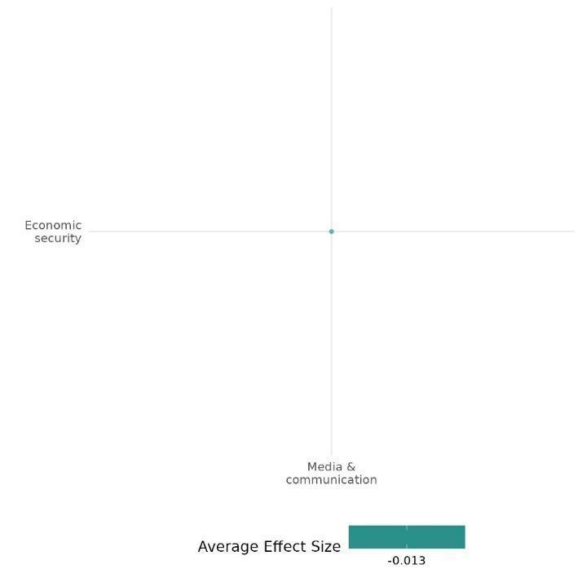

4.3.4(9)
Effect of Media & Communication on Political Security
An evaluation of radio listeners under the PDEV II program documented better political knowledge, but its impact on community engagement was limited.
Geographical region: Sub-Saharan Africa
Effect: Small effect (g=0.05)
Confidence in study findings: Low (1 study with 4 effect size)

Short summary
The Peace through Development II (PDEV II) program, implemented from 2011 to 2016 in Burkina Faso, Chad, and Niger, aimed to enhance resilience to violent extremism by empowering youth, strengthening civil society, and improving governance. The intervention combined community-based initiatives with media outreach, particularly radio, to engage wider audiences. While non-radio listeners showed greater interest in community affairs, radio listeners demonstrated increased political knowledge, highlighting the program’s role in fostering civic awareness rather than direct community engagement.

The Intervention
The PDEV II program included various interventions aimed at building resilience to violent extremism. Activities focused on vocational training for youth, leadership programs, and literacy support. Media initiatives included training for radio stations, creating governance-focused shows, and organizing interfaith dialogues. Civil society was strengthened through capacity-building workshops and forming Community Action Committees.

How the intervention is expected to work
The PDEV II intervention is expected to work by addressing the root causes of violent extremism through a combination of economic, social, and governance-focused activities. By empowering youth with vocational skills and leadership training, it aims to reduce vulnerability to extremist ideologies. Media initiatives, particularly radio, are designed to promote tolerance, good governance, and peaceful coexistence. Strengthening civil society and local governance. Overall, the intervention is expected to foster social cohesion, reduce extremism, and support sustainable development in target communities.

Evidence Base
The cell consists of one medium to high confidence Impact Evaluation conducted in at-risk communities across Burkina Faso, Chad, and Niger.

Evidence findings
The Peace through Development II (PDEV II) program’s radio component increased political knowledge among listeners, while non-listeners showed greater interest in community affairs, indicating its influence on civic awareness rather than direct engagement.

Included studies:
The cell consists of one study/IE. the detailed summary thus provided as below,
Finkel (2018) evaluates The Peace through Development II (PDEV II) program, implemented from 2011 to 2016, aimed to enhance resilience to violent extremism (VE) in at-risk communities across Burkina Faso, Chad, and Niger. It focused on four strategic objectives (SOs): empowering youth, amplifying moderate voices, strengthening civil society, and improving local governance. The program combined community activities with media efforts, notably radio, to reach wider audiences.
Under SO1, "Youth Empowered," PDEV II offered vocational training, leadership programs, and literacy support. SO2, "Moderate Voices Increased," focused on media capacity-building, public campaigns, and interfaith dialogues. SO3, "Civil Society Capacity Increased," aimed to strengthen civil society organizations through training and the formation of Community Action Committees (CACs). SO4, "Local Government Strengthened," improved the skills of local officials in public administration and governance.
The program targeted 83 zones, with core zones receiving full interventions, non-core zones focusing on radio, and no-activity zones having limited engagement. It used high and low-intensity zones to prioritize resources and activities for deeper community engagement. The evaluation of the radio component of the PDEV II program highlights that non-radio listeners to the radio programs are more interested in community affairs, while radio listeners tend to have better political knowledge. The study is rated as medium to high quality confidence.

Confidence assessment
Overall, the cell has a low confidence due to limited numbers of studies included under this cell.

Other outcomes in this study
Social cohesion/Feeling of trust & security
Human security/Economic security
Community & state governance/Civic participation.
Violence & atrocity prevention/social norms regarding violence or atrocity

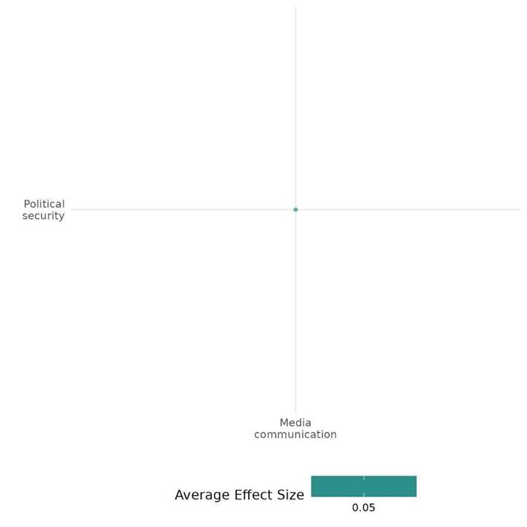

4.3.4(10)
Effect of Media & Communication on Intermediate Social Cohesion Outcome
Media interventions in conflict regions had mixed results, sometimes improving fairness but often reinforcing biases. While fostering cohesion, deep-seated divisions, trauma, and external tensions limited their overall impact.
Geographical Regions: Sub-Saharan Africa, Latin America & Caribbean, Middle east & North Africa
Effect: Small effect (g = 0.025)
Confidence in study findings: Low ( 6 studies with 40 effect sizes)

Short summary
Media-based interventions in conflict-affected regions have yielded mixed results, with deep-seated biases and social divisions often persisting. While some initiatives improved historical perspective-taking, fairness-based reasoning, and self-efficacy, their overall impact was hindered by political tensions, trauma, and societal divides. Efforts to reduce dehumanization and enhance tolerance produced inconsistent effects, sometimes reinforcing obedience to authority or in-group superiority. Although coexistence narratives occasionally promoted understanding, negative stereotypes frequently endured or worsened, particularly where media exposure was unequal or external conflicts remained high. Despite localized successes in civic engagement and intergroup knowledge, media alone proved insufficient to overcome systemic divisions in highly polarized settings. Some interventions successfully reduced in-group superiority and fostered inclusive victim consciousness, yet sustaining broader attitudinal shifts—such as weakening blind obedience to harmful leadership and increasing acceptance of differing perspectives—remained a challenge.

The intervention
The interventions included media and communication strategies such as video campaigns, radio dramas, and counter-narrative approaches. Activities ranged from storytelling, cognitive reappraisal, and historical perspective-taking to peace messaging, dialogue, and community discussions. Many interventions embedded educational messages to challenge stereotypes, promote tolerance, and encourage active participation in peacebuilding.

How the intervention is expected to work
The interventions are expected to work by addressing psychological and social barriers to peace through cognitive belief modification, sociocultural awareness, and reconciliation messaging. By reshaping perceptions of out-group members, promoting tolerance, and fostering self-efficacy, these approaches aim to reduce stereotypes, hostility, and support for violence. Grounded in theories of change, they emphasize building intergroup harmony goals, challenging harmful narratives, and equipping individuals and communities with the skills and confidence needed to drive positive social change.

The evidence base
The cell comprises eight studies, including six impact evaluations (IEs) and two systematic reviews.
All included impact evaluations were conducted in conflict-affected regions—Colombia, Eastern DRC, Burundi, and Burkina Faso’s Sahel region (Seno Province). Notably, three studies were conducted by the same author in different years.

Evidence findings
Media-based interventions in conflict regions had mixed outcomes—while some improved fairness-based reasoning and reduced in-group superiority, their impact was often constrained by external tensions and trauma, at times even reinforcing obedience to authority or deepening stereotypes.

The review evidence
This cell consists of two SRs; A systematic review of counter-narrative and peace-building interventions found that media campaigns, storytelling, dialogue, and training effectively reduced stereotypes, built resistance to extremist narratives, and promoted intergroup understanding. These interventions enhanced emotional regulation, self-efficacy, and the value of peace while fostering knowledge about out-groups and social cohesion. However, their long-term impact on sustaining behavioral change remained inconsistent, with limited evidence on translating attitudinal shifts into concrete peace-building actions.

Included studies:
The cell comprises six primary studies/IEs, with one study excluded from effect size (ES) calculation due to insufficient data for computing “d.” A detailed summary is provided below.

Bruneau (2022) evaluated a 5.5-minute media video intervention designed to address psychological barriers to peace in Colombia. Created in collaboration with Colombian filmmakers, the video featured interviews with ex-FARC combatants and non-FARC Colombians. It focused on reducing negative beliefs about the willingness and ability of FARC members to reintegrate into society. The intervention highlighted successful coexistence initiatives, such as mixed sports teams and community events in demobilization camps, to demonstrate FARC members' capacity for positive change. The primary objective was to promote peace and reintegration by challenging the belief that FARC members are unwilling and incapable of change. This objective was guided by a theory of change rooted in cognitive belief modification rather than affective pathways, such as empathy, to reduce psychological barriers to reconciliation.
The study revealed that the intervention consistently reduced the dehumanization of FARC members across studies, with statistically significant effects that persisted over time. Overall, the study is rated as high confidence in the consistency of findings.

The Billali 2015 evaluates the intervention involved in a radio drama, Kumbuka Kesho, broadcast in Eastern DRC to promote peaceful intergroup relations amidst ongoing violence,it used fictional narratives grounded in social psychology theories to model reconciliation and trauma recovery behaviors. The objective was to test if media-based interventions effective in post-conflict settings (e.g., Rwanda, Burundi) could foster inclusive victim consciousness, reduce social distance, and mitigate conflict-enhancing attitudes in an ongoing conflict context. A mixed-methods study included an experimental priming paradigm with 1,522 participants and focus group interviews with 51 listeners. The intervention showed mixed results. Historical perspective-taking improved, with significant increases in inclusive victim consciousness and reductions in exclusive victim consciousness among listeners. However, priming unexpectedly increased obedience to leaders, contradicting intervention goals. There was no significant impact on tolerance for differing perspectives or reductions in in-group superiority, highlighting the challenges of fostering broader attitudinal changes in ongoing conflict settings. Overall, the study indicated medium-quality methodology and mixed effectiveness in fostering peace under continuous trauma conditions.

The Billali 2015 evaluates the radio drama Murikira Ukuri ("Shedding Light on the Truth") in Burundi, which used an entertainment-education approach to address intergroup conflict and reconciliation. It addressed intergroup conflict and reconciliation through a fictional story of two socio-economically different ethnic groups. The drama embedded educational messages based on psychological theories of intergroup conflict and trauma healing, aiming to challenge stereotypes, foster empathy, and promote active bystandership. Its objectives included raising awareness about violence, encouraging interventions against harmful behaviors, challenging in-group superiority, and fostering trust, tolerance, and cooperation. The design drew on Staub's theories of violence and reconciliation, emphasizing the importance of history, role models, and social norms.
The study involved 1,074 participants and found that listeners showed greater tolerance, reduced in-group superiority, and were more open to trauma disclosure. Exposure to violence led to stronger changes, particularly in perspective-taking, suggesting the drama successfully fostered tolerance, reduced bias, and encouraged discussions on trauma.The study is rated as a low confidence study.

Bilali et al. 2019 evaluated the Voices for Peace project, featuring the radio drama Wuro Potal, which aimed to counter violent extremism in Burkina Faso's Sahel region. The intervention sought to reduce vulnerability to extremism by raising awareness, promoting dialogue, fostering social cohesion, and encouraging collaboration with security forces. It included weekly listening sessions in 66 treatment villages over 12 weeks, where participants engaged in 52 episodes addressing issues such as corruption, governance, and police-community relations. Personnel facilitated group discussions to encourage reflection on key themes and collective learning. Conducted in Seno Province, the study surveyed 2,904 core participants from 132 villages (66 treatment, 66 control) at baseline and endline, with 2,112 network participants also included.
The intervention assessed various outcomes related to self and collective efficacy beliefs. It significantly increased participants' confidence in their community's ability to address violent extremism, reducing collective fatalism. Individually, participants felt more capable of driving positive changes within their community, enhancing their self-efficacy. At the collective level, the intervention bolstered perceptions of the community’s ability to create social change through collaborative efforts. These results demonstrate the intervention’s effectiveness in strengthening both individual and collective agency in addressing security and social challenges. The study is rated as a medium - high confidence study.

Finkel (2018) The Peace through Development II (PDEV II) program (2011-2016) aimed to strengthen resilience against violent extremism in Burkina Faso, Chad, and Niger by promoting social cohesion, civic engagement, and positive community outlooks. It combined media, education, vocational training, and governance-focused initiatives, with a key component being radio programming to counter extremist narratives and encourage dialogue. Additional activities included leadership training, livelihood support, and civic education. The program’s impact was assessed using a quasi-experimental difference-in-differences (DiD) approach, comparing full-intervention core zones, media-only non-core zones, and no-activity zones. Findings showed increased awareness of peace and conflict mediation but no significant improvement in self-efficacy. While some reductions in perceived ethnic and religious differences were observed, especially in Burkina Faso, these effects were weak and inconsistent across countries, indicating that while the program influenced awareness and perceptions, deeper behavioral and attitudinal changes remained limited and context-dependent. The study is rated as a medium confidence.
Cole (2003) evaluates The Rechov Sumsum/Shara’a Simsim television series was designed to promote mutual respect and understanding among Israeli and Palestinian children by depicting positive intergroup interactions. Using a pre-test/post-test design, the study assessed 275 preschoolers from Israeli-Jewish, Palestinian-Israeli, and Palestinian communities in Tel Aviv, Acre, and Ramallah, focusing on stereotypes, cultural knowledge, and conflict resolution.
While the program had some positive effects, particularly among Israeli-Jewish and Palestinian-Israeli children, who showed greater fairness-based reasoning in conflicts, Palestinian children exhibited increased negative stereotypes toward Jewish adults. This regression was likely due to external sociopolitical tensions and differences in media exposure, as the Palestinian version contained fewer direct intergroup interactions. Although Palestinian children improved in rule-based reasoning, their perceptions remained largely shaped by external realities, limiting the program's overall impact on reducing hostility. Ultimately, while the intervention enhanced cultural awareness and encouraged some prosocial behaviors, deep-seated biases and real-world conflicts still heavily influenced children’s perceptions, showing that media alone cannot fully counteract societal divisions. The study is rated as a low confidence.
Confidence assessment
Overall, this cell indicates low confidence. Although the number of studies could suggest a medium level of evidence, the inconsistency in effect sizes across independent studies or the lack of alignment within a single effect size category weakens their reliability.

Other outcomes in this study
Violence and atrocity prevention/Social norms regarding violence and atrocities
Social cohesion/Feelings of trust and acceptance of diversity
Community and state governance/Government performance
Government performance/Civic participation

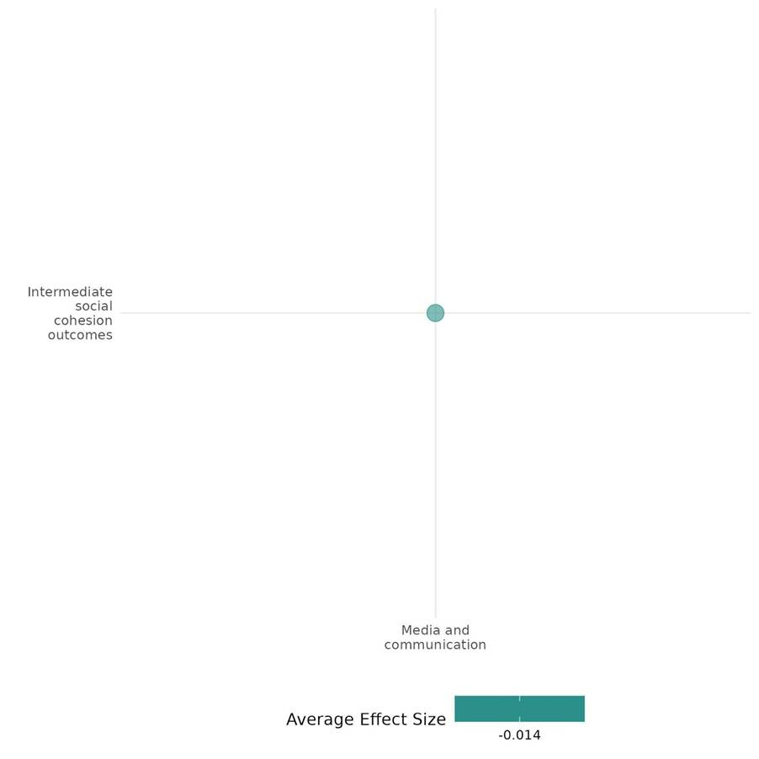

4.3.5 Social inclusion and reintegration activities
4.3.5(1)
Effect of Social Inclusion & Reintegration Activity on Diplomatic relations & Peaceful Dispute Resolution
The Community-Based Reintegration Assistance for Conflict Victims Program (BRA-KDP , showed no significant improvements in dispute resolution mechanisms or power-sharing capacity.
Geographical region: East asia & pacific
Effect: Small effect (g = 0.042)
Confidence in study findings: Low (1 study with 1 effect size)

Short Summary
The BRA-KDP program in Aceh, Indonesia, was designed to support conflict-affected communities across 1,724 villages through block grants. A quasi-experimental study revealed notable social divisions among aid recipients, non-recipients, and different economic groups. While the program may have contributed to enhancing conflict resolution skills, there is no clear evidence that it strengthened community capacity to manage conflicts or significantly improved dispute resolution and power-sharing dynamics. However, participants reported high levels of satisfaction with the program.

The Intervention
The Community-Based Assistance for the Reintegration of Conflict Victims (BRA-KDP) in Aceh focused on community-driven development (CDD), providing block grants to conflict-affected villages, particularly in high-conflict areas. Activities included infrastructure development, livelihood support, and participatory decision-making.

How the intervention is expected to work
The program was designed to empower communities' ability to manage tensions and strengthen the capacity of individuals to resolve conflict through formal mechanisms. Addressing social divisions and enabling inclusive projects aimed to strengthen local dispute resolution mechanisms.

The evidence base
The cell contains one primary study, which was conducted in Indonesia & used a quasi-experimental design to assess the impact of the intervention on outcomes of interest.

Evidence findings
The BRA-KDP program may have contributed to enhancing conflict resolution skills, however there is no clear evidence that it strengthened community capacity to manage conflicts or significantly improved dispute resolution and power-sharing dynamics.

Included Studies
The cell contains one low- confidence primary study, the detailed summary thus provided as below;
Barron (2009): The study evaluated the Community-Based Reintegration Assistance for Conflict Victims Program (BRA-KDP) in Aceh, Indonesia. This intervention aimed to support conflict-affected communities by providing block grants directly to villages. The evaluation used a quasi-experimental design to compare treatment villages that received the program with control villages that did not. Initially planned for two phases across Aceh, only the first phase was completed. Conducted from August to the following year, the program targeted 1,724 villages—about one-third of Aceh's total—across 67 rural subdistricts chosen for their conflict impact and success in fund disbursement, ensuring all villages in these subdistricts received block grants. To address selection bias, the researchers utilized matching techniques, where treatment villages were matched with control villages based on factors like conflict exposure and village characteristics to ensure comparability. An instrumental variables approach addressed non-compliance and confounding factors, isolating the program's effects. Alternative specifications were used to test the robustness of findings, particularly regarding social divisions and conflict escalation.
The study found that social divisions were prevalent, including those between aid recipients, non-recipients, and the rich and poor. Overall, A high proportion of individuals in both treatment and control villages expressed satisfaction with how problems were resolved in their communities. However, there was no significant improvement in satisfaction with dispute resolution processes due to the program. The study hypothesized that the BRA-KDP program would improve collective action and dispute resolution, but there were no notable differences in the ability to secure community projects or the quality of dispute resolution between the treatment and control groups. The frequency and quality of peaceful dispute resolution were consistent across both groups, with no evidence of improved power-sharing or enhanced resolution processes. Overall, the program did not significantly impact the accessibility, capacity, or effectiveness of dispute resolution mechanisms. The study is rated as a low - confidence study.

Confidence assessment
Overall, the cell is rated as low due to the small (n) in the cell and the presence of low confidence in the findings.

The other outcomes assessed
Social cohesion/Feeling of trust & acceptance of diversity. Sense of belonging
Human security/Economic security, Education security, Health security,
Community & state governance/Civic participation, Government performance, Access to justice, rights & Public service
Violence or atrocity prevention/Nature and scale of violence or atrocities

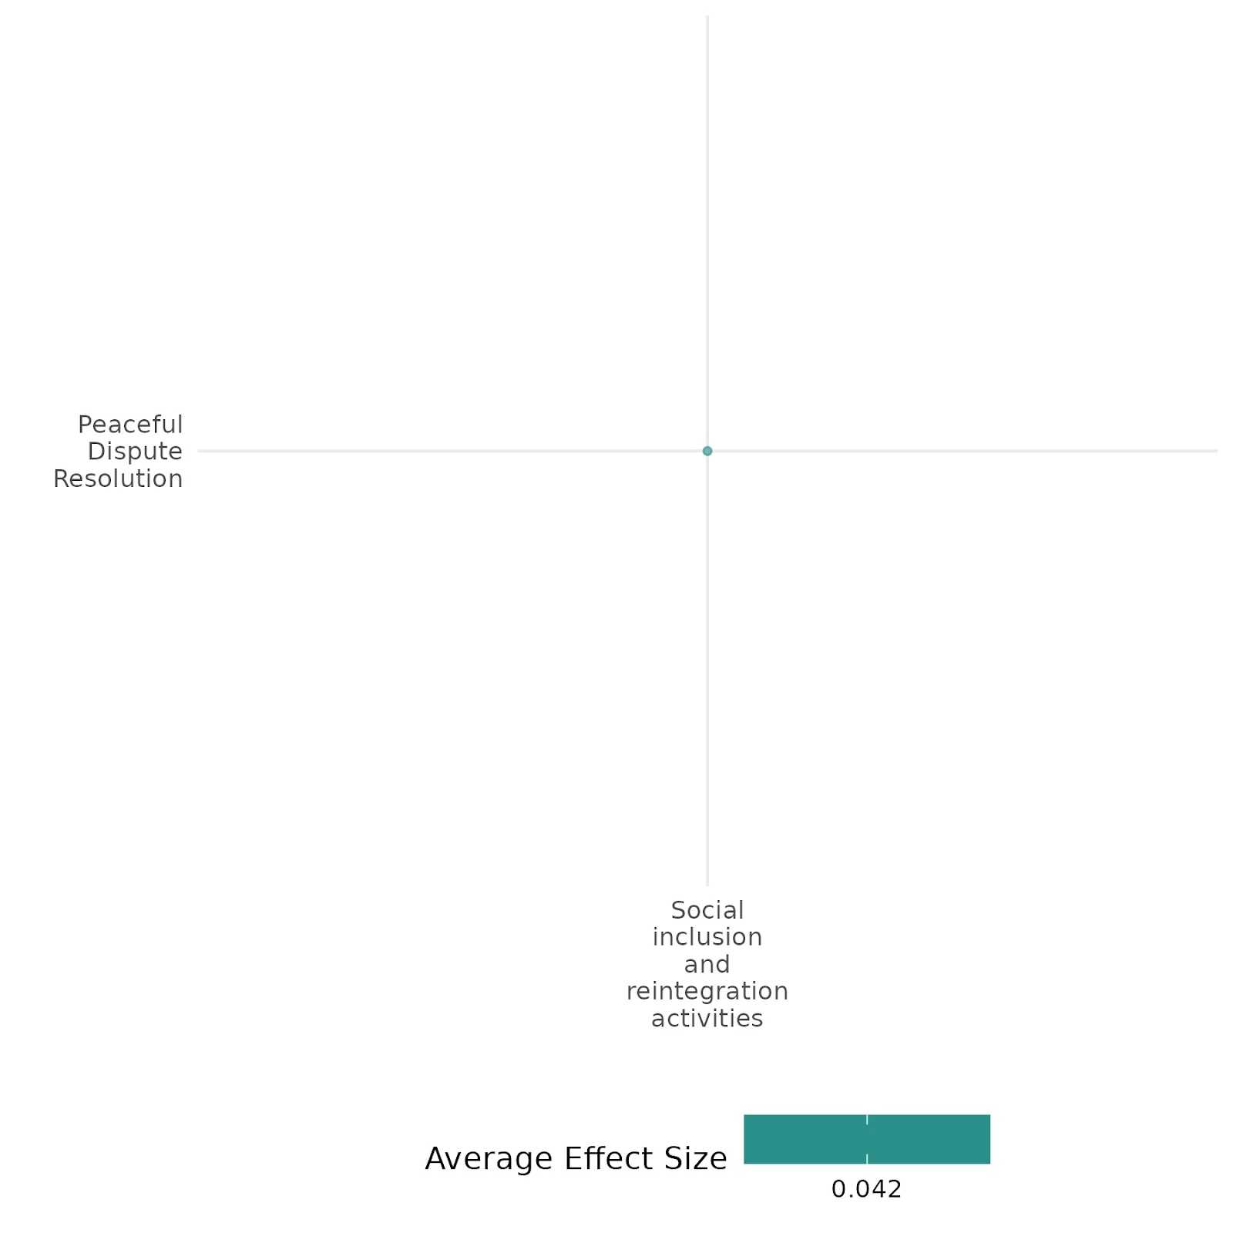

4.3.5(2)
Effect of Social Inclusion & Reintegration Activity on Nature & Scale of Violence or atrocities
The BRA-KDP program had llimited effect on reducing violence. While it did not significantly ease tensions, social divisions among aid recipients, non-recipients, and economic groups seldom led to physical conflict.
Geographical region: East Asia & Pacific
Effect: Small effect (g = 0.012)
Confidence in study findings: Low (1 study with 4 effect size)

Short Summary
The BRA-KDP program in Aceh, Indonesia, was designed to reduce violence and promote social cohesion in 1,724 conflict-affected villages through block grants for community-driven projects. A quasi-experimental study using matching and instrumental variable techniques compared program villages to control villages to assess its impact on violence, social cohesion, and welfare outcomes. Findings indicated that social divisions, such as those between aid recipients and non-recipients or the rich and poor, were prevalent but rarely escalated into violence. The findings suggest that while the program did not significantly reduce the escalation of tensions to physical violence, there were also no significant outbreaks of violence observed in the communities, either in the treatment or control groups. The study highlighted limited impacts due to the program’s short duration, community-driven priorities, and baseline constraints.

The intervention
The Community-Based Assistance for the Reintegration of Conflict Victims (BRA-KDP) in Aceh focused on community-driven development (CDD). It provided block grants to conflict-affected villages, particularly in high-conflict areas. Activities included infrastructure development, livelihood support, and participatory decision-making.

How the intervention is expected to work
The program was designed to empower communities' ability to manage tensions and strengthen the capacity of individuals to resolve conflict through formal mechanisms. Addressing social divisions and enabling inclusive projects aimed to strengthen local dispute resolution mechanisms.

The evidence base
The cell includes two studies: a primary study or IE conducted in Indonesia and a low-confidence qualitative study by Khoury Amal I (2007).

Evidence findings:
The BRA-KDP program had a small effect on violence and did not significantly reduce tensions, although social divisions rarely escalated into physical conflict.

Included studies
The cell includes one low-confidence primary study. The details of the study summary are thus provided here,
Barron (2009): The study evaluated the Community-Based Reintegration Assistance for Conflict Victims Program (BRA-KDP) in Aceh, Indonesia. This intervention aimed to support conflict-affected communities by providing block grants directly to villages. The evaluation used a quasi-experimental design to compare treatment villages that received the program with control villages that did not. Initially planned for two phases across Aceh, only the first phase was completed. Conducted from August to the following year, the program targeted 1,724 villages—about one-third of Aceh's total—across 67 rural sub districts chosen for their conflict impact and success in fund disbursement, ensuring all villages in these sub districts received block grants. To address selection bias, the researchers utilized matching techniques, where treatment villages were matched with control villages based on factors like conflict exposure and village characteristics to ensure comparability. An instrumental variables approach addressed non-compliance and confounding factors, isolating the program's effects. Alternative specifications were used to test the robustness of findings, particularly regarding social divisions and conflict escalation.
The study observed minimal violence and atrocities in both treatment and control villages. Divisions rarely escalated to physical violence in both the treatment and control communities. There is no evidence that the program strengthened the ability of communities to prevent the escalation of tensions to violence. There is some evidence that the program is associated with less acceptance of ex-combatants by conflict victims in the project areas. However, there is no evidence that these tensions escalated to violence. In summary, the findings suggest that while the program did not significantly reduce the escalation of tensions to physical violence, there were also no significant violence outbreaks observed in the communities, either in the treatment or control groups. The study is rated as low confidence.

Confidence assessment
Overall, the cell is rated as low due to the small (n) in the cell and the presence of low confidence in the findings.

The other outcomes assessed
Social cohesion/Feeling of trust & acceptance of diversity. Sense of belonging
Human security/Economic security, Education security, Health security,
Community & state governance/Civic participation, Government performance, Access to justice, rights & Public service
Violence or atrocity prevention/Diplomatic relations & peaceful dispute resolution

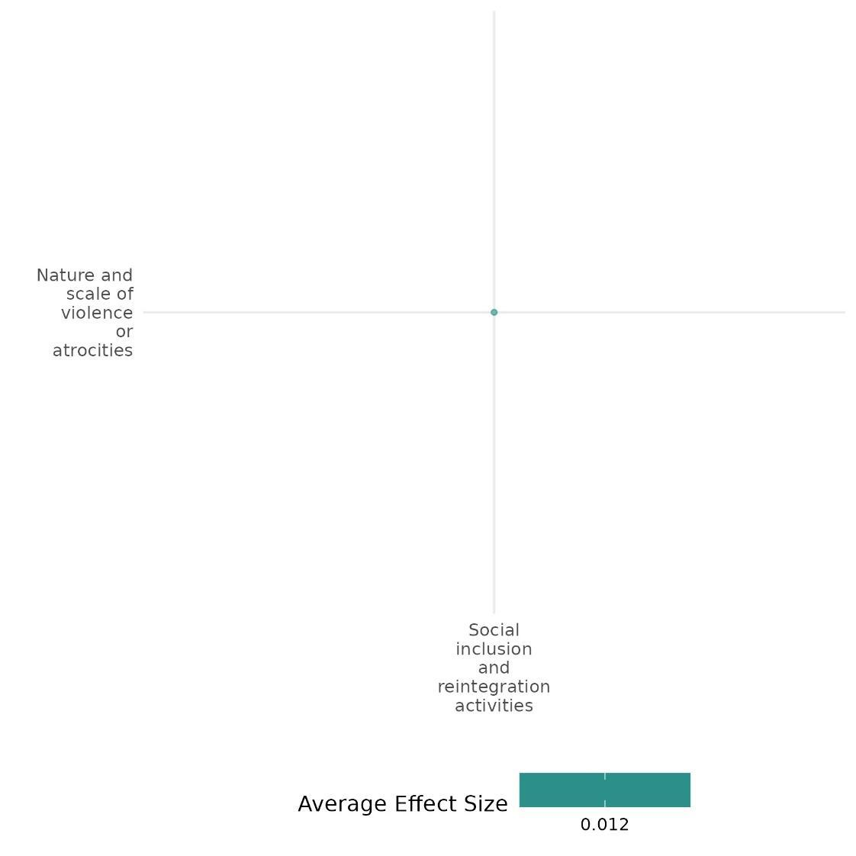

4.3.5(3)
Effect of Social Inclusion & Reintegration Activity on Feeling of Trust & Acceptance of Diversity
The Immigrant Integration Policies and BRA-KDP program indicate that permissive policies enhance diversity acceptance. At the same time, reintegration efforts in conflict-affected areas face challenges.
Geographical regions: East asia & pacific & Europe & Central Asia Indonesia
Effect: Small effect (g=0.056)
Confidence in study findings: low (2 study with 24 effect size)

Short Summary
The Immigrant Integration Policies and Community-Based Reintegration Assistance for Conflict Victims Program (BRA-KDP) were assessed under social inclusion and reintegration policies using cross-national surveys and quasi-experimental designs. Findings suggest that permissive integration policies reduce perceived threats and enhance diversity acceptance, though causal conclusions remain limited. Similarly, reintegration programs in post-conflict settings show overall positive reception but highlight challenges in marginalized group acceptance, particularly ex-combatants. In some cases, reintegration efforts resulted in lower acceptance levels among conflict victims, indicating the complexity of fostering social cohesion through policy interventions in diverse and conflict-affected communities.

The intervention
The BRA-KDP program supported conflict-affected villages by allocating block grants for community-driven development, fostering economic recovery and social reintegration whereas immigrant integration policies promoted inclusive rights and social norms, reducing perceived threats and enhancing diversity acceptance through institutional frameworks and cross-national assessments.

How the intervention is expected to work
The intervention aims to be effective by implementing permissive policies that shape societal norms, fostering tolerance, inclusive attitudes, and harmonious intergroup relations to reduce perceived threats. Additionally, it seeks to engage communities in decision-making, ensure equitable resource distribution to rebuild livelihoods, and strengthen social cohesion and trust in governance in post-conflict settings.

The evidence base
The cell includes three studies: one high-medium confidence systematic review and two low-confidence impact evaluations.
The primary studies were from Indonesia & focused on most group members in European countries.
The systematic review by Lwamba et al. (2022) examines fragile and conflict-affected settings in low- and middle-income countries, particularly in Southeast Asia, Sub-Saharan Africa, Latin America, and the Middle East.

Evidence Findings
Permissive immigrant integration policies promote diversity acceptance, but reintegration in conflict-affected areas struggles to integrate marginalized groups, such as ex-combatants.
Review findings:
Lwamba et al. (2022) review gender-specific and transformative interventions in fragile contexts, including legal rights education, financial inclusion, self-help groups, vocational training, and gender-sensitive policing. These programs aim to empower women, enhance economic opportunities, and promote social cohesion. While community-driven approaches foster trust and improve participation, governance issues and social resistance often hinder progress. Efforts to challenge discriminatory norms increase acceptance of diversity, but deeply rooted biases remain a challenge. Inclusive, context-sensitive strategies are essential for sustainable impact.

Included studies:
The cell contains two low, consistent primary studies. The detailed cell summary thus provided here,
Barron (2009): The study evaluated the Community-Based Reintegration Assistance for Conflict Victims Program (BRA-KDP) in Aceh, Indonesia. This intervention aimed to support conflict-affected communities by providing block grants directly to villages. The evaluation used a quasi-experimental design to compare treatment villages that received the program with control villages that did not. Initially planned for two phases across Aceh, only the first phase was completed. Conducted from August to the following year, the program targeted 1,724 villages—about one-third of Aceh's total—across 67 rural sub districts chosen for their conflict impact and success in fund disbursement, ensuring all villages in these sub districts received block grants. To address selection bias, the researchers utilized matching techniques, where treatment villages were matched with control villages based on factors like conflict exposure and village characteristics to ensure comparability. An instrumental variables approach addressed non-compliance and confounding factors, isolating the program's effects. Alternative specifications were used to test the robustness of findings, particularly regarding social divisions and conflict escalation.
The study found that social acceptance of marginalized groups, such as ex-combatants and internally displaced persons (IDPs), is generally high across communities. However, treatment communities show lower acceptance, particularly among conflict victims and in roles like leaders and close friends. Despite overall high acceptance levels, this unintended negative impact on the inclusion of ex-combatants warrants further investigation. These findings highlight both the program's positive and negative effects on marginalized groups.the study is rated as a low confidence.
Schlueter (2013): examines the impact of immigrant integration policies, assessed using the Migration Integration Policy Index (MIPEX), on perceived group threat among majority group members in European countries. It uses data from two cross-national surveys: Eurobarometer 71.3 (2009), with 21,799 respondents across 25 countries, and the European Values Study (2008-2009), with 34,412 respondents across 27 countries. Multilevel linear regression modelling was employed to analyze the relationship between permissive integration policies and perceptions of group threat, controlling for individual- and country-level variables. The findings reveal that more permissive policies are associated with reduced group threat and greater acceptance of diversity, as they establish societal norms for tolerance and positive intergroup relations. While the study benefits from large, representative samples and replication across datasets, its cross-sectional design limits causal interpretations. Overall, the study is of low quality.

Confidence assessment
Overall, the cell is rated as low due to the small (n) in the cell and the presence of low confidence in the findings.

The other outcomes assessed in the study
Human security/Economic security, Education security, Health security,
Community & state governance/Civic participation, Government performance, Access to justice, rights & public services
Violence or atrocity prevention/Nature and scale of violence or atrocities

Link to review summaries
Lwamba Etienne (2022).
The study may be accessed via the EGM.

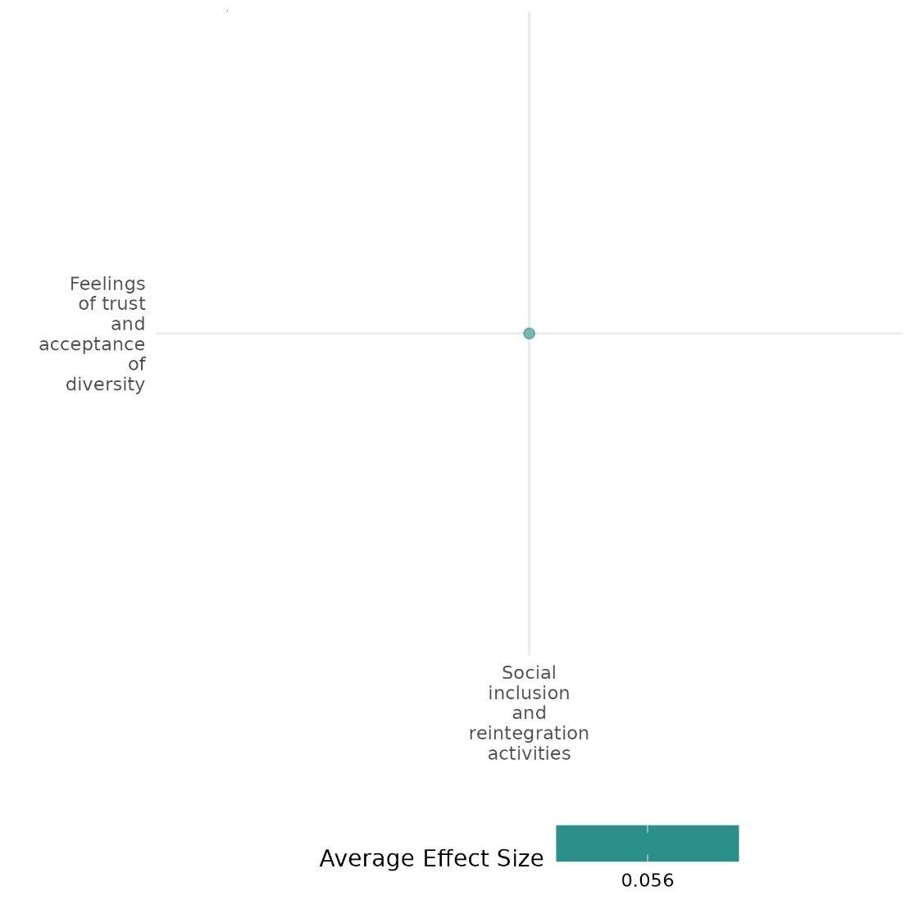

4.3.5(4)
Effect of Social Inclusion & Reintegration Activity on Access to justice, rights & public services

The BRA-KDP program in Aceh documented that Villages that benefited from block grants experienced only slight improvements in public goods accessibility, with findings suggesting limited positive changes in critical areas.
Geographical region: East Asia & Pacific
Effect: Small effect (g = 0.007)
Confidence in study findings: low (1 study with 8 effect size)

Short Summary
The BRA-KDP program aimed to support conflict-affected communities in Aceh by distributing block grants to villages. Conducted across 1,724 villages, The impact on public goods provision was weak, with treatment villages showing more Al Quran schools and mosques, but without strong statistical significance. Most of the program’s funds were used for private economic activities rather than public goods. Findings revealed limited improvements in these areas, with low to medium consistency and quality.

The Intervention
The Community-Based Assistance for the Reintegration of Conflict Victims (BRA-KDP) in Aceh focused on community-driven development (CDD), providing block grants to conflict-affected villages, particularly in high-conflict areas. Activities included infrastructure development, livelihood support, and participatory decision-making.

How the intervention is expected to work
The initiative was created to meet the needs of conflict victims following the Helsinki peace agreement. BRA-KDP focused on enhancing service access by empowering communities to select and carry out projects. These projects could include reconstructing vital infrastructure, such as schools and clinics, or other essential public goods.

The Evidence base
The cell contains two studies: one high-medium confidence systematic review & one low-confidence primary study, which was conducted in Indonesia & used a quasi-experimental design to assess the impact of the intervention on outcomes of interest.

Evidence Findings
The BRA-KDP program in Aceh, Indonesia recorded that villages receiving block grants saw only marginal improvements in public goods accessibility, with findings indicating minimal positive impact in key areas.

The review findings
The review examines interventions improving women’s access to justice, rights, and public services in fragile settings. While legal rights education and gender-sensitive policing increased awareness, long-term impact was limited. Access to healthcare, education, and social services improved but faced gender norms and bureaucratic barriers. Community engagement and institutional collaboration enhanced uptake, yet evidence gaps persist in MENA and Latin America.

Included studies:
The cell contains one low, consistent primary study. The detailed cell summary thus provided here,
Barron (2009): The study evaluated the Community-Based Reintegration Assistance for Conflict Victims Program (BRA-KDP) in Aceh, Indonesia. This intervention aimed to support conflict-affected communities by providing block grants directly to villages. The evaluation used a quasi-experimental design to compare treatment villages that received the program with control villages that did not. Initially planned for two phases across Aceh, only the first phase was completed. Conducted from August to the following year, the program targeted 1,724 villages—about one-third of Aceh's total—across 67 rural sub districts chosen for their conflict impact and success in fund disbursement, ensuring all villages in these sub districts received block grants. To address selection bias, the researchers utilized matching techniques, where treatment villages were matched with control villages based on factors like conflict exposure and village characteristics to ensure comparability. An instrumental variables approach addressed non-compliance and confounding factors, isolating the program's effects. Alternative specifications were used to test the robustness of findings, particularly regarding social divisions and conflict escalation.
The analysis explored the impact of the BDP program on public goods provision in villages. Data from the 2008 village head survey suggest weak evidence linking the program to higher levels of public goods. Treatment communities appeared to have more TPA (Al Quran education) Schools and mosques, but these results lacked strong statistical significance. For other public goods, there was no clear positive or negative impact. This aligns with the finding that only a small portion of program funds were allocated to public goods, as most were used for private economic activities. Overall, the program had minimal influence on public goods provision. The study is rated as a low confidence study.

Confidence assessment
Overall, the cell is rated as low due to the small (n) in the cell and the presence of low confidence in the findings.

Link to review summaries:
Lwamba Etienne (2022).
The study may be accessed via EGM.

The other outcomes were assessed.
Social cohesion/Feeling of trust & acceptance of diversity. Sense of belonging
Human security/Economic security, Education security, Health security,
Community & state governance/Civic participation, Government performance,
Violence or atrocity prevention/Nature and scale of violence or atrocities

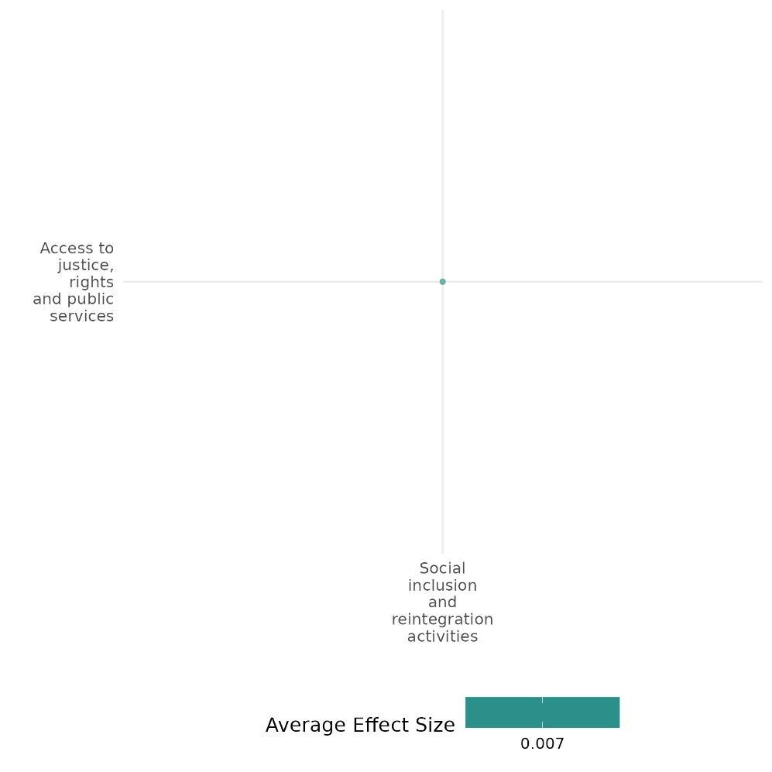

4.3.5(5)
Effect of Social Inclusion & Reintegration Activity on Civic participation
The BRA-KDP program found that while villagers led decisions, their perceived influence was lower in BDP areas, and decision-making efficacy remained low, particularly among conflict victims.
Geographical region: East Asia & Pacific
Effect: No effect (g = 0.003)
Confidence in study findings: low (1 study with 2 effect size)

Short Summary
The BRA-KDP program in Aceh, Indonesia, aimed to support conflict-affected communities through block grants. Using a quasi-experimental design, the study compared program villages with non-recipient ones. While villagers were seen as the primary decision-makers, followed by traditional elders and village government, their perceived influence was lower in BDP communities, despite the program's participatory focus. Overall, decision-making efficacy was low, with conflict victims in treatment areas feeling less influential than those in control groups, though this effect weakened after adjusting for selection biases.

The Intervention
The Community-Based Assistance for the Reintegration of Conflict Victims (BRA-KDP) in Aceh focused on community-driven development (CDD), providing block grants to conflict-affected villages, particularly in high-conflict areas. Activities included infrastructure development, livelihood support, and participatory decision-making.

How the intervention is expected to work:
The initiative was created to meet the needs of conflict victims following the Helsinki peace agreement. BRA-KDP focused on enhancing civic participation access by exposing communities to participatory decision-making and by empowering communities to select and carry out projects. These projects could include reconstructing vital infrastructure, such as schools and clinics, or other essential public goods.

The Evidence base
The cell contains two studies; one high-medium confidence SR & one low confidence IE, which was conducted in Indonesia & used a quasi-experimental design to assess the impact of the intervention on outcomes of interest.

Evidence Findings
Despite its participatory approach, the BRA-KDP program, which provided block grants, aimed to empower communities but saw lower perceived influence of villagers in BDP communities. Decision-making efficacy remained low, particularly for conflict victims in treatment areas, though this effect diminished after adjusting for selection biases.
The review Evidence
Lwamba Etienne (2022) conducted a systematic review on gender-focused interventions in fragile and conflict-affected settings (FCAS), analysing 104 impact evaluations of 14 intervention types. Findings show positive effects on empowerment but weaker impacts on long-term behavioural change. Civic participation increased, yet restrictive gender norms remained a barrier. Collaboration with local institutions facilitated engagement, while gaps in evidence persist for MENA and Latin America.

Included Studies:
The cell contains one low, consistent primary study. The detailed cell summary thus provided here,
Barron (2009): The study evaluated the Community-Based Reintegration Assistance for Conflict Victims Program (BRA-KDP) in Aceh, Indonesia. This intervention aimed to support conflict-affected communities by providing block grants directly to villages. The evaluation used a quasi-experimental design to compare treatment villages that received the program with control villages that did not. Initially planned for two phases across Aceh, only the first phase was completed. Conducted from August to the following year, the program targeted 1,724 villages—about one-third of Aceh's total—across 67 rural sub districts chosen for their conflict impact and success in fund disbursement, ensuring all villages in these sub districts received block grants. To address selection bias, the researchers utilized matching techniques, where treatment villages were matched with control villages based on factors like conflict exposure and village characteristics to ensure comparability. An instrumental variables approach addressed non-compliance and confounding factors, isolating the program's effects. Alternative specifications were used to test the robustness of findings, particularly regarding social divisions and conflict escalation.
The study found that While villagers were seen as the primary decision-makers, followed by traditional elders and village government, their perceived influence was lower in BDP communities, despite the program's participatory focus. Overall, decision-making efficacy was low, with conflict victims in treatment areas feeling less influential than those in control groups, though this effect weakened after adjusting for selection biases. The study is rated as a low confidence.

Link to review study summaries:
Lwamba Etienne (2022).
The study may be accessed via EGM.

Confidence assessment
Overall, the cell is rated as low due to the small (n) in the cell and the presence of low confidence in the findings.

The other outcomes assessed in the study
Social cohesion/Feeling of trust & acceptance of diversity. Sense of belonging
Human security/Economic security, Education security, Health security,
Community & state governance/Government performance,
Violence or atrocity prevention/Nature and scale of violence or atrocities

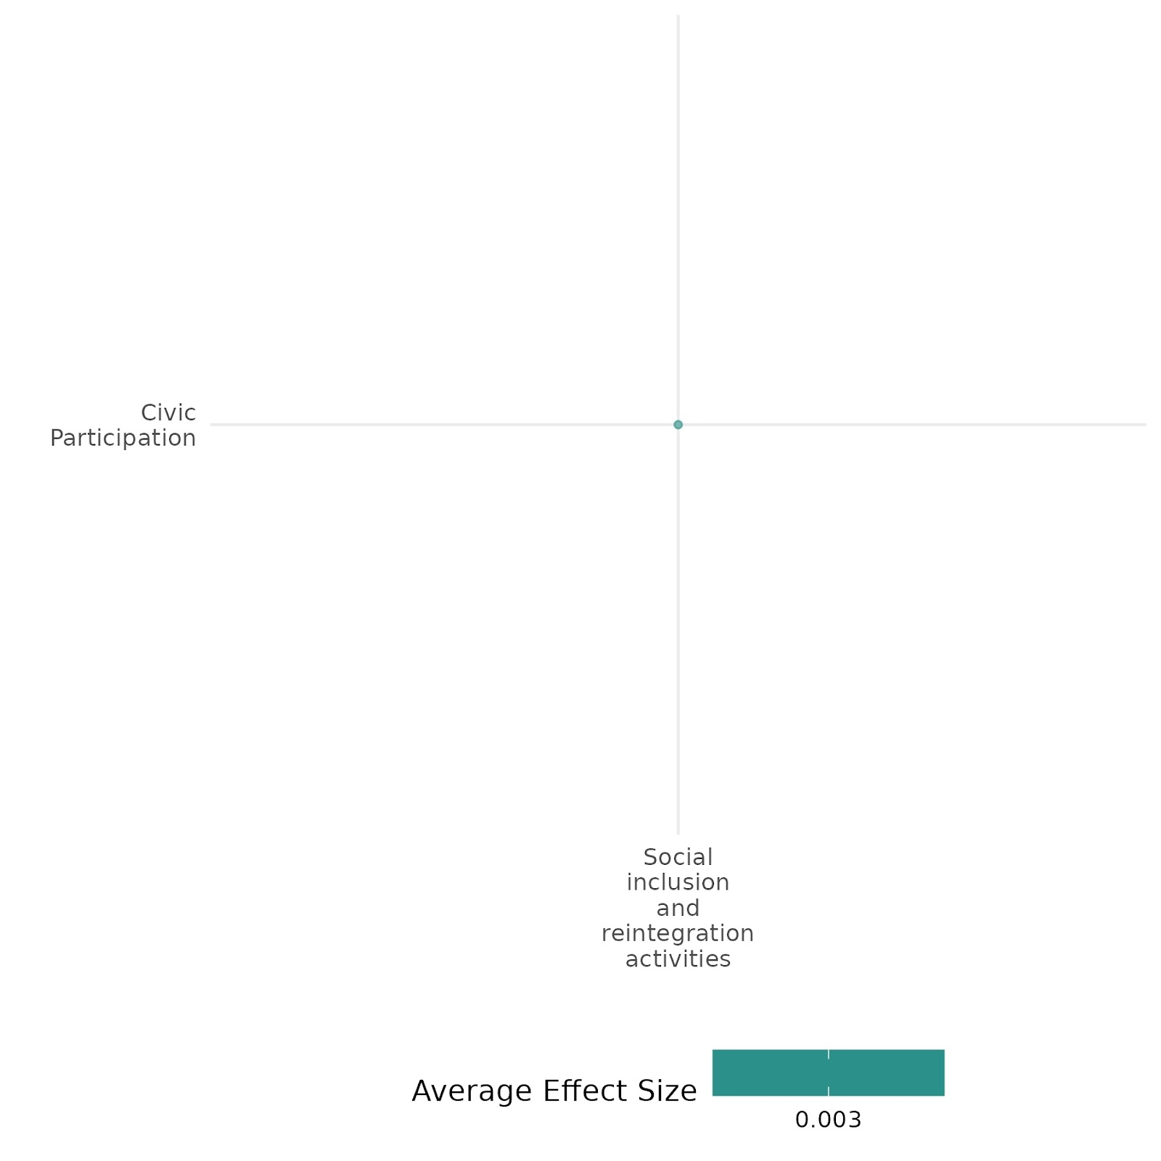

4.3.5(6)
Effect of Social Inclusion & Reintegration Activity on Government Performance
The BRA-KDP program had limited impact on village-level attitudes. However, it boosted confidence in higher government, highlighting the need for broader, long-term strategies.
Geographical region: East Asia & Pacific
Effect: No effect (g = 0)
Confidence in study findings: low (1 study with 4 effect size)

Short Summary
The study evaluated the BRA-KDP program in Aceh, Indonesia, which provided block grants to support conflict-affected communities in 1,724 villages. Using a quasi-experimental design, it compared villages that received the program to those that did not. While the program aimed to improve trust in local government and democratic support, its impact was limited. There was no improvement in trust in village or district governments, though confidence in higher levels of government increased, possibly due to credit being attributed to them. The lack of local improvements may be attributed to the program's short duration and limited scope in addressing deeper governance issues.

The Intervention
The Community-Based Assistance for the Reintegration of Conflict Victims (BRA-KDP) in Aceh focused on community-driven development (CDD), providing block grants to conflict-affected villages, particularly in high-conflict areas. Activities included infrastructure development, livelihood support, and participatory decision-making.

How the intervention is expected to work
The BRA-KDP program aimed to improve government performance by increasing local community involvement in decision-making and enhancing transparency. By fostering trust in authorities and promoting civic engagement, the program strengthened social cohesion and supported the reintegration of conflict victims, ultimately improving governance in affected villages.
‘
The Evidence base
The cell contains one primary study, which was conducted in Indonesia & used a quasi-experimental design to assess the impact of the intervention on outcomes of interest.

Evidence Findings
The BRA-KDP documented that While the program did not significantly improve attitudes toward local governance, it fostered greater confidence in higher levels of government.

Included studies:
The detailed cell summary thus provided here,
Barron (2009) =: The study evaluated the Community-Based Reintegration Assistance for Conflict Victims Program (BRA-KDP) in Aceh, Indonesia. This intervention aimed to support conflict-affected communities by providing block grants directly to villages. The evaluation used a quasi-experimental design to compare treatment villages that received the program with control villages that did not. Initially planned for two phases across Aceh, only the first phase was completed. Conducted from August to the following year, the program targeted 1,724 villages—about one-third of Aceh's total—across 67 rural subdistricts chosen for their conflict impact and success in fund disbursement, ensuring all villages in these subdistricts received block grants. To address selection bias, the researchers utilized matching techniques, where treatment villages were matched with control villages based on factors like conflict exposure and village characteristics to ensure comparability. An instrumental variables approach addressed non-compliance and confounding factors, isolating the program's effects. Alternative specifications were used to test the robustness of findings, particularly regarding social divisions and conflict escalation.
The BRA-KDP program aimed to enhance trust and awareness of local government, but its impact on key indicators of attitudes toward government was limited. There was no significant change in trust levels or support for democracy. Respondents generally felt they had a role in local decision-making, but their perceptions of political efficacy remained low. In fact, some villagers in program areas reported feeling less influential in community decision-making, contrary to the program's empowerment goals. Behavioral measures also showed no improvement in trust in village or district government. However, the program did appear to increase confidence in subdistrict, district, and provincial governments, likely due to their involvement in facilitating the program. This could suggest that the program’s credit was attributed to these higher levels of government, as subdistrict facilitators played a key role, while district government had less involvement. The lack of improvements in trust at the local level may be attributed to the short duration of the program and its limited scope in addressing deeper governance issues. The study is rated as a low-confidence study.

Confidence assessment
Overall, the cell is rated as low due to the small (n) in the cell and the presence of low confidence in the findings.

The other outcomes assessed in the study
Social cohesion/Feeling of trust & acceptance of diversity. Sense of belonging
Human security/Economic security, Education security, Health security,
Community & state governance/Civic Participation
Violence or atrocity prevention/Nature and scale of violence or atrocities

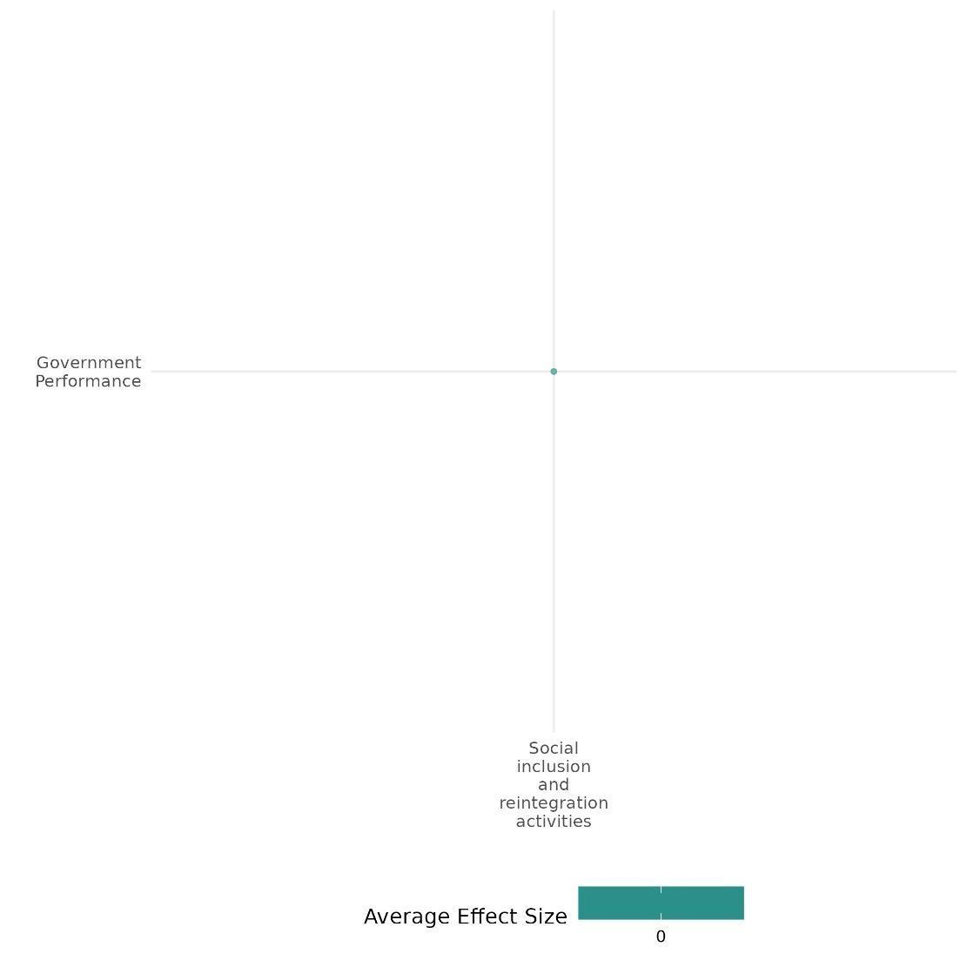

4.3.5(7)
Effect of Social Inclusion & Reintegration Activity on Economic Security.
The BRA-KDP program documented reducing poverty by 11% and increasing asset ownership and indirect economic benefits for conflict victims. However, it did not significantly impact housing, water access, employment, or wages.
Geographical region: East Asia & Pacific
Effect: Small effect (g = 0.036)
Confidence in study findings: Low (1 study with 7 Effect size)

Short Summary
The study evaluated the Community-Based Reintegration Assistance for Conflict Victims Program (BRA-KDP) in Aceh, Indonesia, which provided direct block grants to conflict-affected communities. Using a quasi-experimental design, researchers compared 1,724 villages that received the program to control villages. Researchers matched treatment and control villages to address selection bias and used instrumental variables to isolate the program's effects. The findings revealed an 11% reduction in poverty and increased asset ownership, particularly in motorbikes and agricultural machinery, benefiting conflict victims. These gains likely stemmed from indirect economic benefits rather than direct funding. However, there were no significant impacts on housing quality, clean water access, employment rates, or wages. Overall, the program contributed to improved earnings for lower-income households.

The intervention
The Community-Based Assistance for the Reintegration of Conflict Victims (BRA-KDP) in Aceh focused on community-driven development (CDD), providing block grants to conflict-affected villages, particularly in high-conflict areas. Activities included infrastructure development, livelihood support, and participatory decision-making.

How the intervention is expected to work
The BRA-KDP program improved economic security in conflict-affected Aceh by providing block grants directly to villages. Communities prioritized funds for cash disbursements, boosting asset ownership. This approach aimed to reduce poverty and support local economic recovery through community-driven decision-making.

The Evidence base
The cell contains two studies: one high-medium confidence systematic review & one primary study, which was conducted in Indonesia & used a quasi-experimental design to assess the impact of the intervention on outcomes of interest.

Evidence Findings
The BRA-KDP program reduced poverty by 11%, increased asset ownership, and provided indirect economic benefits to conflict victims. However, it did not significantly impact housing, water access, employment, or wages.

The review Evidence
The review examines gender-focused economic interventions in fragile and conflict-affected settings (FCAS) across 29 countries. It finds limited evidence from the Middle East and North Africa due to gender inequality and instability. While cash transfers and microfinance improved financial access, long-term independence was hindered by social norms. Vocational training and entrepreneurship increased employment but faced cultural barriers. Community-driven development encouraged participation but had limited economic impact.

Included studies
The cell contains one low, consistent primary study. The detailed cell summary thus provided here,
Barron (2009): The study evaluated the Community-Based Reintegration Assistance for Conflict Victims Program (BRA-KDP) in Aceh, Indonesia. This intervention aimed to support conflict-affected communities by providing block grants directly to villages. The evaluation used a quasi-experimental design to compare treatment villages that received the program with control villages that did not. Initially planned for two phases across Aceh, only the first phase was completed. Conducted from August to the following year, the program targeted 1,724 villages—about one-third of Aceh's total—across 67 rural sub districts chosen for their conflict impact and success in fund disbursement, ensuring all villages in these sub districts received block grants. To address selection bias, the researchers utilized matching techniques, where treatment villages were matched with control villages based on factors like conflict exposure and village characteristics to ensure comparability. An instrumental variables approach addressed non-compliance and confounding factors, isolating the program's effects. Alternative specifications were used to test the robustness of findings, particularly regarding social divisions and conflict escalation.
After accounting for selection effects, the study observed that BRA-KDP reduced poverty by 11% in conflict-affected communities. The program led to moderate gains in asset ownership, notably in engine motorbikes and agricultural machinery. Motorcycle ownership increased significantly for conflict victims, suggesting indirect economic benefits rather than direct program funding. However, BRA-KDP did not impact access to quality housing, clean water, employment rates, or wages. While direct income data is unavailable, poverty reductions suggest improved earnings, especially for lower-income households. The study is rated as a low confidence.

Confidence assessment
Overall, the cell is rated as low due to the small (n) in the cell and the presence of low confidence in the findings.

Link to review study summaries:
Lwamba Etienne (2022).
The study may be accessed via EGM.

The other outcomes assessed in the study
Social cohesion/Feeling of trust & acceptance of diversity. Sense of belonging
Human security/Education security, Health security,
Community & state governance/Government performance,
Violence or atrocity prevention/Nature and scale of violence or atrocities

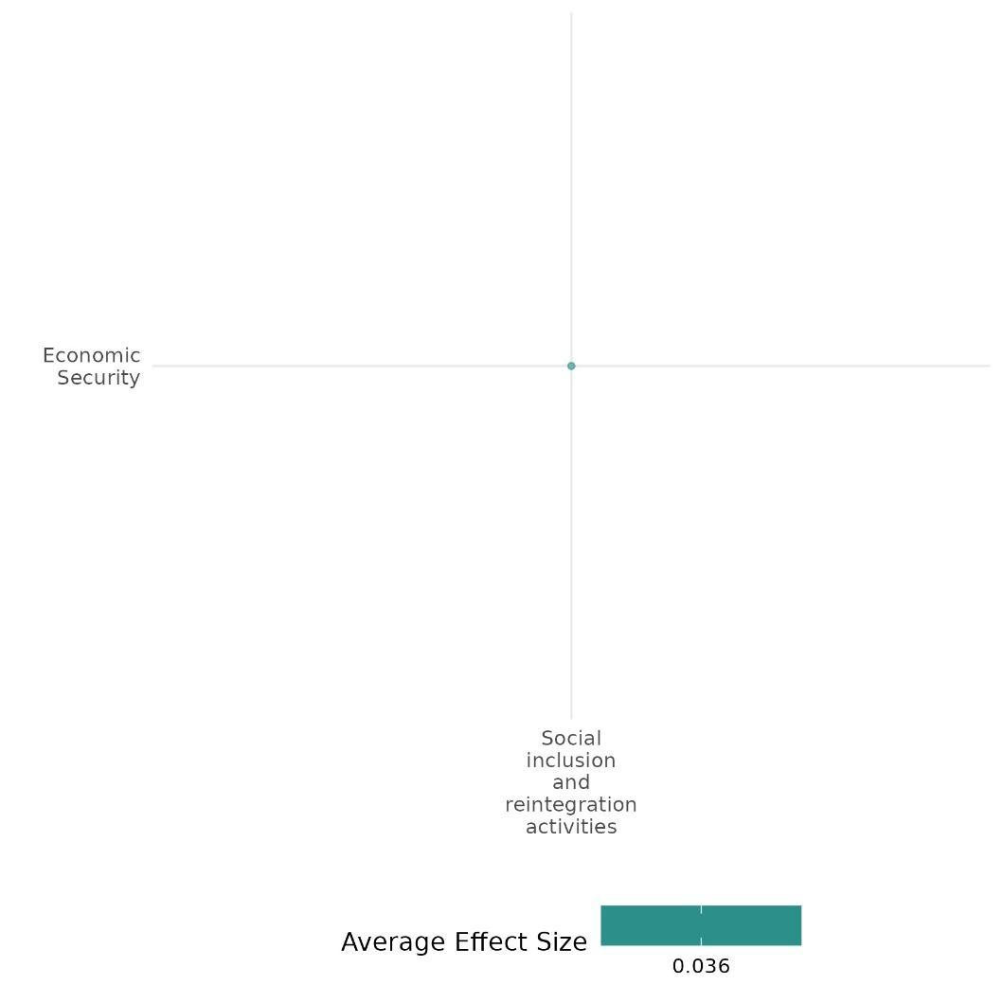

4.3.5(8)
Effect of Social Inclusion & Reintegration Activity on Educational Security
The BRA-KDP program in Aceh, Indonesia showed no significant improvement in school attendance rate, with limited program impact attributed to its short duration and community-driven focus.
Geographic region: East Asia & Pacific
Effect: No effect (g=0.000)
Confidence in study findings: low ( 1 study with 1 Effect size)

Short Summary
The study evaluated the Community-Based Reintegration Assistance for Conflict Victims Program (BRA-KDP) in Aceh, Indonesia, targeting conflict-affected communities with block grants to support village development. Using a quasi-experimental design, researchers compared outcomes in 1,724 treatment villages across 67 sub districts with control villages, employing matching techniques and instrumental variables to address bias and ensure robust findings. In terms of educational security, the program's impact was measured by school enrollment rates, but no significant differences were found between treatment and control communities. The study is rated as a low to medium finding.

The intervention
The Community-Based Assistance for the Reintegration of Conflict Victims (BRA-KDP) in Aceh focused on community-driven development (CDD), providing block grants to conflict-affected villages, particularly in high-conflict areas. Activities included infrastructure development (public services), livelihood support, and participatory decision-making.

How the intervention is expected to work
The program is designed to empower conflict-affected communities through financial support to villages, enabling investments in public goods and services. By fostering inclusive participation and addressing local needs, the program aims to enhance educational security.

The evidence base
The cell contains one primary study, which was conducted in Indonesia. There is a low to medium degree of consistency in the findings. The details of the study summary are thus provided here,

Evidence findings
The BRA-KDP program showed no significant improvement in school attendance rate, with limited program impact attributed to its short duration and community-driven focus.

Included studies
The cell contains one low, consistent primary study. The detailed cell summary thus provided here,
Barron (2009): The study evaluated the Community-Based Reintegration Assistance for Conflict Victims Program (BRA-KDP) in Aceh, Indonesia. This intervention aimed to support conflict-affected communities by providing block grants directly to villages. The evaluation used a quasi-experimental design to compare treatment villages that received the program with control villages that did not. Initially planned for two phases across Aceh, only the first phase was completed. Conducted from August to the following year, the program targeted 1,724 villages—about one-third of Aceh's total—across 67 rural sub districts chosen for their conflict impact and success in fund disbursement, ensuring all villages in these sub districts received block grants. To address selection bias, the researchers utilized matching techniques, where treatment villages were matched with control villages based on factors like conflict exposure and village characteristics to ensure comparability. An instrumental variables approach addressed non-compliance and confounding factors, isolating the program's effects. Alternative specifications were used to test the robustness of findings, particularly regarding social divisions and conflict escalation.
The research examined school enrollment rates and found no significant differences in educational outcomes between communities involved in the BPD program and those that were not. There is also limited evidence of improvements in education within project areas. Additionally, the study assessed violence escalation, conflict resolution, material well-being (poverty reduction and asset ownership), social cohesion (social acceptance and community participation), trust in government, welfare perceptions, and infrastructure development. The study is rated as a low confidence.

Confidence assessment
Overall, the cell is rated as low due to the small (n) in the cell and the presence of low confidence in the findings.

Link to review study summaries:
Lwamba Etienne (2022).
The study may be accessed via EGM.

The other outcomes assessed in the study
Social cohesion/Feeling of trust & acceptance of diversity. Sense of belonging
Human security/Economic security, Education security, Health security,
Community & state governance/Government performance,
Violence or atrocity prevention/Nature and scale of violence or atrocities
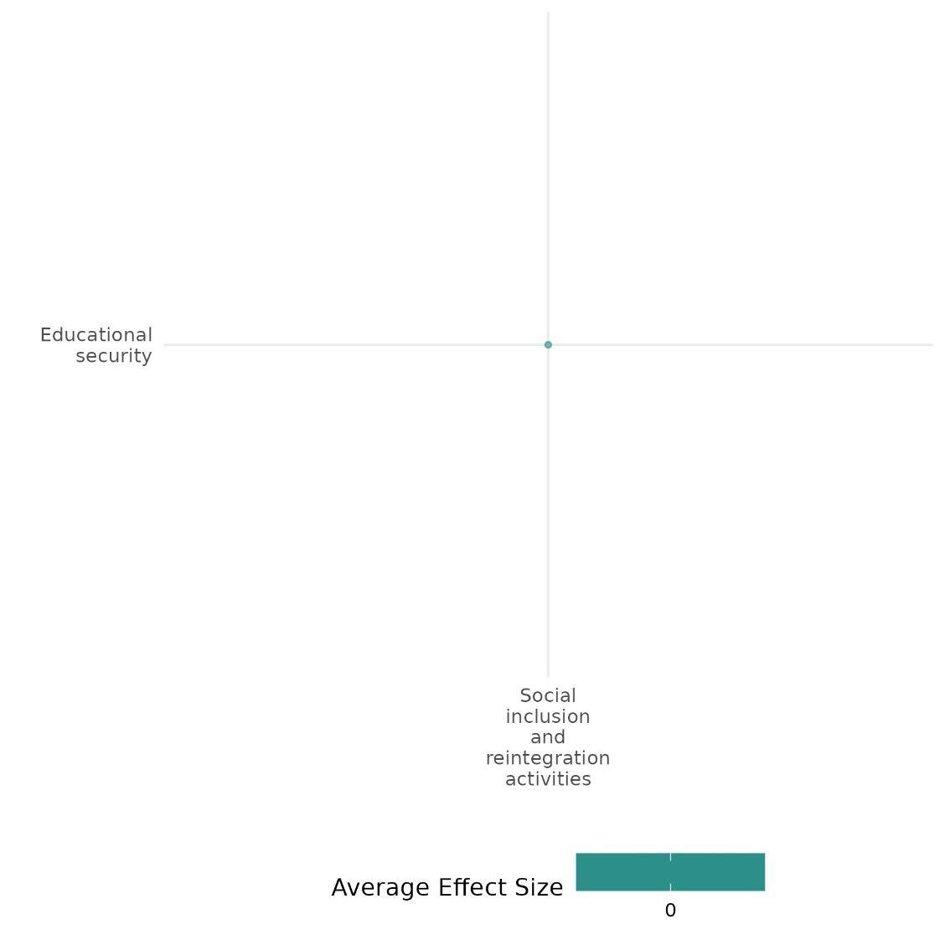

4.3.5(9)
Effect of Social Inclusion & Reintegration Activity on Food Security & Nutrition & Health Security
The BRA-KDP program showed no significant health improvements, with limited program impact attributed to its short duration and community-driven focus.
Geographical region: East Asia & Pacific
Effect: Small effect (g = -0.027)
Confidence in study findings: low (1 study with 2 effect size)

Short Summary
The study evaluated the Community-Based Reintegration Assistance for Conflict Victims Program (BRA-KDP) in Aceh, Indonesia, which aimed to support conflict-affected communities through block grants to villages. Using a quasi-experimental design, the research compared treatment villages with control villages, employing matching techniques to ensure comparable groups based on conflict exposure. The program targeted 1,724 villages across 67 rural subdistricts. Health outcomes measured by sickness incidence showed no significant differences between intervention and control communities, indicating the program's limited impact on health security.

The intervention
The Community-Based Assistance for the Reintegration of Conflict Victims (BRA-KDP) in Aceh focused on community-driven development (CDD), providing block grants to conflict-affected villages, particularly in high-conflict areas. Activities included infrastructure development, livelihood support, and participatory decision-making.

How the intervention is expected to work
The intervention aimed to reduce violence by promoting community collaboration on shared projects. By fostering inclusive decision-making and equitable resource distribution, the program sought to build trust, address grievances, and decrease incentives for violent conflict.

The evidence base
The cell contains one primary study, which was conducted in Indonesia. There is a low to medium degree of consistency in the findings. The details of the study summary are thus provided here,

Evidence findings
The BRA-KDP program showed no significant health improvements, with limited program impact attributed to its short duration and community-driven focus.

Included studies:
The cell includes one primary study. the details summary thus provided here
Barron (2009): The study evaluated the Community-Based Reintegration Assistance for Conflict Victims Program (BRA-KDP) in Aceh, Indonesia. This intervention aimed to support conflict-affected communities by providing block grants directly to villages. The evaluation used a quasi-experimental design to compare treatment villages that received the program with control villages that did not. Initially planned for two phases across Aceh, only the first phase was completed. Conducted from August to the following year, the program targeted 1,724 villages—about one-third of Aceh's total—across 67 rural sub districts chosen for their conflict impact and success in fund disbursement, ensuring all villages in these sub districts received block grants. To address selection bias, the researchers utilized matching techniques, where treatment villages were matched with control villages based on factors like conflict exposure and village characteristics to ensure comparability. An instrumental variables approach addressed non-compliance and confounding factors, isolating the program's effects. Alternative specifications were used to test the robustness of the findings.The study observed that sickness incidence does not show any significant difference in health outcomes between communities that received the program and those that did not. There is no evidence that intervention communities experience better or worse health outcomes than control villages. There is also limited evidence of improvements in health within project areas. The study is rated as a low confidence study.

Confidence assessment
Overall, the cell is rated as low due to the small (n) in the cell and the presence of low confidence in the findings.

The other outcomes assessed in the study
Social cohesion/Feeling of trust & acceptance of diversity. Sense of belonging
Human security/Economic security, Education security, Health security,
Community & state governance/Government performance,
Violence or atrocity prevention/Nature and scale of violence or atrocities

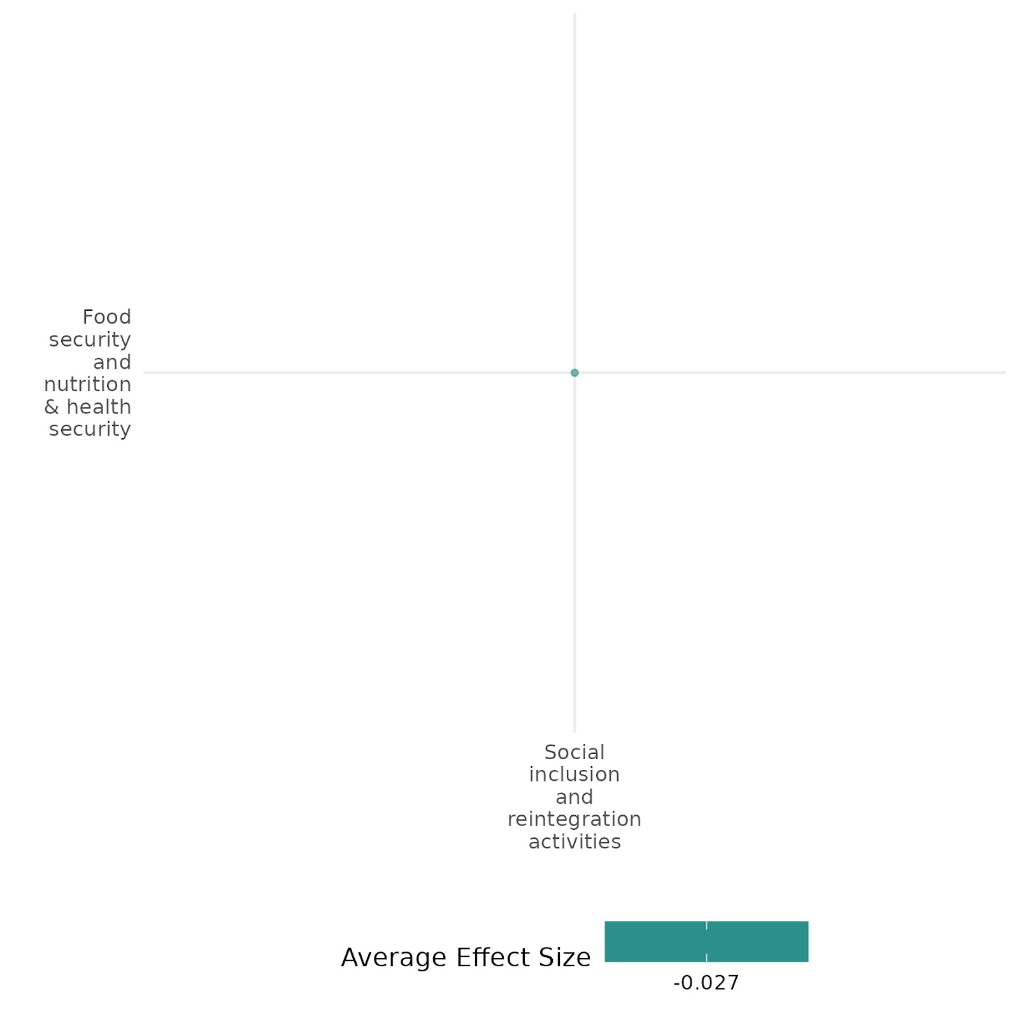

4.3.5(10)
Effect of Social Inclusion & Reintegration Activity on Environmental security
The BRA-KDP program had limited impact on water access. Conflict victims faced greater insecurity, but no significant differences were found between intervention and non-intervention communities.
Geographical region: East Asia & Pacific
Effect: Small effect (g= 0.045)
Confidence in study findings: low (1 study with 1 effect size)

Short Summary
The study evaluated the Community-Based Reintegration Assistance for Conflict Victims Program (BRA-KDP) in Aceh, Indonesia, which aimed to support conflict-affected communities through block grants to villages. Using a quasi-experimental design, the research compared treatment villages with control villages, employing matching techniques to ensure comparable groups based on conflict exposure. The program targeted 1,724 villages across 67 rural subdistricts. The study observed that Less than two-thirds of respondents have access to clean or protected water sources. Conflict victims face greater water insecurity than non-conflict victims. However, there is no significant difference in access between treatment and control communities, indicating limited intervention impact on water availability.

The intervention
The Community-Based Assistance for the Reintegration of Conflict Victims (BRA-KDP) in Aceh focused on community-driven development (CDD), providing block grants to conflict-affected villages, particularly in high-conflict areas. Activities included infrastructure development, livelihood support, and participatory decision-making.

How the intervention is expected to work
The intervention aimed to reduce violence by promoting community collaboration on shared projects. By fostering inclusive decision-making and equitable resource distribution, the program sought to build trust, address grievances, and decrease incentives for violent conflict.

The evidence base
The cell contains one primary study, which was conducted in Indonesia. There is a low to medium degree of consistency in the findings.
Evidence findings
The BRA-KDP program showed no significant health improvements, with limited program impact attributed to its short duration and community-driven focus.

Included studies:

Barron (2009): The study evaluated the Community-Based Reintegration Assistance for Conflict Victims Program (BRA-KDP) in Aceh, Indonesia. This intervention aimed to support conflict-affected communities by providing block grants directly to villages. The evaluation used a quasi-experimental design to compare treatment villages that received the program with control villages that did not. Initially planned for two phases across Aceh, only the first phase was completed. Conducted from August to the following year, the program targeted 1,724 villages—about one-third of Aceh's total—across 67 rural sub districts chosen for their conflict impact and success in fund disbursement, ensuring all villages in these sub districts received block grants. To address selection bias, the researchers utilized matching techniques, where treatment villages were matched with control villages based on factors like conflict exposure and village characteristics to ensure comparability. An instrumental variables approach addressed non-compliance and confounding factors, isolating the program's effects. Alternative specifications were used to test the robustness of the findings. The study observed that Less than two-thirds of respondents have access to clean or protected water sources. Conflict victims face greater water insecurity than non-conflict victims. However, there is no significant difference in access between treatment and control communities, indicating limited intervention impact on water availability. The study is rated as a low confidence study.

Confidence assessment
Overall, the cell is rated as low due to the small (n) in the cell and the presence of low confidence in the findings.

The other outcomes assessed in the study
Social cohesion/Feeling of trust & acceptance of diversity. Sense of belonging
Human security/Economic security, Education security, Health security,
Community & state governance/Government performance,
Violence or atrocity prevention/Nature and scale of violence or atrocities

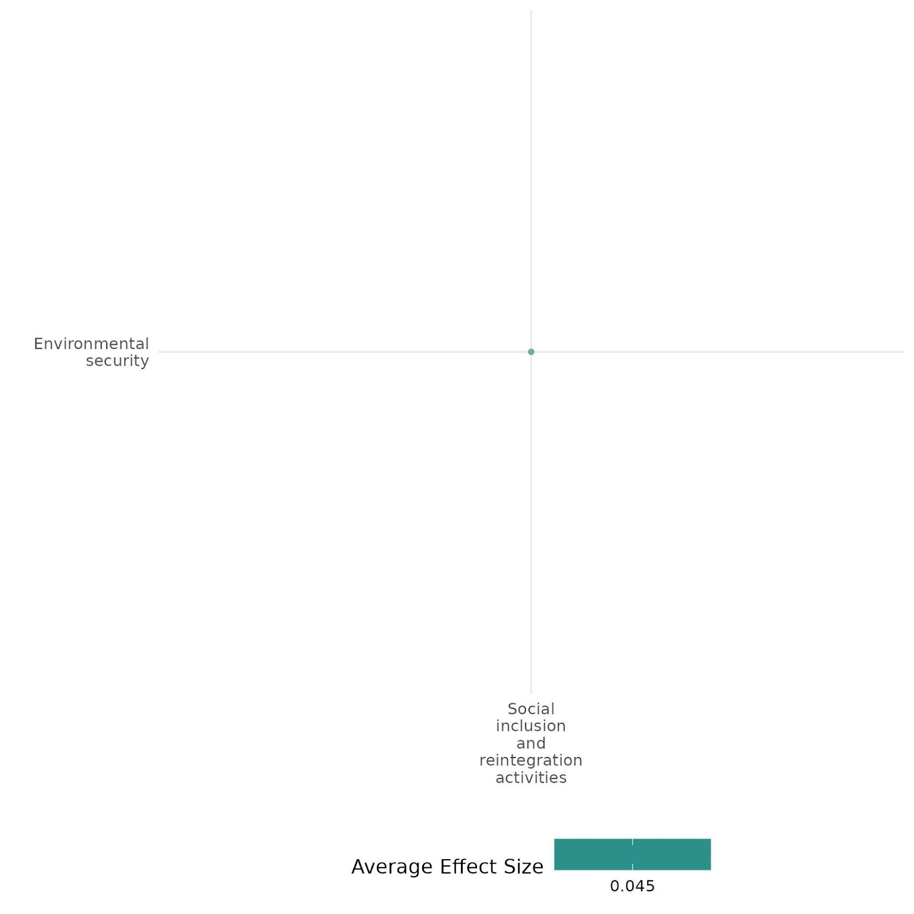

4.4 Civil Society

4.4.1 Civil society capacity building + Civic engagement and empowerment initiatives
4.4.1 (1)
Civil society capacity building and civic engagement and empowerment initiatives on nature and scale of violence and atrocities
The cell analysed fiscal assistance and work-for-relief grants, boosting security spending but mixed effects on ethnic violence and rural development.
Geographical region: East Asia & Pacific
Effect size: Adverse effect (g=-0.088)
Confidence in study findings: Low confidence (01 study; 2 ES)

Short summary
The cell analyses poverty alleviation transfers in Xinjiang under China's "8-7 Plan" (1994–2000). While transfers boosted local government spending on security (15%) and administration (10%), their impact on ethnic violence was mixed, and rural agricultural development showed limited improvement. Ethnic tensions persisted. We have low confidence due to a limited number of studies in the cell.
The intervention
The intervention involved poverty alleviation transfers under China's "8-7 Plan," funding infrastructure projects (roads, power grids, water facilities) to address economic disparities and ethnic grievances in Xinjiang, enhancing administrative and security capacity in conflict-prone regions.
How the intervention is expected to work
The intervention aimed to alleviate poverty and reduce ethnic violence in Xinjiang by financing infrastructure projects under the "8-7 Plan." By improving roads, power grids, and water facilities, it sought to enhance economic development and address grievances among marginalized groups. Additionally, increased fiscal transfers were expected to strengthen local government administrative and security capacity, enabling better governance, surveillance, and conflict prevention. The intervention hypothesized that improved infrastructure and state presence would mitigate ethnic tensions by fostering economic inclusion, enhancing public services, and increasing government control in this ethnically diverse, conflict-prone region.
The evidence base
The cell includes one primary study and two systematic reviews. There is a high degree of consistency in the review findings. The review is concerned with the interventions including civil society capacity building and empowerment initiatives.
The Xinjiang study utilized a county-level panel data analysis from 1994 to 2000. It was conducted in Xinjiang, China.
Evidence findings
The study found that poverty alleviation in Xinjiang increased government security spending but had an ambiguous impact on ethnic violence. Fiscal assistance intensified violence, while work-for-relief grants showed mixed effects.
The review evidence
Civil society initiatives can reduce violence by fostering social cohesion, empowerment, and governance. However, poor implementation or elite co-option may exacerbate tensions, limiting effectiveness in preventing atrocities.
The impact evaluation evidence
Cheng (2021) focuses on the impact of poverty alleviation transfers in Xinjiang on ethnic violence and state-building. The Chinese government allocated significant fiscal assistance and work-for-relief grants under the "8-7 Plan" (1994–2000) to alleviate poverty in Xinjiang, a peripheral and ethnically diverse region prone to instability. The intervention financed infrastructure like roads, power grids, and water facilities to mitigate economic disparities and ethnic grievances. The study employs a county-level panel dataset, using covariate balancing propensity scores (CBPS) and instrumental variable regression to estimate causal effects. The analysis covers all counties in Xinjiang, utilizing data on fiscal transfers, demographic variables, and incidents of ethnic violence from 1994 to 2000. The intervention increased government spending on public security, However, its impact on reducing ethnic violence was ambiguous. Fiscal assistance correlated with intensified violence, while work-for-relief grants had mixed effects. Ethnic violence remained persistent in nearly a third of counties. The study is rated as high and medium confidence quantitative study.
Confidence assessment
We have low confidence due to there being only one study in the cell.
Link to review summaries
Cramer (2016)
Spangaro Jo (2021)
Other outcomes in the study/cell
- Human security/Physical security/Economic security



4.4.1 (2)
Civil society capacity building and civic engagement and empowerment initiatives on social norms regarding violence and atrocities
Civic education in Kenya reduced acceptance of violence, while Somalia’s SYLI program significantly decreased youth support for political violence through secondary education and civic engagement, fostering tolerance and non-violent conflict resolution.
Geographical region: Sub Saharan Africa
Effect size: Moderate effect (g=0.102)
Confidence in study findings: Low confidence (2 studies; 14 ES)

Short summary
Civil society capacity building and civic engagement initiatives played a crucial role in reducing political violence by promoting political knowledge, increasing civic participation, and fostering ethnic tolerance. These efforts significantly strengthened opposition to violence, encouraging peaceful conflict resolution in polarized environments. Education, particularly when combined with civic engagement, led to substantial reductions in youth support for political violence, reinforcing non-violent social norms. These findings highlight the importance of tailored strategies in shaping social norms against violence. We have low confidence in the cell due to a limited number of studies.
The intervention
The Second Kenya National Civic Education Programme (NCEP II-Uraia) provided civic education to promote democratic awareness, ethnic tolerance, and governance, aiming to reduce violence and improve political engagement during Kenya's politically tense period. The Somali Youth Learners Initiative (SYLI) combined secondary education with civic engagement to reduce youth support for political violence. SYLI constructed schools, trained teachers, and organized youth-led initiatives to foster non-violent conflict resolution and community participation, addressing Somalia’s challenges of violence and instability.
How the intervention is expected to work
Both interventions aimed to address underlying drivers of violence by promoting knowledge, participation, and tolerance. In Kenya, civic education under NCEP II-Uraia was expected to enhance citizens' understanding of democracy, governance, and rights, reducing acceptance of violence by fostering ethnic tolerance and peaceful conflict resolution. In Somalia, SYLI's combined approach of improving access to secondary education and civic engagement sought to empower youth with skills, optimism about future opportunities, and confidence in non-violent change. By addressing grievances, providing alternatives to violence, and strengthening trust in government and community structures, both interventions aimed to create long-term resilience against political violence.
The evidence base
The cell includes two primary studies, one study used a matched treatment-control design, surveying 3,600 individuals. It was conducted in Kenya. The second study employed a quasi-experimental design and was conducted in Puntland and South-Central Somalia.
Evidence findings
Civil society capacity building and civic engagement initiatives significantly reduced support for political violence by enhancing opposition to violence, fostering ethnic tolerance, and promoting peaceful conflict resolution. Education combined with civic engagement further strengthened non-violent norms, particularly among women and urban youth.
Included studies
Finkel (2012) focuses on the Second Kenya National Civic Education Programme (NCEP II-Uraia), implemented from 2006 to 2007. It aimed to enhance democratic awareness, ethnic tolerance, and governance in Kenya amid ethnic tensions and post-2007 election violence. Conducted in Kenya, the study involved a matched treatment-control design, surveying 3,600 individuals (1,800 participants and 1,800 nonparticipants). The program increased political knowledge and engagement while modestly reducing ethnic intolerance and democratic backsliding during violence. Limitations include moderate effects on democratic values and challenges in sustaining civic education impacts. Civic education under NCEP II-Uraia significantly increased participants' opposition to the use of violence (p < 0.05), promoting peaceful conflict resolution in Kenya’s polarized political environment. Similarly, the program improved opposition to violence as ethnic defense (p<0.05), fostering ethnic tolerance and discouraging violent responses to perceived threats. Both outcomes highlight the program's moderate success in reducing acceptance of violence in politically and ethnically charged contexts. The study is rated as a low confidence quantitative study due to lack of pretest data and recall bias.
Tesfaye (2018) The Somali Youth Learners Initiative (SYLI) aimed to reduce youth support for political violence through increased access to secondary education and civic engagement. Conducted in Puntland and South-Central Somalia, the study used a quasi-experimental design, surveying 1,220 youth aged 15-24, including in-school and out-of-school participants across eight locations. The study examined support for political violence among Somali youth across 12 scenarios, revealing significant reductions in support due to the Somali Youth Learners Initiative (SYLI). Improved secondary education decreased support by 48.2% (p < 0.05), while combining education with civic engagement reduced support by 64.8% (p < 0.05). Youth involved in civic engagement showed increased confidence in non-violent change and optimism about future opportunities, mediating reduced support for violence. However, impacts varied based on gender, urbanization, and violence levels, with stronger effects for women and urban youth in less violent areas. These findings emphasize tailored intervention strategies. This is a high and medium confidence quantitative study.
Confidence assessment
The cell has low confidence due to a limited number of studies.
Other outcomes in the study
- Social cohesion/Feelings of trust & acceptance of diversity/ Sense of belongingness
- Community and state governance/Civic participation
- Human security/Economic security/Political security/Intermediate social cohesion outcomes


4.4.1 (3)
Effect of civil society capacity building and civic engagement and empowerment initiatives on Feelings of trust and acceptance of diversity
Civic education programs improved democratic engagement and tolerance, modestly reducing ethnic intolerance and fostering political tolerance using participatory workshops and visual tools, thus improving the feeling of trust and acceptance of diversity.
Geographical region: Sub Saharan Africa
Effect size: Small effect (g=0.058)
Confidence in study findings: Low confidence (2 studies; 4 ES)

Short summary
Civic education programs aimed to improve feelings of trust and acceptance of diversity by improving democratic engagement and tolerance. Program modestly increased social tolerance but had limited effects on shifting ethnic identity or political tolerance. By using participatory workshops and visual tools, significantly enhanced political tolerance and democratic values, particularly extending rights to those with non-democratic views, showcasing their effectiveness in fragile democratic settings with low literacy levels. We have low confidence in the cell due to a limited number of studies.
The intervention
The civic education program involved workshops promoting democratic awareness, ethnic tolerance, and governance amid post-election violence. The program used participatory community workshops with visual tools to address low literacy, focusing on decentralization awareness and enhancing democratic engagement, including tolerance and support for democratic norms.
How the intervention is expected to work
The interventions aim to promote democratic engagement and tolerance by enhancing citizens’ understanding of democratic principles and encouraging active participation. In Kenya, workshops focused on increasing political knowledge, fostering ethnic tolerance, and addressing democratic backsliding during post-election violence. The intervention was expected to work by reducing ethnic biases and promoting informed political engagement. In the DRC, the use of visual tools in participatory workshops aimed to address low literacy levels while raising awareness about decentralization and democratic rights. This approach sought to increase political knowledge, efficacy, and tolerance, fostering broader support for democratic norms.
The evidence base
The cell includes two primary studies and one systematic review. There is a high degree of consistency in the review findings. The review is concerned with the intervention for acceptance of diversity by improving trust.
The studies utilized a matched treatment-control design and a randomized encouragement design, with 1,120 respondents, including 800 encouraged to attend workshops, using pre- and post-surveys. The studies took place in Kenya and eight villages in Bandundu Province, Democratic Republic of Congo.
Evidence findings
Civic education modestly increased social tolerance and political tolerance but had no significant impact on national identity or trust.
The review evidence
Civil society capacity building and civic engagement initiatives modestly increased social tolerance but had no significant effect on trust. Acceptance of diversity improved through social norm shifts, but national identity and political tolerance remained unchanged.
The impact evaluation evidence
Finkel (2012) focuses on the Second Kenya National Civic Education Programme (NCEP II-Uraia), implemented from 2006 to 2007. It aimed to enhance democratic awareness, ethnic tolerance, and governance in Kenya amid ethnic tensions and post-2007 election violence. Conducted in Kenya, the study involved a matched treatment-control design, surveying 3,600 individuals (1,800 participants and 1,800 nonparticipants). The program increased political knowledge and engagement while modestly reducing ethnic intolerance and democratic backsliding during violence. Limitations include moderate effects on democratic values and challenges in sustaining civic education impacts. The civic education program had no significant impact on shifting ethnic identity to national identity (coefficient: 0.03, p>0.10) or improving political tolerance toward disliked ethnic groups (coefficient: -0.01, p > 0.10). However, it significantly increased social tolerance toward these groups (coefficient: 0.11, p < 0.05). This highlights the program's moderate effectiveness in fostering social tolerance but its limited influence on broader aspects of democratic orientation, such as national identity and political tolerance, among participants. The study is rated as a low confidence quantitative study due to lack of pretest data and recall bias.
Finkel (2021) The study evaluated the VOICE civic education program in the Democratic Republic of Congo in 2010–2011. It targeted decentralization awareness and democratic engagement through participatory community workshops, using visual tools to address low literacy levels. The program was conducted in eight villages in Bandundu province, involving 1,120 respondents, with 800 randomly encouraged to attend workshops. Using a randomized encouragement design, pre- and post-surveys were conducted to measure changes in democratic attitudes. The sample included diverse demographic characteristics, enabling robust analysis of civic education’s effects on political participation and attitudes toward democracy. The VOICE program significantly increased tolerance as a democratic value, with participants showing a higher likelihood of extending rights to those holding non-democratic views (coefficient: 0.134, p<0.05). This suggests the program effectively fostered political tolerance, enhancing support for democratic norms even in contexts with fragile democratic institutions. This study is considered a low confidence quantitative study.
Confidence assessment
This cell is rated low confidence because of a limited number of studies in the cell.
Link to review summaries
Spangaro Jo (2021)
Other outcomes in the study/cell
- Violence and atrocity prevention/Social norms regarding violence and atrocities
- Community and state governance/Civic participation/ Government performance
- Human security/Political security/Intermediate social cohesion outcomes


4.4.1 (4)
Civil society capacity building and civic engagement and empowerment initiatives on sense of belongingness
The Somali Youth Learners Initiative reduced violence support but failed to impact social isolation with clan divisions persisting. Addressing systemic isolation remains key for lasting stability.
Geographical region: Sub Saharan Africa
Effect size: Small effect (g=0.062)
Confidence in study findings: Low confidence (1 study; 2 ES)

Short summary
The Somali Youth Learners Initiative (SYLI) aimed to reduce youth support for political violence in Somalia through education and civic engagement. However, interventions did not significantly reduce social isolation (p>0.1). Youth continued to feel alienated due to entrenched clan-based divisions. While SYLI succeeded in reducing violence support through other pathways, addressing systemic causes of isolation is essential for long-term stability and inclusivity. However, we have low confidence in the cell as the number of studies are limited.
The intervention
Somali Youth Learners Initiative (SYLI) expanded access to secondary education through school construction, teacher training, and community engagement while integrating civic engagement opportunities. These included leadership training, youth-led service projects, and nonviolent conflict resolution activities, aiming to reduce youth support for political violence by improving education access and community involvement.
How the intervention is expected to work
The intervention is expected to reduce youth support for political violence by addressing key drivers such as limited education, social alienation, and lack of opportunities. Improved access to secondary education enhances knowledge, skills, and optimism about future employment, fostering trust in government services. Civic engagement activities build leadership, nonviolent conflict resolution skills, and community participation, empowering youth to influence their surroundings positively. Together, these components aim to reduce frustration, social isolation, and susceptibility to extremist recruitment.
The evidence base
The cell includes one primary study, employing a quasi-experimental design. It was conducted in Puntland and South-Central Somalia.
Evidence findings
The SYLI intervention in Somalia, which included civil society capacity building and civic engagement, failed to significantly enhance youth's sense of belonging or reduce social isolation.
Included studies
Tesfaye (2018) The Somali Youth Learners Initiative (SYLI) aimed to reduce youth support for political violence through increased access to secondary education and civic engagement. Conducted in Puntland and South-Central Somalia, the study used a quasi-experimental design, surveying 1,220 youth aged 15-24, including in-school and out-of-school participants across eight locations. Contrary to expectations, neither the provision of secondary education nor the addition of civic engagement opportunities significantly impacted youth-reported levels of social isolation. Survey results suggest that the interventions did not sufficiently strengthen community ties or address feelings of social alienation. This is notable, given prior research indicating that a sense of belonging and collective identity are critical in preventing youth from joining extremist groups like Al-Shabaab. Regression models showed no significant mediating effect of reduced social isolation on support for political violence (p>0.1). Interviews also highlighted that deep-rooted clan-based favouritism and societal divisions remained key barriers to fostering inclusivity among Somali youth. While the SYLI interventions effectively reduced support for violence through other pathways, addressing systemic drivers of social isolation remains essential for long-term stability. This is a high and medium confidence quantitative study.
Confidence assessment
This cell confidence is low as the number of studies in the cell is limited.
Other outcomes in the study/cell
- Violence and atrocity prevention/Social norms regarding violence and atrocities
- Human security/Economic security/Political security/Intermediate social cohesion outcomes


4.4.1 (5)
Civil society capacity building and civic engagement and empowerment initiatives on willingness to participate
The civic education program effectively boosted voter engagement and participation, fostering a shift from local to national political choices in post-conflict Liberia, while the security program had more modest effects on electoral diversity. Overall, the programme increased participation.
Geographical region: Sub Saharan Africa
Effect size: Moderate effect (g=0.148)
onfidence in study findings: Low confidence (1 study; 3 ES)

Short summary
The civil society capacity-building and civic engagement initiative in rural Liberia strengthened democratic participation through a nine-month civic education program. It increased voter enthusiasm by 0.22 standard deviations, boosting rally attendance and petition signing, while shifting votes from parochial to national candidates by 10%. Overall, the intervention increased the participation rate. We have low confidence due to a limited number of studies.

The intervention
The study tested two interventions: a civic education program, which provided election training and governance discussions, and a security program that established violence early-warning systems with UN peacekeepers. Conducted in rural Liberia, both aimed to address voter coordination, insecurity, and barriers to democratic participation before the 2011 elections.
How the intervention is expected to work
The interventions aim to address barriers to democratic participation in fragile states. The civic education program seeks to enhance voter knowledge by providing election training, fostering governance discussions, and correcting misinformation, enabling voters to make informed choices and coordinate preferences. The security program builds trust and reduces voter intimidation by connecting communities with UN peacekeepers, establishing early-warning systems, and enhancing perceptions of electoral safety. Together, these interventions are expected to increase voter enthusiasm, reduce parochial voting, and empower citizens to participate more freely and effectively in democratic processes.
The evidence base
The cell includes one primary study, was a cluster-randomized field experiment conducted in rural Liberia across five counties: Bong, Grand Bassa, Grand Gedeh, Lofa, and Nimba.
Evidence findings
The civic education program effectively boosted voter engagement and participation, fostering a shift from local to national political choices in post-conflict Liberia, while the security program had more modest effects on electoral diversity.
Included studies
Mvukiyehe (2017) The study, conducted in rural Liberia during the 2011 elections, used a cluster-randomized field experiment to test two interventions: a nine-month civic education program and a community-based electoral security program. The interventions aimed to promote free democratic expression in a post-conflict context where voter coordination and security were major challenges. The civic education program provided election procedure training and facilitated governance discussions, while the security program involved collaboration with UN peacekeepers to establish violence early-warning mechanisms. The study covered rural villages in five counties, targeting areas affected by Liberia’s 1989–2003 civil war. Participants included all consenting residents, with program events spanning nine months before elections. A total of 142 towns participated, grouped into treatment and control conditions. The findings revealed that the civic education program significantly increased enthusiasm for electoral participation, with a 0.22 standard deviation rise in engagement-related indicators like attending rallies and signing petitions. It also led to a shift from parochial to national candidates, with a 10% reduction in votes for local candidates. The security program modestly enhanced vote diversity but showed weaker effects on participation. Combining both interventions yielded no additional benefits. This study is high and medium confidence quantitative study.
Confidence assessment
This cell has low confidence due to a limited number of studies.
​Other outcomes in the study/cell
- Community and state governance/Civic participation
- Human security/Political security


4.4.1 (6)
Effect of civil society capacity building and civic engagement and empowerment initiatives on access to justice, rights and public services
Civil society capacity building and civic engagement initiatives evaluated access to justice, rights, and public services, finding mixed effects—declining local government knowledge but nationwide improvements in budget awareness and performance information.
Geographical region: Sub Saharan Africa
Effect size: Small effect (g=0.027)
Confidence in study findings: Low confidence (1 studies; 4 ES)

Short summary
Civil society capacity-building and civic engagement initiatives had mixed effects on access to justice, rights, and public services in Rwanda. It found declining perceived local government knowledge but increased nationwide access to budget information. We have low confidence in the cell due to a limited number of studies.
The intervention
The interventions focused on enhancing civic engagement and government accountability. Every Voice Counts campaign aimed to enhance police transparency and accountability by installing anonymous complaint and commendation boxes. It sought to empower citizens, improve trust in governance, and strengthen civic engagement.
How the intervention is expected to work
Every Voice Counts campaign aimed to enhance police accountability and transparency in Rwanda by installing anonymous complaint and commendation boxes. Citizens could report misconduct or praise officers without fear of retaliation. The Rwanda National Police (RNP) reviewed submissions to improve responsiveness and public trust. By increasing civic engagement, the intervention sought to improve governance, reduce corruption, and enhance access to justice and public services.
The evidence base
The cell includes one primary study, uses a quasi-experimental design and is conducted in multiple districts across Rwanda.
Evidence findings
The initiatives had found a 2% decline in local government knowledge and influence, no change in access to information, but nationwide improvements in budget awareness (18–33%) and district performance knowledge (20%).
Included studies
Nichols-Barrer (2014) The Rwanda Threshold Program’s "Every Voice Counts" campaign was implemented to enhance transparency and accountability in the Rwanda National Police (RNP) through anonymous citizen complaint and commendation boxes. This initiative was part of broader efforts to improve public perceptions of governance. The study was conducted in Rwanda, covering multiple districts. A quasi-experimental design was used, comparing sectors with complaint boxes (treatment group) to those without (comparison group), supported by surveys in 2011 and 2012. The study surveyed a nationally representative sample of 10,032 respondents in 2012, alongside qualitative interviews with stakeholders. The study found a statistically significant negative impact of 2 percentage points on knowledge about local government affairs and perceived citizen influence. Access to government information showed no significant change. The treatment group's perception of having enough information to assess local government performance declined by 2.5 percentage points but was not statistically significant (p>0.05). In contrast, nationwide trends indicated an 18% to 33% increase in citizens reporting access to district budget information and a 20% rise in those who felt informed about district performance​. The study is considered high and medium confidence quantitative study.
Confidence assessment
This cell has low confidence due to a limited number of studies.
Other outcomes in the study
- Community and state governance/Civic participation/Government performance


4.4.1 (7)
Effect of civil society capacity building and civic engagement and empowerment initiatives on civic participation

Civil society capacity building and civic engagement initiatives moderately increased local participation and voter coordination, but had limited impact on national engagement, democratic values, and institutional trust, with mixed effects on decentralization support and governance perceptions. Some interventions reduced parochial voting, while others failed to foster broader political activism.
Geographical region: Sub Saharan Africa
Effect size: Adverse effect (g=-0.281)
Confidence in study findings: Low confidence (5 studies; 24 ES)

Short summary
Civil society capacity-building and civic engagement initiatives aimed to enhance civic participation. The interventions had mixed impacts on civic participation. Local political engagement and voter coordination improved, with increased awareness and participation in civic activities. Some initiatives reduced parochial voting and vote monopolization. However, national-level political participation remained unchanged, and effects on democratic values, institutional trust, and decentralization support were limited or even negative. We have low confidence in the cell due to a noticeable inconsistency in the effect sizes reported across studies, with an increasing number of studies exhibiting low confidence.
The intervention
The interventions focused on civil society capacity building and civic engagement, using workshops, media campaigns, voter mobilization efforts, civic education programs, town halls, and security committees. These aimed to enhance political knowledge, voter participation, decentralization awareness, and institutional accountability, targeting citizens in fragile democracies facing governance and electoral challenges.
How the intervention is expected to work
These interventions are expected to work by enhancing civic knowledge, fostering engagement, and increasing political participation. Workshops, media campaigns, and town halls educate citizens on governance, voting rights, and democratic processes, empowering them to engage meaningfully. Voter mobilization efforts, such as SMS campaigns and civic education programs, encourage electoral participation and reduce clientelism. Strengthening civil society helps organizations advocate for policy changes and accountability, promoting decentralization awareness and participatory governance. By improving transparency and civic agency, these initiatives aim to build democratic resilience, increase trust in institutions, and create an informed electorate actively shaping political decisions.
The evidence base
The cell includes five primary studies and used randomized controlled trials, randomized encouragement designs, comparison group designs, and observational survey analysis.
The studies were conducted in Kenya, Democratic Republic of Congo (DRC), Liberia and Rwanda.
Evidence findings
The civil society capacity-building and civic engagement initiatives interventions increased local participation and voter coordination but had limited impact on national engagement and governance perceptions.
Included studies
Finkel (2012) The study evaluates Kenya’s National Civic Education Program II (NCEP II), conducted from 2006 to 2007 in a polarized political environment. Aimed at enhancing civic knowledge and engagement, the program included workshops, theatre performances, and media campaigns, reaching an estimated 4.5–5.5 million people. Using survey data from 3,600 individuals (1,800 treatment, 1,800 control), researchers analysed the program's effects on various democratic measures. Findings indicate significant improvements in political knowledge (p<0.05) and perceived knowledge of the constitution (p<0.05), with moderate gains in local political participation (p<0.05). However, no significant change was found in national political participation. Regarding values, there was no significant shift in attitudes toward democracy being the best system or support for the rule of law. A moderate positive effect was observed in the rejection of vote buying (p<0.05). The program was less impactful in fostering ethnic tolerance and had limited influence on attitudes about women’s rights or democratic values. The study is rated as a low confidence quantitative study due to lack of pretest data and recall bias.
Marx (2016) The study assesses the impact of Kenya’s Independent Electoral and Boundaries Commission (IEBC) voter mobilization via an SMS campaign before the 2013 elections. Conducted across 12,160 polling stations, the intervention targeted 4.9 million voters, encouraging participation, providing election information, and promoting transparency. Researchers employed a randomized controlled trial design using administrative and survey data to measure effects. Findings show a modest increase in voter turnout. Based on votes cast, turnout increased by approximately 0.3 percentage points (88.0% in control vs. 88.3% in treatment, p<0.05). Similarly, valid votes followed this trend, showing consistent treatment effects. However, self-reported turnout demonstrated a stronger increase of about 2 percentage points (93% in control vs. 95% in treatment, p<0.05). This study is considered a low confidence quantitative study.
Finkel (2021) evaluates the Voter Opinion and Involvement through Civic Education (VOICE) program conducted in 2011 in Bandundu Province, Democratic Republic of Congo (DRC). The intervention aimed to increase civic knowledge and engagement with the decentralization process through participatory "Boîtes à Images" workshops that used images to discuss decentralization and broader democratic concepts. The study employed a randomized encouragement design involving 1,120 participants across eight villages, with 800 encouraged to attend workshops. Surveys were conducted pre- and post-intervention to assess changes in attitudes and perceptions. Findings revealed that perceived support for the decentralization process decreased significantly. The Instrumental Variable (IV) estimate indicated a larger decrease of -0.397 (p<0.05). This represents a decline of over 0.75 standard deviations among participants, as exposure to VOICE highlighted deficiencies in the decentralization process and governance in DRC. The program demonstrated the potential to deepen democratic values while revealing dissatisfaction with institutional performance, a dual effect of civic education in fragile democracies. This study is considered a low confidence quantitative study.
Mvukiyehe (2017) examines two democracy promotion interventions in rural Liberia ahead of the 2011 general elections: a civic education program with town halls and a security committee program. Conducted in five counties, the interventions aimed to enhance electoral quality in a post-conflict state marked by fragmented authority and clientelist systems. The study involved 142 towns, randomly assigned to receive civic education, security interventions, both, or none. Data included polling place results and surveys. The diversity of vote choice, measured via the Herfindahl index, improved modestly in communities exposed to the security committee program (p<0.10), indicating reduced vote monopolization. However, the civic education program produced a coordinated shift in voting, particularly toward national-level candidates such as the Unity Party (p<0.01), reducing parochial voting (-9%; p<0.01). Combined interventions showed similar but weaker effects. Overall, civic education increased voter coordination, while the security program modestly reduced localized influences. These findings underscore the potential of targeted interventions to improve electoral dynamics in fragile, post-conflict democracies. This study is considered a high and medium confidence quantitative study.
Nichols-Barrer (2014) The Rwanda Threshold Program (RTP), implemented between 2009 and 2011, aimed to enhance governance and accountability through multiple initiatives, including the "Every Voice Counts" campaign by the Rwanda National Police (RNP). This intervention installed approximately 250 submission boxes for citizen complaints and commendations nationwide. The study evaluated citizen preferences for voicing complaints, using a comparison group design with data from nationwide surveys conducted in 2011 and 2012, involving 20,000 respondents across 416 sectors. Findings reveal that 58% of citizens aware of the program preferred using submission boxes, while 26% favoured contacting police officers directly, 8% preferred contacting police supervisors, and 5% opted for contacting local government officials. About 3% were unsure how to voice complaints. Additionally, completely satisfied with RNP services stood at 39%, reflecting moderate approval levels. Awareness of the submission boxes was higher in sectors containing boxes, with respondents in such areas being 8 percentage points more likely to know about the initiative. However, proximity to submission boxes did not significantly improve perceptions of RNP trustworthiness or effectiveness. This study is considered a high and medium confidence quantitative study.
Confidence assessment
The overall confidence of the cell is low due to a noticeable inconsistency in the effect sizes reported across studies, with an increasing number of studies exhibiting low confidence.
Other outcomes in the study/cell
- Violence and atrocity prevention/Social norms regarding violence and atrocities
- Social cohesion/Feelings of trust & acceptance of diversity/Willingness to participate or help
- Community and state governance/Access to justice, rights and public services/Govt. performance
- Human security/Political security/Intermediate social cohesion outcomes


4.4.1 (8)
Effect of civil society capacity building and civic engagement and empowerment initiatives on government performance
Civic education program using community workshops and illustrative tools aimed to improve political awareness but reduced satisfaction with democracy. The anonymous police complaint boxes were introduced to enhance transparency and accountability, showing limited awareness and mixed public perceptions of police fairness and effectiveness, highlighting the complexities of governance interventions.
Geographical region: Sub Saharan Africa
Effect size: Large effect (g=0.22)
Confidence in study findings: Low confidence (2 studies; 14 ES)

Short summary
Civil society capacity-building and civic engagement initiatives had mixed effects on government performance. The civic education workshops reduced satisfaction with democracy, reflecting misalignment between citizen expectations and weak institutions. The citizen complaint boxes improved awareness and engagement but did not significantly change perceptions of police accountability. We have low confidence in the cell due to the limited number of studies in the cell.
The intervention
The interventions focused on enhancing civic engagement and government accountability. The community workshops used picture boxes to educate citizens on decentralization and democracy. Anonymous complaint boxes aimed to increase police transparency. Both sought to empower citizens but faced challenges in fragile governance contexts.
How the intervention is expected to work
These interventions aim to enhance civic engagement and government accountability by increasing citizen awareness and participation. The civic education workshops sought to inform citizens about democratic processes, expecting that greater knowledge would lead to increased political engagement and demand for accountability. Anonymous complaint boxes were designed to provide a direct, low-risk channel for citizens to report misconduct, anticipating that increased reporting would improve police transparency and responsiveness. Both interventions assume that empowering citizens with knowledge and mechanisms to express grievances will strengthen democratic governance, though their effectiveness depends on institutional capacity and political will for reform.
The evidence base
The cell includes two primary studies, used a field experiment with encouragement design and a quasi-experimental design.
The studies were conducted in Bandundu Province, Democratic Republic of Congo and multiple districts across Rwanda.
Evidence findings
The initiatives had mixed effects, increased awareness and engagement, but limited impact on government accountability, transparency, and overall citizen satisfaction with governance.
Included studies
Finkel (2021) evaluates the "VOICE" civic education program conducted in the Democratic Republic of Congo (DRC) between 2010 and 2011. It aimed to improve political awareness and engagement through community workshops using illustrative "picture boxes" to discuss decentralization reforms and democracy. The program sought to inform citizens about democratic processes in a fragile political context. The study was conducted at Democratic Republic of Congo, specifically Bandundu Province. A field experiment using an encouragement design. Researchers invited a randomly selected subset of individuals to participate in workshops and measured changes in democratic attitudes through pre- and post-intervention surveys. The study involved 1,120 respondents from eight villages, with 800 encouraged to attend the workshops and 320 as controls. The program negatively impacted satisfaction, showing a reduction of nearly 0.4 standard deviations in satisfaction among attendees. This highlights the challenges of aligning citizen expectations with the weak democratic supply in fragile contexts. This study is considered a low confidence quantitative study.
Nichols-Barrer (2014) The Rwanda Threshold Program’s "Every Voice Counts" campaign was implemented to enhance transparency and accountability in the Rwanda National Police (RNP) through anonymous citizen complaint and commendation boxes. This initiative was part of broader efforts to improve public perceptions of governance. The study was conducted in Rwanda, covering multiple districts. A quasi-experimental design was used, comparing sectors with complaint boxes (treatment group) to those without (comparison group), supported by surveys in 2011 and 2012. The study surveyed a nationally representative sample of 10,032 respondents in 2012, alongside qualitative interviews with stakeholders. The findings indicated that 20% of respondents nationwide were aware of the initiative, with awareness 8 percentage points higher in sectors with boxes. 58% of aware respondents preferred boxes as a communication method; usage likelihood was 1.5 times higher in treatment sectors. 68% believed RNP punished officers' crimes, 58% believed crimes by local officials were punished, and 62% believed average citizens faced punishment. Agreement rates for fairness (63%), honesty (61%), consistency (59%), and effectiveness (64%) showed no significant differences across groups. The study is considered high and medium confidence quantitative study.
Confidence assessment
This cell has low confidence due to a limited number of studies in the cell.
Other outcomes in the study
- Social cohesion/Feelings of trust & acceptance of diversity
- Community and state governance/Access to justice, rights and public services/Civic participation
- Human security/Political security/Intermediate social cohesion outcomes



4.4.1 (9)
Effect of civil society capacity building and civic engagement and empowerment initiatives on economic security
Civil society capacity building and civic engagement and empowerment initiatives like work-for-relief and education improved economic security, while fiscal assistance increased security spending. Civic engagement reduced economic disappointment but didn't impact revenue.
Geographical region: East Asia & Pacific
Effect size: Moderate effect (g=0.181)
Confidence in study findings: Low confidence (2 studies; 8 ES)

Short summary
Civil society capacity building and civic engagement initiatives had mixed effects on economic security. Work-for-relief programs improved rural agricultural production, while secondary education and civic engagement reduced youth disappointment in economic opportunities. Fiscal assistance had limited economic impact, and neither intervention significantly influenced immediate revenue collection or fiscal stability. However, we have low confidence in the cell due to a limited number of the studies in the cell.

The intervention
The interventions included fiscal assistance and work-for-relief grants under China’s “8-7 National Plan” (1994–2000) to fund infrastructure in Xinjiang and the Somali Youth Learners Initiative (SYLI) in Somalia, which expanded secondary education and civic engagement. Fiscal aid increased public security spending, while work-for-relief and education boosted economic opportunities.
How the intervention is expected to work
In Xinjiang, fiscal assistance aimed to strengthen government capacity through increased public security and administrative spending, while work-for-relief grants sought to boost rural development by financing infrastructure projects that improve agricultural productivity. These interventions targeted poverty alleviation and stability in a politically sensitive region. In Somalia, improving secondary education was expected to equip youth with skills for future employment and enhance perceptions of government legitimacy, reducing support for armed groups. Civic engagement activities provided youth with opportunities to contribute to their communities, fostering confidence in nonviolent methods of change and reducing the appeal of political violence and extremism.
The evidence base
The cell includes two primary studies, The Xinjiang study utilized a county-level panel data analysis from 1994 to 2000, employing Covariate Balance Propensity Score (CBPS) and instrumental variable regression to estimate causal effects. It was conducted in Xinjiang, China. The Somalia study adopted a mixed-methods quasi-experimental design, incorporating surveys and key informant interviews. The research sampled 1,220 youth across treatment groups and was conducted in South Central Somalia and Puntland areas.
Evidence findings
Work-for-relief grants and education improved economic security, while fiscal assistance mainly increased public security spending. Civic engagement reduced youth disappointment in economic opportunities but had no immediate revenue impact.
Included studies
Cheng (2021) evaluates the impact of poverty alleviation measures in Xinjiang, China, focusing on fiscal assistance and work-for-relief grants under the "8-7 National Plan" (1994–2000). These interventions aimed to address poverty by financing infrastructure projects such as roads, power grids, and irrigation systems. Xinjiang, a peripheral region in China characterized by ethnic diversity, poverty, and political instability. The analysis uses county-level panel data from 1994 to 2000. The study employs Covariate Balance Propensity Score (CBPS) and instrumental variable regression to estimate causal effects. The dataset includes all counties in Xinjiang, focusing on government spending, agricultural production, local fiscal revenues, and incidents of ethnic violence. Fiscal assistance statistically increased per capita spending on public security (10% growth attributable to intervention) and administrative management but showed no significant immediate effect on agricultural production. Work-for-relief grants significantly increased local agricultural production, with a small positive effect on public security spending. Neither intervention had a measurable immediate impact on revenue collection. Work-for-relief grants positively influenced rural development, unlike fiscal assistance, which was less impactful. The study is rated as high and medium confidence quantitative study.
Tesfaye (2018) evaluates the impact of the Somali Youth Learners Initiative (SYLI) program in South Central Somalia and Puntland, focusing on improving access to secondary education and civic engagement to reduce youth support for political violence. The study was conducted in South Central Somalia and Puntland. A mixed-methods quasi-experimental design was used, involving surveys and key informant interviews. The survey sampled 1,220 youth across various treatment groups. The study included 1,220 youth aged 15–24, split into three groups: untreated (283), education-only (215), and education plus civic engagement (722). Secondary education reduced youth disappointment in future livelihood opportunities by 48.2%, while combined interventions reduced disappointment further. This is a high and medium confidence quantitative study.

Confidence assessment
We have low confidence in the cell due to a limited number of the studies in the cell.

Other outcomes in the study
- Violence and atrocity prevention/Nature and scale of violence or atrocities/Social norms regarding violence and atrocities
- Social cohesion/Sense of belongingness
- Human security/Physical security/Political security/Intermediate social cohesion outcome



4.4.1 (10)
Effect of civil society capacity building and civic engagement and empowerment initiatives on physical security
The civil society capacity building and civic engagement and empowerment initiatives increased public security and administrative spending as mechanisms for state capacity-building. Despite limited welfare improvements, the intervention bolstered government control in a politically unstable region.
Geographical region: East Asia & Pacific
Effect size: Moderate effect (g=0.181)
Confidence in study findings: Low confidence (1 study; 4 ES)

Short summary
The civil society capacity-building and civic engagement initiatives in Xinjiang, through poverty alleviation transfers, increased public security spending. However, this shift toward state capacity-building did not necessarily enhance physical security, as funds prioritized administrative control over direct improvements in community safety. However, we have low confidence in the cell due to a limited number of studies.

The intervention
The intervention involved poverty alleviation transfers focusing on infrastructure projects to strengthen local administrative and security capacities in a politically unstable, economically disadvantaged region.

How the intervention is expected to work
The intervention aimed to enhance state capacity by allocating poverty-relief funds for infrastructure projects like roads and irrigation. These projects required strengthened local government presence, leading to increased spending on public security and administrative management. The enhanced administrative and surveillance capacities were expected to improve governance, ensure project implementation, and assert political control. Over time, this capacity-building was anticipated to stabilize the region and support long-term development, although immediate welfare impacts were limited.

The evidence base
The cell includes one primary study and two systematic reviews. There is a high degree of consistency in the review findings. The review is concerned with intervention, including civic empowerment for physical security.
The study was conducted in Xinjiang, China and It used a panel dataset (1994–2000) and covariate balancing propensity scores (CBPS).

Evidence findings
Civil society capacity building and civic engagement and empowerment initiatives increased public security spending and strengthened state control but did not necessarily improve physical security, prioritizing administrative capacity over community safety.

The review evidence
Community mobilization and economic empowerment interventions reduced some violence risks but had inconsistent effects on physical security, as stigma, retaliation, and structural barriers limited long-term impact.

The impact evaluation evidence
Cheng (2021) The Chinese government’s poverty alleviation campaign in Xinjiang aimed to mitigate economic disparity and strengthen state capacity in this ethnically diverse and conflict-prone region. Transfers under the "8-7 National Plan" focused on infrastructure development, such as roads and water systems, to bolster public administration and security. A panel dataset (1994–2000) combined fiscal, economic, and demographic data. The study used covariate balancing propensity scores (CBPS) to estimate the causal effects of poverty alleviation transfers on government spending and socio-economic outcomes. County-level data for all counties in Xinjiang, excluding those under the Xinjiang Production and Construction Corps. Poverty-relief transfers increased per capita public security spending significantly, with fiscal assistance and work-for-relief grants accounting for 10–15% of growth. Fiscal assistance positively impacted per capita administrative spending. This evidence highlights a shift toward capacity-building expenditures over immediate welfare improvement. The study is a high and medium confidence quantitative study.

Confidence assessment
We have low confidence in the cell due to limited number of studies in the cell.

Other outcomes in the study/cell
- Violence and atrocity prevention/Nature and scale of violence or atrocities
- Human security/Economic security

Link to review summaries
Spangaro Jo (2013)
Spangaro Jo (2021)



4.4.1 (11)
Effect of Civil society capacity building and civic engagement and empowerment initiatives on Political security
Civic education programs improved political knowledge, civic participation, and trust in governance, while addressing electoral quality, decentralization, voter turnout, and political violence in fragile democracies.
Geographical region: Sub Saharan Africa
Effect size: Small effect (g=0.08)
Confidence in study findings: Low confidence (4 studies; 22 ES)

Short summary
Civil society capacity building and civic engagement initiatives were implemented across multiple contexts to enhance political security. Programs focused on civic education, participatory governance, voter mobilization, and youth engagement. Interventions increased political knowledge, non-electoral participation, and trust in institutions but also led to dissatisfaction when expectations were unmet. Some initiatives reduced voter manipulation and improved electoral integrity, while others inadvertently lowered institutional trust due to perceived governance failures. While effects varied, these initiatives demonstrated the dual impact of empowerment—enhancing political agency but also heightening awareness of systemic weaknesses. We have low confidence in this cell due to a limited number of studies.

The intervention
Civic education programs included participatory workshops in the DRC to enhance political knowledge and decentralization reform, SMS campaigns in Kenya to encourage voter turnout, and town halls in Liberia addressing governance and voter rights. In Somalia, interventions involved secondary school rehabilitation and youth-led civic engagement campaigns. These initiatives aimed to foster democratic participation, improve trust in governance, and reduce electoral manipulation and political violence.

How the intervention is expected to work
These interventions aim to enhance democratic engagement by increasing political knowledge, trust in institutions, and civic participation. Participatory workshops and civic education raise awareness of governance, voter rights, and decentralization, empowering individuals to make informed decisions and resist manipulation. SMS campaigns encourage voter turnout and institutional trust by signalling inclusivity and transparency. Youth-led civic engagement and education promote confidence in governments and nonviolent action by fostering skills and opportunities for participation. Security measures address election violence, creating safer environments for democratic practices. Overall, these interventions leverage education, outreach, and participation to build more engaged and empowered citizens in fragile democracies.

The evidence base
The cell includes four primary studies; these were conducted across diverse contexts using varied designs. In the DRC an encouragement design was implemented in eight villages in Bandundu province. In Kenya a randomized field experiment across 12,160 polling stations. In Liberia a cluster-randomized design across 142 towns was evaluated. In Somalia a quasi-experimental design studied the Somali Youth Learners Initiative (SYLI) in Somaliland, Puntland, and South-Central Somalia.

Evidence findings
Civil society capacity building and civic engagement initiatives increased political knowledge, non-electoral participation, and institutional trust but also heightened dissatisfaction with governance failures.

Included studies
Finkel (2021) The VOICE civic education program was conducted in the Democratic Republic of Congo (DRC) from 2010-2011, targeting democratic engagement and decentralization reform. The intervention used participatory workshops ("Boîtes à Images") to improve political knowledge and encourage civic participation among citizens. Eight villages in the Bandundu province were sampled using an encouragement design with 1,120 respondents. The program increased general knowledge (SD +0.36) and decentralization knowledge (SD+2.21). Political efficacy improved significantly (SD+1.60). Regarding values and norms, participants expressed stronger support for decentralization ideals (SD+0.77), tolerance (SD+0.64), and the right to criticize (SD+0.47). Political discussion increased moderately (SD+0.54), and non-electoral participation, including community problem-solving and peaceful protests, also rose (SD+0.34). However, electoral participation (e.g., voting intention) showed negligible or slightly negative effects. The study highlights that while civic education fosters democratic ideals and non-electoral engagement, it also increases dissatisfaction with political institutions due to heightened awareness of deficiencies. This study is considered a low confidence quantitative study.
Marx (2016) analyzed the 2013 Kenyan National Elections, where the Independent Electoral and Boundaries Commission (IEBC) sent over 11 million SMS messages to encourage voting and bolster trust. Conducted across 12,160 polling stations, the randomized field experiment targeted a sample of 14,400 individuals, collecting survey responses from 7,400. Trust in the IEBC dropped by 4 percentage points among treated respondents (a 5% decline relative to control), attributed to failures in delivering a transparent and peaceful election. Trust in the Supreme Court of Kenya (SCK) also declined insignificantly. Among those in constituencies with election violence, trust in IEBC fell an additional 7 percent points, underscoring the salience of unmet expectations. The perceived fairness of the election and Supreme Court rulings declined by 2 and 1 percentage points, respectively, among treated groups. Satisfaction with democracy dropped significantly, with "very satisfied" responses declining by 2.6 percentage points (8% relative decline). Despite mobilizing voters (+2% turnout), the intervention highlighted risks in young democracies: heightened expectations from voter outreach can backfire if institutions fail to meet these expectations.This study is considered a low confidence quantitative study.
Mvukiyehe (2017) focusing on manipulation, surrendering of rights, and invalid vote proportions. The study evaluated two interventions during Liberia's 2011 elections: civic education and security committees, using a cluster-randomized design across 142 towns, targeting rural, war-affected communities. The civic education program included town halls discussing governance, elections, and voter rights, while the security program created community-based early-warning systems to address election violence. The civic education program increased participants’ awareness and willingness to report voter intimidation, with self-reported exposure to manipulation rising by 14% compared to control groups. However, this effect may indicate greater willingness to recognize and report manipulation rather than an increase in actual intimidation. Notably, civic education reduced perceptions of being "in trouble" for voting against local patrons by 5 percentage points. The civic education intervention significantly reduced invalid votes by 5 percentage points in presidential and senate races (p<0.05). This reduction reflects improved voter understanding of ballots due to the program's training components. The security program, while less impactful, also contributed to slight reductions in invalid votes. Overall, the study highlights civic education's dual effect: empowering voters against manipulation and enhancing electoral quality, though potentially increasing short-term local contestation. This study is considered a high and medium confidence quantitative study.
Tesfaye (2018) The Somali Youth Learners Initiative (SYLI) was implemented across Somaliland, Puntland, and South-Central Somalia to improve access to secondary education and civic engagement opportunities, with the goal of reducing youth support for political violence and improving governance perceptions. The program involved rehabilitating schools, teacher training, and fostering youth-led civic action campaigns. A quasi-experimental design evaluated the program's impact, with a sample size of 1,220 youth participants across treated and control groups. The provision of secondary education significantly increased youth confidence in both federal and state governments (p<0.05). SYLI participants exhibited higher trust levels, potentially driven by perceptions that the government was fulfilling its responsibilities by supporting education. Federal government confidence increased by 0.15 on a standardized scale (p<0.01), while state government confidence improved by 0.12 (p<0.05). These effects were amplified when education was combined with civic engagement opportunities, which further bolstered perceptions of nonviolent civil action effectiveness. This study is considered a high and medium confidence quantitative study.

Confidence assessment
The overall confidence level of the cell is low due to a limited number of studies in the cell.

Other outcomes in the study
- Violence and atrocity prevention/Social norms regarding violence and atrocities
- Social cohesion/Feelings of trust & acceptance of diversity/Sense of belongingness/
/Willingness to participate or help
- Community and state governance/govt. performance/Civic participation
- Human security/Economic security/Intermediate social cohesion outcomes

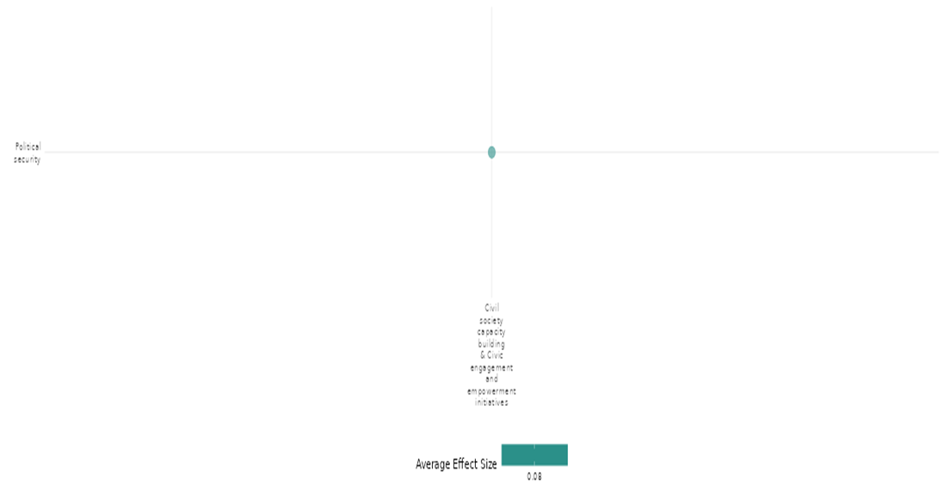

4.4.1 (12)
Effect of civil society capacity building and civic engagement and empowerment initiatives on intermediate social cohesion outcomes
Civic education, participatory workshops, and secondary education improved civic competence, political efficacy, and participation. However, effects on democratic values were limited. Education and civic engagement significantly reduced youth support for political violence. Overall, the interventions had mixed effects on intermediate social cohesion outcomes.
Geographical region: Sub Saharan Africa
Effect size: Moderate effect (g=0.193)
Confidence in study findings: Low confidence (3 studies; 9 ES)

Short summary
Civil society capacity building and civic engagement initiatives increased civic competence, rights awareness, and local participation but had limited effects on democratic values. Political efficacy and decentralization knowledge improved, while secondary education and civic engagement significantly reduced youth support for violence. Overall, the interventions had mixed effects on intermediate social cohesion outcomes. We have low confidence in the cell due to a limited number of studies.

The intervention
Civic education, participatory workshops, secondary education, and civic engagement programs aimed to enhance civic competence, political efficacy, democratic demand, and social cohesion. Interventions promoted rights awareness, decentralization of knowledge, and non-violence while addressing ethnic tolerance, governance, and vote-buying. Effects varied, with more substantial impacts on participation and efficacy than democratic values.

How the intervention is expected to work
These interventions are expected to enhance civic competence, political efficacy, and social cohesion through education, engagement, and capacity-building. Civic education and participatory workshops increase knowledge of rights, governance, and democracy, fostering informed participation. Secondary education and civic engagement reduce susceptibility to political violence by strengthening non-violent norms and empowerment.
The evidence base
The cell includes three primary studies used matched sampling, encouragement design, and quasi-experimental methods.
The studies were conducted in Kenya, the Democratic Republic of Congo, and Somalia, focusing on politically fragile and conflict-affected regions.

Evidence findings
Interventions improved civic competence, political efficacy, and participation but had limited effects on democratic values. Education reduced support for violence significantly.

Included studies
Finkel (2012) The Kenya National Civic Education Programme II (NCEP II-Uraia) was implemented from 2006 to 2007 in Kenya, a context of political polarization and ethnic tension before the 2007 general elections. The program, funded by European donors, aimed to foster nation-building, democracy, good governance, constitutionalism, and human rights. It reached 4.5–5.5 million people through workshops, theatre, religious gatherings, and media campaigns, focusing on issues such as ethnic tolerance and gender equality. The study used a survey of 3,600 participants (1,800 treatment, 1,800 control) conducted in 2008, using matched sampling to minimize selection bias. Results showed significant effects on civic competence: participants were more informed about rights (+0.15 SD), had greater internal efficacy (+0.11 SD), and improved local political participation (+0.07 SD). However, impacts on democratic values were limited. There were small increases in rights consciousness (+0.07 SD), modest rejection of vote-buying (+0.08 SD), and weak effects on support for women’s rights. The study is rated as low confidence quantitative study due to lack of pretest data and recall bias.
Finkel (2021) The VOICE program, conducted in the Democratic Republic of Congo (2010–2011), used participatory workshops featuring "Boîtes à Images" to promote knowledge of decentralization, democracy, and political engagement. Implemented in Bandundu province, the program aimed to foster democratic demand and civic competence within a challenging political environment marked by weak institutions and stalled decentralization reforms. The study design featured an "encouragement approach," randomly inviting 800 individuals (out of 1,120 respondents) to attend workshops. Post-workshop surveys measured changes in attitudes, comparing treatment and control groups to assess causal effects. The findings revealed significant impacts on civic competence (democratic demand). Political efficacy increased by +1.42 SD, and decentralization knowledge rose by (+1.66 SD) among attendees. This study is considered low confidence quantitative study.
Tesfaye (2018) The Somali Youth Learners Initiative (SYLI), conducted in South Central Somalia and Puntland, aimed to reduce youth support for political violence through secondary education and civic engagement interventions. This initiative addressed a critical context of armed conflict, weak governance, and youth vulnerability to recruitment by extremist groups like Al-Shabaab. The study employed a quasi-experimental design, surveying 1,220 youth across treatment and control groups. Treatment groups were further divided into those accessing SYLI-supported secondary education alone and those combining education with civic engagement opportunities. Key mediators such as belief in the ability to effect change and confidence in nonviolence were measured. Findings revealed that secondary education alone decreased youth support for political violence by 48.2% and raised confidence in non-violence (+0.15 SD). When paired with civic engagement opportunities, support for violence dropped by 64.8%, and belief in the ability to effect change increased. Confidence in non-violent means (+0.12 SD) was significantly bolstered through the combined intervention. However, social isolation and perceptions of governance remained largely unchanged, suggesting contextual limitations. This is a high and medium confidence quantitative Study.

Confidence assessment
The cell has low confidence due to a limited number of studies.

Other outcomes in the study/cell
- Violence and atrocity prevention/Social norms regarding violence and atrocities
- Social cohesion/Feelings of trust & acceptance of diversity/Sense of belongingness
- Community and state governance/Govt. performance/Civic participation
- Human security/Economic security/Political security



4.4.2 Social funds, community-driven development and reconstruction
4.4.2(1)
Social funds, community-driven development and reconstruction on diplomatic relations & peaceful dispute resolution
The NSP intervention in Afghanistan aimed to improve diplomatic relations & peaceful dispute resolution. It initially increased disputes and reduced resolution rates due to block grant competition, but this effect faded. While no impact on men’s mediation was found, women’s participation in dispute resolution slightly increased.
Geographical region: South Asia
Effect size: No effect (g=0.004)
Confidence in study findings: Low confidence (1 study; 2 ES)

Short summary
The cell evaluates Afghanistan’s National Solidarity Programme (NSP) using an RCT across 500 villages. Findings suggest NSP initially increases disputes and reduces resolution rates due to block grant competition, but this effect fades. There’s no impact on men’s mediation, though women’s participation in dispute resolution slightly increases. We have low confidence in the study due to the limited number of studies in the cell.
The intervention
The National Solidarity Programme (NSP) aligns with social funds by decentralizing development, empowering communities through block grants and Community Development Councils (CDCs). It fosters local governance, funds small-scale infrastructure, and promotes democratic participation. Despite boosting social capital, its governance impact is limited, with mixed effects on dispute resolution.
How the intervention is expected to work
The National Solidarity Programme (NSP) is expected to work by empowering rural communities through Community Development Councils (CDCs) and block grants. By fostering participatory decision-making, NSP aims to improve local governance, infrastructure, and economic well-being. CDCs, elected through universal suffrage, identify and implement projects addressing community needs, such as water, electricity, and roads. The intervention assumes that democratic participation will enhance local governance, strengthen social cohesion, and promote economic growth. Additionally, NSP encourages women’s involvement in decision-making, aiming for long-term social transformation. However, its success depends on sustained engagement, institutional alignment, and continued funding for lasting impact.
The evidence base
The cell includes one primary study, using a randomized controlled trial (RCT) across 500 villages in 10 districts of Balkh, Baghlan, Daykundi, Ghor, Herat, and Nangarhar provinces.
Evidence findings
NSP initially increases disputes and reduces resolution rates during implementation but shows weak signs of reducing disputes post-implementation. Its effects on mediation are temporary, with short-term increases in women's involvement but no long-term changes in overall governance mediation.
Included studies
Beath (2015) evaluates the impact of Afghanistan’s National Solidarity Programme (NSP), a large-scale rural development initiative aimed at improving local governance and economic well-being through community-driven projects. The NSP facilitates the creation of gender-balanced Community Development Councils (CDCs), providing block grants for local projects. The study covers 500 villages across 10 districts in Balkh, Baghlan, Daykundi, Ghor, Herat, and Nangarhar provinces. The evaluation uses a randomized controlled trial (RCT) approach, with 250 villages receiving NSP (treatment group) and 250 villages not receiving it (control group). Data was collected through baseline, midline, and endline surveys from 2007 to 2011, comprising over 25,000 household interviews and more than 2,600 focus groups. The sample includes 500 villages with household surveys and focus groups of village leaders and women. The data is derived from both male and female respondents. Finding suggests that there is weak evidence that NSP increases disputes and feuds while reducing resolution rates, likely due to competition over block grants during project selection​ but by end line this effect disappears with weak evidence of a 1% reduction in intra-village disputes​. There is no evidence that NSP influences the frequency of disputes reported by village leaders or the likelihood of successful dispute resolution​. There is no significant evidence that NSP impacts dispute mediation for men however, NSP slightly increases women's participation in dispute resolution, though its impact on broader governance structures remains limited​. The study is rated as high and medium confidence quantitative study.
Confidence assessment
Overall: low confidence due to limited number of studies in the cell.
Other outcomes in the study
- Violence and atrocity prevention/Nature and scale of violence or atrocities
- Social cohesion/Feelings of trust & Acceptance of diversity
- Community and state governance/Access to justice, rights and public services/Civic participation/Government performance
- Human security/Economic security/Educational security/Food security and nutrition & Health security/Physical security/Intermediate social cohesion outcomes



4.4.2(2)
Effect of social funds, community-driven development and reconstruction on nature and scale of violence and atrocities
Social funds, community-driven development, and reconstruction programs had mixed effects on violence, with some interventions showing no impact, others leading to small reductions, and a few increasing conflict casualties, highlighting the unintended consequences of these programmes in fragile settings.
Geographical space: South Asia, Middle East & North Africa, Sub Saharan Africa, East Asia & Pacific.
Effect size: No effect (g=-0.005)
Confidence in study findings: Low confidence (8 studies; 27 ES)

Short summary
Social funds, community-driven development, and reconstruction programs had mixed effects on violence and atrocities. Some interventions showed no significant impact on reducing violent incidents, insurgent attacks, or conflict casualties. Others suggested weak reductions in violence under specific conditions, such as small-scale aid projects or targeted governance support. However, certain programs inadvertently increased conflict casualties, highlighting the unintended consequences of development initiatives in fragile settings. The cell's confidence is low due to inconsistencies in effect sizes, and the majority of the studies fall into the low-confidence category.

The intervention
The interventions include social funds, community-driven development (CDD) programs, local governance initiatives, infrastructure projects, livelihood support, mediation and dialogue efforts, and small-scale aid programs. Some projects involved elected Community Development Councils (CDCs), block grants, Provincial Reconstruction Teams, and military-led emergency response programs aimed at improving security, governance, and economic well-being in conflict-affected areas.

How the intervention is expected to work
These interventions are expected to work by fostering local governance, improving economic well-being, and strengthening social cohesion to reduce conflict and violence. Community-driven development (CDD) and social funds aim to empower local decision-making, promoting inclusivity and accountability. Infrastructure projects and livelihood support enhance economic opportunities, reducing grievances that fuel insurgency. Mediation and dialogue initiatives seek to resolve disputes peacefully, decreasing tensions between groups. Small-scale aid programs, particularly in insecure areas, aim to provide immediate relief and build trust between civilians and authorities. By addressing root causes of instability, these interventions are designed to mitigate violence and limit insurgent influence.

The evidence base
The cell includes eight impact evaluations and three systematic reviews. The eight studies employ a mix of randomized controlled trials (RCTs), panel data analysis, first-differences regression, and quasi-experimental designs. Some studies leverage natural experiments or survey experiments.
The studies are conducted in Afghanistan, Iraq, Sierra Leone, the Philippines, and Niger.

Evidence findings
The social funds, community-driven development, and reconstruction programs had mixed effects on violence. Some reduced conflict marginally, others showed no impact, and a few unintentionally increased violence, highlighting the complexity of development programs in conflict settings.

The review evidence
The review evidence suggested that community-driven development and reconstruction efforts had mixed effects on violence, with some interventions reducing conflict, others failing, and some exacerbating violence due to misappropriation or sabotage, highlighting the need for rigorous evaluation.

The impact evaluation evidence
Beath (2012) examines the impact of the National Solidarity Programme (NSP) in Afghanistan, focusing on security perceptions. The intervention aimed to foster local governance through elected Community Development Councils (CDCs) and infrastructure projects. Conducted across 500 villages, with 250 receiving NSP, the study followed a randomized controlled trial design. The findings indicate no significant impact of the intervention on actual security outcomes. For villages that experienced attacks in the past 12 months, the treatment effect was a reduction of 0.3 percentage points, but this was not statistically significant (p>0.1). Similarly, for attacks by anti-government elements in the past year, the treatment effect was a negligible reduction of 0.3 percentage points, again statistically insignificant (p>0.1). Household-level insecurity also showed no significant changes. The proportion of households affected by insecurity in the village during the past year increased slightly by 0.3 percentage points in treatment areas. A similar pattern was observed for households affected by insecurity on roads around the district, where the treatment effect was an increase of 0.3 percentage points with no statistical significance (p>0.1). When looking at the summary measure of survey-based security incidents, the treatment effect showed a slight reduction of 0.003, but this too was not significant (p>0.1). The study is rated as low confidence quantitative study due to presence of sample attrition.
Beath (2015) evaluates the impact of Afghanistan’s National Solidarity Programme (NSP), a large-scale rural development initiative aimed at improving local governance and economic well-being through community-driven projects. The NSP facilitates the creation of gender-balanced Community Development Councils (CDCs), providing block grants for local projects. The study covers 500 villages across 10 districts in Balkh, Baghlan, Daykundi, Ghor, Herat, and Nangarhar provinces. The evaluation uses a randomized controlled trial (RCT) approach, with 250 villages receiving NSP (treatment group) and 250 villages not receiving it (control group). Data was collected through baseline, midline, and endline surveys from 2007 to 2011, comprising over 25,000 household interviews and more than 2,600 focus groups. The sample includes 500 villages with household surveys and focus groups of village leaders and women. The data is derived from both male and female respondents. The findings indicate that the National Solidarity Programme (NSP) had mixed effects on conflict-related outcomes. There is no strong evidence that NSP reduced violent incidents, as the coefficients for violent incidents at both midline and endline (p=0.495) were statistically insignificant. However, the fixed-effects interaction specification suggests a weakly significant reduction in violent incidents at the 10% level at endline. Regarding informal taxation by insurgent groups (p=0.266) indicating a potential decline, but this result was not statistically significant​. The findings suggest that while NSP may have had some positive security effects, they were not robust across all measures, particularly in reducing violent incidents and informal taxation by insurgents. The study is rated as high and medium confidence quantitative study.
Berman (2011) examines violent incidents against Coalition and Iraqi forces in Iraq between 2004 and 2008, using a dataset of significant activity (SIGACT) reports. The research focuses on predictors of violence and the impact of counterinsurgency strategies. Findings indicate that violence was highly concentrated in a few districts and varied significantly over time. Sunni vote share was a key predictor, with districts voting entirely Sunni experiencing 2.1 more violent incidents per 1,000 than those with no Sunni votes (p<0.01). Violence escalated over time, increasing by 0.19 incidents per 1,000 in 2005, 0.53 in 2006, and 0.61 in 2007, before dropping sharply in 2008 (p<0.01). The 2007 increase was particularly pronounced in Sunni-majority districts, where violence rose by 0.23 incidents per 1,000 (p<0.05)​. These results highlight the role of sectarian dynamics in shaping conflict intensity and the temporal patterns of violence. The study is rated as high and medium confidence quantitative study.
Berman (2013) examines the effects of development aid on insurgent violence in Iraq, specifically focusing on the rate of attacks per capita against Coalition and Iraqi government forces. Conducted in Iraq from 2004 to 2009, the study utilizes panel data on U.S. government aid spending and insurgent attack reports, employing a first-differences design to estimate causal effects. The sample includes data from multiple districts across Iraq, incorporating information on troop strength, Provincial Reconstruction Teams, and different types of aid programs. Findings indicate that small-scale aid projects, particularly those funded through the Commander’s Emergency Response Program (CERP), significantly reduced violence. A $50 per capita increase in CERP spending led to approximately six fewer violent incidents per 100,000 residents in six months (p<0.01). Small CERP projects had six times the violence-reducing effect compared to larger projects (p<0.01). The presence of additional battalions strengthened these effects, and areas with Provincial Reconstruction Teams saw enhanced reductions in violence, reinforcing the importance of small, secure, and locally informed aid strategies​. The study is rated as high and medium confidence quantitative study.
Casey (2013) The GoBifo Project, implemented in Sierra Leone, aimed to foster inclusive decision-making, strengthen local institutions, and provide united block grants for community development. A core goal was to shift political and social attitudes towards greater inclusivity and democratic participation. Location of the study was Sierra Leone, specifically targeting rural communities across Bombali and Bonthe districts. A randomized controlled trial (RCT) assigned 236 villages to treatment or control groups. The project involved community facilitation, development planning, and project implementation over four years (2005–2009). Impact was assessed through household surveys, focus groups, and structured community activities. The study surveyed 2,832 households in 236 villages. The GoBifo project in Sierra Leone had no significant impact on reducing crime and conflict. The estimated treatment effect for crime and conflict reduction was 0.028 standard deviation units (p=0.54), indicating a small, statistically insignificant change​. This suggests that while the intervention may have improved governance and economic welfare, it did not lead to measurable reductions in community-level violence or crime. The study is rated as high and medium confidence quantitative study.
Chou (2012) investigates the impact of development assistance on insurgent violence in Afghanistan, focusing on insurgent events per 1,000 population. Conducted across multiple Afghan districts from 2002 to 2010, the study utilizes a panel dataset of 60,075 insurgent incidents and development aid expenditures from three major programs: the National Solidarity Program (NSP), USAID’s Local Governance and Community Development (LGCD) program, and the U.S. military’s Commander’s Emergency Response Program (CERP). Using first-difference regressions to control for district-level characteristics, the study finds no statistically significant reduction in insurgent events per 1,000 population due to NSP or LGCD spending. The coefficient for NSP was 0.00116 (p>0.1), and for LGCD, 0.000246 (p>0.1), indicating no meaningful effect. However, CERP spending showed a negative coefficient of -0.0110 (p>0.1), suggesting a potential reduction in violence, though the effect was not statistically significant. Small-scale CERP projects were more effective, reducing insurgent events by -0.0291 per 1,000 population (p>0.1). The results indicate aid conditionality plays a crucial role in influencing security outcomes​. The study is rated as high and medium confidence quantitative study.
Crost (2014) examines the impact of the KALAHI-CIDSS development program in the Philippines, which aimed to enhance local infrastructure and governance but unexpectedly led to an increase in conflict casualties. Using a regression discontinuity design, the study analysed municipalities just above and below the eligibility threshold. The sample included 222 municipalities, with 7,992 observations over the period 2002-2006. Findings indicate that conflict casualties increased significantly in municipalities eligible for the program. Specifically, insurgent-initiated incidents resulted in an increase in casualties by 0.088 to 0.118 per month (p<0.05), while government casualties rose between 0.048 and 0.070 (p<0.05). Civilian casualties also saw an increase ranging from 0.017 to 0.029 per month, though not all estimates were statistically significant. The impact was most pronounced in the early stages of program preparation, suggesting that insurgents sought to disrupt the initiative before funds were disbursed. These results highlight how development programs can inadvertently exacerbate conflict by altering the political and economic landscape of contested areas​. The study is rated as low confidence quantitative study due to selectively report incidents and the sample size is large, the actual number of conflict incidents and casualties is relatively low.
Lichtenheld (2022) evaluates the PEACE (Preventing Extremism through Action and Community Engagement) program, which aimed to enhance social cohesion and reduce support for violence in Niger's Tillabéri region. The intervention employed community-driven development (CDD) strategies, mediation and dialogue sessions, shared infrastructure projects, livelihoods support, and cultural/sports activities to improve intergroup relations and reduce vulnerability to violent extremism. The study used a quasi-experimental approach, with a difference-in-differences (DiD) analysis comparing communities with different levels of exposure to PEACE activities. It incorporated direct survey questions and indirect survey experiments (list experiments and endorsement experiments) to measure support for violence while minimizing social desirability bias. The study focused on 40 villages and the final sample size for endline survey experiments (measuring support for violence) was 589 respondents. Participants included men, women, and youth across different ethnic and livelihood groups. The findings indicate that the PEACE program in Niger had no significant effect on reducing youth-started conflicts or women-started conflicts, with both showing statistically insignificant results (p>0.1). The incidence of conflict in treatment areas remained unchanged compared to control areas (p=0.37). However, the number of violent incidents slightly decreased in villages with higher participation in the program, but the effect was not statistically significant (p=0.22). These results suggest that while the intervention aimed to strengthen social cohesion, it did not lead to measurable reductions in conflict intensity or frequency​. The study is considered low confidence quantitative study.
Confidence assessment
The cell's confidence is low due to inconsistencies in effect sizes, and the majority of the studies fall into the low-confidence category.
Link to review summaries
Cramer (2016)
Wong (2012)
Zurcher (2017)
Other outcomes in the study
- Violence and atrocity prevention/Diplomatic relations and peaceful dispute resolution/social norms regarding violence and atrocities
- Social cohesion/Feelings of trust and acceptance of diversity/willingness to participate or help
- Community and state governance/Access to justice, rights and public services/Government performance/Civic participation
- Human security/Intermediate social cohesion outcomes/food security and nutrition and health security/Educational security/Physical Security/ Political security



4.4.2(3)
Effect of social funds, community-driven development and reconstruction on social norms regarding violence and atrocities
Social funds interventions aimed to shift social norms on violence and atrocities through community projects, media, and vocational training. Impact was limited, with mediation and dialogue most effective in reducing support for violence.
Geographical region: Sub Saharan Africa.
Effect size: No effect (g=-0.001)
Confidence in study findings: Low confidence (2 studies; 6 ES)

Short summary
The impact of social funds, community-driven development, and reconstruction on social norms regarding violence and atrocities is mixed. Evidence from Niger's PEACE program suggests that community mobilization and participatory projects can enhance social cohesion, trust, and inter-group cooperation. However, while these efforts reduced support for political violence, they had limited impact on perceptions of violent extremist groups. Additionally, in ethnically homogeneous areas, cohesion-building efforts sometimes reinforced in-group trust at the expense of broader inclusivity. We have low confidence due to a smaller number of studies in the cell.
The intervention
Interventions in social funds, community-driven development, and reconstruction included vocational training, infrastructure rehabilitation, mediation, dialogue initiatives, radio programs, natural resource management, and participatory planning. These programs engaged communities in collaborative decision-making, economic empowerment, and governance training, fostering local ownership and resilience through inclusive, multi-stakeholder development efforts​.

How the intervention is expected to work
Both interventions aim to reduce violent extremism by addressing social fragmentation, economic marginalization, and governance deficits. They work by building trust and cooperation between groups, increasing civic engagement, and enhancing economic opportunities. Community-driven projects, mediation, and infrastructure development foster social cohesion by encouraging collaboration across ethnic, religious, and political divides. By strengthening conflict resolution mechanisms and engaging marginalized groups, these programs aim to prevent extremist recruitment, mitigate violence, and create resilient communities resistant to radicalization and political violence.

The evidence base
The cell includes two primary studies and 1 systematic review. There is a high degree of consistency in the review findings. The review is concerned with interventions, including training, for women’s empowerment and gender equity in fragile settings.
The peace through development II (PDEV II) was implemented in Burkina Faso, Chad, and Niger and PEACE program was conducted in the Tillabéri region of Niger. One quasi-experimental difference-in-differences (DiD) approach and other on utilizes the randomized phase-in experimental design.
Evidence findings
The cell had limited yet selective impacts on reducing support for extremist violence. While PDEV II showed broader social norm shifts, external factors influenced outcomes.
The review evidence
Although positive effects were observed in targeted intervention areas, their impact on long-term behavioural changes was smaller. Increased representation of women in local and subnational civil and political processes, including during peacebuilding and post‐conflict restoration.
The impact evaluation evidence
Finkel (2018) The Peace through Development II (PDEV II) program, funded by USAID, aimed to counter violent extremism in Burkina Faso, Chad, and Niger from 2011 to 2016. The program sought to improve social cohesion, increase resilience to extremist ideologies, and promote civic engagement. It included interventions such as vocational training, media campaigns, and community-led initiatives to address underlying causes of extremism. PDEV II was implemented in 45 “core zones” (which received all program interventions) and 56 “non-core zones” (which received only radio-based interventions). The impact evaluation used a quasi-experimental difference-in-differences approach to assess the program’s effects by comparing core and non-core zones. Surveys were conducted with 7,888 respondents across 83 zones. Across all zones, justification for religious violence declined over time. Support for violence as a problem-solving method showed a small decline in core zones, with the most significant effects observed in Burkina Faso. The impact in Chad and Niger was negligible, indicating that while some aspects of PDEV II programming influenced attitudes, the overall effect was limited. Attitudes against using violence for religious reasons improved significantly across all zones. The study found a minor decrease in support for attacks with potential civilian casualties (-3.3%). However, the result was not statistically significant. A 15.1% reduction in support for Islamist groups like AQIM was observed, but this was not statistically significant. We have high confidence in the study due to its quasi-experimental design, large sample size, longitudinal structure, difference-in-differences (DiD) analysis, and rigorous statistical controls reducing bias.
Lichtenheld (2022) The study evaluates the PEACE (Preventing Extremism through Action and Community Engagement) program, which aimed to enhance social cohesion and reduce support for violence in Niger's Tillabéri region. The intervention employed community-driven development (CDD) strategies, mediation and dialogue sessions, shared infrastructure projects, livelihoods support, and cultural/sports activities to improve intergroup relations and reduce vulnerability to violent extremism. The study used a quasi-experimental approach, with a difference-in-differences (DiD) analysis comparing communities with different levels of exposure to PEACE activities. It incorporated direct survey questions and indirect survey experiments (list experiments and endorsement experiments) to measure support for violence while minimizing social desirability bias. The study focused on 40 villages and the final sample size for endline survey experiments (measuring support for violence) was 589 respondents. Participants included men, women, and youth across different ethnic and livelihood groups. The direct measure of support for violence showed no statistically significant reduction in justification of violence due to PEACE. However, the indirect measure revealed a significant reduction in support for violence—but only in relation to the timing of the intervention, not the number of activities or intensity of participation. The study is considered low confidence quantitative study.
Confidence assessment
Overall, Low confidence due to the limited number of studies in the cell.Choose an item.
Link to review summaries
Lwamba (2022)
Other outcomes in the study
- Violence and atrocity prevention/Nature and scale of violence or atrocities
- Social cohesion/Feelings of trust & Acceptance of diversity/
- Community and state governance/Civic participation/Government performance
- Human security/Economic security/Educational security/Political security/Intermediate social cohesion outcomes


4.4.2(4)
Effects of social funds, community-driven development and reconstruction on feelings of trust & acceptance of diversity
The social funds, community-driven development, and reconstruction programs had limited impact on trust and acceptance of diversity, with some localized improvements but no broad or lasting effects on social cohesion beyond existing networks.
Geographical region: Sub Saharan Africa, South Asia, Latin America & Caribbean.
Effect size: Small effect (g=0.037)
Confidence in study findings: Moderate confidence (10 studies; 40 ES)

Short summary
The interventions focusing on social funds, community-driven development, and reconstruction had mixed effects on trust and acceptance of diversity. Trust outcomes showed no significant improvements in most cases, with some studies reporting stability or slight increases in trust toward specific groups, such as NGOs, local leaders, or ex-combatants. Broader trust beyond existing social networks remained largely unchanged. Acceptance of diversity improved in some interventions, with increased support for interethnic and interreligious relations in specific contexts, but effects were often localized and did not persist over time. We have moderate confidence in the cell due to most of the studies in the cell falls in high confidence category and the inconsistency in the effects sizes.

The intervention
The interventions included community-driven development programs, social funds, governance participation, leadership training, and anti-extremism initiatives. These programs provided block grants, facilitated local decision-making, supported infrastructure projects, promoted civic engagement, and encouraged inclusive governance. Some included media campaigns, vocational training, mediation, and cultural activities to foster social cohesion and trust-building.
How the intervention is expected to work
These interventions are expected to work by fostering collective decision-making, enhancing local governance, and strengthening community participation. By providing financial resources, infrastructure, and training, they aim to empower communities, promote inclusive leadership, and improve trust among diverse groups. Social funds and community-driven development create shared economic and social incentives, encouraging cooperation and reducing divisions. Leadership training and civic engagement activities are designed to increase transparency, accountability, and participation in governance, leading to stronger institutional trust. Anti-extremism initiatives use dialogue, media, and livelihood support to counter radicalization and promote acceptance of diversity, fostering resilience against conflict and social fragmentation.
The evidence base
The cell includes ten impact evaluations and four systematic reviews. There is a moderate degree of consistency in the review findings. The ten impact evaluation studies used randomized controlled trials (RCTs), quasi-experimental designs, and difference-in-differences (DiD) analyses. They incorporated household surveys, behavioral experiments, focus groups, and indirect survey methods, with some using longitudinal approaches while others relied on cross-sectional data. The study has one qualitative paper Rojas (2018) from Colombia.
The studies were conducted in Sudan, Afghanistan, Nicaragua, Sierra Leone, Burkina Faso, Chad, Niger, the Democratic Republic of Congo, Liberia, and Jamaica.
Evidence findings
The social funds, community-driven development, and reconstruction programs had limited impact on trust and acceptance of diversity, with some localized improvements but no broad or lasting effects on social cohesion beyond existing networks.
The review evidence
The review evidence suggested that social funds, community-driven development, and reconstruction improved social cohesion.
The impact evaluation evidence
Avdeenko (2014) evaluated a community-driven development (CDD) intervention in Sudan aimed at fostering social cohesion and civic engagement. The research was conducted across various rural villages, where the program encouraged collective action, governance participation, and infrastructure development. The study employed a randomized controlled trial (RCT) design, comparing treatment and control villages. The sample included over 1,400 participants. The program did not significantly increase connectedness beyond family and neighbours. On average, subjects were related to 22% of the group and socialized with 13%. The mean effect was negative indicating the program did not broaden social ties beyond pre-existing relationships​. No significant differences were observed in trust behaviours. Contributions in public goods games remained at 76%, and trust game measures of generosity and reciprocity showed no effect. The ATT for trustworthiness was -0.03 (p>0.1), reinforcing that trust levels did not increase​. For Perceptions of Community Cohesion, self-reported data indicated improvements, reflecting stronger agreement on community cooperation and participation. Improvements were reported in cooperation for development projects (p<0.01) and decision-making ease (<0.01)​. The study was assigned a medium confidence rating primarily due to an overall attrition rate that exceeded 20%. This is evident from the fact that out of the 576 households sampled for the survey, only 475 sent a representative to the game’s session, indicating a significant level of attrition.
Beath (2015) evaluates the impact of Afghanistan’s National Solidarity Programme (NSP), a large-scale rural development initiative aimed at improving local governance and economic well-being through community-driven projects. The NSP facilitates the creation of gender-balanced Community Development Councils (CDCs), providing block grants for local projects. The study covers 500 villages across 10 districts in Balkh, Baghlan, Daykundi, Ghor, Herat, and Nangarhar provinces. The evaluation uses a randomized controlled trial (RCT) approach, with 250 villages receiving NSP (treatment group) and 250 villages not receiving it (control group). Data was collected through baseline, midline, and endline surveys from 2007 to 2011, comprising over 25,000 household interviews and more than 2,600 focus groups. The sample includes 500 villages with household surveys and focus groups of village leaders and women. The data is derived from both male and female respondents. The National Solidarity Programme (NSP) in Afghanistan showed mixed results across social cohesion, gender attitudes, and trust measures. Social Cohesion saw no significant improvement, with weak evidence of reduced disputes and increased trust among men, no lasting effect (p>0.1)​. Gender Attitudes improved, with increased male acceptance of female participation in politics and governance (p<0.01), while women’s mobility outside the village also increased (p<0.05)​. Interpersonal Trust showed no effect at endline, and no impact on women’s trust (p>0.1)​. The study is rated as high and medium confidence quantitative study.
Böhnke (2013) examines the relationship between aid distribution and threat perception in northeast Afghanistan, focusing on the provinces of Kunduz and Takhar. Data were collected through surveys in 2007 and 2009 from 80 Afghan communities. The study utilizes a quasi-experimental design with regression models to assess the impact of aid on security perceptions. The sample consists of 1,617 respondents across multiple villages. The study found no significant improvement in attitudes toward foreign forces, with perceptions of their presence declining slightly (p>0.1)​. Attitudes toward development actors remained unchanged (p>0.1). Aid did not positively influence acceptance of foreign actors, and security perceptions worsened, with threat perception increasing in aid-receiving communities (p<0.01)​. The study is rated as low confidence quantitative study due to limitation in the data quality. The study acknowledged potential problems with data quality, particularly regarding the measurement of aid projects.
Brune (2009) evaluates a management and leadership (M&L) training program designed to increase social capital in post-conflict Nicaraguan communities. The intervention aimed to foster civic engagement, trust, and participation in governance while also assessing its impact on health behaviours, particularly child healthcare practices. The study was conducted in three Nicaraguan communities: Pantasma, Waslala (treatment), and Cinco Pinos (control). A two-year quasi-experimental design was employed, with baseline and follow-up household surveys assessing changes in social capital and health behaviors. The study used logistic regression models to measure associations between social capital and individual/community health practices. The study included a baseline sample of 198 households and a follow-up sample of 210 households. The social capital intervention in post-conflict Nicaraguan communities showed mixed results in trust in most people. General trust increased from 13% to 22% in intervention areas but remained statistically insignificant (p=0.173)​. However, trust in neighbors' assistance significantly improved by 18.1% (p<0.1)​. The study is rated as high and medium confidence quantitative study.
Casey (2013) The GoBifo Project, implemented in Sierra Leone, aimed to foster inclusive decision-making, strengthen local institutions, and provide untied block grants for community development. A core goal was to shift political and social attitudes towards greater inclusivity and democratic participation. Location of the study was Sierra Leone, specifically targeting rural communities across Bombali and Bonthe districts. A randomized controlled trial (RCT) assigned 236 villages to treatment or control groups. The project involved community facilitation, development planning, and project implementation over four years (2005–2009). Impact was assessed through household surveys, focus groups, and structured community activities. The study surveyed 2,832 households in 236 villages. The GoBifo program had no significant overall impact on trust in Sierra Leone. Of 12 trust measures, only one was statistically significant, showing increased trust in NGOs and donor projects (p=0.064). Other trust-related measures, including trust in fellow villagers and officials, showed no significant effects. The study is rated as high and medium confidence quantitative study.
Finkel (2018) The Peace through Development II (PDEV II) program, funded by USAID, aimed to counter violent extremism in Burkina Faso, Chad, and Niger from 2011 to 2016. The program sought to improve social cohesion, increase resilience to extremist ideologies, and promote civic engagement. It included interventions such as vocational training, media campaigns, and community-led initiatives to address underlying causes of extremism. PDEV II was implemented in 45 “core zones” (which received all program interventions) and 56 “non-core zones” (which received only radio-based interventions). The impact evaluation used a quasi-experimental difference-in-differences approach to assess the program’s effects by comparing core and non-core zones. Surveys were conducted with 7,888 respondents across 83 zones. The study found that interpersonal trust remained stable in Chad and Niger but declined in Burkina Faso, with the program offsetting this decline in core zones (p<.05)​. Institutional trust significantly increased in Chad and Burkina Faso, with a pooled effect size of .33 (p<.01)​. Support for interethnic marriage increased in all three countries, with a significant increase in Burkina Faso (p<.01)​. Perceived ethnic differences declined significantly in Chad (p<.05) and Burkina Faso (p<.10)​. Perceived religious differences significantly declined across all three countries, with a pooled effect size of -.197 (p<.05)​. Anti-West attitudes declined in all three countries but were not attributed to the program (p>.10)​. The program had the most pronounced effects in Burkina Faso, where social cohesion and institutional trust significantly improved, while effects were weaker or non-existent in Chad and Niger. We have high and confidence quantitative study.
Humphreys (2014) The Tuungane program in the Democratic Republic of Congo (DRC) aimed to enhance participatory governance by providing communities with funds for local projects and encouraging democratic decision-making. The study was conducted in villages across the eastern DRC. A randomized controlled trial (RCT) was used. Communities were randomly assigned to participate in the Tuungane program or serve as controls. A follow-up intervention, RAPID, tested transparency and accountability effects. The study involved 560 villages. The study found that Trust, measured by the willingness to lend money to other village members, increased for ex-combatants (p<0.05) but had weak overall significance​. The presence of cleavages in the village, including economic, generational, and religious divisions, declined but remained statistically insignificant​. Inter-village cooperation, measured by willingness to share resources, showed no significant impact from the intervention​. We have high and confidence quantitative study.
Kings (2013) The Kokoyah Millennium Villages Project (KMVP) was implemented in Bong County, Liberia, aiming to improve welfare and social cohesion in post-conflict communities. It was designed as a multi-sectoral intervention targeting agriculture, health, education, and infrastructure. The study used a quasi-experimental difference-in-differences (DID) design, comparing 16 project villages (360 respondents) with 30 matched comparison villages (428 respondents), totalling 788 baseline participants. The follow-up survey had an attrition rate of 25%, with 592 re-surveyed respondents. The study found mixed effects on trust and community networks. Trust in national government declined overall but declined less in project areas, showing a 0.2 increase in trust relative to control (p<0.05)​. Trust in local government saw no significant change (p>0.1). Trust in neighbors showed a small, non-significant increase of 0.15 points​. Community network rating (willingness to turn to community members for help) remained unchanged (p>0.1)​. This study has low confidence quantitative study.
Lichtenheld (2022) The study evaluates the PEACE (Preventing Extremism through Action and Community Engagement) program, which aimed to enhance social cohesion and reduce support for violence in Niger's Tillabéri region. The intervention employed community-driven development (CDD) strategies, mediation and dialogue sessions, shared infrastructure projects, livelihoods support, and cultural/sports activities to improve intergroup relations and reduce vulnerability to violent extremism. The study used a quasi-experimental approach, with a difference-in-differences (DiD) analysis comparing communities with different levels of exposure to PEACE activities. It incorporated direct survey questions and indirect survey experiments (list experiments and endorsement experiments) to measure support for violence while minimizing social desirability bias. The study focused on 40 villages and the final sample size for endline survey experiments (measuring support for violence) was 589 respondents. Participants included men, women, and youth across different ethnic and livelihood groups. The study found mixed results on social cohesion and trust. The Social Cohesion Index showed no overall effect, but intra-community trust increased with greater program participation. Trust in community members improved significantly with program dosage, especially in villages with diverse ethnic groups. Trust in other groups increased only where infrastructure and cultural activities were implemented but mediation and livelihood activities showed no effect. Cohabitation between ethnic groups improved in diverse villages but declined in homogeneous ones (p<0.1)​. Leaders keeping commitments improved slightly with increased program participation (p<0.1)​. Interaction with other groups and quality of interactions increased in villages with cultural and infrastructure projects (p<0.05)​. The study is considered low confidence quantitative study.
Rao (2005) examines the Jamaica Social Investment Fund (JSIF), a community-driven development initiative providing grants for infrastructure projects. Conducted in Jamaica, the research employs a mixed-methods approach, integrating qualitative data from five matched pairs of communities and quantitative survey data from 500 households (684 individuals). Findings indicate that community leader responsiveness was mixed; while 80% of residents expressed satisfaction with project outcomes, decision-making was often elite-driven. Better educated and well-networked individuals dominated participation, limiting broad-based involvement. Trust in the community increased in JSIF communities by 8.86 percentage points compared to non-JSIF areas significantly. The nearest neighbor estimate indicates a mean increase of 0.13 but improvements were concentrated among better-networked and economically stable individuals​. The study is considered low confidence quantitative study.
Confidence assessment
The final confidence of the cell is moderate due to most of the studies in the cell falls in high confidence category and the inconsistency in the effects sizes.
Link to review summaries
White (2018)
Lwamba (2022)
Wong (2012)
King (2010)
Other outcomes in the study
- Violence and atrocity prevention/ Nature and scale of violence and atrocities/Diplomatic relations and peaceful dispute resolution/
- Social cohesion/Sense of belonging/Willingness to participate or help
- Community and state governance/Government performance/Access to rights, justice and public services/Civic participation
- Human security/Intermediate social cohesion outcomes/food security and nutrition and health security/Educational security/Physical Security/ Political security/Economical security



4.4.2(5)
Effect of social funds, community-driven development and reconstruction on sense of belongingness
The social funds, community-driven development, and reconstruction programs improved belongingness and social harmony in post-conflict Nicaraguan communities, with significant increases in closeness and cohesion, reinforcing the effectiveness of structured social capital programs in rebuilding communal ties.
Geographical region: Latin America & Caribbean
Effect size: Large effect (g=0.0464)
Confidence in study findings: Low confidence (01studies; 01ES)

Short summary
The social funds and community-driven development intervention significantly improved the sense of belongingness in post-conflict Nicaraguan communities. In Pantasma, feelings of closeness increased by 18.1%, while Waslala experienced a 6.4% rise. The intervention had a statistically significant impact on social harmony (p=0.061), reinforcing community cohesion. These findings suggest that structured social capital interventions can effectively rebuild communal ties and enhance a shared sense of belonging in post-conflict settings. We have low confidence in the cell due to the limited number of studies in the cell.

The intervention
The intervention involved social funds and community-driven development programs to rebuild social capital in post-conflict Nicaraguan communities. It focused on management and leadership (M&L) training, fostering civic engagement, trust, governance participation, and strengthening community cohesion.
How the intervention is expected to work
The intervention is expected to work by fostering local leadership, strengthening community organizations, and promoting civic engagement. Through management and leadership (M&L) training, it builds trust, enhances participation in governance, and encourages collective decision-making. By mobilizing social funds and community-driven development, it empowers residents to take ownership of local projects, fostering cooperation, social cohesion, and a stronger sense of belonging in post-conflict settings.
The evidence base
The cell includes one primary study used a two-year quasi-experimental design in Pantasma, Waslala (treatment), and Cinco Pinos (control), Nicaragua.
Evidence findings
The social funds, community-driven development, and reconstruction programs had significantly increased social harmony, enhancing the sense of belongingness.
Included studies
Brune (2009) evaluates a management and leadership (M&L) training program designed to increase social capital in post-conflict Nicaraguan communities. The intervention aimed to foster civic engagement, trust, and participation in governance while also assessing its impact on health behaviours, particularly child healthcare practices. The study was conducted in three Nicaraguan communities: Pantasma, Waslala (treatment), and Cinco Pinos (control). A two-year quasi-experimental design was employed, with baseline and follow-up household surveys assessing changes in social capital and health behaviors. The study used logistic regression models to measure associations between social capital and individual/community health practices. The study included a baseline sample of 198 households and a follow-up sample of 210 households. Findings indicate that systematic interventions significantly increased feelings of closeness among community members (p = 0.061), suggesting a notable positive shift in social harmony. In Pantasma, closeness increased by 18.1%, while Waslala saw a smaller 6.4% rise. The intervention's impact was statistically significant at the 10% level (p<0.10). The study is rated as high and medium confidence quantitative study.
Confidence assessment
We have low confidence in the cell due to limited number of studies.
Other outcomes in the study
- Social cohesion/Willingness to participate or help
- Community and state governance/Civic participation
- Human security/Food security and nutrition and health security


4.4.2(6)
Effect of social funds, community-driven development and reconstruction on willingness to participate or help
Social funds, community-driven development, and reconstruction programs aimed to enhance collective action and social cohesion. Their impact on willingness to participate or help was mixed, with some positive effects but limited sustained behavioural change.
Geographical space: Sub Saharan Africa, South Asia, and Latin America & Caribbean,
Effect size: Moderate effect (g=0.167)
Confidence in study findings: Moderate confidence (11 studies; 38 ES)

Short summary
Social funds, community-driven development, and reconstruction initiatives generally show mixed effects on willingness to participate or help. Some interventions increase participation in community groups, civic engagement, and public goods contributions, particularly when fostering communication, democratic decision-making, and collaboration. However, several studies reveal minimal or no sustained impact, with behavioural changes often limited to membership rather than active involvement. The cell's confidence is moderate due to inconsistencies in effect sizes, and almost half of the studies fall into the low-confidence category.

The intervention
Social funds, community-driven development, and reconstruction programs aim to strengthen local governance, foster social cohesion, and enhance collective action. They provide funding for infrastructure, promote participatory decision-making, and encourage civic engagement. Some interventions include leadership training, public goods games, and facilitated community planning to build trust and cooperation.

How the intervention is expected to work
These interventions are expected to work by empowering communities to take collective action, improving governance structures, and fostering trust among members. By providing funding for local projects, they encourage participatory decision-making, giving communities a sense of ownership over development efforts. Facilitated discussions and leadership training aim to build social cohesion, enhance cooperation, and strengthen networks for collective problem-solving. Public goods games and structured engagement activities reinforce pro-social behaviour, encouraging contributions to communal welfare. Through repeated interactions, communities develop norms of trust, reciprocity, and accountability, which are expected to sustain long-term improvements in governance, social capital, and collective action.

The evidence base
The cell includes ten impact evaluations and one systematic review. There is a low degree of consistency in the review findings. The review is concerned with interventions, including social funds programs for willingness to participate and ready to help.
The ten impact evaluation studies used randomized controlled trials, quasi-experimental designs, difference-in-differences, public goods games, and mixed methods. Some compare treatment and control groups, while others use lab-in-the-field experiments or propensity score matching. The studies were conducted in Colombia, Sudan, Nicaragua, Sierra Leone, Liberia, Democratic Republic of Congo, and Jamaica.

Evidence findings
The social funds, community-driven development, and reconstruction programs had mixed effects on willingness to participate or help, with some increasing engagement and contributions, while others showed minimal or no sustained behavioural change.

The review evidence
The review evidence suggested that social funds, community-driven development, and reconstruction interventions impact on willingness to participate or help was weakly positive, with inconsistent results across studies.

The impact evaluation evidence
Attanasio (2009) evaluates the impact of the PRDP initiative on social capital through a public goods game experiment conducted in Colombia. The intervention aims to foster cooperation and public good contributions at the municipal level. The research design involves a comparison of treatment and control areas, with participants assigned to a game where they decide whether to invest in a public pot, representing their willingness to contribute to communal welfare. The study sample includes 3,674 participants in the first round and 2,170 in the second round. Findings indicate that in the matched comparison, the contribution to the public good increased by 24.6% in the first round and 31.4% in the second round (p<0.01). In PRDP municipalities only, knowledge of the program led to an 8-9% increase in first-round contributions (p<0.05), but no significant second-round effect. The treatment-control area comparison showed a 26.5% increase in contributions in round 1 and 29.6% in round 2 (p<0.01). The second round confirmed a 29-percentage-point increase in contribution likelihood among treatment participants, independent of prior behaviour​. The study is rated as medium confidence as it is a non-experimental study.
Avdeenko (2014) evaluated a community-driven development (CDD) intervention in Sudan aimed at fostering social cohesion and civic engagement. The research was conducted across various rural villages, where the program encouraged collective action, governance participation, and infrastructure development. The study employed a randomized controlled trial (RCT) design, comparing treatment and control villages. The sample included over 1,400 participants. The study found that observed game behavior related to social capital showed no significant positive effect. Favor exchange relations showed a negligible impact, with babysitting rates unchanged and advice-giving increasing slightly by 0.02. Basic economic relations were largely unaffected, with buy/sell relations dropping by 0.02 (p>0.1) and employment measures unchanged. Voluntary group participation declined in producers’ groups by 0.10 and PTA involvement by 0.03. Perceptions of community cohesion improved slightly, yet the observed pro-social behavior remained largely unchanged​. The study was assigned a medium confidence rating primarily due to an overall attrition rate that exceeded 20%. This is evident from the fact that out of the 576 households sampled for the survey, only 475 sent a representative to the game’s session, indicating a significant level of attrition.
Brune (2009) evaluates a management and leadership (M&L) training program designed to increase social capital in post-conflict Nicaraguan communities. The intervention aimed to foster civic engagement, trust, and participation in governance while also assessing its impact on health behaviours, particularly child healthcare practices. The study was conducted in three Nicaraguan communities: Pantasma, Waslala (treatment), and Cinco Pinos (control). A two-year quasi-experimental design was employed, with baseline and follow-up household surveys assessing changes in social capital and health behaviors. The study used logistic regression models to measure associations between social capital and individual/community health practices. The study included a baseline sample of 198 households and a follow-up sample of 210 households. The study found increased participation in groups (up to 11.9%, p<0.1), contributions (26.2%, p>0.1), and neighbor assistance (29.8%, p<0.1). Community participation rose 3.1 times (p<0.01), with improved engagement in discussions, health reporting, and NGO donations​. The study is rated as high and medium confidence quantitative study.
Casey (2013) The GoBifo Project, implemented in Sierra Leone, aimed to foster inclusive decision-making, strengthen local institutions, and provide untied block grants for community development. A core goal was to shift political and social attitudes towards greater inclusivity and democratic participation. Location of the study was Sierra Leone, specifically targeting rural communities across Bombali and Bonthe districts. A randomized controlled trial (RCT) assigned 236 villages to treatment or control groups. The project involved community facilitation, development planning, and project implementation over four years (2005–2009). Impact was assessed through household surveys, focus groups, and structured community activities. The study surveyed 2,832 households in 236 villages. The study found that participation in community groups and networks saw a small positive effect (0.033, p=0.044), with increased involvement in savings groups, labor gangs, school committees, social clubs, and women's groups. However, there was no significant impact on attendance, financial contributions, or labor contributions within these groups (-0.000, p=0.038), indicating limited behavioral change beyond membership​. The study is rated as high and medium confidence quantitative study.
D’Exelle (2018) examines the impact of Community-Driven Reconstruction (CDR) programs on collective action in Colombia using a lab-in-the-field experiment in 42 municipalities. The intervention aimed to foster social cooperation through development projects led by local councils. The study involved 1,808 participants—both beneficiaries and non-beneficiaries of CDR programs—engaging in a binary public goods game across two rounds, with a communication stage in between. Findings indicate that cooperation significantly increased after communication (p<0.000). The likelihood of cooperation post-communication increased with the proportion of initial cooperators (p<0.01). Beneficiaries exerted a stronger peer influence on collective action than non-beneficiaries, with their cooperative behavior significantly predicting increased cooperation among non-beneficiaries (p=0.01). The findings highlight CDR programs' potential for fostering social cohesion beyond direct beneficiaries, primarily through peer-driven communication​. The study is rated as high and medium confidence quantitative study.
Fearon (2015) examines the impact of a Community-Driven Reconstruction (CDR) program in post-conflict Liberia, focusing on collective action through average contributions in a public goods game. Conducted in 42 randomly selected treatment communities and 41 control communities across Voinjama and Zorzor districts, the intervention aimed to strengthen governance and cooperation through elected councils and community projects. The study involved 1,992 participants across mixed-gender and women-only groups. Findings indicate that the CDR program increased average contributions a 7.5% rise (p=0.037). However, this effect was observed only in mixed-gender communities, where contributions increased significantly from 200 to 243 LD (p <0.001). In contrast, in women-only communities, the CDR intervention had no effect, with contributions decreasing slightly from 253 to 242 LD (p=0.205). Contributions were also influenced by return rates; increasing the return from 100% to 400% raised contributions by 18 LD (p<0.001). The study suggests that CDR enhances collective action when fostering collaboration across social groups​. The study is rated as low confidence quantitative study due to numerous outcome measures, which can lead to inflated type I error rates and reliance on self-reported data.
Humphreys (2014) The Tuungane program in the Democratic Republic of Congo (DRC) aimed to enhance participatory governance by providing communities with funds for local projects and encouraging democratic decision-making. The study was conducted in villages across the eastern DRC. A randomized controlled trial (RCT) was used. Communities were randomly assigned to participate in the Tuungane program or serve as controls. A follow-up intervention, RAPID, tested transparency and accountability effects. The study involved 560 villages. The findings on participation in public good provision indicate mixed effects. Participation increased for road widening projects by 2.21 percentage points (p<0.1). This study is high and medium confidence quantitative study.
Kings (2013) The Kokoyah Millennium Villages Project (KMVP) was implemented in Bong County, Liberia, aiming to improve welfare and social cohesion in post-conflict communities. It was designed as a multi-sectoral intervention targeting agriculture, health, education, and infrastructure. The study used a quasi-experimental difference-in-differences (DID) design, comparing 16 project villages (360 respondents) with 30 matched comparison villages (428 respondents), totalling 788 baseline participants. The follow-up survey had an attrition rate of 25%, with 592 re-surveyed respondents. The study found that the number of groups to which respondents belonged increased by 0.4 groups on average (p<0.01), a 26.1% increase from baseline. This suggests improved social cohesion in post-conflict Liberia​. This study is low confidence quantitative study.
Laudati (2018) The Tuungane 2 program (2011–2014) was a Community-Driven Development (CDD) initiative implemented by the International Rescue Committee (IRC) in eastern Democratic Republic of Congo (DRC). The program aimed to improve local governance, service delivery, and infrastructure, particularly in education and health sectors. Communities elected Village Development Committees (VDCs) to oversee funded infrastructure projects (e.g., school and health facility construction) while promoting participatory decision-making. The study was conducted in South Kivu, Haut Katanga, and Tanganyika provinces of the Democratic Republic of Congo (DRC). The evaluation used a non-randomized, quasi-experimental design, employing propensity score matching to compare Tuungane communities with similar non-Tuungane communities. 781 villages surveyed. In control areas, 6% of health facility heads reported community contributions in kind, while 4% reported monetary contributions. In Tuungane 2 areas, in-kind contributions were almost three times higher (p<0.01). Villagers' self-reports showed a 2% contribution in kind and 3% in cash in control areas, with Tuungane 2 areas having significantly more frequent in-kind contributions (p<0.01). School directors reported higher community contributions, with 30% in kind and 23% in cash, but no difference between treatment and control areas (p>0.1). Villagers' self-reports for school contributions showed 8% in kind and 6% in cash, with no effect from the Tuungane 2 program (p>0.1)​. This study is low confidence quantitative study.
Lichtenheld (2022) The study evaluates the PEACE (Preventing Extremism through Action and Community Engagement) program, which aimed to enhance social cohesion and reduce support for violence in Niger's Tillabéri region. The intervention employed community-driven development (CDD) strategies, mediation and dialogue sessions, shared infrastructure projects, livelihoods support, and cultural/sports activities to improve intergroup relations and reduce vulnerability to violent extremism. The study used a quasi-experimental approach, with a difference-in-differences (DiD) analysis comparing communities with different levels of exposure to PEACE activities. It incorporated direct survey questions and indirect survey experiments (list experiments and endorsement experiments) to measure support for violence while minimizing social desirability bias. The study focused on 40 villages and the final sample size for endline survey experiments (measuring support for violence) was 589 respondents. Participants included men, women, and youth across different ethnic and livelihood groups. The PEACE program increased collective action norms by 14 percentage points in treatment vs. control villages at midline (p<0.05), with higher gains for direct participants at endline. This study is low confidence quantitative study.
Rao (2005) examines the Jamaica Social Investment Fund (JSIF), a community-driven development initiative providing grants for infrastructure projects. Conducted in Jamaica, the research employs a mixed-methods approach, integrating qualitative data from five matched pairs of communities and quantitative survey data from 500 households (684 individuals). The study found that participation in groups outside the immediate household increased significantly in JSIF communities compared to non-JSIF communities. The difference-in-difference analysis showed that 57.15% of JSIF respondents found it easy or very easy to work with such groups, compared to 48.09% in non-JSIF areas significantly (p<0.05)​. This study is low confidence quantitative study.
Confidence assessment
The cell's confidence is moderate due to inconsistencies in effect sizes, and almost half of the studies fall into the low-confidence category.
Link to review summaries
King (2010)
Other outcomes in the study
- Violence and atrocity prevention/ Nature and scale of violence and atrocities
- Social cohesion/Feeling of trust and acceptance of diversity
- Community and state governance/Government performance/Access to rights, justice and public services/Civic participation
- Human security/Intermediate social cohesion outcomes/food security and nutrition and health security/Educational security/ Political security/ Economic security



4.4.2(7)
Effect of social funds, community-driven development and reconstruction on access to justice, rights and public services
The social funds, community-driven development, and reconstruction programs had mixed effects on access to justice, rights, and public services, while it is improving education, water, and electricity access but showing weak governance effects, limited women's empowerment, and no lasting impact on irrigation, transportation, or health services.
Geographical space: South Asia, Sub Saharan Africa, Europe & Central Asia
Effect size: Large effect (g=0.28)
Confidence in study findings: Moderate confidence (6 studies; 30 ES)

Short summary
Social funds, community-driven development, and reconstruction programs had mixed impacts on access to justice, rights, and public services. Local governance structures improved in some cases, increasing village development committees and access to counselling services, but broader governance transparency and accountability effects were weak. Public service infrastructure, particularly in education, water, and electricity, showed notable gains with higher school attendance, improved water access (15–34% increase), and expanded electricity coverage (26%), yet irrigation and transportation projects had limited or no lasting effects. Women's empowerment outcomes were inconsistent, with modest increases in association membership (6.4%) but little progress in local governance participation or legal rights. Service utilization remained unchanged in several cases, particularly in health access. The effectiveness of interventions depended heavily on institutional stability, community participation, and long-term governance engagement, with some positive short-term impacts but limited structural change over time. We have moderate confidence in the cell due to some studies have low confidence and inconsistency in the effect sizes.
The intervention
The interventions in the cell focused on social funds, community-driven development, and reconstruction efforts aimed at improving local governance, infrastructure, and service delivery. These initiatives included block grants for community-selected projects, the creation of village development committees, participatory governance mechanisms, and public service investments in education, health, water, electricity, and justice. Some programs facilitated gender-inclusive governance structures, while others promoted decentralized decision-making to enhance public service provision, infrastructure rehabilitation, and institutional capacity-building, though their impact varied by context.
How the intervention is expected to work
These interventions are expected to work by empowering local communities through participatory decision-making, infrastructure development, and institutional strengthening. Social funds provide block grants to communities, allowing them to prioritize and implement projects that improve education, health, and water access. Community-driven development fosters inclusive governance, strengthening local institutions like village development committees to promote transparency and accountability. Reconstruction efforts aim to restore essential public services, such as electricity and irrigation, while also addressing women’s empowerment through increased participation in governance and service access. By decentralizing control and enhancing community engagement, these interventions seek to create sustainable improvements in governance and public service delivery.
The evidence base
The cell includes six impact evaluations and three systematic reviews. There is a moderate to high degree of consistency in the review findings. The review is concerned with interventions, including social funds programs for access to public services, justice and rights.
The six impact evaluation studies in which three studies used RCTs, while three relied on matching techniques.
The studies were conducted in Afghanistan (Balkh, Baghlan, Daykundi, Ghor, Herat, Nangarhar), Sierra Leone (Bombali, Bonthe), Armenia (Aragatsotn, Lori, Shirak, Sunik, Tavush, Yerevan), and the Democratic Republic of Congo (DRC) (South Kivu, Haut Katanga, Tanganyika, North Kivu, Maniema).
Evidence findings
The social funds, community-driven development, and reconstruction programs had mixed effects on access to justice, rights and public services. While it improved education, water, and electricity access, but had weak governance effects, limited women's empowerment, and no sustained impact on irrigation, transportation, or health service utilization.
The review evidence
The review evidence suggested that social funds, community-driven development, and reconstruction improved infrastructure, water, education, and electricity access but had weak governance effects.
The impact evaluation evidence
Beath (2015) evaluates the impact of Afghanistan’s National Solidarity Programme (NSP), a large-scale rural development initiative aimed at improving local governance and economic well-being through community-driven projects. The NSP facilitates the creation of gender-balanced Community Development Councils (CDCs), providing block grants for local projects. The study covers 500 villages across 10 districts in Balkh, Baghlan, Daykundi, Ghor, Herat, and Nangarhar provinces. The evaluation uses a randomized controlled trial (RCT) approach, with 250 villages receiving NSP (treatment group) and 250 villages not receiving it (control group). Data was collected through baseline, midline, and endline surveys from 2007 to 2011, comprising over 25,000 household interviews and more than 2,600 focus groups. The sample includes 500 villages with household surveys and focus groups of village leaders and women. The data is derived from both male and female respondents. The National Solidarity Programme (NSP) in Afghanistan significantly improved access to clean drinking water, increasing usage of protected sources by 15% at endline, and reduced water collection time by 5%. Electricity access rose by 26% due to NSP-funded projects (p<0.05). Girls' school attendance improved (p<0.035), and child doctor and prenatal visits increased (p<0.013). Women's access to counselling services more than doubled (p<0.001). However, irrigation projects had no impact (p=0.696), and village transportation improvements were not sustained (p=0.669)​. The study is rated as high and medium confidence quantitative study.
Casey (2013) The GoBifo Project, implemented in Sierra Leone, aimed to foster inclusive decision-making, strengthen local institutions, and provide untied block grants for community development. A core goal was to shift political and social attitudes towards greater inclusivity and democratic participation. Location of the study was Sierra Leone, specifically targeting rural communities across Bombali and Bonthe districts. A randomized controlled trial (RCT) assigned 236 villages to treatment or control groups. The project involved community facilitation, development planning, and project implementation over four years (2005–2009). Impact was assessed through household surveys, focus groups, and structured community activities. The study surveyed 2,832 households in 236 villages. The GoBifo Project in Sierra Leone significantly improved functional local institutions, increasing the presence of village development committees (VDCs) and bank accounts (p<0.01). Quality and quantity of public services infrastructure improved, with a 16.4% increase in functional local public goods (p<0.01). However, access to information about local governance saw no significant improvement (p=0.39), indicating limited spillover effects on broader governance engagement​. The study is rated as high and medium confidence quantitative study.
Chase (2002) The Armenian Social Investment Fund (ASIF) aimed to support communities in rehabilitating local infrastructure, particularly schools and water systems, during Armenia's transition from a centrally planned economy. ASIF provided financing for community-driven projects to improve education, water access, and social services. The study was conducted in Armenia, targeting earthquake-affected regions (Aragatsotn, Lori, Shirak), conflict-affected regions (Sunik, Tavush), and urban areas (Yerevan). The study used propensity score matching and pipeline matching techniques to control for selection bias. The evaluation compared households in communities with completed ASIF projects to those in communities with approved but incomplete projects. The study was based on a nationally representative household survey (3,600 households). An oversample of 2,260 households from ASIF-active areas was included. The total sample included 113 clusters where ASIF was active. In Armenia's Social Investment Fund (ASIF), 8% of households in treatment communities reported school service improvements in the past 12 months, compared to 6% in matched comparison groups (p<0.05) but lower than 12% in pipeline communities (p<0.1). For water services, 34% of treatment households reported improvements, significantly higher than 22% in matched groups (p<0.01) and 28% in pipeline groups (p<0.1)​. The study is rated as low confidence quantitative study due to selection bias and a small sample size in subgroup analysis.
Humphreys (2014) The Tuungane program in the Democratic Republic of Congo (DRC) aimed to enhance participatory governance by providing communities with funds for local projects and encouraging democratic decision-making. The study was conducted in villages across the eastern DRC. A randomized controlled trial (RCT) was used. Communities were randomly assigned to participate in the Tuungane program or serve as controls. A follow-up intervention, RAPID, tested transparency and accountability effects. The study involved 560 villages. The rate of accessing services per month showed no significant impact from Tuungane, with mean usage ranging from 14.92 for wells to 0.24 for government services. A negative effect was observed for roads (p=0.054). The study is rated as high and medium confidence quantitative study.
Laudati (2018) The Tuungane 1 program (2007-2011) aimed to improve education infrastructure and service provision in rural areas by funding school construction and supplies. However, it did not directly target teaching quality, affordability, or governance. The study was conducted in the Democratic Republic of Congo (DRC). A randomized controlled trial (RCT) was used to measure the impact of the intervention on educational outcomes. Data was collected from household surveys and direct testing of children’s educational performance. The study included randomly selected households from control and treatment areas. A subset of children aged 6–11 was tested in mathematics, French, and science. The total sample size for education-related measures was 3,054 children. The presence of health providers was similar across treatment and control areas, with 70% of health facilities visited by enumerators and 53% of village chiefs reporting a health provider in control areas. In 2012, 34% of village chiefs confirmed health clinic presence. Education services were more accessible, with 82% of chiefs reporting school presence, and 64% confirming this in 2012. Service costs were high, with health fees averaging $10.59, and school fees at $2.14 per child monthly. No significant difference in service presence or utilization was found across treatment and control areas (p<0.05)​. The study is rated as high and medium confidence quantitative study.
Laudati (2018) The Tuungane 2 program (2011–2014) was a Community-Driven Development (CDD) initiative implemented by the International Rescue Committee (IRC) in eastern Democratic Republic of Congo (DRC). The program aimed to improve local governance, service delivery, and infrastructure, particularly in education and health sectors. Communities elected Village Development Committees (VDCs) to oversee funded infrastructure projects (e.g., school and health facility construction) while promoting participatory decision-making. The study was conducted in South Kivu, Haut Katanga, and Tanganyika provinces of the Democratic Republic of Congo (DRC). The evaluation used a non-randomized, quasi-experimental design, employing propensity score matching to compare Tuungane communities with similar non-Tuungane communities. 781 villages surveyed. The Tuungane 2 program showed mixed results on women's empowerment. Women's rights awareness remained unchanged (p=0.48). Women’s association membership increased by 6.4% (p<0.05), but participation in local development committees remained low (p=0.38). Girls' school attendance increased marginally (1.2%, p=0.09), but 27% of women never attended school (p<0.01). Female representation in local development committees showed no significant change (p=0.41)​. The study is rated as low confidence quantitative study.
Confidence assessment
The overall confidence in the cell is moderate, given that some studies have low confidence and inconsistency in the effect sizes.
Link to review summaries
White (2018)
Wong (2012)
Lwamba (2022)
Other outcomes in the study
- Violence and atrocity prevention/ Nature and scale of violence and atrocities/Diplomatic relations and peaceful dispute resolution/
- Social cohesion/Feelings of trust and acceptance of diversity/willingness to participate or help
- Community and state governance/Government performance/Civic participation
- Human security/Intermediate social cohesion outcomes/food security and nutrition and health security/Educational security/Physical Security/ Political security/Economical security


4.4.2(8)
Effects of social funds, community-driven development and reconstruction on civic participation
The social funds, community-driven development, and reconstruction programs increased governance participation, women's inclusion, and electoral engagement, but gains were often temporary. Voluntary contributions rose, yet dissatisfaction and weak institutional change hindered sustained civic engagement.
Geographical space: South Asia, Latin America & Caribbean, Sub Saharan Africa
Effect size: Moderate effect (g=0.171)
Confidence in study findings: Moderate confidence (7 studies; 28 ES)

Short summary
Social funds, community-driven development, and reconstruction programs had mixed effects on civic participation. Some initiatives increased governance participation, with notable gains in women's involvement and electoral engagement. However, improvements in decision-making inclusivity were often short-lived, with limited long-term institutional change. While voluntary contributions and election participation rose in some cases, dissatisfaction and governance quality concerns emerged. Certain programs mitigated declines in civic engagement, but many failed to sustain participation or foster enduring governance improvements beyond project lifespans. We have moderate confidence in the cell due to the inconsistency in the effects sizes.

The intervention
The interventions focused on social funds, community-driven development, and reconstruction, aiming to enhance governance, civic engagement, and service provision. All promoted local participation through elected councils or committees but varied in scope. Some prioritized governance reforms, while others emphasized infrastructure, education, or countering extremism. Differences emerged in funding mechanisms, decision-making structures, and evaluation timelines.

How the intervention is expected to work
These interventions are expected to work by fostering local ownership, participation, and accountability in governance and service provision. By establishing elected councils, community committees, or participatory decision-making structures, they aim to empower citizens, improve resource allocation, and strengthen social cohesion. Providing block grants or funding for infrastructure incentivizes engagement and builds trust in governance. Training and awareness programs promote democratic norms, inclusivity, and resilience to instability. Improved governance participation is expected to enhance civic engagement, while better infrastructure and services should generate positive spillover effects. However, long-term success depends on institutional integration, sustained participation, and overcoming elite capture.

The evidence base
The cell includes six impact evaluations and two systematic reviews. There is a low to moderate degree of consistency in the review findings. The review is concerned with interventions, including social funds programs for civic engagement.
The six impact evaluation studies used randomized controlled trials (RCTs), quasi-experimental designs, and difference-in-differences approaches, employing household surveys, focus groups, and structured activities to assess intervention.
The studies were conducted across diverse regions like Afghanistan (Balkh, Baghlan, Daykundi, Ghor, Herat, and Nangarhar provinces), Nicaragua (Pantasma, Waslala, and Cinco Pinos), Sierra Leone’s (Bombali and Bonthe), Burkina Faso, Chad, Niger, Democratic Republic of Congo, South Kivu, Haut Katanga, and Tanganyika provinces.

Evidence findings
The social funds, community-driven development, and reconstruction programs boosted governance participation, women's involvement, and electoral engagement but had short-lived inclusivity gains. Voluntary contributions rose, yet dissatisfaction and weak long-term institutional change limited sustained civic engagement.

The review evidence
The review evidence suggested that social funds, community-driven development, and reconstruction improved social cohesion. Interventions in FCAS showed positive effects, but restrictive norms hindered long-term empowerment and civic engagement.

The impact evaluation evidence
Beath (2015) evaluates the impact of Afghanistan’s National Solidarity Programme (NSP), a large-scale rural development initiative aimed at improving local governance and economic well-being through community-driven projects. The NSP facilitates the creation of gender-balanced Community Development Councils (CDCs), providing block grants for local projects. The study covers 500 villages across 10 districts in Balkh, Baghlan, Daykundi, Ghor, Herat, and Nangarhar provinces. The evaluation uses a randomized controlled trial (RCT) approach, with 250 villages receiving NSP (treatment group) and 250 villages not receiving it (control group). Data was collected through baseline, midline, and endline surveys from 2007 to 2011, comprising over 25,000 household interviews and more than 2,600 focus groups. The sample includes 500 villages with household surveys and focus groups of village leaders and women. The data is derived from both male and female respondents. NSP significantly increased participation in local governance (p=0.001, endline = 8.2%) but had no durable effect on governance quality (-1.6%, p=0.245). Acceptance of democratic norms improved (5-7% increase in preference for secret-ballot elections, p<0.01). Electoral participation increased (male +3.5%, female +6%, p<0.01). Weak evidence of increased acceptance of central government (+2.8%, p=0.093) and short-term increase in government linkages (+20.1%, p<0.01). Gender outcomes improved in terms of female governance participation +7.9% (p<0.01). The study is rated as high and medium confidence quantitative study.
Brune (2009) evaluates a management and leadership (M&L) training program designed to increase social capital in post-conflict Nicaraguan communities. The intervention aimed to foster civic engagement, trust, and participation in governance while also assessing its impact on health behaviours, particularly child healthcare practices. The study was conducted in three Nicaraguan communities: Pantasma, Waslala (treatment), and Cinco Pinos (control). A two-year quasi-experimental design was employed, with baseline and follow-up household surveys assessing changes in social capital and health behaviors. The study used logistic regression models to measure associations between social capital and individual/community health practices. The study included a baseline sample of 198 households and a follow-up sample of 210 households. Participation in demonstrations increased significantly in communities receiving interventions, rising by 14% (p=0.006). The odds of participating in a demonstration were 2.33 times higher (p=0.071) after interventions, indicating a substantial but marginally significant increase in civic activism. The study is rated as high and medium confidence quantitative study.
Casey (2013) The GoBifo Project, implemented in Sierra Leone, aimed to foster inclusive decision-making, strengthen local institutions, and provide untied block grants for community development. A core goal was to shift political and social attitudes towards greater inclusivity and democratic participation. Location of the study was Sierra Leone, specifically targeting rural communities across Bombali and Bonthe districts. A randomized controlled trial (RCT) assigned 236 villages to treatment or control groups. The project involved community facilitation, development planning, and project implementation over four years (2005–2009). Impact was assessed through household surveys, focus groups, and structured community activities. The study surveyed 2,832 households in 236 villages. The study found that collective action and contributions to local public goods did not significantly improve, with only 7 out of 59 outcomes meeting statistical significance (p<0.05). Inclusion and participation in community decisions, especially for vulnerable groups, showed no evidence of sustained impact, as participation by women and youth in decision-making remained unchanged (p=0.031)​. Participation in local governance declined at endline (p=0.001), with dissatisfaction rising among villagers​. The study is rated as high and medium confidence quantitative study.
Finkel (2018) The Peace through Development II (PDEV II) program, funded by USAID, aimed to counter violent extremism in Burkina Faso, Chad, and Niger from 2011 to 2016. The program sought to improve social cohesion, increase resilience to extremist ideologies, and promote civic engagement. It included interventions such as vocational training, media campaigns, and community-led initiatives to address underlying causes of extremism. PDEV II was implemented in 45 “core zones” (which received all program interventions) and 56 “non-core zones” (which received only radio-based interventions). The impact evaluation used a quasi-experimental difference-in-differences approach to assess the program’s effects by comparing core and non-core zones. Surveys were conducted with 7,888 respondents across 83 zones. Social inclusiveness, measured by community involvement in decision-making, declined in all three countries, with statistically significant decreases in Burkina Faso (p<0.01). However, PDEV II programming mitigated this decline in core zones, where young people were actively engaged in consultations. Civic outlook improved, with increased interest in community affairs in Chad (p<0.01) and Niger (p<0.01), while Burkina Faso showed smaller, non-significant changes​. The study is rated as high and medium confidence quantitative study.
Laudati (2018) The Tuungane 1 program (2007-2011) aimed to improve education infrastructure and service provision in rural areas by funding school construction and supplies. However, it did not directly target teaching quality, affordability, or governance. The study was conducted in the Democratic Republic of Congo (DRC). A randomized controlled trial (RCT) was used to measure the impact of the intervention on educational outcomes. Data was collected from household surveys and direct testing of children’s educational performance. The study included randomly selected households from control and treatment areas. A subset of children aged 6–11 was tested in mathematics, French, and science. The total sample size for education-related measures was 3,054 children. Community participation in health service provision showed no significant improvement, with participation levels unchanged across treatment and control areas (p=0.467). Similarly, participation in education service provision remained stable, with no statistically significant increase (p=0.512) despite program interventions aimed at fostering engagement​. The study is rated as high and medium confidence quantitative study.
Laudati (2018) The Tuungane 2 program (2011–2014) was a Community-Driven Development (CDD) initiative implemented by the International Rescue Committee (IRC) in eastern Democratic Republic of Congo (DRC). The program aimed to improve local governance, service delivery, and infrastructure, particularly in education and health sectors. Communities elected Village Development Committees (VDCs) to oversee funded infrastructure projects (e.g., school and health facility construction) while promoting participatory decision-making. The study was conducted in South Kivu, Haut Katanga, and Tanganyika provinces of the Democratic Republic of Congo (DRC). The evaluation used a non-randomized, quasi-experimental design, employing propensity score matching to compare Tuungane communities with similar non-Tuungane communities. 781 villages surveyed. The Tuungane 2 program significantly impacted community governance participation. In control areas, 42% of respondents attended a village meeting, 39% spoke, and 1.25 voluntary projects were completed per household. Tuungane areas saw a 16% increase in voluntary contributions (p<0.05), 9% more election participation (p<0.01), and unchanged voting rates (93%). Chiefs’ engagement decreased slightly (-0.2, p>0.1)​. This study is a low confidence quantitative study.
Lichtenheld (2022) The study evaluates the PEACE (Preventing Extremism through Action and Community Engagement) program, which aimed to enhance social cohesion and reduce support for violence in Niger's Tillabéri region. The intervention employed community-driven development (CDD) strategies, mediation and dialogue sessions, shared infrastructure projects, livelihoods support, and cultural/sports activities to improve intergroup relations and reduce vulnerability to violent extremism. The study used a quasi-experimental approach, with a difference-in-differences (DiD) analysis comparing communities with different levels of exposure to PEACE activities. It incorporated direct survey questions and indirect survey experiments (list experiments and endorsement experiments) to measure support for violence while minimizing social desirability bias. The study focused on 40 villages and the final sample size for endline survey experiments (measuring support for violence) was 589 respondents. Participants included men, women, and youth across different ethnic and livelihood groups. The PEACE program did not significantly improve perceptions of youth or women in community decision-making. Women, despite making up nearly 60% of participants, only comprised 30% of leadership committees. The study is considered low confidence quantitative study.

Confidence assessment
The overall confidence level of the cell is moderate due to the inconsistency in the effects sizes.

Link to review summaries
King (2010)
Lwamba (2022)

Other outcomes in the study
- Violence and atrocity prevention/ Nature and scale of violence and atrocities/Diplomatic relations and peaceful dispute resolution/
- Social cohesion/Sense of belonging/Feelings of trust and acceptance of diversity/willingness to participate or help
- Community and state governance/Government performance/ Access to rights, justice and public services
- Human security/Intermediate social cohesion outcomes/food security and nutrition and health security/Educational security/Physical Security/ Political security/Economical security


4.4.2(9)
Effect of social funds, community-driven development and reconstruction on government performance
Community-driven development and social funds enhanced government perceptions and participation but lacked sustained institutional impact, leading to weakened accountability and transparency over time.
Geographical region: South Asia, Sub Saharan Africa, Latin America & Caribbean
Effect size: Small effect (g=0.043)
Confidence in study findings: Low confidence (8 studies; 147 ES)

Short summary
Social funds, community-driven development, and reconstruction programs had mixed effects on government performance. While some initiatives improved perceptions of government actors, local governance services, and democratic values, many failed to create lasting institutional changes. Increased female representation and participation were observed, but parallel governance structures weakened accountability. Some programs enhanced state legitimacy, yet others reinforced elite dominance and exclusionary decision-making. Limited impact on governance quality, transparency, and administrative effectiveness was common, with effects fading post-intervention. The cell's confidence is low due to inconsistencies in effect sizes, and most of the studies fall into the low-confidence category.

The intervention
The interventions in the studies focused on social funds, community-driven development, and reconstruction programs aimed at improving governance, service delivery, and local decision-making. These initiatives established elected councils, funded infrastructure projects, promoted participatory governance, provided block grants, and facilitated mediation or community engagement activities to enhance state legitimacy, social cohesion, and institutional accountability.

How the intervention is expected to work
These interventions are expected to work by fostering participatory governance, strengthening local institutions, and improving service delivery, thereby enhancing government performance and legitimacy. By providing block grants and facilitating infrastructure projects, they aim to empower communities to identify and address their own development needs. Elected councils and representative assemblies are designed to improve accountability and decision-making, ensuring government responsiveness. Community-driven engagement is expected to build trust, reduce elite dominance, and promote inclusivity in governance. Through better access to resources and transparent decision-making, these programs seek to enhance perceptions of government effectiveness and create sustainable institutional reforms.

The evidence base
The cell includes eight impact evaluations and two systematic reviews. There is a low to moderate degree of consistency in the review findings. The review is concerned with interventions, including social funds programs for government performance.
The eight impact evaluation studies used randomized controlled trials, quasi-experimental designs, propensity score matching, and difference-in-differences analysis, incorporating household surveys, focus groups, audits, and administrative data to assess intervention impacts.
The studies were conducted in Afghanistan, Sierra Leone, Jamaica, the Democratic Republic of Congo (DRC), and Niger, covering rural and urban communities across multiple provinces and districts.

Evidence findings
The social funds, community-driven development, and reconstruction programs had mixed effects on government performance, improving perceptions, participation, and legitimacy but failing to sustain institutional change, accountability, and service quality, often reinforcing elite dominance.

The review evidence
The review evidence suggested that social funds, community-driven development, and reconstruction had weak or insignificant effects on governance, and service delivery. While some programs enhanced state legitimacy and participation, elite capture limited equitable decision-making.

The impact evaluation evidence
Beath (2012) examines the impact of the National Solidarity Programme (NSP) in Afghanistan, focusing on security perceptions. The intervention aimed to foster local governance through elected Community Development Councils (CDCs) and infrastructure projects. Conducted across 500 villages, with 250 receiving NSP, the study followed a randomized controlled trial design. The study found that the National Solidarity Program (NSP) significantly improved perceptions of government actors and civil society, with district governors (p<0.01), provincial governors (p<0.01), central government officials (p<0.01), the President of Afghanistan (p<0.01), members of parliament (p<0.01), government judges (p<0.01), national police (p<0.01), NGO employees (p<0.01), and ISAF soldiers (p<0.05). However, in the eastern districts, effects were negative for provincial governors (p<0.01), central officials (p<0.05), the president (p<0.01), MPs (p<0.01), judges (p<0.1), police (p<0.01), and NGOs (p<0.01). The summary measure improved by 12.8% of a standard deviation (p<0.01) but declined by 17.7% (p<0.01) in eastern districts​. The study is rated as low confidence quantitative study due to presence of sample attrition.
Beath (2015) evaluates the impact of Afghanistan’s National Solidarity Programme (NSP), a large-scale rural development initiative aimed at improving local governance and economic well-being through community-driven projects. The NSP facilitates the creation of gender-balanced Community Development Councils (CDCs), providing block grants for local projects. The study covers 500 villages across 10 districts in Balkh, Baghlan, Daykundi, Ghor, Herat, and Nangarhar provinces. The evaluation uses a randomized controlled trial (RCT) approach, with 250 villages receiving NSP (treatment group) and 250 villages not receiving it (control group). Data was collected through baseline, midline, and endline surveys from 2007 to 2011, comprising over 25,000 household interviews and more than 2,600 focus groups. The sample includes 500 villages with household surveys and focus groups of village leaders and women. The data is derived from both male and female respondents. The National Solidarity Programme (NSP) significantly increased female representation in local governance (p<0.01) and assemblies (p<0.01). It also enhanced local governance services (p<0.01), village leadership activity (p<0.01), and the role of representative assemblies (p<0.01). Perceptions of governance quality declined (p<0.05), and informal taxation increased (p<0.05). NSP improved democratic values (p<0.01), state legitimacy (p<0.01), and perceptions of central (p<0.01) and sub-national governments (p<0.01), but its effects faded post-implementation​. The study is rated as high and medium confidence quantitative study.
Böhnke (2013) examines the relationship between aid distribution and threat perception in northeast Afghanistan, focusing on the provinces of Kunduz and Takhar. Data were collected through surveys in 2007 and 2009 from 80 Afghan communities. The study utilizes a quasi-experimental design with regression models to assess the impact of aid on security perceptions. The sample consists of 1,617 respondents across multiple villages. The study found that aid increased perceptions of state legitimacy (p<0.01), indicating that aid positively influenced views of the government’s responsiveness. However, threat perceptions also increased (p<0.01). No significant impact was observed on attitudes toward foreign military or development actors. Perceptions of security drove attitudes toward international forces more than aid did​. The study is rated as low confidence quantitative study due to limitation in the data quality. The study acknowledged potential problems with data quality, particularly regarding the measurement of aid projects.
Casey (2013) The GoBifo Project, implemented in Sierra Leone, aimed to foster inclusive decision-making, strengthen local institutions, and provide untied block grants for community development. A core goal was to shift political and social attitudes towards greater inclusivity and democratic participation. Location of the study was Sierra Leone, specifically targeting rural communities across Bombali and Bonthe districts. A randomized controlled trial (RCT) assigned 236 villages to treatment or control groups. The project involved community facilitation, development planning, and project implementation over four years (2005–2009). Impact was assessed through household surveys, focus groups, and structured community activities. The study surveyed 2,832 households in 236 villages. The GoBifo project had minimal effects on changing local systems of authority (p=0.36), suggesting no significant shifts in leadership roles or public perception of traditional versus elected leaders. ​ The study is rated as high and medium confidence quantitative study.
Laudati (2018) The Tuungane 1 program (2007-2011) aimed to improve education infrastructure and service provision in rural areas by funding school construction and supplies. However, it did not directly target teaching quality, affordability, or governance. The study was conducted in the Democratic Republic of Congo (DRC). A randomized controlled trial (RCT) was used to measure the impact of the intervention on educational outcomes. Data was collected from household surveys and direct testing of children’s educational performance. The study included randomly selected households from control and treatment areas. A subset of children aged 6–11 was tested in mathematics, French, and science. The total sample size for education-related measures was 3,054 children. The Tuungane 1 program had no significant effect on the capacity of health (p=0.89) or education service provision (p=0.74). There were no detectable improvements in the presence of supplies and materials for health (p=0.81) or education (p=0.65). Staff quality remained unchanged in health (p=0.92) and education (p=0.48). Administrative effectiveness in both sectors showed no significant impact (p=0.83)​. The study is rated as high and medium confidence quantitative study.
Laudati (2018) The Tuungane 2 program (2011–2014) was a Community-Driven Development (CDD) initiative implemented by the International Rescue Committee (IRC) in eastern Democratic Republic of Congo (DRC). The program aimed to improve local governance, service delivery, and infrastructure, particularly in education and health sectors. Communities elected Village Development Committees (VDCs) to oversee funded infrastructure projects (e.g., school and health facility construction) while promoting participatory decision-making. The study was conducted in South Kivu, Haut Katanga, and Tanganyika provinces of the Democratic Republic of Congo (DRC). The evaluation used a non-randomized, quasi-experimental design, employing propensity score matching to compare Tuungane communities with similar non-Tuungane communities. 781 villages surveyed. The Tuungane 2 program had no significant impact on the quality of health facilities’ floors, walls or facilities. There was also no significant improvement in school floor quality, wall quality or roof quality. Health staff quality, including doctor/nurse ratio remained unchanged. Community governance improved slightly, with accountability-related activities increasing by 6.4% (p<0.05), but transparency indicators showed no significant changes. ​ The study is rated as low confidence quantitative study.
Lichtenheld (2022) evaluates the PEACE (Preventing Extremism through Action and Community Engagement) program, which aimed to enhance social cohesion and reduce support for violence in Niger's Tillabéri region. The intervention employed community-driven development (CDD) strategies, mediation and dialogue sessions, shared infrastructure projects, livelihoods support, and cultural/sports activities to improve intergroup relations and reduce vulnerability to violent extremism. The study used a quasi-experimental approach, with a difference-in-differences (DiD) analysis comparing communities with different levels of exposure to PEACE activities. It incorporated direct survey questions and indirect survey experiments (list experiments and endorsement experiments) to measure support for violence while minimizing social desirability bias. The study focused on 40 villages and the final sample size for endline survey experiments (measuring support for violence) was 589 respondents. Participants included men, women, and youth across different ethnic and livelihood groups. The PEACE program modestly improved government communication and listening, with more respondents reporting that leaders kept their commitments to the community (+2.5%, p<0.05). However, participation in decision-making did not significantly increase. Infrastructure and cultural activities had the strongest effects on perceived government responsiveness, while mediation and livelihoods activities showed limited impact​. The study is considered low confidence qualitative study.
Rao (2005) examines the Jamaica Social Investment Fund (JSIF), a community-driven development initiative providing grants for infrastructure projects. Conducted in Jamaica, the research employs a mixed-methods approach, integrating qualitative data from five matched pairs of communities and quantitative survey data from 500 households (684 individuals). Findings indicate that community leader responsiveness was mixed; while 80% of residents expressed satisfaction with project outcomes, decision-making was often elite-driven. Better educated and well-networked individuals dominated participation, limiting broad-based involvement. JSIF improved community trust and collective action capacity (p<0.05) but was more beneficial to elites. Decisions by community leaders reflected existing social hierarchies rather than democratic participation (+5.3%, p<0.05). Although JSIF projects were seen as beneficial, participation in decision-making was often low, reinforcing existing power structures​. The study is considered low confidence qualitative study.

Confidence assessment
The overall confidence in the cell is low due to inconsistencies in effect sizes, and most of the studies fall into the low-confidence category.

Link to review summaries
White (2018)
Wong (2012)
Other outcomes in the study
- Violence and atrocity prevention/ Nature and scale of violence and atrocities/Diplomatic relations and peaceful dispute resolution/
- Social cohesion/Feelings of trust and acceptance of diversity/willingness to participate or help
- Community and state governance/Civic participation/Access to rights, justice and public services
- Human security/Intermediate social cohesion outcomes/food security and nutrition and health security/Educational security/Physical Security/ Political security/Economical security


4.4.2(10)
Effect of social funds, community-driven development and reconstruction on economic security
Social funds, community-driven development, and reconstruction programs had mixed effects on economic security, with some increases in income, expenditures, and asset ownership, but limited long-term impacts on productivity, employment, and overall economic stability.
Geographical region: Sub Saharan Africa, South Asia, Europe & Central Asia.
Effect size: Small effect (g=0.028)
Confidence in study findings: Low confidence (11 studies; 57 ES)

Short summary
Social funds, community-driven development, and reconstruction interventions had mixed impacts on economic security. Several studies found no significant effects on household income, asset ownership, or productivity. However, some interventions increased household expenditures, economic optimism, and income security. Large cash transfers under Fadama II led to substantial asset and income growth (p<0.01), though sustainability remains uncertain. Studies showed stronger positive effects. The cell's confidence is moderate due to the inconsistencies in the effect sizes of the studies.

The intervention
The interventions across the cell focused on social funds, community-driven development (CDD), and reconstruction efforts. Programs like FAS, ASIF, and Fadama II provided infrastructure, income support, and asset acquisition. NSP, GoBifo, and Tuungane promoted local governance, community decision-making, and economic empowerment. CERP and PDEV II aimed at economic stability and resilience-building.

How the intervention is expected to work
These social funds, community-driven development (CDD), and reconstruction interventions are expected to work by empowering communities to identify, plan, and implement development projects that address local economic and social needs. Programs like NSP, GoBifo, and Tuungane aim to strengthen local governance through participatory decision-making and infrastructure investment, fostering economic security. FAS, ASIF, and Fadama II focus on income generation, asset acquisition, and public goods provision to improve livelihoods. CERP and PDEV II target economic stabilization and resilience-building in conflict-affected areas. By promoting local ownership, capacity-building, and financial support, these programs seek to enhance economic opportunities and security sustainably.

The evidence base
The cell includes eleven impact evaluations and two systematic reviews. There is a high degree of consistency in the review findings. The review is concerned with interventions, including social funds programs for economic security.
The eleven studies employ a mix of randomized controlled trials (RCTs), quasi-experimental methods, and observational analyses. Some rely on instrumental variable (IV) estimation, difference-in-differences (DiD), propensity score matching (PSM), and pipeline matching.
The studies are conducted in Angola, Balkh, Baghlan, Daykundi, Ghor, Herat, Nangarhar, Bombali, Bonthe districts, Afghanistan, Burkina Faso, Chad, Niger, Democratic Republic of Congo (DRC), Liberia and Nigeria.

Evidence findings
The interventions had mixed effects on economic security, with some increases in income, expenditures, and asset ownership, but limited long-term impacts on productivity, employment, and overall economic stability.

The review evidence
The review evidence suggested that the effect of CDD intervention is mixed on economic security.

The impact evaluation evidence
Arcand (2009) evaluates the impact of the Fundo de Apoio Social (FAS I and II), a World Bank-sponsored social program implemented in Angola during the civil war (1994–2000). The FAS aimed to enhance access to basic infrastructure, improve community capacity, and generate income opportunities. The program was strategically deployed to consolidate government support in contested areas while maintaining support in government-controlled regions. The study focuses on Angola, particularly nine provinces: Cabinda, Luanda, Kwanza Sul, Benguela, Huambo, Namibe, Huila, Cunene, and Bengo. The study employs a linear instrumental variables (IV) approach using the political geography of the conflict as an exogenous variation for treatment assignment. It also utilizes a local IV estimator to analyze marginal treatment effects. The data comes from the 2000 National Household Survey (IDR 2000). The study includes households in communities affected by the FAS program, with a total sample of 10,117 households and 8,328 children under five years old. The study finds that treatment by the FAS program was associated with a 48.5% increase in household expenditures per adult equivalent. The effect was highly significant (p<0.01). Additionally, each 1,000 additional war-related deaths within 20 km increased the marginal treatment effect on household expenditures by 18.2% (p<0.01), indicating higher benefits in conflict-affected areas. The study is rated as medium confidence as it is a non-experimental study.
Beath (2012) examines the impact of the National Solidarity Programme (NSP) in Afghanistan, focusing on security perceptions. The intervention aimed to foster local governance through elected Community Development Councils (CDCs) and infrastructure projects. Conducted across 500 villages, with 250 receiving NSP, the study followed a randomized controlled trial design. While there was no significant overall impact on annual household income, households in high-violence eastern districts experienced an increase (p<0.05). Similarly, annual household consumption showed no significant effect (p>0.1). Unemployment remained unchanged on average, but in eastern districts, it decreased significantly (p<0.05). Employment in subsistence agriculture declined (p<0.05), indicating a shift away from traditional farming. The summary index of income, consumption, and employment showed a 2.6% increase (p<0.05). Perceptions of economic well-being improved significantly, both male and female respondents who felt their household’s situation had improved in the past year (p<0.01). Expectations for future economic welfare also rose, with male respondents’ optimism increasing by 5.3 percentage points (p<0.01) and female respondents by 4.2 percentage points (p<0.01). Finally, while net migration remained unchanged overall, eastern districts saw an increase of 19 families per year (p<0.1). The study is rated as low confidence quantitative study due to presence of sample attrition.
Beath (2015) evaluates the impact of Afghanistan’s National Solidarity Programme (NSP), a large-scale rural development initiative aimed at improving local governance and economic well-being through community-driven projects. The NSP facilitates the creation of gender-balanced Community Development Councils (CDCs), providing block grants for local projects. The study covers 500 villages across 10 districts in Balkh, Baghlan, Daykundi, Ghor, Herat, and Nangarhar provinces. The evaluation uses a randomized controlled trial (RCT) approach, with 250 villages receiving NSP (treatment group) and 250 villages not receiving it (control group). Data was collected through baseline, midline, and endline surveys from 2007 to 2011, comprising over 25,000 household interviews and more than 2,600 focus groups. The sample includes 500 villages with household surveys and focus groups of village leaders and women. The data is derived from both male and female respondents. The study found that the National Solidarity Programme (NSP) had limited impacts on economic welfare and productivity. Stocks and flows of household resources showed no significant improvement, and there were no substantial changes in agricultural or non-agricultural productivity. However, household income security improved (p<0.05), primarily driven by women’s increased perceptions of economic security. NSP had a significant positive impact on the acceptance of female economic and social participation (p<0.01). Attitudes towards women's participation in economic activities improved (p<0.05), and women’s mobility increased (p<0.05). However, there were no lasting effects on women’s participation in household decision-making or economic activity (p>0.1)​. The study is rated as high and medium confidence quantitative study.
Casey (2013) The GoBifo Project, implemented in Sierra Leone, aimed to foster inclusive decision-making, strengthen local institutions, and provide untied block grants for community development. A core goal was to shift political and social attitudes towards greater inclusivity and democratic participation. Location of the study was Sierra Leone, specifically targeting rural communities across Bombali and Bonthe districts. A randomized controlled trial (RCT) assigned 236 villages to treatment or control groups. The project involved community facilitation, development planning, and project implementation over four years (2005–2009). Impact was assessed through household surveys, focus groups, and structured community activities. The study surveyed 2,832 households in 236 villages. The GoBifo project improved general economic welfare (p<0.01), suggesting a significant positive impact on household assets, local market activity, and economic conditions. Households in treatment communities had higher levels of local public goods and greater market participation, indicating improved economic opportunities​. The study is rated as high and medium confidence quantitative study.
Chase (2002) The Armenian Social Investment Fund (ASIF) aimed to support communities in rehabilitating local infrastructure, particularly schools and water systems, during Armenia's transition from a centrally planned economy. ASIF provided financing for community-driven projects to improve education, water access, and social services. The study was conducted in Armenia, targeting earthquake-affected regions (Aragatsotn, Lori, Shirak), conflict-affected regions (Sunik, Tavush), and urban areas (Yerevan). The study used propensity score matching and pipeline matching techniques to control for selection bias. The evaluation compared households in communities with completed ASIF projects to those in communities with approved but incomplete projects. The study was based on a nationally representative household survey (3,600 households). An oversample of 2,260 households from ASIF-active areas was included. The total sample included 113 clusters where ASIF was active. Household expenditure on schooling increased by 22% in earthquake zones (p<0.05) but showed mixed effects in conflict zones​. The study is rated as low confidence quantitative study due to selection bias and a small sample size in subgroup analysis.
Egel (2016) assesses agricultural land use changes in Afghanistan, particularly the impact of the U.S. military’s Commander’s Emergency Response Program (CERP) on agricultural development. The intervention focused on infrastructure and economic stabilization projects aimed at increasing agricultural productivity. The research primarily covers Afghanistan, with a specific focus on Helmand Province. This area was central to CERP agricultural investments. The study uses satellite imagery data, specifically the Normalized Difference Vegetation Index (NDVI), to track changes in agricultural land use from 2009 to 2014. The NDVI measures vegetation density and serves as a proxy for agricultural activity. The study analyses NDVI data for one-kilometre grid squares across Afghanistan, using over 1.5 billion pixels annually. The Commander’s Emergency Response Program (CERP) was associated with 1.5% higher population growth (p<0.05), as people moved to more secure and economically viable areas. Economic activity, measured by nightlights, increased by 0.5% (p<0.05), indicating a modest yet significant boost in local economies​. The study is rated as high and medium confidence quantitative study.
Finkel (2018) The Peace through Development II (PDEV II) program, funded by USAID, aimed to counter violent extremism in Burkina Faso, Chad, and Niger from 2011 to 2016. The program sought to improve social cohesion, increase resilience to extremist ideologies, and promote civic engagement. It included interventions such as vocational training, media campaigns, and community-led initiatives to address underlying causes of extremism. PDEV II was implemented in 45 “core zones” (which received all program interventions) and 56 “non-core zones” (which received only radio-based interventions). The impact evaluation used a quasi-experimental difference-in-differences approach to assess the program’s effects by comparing core and non-core zones. Surveys were conducted with 7,888 respondents across 83 zones. The findings indicate access to jobs worsened significantly (p<0.01). Economic outlook perceptions declined significantly (p<0.01)​. The study is rated as high and medium confidence quantitative study.
Humphreys (2014) The Tuungane program in the Democratic Republic of Congo (DRC) aimed to enhance participatory governance by providing communities with funds for local projects and encouraging democratic decision-making. The study was conducted in villages across the eastern DRC. A randomized controlled trial (RCT) was used. Communities were randomly assigned to participate in the Tuungane program or serve as controls. A follow-up intervention, RAPID, tested transparency and accountability effects. The study involved 560 villages. The findings on welfare indicators show that household income decreased by $3 in Tuungane areas over two weeks significantly (p<0.05)​. Productivity, measured by hours worked in income-generating activities, declined slightly in Tuungane areas but was not statistically significant​. Household agricultural production increased by $8 annually non-significantly​. There was no impact on household asset ownership​. The share of households with high-quality housing walls decreased by 1.8 percentage points. The study is rated as high and medium confidence quantitative study.
Kings (2013) The Kokoyah Millennium Villages Project (KMVP) was implemented in Bong County, Liberia, aiming to improve welfare and social cohesion in post-conflict communities. It was designed as a multi-sectoral intervention targeting agriculture, health, education, and infrastructure. The study used a quasi-experimental difference-in-differences (DID) design, comparing 16 project villages (360 respondents) with 30 matched comparison villages (428 respondents), totalling 788 baseline participants. The follow-up survey had an attrition rate of 25%, with 592 re-surveyed respondents. Findings showed no significant improvement in perceptions of village economic conditions relative to other villages (p>0.1). However, respondents in project communities were 10 percentage points more likely to believe their village’s economic situation had improved over the past year (p<0.1). Despite operational challenges, the project had limited economic impact. The study is rated as low confidence quantitative study.
Laudati (2018) The Tuungane 1 program (2007-2011) aimed to improve education infrastructure and service provision in rural areas by funding school construction and supplies. However, it did not directly target teaching quality, affordability, or governance. The study was conducted in the Democratic Republic of Congo (DRC). A randomized controlled trial (RCT) was used to measure the impact of the intervention on educational outcomes. Data was collected from household surveys and direct testing of children’s educational performance. The study included randomly selected households from control and treatment areas. A subset of children aged 6–11 was tested in mathematics, French, and science. The total sample size for education-related measures was 3,054 children. The study found no significant effect of the Tuungane 1 program on asset ownership, with an index of asset holdings showing a null effect overall. However, households in Tuungane areas owned fewer jerry cans (p<0.05), hoes (p<0.05), pans (p<0.10), and phones (p<0.10).​ In terms of consumption, household expenditures were lower in Tuungane areas, with an average monthly reduction of $7.65 (p<0.10). The only significant category decrease was in small works (p<0.10)​. Economic welfare indicators, including earnings, showed no significant difference between treatment and control groups. The study is rated as high and medium confidence quantitative study.
Nikonya (2012) The Fadama II project in Nigeria aimed to improve household income and productive asset acquisition through community-driven development. The study utilized panel data with difference-in-differences (DID) and propensity score matching (PSM) methods to evaluate project impact. The sample included 3,750 households across 12 states, with 1,281 direct beneficiaries, 1,281 non-beneficiaries within Fadama II communities, and 1,229 non-beneficiaries outside project areas. Findings indicate a significant increase in the value of individually owned productive assets for Fadama II beneficiaries (62,420 Naira vs. 47,370 Naira, p<0.01), while non-beneficiaries experienced only a modest increase (53,450 Naira vs. 46,830 Naira, p<0.01). Group-owned assets increased dramatically by 350.8% for beneficiaries (p<0.01), with the poorest tercile experiencing a 91,780% increase (p<0.01). Household income rose by 58.5% for beneficiaries (p<0.05), far exceeding the program’s 20% target, while non-beneficiaries saw only a 15.5% increase. Female beneficiaries’ income grew by 69.1% (p<0.05), suggesting gender-inclusive economic benefits​. The study is rated as low confidence quantitative study.

Confidence assessment
The cell's confidence is moderate due to the inconsistencies in the effect sizes of the studies.

Link to review summaries
White (2018)
Lwamba (2022)
Wong (2012)

Other outcomes in the study
- Violence and atrocity prevention/Nature and scale of violence or atrocities/ Diplomatic relations and peaceful dispute resolution/social norms regarding violence and atrocities
- Social cohesion/Feelings of trust and acceptance of diversity/willingness to participate or help
- Community and state governance/Access to justice, rights and public services/ Government performance/ Civic participation
- Human security/Intermediate social cohesion outcomes/food security and nutrition and health security/Educational security/Physical Security/ Political security



4.4.2(11)
Effects of social funds, community-driven development and reconstruction on educational security
Social funds, community-driven development, and reconstruction improved infrastructure but failed to sustain learning gains, school attendance, or institutional accountability, limiting long-term educational security.
Geographical region : South Asia, Europe & Central Asia, Sub Saharan Africa
Effect size: Small effect (g=0.07)
Confidence in study findings: Moderate confidence (6 studies; 23 ES)

Short summary
Social funds, community-driven development, and reconstruction programs had mixed impacts on educational security. Some interventions improved infrastructure (e.g., increasing benches in classrooms, constructing schools) but failed to enhance learning outcomes or school attendance. Programs that provided block grants and governance reforms led to temporary gains in literacy and computation skills, but these faded post-intervention. Intervention found no significant improvements in school attendance or exam scores (e.g., French and local language). Findings indicated limited long-term impacts on girls' education, teacher-student ratios, and institutional accountability, reducing overall educational security. The overall confidence in the cell is moderate as there are inconsistencies in the effect sizes of the studies.

The intervention
Social Funds, Community-Driven Development (CDD), and Reconstruction Programs aimed at improving education infrastructure, governance, and service provision. These programs provided block grants for school construction and rehabilitation, vocational training, and governance reforms while promoting community participation in decision-making and local service management.
How the intervention is expected to work
The intervention is expected to work by enhancing education infrastructure, governance, and service delivery through Social Funds, Community-Driven Development (CDD), and Reconstruction Programs. By providing block grants, communities can build or rehabilitate schools, increase access to vocational training, and improve learning conditions. Participatory governance structures (e.g., Village Development Committees) aim to strengthen local decision-making and accountability, ensuring resources align with community needs. Improved infrastructure is expected to increase school attendance, while vocational training boosts employment prospects. Long-term, the intervention hopes to enhance institutional resilience and educational security, though its effectiveness depends on governance, sustainability, and implementation quality.
The evidence base
The cell includes six impact evaluations and one systematic review. There is a high degree of consistency in the review findings. The review is concerned with interventions, including social funds programs for educational security.
The six studies employed varied study designs across multiple locations. Three studies used Randomized Controlled Trials (RCTs) and 2 study used propensity score and pipeline matching. One study used a quasi-experimental difference-in-differences approach. The locations were Burkina Faso, Chad, and Niger, Afghanistan, Democratic Republic of Congo and Armenia.
Evidence findings
The intervention improved infrastructure but had limited lasting effects on learning outcomes, school attendance, and girls’ education, with temporary literacy gains fading post-intervention and weak institutional accountability impacting educational security.
The review evidence
CDD programmes improve facilities for education, health and water. These programmes did not improve education outcomes.
The impact evaluation evidence
Beath (2015) evaluates the impact of Afghanistan’s National Solidarity Programme (NSP), a large-scale rural development initiative aimed at improving local governance and economic well-being through community-driven projects. The NSP facilitates the creation of gender-balanced Community Development Councils (CDCs), providing block grants for local projects. The study covers 500 villages across 10 districts in Balkh, Baghlan, Daykundi, Ghor, Herat, and Nangarhar provinces. The evaluation uses a randomized controlled trial (RCT) approach, with 250 villages receiving NSP (treatment group) and 250 villages not receiving it (control group). Data was collected through baseline, midline, and endline surveys from 2007 to 2011, comprising over 25,000 household interviews and more than 2,600 focus groups. The sample includes 500 villages with household surveys and focus groups of village leaders and women. The data is derived from both male and female respondents. The National Solidarity Programme (NSP) improved basic literacy and computation skills among both men and women during project implementation, but these effects did not persist post-project. NSP had limited impact on cultural barriers restricting girls' education. There was no significant increase in support for girls attending school beyond fourth grade or changes in attitudes regarding female education (p>0.10). These findings suggest temporary gains in education-related outcomes that were not sustained after the intervention. The study is rated as high and medium confidence quantitative study.
Chase (2002) The Armenian Social Investment Fund (ASIF) aimed to support communities in rehabilitating local infrastructure, particularly schools and water systems, during Armenia's transition from a centrally planned economy. ASIF provided financing for community-driven projects to improve education, water access, and social services. The study was conducted in Armenia, targeting earthquake-affected regions (Aragatsotn, Lori, Shirak), conflict-affected regions (Sunik, Tavush), and urban areas (Yerevan). The study used propensity score matching and pipeline matching techniques to control for selection bias. The evaluation compared households in communities with completed ASIF projects to those in communities with approved but incomplete projects. The study was based on a nationally representative household survey (3,600 households). An oversample of 2,260 households from ASIF-active areas was included. The total sample included 113 clusters where ASIF was active. The findings indicated that school attendance at national level 87% of 7–12-year-olds attended school in ASIF communities, significantly higher than 79% in pipeline (control) communities (p<0.05). Attendance was 86% in ASIF areas vs. 76% in pipeline areas (p<0.05) in earthquake zones. Attendance was 93% in ASIF areas vs. 83% in matched communities in conflict zones, though the difference was not statistically significant. The findings suggest that ASIF-supported school rehabilitation increased school attendance, particularly in earthquake-affected regions. The study is rated as low confidence quantitative study due to selection bias and a small sample size in subgroup analysis.
Finkel (2018) The Peace through Development II (PDEV II) program, funded by USAID, aimed to counter violent extremism in Burkina Faso, Chad, and Niger from 2011 to 2016. The program sought to improve social cohesion, increase resilience to extremist ideologies, and promote civic engagement. It included interventions such as vocational training, media campaigns, and community-led initiatives to address underlying causes of extremism. PDEV II was implemented in 45 “core zones” (which received all program interventions) and 56 “non-core zones” (which received only radio-based interventions). The impact evaluation used a quasi-experimental difference-in-differences approach to assess the program’s effects by comparing core and non-core zones. Surveys were conducted with 7,888 respondents across 83 zones. The PDEV II program increased access to vocational schools by 6.5 percentage points in core zones compared to non-core zones (p<0.05), indicating a significant positive impact​. Despite increased access, no significant reduction in support for violent extremism was observed (p>0.10)​. These findings suggest that while vocational training opportunities expanded, their effect on reducing violent extremism remained statistically insignificant. The study is rated as high and medium confidence quantitative study.
Humphreys (2014) The Tuungane program in the Democratic Republic of Congo (DRC) aimed to enhance participatory governance by providing communities with funds for local projects and encouraging democratic decision-making. The study was conducted in villages across the eastern DRC. A randomized controlled trial (RCT) was used. Communities were randomly assigned to participate in the Tuungane program or serve as controls. A follow-up intervention, RAPID, tested transparency and accountability effects. The study involved 560 villages. Efficiency (Level of knowledge of health facts): The RAPID intervention significantly increased health knowledge levels by 9.72 percentage points (p < 0.01). Tuungane areas had a baseline knowledge advantage of 1.74 percentage points (p < 0.1), but no significant improvement in knowledge transmission speed (p > 0.1). Tuungane had no statistically significant effect on school attendance. The estimated change was -0.12 days overall (p>0.1), with -0.21 days for girls and -0.04 days for boys. The study is rated as high and medium confidence quantitative study.
Laudati (2018) The Tuungane 1 program (2007-2011) aimed to improve education infrastructure and service provision in rural areas by funding school construction and supplies. However, it did not directly target teaching quality, affordability, or governance. The study was conducted in the Democratic Republic of Congo (DRC). A randomized controlled trial (RCT) was used to measure the impact of the intervention on educational outcomes. Data was collected from household surveys and direct testing of children’s educational performance. The study included randomly selected households from control and treatment areas. A subset of children aged 6–11 was tested in mathematics, French, and science. The total sample size for education-related measures was 3,054 children. The Tuungane 1 program had no significant impact on key educational outcomes. Uninterrupted school attendance remained unchanged, with no measurable improvement for either sons (-0.04, p>0.05) or daughters (-0.04, p>0.05). Similarly, the proportion of children who had never attended school showed no significant reduction, with both sons (-0.01, p>0.05) and daughters (-0.01, p>0.05) experiencing negligible changes. Additionally, test scores in key subjects did not improve, with students showing no gains in French (-0.11, p>0.05) or local language proficiency (-0.17, p>0.05). The study is rated as high and medium confidence quantitative study.
Laudati (2018) The Tuungane 2 program (2011–2014) was a Community-Driven Development (CDD) initiative implemented by the International Rescue Committee (IRC) in eastern Democratic Republic of Congo (DRC). The program aimed to improve local governance, service delivery, and infrastructure, particularly in education and health sectors. Communities elected Village Development Committees (VDCs) to oversee funded infrastructure projects (e.g., school and health facility construction) while promoting participatory decision-making. The study was conducted in South Kivu, Haut Katanga, and Tanganyika provinces of the Democratic Republic of Congo (DRC). The evaluation used a non-randomized, quasi-experimental design, employing propensity score matching to compare Tuungane communities with similar non-Tuungane communities. 781 villages surveyed. This study evaluates Tuungane 2’s impact on education infrastructure, school attendance, and governance outcomes. The findings on the capacity of education facilities indicate that in control areas, classrooms had an average of 5.29 benches, while Tuungane schools had 8.71 more benches (p<0.01). Room size was slightly smaller in Tuungane schools (p>0.05). The number of teachers decreased by 0.90 in Tuungane schools (p>0.05), and the number of rooms increased slightly by 0.27 (p>0.05). The highest degree offered was unchanged (0.01, p>0.05). The number of registered students increased by 24.43 but was not significant (p>0.05), and the teacher-student ratio remained unchanged (-0.01, p>0.05). School attendance saw no significant improvements for sons or daughters, with no meaningful reduction in the proportion of children who never attended school. Exam grades in French and local languages remained unchanged, with French scores decreasing by -0.11 (p>0.05) and local language scores decreasing by -0.17 (p>0.05)​. The study is rated as low confidence quantitative study.

Confidence assessment
The overall confidence in the cell is moderate as there are inconsistencies in the effect sizes of the studies.

Link to review summaries
White (2018)
Other outcomes in the study:
- Violence and atrocity prevention/Nature and scale of violence or atrocities/ Diplomatic relations and peaceful dispute resolution/ Social norms regarding violence and atrocities
- Social cohesion/Feelings of trust and acceptance of diversity/ Willingness to participate or help
- Community and state governance/Access to justice, rights and public services/ Government performance/ Civic participation
- Human security/Intermediate social cohesion outcomes/ Economic security/ Food security and nutrition + Health security/ Physical Security/ Political security



4.4.2(12)
Effects of social funds, community-driven development and reconstruction on food security and nutrition and health security
Social funds, community-driven development, and reconstruction programs had mixed impacts on food security, nutrition, and health security. Some improved child nutrition and reduced illness, but long-term health benefits remained limited, raising concerns about their effectiveness.
Geographical region: Sub Saharan Africa, South Asia, Latin America & Caribbean, Europe & Central Asia,
Effect size: Small effect (g=0.08)
Confidence in study findings: Moderate confidence (8 studies; 22 ES)

Short summary
The cell assesses the impact of social funds, community-driven development (CDD), and reconstruction programs on food security, nutrition, and health security, yielding mixed results. While some programs improved child nutrition (p<0.05) and reduced illness prevalence (illness -5%, p<0.05), others had no significant impact on food security (p=0.831) or health indicators. Findings also showed no clear health improvements, suggesting limited effectiveness in achieving long-term health security. We have moderate confidence on this cell due to inconsistency in the effect sizes of the studies.

The intervention
The interventions include social funds and community-driven development (CDD) programs aimed at improving infrastructure, local governance, and service delivery in conflict-affected regions. They funded health facilities, schools, and income-generating projects, established community councils, promoted participatory decision-making, and provided block grants for local initiatives to enhance food security, nutrition, and health services.

How the intervention is expected to work
The interventions aim to improve food security, nutrition, and health security by enhancing infrastructure, governance, and service delivery. Health facility construction and upgrades improve access to medical care, reducing illness and mortality. School infrastructure projects promote education, indirectly influencing health awareness. Community-driven governance structures empower local decision-making, ensuring projects align with community needs. Income-generating initiatives boost household economic stability, increasing food access and healthcare affordability. Participatory decision-making and social funds strengthen service delivery, fostering sustainable development. By addressing infrastructure gaps, governance inefficiencies, and economic barriers, these interventions seek to enhance long-term food and health security.

The evidence base
The cell includes eight impact evaluations and one systematic review. There is a high degree of consistency in the review findings. The review is concerned with interventions, including social funds programs for health security.
The eight studies employ a mix of randomized controlled trials (RCTs), quasi-experimental methods, and observational analyses. Some rely on instrumental variable (IV) estimation, difference-in-differences (DiD), propensity score matching, and pipeline matching.
The studies are conducted in Angola, Afghanistan, Nicaragua, Armenia, Burkina Faso, Chad, Niger and the Democratic Republic of Congo (DRC).

Evidence findings
The cell shows mixed impacts of social funds, community-driven development, and reconstruction programs on food security, nutrition, and health security, with some improvements in child nutrition and illness reduction but limited long-term health benefits. High-confidence RCTs found no significant health improvements, questioning the effectiveness of these interventions.

The review evidence
CDD programmes improve facilities for education, health and water. These programmes slightly improve health- and water-related outcomes.

The impact evaluation evidence
Arcand (2009) evaluates the impact of the Fundo de Apoio Social (FAS I and II), a World Bank-sponsored social program implemented in Angola during the civil war (1994–2000). The FAS aimed to enhance access to basic infrastructure, improve community capacity, and generate income opportunities. The program was strategically deployed to consolidate government support in contested areas while maintaining support in government-controlled regions. The study focuses on Angola, particularly nine provinces: Cabinda, Luanda, Kwanza Sul, Benguela, Huambo, Namibe, Huila, Cunene, and Bengo. The study employs a linear instrumental variables (IV) approach using the political geography of the conflict as an exogenous variation for treatment assignment. It also utilizes a local IV estimator to analyze marginal treatment effects. The data comes from the 2000 National Household Survey (IDR 2000). The study includes households in communities affected by the FAS program, with a total sample of 10,117 households and 8,328 children under five years old. Findings on child height-for-age z-scores (HAZ) indicate a significant improvement, with an increase of 0.359 corresponding to a 22.7% reduction in height deficit. Additionally, the study found no significant interaction between conflict intensity and HAZ improvement, suggesting that the benefits of the program on child health outcomes remained consistent regardless of the level of conflict. The study is rated as medium confidence as it is a non-experimental study.
Beath (2015) evaluates the impact of Afghanistan’s National Solidarity Programme (NSP), a large-scale rural development initiative aimed at improving local governance and economic well-being through community-driven projects. The NSP facilitates the creation of gender-balanced Community Development Councils (CDCs), providing block grants for local projects. The study covers 500 villages across 10 districts in Balkh, Baghlan, Daykundi, Ghor, Herat, and Nangarhar provinces. The evaluation uses a randomized controlled trial (RCT) approach, with 250 villages receiving NSP (treatment group) and 250 villages not receiving it (control group). Data was collected through baseline, midline, and endline surveys from 2007 to 2011, comprising over 25,000 household interviews and more than 2,600 focus groups. The sample includes 500 villages with household surveys and focus groups of village leaders and women. The data is derived from both male and female respondents. NSP program had no significant impact on caloric intake (p=0.831), months of food shortages, or the proportion of households experiencing a food shortage at least once in the past week. The time trend suggests that caloric intake fell while weekly food shortages increased in control villages between 2009 and 2011​. The study is rated as high and medium confidence quantitative study.
Brune (2009) evaluates a management and leadership (M&L) training program designed to increase social capital in post-conflict Nicaraguan communities. The intervention aimed to foster civic engagement, trust, and participation in governance while also assessing its impact on health behaviours, particularly child healthcare practices. The study was conducted in three Nicaraguan communities: Pantasma, Waslala (treatment), and Cinco Pinos (control). A two-year quasi-experimental design was employed, with baseline and follow-up household surveys assessing changes in social capital and health behaviors. The study used logistic regression models to measure associations between social capital and individual/community health practices. The study included a baseline sample of 198 households and a follow-up sample of 210 households. Findings on child healthcare behaviours showed mixed results. There was no statistically significant relationship between social capital interventions and the use of modern medicine to treat child diarrhea. However, participation in community groups significantly increased the likelihood of using modern medicine for respiratory illnesses (p=0.022), as did more frequent meeting attendance (p=0.018). Additionally, trust in neighbors was strongly correlated with modern medicine use for respiratory issues (p=0.008). Regarding child growth monitoring, contributing to groups was positively associated (p=0.094), while higher levels of trust had a negative association (p=0.014). Community participation also significantly increased child monitoring behaviors (p=0.069). The study is rated as high and medium confidence quantitative study.
Chase (2002) The Armenian Social Investment Fund (ASIF) aimed to support communities in rehabilitating local infrastructure, particularly schools and water systems, during Armenia's transition from a centrally planned economy. ASIF provided financing for community-driven projects to improve education, water access, and social services. The study was conducted in Armenia, targeting earthquake-affected regions (Aragatsotn, Lori, Shirak), conflict-affected regions (Sunik, Tavush), and urban areas (Yerevan). The study used propensity score matching and pipeline matching techniques to control for selection bias. The evaluation compared households in communities with completed ASIF projects to those in communities with approved but incomplete projects. The study was based on a nationally representative household survey (3,600 households). An oversample of 2,260 households from ASIF-active areas was included. The total sample included 113 clusters where ASIF was active. The findings indicated that ASIF had a measurable impact on reducing household-reported illness and inactivity due to illness over the previous 12 months. The proportion of households reporting illness was 13% in ASIF communities, significantly lower than 18% in matched comparison communities (p<0.05) and 17% in pipeline comparison communities (p<0.05). Similarly, the proportion of households reporting inactivity due to illness was 15% in ASIF communities, notably lower than 25% in pipeline comparison communities (p<0.01) and 20% in matched communities (p<0.10). However, there was no statistically significant difference in the proportion of households reporting ill children between ASIF and comparison communities. The Armenian Social Investment Fund (ASIF) had significant impacts on household water and sanitation infrastructure. Households in ASIF communities were more likely to have indoor water taps (p<0.01), central water systems (p<0.01), flush toilets (p<0.01), and cold running water (p<0.01). Additionally, 34% of households reported water service improvements in the past year (p<0.01), though sanitation improvements were not statistically significant​. The study is rated as low confidence quantitative study due to selection bias and a small sample size in subgroup analysis.
Finkel (2018) The Peace through Development II (PDEV II) program, funded by USAID, aimed to counter violent extremism in Burkina Faso, Chad, and Niger from 2011 to 2016. The program sought to improve social cohesion, increase resilience to extremist ideologies, and promote civic engagement. It included interventions such as vocational training, media campaigns, and community-led initiatives to address underlying causes of extremism. PDEV II was implemented in 45 “core zones” (which received all program interventions) and 56 “non-core zones” (which received only radio-based interventions). The impact evaluation used a quasi-experimental difference-in-differences approach to assess the program’s effects by comparing core and non-core zones. Surveys were conducted with 7,888 respondents across 83 zones. The findings indicate mixed results, in Chad, life satisfaction decreased over time, but this decline appeared to be unrelated to the PDEV II program. In Niger, while life satisfaction improved, core zones experienced a significantly lower increase compared to non-core zones, suggesting an adverse impact of PDEV II activities (p<0.05). In Burkina Faso, there was no significant difference observed. The pooled treatment effect was statistically insignificant, indicating no consistent overall impact of PDEV II on life satisfaction across the study regions​. The study is rated as high and medium confidence quantitative study.
Humphreys (2014) The Tuungane program in the Democratic Republic of Congo (DRC) aimed to enhance participatory governance by providing communities with funds for local projects and encouraging democratic decision-making. The study was conducted in villages across the eastern DRC. A randomized controlled trial (RCT) was used. Communities were randomly assigned to participate in the Tuungane program or serve as controls. A follow-up intervention, RAPID, tested transparency and accountability effects. The study involved 560 villages. The findings indicate Tuungane intervention showed a weak positive correlation with poorer health outcomes, but the results were not statistically significant (p>0.05). The intervention effects included minor increases in fever (1.32 percentage points) and cough (1.08 percentage points) suggesting no clear impact of the program on sickness prevalence. The study is rated as high and medium confidence quantitative study.
Laudati (2018) The Tuungane 1 program (2007-2011) aimed to improve education infrastructure and service provision in rural areas by funding school construction and supplies. However, it did not directly target teaching quality, affordability, or governance. The study was conducted in the Democratic Republic of Congo (DRC). A randomized controlled trial (RCT) was used to measure the impact of the intervention on educational outcomes. Data was collected from household surveys and direct testing of children’s educational performance. The study included randomly selected households from control and treatment areas. A subset of children aged 6–11 was tested in mathematics, French, and science. The total sample size for education-related measures was 3,054 children. The study on health outcomes from the Tuungane 1 program found no significant improvements in overall health conditions. There was no statistically significant difference in health indicators between treatment and control areas. However, a slight reduction in sickness among household heads was observed in Tuungane 1 areas (p<0.05), though no other significant health improvements were found​. We have high confidence in the study due to its randomized controlled trial (RCT) design, large sample size. The study is rated as high and medium confidence quantitative study.
Laudati (2018) The Tuungane 2 program (2011–2014) was a Community-Driven Development (CDD) initiative implemented by the International Rescue Committee (IRC) in eastern Democratic Republic of Congo (DRC). The program aimed to improve local governance, service delivery, and infrastructure, particularly in education and health sectors. Communities elected Village Development Committees (VDCs) to oversee funded infrastructure projects (e.g., school and health facility construction) while promoting participatory decision-making. The study was conducted in South Kivu, Haut Katanga, and Tanganyika provinces of the Democratic Republic of Congo (DRC). The evaluation used a non-randomized, quasi-experimental design, employing propensity score matching to compare Tuungane communities with similar non-Tuungane communities. 781 villages surveyed. This study evaluates Tuungane 2’s impact on education infrastructure, school attendance, and governance outcomes. The study on health outcomes in Tuungane 2 areas found that Under-five mortality was reported at 11% in control areas, aligning with national trends, and remained unchanged in treatment areas. The incidence of household head mortality was significantly higher in Tuungane 2 areas (p<0.01). The percentage of households reporting the death of any member was 13%, with no significant difference between groups. A slight increase in sickness among household heads in Tuungane 2 areas was noted (p<0.1), while illness rates among other members showed no significant change​. The study is rated as low confidence quantitative study.
Confidence assessment
The overall confidence in the studies is moderate due to inconsistency in the effect sizes of the studies.
Link to review summaries
White Howard (2018)
Other outcomes in the study:
- Violence and atrocity prevention/Nature and scale of violence or atrocities/ Diplomatic relations and peaceful dispute resolution/ Social norms regarding violence and atrocities
- Social cohesion/Sense of belonging/ Feelings of trust and acceptance of diversity/ Willingness to participate or help
- Community and state governance/Access to justice, rights and public services/ Government performance/ Civic participation
- Human security/Intermediate social cohesion outcomes/ Economic security/ Educational security/Physical security/ Political security



4.4.2(13)
Effect of social funds, community-driven development and reconstruction on physical security
Social funds, community-driven development, and reconstruction efforts aimed to strengthen security perceptions. While they increased perceived safety, they failed to reduce actual violence or insurgent activity, limiting their overall impact on physical security.
Geographical region: South Asia,
Effect size: Small effect (g=0.031)
Confidence in study findings: Low confidence (3 studies; 13 ES)

Short summary
Social funds, community-driven development, and reconstruction programs in Afghanistan aimed to enhance local governance and security perceptions. While they improved perceived security, they did not reduce actual violence or insurgent threats. We have low confidence in the findings due to the limited number of studies in the cell.

The intervention
The intervention involved social funds and community-driven development, establishing local councils, infrastructure projects, and aid distribution to enhance governance, economic well-being, and security. Variations included block grants, gender-balanced councils, and localized aid allocation across Afghan villages, aiming to improve stability and public service access.

How the intervention is expected to work
Social funds, community-driven development, and reconstruction programs aim to enhance governance, economic resilience, and security by empowering local communities through participatory decision-making and infrastructure projects. These interventions establish Community Development Councils (CDCs) to manage block grants for local projects, fostering inclusive governance and public service access. By improving livelihoods, roads, schools, and water access, they aim to strengthen state legitimacy and reduce support for insurgents.

The evidence base
The cell includes three primary studies and 2systematic review. There is a high degree of consistency in the review findings. The review is concerned with interventions, including training, for women’s empowerment and gender equity in fragile settings.
The primary studies used different methodological approaches. Two studies employed randomized controlled trials (RCTs). The third study followed a quasi-experimental design with regression models. These interventions were implemented in rural Afghanistan, with locations including Balkh, Baghlan, Daykundi, Ghor, Herat, Nangarhar, Kunduz, and Takhar provinces.

Evidence findings
The interventions improved perceived security but did not reduce actual violence or insurgent threats, limiting their real-world impact.

The review evidence
Although positive effects were observed in targeted intervention areas, their impact on long-term behavioural changes was smaller. Increased representation of women in local and subnational civil and political processes, including during peacebuilding and post‐conflict restoration.

The impact evaluation evidence
Beath (2012) examines the impact of the National Solidarity Programme (NSP) in Afghanistan, focusing on security perceptions. The intervention aimed to foster local governance through elected Community Development Councils (CDCs) and infrastructure projects. Conducted across 500 villages, with 250 receiving NSP, the study followed a randomized controlled trial design. Key security perception findings suggested that in male respondents 65.5% of control group respondents believed security improved in the past two years, with a 5.8 percentage point increase in treatment villages​. 12.1% in control villages thought security deteriorated, decreasing by 2.6 percentage points in treatment areas​. Overall, 9.9 percentage point improvement in treatment villages​. In female respondents 29.2% in control areas believed women felt safer working for NGOs or attending training, increasing by 4.9 percentage points in treatment villages​. 17.1% believed women felt less safe, decreasing by 3.9 percentage points​. 29.4% felt teenage girls’ security in travel/socializing improved, increasing by 4.4 percentage points​. 21.3% believed teenage girls felt less safe, which dropped by 3.7 percentage points​. Overall security perception improved by 9.8 percentage points for females​. Overall, the NSP improved security perceptions but did not significantly affect actual security incidents​. We have low confidence in the study due to no significant reduction in actual security incidents, limiting its real-world impact on violence. It excludes highly violent regions (e.g., the South), making results less generalizable to conflict-heavy areas. The study is rated as low confidence quantitative study due to presence of sample attrition.
Beath (2015) evaluates the impact of Afghanistan’s National Solidarity Programme (NSP), a large-scale rural development initiative aimed at improving local governance and economic well-being through community-driven projects. The NSP facilitates the creation of gender-balanced Community Development Councils (CDCs), providing block grants for local projects. The study covers 500 villages across 10 districts in Balkh, Baghlan, Daykundi, Ghor, Herat, and Nangarhar provinces. The evaluation uses a randomized controlled trial (RCT) approach, with 250 villages receiving NSP (treatment group) and 250 villages not receiving it (control group). Data was collected through baseline, midline, and endline surveys from 2007 to 2011, comprising over 25,000 household interviews and more than 2,600 focus groups. The sample includes 500 villages with household surveys and focus groups of village leaders and women. The data is derived from both male and female respondents. The study finds that perceptions of security improved in villages receiving the National Solidarity Program (NSP), with a 5-percentage point increase in the proportion of male villagers who believed security had improved over the past year​. Female respondents also reported improved security for women working with NGOs or attending training courses​. However, there is no evidence that NSP reduced actual violent incidents or insurgent taxation, and its effects were not observed at the endline​. These findings suggest that while NSP improved security perceptions, its tangible impact on violence remained limited. We have low confidence in the study arises from the short evaluation timeframe, which failed to capture long-term institutional changes, and the introduction of parallel governance structures without clear roles, leading to weakened accountability and fading governance impacts post-intervention​. The study is rated as high and medium confidence quantitative study.
Böhnke (2013) examines the relationship between aid distribution and threat perception in northeast Afghanistan, focusing on the provinces of Kunduz and Takhar. Data were collected through surveys in 2007 and 2009 from 80 Afghan communities. The study utilizes a quasi-experimental design with regression models to assess the impact of aid on security perceptions. The sample consists of 1,617 respondents across multiple villages. The study finds that aid does not reduce threat perception but, in some cases, increases it. Specifically, perceived community aid in 2009 is significantly correlated with a rise in threat perception. Households that received more aid were more likely to feel threatened, possibly due to fears of Taliban reprisals or the association of aid with corruption and insecurity. Aid recipients were also more likely to view the state as legitimate, but this did not translate into reduced threat perception. These findings challenge the assumption that aid inherently fosters stability and instead suggest that it can create new security risks for local populations​. We have low confidence in the study due to self-reported threat perceptions findings and while internally valid, results may not generalize to high-conflict areas like southern Afghanistan. The study is rated as low confidence quantitative study due to limitation in the data quality. The study acknowledged potential problems with data quality, particularly regarding the measurement of aid projects.
Confidence assessment
The overall confidence in the cell is low due to the limited number of studies, out of three, 2 of which are rated as low confidence.

Link to review summaries
Lwamba (2022)
Wong (2012)

Other outcomes in the study:
- Violence and atrocity prevention/Diplomatic relation and dispute resolution/Nature and scale of violence or atrocities.
- Social cohesion/Feelings of trust & Acceptance of diversity
- Community and state governance/Access to justice, rights and public services/Civic participation/Government performance
- Human security/Economic security/Educational security/Food security and nutrition & Health security/Intermediate social cohesion outcomes



4.4.2(14)
Effect of social funds, community-driven development and reconstruction on political security
Social funds, community-driven development, and reconstruction had a mixed impact on political security, enhancing women’s participation and governance but failing to create lasting institutional change, accountability, or political stability due to weak structures and short evaluations.
Geographical region: South Asia, Sub Saharan Africa.
Effect size: Small effect (g=0.028)
Confidence in study findings: Moderate confidence (5 studies; 21 ES)

Short summary
The cell assesses social funds, community-driven development, and reconstruction programs aimed at fostering political security inclusive political participation. While some interventions, such as NSP in Afghanistan and Tuungane 2 in the DRC, improved women’s representation, others, like GoBifo in Sierra Leone and PEACE in Niger, showed limited impact on long-term institutional change. We have moderate confidence in the cell due to inconsistency in the effects sizes.

The intervention
In this cell all interventions focused on community-driven development (CDD), social funds, and governance strengthening through participatory decision-making and local development projects. They involved block grants, infrastructure, mediation, gender quotas, civic engagement, and vocational training. While some emphasized women’s empowerment and governance participation, others targeted social cohesion and resilience to extremism, with varying implementation structures and focus areas.

How the intervention is expected to work
These interventions aim to function by engaging communities in decision-making, distributing resources, and strengthening local governance. Through grants and infrastructure projects, they seek to boost economic development and public services. Programs incorporating dialogue, vocational training, and mediation are designed to enhance social cohesion and counter extremism. Gender-focused initiatives, including quotas and leadership training, strive to empower women in governance. By encouraging community collaboration and inclusive governance, these interventions intend to foster accountability and democratic participation. Over time, they are expected to build trust, reduce divisions, and contribute to long-term stability and resilience in fragile regions.

The evidence base
The cell includes six impact evaluations and one systematic review. There is a high degree of consistency in the review findings. The review is concerned with interventions, including training, for women’s empowerment and gender equity in fragile settings.
The six studies used randomized controlled trials (RCTs) and quasi-experimental methods to assess community-driven interventions. Four studies, in Afghanistan, Sierra Leone, and the Democratic Republic of Congo (DRC), applied RCTs. Two studies, in Burkina Faso, Chad, and Niger, as well as Niger’s Tillabéri region, used quasi-experimental difference-in-differences (DiD) designs.

Evidence findings
The overall impact of social funds, community-driven development, and reconstruction on political security outcomes is mixed. Some interventions improved women’s political participation and local governance structures, but most failed to create lasting institutional change, enhance accountability, or shift political attitudes. Short evaluation timeframes and weak governance structures limited long-term political security gains.

The review evidence
Although positive effects were observed in targeted intervention areas, their impact on long-term behavioural changes was smaller. Increased representation of women in local and subnational civil and political processes, including during peacebuilding and post‐conflict restoration.

The impact evaluation evidence
Beath (2015) evaluates the impact of Afghanistan’s National Solidarity Programme (NSP), a large-scale rural development initiative aimed at improving local governance and economic well-being through community-driven projects. The NSP facilitates the creation of gender-balanced Community Development Councils (CDCs), providing block grants for local projects. The study covers 500 villages across 10 districts in Balkh, Baghlan, Daykundi, Ghor, Herat, and Nangarhar provinces. The evaluation uses a randomized controlled trial (RCT) approach, with 250 villages receiving NSP (treatment group) and 250 villages not receiving it (control group). Data was collected through baseline, midline, and endline surveys from 2007 to 2011, comprising over 25,000 household interviews and more than 2,600 focus groups. The sample includes 500 villages with household surveys and focus groups of village leaders and women. The data is derived from both male and female respondents. The study found significant impacts on gender attitudes and participation in governance. At endline, NSP increased acceptance of female political participation by 4.6 percentage points (p=0.005) and female involvement in local governance by 7.9 percentage points (p=0.000)​. Additionally, there was a 22% rise in acceptance of female membership in village councils and a 15% increase in acceptance of women selecting the village headman​. However, there was no lasting impact on women's social activities, with insignificant changes in female socialization. The study is rated as high and medium confidence quantitative study.
Casey (2013) The GoBifo Project, implemented in Sierra Leone, aimed to foster inclusive decision-making, strengthen local institutions, and provide untied block grants for community development. A core goal was to shift political and social attitudes towards greater inclusivity and democratic participation. Location of the study was Sierra Leone, specifically targeting rural communities across Bombali and Bonthe districts. A randomized controlled trial (RCT) assigned 236 villages to treatment or control groups. The project involved community facilitation, development planning, and project implementation over four years (2005–2009). Impact was assessed through household surveys, focus groups, and structured community activities. The study surveyed 2,832 households in 236 villages. The GoBifo Project had no statistically significant impact on fostering more liberal political and social attitudes (p=0.041). It failed to shift entrenched increase women's participation beyond project activities​. The study is rated as high and medium confidence quantitative study.
Finkel (2018) The Peace through Development II (PDEV II) program, funded by USAID, aimed to counter violent extremism in Burkina Faso, Chad, and Niger from 2011 to 2016. The program sought to improve social cohesion, increase resilience to extremist ideologies, and promote civic engagement. It included interventions such as vocational training, media campaigns, and community-led initiatives to address underlying causes of extremism. PDEV II was implemented in 45 “core zones” (which received all program interventions) and 56 “non-core zones” (which received only radio-based interventions). The impact evaluation used a quasi-experimental difference-in-differences approach to assess the program’s effects by comparing core and non-core zones. Surveys were conducted with 7,888 respondents across 83 zones. Political participation increased slightly in Chad (0.3%) and Niger (-0.5%) but declined significantly in Burkina Faso (-31%, p<0.01). Political efficacy dropped in Chad (-18%, p<0.10) and Niger (-10%) but improved in Burkina Faso (+27%, p<0.05)​. Political knowledge improved in Niger (+6%, p < 0.05) but remained insignificant elsewhere​. The study is rated as high and medium confidence quantitative study.
Humphreys (2014) The Tuungane program in the Democratic Republic of Congo (DRC) aimed to enhance participatory governance by providing communities with funds for local projects and encouraging democratic decision-making. The study was conducted in villages across the eastern DRC. A randomized controlled trial (RCT) was used. Communities were randomly assigned to participate in the Tuungane program or serve as controls. A follow-up intervention, RAPID, tested transparency and accountability effects. The study involved 560 villages. They found that no significant effect on perceptions of leader responsibilities (p>0.05)​. 84% of villagers reported they were free to express opinions; Tuungane had no significant impact (p > 0.05)​. Minor declines in perceived duty to participate, but effects were not statistically significant​. No increase in complaints despite expectations of greater accountability (p>0.05)​. Complaints were common, particularly about lack of information (37% in control areas); no significant Tuungane effect​. 900 USD was announced, but 1,000 USD was disbursed, testing awareness. Villagers were not significantly more informed in Tuungane areas. No significant increase in the willingness of citizens to seek details about funding (p>0.05)​. 41% preferred community-led governance over chief-led governance; chiefs remained influential​. No evidence that gender parity rules strengthened women’s roles; some indications of negative effects on attitudes toward women’s participation​ in political decisions. Overall, the Tuungane program did not significantly alter political engagement, transparency, or accountability. The study is rated as high and medium confidence quantitative study.
Laudati (2018) The Tuungane 1 program (2007-2011) aimed to improve education infrastructure and service provision in rural areas by funding school construction and supplies. However, it did not directly target teaching quality, affordability, or governance. The study was conducted in the Democratic Republic of Congo (DRC). A randomized controlled trial (RCT) was used to measure the impact of the intervention on educational outcomes. Data was collected from household surveys and direct testing of children’s educational performance. The study included randomly selected households from control and treatment areas. A subset of children aged 6–11 was tested in mathematics, French, and science. The total sample size for education-related measures was 3,054 children. The findings suggested that women's representation in committees increased 40% in intervention areas (p<0.01)​. Gender rights perception there was no significant difference. Women's association membership was slight increase (7% rise, p<0.05), but participation remained low​. More girls received uninterrupted schooling in intervention areas, but they were also more likely to have never attended school (p<0.1)​. The study is rated as high and medium confidence quantitative study.

Confidence assessment
The overall confidence of the is moderate due to inconsistency in the effects sizes of the studies, however all the studies falls in high confidence category.

Link to review summaries
Lwamba (2022)

Other outcomes in the study:
- Violence and atrocity prevention/Diplomatic relation and dispute resolution/Nature and scale of violence or atrocities/ Social norms regarding violence and atrocities
- Social cohesion/Feelings of trust & Acceptance of diversity/Willingness to participate or help
- Community and state governance/Access to justice, rights and public services/Civic participation/Government performance
- Human security/Economic security/Educational security/Food security and nutrition & Health security/Intermediate social cohesion outcomes



4.4.2(15)
Effect of social funds, community-driven development and reconstruction on economic security
Social funds interventions (CERP initiative) aimed to enhance environmental security but faced disruptions from insurgency, corruption, and poor management. Some initiatives, like irrigation and land use projects, led to unintended environmental degradation, reducing their long-term stability impact​.
Geographical space: South Asia
Effect size: No effect (g=0.00)

Confidence in study findings: Low confidence (1 study; 2 ES)

Short summary
The study highlights how social funds, community-driven development, and reconstruction projects under the CERP initiative impacted environmental security in Afghanistan. While projects like irrigation canals and agricultural infrastructure aimed to improve land use, Taliban intimidation, corruption, and mismanagement often disrupted sustainability. Some water projects led to unforeseen environmental degradation, such as soil depletion and inefficient irrigation systems, undermining their long-term impact on stability​. The overall confidence in the cell is low due to only one study in the cell.

The intervention
The intervention in the study focuses on the Commander’s Emergency Response Program (CERP) as a tool for social funds, community-driven development, and reconstruction in Afghanistan. CERP aimed to empower local communities through quick-impact projects that addressed immediate infrastructure and economic needs.

How the intervention is expected to work
The Commander’s Emergency Response Program (CERP) was expected to work by providing small-scale, rapid-response funding for community-driven development projects, such as schools, roads, water infrastructure, and agriculture. It aimed to empower local leaders, create economic opportunities, and strengthen governance by involving communities in decision-making.

The evidence base
The cell contains one study in which uses a mixed-methods approach, combining qualitative interviews with nearly 200 military personnel and quantitative satellite imagery analysis. The research is focused on Afghanistan, particularly Helmand Province.​

Evidence findings
Social funds and community-driven development programmes expanded agricultural activity into previously uncultivated areas but declined in unstable regions highlighting environmental growth where security allowed and setbacks where conflict persisted.

Included studies
Egel (2016) assesses agricultural land use changes in Afghanistan, particularly the impact of the U.S. military’s Commander’s Emergency Response Program (CERP) on agricultural development. The intervention focused on infrastructure and economic stabilization projects aimed at increasing agricultural productivity. The research primarily covers Afghanistan, with a specific focus on Helmand Province. This area was central to CERP agricultural investments. The study uses satellite imagery data, specifically the Normalized Difference Vegetation Index (NDVI), to track changes in agricultural land use from 2009 to 2014. The NDVI measures vegetation density and serves as a proxy for agricultural activity. The study analyses NDVI data for one-kilometre grid squares across Afghanistan, using over 1.5 billion pixels annually. They found that areas along main roads in Helmand Province saw increased agricultural intensity between 2009 and 2013. These regions already had significant agricultural activity, but production expanded further. Previously uncultivated land, particularly northeast of Helmand’s centre, saw significant agricultural expansion. Agricultural activity declined in areas experiencing instability, particularly in Nad-e-Ali and the Arghandab River Valley​. The study is rated as high and medium confidence quantitative study.

Confidence assessment
The overall confidence in the cell is low based due to one study in this cell.

Other outcomes in the study:
- Human security/Economic security


4.4.2(16)
Effect of social funds, community-driven development and reconstruction/intermediate social cohesion outcomes

Social funds interventions aimed to shift social norms on violence and atrocities through community projects, media, and vocational training. Impact was limited, with mediation and dialogue most effective in reducing support for violence.

Geographical region space: South Asia, Sub Saharan AfricaBalkh, Baghlan, Daykundi, Ghor, Herat, Nangarhar provinces, and Democratic Republic of Congo.

Effect size: Small effect (g=0.095)

Confidence in study findings: Low confidence (2 studies; 35 ES)

Short summary
Social funds and community-driven development programmes modestly improved intermediate social cohesion by enhancing economic perceptions, interethnic tolerance, and service quality, but had mixed effects on trust in local institutions and happiness. We have low confidence in the cell because the cell has limited number of studies.

The intervention
Interventions in social funds, community-driven development, and reconstruction included vocational training, infrastructure rehabilitation, natural resource management, and participatory planning. These programs engaged communities in collaborative decision-making, economic empowerment, and governance training, fostering local ownership and resilience through inclusive, multi-stakeholder development efforts​.

How the intervention is expected to work
Social funds, community-driven development, and reconstruction initiatives aimed to enhance governance, economic well-being, and resilience by funding local projects, establishing participatory councils, and fostering civic engagement. They provided block grants, vocational training, media campaigns, and community dialogues to strengthen service provision, counter extremism, and promote inclusion in fragile and conflict-affected areas.

The evidence base
The cell includes two primary studies and 1 systematic review. There is a high degree of consistency in the review findings. The review is concerned with interventions, including training, for women’s empowerment and gender equity in fragile settings.
One primary study employs randomized controlled trial and one employed quasi-experimental difference-in-differences approach. The primary studies are from 500 villages across Balkh, Baghlan, Daykundi, Ghor, Herat, and Nangarhar provinces and Democratic Republic of Congo.

Evidence findings
Social funds and community-driven development programmes modestly improved intermediate social cohesion outcomes.

The review evidence
Although positive effects were observed in targeted intervention areas, their impact on long-term behavioural changes was smaller. Increased representation of women in local and subnational civil and political processes, including during peacebuilding and post‐conflict restoration.

The impact evaluation evidence
Beath (2015) evaluates the impact of Afghanistan’s National Solidarity Programme (NSP), a large-scale rural development initiative aimed at improving local governance and economic well-being through community-driven projects. The NSP facilitates the creation of gender-balanced Community Development Councils (CDCs), providing block grants for local projects. The study covers 500 villages across 10 districts in Balkh, Baghlan, Daykundi, Ghor, Herat, and Nangarhar provinces. The evaluation uses a randomized controlled trial (RCT) approach, with 250 villages receiving NSP (treatment group) and 250 villages not receiving it (control group). Data was collected through baseline, midline, and endline surveys from 2007 to 2011, comprising over 25,000 household interviews and more than 2,600 focus groups. The sample includes 500 villages with household surveys and focus groups of village leaders and women. The data is derived from both male and female respondents. The study found that NSP improved female economic perceptions significantly at midline and endline (p<0.01). Happiness was not significantly impacted, though a slight decrease in female unhappiness was observed (p<0.05)​. it also improved perceptions (p<0.05) and female optimism. The study is rated as high and medium confidence quantitative study.
Laudati (2018) Tuungane 2 was a community-driven development program in the Democratic Republic of Congo, aimed at enhancing service provision through increased community participation. It focused on improving knowledge about service roles and increasing interactions between villagers, service providers, and local committees (CODESA, COPA, MCZ, and Sous-Proved)​. The study covered villages in Haut Katanga, South Kivu, and Tanganyika. A randomized controlled trial (RCT) was employed, comparing treatment and control areas to measure program impact​. The study surveyed 1,540 villagers, 241 health facility heads, and 272 school heads​. The study found that Knowledge of CODESA, COPA, MCZ, and Sous-Proved was low in control areas (20%-34%) but increased significantly under Tuungane 2.​ Villagers attended more meetings with CODESA (0.47 vs. 0.41, p<0.01) and COPA (0.36 vs. 1.44, p<0.05)​. Service quality perception increased by 11% for health and 17% for education​. Trust in COPA (-113.94, p<0.01) and CODESA (-37.30, p<0.05) declined​. The study is a low confidence quantitative studyThe confidence in the study is low due to lack strong internal validity and may be affected by unobserved confounding variables​. Additionally, the findings are only generalizable to accessible, less conflict-affected areas, reducing external validity​..

Confidence assessment
The overall confidence in the cell is low due to a limited number of the studies in the cell.because short evaluation periods, low statistical power, confounding variables, and restricted generalizability weaken certainty about long-term impacts.

Link to review summaries
Lwamba (2022)

Other outcomes in the study
- Violence and atrocity prevention/Nature and scale of violence or atrocities
- Social cohesion/Feelings of trust & Acceptance of diversity/
- Community and state governance/ Access to justice, rights and public services/Civic participation/Government performance
- Human security/Economic security/Educational security/Political security/ Food security and nutrition and Health security/



4.5 Governance And Justice Institutions
4.5.1 Foundational state design processes + Transitional political processes (e.g. transitional governments) + Election support
4.5.1(1)
Foundational state design processes, transitional political processes, and election support impact on nature and scale of violence or atrocities

The electoral violence prevention, local governance, peace operations, constitution drafting and decentralization interventions have an impact on reducing violence or atrocities.

Geographic region: Global, Sub-Saharan Africa, Latin America & Caribbean, South Asia

Effect: Adverse effect (g= -0.055)

Confidence in study findings: Low (11 studies 52 effect sizes)

Short summary
The interventions focus on constitution drafting, electoral violence prevention, local governance, UN peace operations, and the impacts of decentralization, capacity-building through education, peace messaging, and electoral programming to foster political efficacy and reduce violence. Campaigns using town meetings and media address voter intimidation and promote peaceful political channels. Security-first strategies effectively terminate conflicts, while integrating traditional governance into public administration reduces armed conflict risks. Attitude-transforming interventions lower state and non-state violence, enhancing empowerment against political violence. In some regions, such as Africa and the Americas, participation in constitution drafting decreases violence.

Long summary
The intervention
The interventions focused on the process of writing constitutions, the presence of international election observers on electoral violence, local government institutions in Adivasi districts for devolution of power, micro-level impacts of the United Nations Operations on security, economic recovery, and political reintegration post-civil war; conditions under which traditional governance contributes to state capacity to maintain peace and peace operations and their strategies in post-conflict societies, focusing on the interaction between security and development efforts. The capacity-building interventions included election education events on violent protests and rioting, exposure to electoral programming from broadcast radio on the women’s political behaviors and attitudes; capacity building through training and education, and attitude-transforming strategies through peace messaging, pacting, dialogue, and meditation. Other interventions include tracing of oil palm plantations which results in land conflicts, decentralizing reforms i.e., fiscal resources on acts of selective violence against civilians (e.g., massacres) and acts of indiscriminate violence which include terrorist attacks with small explosive devices, attacks on the infrastructure of the municipality, and displaced households.

How the intervention is expected to work
These interventions increases the chances of sustaining peace, increasing electoral participation, include learning about PKO’s electoral security assistance during elections for mitigating fears of election violence; provision of politically relevant information strengthening political efficacy and people’s ability to make use of peaceful political channels and finally, peace messages during election-education events can change people’s calculus about the utility and appropriateness of violent behavior. The degree of participation in the drafting of constitutions has no major effect on post-ratification levels of violence in some parts of the world, such as Europe, but does make a difference in Africa, the Americas, and the Pacific together. The election education campaigns induced experimental subjects to oppose voter intimidation, trust in courts is related to lower levels of electoral violence while low trust in courts is associated with higher levels of electoral violence. The campaign appealed to collective action through electoral participation and worked through town meetings, popular theatres, and door-to-door distribution of materials. The introduction of local self-government in schedule five areas increased the likelihood of insurgency by almost 8–12 % points; UNOCI deployments had minimal impact on reducing victimization rates. Interventions prioritizing security first, through Security-Only and Sequential strategies, are more successful in terminating conflicts and achieving durable peace compared to Simultaneous strategies. Attitude-transforming interventions are linked to lower rates of state-initiated violence, capacity-building approaches are associated with lower levels of non-state-initiated violence. The campaigning interventions have effect on diminishing perceptions of political violence and increasing empowerment of the population against political violence; integrating traditional authorities into the public administration lowers the risk of armed conflict in comparison to when they remain unrecognized by the state.

The evidence base
The cell contains 21 studies: 13 impact evaluations, 7 qualitative studies (Adedokun 2019, Jochem 2020, Mross 2022, Razakamaharavo 2018, Stokke 2022, Skinner 2012, Schwab 2018) and 1 systematic review.
The studies are from Mozambique (1), Global (5), Nigeria (2), Colombia (1), Afghanistan (2), Coˆte d’Ivoire (2), Liberia (1), India (1), Madagascar (1), Myanmar (1), African states (1), Sudan (1), Syria (1).

Evidence findings
The review findings
The review shows that there were 7 studies in the governance intervention category. There was disagreement among studies regarding the mitigation of violent conflicts in ethnically divided societies with decentralized or competitive political systems intervention conducted within global; context (majority of studies). The quality of evidence was moderate for 6 studies and low for 1 study.

The impact evaluation findings
There are 13 impact evaluations in the cell but effects were extracted from 11 studies. The effects couldn’t be extracted from 2 studies due to a lack of enough data for effect size estimation/calculations. The evidence shows that there was an improvement in the violence and atrocities outcomes with electoral violence prevention, local governance, peace operations, constitution drafting, and decentralization interventions. The overall effect is in the reverse direction due to nature of the outcome. The findings were mixed across studies. The evidence summaries of 13 impact evaluations are here as follows.

Included studies
Akman (2010) examines peace operations and their strategies in post-conflict societies, focusing on the interaction between security and development efforts. It explores three main strategies: Security-only, Sequential, and Simultaneous, in the context of various countries, including Nicaragua, Burundi, Sierra Leone, Angola, Mozambique, and Cambodia. The study employs a mixed-methods approach, combining quantitative analysis with qualitative case studies. The quantitative analysis uses a dataset covering civil wars from 1946 to 2006, employing logit models corrected for temporally dependent data to test the effectiveness of different peace operation strategies. The qualitative component involves structured, focused comparisons of six case studies, selected based on the strategy of intervention and varying in terms of success and failure. The findings indicate that interventions prioritizing security first, through Security-Only and Sequential strategies, are more successful in terminating conflicts and achieving durable peace compared to Simultaneous strategies. The study suggests that while Simultaneous strategies are less effective, the quality of peace achieved is not fully accounted for in the statistical analysis and requires further qualitative investigation. The study is rated medium confidence as it is a non-experimental study, and has partially described the interventions.

Birch (2017) assessed the effectiveness of electoral violence prevention through capacity building through training and education and attitude-transforming strategies through peace messaging, pacting, dialogue, and meditation. The study used secondary datasets to compare state-initiated and non-state-initiated violence across eastern Europe and central Asia, Sub-Saharan Africa, Asia, the Middle East, and North Africa. The study was designed as a quasi-experimental study and used a new global dataset of the EVP strategy between 2013 and 2015. The results provide support for the arguments in favour of both capacity-building and attitude-transformation strategies of EVP, but with an important nuance: whereas attitude-transforming interventions are linked to lower rates of state-initiated violence, capacity-building approaches are associated with lower levels of non-state-initiated violence. The result for attitude-transformation interventions such as pacting, mediation, and peace messaging holds in both the models based on V-DEM and CREV data, whereas the result for capacity-building reaches statistical significance only in the model based on the more finely-grained CREV data. There is also some evidence that attitude transformation may increase non-state electoral violence; though the coefficient is only significant in the CREV model and only weakly so (at the 0.044 level), there is a hint that international efforts to alter the attitudes of non-state actors towards election-related violence may backfire in some contexts. The study was rated as medium confidence due to non-experimental study design, partial description of intervention and outcomes.

Burchard (2019) assessed the effectiveness of conditions which courts can moderate election-related violence in Nigeria. The study argues that increased trust in courts will be correlated with lower levels of electoral violence while low trust in courts will be associated with higher levels of electoral violence. Similarly, we argue that the successful nullification of election results by the EPTs will have a constraining effect on electoral violence. The study was designed as a quasi-experimental study and tested this theory of court effects on electoral violence in the pre-election period in Nigeria during the 2015 and 2019 elections based on the independent variable operationalized as the EPT decisions from the 2011 and 2015 elections. Total number of pre-election violence events includes 33. The study found support that overturning an election outcome by an election tribunal and high trust in courts reduce the likelihood of pre-election violence in the next election. The election overturns by tribunal variable has a coefficient (-0.504) and 0.050 p-values. The high trust in court variable – coefficient (-0.775) and p-value (0.07). The control variable for pre-election fatalities - coefficient (0.186) and p-value (0.00). In model 2 for the analysis of the 2019 elections, the study found that having trust in the court significantly reduced the likelihood of pre-election violence in the 2019 elections. While controlling for population and pre-election fatalities, having some trust in the court was statistically significant with a coefficient of 0.750 and a p-value of 0.006. Similarly, having high trust in the court was also statistically significant with a coefficient of 0.878 and a p-value of 0.001. The study was rated as low confidence due to non-experimental study design.

Chacon (2013) assessed the effectiveness of decentralizing reforms i.e., fiscal resources on acts of selective violence against civilians (e.g., massacres) and acts of indiscriminate violence which include terrorist attacks with small explosive devices, attacks on infrastructure of the municipality, and displaced households. The study was conducted in Colombia. The study was designed as a quasi-experimental design and includes data from 11,257 elected and non-elected officials. The panel, long-difference, and non-linear specifications are robust and consistent with the motivating theory. This theory predicts that in a civil war, an exogenous increase in the public resources of subnational governments can have a detrimental impact on local security and that this effect depends crucially on the capacity and strength of these local governments. As shown, the fiscal transfers to the municipalities and their interaction with various measures of local state capacity have the predicted opposite signs and are statistically significant at conventional levels. The study was rated as low confidence due to non-experimental study design.

Collier (2014) conducted a field experiment based on anti-violence campaigning. The campaign appealed to collective action through electoral participation and worked through town meetings, popular theatres, and door-to-door distribution of materials. The campaign was designed to induce experimental subjects to oppose voter intimidation. The main mechanism employed was to lower the perceived threat to individual voters through collective action. The study was conducted in Nigeria. The study is designed as a randomized controlled trial. The study included 24 enumeration areas, 1200 participants in baseline (50 per area), and 1149 participants during the post-election survey. Overall, the study found clear and statistically significant effects of the campaign on diminishing perceptions of political violence and increasing empowerment of the population against political violence. These effects are 0.39, 0.23, and 0.22 standard deviation units for general political freedom and conflict, local electoral violence from the top, and local empowerment from the bottom (respectively). These effects are strongly significant at the 1 or 5 percent levels using cluster-robust standard error inference. The study is rated as low confidence due to attrition not being reported in the study.

Gonzalez (2015) assessed the impact of a social monitoring initiative in which citizens used cell phones to report instances of fraud during the 2009 Afghan Presidential election on institutional corruption. The study was conducted in Afghanistan. The study was designed as an experimental study design and covered 139 neighborhoods for capturing the mobile coverage. The study found that there is a considerable drop in fraud levels for polling centers within the coverage area. In particular, for centres within a 5.7-kilometer bandwidth around the coverage boundary, the share of votes classifying as Category C+ fraud is about 5.2 percentage points lower in centers on the coverage side. Given an average share of about 19.8 for centers on the non-coverage side, this represents about a 26 percent drop in the share of fraudulent votes. The study was rated as low confidence due to non-experimental study design, partial description of intervention and overall attrition of more than 20% in the study sample.

Mustasilta (2019) The study assessed the conditions under which traditional governance contributes to state capacity to maintain peace. The state traditional governance interaction types includes discordant and concordant. Concordant interaction refers to institutional designs in which either traditional governance is synthesized into the state-steered system or its authority is recognized and demarcated as a parallel structure in certain functional areas. Discordant interaction is defined as interactions without integration or state recognition regarding the functions of traditional governance. The study was conducted in Sub-Saharan Africa. The study is designed as a quasi-experimental study design. The study used 53 onsets of intrastate armed conflicts. The state traditional governance interaction types were obtained from the time series data with a total of 835 observations (486 disconcordant and 349 concordant). The empirical results support the argument that integrating traditional authorities into the public administration lowers the risk of armed conflict in comparison to when they remain unrecognized by the state. Concordant interaction is associated with a decrease in the likelihood of conflict onset, with its coefficient statistically significant (p<0.05). Institutional hybridity decreases the probability of onset by more than 60%, from 0.113 (11.3%) to 0.042 (4.2%), holding everything else constant. The study was rated as low confidence due to non-experimental study design, partial description of intervention and outcomes; and attrition not being reported in the study.

Mvukiyehe (2009) evaluates the micro-level impacts of the United Nations Operations in Côte d’Ivoire (UNOCI) on security, economic recovery, and political reintegration after the 2002-2007 civil war. The analysis used survey data from 1,459 civilians and ex-combatants, conflict event data, and socioeconomic indicators. It employed a mixed-methods approach, including panel methods for time-variant data and cross-sectional methods for static data, alongside hierarchical small-area estimation techniques to address sparsity in community-level observations. Sampling weights and clustering techniques were applied to ensure representativeness and robustness in the estimates. The findings show that UNOCI deployments had minimal impact on reducing victimization rates, as these had already declined significantly prior to its arrival. However, there was limited evidence that UNOCI-monitored zones deterred renewed hostilities. Households in areas with peacekeeping deployments experienced fewer economic losses and somewhat better recovery, although these findings are preliminary and require further causal analysis. UNOCI’s electoral sensitization activities were associated with increased confidence in the fairness of upcoming elections. However, its presence did not significantly influence the return of local political leaders or broader political reintegration. The study is rated low confidence due to non-experimental study design and attrition not being reported in the study.

Mvukiyehe (2017) This study assesses the impacts of exposure to electoral programming from broadcast radio on the women’s political behaviors and attitudes in the context of the 2011 general elections in Liberia. The intervention focused on five special election programs. Listening groups of women were set up in randomly allocated treatment communities in order to isolate any effects. They met on their own three times per week to listen to a specific electoral program in real time. For the fourth weekly meeting, groups were joined by the staff from the implementing partner organization to listen to and discuss a pre-recorded program. The study is designed as a randomized controlled trial and implemented in 600 households across 20 treatment and control communities. In each community, interviews in 10 of the 15 households were conducted with female respondents and 5 were conducted with male respondents. The study showed that there are largely modest, but consistent positive effects of exposure to UNMIL Radio’s elections programs on most outcome indicators (between 1 and 5 percentage points seems to be the most common marginal effect on many outcome indicators, but others also have marginal impacts as high as 9 and 10 percentage points). Only just under half of these estimates are statistically significant at conventional levels, most likely due to a relatively small sample size. Amongst the variables that describe national participation, electoral turnout increased by 9 percentage points for treated women. The study is rated as high confidence.

Nandwani (2019) investigates if devolution of political power in conflict-affected areas can reduce violence. This is addressed by assessing the impact of a local government institution, introduced in the Adivasi districts in 1996, on Maoist insurgency in India. The local councils aimed at addressing Adivasi grievances by recognising their traditional lifestyle and land, forests, and water rights, thereby reducing their incentive to participate in insurgency. The study is designed as a quasi-experimental study design. The study used district-level data on Maoist insurgency for 17 Indian states from the Global Terrorism database. A total of 14,036 observations were included in the analysis. There is a significant (p<0.05) and positive impact of PESA on the increase in insurgency after its implementation. The introduction of local self-government in schedule five areas increased the likelihood of insurgency by almost 8–12 % points. Given the average likelihood of insurgency is 14%, there was a considerable increase (50–75%) in insurgency in schedule five districts. The study is rated as low confidence due to non experimental study design, partial description of intervention and outcomes and attrition not being reported in the study.

Smidt (2016) The study assessed the impact of the presence of international election observers on electoral violence. The study was based on elections conducted in African states. The study was designed as a quasi-experimental design. The sample for analysis was drawn from 230 state-wide elections held in 43 African states. The study shows that the international election deters the government from using post-electoral violence after non-fraudulent elections (p<0.05). The analysis showed that the actors involved in post-electoral violence and over-aggregated measures: the estimated effects of international election monitoring on government and opposition-sponsored post-electoral violence point in opposite directions. Whereas governments refrain from using force in the presence of international election observers, opposition groups become more likely to engage in post-electoral violence, at least in 63% of the sampled elections without massive fraud. If blatant fraud occurs, its exposure by observers can spark repression, but the violence-inducing effect of monitoring opposition groups disappears. The study is rated as low confidence due to non experimental study design, little description of intervention.

Smidt (2020) The study assessed the impact of United Nations peacekeeping operations routinely organizing election education events on violent protests and rioting involving civilians during electoral periods via three pathways in Coˆte d’Ivoire. These include learning about PKO’s electoral security assistance during elections for mitigating fears of election violence; provision of politically relevant information that can strengthen political efficacy and people’s ability to make use of peaceful political channels and finally, peace messages during election-education events can change people’s calculus about the utility and appropriateness of violent behavior. The study was designed as a quasi-experimental design and data for analysis was obtained from secondary datasets. The statistical analyses support the argument that PKOs’ election-education events can mitigate violent protest and rioting (p<0.01) by soothing fears of election violence, reducing political alienation, and delegitimizing violence (p<0.01). Yet election education makes little difference in opposition strongholds and among opposition supporters, who tend to perceive the PKO as biased. The study is rated as low confidence due to non-experimental study design, partial description of intervention and attrition being not reported in the study.

Widner (2005) - Over 1975-2003 nearly 200 new constitutions were drawn up in countries at risk of conflict, as part of peace processes and the adoption of multiparty political systems. The process of writing constitutions is considered to be very important to the chances of sustaining peace, and The Commonwealth and the US Institute for Peace have developed good practice guidelines in this area. The study was designed as a quasi-experimental design. The study used ‘drafting database’ record of roughly 130 procedural and contextual features of over 194 constitution-writing cases carried out since 1975. The study shows that differences in the degree of participation in the drafting of constitutions has no major effect on post-ratification levels of violence in some parts of the world, such as Europe, but does make a difference in Africa, the Americas, and the Pacific together. The study is rated as low confidence due to non-experimental study design, partial description of intervention and attrition being not reported in the study.

Confidence assessment
Overall low confidence as there are 10 studies rated as low confidence and 2 studies rated as medium confidence.

Other outcomes in the study:
Community and state governance/ Civic Participation / Government performance
Violence and atrocity prevention / Social norms regarding violence and atrocities
Human security / Physical security / Political security / Economic security

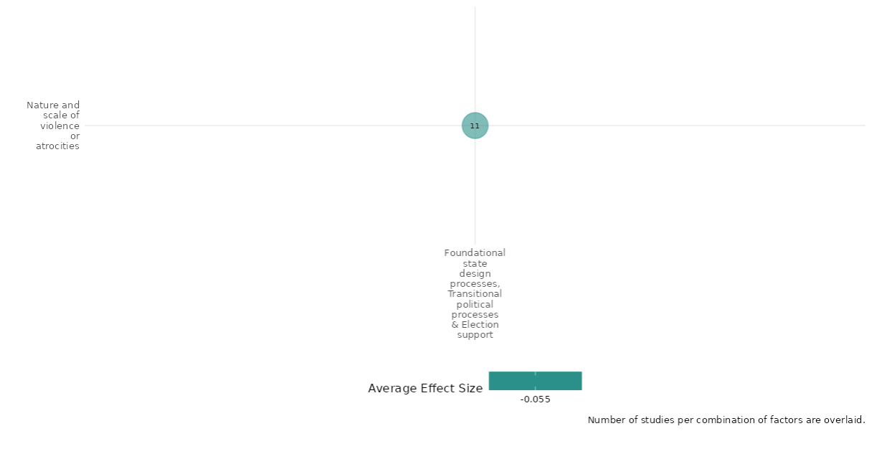

4.5.1(2)
Effect of Foundational state design processes, transitional political processes, and election support intervention on social norms regarding violence and atrocities

Evidence shows that election support interventions including election campaigns and election education events have an impact on voter empowerment and willingness to use political violence.
Geographic Focus: Sub Saharan Africa
Effect: Small effect (g=0.032)
Confidence in study findings: Low (2 studies with 5 effect sizes)

Short summary
The interventions promoted collective electoral participation through town meetings, popular theatre, and door-to-door material distribution. UN peacekeeping operations (PKO) held election education events addressing violent protests and riots, focusing on electoral security, political efficacy, and peace messaging to discourage violence and boost governance legitimacy. The studies had an impact on empowerment measures to counteract violence and willingness to use political violence. Three quasi-experimental studies from Nigeria and Côte d’Ivoire consistently demonstrated the effectiveness of these interventions. There is consistency across both the studies in their findings and we have low confidence in the studies.

Long summary
The intervention
The interventions focused on electoral campaigns appealed to collective action through electoral participation and worked through town meetings, popular theatres, and door-to-door distribution of materials; United Nations peacekeeping operations (PKO) routinely organized election education events on violent protests and rioting involving civilians during electoral periods via three pathways. These include learning about PKO’s electoral security assistance during elections for mitigating fears of election violence; provision of politically relevant information that can strengthen political efficacy and people’s ability to make use of peaceful political channels and finally, peace messages during election-education events can change people’s calculus about the utility and appropriateness of violent behavior.

How the intervention is expected to work
The main mechanism employed affected peacekeeping operations' power of persuasion and influenced people’s perceptions of these conditions and their attitudes to violent conflict and politics. However, these election-education events are short and are organized by international peacekeepers who may lack relevant local knowledge and sensitivity to local contexts. Learning about PKOs’ support for peaceful elections during election education events can augment people’s perceptions that political opponents cannot target them with violence and provide people with politically relevant information by including peace messaging. Also, the anti-violence campaigns increase the sense of security in the general population.

The evidence base
The cell contains 2 studies: 2 impact evaluations designed as quasi-experimental studies. There is consistency in findings across studies.
The studies are from Nigeria (1) and Coˆte d’Ivoire (1).

Evidence findings
Election support interventions, including campaigns and education events, had little effect (g=0.032) on reducing willingness to use political violence and on voter empowerment, confidence in findings remains low. There are 2 impact evaluations in the cell and evidence summaries of the 2 studies are thus provided here:

Included studies
Collier (2014) conducted a field experiment based on anti-violence campaigning. The campaign appealed to collective action through electoral participation and worked through town meetings, popular theatres, and door-to-door distribution of materials. The campaign was designed to induce experimental subjects to oppose voter intimidation. The main mechanism employed was to lower the perceived threat to individual voters through collective action. The study was conducted in Nigeria. The study is designed as a randomized controlled trial. The study included 24 enumeration areas, 1200 participants in baseline (50 per area), and 1149 participants during the post-election survey. The study showed that the anti-violence campaign increased the sense of security in the general population. The campaign also boosted empowerment to counteract electoral violence – the likelihood that the postcard was mailed was 8 percentage points higher for treated respondents. It was also found that there were statistically significant effects of the campaign on diminishing perceptions of political violence and increasing empowerment of the population against political violence. These effects are 0.39, 0.23, and 0.22 standard deviation units for general political freedom and conflict, local electoral violence from the top, and local empowerment from the bottom (respectively). These effects are strongly significant at the 1 or 5 percent levels using cluster-robust standard error inference. The study is rated as low confidence due to attrition not being reported.

Smidt (2020) assessed the impact of United Nations peacekeeping operations routinely organizing election education events on violent protests and rioting involving civilians during electoral periods via three pathways in Coˆte d’Ivoire. These include learning about PKO’s electoral security assistance during elections for mitigating fears of election violence; provision of politically relevant information that can strengthen political efficacy and people’s ability to make use of peaceful political channels and finally, peace messages during election-education events can change people’s calculus about the utility and appropriateness of violent behavior. The study was designed as a quasi-experimental design and data for analysis was obtained from secondary datasets. The statistical analyses support the argument that PKOs’ election-education events can mitigate violent protest and rioting (p<0.01) by soothing fears of election violence, reducing political alienation, and delegitimizing violence (p<0.01). Yet election education makes little difference in opposition strongholds and among opposition supporters, who tend to perceive the PKO as biased. The study is rated as low confidence due to non-experimental study design, partial description of intervention, and attrition not being reported.

Confidence assessment
Overall low confidence as there are only 2 studies in the cell and both are rated as low confidence. There is consistency in findings across both studies.

Other outcomes in this study:
Violence and atrocity prevention / Nature and scale of violence or atrocities
Human security / Political security / Physical security
Community and state governance / civic participation

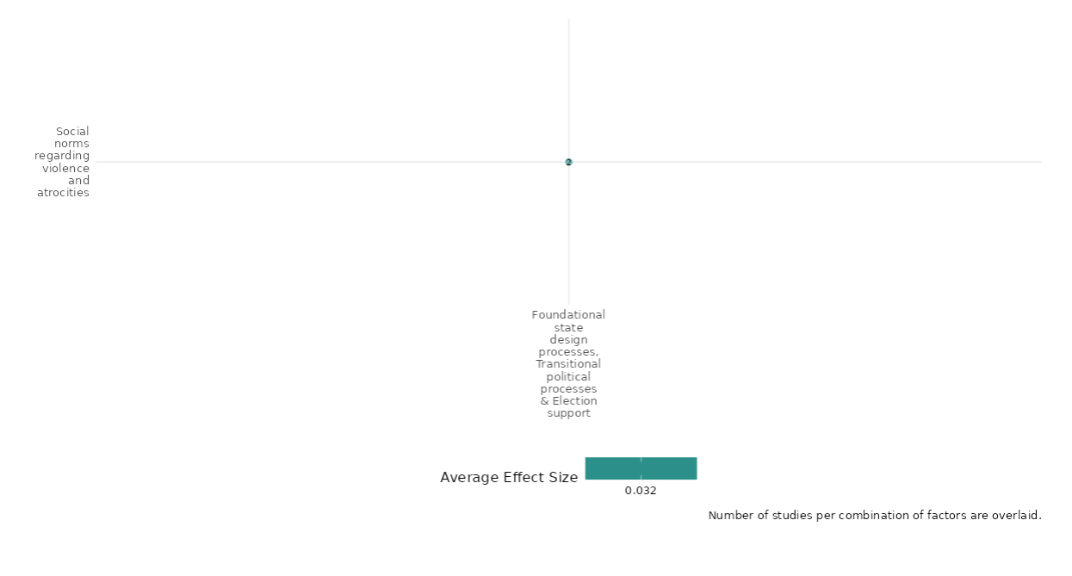

4.5.1(3)
Effect of Foundational state design processes, transitional political processes, and election support intervention on willingness to participate or help

Evidence shows that participatory processes lead to more consultative leadership.
Geographic focus: Sub Saharan Africa
Effect: Adverse effect (g=-0.029)
Confidence in study findings: Low (1 study with 2 effect sizes)

Short summary
This cell examines the impact of participatory processes for selecting clan chiefs in rural Liberia, leveraging a natural experiment after the civil war. Chiefs chosen by communities, rather than appointed, foster greater consultation and political participation but reduce contributions to public goods. Using survey data, behavioral games, and a difference-in-difference strategy, the research highlights that participatory processes encourage consultative leadership but may weaken the enforcement of local cooperation.

Long summary
The intervention
The interventions focused on participatory processes for selecting clan chiefs in rural Liberia. The communities decided to hold public votes to select their new leaders and community members are either asked to line up behind their preferred candidate or to raise their hand, and then each individual is counted. The counting was conducted by the local traditional council, and if objections were raised about the council’s objectivity – outside organizations or individuals were asked to verify the count. The study assessed whether the change in political outcomes caused by the installation of a new chief is larger in places that were non-participatory in 2002 (and so became participatory by virtue of the former chief’s exit) than in places that were participatory in 2002 (and so did not change their selection procedure when the former chief exited).

How the intervention is expected to work
Selecting chiefs through participatory processes enhances community consultation and boosts political participation at both local and national levels. However, it decreases contributions to local public goods, indicating that such chiefs may be less effective in enforcing cooperation. The study reveals that participatory selection does not yield more educated or well-connected leaders but fosters more consultative leadership styles.

The evidence base
The cell contains 1 study: 1 impact evaluation based on difference-in-difference strategy from Liberia.

Evidence findings
The study has an impact on improving consultative leadership and improving political participation. There is 1 impact evaluation in the cell and evidence summaries of the study are provided here:
Included study
Baldwin & Eric (2011) examine the effects of participatory processes for selecting clan chiefs in rural Liberia. After the civil war, some chiefs were appointed by higher authorities, while others were selected by their communities. All chiefs who became incapacitated after 2002 were replaced through participatory processes, providing a natural experiment to study the effects of these processes on established institutions. The research employs a difference-in-difference estimation strategy to identify the effects of participatory processes independent of timing effects. The study draws on survey data and outcomes from behavioral games conducted in 70 clans across 13 of the 15 counties in rural Liberia. Within each clan, 15 households were targeted for interviews, and additional community-level activities were conducted to measure contributions to public goods. The participatory selection of chiefs increases consultation at the community level and raises levels of political participation both locally and nationally. However, it also reduces contributions to local public goods, suggesting that chiefs selected through participatory processes may be less effective at enforcing cooperation. The study finds that participatory processes do not result in the selection of more educated or connected chiefs, but they do lead to more consultative leadership. The study is rated as medium confidence because it is a non-experimental study and only partially describes the intervention.

Confidence assessment
Although the study is rated as medium confidence, the overall confidence of the cell is low as there is only 1 study in the cell.

Other outcomes in the study:
Community and state governance/ Civic Participation / Government performance

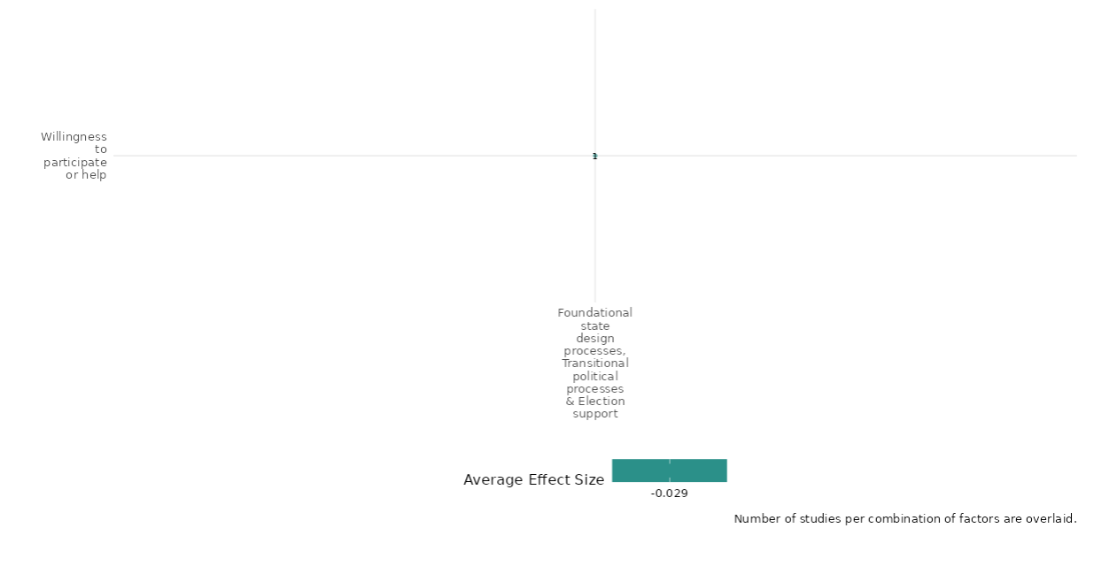

4.5.1(4)
Foundational state design processes, transitional political processes, and election support intervention effect on access to justice, rights and public services

Evidence shows that promoting democracy through the democratization of war-torn states leads to political rights and civil liberties.
Geographic focus: Global
Effect: High effect (g=0.351)
Confidence in study findings: Low (1 study with 4 effect sizes)

Short summary
UN peacebuilding missions aim to promote democratization in post-civil war states by fostering institutional and behavioral change. Steinert & Grimm (2014) evaluated 103 countries, finding a 68% likelihood of democratization in those with missions, compared to 34% without. The study used Freedom House data, controlling for factors like oil wealth and peace agreements. While results suggest missions enhance democracy, unclear descriptions of mission components and non-experimental design reduce confidence, making replication and detailed understanding of their impact challenging.

Long summary
The intervention
The interventions focused on fostering democratic transitions by democratizing war-torn states where peace-building missions are deployed. The study look at the effectiveness of United Nations (UN) peacebuilding missions in democratizing war-torn states, with a focus on missions that include democracy promotion components in their mandates.

How the intervention is expected to work
Democratization is a complex endeavor that triggers substantial institutional and behavioral change requiring targeted and planned substantive action by democracy promoters. A post-civil war country is more likely to experience democratization if a UN peacebuilding mission whose mandate includes democracy promotion is deployed.

The evidence base
The cell contains 1 study: 1 impact evaluation based on a quasi-experimental design assessing democratization trends from 103 post-civil war countries.

Evidence findings
The evidence shows that democratization intervention has an impact in the improvement of political rights and civil liberties. There is 1 impact evaluation in the cell and evidence summaries of the study are provided here:

Steinert & Grimm (2014) examine the effectiveness of United Nations (UN) peacebuilding missions in democratizing war-torn states, with a focus on missions that include democracy promotion components in their mandates. The context involves post-civil war countries where the UN has deployed peacebuilding missions to foster democratic transitions. The research employs a multinominal logistic regression analysis to assess the impact of UN peacebuilding missions on democratization trends in 103 post-civil war countries, of which 31 experienced a UN peacebuilding mission. The study uses Freedom House data to measure democratization, comparing rankings from the first mission year to those five years later. The analysis controls for various factors, including battle deaths, peace agreements, and oil wealth, to account for selection bias in mission deployment. The study finds that democratization is significantly more likely if a UN peacebuilding mission is deployed, with a 68% probability of increased democracy in host countries compared to 34% in non-host countries. The presence of oil wealth negatively impacts democratization prospects, while a clear victory by one conflict party can lead to regime transitions in both directions. Descriptive statistics suggest that greater mission capacity, such as longer duration and more resources, may enhance democratization outcomes, although this relationship is not statistically significant. The study is rated as low confidence as it is a non-experimental study and lacks clear description of the intervention as it does not provide detailed information on the specific components or implementation of the UN peacebuilding missions, making it difficult to replicate or fully understand the intervention's scope and impact.

Confidence assessment
Overall low confidence as there is only 1 study in the cell rated as low confidence. The study is rated as low confidence due to non-experimental study and lacks clear description of the intervention.

Other outcomes in the study:
Community and state governance / Transition of power

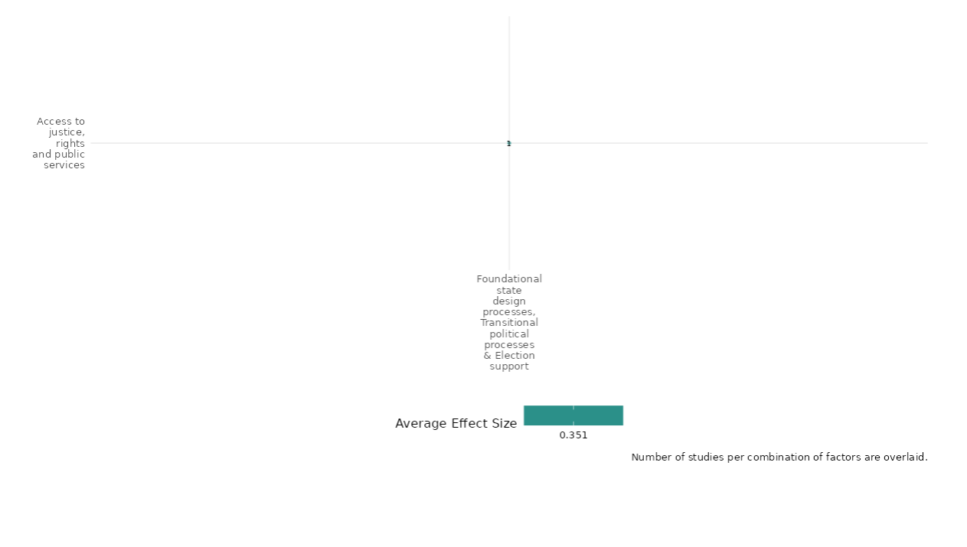

4.5.1(5)
Effect of Foundational state design processes, transitional political processes, and election support intervention on civic participation

The interventions had improved civic participation of the citizens.
Geographic focus: Middle East & North Africa and Sub Saharan Africa
Effect: Moderate effect (g=0.103)
Confidence in study findings: Low (3 studies with 23 effect sizes)

Short summary
The interventions focused on boosting civic and electoral engagement through participatory processes, anti-violence campaigns, and governance strengthening. In Liberia, participatory selection of clan chiefs led to higher political discussion, community engagement, and peaceful protests, with spillover effects on national politics. Nigeria’s anti-violence campaigns increased voter turnout by 7–11 percentage points, countering electoral violence’s suppressive effects. In Iraq, strengthening governance responsiveness improved civic engagement, with 68% of citizens in 2015 viewing political participation as a responsibility, up from 57% in 2013. Despite disillusionment, citizens became more politically active. The quasi-experimental studies from Nigeria, Liberia, and Iraq yielded consistent results.

Long summary
The intervention
The interventions focused on electoral campaigns appealed to collective action through electoral participation and worked through town meetings, popular theatres, and door-to-door distribution of materials; participatory processes for selecting clan chiefs and lastly, strengthening governance responsiveness and legitimacy through civil society leveraging natural experiments. The participatory processes of selecting chiefs affect the type and behavior of leaders and facilitate in selecting more capable leaders.

How the intervention is expected to work
The study shows that communities with participatory processes for selecting their chiefs are more likely to discuss politics with family and friends, speak at community meetings, and contact their clan chief. Furthermore, participatory processes at the local level appear to have effects that spill over into the national political sphere. Individuals in communities with participatory processes for selecting their chiefs are more likely to have contacted their political representative, and more likely to have attended a peaceful protest. They also score higher on the general index of formal political participation. The anti-violence electoral campaigns resulted in 7 and 11 % points larger registered voters in the treated group than the control group for the presidential and gubernatorial contests (respectively). The intervention had a clear effect on the AAIN campaign on voter turnout, which implies that electoral violence was an effective strategy in keeping voters away from the polls. Lastly strengthening responsive governance, As has improved the civic engagement of the citizens. As the majority of citizens feel powerless in the current system, a large number of Iraqis believed that it is their civic responsibility to be involved in politics, with an increase over time (68 percent in 2015 – up from 60 percent in 2014 and 57 percent in 2013). Though Iraqis are becoming increasingly disillusioned with government, a growing number are finding it important to engage in politics and are less fearful of doing so.

The evidence base
The cell contains 3 studies: 3 impact evaluations designed as quasi-experimental studies. The studies are from Nigeria (1), Liberia (1) and Iraq (1).

Evidence findings
The interventions boosted civic and electoral engagement through participatory processes, anti-violence campaigns, and governance strengthening. Results included higher political discussion in Liberia, increased voter turnout in Nigeria, and improved civic engagement in Iraq. There are 3 impact evaluations in the cell and evidence summaries of the study are provided here:

Included studies

Baldwin & Eric (2011) examines the effects of participatory processes for selecting clan chiefs in rural Liberia. After the civil war, some chiefs were appointed by higher authorities, while others were selected by their communities. All chiefs who became incapacitated after 2002 were replaced through participatory processes, providing a natural experiment to study the effects of these processes on established institutions. The research employs a difference-in-difference estimation strategy to identify the effects of participatory processes independent of timing effects. The study draws on survey data and outcomes from behavioral games conducted in 70 clans across 13 of the 15 counties in rural Liberia. Within each clan, 15 households were targeted for interviews, and additional community-level activities were conducted to measure contributions to public goods. The participatory selection of chiefs increases consultation at the community level and raises levels of political participation both locally and nationally. However, it also reduces contributions to local public goods, suggesting that chiefs selected through participatory processes may be less effective at enforcing cooperation. The study finds that participatory processes do not result in the selection of more educated or connected chiefs, but they do lead to more consultative leadership. The study is rated as medium confidence because it is a non-experimental study and only partially describes the intervention and outcome; and attrition is more than 20% as reported in the study.

Collier (2014) conducted a field experiment based on anti-violence campaigning. The campaign appealed to collective action through electoral participation and worked through town meetings, popular theatres, and door-to-door distribution of materials. The campaign was designed to induce experimental subjects to oppose voter intimidation. The main mechanism employed was to lower the perceived threat to individual voters through collective action. The study was conducted in Nigeria. The study is designed as a randomized controlled trial. The study included 24 enumeration areas, 1200 participants in baseline (50 per area), and 1149 participants during the post-election survey. The study showed that the anti-violence campaign was able to increase the sense of security to the general population. The campaign also boosted empowerment to counteract electoral violence – the likelihood that the postcard was mailed was 8 percentage points higher for treated respondents. It was also found clear and statistically significant effects of the campaign on diminishing perceptions of political violence and increasing empowerment of the population against political violence. These effects are 0.39, 0.23, and 0.22 standard deviation units for general political freedom and conflict, local electoral violence from the top, and local empowerment from the bottom (respectively). These effects are strongly significant at the 1 or 5 percent levels using cluster-robust standard error inference. The study is rated as low confidence due to no mention of attrition in the study.

Tesfaye (2016) The study assessed to identify how strengthening governance responsiveness and legitimacy through civil society may lead to sustainable peace in Iraq. The study was designed as a quasi-experimental design. This report is based on data from three rounds of nationwide public opinion surveys between 2013 and 2015, and in-depth interviews with 5,000 respondents across the country in each of the three years. The study found that when people who feel marginalized begin to believe the government is going to be more responsive, accountable, and fair, support for armed violence and the sectarian groups that perpetuate it decreases. Also, as the violent conflict continues or escalates, sectarian divisions have the potential to increase as political opportunists – both domestic and foreign – stoke tensions to gain power. The study is rated as low confidence due to no mention of power calculations.

Confidence assessment
Overall low confidence as there are 3 studies in the cell and 2 out of 3 studies were rated as low confidence. The studies in the cell have mixed results and are not consistent in findings.

Other outcomes in the study:
Social cohesion / Willingness to participate or help
Community and state governance / Government performance
Violence and atrocity prevention / Nature and scale of violence or atrocities / Social norms regarding violence and atrocities

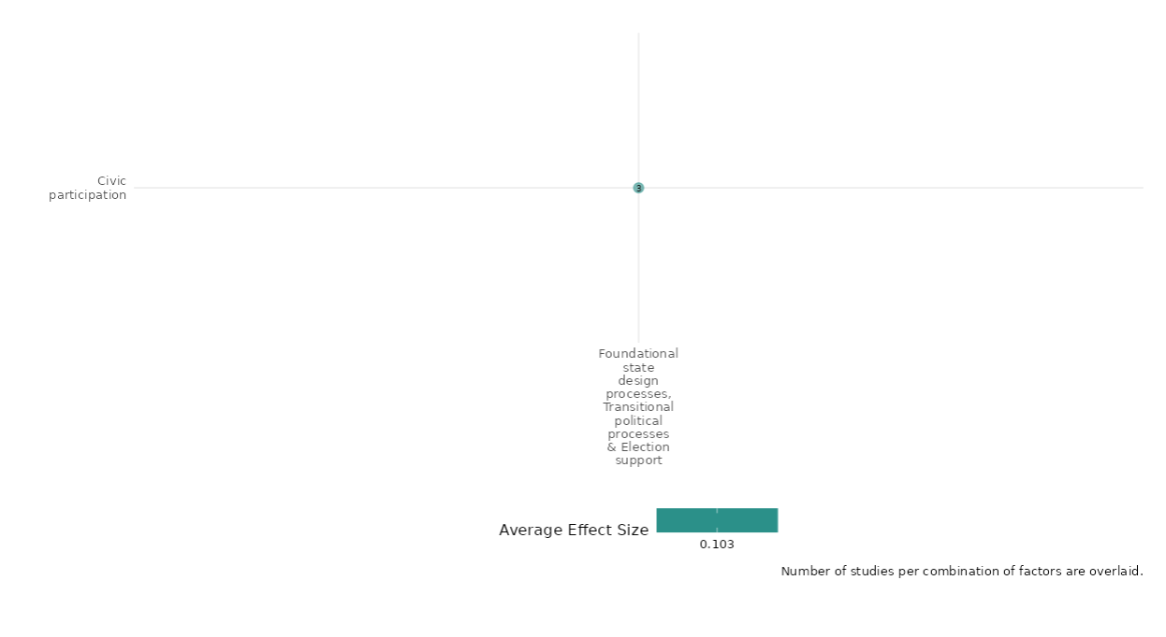

4.5.1(6)
Foundational state design processes, transitional political processes, and election support intervention effect on government performance

The intervention had an impact on the government performance indicators.
Geographical region: Sub Saharan Africa, South Asia, Middle east and North Africa
Effect: Adverse effect (g=-0.095)
Confidence in study findings: Low (4 studies with 23 effect sizes)

Short summary
The intervention includes participatory clan chief selection, anti-fraud measures, citizen social monitoring during elections, UN operations' micro-level impacts, constitution-building, and governance-strengthening initiatives. Participatory processes enhance leader consultation and alignment with citizens’ preferences. Anti-fraud efforts reduce electoral fraud and improve perceptions of government effectiveness. Constitution-building fosters democracy, while governance reforms address corruption and service delivery issues. Despite some progress, public distrust in institutions remains high, as seen in Iraq.

Long summary
The intervention
The intervention covered as part of this cell includes the following: participatory process for selecting clan chiefs, the impact of an anti-fraud intervention on citizens' attitudes toward government and their willingness to comply with its authority, social monitoring initiative in which citizens used cell phones to report instances of fraud during the 2009 Afghan Presidential election on institutional corruption, micro-level impacts of the United Nations Operations on security, economic recovery, and political reintegration after the 2002-2007 civil war, the public participation in constitution building following the war, and strengthening governance responsiveness and legitimacy through civil society may lead to sustainable peace.

How the intervention is expected to work
The participatory processes for selection of clan chief cause more consultation by leaders and greater alignment of interests between leaders and citizens. The study shows that participatory places do not have significantly more meetings, but chiefs are significantly more likely to organize meetings in places where they are selected by participatory processes, suggesting they feel a greater obligation to consult their community in these cases. In addition, the chief was slightly more likely to say he preferred the same project as the rest of the community members in the behavioral game in cases where he had been selected through participatory processes. The anti-fraud intervention affects different indices of perception of government index. The effect of treatment on MP Provides Services is 27 percent, paying taxes – 4.9%, importance of reporting to IEDs to the ANSF-2.38 percent increase. Polling centres inside cell phone coverage areas report up to a 26 percent drop in the share of fraudulent votes relative to centres outside. However, the results exhibit substantial spatial heterogeneity. Participation in the constitution-building process contributes to increased democracy levels, and therefore, it ought to be endorsed regardless of how democracy levels have fared in cases of non-participation. The governance-strengthening interventions have also improved the perceptions of corruption and the worsening of public service delivery. In 2013, 72 percent of Iraqis believed that parliament did not represent the needs and interests of the people. By 2015, that number had jumped to 81 percent. The findings also show that UNOCI’s efforts to meet with locals across the country on election issues are associated with heightened confidence in the likely fairness of the forthcoming elections.

The evidence base
The cell contains 7 studies: 5 impact evaluations designed as quasi-experimental studies and 2 studies as qualitative studies (Richmond 2011 and Stokke 2022).
The studies are from Liberia (1), Afghanistan (2), Bosnia and Herzegovina/ Cambodia/ Kosovo/ Palestine/ Timor-Leste (1), Myanmar (1), Iraq (1) and global (1).

Evidence findings
There are 5 impact evaluations in the cell and effects were estimated for 4 studies as there wasn’t enough data to extract effect for 1 study. The effects ranged very widely for the studies – Baldwin (g= -0.204), Berman (g = 0.121), Gonzalez (g=0.059), Tesfaye (g= -0.368). The interventions had inconsistent effects on the government performance indicators. The evidence summaries of the study are provided here:

Included studies
Baldwin & Eric (2011) examines the effects of participatory processes for selecting clan chiefs in rural Liberia. After the civil war, some chiefs were appointed by higher authorities, while others were selected by their communities. All chiefs who became incapacitated after 2002 were replaced through participatory processes, providing a natural experiment to study the effects of these processes on established institutions. The research employs a difference-in-difference estimation strategy to identify the effects of participatory processes independent of timing effects. The study draws on survey data and outcomes from behavioral games conducted in 70 clans across 13 of the 15 counties in rural Liberia. Within each clan, 15 households were targeted for interviews, and additional community-level activities were conducted to measure contributions to public goods. The participatory selection of chiefs increases consultation at the community level and raises levels of political participation both locally and nationally. However, it also reduces contributions to local public goods, suggesting that chiefs selected through participatory processes may be less effective at enforcing cooperation. The study finds that participatory processes do not result in the selection of more educated or connected chiefs, but they do lead to more consultative leadership. The study is rated as medium confidence because it is a non-experimental study and only partially describes the intervention.
Berman (2019) examines Afghanistan's 2010 parliamentary elections as a case study to tests the impact of an anti-fraud intervention on citizens' attitudes toward government and their willingness to comply with its authority. The study employed a randomized control trial (RCT) involving 471 polling centers, with 238 centers receiving fraud-reducing interventions (notification letters) and 233 serving as controls. Data included election fraud reports, administrative records, and pre- and post-election survey responses from 2,904 citizens near polling centers. Attitudes were assessed using two indices, first measuring government perception (e.g. belief in democracy, trust in governance) and second measuring compliance (e.g. willingness to pay taxes or report insurgent activity). The intervention significantly reduced three measures of election fraud, including tampering with tally sheets, by about 11 percentage points. Government perception and compliance attitudes improved significantly as well. The study is rated low confidence as attrition not being reported in the study.
Gonzalez (2015) assessed the impact of a social monitoring initiative in which citizens used cell phones to report instances of fraud during the 2009 Afghan Presidential election on institutional corruption. The study was conducted in Afghanistan. The study was designed as an experimental study design and covered 139 neighborhoods for capturing the mobile coverage. The study found that there is a considerable drop in fraud levels for polling centers within the coverage area. In particular, for centres within a 5.7-kilometer bandwidth around the coverage boundary, the share of votes classifying as Category C+ fraud is about 5.2 percentage points lower in centers on the coverage side. Given an average share of about 19.8 for centers on the non-coverage side, this represents about a 26 percent drop in the share of fraudulent votes. The study was rated as low confidence due to quasi-experimental study design, partial description of intervention and attrition of more than 20% as reported in the study.
Saati (2015) The study assessed the public participation in constitution building following war, following an institutional crisis or during a transition from authoritarian rule leading to higher levels of democracy. The study is designed as a quasi-experimental study design. The study used 20 cases of participatory constitution-building processes and compared them to each other; and 28 cases of non-participation. The study shows that when all cases of participatory constitution building processes were treated equally, and their individual democracy scores were not viewed in light of the democracy levels of the cases of non-participation, it did indeed appear as if the proposition put forth by advocates of public participation in constitution building had empirical support. In addition, more than half of the cases of non-participation also displayed improved democracy ratings after the second elections following the enactment of the new constitution revealing that, when it comes to strengthening democracy, there is more to the story than public participation in constitution building. The study is rated as medium confidence due to the non-experimental study design and partial description of the intervention.
Tesfaye (2016) The study assessed to identify how strengthening governance responsiveness and legitimacy through civil society may lead to sustainable peace in Iraq. The study was designed as a quasi-experimental design. This report is based on data from three rounds of nationwide public opinion surveys between 2013 and 2015, and in-depth interviews with 5,000 respondents across the country in each of the three years. The study found that when people who feel marginalized begin to believe the government is going to be more responsive, accountable, and fair, support for armed violence and the sectarian groups that perpetuate it decreases. Also, as the violent conflict continues or escalates, sectarian divisions have the potential to increase as political opportunists – both domestic and foreign – stoke tensions to gain power. The study is rated as low confidence due to quasi-experimental study design and partial description of intervention and outcome.

Confidence assessment
Overall low confidence as 3 of 5 studies were rated as low confidence. There is inconsistency in findings across all 4 studies.

Other outcomes in the study
Community and state governance / Civic participation
Violence and atrocity prevention / Nature and scale of violence or atrocities
Social cohesion / Willingness to participate or help

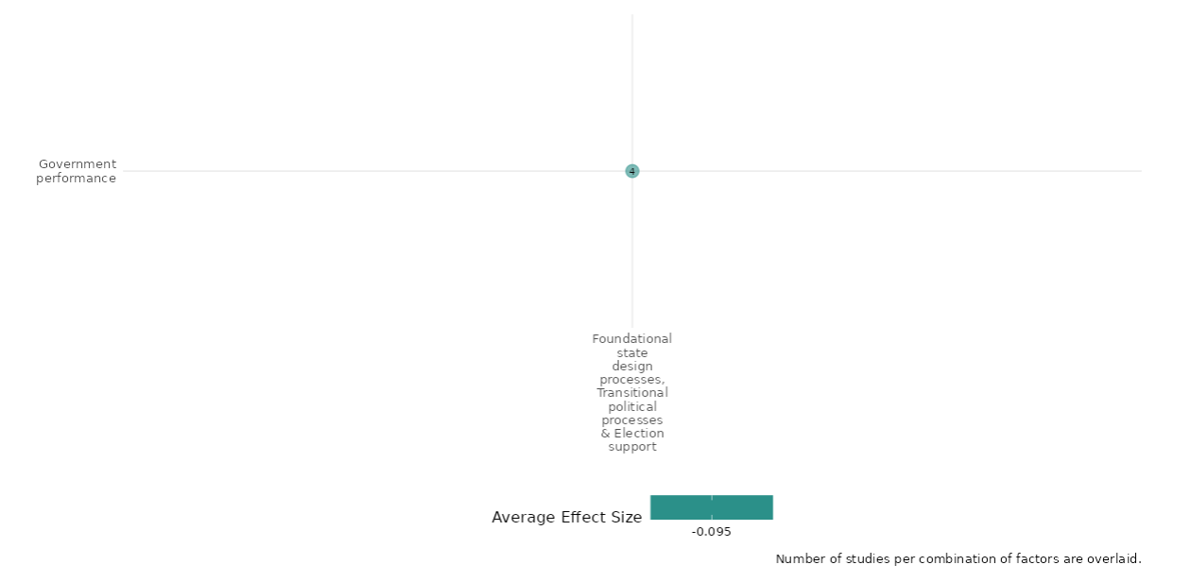

4.5.1(7)
Effect of Foundational state design processes, transitional political processes, and election support intervention on transition of power

UN Peacekeeping operations have an impact on increasing democratisation and electoral democracy.
Geographic focus: Sub Saharan Africa, Global
Effect: Moderate effect (g=0.138)
Confidence in study findings: Low (2 studies with 6 effect sizes)

Short summary
The intervention examines UN peacekeeping missions' role in democratization, focusing on mandates, mission composition, and tactics. From 1991 to 2016, UN missions in Africa supported democracy through voter education, political party assistance, institutional support, and election planning. Using the Peacekeeping Mandates (PEMA) dataset, the study categorizes missions based on explicit democracy mandates and indirect democracy-related activities. Findings suggest that democracy quality improves with specific UN mandates, increased personnel, and engagement with host governments. Election assistance proved the most effective. The evidence base includes two quasi-experimental impact evaluations, with medium and low confidence ratings.

Long summary
The intervention
The intervention focused on UN peacekeeping missions on democratisation focusing on mandates of democracy and composition of peacekeeping missions and democratization datasets. The UN peacekeeping missions on democratisation in Africa since the end of the Cold War (1991 to 2016) addressed three issues: mandates, the composition of peacekeeping missions, and tactics. The authors use the Peacekeeping Mandates (PEMA) dataset to code two treatment variables: UN peacekeeping missions with a democracy mandate, and those carrying out democracy-related activities despite not having the mandate. Democracy-related activities are voter education, assistance to political parties, assistance to democratic institutions such as parliaments, and assistance in planning and conducting elections. And the United Nations (UN) peacebuilding missions in democratizing war-torn states, focused on missions that include democracy promotion components in their mandates. The context involves post-civil war countries where the UN has deployed peacebuilding missions to foster democratic transitions.

How the intervention is expected to work
UN intervention helps overcome challenges to democratization in conflict-affected countries. Consistent with our theory, we find that the quality of democracy improves when a UN mandate is authorized or revised to include democracy promotion; when the number of uniformed or (especially) civilian personnel deployed to a UN mission increase; and when the mission actually attempts to educate voters, train political parties, support democratic institutions, or assist with elections. Although these are correlations rather than relationships of cause and effect, we use multiple identification strategies to mitigate bias and support a causal interpretation of our results. The study finds that the magnitude of the improvement is larger when UN missions engage rather than bypass host governments, especially during periods of peace, and larger for election assistance than for other forms of UN democracy promotion. Also, there was an increased likelihood of democratic transformation, compared with no change, where the UN is deployed with a peacebuilding mandate that includes democracy-promoting components. Further, oil dependence was found to significantly decrease the likelihood of democratization success and a more liberal regime type at the outset turned out to facilitate movements away from democracy.

The evidence base
There are 2 impact evaluations and 1 qualitative study covered in the cell conducted in Africa, Sudan and 103 war-torn states. Of the two impact evaluations, one is of medium confidence and the second one is of low confidence.

Evidence findings
The evidence suggests that democracy improves with specific UN mandates, host government engagement, and election assistance. There are 2 impact evaluations in the cell and evidence summaries of the study are provided here:

Included studies
Blair et al. (2023) assess the effects of UN peacekeeping missions on democratisation in Africa since the end of the Cold War (1991 to 2016). Specifically, they address three issues: mandates, composition of peacekeeping missions, and tactics. The authors use the Peacekeeping Mandates (PEMA) dataset to code two treatment variables: UN peacekeeping missions with a democracy mandate, and those carrying out democracy-related activities despite not having the mandate. Democracy-related activities are voter education, assistance to political parties, assistance to democratic institutions such as parliaments, and assistance in planning and conducting elections. Sensitivity analysis is conducting including also assistance to media and civil society organisations (for which the results do not substantially change). The number of countries with peacekeeping missions with democracy mandates and activities has grown markedly since 2001. The authors code the number and composition of peacekeepers from the Providing for Peacekeeping (PFP) project. The outcome is the Varieties of Democracy (V-Dem) electoral democracy index. Identification is through the following strategies: (i) including country fixed effects, (ii) controlling for time varying confounders such as GNP per capita (lagged to avoid endogeneity); and (iii) instrumental variable estimation, where the instrument is number of missions that year with a democracy mandate or activities in that year, not including the case for those observations. The instrument is provided as evidence shows that a peacekeeping is more likely in a given year if other peacekeeping missions have been approved, with the authors call path dependence and mimicry. The results show that peacekeeping operations go where conflicts are more severe, with larger placements during active conflicts rather than after. This demonstrates that is selection bias in the estimation of effects. Peacekeeping with democracy mandates and activities both increase democratisation. The effect is larger when there is a mandate and is larger if there are more personnel, especially civilian personnel compared to military, Support to elections are the most effective approach to improving electoral democracy, other activities are not statistically significant. This study is rated medium confidence as it is a non-experimental study.
Steinert & Grimm (2014) examines the effectiveness of United Nations (UN) peacebuilding missions in democratizing war-torn states, with a focus on missions that include democracy promotion components in their mandates. The context involves post-civil war countries where the UN has deployed peacebuilding missions to foster democratic transitions. The research employs a multinominal logistic regression analysis to assess the impact of UN peacebuilding missions on democratization trends in 103 post-civil war countries, of which 31 experienced a UN peacebuilding mission. The study uses Freedom House data to measure democratization, comparing rankings from the first mission year to those five years later. The analysis controls for various factors, including battle deaths, peace agreements, and oil wealth, to account for selection bias in mission deployment. The study finds that democratization is significantly more likely if a UN peacebuilding mission is deployed, with a 68% probability of increased democracy in host countries compared to 34% in non-host countries. The presence of oil wealth negatively impacts democratization prospects, while a clear victory by one conflict party can lead to regime transitions in both directions. Descriptive statistics suggest that greater mission capacity, such as longer duration and more resources, may enhance democratization outcomes, although this relationship is not statistically significant. The study is rated as low confidence as it is a non-experimental study and lacks clear description of the intervention as it does not provide detailed information on the specific components or implementation of the UN peacebuilding missions, making it difficult to replicate or fully understand the intervention's scope and impact.
Confidence assessment
Overall low confidence as there are only 2 studies in the cell. There is consistency in findings across 2 studies.

Other outcome in this study
Community and state governance / Access to justice, rights and public services

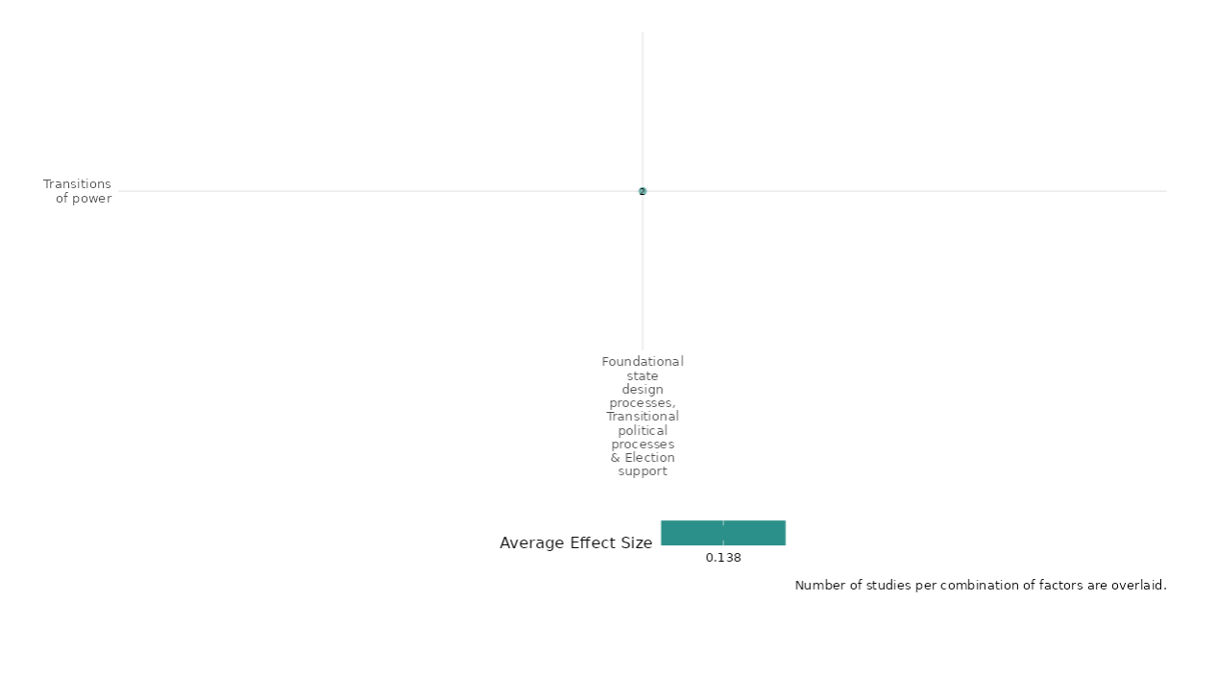

4.5.1(8)
Effect of Foundational state design processes, transitional political processes, and election support intervention on economic security

Evidence shows that rebelocracy, and PESA intervention interventions does not have an impact on improving economic security.
Geographic Focus: Latin America and Caribbean
Effect: No effect (g=0.0)
Confidence in study findings: Low (2 studies with 2 effect sizes)

Short summary
The cell examine diverse interventions addressing economic security. One explores rebelocracy, where non-state armed actors (NSAAs) engage in civilian governance, enabling better coping with weather shocks through public goods provision. Another evaluates India’s PESA Act, which improves literacy and employment in Scheduled Tribes areas and reduces insurgency participation. Both studies, which have quasi-experimental designs and are from Colombia and India, consistently demonstrate no impacts, including economic resilience, improved local governance, and reduced displacement-related economic hardships.

Long summary
The intervention
The studies in this cell study diverse interventions. One study has studied the persistence of the economic legacies of internal conflict through one specific mechanism: rebelocracy. Rebelocracy is the broad intervention of non-state armed actors (NSAAs) in civilian affairs that emanates from a social contract between civilians and combatants, allowing both groups to have clear expectations and a framework to operate. The second study has studied the impact of a decentralization initiative, introduced to address the grievances of a minority ethnic group, Scheduled Tribes (STs) (also commonly referred to as Adivasi), on the rising Maoist insurgency in India. The Panchayats Extension to the Scheduled Areas (PESA) Act of 1996 introduced local governments to ‘schedule five areas’. Schedule five areas are primarily Adivasi areas called by this name because of the fifth schedule in the constitution which is an arrangement to protect the interest of Adivasi communities.

How the intervention is expected to affect this outcome
The intervention showed that the regions where there were strong rebelocracy, households are better able to cope with negative weather shocks than those living in regions with non-state armed actor presence but with limited or no intervention. The former households face a lower economic impact of weather shocks and resort less to survival migration. The effect of rebelocracy is driven mostly by the provision of public goods by non-state armed actors. Implementation of PESA has an impact on improving literacy rates and better employment opportunities as an opportunity cost of participating in the insurgency. However, the areas studied were schedule five districts, and being historically socio-economically backward, they presumably have lower literacy and work participation rates.

The evidence base
The cell contains 5 studies: 3 impact evaluations designed as quasi-experimental studies and 2 qualitative studies. The qualitative studies were conducted in Mozambique (Adedokun (2019)); and Bosnia and Herzegovina, Cambodia, Kosovo, Palestine and Timor-Leste (Richmond 2011). The impact evaluation studies are from Côte d’Ivoire (1), Colombia (1), and India (1). The effects were estimated for 2 impact evaluations (Ibanez 2019 and Nandwani 2019). The effects couldn’t be extracted from Mvukiyehe (2009) due to lack of enough data for calculations.

Evidence findings
The studies didn’t have any impact on economic security outcomes and were consistent across the 2 impact evaluations in the cell. The evidence summaries of the 2 studies are thus provided here:

Ibanez (2019) studies the legacies of wartime institutions, measured as rebelocracy, on the ability of households to cope with negative income shocks. Rebelocracy is the social order established by non-state armed actors in the communities they control. By providing public goods and a predictable framework within which to operate, rebelocracy may generate incentives for households to expand production and accumulate wealth, placing them in a higher income trajectory than households living in war zones amid violence and chaos. The study was conducted in Colombia. The study is designed as a quasi-experimental study design and used a longitudinal household dataset from the Colombian Longitudinal Survey across 33 communities. The study showed that the drought shock harms the value of agricultural production and aggregate consumption. The impact is sizeable: an increase of one standard deviation (SD) in the drought shock decreases the value of annual agricultural production by 0.35SD and aggregate consumption by 0.24SD. The impact of the drought shock for households living in communities with stronger rebelocracy levels is lower. The impact is large: one additional standard deviation in the rainfall and drought shock increases the probability of migration by 0.15 and 0.20 percentage points (pp), respectively. The study was rated as low confidence due to quasi-experimental study design, partial definition of intervention, and no mention of attrition in the study.

Mvukiyehe (2009) evaluates the micro-level impacts of the United Nations Operations in Côte d’Ivoire (UNOCI) on security, economic recovery, and political reintegration after the 2002-2007 civil war. The analysis used survey data from 1,459 civilians and ex-combatants, conflict event data, and socioeconomic indicators. It employed a mixed-methods approach, including panel methods for time-variant data and cross-sectional methods for static data, alongside hierarchical small-area estimation techniques to address sparsity in community-level observations. Sampling weights and clustering techniques were applied to ensure representativeness and robustness in the estimates. The findings show that UNOCI deployments had minimal impact on reducing victimization rates, as these had already declined significantly before their arrival. However, there was limited evidence that UNOCI-monitored zones deterred renewed hostilities. Households in areas with peacekeeping deployments experienced fewer economic losses and somewhat better recovery, although these findings are preliminary and require further causal analysis. UNOCI’s electoral sensitization activities were associated with increased confidence in the fairness of upcoming elections. However, its presence did not significantly influence the return of local political leaders or broader political reintegration. The study is rated low confidence due to the non-experimental study design and attrition not being reported.

Nandwani (2019) investigates if devolution of political power in conflict-affected areas can reduce violence. This is addressed by assessing the impact of a local government institution, introduced in the Adivasi districts in 1996, on Maoist insurgency in India. The local councils aimed to address Adivasi grievances by recognizing their traditional lifestyle and land, forests, and water rights, thereby reducing their incentive to participate in an insurgency. The study is designed as a quasi-experimental study design. The study used district-level data on Maoist insurgency for 17 Indian states from the Global Terrorism database. A total of 14,036 observations were included in the analysis. There is a significant (p<0.05) and positive impact of PESA on the increase in insurgency after its implementation. The introduction of local self-government in Schedule five areas increased the likelihood of insurgency by almost 8–12 % points. Given the average likelihood of insurgency is 14%, there was a considerable increase (50–75%) in insurgency in schedule five districts. The study is rated as low confidence due to quasi-experimental study design, partial definition of intervention and outcome, and no mention of attrition in the study.

Confidence assessment
Overall low confidence as there are only 3 studies in the cell and all studies are rated as low confidence. There is consistency in findings across both studies.

Other outcomes in the study:
Violence and atrocity prevention / Nature and scale of violence or atrocities
Human security / Educational security

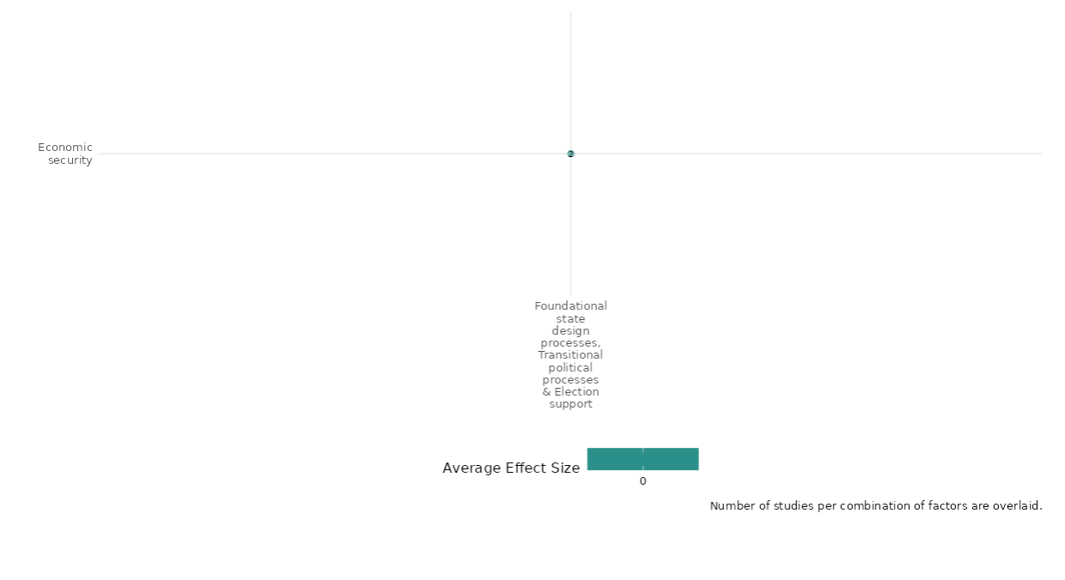
4.5.1(9)
The effect of Foundational state design processes, Transitional political processes & Election support on educational security

Effect: Positive (presence of United Nations involvement, particularly the multilateral interventions, have contributed to a more secure environment for education in Mozambique by facilitating increased funding, improved access, and reduced disparities in education)

Confidence in study findings: Low (one study, low confidence)

Summary
The United Nations(UN) multilateral approach, including disarmament, demobilisation, reintegration programs, humanitarian aid, and post-war reconstruction, was found to be crucial in establishing a more secure environment. This led to increased funding for education, improved access to schools, and reduced regional disparities. By contributing to peacebuilding, economic development, and social equality, the presence of the UN has positively impacted the education sector in Mozambique
The intervention
Demonstrates that any evaluation of the UN’s and the international community’s roles in supporting sustainable peace in Mozambique necessitates a thorough understanding of four crucial mechanisms or instruments: (1) Disarmament, Demobilization, and Reintegration (DDR) before democratisation; (2) Humanitarian assistance; (3) political and electoral assistance; and (4) budget support (p.2-3). All of these components overlapped to achieve the outcome
How is the intervention expected to work
The components of the intervention that worked towards achieving educational security were primarily:
- Disarmament, Demobilization, and Reintegration (DDR): The UN, with the support of bilateral donors, helped demobilise and reintegrate about 100,000 combatants from both the government and rebel forces. This process included counselling, vocational training, and the collection of weapons. According to many interview participants, military inclusion gives feelings of security and confidence
- Humanitarian Assistance: The UN, led by UNOCHA, spearheaded humanitarian and relief efforts, including refugee resettlement, demining initiatives, and food aid. Their decentralised approach, operating at both national and provincial levels, ensured that aid reached all eleven provinces.
- Budget Support: The UN and donor agencies employed budget support, aligning it with Mozambique’s National Poverty Reduction Strategy Document (PARPA). This support helped fund key sectors like education, health, and governance. Budget support significantly increased spending for providing education and human security (p.15-17)
The evidence base
There is one qualitative study assessing the effect of Foundational state design processes, Transitional political processes & Election support on educational security in Mozambique. This study is by A. Adedokun (2019). Transition from civil war to peace: The role of the United Nations and international community in Mozambique. Peace and Conflict Studies, 26(1), 4. All references are from that study.
The evidence
Peace processes and diplomacy in Mozambique, particularly the interventions led by the UN and the international community, have positively impacted the education sector in ways that could be interpreted as contributing to educational security:
- Increased Funding and Resource Allocation for Education: Following the peace agreement in 1992, there was a significant shift in budget allocation from defence to social sectors. This was facilitated by budget support from international donors and the UN, which prioritised sectors like education outlined in Mozambique’s National Poverty Reduction Strategy Document (PARPA). The sources argue that investments in education contribute to peacebuilding by reducing grievances and conflict (Collier and Hoeffler, 2004), promoting economic development and social equality (Thyne, 2016) ultimately promoting a culture of peace (Sargent, 1996).

- Improved Access to Education: As a result of increased funding and peacebuilding efforts, an increase in school enrollment rates was reported, particularly at the primary and secondary levels. Between 1995 and 2011, primary school enrollment increased from 56% to 90%. Secondary school enrollment also saw substantial growth, with the net enrollment rate more than doubling from 8.2% in 2002 to 22% in 2009 (UNDP Report, 2014; International Monetary Fund, 2015; World Bank, 2016).

- Reduced Regional Educational Inequality: Progress in education was observed across all provinces in Mozambique, indicating a reduction in regional disparities in access to education. Data shows the improvement in Net Enrollment Rates (NER) for both primary and secondary schooling across different regions between 2002/03 and 2008/09

Confidence assessment
Overall confidence: Low Confidence Qualitative Study (No explanation and justification for sample/case selection strategy

4.5.1(11)
The effect of Foundational state design processes + Transitional political processes (e.g. transitional governments) + Election support on Food Security, Nutrition & Health Security

Effect: Positive (The presence of United Nations involvement was crucial in achieving well-being & income per capita in Mozambique which had a direct effect on the Food, nutrition & health outcomes)

Confidence in study findings: Low (one study, low confidence)

Summary
The United Nations (UN’s) multilateral approach, encompassing DDR, humanitarian aid, and post-war reconstruction, played a crucial role in Mozambique's successful transition from civil war to relative peace and stability. The UN's involvement was instrumental in achieving lasting peace in Mozambique, with the DDR program, decentralised relief efforts, and financial support for political parties being key strategies
The intervention
Demonstrates that any evaluation of the UN’s and the international community’s roles in supporting sustainable peace in Mozambique necessitates a thorough understanding of four crucial mechanisms or instruments: (1) Disarmament, Demobilization, and Reintegration (DDR) before democratisation; (2) Humanitarian assistance; (3) political and electoral assistance; and (4) budget support (p.2-3). All of these components overlapped to achieve the outcome.
How is the intervention expected to work
- Humanitarian Assistance: this encompassed food aid as one of its components, thus suggesting that food security was at least partially addressed through emergency relief efforts.
- Budget Support: The important role of budget support in funding key sectors relevant to peacebuilding, including agriculture and human and social development. This is grounded in the National Poverty Reduction Strategy Document (PARPA). While not explicitly mentioned, these sectors likely encompass programs and initiatives related to food security, nutrition, and health.
The evidence base
There is one qualitative study assessing the effect of Foundational state design processes + Transitional political processes (e.g. transitional governments) + Election support and Diplomacy on Food Security, Nutrition & Health Security in Mozambique. This study is by Adedokun, A. (2019). Transition from civil war to peace: The role of the United Nations and international community in Mozambique. Peace and Conflict Studies, 26(1), 4. All references are from that study.
The evidence
Below is the data that supports the evidence:
- Mozambique’s human development score increased 75%, or an average annual increase of about 1.66%—a better performance than Zimbabwe or Angola, two countries in the region that had a similar score to Mozambique in 1980 (p.17)
- Life expectancy increased from 46 years in 1995 to 55 years in 2014 (p.17)
- A growth is noted in the income per capita, from $233 in 1995 to $585 in 2014 (constant 2011 U.S. dollars, purchasing power parity) (World Bank, 2016).
- Mozambique has also improved in terms of human development and well-being for instance, Infant mortality declined from 175 deaths per 1,000 live births in 1975 to 70 per 1,000 in 2011 (p.2)

Confidence assessment
Overall confidence: Low Confidence Qualitative Study (No explanation and justification for sample/case selection strategy)

4.5.1(11)
Effect of Foundational state design processes, transitional political processes, and election support intervention on Physical security

Evidence shows that election support interventions including election campaigns, election education events and security, economic recovery, and political reintegration operations have an impact on physical violence and perceived threat of violence during the election campaign.
Geographic focus: Sub Saharan Africa
Effect: Moderate effect (g=0.137)
Confidence in study findings: Low (2 studies with 2 effect sizes)

Short summary
The studies in the cell examined anti-violence election campaigns and UNOCI peacekeeping operations in Cote d’Ivoire. Campaigns promoted opposition to voter intimidation with messages like “No to political violence! Vote against violent politicians.” UNOCI supported peacekeeping by protecting civilians, disarming combatants, and aiding elections through civic education and radio broadcasts. Campaigns reduced voter threats and decreased physical violence by 47 percentage points. Peacekeeping improved security, economic productivity, and political confidence, especially in war-affected regions. Trust in peacekeepers and education campaigns mitigated fears, reduced violence, and fostered peaceful political engagement. Evidence from two studies highlights consistent positive outcomes in Nigeria and Cote d’Ivoire.

Long summary
The intervention
The studies in this cell focused on anti-violence election campaigns and the United Nations Operation in Cote d’Ivoire (UNOCI)—a multi-dimensional peacekeeping Operation. The campaign was designed to induce experimental subjects to oppose voter intimidation. The anti-violence campaign reached a set of enumeration areas, i.e., neighborhoods or villages. The campaign consisted of a clear message against electoral violence, as embedded in its main slogan: “No to political violence! Vote against violent politicians.” UNOCI engages in various election education efforts to counter disinformation during electoral periods. Peacekeeping operations were tasked with a wide range of activities, including protecting civilians, building infrastructure, helping with the disarmament of combatants, and assisting with national and local elections. UNOCI also disseminates civic education through its radio.

How the intervention is expected to work
The campaigns employed lowered the perceived threat to individual voters through collective action. There was a clear decrease in actual violence as reported in the journalists’ diaries. Namely, we detect a 47 percentage-point effect on the likelihood that physical violence occurs. This is evidence that the campaign was able to influence the behavior of violent politicians. The peacebuilding outcomes are associated with increasing people’s (i) sense of security, (ii) ability to be economically productive, and (iii) sense of political normalcy and their ability to resolve political issues through peaceful democratic means. In the war-affected region, there was an enormous increase in political confidence in areas with peacekeepers; nearly all of this difference is attributable to changes in perceptions about whether insecurity will undermine elections. In the non-war-affected regions, large increases in political confidence in areas with peacekeepers, although the reasons for this increase are attributable to large decreases in all types of concerns. The peacekeeping operation intervention also showed that if they are perceived to be trustworthy, then election-education campaigns soothe fears, alleviate political alienation, mitigate people’s willingness to use violence and reduce violent protest and rioting.

The evidence base
The cell contains 2 studies: 2 impact evaluations designed as quasi-experimental studies. The findings were not consistent across the studies. The studies are from Nigeria (1) and Coˆte d’Ivoire (2). The effects couldn’t be extracted from Mvukiyehe (2009) due to a lack of enough data for calculations.

Evidence findings
The estimation of effects includes 2 studies of total 3 studies. One study of the 2 impact evaluations had effects on diminishing perceptions of political violence and increasing empowerment of the population against political violence and second study didn’t had impact on the outcomes. The evidence summaries of the 3 studies are thus provided here:

Included studies
Collier (2014) conducted a field experiment based on anti-violence campaigning. The campaign appealed to collective action through electoral participation and worked through town meetings, popular theatres, and door-to-door distribution of materials. The campaign was designed to induce experimental subjects to oppose voter intimidation. The main mechanism employed was to lower the perceived threat to individual voters through collective action. The study was conducted in Nigeria. The study is designed as a randomized controlled trial. The study included 24 enumeration areas, 1200 participants in baseline (50 per area), and 1149 participants during the post-election survey. Overall, the study found clear and statistically significant effects of the campaign on diminishing perceptions of political violence and increasing empowerment of the population against political violence. These effects are 0.39, 0.23, and 0.22 standard deviation units for general political freedom and conflict, local electoral violence from the top, and local empowerment from the bottom (respectively). These effects are strongly significant at the 1 or 5 percent levels using cluster-robust standard error inference. The study is rated as low confidence due to no attrition being not reported in the study.

Mvukiyehe (2009) evaluates the micro-level impacts of the United Nations Operations in Côte d’Ivoire (UNOCI) on security, economic recovery, and political reintegration after the 2002-2007 civil war. The analysis used survey data from 1,459 civilians and ex-combatants, conflict event data, and socioeconomic indicators. It employed a mixed-methods approach, including panel methods for time-variant data and cross-sectional methods for static data, alongside hierarchical small-area estimation techniques to address sparsity in community-level observations. Sampling weights and clustering techniques were applied to ensure representativeness and robustness in the estimates. The findings show that UNOCI deployments had minimal impact on reducing victimization rates, as these had already declined significantly before their arrival. However, there was limited evidence that UNOCI-monitored zones deterred renewed hostilities. Households in areas with peacekeeping deployments experienced fewer economic losses and somewhat better recovery, although these findings are preliminary and require further causal analysis. UNOCI’s electoral sensitization activities were associated with increased confidence in the fairness of upcoming elections. However, its presence did not significantly influence the return of local political leaders or broader political reintegration. The study is rated low confidence due to the non-experimental study design and attrition not being reported.

Smidt (2020) assessed the impact of United Nations peacekeeping operations routinely organizing election education events on violent protests and rioting involving civilians during electoral periods via three pathways in Coˆte d’Ivoire. These include learning about PKO’s electoral security assistance during elections for mitigating fears of election violence; provision of politically relevant information that can strengthen political efficacy and people’s ability to make use of peaceful political channels and finally, peace messages during election-education events can change people’s calculus about the utility and appropriateness of violent behavior. The study was designed as a quasi-experimental design and data for analysis was obtained from secondary datasets. The statistical analyses support the argument that PKOs’ election-education events can mitigate violent protest and rioting (p<0.01) by soothing fears of election violence, reducing political alienation, and delegitimizing violence (p<0.01). Yet election education makes little difference in opposition strongholds and among opposition supporters, who tend to perceive the PKO as biased. The study is rated as low confidence due to non-experimental study design, partial description of intervention, and attrition being not reported in the study.

Confidence assessment
Overall low confidence as there are 3 studies in the cell and all three studies are rated as low confidence. There is consistency in findings across both the studies.

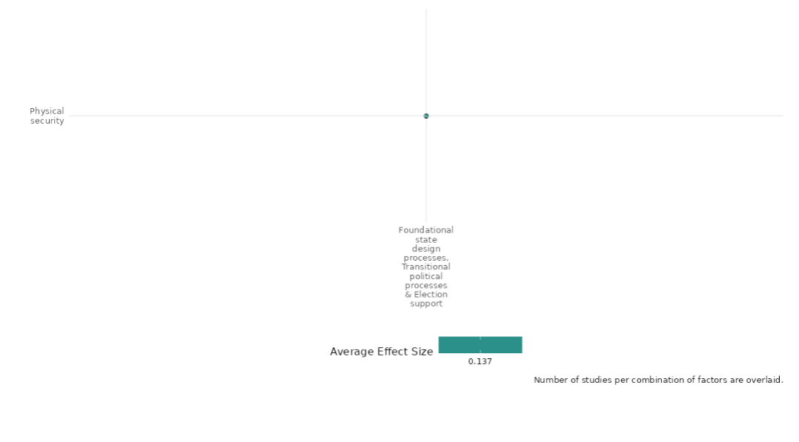

4.5.1(12)
Effect of Foundational state design processes, transitional political processes, and election support on political security

Evidence shows that election support interventions include election campaigns, election education events and strengthened governance have mixed impact on political security.
Geographic focus: Sub Saharan Africa
Effect: Moderate effect (g=0.165)
Confidence in study findings: Low (2 studies with 15 effect sizes)

Short summary
Interventions include anti-electoral violence campaigns, and governance education. UNMIL Radio in Liberia emphasized electoral education during the 2011 elections, focusing on civic roles, voter rights, and peaceful political participation. Electoral education reduces fears of violence and encourages government contact. UNMIL Radio enhances political participation.

Long summary
The intervention
The set of interventions covered as part of this cell summary includes electoral education campaigning and governance-strengthening mechanisms. Electoral programming from broadcast radio on the women’s political behaviors and attitudes in the context of the 2011 general elections in Liberia through mass media - UNMIL radio and UN peacekeeping operations. UNMIL Radio re-focused its programming on the electoral process, covering issues such as education on electoral law, and civic and voter education on roles, rights and responsibilities, among others.

How the intervention is expected to work
UNMIL Radio maintains positive and statistically significant effects on political participation both at the national level and local level. Election education also includes peace messaging. Peacekeepers highlight the utility and normative value of peaceful political behavior. Election education was not found to be correlated with fear and political efficacy, yet election education exposure, on average, tends to reduce fears of violence and increase the frequency of contact with the government.

The evidence base
The cell contains 3 studies: 2 impact evaluations designed as quasi-experimental studies and 1 qualitative study. There is consistency in findings across studies.
The studies are from Mozambique (1), Liberia (1) and Coˆte d’Ivoire (1).

Evidence findings
The evidence shows that election education was not correlated with fear and political efficacy but it increases the frequency of contact with the government. Of the 2 studies, one study had a moderate effect and the second study had no effect on the outcome. There are 2 impact evaluations and 1 qualitative study in the cell and evidence summaries of the 2 studies are thus provided here:
Mvukiyehe (2017) evidence from a field experiment in rural Liberia. This study assesses the impacts of exposure to electoral programming from broadcast radio on women’s political behaviors and attitudes in the context of the 2011 general elections in Liberia. The intervention focused on five special election programs. Listening groups of women were set up in randomly allocated treatment communities in order to isolate any effects. They met on their own three times per week to listen to a specific electoral program in real time. For the fourth weekly meeting, groups were joined by the staff from the implementing partner organization to listen to and discuss a pre-recorded program. The study is designed as a randomized controlled trial and implemented in 600 households across 20 treatment and control communities. In each community, interviews in 10 of the 15 households were conducted with female respondents and 5 were conducted with male respondents. The study showed that there are largely modest, but consistent positive effects of exposure to UNMIL Radio’s elections programs on most outcome indicators (between 1 and 5 percentage points seems to be the most common marginal effect on many outcome indicators, but others also have marginal impacts as high as 9 and 10 percentage points). Only just under half of these estimates are statistically significant at conventional levels, most likely due to a relatively small sample size. Amongst the variables that describe national participation, electoral turnout increased by 9 percentage points for treated women. The study is rated as high confidence.

Smidt (2020) assessed the impact of United Nations peacekeeping operations routinely organizing election education events on violent protests and rioting involving civilians during electoral periods via three pathways in Coˆte d’Ivoire. These include learning about PKO’s electoral security assistance during elections for mitigating fears of election violence; provision of politically relevant information that can strengthen political efficacy and people’s ability to make use of peaceful political channels and finally, peace messages during election-education events can change people’s calculus about the utility and appropriateness of violent behavior. The study was designed as a quasi-experimental design and data for analysis was obtained from secondary datasets. The statistical analyses support the argument that PKOs’ election-education events can mitigate violent protest and rioting (p<0.01) by soothing fears of election violence, reducing political alienation, and delegitimizing violence (p<0.01). Yet election education makes little difference in opposition strongholds and among opposition supporters, who tend to perceive the PKO as biased. The study is rated as low confidence due to quasi-experimental study design, partial definition of intervention, and attrition not being reported in the study.

Confidence assessment
Overall low confidence as there are 2 studies in the cell. The findings are inconsistent across both the studies.

Other outcomes in the study:
Violence and atrocity prevention / Nature and scale of violence or atrocities / Social norms regarding violence and atrocities
Human security / Physical security

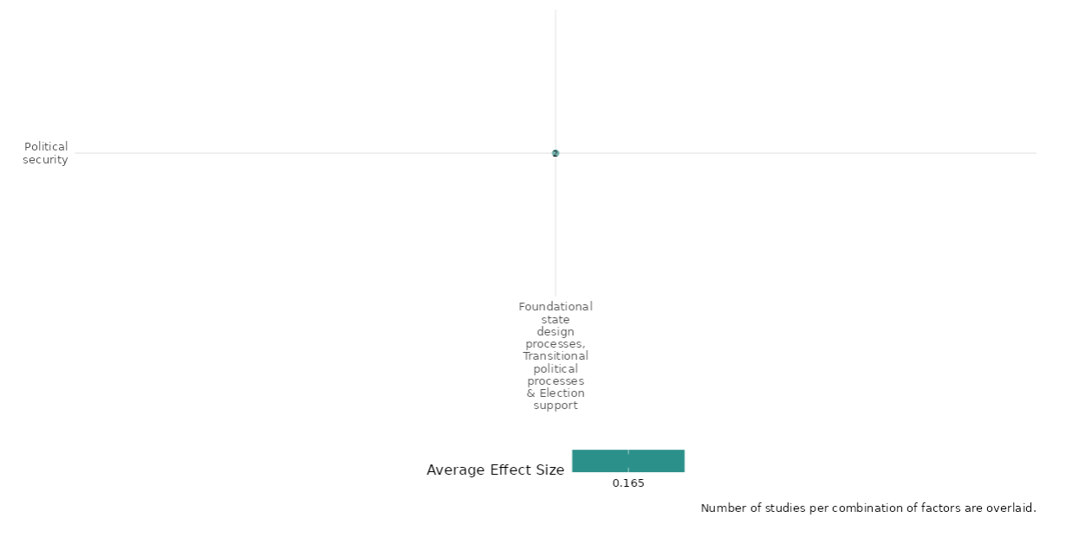

4.5.2 Power-sharing
4.5.2(1)
The effect of power-sharing on government performance
Power-sharing may enhance government performance, although its effectiveness is highly dependent on context.
Geographical Region: Global
Effect size: Small effect (g=0.086)
Confidence in study findings: Low (2 studies with 13 effect sizes)

Short summary
Power-sharing mechanisms, including corporate and liberal approaches, aim to improve government performance by fostering inclusivity and stability in divided societies or post-conflict settings. Evidence shows that rigid corporate systems often stabilize governance short-term but risk elite entrenchment, while liberal systems, emphasizing flexibility and proportionality, better support long-term stability and inclusivity. The effectiveness of these mechanisms varies significantly by context, with liberal approaches generally yielding stronger positive governance outcomes in multi-ethnic societies.

The intervention
Power-sharing mechanisms, such as inclusive governance, equal representation, and institutionalized veto rights, aim to accommodate different groups in governance, particularly in divided societies or post-conflict settings. These interventions often incorporate corporate approaches (rigid, group-based quotas) or liberal approaches (flexible, electorally determined inclusivity). Examples include arrangements in Lebanon (corporate) and Nigeria (liberal), implemented in varying political contexts from 1945 to 2016. These systems seek to balance ethnic or political representation and ensure minority group participation in decision-making, contributing to governance stability.

How the intervention is expected to affect this outcome
Power-sharing is theorized to improve government performance by reducing political instability, fostering inclusivity, and mitigating ethnic or factional conflict. The inclusive nature of power-sharing mechanisms is expected to enhance governance by ensuring diverse participation and accountability, particularly through proportional representation and executive coalitions. However, rigid corporate approaches may limit competition and reinforce elite dominance, potentially stifling broader democratic engagement. Liberal power-sharing, conversely, is posited to better balance inclusivity and governance efficiency, adapting to emerging political dynamics.

The evidence base
The cell includes 2 impact evaluation studies. The analysis utilized global datasets, and consequently focused the analysis on multi-ethnic societies worldwide and diverse political contexts.

Evidence findings
The effects of power-sharing on government performance tends to be highly context dependent. Corporate power-sharing systems, characterized by rigid quotas, often stabilize governance in the short term but can entrench elite control and hinder democratic growth over time. In contrast, liberal power-sharing approaches promote adaptability and inclusivity, supporting long-term governance stability. The effectiveness of these systems varies significantly based on context, with liberal approaches generally showing stronger positive associations with governance outcomes in multi-ethnic and post-conflict societies. However, the trade-offs between stability and democratic competition remain context-dependent.

Included studies
Graham (2017) To protect emerging democracies, political powersharing institutions are recommended, which aim to safeguard minority group interests. Yet there is little empirical research on whether powersharing promotes democratic survival, and some concern that it limits electoral accountability. To fill this gap, we differentiate between inclusive, dispersive, and constraining powersharing institutions and analyze their effects on democratic survival. The study was designed as a quasi-experimental design. The study differentiate between inclusive, dispersive, and constraining powersharing institutions and analyze their effects on democratic survival from 1975 to 2015 using a global dataset. There is a positive effect of constraining powersharing, which is strongly positive for democratic survival both substantively and statistically (p < 0.0001). For the Model 1 sample, the 5-year likelihood of democratic survival is 95.1%. If we increase constraining powersharing by one standard deviation, that probability rises to 97.5%—the risk of democratic failure is cut in half. Remarkably, the effect remains significant controlling for Freedom House, Polity, and Horizontal Constraints. In contrast, neither inclusive nor dispersive powersharing has a significant effect. These results strongly support Hypotheses i.e., constraining powersharing positively promotes democratic survival. The study is rated as low confidence due to no mention of power calculations
Juon (2022) The democratic effect of power-sharing, arguing that it has two antagonist faces. On the positive side, it provides guarantees of inclusion to political elites, allowing them to commit to democratic rules. On the negative side, it also has an illiberal face, entailing limits on competition and individual rights. In this article, these contrary characteristics are traced back to two institutional types of power-sharing: a more flexible and open, liberal, type and a more rigid, corporate one. The study was designed as a quasi-experimental design. Using a novel dataset on power-sharing rules for 138 multi-ethnic countries and the period from 1945 to 2016, their respective democratic merits are tested. The attained coefficients indicate a very substantial effect: over-time increases of our normalized power-sharing index are associated with changes in our similarly normalized dependent variables of around half that magnitude – although one must keep in mind that, in the vast majority of countries, the former only varies across small parts of the theoretically possible range of values. The study is rated as low confidence due to no mention of power calculations.
Confidence assessment
Overall low: The study is rated as low confidence as it only includes 2 studies. Individual confidence assessments of both studies are also low.

Other outcomes in the study:
None

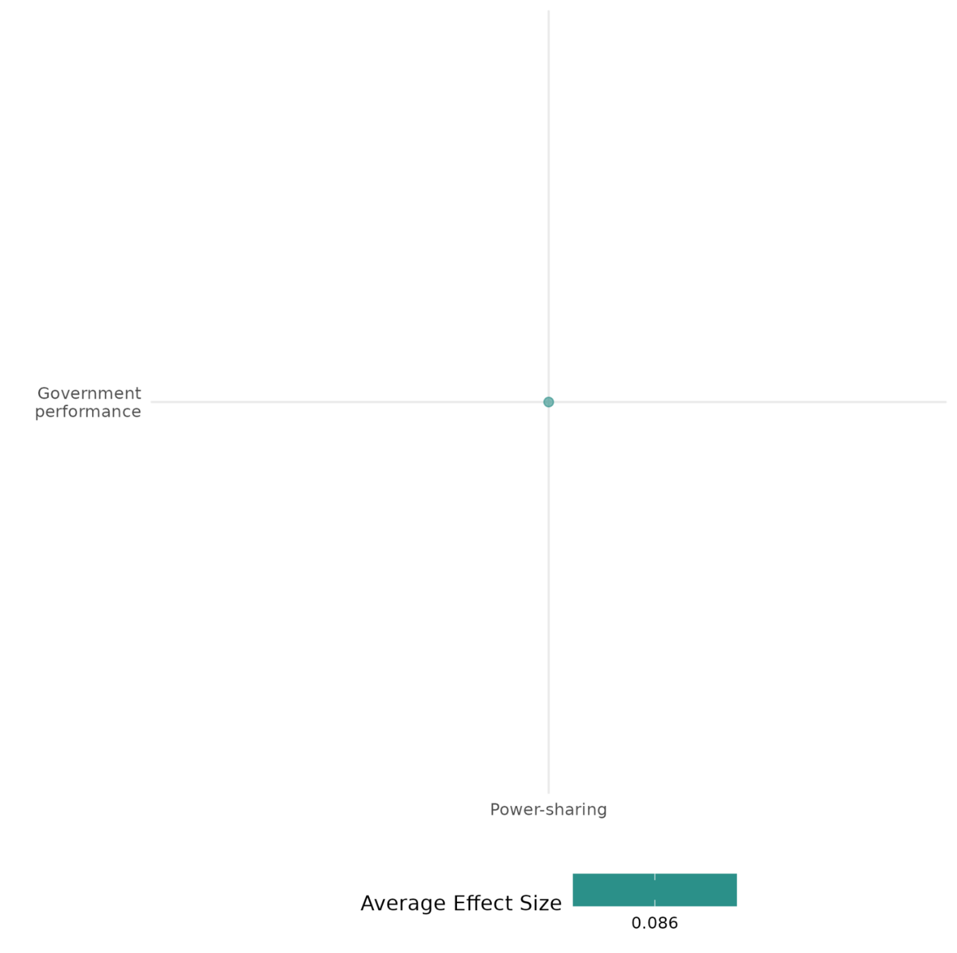

4.5.3 Public sector provision, governance and institutionalisation
4.5.3(1)
Effect of Public sector provision, governance and institutionalization intervention on Diplomatic relations & Peaceful dispute resolution

Evidence shows that peace building fund initiative in public sector provision intervention have an impact on return of displaced person, potential cause of conflict in the community.
Geographic focus: Sub Saharan Africa
Effect: Small effect (g=0.045)
Confidence in study findings: Low (1 study with 38 effect sizes)

Short summary
The evaluation assessed Peace Building Fund (PBF’s) contributions to Burundi’s post-war transition (2007–2013), spanning PBF I, II, and preparations for PBF III. The PBF played a critical role in political negotiations, resolving a 2007 parliamentary deadlock, aiding the FNL’s 2009 transformation into a political party, overcoming logistical challenges for the 2010 elections, and reducing political violence in areas with high IDP and ex-combatant populations. It also facilitated 2013 dialogue workshops that addressed a political impasse ahead of the 2015 elections. PBF-funded initiatives, including the P3P project, prioritized reintegration, land dispute resolution, safety, and human rights, achieving notable improvements in community stability and respect for rights.

Long summary
The intervention
The evaluation involved the assessment of the contribution of the PBF support to Burundi’s post-war transition for the entire period of PBF support to Burundi (2007 – 2013), which included two tranches of PBF funding (PBF I and PBF II) and the preparation of a third one (PBF III), and draws lessons for the PBF based on its support over this entire period. PBF was a powerful tool that provided crucial inputs that advanced Burundi’s ongoing political negotiations, helping to: unblock a deadlock in the Burundian Parliament in 2007; remove the final remaining barrier to the transformation of the FNL rebel group into a political party in 2009; address several critical logistical obstacles in the organization of the 2010 elections; calm communities in provinces that received a high number of IDPs and ex-combatants, and had suffered from the high levels of political violence and instability surrounding the 2010 elections; and it supported dialogue workshops in 2013 that made progress toward breaking another deadlock between political parties surrounding the preparation for the 2015 elections.

How the intervention is expected to work
The PBF-funded interventions in Burundi supported the P3P project, which aimed to assist refugees, internally displaced persons (IDPs), and ex-combatants in returning to and reintegrating into their communities of origin. The P3P project was built on three principles—Inclusion, Appropriation, and Durability—and implemented across three provinces. Addressing land disputes and other conflicts was another key focus of PBF I and II. In the area of land disputes, the PBF’s contribution funded one project that facilitated collaboration between UNHCR and the National Land Commission (CNTB). Land disputes were identified as the most frequent source of conflict. While some security projects effectively addressed safety concerns and acted as catalysts for peacebuilding, others were less relevant or poorly implemented. Human rights were another priority for the PBF, reflected in its support for the Independent National Commission on Human Rights (CNIDH). Local authorities were also recognized for their role in enhancing the human rights environment.

The evidence base
The cell contains 2 studies designed as quasi-experimental study and qualitative study (Coffey 2012).
The study was conducted in Burundi (1) and Sudan (1).

Evidence findings
The evidence shows that peace building funded interventions in Burundi supported refugee reintegration through the P3P project, emphasizing Inclusion, Appropriation, and Durability. These efforts addressed land disputes, security, and human rights, fostering collaboration between UNHCR, CNTB, and local authorities. Although the overall there was a small effect of these intervention on the outcomes.

Included studies
There is 1 impact evaluation in the cell and evidence summaries of the study are thus provided here:

Campbell (2014) assesses the contribution of the peace building fund (PBF) support to Burundi’s post-war transition for the entire period of PBF support to Burundi (2007 – 2013), which included two tranches of PBF funding (PBF I and PBF II) and the preparation of a third one (PBF III), and draws lessons for the PBF based on its support over this entire period. The study was designed as a quasi-experimental design. The evaluation employed an innovative research design that is grounded in a household-level survey of over 250 households from randomly sampled collines with and without PBF involvement, and over 165 semi-structured interviews, 90 of which are drawn from the randomly sampled collines.PBF funded projects made a crucial positive contribution to Burundi’s peacebuilding process and achieved aspects of the Security Council mandate that would have been difficult to do without PBF funding. It provided crucial inputs that advanced Burundi’s ongoing political negotiations, helping to: unblock a deadlock in the Burundian Parliament in 2007; remove the final remaining barrier to the transformation of the FNL rebel group into a political party in 2009; address several critical logistical barriers in the organization of the 2010 elections; calm communities in provinces that received a high number of IDPs and ex-combatants, and had suffered from the high levels of political violence and instability surrounding the 2010 elections; and it supported dialogue workshops in 2013 that made progress toward breaking another deadlock between political parties surrounding the preparation for the 2015 elections. The study is rated as medium confidence due to non experimental study design, partial definition of outcomes and attrition of more than 20% in the study sample.

Confidence assessment
Overall low confidence as there is only one study in the cell.

Other outcome in this study:
Violence and atrocity prevention/Diplomatic relations & Peaceful dispute resolution
Human security / Economic security

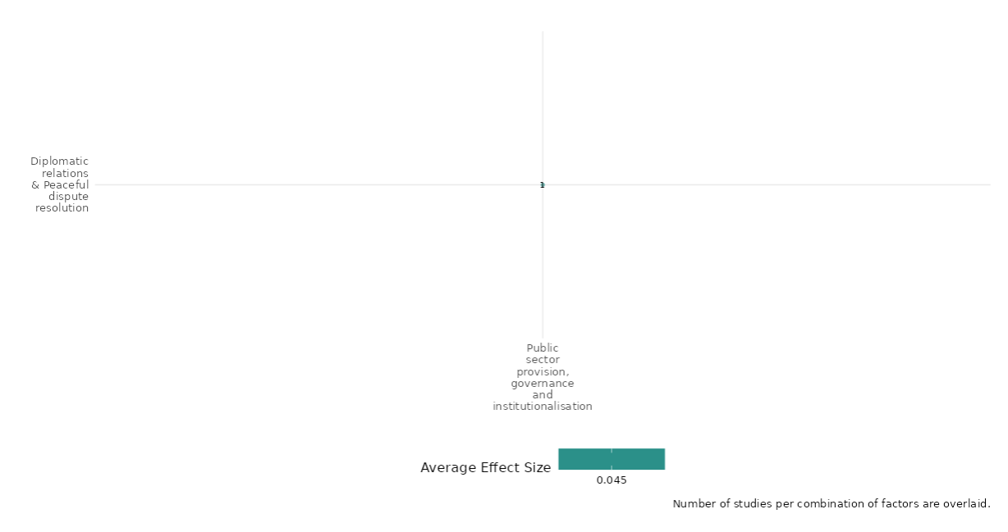

4.5.3(2)
Effect of Public sector provision, governance and institutionalisation on Nature and scale of violence or atrocities

The interventions had mixed impact on nature and scale of violence or atrocities.
Geographic focus: Global, Middle east and North Africa, South Asia, East Asia & Pacific,
Effect: Small effect (g=0.021)
Confidence in study findings: Low (5 studies with 18 effect sizes)

Short summary
The interventions have mixed effects on the violence outcomes. Security-only intervention, focused on establishing security before development; Sequential, prioritizing security first and then development; and Simultaneous, addressing security and development concurrently interventions. Other measures include redistricting, creating new governments, and counterinsurgency aid initiatives. Security-first strategies proved more effective in ending conflicts. Redistricting reduced violence in diverse districts but increased it in ethnically polarized areas. Aid from single donors reduced violence, while fragmented aid diminished impact.

Long summary
The intervention
The set of interventions studied as part of this cell includes the Security-only strategy which proposes providing order and security first and leaving developmental assistance to specialized agencies, 2) the Sequential strategy, which promotes providing security and order first, and then assuming development-related tasks as a means to avoid contradictory effects, and 3) the Simultaneous strategy emphasizes the relationship between underdevelopment and conflict, thus urges the implementation of both security and development related tasks simultaneously. Other interventions include creating new districts and governments; reconstructing sector-specific counterinsurgency aid using data from NATO C3 Agency’s Afghanistan Country Stability Picture (ACSP); aid fragmentation under various donors; and post-conflict institutions and policies can either exacerbate or mitigate group-based violence and identity politics.

How the intervention is expected to work
The interventions designed with strategies prioritizing the establishment of security first (Security-Only and Sequential strategies) are more successful at terminating conflicts; redistricting resulted in no decline in the average incidence of conflict, however, there were relatively larger reductions in violence after splitting in those original districts that experienced the largest reductions in diversity. The child districts exhibited slightly more violence than parents after splitting, and these differences are largest in child districts with high ethnic polarization around the time of the first election; there was a greater incidence of violence in areas more concentrated with reconstruction activity. There was a correlation between reduced political competition with the increased likelihood of violence committed based on group differences and governmental control over rent extraction and armed forces, decentralization, and citizenship also lead to a reduction in violence. And lastly, the intervention showed that when aid is given under one donor the violence is reduced but when it gets fragmented under various donors then the impact of intervention is reduced.

The evidence base
The cell contains 8 studies: 5 impact evaluations designed as quasi-experimental studies, 2 qualitative studies and 1 systematic review.
The impact evaluations studies are from the context of various countries, including Nicaragua, Burundi, Sierra Leone, Angola, Mozambique, and Cambodia (1), Indonesia (1), Afghanistan (2), North Carolina and Iraq (1). The qualitative studies were conducted in Mozambique (1) and Sudan (1). The systematic review focused on developing and middle-income countries.
There is inconsistency across impact evaluations in their findings.

Evidence findings
The review findings
The review evidence shows that there was no consensus on the impacts of international peace operations or community level peacebuilding on armed violence prevention or mitigation.

The impact evaluation evidence
The evidence showed that the interventions prioritizing security first were more effective in ending conflicts, while redistricting did not reduce overall conflict but led to greater violence reductions in districts with decreased diversity. Violence was higher in newly split districts with ethnic polarization, areas with intense reconstruction, and regions with reduced political competition, while centralized aid from a single donor was more effective in lowering violence than fragmented assistance from multiple donors. The evidence summaries of 5 impact evaluations and 1 systematic review are as follows:

Akman (2010) -examines peace operations and their strategies in post-conflict societies, focusing on the interaction between security and development efforts. It explores three main strategies: Security-only, Sequential, and Simultaneous, in the context of various countries, including Nicaragua, Burundi, Sierra Leone, Angola, Mozambique, and Cambodia. The study employs a mixed-methods approach, combining quantitative analysis with qualitative case studies. The quantitative analysis uses a dataset covering civil wars from 1946 to 2006, employing logit models corrected for temporally dependent data to test the effectiveness of different peace operation strategies. The qualitative component involves structured, focused comparisons of six case studies, selected based on the strategy of intervention and varying in terms of success and failure. The findings indicate that interventions prioritizing security first, through Security-Only and Sequential strategies, are more successful in terminating conflicts and achieving durable peace compared to Simultaneous strategies. The study suggests that while Simultaneous strategies are less effective, the quality of peace achieved is not fully accounted for in the statistical analysis and requires further qualitative investigation. The study is rated medium confidence as it is a non-experimental study.
Bazzi (2016) assessed the exogenous timing of new district creation i.e., redistricting in Indonesia to identify the implications of these changes for violent conflict. The study was designed as a quasi-experimental design. A total of 52 districts, 2000 district borders and 7904 conflict observations were used in the analysis. First, we find that ethnic and religious polarization have positive differential effects on the change in conflict after splitting (p<0.05), particularly when focusing on non-crime violence. Meanwhile, ethnic fractionalization has much weaker differential effects close to zero (p<0.05). Second, we find that districts with large reductions in diversity experience a statistically and economically significant decrease in the likelihood of political conflict after splitting. The parent districts with very low diversity (at the 10th percentile) experience a decline in all types of violence after redistricting with the largest and most significant decline happening for political conflict. The study is rated as medium confidence due to quasi-experimental study design.

Child (2019) was conducted in Afghanistan. The study measured the impact of counterinsurgency aid on conflicts by sector-specific reconstruction on conflict by examining monthly changes using a district-level fixed effects model. The study was designed as a quasi-experimental design. The study uses the unit of analysis as district month. The sample covers 398 districts over 57 months (from January 2005 to September 2009), and thus contains a total of 22,686 observations. The study estimates the cross-sectional relationship between (lagged) reconstruction and violence, clustering errors at the province level. Mean projects are significantly positively correlated with violence in the cross-sectional setting (p<0.05). The incidence of greater violence in areas more concentrated with reconstruction activity may simply reflect the spatial selection of projects. The study is rated as low confidence due to quasi experimental study design.

Child (2020) tested the existing theory on aid fragmentation by studying aid provision under numerous donors throughout Afghanistan from 2006-2009. Leveraging granular military data on aid, corruption, public opinion, and conflict, we conduct the first micro-level analysis of aid fragmentation. When delivered by a single donor, aid curtails corruption, boosts public opinion, and reduces conflict. However, under donor fragmentation, the benefits of aid are significantly reduced. The study was designed as a quasi-experimental design. The primary unit of observation is the district-quarter. Total sample covers 398 districts over 15 quarters (from Q1 2006 to Q3 2009), containing 5,970 observations. The study suggests fragmentation facilitates corruption and erodes aid’s ability to win hearts and minds in the fight against insurgents. Independently of aid, however, fragmentation benefits the quality of institutions. The study is rated as medium confidence due to quasi-experimental study design and partial description of interventions and outcomes.

Cramer (2016) focuses on identifying effective interventions for preventing or mitigating armed violence, especially in developing and middle-income countries. The interventions examined include peace operations, economic support, mediation, governance initiatives, justice, reconciliation programs, and media interventions. The analysis considers the various socio-political, economic, and geographic factors influencing these interventions. The assessment uses a systematic review methodology, analyzing 149 studies published from 2010 to 2015. These studies vary widely in quality and design, with a mix of qualitative case studies, quantitative analyses, and mixed methods approaches. It includes literature from English, Spanish, and Portuguese sources, though much of it focuses on sub-Saharan Africa. There is a particular focus on community-level peace initiatives, economic interventions, and security/policing practices, with limited high-quality evidence on governance and justice. The findings are mixed and inconclusive. Only a few high-quality studies provide strong evidence on what consistently "works" across settings. For peacekeeping and mediation there are mixed outcomes, with some studies noting positive impacts on local violence reduction and trust-building but others highlighting unintended negative effects on state-building. For economic interventions employment initiatives may reduce violence under specific conditions, but results are mixed. Limited evidence supports formal justice mechanisms in reducing violence; some success is observed in community-driven reconciliation. Broadcasting and digital media show promise in changing attitudes, though effects on long-term behaviour are uncertain. The study is rated low confidence systematic review as report notes a generally fragmented evidence base with limited high-quality studies. Most of the research assessed as "low quality" limits confidence in overall conclusions about effectiveness. Nonetheless, certain themes—like community-based peacebuilding—show potential, but further rigorous studies are needed to support these findings confidently.
Daugherty (2016) analysed the role of governmental and non-governmental actors in influencing intergroup conflict after war, particularly when group differences have been a significant aspect of war mobilization. The context of this study spans various countries, with specific case studies in Iraq and North Carolina, USA. The dissertation aims to understand how post-conflict institutions and policies can either exacerbate or mitigate group-based violence and identity politics. The study design includes cross-national, national, and sub-national analyses to explore the incentives for actors to institutionalize group differences after war. The research utilizes data from sources like Princeton’s Empirical Studies of Conflict project and public records, focusing on variables such as ethnic violence, political competition, and demographics in Iraq from 2003 onwards. In North Carolina, the study examines lynching violence and its correlation with state capacity and political competition, using historical data and imputation methods to address missing data. Findings from the Iraq case study indicate that higher representation ratios at the governorate level correlate with decreased sectarian violence, while increased budget allocations are associated with higher casualties. In North Carolina, the study finds that higher levels of county-level tax extraction relative to state-level extraction correlate with increased lynching violence, suggesting a political nature to racial violence. These findings highlight the complex interplay between political representation, resource allocation, and violence, suggesting that post-conflict policies need to carefully consider these dynamics to foster lasting peace. The study is rated low confidence as it is a non-experimental study with no clear description of the intervention, as the document primarily focuses on analysing variables such as representation ratios and budget allocations without explicitly detailing the intervention process or its implementation. The study's reliance on existing datasets and imputation methods further complicates the understanding of the intervention's scope and impact.

Confidence assessment
Overall low confidence as 3 studies of 5 are rated as low confidencew. There are mixed findings across all 5 studies.

Link to review summaries
Cramer (2016)
Review can be accessed through EGM

Other outcomes
Community and state governance / Government performance

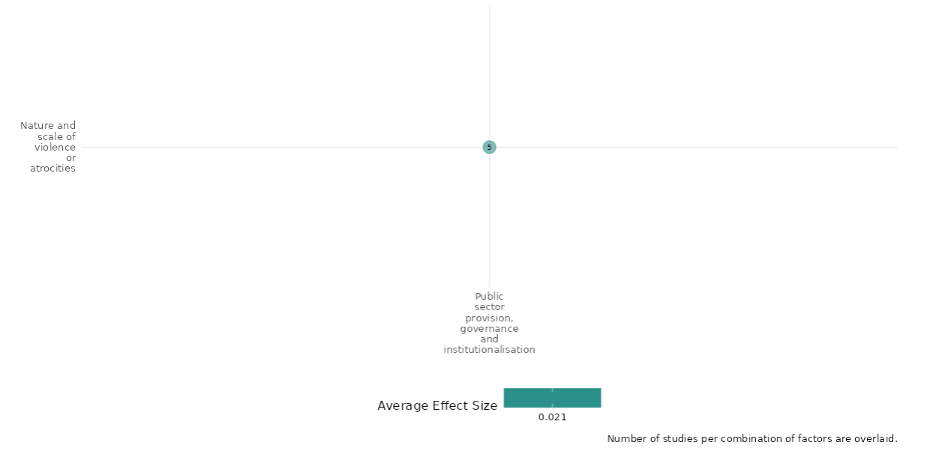

4.5.3(3)
Effect of Public sector provision, governance and institutionalization intervention on Social norms regarding violence and atrocities
Evidence shows that Somali Youth Learners Initiative (SYLI) improved resilience against violence through leadership and conflict resolution skills.
Geographic focus: Sub Saharan Africa
Effect: Moderate effect (g=0.108)
Confidence in study findings: Low (1 study with 12 effect sizes)

Short Summary
Mercy Corps’ Somali Youth Learners Initiative (SYLI) aimed to reduce youth support for armed groups and political violence by improving access to education and fostering civic engagement. SYLI expanded secondary education by constructing and rehabilitating 60 schools across Somaliland, Puntland, and South-Central Somalia, providing education to approximately 45,000 youth. The program also promoted civic engagement by equipping youth with leadership and conflict resolution skills, organizing community action campaigns, and offering recreational activities to build self-confidence and strengthen peer connections. The program significantly reduced youth support for political violence. In-school youth were nearly half as likely (48.2%) as out-of-school youth to support violent groups, with education fostering optimism about job prospects and resilience against recruitment. The evidence is based on a quasi-experimental study conducted in Somalia.

Long summary
The intervention
Mercy Corps’ Somali Youth Learners Initiative (SYLI) was founded on the belief that improving Somali youths’ access to education and civic engagement opportunities could reduce their likelihood of supporting or participating in armed groups and political violence. The first component of the intervention included expanding Access to Secondary Education. This was done by increasing access to formal secondary education, SYLI focused on constructing and rehabilitating schools, training teachers, and developing Community Education Committees. The program opened 60 secondary schools across Somaliland, Puntland, and South-Central Somalia, providing education access to an estimated 45,000 youth. The second component of the intervention was fostering civic engagement by empowering youth to contribute positively to society by supporting them as community leaders. The program provided leadership and nonviolent conflict resolution training, organized community action campaigns, and offered sports and recreational activities to build self-confidence and promote constructive peer interactions.

How the intervention is expected to work
The results indicate that the program’s education component significantly reduced support for political violence. Improved access to secondary education led in-school youth to be nearly half as likely (48.2%) as out-of-school youth to provide moral or material support for political violence. Participants in key informant interviews highlighted education as a critical factor in reducing support for armed opposition groups, with many viewing it as a tool to make youth more resistant to recruitment by such groups. Both academic and vocational education were seen as pathways to employment, another key factor in lowering support for political violence. Interviewees noted that armed groups often target younger people, as they are less likely to think critically and more susceptible to the groups' messaging. They emphasized the importance of educating youth about the risks and consequences of violence—for themselves and the country—and the need for guidance from parents, elders, politicians, and other leaders to instill values and discernment.

The evidence base
The cell contains 1 study designed as quasi-experimental study.
The study was conducted in Somalia (1).

Evidence findings
The study showed that there was an increase in civic engagement by developing youth leadership, conflict resolution skills, and community action efforts. It also boosted self-confidence through recreation, leading to a significant decline in support for political violence. There is 1 impact evaluation in the cell and evidence summaries of the study are thus provided here:

Tesfaye (2018)- This research examines the impact of two common violence-reduction strategies—education and civic engagement—on youth support for armed violence. Armed opposition groups often recruit and indoctrinate frustrated youth, making them a key source of resilience. To counter this, youth development programs in Somalia, including Mercy Corps’ Somali Youth Learners Initiative (SYLI), focus on increasing access to secondary education and civic engagement opportunities for vulnerable youth. An impact evaluation surveying 1,220 youth in two violence-affected regions of Somalia revealed that both SYLI-supported secondary education alone and combined with civic engagement reduced youth support for violent groups. The interventions appeared effective because they increased participants’ optimism about future job prospects and confidence in using nonviolent methods to bring about change in their communities. While the study provides valuable insights, it is rated as medium confidence due to its non-experimental design and the irrelevance of attrition to the study design.

Confidence assessment
Overall low confidence as there is only 1 study in the cell.

Other outcomes in this study:
Violence and atrocity prevention/Social norms regarding violence and atrocities
Violence and atrocity prevention/Diplomatic relations & Peaceful dispute resolution
Social cohesion / Sense of belonging
Human security/Intermediate social cohesion outcomes
Human security/Political security

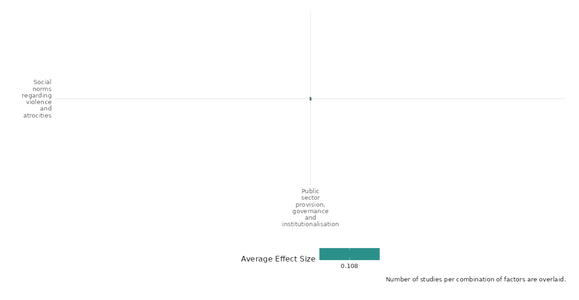

4.5.3(4)
Effect of Public sector provision, governance and institutionalization intervention on Feeling of Trust and acceptance of diversity

Evidence shows that the peace building fund and reforming village-level governance interventions impact perceptions of poverty, targets for discrimination, potential deterioration of human rights, and disputes.
Geographic focus: Sub Saharan Africa
Effect: Small effect (g=0.003)
Confidence in study findings: Low (2 study with 70 effect sizes)

Short summary
The cell assessed the impact of the Peace Building Fund (PBF) on Burundi's post-war transition (2007–2013) and identified lessons for future interventions. PBF facilitated political breakthroughs, including unblocking parliamentary deadlocks, supporting the FNL's transition to a political party, addressing logistical election challenges, and calming politically unstable provinces. Training interventions in Zimbabwe aimed to improve village-level governance by informing village heads and community leaders about regulations and conflict management techniques. The training reduced unresolved disputes when both leaders participated, demonstrating the value of collaborative training. Perceived poverty decreased in PBF areas, with vulnerable groups benefiting most, while human rights perceptions improved significantly.

Long summary
The intervention
The intervention studied was the assessment of contribution of the PBF support to Burundi’s post-war transition for the entire period of PBF support to Burundi (2007 – 2013), which included two tranches of PBF funding (PBF I and PBF II) and the preparation of a third one (PBF III), and draws lessons for the PBF based on its support over this entire period. PBF was a powerful tool that provided crucial inputs that advanced Burundi’s ongoing political negotiations, helping to: unblock a deadlock in the Burundian Parliament in 2007; remove the final remaining barrier to the transformation of the FNL rebel group into a political party in 2009; address several critical logistical obstacles in the organization of the 2010 elections; calm communities in provinces that received a high number of IDPs and ex-combatants, and had suffered from the high levels of political violence and instability surrounding the 2010 elections; and it supported dialogue workshops in 2013 that made progress toward breaking another deadlock between political parties surrounding the preparation for the 2015 elections. Other set of interventions include horizontal pressure in reforming village-level governance in Zimbabwe by comparing two variants of a training intervention for village heads. An international NGO working in rural Manicaland noted that many village heads in the region were not following regulations or recognizing best practices when making decisions and they worried that this was both increasing the bias of their decisions and decreasing the legitimacy of their leadership. The international NGO worked with a local NGO to develop a series of training sessions that would inform village heads of the regulations governing their activities and “best practices” in conflict management techniques. The training sessions were divided into two three-day modules, with about a three month gap in between the two sessions. In one variant of the training session, only the village head attended. But, due to concerns that simply informing village heads of the laws regulating their activities would not be sufficient to change their behavior, there was also a second variant of the training sessions in which another community leader was trained alongside the village head on the rules constraining them. resolving local disputes. More generally, village heads who are more biased and less efficacious in managing village problems may have their legitimacy reduced, thereby leading to a vicious cycle in which citizens’ poor perceptions of them make it difficult for them to resolve village issues.

How the intervention is expected to work
Differences in perceived poverty between PBF and non-PBF collines were most noticeable among women, children, the landless, and the unemployed. These findings are significant because they suggest that vulnerable populations are perceived to be better off in areas where PBF interventions were implemented compared to non-PBF areas, providing evidence of the potential effectiveness of these interventions. This is particularly important since a key objective of the PBF II program is ensuring equitable access to social services for all members of society—a critical component of post-war recovery and conflict resolution. Discrimination, if present, could hinder peacebuilding efforts; however, there is an encouraging trend of decreasing discrimination levels. Human rights were another focal area of the PBF, as demonstrated by its support for the Independent National Commission on Human Rights (CNIDH). Results in this area are similarly promising: 91% of respondents across all collines reported an improvement in respect for human rights in their communities over the past six years. This is further supported by the fact that only 8 out of 202 respondents described their human rights environment as “bad,” while 96% rated it as “good” or “very good.”

The training of civil society leaders enhanced the village head's effectiveness in managing disputes. In villages where only the village head received training, households were somewhat more likely to experience unresolved land or livestock disputes, with a 28% increase observed. While this effect is substantively significant, it is not statistically significant. Conversely, in villages where both the village head and another civil society leader were trained, households were less likely to encounter unresolved disputes, showing a 32% decrease. Although this effect is substantively larger, it is also not statistically significant. Overall, the combined impact of training both the village head and a community leader result in a substantial 59% reduction in the proportion of households with unresolved disputes, which is statistically significant at the 95% confidence level.

The evidence base
The cell contains 3 studies - 2 designed as quasi-experimental and 1 designed as qualitative study (Thiessen 2009).
The study was conducted in Burundi (1), Zimbabwe (1) and Afghanistan (1).

Evidence findings
The peacebuilding fund and training interventions had a small effect in reducing unresolved disputes when both leaders participated, highlighting the benefits of collaborative learning & reduced poverty among vulnerable groups and improvement in human rights perceptions. There are 2 impact evaluations in the cell and evidence summaries of the study are thus provided here:

Included studies
Campbell (2014) assesses the contribution of the peacebuilding fund (PBF) support to Burundi’s post-war transition for the entire period of PBF support to Burundi (2007 – 2013), which included two tranches of PBF funding (PBF I and PBF II) and the preparation of a third one (PBF III), and draws lessons for the PBF based on its support over this entire period. The study was designed as a quasi-experimental design. The evaluation employed an innovative research design that is grounded in a household-level survey of over 250 households from randomly sampled collines with and without PBF involvement, and over 165 semi-structured interviews, 90 of which are drawn from the randomly sampled collines. PBF funded projects made a crucial positive contribution to Burundi’s peacebuilding process and achieved aspects of the Security Council mandate that would have been difficult to do without PBF funding. It provided crucial inputs that advanced Burundi’s ongoing political negotiations, helping to: unblock a deadlock in the Burundian Parliament in 2007; remove the final remaining barrier to the transformation of the FNL rebel group into a political party in 2009; address several critical logistical barriers in the organization of the 2010 elections; calm communities in provinces that received a high number of IDPs and ex-combatants, and had suffered from the high levels of political violence and instability surrounding the 2010 elections; and it supported dialogue workshops in 2013 that made progress toward breaking another deadlock between political parties surrounding the preparation for the 2015 elections. The study is rated as medium confidence.

Baldwin et al. (2017) examines the potential for reforming village-level governance in Zimbabwe through horizontal pressure from civil society leaders. The intervention involved training village heads on governance rules and regulations, with a variant that included training a civil society leader alongside the village head. This approach aims to reduce the abuse of power by village heads and improve governance by leveraging the influence of local civil society leaders. The study was conducted in 270 villages in Zimbabwe, randomly assigned to two intervention variants: one where only the village head was trained, and another where both the village head and a civil society leader were trained. The training sessions were divided into two three-day modules with a three-month gap in between. Surveys were conducted three months after the training to assess the impact on governance outcomes. The inclusion of civil society leaders in the training significantly improved village heads' knowledge and adherence to procedures, with a notable increase in procedural compliance by more than half a standard deviation. The intervention also reduced bias in decision-making, particularly in food aid distribution and dispute resolution, with a 15 percentage point increase in the likelihood of receiving food aid for those with different political views from the village head. Additionally, the presence of civil society leaders increased the perceived legitimacy of village heads among citizens. The study is rated as low confidence due to limited description of the intervention and evaluation questions.

Confidence assessment
Overall low confidence as there are only 2 studies in the cell. The impact of both the studies were inconsistent with each other.

Other outcome in this study:
Baldwin (2017):
Social cohesion/Willingness to participate or help
Community and state governance / Access to justice, rights and public services
Community and state governance / Civic participation
Human security / Education security
Human security / Intermediate social cohesion outcomes

Campbell (2014):
Violence and atrocity prevention/Diplomatic relations & Peaceful dispute resolution
Human security / Economic security

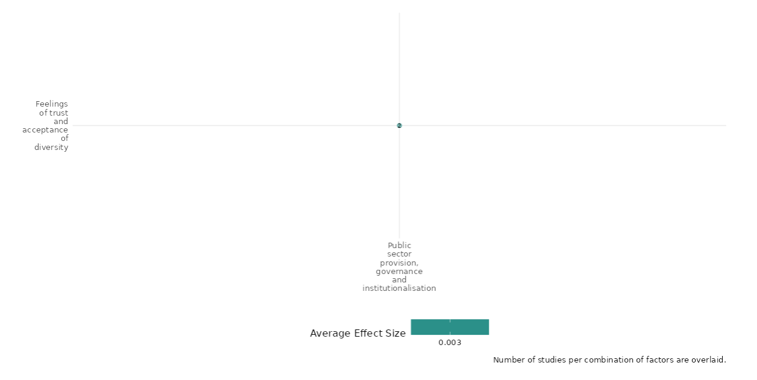

4.5.3(5)
Effect of Public sector provision, governance and institutionalization intervention on Willingness to participate or help

Evidence shows that horizontal pressure for reforming village governance has negative impact on the willingness to participate or help.
Geographic focus: Sub-Saharan Africa
Effect: Adverse effect (g= -0.131)
Confidence in study findings: Low (1 study with 2 effect sizes)

Short Summary
The intervention sought to improve village governance in Zimbabwe by training village heads on regulations and conflict management. An NGO observed that many village heads were not following regulations, leading to biased decisions and reduced legitimacy. Two training variants were tested: one for village heads alone and another including a civil society leader. The cell showed that the training of leaders had an adverse effect on the distribution of food aid by the community leaders.

Long summary
The intervention
The interventions include horizontal pressure in reforming village-level governance in Zimbabwe by comparing two variants of a training intervention for village heads. An international NGO working in rural Manicaland noted that many village heads in the region were not following regulations or recognizing best practices when making decisions and they worried that this was both increasing the bias of their decisions and decreasing the legitimacy of their leadership. The international NGO worked with a local NGO to develop a series of training sessions that would inform village heads of the regulations governing their activities and “best practices” in conflict management techniques. The training sessions were divided into two three-day modules, with about a three-month gap in between the two sessions. Only the village head attended one variant of the training session. But, due to concerns that simply informing village heads of the laws regulating their activities would not be sufficient to change their behaviour, there was also a second variant of the training sessions in which another community leader was trained alongside the village head on the rules constraining them. resolving local disputes. More generally, village heads who are more biased and less efficacious in managing village problems may have their legitimacy reduced, thereby leading to a vicious cycle in which citizens’ poor perceptions of them make it difficult for them to resolve village issues.

How the intervention is expected to work
The first mechanism through which civil society leaders could encourage reform is by competing with the village head to offer services to villagers, thereby allowing villagers to select among them as service providers and motivating both sets of leaders to offer better terms in order to keep clients. If competition is the mechanism driving village-level reforms, we would expect to see an increase in civil society leaders independently offering services in the same domains as the village head as a result of the training. We present data that suggests this did not generally occur. This top row shows other civil society leaders were slightly less likely to be involved in distributing food aid in villages where a civil society leader was trained. The second row shows that, across all treatment arms, household respondents rarely said they would take land or livestock disputes to community leaders other than the village head for resolution, and the training of a civil society leader had little additional effect. The bottom row shows that household respondents were slightly less likely to contact civil society leaders other than the village head for assistance in villages where a civil society leader was trained. Thus, civil society leaders do not appear to have improved local governance by competing with the village head to provide services.

The evidence base
The cell contains 1 study designed as randomized controlled trial.
The study was conducted in Zimbabwe (1).

Evidence findings
The study showed that there was a reduced level of community leader involvement in distributing food aid. There is 1 impact evaluation in the cell and evidence summaries of the study are thus provided here:

Baldwin (2017) examines the potential for reforming village-level governance in Zimbabwe through horizontal pressure from civil society leaders. The intervention involved training village heads on governance rules and regulations, with a variant that included training a civil society leader alongside the village head. This approach aims to reduce the abuse of power by village heads and improve governance by leveraging the influence of local civil society leaders. The study was conducted in 270 villages in Zimbabwe, randomly assigned to two intervention variants: one where only the village head was trained, and another where both the village head and a civil society leader were trained. The training sessions were divided into two three-day modules with a three-month gap in between. Surveys were conducted three months after the training to assess the impact on governance outcomes. The inclusion of civil society leaders in the training significantly improved village heads' knowledge and adherence to procedures, with a notable increase in procedural compliance by more than half a standard deviation. The intervention also reduced bias in decision-making, particularly in food aid distribution and dispute resolution, with a 15-percentage point increase in the likelihood of receiving food aid for those with different political views from the village head. Additionally, the presence of civil society leaders increased the perceived legitimacy of village heads among citizens. The study is rated as low confidence due to the limited description of the intervention and evaluation questions.

Confidence assessment
Overall low confidence as there is only 1 study in the cell.

Other outcomes in this study:
Social cohesion / Feelings of trust & acceptance of diversity / Willingness to participate or help
Community and state governance / Access to justice, rights, and public services / Civic Participation
Human security/ Educational security / Intermediate social cohesion outcomes
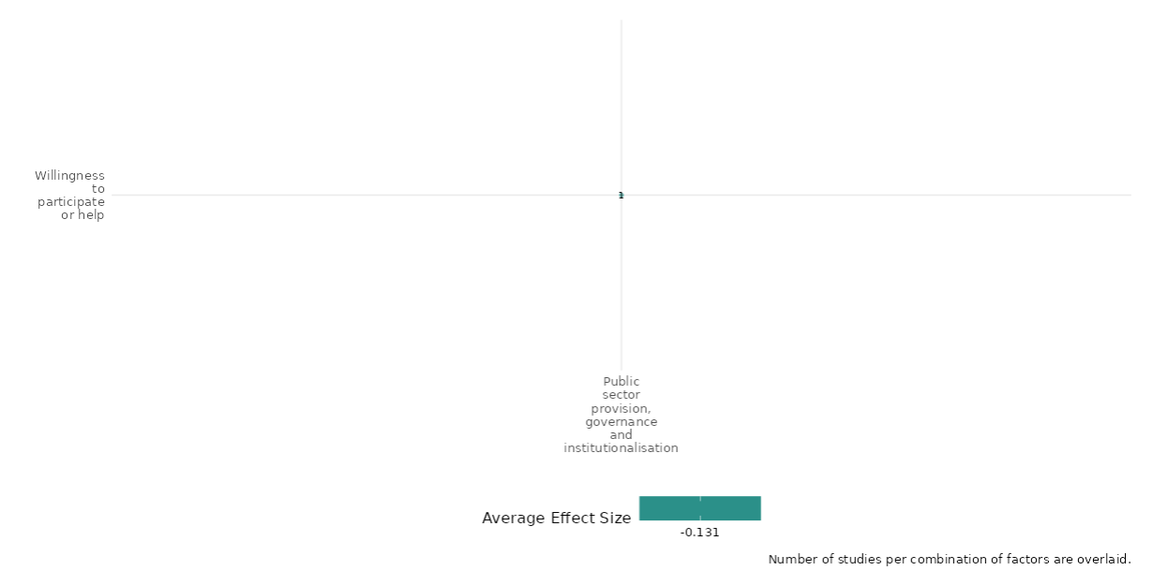

4.5.3(6)
Effect of Public sector provision, governance and institutionalization intervention on Access to justice, rights and public services

Evidence shows that horizontal pressure for reforming village governance improves access to justice, rights and public service outcomes.
Geographic focus: Sub-Saharan Africa
Effect: Small effect (g= 0.059)
Confidence in study findings: Low (1 study with 12 effect sizes)

Short Summary
The intervention aimed to improve village governance in Zimbabwe by training village heads on regulations and conflict management. An NGO observed that many village heads lacked adherence to regulations, leading to biased decisions and reduced legitimacy. Two training variants were tested: one for village heads alone and another including a civil society leader. Evidence suggests that including a civil society leader improved governance, reduced political bias in food aid distribution and dispute resolution, and enhanced dispute management compared to training village heads alone.

Long summary
The intervention
The interventions include horizontal pressure in reforming village-level governance in Zimbabwe by comparing two variants of a training intervention for village heads. An international NGO working in rural Manicaland noted that many village heads in the region were not following regulations or recognizing best practices when making decisions and they worried that this was both increasing the bias of their decisions and decreasing the legitimacy of their leadership. The international NGO worked with a local NGO to develop a series of training sessions that would inform village heads of the regulations governing their activities and “best practices” in conflict management techniques. The training sessions were divided into two three-day modules, with about a three-month gap in between the two sessions. Only the village head attended one variant of the training session. But, due to concerns that simply informing village heads of the laws regulating their activities would not be sufficient to change their behaviour, there was also a second variant of the training sessions in which another community leader was trained alongside the village head on the rules constraining them. resolving local disputes. More generally, village heads who are more biased and less efficacious in managing village problems may have their legitimacy reduced, thereby leading to a vicious cycle in which citizens’ poor perceptions of them make it difficult for them to resolve village issues.

How the intervention is expected to work
The evidence suggests that the inclusion of a civil society leader in the training sessions resulted in improvements in village-level governance. Training of village head resulted in improvement in village head’s knowledge, adherence to procedures, and attitudes toward rights. The variant of the intervention that included a community leader appears to have reduced bias against individuals holding different political views from the village head in both food aid distribution and dispute resolution, and the civil society leader variant of the intervention causes significantly better dispute management than the training variant including only village heads.

The evidence base
The cell contains 1 study designed as randomized controlled trial.
The study was conducted in Zimbabwe (1).

Evidence findings
The intervention sought to improve village governance in Zimbabwe by training village heads, with one variant including a civil society leader. Findings suggest that involving a civil society leader led to better governance, reduced political bias, and improved dispute resolution compared to training village heads alone. There is 1 impact evaluation in the cell and evidence summaries of the study are thus provided here:

Baldwin (2017) examines the potential for reforming village-level governance in Zimbabwe through horizontal pressure from civil society leaders. The intervention involved training village heads on governance rules and regulations, with a variant that included training a civil society leader alongside the village head. This approach aims to reduce the abuse of power by village heads and improve governance by leveraging the influence of local civil society leaders. The study was conducted in 270 villages in Zimbabwe, randomly assigned to two intervention variants: one where only the village head was trained, and another where both the village head and a civil society leader were trained. The training sessions were divided into two three-day modules with a three-month gap in between. Surveys were conducted three months after the training to assess the impact on governance outcomes. The inclusion of civil society leaders in the training significantly improved village heads' knowledge and adherence to procedures, with a notable increase in procedural compliance by more than half a standard deviation. The intervention also reduced bias in decision-making, particularly in food aid distribution and dispute resolution, with a 15-percentage point increase in the likelihood of receiving food aid for those with different political views from the village head. Additionally, the presence of civil society leaders increased the perceived legitimacy of village heads among citizens. The study is rated as low confidence due to the limited description of the intervention and evaluation questions.

Confidence assessment
Overall low confidence as there is only 1 study in the cell.

Other outcomes in this study:
Social cohesion / Feelings of trust & acceptance of diversity / Willingness to participate or help
Community and state governance / Access to justice, rights, and public services / Civic Participation
Human security/ Educational security / Intermediate social cohesion outcomes

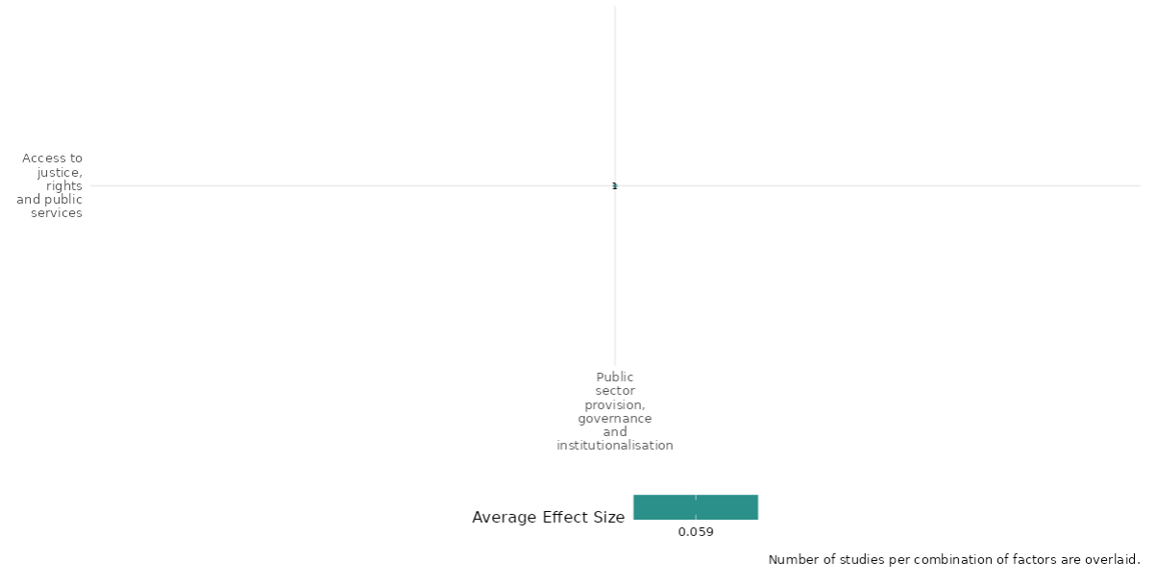

4.5.3(7)
Effect of Public sector provision, governance and institutionalization intervention on Civic participation

Evidence shows that horizontal pressure for reforming village governance reduces the legitimacy index of leaders.
Geographic focus: Sub-Saharan Africa
Effect: Adverse effect (g= -0.007)
Confidence in study findings: Low (1 study with 12 effect sizes)

Short Summary
The intervention aimed to improve village governance in Zimbabwe by training village heads on regulations and conflict management. An NGO observed that many village heads failed to follow regulations, raising concerns about biased decisions and declining legitimacy. Two training variants were tested: one for village heads alone and another including a civil society leader. Training both leaders improved the score for the legitimacy index as compared to the training of only the village head. Overall, there is an adverse impact on the legitimacy index.

Long summary
The intervention
The interventions include horizontal pressure in reforming village-level governance in Zimbabwe by comparing two variants of a training intervention for village heads. An international NGO working in rural Manicaland noted that many village heads in the region were not following regulations or recognizing best practices when making decisions and they worried that this was both increasing the bias of their decisions and decreasing the legitimacy of their leadership. The international NGO worked with a local NGO to develop a series of training sessions that would inform village heads of the regulations governing their activities and “best practices” in conflict management techniques. The training sessions were divided into two three-day modules, with about a three-month gap in between the two sessions. Only the village head attended one variant of the training session. But, due to concerns that simply informing village heads of the laws regulating their activities would not be sufficient to change their behaviour, there was also a second variant of the training sessions in which another community leader was trained alongside the village head on the rules constraining them. resolving local disputes. More generally, village heads who are more biased and less efficacious in managing village problems may have their legitimacy reduced, thereby leading to a vicious cycle in which citizens’ poor perceptions of them make it difficult for them to resolve village issues.

How the intervention is expected to work
The legitimacy index had four sub-components. The training of the village head alone had a negative but statistically insignificant effect on the village head’s legitimacy. This negative trend was driven by households reporting worsened relationships with the village head, suggesting increased suspicion among citizens. In contrast, training both the village head and a civil society leader had a positive but statistically insignificant effect, with the additional civil society leader’s training significantly increasing trust in the village head.

The evidence base
The cell contains 2 studies - 1 study designed as randomized controlled trial and 1 study designed as qualitative study (Arjona 2016).
The study was conducted in Zimbabwe (1) and Colombia (1).

Evidence findings
The cell showed that there is an adverse impact of the intervention on the legitimacy index of the leaders. There is 1 impact evaluation in the cell and evidence summaries of the study are thus provided here:

Baldwin (2017) examines the potential for reforming village-level governance in Zimbabwe through horizontal pressure from civil society leaders. The intervention involved training village heads on governance rules and regulations, with a variant that included training a civil society leader alongside the village head. This approach aims to reduce the abuse of power by village heads and improve governance by leveraging the influence of local civil society leaders. The study was conducted in 270 villages in Zimbabwe, randomly assigned to two intervention variants: one where only the village head was trained, and another where both the village head and a civil society leader were trained. The training sessions were divided into two three-day modules with a three-month gap in between. Surveys were conducted three months after the training to assess the impact on governance outcomes. The inclusion of civil society leaders in the training significantly improved village heads' knowledge and adherence to procedures, with a notable increase in procedural compliance by more than half a standard deviation. The intervention also reduced bias in decision-making, particularly in food aid distribution and dispute resolution, with a 15-percentage point increase in the likelihood of receiving food aid for those with different political views from the village head. Additionally, the presence of civil society leaders increased the perceived legitimacy of village heads among citizens. The study is rated as low confidence due to the limited description of the intervention and evaluation questions.

Confidence assessment
Overall low confidence as there is only 1 study in the cell.

Other outcomes in this study:
Social cohesion / Feelings of trust & acceptance of diversity / Willingness to participate or help
Community and state governance / Access to justice, rights, and public services / Civic Participation
Human security/ Educational security / Intermediate social cohesion outcomes

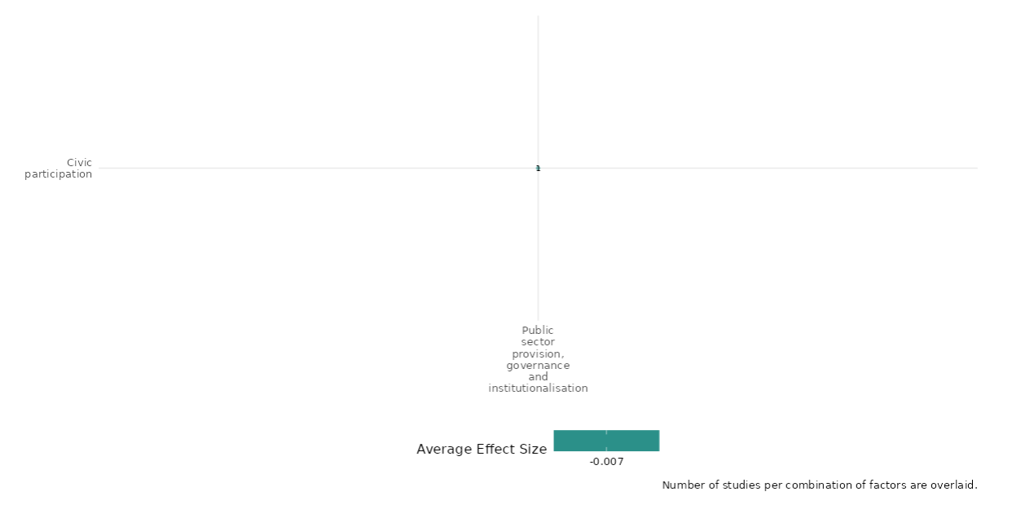

4.5.3(8)
Effect of Public sector provision, governance and institutionalisation on government performance

The intervention had positive impact on government performance outcomes.
Geographic focus: Latin America & Caribbean, South Asia, Middle East & North Africa, East Asia & Pacific
Effect: Small effect (g=0.097)
Confidence in study findings: Low (5 studies with 20 effect sizes)

Short summary
Public sector provision interventions included governance training for village heads and civil society leaders, peace talks, and aid strategies. Information interventions involved nine SMS messages about government projects and public service updates, alongside feedback requests on priorities. Training improved village heads' adherence to procedures by 7%. Aid boosted public support for councils and rebel governance in non-contested areas but had limited impact in contested zones. Information interventions slightly improved satisfaction with services.

Long summary
The intervention
Public sector provisions interventions, including peace talks, peacebuilding funds, and aid fragmentation, aimed to support state-building. Information and feedback interventions involved SMS updates on government projects and service delivery. The content of these messages was provided by the UACT and was tailored to the administrative areas covered by the intervention. Some examples include ‘Territorial Consolidation-Colombian Government is a programme that promotes the presence of the state in your territory. Wait for more information in the next message.’ (Message 1); ‘Territorial Consolidation-Colombian Government has invested more than 175 billion pesos in 58 municipalities affected by violence and drug-trafficking.’ (Message 3). Participants assigned to the feedback treatment condition received nine text messages asking them to submit their priorities for state building programmes and government service provision.

How the intervention is expected to work
The experience of having a rebel governance, civilians were ensured that the peace agreement shall be fully implemented with higher level of trust. The aid had a positive and highly significant effect on public support for local councils in areas in which ISIS was not the dominant actor. In the model when going from no aid to US$500,000 – the mean amount of aid in the sample – boosts support for rebel governance by 0.075 on a scale from 0–1. The average level of support is 0.49; thus, showing that aid can produce limited but real change in perceptions of governance. However, in contested areas, the effect of aid becomes insignificant. The aid fragmentation interventions also have an impact on improving development efforts by the government as there was a standard-deviation increase to non-fragmented aid leading to an approximately one-half-standard-deviation improvement to public opinion of development efforts. The information and feedback intervention showed that those individuals who received the messages with information about activities performed by the UACT had a smaller improvement in the measures of satisfaction with services.

The evidence base
The cell contains 6 studies: 5 impact evaluations designed as quasi-experimental studies and randomized controlled trials & 1 qualitative study. There is inconsistency in findings across studies.
The IE studies are from Philippines (1), Syria (2), Afghanistan (1), Colombia (1) and qualitative study is from Uganda (1).

Evidence findings
The evidence shows that the experience of rebel governance increased trust in peace agreements, while aid significantly boosted public support for local councils, except in contested areas. Non-fragmented aid improved public perception of development, but information interventions had minimal impact on service satisfaction.

Included studies
There are 5 impact evaluations in the cell and evidence summaries of the 5 studies are thus provided here:

Breslawski (2023) assessed that when rebels engage in peace talks with the government, civilians that experienced rebel governance are more likely to trust the government will fully implement the peace agreement than civilians that did not experience rebel governance. The study was designed as a quasi-experimental design. The study shows that there is a positive relationship between having experienced rebel governance by the MILF and trust in the government of the Philippines (p<0.01). Experience with rebel security results in an 7% increase in civilian’s predicted level of confidence that government will implement the full terms of peace agreement, while experience with rebel justice results in a 6% increase in civilian’s predicted level of confidence. The study is rated as medium confidence due to quasi experimental study design and partial description of intervention.

Carnegie (2021) assessed that the foreign aid can improve opinion of the government institutions when they are embedded in demographic, aspirational, and experiential solidarities of their communities in Syria. The study was designed as a quasi-experimental design. The study analyzed perceptions of residents from 27 rebel held communities (13,657 respondents) inside Syria from 2014 to 2016. The study shows that the aid has a positive and significant (p<0.01) effect on public support for local councils in area in which ISIS not the dominant actor. The more OTI provided assistance to a community, the higher the level of support expressed by survey respondents in that community. The study is rated as medium confidence due to quasi-experimental study design.

Carnegie (2021) - The study was conducted in Syria. A primary objective of foreign aid in conflict zones is to help political actors win citizens’ ‘hearts and minds’. Previous studies have focused on assistance provided to state actors; however, this article examines aid’s impact on rebel governance. It argues that aid only bolsters opinions of rebel governors where military control is uncontested. In contested areas, rebels lose credibility if they cannot offer protection, and they have difficulty delivering – and receiving credit for – services in insecure environments crowded with competitors. The study was designed as a quasi-experimental design. The data was gathered in five collection periods: May 2014, September 2014, January 2015, August 2015 and March 2016. A total of 13,657 surveys were administered in twenty-seven Syrian communities. The aid has a modest but positive effect on support for LCs in uncontested areas (p<0.01). Substantively, going from no aid to US$500,000 – the mean amount of aid in our sample– boosts support for rebel governance by 0.075 on a scale from 0–1. The average level of support in our sample is 0.49; thus, we find that aid can produce limited but real change in perceptions of governance. However, in contested areas, the effect of aid becomes insignificant. Also, the baseline level of support for LCs is large, positive and significant, indicating that, as we have argued, civilians tend to identify with and support these bodies. The study is rated as low confidence due to quasi-experimental study design.

Child (2020) NG- 86032267 Aid Fragmentation, Corruption, and Conflict – The study tested the existing theory on aid fragmentation by studying aid provision under numerous donors throughout Afghanistan from 2006-2009. Leveraging granular military data on aid, corruption, public opinion, and conflict, we conduct the first micro-level analysis of aid fragmentation. When delivered by a single donor, aid curtails corruption, boosts public opinion, and reduces conflict. However, under donor fragmentation, the benefits of aid are significantly reduced. The study was designed as a quasi-experimental design. The primary unit of observation is the district-quarter. Total sample covers 398 districts over 15 quarters (from Q1 2006 to Q3 2009), containing 5,970 observations. The study suggests fragmentation facilitates corruption and erodes aid’s ability to win hearts and minds in the fight against insurgents. Independently of aid, however, fragmentation benefits the quality of institutions. The study is rated as medium confidence due to quasi-experimental study design and partial description of intervention and outcomes.

Nussio (2020) – The study was conducted in Colombia. This paper tested two communication interventions in statebuilding areas for improving the communication of government with the public. This include-provision of information on service delivery via text messages – led to a reduction in satisfaction with services and the second treatment – an invitation for citizens to vote on service provision priorities – we can detect no effect. The study was designed as a randomized controlled trial. The randomisation procedure generated a feedback group of 311, an information group of 309, and a control group of 305 subjects. Most of the results are negative and not significant. The negative results indicate that those individuals included in the information intervention did not follow the positive change experienced by the control group, and among Colombians in general during this time period. The positive change in the control group reflects the underlying general mood in Colombia. The study is rated as high confidence.

Confidence assessment
Overall low confidence as only 1 study is rated as high confidence. There is inconsistency in findings across all 5 studies.

Other outcomes
Violence and atrocity prevention / Nature and scale of violence or atrocities

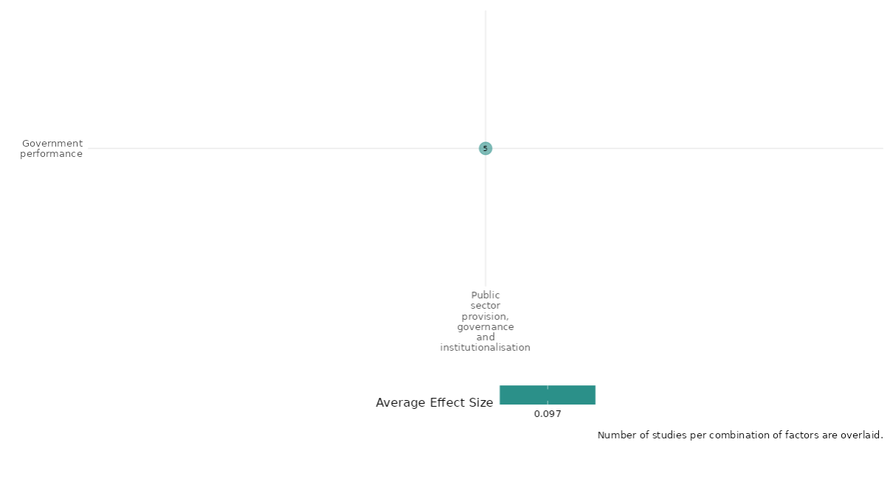

4.5.3(9)
Effect of Public sector provision, governance and institutionalization intervention on economic security

Evidence shows that peace building fund intervention have an impact on reducing poverty and corruption.
Geographic focus: Sub Saharan Africa
Effect: Moderate effect (g=0.167)
Confidence in study findings: Low (1 study with 34 effect sizes)

Short Summary
From 2007 to 2013, Peace Building Fund (PBF) supported Burundi’s post-war transition through three funding phases. It unblocked political deadlocks, helped transform the FNL rebel group into a political party, resolved logistical challenges for the 2010 elections, calmed violence-prone provinces, and facilitated 2013 dialogue workshops for the 2015 elections. PBF areas showed mixed economic outcomes. Residents were 17% more likely to see women’s Revenue generating projects as poverty-reducing but attributed poverty increases (35%) and corruption in police (39%) and officials (30%) to refugee influx and systemic issues.

Long summary
The intervention
PBF support to Burundi’s post-war transition for the entire period of PBF support to Burundi (2007 – 2013), which included two tranches of PBF funding (PBF I and PBF II) and the preparation of a third one (PBF III) and draws lessons for the PBF based on its support over this entire period. PBF was a powerful tool that provided crucial inputs that advanced Burundi’s ongoing political negotiations, helping to: unblock a deadlock in the Burundian Parliament in 2007; remove the final remaining barrier to the transformation of the FNL rebel group into a political party in 2009; address several critical logistical obstacles in the organization of the 2010 elections; calm communities in provinces that received a high number of IDPs and ex-combatants, and had suffered from the high levels of political violence and instability surrounding the 2010 elections; and it supported dialogue workshops in 2013 that made progress toward breaking another deadlock between political parties surrounding the preparation for the 2015 elections.

How the intervention is expected to work
The economic security outcomes studies as part of this intervention include potential causes of increase or decrease in poverty, and instigators of corruption. Although positive responses to potential decreases in poverty were generally low, PBF Collines were, on average, at least more aware of what international organizations are doing and appear to attribute positive effects to such involvement. PBF Colline residents were likely to identify the Revenue Generating Activity (AGR) project for women as a helpful component for reducing poverty. PBF Colline survey respondents were about 35 percentage points higher in attributing increases in poverty to the influx of refugees than were non-PBF respondents. The administrative officials are seen as corrupt overall, respondents in PBF Collines were more likely to mention this than respondents in non-PBF Collines. The same is true of the police — PBF Colline respondents were, likely to cite corruption in the police.

The evidence base
The cell contains 2 studies designed as quasi-experimental and qualitative study.
The study was conducted in Burundi (1) and Mozambique (1).

Evidence findings
The evidence shows that the peace building fund had an impact on the economic security outcomes by having more revenue-generating projects for reducing poverty, however, there was corruption among administrative officials and police. There is 1 impact evaluation in the cell and evidence summaries of the study are thus provided here:

Included studies
Campbell (2014) -83547903 - The study assesses the contribution of the peacebuilding fund (PBF) support to Burundi’s post-war transition for the entire period of PBF support to Burundi (2007 – 2013), which included two tranches of PBF funding (PBF I and PBF II) and the preparation of a third one (PBF III), and draws lessons for the PBF based on its support over this entire period. The study was designed as a quasi-experimental design. The evaluation employed an innovative research design that is grounded in a household-level survey of over 250 households from randomly sampled Collines with and without PBF involvement, and over 165 semi-structured interviews, 90 of which are drawn from the randomly sampled Collines. PBF-funded projects made a crucial positive contribution to Burundi’s peacebuilding process and achieved aspects of the Security Council mandate that would have been difficult to do without PBF funding. It provided crucial inputs that advanced Burundi’s ongoing political negotiations, helping to: unblock a deadlock in the Burundian Parliament in 2007; remove the final remaining barrier to the transformation of the FNL rebel group into a political party in 2009; address several critical logistical barriers in the organization of the 2010 elections; calm communities in provinces that received a high number of IDPs and ex-combatants, and had suffered from the high levels of political violence and instability surrounding the 2010 elections; and it supported dialogue workshops in 2013 that made progress toward breaking another deadlock between political parties surrounding the preparation for the 2015 elections. The study is rated as medium confidence.

Confidence assessment
Overall low confidence as there is only 1 study in the cell.

Other outcomes in this study
Violence and atrocity prevention / Diplomatic relations & Peaceful dispute resolution
Social cohesion / Feelings of trust and acceptance of diversity
Human security / economic security

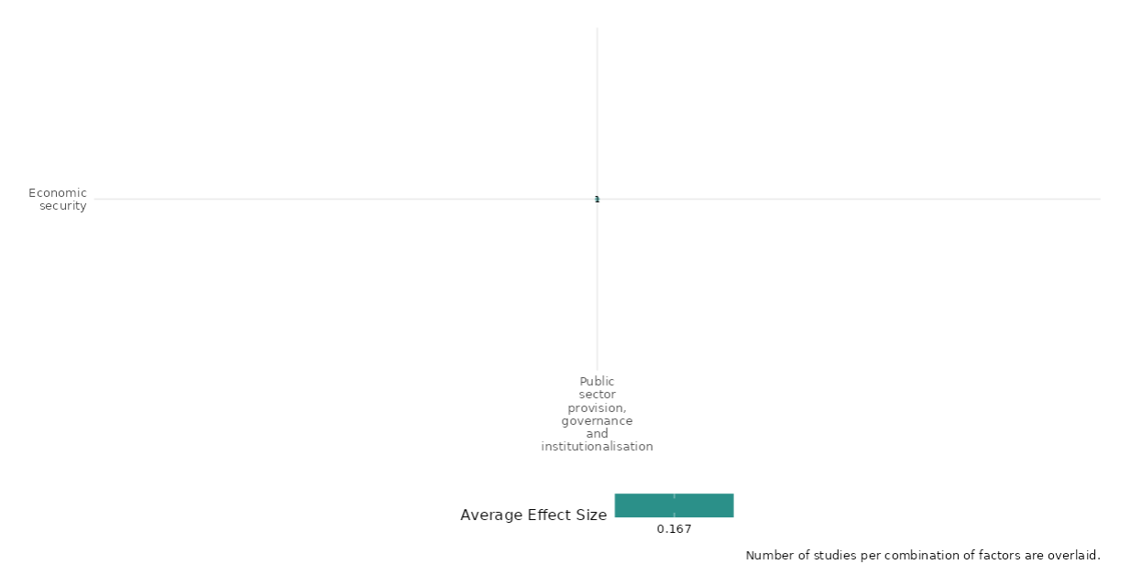

4.5.3(10)
Public sector provision, governance and institutionalization intervention effect on Food security and nutrition & Health security

Evidence shows that implementation of Peace and development teams has an impact reducing malnutrition.
Geographic focus: East Asia & Pacific
Effect: Small effect (g=0.039)
Confidence in study findings: Low (1 study with 1 effect sizes)

Short summary
The "Peace and Development Teams" (PDT) program by the Armed Forces of the Philippines aimed to reduce child malnutrition in conflict-affected areas. Exploiting detailed program data and a staggered rollout over nine years, the study found that PDT interventions reduced child malnutrition by 30% in treated villages within three years, with effects lasting at least seven years. Improved security and access to markets or services likely drove these outcomes, rather than increased government welfare spending.

Long summary
The intervention
The study evaluates a large counterinsurgency program operated by the Armed Forces of the Philippines: “Peace and Development Teams" (PDT). Exploiting unprecedented access to precise program data on location and timing, and the program's staggered roll-out over nine years the study estimated effects on one of the few development outcomes available annually for Philippines municipalities: child malnutrition. Research measured those net welfare effects, in the context of the Philippines, a middle-income economy with a military subject to weak democratic oversight, experiencing a festering, low-intensity insurgency.

How the intervention is expected to work
The Philippines' Peace and Development Teams, operated by the Armed Forces of the Philippines, directly reached 12% of the population over nine years. We estimate that the average implementation reduced child malnutrition by about 30% in treated villages after three years, and persisted afterward until at least year seven. As to mechanism, PDT is not associated with expansions in government expenditure on welfare or health, so we conclude that improvements in security, access to markets, or access to existing government services must have enabled improved infant health.

The evidence base
The cell contains 1 study designed as quasi-experimental study and 1 study as qualitative (Adedokun 2019).
The study was conducted in Philippines (1) and Mozambique (1).

Evidence findings
The peace and development team intervention program had a very small impact on reducing the levels of malnutrition among children in a span of 3 years. There is 1 impact evaluation in the cell and evidence summaries of the study are thus provided here.

Included studies
Berman et al. (2016) evaluates the Peace and Development Teams (PDT) program, a counterinsurgency initiative by the Armed Forces of the Philippines. The authors explore whether PDT's security measures indirectly foster development by enabling better access to markets, services, or governance. The study evaluates the staggered rollout of PDT across municipalities from 2002 to 2010 using an event study design and regression models to analyze malnutrition rates. The dataset includes malnutrition data, PDT rollout information, and violent incidents. PDT interventions reduced child malnutrition rates by 10% within the first year and up to 30% three years post-implementation. These improvements persisted for at least seven years. The reductions were attributed to improved security and market access rather than increased health or welfare spending. Neighboring municipalities experienced increased malnutrition rates due to rebel displacement from treated areas. The negative spillover effects offset the overall net gains, resulting in an aggregate effect close to zero. PDT's effect size on malnutrition was comparable to conventional health interventions. The study is rated low confidence due to non-experimental study design and its little description of the evaluation questions.

Confidence assessment
Overall low confidence as study was rated low due to non-experimental study design and its little description of the evaluation questions and only 1 study in the cell.

Other outcomes in the study
No outcomes

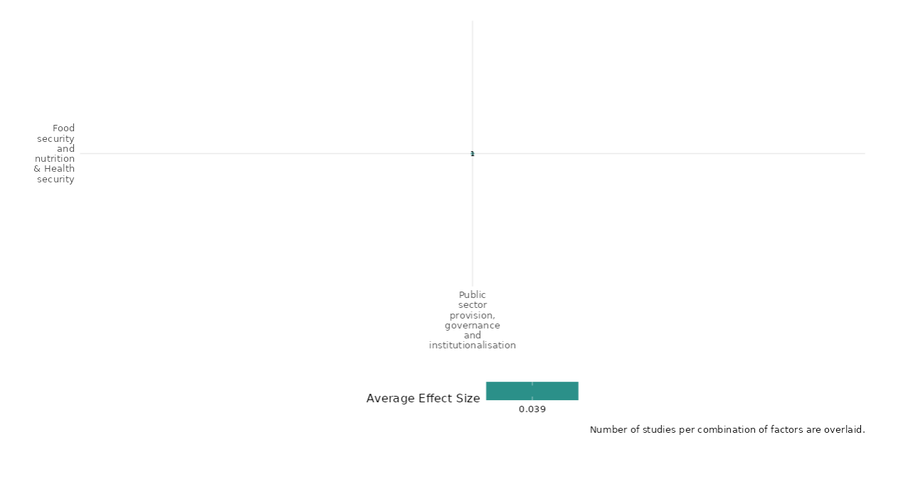

4.5.3(11)
Effect of Public sector provision, governance and institutionalization intervention on Intermediate Social Cohesion outcomes
Evidence shows that horizontal pressure for reforming village governance increases the information exchange between village head and community leader.
Geographic focus: Sub-Saharan Africa
Effect: Adverse effect (g= 0.035)
Confidence in study findings: Low (1 study with 2 effect sizes)

Short Summary
The intervention aimed to reform village-level governance in Zimbabwe by training village heads on regulations and conflict management. An NGO noted that many village heads failed to follow regulations, increasing decision-making bias and reducing legitimacy. Two training variants were tested: one for village heads alone and another including a civil society leader. The latter increased interactions between village heads and civil society leaders.

Long summary
The intervention
The interventions include horizontal pressure in reforming village-level governance in Zimbabwe by comparing two variants of a training intervention for village heads. An international NGO working in rural Manicaland noted that many village heads in the region were not following regulations or recognizing best practices when making decisions and they worried that this was both increasing the bias of their decisions and decreasing the legitimacy of their leadership. The international NGO worked with a local NGO to develop a series of training sessions that would inform village heads of the regulations governing their activities and “best practices” in conflict management techniques. The training sessions were divided into two three-day modules, with about a three-month gap in between the two sessions. Only the village head attended one variant of the training session. But, due to concerns that simply informing village heads of the laws regulating their activities would not be sufficient to change their behaviour, there was also a second variant of the training sessions in which another community leader was trained alongside the village head on the rules constraining them. resolving local disputes. More generally, village heads who are more biased and less efficacious in managing village problems may have their legitimacy reduced, thereby leading to a vicious cycle in which citizens’ poor perceptions of them make it difficult for them to resolve village issues.

How the intervention is expected to work
The training of civil society leaders led to the village head feeling more constrained by the government while also increasing communication between civil society leaders and district administrators—the most influential bureaucrats at the district level. However, contrary to expectations based on the fire alarm channel, village heads did not perceive a decline in their independence from the government due to the inclusion of civil society leaders. Additionally, the exchange of information between civil society leaders and district administrators significantly decreased when civil society leaders participated in the sessions. This suggests that civil society leaders may have been less effective in mobilizing sanctions from higher authorities as a result of the intervention. Instead, they exerted direct social pressure to influence behavior. Although these leaders already held high social standing in their communities, there was no detectable increase in their status due to the intervention. However, their interactions with the village head increased.

The evidence base
The cell contains 1 study designed as a randomized controlled trial.
The study was conducted in Zimbabwe (1).

Evidence findings
The cell showed an increase in the interactions and sharing of information between the village head and community leader after the intervention. Although the overall effect is small in size. There is 1 impact evaluation in the cell and evidence summaries of the study are thus provided here:

Baldwin (2017) examines the potential for reforming village-level governance in Zimbabwe through horizontal pressure from civil society leaders. The intervention involved training village heads on governance rules and regulations, with a variant that included training a civil society leader alongside the village head. This approach aims to reduce the abuse of power by village heads and improve governance by leveraging the influence of local civil society leaders. The study was conducted in 270 villages in Zimbabwe, randomly assigned to two intervention variants: one where only the village head was trained, and another where both the village head and a civil society leader were trained. The training sessions were divided into two three-day modules with a three-month gap in between. Surveys were conducted three months after the training to assess the impact on governance outcomes. The inclusion of civil society leaders in the training significantly improved village heads' knowledge and adherence to procedures, with a notable increase in procedural compliance by more than half a standard deviation. The intervention also reduced bias in decision-making, particularly in food aid distribution and dispute resolution, with a 15-percentage point increase in the likelihood of receiving food aid for those with different political views from the village head. Additionally, the presence of civil society leaders increased the perceived legitimacy of village heads among citizens. The study is rated as low confidence due to the limited description of the intervention and evaluation questions.

Confidence assessment
Overall low confidence as there is only 1 study in the cell.

Other outcomes in this study:
Social cohesion / Feelings of trust & acceptance of diversity / Willingness to participate or help
Community and state governance / Access to justice, rights, and public services / Civic Participation
Human security/ Educational security / Intermediate social cohesion outcomes

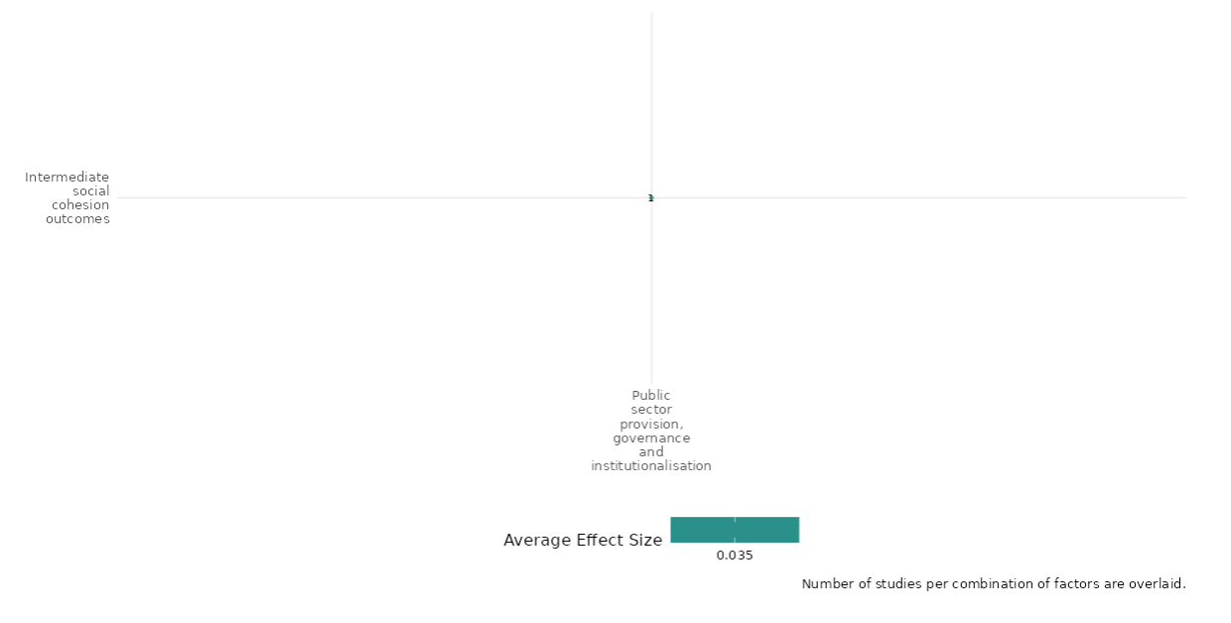

4.5.4 Transitional or restorative justice + Justice system support and reform
4.5.4(1)
Effect of transitional or restorative justice & Justice system support and reform on Nature and scale of violence or atrocities.
Transitional and restorative justice accompanied with reform has the ability to influence the nature and scale of violence. However, legitimising formal justice mechanisms has proven difficult within the context of these studies.
Geographic Location: Latin America & The Caribbean and Sub Saharan Africa
Effect: Small effect (g=0.016)
Confidence in study findings: Low (2 studies with 7 effect sizes)

Short Summary:
Both studies highlight how the nature and scale of violence significantly influence the effectiveness of restorative justice and justice system support programs. In Sierra Leone, the deeply personal, community-driven violence exposed limitations in top-down mechanisms like the Special Court and Truth and Reconciliation Commission, which struggled to address localized grievances. Programs like Fambul Tok filled these gaps by fostering community reconciliation, though they also revealed challenges such as the psychological toll of confronting past traumas. Similarly, in Colombia, the ComunPaz program addressed governance gaps left by demobilized armed groups, emphasizing the role of local dispute resolution in reducing violence and rebuilding trust. While it succeeded in reducing violent disputes and fostering community engagement, it highlighted ongoing struggles to legitimize formal justice mechanisms. Both studies underscore the need for localized, context-specific approaches to restorative justice that consider the social and historical roots of violence while addressing its psychological and structural impacts.
Long Summary
The Intervention:
Any efforts made to convene a meeting between victims and the perpetrators of historic or
current conflict in order to prevent further violent conflict. This could include the role and use of
the Truth and Reconciliation Commission but also any other organisations, states or entities
seeking to convene victims and perpetrators. These efforts could result in the formal
acknowledgement of, or apologies for acts, as well as agreement to repair harm or damages
caused. Any effort made to improve the rule of law and justice system in a country through
improvements to courts and their equitable access and use. This can include integrating human
rights into the legal framework, capacity building for courts and lawyers, and reforming the
criminal penal code to strengthen equal protection for human rights under national laws.

How the Intervention is expected to work:
Both interventions rely on community participation and collaboration among various stakeholders to address post-conflict challenges, though their approaches and expectations differ. The Fambul Tok program in Sierra Leone involves victims, perpetrators, and local leaders, facilitated by a non-governmental organization. It operates through community forums where victims share their experiences, and perpetrators confess their crimes, fostering reconciliation, forgiveness, and the rebuilding of social trust. By addressing local grievances and repairing social ties, the program empowers communities to take ownership of the restorative process and create a foundation for peace. Similarly, the ComunPaz program in Colombia engages state authorities, local organizations, and community members in areas affected by the demobilization of armed groups like the FARC. The program fosters collaboration between state institutions and community organizations to strengthen dispute resolution mechanisms. Through community engagement, it seeks to address governance gaps, reduce violence, enhance trust in institutions, and build resilience in post-conflict societies. Both interventions depend on inclusive participation and local leadership.

The Evidence Base:
​​The cell contains 5 studies, 2 of which are impact evaluations utilising experimental designs (RCTs) to test their outcomes, 1 systematic review and 2 qualitative studies.
The primary studies are from Colombia (1 study), Sierra Leone (1 study), a systematic review (Cramer 2016) which has a global focus, a qualitative study from Colombia by (Lang 2019) and finally a qualitative study from Liberia by Leib (2019)

Evidence findings:
Blair (2022) shows that post-conflict governance gaps in Colombia fuel local violence, with community dispute resolution reducing conflict but failing to increase reliance on formal justice institutions. Cilliers (2018) finds that in Sierra Leone, top-down justice efforts struggled to address localized violence, highlighting the need for community-based reconciliation.
The review evidence:
Cramer seeks to identify effective strategies for preventing and mitigating armed violence, particularly in developing and middle-income countries. It examines a range of interventions, including peace operations, economic support, mediation, governance initiatives, justice and reconciliation programs, and media-based efforts. The analysis takes into account the socio-political, economic, and geographic factors that shape the effectiveness of these interventions. Using a systematic review methodology, it evaluates 149 studies published between 2010 and 2015, encompassing a diverse mix of qualitative case studies, quantitative analyses, and mixed-methods approaches. The review includes literature in English, Spanish, and Portuguese, with a predominant focus on sub-Saharan Africa. Special attention is given to community-level peace initiatives, economic interventions, and security and policing practices, though high-quality evidence on governance and justice remains limited. Overall, the findings are mixed and inconclusive, with few high-quality studies providing definitive evidence on what consistently works across different contexts. While some studies indicate that peacekeeping and mediation can help reduce local violence and foster trust, others highlight unintended negative consequences, particularly for state-building efforts. Cramer (2016) is rated low confidence systematic review as the report notes a generally fragmented evidence base with limited high-quality studies. Most of the research assessed as "low quality" limits confidence in overall conclusions about effectiveness. Nonetheless, certain themes—like community-based peacebuilding—show potential, but further rigorous studies are needed to support these findings confidently.

The impact evaluation evidence :

Blair (2022): The study of the ComunPaz program in Colombia illustrates the complexities of violence within the context of transitional and restorative justice. It highlights post-conflict governance gaps caused by the demobilization of armed groups like the FARC, which often lead to escalated local conflicts and create opportunities for new armed groups to emerge. The study emphasizes the critical role of local dispute resolution in preventing violence during transitions from civil war, noting that the quality of such mechanisms directly influences citizens' trust in both state and communal institutions. The ComunPaz program aimed to foster cooperation between state authorities and community organizations, improving dispute resolution and reducing violent disputes. It highlights how community engagement and empowerment can mitigate violence and build more resilient post-conflict societies. However, while the program increased trust in state institutions for some citizens, it did not significantly enhance reliance on either state or communal authorities for resolving disputes. This reflects the lingering complexities of violence, where trust must be rebuilt over time, and formal justice systems may still struggle to gain legitimacy. The study also points to challenges in security provision, as reliance on armed groups remained low but trust in formal mechanisms like police and JACs did not increase significantly. This suggests that communities may continue to rely on alternative methods for resolving conflicts, complicating restorative justice efforts. Furthermore, the findings highlight that violence is deeply embedded in social structures and relationships, transforming into more localized and manageable forms when communities engage in direct dialogue and informal conflict resolution. Overall, the study demonstrates that restorative justice interventions like ComunPaz must consider the social and historical dynamics of violence. This study is rated low confidence due to the lack of power calculations and partial intervention description.

Cilliers (2018): This study highlights the deeply personal and community-driven nature of violence in Sierra Leone, where grievances often stemmed from local abuses of power in a gerontocratic society. The violence, largely committed by neighbors against neighbors, reflected longstanding tensions over resource allocation and disenfranchisement, particularly among youths. The scale of atrocities and their deeply rooted local dynamics posed significant challenges for transitional and restorative justice mechanisms. Centralized efforts, such as the Special Court and the Truth and Reconciliation Commission, were limited in scope. The Special Court addressed only a small number of high-profile cases, while the Truth and Reconciliation Commission failed to engage rural communities where much of the violence occurred. These gaps reveal the difficulties of addressing widespread, localized violence through top-down mechanisms alone, underscoring the need for community-focused interventions like Fambul Tok to address unresolved grievances and rebuild social cohesion. This highlights how nature and scale of violence directly impact the design, reach, and effectiveness of transitional and restorative justice efforts. This study is rated high confidence.

Confidence Assessment:
Overall Low: While the findings are relatively consistent and highlight similar factors for successful outcomes, the overall rating is lowered due lack of studies within the cell.

Other outcomes in the study:
Social cohesion / Feelings of trust and acceptance in diversity
Community and state governance / Access to justice, rights and public services

Link to review:
Cramer (2016)

Shiny App Screenshot

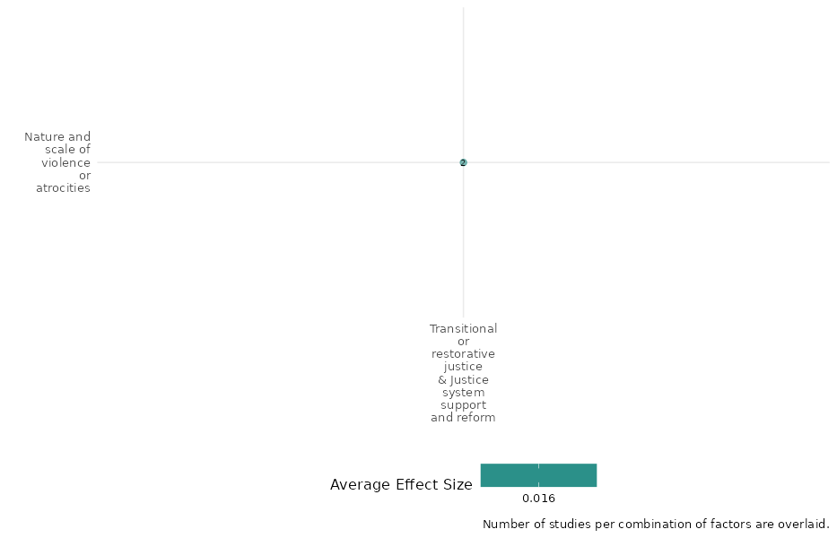
4.5.4(2)
Effect of transitional or restorative justice & Justice system support and reform on Economic Security.
Transitional and restorative justice, along with justice system reforms, can enhance economic security by fostering stability, trust, and equitable resources. However, if care is not taken these interventions can lead to psychological harm.
Geographic Area: Sub Saharan Africa, Latin America & Caribbean and Global
Effect: Adverse effect (g= -0.073)
Confidence in study findings: Low confidence (2 studies with 13 effect sizes)
Short Summary:
These studies evaluate transitional justice and reconciliation mechanisms in post-conflict settings, focusing on societal and economic impacts. Royer examines truth commissions and their effectiveness in fostering democracy, reducing violence, and enhancing economic development. It highlights that truth commissions are more successful when paired with reparations and tailored to local contexts, as seen in Rwanda’s gacaca courts. While Cilliers' assesses the Fambul Tok program in Sierra Leone, which fostered forgiveness and strengthened social networks but also caused significant psychological harm, such as increased anxiety and PTSD. Both studies underscore the need for a balanced approach that addresses psychological recovery while leveraging local and systemic reforms to achieve sustainable societal and economic benefits.

Long Summary
The Intervention:
Any efforts made to convene a meeting between victims and the perpetrators of historic or current conflict in order to prevent further violent conflict. This could include the role and use of the Truth and Reconciliation Commission but also any other organisations, states or entities seeking to convene victims and perpetrators. These efforts could result in the formal acknowledgement of, or apologies for acts, as well as agreement to repair harm or damages caused. Any effort made to improve the rule of law and justice system in a country through improvements to courts and their equitable access and use. This can include integrating human rights into the legal framework, capacity building for courts and lawyers, and reforming the criminal penal code to strengthen equal protection for human rights under national laws.

How the Intervention is expected to work:
The interventions are expected to work by addressing the societal and psychological impacts of conflict to foster reconciliation, rebuild social capital, and support long-term stability. Top-down mechanisms, such as truth commissions, aim to uncover the truth about past atrocities, promote accountability, and strengthen democratic institutions. By pairing these efforts with reparations or criminal tribunals, they seek to address grievances and lay the groundwork for societal and economic recovery. Bottom-up approaches, like Rwanda’s gacaca courts and Sierra Leone’s Fambul Tok program, rely on community participation to rebuild trust, encourage forgiveness, and repair social networks. These interventions aim to restore communal ties and create environments conducive to peace and development.

The Evidence Base:
The cell contains 3 studies, 2 of them are RCTs however, Vargas (2018) is a protocol for an RCT. The other is an observational study using both qualitative and quantitative methodology.
The studies are from Sierra Leone (1 study), Colombia (1 study) and the other study utilises data from other countries focusing specifically on Rwanda.

Evidence Findings:
Both studies indicate that justice system reforms and informal reconciliatory bodies do not directly ensure economic security but lay the foundation for stability, which can facilitate long-term economic growth and resilience.

Included Studies:
Cilliers (2018): For the most part this study focuses on the Fambul Tok project which focused on fostering reconciliation in communities affected by the Civil War. Direct economic outcomes are limited. However, the study’s findings on social capital – offer major insight on how programs focusing on reconciliation can have an impact on the economic climate of states after conflict. For instance, despite the improvements in social capital, the study found no systematic increases in economic activity or outcomes directly related to the reconciliation process. Measures of economic activity, such as labour devoted to agricultural work or the overall perception of economic well-being, did not show significant positive changes either. The reconciliation efforts did not lead to a measurable improvement in economic indicators like household assets or income levels, suggesting that while social ties may strengthen, they do not automatically translate into economic benefits in the short term. Cilliers et al.., suggests that perhaps the psychological impacts of the Civil War could potentially point to why there is stagnation in economic security. For example, within participants involved in the programme there was a measured increase in post-traumatic stress disorder (PTSD). These psychological burdens can create barriers to participating fully in economic activities and can lead to decreased productivity – the deterioration of psychological well-being highlights the challenges faced when addressing past traumas, indicating that psychological recovery is a critical component to consider when measuring economic security in post-conflict contexts. This study is rated high confidence.

Royer (2017): Royer's dissertation examines the role of truth commissions as transitional justice mechanisms in post-conflict countries, focusing on their impact on democracy, human rights, economic development, and communal peace. A key theme throughout the study is the emphasis on economic security. Restorative justice, with its focus on reconciliation and repairing community relationships, is shown to improve relations among groups affected by conflict. This, in turn, strengthens community ties, fostering a stable economic environment where social capital plays a vital role in economic activities. While transitional or restorative justice mechanisms alone may not guarantee economic security, their effective implementation, especially when integrated with broader support and reforms, such as locally tailored truth commissions—can significantly contribute to stability and prosperity. This dual approach not only addresses past injustices but also establishes a foundation for long-term economic growth and stability. This study is rated medium confidence due to non-experimental design.

Confidence Assessment:
Overall Low: While the findings are relatively consistent and highlight similar factors for successful outcomes, the overall rating is lowered due to the lack of studies within the cell.

Other outcomes within the study:
Violence / Social norms regarding violence
Social cohesion / Feelings of trust and acceptance in diversity
Community and state governance / Access to justice, rights and public services

Shiny App Screenshot: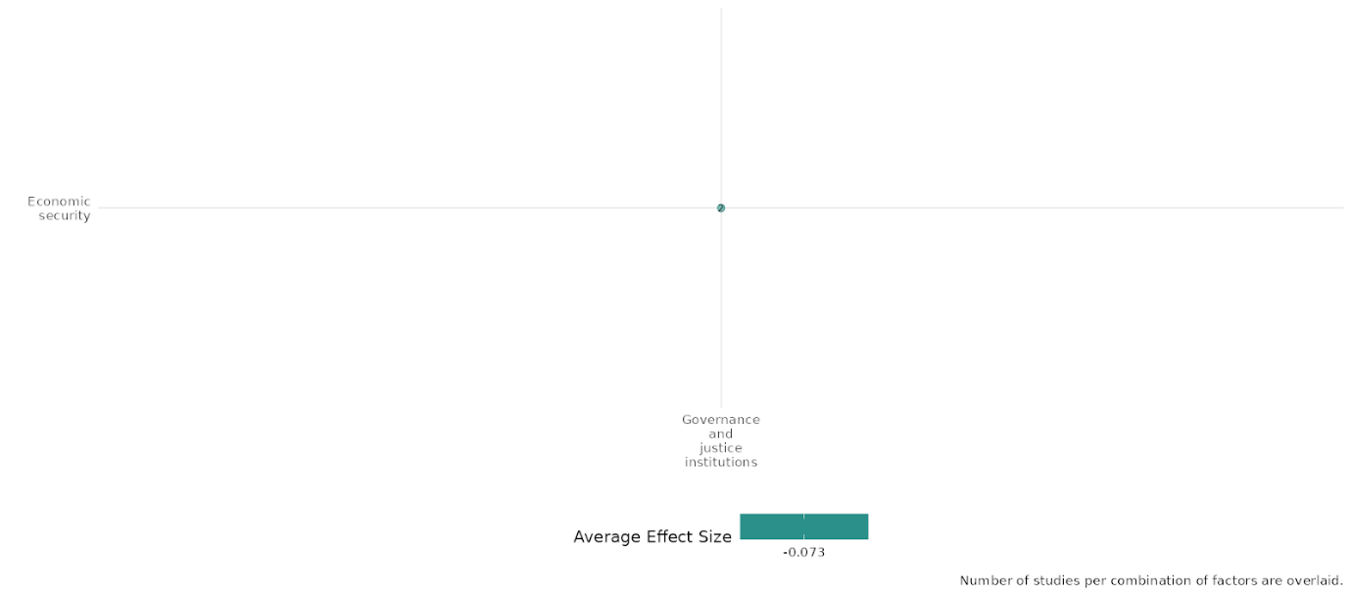

4.5.5 Security sector reform
4.5.5(1)
Effect of Security sector reform on Diplomatic relations & Peaceful dispute resolution

Evidence shows that CommunPaz program does not affect in improving understanding of most important disputes and consensus around resolution.
Geographic focus: Latin America and Caribbean
Effect: Small effect (g=0.019)
Confidence in study findings: Low (1 study with 5 effect sizes)

Short summary
The cell studied a RCT in Colombia evaluated the ComunPaz program, a low-cost, scalable initiative aimed at improving coordination between police, Police Inspectors, and JACs in communities previously under FARC control. The program avoided imposing state laws, focusing instead on facilitating state penetration and preventing the resurgence of rebel governance. Delivered over four one-day modules within three months, it combined lectures, discussions, and group work to help communities adopt new institutional practices. The program showed no significant improvement in consensus around dispute resolution or understanding of JACs’ authority. While some leaders reported better coordination between state and communal authorities, agreement on major disputes was unchanged between treatment and control groups.

Long summary
The intervention
The study evaluated an inexpensive, scalable intervention designed to induce closer coordination between police officers, Police Inspectors, and JACs, while avoiding the pitfalls of forcibly imposing state laws and institutions on communities long accustomed to autonomy or rebel rule. The program was specifically designed to facilitate state penetration and impede the reemergence of rebel rule in communities abandoned by FARC—though, as we discuss in the conclusion, the goals and structure of the intervention are potentially generalizable to settings without histories of rebel governance. The ComunPaz program comprises four modules involving a combination of lectures, discussions, group work, and Q&A. Each module lasts one day for a total of four days per treatment community, implemented over the course of three months per community, with gaps between sessions to allow residents to adopt new institutional arrangements and put new skills into practice.

How the intervention is expected to work
The study found no evidence that the program increased consensus around dispute resolution. There was suggestive evidence that the program increased coordination between state and communal authorities according to leaders. The understanding of the most serious disputes was measured by asking 12 potential sources of disputes they viewed as most important in their community. The responses obtained from leaders, police commanders, and Police Inspectors suggested no evidence that the program increased understanding of JACs’ authority under Colombian law or that it increased understanding of the most serious disputes. There is much agreement among residents and leaders about the most important sources of disputes in their communities, though the extent of this agreement is no greater in the treatment group than in the control group. Thus, there was no evidence suggesting that either state or communal authorities gained a better understanding of the communities under their jurisdiction due to ComunPaz.

The evidence base
The cell contains 1 impact evaluation designed as randomized controlled trial.
The study was conducted in Colombia (1).

Evidence findings
The intervention focused on improving coordination between different stakeholders including police, Police Inspectors, and JACs in communities had a very small effect in improving consensus around dispute resolution and JAC’s authority. There is 1 impact evaluation in the cell and evidence summaries of the study are thus provided here:

Included studies
Blair (2022) evaluated the CommunPaz program in rural Colombia using an experimental study design. The program specifically targets the three obstacles to state–communal cooperation. The program seeks to provide information about the roles and responsibilities of state and communal authorities, build trust between citizens and both state and communal authorities by creating opportunities for them to interact in a structured and secure environment, and improve coordination between state and communal authorities through the design and dissemination of “response routes.” The sample consists of 149 communities distributed across 24 municipalities in four purposefully selected regions of Colombia. The study found that ComunPaz enhanced the quality of local dispute resolution, increased citizens’ trust in (some) state institutions, and strengthened coordination between state and communal authorities. It also appears to have reduced citizens’ confidence in, and reliance on, armed groups. The program did not, however, increase dependence on either state or communal authorities to resolve disputes, nor did it increase citizens’ trust in communal institutions. The study is rated as low confidence due to the partial description of outcomes and attrition not being reported in the study.

Confidence assessment
Overall low confidence as the study was rated low due to the partial description of outcomes and attrition not being reported in the study and only 1 study in the cell.

Other outcomes in this study:
Violence and atrocity prevention/ Nature and scale of violence or atrocities
Community and state governance/ Civic Participation

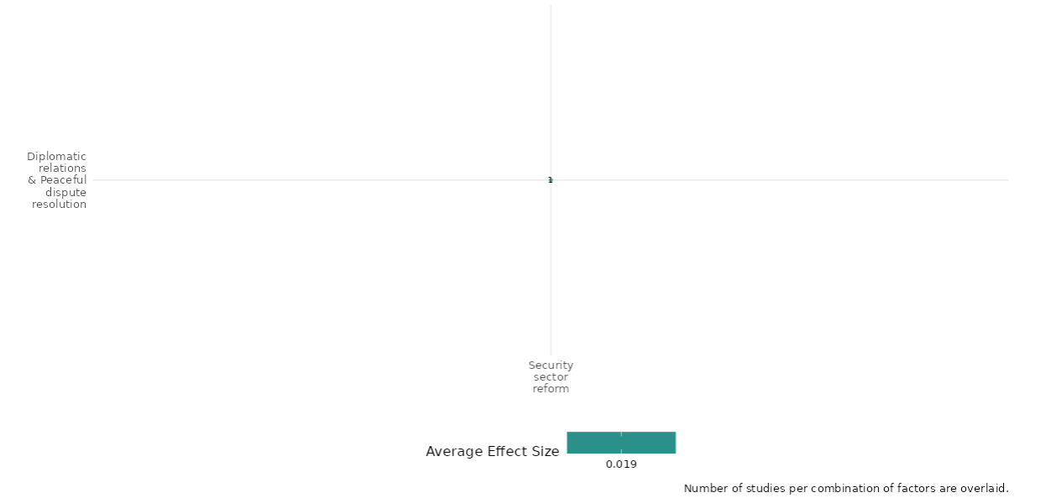

4.5.5(2)
Effect of Security sector reform interventions on Nature and scale of violence or atrocities

Evidence shows that peace operation strategies – security only, sequential and simultaneous, replacement of rebel governance and improvement in justice provision have an impact on conflicts, full scale wars and unresolved and violent disputes.
Geographic focus: Global, Latin America & Caribbean, South Asia
Effect: Small effect (g=0.045)
Confidence in study findings: Low (3 studies with 22 effect sizes)

Short summary
The cell studies interventions which prioritize security using strategies like Security-Only, Sequential, and Simultaneous. Security-Only focuses on order first, leaving development to others. Sequential adds development tasks later to avoid contradictions. Simultaneous tackles security and development together, linking underdevelopment with conflict. Sector security reforms include transitioning from international to local forces and Colombia’s ComunPaz program, which replaced rebel governance and improved justice in FARC-dominated areas. Studies indicate Security-Only and Sequential strategies better terminate conflicts and ensure peace than Simultaneous. ComunPaz reduced community disputes, and violence dropped 10% under Afghan local security.

Long summary
The intervention
Peace operation strategies like prioritizing security first, through Security-Only and Sequential strategies. The Security-only strategy proposes providing order and security first and leaving developmental assistance to specialized agencies, the Sequential strategy promotes providing security and order first, and then assuming development-related tasks as a means to avoid contradictory effects, and the Simultaneous strategy emphasizes the relationship between underdevelopment and conflict, thus urges the implementation of both security and development related tasks simultaneously. Other set of sector security reform interventions include scale security transition from international troops to local forces in the context of the ongoing civil conflict, and Colombia’s ComunPaz program, a scalable, inexpensive intervention that sought to replace rebel governance by harnessing complementarities between state and communal authorities and by improving security and justice provision in areas once dominated by FARC, the country’s largest rebel group.

How the intervention is expected to work
The nature and scale of violence or atrocities outcomes studied as part of this cell summary include low-intensity conflicts, full-scale wars; Conflict – all fatal events, direct fire attacks, IED explosions, all casualty events; Unresolved and violent disputes. The study shows that interventions prioritizing security first, through Security-Only and Sequential strategies, are more successful in terminating conflicts and achieving durable peace compared to Simultaneous strategies. The ComunPaz program reduced the prevalence of both unresolved and violent disputes at the community but not the household level. The intensity of violence dropped sharply when the ANSF became responsible for security provision and the estimated decline is around 10% for all outcomes.
The evidence base
The cell contains 6 studies: 3 impact evaluations designed as quasi-experimental studies and randomized controlled trials; 2 qualitative studies (Kamau 2021 and Leib 2019) and 1 systematic review. There is consistency in findings across studies.
The studies are from Afghanistan (1), the context of various countries (Nicaragua, Burundi, Sierra Leone, Angola, Mozambique, and Cambodia = 1), Colombia (1), Kenya (1) and Liberia (1).

Evidence findings
The Review findings
The review evidence shows that there were 12 moderately-sized, low-quality studies published between 2010-15 which studied impact of security and policing practices on urban violence have mixed findings. The review concluded that public security platforms of newly-elected mayors and governors, heavy handed policing approaches, were effective in their contribution towards reducing urban violence.

The Impact evaluation findings
The evidence from the cell shows that there is a small effect of the security sector reforms in reducing violence and disputes. The ComunPaz program reduced the prevalence of both unresolved and violent disputes at the community but not the household level. There are 3 impact evaluations in the cell and evidence summaries of the 3 studies are thus provided here:

Included studies
Akman (2010) -examines peace operations and their strategies in post-conflict societies, focusing on the interaction between security and development efforts. It explores three main strategies: Security-only, Sequential, and Simultaneous, in the context of various countries, including Nicaragua, Burundi, Sierra Leone, Angola, Mozambique, and Cambodia. The study employs a mixed-methods approach, combining quantitative analysis with qualitative case studies. The quantitative analysis uses a dataset covering civil wars from 1946 to 2006, employing logit models corrected for temporally dependent data to test the effectiveness of different peace operation strategies. The qualitative component involves structured, focused comparisons of six case studies, selected based on the strategy of intervention and varying in terms of success and failure. The findings indicate that interventions prioritizing security first, through Security-Only and Sequential strategies, are more successful in terminating conflicts and achieving durable peace compared to Simultaneous strategies. The study suggests that while Simultaneous strategies are less effective, the quality of peace achieved is not fully accounted for in the statistical analysis and requires further qualitative investigation. The study is rated medium confidence as it is a non-experimental study.

Blair (2022) – The study assessed the Colombia’s ComunPaz program, a scalable, inexpensive intervention that sought to replace rebel governance by harnessing complementarities between state and communal authorities and by improving security and justice provision in areas once dominated by FARC, the country’s largest rebel group. The ComunPaz program comprises four modules involving a combination of lectures, discussions, group work, and Q&A. Each module lasts one day for a total of four days per treatment community, implemented over the course of three months per community, with gaps between sessions to allow residents to adopt new institutional arrangements and put new skills into practice. The study was designed as a randomized controlled trial, wherein randomization was done at the community level. The study had a total of 72 treatment communities. The program reduced the prevalence of both unresolved and violent disputes at the community but not the household level. Treatment group leaders were 5.1 percentage points less likely to report a violent dispute in their community (not significant). Residents in the treatment group were no less likely to report a violent dispute, though this may be an artifact of floor effects, as only 6.4% of control group residents reported a violent dispute in the past six months. The study is rated as low confidence due to partial definition of outcomes and no mention of attrition reported in the study.
Fetzer (2021) -83543614 – The study assessed the recent large-scale security transition from international troops to local forces in the ongoing civil conflict in Afghanistan. The study was designed as a quasi-experimental design. The district level shows that the intensity of violence dropped sharply when the ANSF became responsible for security provision. The estimated decline is around 10% for all outcomes. Also, suggests that the shift in security perceptions matches the changes we observed in the tactical reports. An increased share of respondents reported security improved in the last 6 months after the ANSF took over security. The baseline difference-in-difference specification at the district level showed that the intensity of violence dropped sharply when the ANSF became responsible for security provision. The estimated decline is around 10% for all outcomes. The study is rated as low confidence due to no mention of power calculations.

Confidence assessment
Overall low confidence as there are 3 studies in the cell and 2 of 3 studies are rated as low confidence. There is consistency in findings across all 3 studies.

Other outcomes in the study:
Human security / Physical Security
Violence and atrocity prevention / Diplomatic relations & Peaceful dispute resolution

Link to review summaries
Cramer (2016)
All studies may be accessed via the EGM.

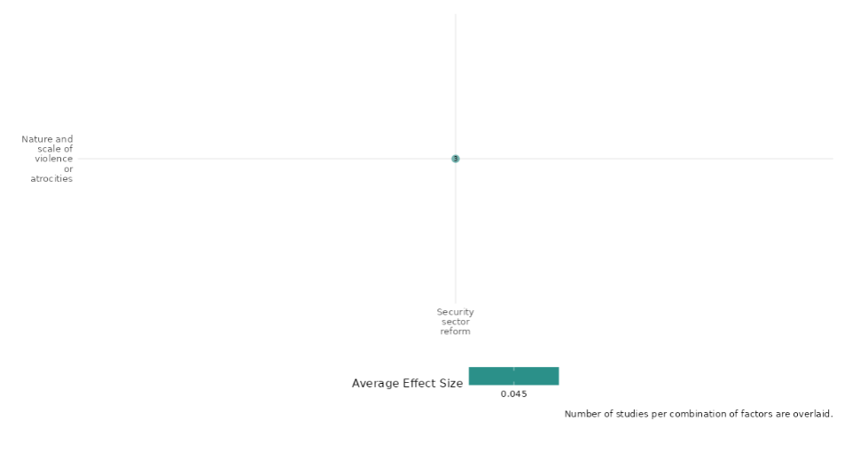

4.5.5(3)
Effect of Security sector reform on Physical security

Evidence shows that security transition intervention had a little effect on improving the perception of security.
Geographical region: South Asia
Effect: Small effect (g=0.013)
Confidence in study findings: Low (1 study with 13 effect sizes)

Short summary
The cell studied a quasi-experimental study conducted in Afghanistan examined the security transition during the conclusion of NATO’s Operation Enduring Freedom in Afghanistan, focusing on the transfer of control from ISAF to ANSF and the withdrawal of ISAF troops. Over three years and five phases, all Afghan districts transitioned to ANSF control. ISAF’s occupation had supported the establishment of a democratic government, training local forces for security provision. The transition improved perceptions of security and ANSF legitimacy, despite challenges with local capacity and Taliban influence.

Long summary
The intervention
The study assessed the impact of the two main phases of the security transition that marked the end of Operation Enduring Freedom in Afghanistan—NATO’s long-running military campaign: (1) the transfer of control from ISAF to the ANSF and (2) the physical withdrawal of ISAF troops. Characteristic of other foreign military interventions, the occupation of ISAF displaced the the incumbent regime and assisted in the installation of an ostensibly democratic government in 2001. During the occupation, foreign forces coordinated under the auspices of NATO helped train and equip local police and military forces. Planning for the transition of security provision from ISAF to Afghan forces began as early as 2010, and was formally announced in 2011. The transition was staggered, and coordinated around administrative districts. Over three years, and five transition tranches, all of Afghanistan’s districts were transferred from ISAF to Afghan control.

How the intervention is expected to work
A security transition may shift the provision of policing and formal military operations from well-trained and equipped foreign fighters to unseasoned local forces using unfamiliar or outdated technology. Even if local fighters are capable, they may lack legitimacy, commit unintended harm to civilians, or deliberately discriminate against ethnic rivals, undermining economic welfare and damaging public confidence in the quality and stability of host nation institutions. An increased share of respondents reported security improved in the last 6 months after the ANSF took over security. It was also perceived that the Taliban had grown weaker since the transition, even if this effect is marginally insignificant. Moreover, respondents were more likely to have seen the Afghan National Army (ANA, i.e. the most important component of the ANSF) in their village at least once a month, and they were more likely to respond that the Afghan forces bring security to their area. The results suggest that the formal transfer of security responsibility during the transition process is perceived to provide security.

The evidence base
The cell contains 1 impact evaluation designed as quasi-experimental study design.
The IE study was conducted in Afghanistan (1).

Evidence findings
The security transition interventions result in improvement in perception of security. There is 1 impact evaluation in the cell and evidence summaries of the study are thus provided here:

Included studies
Fetzer (2021) assessed the recent large-scale security transition from international troops to local forces in the ongoing civil conflict in Afghanistan. Characteristic of other foreign military interventions, the occupation of ISAF displaced the the incumbent regime and assisted in the installation of an ostensibly democratic government in 2001. During the occupation, foreign forces coordinated under the auspices of NATO helped train and equip local police and military forces. Planning for the transition of security provision from ISAF to Afghan forces began as early as 2010, and was formally announced in 2011. The transition was staggered, and coordinated around administrative districts. Over three years, and five transition tranches, all of Afghanistan’s districts were transferred from ISAF to Afghan control. The study was designed as a quasi-experimental design. The study used digital placemats from ISAF archives to link districts to Regional Commands, and classified districts using a standardized administrative map compiled by the Empirical Studies of Conflict (ESOC) research group. All events and survey waves are rectified to match this map. The information was incorporated from Afghan Commander’s Emergency Response Program (CERP), which is a military-led scheme for small-scale development projects. The district level shows that the intensity of violence dropped sharply when the ANSF became responsible for security provision. The estimated decline is around 10% for all outcomes. Also, suggests that the shift in security perceptions matches the changes observed in the tactical reports. An increased share of respondents reported security improved in the last 6 months after the ANSF took over security. The study is rated as low confidence due to non-experimental study design and attrition not being reported in the study.

Confidence assessment
Overall low confidence as the study is rated low due to non-experimental study design and attrition not being reported in the study; and only 1 impact evaluation in the cell.

Other outcomes in the study:
Violence and atrocity prevention/ Nature and scale of violence or atrocities

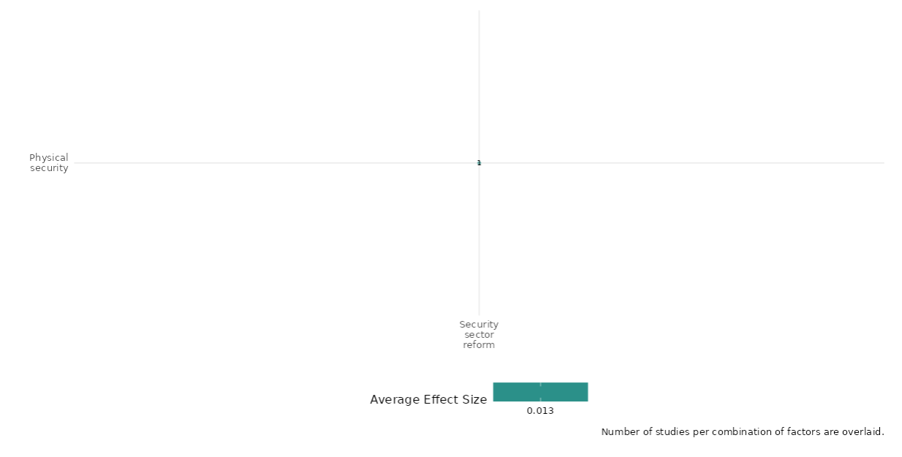

4.6 Socio-Economic Foundations, Especially To Address Intergroup Inequalities

4.6.1 Mental health and psychosocial support
4.6.1(1)
Mental health and psychosocial support on Nature and scale of violence or atrocities
Mental health and psychosocial support interventions show mixed effects on violent behavior. Reductions in antisocial conduct and victimization are influenced by psychological changes.
Geographical Region: Sub- Saharan Africa
Effect size: Small effect (g= 0.028)
Confidence in study findings: Low (2 studies with 8 effect sizes)

Short Summary
Mental health and psychological interventions demonstrate how trauma-focused therapies and behavioral strategies can reduce violence and promote social reintegration. By enhancing emotional regulation, reducing PTSD symptoms and aggression, and challenging harmful social norms, these interventions foster nonviolent identities. Conducted mainly as randomized controlled trials (RCTs) in conflict-affected areas like Eastern DRC and Liberia, the studies show significant reductions in violent behaviors, especially when therapy is combined with economic support. Overall, they highlight the transformative potential of psychological interventions in fragile contexts, consistently reducing violence and supporting healthier social behaviors.

The intervention
All three studies evaluated trauma-focused interventions designed to reduce violence and improve psychosocial well-being. These interventions prioritized emotional regulation and self-control, combining group and individual counselling to foster behavioural change through community engagement and goal-setting. They also emphasized trauma processing with trained counsellors and addressed harmful social norms in the DRC.

How the intervention is expected to work
The intervention aims to reduce violence and promote social stability by integrating structured therapeutic techniques focused on emotional regulation, self-control, and impulse management. It fosters positive behavioral changes while challenging harmful social norms, including stigma and rape myths. Additionally, the intervention addresses individual trauma and supports the reintegration of former combatants through community-based approaches and behavior modification.

The evidence base
The cell includes two primary studies (IEs) and one systematic review. The primary studies were conducted in Liberia, the Democratic Republic of Congo (DRC), and Eastern DRC. The systematic review includes studies from multiple low- and middle-income countries, with the highest concentration in the DRC, as well as Côte d'Ivoire, Afghanistan, Somalia, Uganda, Kenya, Ethiopia, South Sudan, Rwanda, Thailand, Liberia, and Lebanon.

Evidence Findings
Mental health and psychosocial support interventions show mixed effects on violent behavior as an intermediate outcome. Reductions in antisocial conduct and victimization are influenced by psychological changes

The review evidence
A review examined interventions related to personnel training, community mobilization, social norms change, economic empowerment, and survivor support. While some studies indicated a reduction in intimate partner violence (IPV) and sexual violence (SV), the findings were not statistically significant. The evidence suggests a decreased risk and changes in IPV and SV incidence, though none of the results reached statistical significance.

Included studies
The evidence base consists of two impact evaluation studies, with a high & medium level of consistency in their findings. The participants in these studies are predominantly male combatants or individuals affected by conflict.The included three studies summaries are thus provided here:
Blattman 2017 evaluates the impact of two interventions aimed at reducing violence and promoting psychosocial well-being in Liberia: Cognitive Behavioral Therapy (CBT) and the STYL Program (Socio-Behavioral Transformation). CBT is a short-term therapy designed to foster self-regulation, patience, and a non-criminal identity, helping individuals identify and shift self-destructive beliefs, regulate emotions, manage anger, reduce impulsivity, and set practical goals through therapist-guided exercises and homework. The STYL program combines group therapy with one-on-one counseling, led by former program participants who act as relatable role models. It employs techniques such as role-playing, community engagement, exposure therapy, and goal-oriented tasks, progressing from basic tasks like improving hygiene to more advanced emotional regulation and goal-setting exercises.
The study used a 2 × 2 factorial design, randomly assigning 1,000 men to four treatment groups: therapy only, cash only, both interventions, or neither. Randomization was done individually to ensure transparency and safety. Recruitment occurred in three phases, starting with a pilot phase of 100 men, followed by two larger phases involving 900 participants. Treatment groups were balanced, with 25% assigned to cash only, 28% to therapy only, 25% to both, and 22% to neither. Compliance was high, with 98% of participants receiving the cash grant, and two-thirds attending at least 80% of therapy sessions, though 10% dropped out early. Participants who dropped out had lower schooling, less self-control, and were less likely to exhibit antisocial behaviors.
Regarding the nature and scale of violence, participants reported with 17% of the control group initially selling drugs and committing 2.6 thefts in the past two weeks, which dropped to 13.5% selling drugs and 1.9 thefts after a year, about one dispute (Fight) in the past two weeks, with no statistically significant effects from therapy or cash. Intimate partner abuse showed minimal reduction in the short term but a positive correlation with violence after one year. The study also noted a slight reduction in arrests, with a one-third decline in arrests per year for those receiving therapy plus cash. Due to a politically stable period in Liberia, no political violence occurred during the study period, making it impossible to measure this outcome directly.
The outcomes assessed under the nature and scale of violence include victimization and perpetration of violence, Antisocial Behaviors (theft, drug use, and criminal activities), additional outcomes of interest evaluated in this study include Non-Criminal Identity Formation (shift toward adopting nonviolent, goal-oriented identities), Emotional Regulation and Long-Term Behavioral Stability (Sustained reductions in violence and antisocial behaviors when therapy was paired with cash grants). Overall the study is rated as a high & medium confidence.
Robjant (2022) assessed the effectiveness of the NETfacts health system, an integrated model of evidence-based individual trauma treatment (Narrative Exposure Therapy [NET]), and a trauma-informed community-based intervention (NETfacts) in Eastern DRC using randomized controlled trials. The study involved 1,066 participants from six communities, randomly assigned to either intervention, with follow-up interviews conducted at post-test, 3 months, and 6 months. In relation to the nature and scale of violence or atrocity outcomes, the intervention did not show direct effects on victimization and perpetration. However, mediation analysis revealed that at the 6-month follow-up, reduced rape myth acceptance mediated decreases in social victimization (z = –2.56, P = 0.010), physical victimization (z = –2.2, P = 0.027), and perpetration (z = –6, P < 0.001). Additionally, lower rape myth acceptance at follow-up strongly predicted reductions in social (z = 4.45, P < 0.001) and physical victimization (z = 4.74, P < 0.001), and perpetration (z = 2.18, P = 0.029). These results highlight the intervention’s effectiveness in indirectly mitigating violence by challenging harmful social norms.
The outcomes assessed under the nature and scale of violence include victimization and perpetration of violence, rape myth acceptance, stigmatizing attitudes, and skepticism about reintegration. Additional outcomes of interest evaluated in this study include PTSD symptoms, depression, shame and guilt, and social cohesion.The study is rated as high-medium confidence.

Confidence assessment
Overall, low confidence quantitative studies due to limited number of studies included under the cell.

Link to review summaries
Spangaro Jo – 2021.
Study may be accessed via the EGM.

Other outcomes in this study
Violence and atrocity prevention/Social norms regarding violence and atrocities
Human health/Economic security/Health security
Social cohesion/Feelings of trust & acceptance of diversity

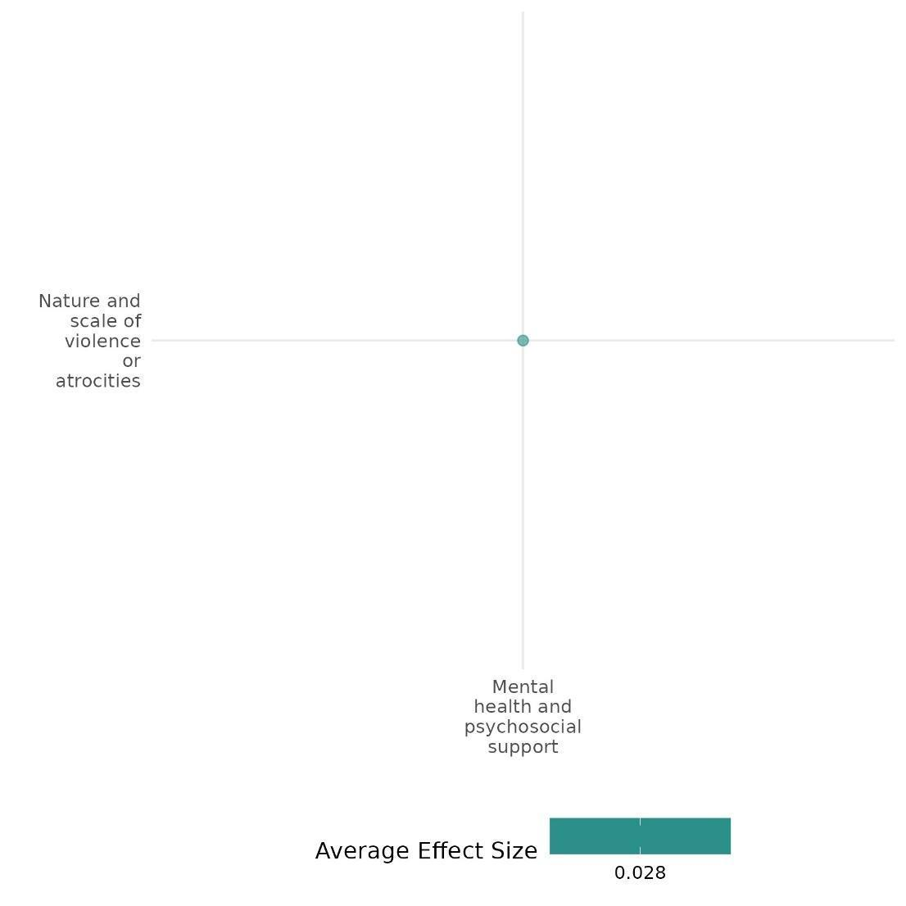

4.6.1(2)
Effects of mental health and psychological support on social norms regarding violence and atrocities
Trauma-focused interventions revealed that while combined strategies, such as therapy with cash incentives, show greater impact, while standalone interventions yield mixed results.
Geographical region - Sub -Saharan - Africa
Effect: No effect (g = -0.003)
Confidence in study findings: Medium (4 studies with 11 effect size)

Short Summary
Trauma-focused interventions in post-conflict settings show how psychological programs like CBT, STYL, FORNET, and NETfacts can influence social norms, addressing trauma, emotional regulation, and aggression among combatants and conflict-affected individuals in Liberia and the DRC. These interventions foster behavioral change and shift harmful social norms. While combined strategies, such as therapy paired with cash incentives, show greater impact in reducing aggression and criminal activities, standalone interventions yield mixed results. The varied effectiveness across contexts highlights the importance of integrated, community-centered, and context-specific approaches for sustainable violence reduction and psychosocial well-being.

The intervention
Trauma-focused interventions encompass CBT, STYL, FORNET, and NETfacts, each designed to support psychological recovery and reintegration. Key activities within these programs include lifeline mapping to identify both traumatic and positive experiences, narrative exposure therapy to help reprocess distressing memories, and role-playing exercises to enhance emotional regulation and reduce aggressive behaviors. Additionally, facilitated discussions address harmful social norms and promote reintegration. The interventions culminate in final ceremonies and action planning, fostering healing, solidarity, and a collective focus on both individual recovery and broader community transformation.

How the intervention is expected to work
These interventions are expected to work by addressing both individual psychological needs and community-level challenges to reduce violence, improve emotional well-being, and foster reintegration. At the individual level, therapeutic techniques such as lifelines and narrative exposure help participants process traumatic memories, regulate emotions, and adopt non-aggressive behaviors. Role-playing and goal-setting further encourage positive behavioral changes and self-control. At the community level, activities like collective lifelines and facilitated discussions challenge harmful social norms, reduce stigma, and promote understanding of shared trauma. These interventions aim to create supportive environments that encourage reintegration and solidarity, addressing the root causes of aggression and violence while fostering emotional recovery.

The evidence base
The cell contains total five studies; one is protocol study authored by Keleher Niall (2019) and four IEs that were completed and conducted in post-conflict settings: Liberia with 1,000 male participants using CBT and STYL, DRC with 98 demobilized combatants using FORNET, and Eastern DRC with 1,066 participants using the NETfacts system. These settings focused on trauma, aggression, and reintegration in communities affected by prolonged violence.

Evidence findings
Trauma-focused interventions show that combined strategies, like therapy with cash incentives, are more effective, while standalone interventions yield mixed results.

Included studies
There are four total impact evaluations; all four studies' summaries are provided here:
Blattman (2017) evaluates the impact of two interventions aimed at reducing violence and promoting psychosocial well-being in Liberia: Cognitive Behavioral Therapy (CBT) and the STYL Program (Socio-Behavioral Transformation). CBT is a short-term therapy designed to foster self-regulation, patience, and a non-criminal identity, helping individuals identify and shift self-destructive beliefs, regulate emotions, manage ange, reduce impulsivity, and set practical goals through therapist-guided exercises and homework. The STYL program combines group therapy with one-on-one counseling, led by former program participants who act as relatable role models. It employs techniques such as role-playing, community engagement, exposure therapy, and goal-oriented tasks, progressing from basic tasks like improving hygiene to more advanced emotional regulation and goal-setting exercises.
The study used a 2 × 2 factorial design, randomly assigning 1,000 men to four treatment groups: therapy only, cash only, both interventions, or neither. Randomization was done individually to ensure transparency and safety. Recruitment occurred in three phases, starting with a pilot phase of 100 men, followed by two larger phases involving 900 participants. Treatment groups were balanced, with 25% assigned to cash only, 28% to therapy only, 25% to both, and 22% to neither. Compliance was high, with 98% of participants receiving the cash grant, and two-thirds attending at least 80% of therapy sessions, though 10% dropped out early.
Study documented weapon carrying attitude fell by about half after both therapy alone and therapy plus cash. A standardized index of 19 questions on aggression showed a reduction of 0.34 standard deviations with both therapy and cash (significant at the 5% level) The study is rated as High- medium confidence.
Kobach (2017) evaluates the impact of “Narrative Exposure Therapy adapted for Forensic Offender Rehabilitation” (FORNET). The intervention was implemented in two successive dissemination stages (DS). In DS1, local counselors were trained by clinical experts, while in DS2, these trained counselors supervised and mentored a second group of local counselors. The training process involved a 3-week workshop focusing on both theoretical concepts and practical therapeutic skills. The study focused on adult male combatants from the eastern Democratic Republic of Congo (DRC) who experienced trauma symptoms and high levels of aggression (defined as ≥7 PTSD symptoms and ≥7 items confirmed on the aggression questionnaire). Individuals with serious physical injuries, acute suicidal thoughts, or psychosis were excluded. Across DS1 and DS2, a total of 98 demobilized combatants participated in the intervention, with treatment-as-usual serving as the control condition. The study documented that no significant effects was found regarding the level of appetitive aggression. The interaction between time and treatment did not show a meaningful difference (F (1, 92) = 1.13, p = 0.291). Additionally, the main effect of time was not significant (F(1, 92) = 0.04, p = 0.947). Comparing between groups also did not show a significant result (t(96) = 1.27, p = 0.104, Cohen’s d = 0.26). There was no significant reduction in drug dependence symptoms and no major difference between the groups six months after demobilization. However, the FORNET group showed a higher remission rate, with a 24% improvement. The study found that participants in the FORNET condition showed significantly better reintegration compared to those in the Treatment-as-Usual (TAU) group (t(96) = 2.77, p = 0.004). However, the connection to paramilitary life was not significantly different between groups (t(96) = 0.60, p = 0.276). Additionally, the covariate setting (DDR vs. local reintegration camp) had no significant impact on primary or secondary outcomes such as , appetitive aggression, depression, or drug dependence. The study is rated as High- medium confidence.
Robjant (2022) assessed the effectiveness of the NETfacts health system, an integrated model of evidence-based individual trauma treatment (Narrative Exposure Therapy [NET]), and a trauma-informed community-based intervention (NETfacts) in Eastern DRC using randomized controlled trials. The study involved 1,066 participants from six communities, randomly assigned to either intervention, with follow-up interviews conducted at post-test, 3 months, and 6 months.
The study found that Rape myth acceptance decreased more in the NETfacts (29.1 (SD = 7.8) at baseline to 26.0 (SD = 7.4) at 6 months) group compared to NET only (29.6 (SD = 7.2) to 27.8 (SD = 6.5), suggesting a potential improvement in attitudes towards sexual violence. Stigmatizing attitudes showed some improvements in both groups, with NETfacts showing a higher percentage of individuals strongly disagreeing with stigmatizing statements. Skepticism about reintegration of former combatants decreased in both groups, with the NETfacts group showing a slightly greater from 32.1 (SD = 10.9) to 26.2 (SD = 10.4) reduction. The study is rated as High- medium confidence.
Hermenau (2013) assesses the effectiveness of Narrative Exposure Therapy for Forensic Offender Rehabilitation (FORNET), a short-term intervention for ex-combatants, using a randomized controlled trial (RCT) in the Democratic Republic of Congo. Male ex-combatants and former child soldiers (ages 16–25) enrolled in vocational training programs were randomly assigned to either FORNET or a control group receiving treatment as usual. The study initially recruited 58 former child soldiers and ex-combatants from a reintegration center in Goma, DRC. Of these, 20 participants were excluded at enrollment and 4 participants dropped out during the study. This resulted in a final sample of 15 matched pairs (30 participants) included in the analysis.
Overall, Appetitive Aggression Scale (AAS) scores reduced from 32.20 (SD = 12.77) at baseline to 11.93 (SD = 8.62) at follow-up. The control group exhibited a similar reduction, from 32.73 (SD = 13.93) to 10.93 (SD = 9.67) with no significance observed between the groups. Participants in the treatment group showed a notable decrease in closeness to combatants, with scores declining from 3.53 (SD = 1.77) pre-treatment to 2.13 (SD = 1.89) at follow-up. In the control group, this reduction was minimal, with scores decreasing from 3.07 (SD = 1.79) to 2.80 (SD = 1.82). The study is rated as High- medium confidence.
Confidence assessment:
Overall, the cell is rated as a Medium confidence as it includes more than three studies and all are rated as a high-medium confidence.

Other outcomes in this study
Violence & atrocity prevention/Nature & scale of violence or atrocities
Human security/Economic security
Huma security/Health security

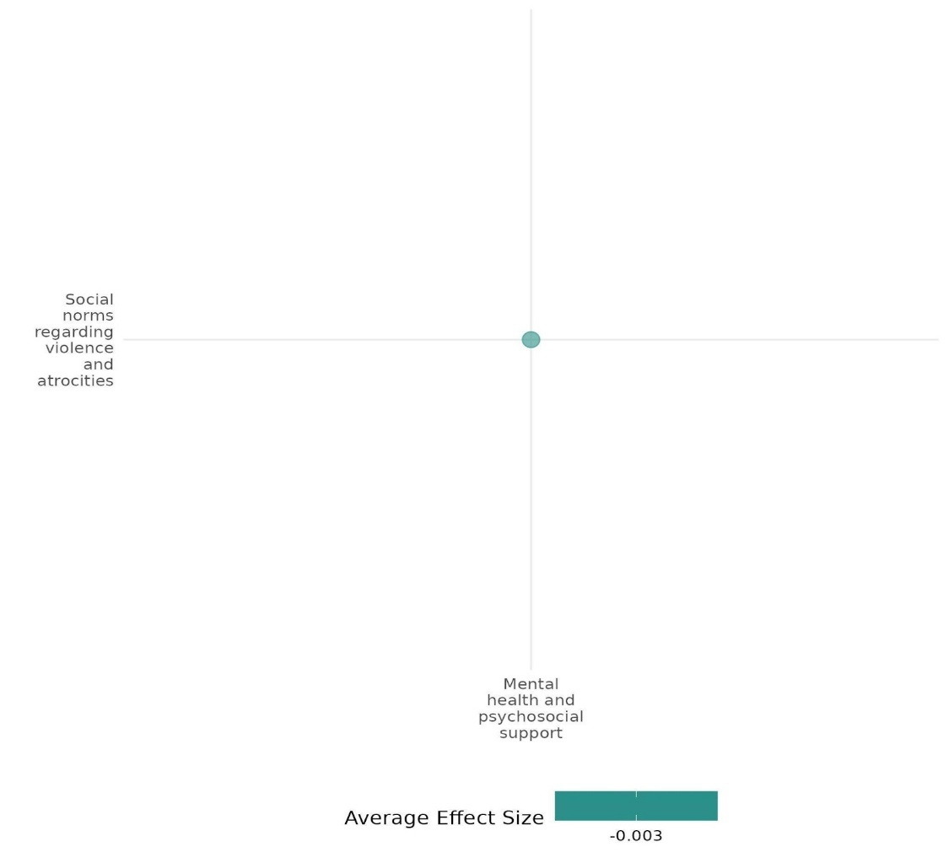

4.6.1(3)
Mental Health & Psychosocial support on Feelings of trust and Acceptance of diversity
NETfacts and FORNET enhanced social reintegration; NETfacts reduced stigma for sexual violence survivors, while FORNET decreased military attachment. However, their effects diminished over time, with no impact on shame or social disapproval.
Effect: No effect (g = -0.001)
Geographical region: Sub -Saharan Africa
Confidence in study findings: Low (2 studies with 8 Effect size)

Short summary
Mental health and psychosocial support interventions, such as the NETfacts health system in Eastern DRC—integrating trauma-focused therapy (NET) with community-based psychosocial support—and trauma therapies like FORNET documented that the NETfacts intervention significantly reduced stigmatization of sexual violence survivors, reflecting greater social support. However, it showed no impact on shame or social disapproval. FORNET effectively decreased solidarity with (para)military life, with the higher effects observed 6 months post-demobilization, though these effects diminished by 12 months. Additionally, perceived social acknowledgement (SAQ) improved, indicating better community reintegration.

The Intervention
The NETfacts Health System integrates Narrative Exposure Therapy (NET) with community-based interventions for trauma treatment and forensic offender rehabilitation (FORNET). The training process includes two stages: in the first stage, clinical experts train local counsellors, and in the second stage, these counsellors mentor a new group. A three-week workshop covers theoretical concepts and practical skills, including narrative exposure for trauma reprocessing.

How the intervention is expected to work
These interventions are expected to work by addressing both individual psychological needs and community-level challenges to reduce violence, improve emotional well-being, and foster reintegration. At the individual level, therapeutic techniques such as lifelines and narrative exposure help participants process traumatic memories, regulate emotions, and adopt non-aggressive behaviours. At the community level, activities like collective lifelines and facilitated discussions challenge harmful social norms, reduce stigma, and promote understanding of shared trauma. These interventions aim to create supportive environments that encourage reintegration and solidarity, addressing the root causes of aggression and violence while fostering emotional recovery.

The evidence base
The cell includes a total of seven studies, consisting of two systematic reviews and two impact evaluations and three ongoing studies. Among the systematic reviews, one is categorized as high-medium confidence, whereas the other is rated as low confidence.

The two impact evaluations were conducted in Eastern DRC, focusing on adult male combatants from the region. These studies primarily examined individuals who had experienced trauma symptoms and exhibited high levels of aggression, providing insights into the psychological and behavioral outcomes of conflict exposure.

In addition to the completed studies, the cell includes three ongoing studies: Luttenberger Katharina (2023), Jansen Stefan, and Aber J. (2018). These studies are being conducted in Lebanon and Rwanda, broadening the geographical and contextual scope of the research in conflict-affected settings.

Evidence findings
Trauma-focused interventions improved social reintegration, reduced the stigmatization of sexual violence survivors and decreased military attachment. However, their impact on shame and social disapproval was limited, and some effects faded over time.

The review evidence
This cell includes a systematic and narrative review of media and communication interventions in conflict and post-conflict settings, mainly in low- and middle-income countries including the Democratic Republic of Congo. Findings revealed improved family communication and greater gender awareness, despite cultural barriers. The narrative review highlighted that while some school-based interventions promoted trust and social inclusion, others were less effective or increased distress, indicating gaps in addressing broader social exclusion.

Included studies:
There are two IEs under this cell & the detailed summary is thus provided below;
Robjant (2022) assessed the effectiveness of the NETfacts health system, an integrated model of evidence-based individual trauma treatment (Narrative Exposure Therapy [NET]), and a trauma-informed community-based intervention (NETfacts) in Eastern DRC using randomized controlled trials. The study involved 1,066 participants from six communities, randomly assigned to either intervention, with follow-up interviews conducted at post-test, 3 months, and 6 months. Study documented that NETfacts was more effective than NET-only in improving social attitudes. While shame and social disapproval showed no significant differences between the two interventions, stigmatization of sexual violence survivors decreased more in the NETfacts group, reflecting greater social support.The study is rated as hig-medium confidence.
Kobach (2021) evaluates the impact of “Narrative Exposure Therapy adapted for Forensic Offender Rehabilitation” (FORNET). The intervention was implemented in two successive dissemination stages (DS). In DS1, local counselors were trained by clinical experts, while in DS2, these trained counselors supervised and mentored a second group of local counselors. The training process involved a 3-week workshop focusing on both theoretical concepts and practical therapeutic skills. The study focused on adult male combatants from the eastern Democratic Republic of Congo (DRC) who experienced trauma symptoms and high levels of aggression (defined as ≥7 PTSD symptoms and ≥7 items confirmed on the aggression questionnaire). Individuals with serious physical injuries, acute suicidal thoughts, or psychosis were excluded. Across DS1 and DS2, a total of 98 demobilized combatants participated in the intervention, with treatment-as-usual serving as the control condition. The study documented that the FORNET intervention significantly reduced solidarity with (para)military life, particularly in DS2, where participants had lower scores than the TAU group at 6 months post-demobilization. However, at 12 months, differences were not statistically significant, suggesting a potential attenuation of effects over time. Perceived social acknowledgement (SAQ) improved in the FORNET group, indicating better community reintegration. These findings highlight FORNET’s effectiveness in reducing military attachment and enhancing social integration, with stronger effects observed at 6 months post-intervention. The study is rated as High & medium confidence quantitative study.

Confidence assessment
Overall, the cell is rated as low confidence, despite including impact evaluations (IEs) and systematic reviews (SRs) with high to medium confidence. However, the limited number of studies lowers its confidence level.

Link to review summaries
Persson T (2009) and Spangaro Jo.
Both the reviews can be accessed via EGM.

Other outcomes in this study
Human security/Health Security
Violence & atrocity prevention/Nature & scale of violence & atrocity
Violence & atrocity prevention/social norms regarding violence or atrocity

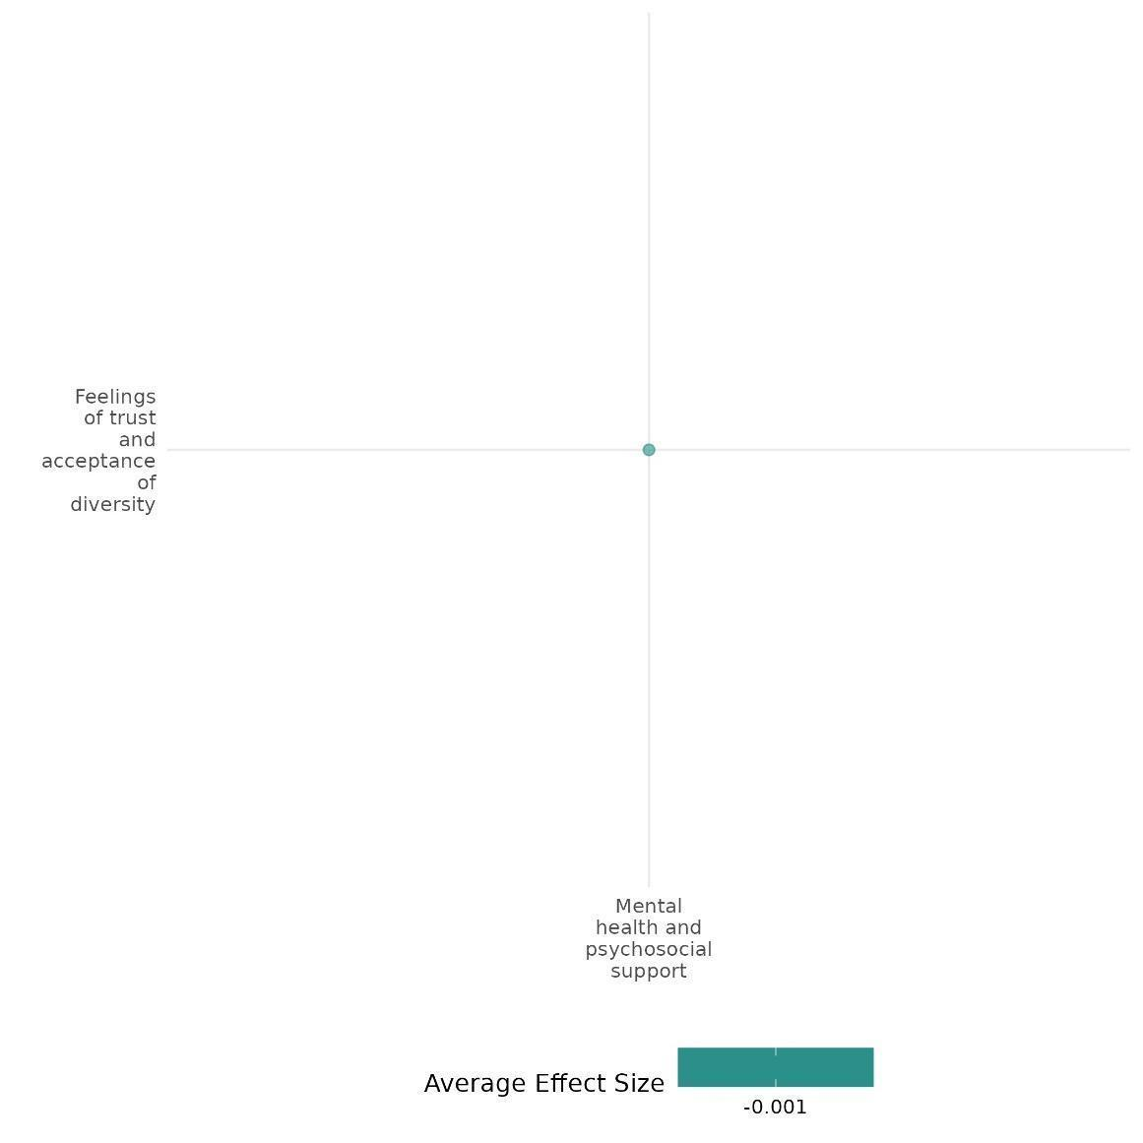

4.6.1(4)
Effect of Mental Health & Psychosocial Support on Economic Security

FORNET and CBT enhance economic reintegration by improving financial stability and social reintegration. However, sustaining these benefits depends on addressing structural challenges such as security, economic opportunities, and political stability.
Geographical Region: Sub - Saharan Africa
Effect: Small effect (g=0.032)
Confidence assessment = Low (2 studies with 12 effect size)

Short Summary
Mental health and psychosocial support interventions, such as Narrative Exposure Therapy (FORNET) and Cognitive Behavioral Therapy (CBT), play a crucial role in improving economic reintegration among vulnerable populations. The findings from both studies indicate that mental health interventions significantly contributed to economic reintegration, with participants showing better financial stability and reintegration outcomes compared to control groups. The impact was more pronounced in certain phases, such as the later stages of implementation and at longer follow-up periods, suggesting that improvements in mental health can facilitate economic stability, particularly in politically stable environments. However, the economic benefits of these interventions varied across different contexts. While participants initially experienced increased income, consumption, and reintegration into society, the sustainability of these gains was contingent on broader structural conditions. Persistent challenges such as theft, property insecurity, and limited opportunities for capital accumulation hindered long-term financial stability. These findings highlight the crucial role of psychosocial support in economic reintegration while emphasizing the need for complementary measures, such as enhanced security and economic policies, to ensure lasting success.

The Intervention
Mental health and psychosocial support interventions, including FORNET, CBT, and the STYL Program, focused on self-regulation, emotional control, and non-criminal identity development. FORNET trained local counsellors in two stages, incorporating a three-week workshop on theoretical and practical skills. CBT helped individuals manage anger, impulsivity, and self-destructive beliefs, while STYL combined group therapy and mentoring. Techniques like role-playing, community engagement, and structured goal-setting progressed from basic hygiene to emotional stability and long-term planning.

How the intervention is expected to work
Mental health interventions like FORNET, CBT, and STYL aid economic reintegration by enhancing emotional regulation, decision-making, and identity formation. FORNET and CBT help manage PTSD, aggression, and impulsivity, while STYL reinforces these skills through mentoring and role-playing.
The evidence base
The cell includes three studies; one ongoing study on Liberia by Keleher (2019) & two impact evaluations conducted in post-conflict settings in the Democratic Republic of Congo (DRC) and Liberia. These studies used different methodologies: a quasi-experimental design with staged dissemination of therapy and a 2 × 2 factorial randomised controlled trial combining therapy and cash grants. Both evaluations examined at-risk populations' psychological, behavioural, and economic reintegration outcomes.

The Evidence findings
Psychosocial support interventions like FORNET and CBT enhance economic reintegration by improving financial stability and social reintegration. However, sustaining these benefits depends on addressing structural challenges such as security, economic opportunities, and political stability.

Included studies
The cell includes two IEs. The detailed summary is thus provided here.
Kobach (2017) examines the effectiveness of “Narrative Exposure Therapy adapted for Forensic Offender Rehabilitation” (FORNET). The intervention was implemented through two successive dissemination stages (DS). In DS1, clinical experts trained local counselors, while in DS2, these trained counselors assumed supervisory and mentoring roles for a second cohort of local counselors. The training program included a three-week workshop that integrated theoretical knowledge with practical therapeutic skills.The study targeted adult male combatants from the eastern Democratic Republic of Congo (DRC) who exhibited trauma symptoms and high levels of aggression, defined as having at least seven PTSD symptoms and endorsing at least seven items on the aggression questionnaire. Individuals with severe physical injuries, acute suicidal ideation, or psychosis were excluded.A total of 98 demobilized combatants participated in the intervention across DS1 and DS2, with treatment-as-usual (TAU) serving as the control condition. The findings revealed that participants in the FORNET group experienced significantly better economic reintegration compared to those in the TAU group (t(96) = 2.77, p = 0.004, Cohen’s d = 0.28). Notably, between-group differences in economic reintegration were only significant in DS2 and at the 12-month follow-up for DS1. This suggests that improvements in mental health may support economic reintegration, particularly in a politically stable environment.The study evaluated multiple outcomes, including appetitive aggression, drug dependence, connection to paramilitary life, PTSD symptoms, depression, and economic reintegration. The study is rated as medium-high confidence.

Blattman (2017) examines the impact of two interventions designed to reduce violence and promote psychosocial well-being in Liberia: Cognitive Behavioral Therapy (CBT) and the Socio-Behavioral Transformation (STYL) program. CBT is a short-term therapeutic approach aimed at fostering self-regulation, patience, and the development of a non-criminal identity. It helps individuals identify and modify self-destructive beliefs, regulate emotions, manage anger, reduce impulsivity, and set practical goals through therapist-led exercises and homework. The STYL program complements this approach by combining group therapy with individualized counseling, facilitated by former participants who serve as mentors. It employs various techniques such as role-playing, community engagement, exposure therapy, and structured goal-setting, progressing from basic self-care routines to more advanced emotional regulation and future planning. The study utilized a 2 × 2 factorial design, randomly assigning 1,000 men to one of four treatment groups: therapy only, cash only, both interventions combined, or neither. To ensure transparency and safety, randomization was conducted at the individual level. Recruitment took place in three phases, starting with a pilot involving 100 participants, followed by two larger phases encompassing 900 additional participants. The allocation was well-balanced, with 25% assigned to cash only, 28% to therapy only, 25% to both, and 22% to neither. Compliance rates were high—98% of participants received the cash grant, and two-thirds attended at least 80% of therapy sessions, although 10% dropped out early. Those who withdrew from the program tended to have lower education levels, weaker self-control, and a lower likelihood of engaging in antisocial behavior.
Economically, the interventions yielded short-term benefits, including increased income, consumption, and investment among cash recipients. However, these gains were not sustained beyond a year. Persistent theft and property insecurity hindered long-term capital accumulation, ultimately eroding the initial financial improvements. The study also evaluated various aspects of violence, including victimization and perpetration, antisocial behaviors (such as theft, drug use, and criminal activity), non-criminal identity formation (adoption of nonviolent, goal-oriented identities), emotional regulation, and long-term behavioral stability. The study is rated as a medium-high confidence.
Confidence assessment
Overall, the cell is rated as Low confidence as it includes a small number of studies.

List of other outcomes assessed:
Violence and atrocity prevention/Nature and scale of violence or atrocities, Social norms regarding violence and atrocities
Human security/health security, economic security

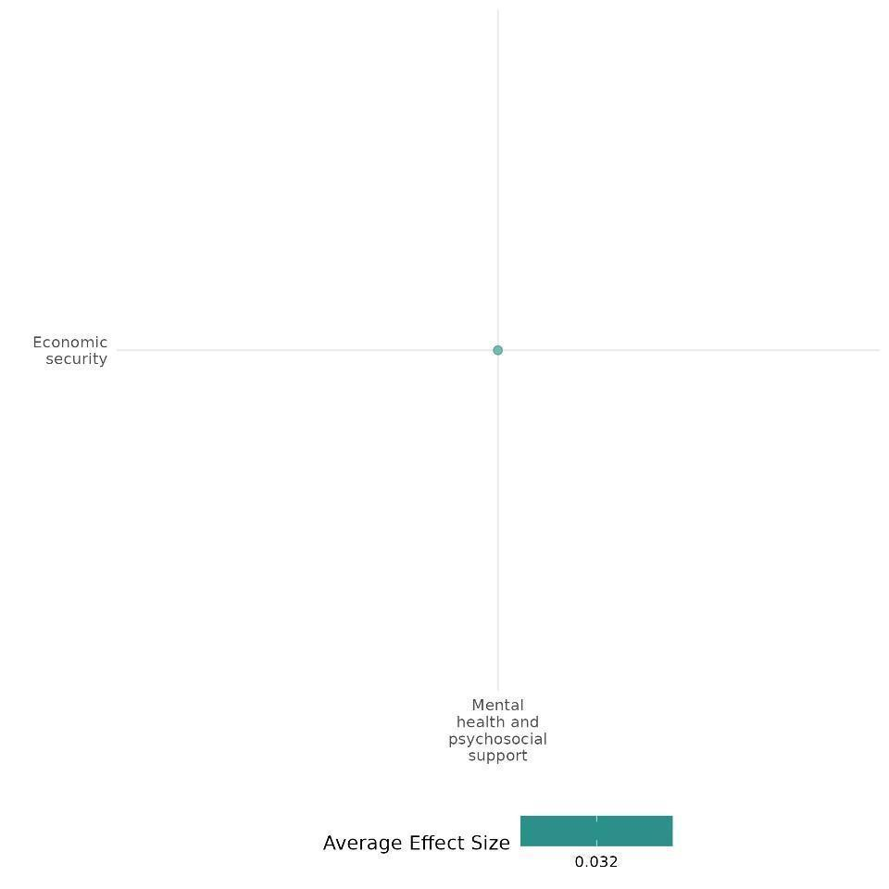

4.6.1(5)
Mental Health & psychosocial support on Food security & Nutrition and Health security
FORNET, CBT, STYL, HCUP, and SMI reduced PTSD symptoms, improved self-regulation, and supported trauma healing. However, SMI, while stabilizing distress, unexpectedly increased PTSD symptoms.
Geographical region: Sub-Saharan Africa
Effect: Large effect (g = 0.263)
Confidence assessment: Medium (5 studies with 25 Effect size)

Short Summary
Mental and psychosocial support interventions include programs such as Narrative Exposure Therapy (FORNET), Cognitive Behavioral Therapy (CBT), the Socio-Behavioral Transformation (STYL) program, Healing through Connection and Understanding Project (HCUP), and School Mediation Intervention (SMI) across diverse conflict-affected regions. The studies took place in the Democratic Republic of Congo (DRC), Liberia, Rwanda, and Gaza, with sample sizes ranging from 30 to 1,000 participants. These interventions primarily utilized randomized controlled trials (RCTs), quasi-experimental designs, and factorial designs. FORNET significantly reduced PTSD symptoms, while CBT and STYL improved self-regulation but showed limited long-term effects. HCUP promoted trauma healing and reconciliation, and SMI helped prevent worsening psychological distress. However, SMI also showed an unexpected increase in PTSD symptoms in the intervention group, suggesting the need for additional targeted interventions for highly traumatized children. These findings highlight both the effectiveness and challenges of structured psychosocial interventions in post-conflict settings.

The Intervention
Mental health and psychosocial support interventions, including FORNET, CBT, STYL, HCUP, and SMI, employed diverse strategies to address trauma and emotional regulation. FORNET used a three-week workshop focusing on trauma processing, aggression management, and PTSD reduction. CBT emphasized self-regulation, impulse control, and goal setting, while STYL incorporated group therapy, counselling, role-playing, and mentorship. HCUP engaged communities through interactive discussions and experiential activities in biweekly two-hour sessions. SMI promoted conflict resolution, socioemotional skills, and peer-led mediation under teacher supervision. These structured approaches support mental health recovery in post-conflict settings.

How the Intervention is expected to work
Mental health and psychosocial support interventions aim to reduce PTSD, aggression, and emotional distress through structured therapeutic approaches for trauma recovery. They were designed to promote long-term behavioral change by enhancing emotional regulation, self-control, and coping strategies. Additionally, these programs were expected to foster psychological healing and reconciliation in conflict-affected communities, strengthen social functioning, and improve emotional resilience, particularly among children.

The Evidence base
The cell includes 11 studies; five primary studies or impact evaluations and three reviews and three ongoing studies. The IES were conducted in the Democratic Republic of Congo (DRC), Liberia, Rwanda, and Gaza, with sample sizes ranging from 30 to 1,000 participants. These interventions were assessed using randomized controlled trials (RCTs), quasi-experimental designs, and factorial designs.

The systematic review includes studies from multiple low- and middle-income countries, with the highest concentration in the DRC, as well as Côte d'Ivoire, Afghanistan, Somalia, Uganda, Kenya, Ethiopia, South Sudan, Rwanda, Thailand, Liberia, and Lebanon.

The cell also includes three ongoing studies in Lebanon and Rwanda, authored by Luttenberger Katharina (2023) and Jansen Stefan (2022), along with a qualitative study conducted by Kumar Samhita.

Evidence Findings
Mental and psychosocial interventions reduced PTSD, improved self-regulation, and supported trauma healing, though long-term effects varied. SMI stabilized distress but unexpectedly increased PTSD, highlighting the need for targeted support for highly traumatized children.

The review Evidence
This cell includes a systematic and narrative review of media and communication interventions in conflict and post-conflict settings, mainly in low- and middle-income countries including the Democratic Republic of Congo. Findings revealed improved family communication and greater gender awareness, despite cultural barriers. The narrative review highlighted that while some school-based interventions promoted trust and social inclusion, others were less effective or increased distress, indicating gaps in addressing broader social exclusion.

Included studies
The cell includes five impact evaluations. The detailed summary of all included IEs is thus provided below;

Kobach (2017) evaluates the effectiveness of Narrative Exposure Therapy adapted for Forensic Offender Rehabilitation (FORNET) in supporting the rehabilitation of ex-combatants in the Democratic Republic of Congo (DRC). The intervention was implemented in two dissemination stages (DS): in DS1, clinical experts trained local counselors, while in DS2, these trained counselors supervised and mentored a new cohort. The training included a three-week workshop integrating theoretical concepts with practical therapeutic skills. The study targeted adult male combatants with significant trauma symptoms and high aggression levels, excluding those with severe injuries, acute suicidal ideation, or psychosis. A total of 98 demobilized combatants participated, with treatment-as-usual (TAU) serving as the control condition. FORNET significantly reduced PTSD symptoms, with 66% remission at six months compared to 43% in TAU, and complete remission was sustained at 12 months. Depression severity also improved significantly, with lasting benefits. While drug dependence reductions were not statistically significant at six months, remission rates were higher in FORNET (53%) than in TAU (24%), with notable improvements at 12 months. These findings indicate that FORNET is an effective intervention for trauma-related disorders and substance dependence in post-conflict settings, even when delivered by locally trained counsellors. The study is rated medium-high confidence in its findings. The study is rated as High- medium confidence. Regarding outcomes, the study assessed multiple outcomes, including PTSD, depression, drug dependence, appetitive aggression, connection to paramilitary life, and economic reintegration.

Blattman (2017) evaluates the impact of Cognitive Behavioral Therapy (CBT) and the Socio-Behavioral Transformation (STYL) program in reducing violence and improving psychosocial well-being in Liberia. CBT fosters self-regulation, patience, and a non-criminal identity by helping individuals manage emotions, control impulses, and set goals through therapist-led exercises. The STYL program combines group therapy with individual counseling, using role-playing, community engagement, and structured goal-setting, facilitated by former participants as mentors. The study used a randomized 2 × 2 factorial design, assigning 1,000 men to therapy, cash, both, or neither. Recruitment occurred in three phases, with 25% receiving cash only, 28% therapy only, 25% both, and 22% neither. Compliance was high—98% received cash, and two-thirds attended at least 80% of therapy sessions, though 10% dropped out early, typically those with lower education and self-control.
Findings showed therapy plus cash had the strongest short-term benefits, significantly improving self-regard (0.34 SD, p < 0.001) and reducing marijuana and alcohol use (p < 0.001, p = 0.009). However, these effects diminished after a year, with minimal sustained improvements in depression and hard drug use. While cash reinforced therapy initially, most benefits faded over time, underscoring the challenge of maintaining long-term behavioral change. The study is rated as high-medium confidence.

Hermenau (2013) evaluated Narrative Exposure Therapy for Forensic Offender Rehabilitation (FORNET) through a randomized controlled trial (RCT) in the Democratic Republic of Congo. The study involved male ex-combatants and former child soldiers (ages 16–25) enrolled in vocational training programs, randomly assigned to FORNET or a control group receiving standard treatment. Initially, 58 participants were recruited, but after exclusions and dropouts, the final analysis included 15 matched pairs (30 participants).
Findings showed no significant overall effect, but moderate group differences emerged (F(3,84) = 2.61, p = .036, η² = .09). The treatment group showed a trend toward PTSD symptom reduction (t(14) = 1.74, p = .052, d = 0.58), while the control group showed no significant change. At follow-up, it showed significantly lower PTSD severity in the treatment group (F(1,27) = 4.70, p = .020, η² = .15), indicating a large effect size. In addition to PTSD, the study examined social norms related to violence, atrocity aggression, and closeness to combatants, highlighting potential benefits of FORNET in reducing PTSD symptoms over time. The study is rated as high-medium confidence.

Staub (2005) evaluated the Healing through Connection and Understanding Project (HCUP), a community-based intervention in Rwanda designed to promote healing and reconciliation after the genocide. The intervention involved a 9-day training for local facilitators, focusing on understanding genocide, processing trauma, and fostering empathy through lectures, discussions, and experiential activities. Trained facilitators then applied these techniques in their community work. The study used a quasi-experimental 3 × 2 × 2 design with three groups: an Integrated (experimental) group, where facilitators incorporated HCUP training; a Traditional (treatment control) group, where facilitators used their standard methods; and a No-treatment control group, where participants only completed assessments. Conducted in rural Rwanda with 194 participants, mostly female (75%) and Tutsi (61%), the study involved two-hour sessions held twice a week for three weeks. Initially, the Integrated group reported the highest trauma symptoms, but over time, their symptoms decreased significantly, while the Traditional and Control groups showed an increase. By the final assessment (Time 3), the Integrated and Traditional groups had lower trauma symptoms than the Control group, with the Integrated group showing the most improvement. Religious and community-based interventions proved more effective than secular or purely healing-focused approaches. Overall, the study demonstrated that the Integrated intervention was the most beneficial, highlighting the importance of combining healing, reconciliation, and community engagement for effective trauma recovery in post-genocide contexts. The study is rated as low confidence

Peltonen et al. (2012) evaluated the School Mediation Intervention (SMI), implemented by the Gaza Community Mental Health Programme (GCMHP), to address the impact of war violence on children's mental health and behavior. The intervention aimed to enhance peer relationships, manage aggression, provide a safe space for victims, and reduce disruptive behavior through problem-solving and conflict resolution. It also promoted active student participation, with older students serving as mediators under the supervision of teachers.
The study was conducted in schools across the Gaza Strip, involving 225 Palestinian children aged 10-14 years. The intervention group included 141 children from SMI-implemented schools, while the control group comprised 84 children from non-SMI schools. Schools were randomly selected, and assessments were conducted at baseline (T1) and post-intervention (T2) after 8 months. The study reported an attrition rate of 23.5%, primarily due to relocation, school leaving, or absenteeism. SMI functioned by improving social functioning through a structured mediation process, socioemotional skills training, and psychoeducation on coping strategies. It encouraged students to actively engage in conflict resolution, fostering a supportive and cooperative school environment by enhancing communication, problem-solving, and emotional resilience.
The study found that while SMI did not significantly reduce psychological distress or depression, it helped prevent symptom deterioration. In terms of psychological distress (SDQ scores), the intervention group had a mean score of 16.08 (SD = 4.35) at T2, whereas the control group exhibited a higher distress level (M = 18.12, SD = 4.90), exceeding the clinical threshold (p = .014, η² = .04), suggesting that SMI contributed to maintaining mental health stability. Similarly, for depression (CDI scores), the intervention group’s depressive symptoms remained subclinical (M = 10.78, SD = 5.55), while the control group’s symptoms increased to a clinically significant level (M = 12.78, SD = 6.99) (p = .024, η² = .03). However, the unexpected increase in PTSD symptoms in the intervention group indicates that additional targeted interventions may be required to better support highly traumatized children. The study is rated as low confidence.

Overall confidence assessment
The cell is rated as Medium confidence due to the large number of included studies and the fact that the majority of primary studies are rated as high to medium confidence and independent effect size is consistent to each other except one. Additionally, one of the included systematic reviews (SR) is also rated as high to medium confidence, further supporting this classification.

Link to review summaries:
Persson T (2009)
Spangaro Jo . (2021).
Kumar Samhita (2016).
Both the studies may be accessed via EGM.

Other outcomes assessed:
Human security/Intermediate social cohesion outcomes
Violence and atrocity prevention/Social norms regarding violence and atrocities
Violence and atrocity prevention/Nature and scale of violence or atrocities

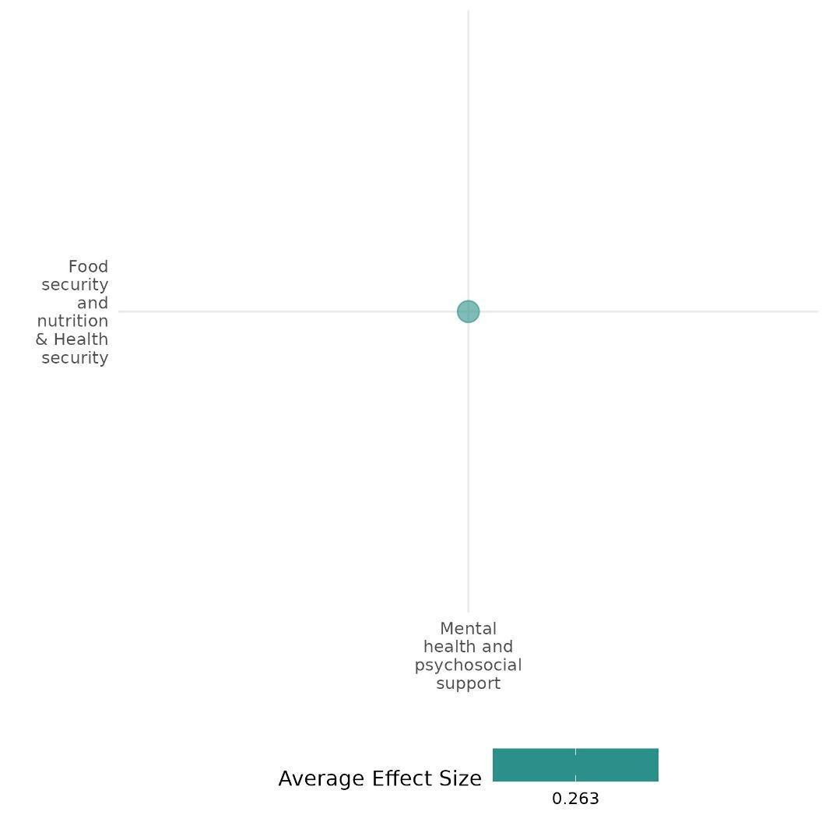

4.6.1(6)
Effect of Mental health and Psychosocial support on Intermediate social cohesion outcome
The Healing through Connection and Understanding Project (HCUP) reduced trauma symptoms and improved social cohesion. Secular and community-focused groups showed greater gains in reconciliation and well-being than religious and healing-focused groups.
Geographic regions: Sub-Saharan Africa
Effect: Large effect (g = 0.583)
Confidence in study Findings: Low (1 study with 3 effect sizes)

Short summary
Staub (2005) evaluated Rwanda's Healing through Connection and Understanding Project (HCUP), designed to promote healing and reconciliation post-genocide. A 9-day training equipped facilitators with psycho-educational and experiential techniques, which they integrated into community work. The study used a quasi-experimental 3 × 2 × 2 design with an integrated (experimental) group, a traditional (treatment control) group, and a no-treatment control group. Conducted in rural Rwanda with 194 participants, the study found that the integrated treatment significantly improved reconciliation and reduced trauma symptoms. Secular participants showed more positive attitudes than religious ones, and community-focused groups benefited more than healing-focused ones.

The Intervention
The Healing through Connection and Understanding Project (HCUP) was a 9-day intervention training. It combined psycho-educational lectures, group discussions, and experiential activities focused on understanding genocide, trauma processing, and fostering empathy. Facilitators were trained in active listening, self-care, and coping mechanisms to support trauma survivors while preventing vicarious trauma.

How the Intervention is Expected to Work
The intervention aimed to help participants process trauma through storytelling and discussions in a safe, supportive environment while addressing basic human needs like security and connection. By reducing trauma symptoms and fostering a positive orientation toward the other group, it sought to promote coexistence. Facilitators were encouraged to integrate these techniques into their community work, ensuring a scalable and sustainable impact.

The evidence base
This cell consists of one primary study or IE. While the findings show high consistency in improved reconciliation and reduced trauma symptoms in integrated treatment groups, the variation in effects between religious and secular groups, as well as control and traditional groups, indicates lower consistency.

Evidence findings: Overall, the mental health & psychosocial intervention showed significantly improved intermediate social cohesion outcomes.
Included study
This cell includes one study conducted in rural Rwanda. the detailed summary thus provided as below;
Staub (2005)
evaluated a community-based intervention in Rwanda called the Healing through Connection and Understanding Project (HCUP). This intervention aimed to promote healing and reconciliation after the genocide by training facilitators from local organizations. The 9-day training included psycho-educational lectures, group discussions, and experiential activities focused on understanding genocide, processing trauma, and fostering empathy. Trained facilitators then integrated these techniques into their community work. The study used a quasi-experimental 3 × 2 × 2 mixed design with three groups: (1) an integrated (experimental) group, where facilitators incorporated the training into their approach; (2) a traditional (treatment control) group, where facilitators used their standard methods; and (3) a no-treatment control group, which only completed assessments. The study took place in rural Rwanda with 194 participants, 75% female, and a majority identifying as Tutsi (61%). Participants met twice a week for three weeks in two-hour sessions.
The study found significant treatment, focus, and goal orientation effects on participants’ attitudes. Integrated treatment led to a more positive orientation towards the other group than traditional and control groups. Secular participants showed more positive attitudes than religious ones. Overall, the integrated treatment showed more positive outcomes, particularly for secular and religious community groups.The study is rated as a low confidence.

Confidence assessment: Overall, this study has low confidence as only one study was included under this category and it was also rated as a low.
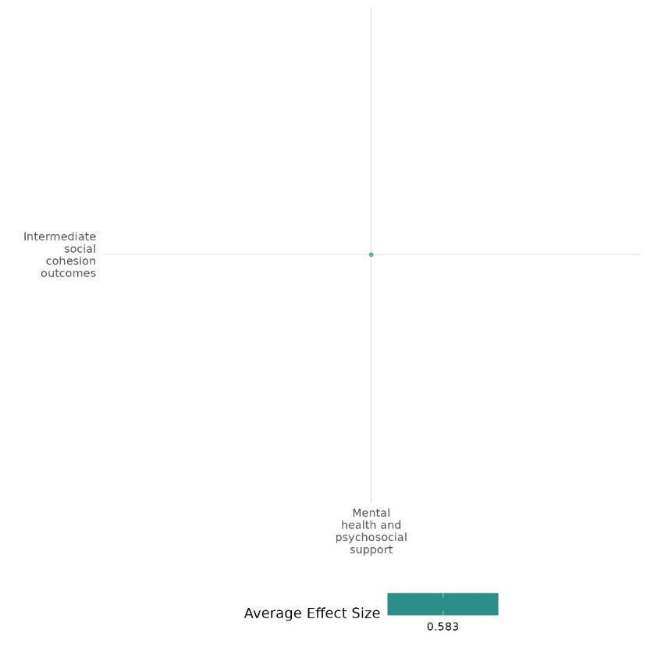
4.6.2 Market development and macroeconomic policy
4.6.2(1)
Effect of market development and macroeconomic policy on diplomatic relations and peaceful dispute resolution

Market development and macroeconomy policies, such as those from international financial institutions generally improve diplomatic relations but may worsen tensions in large ethnic groups, especially those who are excluded from state power.
Geographical region: Africa, Developing Countries
Effect: Large effect (g=0.372)
Confidence in study findings: Low (2 studies with 2 effect sizes)

Short Summary
Market development and macroeconomic policies may include economic measures and aid introduced by international financial institutions. These measures aim to stabilize economies and promote resilience, but they may worsen inequality in some contexts. The studies included in this cell shows that economic measures and aid generally reduce ethnic tensions in fractionalized societies but may heighten tensions in polarized settings or where large ethnic groups are excluded from power.
The intervention
Market development and macroeconomic policy measures include economic reforms introduced by international financial institutions such as the International Monetary Fund (IMF). Examples of these measures include fiscal discipline, market liberalization, and structural adjustment measures. These are typically designed to stabilize economies facing financial crises by correcting fiscal imbalances, enhancing market operations, and fostering economic resilience.
How the intervention is expected to work
Market development and macroeconomic policy measures, such as economic reforms, seek to restore macroeconomic stability by implementing policies that strengthen fiscal management, optimize resource distribution, and attract investment. These initiatives are anticipated to promote sustainable growth and mitigate social/ethnic tensions by stabilizing economic conditions and expanding opportunities for participation. However, they may also inadvertently deepen socio-economic disparities, particularly affecting disadvantaged groups due to reduced government spending and economic restructuring. The overall effectiveness of such programs is influenced by a country’s institutional strength, the inclusivity of policy implementation, and the level of pre-existing social inequalities, all of which determine their broader impact on social stability.
The evidence base
The cell contains 2 impact evaluations and 1 qualitative study.
The first impact evaluation utilizes data from 70 developing countries between 1985 and 2006. Meanwhile, the second impact evaluation study analyzes data from 53 African countries. The qualitative study is set in Sudan.

Evidence findings
Economic aid and macroeconomic policies have mixed effects on violence and atrocities. In post-conflict settings, increased economic aid has been shown to positively impact the sustainability of peace agreements by providing crucial financial resources for rebuilding efforts. However, structural economic reforms, while effective in restoring fiscal stability, can also deepen social inequalities and tensions, particularly in ethnically polarized societies.

Included studies
Emmanuel (2015) investigates the role of economic aid as a peace incentive in post-conflict African countries. It examines how changes in donor aid patterns, particularly increases in economic assistance following peace agreements, can influence the success and longevity of peace processes. The context of the study spans across 53 African countries, focusing on peace processes from 1989 to 2006. The research utilizes a longitudinal dataset comprising 1,166 observations from 53 African countries over 22 years (1989–2010). The study employs various statistical techniques, including Generalized Least Squares (GLS) random-effects regression, to analyze the data. The analysis considers six explanatory variables: aid change, conflict intensity, state capacity, level of democracy, peacekeeping, and military victory. The dependent variable is the success of peace processes, defined as maintaining peace for at least five years post-agreement. The study finds that economic aid plays a significant role in supporting peace processes. The aid change variable is positive and highly significant, indicating that increased economic assistance after a peace agreement enhances the likelihood of sustaining peace. The presence of peacekeeping troops also positively impacts peace maintenance, although peacekeeping shows a negative relationship. The study concludes that donor economic aid is a critical element in achieving lasting peace, suggesting that substantial development assistance can provide strong incentives for peace. The study is rated low due to its little description of the evaluation questions.
Vadlamannati (2014) examines the relationship between IMF interventions and ethnic tensions in developing countries from 1985 to 2006. The authors investigate whether IMF programs disrupt ethnic peace or have a pacifying effect on ethnic relations. The authors use unique data from the International Country Risk Guide (ICRG) that measures the degree of ethnic tension in a country. They analyze a sample of developing countries over two decades (1985-2006). The key independent variable is IMF intervention, measured as countries being under an IMF loan program for more than five months in a particular year. The results show that contrary to common perceptions, IMF interventions reduce ethnic tensions rather than exacerbating them. The pacifying effect of IMF programs is stronger in highly fractionalized societies. However, IMF interventions can increase ethnic tensions when there is a large ethnic minority group (20% or more of the total population) that is excluded from political power. The authors find no evidence to suggest that IMF programs increase ethnic tensions overall. The study rated high and medium confidence quantitative study as the authors have taken appropriate steps to ensure the credibility and confidence in their study findings. The study is rated low due to its little description of the intervention.
Confidence Assessment
Overall low: The study is rated as low confidence as it only includes 2 studies. The difference in the effects between the two studies also tend to be high.

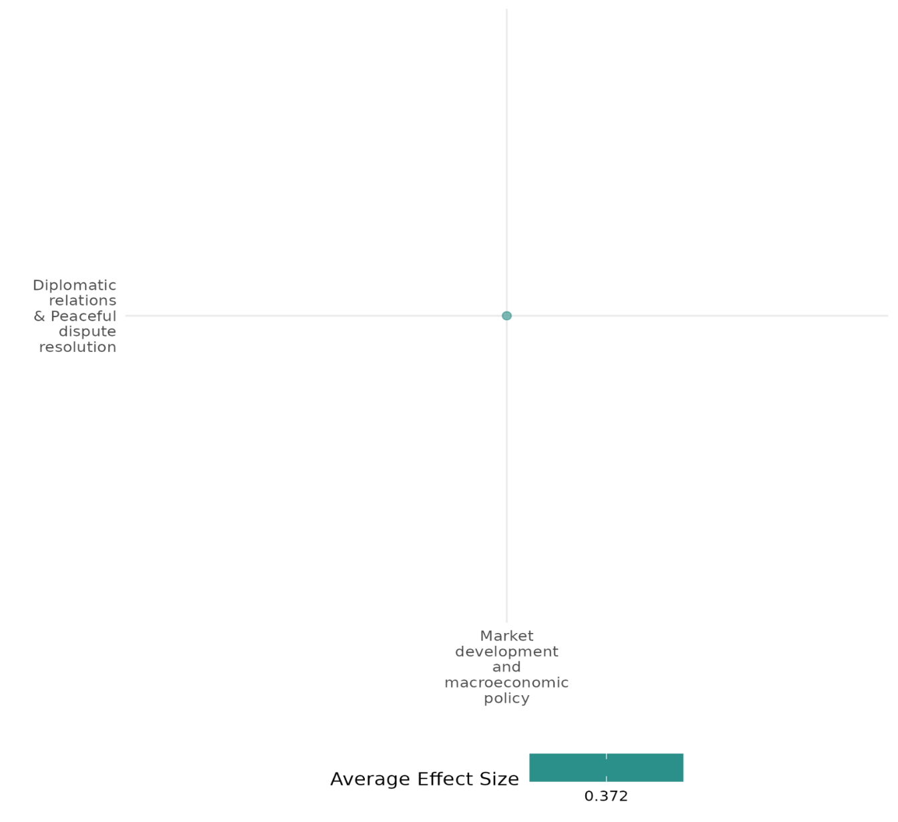

4.6.2(2)
Effect of market development and macroeconomic policy on nature and scale of violence or atrocities

Market development and macroeconomic policies can help reduce violence and instability in conflict-prone areas, but they may also exacerbate violence and atrocities by increasing inequalities and fostering dependency.
Geographic region: Africa, Asia, Global, Latin America, Middle East
Effect: Small effect (g=0.017)
Confidence in study findings: Medium (8 studies with 73 effect sizes)

Short Summary
Market development and macroeconomic policies can influence the nature and scale of violence and atrocities in complex ways. While interventions such as foreign aid and economic liberalization can help reduce violence by addressing economic grievances and fostering stability, they can also inadvertently exacerbate violence by increasing competition for resources, fostering dependency, and becoming targets for insurgent attacks. The effectiveness of these interventions depends on factors such as aid allocation, governance capacity, and the presence of complementary security measures. Evidence across different contexts shows mixed outcomes, with some interventions successfully reducing violence while others contribute to prolonged conflict.
The intervention
Market development and macroeconomic policy measures include a variety of economic reforms and development initiatives aimed at promoting stability and reducing violence in conflict-prone and post-conflict societies. These interventions encompass structural economic reforms such as trade liberalization, fiscal discipline, and targeted aid programs implemented by international financial institutions and donor countries. Specific interventions include foreign aid to stabilize regions post-conflict, economic liberalization efforts to promote long-term growth, and development programs aimed at reducing local grievances and fostering economic resilience.
How the intervention is expected to work
Market development and macroeconomic policies can influence the nature and scale of violence and atrocities through several mechanisms. Economic aid and foreign interventions can either stabilize conflict-prone regions or exacerbate tensions depending on factors such as aid allocation, governance, and the existing socio-political context. In conflict-affected areas, aid can provide immediate relief and stability by improving economic opportunities and reducing grievances that fuel violence. However, in some cases, aid can also become a target for insurgents, leading to an escalation of violence as they attempt to sabotage development projects to undermine government legitimacy and assert control​. Additionally, economic liberalization efforts, such as trade openness and structural reforms, may contribute to long-term stability by fostering economic growth and development​. Yet, in the short term, these policies can create economic dislocation, increasing inequalities and competition for resources, which may heighten the risk of conflict​. Furthermore, the effectiveness of such interventions is shaped by donor approaches.
The evidence base
This cell includes 8 impact evaluation studies, 1 systematic review, and 1 qualitative study. The study findings tend to vary widely.
The review examined how different kinds of interventions (including economic interventions) affect armed violence in developing and middle-income countries.
The primary studies are set in Sierra Leone (1), Pakistan (1), Burundi (1), Global (1), Africa (3), Peru (1), and Israel & Egypt (1)
Evidence findings
Economic interventions such as foreign aid and trade liberalization have mixed impacts on conflict and economic stability. While aid can provide short-term stability and reduce violence, it may also foster dependency and exacerbate conflict when misaligned with local needs. Trade liberalization can promote long-term economic growth but may heighten short-term inequalities, increasing conflict risks. The effectiveness of these interventions depends on factors such as aid allocation, institutional strength, and the presence of complementary security measures. Tailored and well-coordinated approaches are crucial to ensuring that economic policies contribute to sustainable peace and development.
The review evidence
Findings of the systematic review suggest that wage employment interventions can reduce armed violence in certain contexts. It also emphasized that effects of economic interventions are contingent on timing and how they relate to ongoing armed conflict or post-conflict settings.
The impact evaluation evidence
There are 8 impact evaluations. Eight study summaries are thus provided here:
Arena (2016) & Pechenkina (2016) examine the role of external subsidies, specifically U.S. foreign aid, in maintaining peace between Israel and Egypt following the Yom Kippur War. The intervention context is the Arab-Israeli conflict, where the United States provided substantial economic aid to both Israel and Egypt as a means to manage and stabilize the region post-1973. The research employs a quantitative case study approach, analyzing data from 1948 to 2001 for four dyads: Israel with Egypt, Jordan, Lebanon, and Syria. The study uses a Poisson regression model to assess the impact of U.S. economic aid on the incidence of violent militarized interstate disputes (MIDs) between these countries. The analysis includes variables such as economic aid, parity, and anticipated shifts in power, with data sourced from the Correlates of War data set and U.S. foreign aid records. The findings suggest that U.S. foreign aid significantly reduced the likelihood of violent conflicts between Israel and Egypt after the Camp David Accords. The study indicates that without these subsidies, the number of violent MIDs would have been substantially higher. The study is rated as medium confidence as it is a non-experimental study.
Bussman et al. (2016) investigates the relationship between economic liberalization and civil conflict in Sub-Saharan Africa, particularly focusing on the effects of structural adjustment programs (SAPs) implemented by the International Monetary Fund (IMF). The authors argue that while long-term trade openness can lead to development and stability, it may also increase the risk of conflict in the short term due to the redistributive effects of liberalization. The context emphasizes the need for a nuanced understanding of how economic policies impact social tensions and political stability. The study employs a quantitative analysis using a dataset that encompasses 90 developing countries from 1978 to 2000, focusing on the effects of trade policies and institutional arrangements. The authors utilize a 7-point ordinal scale to measure exchange arrangements and restrictions. They also include various control variables, such as cultural diversity and historical conflict data, to avoid omitted variable bias. The sample specifically highlights the case of Guinea-Bissau, contrasting it with other cases of civil conflict in the region, such as Rwanda and Burundi, to illustrate the unique dynamics at play. The findings indicate that trade openness has a conflict-reducing impact in the long term, but the short-term effects of liberalization heighten the risk of civil war onset significantly by 170.6%. The study is rated low confidence because the results are robust across various model specifications, suggesting that the relationship between economic liberalization and conflict is complex and context dependent.
Fielding (2012) investigates the dynamics of violence against civilians during the Peruvian civil conflict (1980-2000), particularly focusing on the roles of the Peruvian government and insurgent groups, such as the Sendero Luminoso (SL) and the Movimiento Revolucionario Tupac Amaru (MRTA). It examines how different types of foreign aid and intervention influenced the levels of violence against civilians. The authors argue that while some forms of aid may reduce violence, others can exacerbate it, highlighting the complexity of foreign intervention in conflict settings. The research utilizes data from the Peruvian Truth and Reconciliation Commission (TRC), which documented nearly 70,000 deaths during the conflict, with a significant number of casualties being unarmed civilians. The sample consists of data collected from approximately 17,000 witnesses to violence, analysis focuses on monthly observations of violence, including the number of attacks initiated by government forces and insurgents, as well as civilian casualties resulting from these attacks. The study finds a strong cyclical relationship between government and insurgent violence, where increases in violence by one side often provoke retaliatory violence from the other. The analysis reveals that the type of foreign aid provided to the Peruvian government significantly influenced the levels of violence against civilians. For instance, military aid with high fungibility was associated with increased violence against civilians, while development aid with low fungibility tended to have a mitigating effect. The study is rated low confidence quantitative study as potential biases in reporting, particularly for rural events.
Gehring (2022) investigates the effects of Chinese and World Bank aid on stability across African regions. It explores the distinct approaches these donors take, with the World Bank promoting democracy, transparency, and human rights, while China emphasizes economic growth with fewer democratic conditions and a stronger tolerance for authoritarian regimes. The paper employs a quasi-experimental design using fixed effects and instrumental variable (IV) approaches, integrating geo-referenced data on aid projects from both donors with subnational measures of stability. The dataset matches the location of aid projects to conflict data to examine variations in stability outcomes across different African regions. The sample includes 728 first-order subnational regions across 45 African countries, analyzing aid data from 1995 to 2012 for the World Bank and 2000 to 2012 for Chinese aid. Subnational stability measures include indicators for conflicts, government repression, and citizen protests. The study finds that neither Chinese nor World Bank aid significantly fuels conflict. Chinese aid is linked with higher levels of government repression and greater acceptance of authoritarian norms. The study is rated high and medium confidence quantitative study.
Ito (2020) examines how foreign aid impacts conflict dynamics in sub-Saharan Africa. It theorizes that aid can both escalate battle intensity in conflict zones (by motivating rebels to disrupt aid projects) and relocate combat activities from neighbouring areas due to resource constraints on rebel forces. The study uses a quasi-experimental design, analyzing geo-referenced data on aid distribution and conflict events. The sample consists of 22 sub-Saharan African states from 1989 to 2008, with 6,369 geo-coded aid project records and 17,846 battle events. Data is divided into grid cells of various sizes (30-100 km) to capture the local effects of aid on battle intensity. Aid provision in targeted regions was associated with a 111% increase in battle intensity showing heightened conflict where aid is directly provided. Aid given in nearby regions was associated with a 40% decrease in battle events suggesting that resources limit conflict escalation across regions. The study is rated low confidence quantitative study as potential measurement errors in data especially in conflict zones where data collection is challenging, insufficient control for spillover effects and oversimplified interpretation of complex social and economic conditions. In addition, unobserved variables—like local political alliances, specific donor priorities, or secret government arrangements with rebels—could still influence where aid is allocated. The study is rated low due to its little description of the intervention.
Magee (2011) examines the relationship between economic openness and internal conflict. The authors investigate whether openness reduces internal conflict and whether internal conflict reduces openness. The study uses an unbalanced panel dataset of 137 countries from 1950 to 2004. The authors use two measures of openness: (1) the natural log of a country's total exports plus imports as a share of GDP, and (2) the number of years the country has been classified as economically open based on the Sachs & Warner (1995) classification. Internal conflict is measured using both a civil war dummy variable and an events-based measure. The authors find a negative correlation between openness and conflict, but this is primarily because internal conflict causes a decline in openness rather than because higher levels of openness reduce conflict. When controlling for endogeneity, trade openness does not significantly reduce internal conflict. The study rated as high and medium confidence quantitative study.
McDougal (2014) examines the effects of agricultural cooperatives on land conflicts, inequality, violence, and community trust in three Burundian villages. Burundi has a history of ethnic tensions and violence, with the Tutsi minority controlling the government and military, and the Hutu majority facing exclusion and repression. The study uses a pseudo-difference-in-differences (DiD) analysis on a cross-sectional dataset of 95 community members in three different villages in which the cooperative has been, or is becoming, operational. In two communities, cooperatives have been operational for 3 years, while in the third, a cooperative membership had just formed, but no harvests had yet been made. The interaction between cooperative membership and being in a cooperative village is positive and significant indicating that cooperative members report more violence toward themselves or their acquaintances. The study is rated medium due to its partial description of the outcomes and intervention.
Tahir (2015) examines the relationship between foreign aid and conflict in Pakistan. It provides evidence that the incompatibility between the strategic objectives of aid donors and the development needs of the recipient country can lead to perpetual and multidimensional domestic conflict. The study uses count data methods to analyze the impact of aid, social sector spending, regime changes, and demographic factors on conflict in Pakistan. At the aggregate level, social sector spending, regime changes, and youth bulge are positively and significantly related to conflict in Pakistan. The impact of aid per capita on conflict is mixed, being significant for terrorism data but insignificant for armed conflict data. At the project level, conflict is strongly related to aid commitment and purpose, indicating that discrepancies in aid allocation and commitment may exacerbate conflict. The study rated low confidence quantitative study as limitations in the data, potential confounding factors, inconsistent findings, and limitations in the study design.
Confidence Assessment
Overall medium: The systematic review included in this cell is rated high. However, there is a high degree of inconsistency in the findings of the impact evaluation studies, therefore bringing the overall mark to medium.
Link to review summaries
Cramer (2016)
All studies may be accessed via the EGM.

Other outcomes in this study:
Social cohesion / feelings of trust & acceptance of diversity

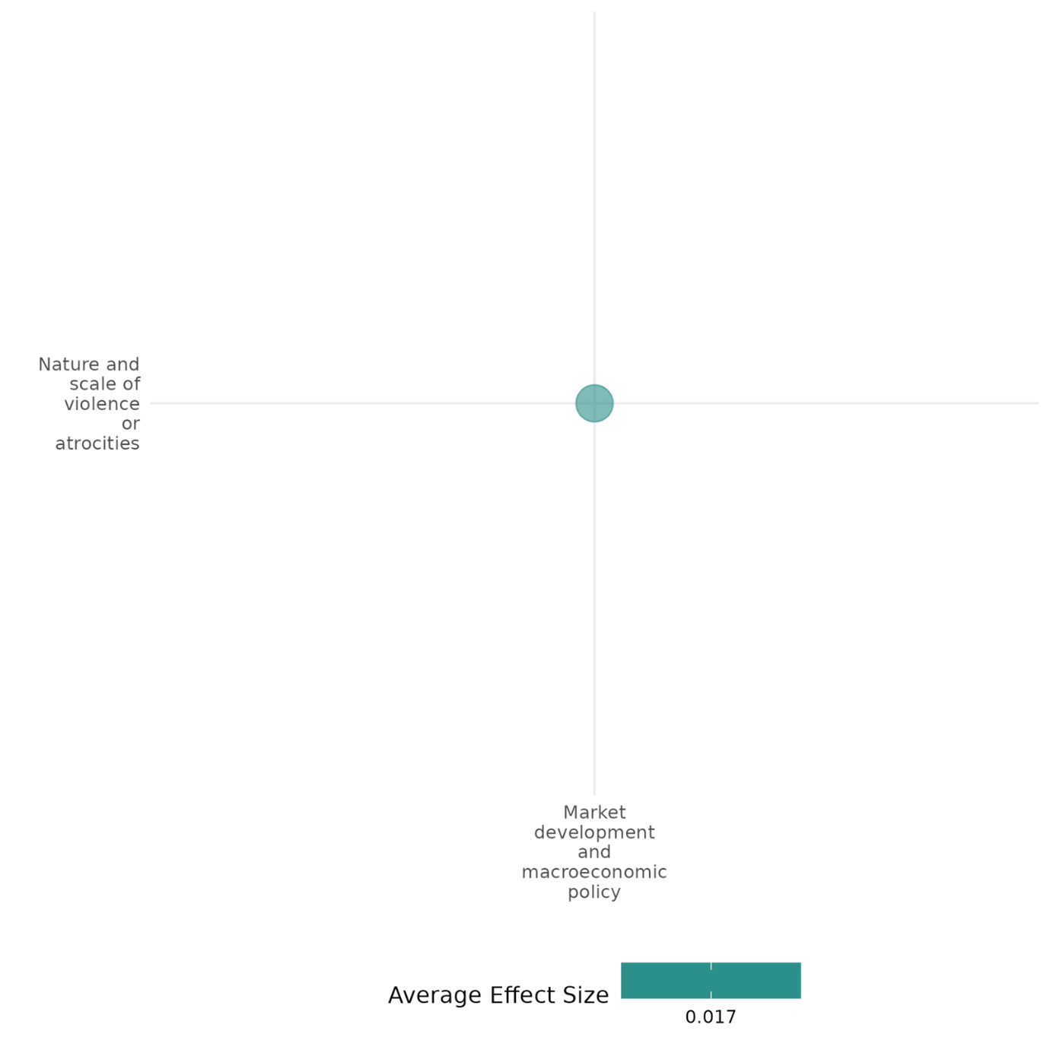

4.6.2(2.1????)
Effect of Market development and macroeconomic policies on nature and scale of violence or atrocities

Market development and macroeconomic policies impact conflict differently-U.S. aid, trade liberalization, and military aid escalate violence, while development aid and economic openness reduce violence, but it is unstable in the long-term.
Geographical region: Middle East & North Africa,Sub Saharan Africa, Global, Latin America & Caribbean,South Asia
Effect size: Adverse effect (g=-0.086)
Confidence in the study findings: Low confidence (8 studies; 20 ES)

Short summary
The cell analyses various studies on the relationship between market development and macroeconomic policies on nature and scale of violence or atrocities. Foreign aid, economic openness, and conflict interact in complex ways. U.S. conditional aid during the Arab Israeli conflict marginally correlates with violence, while trade liberalization in sub-Saharan Africa increases short-term conflict risks but may offer long-term benefits. In Peru, military aid escalates violence, whereas development aid reduces it. World Bank and Chinese aid generally lower conflict likelihood in Africa, though aid can also escalate localized violence. Economic openness has mixed stability effects, while instability disrupts trade. In Burundi, agricultural cooperatives ease land disputes but increase interpersonal tensions. We have low confidence in the cell as the studies have no consistency in the findings.

The intervention
The studies explore various interventions, including U.S. conditional aid in the Arab-Israeli conflict, trade liberalization in sub-Saharan Africa, foreign aid during Peru's civil war, development aid in African states, localized aid in sub-Saharan conflict zones, economic openness globally, agricultural cooperatives in Burundi, and foreign aid in Pakistan. Each intervention highlights specific dynamics: U.S. aid emphasizes conditionality and power shifts, while trade liberalization exposes short-term risks but potential long-term benefits. In Peru, the effects of military, development, and counter-narcotics aid differ significantly. African-focused studies explore development aid’s nuanced impact on conflict likelihood. Localized aid sometimes escalates violence due to competition. Economic openness demonstrates mixed effects on stability, while cooperatives in Burundi reduce land disputes but heighten interpersonal tensions. Finally, aid in Pakistan shows minimal direct impact on conflict, with governance playing a crucial role.

How the intervention is expected to work
The interventions aim to influence conflict dynamics by addressing underlying economic, political, and social drivers. U.S. conditional aid in the Arab Israeli conflict targets commitment and information issues among conflicting parties, promoting peace through leverage. Trade liberalization is expected to stabilize regions by fostering economic growth and reducing grievances, though it may temporarily disrupt societies. In Peru’s civil war, development aid seeks to reduce violence by improving livelihoods, while military aid unintentionally escalates conflict through increased militarization. Development aid in Africa emphasizes promoting stability through economic improvements and governance reforms, whereas localized aid in sub-Saharan Africa can inadvertently heighten violence by intensifying resource competition. Economic openness aims to integrate regions into global markets, reducing isolation and fostering stability, though its effects are context dependent. Agricultural cooperatives address land disputes by encouraging collaboration but may spark interpersonal tensions. Foreign aid in Pakistan aims to enhance governance, though its effectiveness depends on resource allocation and institutional capacity.

The evidence base
The cell contains 8 IE with one systematic review and one qualitative study. There is a high degree of consistency in the review findings.
The IE studies employed various methodologies like three-player bargaining model, mixed methods, logit regression models, time-series data, panel datasets and probit models. One study analysed through a pseudo-difference-in-differences design.
Location of the cell are Israel and its neighbours (Egypt, Jordan, Syria, and Lebanon), sub-Saharan Africa, Guinea, Guinea-Bissau, Peru, Burundi and Pakistan. The qualitative paper (Millar (2016)) is from Sierra Leone (Sub-saharan africa).

Evidence findings
Market development and macroeconomic policies impact conflict differently—U.S. aid, trade liberalization, and military aid escalate violence, while development aid and economic openness reduce violence, but it is unstable in the long-term.

The review evidence
Foreign aid, trade liberalization, and economic openness impact violence differently. Conditional aid and military assistance escalate violence, while development aid and economic openness reduce conflict long-term. Governance failures and redistribution shocks amplify conflict risks.

The impact evaluation evidence
Arena (2016) examines the impact of U.S. foreign aid as third-party subsidies on sustaining peace in the Arab-Israeli conflict, particularly between Israel and Egypt. The study explores how conditional aid can address information and commitment problems among conflicting parties, achieving lasting peace without resolving underlying issues. Using a quantitative analysis, it incorporates an iterated three-player bargaining model and case studies, focusing on dyadic interactions between Israel and its Arab neighbours (Egypt, Jordan, Syria, and Lebanon) from 1948 to 2001. Based on 188 dyad-year observations, the study analyses the correlation between U.S. aid and militarized interstate disputes (MIDs). Results indicated that a one-million USD increase in aid corresponds to a negligible 0.12% increase in the expected count of violent MIDs. This result is not statistically significant, as shown by the large standard error. It suggests that aid alone does not directly reduce conflict but plays a more significant role in interaction with other factors like parity and power shifts.The study is rated as medium confidence as it is a non-experimental study.
Bussmann et al. (2005) explores the relationship between foreign economic liberalization and civil conflict in sub-Saharan Africa. It examines whether economic openness reduces violence in the long term but increases conflict risks in the short term due to re-distributional effects, particularly during structural adjustment programs. The study is focused on sub-Saharan Africa, with specific case studies conducted on Guinea and Guinea-Bissau. The research uses a mixed-method approach: quantitative analysis: logit regression models on panel data of 37 sub-Saharan African countries (1980–2000) to study the effects of trade liberalization and economic openness on civil war onset and qualitative case studies of comparative analysis of Guinea and Guinea-Bissau to understand the divergent outcomes of liberalization in terms of conflict onset. The study explores the effects of trade liberalization on civil war in sub-Saharan Africa (37 countries, 1980–2000) and globally (1,361 cases). Using panel data logit models and case studies (Guinea, Guinea-Bissau), it analyses short-term risks and long-term benefits of economic openness. The findings indicated that when comparing Africa and global contexts, trade liberalization significantly increases the likelihood of conflict onset (p < 0.05), showing a short-term destabilizing effect globally. Trade openness has a negative effect on civil war onset but is not statistically significant. The findings of the case study indicated that in Guinea-Bissau: experienced civil war after liberalization due to unmet redistributive demands, particularly among the military and public servants. The inability of the government to manage grievances, including military dissatisfaction, led to an escalation into violence. In Guinea: Avoided civil war due to the government's compensatory strategies, including wage increases and appeasement of key groups like the military. These concessions mitigated potential unrest despite similar economic pressures. The study demonstrates that economic liberalization can trigger significant social unrest and, in fragile states, escalate into large-scale armed conflict. This is a low confidence quantitative study.
Feilding (2012) The study examines the impact of foreign interventions on violence during the Peruvian civil war (1980–2000). It focuses on three types of aid: military, development, and counter-narcotics, exploring their effects on government and insurgent violence against civilians. Conducted in Peru, primarily in rural highlands, it uses time-series data from the Peruvian Truth and Reconciliation Commission (TRC). The sample includes monthly data from 1983–1993, covering 132 months of observations and over 17,000 testimonies documenting thousands of violent incidents and casualties. After 24 months, a 1% increase in military aid raised government attacks by 0.08% and insurgent attacks by 0.12%, while increasing insurgent killings by 0.14%. A 1% increase in development aid reduced government attacks by 0.96% and insurgent attacks by 1.42%, with insurgent killings decreasing by 1.06%. A 1% increase in counter-narcotics aid growth decreased government attacks by 1.18% and insurgent killings by 0.54%. These results show varying effects of aid types on conflict dynamics.The study is rated low confidence quantitative study as potential biases in reporting, particularly for rural events.
Gehring et al. (2022) analyses the relationship between development aid and conflict in African states. It examines the differing impacts of World Bank (WB) aid, emphasizing democracy and transparency, and Chinese aid, which focuses on stability with less regard for democratic norms. The research uses subnational regions in 45 African countries from 1995–2012 (WB) and 2000–2012 (China). The raw correlation between aid and conflict likelihood is analysed. The sample includes 13,104 observations for WB aid and 9,464 for Chinese aid. WB aid shows a negative correlation with conflict likelihood (p<0.1), suggesting aid reduces conflict. Chinese aid also has a negative correlation (p<0.05), indicating a similar pattern. These results suggest that aid from both donors does not fuel conflict and might reduce violence.The study is rated high and medium confidence quantitative study.
Ito (2020) explores the impact of foreign aid on conflict intensity in sub-Saharan Africa, focusing on how aid provision influences battle dynamics in targeted and neighbouring regions. It employs a quantitative design with geocoded data, analyzing aid inflows and battle events using statistical reweighting techniques to isolate causal effects. The research draws from 6,369 geocoded aid projects and 17,846 battle events between 1997 and 2008, resulting in 24,551 grid-year observations. By examining localized aid impacts across spatial and temporal scales, the study highlights the unintended consequences of aid in conflict zones, particularly its role in escalating violence. Aid inflows significantly escalate battle intensity in targeted regions and show a 10.1% increase in log-transformed battle intensity. At smaller spatial scales (30-50 km grids), a 111.02% increase in battle intensity within two years of aid provision, indicating localized violence escalation. The results highlight how aid inadvertently intensifies violence in targeted areas, driven by rebel sabotage and resource competition, emphasizing the localized nature of these dynamics.The study is rated low confidence quantitative study as potential measurement errors in data especially in conflict zones where data collection is challenging, insufficient control for spillover effects and oversimplified interpretation of complex social and economic conditions. In addition, unobserved variables—like local political alliances, specific donor priorities, or secret government arrangements with rebels—could still influence where aid is allocated.
Magee (2011) The study investigates the impact of economic openness on internal conflict, focusing on civil wars and lower-level conflicts like riots and protests. Conducted across 137 countries from 1950–2004 (civil wars) and 1990–2004 (events data), it examines how openness (trade flows and trade policies) influences stability and vice versa. Using a panel dataset, the study employs probit models. The sample includes diverse socio-economic and demographic variables, with data from sources like the Uppsala Conflict Database and Reuters news reports, encompassing millions of internal events and conflict measures. The results show that trade flows and trade policy openness (p<0.05) have mixed effects on civil wars, with no consistent reduction observed. Trade flows and trade policy significantly reduce internal conflict (p<0.05), though endogeneity may bias results. Finally, civil wars (p<0.05) and internal conflict (p<0.05) significantly decrease trade openness, underscoring the substantial economic costs of internal instability. The study rated as a high and medium confidence quantitative study.
Mcdougal (2014) examines the effects of agricultural cooperatives on community dynamics in three villages in southern Burundi. These cooperatives, supported by an NGO, aim to address land scarcity and improve livelihoods by collective farming. The study employs a pseudo-difference-in-differences design based on a one-shot survey conducted in 2011, comparing villages with established cooperatives to one with a newly formed one. The sample includes 95 respondents, composed of cooperative members and non-members. Findings suggest that cooperative members in villages with established cooperatives report heightened violence toward themselves or acquaintances but show no significant increase in land conflicts. This indicates that while the intervention reduces broader community disputes over land, it may exacerbate interpersonal tensions between members and non-members.The study is rated as high and medium confidence quantitative study that the one-shot evaluation design and the small number of communities surveyed prevent the authors from making causal claims.
Tahir (2015) examines whether foreign aid exacerbates conflict in Pakistan by analyzing its impact on governance, societal expectations, and violence. Located in Pakistan, the research uses UCDP and GTD datasets to explore conflict trends from 1961–2012. Employing macro- and micro-level analyses, it applies Poisson and negative binomial regressions. The sample includes 7,157 conflict events, aid data from multiple sources, and variables like social sector spending, regime changes, and youth bulge. It integrates project- and national-level insights. The positive but insignificant coefficient (0.0017) for aid per capita suggests that while aid inflows might slightly increase conflict, the effect is too small to be meaningful or statistically reliable. This implies aid alone does not strongly drive conflict, and its impact likely depends on other factors like governance and resource allocation. The study rated low confidence quantitative study as limitations in the data, potential confounding factors, inconsistent findings, and limitations in the study design.

Confidence assessment
The cell's confidence level is low due to the studies having no consistency in the findings.

Link to review summaries
Cramer (2016)

Other outcomes in the studies/cell
- Social cohesion/Feelings of trust & Acceptance of diversity
- Human security/ Economic security/intermediate social cohesion outcome



4.6.2(3)
Effect of market development and macroeconomic policy on feelings of trust and acceptance of diversity

Market development and macroeconomic policy, such as the formation of agricultural cooperatives, enhances the feelings of trust among its members but may foster distrust between members and non-members.
Geographic region: Africa
Effect: Adverse effect (g=-0.076)
Confidence in study findings: Low (1 study with 4 effect sizes)

Short Summary
Market development and macroeconomic policy, such as the formation of agricultural cooperatives in rural communities enhance the feelings of trust by promoting collective farming and resource sharing. While members report higher trust and acceptance of diversity, non-members report lower trust on their neighbors.

The intervention
Market development and macroeconomic policy measures may include agricultural cooperatives in rural communities. Rural cooperatives are established for collective bargaining, risk-sharing, information sharing, and to gain from economies of scale. Examples of cooperatives, as shown in the study in this cell, are the three rural cooperatives (i.e., Muzye cooperative, Musongati cooperation, Kiremba association) in Burundi. These cooperatives were organized by Plant with Purpose, a nongovernmental organization. In the Muzye cooperative, membership is open to those who are willing to pay approximately US$40.

How the intervention is expected to work
Rural cooperatives seek to improve the livelihoods of rural farmers by fostering collective farming. These groups allow members to share resources, knowledge, and labor to achieve economies of scale and financial stability. Those who join cooperatives may already have a relatively higher level of trust. However, while beneficial for members, cooperatives may unintentionally increase awareness of social inequalities and create divisions between members and non-members, potentially undermining the goal of fostering community-wide development.

The evidence base
This cell includes one study on agricultural cooperatives in rural Burundi. The study utilized data collected through a one-time survey conducted in 2011 across three villages where cooperatives were either operational or newly established.

Evidence findings
Market development and macroeconomic policies, such as the formation of agricultural cooperatives enhances the feelings of trust and acceptance of diversity among its members. However, tends to lead to lower levels of trust between members and non-members.

Included studies
McDougal (2014) examines the effects of agricultural cooperatives on land conflicts, inequality, violence, and community trust in three Burundian villages. Burundi has a history of ethnic tensions and violence, with the Tutsi minority controlling the government and military, and the Hutu majority facing exclusion and repression. The study uses a pseudo-difference-in-differences (DiD) analysis on a cross-sectional dataset of 95 community members in three different villages in which the cooperative has been, or is becoming, operational. The interaction between cooperative membership and being in a cooperative village is positive and significant indicating that cooperative members report greater trust in their colleagues. The interaction between cooperative membership and being in a cooperative village is not statistically significant. The study is rated as high and medium confidence quantitative study that the one-shot evaluation design and the small number of communities surveyed prevent the authors from making causal claims.

Confidence Assessment
Overall low: The rating for this cell is low as it only includes 1 study.

Other outcomes in the study:
Violence and atrocity prevention / nature and scale of violence and atrocities
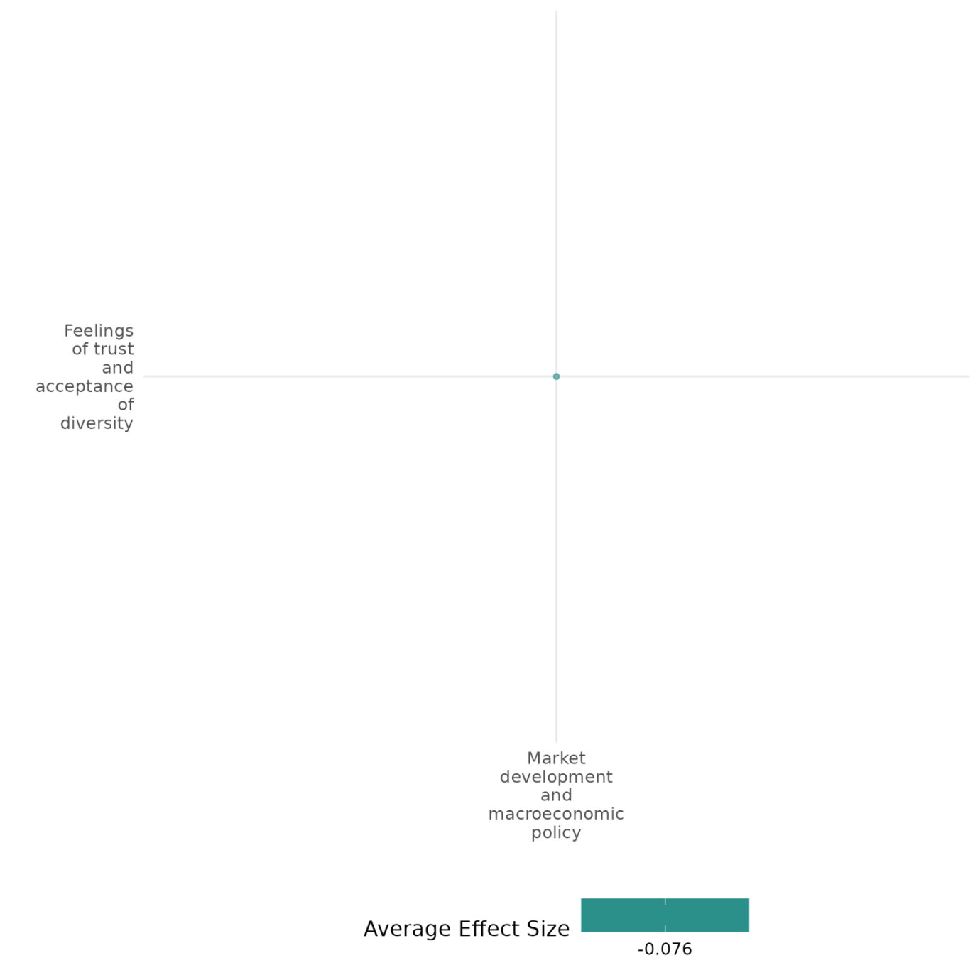

4.6.2(4)
Effect of Market development and macroeconomic policies on economic security

This study analyses the impact of nation-building interventions (economic aid and military assistance) on GDP growth during conflict and post-conflict periods. It finds aid enhances growth during conflict but may hinder post-conflict recovery.
Geographical region: Global
Effect size: Small effect (g=0.013)
Confidence in study findings: Low confidence (1 study; 9 ES)

Short summary
The study examines the impact of nation-building interventions (economic aid and military assistance) on GDP growth during and after conflict across 177 countries (1960–2005) using a panel design. Findings reveal economic aid supports growth during conflict but hinders post-conflict recovery. We have low confidence in the cell due to a limited number of studies.

The intervention
The study investigates nation-building interventions, combining economic aid (financial support for development and stability) and military assistance (security provisions like troops, training, and equipment). These interventions aim to enhance economic growth during and after conflict, with their effects analysed through interactions with conflict and post-conflict periods across 177 countries (1960–2005).

How the intervention is expected to work
The intervention combines economic aid and military assistance to stabilize economies and promote growth in conflict and post-conflict settings. Economic aid provides resources for rebuilding infrastructure, supporting social services, and stimulating economic activity. During conflict, this combination is expected to foster stability, encourage investment, and mitigate disruptions. However, excessive post-conflict aid might hinder growth by fostering dependency or crowding out local initiatives and private investment.

The evidence base
The cell includes one primary study that uses a panel design analysing data from 177 countries over the period 1960–2005. The dataset includes global regions affected by conflict to assess their economic growth outcomes.

Evidence Findings
Market development, through nation-building interventions, has a mixed impact on economic security. Economic aid boosts GDP growth during conflict but hinders post-conflict recovery.

Included studies
Creasey et al. (2012) analyses nation-building interventions (economic aid and military assistance) aimed at stabilizing economies during and after conflict. Conducted across 177 countries (1960–2005) using a panel design, it evaluates aid's impact on GDP growth. The sample includes countries experiencing conflict or post-conflict, examining interactions between aid, military support, and growth. Economic aid boosts growth (p<0.01), especially during conflict (p<0.10), but not post-conflict. Military assistance hinders growth (p<0.10), particularly during conflict (p<0.01), but aids post-conflict (p<0.01). Economic and military aid combined harm growth post-conflict (p<0.01). The study is rated low confidence because selection bias remains due to data limitations (e.g., no data from non-OECD donors like China). Further, high-quality evidence on multilateral versus unilateral impacts is limited, affecting the confidence in conclusions.
Confidence assessment
Overall: Low confidence as there is a limited number of studies.


4.6.2(4.2???)
Effect of market development and macroeconomic policy on economic security

Economic interventions (combined with military aid) provide short-term stability during conflict but can hinder post-conflict economic recovery by fostering dependency and crowding out private investment.
Geographic region: Global
Effect: Adverse effect (g=-0.018)
Confidence in study findings: Low (1 study with 32 effect sizes)

Short Summary
Economic aid, sourced from donor countries or development banks, supports infrastructure and economic growth but may also crowd out private investment. A study covering 176 countries from 1960-2005 finds that economic and military aid together provide stability during conflict but can hinder post-conflict recovery by fostering dependency and reducing private sector participation. Confidence in the findings is low due to data limitations and potential biases.

The intervention
Market development and macroeconomic measures may include economic aid from different sources. As such, it may come from donor assistance countries (e.g., Australia, European economies, United States) or development banks (e.g., World Bank). Economic aid includes financial support for infrastructure, institutional capacity building, and economic development projects, aimed at fostering stability and growth.

How the intervention is expected to work
Market development and macroeconomic policies, such as those in the form of economic aid, can either positively or negatively affect economic security. On one hand, it could help replenish an economy’s depleted capital stock, and on the other, it may crowd out private investments. When combined with military assistance, prolonged economic aid may also lead to dependency and inefficiencies, potentially hindering long-term economic self-sufficiency and growth, especially in post-conflict settings.

The evidence base
This cell includes 1 study which examines data from 176 countries from 1960 to 2005.

Evidence findings
Market development measures such as economic aid (coupled with military assistance) have mixed effects on economic security. During conflict, the combination of economic aid and military aid provides stability and mitigates uncertainty that discourages economic participation. However, post-conflict situations show that sustained military aid alongside economic aid harms economic security by crowding out private sector investments and fostering dependency.

Included studies
Creasy (2014) examines the impact of nation-building efforts—economic aid and military assistance combined—on the economic growth of conflict and post-conflict countries. The study defines nation-building as providing both economic and military aid in conflict and post-conflict situations to foster security and stimulate economic growth. Assess if and how these interventions positively impact economic growth, particularly by reducing conflict-induced instability and encouraging private investment. A 45-year cross-country panel dataset encompassing military, economic, and conflict variables was used. A three-way interaction term involving economic aid, military assistance, and conflict regime is constructed. The study employs a two-stage approach to address potential endogeneity between aid and growth by instrumenting aid based on geopolitical factors. The sample includes 176 countries from 1960 to 2005, covering various conflict periods and aid interventions. Data sources include OECD data for economic aid, military assistance records, and UCDP-PRIO conflict data. During Conflict: Combined military and economic aid correlate with a modest positive effect on economic growth, as military aid may provide stability that enhances the effectiveness of economic support. Post-Conflict: Continuation of both economic and military aid post-conflict was associated with reduced growth, suggesting that prolonged intervention might hinder natural recovery and domestic investment. The study is rated low confidence because selection bias remains due to data limitations (e.g., no data from non-OECD donors like China). Further, high-quality evidence on multilateral versus unilateral impacts is limited, affecting the confidence in conclusions.

Confidence Assessment
Overall low: This cell is overall low considering that it only included 1 study.

Other outcomes in the study:
None
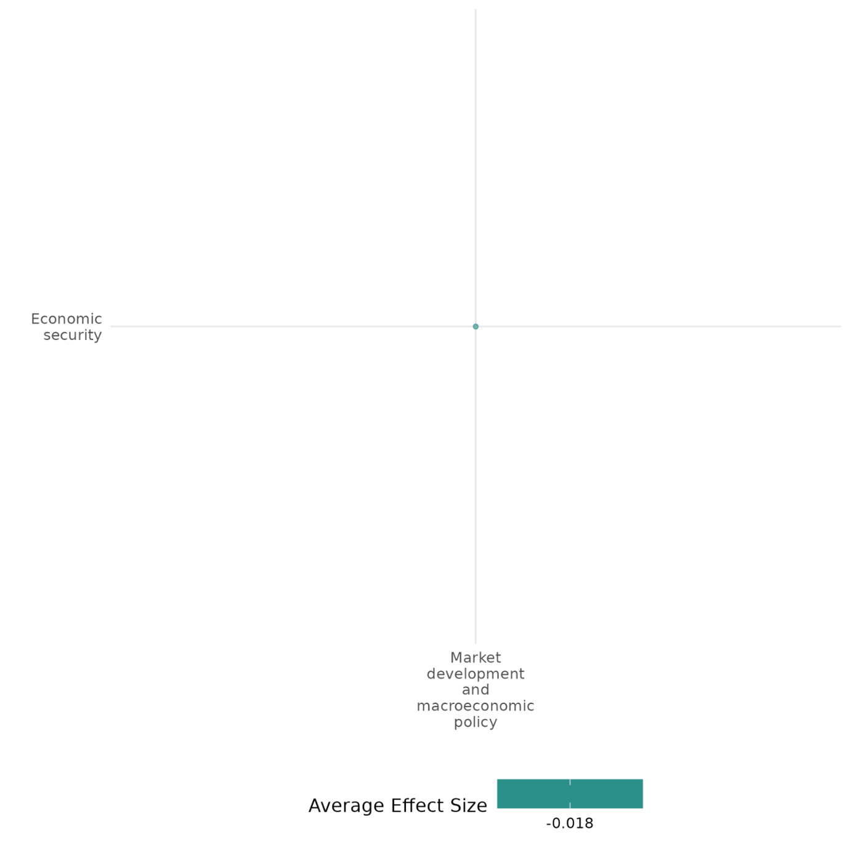

4.6.2(5)
Effect of market development and macroeconomic policy on intermediate social cohesion outcomes

Market development and macroeconomic policies, such as the formation of agricultural cooperatives, increases awareness of inequalities but reduces tolerance for it.
Geographic region: Sub-Saharan Africa
Effect: Small effect (g=0.015)
Confidence in study findings: Low (1 study with 4 effect sizes)

Short Summary
Market development and macroeconomic policy, such as the formation of agricultural cooperatives in rural communities can increase awareness of existing land inequalities but may reduce acceptance of these inequalities. Rural cooperatives are established for collective bargaining, risk-sharing, information sharing, and to gain from economies of scale. However, they may also create perceived division between members and nonmembers – as land inequality decreases, inequalities may become more noticeable, and this increases awareness of inequalities.

The intervention
Market development and macroeconomic policy measures may include agricultural cooperatives in rural communities. Rural cooperatives are established for collective bargaining, risk-sharing, information sharing, and to gain from economies of scale. Examples of cooperatives, as shown in the study in this cell, are the three rural cooperatives (i.e., Muzye cooperative, Musongati cooperation, Kiremba association) in Burundi. These cooperatives were organized by Plant with Purpose, a nongovernmental organization. In the Muzye cooperative, membership is open to those who are willing to pay approximately US$40.

How the intervention is expected to work
Agricultural cooperatives may reduce vertical inequality by improving economic opportunities, but they may also create a perceived division between members and nonmembers. This can be explained through cognitive dissonance—a psychological reaction to conflicting beliefs. Villagers value social equality as key to community cohesion, yet they regularly encounter cooperative members with greater land access, challenging this belief and creating discomfort. Ironically, as land inequality decreases and more villagers attain moderate land ownership, disparities become more visible, heightening awareness of inequality.

The evidence base
This cell includes one study on agricultural cooperatives in rural Burundi. The study utilized data collected through a one-time survey conducted in 2011 across three villages where cooperatives were either operational or newly established.

Evidence findings
Market development and macroeconomic policies, such as the formation of agricultural cooperatives, can influence local perceptions of economic disparities. Specifically, towns that have hosted a cooperative for three years are more likely to recognize land inequalities but are less likely to accept them as fair or justifiable.

Included studies
McDougal (2014) examines the effects of agricultural cooperatives on land conflicts, inequality, violence, and community trust in three Burundian villages. Burundi has a history of ethnic tensions and violence, with the Tutsi minority controlling the government and military, and the Hutu majority facing exclusion and repression. The study uses a pseudo-difference-in-differences (DiD) analysis on a cross-sectional dataset of 95 community members in three different villages in which the cooperative has been, or is becoming, operational. Cooperative villages have a significant higher perception of inequality. The study is rated as high and medium confidence quantitative study that the one-shot evaluation design and the small number of communities surveyed prevent the authors from making causal claims.

Confidence Assessment
Overall low: The rating for this cell is low as it only includes 1 study.

Other outcomes in the study:
Violence and atrocity prevention / nature and scale of violence and atrocities
Social cohesion / feelings of trust and acceptance of diversity

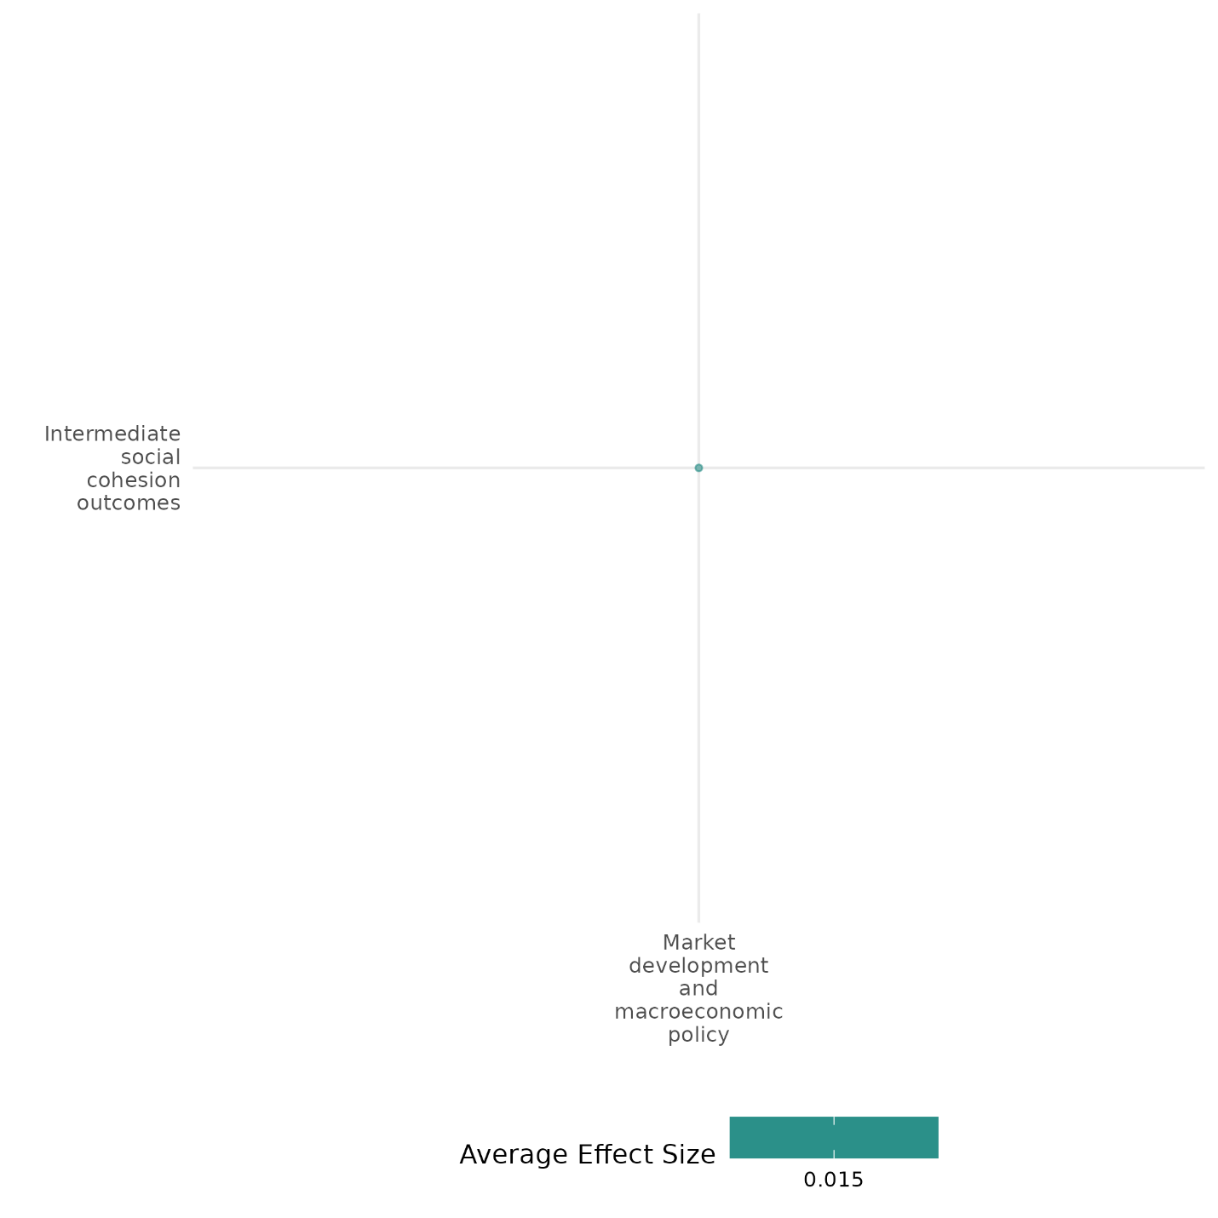

4.6.3 Land reform & NRM
4.6.3(1)
Effect of land reform and natural resource management (NRM) on diplomatic relations and peaceful dispute resolution

Water-related cooperation has significant impacts on diplomatic relations, and this effect is more pronounced in low-conflict settings.
Geographic region: Global, Latin America, Africa
Effect: No effect (g=0.003)
Confidence in study findings: Medium (1 study with 1 effect size)

Short Summary
Environmental cooperation initiatives, such as water-related interactions, aim to address shared environmental challenges while fostering trust and interdependence between states. Evidence indicates that positive water-related interactions significantly increase the likelihood of peaceful transitions between states, particularly in dyads without acute conflict. These interventions provide platforms for dialogue, reduce tensions, and catalyze broader cooperation beyond environmental issues, although their impact is less effective in high-conflict scenarios.

The intervention
The interventions focus on fostering environmental cooperation, specifically through water-related interactions such as treaties, technical support, cultural exchanges, and joint resource management. Examples include cooperative frameworks like the Orange-Senqu River Commission (ORASECOM) and transboundary water agreements in regions such as Central America, Southern Africa, and the Middle East. These initiatives aim to address shared environmental challenges while simultaneously building interdependence, trust, and peaceful relations.

How the intervention is expected to work
Water-related cooperation promotes peace by addressing shared environmental challenges, fostering interdependence, and building trust between states. Liberal theories suggest that interdependent states are less likely to engage in conflict, while constructivist approaches emphasize trust-building and shared perceptions of external threats. Positive water-related interactions—such as treaties, joint problem-solving, and cultural or scientific cooperation—create platforms for dialogue, reduce tensions, and catalyze broader cooperation beyond the immediate environmental issues.

The evidence base
This cell includes 3 studies: 1 systematic review, 1 impact evaluation, and 3 qualitative studies.
The impact evaluation utilized data on events captured by the Basins at Risk Water Event Intensity Scale (BAR scale) and the Peace Scale, covering hundreds of interstate dyads across diverse regions. The qualitative studies are set in The Amazon Basin (2 studies) and
On the other hand, the systematic review analyzed data from 69 case studies worldwide. The qualitative study is set in the Southwestern Amazon, Amazon Basin, and Sudan (Darfur region).

Evidence findings
Findings indicate that positive water-related interactions over a ten-year period significantly increase the likelihood of transitions toward peaceful relations. This effect is most pronounced in state dyads not experiencing acute conflict, highlighting the role of trust-building and interdependence in fostering peace. Cooperative events, such as joint water management or treaties, serve as a platform for broader cooperation, reducing rivalry and supporting peaceful dispute resolution. However, the impact is less evident in high-conflict scenarios where mistrust and security concerns dominate.

The review evidence
Results focused on analyzing variables which significantly influence the success of community forestry, and highlighted that this include congruence between biophysical and socioeconomic boundaries of the resources and sanctioning.

The impact evaluation evidence
This cell includes only 1 impact evaluation study. Only one study summary is thus provided below:
Ide (2018) This study investigates the role of international water cooperation as a mechanism for environmental peacemaking, which promotes transitions toward more peaceful interstate relations. The study examines the relationship between water cooperation and peace from 1956 to 2006, emphasizing its impact in settings without acute conflict, such as the Israel-Jordan "picnic table talks" and the Mahakali Treaty between India and Nepal. The analysis combines data on positive water-related interactions between states with the peace scale developed by Goertz et al. (2016), which measures degrees of positive and negative peace. The results demonstrate that a higher number of positive water-related interactions in the preceding decade significantly increases the likelihood of a shift toward more peaceful relations between states, particularly in dyads that are not in acute conflict. The effect is more pronounced when observing longer time periods and low- and high-intensity cooperative events.

Confidence Assessment
Overall low: The systematic review included in this cell is rated low while the impact evaluation study is medium.

Link to review summaries
Pagdee (2006)
All studies may be accessed via the EGM.

Other outcomes in the study:
None

4.6.3(2)
Effect of land reform and natural resource management (NRM) on nature and scale of violence or atrocities

Land reform and natural resource management programs, including participatory mapping and REIs, show limited success in mitigating resource-related conflicts, as their effectiveness depends on addressing deeper structural issues and pre-existing hostilities.
Geographical region: Asia, Latin America, Africa
Effect: Adverse effect (g=-0.001)
Confidence in study findings: Medium (3 studies with 8 effect sizes)

Short Summary
Land reform and natural resource management programs, such as participatory mapping in the Bolivian Amazon and regional economic institutions (REIs) in Africa, aim to reduce conflicts over shared resources. However, participatory mapping showed no significant impact on disputes without broader socio-political reforms, and REIs sometimes failed to prevent conflicts due to pre-existing tensions and challenges in implementing equitable agreements.

The intervention
Land reform and natural resource management (NRM) programs encompass initiatives such as participatory mapping and regional economic institutions (REIs) that integrate NRM into economic frameworks. For instance, participatory mapping initiatives in indigenous communities across Latin America aimed to clarify land boundaries, reduce disputes, and foster peaceful co-management of resources. These programs involved collaboration with local stakeholders, legal recognition of boundaries, and education on land rights. In parallel, REIs, including trade organizations and regional councils, address shared resources like water through treaties, cooperative mechanisms, and multilateral agreements to mitigate tensions and minimize the risk of militarized disputes.

How the intervention is expected to work
Participatory mapping initiatives are expected to reduce violence by clarifying resource ownership, thus eliminating ambiguities that lead to disputes. By involving local communities in mapping and governance processes, these interventions build trust, empower marginalized groups, and promote equitable access to resources. Formal recognition of land ownership incentivizes sustainable resource use and cooperation. Regional economic institutions (REIs) mitigate resource-related conflicts by providing platforms for negotiation, dispute resolution, and cooperative resource management. Through multilateral agreements and institutionalized frameworks, REIs promote transparency and accountability, reducing the risk of militarized conflicts. The integration of natural resource management into economic policies encourages peaceful resolution by aligning resource governance with broader regional development goals.

The evidence base
This cell includes 3 impact evaluation studies set in: Africa (1 study), Bolivia (1 study), and Uganda (1 study).This cell also has one qualitative study set in Indonesia.

Evidence findings
REIs, while designed to promote cooperation through shared governance and resource management, often fail to effectively mitigate resource-related conflicts. In some instances, states sharing REI water treaties with territorial provisions are more likely to experience conflict, reflecting pre-existing hostilities or difficulties in implementing equitable resource-sharing mechanisms. Meanwhile, participatory mapping initiatives among Tsimane’ communities in Bolivia do not significantly influence conflicts with external actors or internal disputes. This suggests that participatory mapping alone cannot address conflict dynamics without tackling underlying socio-political and economic challenges and fostering community involvement.

Included studies
Baker et al. (2011) examines the impact of park gazettement and Integrated Conservation and Development (ICD) initiatives on community conflict at Bwindi Impenetrable Forest, Uganda. The park was established to protect mountain gorillas and other natural resources, but its creation led to conflicts with local communities who relied on the forest for commercial and subsistence activities. The ICD was implemented to mitigate these conflicts by addressing local development priorities. The study involved a historical analysis of 48 incidents of violent conflict documented between 1986 and 2000, categorized by gazettement period, area, instigator, and type. Data were extracted from documents written by park staff and local people, including patrol reports and letters, to understand the triggers of conflict and the effectiveness of ICD. The analysis focused on the periods before, during, and after the park's gazettement. The analysis revealed that attacks on rangers to free commercial offenders were the most common type of conflict. The study suggests that targeting ICD benefits towards individuals who lost income from commercial activities could enhance conflict resolution and conservation efforts. The study is rated as medium confidence as it is a non-experimental study with limited description of the intervention and evaluation questions.
Powers (2005) examines the role of regional economic institutions (REIs) as formal mechanisms for managing resource-related conflicts, particularly focusing on water resources shared across borders. Using data from African REIs between 1950 and 1996, the study explores whether REI water treaties with provisions for territorial boundary management reduce the likelihood of militarized interstate disputes. The findings show that while REIs aim to promote cooperation through shared governance, trade liberalization, and resource management, they often fail to mitigate conflicts effectively. In some cases, states sharing REI water treaties with territorial provisions are more likely to engage in conflict, possibly reflecting pre-existing hostilities or the challenges of implementing equitable resource-sharing rules. The study is rated medium due to its non-experimental design and its partial description of the intervention.
Reyes-García et al. (2012) investigates the impact of participatory mapping on conflicts involving Tsimane’ indigenous communities in the Bolivian Amazon. Using a randomized evaluation across 32 villages (17 treatment and 15 control), the researchers assessed whether participatory mapping influenced conflicts with external actors (e.g., loggers, traders) and internal conflicts among Tsimane’ villages. Pre- and post-intervention surveys measured reported conflicts and attitudes toward outsiders. The findings reveal no statistically significant effect of participatory mapping on conflicts with external actors or between Tsimane’ villages. The study concludes that conflicts are not an inherent outcome of participatory mapping but are influenced by broader socio-political and economic contexts. The results highlight that participatory mapping alone may not be sufficient to alter conflict dynamics without addressing deeper structural issues and ensuring active community engagement. The study is rated as medium confidence due to the partial description of intervention, outcomes, and evaluation questions.

Confidence Assessment
Overall low: The cell is rated low as it contains less than 4 large N studies.

Other outcomes in the study:
Social cohesion / feelings of trust and acceptance of diversity

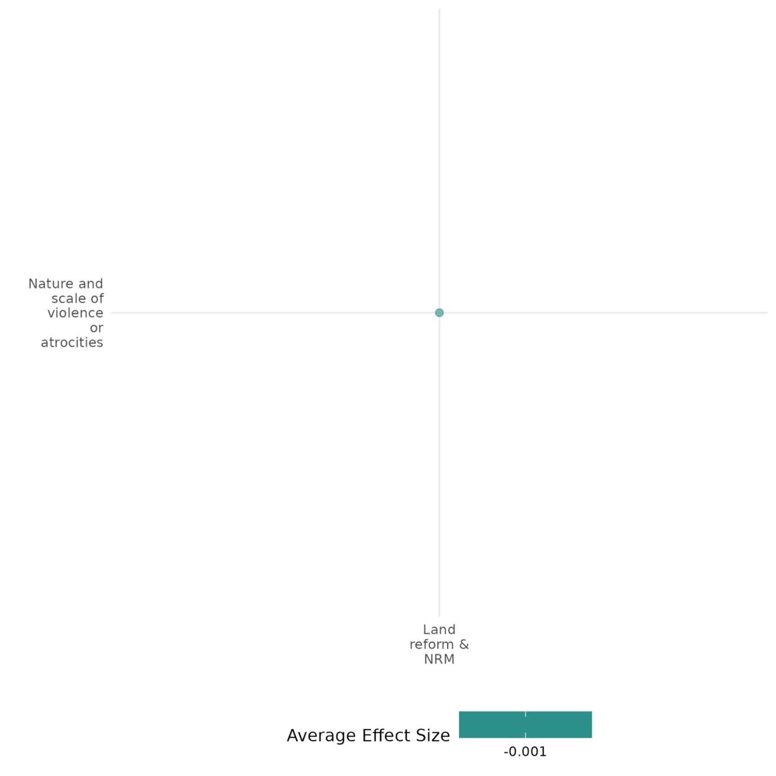

4.6.3(3)
Effect of land reform and natural resource management (NRM) on feelings of trust and diversity

Land reform and natural resource management (NRM) interventions have mixed effects on feelings of trust and diversity.
Geographic scope: South America, Asia, Africa
Effect: Large effect (g=0.423)
Confidence in study findings: Low (3 studies with 41 effect sizes)

Short Summary
Land reform and NRM initiatives include participatory mapping projects, payments for ecosystem services (PES), and information campaigns. These interventions show mixed effects on trust and diversity. Participatory mapping in Bolivia had little impact on trust levels, while payments for ecosystem services (PES) in Indonesia fostered cooperation but did not significantly alter trust toward outsiders. In Mozambique, information campaigns increased trust in governance and civic engagement when widely disseminated, but localized interventions led to elite capture. These findings suggest that while NRM interventions can enhance trust and inclusion, their success depends on equitable implementation, active community engagement, and safeguards against elite control.

The intervention
Land reform and NRM initiatives include participatory mapping projects, PES, and information campaigns. Participatory mapping projects, such as those in Bolivia, involve indigenous communities in delineating land boundaries to reduce disputes and strengthen cooperation. PES programs, such as those in Indonesia, aim to create incentives for conservation while reinforcing social capital through shared responsibilities and benefit-sharing mechanisms. Information campaigns, as seen in Mozambique, provide knowledge about natural resource governance to increase transparency, empower citizens, and build trust between the state and local communities​

How the intervention is expected to work
These interventions are expected to foster trust and diversity by encouraging cooperation, reducing conflicts over resources, and strengthening community ties. Participatory mapping clarifies land ownership, empowering marginalized groups and promoting collective management. PES programs may incentivize conservation through mutual benefit-sharing, therefore reducing social tensions and strengthening local networks. Information campaigns enhance political engagement, increasing trust in governance by providing transparent resource management processes and encouraging collective action.

The evidence base
This cell includes three quantitative studies evaluating interventions in Bolivia, Indonesia, and Mozambique. There is also one qualitative paper included which is set in Kenya [i.e., Klaus (2020)].

Evidence findings
Findings suggest mixed outcomes for land reform and NRM interventions in fostering trust and social diversity. Participatory mapping in Bolivia did not significantly affect trust levels or conflict resolution, possibly due to weak community engagement and lack of long-term implementation. PES programs in Indonesia demonstrated high levels of social capital, with informal benefit-sharing mechanisms helping to mediate tensions between participants and non-participants. However, trust levels remained largely unchanged, and skepticism toward outsiders persisted. Information campaigns in Mozambique successfully increased trust when targeted at the general population. However, when information was restricted to local leaders, elite capture and rent-seeking behavior were observed, undermining trust and social cohesion​.

Included studies

Armand (2019) examine a large-scale information and deliberation campaign focused on the management of natural resources in Cabo Delgado, Mozambique, particularly following the discovery of natural gas in the region. The campaign was sponsored by a coalition of international, national, and local institutions, including governmental and non-governmental organizations. The intervention aimed to increase awareness and knowledge about natural resources among local leaders and citizens through three types of campaigns: information to leaders only, information to both leaders and citizens, and information plus deliberation. The study employed a randomized controlled trial design, involving 50 communities for Treatment 1, 51 for Treatment 2, 50 for Treatment 3, and 55 for the control group. The sampling included baseline and endline surveys at household, local leader, and community levels, as well as structured community activities (SCAs) and lab-in-the-field experiments. The measurements were designed to capture outcomes related to information/awareness, elite capture, rent-seeking, and citizen mobilization, trust, and accountability. When information was targeted at the general population, there were increases in citizen mobilization, trust, voice, and demand for political accountability. The study was rated as low confidence due to the lack of reported attrition. The document mentions that post-treatment attrition was handled through substitutions in the same household when possible. However, there is no detailed reporting on the overall attrition rates or how they might have affected the study's outcomes.

McGrath (2018) examines the role of social capital in mitigating tensions and jealousy between participants and nonparticipants in a Payments for Ecosystem Services (PES) program in the Cidanau Watershed, West Java, Indonesia. Using surveys and focus group discussions, the study finds that while jealousy and tensions arose due to perceived inequities in program participation, high levels of social capital between community members helped alleviate these conflicts. Social networks, trust, and traditions of collective action enabled PES participants to share information and resources with nonparticipants, thereby maintaining social cohesion. The study concludes that strong pre-existing social capital is crucial for minimizing negative social impacts and ensuring the success of PES programs. The study is rated as low confidence due to low or no description of evaluation questions.

Reyes-García et al. (2012) investigates the impact of participatory mapping on conflicts involving Tsimane’ indigenous communities in the Bolivian Amazon. Using a randomized evaluation across 32 villages (17 treatment and 15 control), the researchers assessed whether participatory mapping influenced conflicts with external actors (e.g., loggers, traders) and internal conflicts among Tsimane’ villages. Pre- and post-intervention surveys measured reported conflicts and attitudes toward outsiders. The findings reveal no statistically significant effect of participatory mapping on conflicts with external actors or between Tsimane’ villages. The study concludes that conflicts are not an inherent outcome of participatory mapping but are influenced by broader socio-political and economic contexts. The results highlight that participatory mapping alone may not be sufficient to alter conflict dynamics without addressing deeper structural issues and ensuring active community engagement. The study is rated medium confidence due to partial description of the evaluation questions.

Confidence Assessment
Overall low: There are only 3 impact evaluation studies included in this cell. The effects / findings in the studies included also tend to be inconsistent.

Other outcomes in the study:
Violence and atrocity prevention / Nature and scale of violence or atrocities
Community and state governance / civic participation
Community and state governance / government performance
Social cohesion / willingness to participate or help

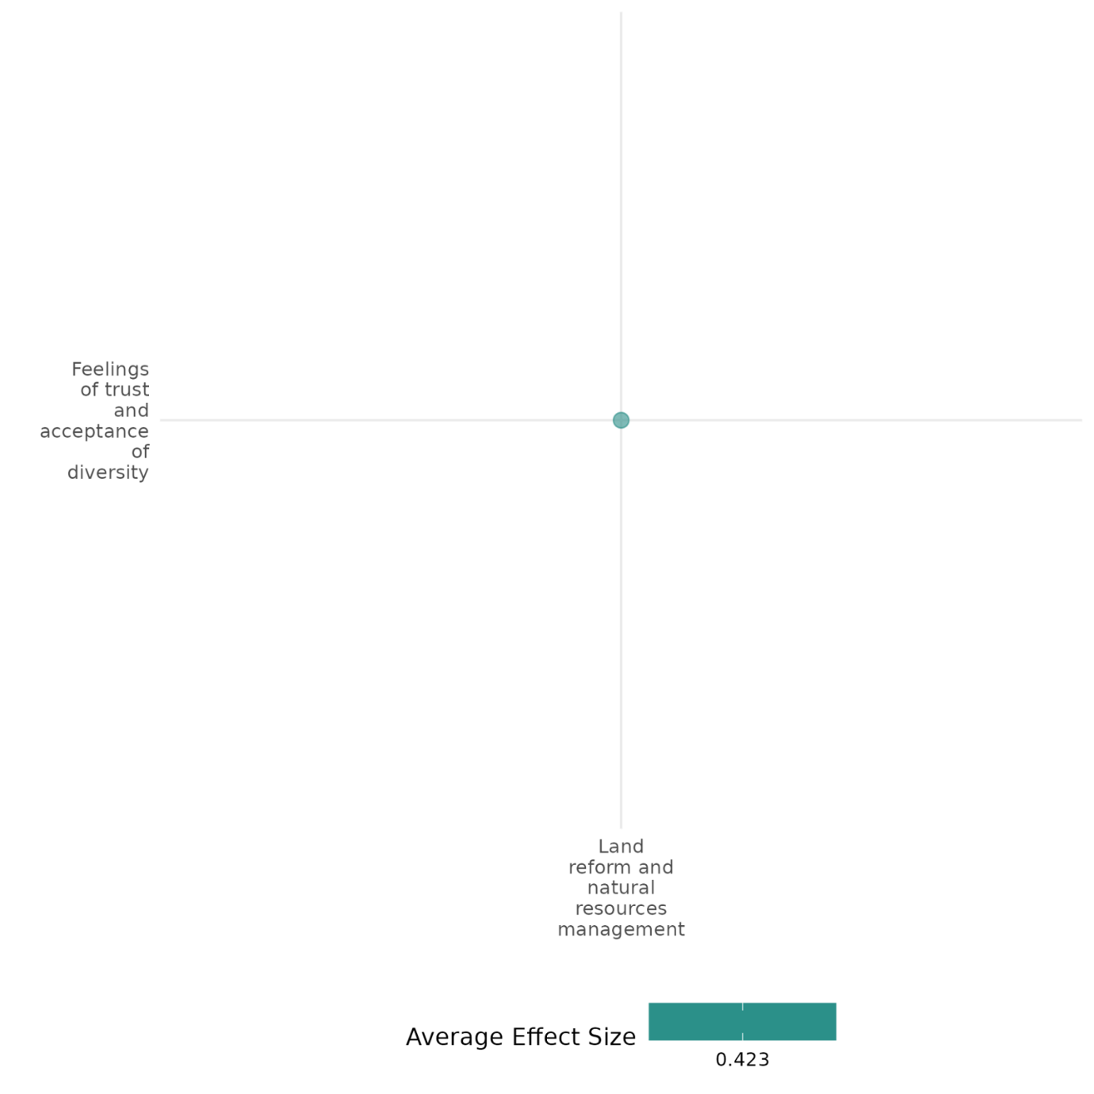

4.6.3(4)
Effect of land reform and natural resource management (NRM) on willingness to participate or help

Land reform and natural resource management (NRM) interventions have generally positive effects on willingness to participate or help.
Geographic region: Asia, Africa
Effect: Large effect (g=0.487)
Confidence in study findings: Low (2 studies with 2 effect sizes)

Short Summary
Land reform and NRM initiatives include interventions such as Payments for Ecosystem Services (PES) community-based watershed restoration projects, as seen in Indonesia and the Democratic Republic of the Congo (DRC), respectively. The PES program provides financial incentives to farmers for maintaining forest cover, while the DRC project leverages on Village Savings and Loans Associations (VSLAs) to encourage voluntary environmental restoration. Findings indicate that PES participants in Indonesia are more likely to financially contribute to village causes and share earnings with nonparticipants, helping to mitigate social tensions. Similarly, in the DRC, participation in VSLAs led to increased household donations to local churches and mosques, reinforcing the role of economic security in strengthening social cohesion and community-driven conservation efforts.

The intervention
Land reform and NRM initiatives include PES and community-based water restoration. PES programs, such as those in Indonesia, aim to create incentives for conservation while reinforcing social capital through shared responsibilities and benefit-sharing mechanisms. Community-based watershed restoration, such as in the DRC, combines VSLAs with environmental conservation efforts. It encouraged collective action by establishing local leadership networks and training communities in sustainable land management.

How the intervention is expected to work
These interventions are expected to foster trust and diversity by encouraging cooperation, reducing conflicts over resources, and strengthening community ties. Participatory mapping clarifies land ownership, empowering marginalized groups and promoting collective management. PES programs may incentivize conservation through mutual benefit-sharing, therefore reducing social tensions and strengthening local networks. Information campaigns enhance political engagement, increasing trust in governance by providing transparent resource management processes and encouraging collective action.

The evidence base
This cell includes three studies: 1 qualitative study and 2 impact evaluations. The impact evaluation studies are set in Indonesia and Democratic Republic of Congo. The qualitative study by Krampe (2018) is set in East Timor.

Evidence findings
The findings in the study from these cells suggest generally positive effects of land reform and NRM initiatives on willingness to participate or help. For one, PES participants were found to be more likely to contribute financially to community causes, with 94% of them giving money to a village cause compared to 84% of nonparticipants. Similarly, in the community-based watershed restoration program in the DRC, the DID analysis showed a statistically significant increase in households donating to religious organizations in the treatment watershed.

Included studies

McGrath (2018) examines the role of social capital in mitigating tensions and jealousy between participants and nonparticipants in a Payments for Ecosystem Services (PES) program in the Cidanau Watershed, West Java, Indonesia. Using surveys and focus group discussions, the study finds that while jealousy and tensions arose due to perceived inequities in program participation, high levels of social capital between community members helped alleviate these conflicts. Social networks, trust, and traditions of collective action enabled PES participants to share information and resources with nonparticipants, thereby maintaining social cohesion. The study concludes that strong pre-existing social capital is crucial for minimizing negative social impacts and ensuring the success of PES programs. The study is rated low due to little description of the evaluation questions.

Sabin (2019) evaluates the impact of a community-based watershed restoration initiative in Eastern Congo, assessing its environmental, economic, and social outcomes. Using a mixed-methods approach, including difference-in-differences (DID) analysis, participatory workshops, and remote sensing data, the study compares two watersheds—one receiving the intervention and the other serving as a control. The intervention involved establishing Village Savings and Loans Associations (VSLAs), promoting sustainable farming practices, and strengthening community leadership networks to encourage environmental restoration. The treatment watershed showed greater community cohesion and cooperation, with a decrease in local disputes. Community members reported improved relationships among different social groups, indicating enhanced peace and reconciliation. The study is rated medium due to partial description of the evaluation questions.

Confidence Assessment
Overall low: The overall rating for this cell is low due to the inclusion of only 2 studies.

Other outcomes in the study:
Social cohesion / feelings of trust and acceptance of diversity
Human security / economic security
Human security / education security
Human security / food security and nutrition & health security
Human security / environmental security

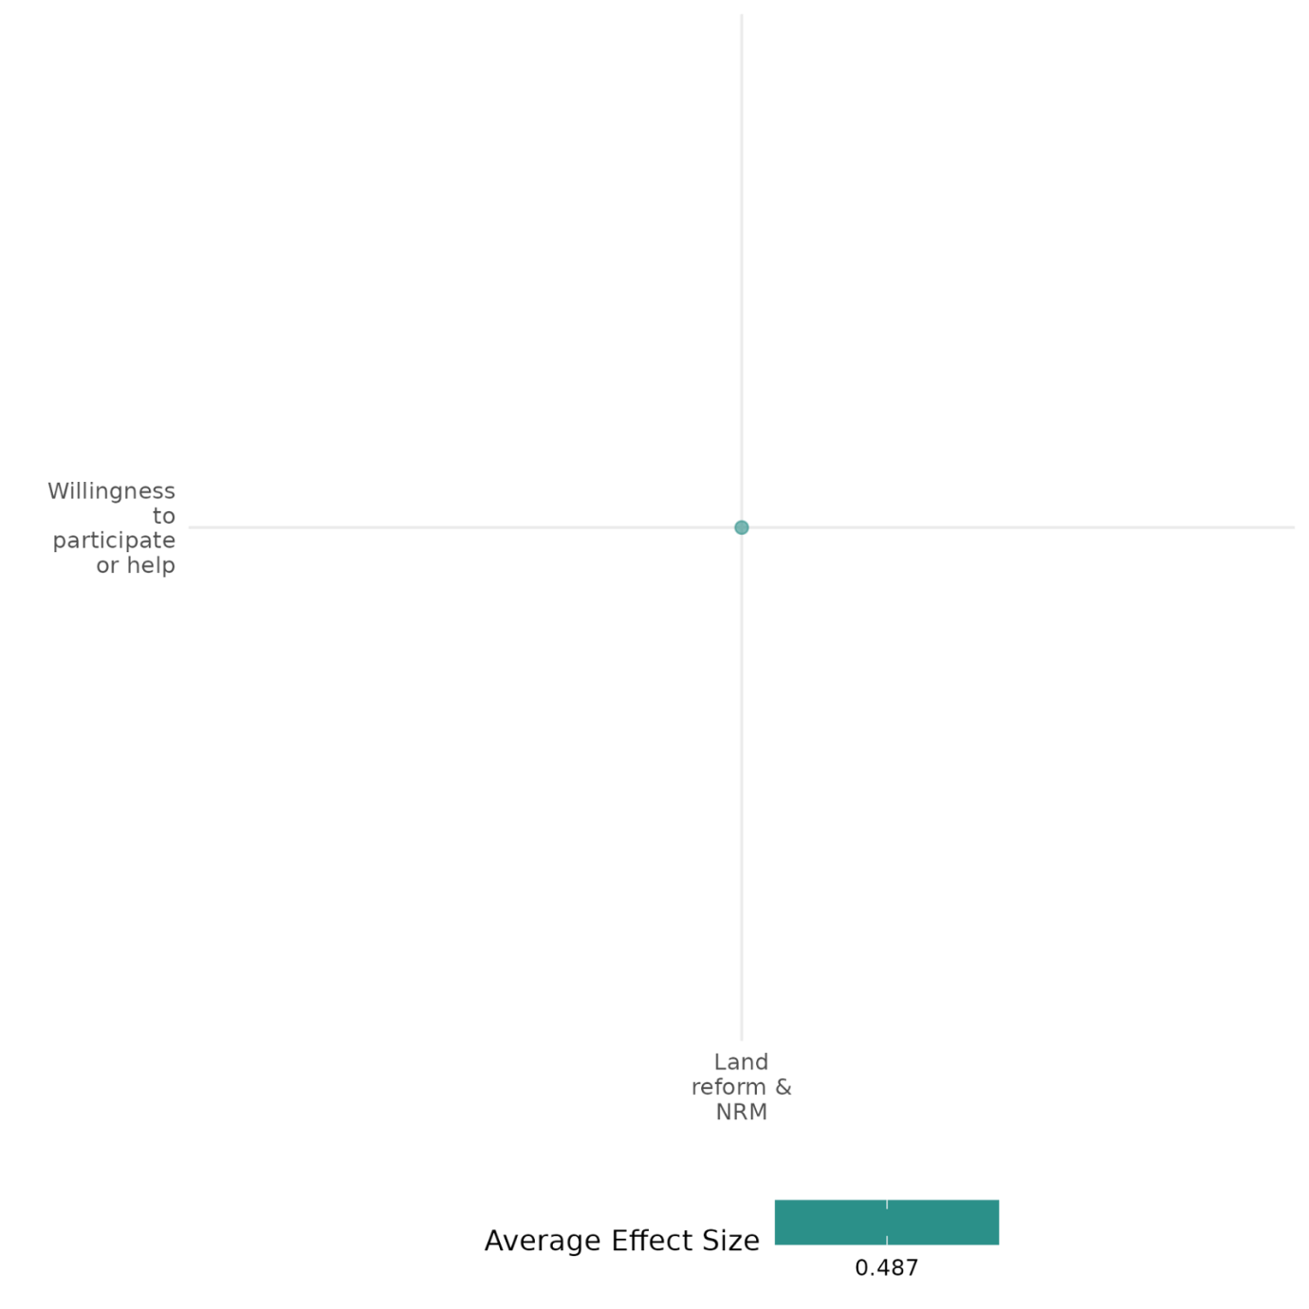

4.6.3(5)
Effect of land reform and natural resource management (NRM) on civic participation

Informational campaigns on natural resource management significantly enhances civic participation and reduces elite capture in resource-rich communities.
Geographic region: Africa
Effect: Moderate effect (g=0.161)
Confidence in study findings: Low (1 study with 42 effect sizes)

Short summary
Land reform and natural resource management interventions (NRM) may include information and deliberation campaigns, as exhibited in Cabo Delgado, Mozambique. This particular intervention aimed to inform local communities about a recent natural gas discovery and its implications on governance and civic participation. Findings suggest that providing information to both leaders and citizens increased public engagement and demand for accountability. The inclusion of deliberation further enhanced collective action.

The intervention
The study included in this cell evaluates the impact of a large-scale information and deliberation campaign on natural resource management in Cabo Delgado, Mozambique. The intervention aimed to educate local communities about the recent discovery of natural gas and its implications for governance and civic participation. Three treatment groups were targeted: one where only local leaders received information, a second where both leaders and citizens received information, and a third that added a deliberation component to the information campaign. The campaign was implemented through community meetings, door-to-door outreach, and materials in local languages, with the goal of increasing citizen engagement and reducing elite capture.

How the intervention is expected to work
The intervention is designed to enhance civic participation by providing citizens with access to information and opportunities for community deliberation. It is expected that increased awareness of natural resource management processes will empower citizens to demand accountability, engage more actively in decision-making, and foster collective action. By promoting transparency and inclusive dialogue, the intervention aims to reduce elite capture and ensure more equitable resource distribution.

The evidence base
This cell includes 1 large-scale randomized controlled trial across multiple communities in Cabo Delgado province, with a sample of over 2000 households. A qualitative study set in Kenya is also included in this cell.

Evidence findings
The findings indicate that providing information solely to local leaders led to an increase in elite capture and rent-seeking behavior, with leaders monopolizing resource-related opportunities. However, when citizens were also informed, the study observed increased civic participation and demand for political accountability. The deliberation component further amplified these effects by fostering collective action and informed discussions on resource allocation. Moreover, the intervention led to a reduction in community violence, suggesting improved social cohesion and engagement in governance.

Included studies
Armand (2019) examine a large-scale information and deliberation campaign focused on the management of natural resources in Cabo Delgado, Mozambique, particularly following the discovery of natural gas in the region. The campaign was sponsored by a coalition of international, national, and local institutions, including governmental and non-governmental organizations. The intervention aimed to increase awareness and knowledge about natural resources among local leaders and citizens through three types of campaigns: information to leaders only, information to both leaders and citizens, and information plus deliberation. The study employed a randomized controlled trial design, involving 50 communities for Treatment 1, 51 for Treatment 2, 50 for Treatment 3, and 55 for the control group. The sampling included baseline and endline surveys at household, local leader, and community levels, as well as structured community activities (SCAs) and lab-in-the-field experiments. The measurements were designed to capture outcomes related to information/awareness, elite capture, rent-seeking, and citizen mobilization, trust, and accountability. The study found that the community-targeted information campaign was effective in raising awareness and knowledge about the natural gas discovery among citizens. When information was provided only to local leaders, there was an increase in elite capture and rent-seeking activities. However, when information was targeted at the general population, there were increases in citizen mobilization, and voice. The study was rated as low confidence due to the lack of reported attrition. The document mentions that post-treatment attrition was handled through substitutions in the same household when possible. However, there is no detailed reporting on the overall attrition rates or how they might have affected the study's outcomes.

Confidence Assessment
Overall low: This cell is rated low confidence since it has less than 4 studies.

Other outcomes in this study:
Social cohesion / feelings of trust & acceptance of diversity
Community and state governance / government performance
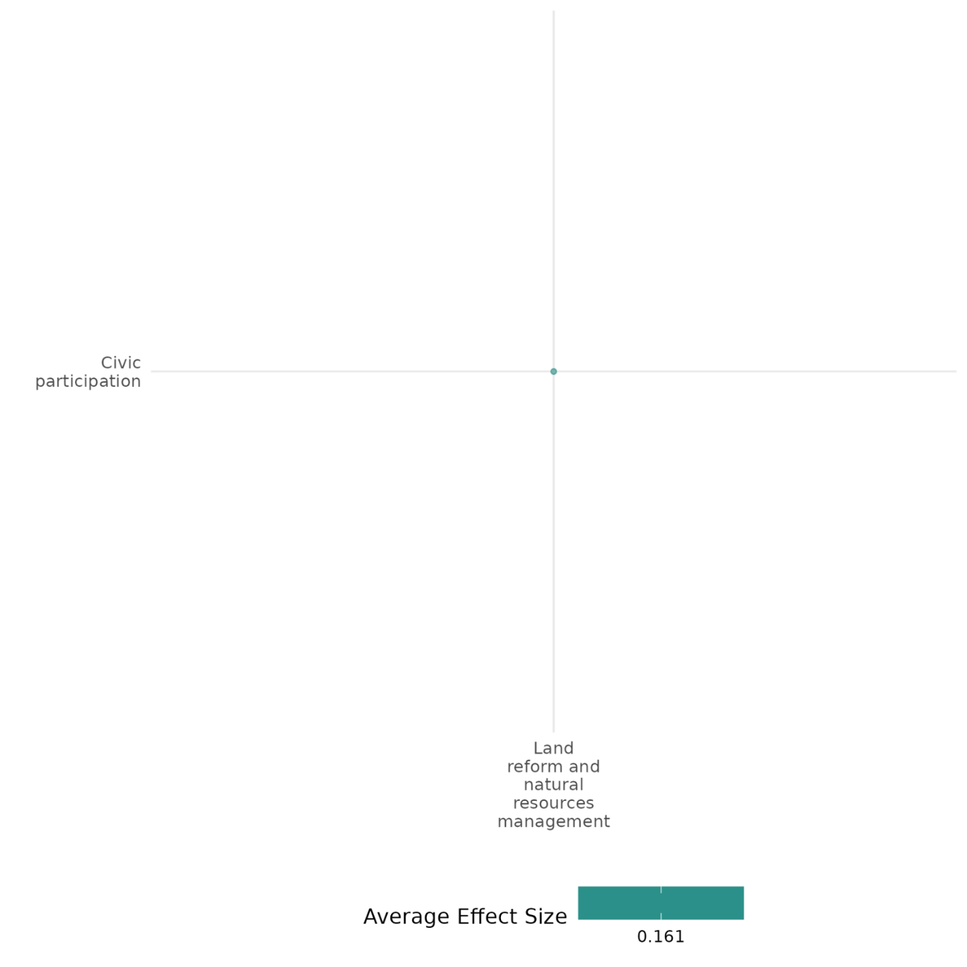

4.6.3(6)
Effect of land reform and natural resource management (NRM) on government performance

Informational campaigns on natural resource management significantly enhances public accountability and reduces misgovernance.
Geographic region: Africa, Latin America, East Timor, Global
Effect: Small effect (g=-0.052)
Confidence in study findings: Low (1 study with 63 effect sizes)

Short Summary
The study in Cabo Delgado, Mozambique examined the effects of an information and deliberation campaign. A randomized controlled trial across 206 communities found that engaging both groups increased public participation and accountability, while focusing only on leaders led to greater elite capture. Broad community engagement also reduced misgovernance, highlighting the importance of inclusive information-sharing for better governance.

The intervention
The study included in this cell evaluates the impact of a large-scale information and deliberation campaign on natural resource management in Cabo Delgado, Mozambique. The intervention aimed to educate local communities about the recent discovery of natural gas and its implications for governance and civic participation. Three treatment groups were targeted: one where only local leaders received information, a second where both leaders and citizens received information, and a third that added a deliberation component to the information campaign. The campaign was implemented through community meetings, door-to-door outreach, and materials in local languages, with the goal of increasing citizen engagement and reducing elite capture.

How the intervention is expected to work
The campaign aims to improve awareness of natural resource management, empowering communities to engage in governance. Providing information to leaders enhances decision-making, while involving citizens promotes transparency and participation. Public discussions foster dialogue, addressing concerns and reducing elite control. By informing both leaders and citizens, the initiative seeks to build trust, encourage civic engagement, and improve accountability, leading to better resource management.

The evidence base
This cell includes 4 studies: 1 systematic review, 2 qualitative studies, and 1 impact evaluation.
The impact evaluation study implemented a large-scale randomized controlled trial across multiple communities in Cabo Delgado province, with a sample of over 2000 households.
The qualitative studies are set in the Amazon Basin and East Timor. Meanwhile, the systematic review covered 69 case studies worldwide.

Evidence findings
The intervention improved government performance by enhancing citizen engagement, trust, and demand for accountability. Providing information to both leaders and citizens increased public participation and transparency, while limiting it to leaders led to greater elite capture and rent-seeking. Broad public engagement also contributed to reduced misgovernance, fostering better government responsiveness.

The review evidence
The systematic review analyzed the factors which determine the success of community-forest management. It finds that effective enforcement of results and regulations and strong leadership are some of the factors that affect its success.

The impact evaluation evidence
There is only 1 impact evaluation included in this cell. One study summary thus provided here:
Armand (2019) examine a large-scale information and deliberation campaign focused on the management of natural resources in Cabo Delgado, Mozambique, particularly following the discovery of natural gas in the region. The campaign was sponsored by a coalition of international, national, and local institutions, including governmental and non-governmental organizations. The intervention aimed to increase awareness and knowledge about natural resources among local leaders and citizens through three types of campaigns: information to leaders only, information to both leaders and citizens, and information plus deliberation. The study employed a randomized controlled trial design, involving 50 communities for Treatment 1, 51 for Treatment 2, 50 for Treatment 3, and 55 for the control group. The sampling included baseline and endline surveys at household, local leader, and community levels, as well as structured community activities (SCAs) and lab-in-the-field experiments. The measurements were designed to capture outcomes related to information/awareness, elite capture, rent-seeking, and citizen mobilization, trust, and accountability. When information was provided only to local leaders, there was an increase in elite capture and rent-seeking activities. However, when information was targeted at the general population, there were increases in demand for political accountability. The study concluded that information campaigns can play a crucial role in countering the resource curse by improving accountability and reducing misgovernance. The study was rated as low confidence due to the lack of reported attrition. The document mentions that post-treatment attrition was handled through substitutions in the same household when possible. However, there is no detailed reporting on the overall attrition rates or how they might have affected the study's outcomes.

Confidence Assessment
Overall low: The cell could be rated as low confidence as it only includes 1 impact evaluation study.

Link to review summaries
Pagdee (2006)
All studies may be accessed via the EGM.

Other outcomes in this study:
Social cohesion / feelings of trust & acceptance of diversity
Community and state governance / civic participation
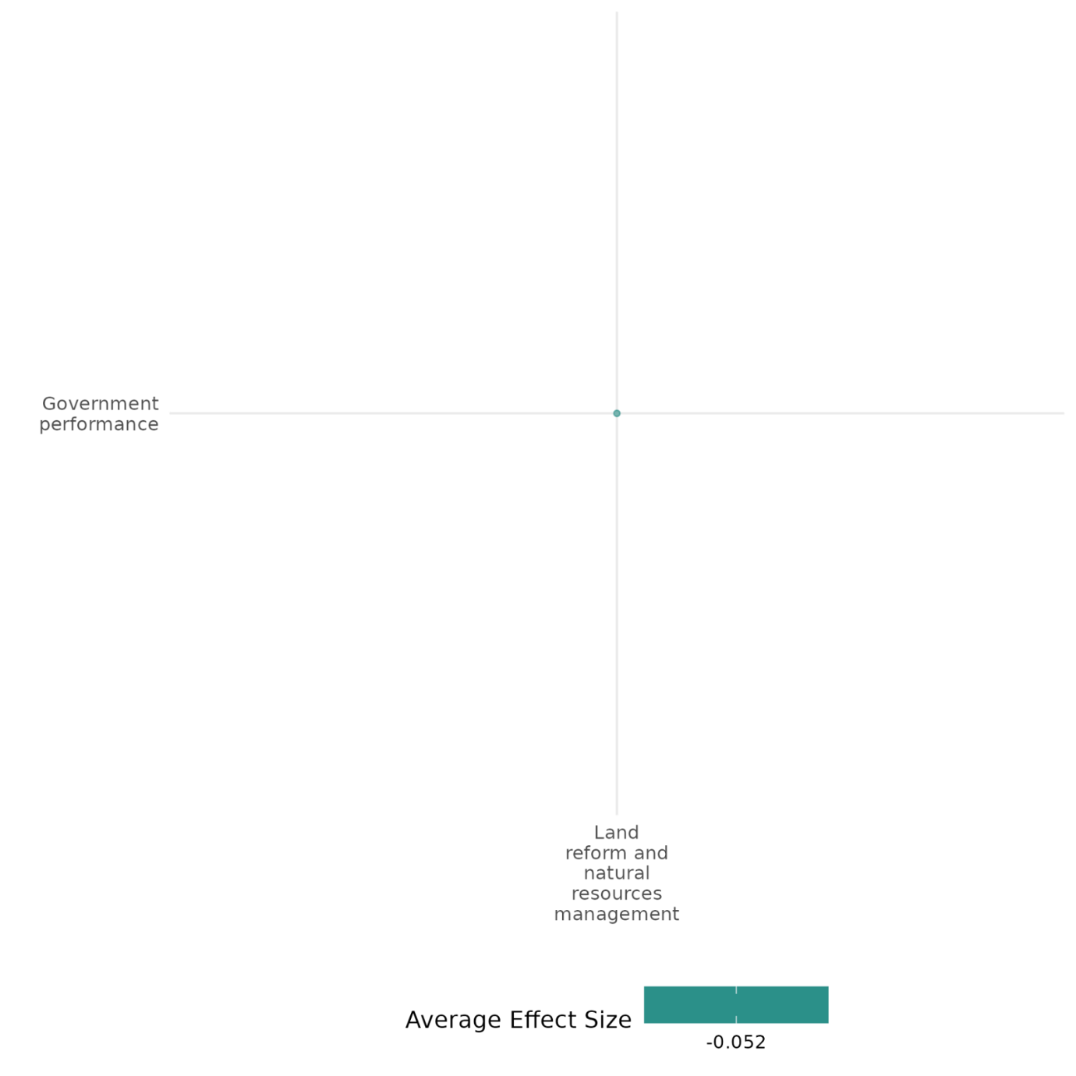

4.6.3(7)
Effect of land reform and natural resource management (NRM) on economic security
Land reform and natural resource management initiatives enhance economic security by improving tenure security, promoting long-term investments, and fostering financial stability, but their effectiveness varies due to contextual and implementation challenges.
Geographic region: Africa, Asia, Middle East, Global
Effect: Large effect (g=0.207)
Confidence in study findings: Low (3 studies with 36 effect sizes)

Short Summary
Land reform and natural resource management (NRM) initiatives, including Rwanda’s villagization policy, Benin’s land demarcation program, and watershed restoration in the DRC, aim to secure land tenure, enhance resource equity, and promote sustainable agriculture. These interventions improved tenure security, encouraged long-term investments, and diversified incomes, particularly through community-based savings and leadership initiatives. However, their impact on agricultural productivity and equitable resource access varied, highlighting the need for context-specific design and effective implementation strategies.

The intervention
Land reform and natural resource management (NRM) initiatives aim to improve economic security by securing land tenure, fostering sustainable farming practices, and enhancing resource management. Interventions include formalizing land ownership through Rural Land Use Plans (PFRs) in Benin, the villagization policy relocating rural populations into grouped settlements in Rwanda, and implementing community-driven watershed restoration programs with Village Savings and Loan Associations (VSLAs) in the Democratic Republic of Congo (DRC). These interventions target rural populations dependent on agriculture and natural resources for their livelihoods.

How the intervention is expected to work
Land reform interventions aim to secure land tenure, incentivizing farmers to invest in long-term improvements, such as planting perennial crops or adopting sustainable farming techniques. By ensuring equitable access to land and resources, these initiatives reduce disputes, strengthen resilience, and promote economic stability. NRM interventions, such as community-based watershed restoration, are expected to foster environmental sustainability and improve household incomes by enhancing agricultural productivity and diversifying livelihoods.

The evidence base
This cell includes 6 studies: 2 systematic reviews, 3 impact evaluation studies, and 1 qualitative paper.
One of the reviews studied the community-based forest management based on 69 case studies worldwide, while the other review had a specific focus on this topic in Indonesia.
The primary studies are set in Benin (1), DRC (1), Rwanda (1), Middle East (1, Israel & Palestine).

Evidence findings
The studies highlight that strengthened land tenure security and NRM promotes investments in sustainable agricultural practices and improves economic resilience. In Rwanda, villagization reduced land disputes and improved access to public services, but its impact on agricultural productivity was mixed due to implementation challenges. In Benin, land demarcation significantly increased perennial crop cultivation and soil conservation, especially for women, though short-term agricultural productivity gains were minimal. Across West Africa, land titling improved tenure security and encouraged investment but had mixed results on productivity due to persistent socio-cultural barriers. In summary, land reform and NRM interventions tend to have positive effects, although these effects can be affected by implementation challenges.

The review evidence
Results from one of the reviews show that community-based forest management had positive impacts on economic security, particularly through subsistence, savings, and income for most of the case studies covered. Meanwhile, the other review focused on analyzing variables which significantly influence the success of community forestry, and highlighted that this include tenure security, socioeconomic boundaries of the resources, and expectation of benefits.

The impact evaluation evidence
There are three impact evaluations included in this cell. Three study summaries are thus provided here:
Goldstein (2015) This study examines the effects of the Plan Foncier Rural (PFR), a land formalization program in rural Benin aimed at improving tenure security and stimulating agricultural investment. The intervention includes community-led land demarcation through socio-legal studies, systematic topographic surveys, and marking parcel boundaries with cornerstones. Demarcation activities are intended to resolve land disputes and prepare for land certification. The study is a large-scale randomized controlled trial conducted in rural Benin, covering villages selected for land registration. The study findings that treated villages showed a 27 percentage point increase in the likelihood of delineated parcels, translating into a modest but significant 4 percentage point improvement in perceived tenure security. The program induced a shift toward long-term investment, with treated parcels 1.7 percentage points more likely to have newly planted trees (a 50% increase from the control mean). A temporary contraction in land rental markets was observed, with a 1.6 percentage point decline in parcels rented or sharecropped out, representing a 25% drop relative to control parcels. This is attributed to landowners reclaiming parcels to secure rights before certification. While the intervention spurred long-term investment, there was no immediate increase in agricultural productivity. The study is rated medium Confidence quantitative study due to attrition rate
Kondylis (2008) Rwanda has experienced recurring waves of ethnic violence since 1959, leading to massive population displacements and land shortages. In 1997, the Rwandan government implemented the imidugudu or villagization policy to address land disputes, enhance security, and improve agricultural productivity by resettling displaced returnees into agglomerated settlements and redistributing land outside these settlements. The study leverages data from the 2000/2001 National Rwandan Enquête Intégrée des Conditions de Vie des Ménages (EICV) and a concurrent Community Survey, examining over 6,400 households across Rwanda. Returnees were randomly assigned to program villages, and the analysis uses geographic variation in policy implementation and a difference-in-differences approach. The study finds that the imidugudu policy significantly increased access to land for returnees in policy areas, though the effect diminished when regional disparities were controlled. Seed consumption was higher in policy areas, but the causality of this relationship remains unclear. Displacement negatively impacted on-farm labor participation, but the villagization policy mitigated this effect for returnees in policy areas. However, controlling for regional and household characteristics nullified these effects. Agricultural productivity showed mixed outcomes; while inputs like land and seeds had variable returns, overall output was lower for returnees in policy areas. The interaction between policy and returnee status often resulted in reduced efficiency in agricultural input utilization, particularly in seed returns. The study is rated low due to lack of reporting on attrition.
Sabin (2019) evaluates the impact of a community-based watershed restoration initiative in Eastern Congo, assessing its environmental, economic, and social outcomes. Using a mixed-methods approach, including difference-in-differences (DID) analysis, participatory workshops, and remote sensing data, the study compares two watersheds—one receiving the intervention and the other serving as a control. The intervention involved establishing Village Savings and Loans Associations (VSLAs), promoting sustainable farming practices, and strengthening community leadership networks to encourage environmental restoration. Households in the treatment watershed experienced significant economic improvements, with an increase in savings habits and amounts saved per household (p < 0.001). There was a diversification of income sources (p < 0.001) and an increase in cell phone ownership (p < 0.001), reflecting improved financial stability. Households reported an increase in investment in education, with a higher proportion of girls attending secondary school (p < 0.01). The study is rated low due to lack of reporting on attrition-

Confidence Assessment:
Overall low: Both of the reviews were rated as low. Similarly, two out of the three impact evaluation studies were also rated low.

Link to review summaries
Pagdee (2006)
Harbi (2020)
All studies may be accessed via the EGM.

Other outcomes in the study:
Social cohesion / willingness to participate or help
Human security / education security
Human security / food security and nutrition & health security
Human security / environmental security
Community and state governance / access to justice, rights, and public services

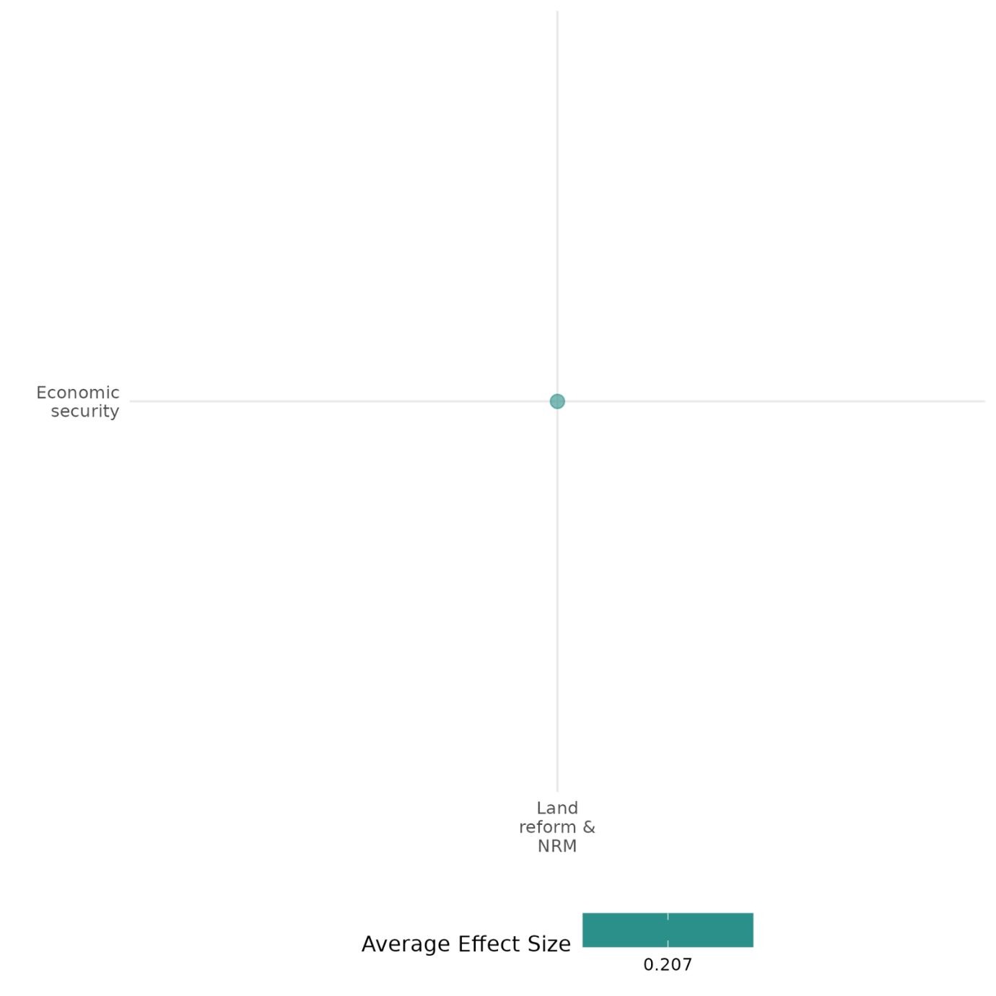

4.6.3(8)
Effect of land reform and natural resource management (NRM) on educational security
Community-driven watershed restoration initiatives can enhance educational security, as demonstrated in the increased enrollment of girls in secondary education.
Geographical scope: Africa
Effect: Large effect (g=0.383)
Confidence in study findings: Medium (1 study with 1 effect size)

Short Summary
Land reform and natural resource management interventions may include community-based watershed restoration initiatives, such as in Eastern Democratic Republic of the Congo (DRC), which aimed to improve environmental security and household economic stability through sustainable farming, reforestation, and Village Savings and Loan Associations (VSLAs). The intervention resulted in increased enrollment of girls in secondary education. However, long-term can be contingent on sustained community engagement and institutional support.

The intervention
The study examines a community-based watershed restoration initiative in Eastern DRC, aimed at improving environmental sustainability and socioeconomic conditions, including educational security. The intervention involved sustainable farming training, reforestation, and community forest management, implemented through Village Savings and Loan Associations (VSLAs) and partnerships with local institutions such as schools, churches, and mosques. The initiative sought to address environmental degradation and conflict by fostering community-driven natural resource management and economic resilience.

How the intervention is expected to work
The intervention may improve educational security by enhancing household economic stability through VSLAs, which provide financial resources for school-related expenses, particularly for girls’ secondary education. Increased household income from improved agricultural practices and access to savings enables families to invest in education. Additionally, the intervention’s focus on environmental restoration and community engagement fosters a sense of stability and cooperation, which can create a more conducive environment for educational pursuits.

The evidence base
This cell includes one study which is set in Eastern Congo. Data were collected from 320 randomly selected households across the two watersheds.

Evidence findings
The findings suggest that the community-based watershed restoration initiative led to positive changes in educational security, with a significant increase in the number of households with girls enrolled in secondary school in the treatment watershed.

Included studies
Sabin (2019) evaluates the impact of a community-based watershed restoration initiative in Eastern Congo, assessing its environmental, economic, and social outcomes. Using a mixed-methods approach, including difference-in-differences (DID) analysis, participatory workshops, and remote sensing data, the study compares two watersheds—one receiving the intervention and the other serving as a control. The intervention involved establishing Village Savings and Loans Associations (VSLAs), promoting sustainable farming practices, and strengthening community leadership networks to encourage environmental restoration. Households reported an increase in investment in education, with a higher proportion of girls attending secondary school (p < 0.01). The study is rated medium due to its partial description of the evaluation questions.

Confidence Assessment
Overall low: The overall rating is low considering that there is only 1 study included in this cell.

Other outcomes in the study:
Social cohesion / willingness to participate or help
Human security / economic security
Human security / food security and nutrition & health security
Human security / environmental security

4.6.3(9)
Effect of land reform and natural resource management (NRM) on food security and nutrition and health security

Community-driven watershed restoration initiatives improve food security and nutrition through increases in dietary diversity and meal frequency.
Geographic region: Africa
Effect: Large effect (g=0.599)
Confidence in study findings: Medium (1 study with 4 effect sizes)

Short Summary
Land reform and natural resource management interventions may include community-based watershed restoration initiatives, such as in Eastern Democratic Republic of the Congo (DRC), which aimed to improve environmental security and household economic stability through sustainable farming, reforestation, and Village Savings and Loan Associations (VSLAs). A key finding is the positive impact on food security and nutrition, with households in the treatment watershed reporting a significant increase in meal frequency and dietary diversity, leading to improved nutrition. However, no significant improvements were observed in household access to drinking water.

The intervention
The study examines a community-based watershed restoration initiative in Eastern DRC, aimed at improving environmental sustainability and socioeconomic conditions, including educational security. The intervention involved sustainable farming training, reforestation, and community forest management, implemented through Village Savings and Loan Associations (VSLAs) and partnerships with local institutions such as schools, churches, and mosques. The initiative sought to address environmental degradation and conflict by fostering community-driven natural resource management and economic resilience.

How the intervention is expected to work
The intervention is expected to enhance food security, nutrition, and health security by improving agricultural productivity through sustainable farming practices, leading to increased food availability and dietary diversity. By encouraging agroforestry and soil conservation measures, the initiative aims to boost crop yields and enhance household access to nutritious foods. Additionally, increased household incomes through savings groups provide families with greater financial resources to invest in healthcare and improved nutrition.

The evidence base
This cell includes one study which is set in Eastern Congo. Data were collected from 320 randomly selected households across the two watersheds.

Evidence findings
The intervention positively impacted food security and nutrition, with households in the treatment watershed reporting greater dietary diversity and an increase in the number of meals consumed per day. The participatory workshops highlighted a notable decrease in food shortages and an improvement in household nutrition.

Included studies
Sabin (2019) evaluates the impact of a community-based watershed restoration initiative in Eastern Congo, assessing its environmental, economic, and social outcomes. Using a mixed-methods approach, including difference-in-differences (DID) analysis, participatory workshops, and remote sensing data, the study compares two watersheds—one receiving the intervention and the other serving as a control. The intervention involved establishing Village Savings and Loans Associations (VSLAs), promoting sustainable farming practices, and strengthening community leadership networks to encourage environmental restoration. Households in the treatment watershed experienced a significant improvement in dietary diversity (p < 0.001), with an increased variety of food categories consumed, suggesting better nutritional intake. The number of meals consumed per household also increased significantly (p < 0.001), indicating improved food security and access to nutrition.

Confidence Assessment
Overall low: The overall rating for this cell is low given that there is only one study that falls under it.

Other outcomes in the study:
Social cohesion / willingness to participate or help
Human security / economic security
Human security / education security
Human security / environmental security

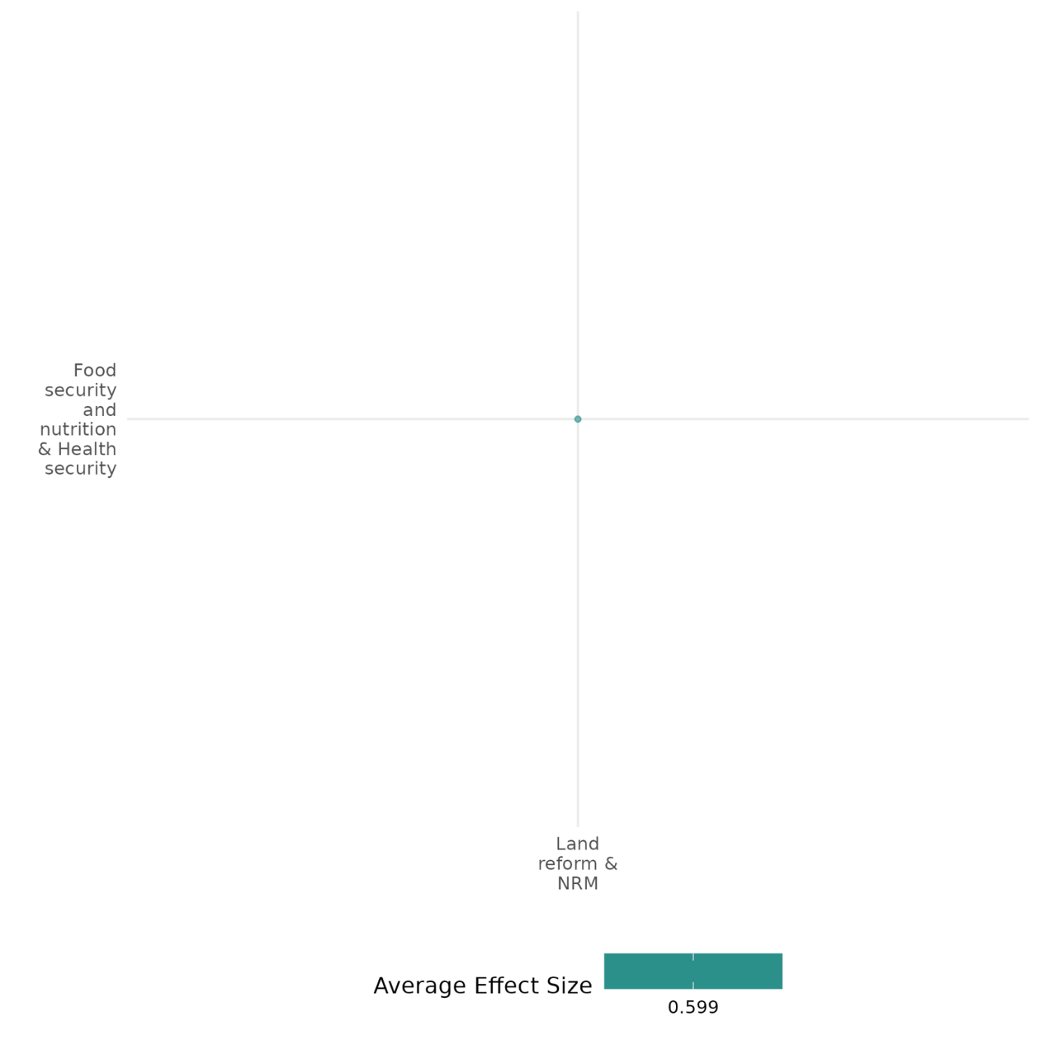

4.6.3(10)
Effect of land reform and natural resource management (NRM) on environmental security

Watershed restoration initiatives lead to significant improvements on outcomes related to environmental security.
Geographical space: Africa, Latin America, Global, Asia, Middle East
Effect: Large effect (g=0.908)
Confidence in study findings: Low (2 studies with 4 effect sizes)

Short Summary
Land reform and natural resource management interventions may include community-based watershed restoration initiatives, such as in the Democratic Republic of the Congo (DRC), which aimed to improve environmental security and household economic stability through sustainable farming, reforestation, and Village Savings and Loan Associations (VSLAs). The intervention led to significant improvements in environmental security, with the treatment watershed showing increased tree cover, improved soil quality, and a reduction in harmful agricultural practices such as burning fields for land preparation.

The intervention
The study examines a community-based watershed restoration initiative in Eastern DRC, aimed at improving environmental sustainability and socioeconomic conditions. The intervention involved sustainable farming training, reforestation, and community forest management, implemented through Village Savings and Loan Associations (VSLAs) and partnerships with local institutions such as schools, churches, and mosques. The initiative sought to address environmental degradation and conflict by fostering community-driven natural resource management and economic resilience.

How the intervention is expected to work
The intervention is designed to enhance environmental security by fostering community-led efforts to restore degraded landscapes, increase forest cover, and improve soil quality. By providing training in sustainable agriculture and environmental stewardship, the initiative aims to reduce harmful practices such as slash-and-burn agriculture and promote long-term environmental sustainability. Additionally, community involvement in conservation activities is expected to create a sense of ownership and responsibility, leading to better resource management and resilience against environmental degradation.

The evidence base
This cell includes 6 studies: 2 impact evaluations, 2 systematic reviews, and 2 qualitative studies.
One of the reviews studies community-based forest management based on 69 case studies worldwide, while the other review had a specific focus of this topic in Indonesia.
The primary studies are from Eastern Congo (1), Israel and Palestine (1), and East Timor (1), Brazil (1).

Evidence findings
The intervention led to significant improvements in environmental security, with the treatment watershed showing increased tree cover, improved soil quality, and a reduction in harmful agricultural practices such as burning fields for land preparation. Households in the treatment area adopted more sustainable farming techniques, contributing to improved ecosystem health and reduced erosion. Despite these positive outcomes, the study notes that environmental gains remain fragile and require sustained community participation and institutional support to ensure long-term impact.

The review evidence
Results from one of the reviews show that community-based forest management had positive impacts on environmental security, particularly through subsistence, savings, and income for most of the case studies covered.

The impact evaluation evidence
There are two impact evaluations. Two study summaries are thus provided here:
Sabin (2019) evaluates the impact of a community-based watershed restoration initiative in Eastern Congo, assessing its environmental, economic, and social outcomes. Using a mixed-methods approach, including difference-in-differences (DID) analysis, participatory workshops, and remote sensing data, the study compares two watersheds—one receiving the intervention and the other serving as a control. The intervention involved establishing Village Savings and Loans Associations (VSLAs), promoting sustainable farming practices, and strengthening community leadership networks to encourage environmental restoration. Households in the treatment watershed planted significantly more trees (p < 0.001) and adopted sustainable farming techniques such as agroforestry and soil conservation (p < 0.001). There was a notable improvement in soil quality (p < 0.001) and crop diversity (p < 0.001), contributing to enhanced ecosystem health. Although remote sensing data showed an increase in vegetation cover, the difference between treatment and control was not statistically significant. The study is rated as medium due to its partial description of the evaluation questions.
Van Oel, Krol and Hoekstra (2007) examines the governance of water resources in the Jaguaribe Basin, Brazil, using common-pool resource (CPR) concepts to assess how water is managed in a semi-arid environment. The research focuses on rainfall variability, water storage, land use, and agricultural performance, highlighting the challenges of equitable and sustainable water allocation. Through an analysis of governance structures and human-environment interactions, the study finds that water resource management is highly asymmetrical, with upstream users disproportionately benefiting from water storage while downstream users face greater variability and scarcity. The study is rated medium confidence as it is a non-experimental study and due to its partial description of the intervention, outcomes, and evaluation questions.

Link to review summaries
Harbi (2020)
Pagdee (2006)
All studies may be accessed via the EGM.

Other outcomes in the study:
Social cohesion / willingness to participate or help
Human security / economic security
Human security / food security and nutrition & health security
Human security / education security
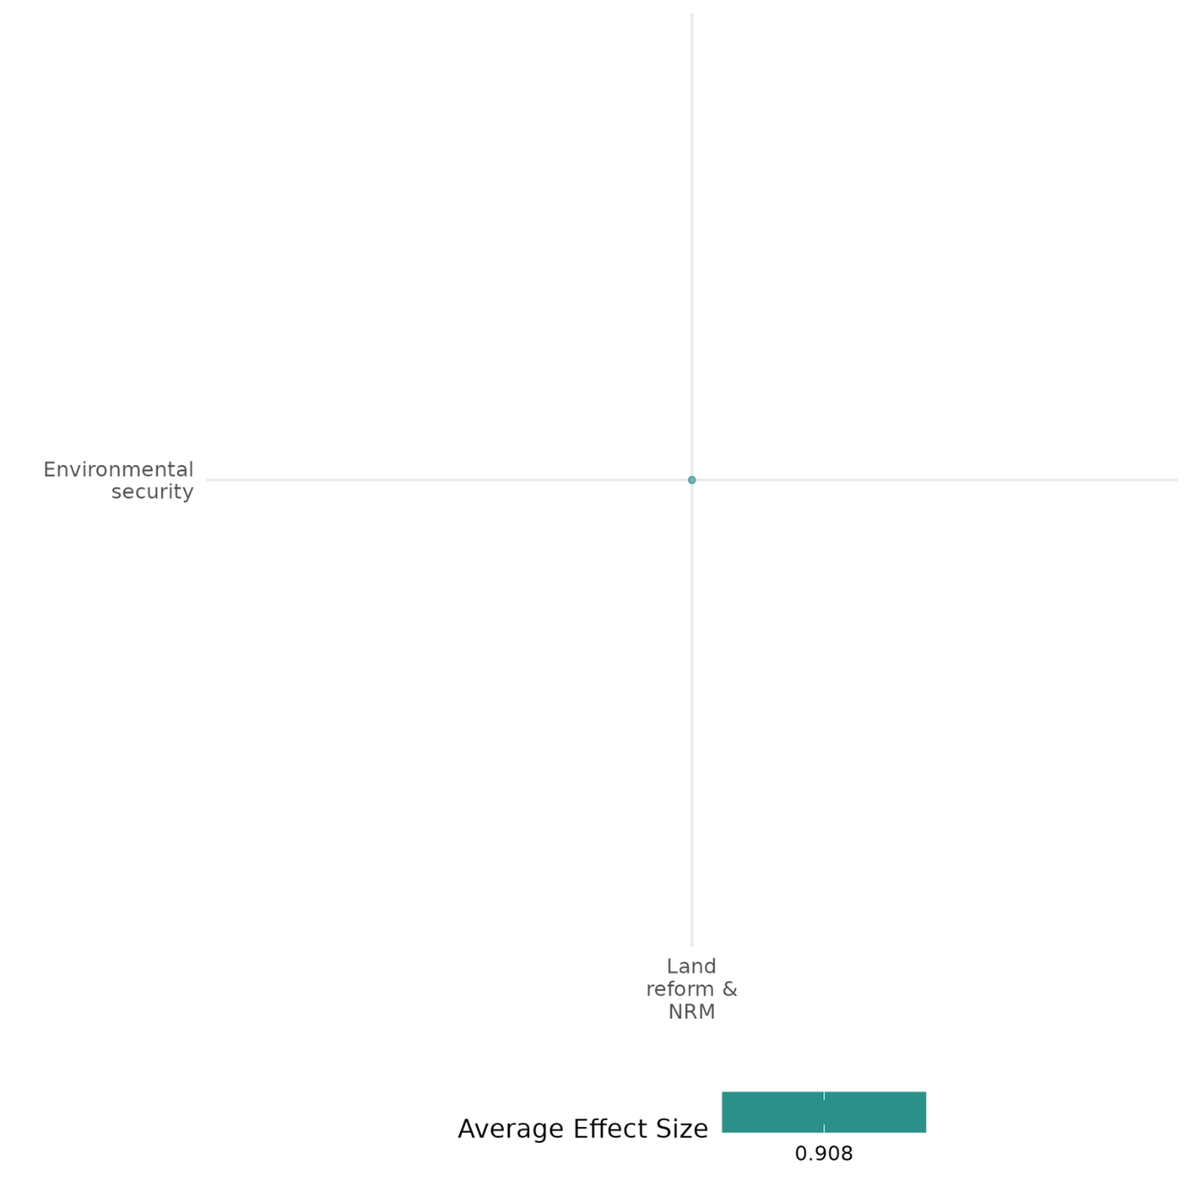

4.6.3(11)
Effect of land reform and natural resource management (NRM) on intermediate social cohesion outcomes

Evaluation results showed that clearer property rights led to improved respect for ownership and reduced conflicts.
Geographic region: Africa
Effect: Large effect (g=0.826)
Confidence in study findings: Medium (1 study with 2 effect sizes)

Short Summary
A land tenure reform in rural Benin aimed to formalize property rights by converting informal communal claims into legally recognized individual ownership. A randomized controlled trial measured its impact on respect for property, showing a significant reduction in resource appropriation in treated villages. The findings suggest that formal ownership can encourage responsible behavior and reduce conflicts.

The intervention
The intervention focuses on converting informal communal land rights into officially recognized individual property rights. This process involves documenting and registering land parcels, ensuring individuals gain legally acknowledged ownership with formal protections.

How the intervention is expected to work
Formalizing private property rights is expected to enhance respect for ownership by providing individuals with legally recognized claims, reducing disputes, and encouraging responsible land use. Clear ownership rights create incentives for individuals to invest in their property, fostering economic development and social stability. By transforming informal collective arrangements into legally defined individual ownership, the reform aims to shift social norms toward greater respect for others’ property. This formalization is also expected to reduce reliance on costly enforcement mechanisms, as individuals internalize the value of respecting property rights, leading to improved cooperation and lower instances of conflicts over land.

The evidence base
The cell contains 1 impact evaluation set in rural Benin. A randomized controlled trial was implemented, where villages were randomly assigned to a land tenure reform program.

Evidence findings
The formalization of property rights through the land tenure reform fostered a greater sense of respect for others’ ownership, resulting in fewer disputes and increased trust within communities. It also encouraged collective involvement in decision-making, which helped strengthen social ties and alleviate land-related tensions. However, the level of improvement differed across communities, with some facing ongoing challenges in adjusting to the formalized system.

Included studies
Fabbri (2021) This study examines the impact of formalizing private property rights through a randomized land tenure reform in West Africa, specifically in the Coffou province. The reform aimed to secure private property rights and assess its influence on individuals’ respect for others' property. The intervention was implemented at a large scale and was unique in being carried out as a randomized control trial (RCT). The study utilized a modified dictator game to measure the effect of the reform on individuals' behavior toward appropriating resources from others. Participants were residents of villages randomly selected from the land tenure reform lottery pool, with 16 experimental sessions conducted in February and March 2017. Villages were divided into treatment (reform-experienced) and control (no reform experience) groups. The study found that the formalization of private property rights significantly reduced individuals’ willingness to appropriate resources from others. Participants in villages exposed to the reform took fewer coins from passive participants’ endowments compared to those in control villages. Graphical analysis and statistical tests revealed that treated participants appropriated significantly less of the passive players’ endowment (p-value < 1%). The reform led to a 40–60% reduction in the amount appropriated by dictators on average. The proportion of participants who took no coins increased from 5% in control villages to 26% in treated villages. The study is rated medium confidence due to its partial description of the evaluation questions.

Confidence Assessment
Overall low: The cell is rated low as it contains less than 4 impact evaluations.

Other outcomes in this study:
None.
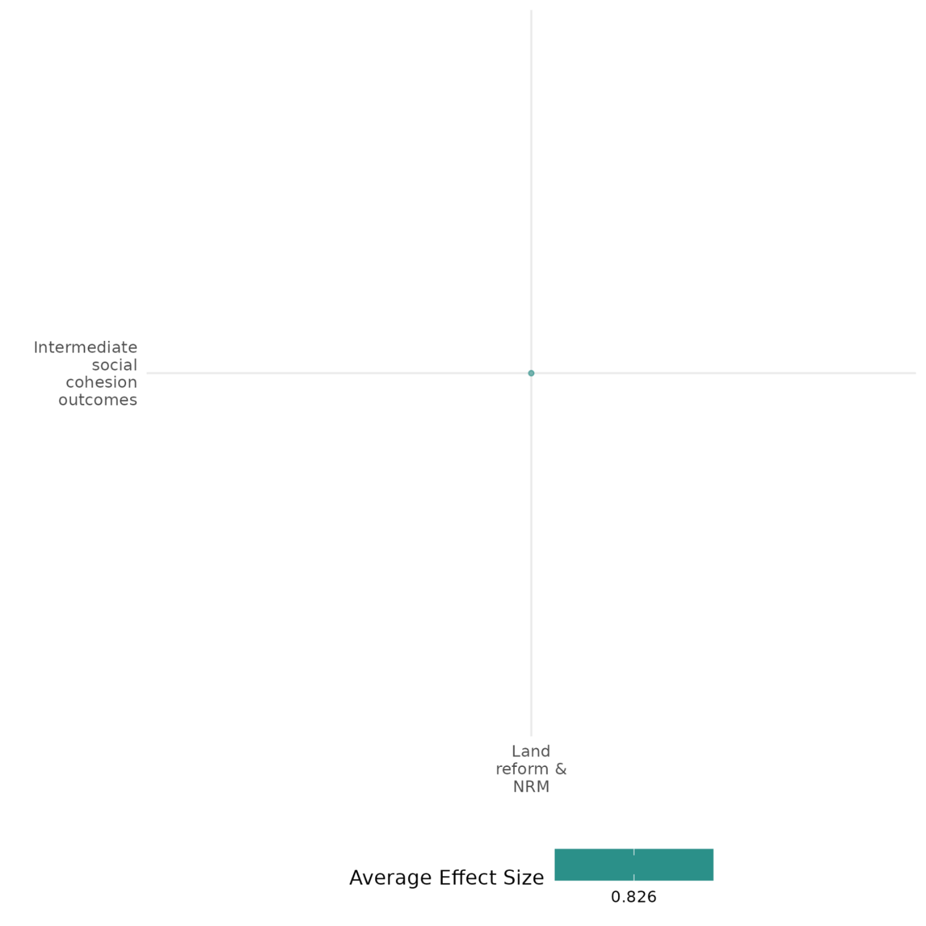

4.6.4 Training + Job creation (including public works)
4.6.4(1)
Effect of training & job creation on nature and scale of violence or atrocities

Training and job creation interventions can reduce conflict-related violence by decreasing insurgent recruitment and mitigating economic shocks, but their effectiveness depends on governance capacity, security conditions, and implementation quality.

Geographic region: Asia, Middle East, Global
Effect size: No effect (g=0.01)
Confidence in study findings: Medium (7 studies with 41 effect sizes)

Short Summary
Training and job creation programs, such as cash-for-work initiatives, vocational training, and guaranteed employment schemes, have been implemented in conflict-affected areas to mitigate violence and reduce recruitment into armed groups. Studies show that these interventions can lower conflict intensity and improve stability, although their effectiveness varies depending on governance capacity, security conditions, and economic factors. In some cases, they successfully decrease violence, while in others, unintended consequences arise, particularly when implementation interacts with broader political and security dynamics.

The intervention
The studies under this cell examine various job creation and training programs designed to address economic vulnerability and mitigate violence. The United Nations Development Programme’s Iraq Crisis Response and Resilience Programme (ICRRP) provided vocational training, cash-for-work, and small business grants to displaced women in Iraq (2014–2016) to reduce child recruitment into armed groups. India’s National Rural Employment Guarantee Scheme (NREGS/NREGA) guaranteed up to 100 days of paid rural employment through public works, aiming to stabilize incomes and deter insurgency in Maoist-affected regions. The Commander’s Emergency Response Program (CERP) in Iraq (2004–2008) focused on labor-intensive infrastructure projects to generate employment and reduce insurgent activity. Other interventions included the Prime Minister’s Reconstruction Plan (PMRP) for Jammu and Kashmir, which combined infrastructure development with job creation to promote stability.

How the intervention is expected to work
Training & job creation interventions may reduce violence through multiple mechanisms. By increasing employment opportunities, they can raise the opportunity cost of insurgency participation, discouraging recruitment into armed groups. They can also alleviate economic grievances, particularly in regions affected by poverty and resource shocks. For example, in India, NREGS provides a buffer for rural households against monsoon-related income fluctuations, which previously fueled conflict. In Iraq, CERP can reduce daytime insurgent violence by occupying potential recruits with labor-intensive work.

The evidence base
The cell contains 8 impact evaluation studies (one is an ongoing study) and 2 systematic reviews. The study setting for the impact evaluation studies include: India (5 studies), Iraq (2 studies) and Central African Republic [1 ongoing study - Alik-Lagrange (2019)].
One of the reviews assessed whether different types of aid—such as public employment programs—help reduce violence or inadvertently fuel conflict. The other conducted a rapid evidence assessment on conflict prevention interventions, evaluating their effectiveness in reducing armed violence in developing and middle-income countries.

Evidence findings
The impact of training and job creation programs on violence varies across contexts. In Iraq, ICRRP reduced grave violations against children, suggesting that livelihood programs can mitigate conflict effects on vulnerable populations. In India, NREGS significantly reduced Maoist conflict violence by 57% and conflict-related deaths by 63%, but the effect was contingent on strong local governance. Similarly, CERP spending in Iraq was associated with a 15-20% decline in labor-intensive insurgent violence, particularly against civilians. However, in some regions, job creation efforts initially correlated with increased state-led counterinsurgency operations, as seen in early NREGS implementation, which led to a temporary rise in fatalities and insurgent arrests.

The review evidence
Both reviews find that expanding wage employment opportunities or programs may reduce conflict.

The impact evaluation evidence
This cell includes 8 impact evaluations, however one of these is an ongoing study. Thus, seven summaries are provided below:
Atkinson (2022) focuses on the United Nations Development Programme’s Iraq Crisis Response and Resilience Programme (ICRRP), which was implemented in Iraq from 2014 to 2016. This program aimed to empower displaced women through economic and social initiatives, including cash-for-work programs, vocational training, and small business grants, to mitigate the impact of conflict on children by reducing their vulnerability to recruitment by armed groups. The research employs a mixed-method approach, combining qualitative interviews with elite professionals from United Nations agencies and non-governmental organizations, and quantitative analysis using data from the United Nations Monitoring and Reporting Mechanism (MRM). The study specifically examines the impact of the ICRRP on grave violations against children in armed conflict across various governorates in Iraq, comparing those with and without the livelihood programs. The findings suggest that governorates benefiting from the UNDP’s ICRRP livelihoods programs experienced a reduction in the rate of grave violations against children compared to those without such programs. While the overall number of violations decreased, the rate of increase in violations was significantly lower in governorates with the programs, indicating a correlation between the implementation of gender-based development policies and the mitigation of conflict impacts on children. The study is rated as low confidence as it is a before vs after study.

Dasgupta (2017) The study examines the National Rural Employment Guarantee Scheme (NREGS), a large-scale anti-poverty program implemented in India, which guarantees wage employment to rural households. It explores how the program affects Maoist conflict violence in India’s “Red Corridor”, a region with high levels of insurgency. Using a difference-in-differences approach, the study leverages the staggered roll-out of NREGS across 144 districts between 2006 and 2008. Data on Maoist conflict incidents and deaths were compiled from multiple sources, including local-language newspapers. The analysis incorporates district-level variables such as state capacity and rainfall shocks to evaluate heterogeneity in program effects. The study finds that NREGS adoption led to a significant reduction in Maoist conflict violence, with a 57% decrease in incidents and a 63% reduction in deaths. However, these effects were contingent on local state capacity. High-capacity districts experienced substantial reductions in violence, while low-capacity districts showed negligible or slightly positive effects. Additionally, the program’s impact was amplified in districts experiencing agricultural shocks, highlighting its role as an income safety net. The findings suggest that while anti-poverty programs can mitigate violence, their success depends critically on the strength of local governance. The study was rated as low confidence as the author did not report the evaluation questions.

Fetzer (2020) The study assesses the impact of India’s National Rural Employment Guarantee Act (NREGA) on reducing conflict intensity by moderating the effects of adverse weather shocks, specifically monsoon rainfall deficits, on household incomes. Launched in 2006 in India, NREGA is the world’s largest public employment program, guaranteeing up to 100 days of employment annually at minimum wages for rural households through public works aimed at creating sustainable infrastructure. By providing a safety net, the program stabilizes household incomes, particularly for individuals with limited income options during adverse economic conditions, aiming to reduce economic vulnerabilities and their potential link to conflict. The study combines household-level panel data with district-level conflict records in India, revealing that prior NREGA, adverse monsoon rainfall reduced agricultural output by 0.32% for every 1% rainfall deficit and significantly lowered agricultural wages. However, post-NREGA, this relationship disappears, showing that the program has a stabilizing effect on incomes. The study also finds that before NREGA, a 1% reduction in monsoon rainfall increased conflict intensity by 1.4%, but this effect vanishes after NREGA’s introduction, suggesting that the program helps decouple economic shocks from conflict. A 25% shock to rainfall previously led to a 33% increase in conflict intensity, translating to 1.5 additional conflict events per district annually. In summary, NREGA reduces the vulnerability of rural households to weather-induced income shocks, stabilizes agricultural labor markets, and indirectly lowers conflict intensity, demonstrating its effectiveness as a social insurance mechanism in resource.

Hoelscher (2012) The study investigates the relationship between India’s Maoist insurgency and development interventions, focusing on the role of public works programs and natural resource extraction in conflict-affected districts. The government’s strategy of securitized development leverages programs like the National Rural Employment Guarantee Act (NREGA) to reduce allegiance to insurgents by providing employment and economic stability. Concurrently, mining activities in these districts drive economic growth but may exacerbate local grievances. The study utilizes a cross-sectional analysis at the district level, combining qualitative fieldwork with quantitative data from six Indian states most affected by Maoist violence. Data cover the period from January 2004 to November 2010, including 1,827 conflict events and 4,816 fatalities.The study finds that districts with higher SC/ST populations are more prone to Maoist violence, suggesting that horizontal inequalities are significant conflict drivers. Lower per capita GDP is linked to increased frequency and severity of violence, though the availability of public goods showed no significant effect. Mining activities alone do not strongly predict violence but amplify conflict where socio-economic exclusion is prevalent. Effective implementation of NREGA correlates with reduced violence, indicating potential benefits of government development programs, though causality remains uncertain. Additionally, violence is more intense in border districts and regions with dense forest cover, emphasizing the role of geographical factors in insurgent mobility and access. The study is rated as medium confidence as it is non- experimental study design.

Iyengar (2011) The study evaluates the effect of labor-intensive reconstruction programs on insurgent violence in Iraq, focusing on the Commander’s Emergency Response Program (CERP) implemented by U.S. military divisions between 2004 and 2008. The programs aimed to generate employment through labor-intensive development activities in conflict-affected districts. The study employs an instrumental variables (IV) approach and a difference-in-differences strategy. The analysis leverages district-level data on violence and CERP project allocations, controlling for fixed effects and other counterinsurgency efforts. Outcomes include types, frequency, and intensity of insurgent violence. The study found that a 10% increase in labor-intensive CERP spending correlates with a 15-20% decline in labor-intensive insurgent violence and a nearly 10% overall reduction in violence. This decline is driven primarily by reduced attacks on civilians, with a 49% decrease in civilian-targeted incidents and a 56% reduction in civilian fatalities. However, attacks on U.S. forces increased by 13%, suggesting a shift in insurgent focus from “soft” civilian to “hard” military targets. Violence reduction occurs predominantly during daytime hours, consistent with the hypothesis that increased employment raises opportunity costs for insurgents. These results suggest that economic opportunities through development programs can effectively reduce insurgent recruitment and violence. The study is rated as medium confidence as it is non- experimental study design.

Kaila (2020) The study investigates the impact of interventions aimed at reducing violence in Jammu and Kashmir, India, between 1998 and 2017. Key interventions include (i) the fencing of the border with Pakistan, 9ii) the implementation of the Prime Minister’s Reconstruction Plan for J&K (PMRP), and (iii) the phased rollout of the National Rural Employment Guarantee Scheme (NREGS). These measures addressed security, infrastructure development, and rural livelihoods, aiming to foster stability and reduce violence in the region. The research employs time series analysis and panel data methods to detect structural breaks in violence levels, using district-level data from 1998 to 2017. The study applies smooth transition regressions (LSTR) models to capture gradual transitions and Bai-Perron (BP) procedures to detect sharp breakpoints. Violence metrics include casualties among civilians, insurgents, and security personnel, as well as incidents involving explosives. The analysis identifies a transition from a high-violence regime (pre-2003) to a low-violence regime (post-2007), with a transition period between 2003 and 2007. This shift coincides with (i) the completion of border fencing in 2004, (ii) the launch of PMRP in 2005, and (iii) the rollout of NREGS between 2006 and 2008. Results highlight that improved security facilitated the effective implementation of economic development programs, contributing to reduced violence levels. Average monthly casualties declines significantly from 253.5 in the high-violence regime to 24.3 in the low-violence regime. The findings emphasize the complementary roles of security and development interventions in reducing violence.

Khanna (2014) The study examines the impact of the National Rural Employment Guarantee Scheme (NREGS) in districts affected by Maoist insurgency in India, commonly referred to as the “red corridor”. NREGS is a flagship anti-poverty initiative of the Indian government, offering a legal guarantee of 100 days of public-works employment annually for rural households at the minimum wage. The program was rolled out in phases, starting with underdeveloped districts, with Phase 1 launched in February 2006. The research employs a quasi-experimental design, focusing on the Phase 1 implementation of NREGS across 200 districts. It analyses data form the South Asian Terrorism Portal (SATP), which tracks Maoist-related incidents, including fatalities, injuries, abductions, and arrests. Trends in Phase 1 districts are compared with non-Phase 1 districts over time, considering both police- and Maoist-initiated violence. The findings indicate that the introduction of NREGS is associated with a significant short-term increase in Maoist-related violence. Fatalities rose by 43% (0.19 deaths per month), incidents increased by 20.6%, and the number of individuals affected (injuries, abductions, or captures) grew by 0.05 persons per month. These increases were primarily driven by police-initiated actions, including combing operations and encounters with Maoists, rather than by insurgent-initiated attacks. Furthermore, there was a marked rise in the number of Maoists surrendered or captured in Phase 1 districts following NREGS implementation, suggesting improved police efficiency due to enhanced civilian cooperation. The study rated as low confidence due to a lack of reporting attrition. The study is rated as having low confidence due to a lack of clarity in reporting evaluation questions.

Confidence assessment:
Overall medium: There are 8 impact evaluations included in this cell. Among those with effect sizes, the findings tend to be mostly consistent.

Link to review summaries
Cramer (2016)
Zurcher (2017)
All studies may be accessed via the EGM.

Other outcomes in this study:
Human security / economic security

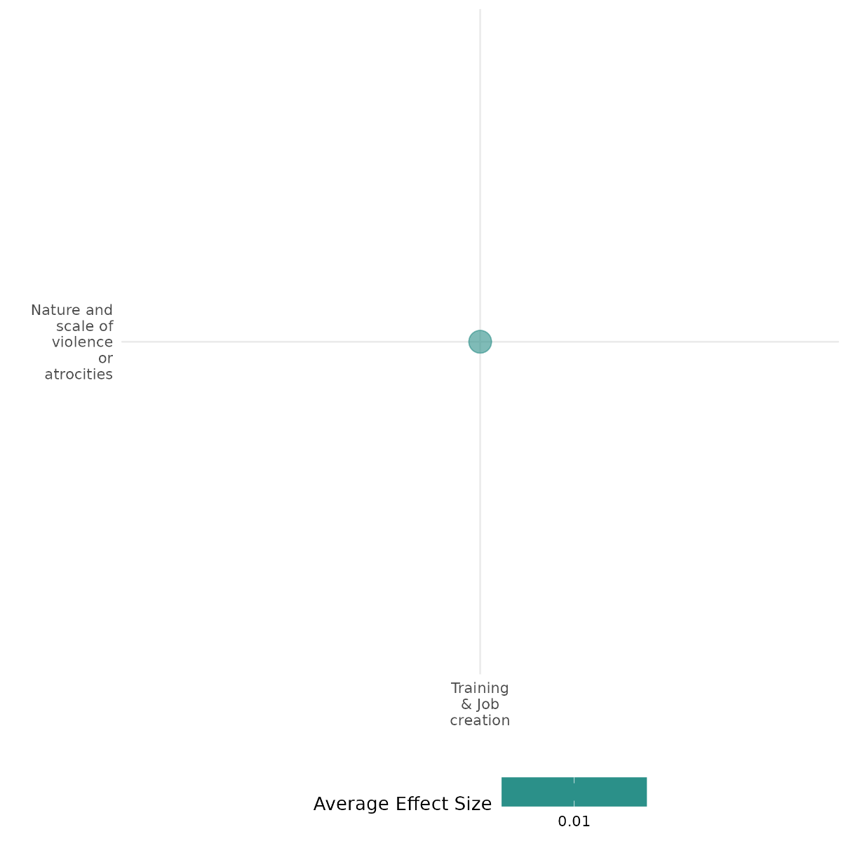
4.6.4(2)
Effect of training & job creation on social norms regarding violence and atrocities
Employment programs can reduce support for violence by improving economic security and fostering social cohesion, but their ability to shift social norms around violence varies. While some initiatives successfully decrease justification for violence, others show limited or no impact.
Geographic region: Africa, Middle East, Latin America
Effect: Small effect (g=0.1)
Confidence in study findings: Low (6 studies with 41 effect sizes)

Short Summary
Employment programs may include vocational training and business support initiatives. Studies in Liberia, Somalia, and Afghanistan suggest mixed effects. While programs in Liberia and Somalia reduced support for violence and illicit activities, findings from Afghanistan show little or adverse impact on willingness to engage or support in violence.

The intervention
The studies analyzed various employment-focused interventions targeting high-risk youth in conflict-affected settings. In Liberia, the Action on Armed Violence (AoAV) Agricultural Training Program provided residential training, ounselling, and life skills classes to young men involved in illicit activities such as logging and mining. Participants received farm inputs worth $125 at the end of the program. In Somalia, the International Labour Organization (ILO) YES and Y4C programs offered vocational training, cash-for-work opportunities, and microenterprise support to at-risk youth in Puntland, Somaliland, and South Somalia. These initiatives aimed to reduce support for violence by promoting economic inclusion and social cohesion. In Afghanistan, the UK-supported INVEST program provided vocational training to 25,000 youth in Helmand Province to improve employment outcomes and economic optimism.

How the intervention is expected to work
These interventions aim to shift social norms around violence through multiple mechanisms. By providing stable employment and skills, they reduce economic grievances that may otherwise push individuals toward violence. Training programs that bring together individuals from different ethnic or tribal backgrounds foster dialogue and social cohesion, potentially reducing intergroup tensions and support for violent movements. Additionally, perceived economic opportunity and government responsiveness may weaken the appeal of extremist groups that exploit economic and political frustrations. However, the extent to which these programs influence attitudes toward violence depends on the depth of economic benefits, program transparency, and participants’ initial predispositions.

The evidence base
This cell includes: 1 qualitative study, 6 impact evaluation, and 1 systematic review. The primary studies are set in Liberia (2 studies), Afghanistan (3 studies), Somalia (1 study), and Colombia (1 study)
The review is concerned with interventions, including training, for women’s empowerment and gender equity in fragile settings.

The review evidence
Both reviews conclude that training interventions are successful in increasing employment. One of the reviews conducts meta-analysis, a reports a standardized mean difference of 0.07, which is a small effect.

Evidence findings
Findings indicate that employment interventions can reduce support for violence but with varying degrees of success. In Liberia, the agricultural training program led to a 20% reduction in illicit activities, though no participant abandoned them completely. During a short war that occurred during the study period, participants were less likely than the control group to engage with recruiters, suggesting that economic engagement can deter participation in violence. However, the long-term impact on social norms surrounding violence was unclear. In Somalia, the YES and Y4C programs significantly reduced support for violence. In Afghanistan, the INVEST program had no adverse or no measurable impact on young people’s willingness to use violence for political or other causes.

The impact evaluation evidence
There are 6 impact evaluations. Of these two papers are earlier versions of a later paper also included in the cell. Four study summaries are thus provided here:

Blattman and Annan (2011) and Blattman and Annan (2016) Specifically, the NGO Action on Armed Violence’s (AoAV) implemented a programme of residential agricultural training combined with counselling and “life skills” classes. The target group were youth engaged in illicit activities of mining and logging who were seen as at risk of engaging in conflict. At the end of the training participants received farm inputs worth $125. The NGO recruited 1100 high-risk men in 138 communities of which roughly half were assigned to the program on a random basis. Engagement in agriculture was of interest, with three-quarters of those assigned to the programme attending the training. Participants reduced their illicit activities by about 20%, though n one abandoned them completely. Incomes rose by on average US$12 a month. One-third of the participants did not receive the inputs because of supply issues, and so were promised future cash provided they stayed in the village. This group saw the largest reduction in illicit activities. A short war occurred during the study period. Participants were less likely than the control to have met with recruiters. The study is rated low confidence because of lack of information on power calculations.

Borino (2019) investigates the role of employment programs in reducing the willingness of individuals to engage in violence in Somalia. Specifically, it evaluates the impact of the International Labour Organization (ILO)'s "Joint Program Youth Employment Somalia" (YES) and "Youth for Change" (Y4C) initiatives on promoting stability and reducing support for violence among at-risk Somali youth. The YES and Y4C programs are employment-focused initiatives implemented in Somalia, targeting youth at risk of engaging in violent activities. These programs provide vocational training, cash-for-work opportunities, and support for micro, small, and medium enterprises (MSMEs). Although not designed explicitly for peacebuilding, their conflict-sensitive approach emphasizes inclusivity, transparency, and fostering social cohesion among beneficiaries in Bosasso (Puntland), Berbera (Somaliland), and Baidoa (South Somalia). The study analyzed data from approximately 200 participants to assess the impact of the YES and Y4C vocational training programs. Support for violence among beneficiaries significantly decreased, with those justifying violence for better services dropping from 16% to 6% and those endorsing violence for political causes falling from 37% to 27%. The study is rated as low confidence as it is before and after study design.

Kurtz (2015 and 2018) examines the effect of the UK-supported INVEST program, which offered vocational and technical training courses in nine technical vocational education and training (TVET) centres in Helmand Province in Southern Afghanistan from 2011. The programme was implemented by a US NGO, Mercy Corps. At the time of the evaluation 25,000 students had graduated from the programme of which nearly on-third were women. The study used propensity score matching to match recruits from February to April 2014 with successful applicants who had not yet started the programme. There was no effect on young people’s willingness to use violence for political or other cause. The study is rated low confidence because of lack of information on power calculations.

Lyall (2019) The study assessed that how aid can affect individual attitudes toward combatants (“combatant support”) in wartime. Study experimentally evaluated Mercy Corps’ “Introducing New Vocational Education and Skills Training” (INVEST) program in Kandahar, Afghanistan. INVEST sought to improve the economic livelihood of marginalized youth in a setting marked by high unemployment, weak government presence, and ongoing insurgency using two familiar staples of hearts and minds programming: vocational training (TVET) and unconditional cash transfers (UCT). The study was designed as a factorial randomized control trial design. Our sample consists of 2,597 at-risk men and women who were deemed vulnerable. The findings suggest that the intervention created a “boom and bust” dynamic marked by an immediate spike in pro-government sentiment followed quickly by a sharp reversal that led recipients to report increased support for the Taliban, including greater willingness to donate financially to its cause. Third, beneficiaries who received the combination of vocational training and cash transfers reported increased support for the government up to 7–8 months after INVEST concluded. The study is rated low confidence due to high attrition.

Confidence assessment
Overall low: The findings across the studies tend to be mixed, as also observed with the wide range of effect sizes. All the studies were rated low in their individual critical appraisals.

Link to review summaries
Lwamba (2022)
All studies may be accessed via the EGM.

Other outcomes of the study:
Social cohesion / Willingness to participate or help
Social cohesion / Feelings of trust & Acceptance of diversity
Social cohesion / Sense of belonging
Community and state governance / Government performance
Human security / Economic security
Human security / Food security & nutrition & Health security
Violence and atrocity prevention / Nature and scale of violence or atrocities
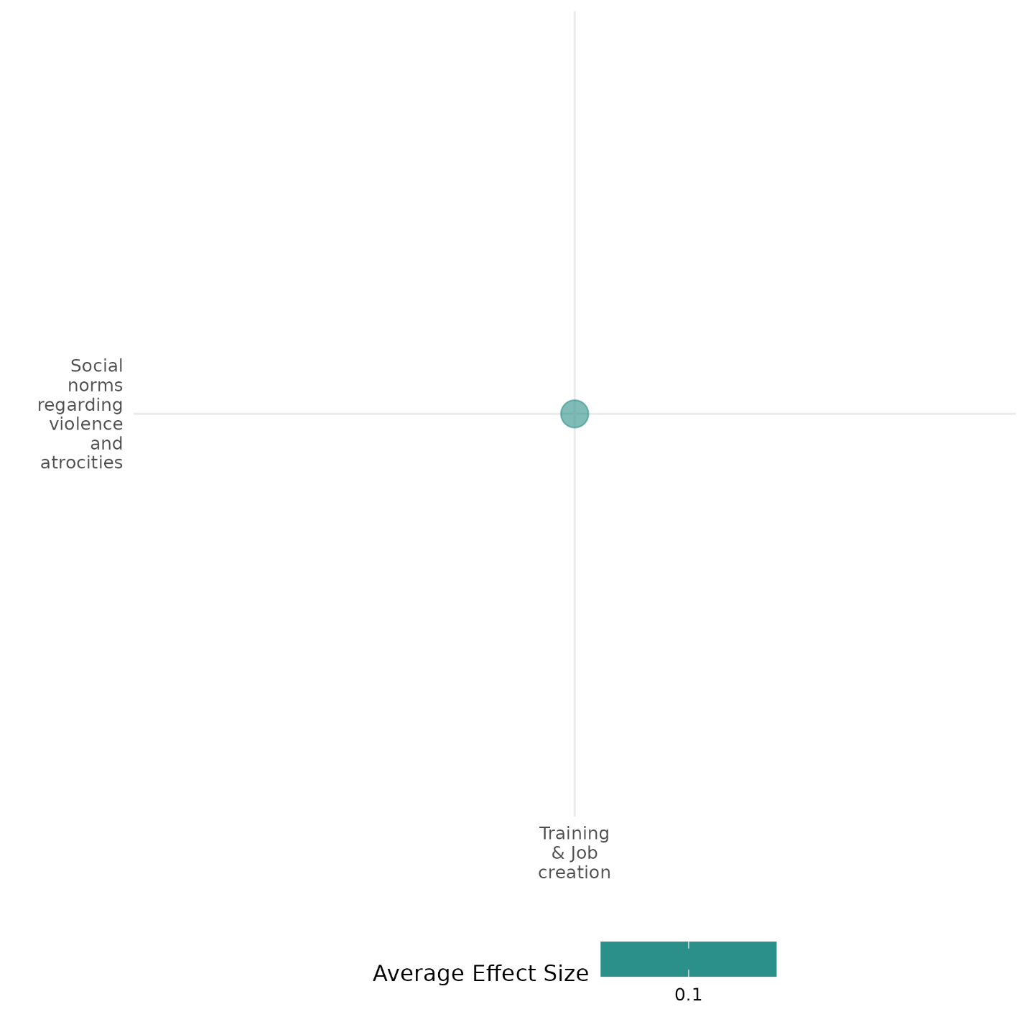

4.6.4(3)
Effect of training & job creation on Feelings of trust & Acceptance of diversity
Employment and training programs can foster social cohesion, but their impact on trust and diversity acceptance varies by context.
Geographic scope: Middle East, Africa
Effect: Large effect (g=0.239)
Confidence in study findings: Low (5 studies with 43 effect sizes)

Short Summary
Training and job creation programs, such as vocational training and business mentorship initiatives, aim to promote economic stability and social cohesion. Studies in Uganda, Somalia, Lebanon, South Sudan, and Mozambique reveal mixed effects on trust and acceptance of diversity. Some interventions foster cross-group interactions and reduce discrimination, particularly among refugees, while others show no impact or even negative effects on host community perceptions.

The intervention
The studies examined a range of employment and training initiatives designed to enhance economic opportunities and promote social cohesion among diverse groups. In Uganda, a program provided microentrepreneurs with cash grants and mentorship, testing whether pairing Ugandan business owners with refugee mentors could foster trust and support for inclusive policies. In Somalia, the YES and Y4C programs offered vocational training, cash-for-work opportunities, and business support to at-risk youth, aiming to improve economic conditions while also encouraging dialogue across clans and genders. In Lebanon and Jordan, vocational training programs targeted both host and refugee populations, offering skills in trades such as carpentry, electrical repair, and food processing, with some sessions designed to integrate participants from different backgrounds. In South Sudan, a youth business grant program provided a mix of financial assistance and business training, but its abrupt cancellation meant some participants received only training, leading to frustrations. In Mozambique, an economic training program sought to reduce anti-social behavior and radicalization among young Muslim men by improving entrepreneurship skills and employment prospects.

How the intervention is expected to work
Programs such as vocational training, public works employment, and startup grants seek to enhance financial independence and strengthen labor market integration. These are expected to provide stable income opportunities that will lower incentives for participation in crime or violent movements, while also fostering greater trust in government institutions. Some studies also assess how the expectation or cancellation of assistance affects decision-making and risk tolerance. Fostering social cohesion by incorporating mentorship programs, diverse hiring policies, and economic collaboration across different social groups aim to bridge social divisions through cross-community interactions. These seek to promote peaceful cooperation and reduce tensions linked to economic inequality. Ideological influences integrated with economic opportunities focus on shifting attitudes toward violence and promote alternative, non-violent pathways for social engagement.

The evidence base
This cell includes 6 impact evaluation studies, 1 systematic review, and 1 qualitative paper.
The review is concerned with interventions, including training, for women’s empowerment and gender equity in fragile settings.
The primary studies are conducted in the Middle East (Lebanon & Jordan) and Africa (Uganda, Somalia, South Sudan, and Mozambique). There is one ongoing primary study (quantiative) included which is set in Cote d'Ivoire, i.e., Marguerie (2018).

The review evidence
The review suggests that training programs that integrate social capital-building mechanisms contribute positively to trust and acceptance of diversity.

Evidence findings
Results show mixed outcomes. In Uganda, training that emphasized inclusive refugee policies increased support for refugees' rights, while mentorship had a weaker effect. In Somalia, employment programs promoted social cohesion across clans and genders, reducing support for violence. In Lebanon and Jordan, vocational training reduced discrimination among refugees but had no effect on host communities. In South Sudan, unmet expectations from a cash grant program eroded trust, particularly among women. In Mozambique, an economic training program did not increase trust and, in some cases, worsened perceptions of aggression.

The impact evaluation evidence
There are 6 impact evaluations, one of which is still ongoing. Five study summaries are thus provided here:
Baseler (2021) The study investigated two programs for Ugandan (host) microentrepreneurs: cash grants delivered with information that connects the grant with Uganda's inclusive refugee policies and existing aid-sharing policy, and mentorship by an experienced refugee. This tests whether mentorship is an effective means to promote skill transfer across nationalities and increase small business profits. The study is designed as a randomized controlled trial. The main sample consisted of 1,406 Ugandan businesses. These were randomly assigned to treatments (cash and information, cash, information, a refugee mentor, a Ugandan mentor) or control. The study found a positive effect of all treatment groups on the main outcome, a pre-specified index of policy preferences – inclusive policies including refugees' right to work and hosting additional refugees, that is statically significant at the 10% level. The cash and information combined treatment (T1), however, has a larger effect than the other four treatments. The study is rated as medium confidence.

Borino (2019) This study investigates the role of employment programs in reducing the willingness of individuals to engage in violence in Somalia. Specifically, it evaluates the impact of the International Labour Organization (ILO)'s "Joint Program Youth Employment Somalia" (YES) and "Youth for Change" (Y4C) initiatives on promoting stability and reducing support for violence among at-risk Somali youth. The YES and Y4C programs are employment-focused initiatives implemented in Somalia, targeting youth at risk of engaging in violent activities. These programs provide vocational training, cash-for-work opportunities, and support for micro, small, and medium enterprises (MSMEs). Although not designed explicitly for peacebuilding, their conflict-sensitive approach emphasizes inclusivity, transparency, and fostering social cohesion among beneficiaries in Bosasso (Puntland), Berbera (Somaliland), and Baidoa (South Somalia). The study analyzed data from approximately 200 participants to assess the impact of the YES and Y4C vocational training programs. Support for violence among beneficiaries significantly decreased, with those justifying violence for better services dropping from 16% to 6% and those endorsing violence for political causes falling from 37% to 27%. These changes were driven by three mechanisms: improved economic opportunities through skill development, enhanced social cohesion via dialogue across clans and genders, and grievance redressal through the programs’ inclusive and equitable design. The study is rated as low confidence as it is before and after study design.

Ferguson (2022) examine the effects of vocational training provided to both host and refugee participants in Lebanon and Jordan, both of which have large numbers of Syrian refugees. The programmes - Fostering Resilience by Strengthening Abilities and 3Amaly in Lebanon and the Access to Justice and Jobs in Jordan - were managed by a US NGO, Mercy Corps and implemented by local training providers. The courses provided marketable skills, such as aluminium fabrication and installation, woodworking and carpentry, food and dairy processing, electrical repair. Most of these activities are allowable for refugees, and so delivered in mixed sessions, although a small number were delivered to locals only because of employment restrictions. Courses lasted from two to eight weeks. The programme was oversubscribed, so treatment and control were sampled from successful and unsuccessful applicants respectively. There is some evidence that the training reduces ‘outgroup’ discrimination amongst refugees, but not the host population. The study is rated as medium confidence as it is non experimental and due to its attrition rate.

Muller et al. (2019) examine the effects of the unintended closure in 2016 of the Youth Business Start-Up Grant Programme in South Sudan. The intervention consisted of an unconditional cash grant worth US$1,000 combined with a one week business and life skills training. The grants were accessible through a commercial bank account. The group of approximately 1,200 participants were randomly selected from 6,000 applicants for the programme. A similar size group was randomly selected to be the control group. Because of the cancellation of the programme on account of escalating violence some participants received the training but no grant. Estimate of the ITT effect is by a regression with a treatment dummy and exogenous covariants. ToT effects are also estimated with a regression, though these cannot be interpreted as causal effects. To estimate causal effects are estimated with an instrumental variable, with proximity to a bank as the instrument, as having a commercial bank account was a condition of participation, and selection into training with grant or training but no grant. Baseline data were collected in April and May 2015. Many participants migrated to escape the violence, so attrition was a problem: 55 per cent were reached by phone prior to the endline, most of whom agreed to participant in the survey. Endline data were collected in 2017. There is no effect on trust overall, but it falls for women who expected the cash but did not receive it. The study is rated medium confidence because of moderate levels of attrition and incomplete description of the intervention

Vicente (2022) valuates the effectiveness of two interventions aimed at preventing Islamic radicalization and reducing anti-social behaviour in Cabo Delgado, Mozambique. This include a religious sensitization program, led by Muslim leaders to counter extremist narratives, and an economic training program, providing entrepreneurship skills and employment guidance to raise the opportunity cost of engaging in violence. The study employs a randomized controlled trial among young Muslim men, using a behavioural experiment (the Joy-of-Destruction game) and surveys to track changes on attitudes. Findings indicate that only the religious campaign was effective in reducing anti-social behaviour and increasing trust in government institutions, while the economic training had no significant behavioural impact and may increase perceptions of aggression from others. The study is rated low confidence as its attrition rate is not reported.

Confidence Assessment:
Overall medium: There are 6 studies covered under this cell with individual confidence assessments ranging from low to medium. Heterogeneity in study findings is observed.

Link to review summaries
Lwamba (2022)
All studies may be accessed via the EGM.

Other outcomes in the study:
Human Security / Economic Security
Human Security / Educational Security
Human Security / Food Security & Nutrition / Health Security
Violence & Atrocity Prevention / Social Norms on Violence
Community & State Governance / Government Performance
Human Security / Political Security

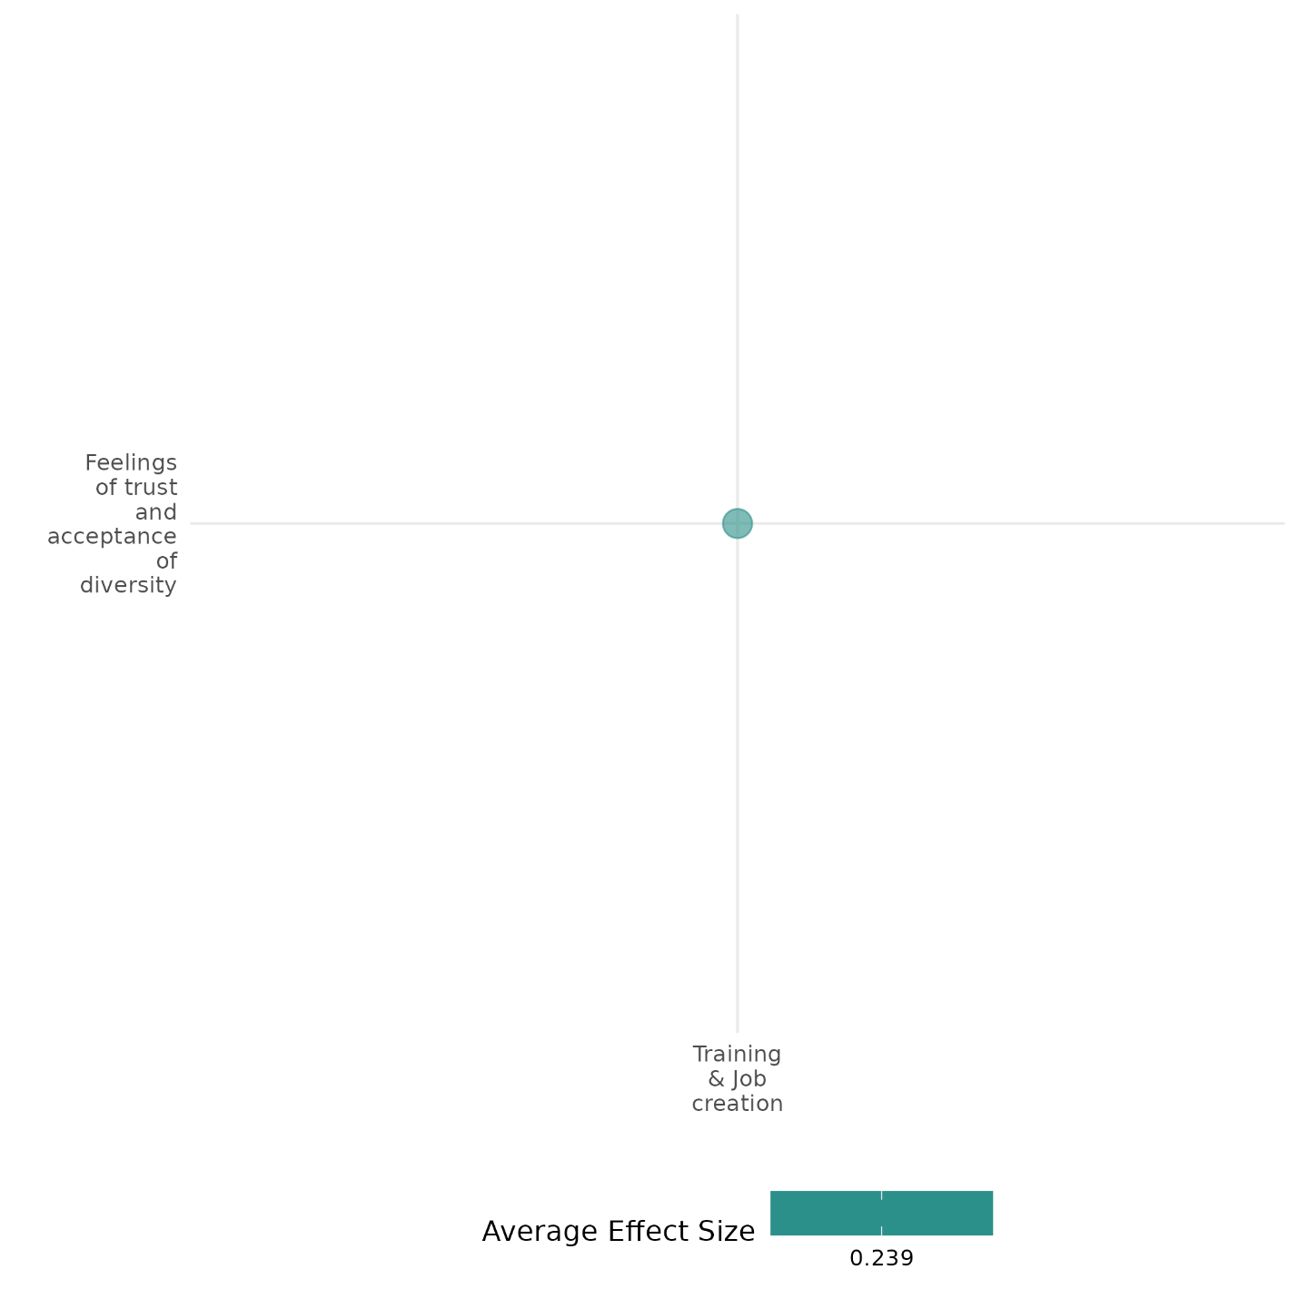
4.6.4(4)
Effect of training & job creation on sense of belonging
Vocational training programs can strengthen social connectedness and cross-tribal interactions, but they do not necessarily improve an individual’s perceived social status.
Geographic region: Middle East, Latin America, Africa
Effect: Moderate effect (g=0.114)
Confidence in study findings: Low (2 studies with 13 effect sizes)

Short Summary
Training and job creation programs, such as vocational and technical training initiatives, aim to enhance economic opportunities while potentially fostering a stronger sense of belonging. The INVEST program in Afghanistan, which provided vocational training, had mixed effects on social cohesion. While participants reported increased social connectedness and cross-tribal interactions, the program had no impact on their perceived social status, personal confidence, or feelings of respect within their community. Meanwhile, the mentorship program in Uganda increased increased support for inclusion among refugees.

The intervention
The programs included in this cell involve mentorship and technical and vocational training courses. The mentorship program in Uganda matched business owners with refugee mentors in the same industry who have more experience. Inclusion of this program is premised on the contact hypothesis, which suggests that close collaboration with outgroups fosters inclusion. Meanwhile, the program in Afghanistan aimed to improve youth employment by offering vocational and technical training in nine technical vocational education and training (TVET) centers. The training covered a variety of skills aligned with labor market needs, including tailoring, mobile phone repair, and information technology.

How the intervention is expected to work
Job training and employment programs can contribute to a greater sense of belonging through multiple mechanisms. By increasing economic security, these programs may enhance participants’ ability to integrate into their communities. Exposure to training environments can also expand social networks, promoting interactions across different social groups. Additionally, vocational training can provide individuals with a sense of purpose and shared identity, potentially strengthening social ties and reducing exclusion. However, in deeply stratified societies, employment alone may not be sufficient to change entrenched social hierarchies or improve perceptions of respect and status.

The evidence base
This cell includes 3 studies: 2 quantitative studies and 1 qualitative study. The study locations include Afghanistan, Uganda, and Colombia.

Evidence findings
The evaluation of the TVET program in Afghanistan found that it had some positive effects on social connectedness. Graduates were 10.7 percentage points more likely to report having friends to turn to for help or advice, suggesting an improvement in their social networks. Additionally, the program led to an 8.1 percentage point increase in participants identifying as Afghan above tribal or religious affiliations, indicating a shift toward broader national identity. However, the program did not significantly impact participants' sense of personal confidence, perceived respect within the community, or their social standing, suggesting that vocational training alone does not necessarily alter deeply ingrained social structures. Meanwhile, the mentorship program in Uganda increased support for inclusion (e.g., inclusive refugee hosting).

Included studies
Baseler (2021) investigated two programs for Ugandan (host) microentrepreneurs: cash grants delivered with information that connects the grant with Uganda's inclusive refugee policies and existing aid-sharing policy, and mentorship by an experienced refugee. This tests whether mentorship is an effective means to promote skill transfer across nationalities and increase small business profits. The study is designed as a randomized controlled trial. The main sample consisted of 1,406 Ugandan businesses. These were randomly assigned to treatments (cash and information, cash, information, a refugee mentor, a Ugandan mentor) or control. The study found a positive effect of all treatment groups on the main outcome, a pre-specified index of policy preferences – inclusive policies including refugees' right to work and hosting additional refugees, that is statically significant at the 10% level. The cash and information combined treatment (T1), however, has a larger effect than the other four treatments. The study is rated as medium confidence.
Kurtz (2015) examines the effect of the UK-supported INVEST program, which offered vocational and technical training courses in nine technical vocational education and training (TVET) centres in Helmand Province in Southern Afghanistan from 2011. The programme was implemented by a US NGO, Mercy Corps. At the time of the evaluation 25,000 students had graduated from the programme of which nearly on-third were women. The study used propensity score matching to match recruits from February to April 2014 with successful applicants who had not yet started the programme. There was some effect on social connectedness. Participants reported that they had more friends to turn to for help or advice (10.7 percentage points), as well as affecting participants’ identifying as an Afghan above a tribe or religion (8.1 percentage points). INVEST also had a positive effect on participants’ social interactions with people from other tribes. But the program had no impact on participants’ feelings of being respected, personal confidence, or their perceived social standing in their community.

Confidence Assessment:
Overall low: The overall rating is low given that there are only two studies in this cell.

Other outcomes in the study:
Violence and atrocity prevention / Social norms regarding violence and atrocities
Social cohesion / Willingness to participate or help
Social cohesion / Feelings of trust and acceptance of diversity
Community and state governance / Government performance
Human security / Economic security
Human security / Food security and nutrition & health security
Human security / Intermediate social cohesion outcomes

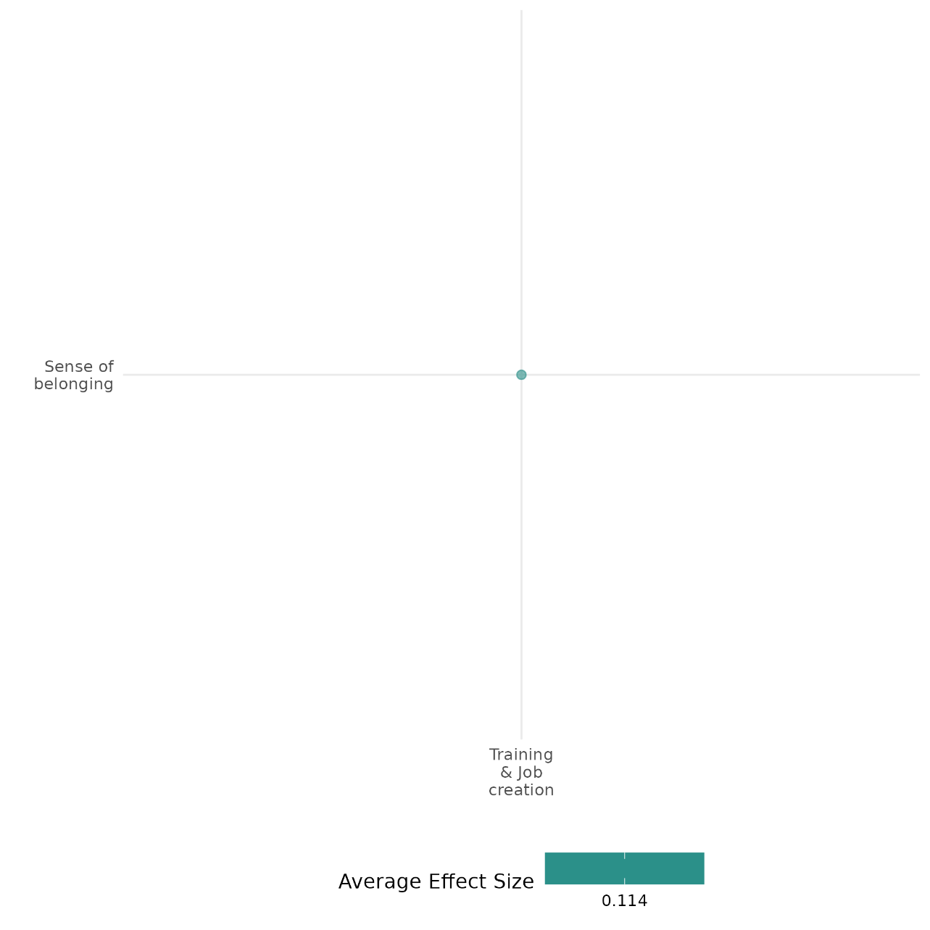

4.6.4(5)
Effect of training & job creation on willingness to participate or help
Job training and employment programs’ effect on willingness to participate or help tend to be unclear, although some positive association is found with connectedness to other tribes.
Geographic region: Africa, Middle East
Effect: Small effect (g=0.064)
Confidence in study findings: Low (2 studies with 3 effect sizes)

Short Summary
Training and job creation programs, such as vocational training and self-employment initiatives, aim to increase economic opportunities while also influencing individuals' willingness to participate in productive and social activities. Studies in Liberia and Afghanistan suggest mixed effects on willingness to help. No clear evidence is found in Liberia while positive effects were found in Afghanistan.

The intervention
Two major interventions were assessed for their effects on willingness to participate or help. In Liberia, the Action on Armed Violence (AoAV) agricultural training program targeted high-risk youth engaged in illicit mining and logging. The program provided residential agricultural training, counseling, and life skills classes, followed by farm inputs worth $125. Of the 1,100 men recruited, approximately half were randomly assigned to receive training. In Afghanistan, vocational and technical training courses in nine technical vocational education and training (TVET) centres were offered.

How the intervention is expected to work
These interventions are expected to increase willingness to participate in work and community life by enhancing skills, providing economic stability, and creating incentives for productive engagement. Vocational training programs improve employment prospects, reducing dependency on illicit activities or informal labor. Business grants and startup support enable individuals to invest in productive enterprises, strengthening their sense of agency and long-term engagement in economic activities. Additionally, structured programs that incorporate counseling and social components may help build social networks, which could encourage civic participation and community involvement. However, participation in economic activities does not necessarily lead to increased engagement in political or social movements, particularly in fragile settings where other barriers to civic participation exist.

The evidence base
There are 3 impact evaluation studies included in this cell. The study settings are: Afghanistan (1 study), Liberia (1 study), and Cote d'Ivoire [ongoing – Marguerie (2018)].

Evidence findings
Findings across the studies highlight mixed effects on willingness to participate or help. In Liberia, participants were less likely to engage with armed recruiters than those in the control group. However, there was no clear evidence that the program increased broader civic participation. On the other hand, in Afghanistan, positive effects were found on social connectedness, particularly on participants’ social interactions with people from other tribes.

Included studies
Blattman and Annan (2016) assess a training programme for high risk youth in Liberia. Specifically, the NGO Action on Armed Violence’s (AoAV) implemented a programme of residential agricultural training combined with counselling and “life skills” classes. The target group were youth engaged in illicit activities of mining and logging who were seen as at risk of engaging in conflict. At the end of the training participants received farm inputs worth $125. The NGO recruited 1100 high-risk men in 138 communities of which roughly half were assigned to the program on a random basis. Engagement in agriculture was of interest, with three-quarters of those assigned to the programme attending the training. Participants were less likely than the control to have met with armed recruiters. The study is rated low confidence because of lack of information on power calculations.

Kurtz (2015) examines the effect of the UK-supported INVEST program, which offered vocational and technical training courses in nine technical vocational education and training (TVET) centres in Helmand Province in Southern Afghanistan from 2011. The programme was implemented by a US NGO, Mercy Corps. At the time of the evaluation 25,000 students had graduated from the programme of which nearly on-third were women. The study used propensity score matching to match recruits from February to April 2014 with successful applicants who had not yet started the programme. There was some effect on social connectedness. Participants reported that they had more friends to turn to for help or advice (10.7 percentage points), as well as affecting participants’ identifying as an Afghan above a tribe or religion (8.1 percentage points). INVEST also had a positive effect on participants’ social interactions with people from other tribes, as well as a positive effect on a measure of discrimination. The study is rated low confidence because of lack of information on power calculations.

Confidence assessment
Overall low: There are less than four studies included in this cell, and all were rated as low confidence.

Other outcomes:
Violence and atrocity prevention / social norms regarding violence and atrocities
Human security / economic security
Human security / food security and nutrition & health security

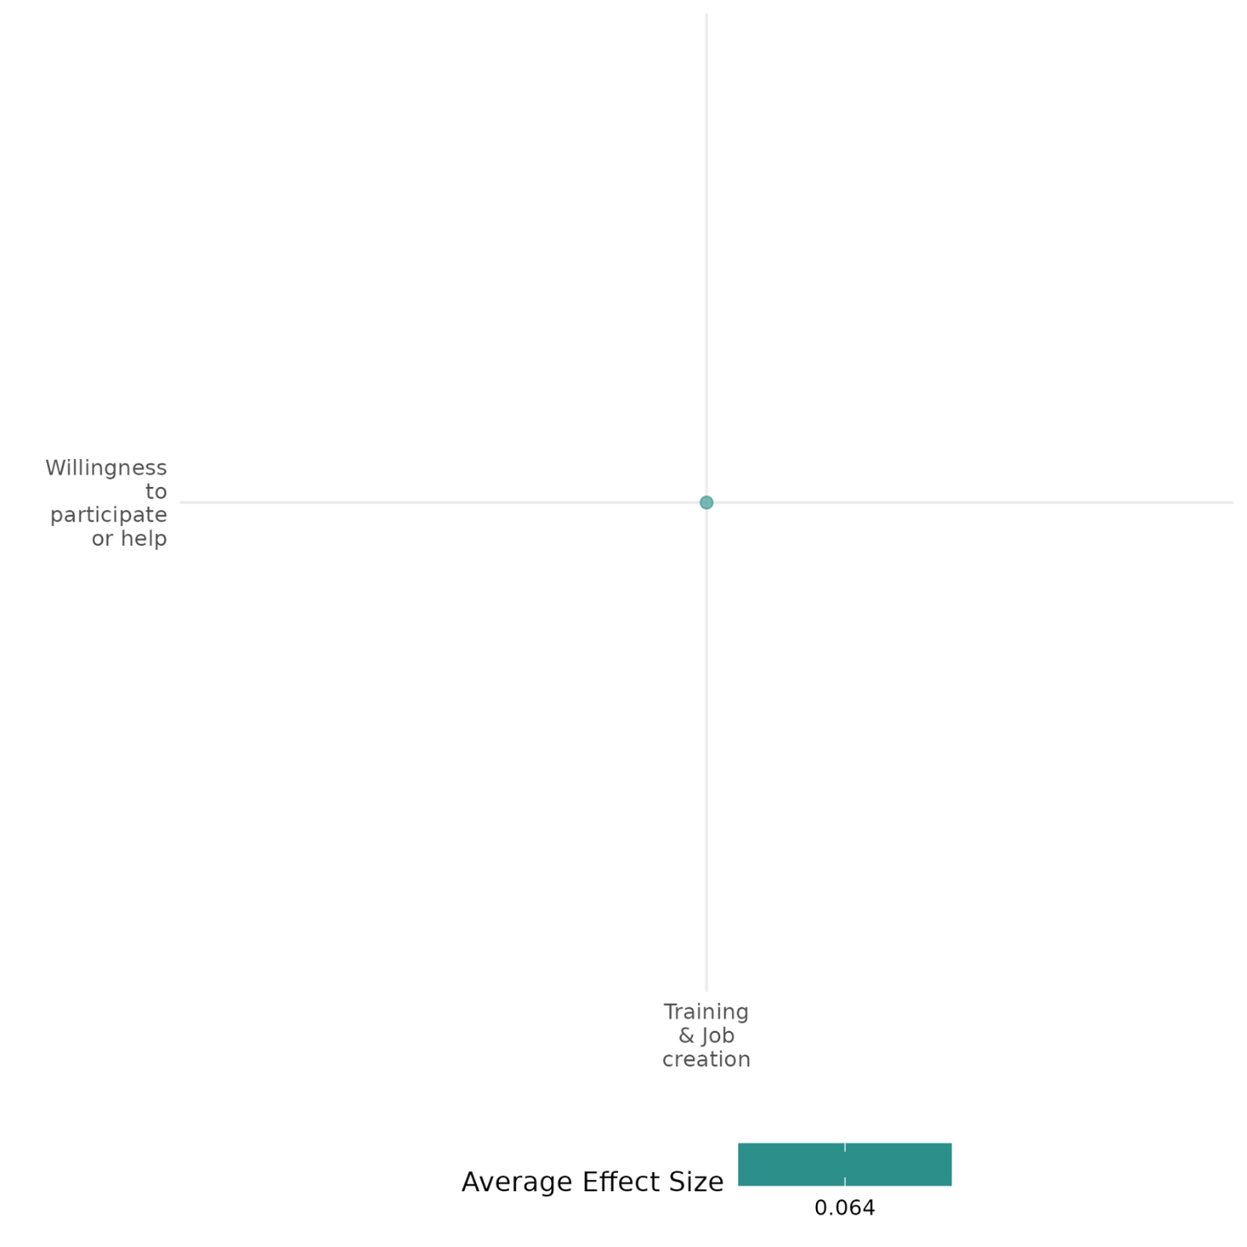

4.6.4(6)
Effect of training & job creation on government performance

Training & job creation interventions have mixed impact on government performance—while some initiatives enhance perceptions of governance, others show null or adverse effects.
Geographic region: Middle East, Africa
Effect size: Small effect (g=0.051)

Confidence in study findings: Low (5 studies with 29 effect sizes)

Short Summary
Training and job creation programs, such as vocational training programs, aim to improve economic stability and, in some cases, enhance perceptions of government performance. These interventions have been implemented in fragile and conflict-affected regions, often targeting vulnerable youth populations. Programs such as the International Labour Organization’s (ILO) Youth Employment Somalia (YES) and Youth for Change (Y4C) initiatives, the UK-supported INVEST vocational training program in Afghanistan, and various employment programs in African countries have been examined for their effects on government performance. While these interventions generally improve economic outcomes and reduce fears of crime, their impact on governance perceptions varies. Some studies show modest improvements in trust in government, while others find no effect or even a decline in institutional confidence.

The intervention
The interventions covered in this cell include a range of employment-focused initiatives designed to promote stability and economic security. In Somalia, the YES and Y4C programs provided vocational training, cash-for-work opportunities, and support for small businesses in conflict-affected regions, with a focus on social cohesion and equitable participation. In Afghanistan, the INVEST program, implemented by Mercy Corps, offered vocational and technical training to over 25,000 participants, including a significant number of women. For the five African countries, large employment for peace programmes were examined.

How the intervention is expected to work
Training and job creation interventions are expected to influence government performance through several mechanisms. By improving economic stability, they aim to reduce grievances related to unemployment and poverty, which can contribute to dissatisfaction with governance. Programs that incorporate social inclusion strategies, such as fostering dialogue across different communities, may also enhance perceptions of government responsiveness. Additionally, when employment initiatives are perceived as government-led or state-supported, they can serve as a signal that authorities are addressing economic needs, potentially increasing trust in public institutions. Finally, by providing alternative economic opportunities, these programs seek to reduce the appeal of armed opposition groups and political violence, indirectly promoting governance stability.

The evidence base
This cell includes 6 quantitative studies set in Somalia (1 study), Afghanistan (2 studies), and Uganda (1 study). Another study is conducted a pseudo-meta-analysis using data from five African nations. Finally, there is one ongoing study included in this cell which is set in Central African Republic, i.e., Alik-Lagrange Arthur (2019).

Evidence findings
Evidence on the effects of these programs on governance perceptions is mixed. The INVEST program in Afghanistan showed small improvements in perceptions of local government, particularly regarding its ability to provide employment. However, there was no measurable effect on young people’s willingness to engage in political violence. In Somalia, the YES and Y4C programs led to a decline in support for violence, with improved perceptions of governance attributed to the programs' inclusivity and transparency. Employment programs in Africa had a notable effect on reducing fears of crime, yet their impact on trust in government was inconsistent—some countries experienced a decline in government trust, while others saw no significant change.

Included studies
Baseler (2021) The study investigated two programs for Ugandan (host) microentrepreneurs: cash grants delivered with information that connects the grant with Uganda's inclusive refugee policies and existing aid-sharing policy, and mentorship by an experienced refugee. This tests whether mentorship is an effective means to promote skill transfer across nationalities and increase small business profits. The study is designed as a randomized controlled trial. The main sample consisted of 1,406 Ugandan businesses. These were randomly assigned to treatments (cash and information, cash, information, a refugee mentor, a Ugandan mentor) or control. The study found a positive effect of all treatment groups on the main outcome, a pre-specified index of policy preferences – inclusive policies including refugees' right to work and hosting additional refugees, that is statically significant at the 10% level. The cash and information combined treatment (T1), however, has a larger effect than the other four treatments. The study is rated as medium confidence.
Borino (2019) This study investigates the role of employment programs in reducing the willingness of individuals to engage in violence in Somalia. Specifically, it evaluates the impact of the International Labour Organization (ILO)'s "Joint Program Youth Employment Somalia" (YES) and "Youth for Change" (Y4C) initiatives on promoting stability and reducing support for violence among at-risk Somali youth. The YES and Y4C programs are employment-focused initiatives implemented in Somalia, targeting youth at risk of engaging in violent activities. These programs provide vocational training, cash-for-work opportunities, and support for micro, small, and medium enterprises (MSMEs). Although not designed explicitly for peacebuilding, their conflict-sensitive approach emphasizes inclusivity, transparency, and fostering social cohesion among beneficiaries in Bosasso (Puntland), Berbera (Somaliland), and Baidoa (South Somalia). The study analyzed data from approximately 200 participants to assess the impact of the YES and Y4C vocational training programs. Support for violence among beneficiaries significantly decreased, with those justifying violence for better services dropping from 16% to 6% and those endorsing violence for political causes falling from 37% to 27%. These changes were driven by three mechanisms: improved economic opportunities through skill development, enhanced social cohesion via dialogue across clans and genders, and grievance redressal through the programs’ inclusive and equitable design. The study is rated as low confidence as it is before and after study design.
Ferguson (2019) examines whether employment programs contribute to peace and stability in Africa by analyzing data from five countries: Burundi, Guinea, Liberia, Mali, and Uganda. Using a pseudo-meta-analysis and a difference-in-differences (DID) approach with matched samples, the study evaluates the relationship between employment programs and stability-related outcomes. Findings indicate that employment programs significantly reduce fears of being victimized by crime across all case-study countries. However, effects on other indicators are mixed—trust in government declines in some contexts, while satisfaction with government performance remains largely unchanged. These results suggest that while employment interventions can enhance perceptions of safety, their broader impacts on governance and institutional trust are less consistent. The study calls for further research into the mechanisms driving these effects and highlights the need for targeted program designs that maximize positive stability outcomes while minimizing unintended consequences. The study is rated low due to little description of the intervention, outcomes, and evaluation questions.
Kurtz (2015 and 2018) examines the effect of the UK-supported INVEST program, which offered vocational and technical training courses in nine technical vocational education and training (TVET) centres in Helmand Province in Southern Afghanistan from 2011. The programme was implemented by a US NGO, Mercy Corps. At the time of the evaluation 25,000 students had graduated from the programme of which nearly on-third were women. The study used propensity score matching to match recruits from February to April 2014 with successful applicants who had not yet started the programme. The training had substantial economic benefits for participants, with a greater likelihood of employment (currently employed 35.7 percentage points and, paid work 12.7 percentage points increase), as well as greater job satisfaction and economic optimism and being more likely to engage in economic activity with another tribe. There was no effect on young people’s willingness to use violence for political or other cause. There was a small improvement in perception of local government, especially their ability to provide employment. However, increased confidence in local, informal institutions, including traditional leaders (shuras), civil society organizations and religious leaders did not have any effect on willingness to engage in political violence. The study is rated low confidence because of lack of information on power calculations.

Confidence assessment:
Overall low: The cell is rated low considering that almost all the included studies were rated with low confidence.

Other outcomes in this study:
Violence and atrocity prevention / Social norms regarding violence and atrocities
Social cohesion / Feelings of trust & Acceptance of diversity
Social cohesion / Sense of belonging
Human security / Economic security
Human security / Physical security

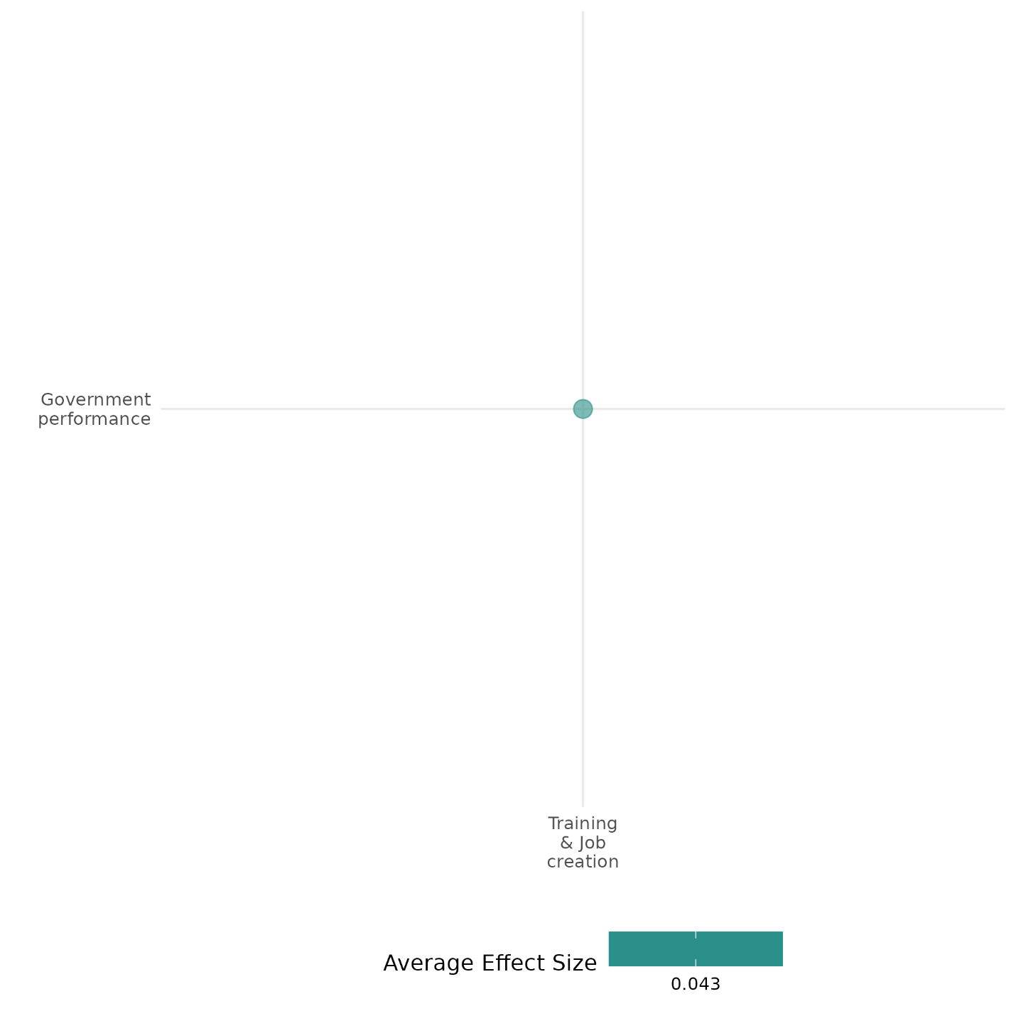

4.6.4(7)
Effect of training & job creation on economic security
Training and job creation programs have a generally positive impact on economic security, increasing employment rates, stabilizing incomes, and reducing reliance on illegal work.
Geographic region: Global, Africa, Middle East, Asia
Effect: Moderate effect (g=0.188)
Confidence in study findings: High (15 studies with 190 effect sizes)

Short Summary
Training and job creation programs may include vocational training, business mentorship, and financial assistance interventions. Evidence from 15 impact evaluations and 2 systematic reviews suggests that these programs generally lead to increased employment and higher incomes. Notable examples include Liberia’s agricultural training program, which achieved a 77% engagement in farming, and Tanzania’s RukaJuu! initiative, where entrepreneurship training raised earnings by 146%. Public works programs, such as India’s NREGA, demonstrated success in stabilizing incomes during economic shocks. However, some interventions yielded mixed effects, particularly in fragile and gender-unequal settings where access to decent work remained limited despite training.

The intervention
The interventions covered in the impact evaluations primarily involve vocational training, business skills development, and direct financial grants aimed at improving economic security. These programs may target marginalized or high-risk groups, such as youth engaged in illicit activities, refugees, or individuals affected by conflict and poverty. Many interventions integrate skill-building with financial assistance (e.g., microgrants, farm inputs) and, in some cases, life skills or counseling to encourage sustainable economic participation.

How the intervention is expected to work
The interventions aim to enhance economic security by increasing employment opportunities, stabilizing incomes, and reducing reliance on illicit or precarious work. By providing vocational training, business mentorship, and financial grants, these programs equip participants with the skills and resources needed to enter the labor market or start their own enterprises. Additionally, training programs help shift participants away from informal or illegal work—such as mercenary activities or illicit mining—toward stable livelihoods, thereby promoting economic resilience. In conflict-affected areas, these interventions also contribute to social cohesion and stability by reducing economic grievances and decreasing incentives to engage in violence or criminal activities.

The evidence base
This cell includes 17 impact evaluation studies and 2 systematic reviews. Note that two of the 17 impact evaluations are study protocols. These include Alik-Lagrange (2019) and Marguerie (2018) which are set in the Central African Republic and Cote d’Ivoire.
One of the reviews discusses employment programmes in general, which are mainly vocational training. The other is concerned with interventions, including training, for women’s empowerment and gender equity in fragile settings.
The study settings for the impact evaluation evidence include: South Africa (1 study), Uganda (1 study), Liberia (3 studies), Somalia (1 study), five African countries (1 study), Lebanon and Jordan (1 study), India (1 study), Tanzania (2 studies), Afghanistan (2 studies), South Sudan (1 study), and Sierra Leone (1 study).

Evidence findings
The evidence indicates that training and job creation program generally have a positive effect on economic security. Several studies report increased employment rates, such as the INVEST program in Afghanistan and Sierra Leone’s Cash-for-Work initiative, with Liberia’s agricultural training program leading to a 77% employment rate in farming among participants. Income gains were observed in multiple programs, including RukaJuu! in Tanzania, where entrepreneurship training increased earnings by 146%. Business growth and financial resilience were also noted, with youth microenterprise programs in Uganda and South Sudan leading to higher savings, although employment effects varied. Programs like India’s NREGA played a crucial role in stabilizing incomes during economic shocks by mitigating wage declines in agriculture. Additionally, several interventions successfully facilitated a shift from illicit activities to formal employment, demonstrating the potential of training and job creation initiatives to enhance economic security, particularly in fragile contexts.

The review evidence
Both reviews show that training interventions have positive effects on economic security, especially employment. One of the reviews conducts meta-analysis and finds that technical and vocational training improved the capacities of women entrepreneurs and their access to assets, credit and income. However, null effects were found in terms of women’s access to decent work, particularly in fragile and gender unequal states.

The impact evaluation evidence
There are 17 impact evaluations included in this cell. Two of these studies are earlier versions, one study evaluated the same program, and two are protocols. Thus, 12 summaries are provided below:
Adato (2005) examines the effectiveness of public works programs as a tool for poverty alleviation in the Western Cape province of South Africa. The study focuses on seven different public works programs that were designed to provide short-term employment opportunities. The study employs mixed-methods approach, using quantitative data from 101 public works projects and qualitative insights from eight in-depth case studies in the Western Cape province. Quantitative analysis examined outcomes such as job creation, cost efficiency, and labor intensity, while case studies explored the roles and challenges of community involvement. The study finds that community participation significantly improved project outcomes, including increased labor intensity, reduced cost of job creation, and higher inclusion of women. Participation also enhanced the number of training and workdays provided. The study is rated medium as it is non-experimental.
Baseler (2021) The study investigated two programs for Ugandan (host) microentrepreneurs: cash grants delivered with information that connects the grant with Uganda's inclusive refugee policies and existing aid-sharing policy, and mentorship by an experienced refugee. This tests whether mentorship is an effective means to promote skill transfer across nationalities and increase small business profits. The study is designed as a randomized controlled trial. The main sample consisted of 1,406 Ugandan businesses. These were randomly assigned to treatments (cash and information, cash, information, a refugee mentor, a Ugandan mentor) or control. The study found a positive effect of all treatment groups on the main outcome, a pre-specified index of policy preferences – inclusive policies including refugees' right to work and hosting additional refugees, that is statically significant at the 10% level. The cash and information combined treatment (T1), however, has a larger effect than the other four treatments. The study is rated medium confidence.
Blattmann and Annan (2011) and Blattman and Annan (2016) assess a training programme for high-risk youth in Liberia. Specifically, the NGO Action on Armed Violence’s (AoAV) implemented a programme of residential agricultural training combined with counselling and “life skills” classes. The target group were youth engaged in illicit activities of mining and logging who were seen as at risk of engaging in conflict. At the end of the training participants received farm inputs worth $125. The NGO recruited 1100 high-risk men in 138 communities of which roughly half were assigned to the program on a random basis. Engagement in agriculture was of interest, with three-quarters of those assigned to the programme attending the training. About 77% of participants engaged in farming, compared to 61% of controls. Participants reduced their illicit activities by about 20%, though n one abandoned them completely. Incomes rose by on average US$12 a month. One-third of the participants did not receive the inputs because of supply issues, and so were promised future cash provided they stayed in the village. This group saw the largest reduction in illicit activities. A short war occurred during the study period. Participants were less likely than the control to have met with recruiters. The study is rated low confidence because of lack of information on power calculations.
Borino (2019) This study investigates the role of employment programs in reducing the willingness of individuals to engage in violence in Somalia. Specifically, it evaluates the impact of the International Labour Organization (ILO)'s "Joint Program Youth Employment Somalia" (YES) and "Youth for Change" (Y4C) initiatives on promoting stability and reducing support for violence among at-risk Somali youth. The YES and Y4C programs are employment-focused initiatives implemented in Somalia, targeting youth at risk of engaging in violent activities. These programs provide vocational training, cash-for-work opportunities, and support for micro, small, and medium enterprises (MSMEs). Although not designed explicitly for peacebuilding, their conflict-sensitive approach emphasizes inclusivity, transparency, and fostering social cohesion among beneficiaries in Bosasso (Puntland), Berbera (Somaliland), and Baidoa (South Somalia). The study analyzed data from approximately 200 participants to assess the impact of the YES and Y4C vocational training programs. Support for violence among beneficiaries significantly decreased, with those justifying violence for better services dropping from 16% to 6% and those endorsing violence for political causes falling from 37% to 27%. These changes were driven by three mechanisms: improved economic opportunities through skill development, enhanced social cohesion via dialogue across clans and genders, and grievance redressal through the programs’ inclusive and equitable design. The study is rated as low confidence as it is before and after study design.
de Chaisemartin (2020) revisits the Blattman & Annan (2016) experiment in Liberia, which evaluated the impact of an agricultural training program on ex-combatants who were at risk of engaging in illegal activities, including mercenary work. Participants were randomly assigned to training through a randomized waitlist mechanism, and the study sought to estimate the program's effects on employment, income, and social outcomes. The authors proposed a new estimator, the Doubly Reweighted Ever-Offer (DREO) estimator, which corrects for this bias by adjusting for endogenous selection in treatment offers. The study finds that the agricultural training program had a positive impact on economic stability, particularly through employment shifts. For one, the income index improved, though the effect size was small (0.169 standard deviations). While the income index showed a modest increase, the most significant changes were observed in occupational shifts, particularly moving away from illegal work toward farming. The study is rated as low confidence due little description of the evaluation questions and outcomes.
Ferguson (2019) explores whether employment programs contribute to peacebuilding by analyzing stability-related outcomes in five African countries (Burundi, Guinea, Liberia, Mali, and Uganda). Using a pseudo-meta-analysis and a difference-in-differences (DID) approach with matched samples, the study finds mixed effects. Employment programs significantly reduced fear of crime in all five countries, suggesting a positive impact on perceived security. The study is rated low due to little description of the intervention, outcomes, and evaluation questions. The study is rated low confidence due to little description of intervention, outcomes, and evaluation questions.
Ferguson (2022) examine the effects of vocational training provided to both host and refugee participants in Lebanon and Jordan, both of which have large numbers of Syrian refugees. The programmes - Fostering Resilience by Strengthening Abilities and 3Amaly in Lebanon and the Access to Justice and Jobs in Jordan - were managed by a US NGO, Mercy Corps and implemented by local training providers. The courses provided marketable skills, such as aluminium fabrication and installation, woodworking and carpentry, food and dairy processing, electrical repair. Most of these activities are allowable for refugees, and so delivered in mixed sessions, although a small number were delivered to locals only because of employment restrictions. Courses lasted from two to eight weeks. The programme was oversubscribed, so treatment and control were sampled from successful and unsuccessful applicants respectively. The intervention has little impact on perceptions of economic scarcity, and no effect from participation on optimism about the respondent’s economic situation. But there are effects from assignment to the programme, which are negative for hosts but positive for refugees. There are also no significant effects on perceived economic scarcity across a range of measures. The study is rated medium since it is non-experimental and due to its attrition rate.
Fetzer (2020) The study assesses the impact of India's National Rural Employment Guarantee Act (NREGA) on reducing conflict intensity by moderating the effects of adverse weather shocks, specifically monsoon rainfall deficits, on household incomes. Launched in 2006 in India, NREGA is the world’s largest public employment program, guaranteeing up to 100 days of employment annually at minimum wages for rural households through public works aimed at creating sustainable infrastructure. By providing a safety net, the program stabilizes household incomes, particularly for individuals with limited income options during adverse economic conditions, aiming to reduce economic vulnerabilities and their potential link to conflict. The study combines household-level panel data with district-level conflict records in India, revealing that prior to NREGA, adverse monsoon rainfall reduced agricultural output by 0.32% for every 1% rainfall deficit and significantly lowered agricultural wages. However, post-NREGA, this relationship disappears, showing that the program has a stabilizing effect on incomes. In summary, NREGA reduces the vulnerability of rural households to weather-induced income shocks, stabilizes agricultural labor markets, and indirectly lowers conflict intensity, demonstrating its effectiveness as a social insurance mechanism in resource. The study is rated as medium confidence as it is non- experimental study design.
Jansen (2022) and Outwater et al. (2019) report findings from a pilot study of RukaJuu!, an intervention conducted in 2015 which offered vocational training in beekeeping, entrepreneurship or both in Dar es Salaam, Tanzania where community violence is high. Participants were young men aged 16 and above. For the entrepreneurship training participants were shown videos of an edutainment series which had been on television a few years earlier. The beekeeping training was led by beekeeping officers of the Tanzanian Ministry of Natural Resources and Tourism, covering practical aspects of beekeeping such as and to build a beehive. No financial support was provided. The study was conducted in four neighborhood camps (called ) in Dar es Salaam, Tanzania, with each camp randomly assigned to one treatment arm. A total of 55 men participated from the four camps. All arms, including the control, also received a health intervention. The number of training sessions was: Health/Control (2 sessions), Entrepreneurship + Health (6 sessions), Beekeeping + Health(6 sessions), and Entrepreneurship + Beekeeping + Health (10 sessions). data were collected at baseline and 3 months, 6 months, and 1 year after the sessions were completed. Deteriorating economic conditions meant that earnings fell by 37% in the control group. By contrast, incomes increased in all three intervention camps: beekeeping by 43%, entrepreneurship by 146% and combined by 50%, The most persistently reported constraint to business operations was insufficient start-up capital. Financial capital increased in all three treatment arms, though the effect is not significant for either of the arms including beekeeping: beekeeping (TSh29,310), entrepreneurship (82,334), and both (23,145). The study is rated medium confidence based on study design (pre-post test with one comparison camp).
Kurtz (2015 and 2018) examines the effect of the UK-supported INVEST program, which offered vocational and technical training courses in nine technical vocational education and training (TVET) centres in Helmand Province in Southern Afghanistan from 2011. The programme was implemented by a US NGO, Mercy Corps. At the time of the evaluation 25,000 students had graduated from the programme of which nearly on-third were women. The study used propensity score matching to match recruits from February to April 2014 with successful applicants who had not yet started the programme. The training had substantial economic benefits for participants, with a greater likelihood of employment (currently employed 35.7 percentage points and, paid work 12.7 percentage points increase), as well as greater job satisfaction and economic optimism and being more likely to engage in economic activity with another tribe. The study is rated low confidence because of lack of information on power calculations.
Muller (2019) examine the effects of the unintended closure in 2016 of the Youth Business Start-Up Grant Programme in South Sudan. The intervention consisted of an unconditional cash grant worth US$1,000 combined with a one week business and life skills training. The grants were accessible through a commercial bank account. The group of approximately 1,200 participants were randomly selected from 6,000 applicants for the programme. A similar size group was randomly selected to be the control group. Because of the cancellation of the programme on account of escalating violence some participants received the training but no grant. Estimate of the ITT effect is by a regression with a treatment dummy and exogenous covariants. ToT effects are also estimated with a regression, though these cannot be interpreted as causal effects. To estimate causal effects are estimated with an instrumental variable, with proximity to a bank as the instrument, as having a commercial bank account was a condition of participation, and selection into training with grant or training but no grant. Baseline data were collected in April and May 2015. Many participants migrated to escape the violence, so attrition was a problem: 55 per cent were reached by phone prior to the endline, most of whom agreed to participant in the survey. Endline data were collected in 2017. Participants who received training and cash displayed significant increases in savings partly as a result of reduced consumption, but no effect on employment or business skills. The effects on savings are large for males than females. The study is rated medium confidence because of moderate levels of attrition and incomplete description of the intervention
Rosas (2016) The study provides a comprehensive analysis of the short-term impacts of Sierra Leone's Cash for Work (CfW) public works program, launched in 2010 under the Youth Employment Support Project with World Bank support. By employing a phased-in randomized control trial, the study examines how the program influenced household welfare, economic prospects, and labor market participation. The key findings from the study on the labor-intensive public works program in Sierra Leone are as follows: the program significantly boosted cash income among participants, with an increase of nearly three times the amount compared to control households. Overall, treated households saw a 29% rise in monthly income. Participation in the program led to increased labor force participation not only among program participants but also among other household members, especially in rural areas. The program notably increased female labor force participation. Households used the additional income for food, health services, and investments in home improvements and businesses. However, some consumption of "temptation goods," like cigarettes, increased slightly, and student absenteeism rose, likely due to children helping with household tasks. Treated households were more likely to start new businesses (nearly four times more likely than control households) and increased their participation in informal savings groups. Participation in the program led to greater utilization of health services, particularly for young male children. The program demonstrated the potential of public works as productive safety nets, providing immediate income support and opening avenues for investment in household resilience and productivity. However, some challenges, such as informal rotation and leakage, may have affected its effectiveness. The program's cost-effectiveness was evaluated, with the average cost per subproject being about $16,000, which led to significant impacts on job creation and income enhancement, providing a valuable model for future programs in post-conflict settings. The study was rated as having low confidence because the author provided little or no description of the evaluation question.

Confidence assessment
Overall high: Given the large number of studies included in this cell, as well as the consistency in the findings of most studies, this cell is rated high.

Link to review summaries
Bruck (2018)
Lwamba (2022)
All studies may be accessed via the EGM.

Other outcomes in the study:
Human security / Educational security
Human security / Food security and nutrition & Health security
Violence and atrocity prevention
Social cohesion / Feelings of trust & Acceptance of diversity
Violence and atrocity prevention / Social norms regarding violence and atrocities
Social cohesion / Sense of belonging
Social cohesion / Willingness to participate or help
Community and state governance / Government performance
Human security / Intermediate social cohesion outcomes
Violence and atrocity prevention / Nature and scale of violence or atrocities

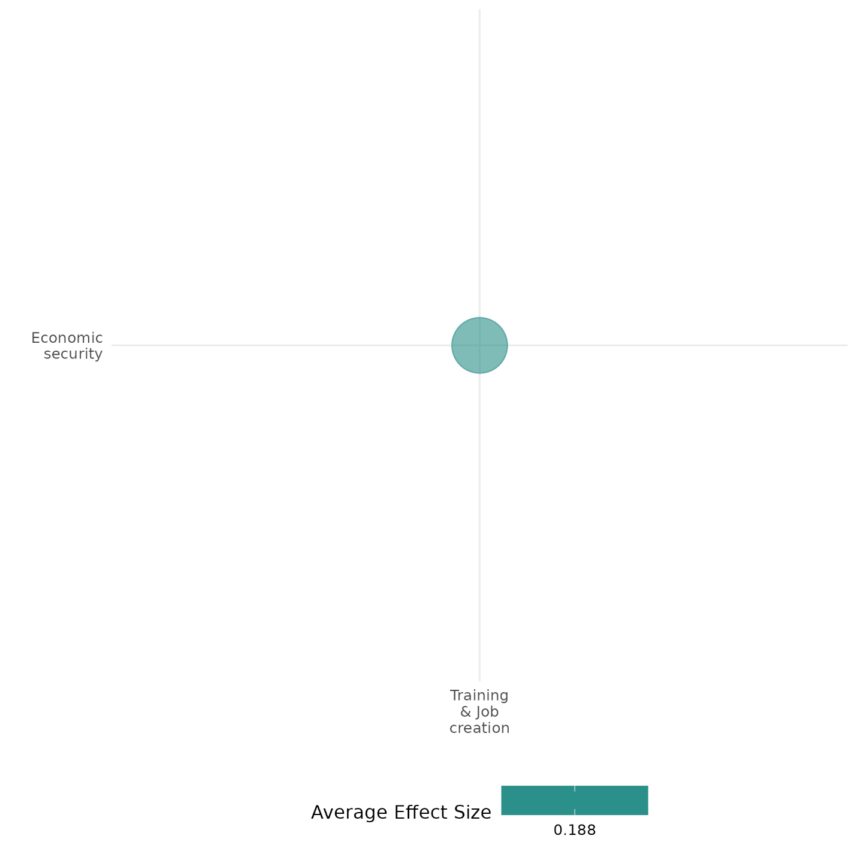

4.6.4(8)
Effect of training & job creation on educational security

Training and job creation programs, such as labor-intensive public works, increased school absenteeism, which reflects potential trade-offs between short-term employment and educational security.

Geographic scope: Africa

Effect: Adverse effect (g=-0.027)

Confidence in study findings: Low (1 study with 2 effect sizes)

Short Summary
Training and job creation programs, such as labor-intensive public works (PW), aim to provide temporary employment and economic stability, particularly in post-conflict settings. The Sierra Leone Cash-for-Work (CfW) program successfully increased economic outcomes, led to higher student absenteeism, suggesting potential trade-offs between short-term employment and educational security.
The intervention
Training and job creation interventions may include labor-intensive public works program, such as the Cash-for-Work (CfW) program in Sierra Leone. Implemented under the Youth Employment Support Project with World Bank support, this program aimed to provide temporary employment to vulnerable youth aged 15–35. The program offered 50–75 days of paid labor in community infrastructure projects, such as feeder road rehabilitation, agriculture, and environmental initiatives. Payments were made weekly at a daily wage of approximately $1.80, slightly below market wages to encourage participation from the most economically disadvantaged groups. The program was rolled out through a randomized phase-in strategy across 276 communities, with 143 receiving the intervention during the study period.

How the intervention is expected to work
The CfW program was designed to provide immediate income support while fostering long-term economic participation. By increasing cash flow within households, the intervention aimed to stabilize consumption, improve welfare, and reduce economic-driven instability. It was also expected to allow households to invest in productive assets and encourage workforce participation beyond direct program beneficiaries. However, as young adults in targeted households take up temporary employment, the program could potentially have negative effects on school attendance and long-term educational security.

The evidence base
This cell includes one impact evaluation study conducted in Sierra Leone.

Evidence findings
Findings show that labor-intensive public works program increased student absenteeism in treatment households, indicating that work opportunities may have diverted time from education. Although the program improved short-term financial stability, it did not significantly enhance skills development or long-term employment prospects that could support sustained educational engagement.

Included studies
Rosas (2016) The study provides a comprehensive analysis of the short-term impacts of Sierra Leone's Cash for Work (CfW) public works program, launched in 2010 under the Youth Employment Support Project with World Bank support. By employing a phased-in randomized control trial, the study examines how the program influenced household welfare, economic prospects, and labor market participation. The key findings from the study on the labor-intensive public works program in Sierra Leone are as follows: Households used the additional income for food, health services, and investments in home improvements and businesses. However, some consumption of "temptation goods," like cigarettes, increased slightly, and student absenteeism rose, likely due to children helping with household tasks. The study is rated low due to its little description of the evaluation questions.

Confidence Assessment
Overall low: The cell is rated low given that it only includes 1 impact evaluation study.

Other outcomes in the study:
Human security / Economic security
Human security / Food security and nutrition & Health security
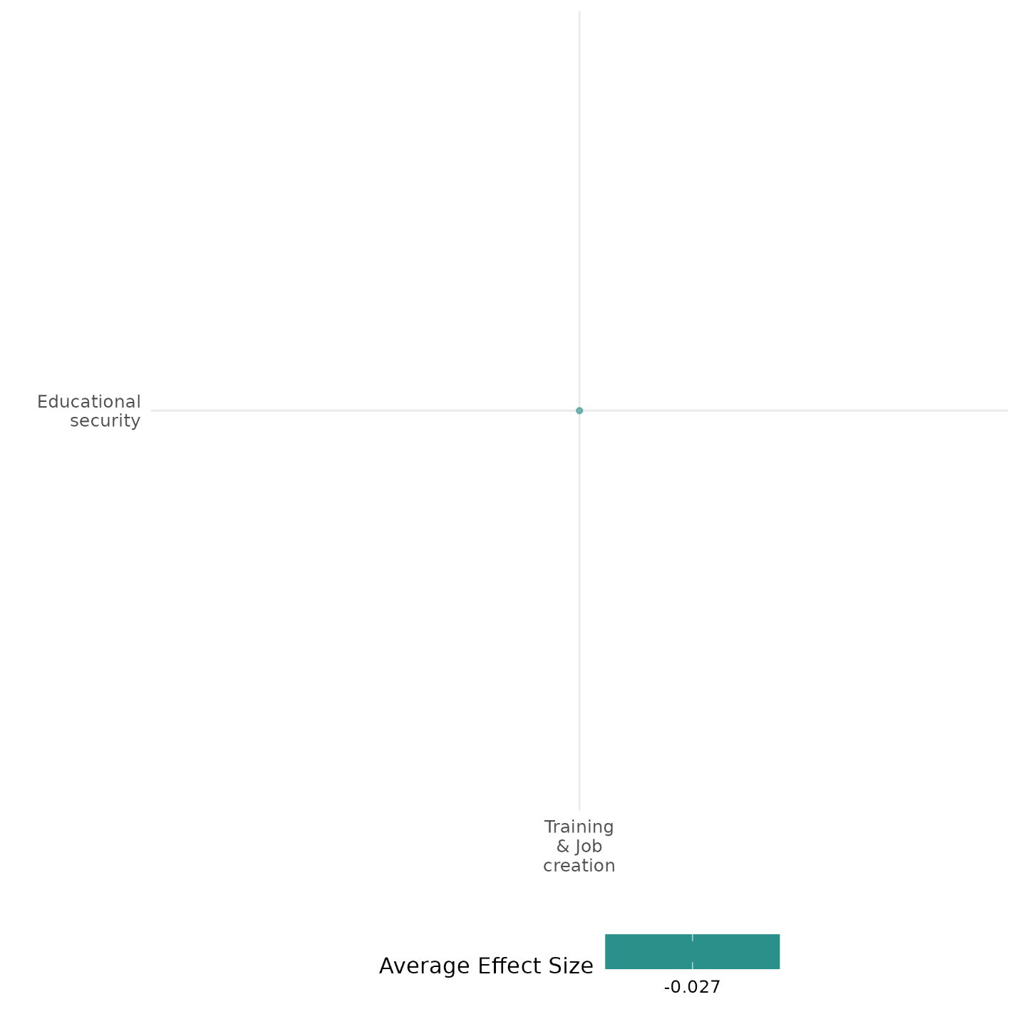

4.6.4(9)
Effect of training & job creation on food security and nutrition & health security
While some training & job creation programs enhance access to healthcare, others show li
mited effects on food availability and psychosocial well-being.
Geographical region: Africa
Effect: Small effect (g=0.036)
Confidence in study findings: Low (3 studies with 6 effect sizes)

Short Summary
Training and job creation programs aim to improve food security and health outcomes by enhancing employment opportunities, skills development, and access to resources. These interventions range from vocational training to cash-for-work programs. Evidence suggests that such programs can lead to improved healthcare utilization, though no significant effects were found on food availability and psychosocial well-being (when the intervention is implemented solitarily).
The intervention
The studies reviewed cover a variety of interventions aimed at enhancing food security and health security through training and job creation. These include asset transfer programs combined with agricultural training, vocational training linked to entrepreneurship, and public works employment schemes. Some interventions also integrate nutrition education and social protection measures, such as cash transfers or food rations.

How the intervention is expected to work
Training and job creation programs improve food security and health security through multiple mechanisms. First, they increase household income, enabling better access to nutritious food and essential healthcare. Second, vocational and agricultural training equip individuals with skills to sustain food production and manage small businesses. Third, public works programs provide direct income support while also building infrastructure that can enhance long-term agricultural productivity and access to markets. In addition, interventions that integrate nutrition education promote healthier dietary choices and improved childcare practices.

The evidence base
The cell contains 4 studies: 1 systematic review and 3 impact evaluations.
The review examines the integration of psychosocial support with livelihood interventions in fragile and conflict-affected settings (FCS). It assesses whether this combination improves both mental well-being and economic resilience.
The quantitative studies are set in Sierra Leone (1), South Sudan (1), and Uganda (1).

Evidence findings
Empirical evidence from randomized control trials indicates that training and job creation interventions have varying effects on food security and health security. In Sierra Leone, CfW led to a marked rise in healthcare utilization, especially for young boys. However, null effects were found in psychosocial well-being and food availability.

The review evidence
The evidence from the systematic reviews shows that livelihood programs alone do not necessarily lead to improved psychosocial well-being. When combined with economic support, they tend to have stronger and more sustained impacts on mental well-being.

The impact evaluation evidence
There are 3 impact evaluations. Three study summaries are thus provided here:
Baseler (2021) The study investigated two programs for Ugandan (host) microentrepreneurs: cash grants delivered with information that connects the grant with Uganda's inclusive refugee policies and existing aid-sharing policy, and mentorship by an experienced refugee. This tests whether mentorship is an effective means to promote skill transfer across nationalities and increase small business profits. The study is designed as a randomized controlled trial. The main sample consisted of 1,406 Ugandan businesses. These were randomly assigned to treatments (cash and information, cash, information, a refugee mentor, a Ugandan mentor) or control. Sub-components of household well-being index, which include an indicator on ‘having food’, did not display any significant change. The study is rated as medium confidence due to its attrition rate.
Muller (2019) examine the effects of the unintended closure in 2016 of the Youth Business Start-Up Grant Programme in South Sudan. The intervention consisted of an unconditional cash grant worth US$1,000 combined with a one week business and life skills training. The grants were accessible through a commercial bank account. The group of approximately 1,200 participants were randomly selected from 6,000 applicants for the programme. A similar size group was randomly selected to be the control group. Because of the cancellation of the programme on account of escalating violence some participants received the training but no grant. Estimate of the ITT effect is by a regression with a treatment dummy and exogenous covariants. ToT effects are also estimated with a regression, though these cannot be interpreted as causal effects. To estimate causal effects are estimated with an instrumental variable, with proximity to a bank as the instrument, as having a commercial bank account was a condition of participation, and selection into training with grant or training but no grant. Baseline data were collected in April and May 2015. Many participants migrated to escape the violence, so attrition was a problem: 55 per cent were reached by phone prior to the endline, most of whom agreed to participant in the survey. Endline data were collected in 2017. There were very limited effects on behavioural outcomes, with a small reduction in crime and violence but an increase in cattle raiding, but none on overall psychological wellbeing, attitudes to risk, or migration. The study is rated medium confidence because of moderate levels of attrition and incomplete description of the intervention
Rosas (2016) The study provides a comprehensive analysis of the short-term impacts of Sierra Leone's Cash for Work (CfW) public works program, launched in 2010 under the Youth Employment Support Project with World Bank support. By employing a phased-in randomized control trial, the study examines how the program influenced household welfare, economic prospects, and labor market participation. The key findings from the study on the labor-intensive public works program in Sierra Leone are as follows: the program significantly boosted cash income among participants, with an increase of nearly three times the amount compared to control households. Participation in the program led to greater utilization of health services, particularly for young male children. The study was rated as having low confidence because the author provided little or no description of the evaluation question.

Confidence Assessment
Overall low: This cell is rated overall low since it only includes 3 studies, although the study findings tend to be consistent.

Link to review summaries
Kumar (2016)
All studies may be accessed via the EGM.

Other outcomes in the study:
Human security / Economic security
Social cohesion / Feelings of trust & Acceptance of diversity
Violence and atrocity prevention / Social norms regarding violence and atrocities
Social cohesion / Willingness to participate or help
Human security / Educational security

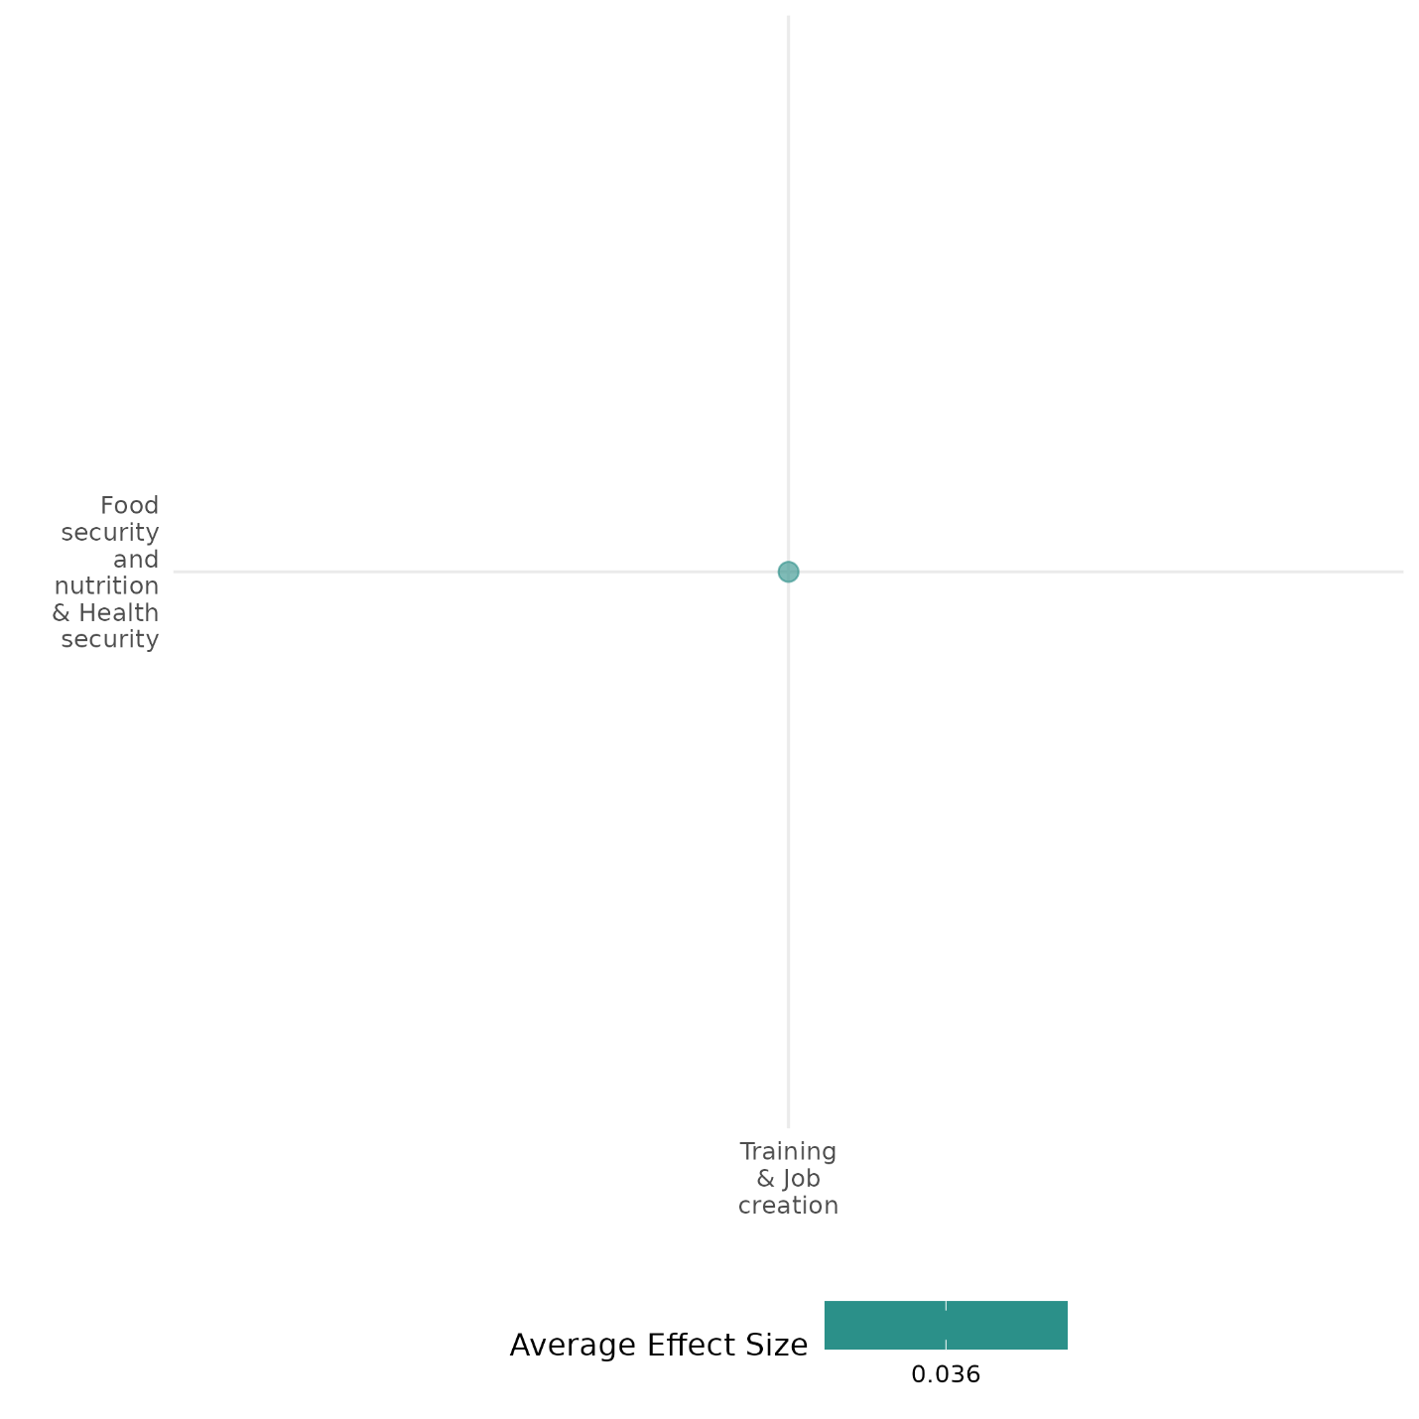

4.6.4(10)
Effect of training & job creation on physical security

Employment programs which aim to create jobs for stability reduce fear of crime and improve perceived security, particularly for African countries.

Geographical scope: Africa

Effect: Moderate effect (g=0.154)

Confidence in study findings: Low (1 study with 1 effect size)

Short Summary
Employment programs in Burundi, Guinea, Liberia, Mali, and Uganda were designed to promote stability by creating job opportunities in economically vulnerable areas. These interventions aimed to reduce grievances, deter criminal activity, and foster social cohesion. A pseudo-meta-analysis using a difference-in-differences (DID) approach found that these programs consistently lowered fear of crime, suggesting a positive effect on perceived security.
The intervention
The employment programs assessed in the study focused on job creation as a tool for stability. These interventions varied in scale, with "large" programs defined as those spending over $0.50 per capita. The programs were implemented in Burundi, Guinea, Liberia, Mali, and Uganda, targeting regions with existing instability but not necessarily the worst economic or security conditions. The programs aimed to provide employment opportunities, but their impact extended beyond just job creation, influencing social stability-related indicators.

How the intervention is expected to work
The underlying mechanism assumes that increased employment reduces grievances and the likelihood of engagement in antisocial or criminal activities. Economic stability can deter individuals from participating in violence or illicit activities, while structured employment fosters positive social norms and interactions. Additionally, the presence of job programs may signal improvements in economic and social conditions, reducing anxiety related to crime. However, these programs can also shift perceptions of government effectiveness, sometimes leading to reduced trust in institutions.

The evidence base
This cell includes 1 quantitative study and 1 systematic review.
The review examines the integration of psychosocial support with livelihood interventions in fragile and conflict-affected settings (FCS). It assesses whether this combination improves both mental well-being and economic resilience.

Evidence findings
The analysis across five African countries revealed that employment programs were consistently linked to lower fear of crime, suggesting they play a role in improving perceived security.

The review evidence
The evidence from the systematic reviews shows that livelihood programs alone do not necessarily lead to improved psychosocial well-being. When combined with economic support, they tend to have stronger and more sustained impacts on mental well-being.
The impact evaluation evidence
There is only 1 impact evaluation included in this cell. One study summary is thus provided here:
Ferguson (2019) explores whether employment programs contribute to peacebuilding by analyzing stability-related outcomes in five African countries (Burundi, Guinea, Liberia, Mali, and Uganda). Using a pseudo-meta-analysis and a difference-in-differences (DID) approach with matched samples, the study finds mixed effects. Employment programs significantly reduced fear of crime in all five countries, suggesting a positive impact on perceived security. The study is rated low due to little description of the intervention, outcomes, and evaluation questions.

Confidence Assessment
Overall low: The cell only includes 1 study, and this study is also rated low.

Other outcomes in the study:
Community and state governance / Government performance
Human security / Economic security

Link to study summaries
Lwamba (2022)
All studies may be accessed via the EGM.

4.6.4(11)
Effect of training & job creation on political security
Training and job creation programs, such as technical and vocational education programs, have negative effects on interest in politics, while moderate effects are found on women’s representation in the political process.
Geographic region: Africa, Global
Effect: Adverse effect (g=-0.577)
Confidence in study findings: Low (1 study with 1 effect size)

Short Summary
Training and job creation interventions, particularly technical and vocational education and training (TVET) programs, have been implemented to improve economic opportunities and social mobility. These programs provide skill-building, entrepreneurship training, and support networks, which can enhance political security by increasing representation, decision-making participation, and social cohesion. Evidence from a systematic review suggests positive effects on women’s participation in political processes, decision-making at various levels, and support for human rights. On the other hand, results from the impact evaluation show negative effects of employment training interventions on political interest.

The intervention
TVET programs or employment training programs can be designed to provide individuals—especially women and marginalized groups—with marketable skills, entrepreneurship training, and access to job opportunities. Some programs incorporate life skills training and mentorship, while others integrate TVET with financial literacy or self-help groups to enhance long-term employability.

How the intervention is expected to work
TVET programs could contribute to political security by fostering economic empowerment, which in turn enhances participation in political processes and decision-making. By increasing employment and financial stability, these programs enable individuals to engage more actively in governance and civic activities. Women’s economic empowerment can shift gender norms, allowing greater representation in local governance, peacebuilding, and community decision-making structures. Additionally, peer support mechanisms within these programs may strengthen collective political action and advocacy.

The evidence base
This cell contains 1 quantitative study and 1 systematic review. The quantitative study is conducted in Mozambique.
The systematic review and meta-analysis included in this cell focused on TVET programs designed to provide individuals—especially women and marginalized groups—with marketable skills, entrepreneurship training, and access to job opportunities.

The review evidence
The meta-analysis from the review suggests a mean difference of 0.28 on women’s representation in political processes, which is a moderate effect.

Evidence findings
Findings of the impact evaluation suggest that both religious sensitization and employment training interventions reduced political interest among young Muslim men in Mozambique, with the religious intervention decreasing political engagement by 0.44 standard deviations and the employment training intervention by 0.3 standard deviations.

The impact evaluation evidence
This cell includes one impact evaluation. Thus, one summary is provided below.
Vicente (2022) evaluates the effectiveness of two interventions—a religious sensitization campaign and an entrepreneurship and employment training module—in preventing Islamic radicalization and anti-social behavior among young Muslim men in Mozambique. The study used a randomized controlled trial (RCT) in partnership with Mozambique’s main Islamic authority (CISLAMO). Findings suggest that both religious sensitization and employment training interventions had a negative effect on interest in politics among young Muslim men in Mozambique. The religious intervention led to a 0.44 standard deviation decrease in political interest, while the employment training intervention resulted in a 0.3 standard deviation decrease.

Confidence Assessment:
Overall low: This cell is rated low considering that it only includes one impact evaluation.

Link to study summaries
Lwamba (2022)
All studies may be accessed via the EGM.

Other outcomes in the study:
Social cohesion / feelings of trust & acceptance of diversity

4.6.4(12)
Effect of training & job creation on intermediate social cohesion
Impact off training and job creation on intermediate social cohesion outcomes depend on the intervention type, with sports-based programs showing more positive effects.
Geographic scope: Africa, Middle East, Latin America
Effect: Large effect (g=0.26)
Confidence in study findings: Low (3 studies with 40 effect sizes)

Short Summary
Training and job creation programs include vocational training and sport-for-development initiatives. Programs like INVEST in Afghanistan and L.A.C.E.S. in Liberia integrate economic opportunities with psychosocial support. Evidence shows mixed effects—vocational training alone had limited impact on self-efficacy, while sport-based programs enhanced social responsibility and purpose.

The intervention
Training and job creation programs may include vocational training, cash-for-work, and sport-for-development initiatives. For instance, the INVEST program in Afghanistan provided vocational training and unconditional cash transfers to young men and women, equipping them with employable skills while testing its impact on self-efficacy and attitudes toward violence​. In Liberia, the L.A.C.E.S. sport-for-development program combined sports, mentorship, and character education to instill social responsibility and a sense of purpose among marginalized youth​. These programs not only provided technical skills but also emphasized personal development, leadership, and psychosocial well-being.

How the intervention is expected to work
Training and job creation programs may enhance social cohesion by improving economic prospects and strengthening psychosocial well-being. Specifically, vocational training is expected to increase employability, thereby fostering a sense of purpose and self-reliance. Social responsibility may develop through mentorship and structured community engagement. Additionally, sport-based interventions, such as L.A.C.E.S., could promote resilience and pro-social behavior by emphasizing teamwork, discipline, and moral values. Finally, cash transfers, when paired with training, may mitigate financial stress, potentially reducing frustration and anger associated with job searching.

The evidence base
This cell includes 5 studies: 1 systematic review, 1 qualitative study, and 3 quantitative studies.
The primary studies are set in Uganda (1 study), Liberia (1), Afghanistan (1), and Colombia (1 study).
The review examines the integration of psychosocial support with livelihood interventions in fragile and conflict-affected settings (FCS). It assesses whether this combination improves both mental well-being and economic resilience.

Evidence findings
Evidence from randomized controlled trials and quasi-experimental studies highlights mixed effects. The vocational training program in Afghanistan had limited effects on self-efficacy and social responsibility unless combined with cash transfers​. In Liberia, participation in the sport-for-development program led to increased social responsibility and a stronger sense of purpose.

The review evidence
The evidence from the systematic reviews shows that livelihood programs alone do not necessarily lead to improved psychosocial well-being. When combined with economic support, they tend to have stronger and more sustained impacts on mental well-being.

The impact evaluation evidence
There are 3 impact evaluations. Three summaries are thus provided here:
Baseler (2021) The study investigated two programs for Ugandan (host) microentrepreneurs: cash grants delivered with information that connects the grant with Uganda’s inclusive refugee policies and existing aid-sharing policy, and mentorship by an experienced refugee. This tests whether mentorship is an effective means to promote skill transfer across nationalities and increase small business profits. The study is designed as a randomized controlled trial. The main sample consisted of 1,406 Ugandan businesses. These were randomly assigned to treatments (cash and information, cash, information, a refugee mentor, a Ugandan mentor) or control. The study found a positive effect of all treatment groups on the main outcome, a pre-specified index of policy preferences – inclusive policies including refugees’ right to work and hosting additional refugees, that is statically significant at the 10% level. The cash and information combined treatment (T1), however, has a larger effect than the other four treatments. The study is rated as medium confidence.
Blom (2021) The study aimed to assess whether participation in the L.A.C.E.S. sport-for-development program could enhance indicators of positive youth development – specifically social responsibility, close personal relationships, peace, and purpose – among Liberian youth. It also sought to identify the experiences, relationships, and conditions that fostered or hindered healthy development. The Life and Change Experienced Through Sport (L.A.C.E.S.) program, established in Liberia in 2007, promotes life skills and leadership through mentor-based soccer and kickball leagues. The 40-week program includes practice, games, life lessons, and family visits, emphasizing values such as self-esteem, respect, teamwork, and discipline. Meals are provided during sessions to support youth well-being. The study employed a mixed-methods quasiexperimental design with 181 Liberian youth (54% female), aged 9-13, participating during the 2016-2017 program year. Quantitative data were collected through pre- and post-intervention surveys, while qualitative data included interviews and photojournalistic exercises where youth documented factors influencing their development. The program led to significant decreases in attitude toward violence (moderate effect size, partial η² = .36) and increased in social responsibility (partial η² = .34) and sense of purpose (partial η² = .22). The study is rated as medium confidence as it is non-experimental study design.
Kurtz (2018) examines the effect of the UK-supported INVEST program, which offered vocational and technical training courses in nine technical vocational education and training (TVET) centres in Helmand Province in Southern Afghanistan from 2011. The programme was implemented by a US NGO, Mercy Corps. At the time of the evaluation 25,000 students had graduated from the programme of which nearly on-third were women. The study used propensity score matching to match recruits from February to April 2014 with successful applicants who had not yet started the programme. The program had no impact on participants’ feelings of being respected, personal confidence, or their perceived social standing in their community. The study is rated low confidence because of lack of information on power calculations.

Confidence assessment
Overall low: The study is rated low confidence as it only includes 3 impact evaluations. The effects are also inconsistent in these studies.

Link to review summaries
Lwamba (2022)
All studies may be accessed via the EGM.

Other outcomes in the study:
Violence and atrocity prevention / Social norms regarding violence and atrocities
Community and state governance / Government performance
Human security / Economic security

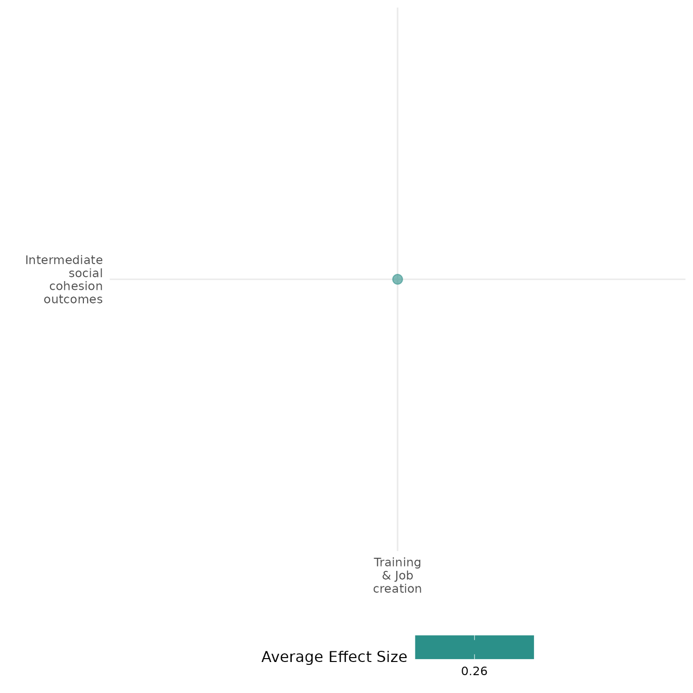

4.6.5 Financial products and services + Cash and in-kind transfers
4.6.5(1)
Effect of Financial products and services Cash and in-kind transfers on Diplomatic relations & Peaceful dispute resolution
Financial products etc, can influence diplomatic relations and peaceful dispute resolution by fostering economic stability, reducing tensions, and promoting cooperation.However, the effectiveness of these interventions depends on fair distribution and alignment with local needs to prevent exacerbating inequalities or tensions.
Geographic Location: Global
Effect: Adverse effect (g = -0.065)
Confidence in study findings: Low (1 study with 2 effect sizes)

Short Summary:
Narang (2014) examines how humanitarian aid—including financial products such as cash and in-kind transfers—can have unintended political effects on diplomatic relations and peaceful dispute resolution in post-conflict settings. Finding that when aid is distributed after a decisive military victory, it tends to disproportionately benefit the losing side, effectively “creating a revisionist party” that may challenge the existing peace settlement. As Narang explains, “the principles of humanitarian assistance dictate that aid be distributed in accordance with need,” yet in practice this often means that aid flows to those who suffered the most, thereby altering the balance of power and potentially undermining diplomatic efforts to sustain peace. Ultimately, the analysis suggests that while such financial transfers are critical for immediate relief, their impact on long-term peace depends heavily on the conflict’s outcome and the subsequent distribution of resources.

Long Summary
The Intervention:
This typically comprises microcredit, microinsurance, and microsavings interventions (including establishing village savings and loan associations) and financial literacy support. This includes interventions that both in-kind and cash transfers. This covers the provision of goods and assistance, and specifically includes food assistance (where it is given directly to the community), and social safety nets, in terms of cash and subsidies to community members, which might be conditional or unconditional. This category also includes short-term cash-for-work programmes, which provide assistance in the form of cash for performing labour (rather than a traditional aid hand-out), and interventions that combine transfers with other forms of support, such as skills training or health support.

How the Intervention is expected to work:
Narang (2014) explains that humanitarian interventions—such as cash and in-kind transfers—are designed to meet immediate needs in post-conflict environments by allocating resources based on the severity of hardship. The underlying expectation was that by providing essential relief, these interventions would help stabilize societies and foster diplomatic engagement, thereby supporting peaceful dispute resolution.

The Evidence Base:
This cell has 1 study which utilises a non experimental design. The cell also has a Global focus.

Evidence Findings:
The evidence indicates that financial transfers—whether cash or in-kind—have a nuanced impact on post-conflict diplomatic relations and the durability of peace. Specifically, when such transfers are provided following a decisive military victory, they can inadvertently exacerbate power imbalances by disproportionately bolstering the losing side. This asymmetry may create a “revisionist” incentive, leading to renewed demands for a redistribution of power and increasing the risk of conflict recurrence. In contrast, when conflicts end in stalemate or through negotiated settlements, the distribution of aid tends to be more balanced, having little effect on altering the post-conflict status quo and thus minimally influencing the prospects for sustained peace and effective diplomatic dispute resolution.

Included Studies
Narang (2014): This study suggests that financial interventions, particularly humanitarian aid in the form of financial products, services, and in-kind transfers, play a complex role in diplomatic relations and peaceful dispute resolution. The study argues that while humanitarian assistance is generally provided with the intention of alleviating suffering and maintaining stability, its effects on post-conflict peace depend heavily on the nature of the preceding conflict settlement. Narang highlights that in cases where civil conflicts end with a decisive military victory, financial assistance can inadvertently fuel instability by empowering revisionist factions that seek to renegotiate the terms of peace. This occurs when aid disproportionately benefits the losing party, thereby shifting the balance of power and creating incentives to challenge the existing settlement. The study references historical cases where aid inadvertently prolonged conflict by relieving warring parties of logistical burdens, as seen in the Bosnian conflict​. Conversely, financial assistance appears to have a more stabilizing effect in post-conflict environments where neither side achieved a decisive victory, such as in negotiated settlements or temporary truces. Under these conditions, aid can serve as a confidence-building measure, providing essential services that foster cooperation rather than renewed conflict. This study is rated medium confidence due to partial description of the intervention and little to no mention of power calculations.

Confidence assessment
Overall Low: This cell is rated low confidence due to lack of studies within the cell.

Other outcomes in this study:
Human security / Economic security
Community and state governance / Government performance
Human security / Political security

Shiny App Screenshot:
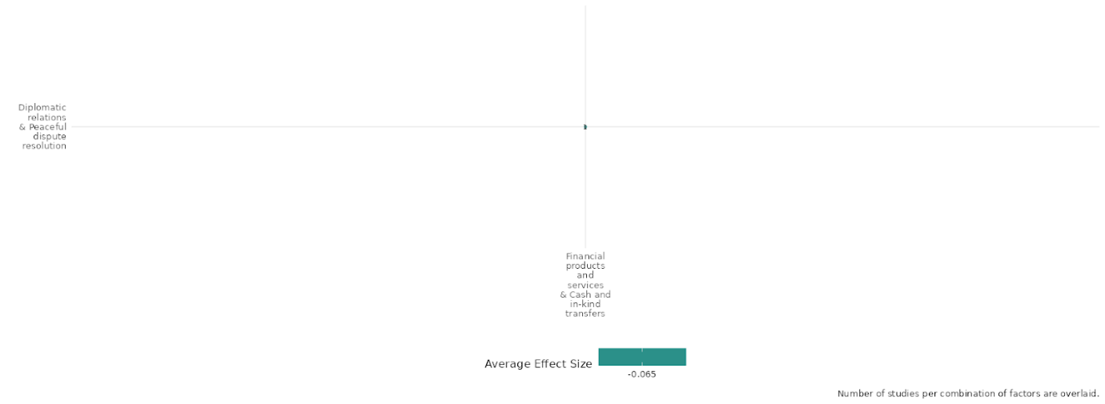

4.6.5(2)
Effect of Financial products and services Cash and in-kind transfers on the nature and scale of violence or atrocities

Financial aid and in-kind support can curb violence and boost stability when applied with context in mind.

Effect: No effect (g=0.008)

Geographic Location: Sub Saharan Africa, South Asia, East Asia & Pacific, Global, Latin America & The Caribbean

Confidence in study findings: Low (7 studies with 28 effect sizes)

Short Summary:
During times of conflict and post-conflict recovery, the most common financial interventions include cash transfers, upskilling workshops, and life skills training aimed at supporting those affected by war and deterring recruitment into armed groups, as seen in Weintraub’s study. However, the effectiveness of unconditional cash transfers (UCTs) remains debated. Some studies, such as Narang’s, suggest that UCTs may inadvertently fuel violence, while Wood highlights the risk of aid recipients being looted by rebel forces, potentially prolonging conflict. In contrast, other studies found no evidence of increased violence, instead reporting decreased rebel recruitment and mobilization. Overall, findings indicate that cash transfers alone are not the most effective tool for reducing conflict-related violence. However, in lower-intensity conflicts, conditional cash transfers (CCTs) may help reduce localized violence, as Crost (2015) found in village settings, though effects were not statistically significant at the municipal level due to limited conflict incidents. Crost suggests that CCTs may have impact only at a localized level rather than across broader conflict zones.

Long Summary

The Intervention: ​​
This typically comprises microcredit, microinsurance, and microsavings interventions (including establishing village savings and loan associations) and financial literacy support. This includes interventions that both in-kind and cash transfers. This covers the provision of goods and assistance, and specifically includes food assistance (where it is given directly to the community), and social safety nets, in terms of cash and subsidies to community members, which might be conditional or unconditional. This category also includes short-term cash-for-work programmes, which provide assistance in the form of cash for performing labour (rather than a traditional aid hand-out), and interventions that combine transfers with other forms of support, such as skills training or health support.

How the Intervention is expected to work:
Interventions work primarily by addressing economic vulnerabilities and fostering stability. Financial products, such as microcredit and cash transfers, aim to empower individuals economically by reducing poverty and increasing stability, thereby raising the opportunity costs of engaging in violence. Similarly, cognitive-behavioral therapy and skills training promote behavioral change by improving non-cognitive skills like self-regulation and patience, encouraging participants to adopt non-violent lifestyles. Development aid and social protection projects target community-level stability, aiming to reduce grievances and foster trust in government institutions by improving public services and infrastructure. Additionally, targeted interventions like conditional cash transfers can weaken insurgent influence by incentivizing cooperation with authorities. Humanitarian aid and safety nets mitigate immediate risks, such as food insecurity or displacement, decreasing the nature and scale. However, the effectiveness of these mechanisms often depends on local contexts and implementation quality, with some interventions potentially exacerbating conflict or having only temporary effects.

The Evidence Base:
The cell contains 10 studies: and contains 7 impact evaluations. Of the 7 impact evaluations, 6 of them utilise quasi-experimental designs (QED) and one of them utilising a RCT. It should be noted that of the 6 QEDs, 3 of them utilise an observational approach - analysing specific data sets to suggest outcome effects. Accompanied with 2 systematic reviews and 1 qualitative study (Adedokun 2019).
The evidence base includes research conducted in Mozambique (1 study), Philippines (2 studies), Afghanistan (2 studies) , Colombia (1 study), and multi-country analyses ( 4 studies).

Evidence Findings:
In the 6 studies, the overarching sentiment is that most forms of cash transfer programs and financial products and services often had little to no effect on current rates of violence or levels of atrocities. However, in some cases, they exacerbated violence, whether at a communal or regional level.

The review evidence:
This study includes two systematic reviews: Zürcher (2017), What Do We (Not) Know about Development Aid and Violence? A Systematic Review, and Cramer (2016), Evidence Synthesis: What Interventions Have Been Effective in Preventing or Mitigating Armed Violence in Developing and Middle-Income Countries? However, both reviews are rated with low confidence. Cramer (2016) suffers from a fragmented evidence base and a lack of high-quality studies, with the predominance of low-quality research further weakening confidence in its conclusions. Similarly, Zürcher (2017) is rated poorly due to its overall low score against the AMSTAR framework, limiting the reliability of its findings.

The impact evaluation evidence
Blair (2021): The study examines the impact of a large-scale cash assistance program on insurgent and communal violence among refugee returnees in Afghanistan, leveraging detailed records from the International Distributed Unified Reporting Environment (INDURE). These records, cataloging significant insurgent and counterinsurgent engagements in Afghanistan between 2015 and 2017, offer high-resolution data on combat activity. Face-to-face interviews were conducted with gender-matched enumerators in Kandahar, Nangarhar, Kabul, Balkh, and Herat Provinces. In 65 districts, returnees were randomly sampled from settlements identified by the IOM Baseline Mobility Assessment. The sample was proportionate to the population size in each province and representative of returnees in the five regions studied. Households within each settlement were selected through a random walk method, and individual respondents were chosen using a Kish grid. Interview data captured details such as respondents’ country of asylum, repatriation date, and registration status to identify likely program beneficiaries. The survey achieved an 84.6% contact rate, with a 74.57% response rate. The study is rated medium confidence as it is a non- experimental study.
Crost (2015): The study evaluates the impact of the Pantawid Pamilyang Pilipino Program (Pantawid Pamilya), a large conditional cash transfer (CCT) program, on the nature and scale of violence, particularly civil conflict, in the Philippines. Using an impact evaluation through a randomized controlled trial (RCT), 130 villages across 8 municipalities were assigned to treatment and control groups. Villages receiving the CCT program experienced a significant reduction in conflict incidents during the first year, though the effect diminished in the second year. The program also decreased insurgent influence at the village level, indicating a weakening of rebel presence. However, these effects were not statistically significant at the municipal level, suggesting conflict displacement to nearby areas. Treated villages saw fewer casualties, though the small number of incidents limited statistical significance. These findings highlight the potential of CCTs to reduce localized conflict and insurgent activity, demonstrating the context-dependent effectiveness of financial interventions in addressing violence. The study is rated high confidence.
Lyall (2018): This study examines the impact of humanitarian assistance in Afghanistan, focusing on how humanitarian assistance influences insurgent activity. The analysis finds that humanitarian aid, in particular, has a violence-reducing effect. The study uses declassified data from the Combined Information Data Network Exchange (CIDNE) and iMMAP, which track insurgent attacks on ISAF forces and Afghan forces, respectively. The study shows that the frequency of Taliban attacks decreases significantly, with a 35 percent reduction in attacks for up to two years after a village receives aid. However, the study notes that ACAP aid (Afghan Civilian Assistance Program) has no effect on violence against Afghan forces for at least one year post-disbursement.The study is rated as low confidence due to non-experimental study design and no mention of power calculations

Narang (2015): This study examined the impact of humanitarian aid on the duration of civil wars, using a bargaining framework to suggest that aid could inadvertently increase uncertainty among combatants, potentially prolonging conflict. The study analyzed panel data on cross-national humanitarian aid expenditures from 1989 to 2008. The findings revealed that increased levels of humanitarian assistance were associated with longer civil wars, particularly those involving rebel groups on the periphery of a state. This suggests that while aid is intended to support post-conflict recovery, it may, in some cases, prolong the violence, highlighting the need for careful consideration in its disbursement. The study is rated as medium confidence due to non-experimental study design, partial description of intervention and no mention of power calculations.

Nunn (2014): This study investigates the impact of food aid shipments, influenced by changes in US wheat production, on the onset and duration of civil conflicts. Using a quasi-experimental design, it analyzes an annual panel of 125 non-OECD countries, incorporating country fixed effects and region-specific year fixed effects. The findings show that food aid does not significantly affect the onset of civil conflicts. However, it has a strong positive effect on the duration of these conflicts, suggesting that while food aid may not trigger conflict, it may contribute to prolonging existing civil wars. The study is rated as low confidence due to non-experimental study design, partial description of intervention and no mention of power calculations
Weintraub (2016): This study examines the impact of anti-poverty subsidies, specifically a conditional cash transfer program in Colombia, on insurgent violence. The study proposes that development assistance increases overall violence by insurgents, particularly indiscriminate violence, as it incentivizes information sharing with the government and increases territorial control by incumbents. Using a quasi-experimental design with a difference-in-differences strategy and matching tests, the study analyzes data from 122 municipalities (57 treatment, 65 control). The findings show that cash transfers had a significant effect on violence, with a 160% increase in FARC civilian killings and a 250% increase in indiscriminate violence. The study is rated as medium confidence due to non-experimental study design, and no mention of power calculations

Wood (2015): This study investigates the potential negative externalities of humanitarian aid, specifically how it might incentivize armed actors to target civilians. The study argues that aid can encourage rebel violence by offering opportunities for looting and resentment toward challenges to rebel authority. It may also increase state violence by augmenting rebel capabilities or providing rebels with a resource base. Using spatially disaggregated data from nearly two-dozen post-Cold War African countries, the study finds that aid increases the rate of rebel attacks on civilian targets. Compared to units receiving no aid, those receiving aid experienced a 25% increase in rebel violence. The study is rated as medium confidence due to non-experimental study design, and no mention of power calculations

Confidence assessment
Overall Low: There is a high consistency of findings across the studies. However, confidence across the cell falls short as there are quite a few studies with little to no mention of power calculations.

Other outcomes in this study:
Violence / social norms regarding violence
Social cohesion / Feelings of trust & Acceptance of diversity
Human security / Economic security

Shiny App Screenshot

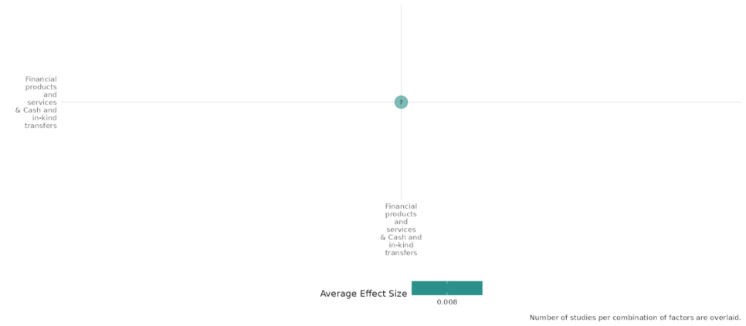

4.6.5(3)
Effect of Financial products and services Cash and in-kind transfers on Social norms regarding violence and atrocities

Integrated interventions combining cash with behavioral or vocational support can reduce violence and shift social norms, while standalone cash transfers yield mixed social impacts.

Geographic Location: Global, Middle East & North Africa, Sub Saharan Africa, South Asia, Latin America & Caribbean

Effect: Adverse effect (g= -0.007)

Confidence in study findings: Low confidence (7 studies with 48 effect sizes)

Short Summary:
The combination of cash and cash based services in Afghanistan reduced support for armed opposition groups (AOGs) and increased pro-government sentiment. In Colombia (Pena), cash transfers helped demobilize combatants, though not directly reducing violence. In Liberia, combining therapy with cash resulted in decreased antisocial behaviors and improved self-control. However, while the studies demonstrate positive effects in shifting attitudes, the impact on actual behavioral change regarding violence and support for armed groups is more nuanced. For instance, in Afghanistan, the effects of cash transfers were short-lived, with some participants showing increased support for the Taliban after an initial boost in pro-government sentiment. Similarly, while cash transfers in Liberia improved self-control and reduced antisocial behaviors, economic performance improvements were short-lived. The studies also highlight that the combination of financial aid and training, especially when tailored to local contexts, appears to have more sustained effects on attitudes.

The Intervention:
This typically comprises microcredit, microinsurance, and microsavings interventions (including establishing village savings and loan associations) and financial literacy support. This includes interventions that both in-kind and cash transfers. This covers the provision of goods and assistance, and specifically includes food assistance (where it is given directly to the community), and social safety nets, in terms of cash and subsidies to community members, which might be conditional or unconditional. This category also includes short-term cash-for-work programmes, which provide assistance in the form of cash for performing labour (rather than a traditional aid hand-out), and interventions that combine transfers with other forms of support, such as skills training or health support.

How the intervention is expected to work:
The interventions are designed to improve economic outcomes and shift social norms by offering financial support through cash transfers or in-kind support, often paired with skills training or behavioral programs. Cash transfers aim to alleviate financial pressures, while vocational training enhances employability. Combining these with interventions like cognitive behavioral therapy or merit scholarships seeks to address underlying attitudes toward violence, improve self-control, and promote prosocial behavior. These interventions are expected to reduce support for armed groups and political violence by enhancing economic stability, boosting government perceptions, and fostering better decision-making and self-regulation among participants.

The Evidence Base:
The cell consists of 9 studies: of the 9 studies 7 of them are impact evaluations, 5 studies are RCTS, 2 non-experimental studies, 1 is a protocol for an RCT by Keleher (2019) and finally a systematic review.

The studies are from South Sudan (1 study), Uganda (1 study), Liberia (2 studies), Afghanistan (2 studies), Lebanon (1 study), Colombia (1 study) and finally a study with a Global focus.

Evidence Findings:
The studies consistently show that financial aid paired with other socio-economic interventions such as vocational training have the potential to shift attitudes and behaviors, particularly regarding support for violence.

The review evidence:
The systematic review of Lwamba et al. is entitled 'Strengthening women's empowerment and gender equality in fragile contexts towards peaceful and inclusive societies: A systematic review and meta-analysis'. The review is rated as high confidence in review findings.

The impact evaluation evidence:

Blattman et al. (2017):The study investigates how combining cognitive behavioral therapy (CBT) with cash grants can influence social norms regarding violence and atrocities by targeting harmful behaviors and attitudes among high-risk men in Liberia. The intervention, delivered to 999 men aged 18–35 in Monrovia, used a randomized controlled trial to compare four groups: therapy only, cash only, both therapy and cash, and neither. Therapy alone reduced antisocial behaviors by 24% in the short term but showed sustained reductions only when combined with cash, achieving a 33% decrease in aggressive behaviors. The combined intervention also improved self-control and decision-making, with a 25% enhancement in self-control after one year. While economic gains were temporary, the results demonstrate that pairing financial incentives with behavioral interventions can significantly and durably reduce antisocial behaviors, contributing to shifts in norms and behaviors surrounding violence and conflict in fragile settings. The study is rated high confidence.

Blattman (2014): examines the impact of financial products, services, and cash and in-kind transfers on social norms regarding violence and atrocities. The study evaluates a large cash transfer program in Uganda, the Youth Opportunities Program (YOP), and its broader social consequences. While the intervention led to significant economic improvements, there was little evidence of substantial social effects on reducing violence or altering norms related to collective action and antisocial behavior. The research states, "In spite of large economic gains, however, we see little non-economic impact at the individual level. There was little to no effect on our measures of individual community integration, local and national collective action, antisocial behavior, or violent protest"​. Additionally, the study suggests that employment and entrepreneurship programs, even when financially successful, may not inherently lead to greater social cohesion or reductions in violence. Another key finding emphasizes that while financial support can empower marginalized groups, particularly women, it does not necessarily alter entrenched social attitudes towards violence: "Despite randomization, we observe little effect on attitudes towards violent protest, even in contexts with historical instability"​. These findings highlight the limitations of financial interventions in transforming deeply rooted social norms related to violence and atrocities. This study is assigned a medium confidence rating due to the incomplete description of the intervention and outcomes, as well as the absence of reported power calculations.

Masterson (2020): This study examines the impact of financial aid—specifically humanitarian cash transfers—on social norms regarding violence and atrocities, particularly in the context of Syrian refugees in Lebanon. The study leverages quasi-experimental methods to evaluate whether unconditional cash transfers (UCTs) affected refugee mobilization into armed groups. The findings suggest that the provision of humanitarian aid did not exacerbate conflict or increase recruitment into armed groups. Contrary to prevailing concerns in the literature, the study finds "little evidence that the aid program had a large effect on mobilization. If anything, our estimates indicate a small decrease in mobilization”. This suggests that financial assistance may, in some cases, contribute to stabilizing vulnerable populations rather than fueling conflict. One of the key mechanisms through which cash transfers impacted social norms regarding violence was by increasing the opportunity costs of joining armed groups. The study highlights that "humanitarian aid increases the opportunity cost of fighting, and economic theories of insurrection predict that incentives to rebel grow smaller as household income and economic opportunities from non-rebel activities rise”. Additionally, the study counters fears that humanitarian aid could be captured by insurgent groups, thus indirectly funding violence. It states, "existing academic and journalistic work highlights cases where transnational insurgent groups captured aid intended for refugees, increasing their operating budget and recruitment capacity”​. However, in the case of Syrian refugees in Lebanon, no strong evidence was found to support such claims. This study is rated medium confidence due to no mention of power calculations.

Muller (2019): examines the impact of financial interventions, specifically unconditional cash transfers (UCTs), on social norms regarding violence and atrocities in South Sudan. The study evaluates the Youth Startup Business Grant Program, which was abruptly canceled due to escalating conflict, thereby allowing an assessment of the unintended social consequences of program disruption. The research finds that while cash grants had the potential to improve economic stability and psychological well-being, the incomplete implementation had mixed effects on social trust and behavior. Participants who successfully received both the business skills training and the grant exhibited "significant improvements in their consumption, savings, and psychological well-being". However, those who expected the grant but did not receive it due to program cancellation experienced negative social consequences. In particular, the study notes, "women among this subgroup also experienced strong reductions in their trust level". This decline in trust is critical, as it suggests that the failed promise of financial aid can erode social cohesion, particularly among vulnerable groups. Additionally, the study raises concerns about the unintended consequences of such disruptions, noting that "young women who expected to receive the grant were less likely to migrate". Given the context of South Sudan’s conflict, where migration was often a necessary response to violence, this suggests that the expectation of financial support may have led individuals to delay critical security-related decisions. The study further emphasizes that financial interventions must be designed with the risks of implementation failure in mind, as "unintended negative consequences on program participants who did not receive the full set of benefits anticipated at the program outset" can deepen social divisions and increase vulnerability to violence. This study is rated medium confidence due to partial description of the evaluation questions and little to no mention of power calculations.

Pena (2017): The study investigates the impact of Familias en Acción, a cash transfer program implemented in Colombia during the early 2000s, on social norms regarding violence and atrocities. Through a quasi-experimental design leveraging the program's gradual rollout, the study examined whether financial assistance could influence behaviours associated with Colombia's internal conflict. Results indicate that the program contributed to an average 6.8% increase in the number of demobilized combatants per municipality, suggesting a shift in attitudes away from violence and participation in armed groups. By addressing poverty and providing economic stability, the cash transfers appear to have created incentives for combatants to disengage from violent conflict, demonstrating the potential of financial interventions to reshape norms and behaviours surrounding violence. The study is rated as low confidence due to non-experimental study design (QED utilising a natural experiment), and no mention of power calculations.

Kurtz (2018): This study examines the use of financial interventions, including cash transfers and vocational training, to influence social norms surrounding violence and atrocities. By providing technical and vocational education and training (TVET) alongside unconditional cash transfers, the program aimed to improve employability and economic stability among Afghan youth in Kandahar. The study measured changes in attitudes toward political violence, specifically support for armed opposition groups (AOGs), as a proxy for shifting social norms. Results showed that pairing vocational training with cash transfers reduced willingness to support AOGs, driven not only by economic benefits but also by improved perceptions of the government. This highlights the potential for financial interventions to reshape norms and reduce acceptance of violence by addressing both material and psychosocial factors. This study is rated low confidence due to lack of power calculations.

Lyall (2019): This study examines how cash transfers and vocational training programs can shape social norms regarding violence in Afghanistan. Findings show unconditional cash transfers (UCTs) increased support for pro-Taliban acts (11.63 percentage points) and normalized violence, with recipients more likely to justify violence to defend family (12.94%) and assets (14.92%). Anger toward the government rose, leading to more disputes with local leaders. However, combining UCTs with vocational training reduced justification for violence by 20 percentage points, implying that structured financial assistance tied to skill development may reduce the legitimacy of violence as a response to perceived injustice. Overall, the study reveals that cash transfers alone may inadvertently encourage support for violence, while integrating financial aid with structured programs like vocational training can mitigate these effects by shaping attitudes toward peace and governance. These findings underscore the importance of designing financial interventions carefully to avoid reinforcing harmful social norms. This study is rated low confidence due to the lack of power calculations.

Confidence assessment
Overall low confidence: While findings are consistent across studies, the lack of power calculations across the majority of the studies in the cell raise concerns about selection bias and reliability.

Other outcomes in this study:
Community and state governance / government performance
Human security / economic security.
Violence and atrocity prevention / Sexual and gender-based violence
Violence and atrocity prevention / Intermediate social cohesion outcomes

Shiny App Screenshot
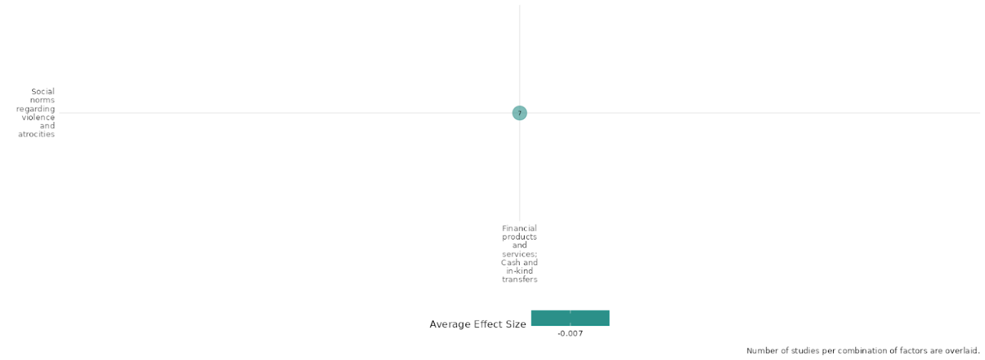

4.6.5(4)
Effect of Financial products, services and Cash and in-kind transfers on Feelings of trust and Acceptance of diversity
Financial interventions have the potential to build trust and foster acceptance within communities by boosting confidence in the economy. However, success of these initiatives often depends on different factors.
Geographic Location: Global, South Asia, Sub Saharan Africa, Latin America & Caribbean and Middle East & North Africa

Effect: Small effect (g=0.05)

Confidence in study findings: Moderate (7 studies with 101 effect sizes)

Short Summary:
Across the studies in this cell, financial aid—whether in the form of cash, in-kind transfers, or services—consistently impacts trust and social cohesion, both positively and negatively. The effects, however, vary depending on context and implementation. Overall, the findings suggest that financial interventions, especially when paired with engagement strategies, can promote trust and enhance acceptance of diversity. However, their effectiveness hinges on consistent delivery and the broader contextual factors at play.

Long Summary
The Intervention:
This typically comprises microcredit, microinsurance, and microsavings interventions (including establishing village savings and loan associations) and financial literacy support. This includes interventions that both in-kind and cash transfers. This covers the provision of goods and assistance, and specifically includes food assistance (where it is given directly to the community), and social safety nets, in terms of cash and subsidies to community members, which might be conditional or unconditional. This category also includes short-term cash-for-work programmes, which provide assistance in the form of cash for performing labour (rather than a traditional aid hand-out), and interventions that combine transfers with other forms of support, such as skills training or health support.
How the Intervention is expected to work:
These interventions work through mechanisms that address economic and social challenges to foster trust and acceptance of diversity: Economic Empowerment: Financial aid programs are designed to alleviate poverty, improve livelihoods, and enhance financial stability. By reducing economic stress, creating conditions for positive social interactions and greater trust in institutions or external actors. Aid programs that link financial support with inclusive narratives or policy frameworks (e.g., refugee aid in Uganda) are expected to encourage acceptance of marginalized groups and reduce social tensions by fostering shared benefits and understanding. Cash transfers may improve beneficiaries' psychological well-being, confidence, and perceptions of fairness, which can positively influence trust in individuals, communities, and institutions. Conversely, unmet expectations can erode trust, particularly in vulnerable contexts. Face-to-face interactions between aid providers and recipients (e.g., post-disaster aid in Pakistan) are expected to humanize external actors, reduce stereotypes, and build trust in those seen as providing tangible support. Employment and community-based interventions (e.g., cash-for-work in Côte d’Ivoire) aim to strengthen social networks and promote collaborative, peace-oriented attitudes by fostering a sense of belonging and shared goals.

The Evidence Base:
The cell contains 9 studies, examining the impact of financial products and services, including cash and in-kind transfers, measuring outcomes on different factors contributing to feelings of trust and acceptance of diversity. These studies predominantly use randomized controlled trials (RCTs) and quasi-experimental designs (QEDs).
The primary studies are from Kenya (1 study), South Sudan (1 study), Pakistan (1 study), Uganda (2 studies), Côte Ivoire (1 study), 1 (Lebanon) and Ecuador (1 study). Finally there is one systematic study with a Global focus.

Evidence Findings:
Across the studies, financial interventions such as cash transfers and in-kind aid have shown diverse impacts on feelings of trust and acceptance of diversity. Collectively, these findings highlight the nuanced and context-dependent effects of financial interventions on trust and diversity acceptance.

The review evidence:
The systematic review of Lwamba et al. is entitled 'Strengthening women's empowerment and gender equality in fragile contexts towards peaceful and inclusive societies: A systematic review and meta-analysis'. The review is rated as high confidence in review findings.

The impact evaluation evidence:
Andrabi & Das (2017): In this study, Andrabi examined the impact of global aid, including cash and in-kind transfers, on feelings of trust and acceptance of diversity - measured by the attitudinal changes towards Westerners. It finds that exposure to a natural disaster, specifically proximity to the earthquake fault line, significantly increased trust in Westerners among affected populations in Pakistan—a notable shift from one of the world's lowest levels of trust to levels comparable to those in Sweden, one of the highest. The data indicates that this durable attitudinal change suggests a significant malleability in trust toward Westerners within a large Muslim population. The researchers attribute this shift to foreign aid, particularly direct, face-to-face interactions with Westerners acting as aid providers. However, the causal link between the earthquake and increased trust relies on the assumption that pre-earthquake levels of trust were not correlated with the household's distance from the fault line. The study is rated as medium confidence as it is a non-experimental study with only partial reporting of interventions and outcomes.
Baseler (2021): This study investigates how aid for refugees can be allocated to assist refugees while fostering support from host communities. It highlights the potential of aid to reduce tension and promote positive relations. A randomized controlled trial in Uganda compared two interventions targeting host microentrepreneurs: (1) cash grants accompanied by information linking the grants to Uganda’s inclusive refugee policies and aid-sharing initiatives, and (2) mentorship programs led by either an experienced refugee or a Ugandan mentor. The results show that cash grants tagged with information about aid-sharing policies had the most significant impact, substantially increasing support for inclusive policies, such as refugees’ right to work and hosting additional refugees. While cash grants or mentorship programs independently improved support for inclusion, their effects were smaller compared to the combined cash and information intervention. Interaction with a refugee-led organization was a key driver of these outcomes. Although no significant effects on business profits were observed through any treatments by the first endline, mentorship by a Ugandan did result in other positive economic effects. Overall, the findings underscore that cash transfers, particularly when contextualized with relevant policy information, are more effective at bolstering social adhesion than other social interventions. The study is rated as medium confidence.

Hidrobo (2012): The study is the impact evaluation of the World Food Programme’s Food, Cash, and Voucher intervention on outcomes including food security, social capital, anemia, and gender issues among Colombian refugees and poor Ecuadorians in Northern Ecuador.The study was designed as a randomized controlled trial. The total sample was 1880 including 1373 in treatment arm and 507 in control arm. Cash transfers significantly reduce discrimination but show no variation in impact across treatment arms. They also increase trust in institutions and decrease trust in individuals (p < 0.01). The rise in institutional trust is significantly greater than with vouchers, while the decline in individual trust is significantly larger than with food aid. Conversely, only vouchers significantly boost group participation, with a markedly greater effect than cash transfers. The study is rated as high confidence.

Kimou (2019): This study evaluates the effects of a cash-for-work program for unskilled youth in post-conflict Côte d’Ivoire, focusing on its influence on feelings of trust and social cohesion. The intervention involved providing financial opportunities through paid employment, with outcomes assessed over the short and mid-term. In the short term, program participation reduced trust in out-community peers by 29% and trust in colleagues by 16%. However, in the midterm, having a paid job increased trust in family members (17%) and colleagues (25%) and improved community engagement, as seen in a 20% rise in attendance at community meetings. Additionally, the program significantly predicted pro-peace behaviors among participants. The findings indicate that while short-term impacts may challenge trust dynamics, cash-based employment opportunities have a positive influence on building trust, social cohesion, and peace-oriented attitudes over time. However, entrepreneurship training was found to negatively affect social cohesion compared to job training, which positively predicted peace-promoting attitudes. The study is rated as medium confidence due to experimental study design, partial description of outcomes and no mention of power calculations.

Muller et al. (2019): This study assesses the effects of a disrupted financial intervention, the South Sudan Youth Business Start-Up Grant Program, on trust and related outcomes. The program, designed to provide unconditional cash grants and business/life skills training, was terminated prematurely due to escalating violence, leaving many beneficiaries without the expected support. Participants who received the grant as planned experienced significant improvements in consumption, savings, and psychological well-being. However, those who anticipated but did not receive the grant faced negative outcomes, including reduced consumption levels. Among women in this subgroup, trust levels significantly declined, reflecting the detrimental impact of unmet expectations. The findings highlight that while cash grants can positively influence financial and psychological stability, their disruption can undermine trust, particularly among vulnerable groups, in fragile and insecure contexts. The study is rated medium confidence because of moderate levels of attrition and incomplete description of the intervention.

Friedman (2011): This study highlights that financial interventions can have nuanced effects on social cohesion. In particular, the findings suggest that financial aid—whether through direct cash transfers, merit-based scholarships, or in-kind benefits—does not uniformly increase trust or social integration but rather interacts with contextual and implementation factors to shape outcomes. One of the key insights is that financial aid programs, such as merit scholarships, can enhance political awareness and knowledge, but they do not necessarily translate into greater political participation or community engagement​. Instead, these programs sometimes lead to increased ethnic identification, which may, paradoxically, weaken trust between different groups rather than fostering a broader sense of cohesion​. Additionally, while recipients of financial aid express reduced deference to authority and traditional structures, this does not necessarily equate to higher acceptance of diversity. In some cases, education-based financial assistance strengthens ethnic attachment rather than promoting national identity. The study further suggests that financial interventions can challenge traditional power structures, particularly in the household, by increasing autonomy and reducing the acceptance of domestic violence​. However, in the broader social and political realm, increased financial support does not consistently lead to stronger trust across ethnic or religious lines. Rather, in some cases, the interventions heighten dissatisfaction with existing structures without providing effective channels for democratic engagement, leading to an increase in the perceived legitimacy of political violence​. The study is rated as low confidence as there was partial description of interventions and outcomes.

Lehmann (2014): The Winter Cash Assistance Program for Syrian refugees in Lebanon had a positive effect on feelings of trust and acceptance of diversity within communities. The study found that cash assistance improved relationships between beneficiaries and Lebanese community members. Specifically, 31% of households in the treatment group received help from Lebanese neighbors, compared to 26% in the control group. This help included childcare, assistance during illness, housework, or financial aid, suggesting that cash assistance fostered mutual support within communities​. Moreover, beneficiaries were also more likely to provide help to Lebanese community members, reinforcing social ties and trust. This aligns with prior research, which indicates that recipients of cash transfers often share resources with others in their community, creating a reciprocal support network (Angelucci & DeGiorgi, 2009). The study suggests that as economic pressures were reduced, beneficiaries had more time and emotional energy to build relationships, which likely contributed to increased social cohesion​. Another significant finding was that cash assistance reduced negative interactions between refugees and Lebanese hosts. The study noted that 90% of the control group reported never being insulted by Lebanese community members, compared to 94% in the treatment group. While seemingly small, this difference is statistically significant, indicating a modest but meaningful reduction in hostility towards refugees​. However, the study did not find significant changes in relationships among Syrian refugees themselves, suggesting that the effect was more prominent in refugee-host interactions rather than within refugee communities​. The study is rated medium confidence because of moderate levels of attrition and incomplete description of the intervention.
Blattman (2013): The study examines the effects of financial products on feelings of trust and acceptance of diversity, particularly within the context of the WINGS program.t finds that participation in financial interventions, particularly those involving grants and skills training, leads to an increase in social capital. Beneficiaries of the program reported an 8% increase in their perceived trustworthiness compared to non-participants, suggesting that financial support enhanced their confidence and social positioning within their communities​. Additionally, program participants engaged in nearly 50% more group activities, fostering greater social interaction and resource sharing. However, while financial assistance improved trust among beneficiaries, it also resulted in a slight increase in perceived hostility from community members, possibly due to envy or competition effects. The findings suggest that while financial interventions can strengthen trust and cooperation among direct beneficiaries, they may also introduce social tensions that require careful management​. Though this cell has a high confidence rating, effect size data could not be extracted from this study due to insufficient data pertaining to the specific outcome category.

Confidence Assessment:
Overall, the findings demonstrate a moderate level of consistency across the studies. However, the absence of power calculations and the partial description of outcomes and interventions in some studies limit the ability to assign a high confidence rating to the cell.

Other outcomes in the study:
Violence / social norms regarding violence
Community and state governance / government performance
Human security / economic security.

Link to review summaries:
Lwamba (2022)
Shiny App Screenshot
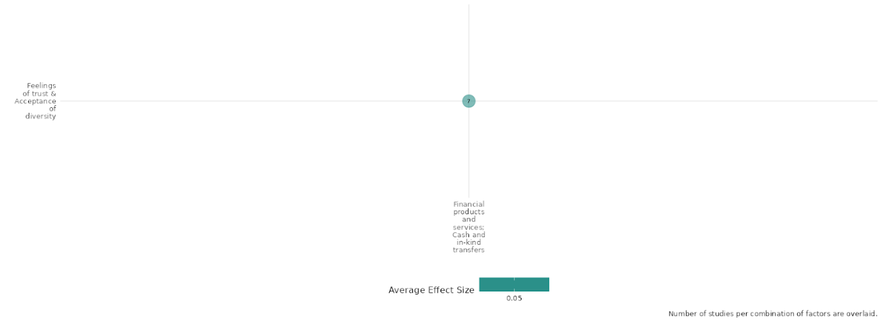

4.6.5(5)
Effect of Financial products and services Cash and in-kind transfers on Willingness to participate or to help

Financial aid spurs community engagement and stability by easing economic pressures and fostering shared purpose. However, success is also dependent on supplementary programs,
Geographic Location: Sub Saharan Africa and Middle East & North Africa
Effect: Low effect (g=0.055)

Confidence in study findings: Moderate (3 studies with 21 effect sizes)

Short Summary:
Cash-based interventions influence community members' willingness to participate and offer support, as emphasised in all studies. Blattman (2014) found that the training program increased community participation, but after four years the program's impact on participation stagnated. Kimou (2019) found that while employment programs initially decreased trust, they later enhanced community participation, trust in family and colleagues, and pro-peace attitudes, particularly through job-related training. However, entrepreneurship training weakened social cohesion. Lehmann (2014) demonstrated that cash assistance for Syrian refugees, though insufficient for winter needs, increased access to education by reducing child labor, fostering greater community engagement and support for children's well-being. These findings suggest that cash-based interventions can promote long-term participation and cooperation when effectively designed.

Long summary
The Intervention:
This typically comprises microcredit, microinsurance, and microsavings interventions (including establishing village savings and loan associations) and financial literacy support. This includes interventions that both in-kind and cash transfers. This covers the provision of goods and assistance, and specifically includes food assistance (where it is given directly to the community), and social safety nets, in terms of cash and subsidies to community members, which might be conditional or unconditional. This category also includes short-term cash-for-work programmes, which provide assistance in the form of cash for performing labour (rather than a traditional aid hand-out), and interventions that combine transfers with other forms of support, such as skills training or health support.

How the Intervention is expected to work:
The interventions in these studies aimed to enhance social participation and community engagement through different approaches. Kimou’s study sought to increase youth involvement in peacebuilding and community activities by providing job training and employment opportunities, expecting improved social cohesion and trust to drive greater participation in local meetings and peace efforts. Lehmann’s study used cash transfers to support Syrian refugees in Lebanon, aiming to reduce child labor, increase access to education, and strengthen community participation by helping families better meet their needs. Both interventions were designed to foster social inclusion and support community development, particularly in employment and education. Blattman’s study developed the Youth Opportunities Program (YOP) in Uganda, which was designed to provide cash grants to groups of young adults to invest in vocational training and business startup costs. The goal was to alleviate financial constraints, particularly credit constraints, and enable recipients to transition into skilled self-employment, thereby increasing incomes and promoting economic stability.

The Evidence Base:
The cell contains 3 studies: and 3 impact evaluations. All studies are RCTs.
The evidence base includes research conducted in Cote D’Ivoire (1 study), Uganda (1 study) and Syrian refugees in Lebanon (1 study).

Evidence Findings:
The studies show varied impacts of financial and educational interventions on willingness to participate or help. Blattman found that the training program increased community participation, but after four years the program's impact on participation stagnated. Hidrobo demonstrated that food, cash, and voucher interventions increased participation, with vouchers especially boosting social involvement and sharing behaviors. Kimou indicated that short-term, paid employment reduced trust but long-term job opportunities enhanced community involvement and peacebuilding. Lehmann found that winter cash assistance helped Syrian refugees by reducing child labor and increasing participation in education, fostering community engagement.

Included Studies
Kimou (2019): Youth Employability and Peacebuilding in Post-Conflict Côte D’Ivoire: Evidence from a Randomized Controlled Trial: Based in Côte d’Ivoire, this study evaluated the impact of an employment promotion program on youth’s willingness to participate or help within their communities and contribute to peacebuilding. In the short term, participation in the program decreased trust in out-community youth by 29% and trust in colleagues by 16%. However, long-term effects were more positive, with having a paid job increasing community meeting attendance by 20%, trust in family members by 17%, and trust in colleagues by 25%. Additionally, program participation was strongly associated with pro-peace behaviors, with job-related training positively influencing peace-oriented attitudes, while entrepreneurship training had a negative effect on social cohesion. Despite its limitations, including partial outcome descriptions and no mention of power calculations, the study highlights the potential of employment programs to foster long-term engagement and cooperation, even in challenging post-conflict settings. The study is rated as medium confidence due to experimental study design, partial description of outcomes and no mention of power calculations.

Lehmann (2014): This study evaluated the UNHCR winter cash assistance program in Lebanon, which aimed to provide $575 USD via ATM cards to 87,700 registered Syrian refugee households to help them stay warm during cold winter months. The program used a quasi-experimental design with 827 households in the treatment group and 962 in the control group. The study found that while the cash assistance was insufficient to fully meet the program’s goal of ensuring beneficiaries stayed warm throughout the winter, it had positive impacts on other areas. Notably, the assistance increased access to education by reducing child labor, indicating a positive shift in community engagement and support for children’s well-being. The findings suggest that cash transfers can foster willingness to participate or help, as beneficiaries were able to better support their children’s education, reducing the need for child labor and increasing participation in educational opportunities. The study is rated as medium confidence due to experimental study design, partial description of outcomes and no mention of power calculations.

Blattman (2014): Blattman (2014) examines the effects of financial products, services, and cash and in-kind transfers on individuals' willingness to participate or help, particularly in the context of employment and economic engagement. The study focuses on a program in Uganda that provided cash grants to young, underemployed individuals to invest in vocational training and business assets. The findings suggest that financial constraints, especially credit limitations, play a significant role in preventing individuals from engaging in productive economic activities. When provided with financial resources, participants—especially women—showed significant increases in earnings, work hours, and investments in skilled trades. However, despite these economic gains, the study found little evidence of increased participation in community activities, collective action, or political engagement - "First, treatment is associated with a 0.098 standard deviation increase in community participation, but the treatment effect at four years is 0”.Suggesting that while financial support can alleviate economic constraints and improve employment outcomes, it does not necessarily translate into higher levels of social participation or willingness to help in communal or political contexts​. The study is rated as medium confidence due to experimental study design, partial description of outcomes and interventions with no mention of power calculations.

Confidence assessment
Overall Moderate confidence assessment: There is a high consistency of findings across the studies. However, there is little to no mention of power calculations.

Other outcomes in this study:
Social cohesion / Feelings of trust & Acceptance of diversity
Human security / Economic security

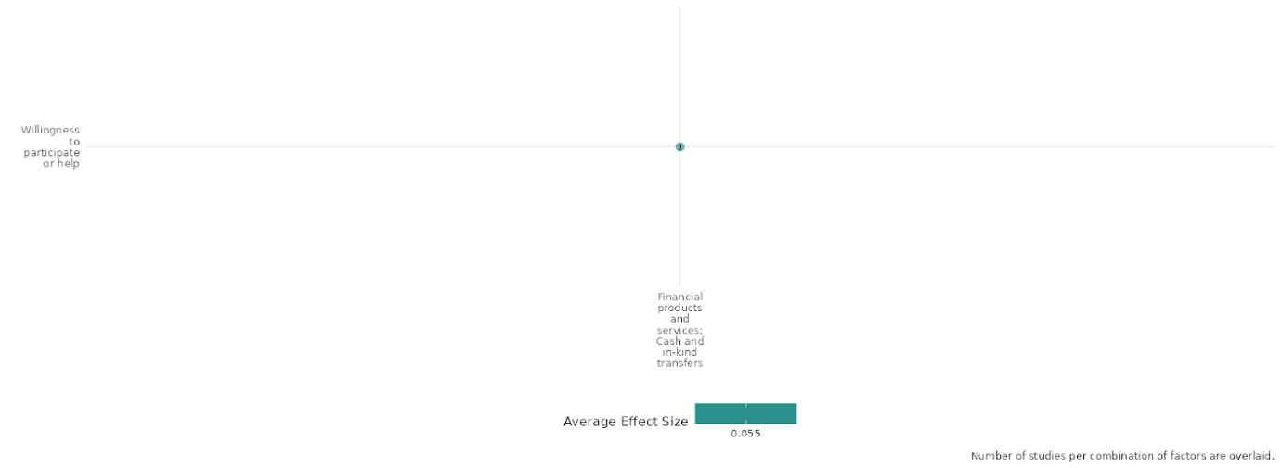

4.6.5(6)
Effect of Financial products and services Cash and in-kind transfers on Civic Participation

Access to financial resources empowers individuals and groups to engage in political or civil society activities, while cash and in-kind transfers address immediate needs, freeing resources and energy for altruistic actions like volunteering or donating.

Geographic Location: Sub Saharan Africa and Global

Effect: No effect (g=0.056)

Confidence in study findings: Low confidence (2 studies 10 effect sizes)

Short Summary:
Financial products, services, and cash and in-kind transfers have mixed effects on civic participation, depending on context and intervention type. Blattman (2013) shows that financial grants and business training for women in Uganda increased civic participation by strengthening economic roles and community engagement, though broader social empowerment remained limited. In contrast, Blattman (2014) and Friedman (2011) found that financial aid improved economic and educational outcomes but did not boost political engagement or community participation. Hidrobo (2012) suggests that while financial support was not explicitly designed to increase civic engagement, it indirectly encouraged community involvement in Ecuador by fostering social capital. Overall, financial interventions can support civic participation through economic stability, but their effects on direct engagement remain inconsistent.

The Intervention:
This typically comprises microcredit, microinsurance, and microsavings interventions (including establishing village savings and loan associations) and financial literacy support. This includes interventions that both in-kind and cash transfers. This covers the provision of goods and assistance, and specifically includes food assistance (where it is given directly to the community), and social safety nets, in terms of cash and subsidies to community members, which might be conditional or unconditional. This category also includes short-term cash-for-work programmes, which provide assistance in the form of cash for performing labour (rather than a traditional aid hand-out), and interventions that combine transfers with other forms of support, such as skills training or health support.

How the Intervention is expected to work:
The WINGs intervention was designed to address barriers to economic productivity and social inclusion among the poorest women in northern Uganda through a combination of business skills training, cash grants, and ongoing support. Participants receive entrepreneurial training to equip them with the knowledge needed to start and manage income-generating activities effectively. The Youth Opportunities Program (YOP) in Uganda was designed to help unemployed young adults transition into self-employed skilled artisans, aiming to increase incomes, reduce poverty, and promote social stability. The intervention invited young adults (aged 16–35) in conflict-affected Northern Uganda to form groups and submit proposals for vocational training and business startup. In Hidrobo (2012), the intervention aimed to improve food security and social integration among Colombian refugees and poor Ecuadorians in Carchi and Sucumbíos, Ecuador, through cash transfers, food vouchers, and in-kind food transfers. The program was designed and implemented by the World Food Programme (WFP) in collaboration with local NGOs. The intervention in Friedman (2011) was designed to evaluate the impact of a randomized merit scholarship program on adolescent girls in Kenya. The Girls' Scholarship Program (GSP) aimed to improve educational attainment, political awareness, and social attitudes by providing financial incentives to students based on academic performance.

The Evidence Base
The cell consists of 3 studies, two of which are RCTs and 1 systematic review.
The studies are based in Uganda (2 studies) and the review study has a global focus.

Evidence Findings:
Studies found no significant impact on civic participation, despite generating substantial economic benefits such as increased income and poverty reduction.

The review evidence:
The systematic review of Lwamba et al. is entitled 'Strengthening women's empowerment and gender equality in fragile contexts towards peaceful and inclusive societies: A systematic review and meta-analysis'. The review is rated as high confidence in review findings.

The impact evaluation evidence:
Blattman (2013): The study demonstrates that providing financial grants and business skills training to poor women in war-affected northern Uganda significantly increases their civic participation by enhancing their economic roles within the community. Women who received these interventions experienced substantial gains in income, savings, and asset accumulation, enabling them to engage more actively in local economic activities. Additionally, the program generated broader economic benefits for the village economy, fostering an environment of collective growth. However, the intervention had limited immediate effects on social empowerment, independence, or reductions in intimate partner violence, highlighting a gap between economic success and broader societal empowerment. Despite this, the economic upliftment indirectly contributed to civic participation by increasing women's visibility and involvement in community trade and financial networks. Spillover effects, such as lowered consumer goods prices and increased demand for local products, further encouraged community-wide participation and cooperation. Ultimately, while the intervention primarily succeeded in poverty alleviation, it indirectly supported civic engagement by integrating women into economic systems and fostering communal interdependence. To enhance civic participation more comprehensively, future efforts may require additional strategies targeting social empowerment and inclusion alongside economic development. This study is rated high confidence. Additionally, effect size data could not be extracted from this study due to insufficient data pertaining to the outcome category.

Blattman (2014): The study examines the impact of financial products and services, particularly cash and in-kind transfers, on civic participation. While the Youth Opportunities Program (YOP) in Uganda led to substantial economic benefits—including increased investment, employment, and earnings—its effects on civic participation were minimal. The study found little to no impact on individual community integration, collective action, or political engagement. Even after four years, treatment groups did not exhibit higher levels of social cohesion, antisocial behavior reduction, or engagement in public good contributions. Political attitudes and support for the government also remained unchanged​. These findings challenge the common assumption that financial support programs inherently lead to greater civic involvement. This study is rated medium confidence due to partial description of intervention and outcome as well as little to no mention of power calculations. . Additionally, effect size data could not be extracted from this study due to insufficient data pertaining to the outcome category.
Friedman (2011): This study examines the impact of financial products, services, and cash and in-kind transfers on civic participation, with a particular focus on a randomised merit scholarship program for adolescent girls in Kenya. The findings indicate that while the program improved academic performance and increased political awareness, it did not lead to higher civic participation. Specifically, "the GSP did not increase interest or participation in politics or community affairs" as measured by indicators such as public interest, voting intentions, or membership in community groups. The study highlights that although education can foster political knowledge and reduce satisfaction with existing authority structures, this does not necessarily translate into higher engagement in democratic processes. Moreover, there was no significant impact on trust in others or broader measures of community participation. These findings suggest that financial interventions targeting education may enhance political consciousness without necessarily fostering active civic engagement. This study is rated low confidence due to partial description of intervention and outcome as well as no report of attrition.

Hidrobo (2012): The study examines the impact of financial products, services, and cash and in-kind transfers on civic participation. The research highlights that while these interventions were not explicitly designed to increase social capital, their implementation in a mixed-nationality setting—alongside interactions facilitated by training sessions—may have influenced community participation. The study defines social capital as "features of social life, networks, norms, trust that enable participants to act together more effectively to pursue shared objectives"​. The study measures civic participation through engagement in various community groups, including agricultural cooperatives, religious organizations, neighborhood associations, and political movements. Findings indicate that while participation in such groups was not a primary objective of financial aid programs, recipients of cash and in-kind transfers exhibited some level of increased involvement in community activities. Specifically, the research states that households receiving assistance were more likely to engage in local organizations, suggesting that financial stability and economic security provided by these transfers may have contributed to a greater willingness to participate in civic life​. However, the study does not provide conclusive evidence that financial aid directly causes increased civic engagement, as other contextual factors such as political environment and social structures also play a role. This study is rated high confidence.

Confidence assessment:
Overall Low: The findings across the studies are highly consistent. However, the confidence rating is low due to partial descriptions of interventions and outcomes - and in some studies lack of power calculations.

Other outcomes in this study:
Violence / social norms regarding violence
Social cohesion / Feelings of trust & Acceptance of diversity

Link to review summaries:
Lwamba (2022)
Shiny App Screenshot:


4.6.5(7)
Effect of Financial products and services Cash and in-kind transfers on Government Performances

Financial products and cash-in-kind transfers can enhance government performance by offering immediate monetary solutions. However, the effectiveness of these measures depends heavily on the efficient and equitable distribution of funds and services.

Geographic Area: Sub-Saharan Africa and South Asia

Effect: Adverse effect (g= -0.028)

Confidence in study findings: Low (4 studies with 46 effect sizes)

Short Summary:
Financial products, services, and cash or in-kind transfers can enhance government performance by improving service delivery and public trust. While cash transfers provide immediate relief and financial products foster resilience, effective distribution is crucial to prevent undermining perceptions of government efficiency. Studies highlight mixed outcomes—Ghorpade notes clientelist dynamics can erode trust, while Friedman’s CCT study found scholarship recipients were less satisfied with the government, suggesting a disconnect between education and institutional trust. However, Kurtz’s findings show that well-designed, context-aware cash transfers improve both economic stability and perceptions of governance, reinforcing the importance of strategic implementation with local institutions.

Long Summary
The Intervention:
This typically comprises microcredit, microinsurance, and microsavings interventions (including establishing village savings and loan associations) and financial literacy support. This includes interventions that both in-kind and cash transfers. This covers the provision of goods and assistance, and specifically includes food assistance (where it is given directly to the community), and social safety nets, in terms of cash and subsidies to community members, which might be conditional or unconditional. This category also includes short-term cash-for-work programmes, which provide assistance in the form of cash for performing labour (rather than a traditional aid hand-out), and interventions that combine transfers with other forms of support, such as skills training or health support.

How the Intervention is expected to work:
Interventions using financial products, cash, and in-kind transfers aim to improve economic stability, reduce poverty, and enhance government performance. Financial products (e.g., loans, savings, and insurance) provide individuals with tools for financial resilience. Cash transfers offer direct monetary aid, while in-kind transfers supply goods or services, such as food or healthcare. These interventions are designed to boost consumption, encourage investment in education and health, and improve trust in government. However, their success depends on effective distribution, transparency, and alignment with recipients' needs.

Evidence Base:
The cell contains 4 studies: 3 RCT based impact evaluations and 1 quasi-experimental impact evaluations. There is a moderate degree of consistency in the review findings.
The studies are based in Uganda (1 study), Kenya (1 study), Pakistan (1 study) and Afghanistan (1 study).

Evidence Findings:
Studies indicate that while financial products can enhance government performance and public perception (e.g., the RCT in Afghanistan), increased awareness of government performance does not always lead to positive views.

Included Studies:
Baseler (2021): The study examines the impact of financial products, specifically cash and in-kind transfers, on government performance through their influence on social cohesion and policy support. The research, conducted in Uganda, explores how business grants and mentorship programs for host microentrepreneurs affect their attitudes toward inclusive refugee policies. The study finds that cash grants combined with information about Uganda’s aid-sharing policy increased support for inclusive policies, such as refugees’ right to work and freedom of movement, with treated individuals being "15 percentage points more likely to support allowing more refugees into Uganda" and "13 percentage points more likely to support refugees’ right to work"​. These findings suggest that financial aid tied to policy narratives can enhance public perception and support for government initiatives, reinforcing the role of aid-sharing in improving governance outcomes. However, the study does not find direct economic benefits from the interventions, highlighting that financial products can shape political attitudes even in the absence of economic gains​. The study is rated as medium confidence.

Friedman (2011) : The study assessed the political and social impacts of a randomized girls’ merit scholarship incentive program coinciding with this the study measured respondents' satisfaction with government performance, including their views on the economy and democracy. The results indicate that participants in the scholarship program expressed lower satisfaction with the government and its performance, suggesting a potential disconnect between increased educational attainment and trust in government institutions as people become more aware of the government's poor performance and become more critical of the existing political standards. The study is rated as low confidence as there was partial description of interventions and outcomes.

Ghorpade (2019) : The study infers that while cash transfers can improve perceptions of government among beneficiaries, this effect is likely driven by clientelist dynamics rather than genuine improvements in government performance or state capacity. The findings highlight the complexity of the relationship between welfare programs and political attitudes, suggesting that cash transfers may not inherently strengthen the social contract between citizens and the state without accompanying institutional reforms. The study is rated as low confidence due to non-experimental study design and no mention of power calculations.

Kurtz (2018) : This study examines the effect of financial interventions on government performance by investigating their potential to reduce youth support for political violence in fragile contexts like Afghanistan. It focuses on a youth employability program, INVEST, which combines vocational training and unconditional cash transfers to assess their impact on attitudes toward armed opposition groups (AOGs). Key findings highlight that combining vocational training with cash transfers not only improved economic outcomes but also positively influenced psychosocial well-being and perceptions of the government. This suggests that such interventions can enhance government legitimacy and reduce the appeal of violent groups, demonstrating that well-designed economic programs can address the socio-political factors underlying instability. This approach underscores the importance of coupling financial initiatives with broader strategies aimed at improving governance and fostering trust in state institutions. The study is rated low confidence because of its lack of power calculations.

Confidence assessment
Overall Low: There is a notable consistency across the studies, as they frequently outline similar conditions necessary for successful outcomes. However the majority of studies in this cell are rated low confidence due to issues with design, power calculations and partial descriptions of interventions and outcomes. Thus lowering the overall confidence rating.

Other outcomes in this study:
Community and state governance / Feelings of trust and acceptance of diversity
Human security / Economic security.
Community and state governance / Civic Participation



4.6.5(8)
Effect of Financial products and services Cash and in-kind transfers on Presence and quality of social safety nets

Financial aid programs play a vital role in establishing and improving the presence and quality of social safety nets within communities. These interventions provide a foundation for economic stability and resilience, helping individuals and families mitigate risks such as unemployment, illness, or other financial shocks.

Geographic Location: South Asia & Global

Effect: No effect sizes could be extracted for this cell.

Confidence in study findings: Low ( 2 studies with 0 effect sizes)

Short Summary:
The study provides evidence relevant to the presence and quality of social safety nets by examining the Benazir Income Support Programme (BISP) and its effects on household-level recipients in Pakistan. The findings of the study highlight the interventions: Effectiveness of Cash Transfers in Enhancing Stability: The program increases satisfaction with the government among beneficiaries. This suggests that the cash transfer program functions as a mechanism for reducing discontent, which could mitigate political and economic shocks by preserving trust in governance and reducing potential for unrest.

The Intervention:
The intervention focused on in this study is the Benazir Income Support Programme (BISP) in Pakistan, which provides household-level cash transfers. The study evaluates the program’s effects on political attitudes, specifically beneficiaries’ satisfaction with the government, using data from an eligibility cut-off and analyzing the shift from parliamentarian-nominated targeting to proxy-means test-based targeting after two years of implementation.

How the Intervention is expected to work:
Through the provision of direct cash transfers, the BISP is intended to enhance the resilience and general well-being of low-income households in Pakistan. Enhancing household economic stability is the intervention's main goal, and it is accomplished through cash apparatus, Encourage fair targeting practices by moving away from parliamentary nominations to proxy-means testing, which aims to guarantee a more impartial and equitable distribution of benefits, and strengthen political attitudes by boosting beneficiaries' faith in the government.

The Evidence Base:
This cell features 2 studies one is a quasi-experimental (QED) study and the other is a systematic review.
The QED is based in Pakistan and the review has a more global focus.

Evidence Findings:
The study finds no evidence that the BISP improved households' financial conditions, reduced harmful coping strategies, or influenced political attitudes through better financial prospects or social protection. However, it is asserted that positive effects emerge only after the program has been in place for over two years, coinciding with the shift to proxy-means testing for eligibility. This indicates the importance of well-targeted and objective mechanisms in enhancing the quality of social safety nets.

The review evidence:
The systematic review of Lwamba et al. is entitled 'Strengthening women's empowerment and gender equality in fragile contexts towards peaceful and inclusive societies: A systematic review and meta-analysis'. The review is rated as high confidence in review findings.

The impact evaluation evidence:
Ghorpade (2019) Winning or buying hearts and minds?: Cash transfers and political attitudes in Pakistan: The study assesses the effects of a large cash transfer programme implemented in Pakistan—the Benazir Income Support Programme (BISP)—on citizens’ attitudes towards the government. The study was designed as a quasi-experimental study. The total sample size is 3907 including 572 program recipients and 3335 as non-recipients. The study shows that the BISP had no effect on households’ exposure to shocks, their resorting to harmful coping strategies in the 12 months preceding the survey, self-reported improvements in the households’ financial condition over the past two years, or positive prospects for an improved economic situation. Also, there is no causal effect of the BISP on political attitudes through pathways related to the improved financial conditions and expectations, or more effective social protection. The study is rated as low confidence due to non-experimental study design and no mention of power calculations. . Additionally, effect size data could not be extracted from this study due to insufficient data pertaining to the outcome category.

Confidence assessment:
Overall Low: There is consistency across the findings in the study. However, the cell is rated as low confidence due to non-experimental study design and no mention of power calculations and has under three studies.

Other outcomes in this study:
Violence / social norms regarding violence
Human security / Environmental security
Human security / Economic security
Community and state governance / Government performance

Link to review summaries:
Lwamba (2022)

4.6.5(9)
Effect of Financial products and services Cash and in-kind transfers on Economic Security
Financial products, cash, and in-kind transfers enhance economic security by providing immediate financial relief, reducing poverty, and supporting long-term stability. However, the studies suggest that cash transfers without any supplementary interventions such as upskilling projects, are often only effective in the short-term creating a “boom and bust” effect.
Effect: Moderate effect (g=0.103)

Geographic Location: Sub Saharan Africa, South Asia, Global and Middle East & North Africa

Confidence in study findings: Low (6 studies with 162 effect sizes)

Short Summary:
All studies examined economic security at the individual and household levels, focusing on unconditional cash transfers (UCTs), life and business skills training to promote entrepreneurship and employment. However, results were mixed. While cash transfers were a common intervention, their implementation varied based on national and sub-national contexts. For example, Baseler (2021) found that combining cash transfers with mentorship and aid-sharing information had a greater impact than cash alone. Some interventions targeted specific quality-of-life improvements, such as Lehmann’s (2014) study on home heating subsidies, which proved ineffective. A randomized controlled trial (RCT) in Liberia combined UCTs with cognitive behavioral therapy (CBT), improving short-term income but failing to sustain long-term gains. Meanwhile, Muller et al. (2019) conducted an RCT-turned-empirical analysis of conditional cash transfers (CCTs), finding that requiring bank accounts and life skills training increased savings but had no impact on employment or business skills. However, some studies did not find significant effects of these UCT programs. Two RCTs on the INVEST program led by the US government found limited improvement with employment training programs, and UCT exerted no effects on economic security. Ghorpade’s QES suggests that UCT programs had no effect on self-rated improvements on household financial situations in Pakistan. Some studies provided data that suggests skill programs have greater efficacy with increased time elapsed from initial intervention, with which the inverse is true in cash transfer programs.

The Intervention:
This typically comprises microcredit, microinsurance, and microsavings interventions (including establishing village savings and loan associations) and financial literacy support. This includes interventions that both in-kind and cash transfers. This covers the provision of goods and assistance, and specifically includes food assistance (where it is given directly to the community), and social safety nets, in terms of cash and subsidies to community members, which might be conditional or unconditional. This category also includes short-term cash-for-work programmes, which provide assistance in the form of cash for performing labour (rather than a traditional aid hand-out), and interventions that combine transfers with other forms of support, such as skills training or health support.

How the Intervention is expected to work:
Cash transfers benefit individuals and households in the short term, but their medium- and long-term effects remain debated. While they provide immediate financial relief and improve economic stability by offsetting living costs, their sustained impact varies. Surplus cash is often reinvested into small businesses, stimulating local economies. Life and business skills workshops aim to enhance entrepreneurship and employability, increasing financial independence. Additionally, financial services and products tend to have longer-term effects, as access to credit, savings, and insurance continues to support economic stability even after cash assistance ends. Effective implementation and market conditions ultimately determine their lasting impact.

The evidence base:
The cell contains 12 records: 1 systematic review, 9 quantitative impact evaluations, one qualitative study and one protocol for an RCT which is by Keleher (2019) .
The primary studies are from Uganda (2 study), Mozambique (1 qualitative study Adedokun 2019), Afghanistan (2 study), Ecuador (1 study) Pakistan (1 study), Liberia (2 study), Syrian refugees in Lebanon (1 study), and South Sudan (1 study). The review study has a global focus.

Evidence Findings:
Financial products and services accompanied with cash and in kind services have some ability to stimulate economic security. However, in some cases, cash transfers mildly worsened long-term economic outcomes.

The review evidence:
The systematic review of Lwamba et al. is entitled 'Strengthening women's empowerment and gender equality in fragile contexts towards peaceful and inclusive societies: A systematic review and meta-analysis'. The review is rated as high confidence in review findings.

The impact evaluation evidence
Baseler (2021): The study on the Sustainable Transformation of Youth in Liberia (STYL) program examined the impact of cognitive behavioral therapy (CBT) and cash transfers on reducing crime and violence among high-risk men aged 18–35 in Monrovia, Liberia. Using a randomized controlled trial with 999 participants, it tested four groups: therapy only, cash only, both therapy and cash, or neither. Results showed that therapy alone reduced antisocial behaviors by 24%, but effects faded over time unless combined with cash, which led to a 33% reduction in aggression. The therapy-plus-cash group also showed a 25% improvement in self-control, though economic gains were temporary. The study suggests that pairing CBT with financial support enhances long-term behavioral change in vulnerable populations. This study is rated as medium confidence.

Blattman (2017): The study on the Sustainable Transformation of Youth in Liberia (STYL) program evaluated the impact of cognitive behavioral therapy (CBT) and cash transfers on reducing crime and violence among high-risk men in Monrovia, Liberia. Using a randomized controlled trial with 999 participants, the study assigned individuals to four groups: therapy only, cash only, both, or neither. A $200 cash grant, equivalent to three months' wages, was provided to assess its effect on economic decisions. Results showed therapy alone reduced antisocial behaviors by 24%, but effects faded over time. However, when therapy was combined with cash, aggressive behaviors dropped by 33% and self-control improved by 25% after a year. Economic gains were temporary, with no long-term improvements in income or assets. The findings suggest that pairing behavioral therapy with financial support enhances long-term behavioral change, highlighting the role of cash transfers in reinforcing psychological interventions for crime reduction. The study is rated high confidence.

Ghorpade (2019): The study on the Benazir Income Support Programme (BISP) in Pakistan examined the impact of cash transfers on citizens’ political attitudes. Using a quasi-experimental design with 3,907 participants (572 recipients, 3,335 non-recipients), the study found no significant effect of BISP on households’ financial stability, coping strategies, or economic outlook. Additionally, there was no evidence that improved financial conditions or social protection influenced political attitudes. Due to its non-experimental design and lack of power calculations, the study is rated as low confidence.

Kurtz (2018):The study examined the impact of vocational training and cash transfers on youth attitudes toward political violence in Kandahar, Afghanistan. Using a randomized controlled trial with 1,590 participants, the study tested whether economic interventions, particularly a youth employability program (TVET) and unconditional cash transfers, could reduce support for armed opposition groups (AOGs). Findings showed that vocational training alone had limited impact, but when paired with cash transfers, it significantly reduced support for AOGs six to nine months later. The effects were not solely economic but also linked to improved perceptions of the government. This suggests that targeted economic interventions can help address the root causes of political violence in conflict-affected areas. This study is rated as low confidence due to no mention of power calculations.

Lehmann (2014): The study evaluated the 2013-2014 UNHCR Winter Cash Assistance Program for Syrian refugees in Lebanon, which provided $575 via ATM cards to 87,700 households to help them stay warm during winter. Using a quasi-experimental design, the study analyzed 1,789 households across treatment and control groups. Findings revealed that cash assistance was insufficient to fully meet winter needs, as beneficiaries only partially used it for warmth. However, the program had positive secondary effects, including increased school attendance and reduced child labor, highlighting the broader social benefits of cash transfers beyond their immediate intended purpose. The study is rated as medium confidence due to non-experimental study design, partial description of intervention and outcomes and mention of power calculations.

Muller et al. (2019): The study evaluated the unintended closure of South Sudan’s Youth Business Start-Up Grant Programme (2016), which provided unconditional $1,000 cash grants and one-week business/life skills training. Due to escalating violence, some participants received training but no grant, allowing for a natural experiment. Findings showed that cash plus training increased savings (mostly by reducing consumption) but had no effect on employment or business skills. Behavioral impacts were limited, with a small reduction in crime but increased cattle raiding. Trust remained unchanged, except among women who expected cash but didn’t receive it, leading to declining trust. Attrition due to migration posed challenges to data collection. The study is rated medium confidence because of moderate levels of attrition and incomplete description of the intervention.

Lyall (2019): The study examines the impact of financial products, services, and cash and in-kind transfers on economic security, particularly in conflict-affected regions like Afghanistan. It evaluates the effects of economic interventions, specifically vocational training and unconditional cash transfers, on individuals' economic stability and support for the government. The findings suggest that vocational training only modestly improved economic well-being, while cash transfers led to a temporary spike in economic activity but failed to create lasting financial stability. Instead, cash transfers resulted in a "boom-and-bust" cycle, initially boosting pro-government sentiment before reversing and increasing support for insurgents like the Taliban. The study highlights that while financial interventions can provide short-term relief, they do not necessarily lead to sustained economic security in conflict zones. This study is rated low confidence due to no mention of power calculations. . Additionally, effect size data could not be extracted from this study due to insufficient data pertaining to the outcome category.

Hidrobo (2012): The study evaluates the effect of financial products, services, and cash and in-kind transfers on economic security, particularly among Colombian refugees and poor Ecuadorians in northern Ecuador. It finds that all forms of financial transfers—cash, food vouchers, and direct food aid—significantly improve household food security, increasing per capita food consumption by 13%, caloric intake by 10%, and dietary diversity scores by over 12%. Cash transfers provide the greatest flexibility, allowing recipients to allocate funds according to their specific needs, including savings and non-food expenditures. However, food vouchers result in the highest dietary diversity, ensuring better nutritional outcomes. The study also highlights that while these interventions effectively address immediate food insecurity, they do not significantly impact broader economic security measures such as long-term income stability or asset accumulation. Furthermore, the program does not lead to significant increases in non-food expenditures beyond small increases in discretionary spending, indicating that financial aid primarily serves as a consumption support mechanism rather than a tool for sustained economic empowerment. This study is rated low confidence due to no mention of power calculations. Additionally, effect size data could not be extracted from this study due to insufficient data pertaining to the outcome category.

Blattman (2013): The findings from the Women’s Income Generating Support (WINGS) program demonstrate significant improvements in economic well-being among the poorest women, who were given cash grants and business training. Participants experienced a substantial increase in income, with monthly cash earnings doubling on average, and household spending and savings also rising significantly. These financial interventions enabled recipients to transition from casual labor and subsistence farming to small-scale trading and entrepreneurship, fostering greater financial independence. The program particularly benefited those with limited initial capital and access to credit, validating economic theories suggesting that poverty is often perpetuated by capital constraints. This study is rated high confidence. Though this cell has a high confidence rating, effect size data could not be extracted from this study due to insufficient data pertaining to the outcome category.

Confidence assessment:
Overall Low: There is a high consistency of findings across the studies, with heterogeneity being clearly explained. However, a few studies fall short due to little or no mention of power calculations.

Other outcomes in this study:
Violence / social norms regarding violence
Social cohesion / Feelings of trust & Acceptance of diversity

Link to review summaries:
Lwamba (2022)

Shiny App Screenshot
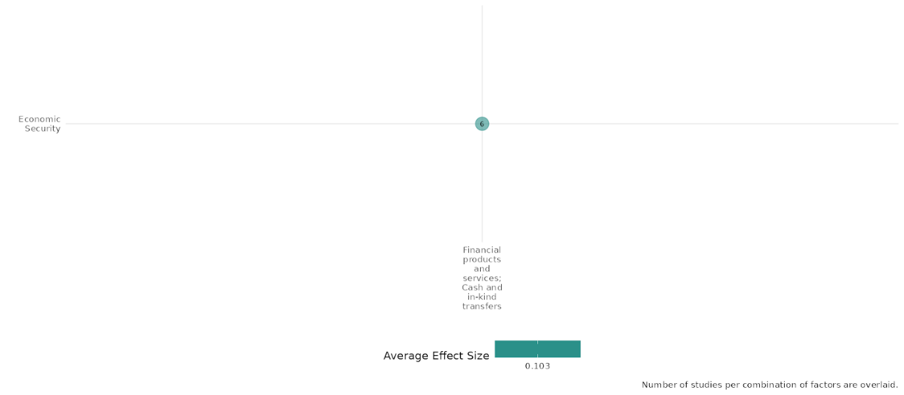

4.6.5(10)
Effect of Financial products and services Cash and in-kind transfers on Education Security

Financial products, cash transfers, and in-kind support can enhance education security by reducing economic barriers that hinder access to education.These interventions can improve school attendance, reduce dropout rates, and increase the likelihood of continued education, ultimately contributing to long-term educational stability.

Effect: Moderate effect (g=0.105)

Geographic Location: Sub Saharan Africa and Middle East & North Africa

Confidence in study findings: Low (2 studies with 8 effect sizes)

Short Summary:
The studies in this cell examine interventions designed to enhance social, political, and educational security. Friedman (2011) evaluates the impact of a girls' merit scholarship program in Kenya, which significantly improved test scores and increased political engagement through newspaper reading. However, the study found minimal effects on gender equality and modern values. By enhancing educational attainment for disadvantaged girls, the scholarship program directly strengthens educational security by improving human capital. Finally, Lehmann (2014) evaluated a winter cash assistance program for Syrian refugees in Lebanon, finding that while cash transfers did not fully meet winterization needs, they unexpectedly increased school attendance by reducing child labor, thereby strengthening educational security for vulnerable refugee children. Although these studies approach educational security from different angles, they collectively highlight the impact of financial support, educational incentives, and inclusive policies in expanding access to education and improving related outcomes.

The Intervention:
This typically comprises microcredit, microinsurance, and microsavings interventions (including establishing village savings and loan associations) and financial literacy support. This includes interventions that both in-kind and cash transfers. This covers the provision of goods and assistance, and specifically includes food assistance (where it is given directly to the community), and social safety nets, in terms of cash and subsidies to community members, which might be conditional or unconditional. This category also includes short-term cash-for-work programmes, which provide assistance in the form of cash for performing labour (rather than a traditional aid hand-out), and interventions that combine transfers with other forms of support, such as skills training or health support.

How the Intervention is expected to work:
The interventions in these studies are expected to work by addressing specific socioeconomic challenges through targeted financial support and complementary measures.

Friedman (2011) focuses on empowering young girls in Kenya through merit scholarships, incentivizing academic achievement, and improving human capital to foster educational and social advancement.

Lehmann (2014) seeks to alleviate the hardships faced by Syrian refugees in Lebanon during winter by providing cash assistance to meet basic needs, while also indirectly promoting school attendance and reducing child labor. These interventions leverage financial aid alongside behavioral incentives or capacity-building measures to achieve broader social, economic, or attitudinal changes.

The Evidence Base:
The evidence base comprises 3 studies, 2 being impact evaluations and one qualitative study Adedokun (2019). Of the 2 studies,1 is an RCT and the other uses a quasi-experimental design.

The studies in this cell are from Lebanon and Kenya and the qualitative story was based in Mozambique.

Evidence Findings:
The findings across studies are consistent, demonstrating the propensity for positive impacts on financial support on educational outcomes.

Included Studies

Friedman (2011): This study assessed the political and social impacts of a randomized girls' merit scholarship incentive program in Kenya, which raised test scores and secondary school enrollment. While the primary focus was on the program’s broader political implications, its connection to educational security is significant. The intervention enhanced educational access and academic performance, providing a foundation for long-term empowerment and stability. Improved educational outcomes were linked to reduced tolerance for domestic violence and increased political knowledge, suggesting that educational security can influence social attitudes. However, the program did not lead to greater perceived political efficacy, community participation, or voting intentions, and unexpectedly, it increased the perceived legitimacy of political violence. The study is rated as low confidence as there was partial description of interventions and outcomes.

Lehmann (2014): This study examined the impacts of the UNHCR winter cash transfer program in Lebanon, which provided $575 USD to 87,700 registered Syrian refugees to help them stay warm during the cold months. While the primary focus was on household well-being, negative coping strategies, and economic impacts, the program also indirectly affected educational security. Cash assistance increased access to schooling and reduced child labor, key factors in enhancing educational security. However, beneficiaries faced challenges in fully utilizing the assistance for heating needs due to competing demands for basic necessities like food. Despite these challenges, the program also led to positive economic effects, including a significant multiplier effect on the local economy. The study is rated as medium confidence due to non-experimental study design, partial description of intervention and outcomes and mention of power calculations
Confidence Assessment:
Overall Low: There is a high consistency of findings across the studies, however, study design limitations, including partial descriptions of interventions and outcomes, along with little to no power calculations, reduce overall confidence in the results.

Other outcomes in the study:

Human Security / Economic Security

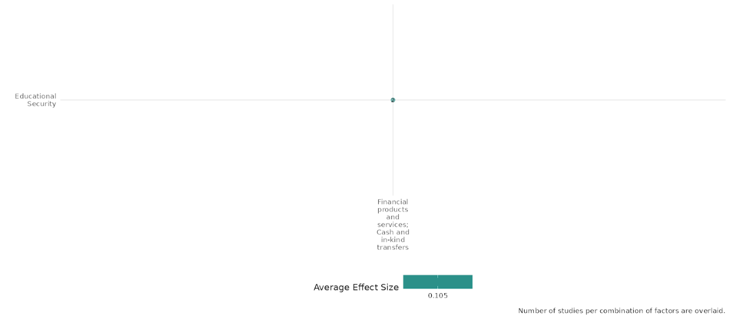

4.6.5(11)
Effect of Financial products and services Cash and in-kind transfers on Food security and nutrition & Health security

Financial aid can improve food security, nutrition, and health security by addressing resource constraints and increasing access to essential goods and services.

Geographic Location: Sub Saharan Africa, South Asia, Latin America & Caribbean, Middle East & North Africa

Effect: Small effect (g=0.096)

Confidence in study findings: Moderate (6 studies with 51 effect sizes)

Short Summary:
The studies in this cell explore the impact of financial products and cash-based interventions on food and health security in fragile and high-risk settings. Blattman (2017) found that combining cognitive behavioral therapy (CBT) with cash transfers reduced aggression and improved self-control among high-risk men in Liberia, indirectly enhancing mental well-being and health security. Hidrobo (2012) evaluated the World Food Programme's Food, Cash, and Voucher intervention for Colombian refugees and Ecuadorians, showing that cash transfers were the most cost-effective and preferred option, leading to improved food consumption and nutrition knowledge. Lehmann (2014) reported that cash assistance for Syrian refugees in Lebanon helped beneficiaries prioritize essential needs like food and water, improving food security, though it fell short of meeting heating needs. Muller et al. (2019) highlighted the negative consequences of an incomplete cash transfer program in South Sudan, where unmet expectations led to reduced consumption and psychological distress, particularly among women, emphasizing the need for reliable aid to ensure health security. Together, these studies underscore the potential of cash-based interventions in supporting food and health security, while stressing the importance of well-designed, consistently implemented programs for sustainable impact.

The Intervention:
This typically comprises microcredit, microinsurance, and microsavings interventions (including establishing village savings and loan associations) and financial literacy support. This includes interventions that both in-kind and cash transfers. This covers the provision of goods and assistance, and specifically includes food assistance (where it is given directly to the community), and social safety nets, in terms of cash and subsidies to community members, which might be conditional or unconditional. This category also includes short-term cash-for-work programmes, which provide assistance in the form of cash for performing labour (rather than a traditional aid hand-out), and interventions that combine transfers with other forms of support, such as skills training or health support.

How the Intervention is expected to work:
The interventions across the studies are designed to address immediate and long-term needs through cash-based assistance and complementary measures. Blattman et al. (2017) combined cognitive behavioral therapy (CBT) with cash transfers to improve self-control and reduce antisocial behaviors, aiming to foster lasting behavioral change. Hidrobo et al. (2012) evaluated cash, food, and voucher transfers to improve food security and nutrition, with an emphasis on participant choice and cost-effectiveness. Lehmann (2014) provided winter cash assistance to Syrian refugees to help them meet heating and basic needs, such as food and water, during colder months, while also assessing its broader socioeconomic impacts. Muller et al. (2019) combined unconditional cash grants with business and life skills training to support youth entrepreneurship and economic stability in South Sudan, though the program's unplanned cancellation left some participants without the intended support.

The Evidence base:
There are 8 studies in the cell: 7 are impact evaluations utilising experimental methodologies 6 RCTs, 2 non-experimental design studies and 1 qualitative study. The qualitative study by Adedokun (2019) is called, Transition from Civil War to Peace: The Role of the United Nations and International Community in Mozambique and is rated high confidence.

The impact evaluations are from Afghanistan (1 study), Uganda (2 studies), Liberia (1 study), Syrian refugees in Lebanon (1 study), South Sudan (1 study) and Ecuador (1 study). Whilst the qualitative study is based in Mozambique.

Evidence findings:
The studies collectively indicate that cash transfers can indirectly improve food security and health outcomes, but their effects vary depending on program design and implementation. While cash transfers can enhance short-term well-being and food access, their long-term impact on health and food security depends on stable implementation and complementary support mechanisms.

Included Studies:
Kurtz (2018):examines the effects of financial products, services, and cash and in-kind transfers on food security, nutrition, and health security in Afghanistan, specifically through the INVEST program, which provided vocational training and unconditional cash transfers (UCTs) to vulnerable youth. While the program was primarily designed to improve employment and reduce support for armed opposition groups, it also had indirect implications for food and health security. The study found that UCTs provided short-term financial relief, enabling recipients to meet basic needs such as food and healthcare. However, this effect was temporary, as most beneficiaries spent the cash transfers on immediate consumption rather than long-term investments. The study states, "Recipients spent their money on basic needs, which may have reduced the lure of financial incentives from armed opposition groups in the short term". However, six to nine months later, the effect dissipated, indicating that a one-time cash transfer was insufficient to generate lasting improvements in food or health security. Interestingly, the combination of vocational training and cash transfers produced the most positive long-term effects, including improved perceptions of government responsiveness, which could influence broader economic and health security outcomes. The study concludes that “multidimensional interventions that address both economic and governance-related grievances appear more effective”.

Blattman (2017): Blattman et al. (2017) focused on a combination of cognitive behavioral therapy (CBT) and cash transfers as an intervention for high-risk men in Liberia, with the goal of improving self-control and reducing antisocial behaviors. The study found that the combination of CBT and cash led to significant reductions in aggressive behaviors and improved self-control, suggesting that integrating financial products with psychological support can have a lasting impact on behavior. While the study didn't directly measure food security, the findings directly relate to health security by addressing behavioral improvements, such as reduced aggression, which can affect overall mental well-being in high-risk populations. The short-term improvements in economic performance, however, did not show significant changes in income or assets after a year, implying that while cash transfers may contribute to immediate behavioral shifts, their longer-term effects on financial stability outcomes require further exploration. The study is rated high confidence.

Hidrobo (2012): This final impact evaluation of the World Food Programme's Food, Cash, and Voucher intervention examines outcomes such as food security, anemia, and gender issues among Colombian refugees and poor Ecuadorians in Northern Ecuador. The study finds that cash transfers incurred lower costs to participants and were preferred over food or vouchers. While all transfer modalities were mainly used for food consumption, voucher recipients spent a larger portion on food. The nutrition knowledge gained through the program was most significant for iron- and vitamin A-rich foods and infant feeding practices. Although the study highlights various benefits, including increased food consumption and improved nutrition knowledge, it does not directly measure health security or food security beyond consumption patterns. The findings suggest that cash transfers may provide a cost-effective and preferred option for improving food consumption, which indirectly supports food security and health, particularly when accompanied by nutrition education. The study is rated high confidence due to experimental study design and no mention of power calculations.

Lehmann (2014): This study evaluates the impacts of the winter cash transfer program run by UNHCR for Syrian refugees in Lebanon. The cash assistance, which aimed to help beneficiaries stay warm during winter, was primarily used for food and water, with beneficiaries spending more than half of the cash on these basic needs, despite also receiving food vouchers. The study found that cash assistance did not meet the program's objective of keeping all beneficiaries warm, as many reported insufficient heating supplies. However, the program did not cause negative consequences such as inflation or increased refugee migration. Additionally, cash assistance improved access to education, reduced child labor, and increased community support. While the study primarily focused on well-being metrics, it also suggested that cash transfers can improve food security by enhancing beneficiaries' ability to meet basic needs, including food consumption, thereby indirectly supporting health security. The study is rated as medium confidence due to non-experimental study design, partial description of intervention and outcomes and mention of power calculations

Muller et al. (2019): examine the effects of the unintended closure in 2016 of the Youth Business Start-Up Grant Programme in South Sudan. This study investigates the consequences of the unplanned cancellation of the South Sudan Youth Business Start-Up Grant Program, which aimed to provide unconditional cash grants and business and life skills training to youth in South Sudan. The study reveals that participants who received the planned support showed improvements in consumption, savings, and psychological well-being. However, individuals who were unable to access the grant after anticipating it faced negative outcomes, including reduced consumption, with women in particular experiencing significant declines in trust. The disruption of the program underscores the importance of consistent and reliable support, as the failure to implement the program as intended had a detrimental impact on both economic and psychological well-being—key factors in ensuring health security, especially in fragile and insecure contexts. The study is rated medium confidence because of moderate levels of attrition and incomplete description of the intervention.

Blattman (2013): The study assessed self-reported health indicators including the number of days sick in the last 30 days, perception of health status, and mental well-being (depression and anxiety index). The findings showed little impact on these measures, with the only statistically significant result being that WINGS program beneficiaries reported 20% more days sick per month than the control group. However, the study found no meaningful difference in perceptions of health status or symptoms of depression and anxiety​. Regarding food security, the study measured whether participants went to bed hungry in the past week. While treated individuals were slightly less likely to report going to bed hungry, this change was not statistically significant. The study also found that although beneficiaries increased spending on children's health and education, there was no measurable improvement in children's health outcomes​. Overall, the study suggests that while cash grants can improve economic well-being, they do not necessarily lead to better health or food security outcomes in the short term. This study is rated high confidence. However, there is not enough effect size data within the study related to the outcome measured in the cell.
Baseler (2021): In this study,cash grants were assessed for their impact on food security, nutrition, and health security among Ugandan microentrepreneurs. The study measured food insecurity by tracking how often participants went without enough food and whether they struggled to afford basic household expenses like medicine, rent, and school fees. While cash assistance provided some economic relief, the findings suggest that financial transfers alone did not significantly improve food security or health security in the long term. Many households still faced economic distress, with some needing to sell assets or borrow money to cover basic necessities, indicating that short-term cash transfers may not provide sustained improvements in food and health security without complementary interventions​. This study is rated medium confidence due to no power calculations.

Confidence assessment:
Overall, moderate confidence: The findings across all studies are consistent but the lack of power calculations across studies lowers the confidence rating.

Other outcomes in the study

Human Security / Economic Security

Violence and atrocity prevention / Social norms regarding violence and atrocities

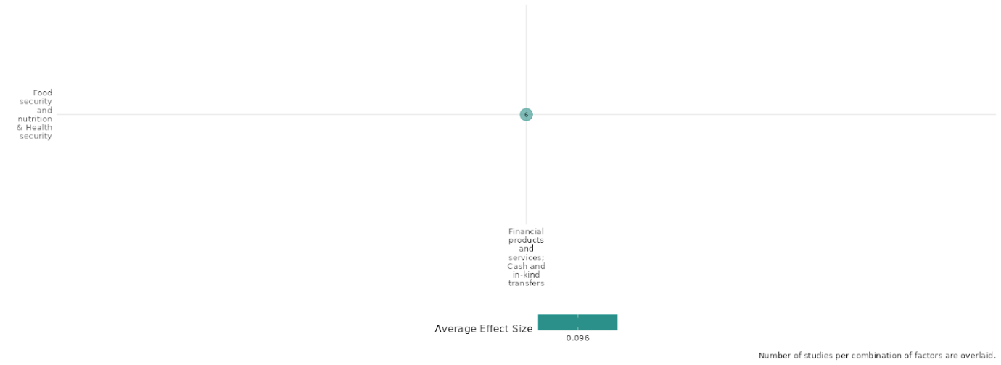

4.6.5(12)

Effect of Financial products and services Cash and in-kind transfers on Physical Security

Financial aid, in this case welfare based cash grants, can influence physical security by improving citizens' perceptions of government effectiveness and legitimacy. However, the effects can vary, with some areas seeing improvements in peace and security, while others experienced minimal or even negative impacts, particularly if the programs are perceived as tools for political manipulation or clientelism.

Geographic Area: South Asia, Sub Saharan Africa and Global

Effect: Adverse effect (g= -0.027)

Confidence in study findings: Low confidence (2 studies with 5 effect sizes)

Short Summary:
The studies on financial products, services, and cash and in-kind transfers reveal mixed effects on physical security, with outcomes largely dependent on program design and implementation. Ghorpade (2019) evaluates the Benazir Income Support Programme (BISP) in Pakistan and finds no significant impact on household financial security, coping strategies, or perceptions of government effectiveness, suggesting that cash transfers alone did not enhance physical security. In contrast, Muller (2019) examines interventions in conflict-affected Afghanistan, showing that while one-time cash transfers provided temporary reductions in youth support for armed opposition groups (AOGs), the effect dissipated within months. However, when combined with vocational training, cash transfers led to a 17% reduction in pro-AOG sentiment, highlighting the importance of multi-dimensional approaches. Overall, the findings suggest that cash transfers alone may have limited or short-term effects on physical security, while integrated programs that enhance economic and governance-related factors can yield more sustained benefits.

Long Summary:
The Intervention:
This typically comprises microcredit, microinsurance, and microsavings interventions (including establishing village savings and loan associations) and financial literacy support. This includes interventions that both in-kind and cash transfers. This covers the provision of goods and assistance, and specifically includes food assistance (where it is given directly to the community), and social safety nets, in terms of cash and subsidies to community members, which might be conditional or unconditional. This category also includes short-term cash-for-work programmes, which provide assistance in the form of cash for performing labour (rather than a traditional aid hand-out), and interventions that combine transfers with other forms of support, such as skills training or health support.

How the intervention is expected to work:
Through the provision of direct cash transfers, the BISP was intended to enhance the resilience and general well-being of low-income households in Pakistan. Enhancing household economic stability is the intervention's main goal, and it is accomplished through cash apparatus, Encourage fair targeting practices by moving away from parliamentary nominations to proxy-means testing, which aims to guarantee a more impartial and equitable distribution of benefits, and strengthen political attitudes by boosting beneficiaries' faith in the government.
Secondly, the Youth Startup Business Grant Program in South Sudan, designed to improve economic opportunities for young people, particularly women, in a conflict-affected environment. The program combined unconditional cash grants of $1,000 with a one-week business and life skills training, aiming to promote self-employment and business development. Beneficiaries were required to attend the training before accessing the grant, which was deposited into a commercial bank account. The intervention was expected to increase income, savings, and economic stability, thereby reducing vulnerability to violence and criminal activities.

The Evidence Base:
This cell features 3 studies, 2 impact evaluations, (1 RCT and 1 non-experimental study) and finally, one systematic review.
The studies are based in South Sudan, Pakistan and the review has a Global focus.

Evidence findings:
Overall, the findings suggest that cash transfers alone may have limited or short-term effects on physical security, while integrated programs that enhance economic and governance-related factors can yield more sustained benefits.

The review evidence:
The systematic review of Lwamba et al. is entitled 'Strengthening women's empowerment and gender equality in fragile contexts towards peaceful and inclusive societies: A systematic review and meta-analysis'. The review is rated as high confidence in review findings.

The impact evaluation evidence:
Ghorpade (2019): The study assesses the effects of a large cash transfer programme implemented in Pakistan—the Benazir Income Support Programme (BISP)—on citizens’ attitudes towards the government. The study was designed as a quasi-experimental study. The total sample size is 3907 including 572 program recipients and 3335 as non-recipients. The study shows that the BISP had no effect on households’ exposure to shocks, their resorting to harmful coping strategies in the 12 months preceding the survey, self-reported improvements in the households’ financial condition over the past two years, or positive prospects for an improved economic situation. Also, there is no causal effect of the BISP on political attitudes through pathways related to the improved financial conditions and expectations, or more effective social protection. The study is rated as low confidence due to non-experimental study design and no mention of power calculations.

Muller (2019): explores the impact of financial products, services, and cash and in-kind transfers on physical security, particularly in conflict-affected regions such as Afghanistan. The research evaluates two interventions: a technical and vocational education and training (TVET) program and an unconditional cash transfer (UCT) initiative, both aimed at improving economic conditions and potentially reducing support for political violence. Findings indicate that while the one-time cash transfer of $75 initially reduced youth support for armed opposition groups (AOGs), this effect dissipated within six to nine months, with some recipients even registering increased support for violent groups​. Conversely, the combination of vocational training and cash transfers resulted in a significant 17% decrease in willingness to engage in pro-AOG actions after six to nine months​. The study suggests that economic stability alone does not explain these outcomes; rather, improvements in perceptions of government responsiveness played a critical role in reducing political violence. This underscores the need for multidimensional interventions that address economic, governance, and psychosocial factors to enhance physical security​. This study is rated medium confidence due to partial descriptions of evaluation questions and no mention of power calculations.

Confidence assessment:
Overall Low: The cell is rated low confidence due to a limited number of studies.

Other outcomes in this study:
Violence / social norms regarding violence
Social cohesion / Feelings of trust & Acceptance of diversity

Link to review summaries:
Lwamba (2022)



4.6.5(13)
Effect of Financial products and services Cash and in-kind transfers on Political Security

Educational and political security interact: heightened political awareness curbed acceptance of corruption.

Effect: Adverse effect g= (-0.134)

Geographic Location: Sub Saharan Africa and Global

Confidence in study findings: (1 study with 1 effect sizes)

Short Summary:
This study analyses the political and social consequences of a randomised girls' merit scholarship program in Kenya that aimed to boost test scores and secondary school enrolment. The findings call into question the "modernisation theory" that education increases democratic sentiments. Instead, the study supports the "empowerment view," demonstrating that young women in the program were less likely to accept domestic abuse, had higher levels of political education, and were less accepting of political power. However, this rejection of authority did not result in increased political efficacy, community participation, or voter intentions. Surprisingly, the study discovered that the perceived legitimacy of political violence has increased. Reverse causation may explain why people believe that education promotes acceptance of authority.

The Intervention:
This typically comprises microcredit, microinsurance, and microsavings interventions (including establishing village savings and loan associations) and financial literacy support. This includes interventions that both in-kind and cash transfers. This covers the provision of goods and assistance, and specifically includes food assistance (where it is given directly to the community), and social safety nets, in terms of cash and subsidies to community members, which might be conditional or unconditional. This category also includes short-term cash-for-work programmes, which provide assistance in the form of cash for performing labour (rather than a traditional aid hand-out), and interventions that combine transfers with other forms of support, such as skills training or health support.

How the Intervention is expected to work:
The intervention is expected to work by providing financial incentives in the form of merit-based scholarships, which would encourage girls to perform better academically and complete secondary schooling. The idea is that by increasing educational attainment, particularly among young women, the program would foster empowerment and promote broader social and political impacts. Specifically, it is anticipated that education would lead to more informed political attitudes, a reduction in acceptance of domestic violence, and changes in political views, including greater political knowledge. Although not expected to directly affect voting intentions or community participation, the scholarship program is designed to alter the way girls perceive authority, political violence, and their roles in society

The Evidence Base:
This cell includes 3 studies: a randomized controlled trial (RCT), a systematic review, and a qualitative study. The impact evaluation is conducted in Kenya, the systematic review takes a global perspective, and the qualitative study by Adedokun (2019) focuses on Mozambique.

Evidence Findings:
The study offers multiple insights related to political security. While the scholarship program raised political knowledge and reduced trust in political authority, it also increased the perceived legitimacy of political violence. Although participants rejected traditional political authority, this did not lead to increased political efficacy, community participation, or voting intentions. To summarise, while the program empowered young women with more political awareness and reduced their acceptance of domestic abuse, it also revealed the complex relationship between education and political security, with some bad consequences, such as increased support for political violence.

The review evidence:
The systematic review of Lwamba et al. is entitled 'Strengthening women's empowerment and gender equality in fragile contexts towards peaceful and inclusive societies: A systematic review and meta-analysis'. The review is rated as high confidence in review findings.

The impact evaluation evidence
Friedman (2011) Education as Liberation?
This study evaluated the political and social impacts of a randomized girls' merit scholarship program in Kenya aimed at increasing test scores and secondary schooling. The study, which included 1,387 girls and followed up after baseline data and test scores from 2001 or 2002, found that the scholarship program led to significant test score gains in treatment schools compared to control schools. However, the program did not significantly alter views on gender roles or promote modern values. There was also no notable impact on participants' attitudes toward women's rights. Interestingly, the study found that girls in treatment schools spent significantly less time listening to music and entertainment-focused radio and more time reading newspapers, which are more politically oriented. This suggests that the program may have influenced the participants' engagement with politics, although it did not directly promote modern or pro-democratic values. This study is rated as having low confidence due to incomplete descriptions of the intervention and outcomes, as well as a lack of reported attrition.

Confidence assessment:
Overall Low: There is a high consistency of outcome findings in this study. However, a few studies fall short due to little or no mention of power calculations.

Other outcomes in this study:
Human security / economic security
Human security / educational security
Community and state governance / government performance

Link to review summaries:
Lwamba (2022)

Shiny App Screenshot:
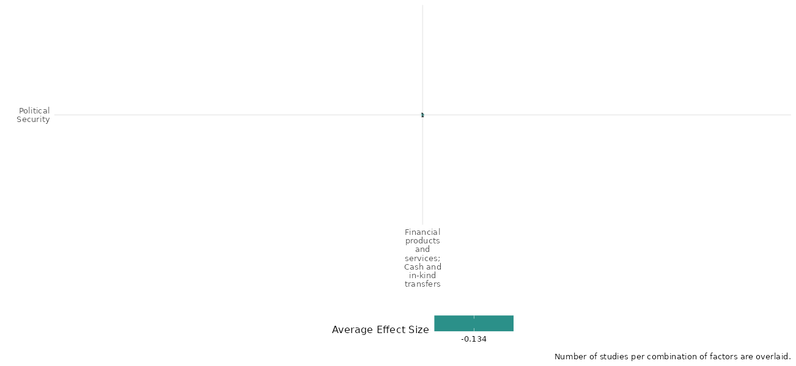

4.6.6 Infrastructure investment
4.6.6(1)
Effect of infrastructure investment on diplomatic relations & peaceful dispute resolution

Infrastructure investments, such as those made under the Belt and Road Initiative (B&R), enhance diplomatic relations and support peaceful dispute resolution.

Geographic region: Global

Effect: Moderate effect (g=0.153)

Confidence in study findings: Low (1 study with 1 effect size)

Short summary
The Belt and Road Initiative (B&R) demonstrates how transport infrastructure connectivity (TIC) fosters diplomatic relations and peaceful dispute resolution. By enhancing trade, creating economic opportunities, and promoting regional interdependence, B&R projects improve conflict governance rankings globally. While developed countries benefit more due to institutional stability, governance challenges in developing nations highlight the need for strategic implementation.

The intervention
Infrastructure investments could be directed on improving transport infrastructure connectivity (TIC) in roads, railways, ports, and air transport facilities. These projects, such as China's Belt and Road Initiative (B&R), emphasize reducing trade costs and facilitating mobility across borders. It focuses on building and upgrading TIC across Asia, Africa, Europe, and beyond. By addressing infrastructure deficits, particularly in developing countries, the B&R seeks to create economic opportunities while positioning China as a key player in global trade and diplomacy.

How the intervention is expected to affect this outcome
Infrastructure investments are hypothesized to improve diplomatic relations and peaceful dispute resolution by improving mobility among peacekeepers. It could promote shared economic interests, which could also reduce the likelihood of interstate conflict and foster cooperation. In conflict-affected areas, improved infrastructure may address grievances by creating jobs, reducing poverty, and enhancing regional interdependence, which collectively encourage peaceful engagement over hostility. However, poorly implemented infrastructure projects may exacerbate vulnerabilities by providing access to resources for militant groups or heightening economic inequalities.

The evidence base
The cell includes 1 impact evaluation study. This study utilized a global data set and leveraged on the variation in the timing and location of B&R-related infrastructure projects to create a natural experiment.

Evidence findings
Infrastructure investment significantly enhances a country’s ability to resolve conflicts and improve diplomatic relations, increasing their global conflict governance rankings (an average of 6-13 ranking positions). This effect is more pronounced in developed countries due to stronger governance and institutional stability. Mechanisms such as trade facilitation, income growth, and gender-balanced employment opportunities play critical roles in mediating these effects. However, in developing nations, challenges such as weak governance and financial risks can limit the effectiveness of TIC.

Included studies
Luo et. al (2022) explores the impact of Transport Infrastructure Connectivity (TIC) on conflict resolution, leveraging data from 192 countries between 2010 and 2017. A key focus is the Belt and Road Initiative (B&R), which serves as a natural experiment for examining TIC’s influence on global conflict resolution. The study employs a Difference-in-Differences (DID) approach and dual machine learning (DML) techniques to address endogeneity and heterogeneity. Key data sources include the Global Justice Index, World Bank indicators, and UCDP conflict databases. Subsample analyses differentiate between developed and developing countries, considering varying impacts of TIC. The findings reveal that TIC improves conflict governance rankings (an average of 6-13 ranking positions), with greater benefits observed in developed countries due to their higher marginal utility for peace. Mechanisms include enhanced trade facilitation, increased female labor participation, and income growth. However, results highlight context-dependent effects and emphasize the importance of balancing TIC with security measures to prevent unintended consequences like easier militant access. The study is rated as medium since it is a non-experimental study.

Confidence Assessment
Overall low: The confidence rating for this cell is low considering that it only includes 1 study.:

Other outcomes in the study:
None

4.6.6(2)
Effect of infrastructure investment on nature and scale of violence and atrocities

Infrastructure investment initiatives, particularly those which are smaller in size and localized, reduce violence. Larger projects tend to have insignificant or adverse effects.

Geographic scope: Middle East, Global

Effect: No effect (g=0)

Confidence in study findings: Low (3 studies with 9 effect sizes)

Short Summary
The infrastructure investment intervention examined in this cell focuses on the Commander’s Emergency Response Program (CERP), a U.S. military-led initiative designed to provide rapid, small-scale aid in conflict zones, particularly in Afghanistan and Iraq. CERP projects range from road construction, water supply systems, and electricity infrastructure to smaller community-driven initiatives. The program follows the “hearts and minds” counterinsurgency approach, assuming that improving living conditions will lead local populations to support the government and reject insurgent groups. Findings indicate that small infrastructure projects were more successful in mitigating violence, particularly when implemented with localized military units and flexible funding mechanisms such as “cash on hand” disbursement. In Iraq, smaller projects were found to be about five times more effective than large projects in reducing violence. Conversely, large infrastructure projects in Afghanistan had no significant effect or were even associated with increased violence.

The intervention
The infrastructure investment initiative examined in this cell focuses mainly on the Commander’s Emergency Response Program (CERP). The CERP is a U.S. military-administered development initiative designed to provide rapid, small-scale aid to communities in conflict zones, primarily Afghanistan and Iraq. CERP-funded projects include road construction, water supply systems, and electricity infrastructure, alongside smaller-scale community initiatives.

How the intervention is expected to work
The CERP is developed under the “hearts and minds” counterinsurgency approach, which assumes that improving living conditions will lead local populations to support the government and reject insurgent groups. CERP funding was highly decentralized, meaning local military commanders could decide which projects to implement based on immediate needs. Funds were often allocated based on security priorities rather than long-term development goals, meaning money flowed to high-conflict areas rather than those with the greatest economic need.

The evidence base
This cell includes three impact evaluations in Afghanistan and Iraq. These analyzed a U.S. military initiative.

One of the reviews discusses the effects of different interventions (which include infrastructure investment) on mitigating or preventing armed violence in developing and middle-income countries. The other is concerned with development aid, including infrastructure aid, and its effects on violence.

Evidence findings
Infrastructure investment projects, such as the CERP, reduces the scale of violence, although this effect is only observed in small projects. For instance, smaller projects implemented with localized units were found to be more effective than larger projects in Iraq. Projects which were disbursed through “cash on hand” methods were also found to be more effective, as compared to those which goes through extensive administrative approval. Meanwhile, large projects were found to have insignificant or adverse effects on violence and atrocities in Afghanistan.

The review evidence
The reviews show that infrastructure programs either have no significant effect or exacerbate violence. One of the reviews discussed that public works programs could lead to an increase in insurgent attacks or casualties, while the other noted that large-scale infrastructure projects did not have significant effect on violence.

The impact evaluation evidence
There are 3 impact evaluations. Three study summaries are thus provided here:

Adams (2015) explores the effectiveness of the Commander’s Emergency Response Program (CERP) in Afghanistan, a U.S. military initiative aimed at promoting local development. It provides the commander the ability to mould the combat environment. The study utilizes the CERP project spending and SIGACTs (Significant Activities) data documenting violence. The dataset covers 32 months (2011-2013), which include 398 Afghan districts – 4,148 CERP projects categorized as small (<USD50,000) or large (>USD50,000). District-level fixed-effects regression which accounts for population size, prior violence trends, and seasonal controls is applied to evaluate how spending correlates with changes in violence. The findings show that small CERP projects are significantly associated with reductions in violence, particularly after a lag of three months. In contrast, large projects correlate with increases in violence. Projects disbursed with “cash on hand” methods (bulk CERP) were also found to be more effective in reducing violence compared to those requiring extensive administrative approval. The study is rated medium as it is non-experimental and due to its partial description of the evaluation question.

Berman (2011 & 2013) investigates the effectiveness of reconstruction spending, particularly through the Commander’s Emergency Response Program (CERP), in reducing violence in Iraq. The authors analyze whether improved service provision can mitigate insurgent violence and enhance community stability. The study employs a panel data analysis approach, utilizing a combination of violence data against Coalition and Iraqi forces, reconstruction spending data, and community characteristics. The sample consists of district-level observations. The study analyzes 1,040 district/half-year observations, covering 104 districts over a period from January 2004 through December 2008. The study finds that every additional dollar per capita of CERP spending is associated with a reduction of 1.59 violent incidents per 100,000 population per half year, particularly after January 2007 when operational changes improved understanding of community needs. The average violence rate in Iraq during the study period was 58.6 incidents per 100,000 per half year. Smaller projects, implemented by units with better local knowledge, were found to be about five times more effective in reducing violence compared to larger projects.The study is rated medium as it is non-experimental and due to its partial description of the evaluation question.

Child (2014) The Commander’s Emergency Response Program (CERP) was implemented by the U.S. military in Afghanistan from 2005 to 2009 to fund reconstruction projects. These projects aimed to reduce violence by fostering economic development and improving cooperation with local communities as part of a broader counterinsurgency (COIN) strategy under the "hearts and minds" credo. The study analyzed the impact of CERP spending on violence across 227 districts in Afghanistan over a 57-month period. The analysis found no statistically significant effect of CERP spending on reducing violence. Instead, a weak positive relationship was observed in the OLS estimates, indicating that higher spending might be associated with increased violence, possibly reflecting project targeting in volatile regions. Distinguishing between small and large projects did not yield statistically significant estimates, but large projects showed a potential for adverse effects. The confidence in the findings was rated as low due to insufficient information on the evaluation questions.

Confidence Assessment
Overall low: This cell is rated low as it contains less than 4 impact evaluation studies.

Link to review summaries
Cramer (2016)
Zurcher (2017)
All studies may be accessed via the EGM.

Other outcomes in the study:
None

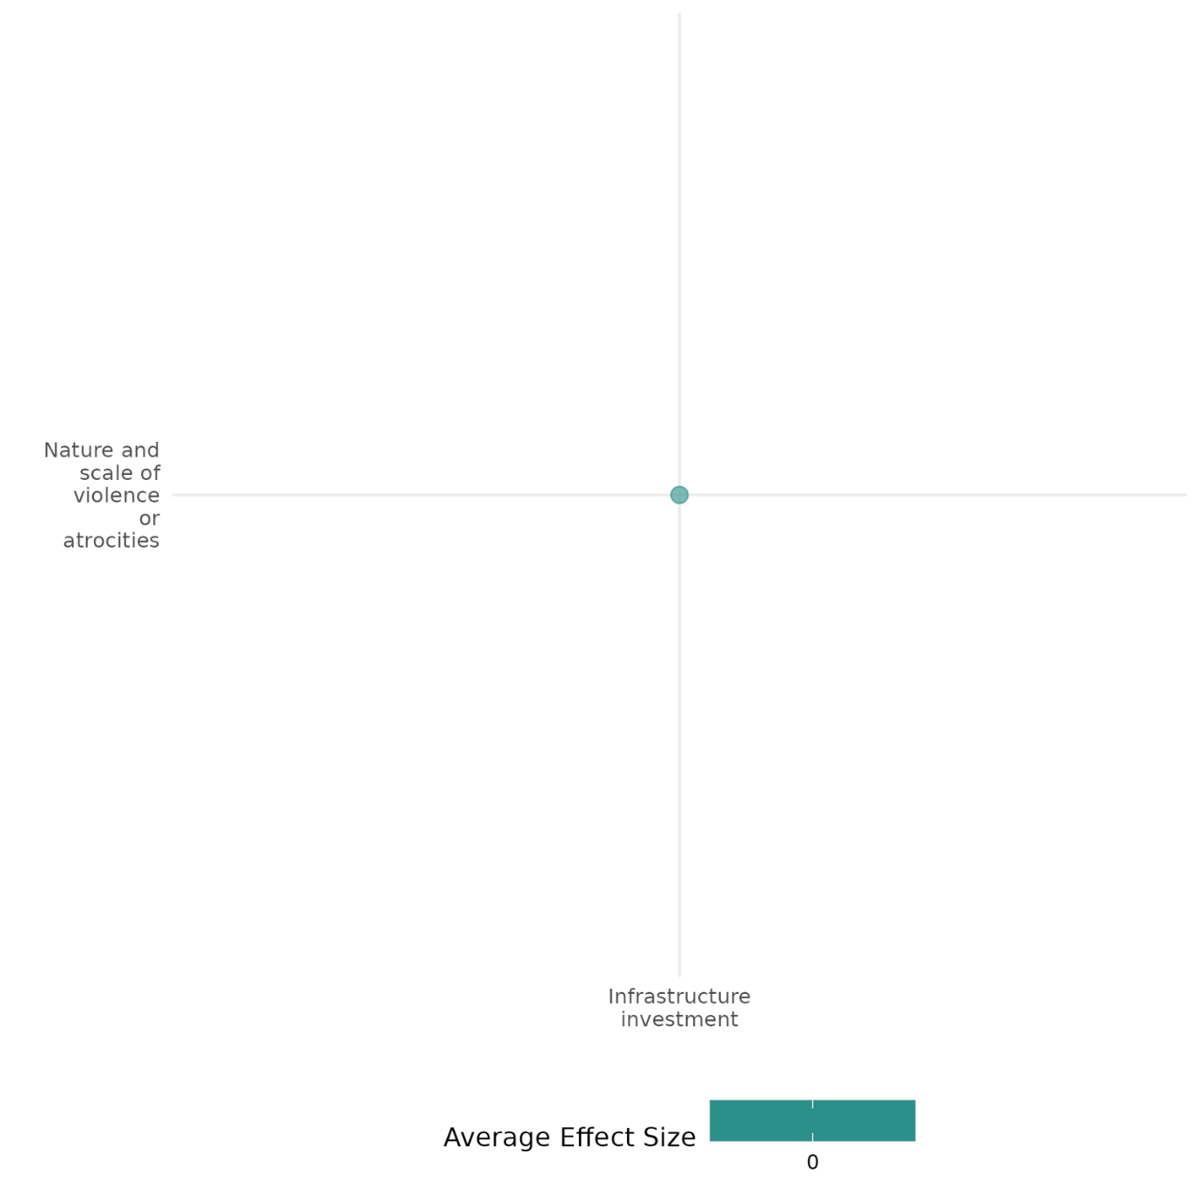

5.1 Cells Only with Qualitative Studies
Military Operations

The effect of military operations on justice

Effect: negative (securitisation was not an effective strategy for resolving the punjab crisis. While it may have achieved some short-term gains, it ultimately failed to address the underlying causes of the conflict and may have even exacerbated tensions)
Confidence in study findings: low (one study, low confidence)

Summary
The Sikh community suffered significant injustice during the Punjab crisis. State violence, communal riots, and a compromised legal system exacerbated their grievances. The government’s heavy-handed security approach, exemplified by Operation Bluestar, failed to address the root causes of the conflict. Instead, it fueled resentment, securitised sikh identity, and hindered the pursuit of justice. This approach proved ineffective in resolving the crisis and ultimately exacerbated tensions

The intervention
The Indian government’s response to the Punjab ethnic crisis, which involved a combination of legal measures, military operations, and increased security presence, can be considered a multifaceted intervention. While political engagement was attempted, it was largely eclipsed by the dominant security approach

How is the intervention expected to work
This was characterised by heavy-handed security measures and limited political engagement, suppressed militancy but also securitised Sikh identity and failed to address underlying grievances. This approach undermined democratic principles, led to human rights abuses, and hindered the pursuit of justice for all affected parties

The evidence base
There is one qualitative study assessing the effect of military operations on achieving justice as an outcome in Punjab, India. This study is by sm. Roychoudhury. State securitization and internal ethnic conflicts in India: re-examining the Punjab crisis. Jadavpur journal of international relations 18, no. 2 (2014): 155-173. All references are from that study.

The evidence
The evidence while discussing the securitisation approach employed in the Punjab crisis, does not explicitly detail how the intervention was expected to deliver justice as an outcome. The primary focus of the intervention is on restoring order and maintaining national unity, with less emphasis on addressing the underlying injustices that fueled the conflict.

- Human rights abuses and lack of redressal: the author, while acknowledging the government's justification for Operation Bluestar as a necessary action to combat terrorism, criticises the operation for its intensity and brutality. This suggests that the operation resulted in human rights violations and casualties that went beyond what was necessary, implying a denial of justice to those affected. Furthermore, the author mentions the lack of judicial redressal for the victims of the anti-Sikh riots that followed the assassination of Indira Gandhi. The failure to hold those responsible for the riots accountable further underscores the lack of justice experienced by the Sikh community. (p.163-164)
- Securitisation and marginalization of Sikhs: the author argues that this approach targeted not just the militants but also the Sikh identity itself (p.160). The perception of Sikh demands for autonomy and their religious symbols as threats led to their marginalisation and the creation of an environment of fear and suspicion denied the Sikh community equal treatment and recognition within the Indian state. The failure to engage with the communities’ grievances in a meaningful and timely manner is presented as a key factor contributing to the escalation of the conflict. This neglect of grievances can be interpreted as a denial of justice, as it ignores the root causes of the conflict and perpetuates the conditions that led to sikh dissatisfaction and the rise of militancy. (p.161)
- Military operations: the Indian governments use of emergency laws and military force in Punjab, is argued as undermining democratic principles that restricted civil liberties.678 the author gives an example of the lack of judicial investigation into the killing of a family by the police, highlighting how the justice system may have been compromised during this period. The weakening of democratic processes and institutions is presented as a factor that further hindered the pursuit of justice in Punjab. (p.168-169)

The intervention may have achieved some short-term security gains, they failed to deliver justice as an outcome for the sikh community.

Confidence assessment
Overall confidence: low confidence qualitative study (established small n approach is not used/unclear, no description of the data collection method, no explanation and justification for sample/case selection strategy, no triangulation done, no discussion of bias).

The effect of Military operations on feelings of trust & acceptance of diversity

Effect: Negative (military operations in Ramadi had a negative impact on public trust and tolerance for diversity. This is attributed to heavy-handed tactics and a lack of political efforts to address sectarian divisions. However, in Tal Afar, a mixed impact is assessed of military operations on feelings of trust and acceptance of diversity)

Confidence in study findings: Low (one study, low confidence)
Short Summary
The US counterinsurgency in Iraq prioritised good governance and security but neglected underlying sectarian divisions. While the strategy in one of the regions- Tal Afar showed initial success, it was fragile. In contrast, Ramadi’s (another region in Iraq) failure highlighted the insufficiency of governance-focused approaches without addressing sectarian tensions. Heavy-handed military tactics alienated the Sunni population, while the deployment of Shia security forces further exacerbated sectarian divisions. In Tal Afar, a more nuanced approach and efforts to address sectarian tensions fostered a more positive environment for reconciliation and acceptance of diversity. Thus in contexts with significant ethno-religious cleavages, addressing those divisions is crucial for counterinsurgency success, even more so than good governance alone.

The intervention
The US counterinsurgency efforts in Iraq (Ramadi and Tal Afar), have a range of military interventions employed, which can be broadly categorised into two phases: offensive operations aimed at disrupting insurgent activity and population-centric operations focused on securing the local population and building relationships.

How is the intervention expected to work
Several interconnected elements contribute to the counterinsurgency efforts, these are:
- Establishing legitimacy: The overarching goal was to establish the legitimacy of the incumbent government in the eyes of the local population. This legitimacy can be achieved primarily in two ways- firstly, traditional counterinsurgency doctrine emphasises the importance of effective governance, including basic service delivery, economic development, and a just legal system, to win popular support. Secondly, by addressing ethno-religious cleavages in Ramadi and Tal Afar, addressing sectarian tensions is crucial for building legitimacy. This involves power-sharing, grievance redressal, and reconciliation efforts.
- Providing security: This was found to be fundamental to counterinsurgency success. Without a secure environment, governance initiatives, infrastructure development, and community trust-building is argued as challenging. A population-centric approach that prioritises civilian protection and community engagement was essential. Maintaining sufficient troop presence to deter insurgents and provide a sense of security.
- Military cooperation with the local population: Building strong relationships with the local population and engaging with the community, understanding their needs, and fostering trust are identified as key factors. This involves identifying and collaborating with influential local leaders and demonstrating cultural sensitivity to avoid alienating the population

The evidence base
There is one qualitative study assessing the effect of military operations on feelings of trust & acceptance of diversity in Iraq. This study is by M Fitzsimmons. (2013). Governance, identity, and counterinsurgency: Evidence from Ramadi and Tal Afar. All references are from that study.

The evidence
- In Ramadi, the initial reliance on large-scale offensive operations, characterised by cordon and search missions and frequent artillery bombardments, proved largely counterproductive in building trust with the local population. These operations, often perceived as indiscriminate and heavy-handed, alienated many residents and reinforced existing sectarian grievances (p.41-43). Further exacerbating the situation was the deployment of predominantly Shi'a Iraqi security military forces, which fueled sectarian tensions and deepened mistrust between the US forces and the Sunni population. The perceived bias of these forces, coupled with the aggressive tactics employed by US troops, fostered an environment of fear and resentment, blocking efforts to promote acceptance of diversity (p.32-46)
- In contrast to Ramadi, the shift towards a more population-centric approach in Tal Afar had a moderately positive impact on trust and acceptance of diversity. By establishing a persistent presence within the city, increasing foot patrols, and engaging in more direct interactions with residents, US forces were able to build relationships and foster a sense of security. he 3ACR recognised the importance of addressing the sectarian divisions within Tal Afar. They focused on building relationships with both Sunni and Shia tribal leaders, mediating disputes, and promoting a shared sense of community against the threat of extremist groups like al-Qaeda in Iraq (p.81-96). There was a focus on addressing the root causes of sectarian tension, coupled with the more nuanced approach to military operations, created an environment conducive to reconciliation and acceptance of diversity
Confidence assessment
Overall confidence: Low Confidence Qualitative Study (Established small n approach is not used/Unclear, no triangulation done, no discussion of bias)

The effect of military operations on transitions of power

Effect: Positive (presence or absence of external intervention played a significant role in the outcome of TSG claims)

Confidence in study findings: Low (one study, low confidence)

Summary
The study analyses the minority territorial self-government (TSG) claims in post-communist Central and Eastern Europe (CEE). It finds that TSG arrangements were more likely to emerge in low-capacity, partially democratic states, often as a result of externally facilitated conflict management. Peaceful TSG claims were frequently denied in high-capacity democracies. The authors argue that external intervention, particularly in cases of violent conflict, was crucial in shaping the outcomes of territorial disputes. International intervention often led to TSG arrangements, while patron-state intervention had a more complex and varied impact. These findings highlight the importance of external actors in facilitating peaceful resolutions of territorial conflicts in the region.

The intervention
The authors identify two main types of external intervention influencing TSG in post-communist CEE: international intervention and patron-state intervention. International intervention, often non-military, is associated with TSG arrangements, especially in cases of violent conflict. Patron-state intervention, while less common, can also impact TSG outcomes, but its effects are more complex and varied.

How is the intervention expected to work
The authors do not explicitly detail the specific mechanisms by which these interventions are expected to work. However, the analysis suggests the following-
- By establishing a secure environment and deterring further violence. This creates space for negotiations and reduces the incentives for parties to pursue their claims through force. By deploying military personnel and demonstrating a commitment to enforcing peace, international actors alter the cost-benefit calculus of the conflicting parties, making violence a less attractive option (p.511)
- By facilitating negotiations between states and minority groups, proposing power-sharing mechanisms, and using conditionality and incentives (like EU membership) to encourage states to accommodate minority demands. By linking aid, trade, or other benefits to progress on these issues, thus to adopt more inclusive policies (p.511-512)
- Patron-state intervention, particularly military support, is expected to work by strengthening the position of the minority group vis-a-vis the state. By providing resources, training, or direct military involvement, patron states aim to empower the minority group to either negotiate from a position of strength or achieve de-facto control over the contested territory (p. 502, 506)

The evidence base
There is one qualitative study assessing the effect of military operations on the transition of power in post-communist Central and Eastern Europe (CEE). This study is by Z. Csergo, P. Roseberry, & S. Wolff (2017). Institutional outcomes of territorial contestation: Lessons from post-communist Europe, 1989–2012. Publius: The Journal of Federalism, 47(4), 491-521. All references are from that study.

The evidence
- International Intervention: Evidence highlights the role of international military intervention in creating a secure environment for negotiations and deterring violence. For example, in the case of Bosnia and Herzegovina, the deployment of NATO peacekeeping forces was instrumental in ending the war and enforcing peace. This created the conditions for the establishment of TSG arrangements within the Bosnian federation. Similarly, in Macedonia, international intervention, including the deployment of NATO troops, helped to prevent the escalation of the conflict in 2001 and facilitated the Ohrid Agreement, which introduced TSG provisions for the Albanian minority (p.497).
- The sources provide evidence for the significant role of international organisations in mediating and facilitating negotiations between states and minority groups seeking TSG. The EU also played a crucial role in mediating the 2013 agreement between Serbia and Kosovo, which, although Kosovo had declared independence from Serbia in 2008, addressed TSG for Kosovo Serbs, even in the context of the existing de-facto state in the Mitrovica region. This highlights the potential for international actors to facilitate negotiated settlements even in complex situations involving de-facto statehood (p.512)
- EU’s use of conditionality to promote TSG arrangements and minority rights in candidate countries has incentivised states like Serbia to consider and implement TSG arrangements, such as the autonomy granted to Vojvodina, partly in response to pressures from Hungary, an EU member state advocating for the Hungarian minority in Serbia (p.507). Similarly, the influence of ‘Europeanization’ in promoting norms and practices of minority accommodation creates expectations and pressures for similar approaches in CEE (p. 494, 504).
- Patron-State Intervention: this can shift the balance of power and empower minority groups and influence the outcome of territorial disputes. The cases of Abkhazia and South Ossetia in Georgia are prominent examples where Russian military intervention significantly strengthened the separatist movements, leading to the establishment of de-facto states (p. 505-507)
- Evidence also includes instances where patron-state actions, even without direct military involvement, have served as a deterrent and influenced negotiations. For instance, Russia’s involvement in the 1990s helped to prevent the escalation of the conflict in Crimea and facilitated a negotiated agreement granting TSG to Crimean Russians (p. 505-506)

Confidence assessment
Overall confidence: Low Confidence Qualitative Study (Established small n approach is not used/Unclear, no analysis based on an explicit theory of change or theoretical framework, no triangulation done, no discussion of bias)

Diplomatic Recognition + Other Diplomatic Efforts

The effect of Diplomatic recognition & other diplomatic efforts on Sense of belonging

Effect: Positive (presence of United Nations involvement, particularly the multilateral interventions, has contributed toward social cohesion in the region)

Confidence in study findings: Low (one study, low confidence)

Summary
The Economic Community of West African States (ECOWAS) intervention in the Sierra Leone civil war was widely viewed as legitimate and effective in achieving peace. The deployment of ECOWAS Monitoring Group (ECOMOG) troops was crucial in deterring rebel violence and establishing a secure environment. While the intervention was successful in restoring peace, it was marred by human rights abuses, including the use of child soldiers and sexual violence. To ensure lasting peace, ECOWAS needs to address these issues and establish a new disciplinary unit to prevent future abuses

The intervention
Deployment of a peacekeeping force by the ECOWAS to Sierra Leone during the civil war (1991-2002). This force, known as the ECOWAS Monitoring Group (ECOMOG), was tasked with restoring peace and stability in the country

How is the intervention expected to work
ECOWAS intervention was expected to work by employing various strategic processing tools, both military and non-military. The deployment of ECOMOG troops was a key component of the intervention, serving to deter rebel violence and establish a secure environment. The non-military component encompassed diplomatic efforts to negotiate peace agreements, humanitarian aid to address the needs of the population, and economic support to promote recovery.

The evidence base
There is one qualitative study assessing the effect of diplomatic recognition & other diplomatic efforts on the sense of belonging in Sierra Leone. This study is by Touray, M. (2019). The Role of the Economic Community of West African States in Counterinsurgency and Conflict Resolution (Doctoral dissertation, Walden University). All references are from that study.

The evidence
Diplomacy efforts to build popular support contributed to a reduction in violence, the disarmament of combatants, and the restoration of a democratically elected government. However, the challenges reported highlight the importance of accountability, respect for human rights, and sustained engagement in peacebuilding efforts.
- ECOMOG’s military operations against the Revolutionary United Front (RUF) were crucial in creating a more stable environment where diplomatic efforts could be effective. The presence of a robust peacekeeping force also deterred further violence and provided a sense of security
- ECOWAS’s role as a mediator and facilitator of peace talks between the Sierra Leone government and the RUF culminated in the signing of the Lome Peace Accord in 1999, which provided a framework for ending the conflict. The peace accord included provisions for a ceasefire, disarmament, demobilisation, and the reintegration of former combatants. The ceasefire led to a significant reduction in violence (p.104)
- The organisation leveraged its regional influence and understanding of local dynamics to encourage dialogue and compromise. This included working with leaders from other West African countries to apply pressure on the RUF and the Sierra Leone government to engage in negotiations.
Confidence assessment
Overall confidence: Low Confidence Qualitative Study (It is unclear whether the study uses an established small n approach)

The effect of Diplomatic recognition & other diplomatic efforts on Transitions of Power

Effect: Positive (presence of United Nations involvement, particularly the multilateral interventions, have contributed to a more secure environment for education in Mozambique by facilitating increased funding, improved access, and reduced regional disparities in education)

Confidence in study findings: Low (one study, low confidence)

Summary
The study investigates the minority territorial self-government (TSG) claims in post-communist Central and Eastern Europe (CEE). It finds that TSG arrangements were more likely to emerge in low-capacity, partially democratic states, often as a result of externally facilitated conflict management. Peaceful TSG claims were frequently denied in high-capacity democracies. The authors argue that external intervention, particularly in cases of violent conflict, was crucial in shaping the outcomes of territorial disputes. International intervention often led to TSG arrangements, while patron-state intervention had a more complex and varied impact. These findings highlight the importance of external actors in facilitating peaceful resolutions of territorial conflicts in the region.

The intervention
Non-military international intervention, led by organisations like the UN and EU etc. was crucial for TSG arrangements in violent conflicts. External intervention and state capacity are identified as crucial factors influencing the outcomes of territorial contestation

How is the intervention expected to work
The effectiveness of international intervention in facilitating TSG arrangements is highly contextual. While military interventions have been observed in some cases (e.g., Bosnia and Herzegovina, Macedonia, Kosovo), diplomatic efforts, often led by international organisations, have played a more significant role. Patron-state interventions have had mixed results, sometimes leading to TSG (Georgia, Kosovo, Serbia, Ukraine) but often resulting in de-facto states (Nagorno-Karabakh, Abkhazia, South Ossetia, Northern Kosovo, Transnistria). The success of intervention depends on various factors, including state capacity, violence levels, and the presence of status loss for minority groups.

The evidence base
There is one qualitative study assessing the effect of Diplomatic recognition & other diplomatic efforts on Transitions of Power in Central and Eastern Europe. This study is by Z. Csergo, P. Roseberry, & S. Wolff (2017). Institutional outcomes of territorial contestation: Lessons from post-communist Europe, 1989–2012. Publius: The Journal of Federalism, 47(4), 491-521. All references are from that study.

The evidence
- The role of diplomatic efforts with respect to international intervention is to create a secure environment for negotiations, mediate, and deter violence. For example, in the case of Bosnia and Herzegovina, the deployment of NATO peacekeeping forces was instrumental in ending the war and enforcing peace. This created the conditions for the establishment of TSG arrangements within the Bosnian federation. Similarly, in Macedonia, international intervention, including the deployment of NATO troops, helped to prevent the escalation of the conflict in 2001 and facilitated the Ohrid Agreement, which introduced TSG provisions for the Albanian minority (p.497). The EU also played a crucial role in mediating the 2013 agreement between Serbia and Kosovo, which, although Kosovo had declared independence from Serbia in 2008, addressed TSG for Kosovo Serbs, even in the context of the existing de-facto state in the Mitrovica region. This highlights the potential for international actors to facilitate negotiated settlements even in complex situations involving de facto statehood (p.512).
- Evidence also includes instances where patron-state actions, even without direct military involvement, have served as a deterrent and influenced negotiations. For instance, Russia’s involvement in the 1990s helped to prevent the escalation of the conflict in Crimea and facilitated a negotiated agreement granting TSG to Crimean Russians (p. 505-506). This can empower minority groups and influence the outcome of territorial disputes. The cases of Abkhazia and South Ossetia in Georgia are prominent examples where Russian military intervention significantly strengthened the separatist movements, leading to the establishment of de facto states (p.507).

Confidence assessment
Overall confidence: Low Confidence Qualitative Study (Established small n approach is not used/Unclear, no analysis based on an explicit theory of change or theoretical framework, no triangulation done, no discussion of bias)

The effect of Diplomatic recognition & other diplomatic efforts on Physical security

Effect: Moderate (While ECOMOG played a critical role in protecting civilians and ultimately contributing to the end of the war, their actions also resulted in human rights violations and civilian casualties)

Confidence in study findings: Low (one study, low confidence)

Summary
The Economic Community of West African States (ECOWAS) intervention in the Sierra Leone civil war was widely viewed as legitimate and effective in achieving peace. The deployment of ECOWAS Monitoring Group (ECOMOG) troops was crucial in deterring rebel violence and establishing a secure environment. While the intervention was successful in restoring peace, it was marred by human rights abuses, including the use of child soldiers and sexual violence. According to the author, to ensure lasting peace, ECOWAS needs to address these issues and establish a new disciplinary unit to prevent future abuses.

The intervention
Deployment of a peacekeeping force by the ECOWAS to Sierra Leone during the civil war (1991-2002). This force, known as the ECOWAS Monitoring Group (ECOMOG), was tasked with restoring peace and stability in the country

How is the intervention expected to work
ECOWAS intervention was expected to work by employing various strategic processing tools, both military and non-military. The deployment of ECOMOG troops was a key component of the intervention, serving to deter rebel violence and establish a secure environment. The non-military component encompassed humanitarian aid to address the needs of the population and provide economic and physical security to promote recovery.

The evidence base
There is one qualitative study assessing the effect of diplomatic recognition & other diplomatic efforts on physical security in Sierra Leone. This study is by Touray, M. (2019). The Role of the Economic Community of West African States in Counterinsurgency and Conflict Resolution (Doctoral dissertation, Walden University). All references are from that study.

The evidence
Diplomacy efforts to build popular support contributed to a reduction in violence, the disarmament of combatants, and the restoration of a democratically elected government. However, the challenges reported highlight the importance of accountability, respect for human rights, and sustained engagement in peacebuilding efforts.
- ECOMOG’s military operations against the Revolutionary United Front (RUF) were crucial in creating a more stable environment where diplomatic efforts could be effective. The presence of a robust peacekeeping force also deterred further violence and provided a sense of security. ECOMOG’s military presence deterred rebel attacks and provided protection for civilians. Participants in the study express gratitude for ECOMOG's willingness to fight the rebels and protect them from violence (p.91-95)
- ECOWAS’s role as a mediator and facilitator of peace talks between the Sierra Leone government and the RUF culminated in the signing of the Lome Peace Accord in 1999, which provided a framework for ending the conflict. The peace accord included provisions for a ceasefire, disarmament, demobilisation, and the reintegration of former combatants. The ceasefire led to a significant reduction in violence (p.104)
- ECOWAS facilitated the disarmament, demobilisation, and reintegration of combatants, which contributed to reducing violence. The DDR program was a part of ECOMOG’s mandate. This program aimed to remove weapons from circulation and help former fighters reintegrate into civilian life, thereby reducing the potential for future violence (p.155)
- On the other hand, a negative impact is that ECOMOG’s military operations sometimes resulted in civilian casualties. Participants describe instances where the use of force, particularly airstrikes, led to the unintended deaths of civilians. This underscores the challenges inherent in military interventions, where the use of force can have unintended and harmful consequences for non-combatants (p. 113-115)
- ECOMOG was accused of committing human rights violations, including extrajudicial killings and sexual assault. Nine out of ten participants in the study mention ECOMOG's involvement in the killing of innocent civilians, and seven report ECOMOG’s participation in the rape of women. These actions directly contradicted ECOWAS’s stated goals of protecting civilians and establishing peace (p.113-115)
Confidence assessment
Overall confidence: Low Confidence Qualitative Study (It is unclear whether the study uses an established small n approach)

Human Security Law + International Criminal Court (Icc) Or Regional Equivalents

The effect of Human Security Law & International Criminal Court (ICC) or Regional Equivalents on Transition to Power

Effect: positive (attributed to the potential for International criminal tribunals to be manipulated for political gain)

Confidence in study findings: Low (one study, low confidence)

Summary
International criminal tribunals (ICTs) can inadvertently empower political elites facing indictment. As seen in the case of Lebanon and Kenya, ambiguities in international law, declining asylum options, and the dependence of ICTs on state cooperation allow indicted leaders to consolidate power and evade justice, highlighting the complex interplay between international justice and domestic politics.

The intervention
The involvement of ICTs, such as the International Criminal Court (ICC) or the Special Tribunal for Lebanon (STL), in the domestic political affairs of countries where they are conducting investigations and prosecutions has significant implications. his refers to the multifaceted ways in which ICTs, by their very nature and actions, become enmeshed in the domestic political processes of the countries they are engaged with. Thus influencing political stability, electoral outcomes, coalitional dynamics, public perceptions, and the broader pursuit of justice and accountability
How is the intervention expected to work
- ICTs, through their investigations and indictments of political figures, become deeply entangled in the domestic political landscape of the countries in question. This involvement itself constitutes a form of intervention, as it directly impacts political dynamics, power struggles, and electoral processes (p.457, 461)
- These can deepen existing political and social cleavages, especially when the tribunals are perceived as targeting only one side of a conflict. This selective focus can fuel resentment, bolster anti-ICT sentiment, and create a “rally-round-the-flag” (p.464) effect that benefits those under investigation
- Given their international nature and UN sponsorship, ICTs can exacerbate divisions within countries that are already politically polarized between global North/West and South/East alignments. The threat of prosecution can push domestic actors to close ranks, particularly when there is a perception of foreign interference or a challenge to national sovereignty (p.464)
The evidence base
There is one qualitative study assessing the effect of Human Security Law & International Criminal Court (ICC) or Regional Equivalents on the Transition to Power in Lebanon and Kenya. This study is by C. Hillebrecht (2020). International Criminal Accountability and the Domestic Politics of Resistance. Law & Society Review, 54(2), 453-486. All references are from that study.

The evidence
- ICTs acted as catalysts for political upheaval as evinced in both the regions:
- Lebanon: The establishment of the STL, was mandated to investigate the assassination of the Prime Minister and triggered the formation of the March 8th Alliance, a coalition spearheaded by Hezbollah. This alliance actively campaigned against the STL, framing it as a tool of Western interference. The STLs indictment of Hezbollah members further intensified political tensions, leading to the collapse of the government and the subsequent election of a Hezbollah-backed Prime Minister. This demonstrates how the STLs actions directly impacted the balance of power and electoral outcomes in Lebanon (p.468-469)
- Kenya: The ICC's investigation into the 2007-2008 post-election violence, which included indictments against prominent political figures like Uhuru Kenyatta and William Ruto, significantly altered the Kenyan political landscape. The indictments led to the disintegration of existing political alliances and fueled uncertainty about the future of Kenyan politics. The subsequent alliance between Kenyatta and Ruto, two former rivals who united under the banner of opposing the ICC, illustrates how the tribunal's actions became a pivotal factor in shaping political coalitions (p.473-475)
- Both the Lebanese and Kenyan cases provide evidence of political actors strategically utilizing the threat of ICT prosecution to bolster their electoral prospects. They achieved this by framing the tribunals as instruments of neo-colonialism and Western dominance, tapping into existing anti-Western sentiment within their respective populations. For instance, in Kenya, Kenyatta and Ruto, during their 2013 presidential campaign, effectively turned the ICC indictments into a rallying cry, accusing foreign powers of trying to manipulate the election. Their rhetoric resonated with a segment of the Kenyan population, leading to a decline in public support for the ICC and solidifying their electoral victory (p.476). Hezbollah, capitalized on the tribunal's actions to consolidate its political power (p.469). They portrayed the STL as an attack on Lebanon's sovereignty, strengthening their position within the March 8th Alliance and ultimately influencing the selection of a sympathetic Prime Minister (p.472)
- Individuals who attain positions of power after being indicted by ICTs can leverage their influence to obstruct justice and manipulate the tribunal's operations (p.453). This “tribunal capture” (p.480) can undermine the ICCs effectiveness and erode public trust in the pursuit of international criminal justice
- In Kenya, Kenyatta and Ruto, following their election, employed various tactics to hinder the ICC's investigation, including non-cooperation, witness intimidation, and challenges to the court's jurisdiction.19 Their actions ultimately contributed to the collapse of the cases against them, showcasing how political power can be utilized to thwart international justice mechanisms (p.477)
- While the STLs mandate was narrower in Lebanon than the ICCs, Hezbollah’s influence over the Lebanese government raised concerns about potential obstruction of justice. The debate surrounding Lebanon’s financial contributions to the STL highlights how political considerations can impact the tribunal’s functioning and its ability to pursue its mandate effectively (p.472)

Confidence assessment
Overall confidence: Low Confidence Qualitative Study (potential sources of bias is not addressed)

Peace Processes And Diplomacy

The effect of peace processes and diplomacy on transitions of power

Effect: Moderate (presence of IEOs increases the legitimacy of the election and acceptance of the result, but they are unlikely to achieve the structural changes necessary for lasting peace)

Confidence in study findings: Low (one study, low confidence)

Summary
Independent Election Observers (IEOs) are foreign observers from official and non-governmental agencies who are in the country during preparations for the election and during the election itself. They issue periodic reports on the process. IEOs can have positive systemic (macro) and local (micro) effects on election processes and so build confidence in the outcome. The presence of the observers adds legitimacy to the election, which can encourage broader participation. However, there is a danger of giving inappropriate legitimacy to an election held by an authoritarian government. The Sudan case study supports that these benefits were observed at macro and micro levels, even if the resulting election has shortcomings. And, they are unlikely to achieve the structural changes necessary for lasting peace

The intervention
Independent Election Observers (IEOs) are foreign observers from official and non-governmental agencies who are in the country during preparations for the election and during the election itself. They issue periodic reports on the process.
The 2005 Declaration of Principles for International Observation and The Code of Conduct for International Election Observers lays out three principles:
- observers should “establish communications with all political competitors in the election process, including representatives of political parties and candidates who may have information concerning the integrity of the election process” (Article 15a).

- observers must “welcome information provided to them concerning the nature of the process" (Art. 15b), and the third principle articulates that the observer should “independently and impartiality evaluate such information” (Article 15c).

- observers: should evaluate as an important aspect of international election observation whether the political contestants are, on a non-discriminatory basis, afforded access to verify the integrity of all elements and stages of the election process. International election observation missions should in their recommendations, which may be issued in writing or otherwise presented at various stages of the election process, advocate for removing activities by political competitors to safeguard the integrity of the electoral processes. (Article 15d) (p.41-42)

How is the intervention expected to work
To assess how the IEO can support elections, resulting in a transition in power (e.g. leadership changes):
- the legitimisation of the political process adopted by the observed country and of the electoral processes involved
- IEO contributes to confidence-building measures; deterrence of manipulation and intimidation; improvement and change of the political system; democracy and human rights observance; training of observers or parliamentarians as resource persons for other elections
- help promote national reconciliation and sound democratic practices
However, there are several counter-theories as to why this may not work:
- a false sense of legitimacy that may be inferred by having elections observers
- insufficient standards used to judge an electoral process
- political conditionality to impose their hegemony and undermine the sovereignty of the concerned African states
- the international community is not well positioned to do peacebuilding activities required by intra-state conflict. The first impediment he outlined was that the charters of the major regional and international institutions are founded based on respect for sovereignty, which intervenes in intra-state conflicts. Further, he noted that there is a “lack of appropriate and adequate concepts, approaches, and modalities for intervention” (p. 16).
The evidence base
There is one qualitative study assessing the effect of peace processes and diplomacy on transitions of power in Sudan. This study is Skinner, S. M. (2012). Elections observation as a tool for building sustainable peace in the aftermath of Civil War. Library and Archives Canada= Bibliothèque et Archives Canada, Ottawa. All references are from that study.

The evidence
International election observers may improve or bring changes to the political system. At both the macro and micro levels in Sudan, it is clear that there was ample opportunity for this. At the macro level, the periodic statements issued by observation groups gave advice and recommendations on how to improve the process, with evidence that this advice did affect sometimes processes. The public reports of the IEO missions in Sudan considered every aspect of the electoral process and provided recommendations on how the process could be improved. The areas that were addressed throughout the reports covered each of the five goals as laid out by The Peace Building Initiative, albeit IEO is more relevant to some than others. However, this advice is not always taken into consideration, but, at the very least, is present to help inform decisions and can be kept as a point of reference to assist in future processes.
At the micro level, stakeholders reported that meetings with observers were beneficial because they assisted in keeping them focused on the upcoming milestones and highlighted problems that they had to consider.
An aspect that detracts from the ability of IEO to maximise its effectiveness is that the host government is not obliged to follow the recommendations provided by the reports of international observers; therefore, can only be as effective in assisting in the rebuilding of institutions as the host country is willing.

Confidence assessment
Overall confidence: Low Confidence Qualitative Study (It is unclear whether the study uses an established small n approach; the procedural steps for data analysis are not clearly defined; no explanation and justification for the sample/case selection strategy; no triangulation of findings; No discussion of bias reported)

The effect of peace processes and diplomacy on economic security

Effect: Moderate (Mixed impact with limited and uneven economic gain that often fails to reach the broader population)

Confidence in study findings: Low (two studies, low confidence)

Summary
Examining the implementation of neoliberal economic models in post-conflict environments shows significant challenges and unintended consequences. The studies emphasise the need for more context-specific and locally driven peacebuilding strategies, moving away from a top-down approach. While acknowledging the positive role of multilateral interventions, the studies conclude that liberal peacebuilding efforts have had a mixed impact. While they can promote peace by addressing the commitment problem and fostering political participation, they often fail to deliver significant and equitable economic benefits to the broader population.

The intervention
The intervention focuses on liberal peacebuilding programs, examining the implementation in post-Cold War conflict zones across regions such as Cambodia, Kosovo, the Middle East, Bosnia, and East Timor. It highlights the importance of intervention, particularly by the UN, in facilitating peace processes, particularly multilateral processes as exemplified by Mozambique’s successful transition from conflict to peace through the Rome General Peace Agreement of 1992

How is the intervention expected to work
- Interventions are expected to promote peace by addressing the commitment problem and by acknowledging the lack of trust between former warring parties. Multilateral organisations provide credible guarantees and enforcement mechanisms for peace agreements, which help ensure that all parties adhere to their commitments.
- Liberal peacebuilding to redirect conflict away from violence and towards political processes. This involves creating formal institutions and mechanisms for dialogue, negotiation, and compromise within a democratic framework. By providing a structured international platform for political participation, liberal peacebuilding to encourage actors to pursue their interests peacefully rather than resorting to violence
The evidence base
There are two qualitative studies reporting on the effect of peace processes and diplomacy on economic security. These studies are Adedokun, A. (2019). Transition from civil war to peace: The role of the United Nations and international community in Mozambique. Peace and Conflict Studies, 26(1), 4; and Richmond, O. P. (2009). Liberal peace transitions: between state-building and peacebuilding. Edinburgh University Press. All references are from these two studies.

The evidence
- Budget support has been instrumental in Mozambique’s sustainable peacebuilding efforts. The evidence indicates the positive economic trends following the peace agreement, including a substantial increase in total spending on priority sectors designated in the National Poverty Reduction Strategy Document (PARPA), including rural and agricultural development, poverty and macroeconomic management, governance, and human and social development. For example, between 1980 and 2014, the human development score increased by 75%, surpassing neighbouring countries. This progress was driven by improvements in life expectancy, income, and education. These show the positive impact of budget support on post-conflict development. However, despite progress, numerous challenges like poverty, unemployment, natural resource management issues, increasing political exclusion, dependence on foreign aid, and limited access to social and economic services are still to be addressed
- While acknowledging some positive developments, the case studies highlight significant challenges and unintended consequences associated with the imposition of neoliberal economic models in post-conflict environments
- The effects of peace processes on economic security are not straightforward and overlap with other indicators such as health, education security, better safety, etc. In the case of economic security, growth is found limited, unevenly distributed, and failing to benefit the broader population. Economic security requires a context-specific and locally-driven approach.

Confidence assessment
Overall confidence: Low Confidence Qualitative Study (No explanation and justification for sample/case selection strategy; It is unclear whether the study uses an established small n approach; the procedural steps for data analysis are not clearly defined; no triangulation done; sources of potential data bias is not addressed)

The effect of peace processes and diplomacy on educational security

Effect: Positive (presence of United Nations involvement, particularly the multilateral interventions, have contributed to a more secure environment for education in Mozambique by facilitating increased funding, improved access, and reduced regional disparities in education)

Confidence in study findings: Low (one study, low confidence)

Summary
The United Nations (UN’s) multilateral approach, encompassing DDR, humanitarian aid, and post-war reconstruction, played a crucial role in Mozambique's successful transition from civil war to relative peace and stability. The UN's support, particularly through multilateral interventions, contributed to a more secure environment for education by facilitating increased funding, improved access, and reduced regional disparities

The intervention
Demonstrates that any evaluation of the UN’s and the international community’s roles in supporting sustainable peace in Mozambique necessitates a thorough understanding of four crucial mechanisms or instruments: (1) Disarmament, Demobilization, and Reintegration (DDR) before democratisation; (2) Humanitarian assistance; (3) political and electoral assistance; and (4) budget support (p.2-3). All of these components overlapped to achieve the outcome

How is the intervention expected to work
The components of the intervention that worked towards achieving educational security were primarily:
- Disarmament, Demobilization, and Reintegration (DDR): The UN, with the support of bilateral donors, helped demobilise and reintegrate about 100,000 combatants from both the government and rebel forces. This process included counselling, vocational training, and the collection of weapons. According to many interview participants, military inclusion gives feelings of security and confidence
- Humanitarian Assistance: The UN, led by UNOCHA, spearheaded humanitarian and relief efforts, including refugee resettlement, demining initiatives, and food aid. Their decentralised approach, operating at both national and provincial levels, ensured that aid reached all eleven provinces.67
- Budget Support: The UN and donor agencies employed budget support, aligning it with Mozambique’s National Poverty Reduction Strategy Document (PARPA). This support helped fund key sectors like education, health, and governance
The evidence base
There is one qualitative study assessing the effect of peace processes and diplomacy on educational security in Mozambique. This study is by Adedokun, A. (2019). Transition from civil war to peace: The role of the United Nations and international community in Mozambique. Peace and Conflict Studies, 26(1), 4. All references are from that study.

The evidence
While the paper does not directly define or use the term educational security, it provides evidence of how the peace processes and diplomacy in Mozambique, particularly the interventions led by the UN and the international community, have positively impacted the education sector in ways that could be interpreted as contributing to educational security:
- Increased Funding and Resource Allocation for Education: Following the peace agreement in 1992, there was a significant shift in budget allocation from defence to social sectors. This was facilitated by budget support from international donors and the UN, which prioritised sectors like education outlined in Mozambique’s National Poverty Reduction Strategy Document (PARPA). The sources argue that investments in education contribute to peacebuilding by reducing grievances and conflict (Collier and Hoeffler, 2004), promoting economic development and social equality (Thyne, 2016) ultimately promoting a culture of peace (Sargent, 1996).
- Improved Access to Education: As a result of increased funding and peacebuilding efforts, an increase in school enrollment rates was reported, particularly at the primary and secondary levels. Between 1995 and 2011, primary school enrollment increased from 56% to 90%. Secondary school enrollment also saw substantial growth, with the net enrollment rate more than doubling from 8.2% in 2002 to 22% in 2009 (UNDP Report, 2014; International Monetary Fund, 2015; World Bank, 2016).
- Reduced Regional Educational Inequality: Progress in education was observed across all provinces in Mozambique, indicating a reduction in regional disparities in access to education. Data shows the improvement in Net Enrollment Rates (NER) for both primary and secondary schooling across different regions between 2002/03 and 2008/09
Confidence assessment
Overall confidence: Low Confidence Qualitative Study (No explanation and justification for sample/case selection strategy

The effect of peace processes and diplomacy on Food Security, Nutrition & Health Security

Effect: Positive (The presence of United Nations involvement was crucial in achieving lasting peace in Mozambique which had a direct effect on the outcome)

Confidence in study findings: Low (one study, low confidence)

Summary
The United Nations (UN’s) multilateral approach, encompassing DDR, humanitarian aid, and post-war reconstruction, played a crucial role in Mozambique's successful transition from civil war to relative peace and stability. The UN's involvement was instrumental in achieving lasting peace in Mozambique, with the DDR program, decentralised relief efforts, and financial support for political parties being key strategies

The intervention
Demonstrates that any evaluation of the UN’s and the international community’s roles in supporting sustainable peace in Mozambique necessitates a thorough understanding of four crucial mechanisms or instruments: (1) Disarmament, Demobilization, and Reintegration (DDR) before democratisation; (2) Humanitarian assistance; (3) political and electoral assistance; and (4) budget support (p.2-3). All of these components overlapped to achieve the outcome.

How is the intervention expected to work
- Humanitarian Assistance: this encompassed food aid as one of its components, thus suggesting that food security was at least partially addressed through emergency relief efforts.
- Budget Support: The important role of budget support in funding key sectors relevant to peacebuilding, including agriculture and human and social development. This is grounded in the National Poverty Reduction Strategy Document (PARPA). While not explicitly mentioned, these sectors likely encompass programs and initiatives related to food security, nutrition, and health.
The evidence base
There is one qualitative study assessing the effect of Peace Processes and Diplomacy on Food Security, Nutrition & Health Security in Mozambique. This study is by Adedokun, A. (2019). Transition from civil war to peace: The role of the United Nations and international community in Mozambique. Peace and Conflict Studies, 26(1), 4. All references are from that study.

The evidence
It is important to note that the sources do not provide detailed information on the specific component in the program implemented. While we can infer some contributions from the broader intervention focusing on the peacebuilding context, we cannot achieve a comprehensive assessment of the effectiveness in achieving these specific outcomes on food, nutrition, and health security. Further research specifically on these areas is needed.
As a result of budget support and peacebuilding initiatives, there is evidence of significant progress in education and health outcomes. The interconnectedness of development outcomes suggests that progress in education and health in Mozambique is a result of peacebuilding efforts and budget support. Improved health outcomes can be seen as a direct contribution to health security. Moreover, better education can indirectly contribute to food security and nutrition by empowering individuals with knowledge and skills related to agriculture, health, and economic opportunities
Confidence assessment
Overall confidence: Low Confidence Qualitative Study (No explanation and justification for sample/case selection strategy)

The effect of peace processes and diplomacy on physical security

Effect: Positive (ECOMOG’s use of force was seen as vital for the peace process, it helped to stabilise the country, protect civilians, and create an environment where negotiations could take place)

Confidence in study findings: Low (one study, low confidence)

Summary
The Economic Community of West African States (ECOWAS) intervention in the Sierra Leone civil war was widely viewed as legitimate and effective in achieving peace. The deployment of ECOWAS Monitoring Group ECOMOG troops was crucial in deterring rebel violence and establishing a secure environment. While the intervention was successful in restoring peace, it was marred by human rights abuses, including the use of child soldiers and sexual violence. The study concludes that to ensure lasting peace, ECOWAS needs to address these issues and establish a new disciplinary unit to prevent future abuses.

The intervention
Deployment of a peacekeeping force by the ECOWAS to Sierra Leone during the country’s civil war (1991-2002). This force, known as the ECOWAS Monitoring Group (ECOMOG), was tasked with restoring peace and stability in the country

How is the intervention expected to work
ECOWAS intervention was expected to work by employing various strategic processing tools, both military and non-military. The deployment of ECOMOG troops was a key component of the intervention, serving to deter rebel violence and establish a secure environment. The non-military component encompassed diplomatic efforts to negotiate peace agreements, humanitarian aid to address the needs of the population, and economic support to promote recovery. Additionally, ECOWAS’s legitimacy, bolstered by international support, fostered cooperation and discouraged external interference

The evidence base
There is one qualitative study assessing the effect of peace processes and diplomacy on physical security in Sierra Leone. This study is by Touray, M. (2019). The Role of the Economic Community of West African States in Counterinsurgency and Conflict Resolution (Doctoral dissertation, Walden University). All references are from that study.

The evidence
The combination of military force, diplomacy, and efforts to build popular support contributed to a reduction in violence, the disarmament of combatants, and the restoration of a democratically elected government. However, the challenges reported highlight the importance of accountability, respect for human rights, and sustained engagement in peacebuilding efforts.
- ECOMOG’s military operations against the Revolutionary United Front (RUF) were crucial in creating a more stable environment where diplomatic efforts could be effective. The presence of a robust peacekeeping force also deterred further violence and provided a sense of security
- ECOWAS's role as a mediator and facilitator of peace talks between the Sierra Leone government and the RUF culminated in the signing of the Lome Peace Accord in 1999, which provided a framework for ending the conflict. The peace accord included provisions for a ceasefire, disarmament, demobilisation, and the reintegration of former combatants. The ceasefire led to a significant reduction in violence.
- The peace process also fostered greater public support for ECOWAS and the Sierra Leonean government, which further bolstered security. It is reported that the population’s willingness to cooperate with ECOMOG and participate in the disarmament and demobilisation process helped to solidify the peace.
However, on the other hand, the program faced several challenges. Human rights abuses committed by ECOMOG troops undermined the intervention’s legitimacy and effectiveness.

Confidence assessment
Overall confidence: Low Confidence Qualitative Study (It is unclear whether the study uses an established small n approach)

Research, Monitoring, And Assessments

The effect of Research, Monitoring, and Assessments on Feeling of Trust & Acceptance of Diversity

Effect: positive (attributed to its ability to leverage existing social capital mechanisms and foster a more balanced and equitable distribution of social capital resources)

Confidence in study findings: Low (one study, low confidence)

Summary
The implementation of the Early Warning and Early Response System (EWERS) led to a variety of positive outcomes in the conflict clusters in Northwestern Kenya. The report primarily attributes these outcomes to the system’s ability to facilitate information sharing, leading to quicker and more effective responses to potential security threats. This, in turn, contributed to increased trust and reciprocity between community members and authorities, fostering a more balanced distribution of social capital.

The intervention
EWERS is an Early Warning and Early Response System implemented by a Faith-Based Organization (FBO) in Kenya to address ethnic violence. The system is designed to facilitate communication and collaboration between community members and authorities, enabling timely reporting and response to potential security threats

How is the intervention expected to work
The outcomes demonstrate that the EWERS, as an ICT-based intervention, played a significant role in promoting peacebuilding efforts and inclusivity by:
- Strengthening Bridging and Linking Social Capital: the system facilitated connections and trust between different ethnic groups and between communities and authorities.
- Weakening Bonding Social Capital: it broke down the barriers of exclusivity within certain groups that contributed to the marginalization of others.
- Creating New Forms of Social Capital: it led to the emergence of peace networks and collaborative relationships that transcended ethnic divides and power structures.
This enabled the leveraging of existing social capital mechanisms and fostered a more balanced and equitable distribution of social capital resources.

The evidence base
There is one qualitative study assessing the effect of Research, Monitoring, and Assessments on Feeling of Trust & Acceptance of Diversity in Kenya. This study is by F. Mukoya; and AS. Mukherjee (2020). The Role of Social Capital in Mediating ICT-Enabled Peace Building Efforts: A Case Study from Kenya. In The Future of Digital Work: The Challenge of Inequality: IFIP WG 8.2, 9.1, 9.4 Joint Working Conference, IFIPJWC 2020, Hyderabad, India, December 10–11, 2020, Proceedings (pp. 326-340). Springer International Publishing. All references are from this study.

The evidence
- Community-based monitoring and reporting, ie., the system relies on a network of field agents embedded within communities, familiar with local dynamics and violence hotspots. These agents are equipped with mobile phones and trained to identify and report potential security threats based on pre-defined indicators of violence. Using the EWERS platform, they can anonymously share sensitive information via SMS or voice calls. This anonymity is crucial for overcoming mistrust and encouraging reporting, particularly in cases where communities fear victimization by authorities or involvement in legal proceedings (p. 4-5)
- Centralized information processing and verification, ie, reports from field agents are received and processed by a control unit equipped with a web-based software system. The control unit personnel are responsible for analyzing, interpreting, and verifying the information, ensuring accuracy and reliability before disseminating reports to the response team. This verification process adds credibility to the information and helps prevent the spread of misinformation or rumors, which can exacerbate conflict situations. The shared platform provided by EWERS encouraged interaction and collaboration between communities and authorities, creating opportunities for dialogue and reconciliation. This contributed to increased understanding, reduced tensions, and fostered a more cooperative approach to conflict resolution (p.4)
- Further, the verified information is then relayed to a diverse response unit comprising state security agencies, NGOs, and local administrators. This multi-stakeholder approach ensures that responses are comprehensive and tailored to the specific needs of the situation. The response unit leverages the information to take swift and appropriate action, preventing violence, recovering stolen assets, and addressing underlying causes of conflict. EWERS provided a platform for minority groups and women to raise their voices and participate in peacebuilding efforts. By amplifying their concerns and enabling them to challenge existing power structures, the system fostered greater inclusivity and promoted a sense of justice and equity (p.5)
Confidence assessment
Overall confidence: Low Confidence Qualitative Study (It is unclear whether the study uses an established small n approach; no triangulation done; sources of potential data bias is not addressed)

Dispute Resolution

The effect of Dispute Resolution on Physical Security

Effect: positive (conflict resolution practices are effective in facilitating conflict transformation in various contexts in Southeast Asia)

Confidence in study findings: Low (two studies, low confidence)

Summary
While mediation holds significant potential for addressing conflict and promoting security in Southeast Asian countries, its effectiveness hinges on a number of factors. These include the perceived legitimacy and authority of the mediators, the willingness of all parties to engage in a participatory process, and the capacity of mediators and institutions to implement agreements and address systemic issues

The intervention
The intervention across the two studies refers to the actions taken by mediators or other third parties to facilitate conflict resolution and promote transformation. These interventions can encompass a range of activities undertaken during the pre-mediation, mediation, and post-mediation phases

How is the intervention expected to work
The specific interventions employed will vary depending on the context of the conflict, the nature of the parties involved, and the skills and resources of the mediators. However, the overarching goal of these interventions is to shift the dynamics of the conflict from confrontation to collaboration, facilitate dialogue, agreement building, and promote sustainable solutions that address the needs and interests of all stakeholders.
For instance, the mediators could provide training on conflict management, negotiation, and communication skills. This empowers parties to address future conflicts constructively (Demartoto et al., 2014, p.135). Supporting the development of local institutions for conflict transformation could involve strengthening existing community structures or creating new platforms for dialogue and grievance resolution (Dhiaulhaq et al., 2015, p.141). The dispute resolution processes were facilitated by using participatory tools, such as mapping or boundary demarcation, to reach a consensus on resource use and management (ibid., p.139).

The evidence base
There are two qualitative studies assessing the effect of Dispute resolution on Physical security in Southeast Asia- Cambodia, Indonesia, and Thailand. These studies are by A. Demartoto, P. Nilan, A. Broom, & J. Germov (2014). Indonesian men's contrasting perceptions of how to deal with local violence. Asian Journal of Criminology, 9, 125-142; and A. Dhiaulhaq, T. De Bruyn, & D. Gritten (2015). The use and effectiveness of mediation in forest and land conflict transformation in Southeast Asia: Case studies from Cambodia, Indonesia and Thailand. Environmental Science & Policy, 45, 132-145. All references are from these studies.

The evidence
Mediation can be an effective tool for promoting physical security in the region by addressing the root causes of conflict and building trust between stakeholders. However, the success of mediation depends on several factors, including the perceived legitimacy and authority of the mediators, the willingness of all parties to engage in a participatory process, and the capacity of mediators and institutions to implement agreements and address systemic issues

Confidence assessment
Overall confidence: Low Confidence Qualitative Study (It is unclear whether the study uses an established small n approach; theoretical framework is not presented; no triangulation done; sources of potential data bias is not addressed)

Foundational State Design Processes + Transitional Political Processes (E.G. Transitional Governments) + Election Support

The effect of Foundational state design processes, Transitional political processes & Election support on Diplomatic relations & Peaceful dispute resolution

Effect: Negative (While decentralisation as a policy was partly successful in Ghana, it was met with several limitations in Sudan, the state design processes in terms of the military junta and its illiberal state policies have been unsuccessful in Myanmar towards achieving the outcome)

Confidence in study findings: Low (three studies, low confidence)

Summary
State design processes are examined through the complex interaction between formal and informal rules in governing countries with dual governance systems, ie, decentralization, specifically focusing on Ghana and South Sudan by Aikins and Kwori. Both studies highlight how the legacy of colonialism, with its imposition of formal structures upon existing traditional systems, has created a situation where formal and informal rules often operate in parallel, leading to conflicts and challenges in implementing effective governance and conflict resolution mechanisms. The study on Ghana explores this dynamic through the lenses of chieftaincy succession and traditional land management, finding that while the formal government institutions are not directly involved in the selection of chiefs or land allocation, their actions and interference can significantly impact the informal processes, leading to distortions and disputes. Kwori's study on decentralization in Juba County, South Sudan, reveals a mixed picture of its impact on ethnic conflict resolution. The study focuses on decentralization as a strategy for resolving ethnic conflicts but states its limitations in a context where formal decentralization efforts have not been fully implemented and are often undermined by the continued influence of informal power structures and practices. The study uncovers factors hindering decentralization’s effectiveness in achieving distributive justice and resolving conflicts.
The state processes and governance structures in the study on Myanmar, on the other hand, refer to the military regime approach to peacebuilding, characterising it as “illiberal” due to its focus on state security and control through coercion and clientelist concessions, rather than addressing core issues of democracy, human rights, and federalism. This illiberal peacebuilding, while achieving some degree of conflict containment, ultimately fails to resolve the underlying political and ethnic tensions, leading to a cycle of ceasefires and renewed hostilities

The intervention
The interventions discussed aim to create governance structures that facilitate peaceful dispute resolution, which can be seen as a foundation for stable diplomatic relations. In Ghana, the proposed interventions for resolving chieftaincy and land disputes, such as documentation, independent mediation, and law enforcement, aim to build trust and transparency between traditional authorities and the state (Aikins, p.344-346). This, in turn, could contribute to a more stable and cooperative environment for diplomacy by reducing the potential for conflict escalation. In South Sudan, the call for a fully devolved system of governance with strong accountability mechanisms seeks to address the root causes of ethnic conflict by promoting distributive justice and equitable access to resources (Kwori,p.3,10). This approach could foster a more inclusive and participatory political landscape, potentially leading to improved inter-group relations and a conducive environment for diplomacy. In Myanmar, the military junta resorts to a range of illiberal peacebuilding strategies aimed at consolidating its power and suppressing dissent, thus centralising governance and power.

How is the intervention expected to work
The interventions focus on addressing the root causes of conflict and promoting more just and equitable governance structures. By mitigating the underlying tensions and grievances that often fuel conflict, these interventions aim to create a more stable and cooperative environment conducive to peaceful interactions both domestically and internationally.
For instance, in Ghana, the measures for resolving chieftaincy and land disputes aim to establish clear procedures, enhance transparency, and foster greater trust between traditional authorities and the state which is undermined by a high level of government interference (p.iii). Resolving these long-standing disputes could reduce the potential for violence and instability, contributing to a more harmonious domestic political landscape. This internal stability and cooperation could, in turn, create a more favourable environment for diplomatic engagement with other countries as it reduces the risk of internal conflicts spilling over into regional or international affairs (p.92).
Similarly, in South Sudan, the emphasis on fully devolved governance with robust accountability mechanisms seeks to address the underlying causes of ethnic conflict, such as unequal access to resources and political power (p.3). By promoting distributive justice and ensuring that all groups feel represented and included in the political process, this intervention could contribute to a more stable and peaceful society. A more inclusive and equitable society is likely to be less prone to internal conflict and better equipped to engage in constructive diplomatic relations with its neighbours (p.5) Furthermore, by establishing a framework for peaceful dispute resolution within South Sudan, the intervention could create a model for addressing regional conflicts and promoting cooperation among neighbouring countries (p.10)
In Myanmar, the intervention, characterised as illiberal peacebuilding prioritises state security and control through a combination of military force and economic incentives designed to co-opt ethnic armed organisations (p.3). However, this approach fails to address the root causes of the conflicts, such as the demand for federalism and greater ethnic autonomy (p.9). It is argued that this strategy will likely result in a cycle of ceasefires and renewed hostilities as underlying grievances remain unaddressed (Smith 2018, Lintner, 2020 in Stokke, p.5) This continued instability and the military junta's prioritisation of control over genuine dialogue is unlikely to foster trust or create a conducive environment for meaningful diplomatic relations with other countries or peaceful resolution of internal conflicts (p.13).

The evidence base
There are three qualitative studies reporting on the effects of Foundational state design processes, Transitional political processes & Election support on Diplomatic relations & Peaceful dispute resolution. These studies are Aikins, K. S. (2011). Can local governments be effective? Case studies of post-Independence Ghana (Doctoral dissertation, University of Kansas); and Kwori, M. W. (2022). Effects of decentralization on ethnic conflict resolution in South Sudan: A case study of Juba county. Social Sciences & Humanities Open, 6(1), 100369.; and Stokke, K., Kham, K. K. M., Nge, N. K., & Kvanvik, S. H. (2022). Illiberal peacebuilding in a hybrid regime. Authoritarian strategies for conflict containment in Myanmar. Political Geography, 93, 102551. Liberal peace transitions: between state-building and peacebuilding. Edinburgh University Press. All references are from these three studies.

The evidence
The evidence focuses on the interaction of formal and informal governance structures and their impact on conflict resolution but does not explicitly discuss diplomatic relations in this context
- Kwori’s study on decentralization in South Sudan, reveals a mixed picture of its impact on ethnic dispute resolution. While decentralization has increased local responsiveness and citizen participation, its implementation has been hindered by various factors. Limited local autonomy due to external forces, impunity of powerful individuals, and a lack of distributive justice have constrained local government's ability to address conflicts effectively. Weak institutional capacity at the local level exacerbates these challenges. Although decentralization has fostered inter-ethnic cooperation to a limited extent, achieving its full potential requires complete devolution of power, robust accountability systems, and a strong commitment to distributive justice
- Myanmar’s transitional political processes have been largely orchestrated by the military to maintain its dominance. The 2008 Constitution, a cornerstone of this strategy, establishes a facade of democracy while preserving military control. Election support, often limited to technical aspects, has raised concerns about fairness and credibility. The military's reluctance to address the root causes of ethnic conflicts and its obstruction of meaningful political reforms have hindered progress towards a lasting and inclusive peace. The peace initiatives under military leadership have been primarily focused on containing armed groups and maintaining the status quo, rather than on achieving a just and sustainable peace. This approach has resulted in a prolonged state of "no war, no peace," with limited prospects for genuine conflict resolution (p.1)

Confidence assessment
Overall confidence: Low Confidence Qualitative Study (It is unclear whether the study uses an established small n approach; theoretical framework is not presented; the procedural steps for data analysis is not clearly defined; no triangulation done; no explanation and justification for sample/case selection strategy is provided; sources of potential data bias is not addressed)

The effect of Foundational state design processes, Transitional political processes & Election support on Feelings of trust & Acceptance of diversity

Effect: Moderate (studies highlight the complex relationship between state institutions, political processes, and individual perceptions of trust and stability

Confidence in study findings: Low (three studies, low confidence)

Summary
Overall, the studies highlight the complex relationship between state institutions, political processes, and individual perceptions of trust and stability. They suggest that policies aimed at increasing trust and promoting stability should focus on creating inclusive and representative institutions, addressing historical grievances, and ensuring equitable access to resources and opportunities. For instance, land titling can be seen as a foundational state design process, as it involves the establishment and enforcement of property rights, a fundamental aspect of state functioning. The study’s finding that the acquisition of title deeds can increase trust in state institutions suggests that foundational state design processes that demonstrably benefit citizens can potentially foster positive feelings of trust towards the state (Klaus, 2020). Jochem (2020) suggests that BV, and to a lesser extent MBC, could have positive effects on security perceptions, potentially encouraging greater participation in elections, even in areas where insecurity has previously hindered voter turnout.

The intervention
The three studies provide information about the effects of several specific interventions related to elections, post-conflict transitions, and land ownership. The interventions studied are generally limited to one geographic area and time.
Two studies (Jochen, 2020; and Klaus, 2020) focus on evaluating interventions related to election support or transitional political processes. Jochem (2020) assesses the effects of different electoral systems on various measures of trust and participation in Afghanistan’s elections. Klaus (2020) analyses the land titling program implemented by the Kenyan government before the 2017 general election and its effects on political trust and perceptions of electoral violence. Szy (2018) looks at the use of traditional justice mechanisms as a tool for addressing the legacy of conflict and promoting reconciliation in post-conflict societies. This intervention is situated within the broader field of transitional justice, which encompasses a range of approaches aimed at addressing past human rights abuses and fostering a more peaceful and just society.

How the intervention is expected to work
The three studies collectively suggest that well-designed institutions can play a crucial role in fostering trust, promoting reconciliation, and ultimately strengthening democratic processes, particularly in fragile and post-conflict contexts.
Jochem(2020) argues that electoral systems that allow for greater voter preference expression, such as block vote (BV), and multi-member Borda count (MBC) can increase public trust in democratic institutions, especially among marginalised groups. These systems enhance the perceived legitimacy of elections and encourage participation, even among those who might be sceptical of the political process. Similarly, land reform programs such as land titling, as shown in the case of Kenya by Klaus(2020), can significantly impact trust in state institutions. By providing secure land rights, these programs reduce conflict, increase economic opportunities, and give a sense of ownership and belonging. This, in turn, can lead to greater trust in the government and its institutions.
On the other hand, Szy (2018) argues that for the locally-led traditional justice processes to be effective in healing collective trauma and promoting reconciliation. By providing a platform for community engagement, facilitating dialogue between former adversaries, and addressing the root causes of conflict, these processes contribute to the rebuilding of social cohesion and trust. However, the success of these processes depends on factors such as community ownership, voluntary participation and the ability to adapt to local contexts.

The evidence base
There are three qualitative studies reporting on the effects of Foundational state design processes, Transitional political processes & Election support on Feelings of trust & Acceptance of diversity. These studies are Jochem, T., Murtazashvili, I., & Murtazashvili, J. (2020). Can the Design of Electoral Institutions Improve Perceptions of Democracy in Fragile States? Evidence from Afghanistan. Journal of Global Security Studies, 5(3), 443-462; and Klaus, K. (2020). Raising the stakes: Land titling and electoral stability in Kenya. Journal of Peace Research, 57(1), 30-45; and Szy, P. (2018). Back to the Roots: How Traditional Justice Processes Heal Collective Trauma after Conflict. All references are from these three studies.

The evidence
The studies offer insights into the potential for various interventions to promote trust and, to a lesser extent, acceptance of diversity. They highlight how interventions that empower citizens, address grievances and foster inclusive participation can contribute to more peaceful and cohesive societies. However, it is essential to acknowledge the complexities and potential limitations of these interventions, as well as the need for careful consideration of context-specific factors. For example, Szy’s (2018) analysis highlights the importance of context and local ownership in designing and implementing interventions aimed at healing collective trauma. A one-size-fits-all approach may not be effective, and interventions should be tailored to the specific needs and cultural contexts of the communities involved. The study argues for a nuanced understanding of traditional justice processes as interventions to foster a sense of belonging and encourage trust. Thus, emphasizing the potential benefits of locally-led initiatives while acknowledging the complexities and challenges associated with institutionalised approaches (p. 62)
Additionally, the emphasis is on the importance of understanding the mechanisms through which these interventions operate, such as community engagement, perceptions of fairness and justice, and the voluntary nature of participation for instance, uneven land distribution can create tensions between those who benefit and those who do not. This can heighten the stakes of elections, as beneficiaries may fear losing their newly acquired land, while others may see elections as an opportunity to reclaim lost rights. This dynamic can potentially lead to conflict and violence (Klaus, 2020)

Confidence assessment
Overall confidence: Low Confidence Qualitative Study ( It is unclear whether the study uses an established small n approach; theoretical framework is not presented; no triangulation done; sources of potential data bias are not addressed)

The effect of Foundational state design processes, Transitional political processes & Election support on a Sense of belonging

Effect: negative (attributed to a lack of effective state design, transitional processes, and credible elections)

Confidence in study findings: Low (one study, low confidence)

Summary
The study suggests that civilian actors, focused on local service provision, tend to promote local identities, while armed groups, often aiming for territorial expansion, prefer more abstract identities like ethnicity or nationality. This highlights the impact of actor interests and local dynamics on identity salience in states experiencing a breakdown. Additionally, the research concludes that ineffective state design, transitional processes, and elections can negatively impact a sense of belonging

The intervention
The study highlights the link between institutional control and identity salience. Civilian actors, focused on local governance, often promote local identities. Conversely, armed groups, seeking broader control, tend to favour abstract, often national or ethnic identities. This study contributes to understanding how identities are shaped in areas of state failure.

How is the intervention expected to work
The key argument presented is that the interests of those who build institutions and seek authority in the absence of the state determine which identities are promoted and potentially adopted by the population.
- Gilbert argues that civilian actors are more likely to promote local identities, such as those tied to a clan or tribe, as their objectives often centre around providing essential services and maintaining local order within a limited geographic area (p. 24).
- Armed groups, on the other hand, tend to promote more abstract or space-based identities, such as ethnic or national identities, as their goals often involve expanding their control over territory and establishing a new political order
- External actors can also influence identity outcomes by supporting or undermining local actors capacity for institution building. For instance, international aid directed towards a specific group can bolster that group’s legitimacy and help them promote their chosen identity. Conversely, military intervention targeting a particular group can hinder their ability to establish institutions and exert influence (p. 22-24)
- Building a shared national identity through Institutions and processes such as constitutional provisions, which define the state’s values and principles and outline citizens’ rights and responsibilities, to foster a sense of shared purpose and belonging (p.116)
The evidence base
There is one qualitative study assessing the effect of Foundational state design processes, Transitional political processes & Election support on a Sense of belonging in Syria. This study is by V., Gilbert. (2019). Identity in The Wake of the State: Local, National, and Supranational Dynamics of the Syrian Conflict (Doctoral dissertation, University of Pennsylvania). All references are from that study.

The evidence
To examine how actors in Syria, operating in areas where the state has retreated, use institutions to promote different identities, the author analyses three case studies: Ma’arat a-Nu’man (civilian rule), the Jazira Canton (Kurdish-led rebelocracy under the Democratic Union Party, or PYD), and Eastern Ghouta (rebelocracy under the Islamist armed group Jaish al-Islam).
- content analysis of social media posts to examine the types of identities promoted by local institutions. Text and images from Facebook pages of local councils, judicial councils, and armed groups, focus on references to national, ethnic, religious, and local identities. For instance, in Ma’arat a-Numan, the local council's Facebook page uses local historical figures and symbols to promote a local identity. In Jazira Canton, the PYD’s social media presence emphasizes both the Kurdish national identity and a broader Syrian identity. In Eastern Ghouta, the Judicial Council’s Facebook page heavily relies on religious identity, using Quranic quotations to legitimise legal decisions (p.133-138)
- The evidence also comprises visual elements used by local institutions, such as logos. For instance, the Ma’arat a-Numan Local Council’s logo features a historical artefact, symbolising local history and identity. In contrast, the Judicial Council of Eastern Ghouta's logo incorporates Islamic green colour schemes and geometric patterns, visually reinforcing their religious identity. These visual cues provide additional insights into the identities that institutions seek to project (p. 84-85, 178-179)

Confidence assessment
Overall confidence: Low Confidence Qualitative Study (It is unclear whether the study uses an established small n approach; the theoretical framework is not presented)

The effect of Foundational state design processes, transitional political processes & election support on transitions of power

Effect: Positive (presence of IEOs increases the legitimacy of the election and acceptance of the result)

Confidence in study findings: Low (one study, low confidence)

Summary
The paper explores the impact of Independent Election Observers (IEOs) on peacebuilding, using the 2010 Sudanese election as a case study. IEOs can positively influence election processes at both macro and micro levels. Macro-level benefits include improving the overall electoral process through recommendations and advice, while micro-level benefits involve immediate local changes and increased stakeholder engagement. While IEOs can enhance the legitimacy of elections and encourage broader participation, their ability to achieve lasting peace is limited by factors such as the host governments willingness to implement recommendations and the complex nature of post-conflict settings. Nonetheless, IEOs can be a valuable tool in peacebuilding efforts, especially when combined with other initiatives.

The intervention
IEOs are foreign observers from official and non-governmental agencies who are in the country during preparations for the election and during the election itself. They issue periodic reports on the process.
The 2005 Declaration of Principles for International Observation and The Code of Conduct for International Election Observers lays out three principles:
- observers should "establish communications with all political competitors in the election process, including representatives of political parties and candidates who may have information concerning the integrity of the election process" (Article 15a).

- observers must "welcome information provided to them concerning the nature of the process" (Art. 15b), and the third principle articulates that the observer should "independently and impartiality evaluate such information" (Article 15c).

- observers: should evaluate as an important aspect of international election observation whether the political contestants are, on a non-discriminatory basis, afforded access to verify the integrity of all elements and stages of the election process. International election observation missions should in their recommendations, which may be issued in writing or otherwise presented at various stages of the election process, advocate for removing activities by political competitors to safeguard the integrity of the electoral processes. (Article 15d) (p.41-42)

How is the intervention expected to work
To assess how the IEO can support elections, resulting in a transition in power (e.g. leadership changes):
- the legitimisation of the political process adopted by the observed country and of the electoral processes involved
- IEO contributes to confidence-building measures; deterrence of manipulation and intimidation; improvement and change of the political system; democracy and human rights observance; training of observers or parliamentarians as resource persons for other elections
- help promote national reconciliation and sound democratic practices
However, there are several counter-theories as to why this may not work:
- a false sense of legitimacy that may be inferred by having election observers
- insufficient standards used to judge an electoral process
- political conditionality to impose their hegemony and undermine the sovereignty of the concerned African states
- the international community is not well positioned to do peacebuilding activities required by intra-state conflict. The first impediment he outlined was that the charters of the major regional and international institutions are founded based on respect for sovereignty, which intervenes in intra-state conflicts. Further, he noted that there is a "lack of appropriate and adequate concepts, approaches, and modalities for intervention" (p. 16).

The evidence base
There is one qualitative study assessing the effect of Foundational state design processes, Transitional political processes & Election support on transitions of power in Sudan. This study is Skinner, S. M. (2012). Elections observation as a tool for building sustainable peace in the aftermath of Civil War. Library and Archives Canada= Bibliothèque et Archives Canada, Ottawa. All references are from that study.

The evidence
International election observers may improve or bring changes to the political system. At both the macro and micro levels in Sudan, it is clear that there was ample opportunity for this. At the macro level, the periodic statements issued by observation groups gave advice and recommendations on how to improve the process, with evidence that this advice did affect sometimes processes. The public reports of the IEO missions in Sudan considered every aspect of the electoral process and provided recommendations on how the process could be improved. The areas that were addressed throughout the reports covered each of the five goals as laid out by The Peace Building Initiative, albeit IEO is more relevant to some than others. However, this advice is not always taken into consideration, but, at the very least, is present to help inform decisions and can be kept as a point of reference to assist in future processes.
At the micro level, stakeholders reported that meetings with observers were beneficial because they assisted in keeping them focused on the upcoming milestones and highlighted problems that they had to consider.
An aspect that detracts from the ability of IEO to maximize its effectiveness is that the host government is not obliged to follow the recommendations provided by the reports of international observers; therefore, can only be as effective in assisting in the rebuilding of institutions as the host country is willing.

Confidence assessment
Overall confidence: Low Confidence Qualitative Study (It is unclear whether the study uses an established small n approach; the procedural steps for data analysis are not clearly defined; no explanation and justification for the sample/case selection strategy; no triangulation of findings; No discussion of bias reported)

Public Sector Provision, Governance And Institutionalisation

The effect of Public sector provision, governance and institutionalisation on educational security

Effect: Positive (presence of United Nations involvement, particularly the multilateral interventions, have contributed to a more secure environment for education in Mozambique by facilitating increased funding, improved access, and reduced disparities in education)

Confidence in study findings: Low (one study, low confidence)

Summary
The United Nations(UN) multilateral approach, including disarmament, demobilisation, reintegration programs, humanitarian aid, and post-war reconstruction, was found to be crucial in establishing a more secure environment. This led to increased funding for education, improved access to schools, and reduced regional disparities. By contributing to peacebuilding, economic development, and social equality, the presence of UN has positively impacted the education sector in Mozambique

The intervention
Demonstrates that any evaluation of the UN’s and the international community’s roles in supporting sustainable peace in Mozambique necessitates a thorough understanding of four crucial mechanisms or instruments: (1) Disarmament, Demobilization, and Reintegration (DDR) before democratisation; (2) Humanitarian assistance; (3) political and electoral assistance; and (4) budget support (p.2-3). All of these components overlapped to achieve the outcome

How is the intervention expected to work
The components of the intervention that worked towards achieving educational security were primarily:

- Disarmament, Demobilization, and Reintegration (DDR): The UN, with the support of bilateral donors, helped demobilise and reintegrate about 100,000 combatants from both the government and rebel forces. This process included counselling, vocational training, and the collection of weapons. According to many interview participants, military inclusion gives feelings of security and confidence
- Humanitarian Assistance: The UN, led by UNOCHA, spearheaded humanitarian and relief efforts, including refugee resettlement, demining initiatives, and food aid. Their decentralised approach, operating at both national and provincial levels, ensured that aid reached all eleven provinces.
- Budget Support: The UN and donor agencies employed budget support, aligning it with Mozambique’s National Poverty Reduction Strategy Document (PARPA). This support helped fund key sectors like education, health, and governance. Budget support significantly increased spending for providing education and human security (p.15-17)

The evidence base
There is one qualitative study assessing the effect of Public sector provision, governance and institutionalisation on educational security in Mozambique. This study is by A. Adedokun (2019). Transition from civil war to peace: The role of the United Nations and international community in Mozambique. Peace and Conflict Studies, 26(1), 4. All references are from that study.

The evidence
Peace processes and diplomacy in Mozambique, particularly the interventions led by the UN and the international community, have positively impacted the education sector in ways that could be interpreted as contributing to educational security:
- Increased Funding and Resource Allocation for Education: Following the peace agreement in 1992, there was a significant shift in budget allocation from defence to social sectors. This was facilitated by budget support from international donors and the UN, which prioritised sectors like education outlined in Mozambique’s National Poverty Reduction Strategy Document (PARPA). The sources argue that investments in education contribute to peacebuilding by reducing grievances and conflict (Collier and Hoeffler, 2004), promoting economic development and social equality (Thyne, 2016) ultimately promoting a culture of peace (Sargent, 1996).
- Improved Access to Education: As a result of increased funding and peacebuilding efforts, an increase in school enrollment rates was reported, particularly at the primary and secondary levels. Between 1995 and 2011, primary school enrollment increased from 56% to 90%. Secondary school enrollment also saw substantial growth, with the net enrollment rate more than doubling from 8.2% in 2002 to 22% in 2009 (UNDP Report, 2014; International Monetary Fund, 2015; World Bank, 2016).
- Reduced Regional Educational Inequality: Progress in education was observed across all provinces in Mozambique, indicating a reduction in regional disparities in access to education. Data shows the improvement in Net Enrollment Rates (NER) for both primary and secondary schooling across different regions between 2002/03 and 2008/09
Confidence assessment
Overall confidence: Low Confidence Qualitative Study (No explanation and justification for sample/case selection strategy

The effect of Public sector provision, governance and institutionalisation on Physical security

Effect: Positive (The study finds that the program has contributed to peacebuilding and social transformation in the region, hence contributing to physical security)

Confidence in study findings: Low (one study, low confidence)

Summary
The paper finds a positive impact of the Alternative Basic Education Karamoja (ABEK) program on physical security in Karamoja. The program is credited with increasing security by offering an alternative to violence and helping to break the cycle by “transforming child warriors into pupils” (p.339). This is achieved by enrolling children in school, which discourages them from participating in cattle raiding and other forms of violence. ABEK has acted as a preventative measure against the recruitment of children into armed groups by offering an alternative path that focuses on education and personal growth. The success of ABEK highlights the importance of developing context-specific and culturally sensitive approaches to peacebuilding and education. Interventions that acknowledge local norms, values, and challenges are more likely to be effective and sustainable

The intervention
Alternative Basic Education Karamoja (ABEK) program in Uganda, a non-formal education (NFE) program to provide basic education to children, youth, and adults from pastoral communities. ABEK responds to the needs of the local population by offering flexible learning hours, mobile learning centres, and a curriculum that reflects the local culture, economy, and ecology. ​​

How is the intervention expected to work
ABEK employs the principles of redistribution, recognition, representation, and reconciliation to achieve its goals. It redistributes educational resources to marginalised pastoralist communities, recognising and respecting their cultural identity. By involving the community in program design and implementation, ABEK ensures representation and fosters social cohesion. This approach promotes reconciliation and builds relationships between individuals and communities.
There are two ways in which the centres operate: Sedentary ABEK centres cater to children who live permanently in homesteads, while mobile ABEK centres serve children who move constantly with their animals in search of pasture and water. Teachers in mobile centres travel with the communities. Both types of ABEK centres offer flexible learning hours so that children and youth can balance their schooling with their responsibilities. After four years in ABEK (P1-P4), learners can transfer to formal schooling at the P5 level if they wish. The program follows an ‘open door policy’, meaning that out-of-school youth and adults can join ABEK at any time (p. 337-338)
ABEK’s culturally relevant curriculum, developed in consultation with the community, incorporates topics relevant to the lives of the students, such as livestock education, crop production, and peace and security. By employing local teachers, the program builds trust with the community and ensures that education is more appealing and engaging for the people (p.339)

The evidence base
There is one qualitative study assessing the effect of Public sector provision, governance and institutionalisation on Physical security in Uganda. This study is by S. Datzberger. (2017). Peacebuilding through non-formal education programmes: a case study from Karamoja, Uganda. International Peacekeeping, 24(2), 326-349. All references are from that study.

The evidence
- Focus group discussions in Moroto revealed that ABEK has empowered married girls and young mothers by providing them with educational opportunities. This aligns with the program’s goal of addressing gender inequality in education (p.339)
- To illustrate ABEK's role in reducing the number of children turning into warriors, the author quotes a local senior district official who stated that ABEK "has helped to break the cycle of child to warrior by enrolling them to school." (p.339). Additionally, a survey by SCU found that 88.2% of parents believed that mobile ABEK discouraged children from cattle rustling (p.340).
- It is also emphasised that ABEK’s curriculum incorporates culturally relevant themes. Interviews state that “You can’t do anything in Karamoja if you don't talk about the cow” (p.338). Survey data shows a significant percentage of parents (72.9%) believed ABEK helped children understand the importance of environmental protection, a crucial topic in the context of Karamoja's environmental challenges (p.338)
Confidence assessment
Overall confidence: Low Confidence Qualitative Study (It is unclear whether the study uses an established small n approach; the procedural steps for data analysis is not clearly defined; no explanation and justification for sample/case selection strategy is provided; no triangulation done; sources of potential data bias is not addressed)

The effect of Public sector provision, governance and institutionalisation on Political security

Effect: Positive (The presence of United Nations involvement was crucial in achieving lasting peace in Mozambique which had a direct effect on the outcome)

Confidence in study findings: Low (one study, low confidence)

Summary
The paper analyses the crucial role of the United Nations(UN) in Mozambique’s transition from civil war to peace. The UN’s multilateral approach, encompassing disarmament, demobilisation, and reintegration (DDR), humanitarian aid, political and electoral assistance, and budget support, was instrumental in fostering sustainable peace. The success of this program, the transformation of Renamo into a political party, and the promotion of inclusive politics contributed to reducing the threat of militarisation, encouraged building trust, and strengthened democratic institutions. These efforts ultimately contributed to improved human security outcomes, including advancements in education, health, and political stability.

The intervention
Demonstrates that any evaluation of the UN’s and the international community’s roles in supporting sustainable peace in Mozambique necessitates a thorough understanding of four crucial mechanisms or instruments: (1) Disarmament, Demobilization, and Reintegration (DDR) before democratisation; (2) Humanitarian assistance; (3) political and electoral assistance; and (4) budget support (p.2-3). All of these components overlapped to achieve the outcome.

How is the intervention expected to work
- Humanitarian aid supporting public sector provisions encompassed human security in education, healthcare, infrastructure, and social welfare programs, thus suggesting that food security was at least partially addressed through emergency relief efforts.
- The important role of budget support in funding key sectors relevant to peacebuilding, including agriculture and human and social development. This is grounded in the National Poverty Reduction Strategy Document (PARPA). While not explicitly mentioned, these sectors likely encompass programs and initiatives related to food security, nutrition, and health.
- Strengthening state legitimacy and capacity requires enhancing government accountability through improved governance mechanisms, building effective institutions like an independent judiciary and professional civil service, and preventing state failure by investing in these areas to ensure effective governance (p. 14-15).

The evidence base
There is one qualitative study assessing the effect of Public sector provision, governance and institutionalisation on Political security in Mozambique. This study is by A. Adedokun (2019). Transition from civil war to peace: The role of the United Nations and international community in Mozambique. Peace and Conflict Studies, 26(1), 4. All references are from that study.

The evidence
- The success of the DDR program in Mozambique, with the UN and donor agencies demobilising and reintegrating about 100,000 combatants, was crucial for reducing the threat of remilitarisation by removing weapons and providing alternative livelihoods, and building trust and confidence by integrating former combatants into the newly formed Mozambican Defense Force (p. 11-12).
- The UN and donors facilitated Renamo’s transformation into a viable political party through financial assistance and electoral support, while promoting inclusive politics by encouraging the participation of all groups to reduce marginalisation and build confidence in the democratic process (p. 14)
- As a result of budget support and peacebuilding initiatives, there is evidence of significant progress in human security outcomes including political outcomes. The interconnectedness of development outcomes suggests that progress in education and health was affected by political consolidation in Mozambique, which further is a result of peacebuilding efforts and budget support. Improved political outcomes can be seen as a direct contribution to human security. Moreover, better education can indirectly contribute to food security and nutrition by empowering individuals with knowledge and skills related to agriculture, health, and economic opportunities
Confidence assessment
Overall confidence: Low Confidence Qualitative Study (No explanation and justification for sample/case selection strategy)
Transitional Or Restorative Justice + Justice System Support And Reform

The effect of Transitional or Restorative Justice on Physical Security

Effect: Negative (The intervention successfully improved law and order, however, it fell short in resolving systemic problems like human rights framework)

Confidence in study findings: Low (two studies, low confidence)

Summary
The first wave of transitional justice in Colombia, despite effectively enhancing law and order, ultimately failed to adequately address critical systemic issues such as state impunity, judicial inefficiency, and the comprehensive protection of human rights, thereby limiting its overall positive impact on the rule of law

The intervention
Colombia’s “Justice and Peace” process, established through Law 975 of 2005, represents the nation’s first major attempt at transitional justice. This process aimed to address the legacy of its long-running internal conflict, particularly the violence perpetrated by paramilitary groups to provide security for civilians

How is the intervention expected to work
The intervention employed a multifaceted approach. This included special tribunals offering reduced sentences to paramilitaries in exchange for confessions and cooperation, alongside truth-telling initiatives like the National Commission for Reparation and Reconciliation’s “Basta YA” report. The process also established a reparation fund for victims to provide security, though inconsistencies arose in the compensation mechanisms. While amnesties encouraged demobilization and contributed to reduced violence, the 2012 Legal Framework for Peace acknowledged the need to address state impunity and prioritize investigations into serious crimes, indicating a recognition of the initial framework’s limitations

The evidence base
There are two qualitative studies assessing the effect of Transitional or Restorative Justice on Physical Security in Colombia. These studies are by CK Lang (2019) The Impact of Transitional Justice on Colombia's Rule of Law. Middle Atlantic Review of Latin American Studies, 3(1); and J. Vargas (2018) Colombia Mobile Victims Unit Impact Evaluation.
The study by J. Vargas is ongoing hence no evidence can be drawn from this study. All references are from CK Lang’s study.

The evidence
- The ‘Justice and Peace’ process in the country exhibited significant shortcomings in establishing government subordination to the law and ensuring equality before it. Law 975, the foundational legislation, excluded state actors from the Special Tribunals and truth-telling mechanisms. This exclusion, coupled with the documented history of state crimes, including ‘false positives’ and the involvement of government officials in paramilitary activities, demonstrated a persistent disregard for the rule of law. Despite the Santos administration’s later efforts to address state impunity through the 2016 peace accord, the initial framework failed to effectively deter state crimes (p. 21-23)
- While the process demonstrated some success in improving law and order, this was primarily attributed to the demobilization of over 50,000 paramilitaries and guerrillas (p.23). This led to a decline in political violence, kidnappings, and civilian deaths. The amnesties offered to most combatants played a crucial role in encouraging their withdrawal from the conflict, thereby enhancing civilian security. The improvement in law and order is evidenced by a significant decrease in kidnappings and conflict-related killings, as well as an improvement in the country’s Political Terror Scale rating (Gibney et al. 2016, cited on p.24)
- Despite these positive developments, several factors hindered the overall development of the rule of law in Colombia during this period. The judicial processes under ‘Justice and Peace’ were slow and inefficient, with significant delays in both criminal proceedings and the disbursement of reparations. This, coupled with resource limitations and inadequate legal support for victims, further exacerbated the challenges (p.27). Furthermore, the enforcement of human rights remained problematic, with ongoing victimization, displacement, and attacks against human rights defenders persisting in many regions. These factors, combined with the exclusion of state actors from initial accountability mechanisms, significantly undermined the effectiveness of the intervention (p.28-29)

Confidence assessment
Overall confidence: Low Confidence Qualitative Study (Theoretical framework is not presented; the procedural steps for data analysis is not clearly defined; no triangulation done; sources of potential data bias is not addressed)

